exploring measurement variables

2022-08-02

library(tidyverse)

## ── Attaching packages ─────────────────────────────────────── tidyverse 1.3.2 ──  
## ✔ ggplot2 3.3.6 ✔ purrr 0.3.4  
## ✔ tibble 3.1.8 ✔ dplyr 1.0.9  
## ✔ tidyr 1.2.0 ✔ stringr 1.4.0  
## ✔ readr 2.1.2 ✔ forcats 0.5.1  
## ── Conflicts ────────────────────────────────────────── tidyverse_conflicts() ──  
## ✖ dplyr::filter() masks stats::filter()  
## ✖ dplyr::lag() masks stats::lag()

library(readxl)  
library(extrafont)

## Registering fonts with R

library(flextable)

##   
## Attaching package: 'flextable'  
##   
## The following object is masked from 'package:purrr':  
##   
## compose

library(corrr)  
library(ggcorrplot)  
library(writexl)

#times new roman tables  
my_ft_theme <- function(ft, ...) {  
 # Remove vertical cell padding  
 ft <- padding(ft, padding.top = 0, padding.bottom = 0, part = "all")  
   
 # Change font to TNR 11  
 ft <- font(ft, fontname = "Times New Roman", part = "all")  
 ft <- fontsize(ft, part = "all", size = 12)  
 ft  
}

headscan_full1<-read_excel("C:\\Users\\19177\\OneDrive - Colostate\\Desktop\\Dissertation\\headscan_dissertation\\headscan_full1.xlsx")  
  
headscan_num <- select_if(headscan_full1, is.numeric)  
headscan_num <- subset(headscan_num, select= -age)  
  
str(headscan_num)

## tibble [2,016 × 27] (S3: tbl_df/tbl/data.frame)  
## $ AA_C : num [1:2016] 65 55 70 58 67 60 59 59 65 65 ...  
## $ BGl_C : num [1:2016] 315 289 293 313 288 306 320 NA 300 277 ...  
## $ BiW_C : num [1:2016] 130 127 143 140 137 130 141 138 143 150 ...  
## $ BiW_L : num [1:2016] 115 108 121 109 104 106 109 111 113 116 ...  
## $ ChCh_C : num [1:2016] 62 64 68 70 70 70 67 69 67 63 ...  
## $ GoSub_C : num [1:2016] 93 93 115 93 103 100 79 106 85 102 ...  
## $ NRB_L : num [1:2016] 17 18 19 21 19 14 17 18 16 17 ...  
## $ ProA_L : num [1:2016] 28 25 31 23 28 28 26 27 32 28 ...  
## $ ProA_C : num [1:2016] 31 27 33 27 31 29 27 29 34 31 ...  
## $ ProS_C : num [1:2016] 18 20 14 13 22 22 19 14 26 24 ...  
## $ ProS_L : num [1:2016] 17 18 14 13 20 20 18 12 24 22 ...  
## $ SelP_C : num [1:2016] 42 41 51 45 47 48 46 42 47 44 ...  
## $ SelP_L : num [1:2016] 42 41 51 44 47 48 46 41 46 44 ...  
## $ SelDH_C : num [1:2016] 15 9 9 11 13 15 9 9 12 14 ...  
## $ SelM_L : num [1:2016] 122 99 130 115 119 126 117 112 117 117 ...  
## $ SnasM_C : num [1:2016] 82 55 84 74 73 80 78 76 64 75 ...  
## $ SmanM_C : num [1:2016] 59 51 45 43 33 34 55 37 61 41 ...  
## $ SmanM_L : num [1:2016] 55 50 45 42 33 34 50 36 59 40 ...  
## $ SnasM_L : num [1:2016] 75 53 78 69 67 76 69 71 62 69 ...  
## $ TrHO_C : num [1:2016] 179 163 169 166 159 162 169 NA 167 166 ...  
## $ TrEJ_C : num [1:2016] 40 32 39 29 46 42 29 32 29 33 ...  
## $ TrGo_C : num [1:2016] 84 57 70 61 68 70 75 61 67 64 ...  
## $ TrSel_C : num [1:2016] 149 138 150 133 140 151 140 138 156 143 ...  
## $ TrSman_C: num [1:2016] 177 145 178 147 157 164 149 159 151 160 ...  
## $ TrSnas_C: num [1:2016] 163 142 167 145 152 157 148 149 157 NA ...  
## $ TrTr_C : num [1:2016] 296 276 292 273 279 300 283 275 307 286 ...  
## $ TrTr_L : num [1:2016] 155 141 156 149 146 146 147 151 157 144 ...

correlation_data_full <- correlate(headscan_num)

##   
## Correlation method: 'pearson'  
## Missing treated using: 'pairwise.complete.obs'

write_xlsx(correlation_data_full, "C:\\Users\\19177\\OneDrive - Colostate\\Desktop\\Dissertation\\headscan_dissertation\\correlation_data_full.xlsx")  
  
  
#correlation_data.xlxs was created one time and upper (duplicate) values were deleted in excel

correlation_data_wide <- correlation_data_full %>%   
 column_to_rownames(var="term")  
  
str(correlation_data_wide)

## 'data.frame': 27 obs. of 27 variables:  
## $ AA_C : num NA 0.2505 0.156 0.0363 0.3353 ...  
## $ BGl_C : num 0.25 NA 0.222 0.259 0.303 ...  
## $ BiW_C : num 0.156 0.222 NA 0.893 0.11 ...  
## $ BiW_L : num 0.0363 0.259 0.8934 NA 0.1442 ...  
## $ ChCh_C : num 0.335 0.303 0.11 0.144 NA ...  
## $ GoSub_C : num 0.3369 0.3643 0.0818 0.1385 0.3502 ...  
## $ NRB_L : num -0.0276 0.0444 0.1967 0.2855 -0.0346 ...  
## $ ProA_L : num 0.896 0.255 0.226 0.116 0.331 ...  
## $ ProA_C : num 0.8869 0.2355 0.1696 0.0513 0.3083 ...  
## $ ProS_C : num 0.4921 0.1418 -0.0199 -0.117 0.1756 ...  
## $ ProS_L : num 0.4802 0.1377 -0.0566 -0.1641 0.1337 ...  
## $ SelP_C : num 0.421 0.12 0.295 0.128 0.093 ...  
## $ SelP_L : num 0.4135 0.1213 0.2902 0.1247 0.0891 ...  
## $ SelDH_C : num 0.0598 0.0823 0.2934 0.2225 0.0653 ...  
## $ SelM_L : num 0.228 0.301 0.546 0.509 0.212 ...  
## $ SnasM_C : num 0.0396 0.2568 0.5442 0.6019 0.1756 ...  
## $ SmanM_C : num 0.2214 0.1706 -0.1241 -0.0919 0.3054 ...  
## $ SmanM_L : num 0.2042 0.197 -0.0744 -0.0321 0.3264 ...  
## $ SnasM_L : num 0.0237 0.2326 0.5423 0.5602 0.1441 ...  
## $ TrHO_C : num 0.2973 0.3105 -0.0949 -0.1117 0.1574 ...  
## $ TrEJ_C : num 0.1861 0.0427 0.2737 0.2266 0.0126 ...  
## $ TrGo_C : num 0.1878 0.0752 0.3999 0.3457 0.0745 ...  
## $ TrSel_C : num 0.414 0.45 0.454 0.512 0.383 ...  
## $ TrSman_C: num 0.415 0.399 0.331 0.375 0.366 ...  
## $ TrSnas_C: num 0.444 0.446 0.42 0.501 0.434 ...  
## $ TrTr_C : num 0.44 0.492 0.466 0.517 0.402 ...  
## $ TrTr_L : num 0.463 0.445 0.416 0.457 0.326 ...

correlation_data_round <- round(correlation_data_wide, digits=1)  
  
ggcorrplot(correlation_data_round, hc.order=FALSE,  
 type= "lower",  
 lab= TRUE,  
 lab_size= 3,  
 method= "circle",  
 colors = c("tomato2", "white", "springgreen3"))+  
 theme_bw()+theme(text=element_text(family= "Times New Roman"))+  
 theme(axis.text.x = element_text(angle=90))+  
 labs(title="Correlation of facial dimension measurement variables")

## Warning: `guides(<scale> = FALSE)` is deprecated. Please use `guides(<scale> =  
## "none")` instead.

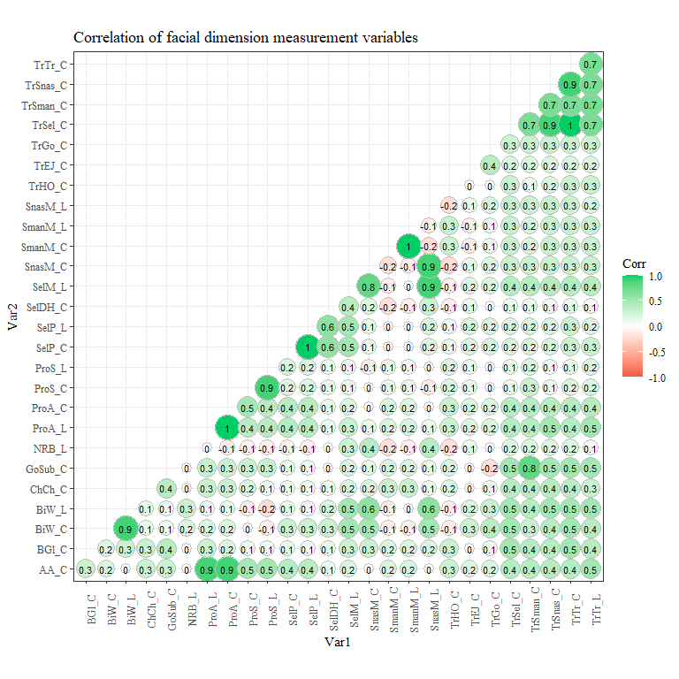

correlation_data<-read_excel("C:\\Users\\19177\\OneDrive - Colostate\\Desktop\\Dissertation\\headscan_dissertation\\correlation_data.xlsx")

correlation_data <- pivot_longer(correlation_data, AA_C:TrTr_L, names_to = "second_measure", values_to = "correlation")  
  
correlation_data <- correlation_data %>%   
 rename(first_measure = "term")  
  
correlation_data$both_measures <- paste(correlation_data$first_measure, sep= " & ", correlation_data$second_measure)  
  
str(correlation_data)

## tibble [729 × 4] (S3: tbl_df/tbl/data.frame)  
## $ first_measure : chr [1:729] "AA_C" "AA_C" "AA_C" "AA_C" ...  
## $ second_measure: chr [1:729] "AA_C" "BGl_C" "BiW_C" "BiW_L" ...  
## $ correlation : num [1:729] NA NA NA NA NA NA NA NA NA NA ...  
## $ both_measures : chr [1:729] "AA_C & AA_C" "AA_C & BGl_C" "AA_C & BiW_C" "AA_C & BiW_L" ...

correlation_data1 <- correlation_data[-c(1,2)]  
  
correlation_data1 <- correlation_data1[, c(2,1)]  
  
correlation_data1$correlation <- round(correlation_data1$correlation, digits=4)  
  
correlation_data1 <- na.omit(correlation_data1)

#Size 12 Table TNR  
flextable(correlation_data1) %>%  
 my_ft_theme()%>%   
 bold(part = "header") %>%   
 set_caption("Correlations") %>%   
 set_header_labels(values = list(both_measures = "Correlated Measurements",  
 correlation = "Correlation")) %>%   
 autofit()

**Table** **1**: Correlations

| **Correlated Measurements** | **Correlation** |
| --- | --- |
| BGl_C & AA_C | 0.2511 |
| BiW_C & AA_C | 0.1559 |
| BiW_C & BGl_C | 0.2220 |
| BiW_L & AA_C | 0.0361 |
| BiW_L & BGl_C | 0.2588 |
| BiW_L & BiW_C | 0.8934 |
| ChCh_C & AA_C | 0.3356 |
| ChCh_C & BGl_C | 0.3035 |
| ChCh_C & BiW_C | 0.1101 |
| ChCh_C & BiW_L | 0.1441 |
| GoSub_C & AA_C | 0.3231 |
| GoSub_C & BGl_C | 0.3238 |
| GoSub_C & BiW_C | 0.0658 |
| GoSub_C & BiW_L | 0.1134 |
| GoSub_C & ChCh_C | 0.3175 |
| NRB_L & AA_C | -0.0242 |
| NRB_L & BGl_C | 0.0501 |
| NRB_L & BiW_C | 0.1915 |
| NRB_L & BiW_L | 0.2797 |
| NRB_L & ChCh_C | -0.0358 |
| NRB_L & GoSub_C | 0.0219 |
| ProA_L & AA_C | 0.8962 |
| ProA_L & BGl_C | 0.2555 |
| ProA_L & BiW_C | 0.2257 |
| ProA_L & BiW_L | 0.1163 |
| ProA_L & ChCh_C | 0.3311 |
| ProA_L & GoSub_C | 0.2826 |
| ProA_L & NRB_L | -0.0199 |
| ProA_C & AA_C | 0.8870 |
| ProA_C & BGl_C | 0.2360 |
| ProA_C & BiW_C | 0.1695 |
| ProA_C & BiW_L | 0.0512 |
| ProA_C & ChCh_C | 0.3086 |
| ProA_C & GoSub_C | 0.2637 |
| ProA_C & NRB_L | -0.0762 |
| ProA_C & ProA_L | 0.9712 |
| ProS_C & AA_C | 0.4925 |
| ProS_C & BGl_C | 0.1422 |
| ProS_C & BiW_C | -0.0199 |
| ProS_C & BiW_L | -0.1171 |
| ProS_C & ChCh_C | 0.1758 |
| ProS_C & GoSub_C | 0.2612 |
| ProS_C & NRB_L | -0.1206 |
| ProS_C & ProA_L | 0.4381 |
| ProS_C & ProA_C | 0.4554 |
| ProS_L & AA_C | 0.4806 |
| ProS_L & BGl_C | 0.1382 |
| ProS_L & BiW_C | -0.0566 |
| ProS_L & BiW_L | -0.1642 |
| ProS_L & ChCh_C | 0.1341 |
| ProS_L & GoSub_C | 0.2601 |
| ProS_L & NRB_L | -0.1150 |
| ProS_L & ProA_L | 0.4197 |
| ProS_L & ProA_C | 0.4375 |
| ProS_L & ProS_C | 0.8963 |
| SelP_C & AA_C | 0.4216 |
| SelP_C & BGl_C | 0.1206 |
| SelP_C & BiW_C | 0.2952 |
| SelP_C & BiW_L | 0.1277 |
| SelP_C & ChCh_C | 0.0932 |
| SelP_C & GoSub_C | 0.0850 |
| SelP_C & NRB_L | -0.0786 |
| SelP_C & ProA_L | 0.4312 |
| SelP_C & ProA_C | 0.4157 |
| SelP_C & ProS_C | 0.1868 |
| SelP_C & ProS_L | 0.1816 |
| SelP_L & AA_C | 0.4135 |
| SelP_L & BGl_C | 0.1215 |
| SelP_L & BiW_C | 0.2902 |
| SelP_L & BiW_L | 0.1246 |
| SelP_L & ChCh_C | 0.0892 |
| SelP_L & GoSub_C | 0.0804 |
| SelP_L & NRB_L | -0.0766 |
| SelP_L & ProA_L | 0.4222 |
| SelP_L & ProA_C | 0.4078 |
| SelP_L & ProS_C | 0.1928 |
| SelP_L & ProS_L | 0.1874 |
| SelP_L & SelP_C | 0.9931 |
| SelDH_C & AA_C | 0.0472 |
| SelDH_C & BGl_C | 0.0725 |
| SelDH_C & BiW_C | 0.2836 |
| SelDH_C & BiW_L | 0.2145 |
| SelDH_C & ChCh_C | 0.0532 |
| SelDH_C & GoSub_C | 0.0182 |
| SelDH_C & NRB_L | 0.0142 |
| SelDH_C & ProA_L | 0.0787 |
| SelDH_C & ProA_C | 0.0567 |
| SelDH_C & ProS_C | 0.0512 |
| SelDH_C & ProS_L | 0.0492 |
| SelDH_C & SelP_C | 0.4814 |
| SelDH_C & SelP_L | 0.4867 |
| SelM_L & AA_C | 0.2278 |
| SelM_L & BGl_C | 0.3012 |
| SelM_L & BiW_C | 0.5461 |
| SelM_L & BiW_L | 0.5086 |
| SelM_L & ChCh_C | 0.2124 |
| SelM_L & GoSub_C | 0.2186 |
| SelM_L & NRB_L | 0.2751 |
| SelM_L & ProA_L | 0.2569 |
| SelM_L & ProA_C | 0.2009 |
| SelM_L & ProS_C | 0.0998 |
| SelM_L & ProS_L | 0.1044 |
| SelM_L & SelP_C | 0.4983 |
| SelM_L & SelP_L | 0.5074 |
| SelM_L & SelDH_C | 0.3751 |
| SnasM_C & AA_C | 0.0439 |
| SnasM_C & BGl_C | 0.2373 |
| SnasM_C & BiW_C | 0.5304 |
| SnasM_C & BiW_L | 0.5795 |
| SnasM_C & ChCh_C | 0.1736 |
| SnasM_C & GoSub_C | 0.1063 |
| SnasM_C & NRB_L | 0.3499 |
| SnasM_C & ProA_L | 0.0975 |
| SnasM_C & ProA_C | 0.0291 |
| SnasM_C & ProS_C | -0.0454 |
| SnasM_C & ProS_L | -0.0752 |
| SnasM_C & SelP_C | 0.1193 |
| SnasM_C & SelP_L | 0.1190 |
| SnasM_C & SelDH_C | 0.2270 |
| SnasM_C & SelM_L | 0.8020 |
| SmanM_C & AA_C | 0.2223 |
| SmanM_C & BGl_C | 0.1713 |
| SmanM_C & BiW_C | -0.1241 |
| SmanM_C & BiW_L | -0.0920 |
| SmanM_C & ChCh_C | 0.3057 |
| SmanM_C & GoSub_C | 0.1708 |
| SmanM_C & NRB_L | -0.1670 |
| SmanM_C & ProA_L | 0.1913 |
| SmanM_C & ProA_C | 0.2126 |
| SmanM_C & ProS_C | 0.1490 |
| SmanM_C & ProS_L | 0.1199 |
| SmanM_C & SelP_C | -0.0341 |
| SmanM_C & SelP_L | -0.0415 |
| SmanM_C & SelDH_C | -0.1576 |
| SmanM_C & SelM_L | -0.1012 |
| SmanM_C & SnasM_C | -0.1434 |
| SmanM_L & AA_C | 0.2052 |
| SmanM_L & BGl_C | 0.1976 |
| SmanM_L & BiW_C | -0.0745 |
| SmanM_L & BiW_L | -0.0323 |
| SmanM_L & ChCh_C | 0.3267 |
| SmanM_L & GoSub_C | 0.2101 |
| SmanM_L & NRB_L | -0.1293 |
| SmanM_L & ProA_L | 0.1746 |
| SmanM_L & ProA_C | 0.1846 |
| SmanM_L & ProS_C | 0.1425 |
| SmanM_L & ProS_L | 0.1115 |
| SmanM_L & SelP_C | -0.0347 |
| SmanM_L & SelP_L | -0.0399 |
| SmanM_L & SelDH_C | -0.1149 |
| SmanM_L & SelM_L | -0.0359 |
| SmanM_L & SnasM_C | -0.0779 |
| SmanM_L & SmanM_C | 0.9614 |
| SnasM_L & AA_C | 0.0238 |
| SnasM_L & BGl_C | 0.2326 |
| SnasM_L & BiW_C | 0.5423 |
| SnasM_L & BiW_L | 0.5602 |
| SnasM_L & ChCh_C | 0.1441 |
| SnasM_L & GoSub_C | 0.1201 |
| SnasM_L & NRB_L | 0.3484 |
| SnasM_L & ProA_L | 0.0722 |
| SnasM_L & ProA_C | 0.0095 |
| SnasM_L & ProS_C | -0.0608 |
| SnasM_L & ProS_L | -0.0496 |
| SnasM_L & SelP_C | 0.1503 |
| SnasM_L & SelP_L | 0.1537 |
| SnasM_L & SelDH_C | 0.2557 |
| SnasM_L & SelM_L | 0.8641 |
| SnasM_L & SnasM_C | 0.9466 |
| SnasM_L & SmanM_C | -0.1693 |
| SnasM_L & SmanM_L | -0.0977 |
| TrHO_C & AA_C | 0.2973 |
| TrHO_C & BGl_C | 0.3105 |
| TrHO_C & BiW_C | -0.0949 |
| TrHO_C & BiW_L | -0.1117 |
| TrHO_C & ChCh_C | 0.1574 |
| TrHO_C & GoSub_C | 0.1762 |
| TrHO_C & NRB_L | -0.2132 |
| TrHO_C & ProA_L | 0.2774 |
| TrHO_C & ProA_C | 0.2944 |
| TrHO_C & ProS_C | 0.2184 |
| TrHO_C & ProS_L | 0.2223 |
| TrHO_C & SelP_C | 0.0917 |
| TrHO_C & SelP_L | 0.0880 |
| TrHO_C & SelDH_C | -0.1174 |
| TrHO_C & SelM_L | -0.0887 |
| TrHO_C & SnasM_C | -0.1800 |
| TrHO_C & SmanM_C | 0.3184 |
| TrHO_C & SmanM_L | 0.2673 |
| TrHO_C & SnasM_L | -0.2198 |
| TrEJ_C & AA_C | 0.1865 |
| TrEJ_C & BGl_C | 0.0431 |
| TrEJ_C & BiW_C | 0.2736 |
| TrEJ_C & BiW_L | 0.2266 |
| TrEJ_C & ChCh_C | 0.0129 |
| TrEJ_C & GoSub_C | 0.0054 |
| TrEJ_C & NRB_L | 0.0550 |
| TrEJ_C & ProA_L | 0.2127 |
| TrEJ_C & ProA_C | 0.1904 |
| TrEJ_C & ProS_C | 0.1148 |
| TrEJ_C & ProS_L | 0.1173 |
| TrEJ_C & SelP_C | 0.2310 |
| TrEJ_C & SelP_L | 0.2315 |
| TrEJ_C & SelDH_C | 0.1144 |
| TrEJ_C & SelM_L | 0.1974 |
| TrEJ_C & SnasM_C | 0.1068 |
| TrEJ_C & SmanM_C | -0.0783 |
| TrEJ_C & SmanM_L | -0.0923 |
| TrEJ_C & SnasM_L | 0.1262 |
| TrEJ_C & TrHO_C | 0.0009 |
| TrGo_C & AA_C | 0.1855 |
| TrGo_C & BGl_C | 0.0830 |
| TrGo_C & BiW_C | 0.3849 |
| TrGo_C & BiW_L | 0.3305 |
| TrGo_C & ChCh_C | 0.0729 |
| TrGo_C & GoSub_C | -0.1844 |
| TrGo_C & NRB_L | 0.0368 |
| TrGo_C & ProA_L | 0.2293 |
| TrGo_C & ProA_C | 0.2150 |
| TrGo_C & ProS_C | 0.0159 |
| TrGo_C & ProS_L | -0.0029 |
| TrGo_C & SelP_C | 0.2111 |
| TrGo_C & SelP_L | 0.2085 |
| TrGo_C & SelDH_C | 0.0242 |
| TrGo_C & SelM_L | 0.2071 |
| TrGo_C & SnasM_C | 0.1573 |
| TrGo_C & SmanM_C | 0.1458 |
| TrGo_C & SmanM_L | 0.1210 |
| TrGo_C & SnasM_L | 0.1515 |
| TrGo_C & TrHO_C | 0.0355 |
| TrGo_C & TrEJ_C | 0.3478 |
| TrSel_C & AA_C | 0.4141 |
| TrSel_C & BGl_C | 0.4506 |
| TrSel_C & BiW_C | 0.4534 |
| TrSel_C & BiW_L | 0.5121 |
| TrSel_C & ChCh_C | 0.3829 |
| TrSel_C & GoSub_C | 0.4293 |
| TrSel_C & NRB_L | 0.1661 |
| TrSel_C & ProA_L | 0.4206 |
| TrSel_C & ProA_C | 0.3722 |
| TrSel_C & ProS_C | 0.1358 |
| TrSel_C & ProS_L | 0.1063 |
| TrSel_C & SelP_C | 0.2391 |
| TrSel_C & SelP_L | 0.2345 |
| TrSel_C & SelDH_C | 0.0681 |
| TrSel_C & SelM_L | 0.4028 |
| TrSel_C & SnasM_C | 0.3028 |
| TrSel_C & SmanM_C | 0.2550 |
| TrSel_C & SmanM_L | 0.2815 |
| TrSel_C & SnasM_L | 0.2919 |
| TrSel_C & TrHO_C | 0.2811 |
| TrSel_C & TrEJ_C | 0.2134 |
| TrSel_C & TrGo_C | 0.2952 |
| TrSman_C & AA_C | 0.4115 |
| TrSman_C & BGl_C | 0.3880 |
| TrSman_C & BiW_C | 0.3381 |
| TrSman_C & BiW_L | 0.3746 |
| TrSman_C & ChCh_C | 0.3584 |
| TrSman_C & GoSub_C | 0.7850 |
| TrSman_C & NRB_L | 0.1486 |
| TrSman_C & ProA_L | 0.3991 |
| TrSman_C & ProA_C | 0.3643 |
| TrSman_C & ProS_C | 0.2631 |
| TrSman_C & ProS_L | 0.2424 |
| TrSman_C & SelP_C | 0.2097 |
| TrSman_C & SelP_L | 0.2063 |
| TrSman_C & SelDH_C | 0.0702 |
| TrSman_C & SelM_L | 0.4292 |
| TrSman_C & SnasM_C | 0.2913 |
| TrSman_C & SmanM_C | 0.1761 |
| TrSman_C & SmanM_L | 0.2229 |
| TrSman_C & SnasM_L | 0.3074 |
| TrSman_C & TrHO_C | 0.1149 |
| TrSman_C & TrEJ_C | 0.2062 |
| TrSman_C & TrGo_C | 0.2100 |
| TrSman_C & TrSel_C | 0.6548 |
| TrSnas_C & AA_C | 0.4436 |
| TrSnas_C & BGl_C | 0.4463 |
| TrSnas_C & BiW_C | 0.4201 |
| TrSnas_C & BiW_L | 0.5009 |
| TrSnas_C & ChCh_C | 0.4339 |
| TrSnas_C & GoSub_C | 0.4860 |
| TrSnas_C & NRB_L | 0.2109 |
| TrSnas_C & ProA_L | 0.4547 |
| TrSnas_C & ProA_C | 0.4034 |
| TrSnas_C & ProS_C | 0.1426 |
| TrSnas_C & ProS_L | 0.0947 |
| TrSnas_C & SelP_C | 0.2171 |
| TrSnas_C & SelP_L | 0.2096 |
| TrSnas_C & SelDH_C | 0.0374 |
| TrSnas_C & SelM_L | 0.3867 |
| TrSnas_C & SnasM_C | 0.3212 |
| TrSnas_C & SmanM_C | 0.3019 |
| TrSnas_C & SmanM_L | 0.3350 |
| TrSnas_C & SnasM_L | 0.2963 |
| TrSnas_C & TrHO_C | 0.2078 |
| TrSnas_C & TrEJ_C | 0.2226 |
| TrSnas_C & TrGo_C | 0.3155 |
| TrSnas_C & TrSel_C | 0.8902 |
| TrSnas_C & TrSman_C | 0.7238 |
| TrTr_C & AA_C | 0.4395 |
| TrTr_C & BGl_C | 0.4922 |
| TrTr_C & BiW_C | 0.4662 |
| TrTr_C & BiW_L | 0.5168 |
| TrTr_C & ChCh_C | 0.4022 |
| TrTr_C & GoSub_C | 0.4528 |
| TrTr_C & NRB_L | 0.1606 |
| TrTr_C & ProA_L | 0.4403 |
| TrTr_C & ProA_C | 0.3911 |
| TrTr_C & ProS_C | 0.1651 |
| TrTr_C & ProS_L | 0.1419 |
| TrTr_C & SelP_C | 0.2635 |
| TrTr_C & SelP_L | 0.2596 |
| TrTr_C & SelDH_C | 0.0898 |
| TrTr_C & SelM_L | 0.4369 |
| TrTr_C & SnasM_C | 0.3171 |
| TrTr_C & SmanM_C | 0.2708 |
| TrTr_C & SmanM_L | 0.3014 |
| TrTr_C & SnasM_L | 0.3105 |
| TrTr_C & TrHO_C | 0.3105 |
| TrTr_C & TrEJ_C | 0.2106 |
| TrTr_C & TrGo_C | 0.2828 |
| TrTr_C & TrSel_C | 0.9540 |
| TrTr_C & TrSman_C | 0.6719 |
| TrTr_C & TrSnas_C | 0.8753 |
| TrTr_L & AA_C | 0.4629 |
| TrTr_L & BGl_C | 0.4449 |
| TrTr_L & BiW_C | 0.4157 |
| TrTr_L & BiW_L | 0.4570 |
| TrTr_L & ChCh_C | 0.3257 |
| TrTr_L & GoSub_C | 0.4851 |
| TrTr_L & NRB_L | 0.0954 |
| TrTr_L & ProA_L | 0.4609 |
| TrTr_L & ProA_C | 0.4249 |
| TrTr_L & ProS_C | 0.2128 |
| TrTr_L & ProS_L | 0.1845 |
| TrTr_L & SelP_C | 0.2561 |
| TrTr_L & SelP_L | 0.2472 |
| TrTr_L & SelDH_C | 0.0622 |
| TrTr_L & SelM_L | 0.3723 |
| TrTr_L & SnasM_C | 0.2482 |
| TrTr_L & SmanM_C | 0.2538 |
| TrTr_L & SmanM_L | 0.2813 |
| TrTr_L & SnasM_L | 0.2348 |
| TrTr_L & TrHO_C | 0.2930 |
| TrTr_L & TrEJ_C | 0.2028 |
| TrTr_L & TrGo_C | 0.2913 |
| TrTr_L & TrSel_C | 0.7114 |
| TrTr_L & TrSman_C | 0.6826 |
| TrTr_L & TrSnas_C | 0.7053 |
| TrTr_L & TrTr_C | 0.7414 |

#correlation_data1 %>%  
 #mutate(both_measures=fct_reorder(both_measures, correlation)) %>%   
 #ggplot(aes(x=correlation, y=both_measures))+  
 #geom_bar(stat= "identity", color= "black", fill = "white")+  
 #theme_bw()+theme(text=element_text(family= "Times New Roman"))+  
 #theme(axis.text.x = element_text(angle = 90))+   
 #labs(title="Correlations",  
 #y="Correlated Measures Abbreviation (see Appendix B)",  
 #x="Correlation value")

high_cor <- filter(correlation_data1, correlation > 0.7)  
str(high_cor)

## tibble [18 × 2] (S3: tbl_df/tbl/data.frame)  
## $ both_measures: chr [1:18] "BiW_L & BiW_C" "ProA_L & AA_C" "ProA_C & AA_C" "ProA_C & ProA_L" ...  
## $ correlation : num [1:18] 0.893 0.896 0.887 0.971 0.896 ...  
## - attr(*, "na.action")= 'omit' Named int [1:378] 1 2 3 4 5 6 7 8 9 10 ...  
## ..- attr(*, "names")= chr [1:378] "1" "2" "3" "4" ...

flextable(high_cor) %>%  
 my_ft_theme()%>%   
 bold(part = "header") %>%   
 set_caption("Correlations over 0.7") %>%   
 set_header_labels(values = list(both_measures = "Correlated Measurements",  
 correlation = "Correlation")) %>%   
 autofit()

**Table** **2**: Correlations over 0.7

| **Correlated Measurements** | **Correlation** |
| --- | --- |
| BiW_L & BiW_C | 0.8934 |
| ProA_L & AA_C | 0.8962 |
| ProA_C & AA_C | 0.8870 |
| ProA_C & ProA_L | 0.9712 |
| ProS_L & ProS_C | 0.8963 |
| SelP_L & SelP_C | 0.9931 |
| SnasM_C & SelM_L | 0.8020 |
| SmanM_L & SmanM_C | 0.9614 |
| SnasM_L & SelM_L | 0.8641 |
| SnasM_L & SnasM_C | 0.9466 |
| TrSman_C & GoSub_C | 0.7850 |
| TrSnas_C & TrSel_C | 0.8902 |
| TrSnas_C & TrSman_C | 0.7238 |
| TrTr_C & TrSel_C | 0.9540 |
| TrTr_C & TrSnas_C | 0.8753 |
| TrTr_L & TrSel_C | 0.7114 |
| TrTr_L & TrSnas_C | 0.7053 |
| TrTr_L & TrTr_C | 0.7414 |

high_cor %>%  
 mutate(both_measures=fct_reorder(both_measures, correlation)) %>%   
 ggplot(aes(x=correlation, y=both_measures))+  
 geom_bar(stat= "identity", color= "black", fill = "white")+  
 theme_bw()+theme(text=element_text(family= "Times New Roman"))+  
 #theme(axis.text.x = element_text(angle = 90))+   
 labs(title="Correlations over 0.7",  
 y="Correlated Measures Abbreviation (see Appendix B)",  
 x="Correlation value")

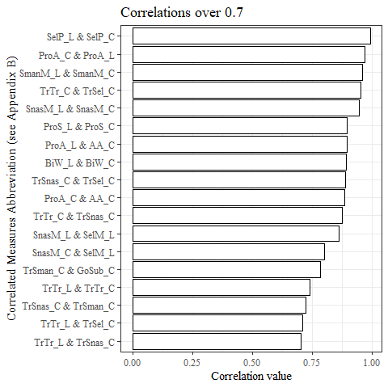

#headscan_full1<-read_excel("C:\\Users\\19177\\OneDrive - Colostate\\Desktop\\Dissertation\\headscan_dissertation\\headscan_full1.xlsx")  
  
coders <- headscan_full1[-c(2:28, 30:33)]  
  
coders <- coders %>%   
 rename(coder_name = "coder")  
  
coders <- coders %>%   
 mutate(coder= case_when(  
 coder_name == "Isabel" ~ "A",  
 coder_name == "Kayna" ~ "B",  
 coder_name == "Chandler" ~ "C",  
 coder_name == "Jared" ~ "D"  
 ))  
  
str(coders)

## tibble [2,016 × 3] (S3: tbl_df/tbl/data.frame)  
## $ ID : chr [1:2016] "400-20201012-002" "400-20201012-003" "400-20201012-004" "400-20201012-005" ...  
## $ coder_name: chr [1:2016] "Kayna" "Kayna" "Kayna" "Kayna" ...  
## $ coder : chr [1:2016] "B" "B" "B" "B" ...

coders %>%   
 ggplot(aes(x=fct_infreq(coder), label=scales::percent(prop.table(stat(count)))))+  
 geom_bar(stat="count", binwidth = 4, color= "black", fill = "white")+  
 geom_text(stat="count",  
 position= position_dodge(0.9),  
 vjust = -0.5,   
 size = 3)+  
 theme_bw()+theme(text=element_text(family= "Times New Roman"))+  
 labs(title="Data Collection Count per Coder",  
 y="# of Scans Digitized",  
 x="Coder")

## Warning: Ignoring unknown parameters: binwidth

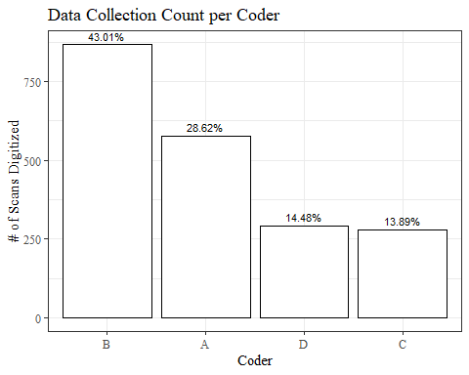

intraRR<-read_excel("C:\\Users\\19177\\OneDrive - Colostate\\Desktop\\Dissertation\\headscan_dissertation\\intraRR_iccs.xlsx")  
intraRR <- intraRR[-1]  
str(intraRR)

## tibble [108 × 3] (S3: tbl_df/tbl/data.frame)  
## $ coder : chr [1:108] "A" "A" "A" "A" ...  
## $ measure : chr [1:108] "AA_C" "BGl_C" "BiW_L" "BiW_C" ...  
## $ icc_value: num [1:108] 0.987 0.96 0.924 0.917 0.984 0.937 0.83 0.986 0.975 0.961 ...

intraRR %>%  
 mutate(measure=fct_reorder(measure, icc_value, .desc=TRUE)) %>%   
 ggplot(aes(x=icc_value, y=measure))+  
 geom_bar(stat= "identity", color= "black", fill = "white")+  
 theme_bw()+theme(text=element_text(family= "Times New Roman"))+  
 facet_wrap(coder~.)+  
 #theme(axis.text.x = element_text(angle = 90))+   
 labs(title="IntraRR ICC Values",  
 subtitle = "Percent of Data Collected per Coder: A=29%, B=43%, C=14%, D=14%",  
 y="Measurement Location",  
 x="ICC Value")

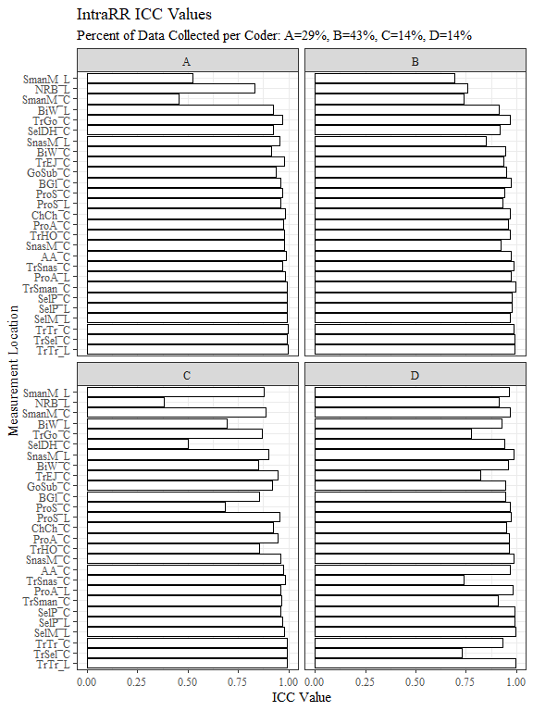

THIS IS WHERE I LEFT OFF NOTATIONS

isabel_intra <- intraRR[intraRR$coder=="A",]  
kayna_intra <- intraRR[intraRR$coder == "B",]  
chandler_intra <- intraRR[intraRR$coder == "C",]  
jared_intra <- intraRR[intraRR$coder == "D",]  
  
#write_xlsx(isabel_intra, "C:\\Users\\19177\\OneDrive - Colostate\\Desktop\\Dissertation\\headscan_dissertation\\isabel_intra.xlsx")  
#write_xlsx(kayna_intra, "C:\\Users\\19177\\OneDrive - Colostate\\Desktop\\Dissertation\\headscan_dissertation\\kayna_intra.xlsx")  
#write_xlsx(chandler_intra, "C:\\Users\\19177\\OneDrive - Colostate\\Desktop\\Dissertation\\headscan_dissertation\\chandler_intra.xlsx")  
#write_xlsx(jared_intra, "C:\\Users\\19177\\OneDrive - Colostate\\Desktop\\Dissertation\\headscan_dissertation\\jared_intra.xlsx")

isabel_intra %>%  
 mutate(measure=fct_reorder(measure, icc_value, .desc=TRUE)) %>%   
 ggplot(aes(x=icc_value, y=measure))+  
 geom_bar(stat= "identity", color= "black", fill = "white")+  
 theme_bw()+theme(text=element_text(family= "Times New Roman"))+  
 #theme(axis.text.x = element_text(angle = 90))+   
 labs(title="Coder A ICC Values",  
 subtitle = "completed 28.61% of data collection",  
 y="Measurement Location",  
 x="ICC Value")

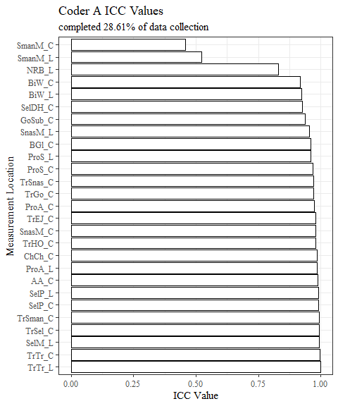

kayna_intra %>%  
 mutate(measure=fct_reorder(measure, icc_value, .desc=TRUE)) %>%   
 ggplot(aes(x=icc_value, y=measure))+  
 geom_bar(stat= "identity", color= "black", fill = "white")+  
 theme_bw()+theme(text=element_text(family= "Times New Roman"))+  
 #theme(axis.text.x = element_text(angle = 90))+   
 labs(title="Coder B ICC Values",  
 subtitle = "completed 42.98% of data collection",  
 y="Measurement Location",  
 x="ICC Value")

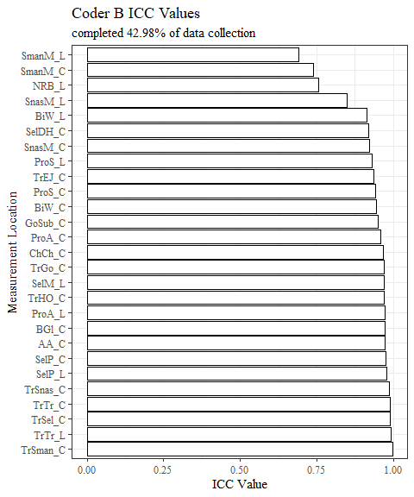

chandler_intra %>%  
 mutate(measure=fct_reorder(measure, icc_value, .desc=TRUE)) %>%   
 ggplot(aes(x=icc_value, y=measure))+  
 geom_bar(stat= "identity", color= "black", fill = "white")+  
 theme_bw()+theme(text=element_text(family= "Times New Roman"))+  
 #theme(axis.text.x = element_text(angle = 90))+   
 labs(title="Coder C ICC Values",  
 subtitle = "completed 14.53% of data collection",  
 y="Measurement Location",  
 x="ICC Value")

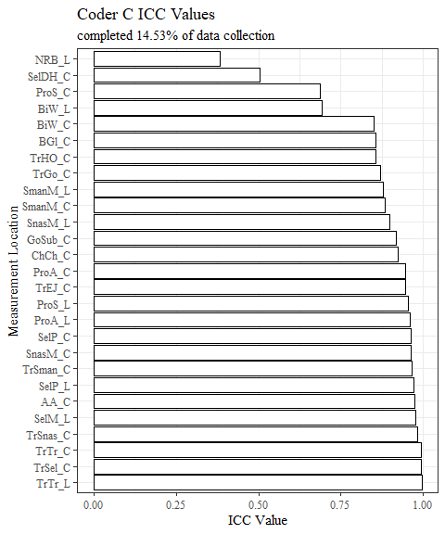

jared_intra %>%  
 mutate(measure=fct_reorder(measure, icc_value, .desc=TRUE)) %>%   
 ggplot(aes(x=icc_value, y=measure))+  
 geom_bar(stat= "identity", color= "black", fill = "white")+  
 theme_bw()+theme(text=element_text(family= "Times New Roman"))+  
 #theme(axis.text.x = element_text(angle = 90))+   
 labs(title="Coder D ICC Values",  
 subtitle = "completed 13.88% of data collection",  
 y="Measurement Location",  
 x="ICC Value")

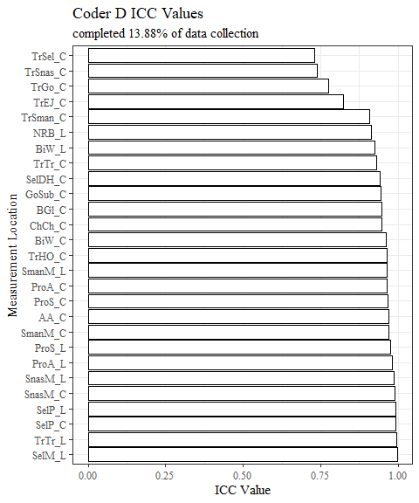

low_intraRR <- filter(intraRR, icc_value < 0.9)  
  
low_intraRR <- low_intraRR %>%   
 mutate(percent_coded= case_when(  
 coder == "A" ~ "28.61%",  
 coder == "B" ~ "42.98%",  
 coder == "C" ~ "14.53%",  
 coder == "D" ~ "13.88%"  
 ))  
  
str(low_intraRR)

## tibble [22 × 4] (S3: tbl_df/tbl/data.frame)  
## $ coder : chr [1:22] "A" "A" "A" "B" ...  
## $ measure : chr [1:22] "NRB_L" "SmanM_L" "SmanM_C" "NRB_L" ...  
## $ icc_value : num [1:22] 0.83 0.522 0.457 0.757 0.849 0.692 0.74 0.856 0.692 0.849 ...  
## $ percent_coded: chr [1:22] "28.61%" "28.61%" "28.61%" "42.98%" ...

low_intraRR %>%  
 mutate(measure=fct_reorder(measure, icc_value, .desc=TRUE)) %>%   
 ggplot(aes(x=icc_value, y=measure))+  
 geom_bar(stat= "identity", color= "black", fill = "white")+  
 theme_bw()+theme(text=element_text(family= "Times New Roman"))+  
 facet_wrap(coder~.)+  
 #theme(axis.text.x = element_text(angle = 90))+   
 labs(title="Low ICC Values",  
 subtitle = "Percent of Data Collected per Coder: A=29%, B=43%, C=14%, D=14%",  
 y="Measurement Location",  
 x="ICC Value")

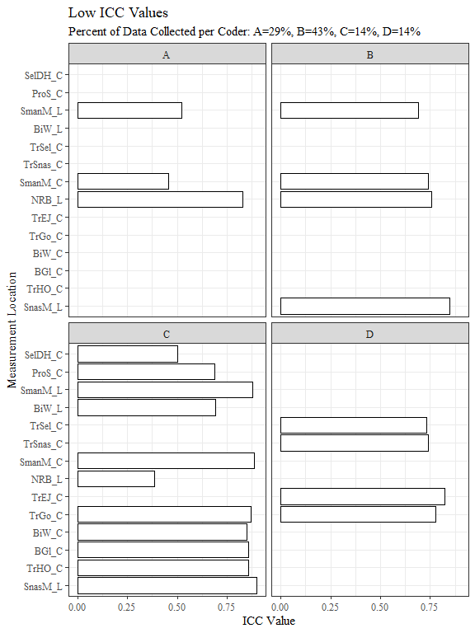

low_intraRR %>%   
 ggplot(aes(x=measure, y=icc_value, fill=coder))+  
 geom_bar(position = "dodge", stat = "identity")+  
 theme_bw()+theme(text=element_text(family= "Times New Roman"))+  
 theme(axis.text.x = element_text(angle = 90))+   
 labs(title="Low ICC values for all Coders",  
 subtitle = "Percent of Data Collected per Coder: A=29%, B=43%, C=14%, D=14%",  
 y="ICC Value",  
 x="Measurement Location")

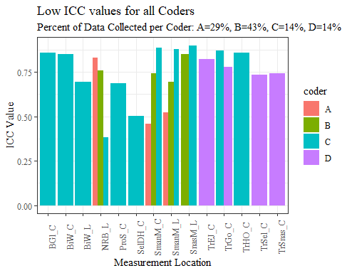

correlation_datafl <- pivot_longer(correlation_data_full, AA_C:TrTr_L, names_to = "second_measure", values_to = "correlation")  
  
correlation_datafl <- correlation_datafl %>%   
 rename(first_measure = "term")  
  
correlation_datafl$both_measures <- paste(correlation_datafl$first_measure, sep= " & ", correlation_datafl$second_measure)  
  
str(correlation_data)

## tibble [729 × 4] (S3: tbl_df/tbl/data.frame)  
## $ first_measure : chr [1:729] "AA_C" "AA_C" "AA_C" "AA_C" ...  
## $ second_measure: chr [1:729] "AA_C" "BGl_C" "BiW_C" "BiW_L" ...  
## $ correlation : num [1:729] NA NA NA NA NA NA NA NA NA NA ...  
## $ both_measures : chr [1:729] "AA_C & AA_C" "AA_C & BGl_C" "AA_C & BiW_C" "AA_C & BiW_L" ...

correlation_datafl$correlation <- round(correlation_datafl$correlation, digits=4)  
  
correlation_datafl <- na.omit(correlation_datafl)

high_cor_full <- filter(correlation_datafl, correlation > 0.7)  
high_cor_full <- high_cor_full %>%   
 rename(measure = "first_measure")  
str(high_cor_full)

## tibble [36 × 4] (S3: tbl_df/tbl/data.frame)  
## $ measure : chr [1:36] "AA_C" "AA_C" "BiW_C" "BiW_L" ...  
## $ second_measure: chr [1:36] "ProA_L" "ProA_C" "BiW_L" "BiW_C" ...  
## $ correlation : num [1:36] 0.896 0.887 0.893 0.893 0.804 ...  
## $ both_measures : chr [1:36] "AA_C & ProA_L" "AA_C & ProA_C" "BiW_C & BiW_L" "BiW_L & BiW_C" ...  
## - attr(*, "na.action")= 'omit' Named int [1:27] 1 29 57 85 113 141 169 197 225 253 ...  
## ..- attr(*, "names")= chr [1:27] "1" "29" "57" "85" ...

#join lower intra and high cor full, retain lower intra dataset  
questionable_measures <- full_join(low_intraRR, high_cor_full, by="measure", all=TRUE)  
questionable_measures <- questionable_measures %>%   
 rename(correlated_measure = "second_measure",  
 intra_icc = "icc_value")  
  
questionable_measures <- questionable_measures[, c(1,4,2,5,3,6,7)]  
  
str(questionable_measures)

## tibble [51 × 7] (S3: tbl_df/tbl/data.frame)  
## $ coder : chr [1:51] "A" "A" "A" "B" ...  
## $ percent_coded : chr [1:51] "28.61%" "28.61%" "28.61%" "42.98%" ...  
## $ measure : chr [1:51] "NRB_L" "SmanM_L" "SmanM_C" "NRB_L" ...  
## $ correlated_measure: chr [1:51] NA "SmanM_C" "SmanM_L" NA ...  
## $ intra_icc : num [1:51] 0.83 0.522 0.457 0.757 0.849 0.849 0.692 0.74 0.856 0.692 ...  
## $ correlation : num [1:51] NA 0.961 0.961 NA 0.864 ...  
## $ both_measures : chr [1:51] NA "SmanM_L & SmanM_C" "SmanM_C & SmanM_L" NA ...

questionable_measures$both_measures <-  
 recode_factor(questionable_measures$both_measures, 'SmanM_C & SmanM_L' = "SmanM_L & SmanM_C",  
 'BiW_C & BiW_L' = "BiW_L & BiW_C",  
 'TrSnas_C & TrSel_C' = "TrSel_C & TrSnas_C",  
 'ProA_L & AA_C' = "AA_C & ProA_L",  
 'ProA_C & AA_C' = "AA_C & ProA_C",  
 'TrSman_C & GoSub_C' = "GoSub_C & TrSman_C",  
 'ProA_C & ProA_L' = "ProA_L & ProA_C",  
 'ProS_C & ProS_L' = "ProS_L & ProS_C",  
 'SelP_C & SelP_L' = "SelP_L & SelP_C",  
 'SnasM_C & SelM_L' = "SelM_L & SnasM_C",  
 'SnasM_C & SnasM_L' = "SnasM_L & SnasM_C",  
 'TrSnas_C & TrSman_C' = "TrSman_C & TrSnas_C",  
 'TrTr_C & TrTr_L' = "TrTr_L & TrTr_C",  
 'TrSnas_C & TrTr_L' = "TrTr_L & TrSnas_C",  
 'TrSel_C & TrTr_L' = "TrTr_L & TrSel_C",  
 'SelM_L & SnasM_L' = "SnasM_L & SelM_L",  
 'TrSnas_C & TrTr_C' = "TrTr_C & TrSnas_C",  
 'TrSel_C & TrTr_C' = "TrTr_C & TrSel_C")  
  
str(questionable_measures$both_measures)

## Factor w/ 18 levels "SmanM_L & SmanM_C",..: NA 1 1 NA 16 11 1 1 NA 2 ...

quest_meas_nona <- na.omit(questionable_measures)

myFont1 <- "Times New Roman"

library(ggrepel)  
  
quest_meas_nona %>%   
 ggplot(aes(x=intra_icc, y=correlation))+  
 geom_point(aes(shape=both_measures, color=coder), size=5)+  
 geom_text_repel(aes(label=measure), family="Times New Roman", size= 2.5, color="gray50")+  
 annotate(geom="text", x=0.4, y=0.84, label= "Highly correlated measures with low intraRR",   
 size=3.5, fontface = 'italic', family= myFont1, hjust=0, vjust=0)+  
 scale_shape_manual(values=seq(0,12))+  
 geom_rect(aes(xmin=0.4, xmax=0.75, ymin=0.85, ymax=1), fill= NA, alpha=0.4, colour="black")+  
 theme_bw()+theme(text=element_text(family= "Times New Roman"))+  
 #theme(axis.text.x = element_text(angle = 90))+   
 labs(title="Correlation by IntraRR ICC values",  
 subtitle = "Percent of Data Collected per Coder: A=29%, B=43%, C=14%, D=14%",  
 y="Correlation",  
 x="IntraRR ICC Value",  
 shape="Correlated Measurements",  
 color="Coder")

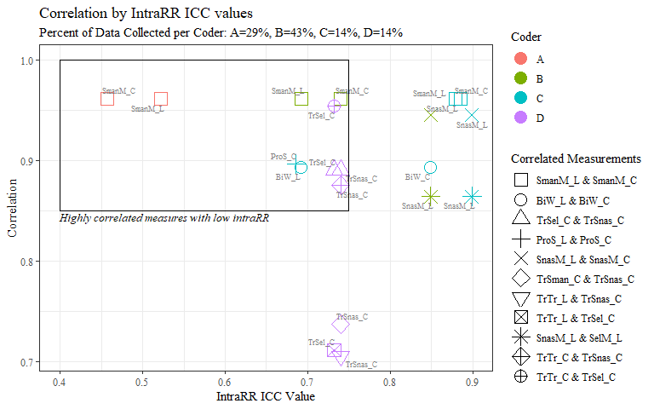

quest_meas_nona %>%   
 ggplot(aes(x=intra_icc, y=correlation))+  
 geom_point(aes(shape=both_measures, color=both_measures), size=5)+  
 geom_text_repel(aes(label=measure), family="Times New Roman", size= 2.5, color="gray50")+  
 annotate(geom="text", x=0.4, y=0.833, label= "Highly correlated measures with low intraRR",   
 size=2.5, fontface = 'italic', family= myFont1, hjust=0, vjust=0)+  
 scale_shape_manual(values=seq(0,12))+  
 geom_rect(aes(xmin=0.4, xmax=0.75, ymin=0.85, ymax=1), fill= NA, alpha=0.4, colour="black")+  
 facet_wrap(coder~.)+  
 theme_bw()+theme(text=element_text(family= "Times New Roman"))+  
 #theme(axis.text.x = element_text(angle = 90))+   
 labs(title="Correlation by IntraRR ICC values",  
 subtitle = "Percent of Data Collected per Coder: A=29%, B=43%, C=14%, D=14%",  
 y="Correlation",  
 x="IntraRR ICC Value",  
 shape="Correlated Measurements",  
 color="Correlated Measurements")

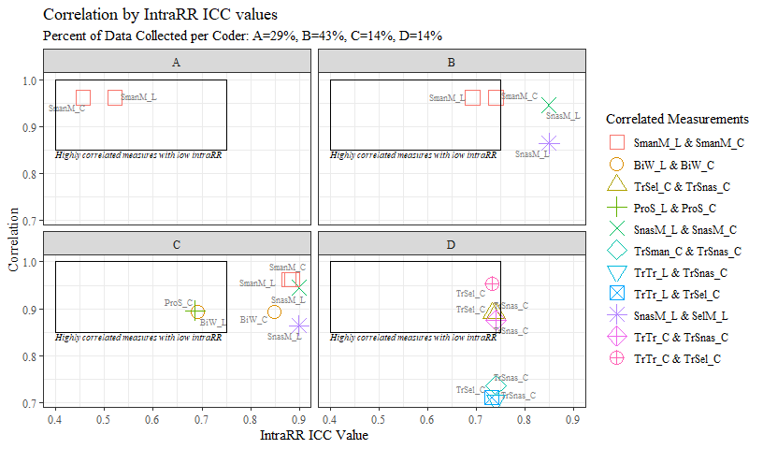

interRR<-read_excel("C:\\Users\\19177\\OneDrive - Colostate\\Desktop\\Dissertation\\headscan_dissertation\\interRR_iccs.xlsx")  
interRR <- interRR[-1]  
interRR <- interRR %>%   
 rename(inter_icc = "icc_value")  
  
  
write_xlsx(interRR, "C:\\Users\\19177\\OneDrive - Colostate\\Desktop\\Dissertation\\headscan_dissertation\\interRR.xlsx")  
  
low_interRR <- filter(interRR, inter_icc < 0.9)

interRR %>%  
 mutate(measure=fct_reorder(measure, inter_icc, .desc=TRUE)) %>%   
 ggplot(aes(x=inter_icc, y=measure))+  
 geom_bar(stat= "identity", color= "black", fill = "white")+  
 theme_bw()+theme(text=element_text(family= "Times New Roman"))+  
 #theme(axis.text.x = element_text(angle = 90))+   
 labs(title="InterRR Values",  
 y="Measurement Location",  
 x="ICC Value")

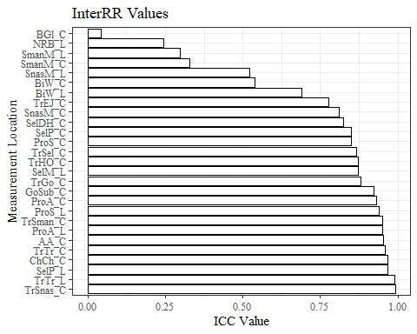

low_interRR %>%  
 mutate(measure=fct_reorder(measure, inter_icc, .desc=TRUE)) %>%   
 ggplot(aes(x=inter_icc, y=measure))+  
 geom_bar(stat= "identity", color= "black", fill = "white")+  
 theme_bw()+theme(text=element_text(family= "Times New Roman"))+  
 #theme(axis.text.x = element_text(angle = 90))+   
 labs(title="Low InterRR Values",  
 y="Measurement Location",  
 x="ICC Value")

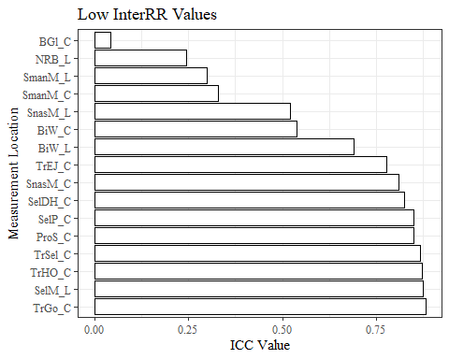

questionable_measures <- full_join(questionable_measures, low_interRR, by = "measure", all= TRUE)  
  
questionable_measures <- questionable_measures[, c(1,2,3,4,5,8,6,7)]  
  
str(questionable_measures)

## tibble [51 × 8] (S3: tbl_df/tbl/data.frame)  
## $ coder : chr [1:51] "A" "A" "A" "B" ...  
## $ percent_coded : chr [1:51] "28.61%" "28.61%" "28.61%" "42.98%" ...  
## $ measure : chr [1:51] "NRB_L" "SmanM_L" "SmanM_C" "NRB_L" ...  
## $ correlated_measure: chr [1:51] NA "SmanM_C" "SmanM_L" NA ...  
## $ intra_icc : num [1:51] 0.83 0.522 0.457 0.757 0.849 0.849 0.692 0.74 0.856 0.692 ...  
## $ inter_icc : num [1:51] 0.245 0.299 0.329 0.245 0.521 0.521 0.299 0.329 0.043 0.689 ...  
## $ correlation : num [1:51] NA 0.961 0.961 NA 0.864 ...  
## $ both_measures : Factor w/ 18 levels "SmanM_L & SmanM_C",..: NA 1 1 NA 16 11 1 1 NA 2 ...

quest_meas_nona1 <- questionable_measures %>%   
 drop_na(inter_icc) %>%   
 drop_na(correlation)

quest_meas_nona1 %>%   
 ggplot(aes(x=inter_icc, y=correlation, na.rm=TRUE))+  
 geom_point(aes(shape=both_measures, color=both_measures), size=5, na.rm = TRUE)+  
 geom_text_repel(aes(label=measure), family="Times New Roman", size= 2.5, color="gray50")+  
 annotate(geom="text", x=0.25, y=0.835, label= "Highly correlated measures with low interRR",   
 size=3.5, fontface = 'italic', family= myFont1, hjust=0, vjust=0)+  
 scale_shape_manual(values=seq(0,12))+  
 geom_rect(aes(xmin=0.25, xmax=0.75, ymin=0.845, ymax=1), fill= NA, alpha=0.4, colour="black")+  
 xlim(0.25, 0.9)+  
 theme_bw()+theme(text=element_text(family= "Times New Roman"))+  
 #theme(axis.text.x = element_text(angle = 90))+   
 labs(title="Correlation by InterRR ICC values",  
 y="Correlation",  
 x="InterRR ICC Value",  
 shape="Correlated Measurements",  
 color="Correlated Measurements")

## Warning: ggrepel: 6 unlabeled data points (too many overlaps). Consider  
## increasing max.overlaps

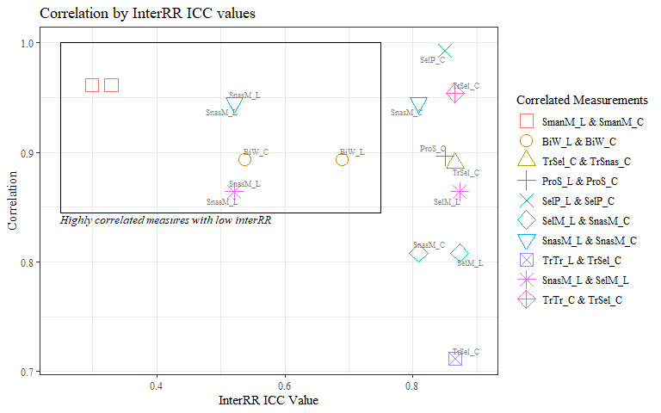

quest_meas_nona2 <- questionable_measures %>%   
 drop_na(inter_icc) %>%   
 drop_na(intra_icc)

quest_meas_nona2 %>%   
 ggplot(aes(x=inter_icc, y=intra_icc, na.rm=TRUE))+  
 geom_point(aes(shape=measure, color=measure), size=5, na.rm = TRUE)+  
 #geom_text_repel(aes(label=measure), family="Times New Roman", size= 2.5, color="gray50")+  
 annotate(geom="text", x=0.02, y=0.27, label= "Measurements w/ low intraRR and interRR",   
 size=2.5, fontface = 'italic', family= myFont1, hjust=0, vjust=0)+  
 scale_shape_manual(values=seq(0,18))+  
 geom_rect(aes(xmin=0, xmax=0.75, ymin=0.25, ymax=0.75), fill= NA, alpha=0.4, colour="black")+  
 facet_wrap(coder~.)+  
 theme_bw()+theme(text=element_text(family= "Times New Roman"))+  
 #theme(axis.text.x = element_text(angle = 90))+   
 labs(title="Correlation by InterRR ICC values",  
 subtitle = "Percent of Data Collected per Coder: A=29%, B=43%, C=14%, D=14%",  
 y="IntraRR ICC Value",  
 x="InterRR ICC Value",  
 shape="Measurement Location",  
 color="Measurement Location")

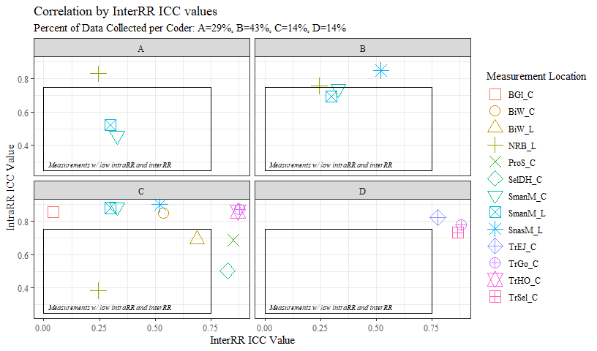

#it might be a good idea to show this plot several times and color code specific correlations as they are discussed  
questionable_measures %>%   
 ggplot(aes(x=fct_infreq(measure), label=scales::percent(prop.table(stat(count)))))+  
 geom_bar(stat="count", binwidth = 4, color= "black", fill = "white")+  
 theme_bw()+theme(text=element_text(family= "Times New Roman"))+  
 theme(axis.text.x = element_text(angle = 90))+  
 labs(title="Questionable Stats per Measure",  
 y="# of Questionable Stats",  
 x="Measure Abbreviation")

## Warning: Ignoring unknown parameters: binwidth

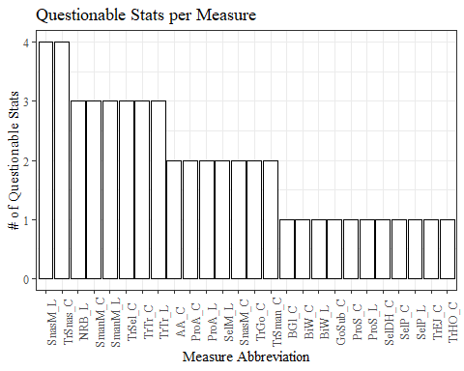

write_xlsx(questionable_measures, "C:\\Users\\19177\\OneDrive - Colostate\\Desktop\\Dissertation\\headscan_dissertation\\questionable_measures.xlsx")