exploring-emmeans-imputed

2022-09-21

library(tidyverse)

## ── Attaching packages ─────────────────────────────────────── tidyverse 1.3.2 ──  
## ✔ ggplot2 3.3.6 ✔ purrr 0.3.4  
## ✔ tibble 3.1.8 ✔ dplyr 1.0.9  
## ✔ tidyr 1.2.0 ✔ stringr 1.4.0  
## ✔ readr 2.1.2 ✔ forcats 0.5.1  
## ── Conflicts ────────────────────────────────────────── tidyverse_conflicts() ──  
## ✖ dplyr::filter() masks stats::filter()  
## ✖ dplyr::lag() masks stats::lag()

library(readxl)  
library(flextable)

##   
## Attaching package: 'flextable'  
##   
## The following object is masked from 'package:purrr':  
##   
## compose

library(extrafont)

## Registering fonts with R

library(scales)

##   
## Attaching package: 'scales'  
##   
## The following object is masked from 'package:purrr':  
##   
## discard  
##   
## The following object is masked from 'package:readr':  
##   
## col_factor

#times new roman tables  
my_ft_theme <- function(ft, ...) {  
 # Remove vertical cell padding  
 ft <- padding(ft, padding.top = 0, padding.bottom = 0, part = "all")  
   
 # Change font to TNR 11  
 ft <- font(ft, fontname = "Times New Roman", part = "all")  
 ft <- fontsize(ft, part = "all", size = 12)  
 ft  
}

gender_means_data1 <- read_excel("C:\\Users\\19177\\OneDrive - Colostate\\Desktop\\Dissertation\\headscan_dissertation\\gender_means_data1.xlsx")  
  
race_means_data1 <- read_excel("C:\\Users\\19177\\OneDrive - Colostate\\Desktop\\Dissertation\\headscan_dissertation\\race_means_data1.xlsx")  
  
age_means_data1 <- read_excel("C:\\Users\\19177\\OneDrive - Colostate\\Desktop\\Dissertation\\headscan_dissertation\\age_means_data1.xlsx")  
  
  
gender_est_data1 <- read_excel("C:\\Users\\19177\\OneDrive - Colostate\\Desktop\\Dissertation\\headscan_dissertation\\gender_est_data1.xlsx")  
  
race_est_data1 <- read_excel("C:\\Users\\19177\\OneDrive - Colostate\\Desktop\\Dissertation\\headscan_dissertation\\race_est_data1.xlsx")  
  
age_est_data1 <- read_excel("C:\\Users\\19177\\OneDrive - Colostate\\Desktop\\Dissertation\\headscan_dissertation\\age_est_data1.xlsx")

chosen_imputed1 <- read_excel("C:\\Users\\19177\\OneDrive - Colostate\\Desktop\\Dissertation\\headscan_dissertation\\chosen_imputed1.xlsx")

chosenimputed1_num <- select_if(chosen_imputed1, is.numeric)

measure_means <- colMeans(chosenimputed1_num)  
measure_means <- as.data.frame(measure_means)  
measure_means <- rownames_to_column(measure_means)  
  
measure_means <- measure_means %>%   
 rename(measure=rowname)

GENDER

gender_means_data1$measure <- fct_reorder(gender_means_data1$measure, gender_means_data1$emmean, .desc=FALSE)  
  
gender_means_data1 %>%   
 ggplot(aes(x=gender, y=emmean, fill=measure))+  
 geom_bar(position=position_dodge(), stat="identity")+  
 geom_errorbar(aes(ymin=lower.CL, ymax=upper.CL), width=0.2, position=position_dodge(0.9))+  
 theme(axis.text.x = element_text(angle = 45, vjust=0.7))+  
 theme_bw()+theme(text=element_text(family= "Times New Roman"))+  
 labs(title="Estimated Marginal Means (Imputed)",  
 subtitle= "All Genders in MANOVA",  
 y="Emmean in mm",  
 x="Gender",  
 fill="Measurement")

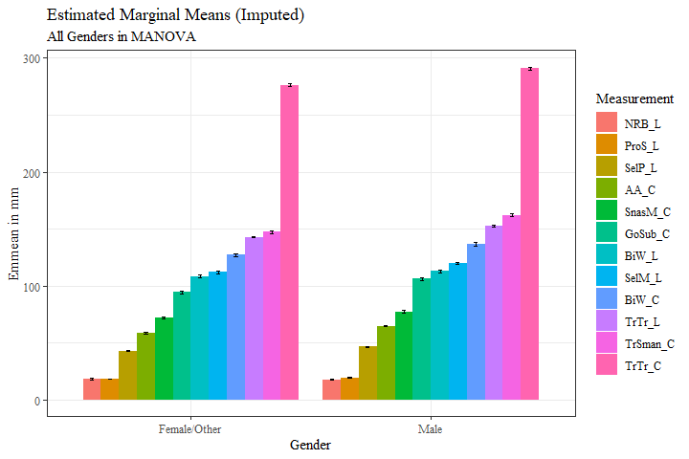

gender_means_data1 %>%   
 ggplot(aes(x=measure, y=emmean, fill=gender))+  
 geom_bar(position=position_dodge(), stat="identity")+  
 geom_errorbar(aes(ymin=lower.CL, ymax=upper.CL), width=0.2, position=position_dodge(0.9))+  
 theme_bw()+  
 theme(axis.text.x = element_text(angle = 45, vjust=0.7))+  
 theme(text=element_text(family= "Times New Roman"))+  
 labs(title="Estimated Marginal Means (Imputed)",  
 subtitle= "All Genders in MANOVA",  
 y="Emmean in mm",  
 x="Measurement",  
 fill="Gender")

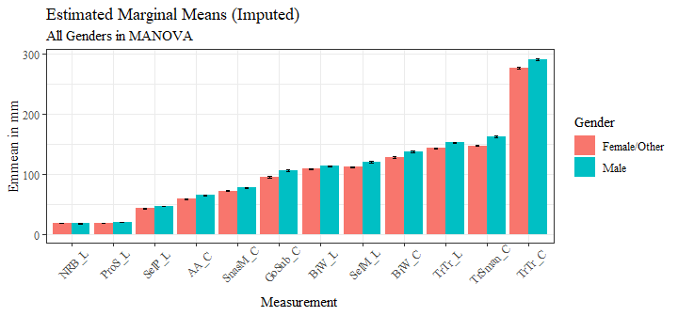

gender_means_data11 <- gender_means_data1 %>%   
 filter(gender != "Other")  
  
gender_means_data11$measure <- fct_reorder(gender_means_data11$measure, gender_means_data11$emmean, .desc=FALSE)  
  
gender_means_data11 %>%   
 ggplot(aes(x=measure, y=emmean, fill=gender))+  
 geom_bar(position=position_dodge(), stat="identity")+  
 geom_errorbar(aes(ymin=lower.CL, ymax=upper.CL), width=0.2, position=position_dodge(0.9))+  
 theme_bw()+  
 theme(axis.text.x = element_text(angle = 45, vjust=0.7))+  
 theme(text=element_text(family= "Times New Roman"))+  
 labs(title="Estimated Marginal Means (Imputed)",  
 subtitle= "Two primary genders",  
 y="Emmean in mm",  
 x="Measurement",  
 fill="Gender")

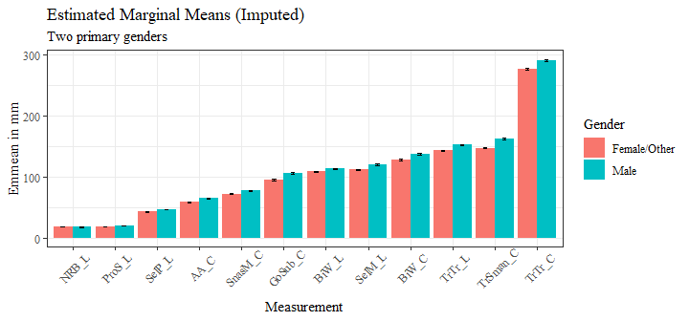

sig_gender_est <- gender_est_data1 %>%   
 filter(signif=="TRUE")  
  
sig_gender_est <- sig_gender_est %>%   
 mutate(across(where(is.numeric), round, digits=3))

sig_gender_est$measure <- fct_reorder(sig_gender_est$measure, sig_gender_est$estimate, .desc=FALSE)  
  
sig_gender_est %>%   
 ggplot(aes(x=estimate, y= measure, fill=contrast))+  
 geom_bar(position=position_dodge(), stat="identity")+  
 theme_bw()+theme(text=element_text(family= "Times New Roman"))+  
 labs(title="Gender Significant Differences in Estimated Marginal Means (Imputed)",  
 subtitle= "Tukey significance level 0.05",  
 y="Measurement Location",  
 x="Difference in mm")

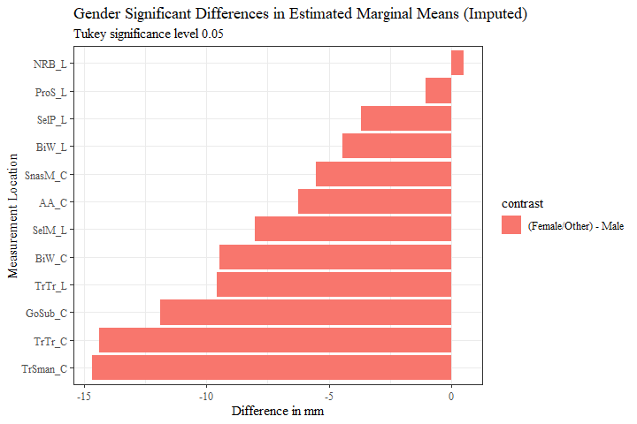

g_f_minus_m <- sig_gender_est %>%   
 filter(contrast == "(Female/Other) - Male")

g_f_minus_m <- full_join(g_f_minus_m, measure_means, by="measure")

g_f_minus_m$prop_diff <- (g_f_minus_m$estimate/g_f_minus_m$measure_means)  
  
g_f_minus_m <- g_f_minus_m %>%   
 mutate(across(where(is.numeric), round, digits=3))  
  
g_f_minus_m$percent_diff <- percent(g_f_minus_m$prop_diff)

g_f_minus_m$measure <- fct_reorder(g_f_minus_m$measure, g_f_minus_m$estimate, .desc=FALSE)  
  
g_f_minus_m %>%   
 ggplot(aes(x=estimate, y= measure, label=estimate))+  
 geom_bar(stat="identity", color= "black", fill = "white")+  
 geom_text(hjust=-0.15, position = position_dodge(.9), size = 3, family= "Times New Roman")+  
 scale_x_continuous(expand = expansion(mult = 0.1))+  
 theme_bw()+theme(text=element_text(family= "Times New Roman"))+  
 labs(title="Female/Other - Male Significant Differences in Estimated Marginal Means (Imputed)",  
 subtitle= "Tukey significance level 0.05",  
 y="Measurement Location",  
 x="Difference in mm")

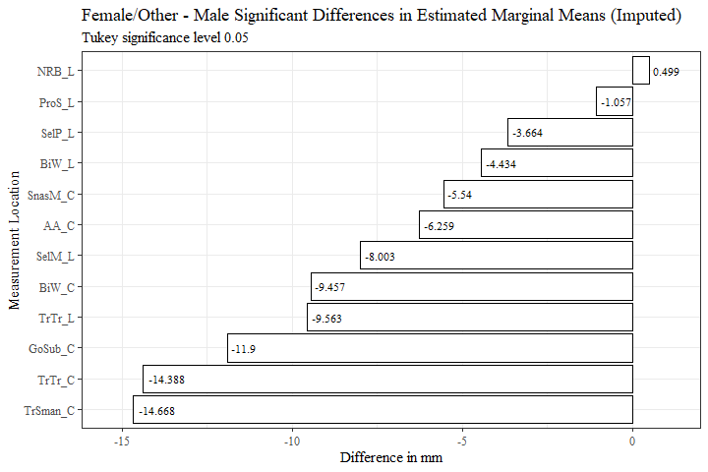

g_f_minus_m$measure <- fct_reorder(g_f_minus_m$measure, g_f_minus_m$prop_diff, .desc=FALSE)  
  
g_f_minus_m %>%   
 ggplot(aes(x=prop_diff, y= measure, label=percent_diff))+  
 geom_bar(stat="identity", color= "black", fill = "white")+  
 geom_text(hjust=-0.15, position = position_dodge(.9), size = 3, family= "Times New Roman")+  
 scale_x_continuous(labels = scales::percent,  
 expand = expansion(mult = 0.1))+  
 theme_bw()+theme(text=element_text(family= "Times New Roman"))+  
 labs(title="Female/Other - Male Significant Differences in Estimated Marginal Means (Imputed)",  
 subtitle= "Tukey significance level 0.05",  
 y="Measurement Location",  
 x="Percent Difference from Total Measurement Mean")

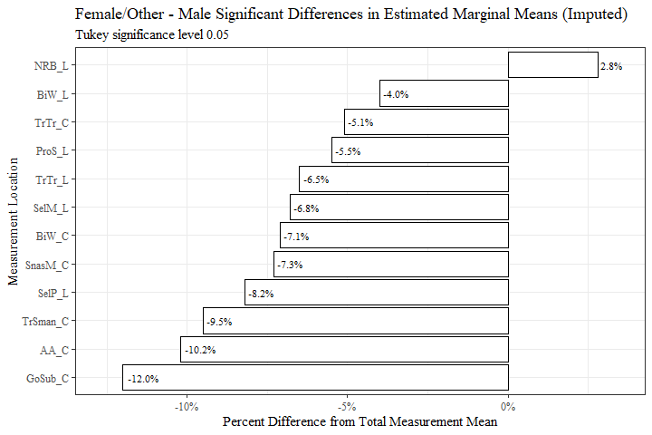

g_f_minus_m <- g_f_minus_m[c(8, 2, 6, 9, 10)]  
  
flextable(g_f_minus_m) %>%  
 my_ft_theme()%>%   
 bold(part = "header") %>%   
 set_caption("Female/Other - Male Significant Differences in Estimated Marginal Means (Imputed)") %>%   
 fit_to_width(7.5) %>%   
 autofit()

**Table** **1**: Female/Other - Male Significant Differences in Estimated Marginal Means (Imputed)

| **measure** | **estimate** | **p.value** | **measure_means** | **prop_diff** |
| --- | --- | --- | --- | --- |
| AA_C | -6.259 | 1.3605e-134 | 61.222 | -0.102 |
| BiW_L | -4.434 | 2.5525e-26 | 111.187 | -0.040 |
| BiW_C | -9.457 | 9.1294e-67 | 133.391 | -0.071 |
| GoSub_C | -11.900 | 1.0636e-86 | 99.174 | -0.120 |
| NRB_L | 0.499 | 1.4186e-02 | 17.947 | 0.028 |
| ProS_L | -1.057 | 2.9099e-23 | 19.120 | -0.055 |
| SelP_L | -3.664 | 1.0765e-91 | 44.534 | -0.082 |
| SelM_L | -8.003 | 1.9838e-97 | 116.956 | -0.068 |
| SnasM_C | -5.540 | 3.0552e-39 | 75.616 | -0.073 |
| TrSman_C | -14.668 | 4.1901e-156 | 153.752 | -0.095 |
| TrTr_C | -14.388 | 2.3722e-138 | 282.695 | -0.051 |
| TrTr_L | -9.563 | 1.6050e-224 | 146.472 | -0.065 |

g_m_minus_f <- g_f_minus_m  
  
g_m_minus_f$estimate <- g_m_minus_f$estimate*(-1)  
g_m_minus_f$prop_diff <- g_m_minus_f$prop_diff*(-1)  
  
g_m_minus_f$percent_diff <- percent(g_m_minus_f$prop_diff)  
  
#g_m_minus_f$contrastx <- "Male - Female/Other"  
  
g_m_minus_f$measure <- fct_reorder(g_m_minus_f$measure, g_m_minus_f$estimate, .desc=TRUE)  
  
g_m_minus_f %>%   
 ggplot(aes(x=estimate, y= measure, label=estimate))+  
 geom_bar(stat="identity", color= "black", fill = "white")+  
 geom_text(hjust=1.1, position = position_dodge(.9), size = 3, family= "Times New Roman")+  
 scale_x_continuous(expand = expansion(mult = 0.1))+  
 theme_bw()+theme(text=element_text(family= "Times New Roman"))+  
 labs(title="Male - Female/Other Significant Differences in Estimated Marginal Means (Imputed)",  
 subtitle= "Tukey significance level 0.05",  
 y="Measurement Location",  
 x="Difference in mm")

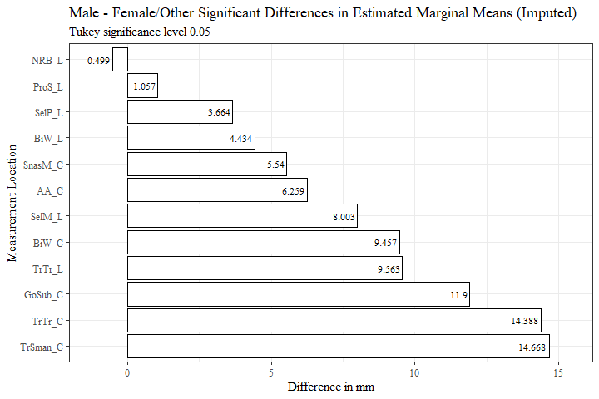

g_m_minus_f$measure <- fct_reorder(g_m_minus_f$measure, g_m_minus_f$prop_diff, .desc=TRUE)  
  
g_m_minus_f %>%   
 ggplot(aes(x=prop_diff, y= measure, label=percent_diff))+  
 geom_bar(stat="identity", color= "black", fill = "white")+  
 geom_text(hjust=1.1, position = position_dodge(.9), size = 3, family= "Times New Roman")+  
 scale_x_continuous(labels = scales::percent,  
 expand = expansion(mult = 0.1))+  
 theme_bw()+theme(text=element_text(family= "Times New Roman"))+  
 labs(title="Male - Female/Other Significant Differences in Estimated Marginal Means (Imputed)",  
 subtitle= "Tukey significance level 0.05",  
 y="Measurement Location",  
 x="Percent Difference from Total Measurement Mean")

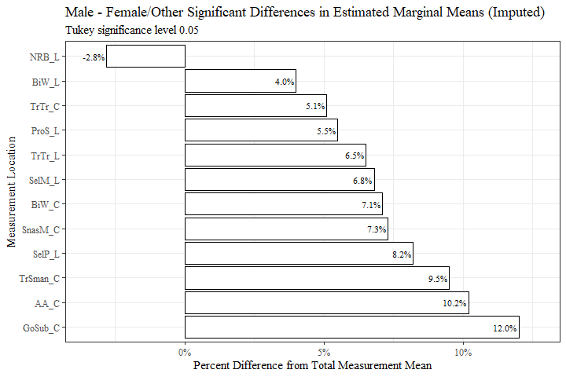

g_m_minus_f <- g_m_minus_f[-c(6)]  
  
flextable(g_m_minus_f) %>%  
 my_ft_theme()%>%   
 bold(part = "header") %>%   
 set_caption("Male - Female/Other Significant Differences in Estimated Marginal Means (Imputed)") %>%   
 fit_to_width(7.5) %>%   
 autofit()

**Table** **2**: Male - Female/Other Significant Differences in Estimated Marginal Means (Imputed)

| **measure** | **estimate** | **p.value** | **measure_means** | **prop_diff** |
| --- | --- | --- | --- | --- |
| AA_C | 6.259 | 1.3605e-134 | 61.222 | 0.102 |
| BiW_L | 4.434 | 2.5525e-26 | 111.187 | 0.040 |
| BiW_C | 9.457 | 9.1294e-67 | 133.391 | 0.071 |
| GoSub_C | 11.900 | 1.0636e-86 | 99.174 | 0.120 |
| NRB_L | -0.499 | 1.4186e-02 | 17.947 | -0.028 |
| ProS_L | 1.057 | 2.9099e-23 | 19.120 | 0.055 |
| SelP_L | 3.664 | 1.0765e-91 | 44.534 | 0.082 |
| SelM_L | 8.003 | 1.9838e-97 | 116.956 | 0.068 |
| SnasM_C | 5.540 | 3.0552e-39 | 75.616 | 0.073 |
| TrSman_C | 14.668 | 4.1901e-156 | 153.752 | 0.095 |
| TrTr_C | 14.388 | 2.3722e-138 | 282.695 | 0.051 |
| TrTr_L | 9.563 | 1.6050e-224 | 146.472 | 0.065 |

AGE

age_means_data1$measure <- fct_reorder(age_means_data1$measure, age_means_data1$emmean, .desc=FALSE)  
  
age_means_data1 %>%   
 ggplot(aes(x=age_group, y=emmean, fill=measure))+  
 geom_bar(position=position_dodge(), stat="identity")+  
 geom_errorbar(aes(ymin=lower.CL, ymax=upper.CL), width=0.2, position=position_dodge(0.9))+  
 theme(axis.text.x = element_text(angle = 45, vjust=0.7))+  
 theme_bw()+theme(text=element_text(family= "Times New Roman"))+  
 labs(title="Estimated Marginal Means (Imputed)",  
 subtitle= "All ages in MANOVA",  
 y="Emmean in mm",  
 x="Age",  
 fill="Measurement")

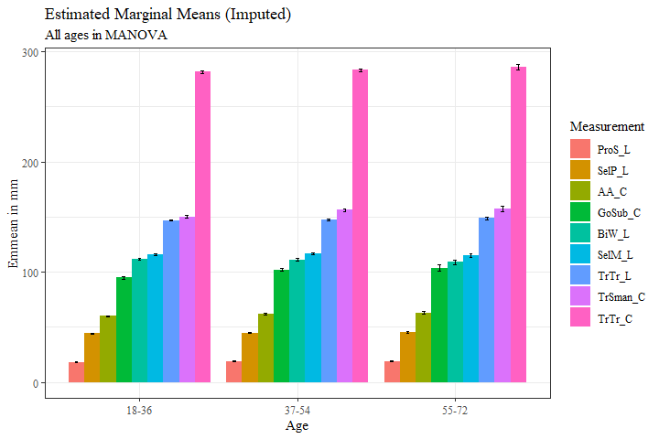

#age_means_data1$measure <- fct_reorder(age_means_data1$measure, age_means_data1$emmean, .desc=FALSE)  
  
age_means_data1 %>%   
 ggplot(aes(x=measure, y=emmean, fill=age_group))+  
 geom_bar(position=position_dodge(), stat="identity")+  
 geom_errorbar(aes(ymin=lower.CL, ymax=upper.CL), width=0.2, position=position_dodge(0.9))+  
 theme(axis.text.x = element_text(angle = 45, vjust=0.7))+  
 theme_bw()+theme(text=element_text(family= "Times New Roman"))+  
 labs(title="Estimated Marginal Means (Imputed)",  
 subtitle= "All ages in MANOVA",  
 y="Emmean in mm",  
 x="Measurement",  
 fill="Age")

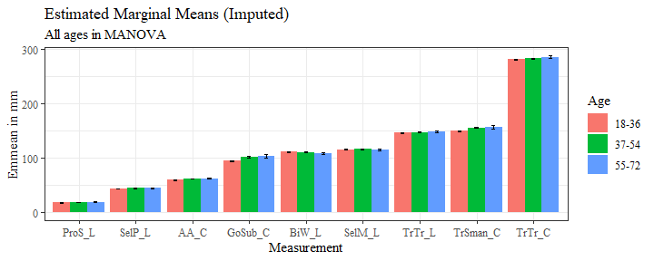

sig_age_est <- age_est_data1 %>%   
 filter(signif=="TRUE")  
  
sig_age_est <- sig_age_est %>%   
 mutate(across(where(is.numeric), round, digits=3))

sig_age_est$measure <- fct_reorder(sig_age_est$measure, sig_age_est$estimate, .desc=FALSE)  
  
sig_age_est %>%   
 ggplot(aes(x=estimate, y= measure, fill=contrast))+  
 geom_bar(position=position_dodge(), stat="identity")+  
 theme_bw()+theme(text=element_text(family= "Times New Roman"))+  
 labs(title="Age Significant Differences in Estimated Marginal Means (Imputed)",  
 subtitle= "Tukey significance level 0.05",  
 y="Measurement Location",  
 x="Difference in mm")

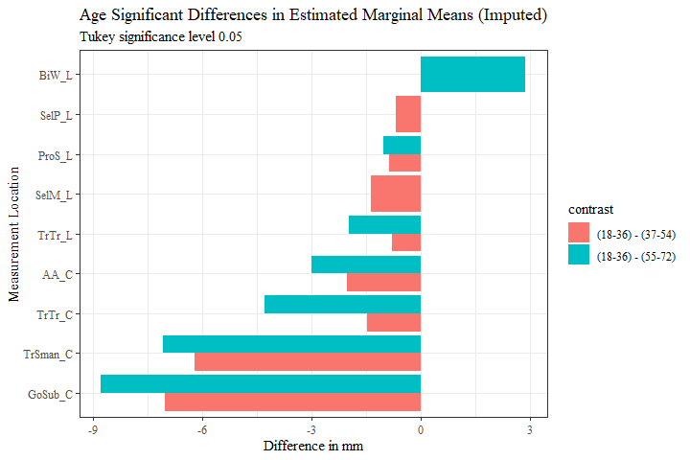

age_est_data11 <- full_join(sig_age_est, measure_means, by="measure")  
  
age_est_data11$prop_diff <- (age_est_data11$estimate/age_est_data11$measure_means)  
  
age_est_data11 <- age_est_data11 %>%   
 mutate(across(where(is.numeric), round, digits=3))  
  
age_est_data11$percent_diff <- percent(age_est_data11$prop_diff)  
  
age_est_data11 <- drop_na(age_est_data11)  
  
age_est_data11$measure <- fct_reorder(age_est_data11$measure, age_est_data11$prop_diff, .desc=FALSE)  
  
age_est_data11 %>%   
 ggplot(aes(x=prop_diff, y= measure, fill=contrast))+  
 geom_bar(stat="identity", position="dodge")+  
 theme_bw()+theme(text=element_text(family= "Times New Roman"))+  
 labs(title="Age-Related Significant Differences in Estimated Marginal Means (Imputed)",  
 subtitle= "Tukey significance level 0.05",  
 y="Measurement Location",  
 x="Percent Difference from Total Measurement Mean")

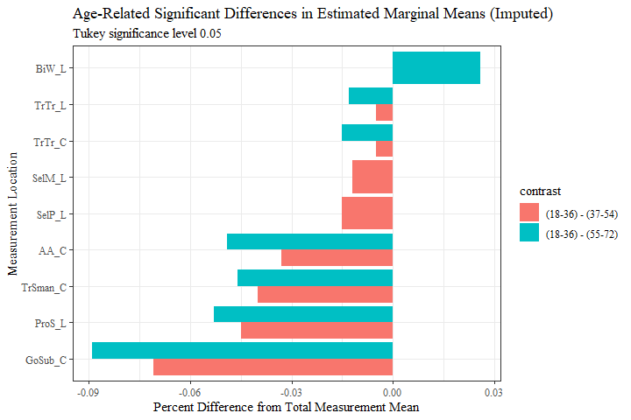

y_v_m <- age_est_data11 %>%   
 filter(contrast == "(18-36) - (37-54)")  
  
y_v_m <- y_v_m %>%   
 mutate(across(where(is.numeric), round, digits=3))  
  
y_v_m$measure <- fct_reorder(y_v_m$measure, y_v_m$estimate, .desc=FALSE)  
  
y_v_m %>%   
 ggplot(aes(x=estimate, y= measure, label=estimate))+  
 geom_bar(stat="identity", color= "black", fill = "white")+  
 geom_text(hjust=-0.1, position = position_dodge(.9), size = 3, family= "Times New Roman")+  
 scale_x_continuous(expand = expansion(mult = 0.1))+  
 theme_bw()+theme(text=element_text(family= "Times New Roman"))+  
 labs(title="(18-36) - (37-54) Significant Differences in Estimated Marginal Means (Imputed)",  
 subtitle= "Tukey significance level 0.05",  
 y="Measurement Location",  
 x="Difference in mm")

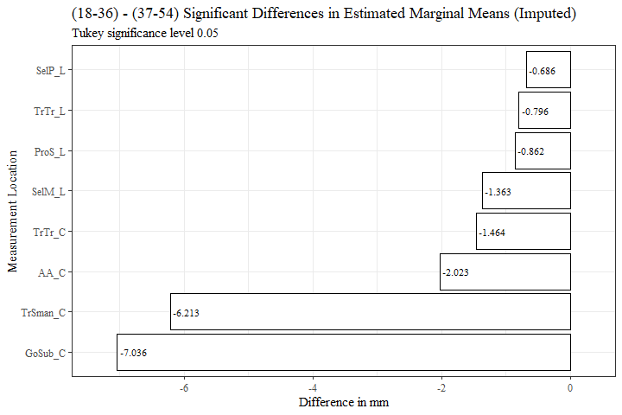

y_v_m$measure <- fct_reorder(y_v_m$measure, y_v_m$prop_diff, .desc=FALSE)  
  
y_v_m %>%   
 ggplot(aes(x=prop_diff, y= measure, label=percent_diff))+  
 geom_bar(stat="identity", color= "black", fill = "white")+  
 geom_text(hjust=-0.1, position = position_dodge(.9), size = 2.7, family= "Times New Roman")+  
 scale_x_continuous(labels = scales::percent,  
 expand = expansion(mult = 0.1))+  
 theme_bw()+theme(text=element_text(family= "Times New Roman"))+  
 labs(title="(18-36) - (37-54) Significant Differences in Estimated Marginal Means (Imputed)",  
 subtitle= "Tukey significance level 0.05",  
 y="Measurement Location",  
 x="Percent Difference from Total Measurement Mean")

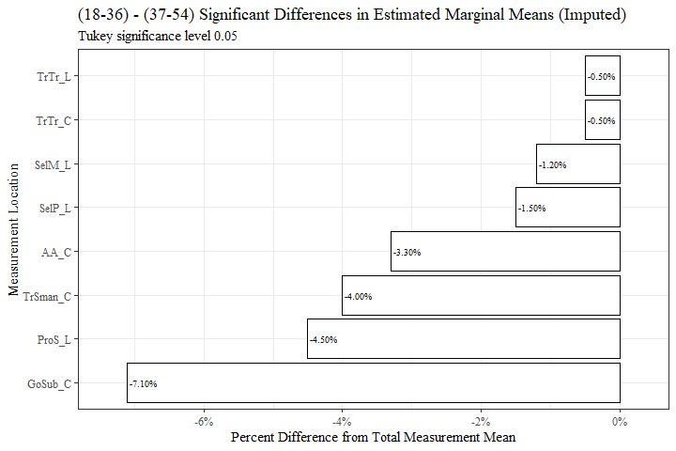

y_v_m <- y_v_m[c(8, 2, 6, 9, 10)]  
  
  
  
  
flextable(y_v_m) %>%  
 my_ft_theme()%>%   
 bold(part = "header") %>%   
 set_caption("(18-36) - (37-54) Significant Differences in Estimated Marginal Means (Imputed)") %>%   
 fit_to_width(7.5) %>%   
 autofit()

**Table** **3**: (18-36) - (37-54) Significant Differences in Estimated Marginal Means (Imputed)

| **measure** | **estimate** | **p.value** | **measure_means** | **prop_diff** |
| --- | --- | --- | --- | --- |
| AA_C | -2.023 | 4.6513e-11 | 61.222 | -0.033 |
| GoSub_C | -7.036 | 4.6484e-11 | 99.174 | -0.071 |
| ProS_L | -0.862 | 4.6526e-11 | 19.120 | -0.045 |
| SelP_L | -0.686 | 2.6383e-04 | 44.534 | -0.015 |
| SelM_L | -1.363 | 6.5142e-04 | 116.956 | -0.012 |
| TrSman_C | -6.213 | 4.6484e-11 | 153.752 | -0.040 |
| TrTr_C | -1.464 | 1.8855e-02 | 282.695 | -0.005 |
| TrTr_L | -0.796 | 8.1969e-03 | 146.472 | -0.005 |

m_v_y <- y_v_m  
  
m_v_y$estimate <- m_v_y$estimate*(-1)  
m_v_y$prop_diff <- m_v_y$prop_diff*(-1)  
m_v_y$percent_diff <- percent(m_v_y$prop_diff)  
  
#m_v_y$contrastx <- "(37-54) - (18-36)"  
  
  
m_v_y$measure <- fct_reorder(m_v_y$measure, m_v_y$estimate, .desc=TRUE)  
  
m_v_y %>%   
 ggplot(aes(x=estimate, y= measure, label=estimate))+  
 geom_bar(stat="identity", color= "black", fill = "white")+  
 geom_text(hjust=1.1, position = position_dodge(.9), size = 3, family= "Times New Roman")+  
 scale_x_continuous(expand = expansion(mult = 0.1))+  
 theme_bw()+theme(text=element_text(family= "Times New Roman"))+  
 labs(title="(37-54) - (18-36) Significant Differences in Estimated Marginal Means (Imputed)",  
 subtitle= "Tukey significance level 0.05",  
 y="Measurement Location",  
 x="Difference in mm")

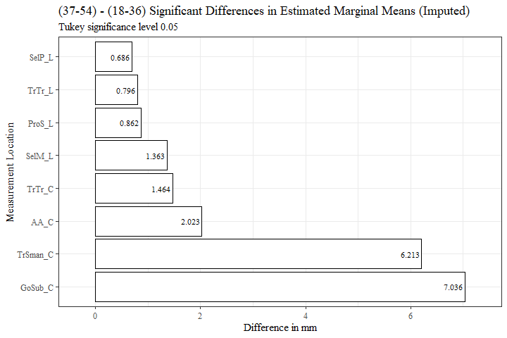

m_v_y$measure <- fct_reorder(m_v_y$measure, m_v_y$prop_diff, .desc=TRUE)  
  
m_v_y %>%   
 ggplot(aes(x=prop_diff, y= measure, label=percent_diff))+  
 geom_bar(stat="identity", color= "black", fill = "white")+  
 geom_text(hjust=1.2, position = position_dodge(.9), size = 3, family= "Times New Roman")+  
 scale_x_continuous(labels = scales::percent,  
 expand = expansion(mult = 0.1))+  
 theme_bw()+theme(text=element_text(family= "Times New Roman"))+  
 labs(title="(37-54) - (18-36) Significant Differences in Estimated Marginal Means (Imputed)",  
 subtitle= "Tukey significance level 0.05",  
 y="Measurement Location",  
 x="Percent Difference from Total Measurement Mean")

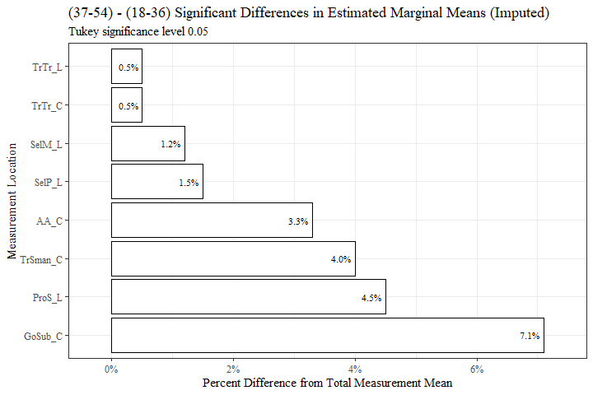

m_v_y <- m_v_y[-c(6)]  
  
flextable(m_v_y) %>%  
 my_ft_theme()%>%   
 bold(part = "header") %>%   
 set_caption("(37-54) - (18-36) Significant Differences in Estimated Marginal Means (Imputed)") %>%   
 fit_to_width(7.5) %>%   
 autofit()

**Table** **4**: (37-54) - (18-36) Significant Differences in Estimated Marginal Means (Imputed)

| **measure** | **estimate** | **p.value** | **measure_means** | **prop_diff** |
| --- | --- | --- | --- | --- |
| AA_C | 2.023 | 4.6513e-11 | 61.222 | 0.033 |
| GoSub_C | 7.036 | 4.6484e-11 | 99.174 | 0.071 |
| ProS_L | 0.862 | 4.6526e-11 | 19.120 | 0.045 |
| SelP_L | 0.686 | 2.6383e-04 | 44.534 | 0.015 |
| SelM_L | 1.363 | 6.5142e-04 | 116.956 | 0.012 |
| TrSman_C | 6.213 | 4.6484e-11 | 153.752 | 0.040 |
| TrTr_C | 1.464 | 1.8855e-02 | 282.695 | 0.005 |
| TrTr_L | 0.796 | 8.1969e-03 | 146.472 | 0.005 |

y_v_o <- age_est_data11 %>%   
 filter(contrast == "(18-36) - (55-72)")  
  
  
  
y_v_o$measure <- fct_reorder(y_v_o$measure, y_v_o$estimate, .desc=FALSE)  
  
y_v_o %>%   
 ggplot(aes(x=estimate, y= measure, label=estimate))+  
 geom_bar(stat="identity", color= "black", fill = "white")+  
 geom_text(hjust=-0.15, position = position_dodge(.9), size = 3, family= "Times New Roman")+  
 scale_x_continuous(expand = expansion(mult = 0.1))+  
 theme_bw()+theme(text=element_text(family= "Times New Roman"))+  
 labs(title="(18-36) - (55-72) Significant Differences in Estimated Marginal Means (Imputed)",  
 subtitle= "Tukey significance level 0.05",  
 y="Measurement Location",  
 x="Difference in mm")

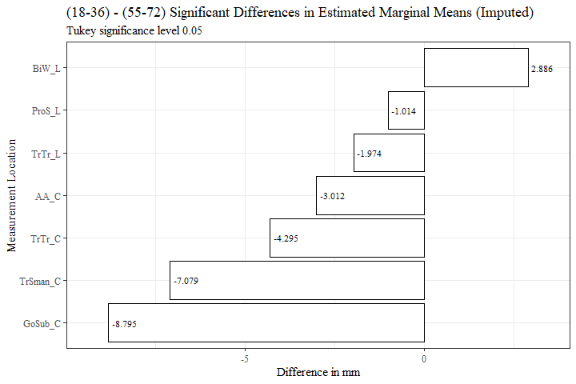

y_v_o$measure <- fct_reorder(y_v_o$measure, y_v_o$prop_diff, .desc=FALSE)  
  
y_v_o %>%   
 ggplot(aes(x=prop_diff, y= measure, label=percent_diff))+  
 geom_bar(stat="identity", color= "black", fill = "white")+  
 geom_text(hjust=-0.15, position = position_dodge(.9), size = 3, family= "Times New Roman")+  
 scale_x_continuous(labels = scales::percent,  
 expand = expansion(mult = 0.1))+  
 theme_bw()+theme(text=element_text(family= "Times New Roman"))+  
 labs(title="(18-36) - (55-72) Significant Differences in Estimated Marginal Means (Imputed)",  
 subtitle= "Tukey significance level 0.05",  
 y="Measurement Location",  
 x="Percent Difference from Total Measurement Mean")

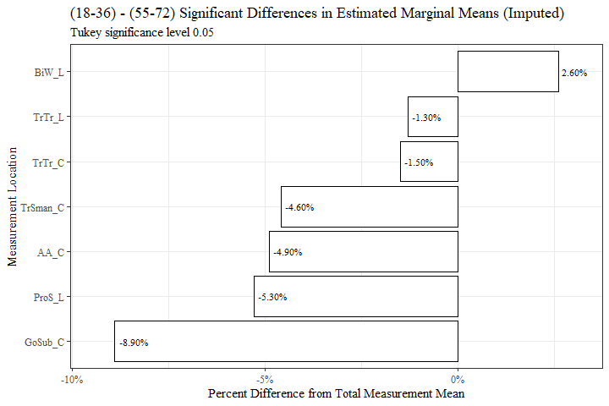

y_v_o <- y_v_o[c(8, 2, 6, 9, 10)]  
  
y_v_o <- y_v_o %>%   
 mutate(across(where(is.numeric), round, digits=3))  
  
flextable(y_v_o) %>%  
 my_ft_theme()%>%   
 bold(part = "header") %>%   
 set_caption("(18-36) - (55-72) Significant Differences in Estimated Marginal Means (Imputed)") %>%   
 fit_to_width(7.5) %>%   
 autofit()

**Table** **5**: (18-36) - (55-72) Significant Differences in Estimated Marginal Means (Imputed)

| **measure** | **estimate** | **p.value** | **measure_means** | **prop_diff** |
| --- | --- | --- | --- | --- |
| AA_C | -3.012 | 1.3204e-06 | 61.222 | -0.049 |
| BiW_L | 2.886 | 1.5873e-02 | 111.187 | 0.026 |
| GoSub_C | -8.795 | 5.3946e-09 | 99.174 | -0.089 |
| ProS_L | -1.014 | 4.2653e-04 | 19.120 | -0.053 |
| TrSman_C | -7.079 | 9.7485e-08 | 153.752 | -0.046 |
| TrTr_C | -4.295 | 4.0689e-03 | 282.695 | -0.015 |
| TrTr_L | -1.974 | 8.3491e-03 | 146.472 | -0.013 |

o_v_y <- y_v_o  
  
o_v_y$estimate <- o_v_y$estimate*(-1)  
o_v_y$prop_diff <- o_v_y$prop_diff*(-1)  
  
o_v_y$percent_diff <- percent(o_v_y$prop_diff)  
  
#o_v_y$contrastx <- "(55-72) - (18-36)"  
  
  
  
o_v_y$measure <- fct_reorder(o_v_y$measure, o_v_y$estimate, .desc=TRUE)  
  
o_v_y %>%   
 ggplot(aes(x=estimate, y= measure, label=estimate))+  
 geom_bar(stat="identity", color= "black", fill = "white")+  
 geom_text(hjust=1.1, position = position_dodge(.9), size = 3, family= "Times New Roman")+  
 scale_x_continuous(expand = expansion(mult = 0.1))+  
 theme_bw()+theme(text=element_text(family= "Times New Roman"))+  
 labs(title="(55-72) - (18-36) Significant Differences in Estimated Marginal Means (Imputed)",  
 subtitle= "Tukey significance level 0.05",  
 y="Measurement Location",  
 x="Difference in mm")

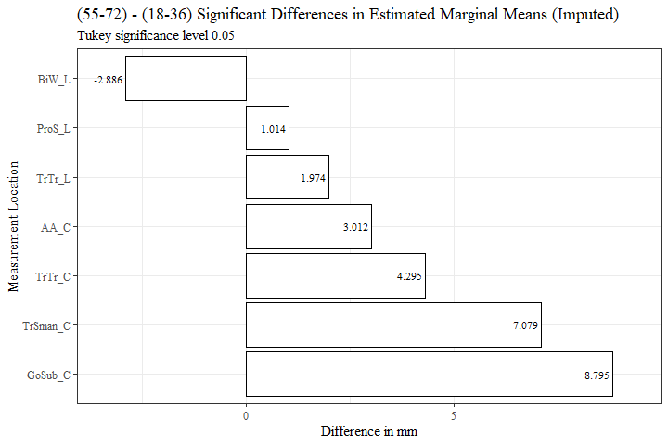

o_v_y$measure <- fct_reorder(o_v_y$measure, o_v_y$prop_diff, .desc=TRUE)  
  
o_v_y %>%   
 ggplot(aes(x=prop_diff, y= measure, label=percent_diff))+  
 geom_bar(stat="identity", color= "black", fill = "white")+  
 geom_text(hjust=1.1, position = position_dodge(.9), size = 3, family= "Times New Roman")+  
 scale_x_continuous(labels = scales::percent,  
 expand = expansion(mult = 0.1))+  
 theme_bw()+theme(text=element_text(family= "Times New Roman"))+  
 labs(title="(55-72) - (18-36) Significant Differences in Estimated Marginal Means (Imputed)",  
 subtitle= "Tukey significance level 0.05",  
 y="Measurement Location",  
 x="Percent Difference from Total Measurement Mean")

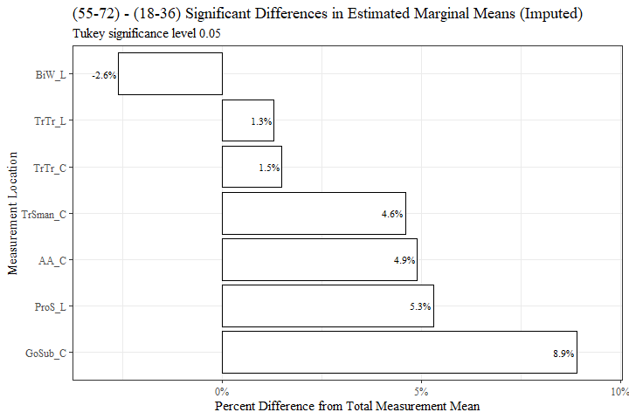

o_v_y <- o_v_y[-c(6)]  
  
flextable(o_v_y) %>%  
 my_ft_theme()%>%   
 bold(part = "header") %>%   
 set_caption("(55-72) - (18-36) Significant Differences in Estimated Marginal Means (Imputed)") %>%   
 fit_to_width(7.5) %>%   
 autofit()

**Table** **6**: (55-72) - (18-36) Significant Differences in Estimated Marginal Means (Imputed)

| **measure** | **estimate** | **p.value** | **measure_means** | **prop_diff** |
| --- | --- | --- | --- | --- |
| AA_C | 3.012 | 1.3204e-06 | 61.222 | 0.049 |
| BiW_L | -2.886 | 1.5873e-02 | 111.187 | -0.026 |
| GoSub_C | 8.795 | 5.3946e-09 | 99.174 | 0.089 |
| ProS_L | 1.014 | 4.2653e-04 | 19.120 | 0.053 |
| TrSman_C | 7.079 | 9.7485e-08 | 153.752 | 0.046 |
| TrTr_C | 4.295 | 4.0689e-03 | 282.695 | 0.015 |
| TrTr_L | 1.974 | 8.3491e-03 | 146.472 | 0.013 |

m_v_o <- age_est_data11 %>%   
 filter(contrast == "(37-54) - (55-72)")  
  
  
m_v_o$measure <- fct_reorder(m_v_o$measure, m_v_o$estimate, .desc=FALSE)  
  
m_v_o %>%   
 ggplot(aes(x=estimate, y= measure))+  
 geom_bar(stat="identity", color= "black", fill = "white")+  
 theme_bw()+theme(text=element_text(family= "Times New Roman"))+  
 labs(title="(37-54) - (55-72) Significant Differences in Estimated Marginal Means (Imputed)",  
 subtitle= "Tukey significance level 0.05",  
 y="Measurement Location",  
 x="Difference in mm")

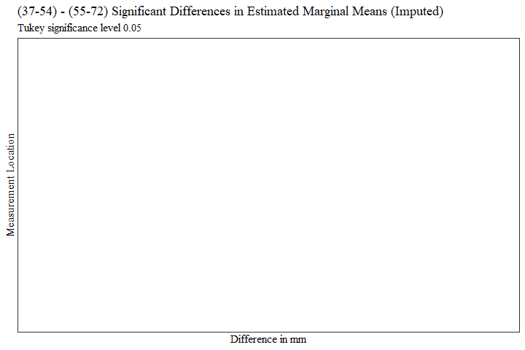

m_v_o$measure <- fct_reorder(m_v_o$measure, m_v_o$prop_diff, .desc=FALSE)  
  
m_v_o %>%   
 ggplot(aes(x=prop_diff, y= measure))+  
 geom_bar(stat="identity", color= "black", fill = "white")+  
 scale_x_continuous(labels = scales::percent)+  
 theme_bw()+theme(text=element_text(family= "Times New Roman"))+  
 labs(title="(37-54) - (55-72) Significant Differences in Estimated Marginal Means (Imputed)",  
 subtitle= "Tukey significance level 0.05",  
 y="Measurement Location",  
 x="Percent Difference from Total Measurement Mean")

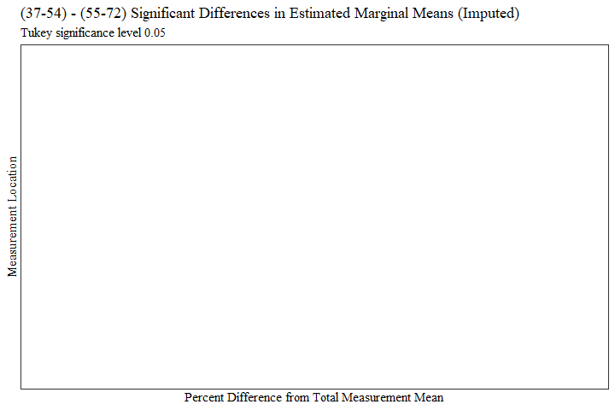

m_v_o <- m_v_o[c(8, 2, 6, 9, 10)]  
  
m_v_o <- m_v_o %>%   
 mutate(across(where(is.numeric), round, digits=3))  
  
  
flextable(m_v_o) %>%  
 my_ft_theme()%>%   
 bold(part = "header") %>%   
 set_caption("(37-54) - (55-72) Significant Differences in Estimated Marginal Means (Imputed)") %>%   
 fit_to_width(7.5) %>%   
 autofit()

**Table** **7**: (37-54) - (55-72) Significant Differences in Estimated Marginal Means (Imputed)

| **measure** | **estimate** | **p.value** | **measure_means** | **prop_diff** |
| --- | --- | --- | --- | --- |

o_v_m <- m_v_o  
  
o_v_m$estimate <- o_v_m$estimate*(-1)  
o_v_m$prop_diff <- o_v_m$prop_diff*(-1)  
  
  
  
  
  
  
o_v_m$measure <- fct_reorder(o_v_m$measure, o_v_m$estimate, .desc=TRUE)  
  
o_v_m %>%   
 ggplot(aes(x=estimate, y= measure))+  
 geom_bar(stat="identity", color= "black", fill = "white")+  
 theme_bw()+theme(text=element_text(family= "Times New Roman"))+  
 labs(title="(55-72) - (37-54) Significant Differences in Estimated Marginal Means (Imputed)",  
 subtitle= "Tukey significance level 0.05",  
 y="Measurement Location",  
 x="Difference in mm")

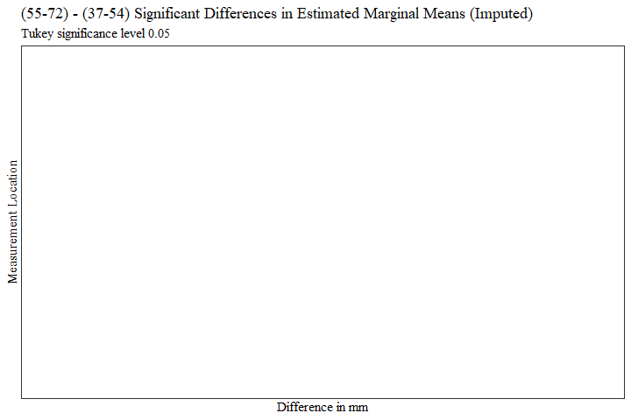

o_v_m$measure <- fct_reorder(o_v_m$measure, o_v_m$prop_diff, .desc=TRUE)  
  
o_v_m %>%   
 ggplot(aes(x=prop_diff, y= measure))+  
 geom_bar(stat="identity", color= "black", fill = "white")+  
 scale_x_continuous(labels = scales::percent)+  
 theme_bw()+theme(text=element_text(family= "Times New Roman"))+  
 labs(title="(55-72) - (37-54) Significant Differences in Estimated Marginal Means (Imputed)",  
 subtitle= "Tukey significance level 0.05",  
 y="Measurement Location",  
 x="Percent Difference from Total Measurement Mean")

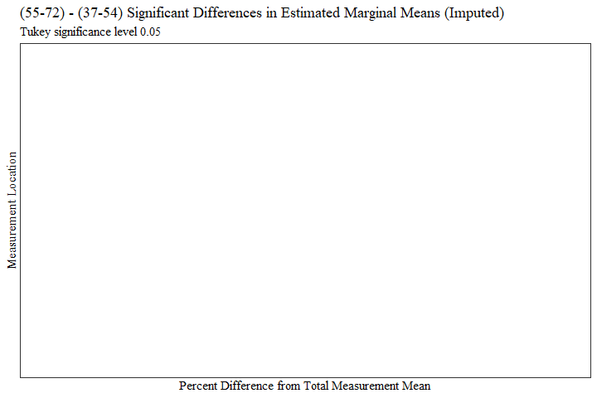

flextable(o_v_m) %>%  
 my_ft_theme()%>%   
 bold(part = "header") %>%   
 set_caption("(55-72) - (37-54) Significant Differences in Estimated Marginal Means (Imputed)") %>%   
 fit_to_width(7.5) %>%   
 autofit()

**Table** **8**: (55-72) - (37-54) Significant Differences in Estimated Marginal Means (Imputed)

| **measure** | **estimate** | **p.value** | **measure_means** | **prop_diff** |
| --- | --- | --- | --- | --- |

RACE/ETHNICITY

race_means_data1$measure <- fct_reorder(race_means_data1$measure, race_means_data1$emmean, .desc=FALSE)  
  
race_means_data1 %>%   
 ggplot(aes(x=race_eth, y=emmean, fill=measure))+  
 geom_bar(position=position_dodge(), stat="identity")+  
 geom_errorbar(aes(ymin=lower.CL, ymax=upper.CL), width=0.2, position=position_dodge(0.9))+  
 theme(axis.text.x = element_text(angle = 45, vjust=0.7))+  
 theme_bw()+theme(text=element_text(family= "Times New Roman"))+  
 labs(title="Estimated Marginal Means (Imputed)",  
 subtitle= "All races/ethnicities in MANOVA",  
 y="Emmean in mm",  
 x="Age",  
 fill="Measurement")

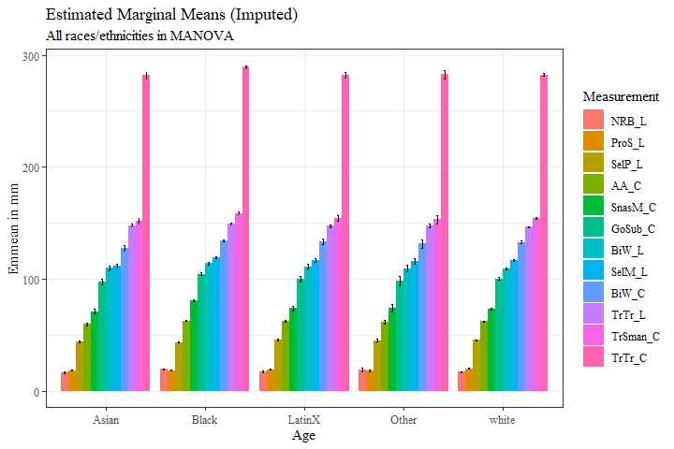

#race_means_data1$measure <- fct_reorder(race_means_data1$measure, race_means_data1$emmean, .desc=FALSE)  
  
race_means_data1 %>%   
 ggplot(aes(x=measure, y=emmean, fill=race_eth))+  
 geom_bar(position=position_dodge(), stat="identity")+  
 geom_errorbar(aes(ymin=lower.CL, ymax=upper.CL), width=0.2, position=position_dodge(0.9))+  
 theme_bw()+  
 theme(axis.text.x = element_text(angle = 45, vjust=0.7))+  
 theme(text=element_text(family= "Times New Roman"))+  
 labs(title="Estimated Marginal Means (Imputed)",  
 subtitle= "All races/ethnicities in MANOVA",  
 y="Emmean in mm",  
 x="Measurement",  
 fill="Race/Ethnicity")

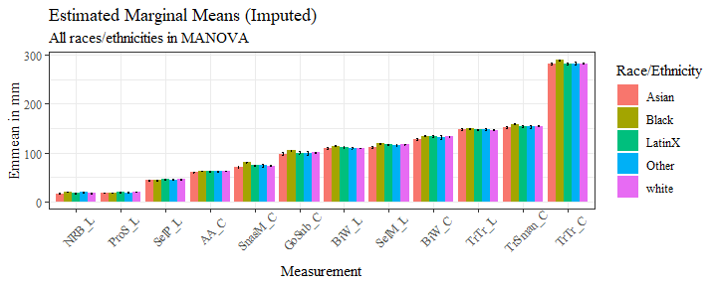

sig_race_est <- race_est_data1 %>%   
 filter(signif=="TRUE")  
  
sig_race_est <- sig_race_est %>%   
 mutate(across(where(is.numeric), round, digits=3))

sig_race_est$measure <- fct_reorder(sig_race_est$measure, sig_race_est$estimate, .desc=FALSE)  
  
sig_race_est %>%   
 ggplot(aes(x=estimate, y= measure, fill=contrast))+  
 geom_bar(position=position_dodge(), stat="identity")+  
 theme_bw()+theme(text=element_text(family= "Times New Roman"))+  
 labs(title="Age Significant Differences in Estimated Marginal Means (Imputed)",  
 subtitle= "Tukey significance level 0.05",  
 y="Measurement Location",  
 x="Difference in mm")

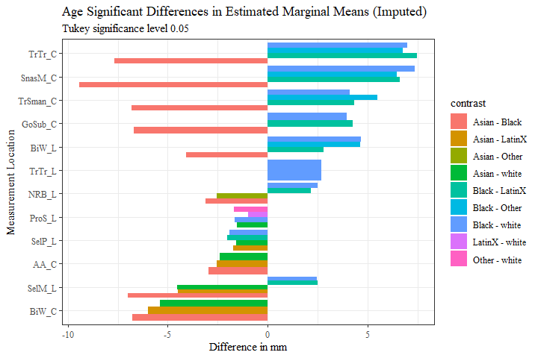

race_est_data11 <- full_join(sig_race_est, measure_means, by="measure")

race_est_data11$prop_diff <- (race_est_data11$estimate/race_est_data11$measure_means)  
  
race_est_data11 <- race_est_data11 %>%   
 mutate(across(where(is.numeric), round, digits=3))  
  
race_est_data11$percent_diff <- percent(race_est_data11$prop_diff)

race1 <- race_est_data11 %>%   
 filter(contrast == "Asian - Black")  
  
  
race1$measure <- fct_reorder(race1$measure, race1$estimate, .desc=FALSE)  
  
race1 %>%   
 ggplot(aes(x=estimate, y= measure, label=estimate))+  
 geom_bar(stat="identity", color= "black", fill = "white")+  
 geom_text(hjust=-0.15, position = position_dodge(.9), size = 3, family= "Times New Roman")+  
 scale_x_continuous(expand = expansion(mult = 0.1))+  
 theme_bw()+theme(text=element_text(family= "Times New Roman"))+  
 labs(title="Asian - Black Significant Differences in Estimated Marginal Means (Imputed)",  
 subtitle= "Tukey significance level 0.05",  
 y="Measurement Location",  
 x="Difference in mm")

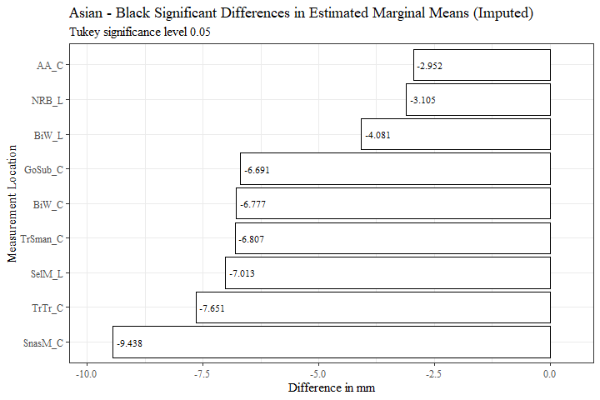

race1$measure <- fct_reorder(race1$measure, race1$prop_diff, .desc=FALSE)  
  
race1 %>%   
 ggplot(aes(x=prop_diff, y= measure, label=percent_diff))+  
 geom_bar(stat="identity", color= "black", fill = "white")+  
 geom_text(hjust=-0.15, position = position_dodge(.9), size = 3, family= "Times New Roman")+  
 scale_x_continuous(labels = scales::percent,  
 expand = expansion(mult = 0.1))+  
 theme_bw()+theme(text=element_text(family= "Times New Roman"))+  
 labs(title="Asian - Black Significant Differences in Estimated Marginal Mean",  
 subtitle= "Tukey significance level 0.05",  
 y="Measurement Location",  
 x="Percent Difference from Total Measurement Mean")

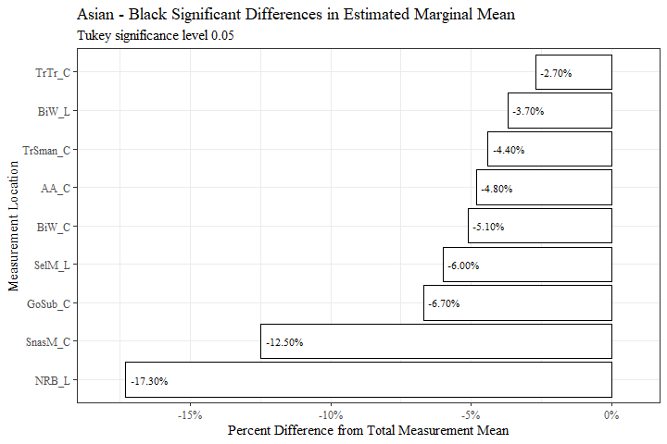

race1 <- race1[c(8, 2, 6, 9, 10)]  
  
race1 <- race1 %>%   
 mutate(across(where(is.numeric), round, digits=3))  
  
  
flextable(race1) %>%  
 my_ft_theme()%>%   
 bold(part = "header") %>%   
 set_caption("Asian - Black Significant Differences in Estimated Marginal Means (Imputed)") %>%   
 fit_to_width(7.5) %>%   
 autofit()

**Table** **9**: Asian - Black Significant Differences in Estimated Marginal Means (Imputed)

| **measure** | **estimate** | **p.value** | **measure_means** | **prop_diff** |
| --- | --- | --- | --- | --- |
| AA_C | -2.952 | 6.7530e-06 | 61.222 | -0.048 |
| BiW_L | -4.081 | 8.6188e-04 | 111.187 | -0.037 |
| BiW_C | -6.777 | 4.0133e-06 | 133.391 | -0.051 |
| GoSub_C | -6.691 | 4.1194e-05 | 99.174 | -0.067 |
| NRB_L | -3.105 | 1.8333e-08 | 17.947 | -0.173 |
| SelM_L | -7.013 | 4.6765e-11 | 116.956 | -0.060 |
| SnasM_C | -9.438 | 4.6530e-11 | 75.616 | -0.125 |
| TrSman_C | -6.807 | 9.5178e-07 | 153.752 | -0.044 |
| TrTr_C | -7.651 | 1.3029e-07 | 282.695 | -0.027 |

race1.1 <- race1  
  
race1.1$estimate <- race1.1$estimate*(-1)  
race1.1$prop_diff <- race1.1$prop_diff*(-1)  
  
race1.1$percent_diff <- percent(race1.1$prop_diff)  
  
  
race1.1$measure <- fct_reorder(race1.1$measure, race1.1$estimate, .desc=TRUE)  
  
race1.1 %>%   
 ggplot(aes(x=estimate, y= measure, label=estimate))+  
 geom_bar(stat="identity", color= "black", fill = "white")+  
 geom_text(hjust=1.1, position = position_dodge(.9), size = 3, family= "Times New Roman")+  
 scale_x_continuous(expand = expansion(mult = 0.1))+  
 theme_bw()+theme(text=element_text(family= "Times New Roman"))+  
 labs(title="Black - Asian Significant Differences in Estimated Marginal Means (Imputed)",  
 subtitle= "Tukey significance level 0.05",  
 y="Measurement Location",  
 x="Difference in mm")

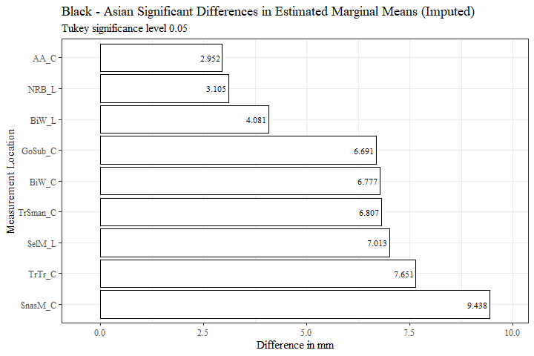

race1.1$measure <- fct_reorder(race1.1$measure, race1.1$prop_diff, .desc=TRUE)  
  
race1.1 %>%   
 ggplot(aes(x=prop_diff, y= measure, label=percent_diff))+  
 geom_bar(stat="identity", color= "black", fill = "white")+  
 geom_text(hjust=1.1, position = position_dodge(.9), size = 3, family= "Times New Roman")+  
 scale_x_continuous(labels = scales::percent,  
 expand = expansion(mult = 0.1))+  
 theme_bw()+theme(text=element_text(family= "Times New Roman"))+  
 labs(title="Black - Asian Significant Differences in Estimated Marginal Means (Imputed)",  
 subtitle= "Tukey significance level 0.05",  
 y="Measurement Location",  
 x="Percent Difference from Total Measurement Mean")

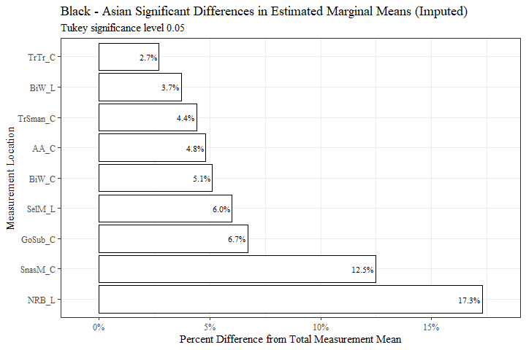

race1.1 <- race1.1[-c(6)]  
  
flextable(race1.1) %>%  
 my_ft_theme()%>%   
 bold(part = "header") %>%   
 set_caption("Black - Asian Significant Differences in Estimated Marginal Means (Imputed)") %>%   
 fit_to_width(7.5) %>%   
 autofit()

**Table** **10**: Black - Asian Significant Differences in Estimated Marginal Means (Imputed)

| **measure** | **estimate** | **p.value** | **measure_means** | **prop_diff** |
| --- | --- | --- | --- | --- |
| AA_C | 2.952 | 6.7530e-06 | 61.222 | 0.048 |
| BiW_L | 4.081 | 8.6188e-04 | 111.187 | 0.037 |
| BiW_C | 6.777 | 4.0133e-06 | 133.391 | 0.051 |
| GoSub_C | 6.691 | 4.1194e-05 | 99.174 | 0.067 |
| NRB_L | 3.105 | 1.8333e-08 | 17.947 | 0.173 |
| SelM_L | 7.013 | 4.6765e-11 | 116.956 | 0.060 |
| SnasM_C | 9.438 | 4.6530e-11 | 75.616 | 0.125 |
| TrSman_C | 6.807 | 9.5178e-07 | 153.752 | 0.044 |
| TrTr_C | 7.651 | 1.3029e-07 | 282.695 | 0.027 |

race2 <- race_est_data11 %>%   
 filter(contrast == "Asian - LatinX")  
  
  
  
race2$measure <- fct_reorder(race2$measure, race2$estimate, .desc=FALSE)  
  
race2 %>%   
 ggplot(aes(x=estimate, y= measure, label=estimate))+  
 geom_bar(stat="identity", color= "black", fill = "white")+  
 geom_text(hjust=-0.15, position = position_dodge(.9), size = 5, family="Times New Roman")+  
 scale_x_continuous(expand = expansion(mult = 0.1))+  
 theme_bw()+theme(text=element_text(family= "Times New Roman"))+  
 labs(title="Asian - LatinX Significant Differences in Estimated Marginal Means (Imputed)",  
 subtitle= "Tukey significance level 0.05",  
 y="Measurement Location",  
 x="Difference in mm")

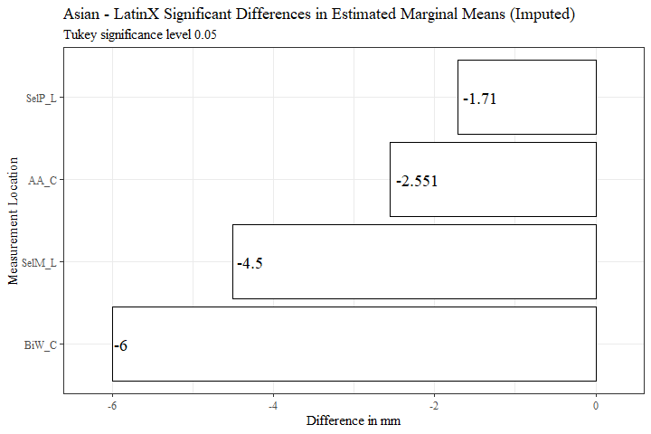

race2$measure <- fct_reorder(race2$measure, race2$prop_diff, .desc=FALSE)  
  
race2 %>%   
 ggplot(aes(x=prop_diff, y= measure, label=percent_diff))+  
 geom_bar(stat="identity", color= "black", fill = "white")+  
 geom_text(hjust=-0.15, position = position_dodge(.9), size = 5, family= "Times New Roman")+  
 scale_x_continuous(labels = scales::percent,  
 expand = expansion(mult = 0.1))+  
 theme_bw()+theme(text=element_text(family= "Times New Roman"))+  
 labs(title="Asian - LatinX Significant Differences in Estimated Marginal Means (Imputed)",  
 subtitle= "Tukey significance level 0.05",  
 y="Measurement Location",  
 x="Percent Difference from Total Measurement Mean")

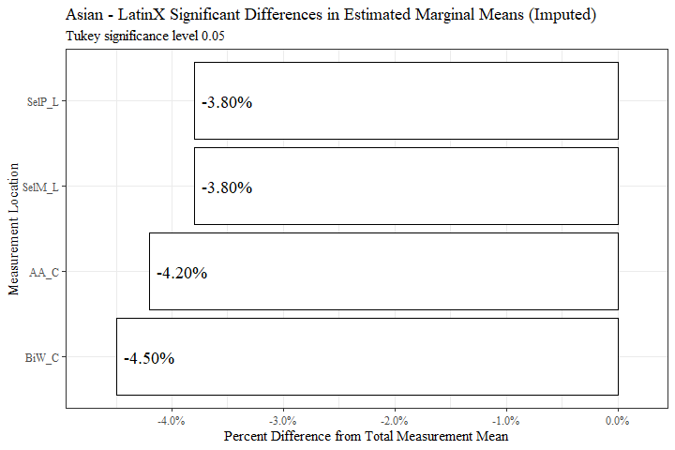

race2 <- race2[c(8, 2, 6, 9, 10)]  
  
race2 <- race2 %>%   
 mutate(across(where(is.numeric), round, digits=3))  
  
  
flextable(race2) %>%  
 my_ft_theme()%>%   
 bold(part = "header") %>%   
 set_caption("Asian - LatinX Significant Differences in Estimated Marginal Means (Imputed)") %>%   
 fit_to_width(7.5) %>%   
 autofit()

**Table** **11**: Asian - LatinX Significant Differences in Estimated Marginal Means (Imputed)

| **measure** | **estimate** | **p.value** | **measure_means** | **prop_diff** |
| --- | --- | --- | --- | --- |
| AA_C | -2.551 | 7.0804e-03 | 61.222 | -0.042 |
| BiW_C | -6.000 | 4.1198e-03 | 133.391 | -0.045 |
| SelP_L | -1.710 | 1.7568e-02 | 44.534 | -0.038 |
| SelM_L | -4.500 | 1.1590e-03 | 116.956 | -0.038 |

race2.1 <- race2  
  
race2.1$estimate <- race2.1$estimate*(-1)  
race2.1$prop_diff <- race2.1$prop_diff*(-1)  
  
race2.1$percent_diff <- percent(race2.1$prop_diff)  
  
  
  
race2.1$measure <- fct_reorder(race2.1$measure, race2.1$estimate, .desc=TRUE)  
  
race2.1 %>%   
 ggplot(aes(x=estimate, y= measure, label=estimate))+  
 geom_bar(stat="identity", color= "black", fill = "white")+  
 geom_text(hjust=1.1, position = position_dodge(.9), size = 5, family="Times New Roman")+  
 scale_x_continuous(expand = expansion(mult = 0.1))+  
 theme_bw()+theme(text=element_text(family= "Times New Roman"))+  
 labs(title="LatinX - Asian Significant Differences in Estimated Marginal Means (Imputed)",  
 subtitle= "Tukey significance level 0.05",  
 y="Measurement Location",  
 x="Difference in mm")

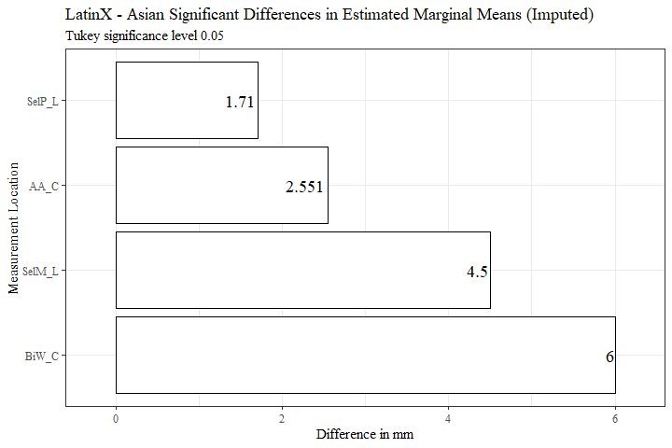

race2.1$measure <- fct_reorder(race2.1$measure, race2.1$prop_diff, .desc=TRUE)  
  
race2.1 %>%   
 ggplot(aes(x=prop_diff, y= measure, label=percent_diff))+  
 geom_bar(stat="identity", color= "black", fill = "white")+  
 geom_text(hjust=1.1, position = position_dodge(.9), size = 5, family= "Times New Roman")+  
 scale_x_continuous(labels = scales::percent,  
 expand = expansion(mult = 0.1))+  
 theme_bw()+theme(text=element_text(family= "Times New Roman"))+  
 labs(title="LatinX - Asian Significant Differences in Estimated Marginal Means (Imputed)",  
 subtitle= "Tukey significance level 0.05",  
 y="Measurement Location",  
 x="Percent Difference from Total Measurement Mean")

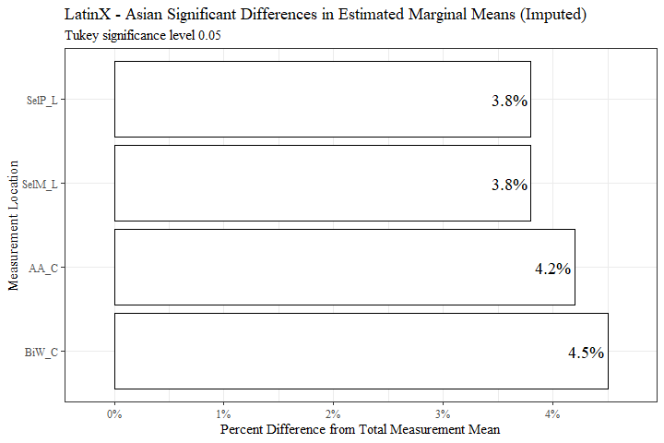

race2.1 <- race2.1[-c(6)]  
  
  
flextable(race2.1) %>%  
 my_ft_theme()%>%   
 bold(part = "header") %>%   
 set_caption("LatinX - Asian Significant Differences in Estimated Marginal Means (Imputed)") %>%   
 fit_to_width(7.5) %>%   
 autofit()

**Table** **12**: LatinX - Asian Significant Differences in Estimated Marginal Means (Imputed)

| **measure** | **estimate** | **p.value** | **measure_means** | **prop_diff** |
| --- | --- | --- | --- | --- |
| AA_C | 2.551 | 7.0804e-03 | 61.222 | 0.042 |
| BiW_C | 6.000 | 4.1198e-03 | 133.391 | 0.045 |
| SelP_L | 1.710 | 1.7568e-02 | 44.534 | 0.038 |
| SelM_L | 4.500 | 1.1590e-03 | 116.956 | 0.038 |

race3 <- race_est_data11 %>%   
 filter(contrast == "Asian - white")  
  
race3$measure <- fct_reorder(race3$measure, race3$estimate, .desc=FALSE)  
  
race3 %>%   
 ggplot(aes(x=estimate, y= measure, label=estimate))+  
 geom_bar(stat="identity", color= "black", fill = "white")+  
 geom_text(hjust=-0.15, position = position_dodge(.9), size = 4, family="Times New Roman")+  
 scale_x_continuous(expand = expansion(mult = 0.1))+  
 theme_bw()+theme(text=element_text(family= "Times New Roman"))+  
 labs(title="Asian - white Significant Differences in Estimated Marginal Means (Imputed)",  
 subtitle= "Tukey significance level 0.05",  
 y="Measurement Location",  
 x="Difference in mm")

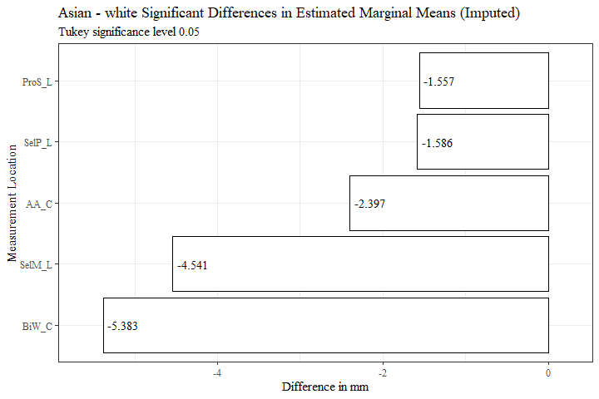

race3$measure <- fct_reorder(race3$measure, race3$prop_diff, .desc=FALSE)  
  
race3 %>%   
 ggplot(aes(x=prop_diff, y= measure, label=percent_diff))+  
 geom_bar(stat="identity", color= "black", fill = "white")+  
 geom_text(hjust=-0.15, position = position_dodge(.9), size = 4, family= "Times New Roman")+  
 scale_x_continuous(labels = scales::percent,  
 expand = expansion(mult = 0.1))+  
 theme_bw()+theme(text=element_text(family= "Times New Roman"))+  
 labs(title="Asian - white Significant Differences in Estimated Marginal Means (Imputed)",  
 subtitle= "Tukey significance level 0.05",  
 y="Measurement Location",  
 x="Percent Difference from Total Measurement Mean")

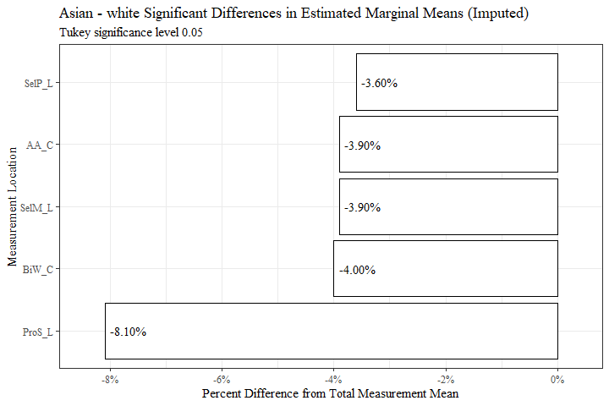

race3 <- race3[c(8, 2, 6, 9, 10)]  
  
race3 <- race3 %>%   
 mutate(across(where(is.numeric), round, digits=3))  
  
  
flextable(race3) %>%  
 my_ft_theme()%>%   
 bold(part = "header") %>%   
 set_caption("Asian - white Significant Differences in Estimated Marginal Means (Imputed)") %>%   
 fit_to_width(7.5) %>%   
 autofit()

**Table** **13**: Asian - white Significant Differences in Estimated Marginal Means (Imputed)

| **measure** | **estimate** | **p.value** | **measure_means** | **prop_diff** |
| --- | --- | --- | --- | --- |
| AA_C | -2.397 | 2.4797e-04 | 61.222 | -0.039 |
| BiW_C | -5.383 | 2.5696e-04 | 133.391 | -0.040 |
| ProS_L | -1.557 | 1.1364e-08 | 19.120 | -0.081 |
| SelP_L | -1.586 | 1.2859e-03 | 44.534 | -0.036 |
| SelM_L | -4.541 | 2.3542e-06 | 116.956 | -0.039 |

race3.1 <- race3  
  
race3.1$estimate <- race3.1$estimate*(-1)  
race3.1$prop_diff <- race3.1$prop_diff*(-1)  
  
  
race3.1$percent_diff <- percent(race3.1$prop_diff)  
  
  
  
race3.1$measure <- fct_reorder(race3.1$measure, race3.1$estimate, .desc=TRUE)  
  
race3.1 %>%   
 ggplot(aes(x=estimate, y= measure, label=estimate))+  
 geom_bar(stat="identity", color= "black", fill = "white")+  
 geom_text(hjust=1.1, position = position_dodge(.9), size = 4, family="Times New Roman")+  
 scale_x_continuous(expand = expansion(mult = 0.1))+  
 theme_bw()+theme(text=element_text(family= "Times New Roman"))+  
 labs(title="white - Asian Significant Differences in Estimated Marginal Means (Imputed)",  
 subtitle= "Tukey significance level 0.05",  
 y="Measurement Location",  
 x="Difference in mm")

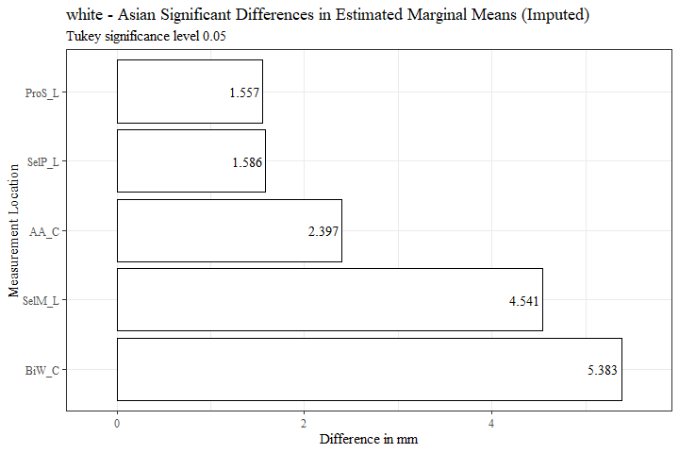

race3.1$measure <- fct_reorder(race3.1$measure, race3.1$prop_diff, .desc=TRUE)  
  
race3.1 %>%   
 ggplot(aes(x=prop_diff, y= measure, label=percent_diff))+  
 geom_bar(stat="identity", color= "black", fill = "white")+  
 geom_text(hjust=1.1, position = position_dodge(.9), size = 4, family= "Times New Roman")+  
 scale_x_continuous(labels = scales::percent,  
 expand = expansion(mult = 0.1))+  
 theme_bw()+theme(text=element_text(family= "Times New Roman"))+  
 labs(title="white - Asian Significant Differences in Estimated Marginal Means (Imputed)",  
 subtitle= "Tukey significance level 0.05",  
 y="Measurement Location",  
 x="Percent Difference from Total Measurement Mean")

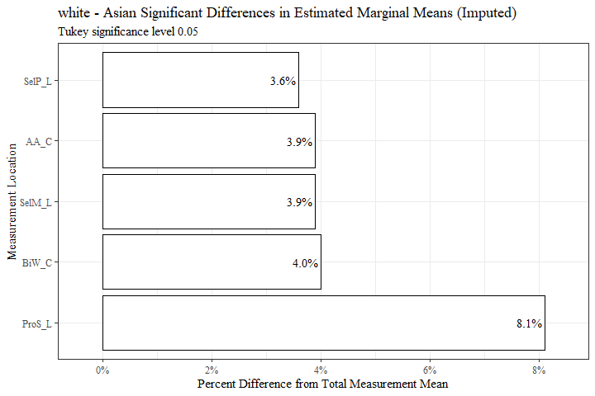

flextable(race3.1) %>%  
 my_ft_theme()%>%   
 bold(part = "header") %>%   
 set_caption("white - Asian Significant Differences in Estimated Marginal Means (Imputed)") %>%   
 fit_to_width(7.5) %>%   
 autofit()

**Table** **14**: white - Asian Significant Differences in Estimated Marginal Means (Imputed)

| **measure** | **estimate** | **p.value** | **measure_means** | **prop_diff** | **percent_diff** |
| --- | --- | --- | --- | --- | --- |
| AA_C | 2.397 | 2.4797e-04 | 61.222 | 0.039 | 3.9% |
| BiW_C | 5.383 | 2.5696e-04 | 133.391 | 0.040 | 4.0% |
| ProS_L | 1.557 | 1.1364e-08 | 19.120 | 0.081 | 8.1% |
| SelP_L | 1.586 | 1.2859e-03 | 44.534 | 0.036 | 3.6% |
| SelM_L | 4.541 | 2.3542e-06 | 116.956 | 0.039 | 3.9% |

race4 <- race_est_data11 %>%   
 filter(contrast == "Black - LatinX")  
  
race4$measure <- fct_reorder(race4$measure, race4$estimate, .desc=TRUE)  
  
race4 %>%   
 ggplot(aes(x=estimate, y= measure, label=estimate))+  
 geom_bar(stat="identity", color= "black", fill = "white")+  
 geom_text(hjust=1.1, position = position_dodge(.9), size = 3, family="Times New Roman")+  
 scale_x_continuous(expand = expansion(mult = 0.1))+  
 theme_bw()+theme(text=element_text(family= "Times New Roman"))+  
 labs(title="Black - LatinX Significant Differences in Estimated Marginal Means (Imputed)",  
 subtitle= "Tukey significance level 0.05",  
 y="Measurement Location",  
 x="Difference in mm")

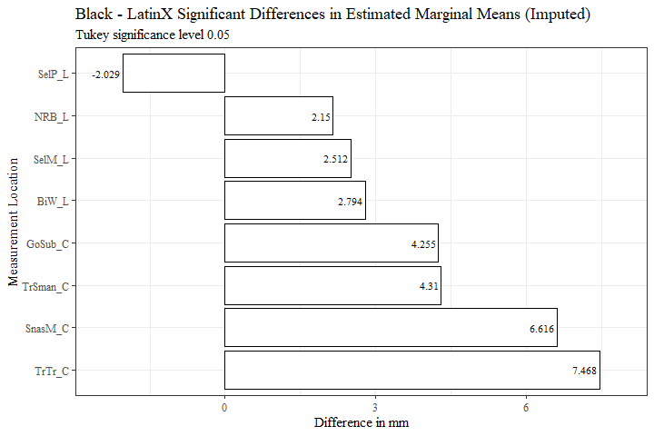

race4$measure <- fct_reorder(race4$measure, race4$prop_diff, .desc=TRUE)  
  
race4 %>%   
 ggplot(aes(x=prop_diff, y= measure, label=percent_diff))+  
 geom_bar(stat="identity", color= "black", fill = "white")+  
 geom_text(hjust=1.1, position = position_dodge(.9), size = 3, family= "Times New Roman")+  
 scale_x_continuous(labels = scales::percent,  
 expand = expansion(mult = 0.1))+  
 theme_bw()+theme(text=element_text(family= "Times New Roman"))+  
 labs(title="Black - LatinX Significant Differences in Estimated Marginal Means (Imputed)",  
 subtitle= "Tukey significance level 0.05",  
 y="Measurement Location",  
 x="Percent Difference from Total Measurement Mean")

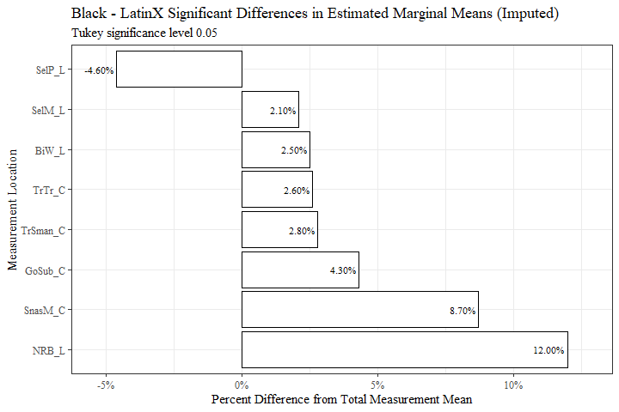

race4 <- race4[c(8, 2, 6, 9, 10)]  
  
race4 <- race4 %>%   
 mutate(across(where(is.numeric), round, digits=3))  
  
  
flextable(race4) %>%  
 my_ft_theme()%>%   
 bold(part = "header") %>%   
 set_caption("Black - LatinX Significant Differences in Estimated Marginal Means (Imputed)") %>%   
 fit_to_width(7.5) %>%   
 autofit()

**Table** **15**: Black - LatinX Significant Differences in Estimated Marginal Means (Imputed)

| **measure** | **estimate** | **p.value** | **measure_means** | **prop_diff** |
| --- | --- | --- | --- | --- |
| BiW_L | 2.794 | 4.2843e-02 | 111.187 | 0.025 |
| GoSub_C | 4.255 | 1.9998e-02 | 99.174 | 0.043 |
| NRB_L | 2.150 | 1.4629e-04 | 17.947 | 0.120 |
| SelP_L | -2.029 | 1.2188e-05 | 44.534 | -0.046 |
| SelM_L | 2.512 | 3.5259e-02 | 116.956 | 0.021 |
| SnasM_C | 6.616 | 6.9726e-10 | 75.616 | 0.087 |
| TrSman_C | 4.310 | 4.0678e-03 | 153.752 | 0.028 |
| TrTr_C | 7.468 | 8.5346e-08 | 282.695 | 0.026 |

race5 <- race_est_data11 %>%   
 filter(contrast == "Black - Other")  
  
race5$measure <- fct_reorder(race5$measure, race5$estimate, .desc=TRUE)  
  
race5 %>%   
 ggplot(aes(x=estimate, y= measure, label=estimate))+  
 geom_bar(stat="identity", color= "black", fill = "white")+  
 geom_text(hjust=1.1, position = position_dodge(.9), size = 5, family="Times New Roman")+  
 scale_x_continuous(expand = expansion(mult = 0.1))+  
 theme_bw()+theme(text=element_text(family= "Times New Roman"))+  
 labs(title="Black - Other Significant Differences in Estimated Marginal Means (Imputed)",  
 subtitle= "Tukey significance level 0.05",  
 y="Measurement Location",  
 x="Difference in mm")

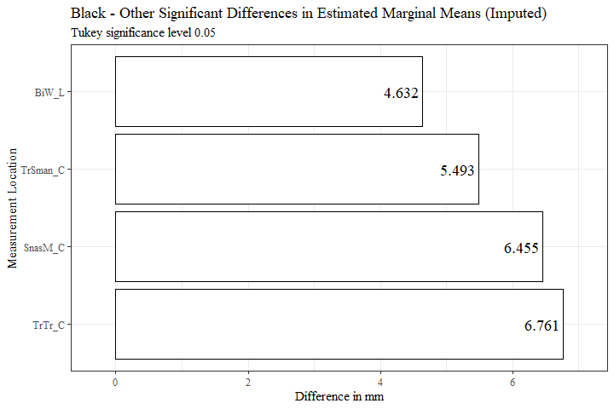

race5$measure <- fct_reorder(race5$measure, race5$prop_diff, .desc=TRUE)  
  
race5 %>%   
 ggplot(aes(x=prop_diff, y= measure, label=percent_diff))+  
 geom_bar(stat="identity", color= "black", fill = "white")+  
 geom_text(hjust=1.1, position = position_dodge(.9), size = 5, family= "Times New Roman")+  
 scale_x_continuous(labels = scales::percent,  
 expand = expansion(mult = 0.1))+  
 theme_bw()+theme(text=element_text(family= "Times New Roman"))+  
 labs(title="Black - Other Significant Differences in Estimated Marginal Means (Imputed)",  
 subtitle= "Tukey significance level 0.05",  
 y="Measurement Location",  
 x="Percent Difference from Total Measurement Mean")

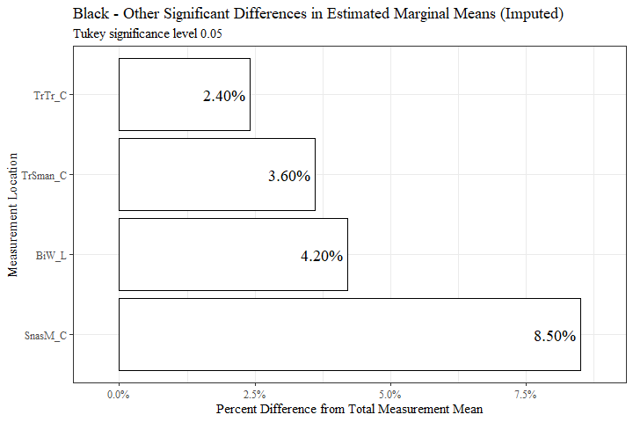

race5 <- race5[c(8, 2, 6, 9, 10)]  
  
race5 <- race5 %>%   
 mutate(across(where(is.numeric), round, digits=3))  
  
  
flextable(race5) %>%  
 my_ft_theme()%>%   
 bold(part = "header") %>%   
 set_caption("Black - Other Significant Differences in Estimated Marginal Means (Imputed)") %>%   
 fit_to_width(7.5) %>%   
 autofit()

**Table** **16**: Black - Other Significant Differences in Estimated Marginal Means (Imputed)

| **measure** | **estimate** | **p.value** | **measure_means** | **prop_diff** |
| --- | --- | --- | --- | --- |
| BiW_L | 4.632 | 2.2566e-02 | 111.187 | 0.042 |
| SnasM_C | 6.455 | 3.0774e-04 | 75.616 | 0.085 |
| TrSman_C | 5.493 | 2.9417e-02 | 153.752 | 0.036 |
| TrTr_C | 6.761 | 6.0459e-03 | 282.695 | 0.024 |

race6 <- race_est_data11 %>%   
 filter(contrast == "Black - white")  
  
  
race6$measure <- fct_reorder(race6$measure, race6$estimate, .desc=TRUE)  
  
race6 %>%   
 ggplot(aes(x=estimate, y= measure, label=estimate))+  
 geom_bar(stat="identity", color= "black", fill = "white")+  
 geom_text(hjust=1.1, position = position_dodge(.9), size = 3, family="Times New Roman")+  
 scale_x_continuous(expand = expansion(mult = 0.1))+  
 theme_bw()+theme(text=element_text(family= "Times New Roman"))+  
 labs(title="Black - white Significant Differences in Estimated Marginal Means (Imputed)",  
 subtitle= "Tukey significance level 0.05",  
 y="Measurement Location",  
 x="Difference in mm")

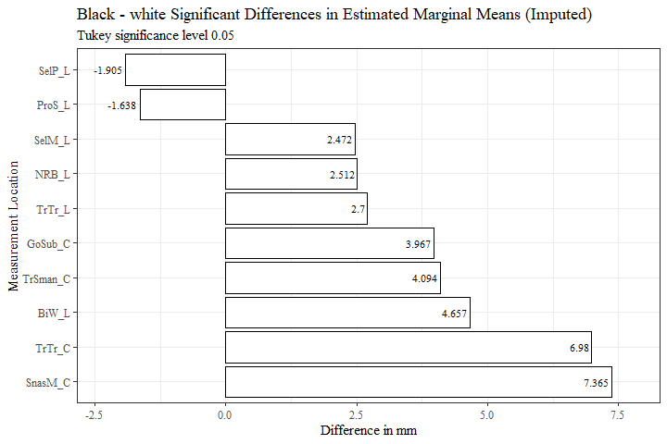

race6$measure <- fct_reorder(race6$measure, race6$prop_diff, .desc=TRUE)  
  
race6 %>%   
 ggplot(aes(x=prop_diff, y= measure, label=percent_diff))+  
 geom_bar(stat="identity", color= "black", fill = "white")+  
 geom_text(hjust=1.1, position = position_dodge(.9), size = 3, family= "Times New Roman")+  
 scale_x_continuous(labels = scales::percent,  
 expand = expansion(mult = 0.1))+  
 theme_bw()+theme(text=element_text(family= "Times New Roman"))+  
 labs(title="Black - white Significant Differences in Estimated Marginal Means (Imputed)",  
 subtitle= "Tukey significance level 0.05",  
 y="Measurement Location",  
 x="Percent Difference from Total Measurement Mean")

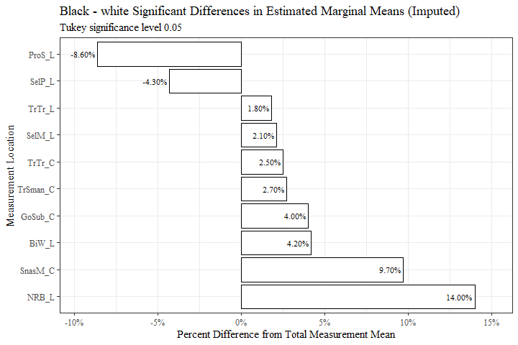

race6 <- race6[c(8, 2, 6, 9, 10)]  
  
race6 <- race6 %>%   
 mutate(across(where(is.numeric), round, digits=3))  
  
  
flextable(race6) %>%  
 my_ft_theme()%>%   
 bold(part = "header") %>%   
 set_caption("Black - white Significant Differences in Estimated Marginal Means (Imputed)") %>%   
 fit_to_width(7.5) %>%   
 autofit()

**Table** **17**: Black - white Significant Differences in Estimated Marginal Means (Imputed)

| **measure** | **estimate** | **p.value** | **measure_means** | **prop_diff** |
| --- | --- | --- | --- | --- |
| BiW_L | 4.657 | 4.6531e-11 | 111.187 | 0.042 |
| GoSub_C | 3.967 | 1.8608e-08 | 99.174 | 0.040 |
| NRB_L | 2.512 | 4.6529e-11 | 17.947 | 0.140 |
| ProS_L | -1.638 | 4.6484e-11 | 19.120 | -0.086 |
| SelP_L | -1.905 | 4.6532e-11 | 44.534 | -0.043 |
| SelM_L | 2.472 | 2.7139e-08 | 116.956 | 0.021 |
| SnasM_C | 7.365 | 4.6484e-11 | 75.616 | 0.097 |
| TrSman_C | 4.094 | 6.2836e-11 | 153.752 | 0.027 |
| TrTr_C | 6.980 | 4.6485e-11 | 282.695 | 0.025 |
| TrTr_L | 2.700 | 4.6528e-11 | 146.472 | 0.018 |

race7 <- race_est_data11 %>%   
 filter(contrast == "LatinX - white")  
  
  
  
race7$measure <- fct_reorder(race7$measure, race7$estimate, .desc=FALSE)  
  
race7 %>%   
 ggplot(aes(x=estimate, y= measure, label=estimate))+  
 geom_bar(stat="identity", color= "black", fill = "white")+  
 geom_text(hjust=1.1, position = position_dodge(.9), size = 3, family="Times New Roman")+  
 scale_x_continuous(expand = expansion(mult = 0.1))+  
 theme_bw()+theme(text=element_text(family= "Times New Roman"))+  
 labs(title="LatinX - white Significant Differences in Estimated Marginal Means (Imputed)",  
 subtitle= "Tukey significance level 0.05",  
 y="Measurement Location",  
 x="Difference in mm")

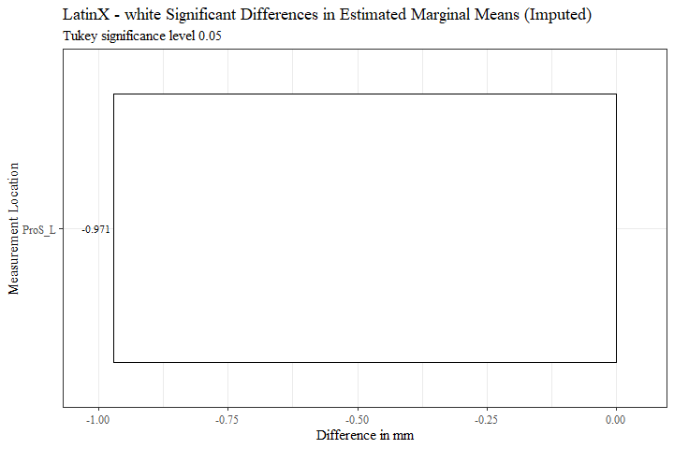

race7$measure <- fct_reorder(race7$measure, race7$prop_diff, .desc=FALSE)  
  
race7 %>%   
 ggplot(aes(x=prop_diff, y= measure, label=percent_diff))+  
 geom_bar(stat="identity", color= "black", fill = "white")+  
 geom_text(hjust=1.1, position = position_dodge(.9), size = 3, family= "Times New Roman")+  
 scale_x_continuous(labels = scales::percent,  
 expand = expansion(mult = 0.1))+  
 theme_bw()+theme(text=element_text(family= "Times New Roman"))+  
 labs(title="LatinX - white Significant Differences in Estimated Marginal Means (Imputed)",  
 subtitle= "Tukey significance level 0.05",  
 y="Measurement Location",  
 x="Percent Difference from Total Measurement Mean")

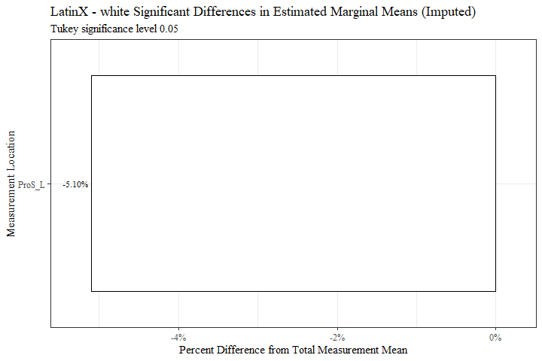

race7 <- race7[c(8, 2, 6, 9, 10)]  
  
race7 <- race7 %>%   
 mutate(across(where(is.numeric), round, digits=3))  
  
  
flextable(race7) %>%  
 my_ft_theme()%>%   
 bold(part = "header") %>%   
 set_caption("LatinX - white Significant Differences in Estimated Marginal Means (Imputed)") %>%   
 fit_to_width(7.5) %>%   
 autofit()

**Table** **18**: LatinX - white Significant Differences in Estimated Marginal Means (Imputed)

| **measure** | **estimate** | **p.value** | **measure_means** | **prop_diff** |
| --- | --- | --- | --- | --- |
| ProS_L | -0.971 | 7.0932e-04 | 19.12 | -0.051 |

race8 <- race_est_data11 %>%   
 filter(contrast == "Other - white")  
  
  
  
race8$measure <- fct_reorder(race8$measure, race8$estimate, .desc=FALSE)  
  
race8 %>%   
 ggplot(aes(x=estimate, y= measure, label=estimate))+  
 geom_bar(stat="identity", color= "black", fill = "white")+  
 geom_text(hjust=1.1, position = position_dodge(.9), size = 3, family="Times New Roman")+  
 scale_x_continuous(expand = expansion(mult = 0.1))+  
 theme_bw()+theme(text=element_text(family= "Times New Roman"))+  
 labs(title="Other - white Significant Differences in Estimated Marginal Means (Imputed)",  
 subtitle= "Tukey significance level 0.05",  
 y="Measurement Location",  
 x="Difference in mm")

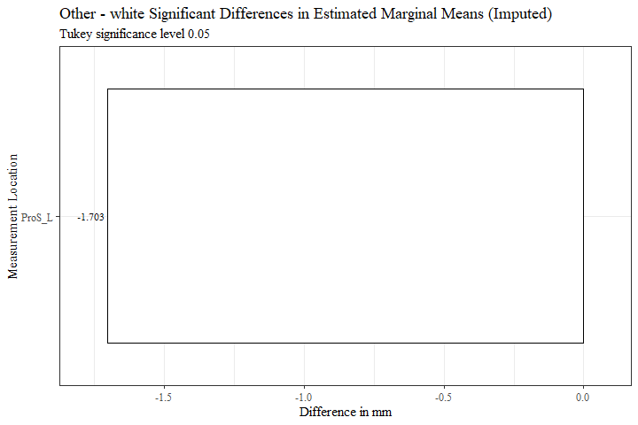

race8$measure <- fct_reorder(race8$measure, race8$prop_diff, .desc=FALSE)  
  
race8 %>%   
 ggplot(aes(x=prop_diff, y= measure, label=percent_diff))+  
 geom_bar(stat="identity", color= "black", fill = "white")+  
 geom_text(hjust=1.1, position = position_dodge(.9), size = 3, family= "Times New Roman")+  
 scale_x_continuous(labels = scales::percent,  
 expand = expansion(mult = 0.1))+  
 theme_bw()+theme(text=element_text(family= "Times New Roman"))+  
 labs(title="Other - white Significant Differences in Estimated Marginal Means (Imputed)",  
 subtitle= "Tukey significance level 0.05",  
 y="Measurement Location",  
 x="Percent Difference from Total Measurement Mean")

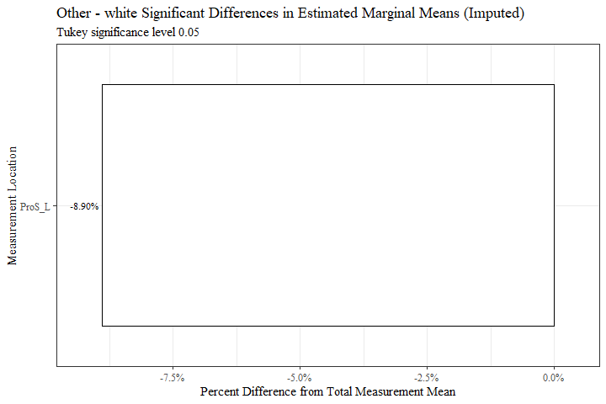

race8 <- race8[c(8, 2, 6, 9, 10)]  
  
race8 <- race8 %>%   
 mutate(across(where(is.numeric), round, digits=3))  
  
  
flextable(race8) %>%  
 my_ft_theme()%>%   
 bold(part = "header") %>%   
 set_caption("Other - white Significant Differences in Estimated Marginal Means (Imputed)") %>%   
 fit_to_width(7.5) %>%   
 autofit()

**Table** **19**: Other - white Significant Differences in Estimated Marginal Means (Imputed)

| **measure** | **estimate** | **p.value** | **measure_means** | **prop_diff** |
| --- | --- | --- | --- | --- |
| ProS_L | -1.703 | 1.0482e-04 | 19.12 | -0.089 |