PCA

library(tidyverse)

## ── Attaching packages ─────────────────────────────────────── tidyverse 1.3.2 ──  
## ✔ ggplot2 3.3.6 ✔ purrr 0.3.4  
## ✔ tibble 3.1.8 ✔ dplyr 1.0.9  
## ✔ tidyr 1.2.0 ✔ stringr 1.4.0  
## ✔ readr 2.1.2 ✔ forcats 0.5.1  
## ── Conflicts ────────────────────────────────────────── tidyverse_conflicts() ──  
## ✖ dplyr::filter() masks stats::filter()  
## ✖ dplyr::lag() masks stats::lag()

library(flextable)

##   
## Attaching package: 'flextable'  
##   
## The following object is masked from 'package:purrr':  
##   
## compose

library(readxl)  
library(extrafont)

## Registering fonts with R

#library(forcats)  
library(writexl)  
library(ggfortify) #autoplot  
library(scales) #percent()

##   
## Attaching package: 'scales'  
##   
## The following object is masked from 'package:purrr':  
##   
## discard  
##   
## The following object is masked from 'package:readr':  
##   
## col_factor

#times new roman tables  
my_ft_theme <- function(ft, ...) {  
 # Remove vertical cell padding  
 ft <- padding(ft, padding.top = 0, padding.bottom = 0, part = "all")  
   
 # Change font to TNR 11  
 ft <- font(ft, fontname = "Times New Roman", part = "all")  
 ft <- fontsize(ft, part = "all", size = 12)  
 ft  
}

measureNAs <- read_excel("C:\\Users\\19177\\OneDrive - Colostate\\Desktop\\Dissertation\\headscan_dissertation\\measureNAs.xlsx")  
  
PCA_NAs <- slice(measureNAs, c(1,3,4,6,7,11,13,15,16,24,26,27))  
  
#Size 12 Table TNR  
flextable(PCA_NAs) %>%  
 my_ft_theme()%>%   
 bold(part = "header") %>%   
 set_caption("NA values for PCA Measurement Locations, total 891 NA values") %>%   
 autofit() %>%   
 set_header_labels(values = list(measure_name = "Measurement Location",  
 measureNAprops = "Proportion of NA values",  
 measureNAsums = "Count of NA values"))

**Table** : NA values for PCA Measurement Locations, total 891 NA values

| **Measurement Location** | **Proportion of NA values** | **Count of NA values** |
| --- | --- | --- |
| AA_C | 0.0084 | 17 |
| BiW_C | 0.0084 | 17 |
| BiW_L | 0.0084 | 17 |
| GoSub_C | 0.0630 | 127 |
| NRB_L | 0.0074 | 15 |
| ProS_L | 0.0094 | 19 |
| SelP_L | 0.0074 | 15 |
| SelM_L | 0.1111 | 224 |
| SnasM_C | 0.1171 | 236 |
| TrSman_C | 0.0655 | 132 |
| TrTr_C | 0.0188 | 38 |
| TrTr_L | 0.0169 | 34 |

PCA_NAs$measure_name <- fct_reorder(PCA_NAs$measure_name, PCA_NAs$measureNAsums, .desc=TRUE)  
  
#bar chart with counts  
ggplot(data=PCA_NAs, aes(x=measure_name, y=measureNAsums))+  
 geom_bar(stat= "identity", color= "black", fill = "white")+  
 theme_bw()+theme(text=element_text(family= "Times New Roman"))+  
 theme(axis.text.x = element_text(angle = 45, vjust=0.7))+  
 labs(title="Missing Values by Measurement Location (Count)",  
 y="Count of Missing Values",  
 x="Measurement Location")

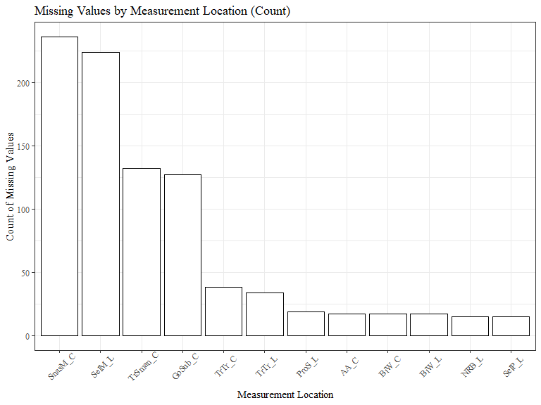

#bar chart with proportions  
ggplot(data=PCA_NAs, aes(x=measure_name, y=measureNAprops))+  
 geom_bar(stat= "identity", color= "black", fill = "white")+  
 theme_bw()+theme(text=element_text(family= "Times New Roman"))+  
 theme(axis.text.x = element_text(angle = 45, vjust=0.7))+  
 labs(title="Missing Values by Measurement Location (Proportion)",  
 y="Proportion of Missing Values",  
 x="Measurement Location")

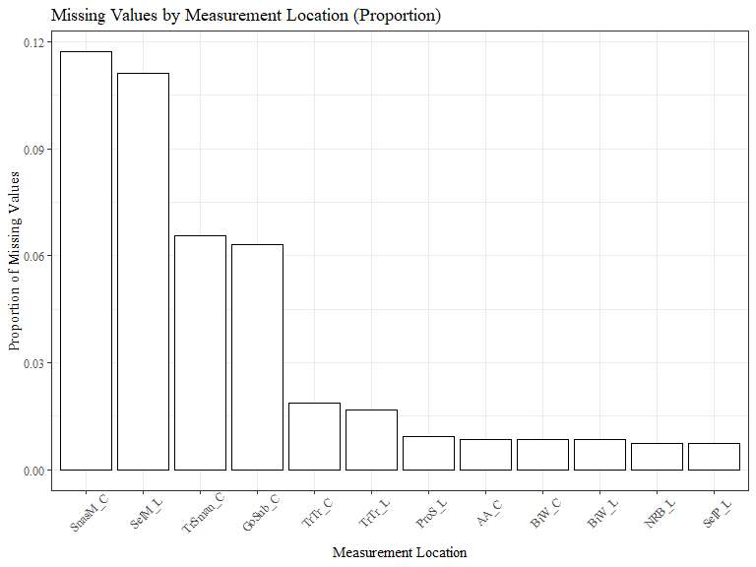

#PCAdata_num <- PCAdata_num %>% drop_na()  
PCAdata_full<-read_excel("C:\\Users\\19177\\OneDrive - Colostate\\Desktop\\Dissertation\\headscan_dissertation\\chosen_nona.xlsx")  
  
  
  
PCAdata_num <- select_if(PCAdata_full, is.numeric)  
  
str(PCAdata_num)

## tibble [1,677 × 12] (S3: tbl_df/tbl/data.frame)  
## $ AA_C : num [1:1677] 65 55 70 58 67 60 59 59 65 65 ...  
## $ BiW_C : num [1:1677] 130 127 143 140 137 130 141 138 143 150 ...  
## $ BiW_L : num [1:1677] 115 108 121 109 104 106 109 111 113 116 ...  
## $ GoSub_C : num [1:1677] 93 93 115 93 103 100 79 106 85 102 ...  
## $ NRB_L : num [1:1677] 17 18 19 21 19 14 17 18 16 17 ...  
## $ ProS_L : num [1:1677] 17 18 14 13 20 20 18 12 24 22 ...  
## $ SelP_L : num [1:1677] 42 41 51 44 47 48 46 41 46 44 ...  
## $ SelM_L : num [1:1677] 122 99 130 115 119 126 117 112 117 117 ...  
## $ SnasM_C : num [1:1677] 82 55 84 74 73 80 78 76 64 75 ...  
## $ TrSman_C: num [1:1677] 177 145 178 147 157 164 149 159 151 160 ...  
## $ TrTr_C : num [1:1677] 296 276 292 273 279 300 283 275 307 286 ...  
## $ TrTr_L : num [1:1677] 155 141 156 149 146 146 147 151 157 144 ...

#https://www.statology.org/principal-components-analysis-in-r/  
  
#calculate principal components  
pca_res <- prcomp(PCAdata_num, scale=TRUE)  
  
#reverse the signs (R calculates eigenvectors in negative direction)  
pca_res$rotation <- -1*pca_res$rotation  
  
#display PCs  
pca_res$rotation

## PC1 PC2 PC3 PC4 PC5 PC6  
## AA_C 0.22610676 -0.3779251 -0.27191984 -0.02721567 0.3556110 -0.12090072  
## BiW_C 0.31862749 0.3092589 -0.14925876 0.35514129 0.2108243 0.24615880  
## BiW_L 0.31985590 0.3603274 0.06247600 0.32013256 0.1828813 0.20770972  
## GoSub_C 0.26391016 -0.3194544 0.39647678 -0.15385828 -0.3479355 0.06760927  
## NRB_L 0.13011314 0.2687254 0.20783339 -0.62739232 0.5704433 -0.29655591  
## ProS_L 0.09639314 -0.4223793 -0.26287412 -0.25265740 0.2689233 0.67499183  
## SelP_L 0.19424050 -0.1133301 -0.63600471 0.01513560 -0.1689219 -0.47381013  
## SelM_L 0.35269639 0.1874002 -0.28461427 -0.32224625 -0.3309942 0.07666820  
## SnasM_C 0.29601013 0.3659376 -0.06456278 -0.29055474 -0.2928247 0.16642690  
## TrSman_C 0.36861199 -0.2192867 0.30097637 -0.06486586 -0.1644443 -0.01555157  
## TrTr_C 0.37142151 -0.1152908 0.15450138 0.18924213 0.1257169 -0.21189804  
## TrTr_L 0.35440086 -0.1891442 0.16203007 0.24699373 0.1008921 -0.17407053  
## PC7 PC8 PC9 PC10 PC11  
## AA_C 0.4862279 -0.58217734 0.019752828 -0.01922694 0.04225697  
## BiW_C -0.2398765 -0.23360217 -0.006951676 0.03215282 -0.62595677  
## BiW_L -0.1748471 -0.12365882 0.016096432 -0.14704919 0.66078776  
## GoSub_C -0.2771165 -0.31614736 0.036009203 -0.57814816 -0.09591045  
## NRB_L -0.2261964 0.02151877 -0.056541435 -0.05598251 -0.04673018  
## ProS_L -0.1716974 0.31391995 0.014048789 -0.02036862 0.10095828  
## SelP_L -0.4443011 0.04196601 -0.007291606 -0.07718999 0.18700636  
## SelM_L 0.1099394 0.14528113 -0.012688564 0.04320080 -0.24290730  
## SnasM_C 0.4378817 -0.02520448 -0.042472041 -0.05004832 0.18605244  
## TrSman_C -0.2119913 -0.15522542 0.005263963 0.78090703 0.10807178  
## TrTr_C 0.1981064 0.43534824 0.695647070 -0.08789820 -0.07075662  
## TrTr_L 0.1805959 0.39385796 -0.713190608 -0.10628978 -0.05385218  
## PC12  
## AA_C 0.11134458  
## BiW_C -0.21065658  
## BiW_L 0.28371343  
## GoSub_C -0.01762083  
## NRB_L -0.02340568  
## ProS_L -0.11225570  
## SelP_L -0.22697521  
## SelM_L 0.66781644  
## SnasM_C -0.58748037  
## TrSman_C -0.05832774  
## TrTr_C -0.05416325  
## TrTr_L -0.01754129

var_explained = pca_res$sdev^2 / sum(pca_res$sdev^2)  
  
var_explained_total <- var_explained

qplot(c(1:12), var_explained) +   
 geom_line() +   
 theme_bw() + theme(text=element_text(family= "Times New Roman"))+  
 xlab("Principal Component") +   
 ylab("Variance Explained (proportion)") +  
 ggtitle("Scree Plot") +  
 ylim(0, 1) +  
 scale_x_discrete(limits=c("PC1","PC2","PC3","PC4","PC5","PC6","PC7","PC8","PC9","PC10","PC11","PC12"))

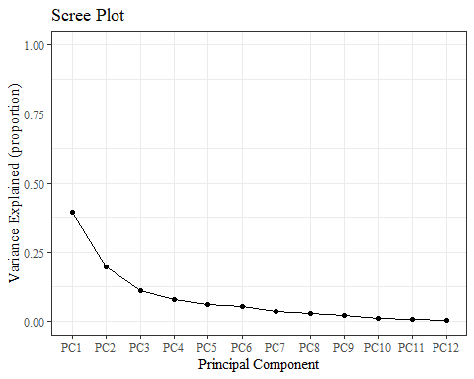

var_explained_data <- data.frame(var_explained)  
  
var_explained_data <- var_explained_data %>%   
 rename(v_e = "var_explained")  
  
  
var_explained_data$vep <- var_explained_data$v_e  
  
var_explained_data <- rownames_to_column(var_explained_data, "PC_num")  
  
var_explained_data$vep <- percent(var_explained_data$vep, accuracy=0.01)  
  
var_explained_data$PC_num <- as.factor(var_explained_data$PC_num)  
  
var_explained_data$PC_num <-   
 recode_factor(var_explained_data$PC_num,   
 '1'= "PC1",  
 '2'= "PC2",  
 '3'= "PC3",  
 '4'= "PC4",  
 '5'= "PC5",  
 '6'= "PC6",  
 '7'= "PC7",  
 '8'= "PC8",  
 '9'= "PC9",  
 '10'= "PC10",  
 '11'= "PC11",  
 '12'= "PC12")

ggplot(data=var_explained_data, aes(x=PC_num, y=v_e, group=1)) +   
 geom_line() +  
 geom_point() +   
 geom_text(aes(label=vep),  
 position= position_dodge(0.9),  
 vjust = -0.5,   
 size = 3)+  
 theme_bw() + theme(text=element_text(family= "Times New Roman"))+  
 theme(axis.text.y=element_blank(),  
 axis.ticks.y=element_blank()   
 )+  
 labs(title="Scree Plot",  
 x="Principal Component",  
 y="Total Variance Explained")

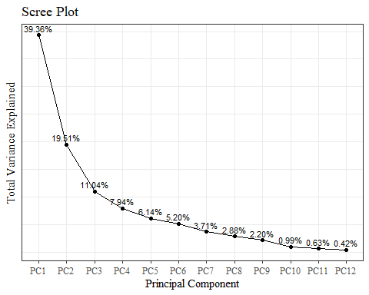

#making plot axis match the ggplot versions in PCA2.Rmd!!!   
#compare to PCAdata_full1 pc1 and pc2 columns (should be same sign, here times 100)  
pca_res$x <- pca_res$x * 100  
pca_res$x[,1] <- pca_res$x[,1] * -1  
#pca_res$x <- pca_res$x[,2] * 100  
  
#pca_res$x

#<https://cran.r-project.org/web/packages/ggfortify/vignettes/plot_pca.html>

autoplot(pca_res, data=PCAdata_full)+  
 geom_hline(yintercept = 0, lty = 2) +  
 geom_vline(xintercept = 0, lty = 2) +  
 theme_bw() + theme(text=element_text(family= "Times New Roman"))+   
 labs(y="PC2 (18.83%)",  
 x="PC1 (38.4%)",  
 title="PCA plot")

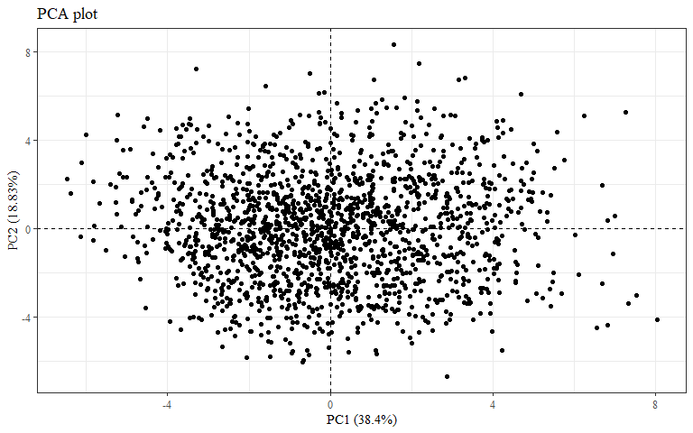

autoplot(pca_res, data=PCAdata_full, colour="race_eth")+  
 geom_hline(yintercept = 0, lty = 2) +  
 geom_vline(xintercept = 0, lty = 2) +  
 theme_bw() + theme(text=element_text(family= "Times New Roman")) +  
 labs(y="PC2 (18.83%)",  
 x="PC1 (38.4%)",  
 title = "All Race/Ethnicities PCA plot",  
 color = "Race/Ethnicity")

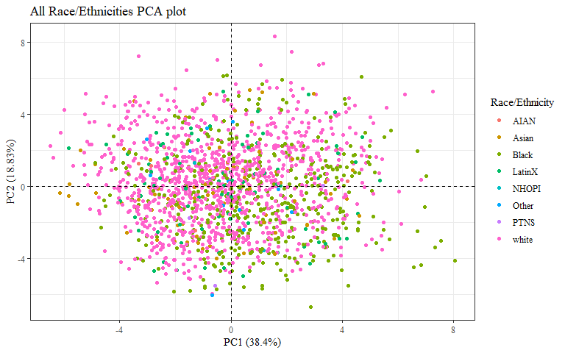

autoplot(pca_res, data=PCAdata_full, colour="race_eth",  
 loadings = TRUE, loadings.colour = 'blue',  
 loadings.label = TRUE, loadings.label.size = 3)+  
 geom_hline(yintercept = 0, lty = 2) +  
 geom_vline(xintercept = 0, lty = 2) +  
 theme_bw() + theme(text=element_text(family= "Times New Roman"))+  
 labs(y="PC2 (18.83%)",  
 x="PC1 (38.4%)",  
 title = "All Race/Ethnicities PCA plot",  
 subtitle = "with factor loadings",  
 color = "Race/Ethnicity")

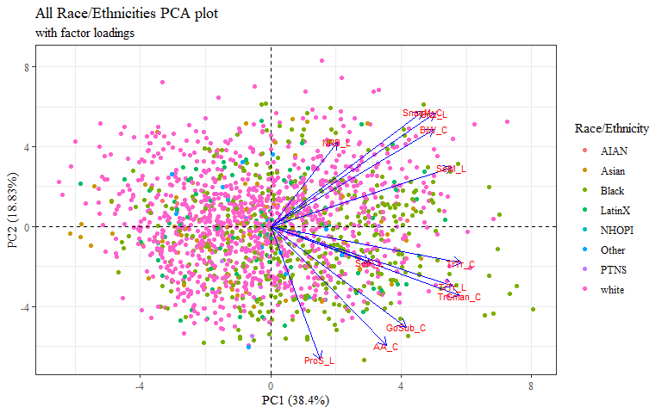 arrows close together=higher correlation

COULD add ellipses (like in PCA2) to this graph with factor loadings.. but cannot add loadings to plot in PCA2 with ellipses

autoplot(pca_res, data=PCAdata_full, colour="gender")+  
 geom_hline(yintercept = 0, lty = 2) +  
 geom_vline(xintercept = 0, lty = 2) +  
 theme_bw() + theme(text=element_text(family= "Times New Roman"))+  
 labs(y="PC2 (18.83%)",  
 x="PC1 (38.4%)",  
 title = "All Genders PCA plot",  
 color = "Gender")

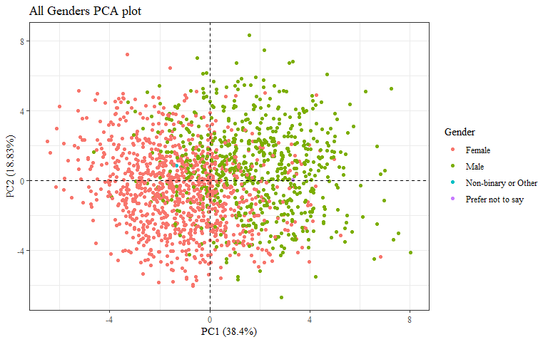

autoplot(pca_res, data=PCAdata_full, colour="gender",  
 loadings = TRUE, loadings.colour = 'blue',  
 loadings.label = TRUE, loadings.label.size = 3)+  
 geom_hline(yintercept = 0, lty = 2) +  
 geom_vline(xintercept = 0, lty = 2) +  
 theme_bw() + theme(text=element_text(family= "Times New Roman"))+  
 labs(y="PC2 (18.83%)",  
 x="PC1 (38.4%)",  
 title = "All Genders PCA plot",  
 subtitle = "with factor loadings",  
 color = "Gender")

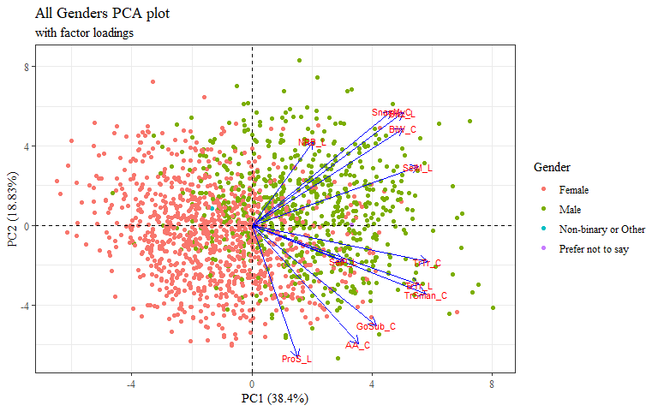

autoplot(pca_res, data=PCAdata_full, colour="age_group")+  
 geom_hline(yintercept = 0, lty = 2) +  
 geom_vline(xintercept = 0, lty = 2) +  
 theme_bw() + theme(text=element_text(family= "Times New Roman"))+  
 labs(y="PC2 (18.83%)",  
 x="PC1 (38.4%)",  
 title = "All Age Groups PCA plot",  
 color = "Age Group")

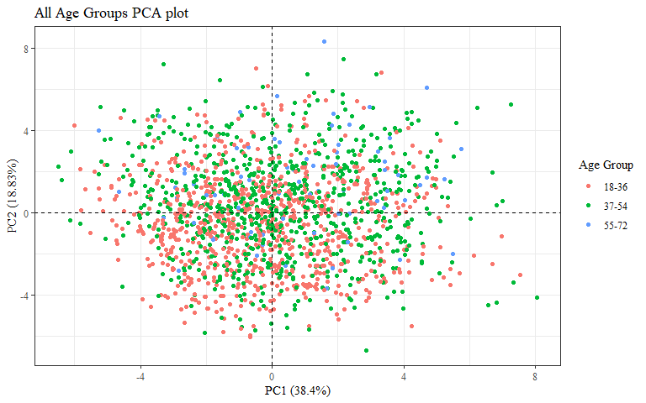

autoplot(pca_res, data=PCAdata_full, colour="age_group",  
 loadings = TRUE, loadings.colour = 'blue',  
 loadings.label = TRUE, loadings.label.size = 3)+  
 geom_hline(yintercept = 0, lty = 2) +  
 geom_vline(xintercept = 0, lty = 2) +  
 theme_bw() + theme(text=element_text(family= "Times New Roman"))+  
 labs(y="PC2 (18.83%)",  
 x="PC1 (38.4%)",  
 title = "All Age Groups PCA plot",  
 subtitle = "with factor loadings",  
 color = "Age Group")

