exploring-emmeans

2022-09-21

library(tidyverse)

## ── Attaching packages ─────────────────────────────────────── tidyverse 1.3.2 ──  
## ✔ ggplot2 3.3.6 ✔ purrr 0.3.4  
## ✔ tibble 3.1.8 ✔ dplyr 1.0.9  
## ✔ tidyr 1.2.0 ✔ stringr 1.4.0  
## ✔ readr 2.1.2 ✔ forcats 0.5.1  
## ── Conflicts ────────────────────────────────────────── tidyverse_conflicts() ──  
## ✖ dplyr::filter() masks stats::filter()  
## ✖ dplyr::lag() masks stats::lag()

library(readxl)  
library(flextable)

##   
## Attaching package: 'flextable'  
##   
## The following object is masked from 'package:purrr':  
##   
## compose

library(extrafont)

## Registering fonts with R

library(scales)

##   
## Attaching package: 'scales'  
##   
## The following object is masked from 'package:purrr':  
##   
## discard  
##   
## The following object is masked from 'package:readr':  
##   
## col_factor

#times new roman tables  
my_ft_theme <- function(ft, ...) {  
 # Remove vertical cell padding  
 ft <- padding(ft, padding.top = 0, padding.bottom = 0, part = "all")  
   
 # Change font to TNR 11  
 ft <- font(ft, fontname = "Times New Roman", part = "all")  
 ft <- fontsize(ft, part = "all", size = 12)  
 ft  
}

gender_means_data <- read_excel("C:\\Users\\19177\\OneDrive - Colostate\\Desktop\\Dissertation\\headscan_dissertation\\gender_means_data.xlsx")  
  
race_means_data <- read_excel("C:\\Users\\19177\\OneDrive - Colostate\\Desktop\\Dissertation\\headscan_dissertation\\race_means_data.xlsx")  
  
age_means_data <- read_excel("C:\\Users\\19177\\OneDrive - Colostate\\Desktop\\Dissertation\\headscan_dissertation\\age_means_data.xlsx")  
  
  
gender_est_data <- read_excel("C:\\Users\\19177\\OneDrive - Colostate\\Desktop\\Dissertation\\headscan_dissertation\\gender_est_data.xlsx")  
  
race_est_data <- read_excel("C:\\Users\\19177\\OneDrive - Colostate\\Desktop\\Dissertation\\headscan_dissertation\\race_est_data.xlsx")  
  
age_est_data <- read_excel("C:\\Users\\19177\\OneDrive - Colostate\\Desktop\\Dissertation\\headscan_dissertation\\age_est_data.xlsx")

chosen_nona1 <- read_excel("C:\\Users\\19177\\OneDrive - Colostate\\Desktop\\Dissertation\\headscan_dissertation\\chosen_nona1.xlsx")

chosennona1_num <- select_if(chosen_nona1, is.numeric)

measure_means <- colMeans(chosennona1_num)  
measure_means <- as.data.frame(measure_means)  
measure_means <- rownames_to_column(measure_means)  
  
measure_means <- measure_means %>%   
 rename(measure=rowname)

GENDER

gender_means_data$measure <- fct_reorder(gender_means_data$measure, gender_means_data$emmean, .desc=FALSE)  
  
gender_means_data %>%   
 ggplot(aes(x=gender, y=emmean, fill=measure))+  
 geom_bar(position=position_dodge(), stat="identity")+  
 geom_errorbar(aes(ymin=lower.CL, ymax=upper.CL), width=0.2, position=position_dodge(0.9))+  
 theme(axis.text.x = element_text(angle = 45, vjust=0.7))+  
 theme_bw()+theme(text=element_text(family= "Times New Roman"))+  
 labs(title="Estimated Marginal Means",  
 subtitle= "All Genders in MANOVA",  
 y="Emmean in mm",  
 x="Gender",  
 fill="Measurement")

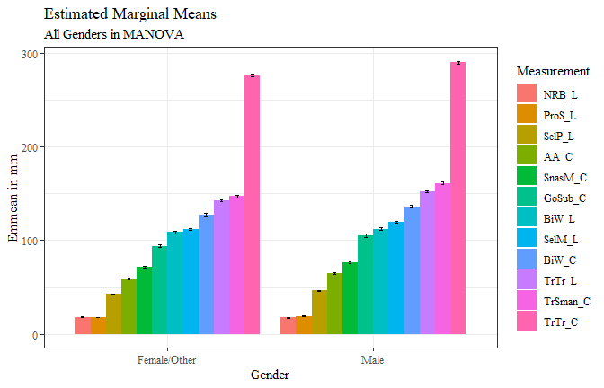

gender_means_data %>%   
 ggplot(aes(x=measure, y=emmean, fill=gender))+  
 geom_bar(position=position_dodge(), stat="identity")+  
 geom_errorbar(aes(ymin=lower.CL, ymax=upper.CL), width=0.2, position=position_dodge(0.9))+  
 theme_bw()+  
 theme(axis.text.x = element_text(angle = 45, vjust=0.7))+  
 theme(text=element_text(family= "Times New Roman"))+  
 labs(title="Estimated Marginal Means",  
 subtitle= "All Genders in MANOVA",  
 y="Emmean in mm",  
 x="Measurement",  
 fill="Gender")

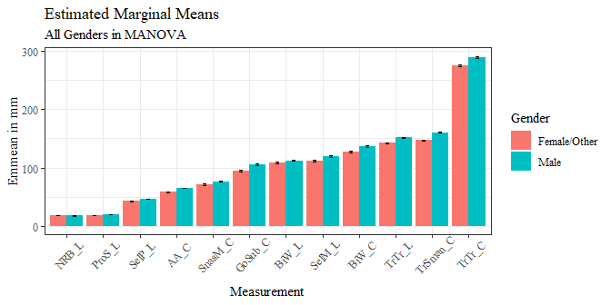

gender_means_data1 <- gender_means_data %>%   
 filter(gender != "Other")  
  
gender_means_data1$measure <- fct_reorder(gender_means_data1$measure, gender_means_data1$emmean, .desc=FALSE)  
  
gender_means_data1 %>%   
 ggplot(aes(x=measure, y=emmean, fill=gender))+  
 geom_bar(position=position_dodge(), stat="identity")+  
 geom_errorbar(aes(ymin=lower.CL, ymax=upper.CL), width=0.2, position=position_dodge(0.9))+  
 theme_bw()+  
 theme(axis.text.x = element_text(angle = 45, vjust=0.7))+  
 theme(text=element_text(family= "Times New Roman"))+  
 labs(title="Estimated Marginal Means",  
 subtitle= "Two primary genders",  
 y="Emmean in mm",  
 x="Measurement",  
 fill="Gender")

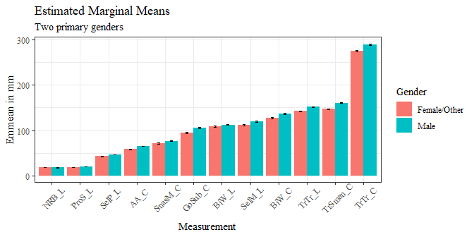

sig_gender_est <- gender_est_data %>%   
 filter(signif=="TRUE")  
  
sig_gender_est <- sig_gender_est %>%   
 mutate(across(where(is.numeric), round, digits=3))

sig_gender_est$measure <- fct_reorder(sig_gender_est$measure, sig_gender_est$estimate, .desc=FALSE)  
  
sig_gender_est %>%   
 ggplot(aes(x=estimate, y= measure, fill=contrast))+  
 geom_bar(position=position_dodge(), stat="identity")+  
 theme_bw()+theme(text=element_text(family= "Times New Roman"))+  
 labs(title="Gender Significant Differences in Estimated Marginal Means",  
 subtitle= "Tukey significance level 0.05",  
 y="Measurement Location",  
 x="Difference in mm")

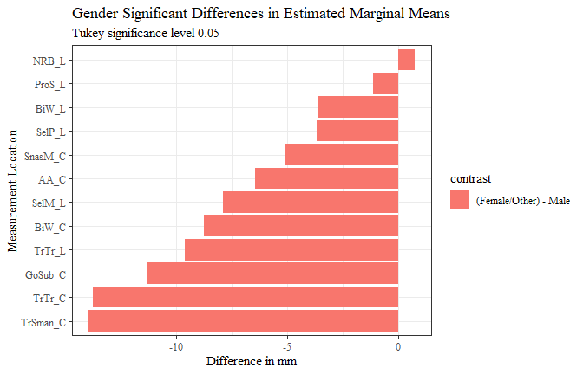

g_f_minus_m <- sig_gender_est %>%   
 filter(contrast == "(Female/Other) - Male")

g_f_minus_m <- full_join(g_f_minus_m, measure_means, by="measure")

g_f_minus_m$prop_diff <- (g_f_minus_m$estimate/g_f_minus_m$measure_means)  
  
g_f_minus_m <- g_f_minus_m %>%   
 mutate(across(where(is.numeric), round, digits=3))  
  
g_f_minus_m$percent_diff <- percent(g_f_minus_m$prop_diff)

g_f_minus_m$measure <- fct_reorder(g_f_minus_m$measure, g_f_minus_m$estimate, .desc=FALSE)  
  
g_f_minus_m %>%   
 ggplot(aes(x=estimate, y= measure, label=estimate))+  
 geom_bar(stat="identity", color= "black", fill = "white")+  
 geom_text(hjust=-0.2, position = position_dodge(.9), size = 3, family= "Times New Roman")+  
 scale_x_continuous(expand = expansion(mult = 0.1))+  
 theme_bw()+theme(text=element_text(family= "Times New Roman"))+  
 labs(title="Female/Other - Male Significant Differences in Estimated Marginal Means",  
 subtitle= "Tukey significance level 0.05",  
 y="Measurement Location",  
 x="Difference in mm")

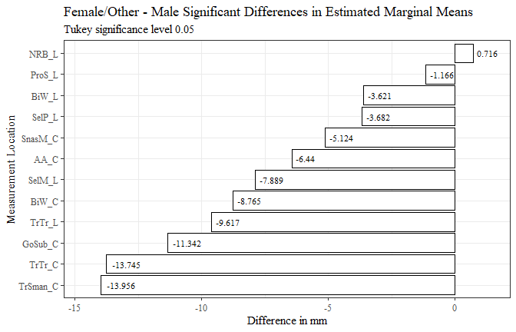

g_f_minus_m$measure <- fct_reorder(g_f_minus_m$measure, g_f_minus_m$prop_diff, .desc=FALSE)  
  
g_f_minus_m %>%   
 ggplot(aes(x=prop_diff, y= measure, label=percent_diff))+  
 geom_bar(stat="identity", color= "black", fill = "white")+  
 geom_text(hjust=-0.15, position = position_dodge(.9), size = 3, family= "Times New Roman")+  
 scale_x_continuous(labels = scales::percent,  
 expand = expansion(mult = 0.1))+  
 theme_bw()+theme(text=element_text(family= "Times New Roman"))+  
 labs(title="Female/Other - Male Significant Differences in Estimated Marginal Means",  
 subtitle= "Tukey significance level 0.05",  
 y="Measurement Location",  
 x="Percent Difference from Total Measurement Mean")

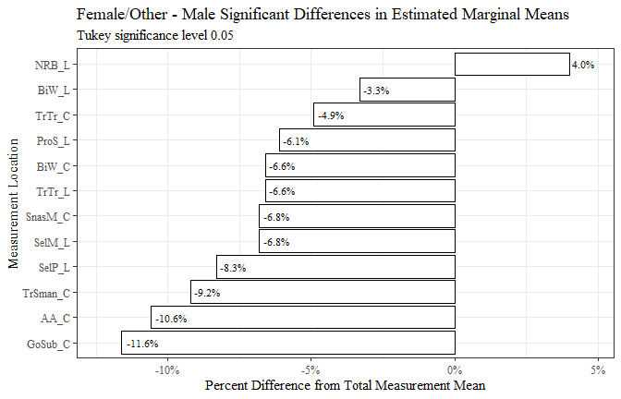

g_f_minus_m <- g_f_minus_m[c(8, 2, 6, 9, 10)]  
  
flextable(g_f_minus_m) %>%  
 my_ft_theme()%>%   
 bold(part = "header") %>%   
 set_caption("Female/Other - Male Significant Differences in Estimated Marginal Means") %>%   
 fit_to_width(7.5) %>%   
 autofit()

**Table** : Female/Other - Male Significant Differences in Estimated Marginal Means

| **measure** | **estimate** | **p.value** | **measure_means** | **prop_diff** |
| --- | --- | --- | --- | --- |
| AA_C | -6.440 | 1.6174e-114 | 60.894 | -0.106 |
| BiW_L | -3.621 | 6.9475e-15 | 110.519 | -0.033 |
| BiW_C | -8.765 | 3.6202e-46 | 132.450 | -0.066 |
| GoSub_C | -11.342 | 1.2457e-64 | 97.873 | -0.116 |
| NRB_L | 0.716 | 1.7239e-03 | 17.857 | 0.040 |
| ProS_L | -1.166 | 1.9456e-22 | 19.094 | -0.061 |
| SelP_L | -3.682 | 3.4570e-75 | 44.327 | -0.083 |
| SelM_L | -7.889 | 4.8857e-73 | 116.259 | -0.068 |
| SnasM_C | -5.124 | 2.0944e-26 | 74.956 | -0.068 |
| TrSman_C | -13.956 | 1.5461e-119 | 152.212 | -0.092 |
| TrTr_C | -13.745 | 2.0182e-105 | 281.198 | -0.049 |
| TrTr_L | -9.617 | 2.1351e-185 | 145.681 | -0.066 |

g_m_minus_f <- g_f_minus_m  
  
g_m_minus_f$estimate <- g_m_minus_f$estimate*(-1)  
g_m_minus_f$prop_diff <- g_m_minus_f$prop_diff*(-1)  
  
g_m_minus_f$percent_diff <- percent(g_m_minus_f$prop_diff)  
  
#g_m_minus_f$contrastx <- "Male - Female/Other"  
  
g_m_minus_f$measure <- fct_reorder(g_m_minus_f$measure, g_m_minus_f$estimate, .desc=TRUE)  
  
g_m_minus_f %>%   
 ggplot(aes(x=estimate, y= measure, label=estimate))+  
 geom_bar(stat="identity", color= "black", fill = "white")+  
 geom_text(hjust=1.1, position = position_dodge(.9), size = 3, family= "Times New Roman")+  
 scale_x_continuous(expand = expansion(mult = 0.1))+  
 theme_bw()+theme(text=element_text(family= "Times New Roman"))+  
 labs(title="Male - Female/Other Significant Differences in Estimated Marginal Means",  
 subtitle= "Tukey significance level 0.05",  
 y="Measurement Location",  
 x="Difference in mm")

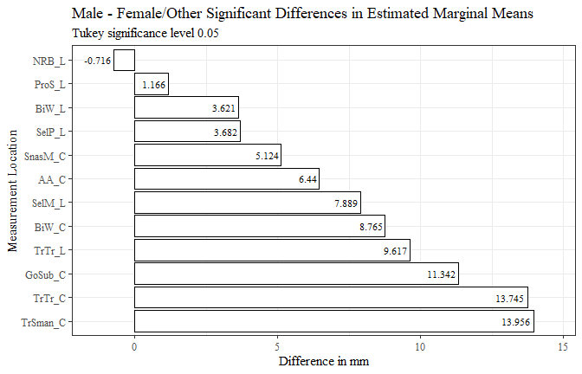

g_m_minus_f$measure <- fct_reorder(g_m_minus_f$measure, g_m_minus_f$prop_diff, .desc=TRUE)  
  
g_m_minus_f %>%   
 ggplot(aes(x=prop_diff, y= measure, label=percent_diff))+  
 geom_bar(stat="identity", color= "black", fill = "white")+  
 geom_text(hjust=1.1, position = position_dodge(.9), size = 3, family= "Times New Roman")+  
 scale_x_continuous(labels = scales::percent,  
 expand = expansion(mult = 0.1))+  
 theme_bw()+theme(text=element_text(family= "Times New Roman"))+  
 labs(title="Male - Female/Other Significant Differences in Estimated Marginal Means",  
 subtitle= "Tukey significance level 0.05",  
 y="Measurement Location",  
 x="Percent Difference from Total Measurement Mean")

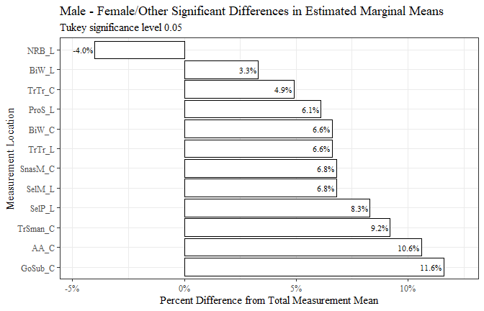

g_m_minus_f <- g_m_minus_f[-c(6)]  
  
flextable(g_m_minus_f) %>%  
 my_ft_theme()%>%   
 bold(part = "header") %>%   
 set_caption("Male - Female/Other Significant Differences in Estimated Marginal Means") %>%   
 fit_to_width(7.5) %>%   
 autofit()

**Table** : Male - Female/Other Significant Differences in Estimated Marginal Means

| **measure** | **estimate** | **p.value** | **measure_means** | **prop_diff** |
| --- | --- | --- | --- | --- |
| AA_C | 6.440 | 1.6174e-114 | 60.894 | 0.106 |
| BiW_L | 3.621 | 6.9475e-15 | 110.519 | 0.033 |
| BiW_C | 8.765 | 3.6202e-46 | 132.450 | 0.066 |
| GoSub_C | 11.342 | 1.2457e-64 | 97.873 | 0.116 |
| NRB_L | -0.716 | 1.7239e-03 | 17.857 | -0.040 |
| ProS_L | 1.166 | 1.9456e-22 | 19.094 | 0.061 |
| SelP_L | 3.682 | 3.4570e-75 | 44.327 | 0.083 |
| SelM_L | 7.889 | 4.8857e-73 | 116.259 | 0.068 |
| SnasM_C | 5.124 | 2.0944e-26 | 74.956 | 0.068 |
| TrSman_C | 13.956 | 1.5461e-119 | 152.212 | 0.092 |
| TrTr_C | 13.745 | 2.0182e-105 | 281.198 | 0.049 |
| TrTr_L | 9.617 | 2.1351e-185 | 145.681 | 0.066 |

AGE

age_means_data$measure <- fct_reorder(age_means_data$measure, age_means_data$emmean, .desc=FALSE)  
  
age_means_data %>%   
 ggplot(aes(x=age_group, y=emmean, fill=measure))+  
 geom_bar(position=position_dodge(), stat="identity")+  
 geom_errorbar(aes(ymin=lower.CL, ymax=upper.CL), width=0.2, position=position_dodge(0.9))+  
 theme(axis.text.x = element_text(angle = 45, vjust=0.7))+  
 theme_bw()+theme(text=element_text(family= "Times New Roman"))+  
 labs(title="Estimated Marginal Means",  
 subtitle= "All ages in MANOVA",  
 y="Emmean in mm",  
 x="Age",  
 fill="Measurement")

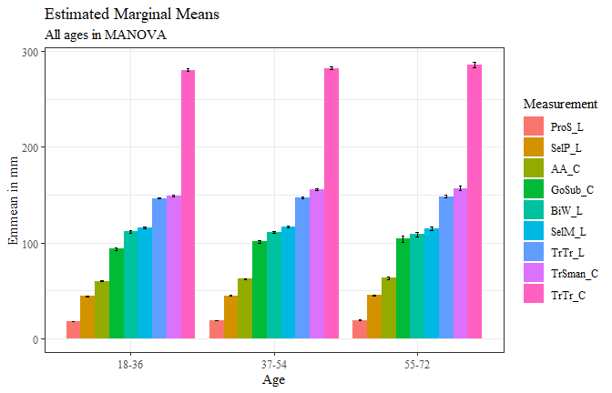

#age_means_data$measure <- fct_reorder(age_means_data$measure, age_means_data$emmean, .desc=FALSE)  
  
age_means_data %>%   
 ggplot(aes(x=measure, y=emmean, fill=age_group))+  
 geom_bar(position=position_dodge(), stat="identity")+  
 geom_errorbar(aes(ymin=lower.CL, ymax=upper.CL), width=0.2, position=position_dodge(0.9))+  
 theme(axis.text.x = element_text(angle = 45, vjust=0.7))+  
 theme_bw()+theme(text=element_text(family= "Times New Roman"))+  
 labs(title="Estimated Marginal Means",  
 subtitle= "All ages in MANOVA",  
 y="Emmean in mm",  
 x="Measurement",  
 fill="Age")

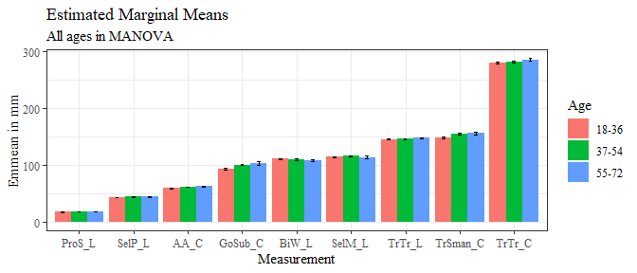

sig_age_est <- age_est_data %>%   
 filter(signif=="TRUE")  
  
sig_age_est <- sig_age_est %>%   
 mutate(across(where(is.numeric), round, digits=3))

sig_age_est$measure <- fct_reorder(sig_age_est$measure, sig_age_est$estimate, .desc=FALSE)  
  
sig_age_est %>%   
 ggplot(aes(x=estimate, y= measure, fill=contrast))+  
 geom_bar(position=position_dodge(), stat="identity")+  
 theme_bw()+theme(text=element_text(family= "Times New Roman"))+  
 labs(title="Age Significant Differences in Estimated Marginal Means",  
 subtitle= "Tukey significance level 0.05",  
 y="Measurement Location",  
 x="Difference in mm")

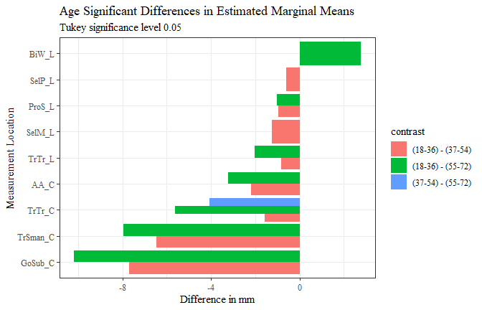

age_est_data1 <- full_join(sig_age_est, measure_means, by="measure")  
  
age_est_data1$prop_diff <- (age_est_data1$estimate/age_est_data1$measure_means)  
  
age_est_data1 <- age_est_data1 %>%   
 mutate(across(where(is.numeric), round, digits=3))  
  
age_est_data1$percent_diff <- percent(age_est_data1$prop_diff)  
  
age_est_data1 <- drop_na(age_est_data1)  
  
age_est_data1$measure <- fct_reorder(age_est_data1$measure, age_est_data1$prop_diff, .desc=FALSE)  
  
age_est_data1 %>%   
 ggplot(aes(x=prop_diff, y= measure, fill=contrast))+  
 geom_bar(stat="identity", position="dodge")+  
 theme_bw()+theme(text=element_text(family= "Times New Roman"))+  
 labs(title="Age-Related Significant Differences in Estimated Marginal Means",  
 subtitle= "Tukey significance level 0.05",  
 y="Measurement Location",  
 x="Percent Difference from Total Measurement Mean")

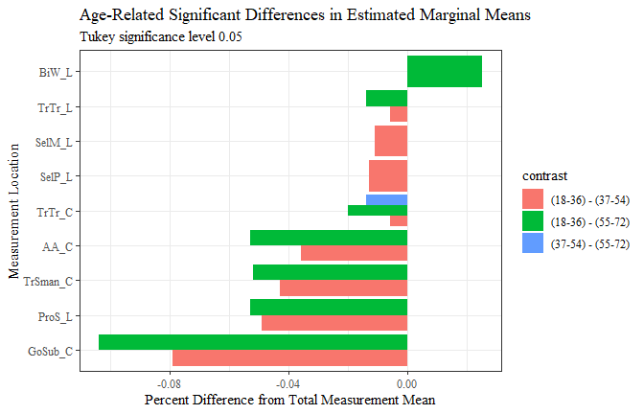

y_v_m <- age_est_data1 %>%   
 filter(contrast == "(18-36) - (37-54)")  
  
y_v_m <- y_v_m %>%   
 mutate(across(where(is.numeric), round, digits=3))  
  
y_v_m$measure <- fct_reorder(y_v_m$measure, y_v_m$estimate, .desc=FALSE)  
  
y_v_m %>%   
 ggplot(aes(x=estimate, y= measure, label=estimate))+  
 geom_bar(stat="identity", color= "black", fill = "white")+  
 geom_text(hjust=-0.1, position = position_dodge(.9), size = 3, family= "Times New Roman")+  
 scale_x_continuous(expand = expansion(mult = 0.1))+  
 theme_bw()+theme(text=element_text(family= "Times New Roman"))+  
 labs(title="(18-36) - (37-54) Significant Differences in Estimated Marginal Means",  
 subtitle= "Tukey significance level 0.05",  
 y="Measurement Location",  
 x="Difference in mm")

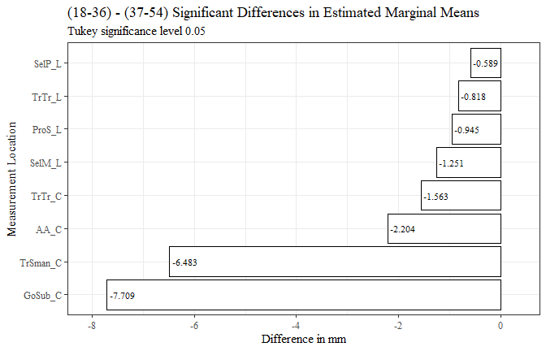

y_v_m$measure <- fct_reorder(y_v_m$measure, y_v_m$prop_diff, .desc=FALSE)  
  
y_v_m %>%   
 ggplot(aes(x=prop_diff, y= measure, label=percent_diff))+  
 geom_bar(stat="identity", color= "black", fill = "white")+  
 geom_text(hjust=-0.1, position = position_dodge(.9), size = 2.7, family= "Times New Roman")+  
 scale_x_continuous(labels = scales::percent,  
 expand = expansion(mult = 0.1))+  
 theme_bw()+theme(text=element_text(family= "Times New Roman"))+  
 labs(title="(18-36) - (37-54) Significant Differences in Estimated Marginal Means",  
 subtitle= "Tukey significance level 0.05",  
 y="Measurement Location",  
 x="Percent Difference from Total Measurement Mean")

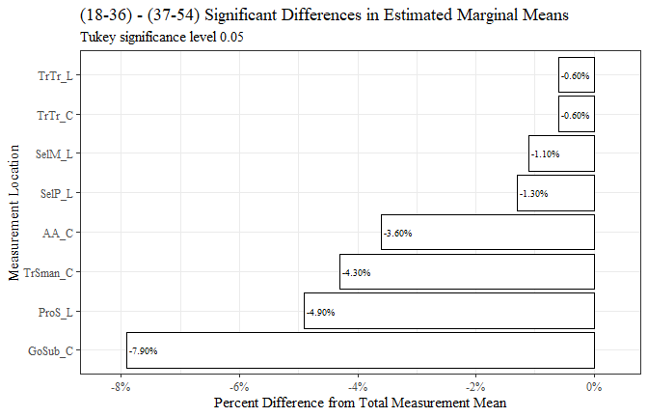

y_v_m <- y_v_m[c(8, 2, 6, 9, 10)]  
  
  
  
  
flextable(y_v_m) %>%  
 my_ft_theme()%>%   
 bold(part = "header") %>%   
 set_caption("(18-36) - (37-54) Significant Differences in Estimated Marginal Means") %>%   
 fit_to_width(7.5) %>%   
 autofit()

**Table** : (18-36) - (37-54) Significant Differences in Estimated Marginal Means

| **measure** | **estimate** | **p.value** | **measure_means** | **prop_diff** |
| --- | --- | --- | --- | --- |
| AA_C | -2.204 | 1.6358e-12 | 60.894 | -0.036 |
| GoSub_C | -7.709 | 1.6044e-12 | 97.873 | -0.079 |
| ProS_L | -0.945 | 1.6505e-12 | 19.094 | -0.049 |
| SelP_L | -0.589 | 6.1003e-03 | 44.327 | -0.013 |
| SelM_L | -1.251 | 7.7968e-03 | 116.259 | -0.011 |
| TrSman_C | -6.483 | 1.6046e-12 | 152.212 | -0.043 |
| TrTr_C | -1.563 | 2.1890e-02 | 281.198 | -0.006 |
| TrTr_L | -0.818 | 1.4161e-02 | 145.681 | -0.006 |

m_v_y <- y_v_m  
  
m_v_y$estimate <- m_v_y$estimate*(-1)  
m_v_y$prop_diff <- m_v_y$prop_diff*(-1)  
m_v_y$percent_diff <- percent(m_v_y$prop_diff)  
  
#m_v_y$contrastx <- "(37-54) - (18-36)"  
  
  
m_v_y$measure <- fct_reorder(m_v_y$measure, m_v_y$estimate, .desc=TRUE)  
  
m_v_y %>%   
 ggplot(aes(x=estimate, y= measure, label=estimate))+  
 geom_bar(stat="identity", color= "black", fill = "white")+  
 geom_text(hjust=1.1, position = position_dodge(.9), size = 3, family= "Times New Roman")+  
 scale_x_continuous(expand = expansion(mult = 0.1))+  
 theme_bw()+theme(text=element_text(family= "Times New Roman"))+  
 labs(title="(37-54) - (18-36) Significant Differences in Estimated Marginal Means",  
 subtitle= "Tukey significance level 0.05",  
 y="Measurement Location",  
 x="Difference in mm")

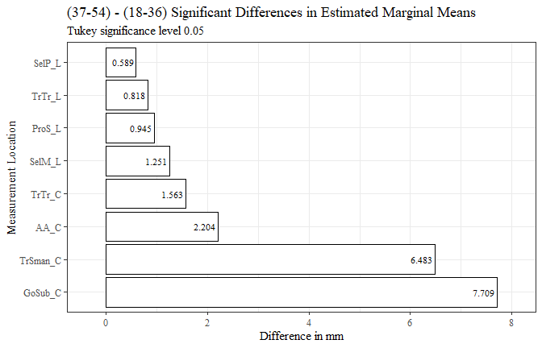

m_v_y$measure <- fct_reorder(m_v_y$measure, m_v_y$prop_diff, .desc=TRUE)  
  
m_v_y %>%   
 ggplot(aes(x=prop_diff, y= measure, label=percent_diff))+  
 geom_bar(stat="identity", color= "black", fill = "white")+  
 geom_text(hjust=1.2, position = position_dodge(.9), size = 3, family= "Times New Roman")+  
 scale_x_continuous(labels = scales::percent,  
 expand = expansion(mult = 0.1))+  
 theme_bw()+theme(text=element_text(family= "Times New Roman"))+  
 labs(title="(37-54) - (18-36) Significant Differences in Estimated Marginal Means",  
 subtitle= "Tukey significance level 0.05",  
 y="Measurement Location",  
 x="Percent Difference from Total Measurement Mean")

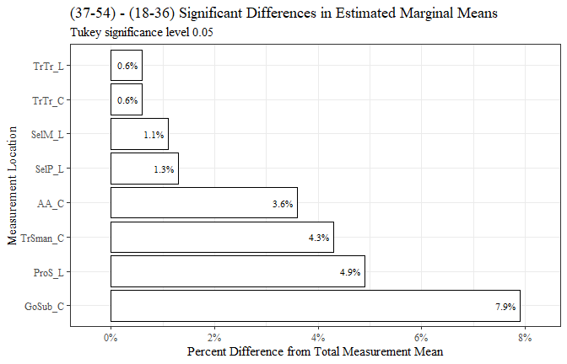

m_v_y <- m_v_y[-c(6)]  
  
flextable(m_v_y) %>%  
 my_ft_theme()%>%   
 bold(part = "header") %>%   
 set_caption("(37-54) - (18-36) Significant Differences in Estimated Marginal Means") %>%   
 fit_to_width(7.5) %>%   
 autofit()

**Table** : (37-54) - (18-36) Significant Differences in Estimated Marginal Means

| **measure** | **estimate** | **p.value** | **measure_means** | **prop_diff** |
| --- | --- | --- | --- | --- |
| AA_C | 2.204 | 1.6358e-12 | 60.894 | 0.036 |
| GoSub_C | 7.709 | 1.6044e-12 | 97.873 | 0.079 |
| ProS_L | 0.945 | 1.6505e-12 | 19.094 | 0.049 |
| SelP_L | 0.589 | 6.1003e-03 | 44.327 | 0.013 |
| SelM_L | 1.251 | 7.7968e-03 | 116.259 | 0.011 |
| TrSman_C | 6.483 | 1.6046e-12 | 152.212 | 0.043 |
| TrTr_C | 1.563 | 2.1890e-02 | 281.198 | 0.006 |
| TrTr_L | 0.818 | 1.4161e-02 | 145.681 | 0.006 |

y_v_o <- age_est_data1 %>%   
 filter(contrast == "(18-36) - (55-72)")  
  
  
  
y_v_o$measure <- fct_reorder(y_v_o$measure, y_v_o$estimate, .desc=FALSE)  
  
y_v_o %>%   
 ggplot(aes(x=estimate, y= measure, label=estimate))+  
 geom_bar(stat="identity", color= "black", fill = "white")+  
 geom_text(hjust=-0.15, position = position_dodge(.9), size = 3, family= "Times New Roman")+  
 scale_x_continuous(expand = expansion(mult = 0.1))+  
 theme_bw()+theme(text=element_text(family= "Times New Roman"))+  
 labs(title="(18-36) - (55-72) Significant Differences in Estimated Marginal Means",  
 subtitle= "Tukey significance level 0.05",  
 y="Measurement Location",  
 x="Difference in mm")

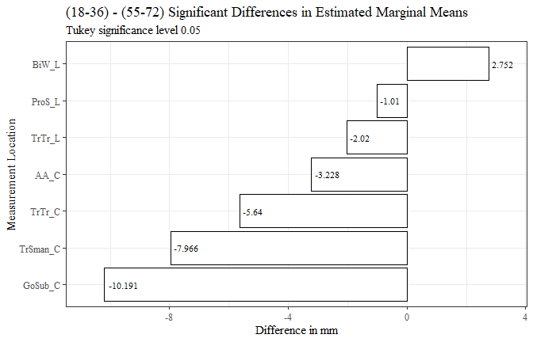

y_v_o$measure <- fct_reorder(y_v_o$measure, y_v_o$prop_diff, .desc=FALSE)  
  
y_v_o %>%   
 ggplot(aes(x=prop_diff, y= measure, label=percent_diff))+  
 geom_bar(stat="identity", color= "black", fill = "white")+  
 geom_text(hjust=-0.15, position = position_dodge(.9), size = 3, family= "Times New Roman")+  
 scale_x_continuous(labels = scales::percent,  
 expand = expansion(mult = 0.1))+  
 theme_bw()+theme(text=element_text(family= "Times New Roman"))+  
 labs(title="(18-36) - (55-72) Significant Differences in Estimated Marginal Means",  
 subtitle= "Tukey significance level 0.05",  
 y="Measurement Location",  
 x="Percent Difference from Total Measurement Mean")

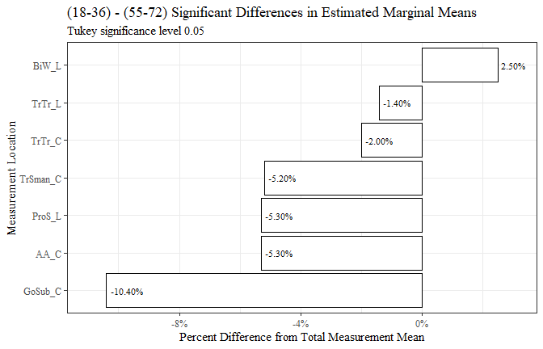

y_v_o <- y_v_o[c(8, 2, 6, 9, 10)]  
  
y_v_o <- y_v_o %>%   
 mutate(across(where(is.numeric), round, digits=3))  
  
flextable(y_v_o) %>%  
 my_ft_theme()%>%   
 bold(part = "header") %>%   
 set_caption("(18-36) - (55-72) Significant Differences in Estimated Marginal Means") %>%   
 fit_to_width(7.5) %>%   
 autofit()

**Table** : (18-36) - (55-72) Significant Differences in Estimated Marginal Means

| **measure** | **estimate** | **p.value** | **measure_means** | **prop_diff** |
| --- | --- | --- | --- | --- |
| AA_C | -3.228 | 1.2876e-06 | 60.894 | -0.053 |
| BiW_L | 2.752 | 3.7701e-02 | 110.519 | 0.025 |
| GoSub_C | -10.191 | 2.2804e-10 | 97.873 | -0.104 |
| ProS_L | -1.010 | 1.2805e-03 | 19.094 | -0.053 |
| TrSman_C | -7.966 | 1.1100e-08 | 152.212 | -0.052 |
| TrTr_C | -5.640 | 2.3296e-04 | 281.198 | -0.020 |
| TrTr_L | -2.020 | 1.1912e-02 | 145.681 | -0.014 |

o_v_y <- y_v_o  
  
o_v_y$estimate <- o_v_y$estimate*(-1)  
o_v_y$prop_diff <- o_v_y$prop_diff*(-1)  
  
o_v_y$percent_diff <- percent(o_v_y$prop_diff)  
  
#o_v_y$contrastx <- "(55-72) - (18-36)"  
  
  
  
o_v_y$measure <- fct_reorder(o_v_y$measure, o_v_y$estimate, .desc=TRUE)  
  
o_v_y %>%   
 ggplot(aes(x=estimate, y= measure, label=estimate))+  
 geom_bar(stat="identity", color= "black", fill = "white")+  
 geom_text(hjust=1.1, position = position_dodge(.9), size = 3, family= "Times New Roman")+  
 scale_x_continuous(expand = expansion(mult = 0.1))+  
 theme_bw()+theme(text=element_text(family= "Times New Roman"))+  
 labs(title="(55-72) - (18-36) Significant Differences in Estimated Marginal Means",  
 subtitle= "Tukey significance level 0.05",  
 y="Measurement Location",  
 x="Difference in mm")

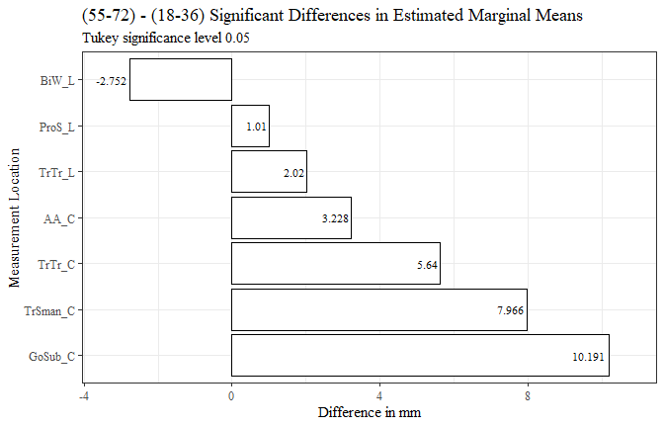

o_v_y$measure <- fct_reorder(o_v_y$measure, o_v_y$prop_diff, .desc=TRUE)  
  
o_v_y %>%   
 ggplot(aes(x=prop_diff, y= measure, label=percent_diff))+  
 geom_bar(stat="identity", color= "black", fill = "white")+  
 geom_text(hjust=1.1, position = position_dodge(.9), size = 3, family= "Times New Roman")+  
 scale_x_continuous(labels = scales::percent,  
 expand = expansion(mult = 0.1))+  
 theme_bw()+theme(text=element_text(family= "Times New Roman"))+  
 labs(title="(55-72) - (18-36) Significant Differences in Estimated Marginal Means",  
 subtitle= "Tukey significance level 0.05",  
 y="Measurement Location",  
 x="Percent Difference from Total Measurement Mean")

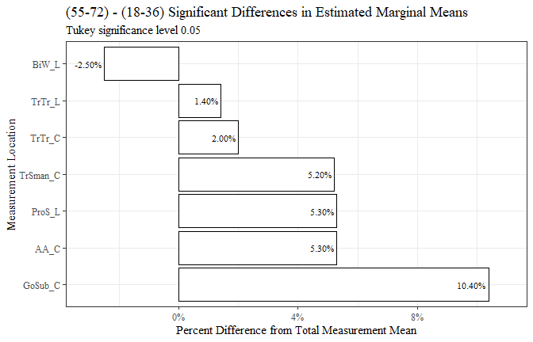

o_v_y <- o_v_y[-c(6)]  
  
flextable(o_v_y) %>%  
 my_ft_theme()%>%   
 bold(part = "header") %>%   
 set_caption("(55-72) - (18-36) Significant Differences in Estimated Marginal Means") %>%   
 fit_to_width(7.5) %>%   
 autofit()

**Table** : (55-72) - (18-36) Significant Differences in Estimated Marginal Means

| **measure** | **estimate** | **p.value** | **measure_means** | **prop_diff** |
| --- | --- | --- | --- | --- |
| AA_C | 3.228 | 1.2876e-06 | 60.894 | 0.053 |
| BiW_L | -2.752 | 3.7701e-02 | 110.519 | -0.025 |
| GoSub_C | 10.191 | 2.2804e-10 | 97.873 | 0.104 |
| ProS_L | 1.010 | 1.2805e-03 | 19.094 | 0.053 |
| TrSman_C | 7.966 | 1.1100e-08 | 152.212 | 0.052 |
| TrTr_C | 5.640 | 2.3296e-04 | 281.198 | 0.020 |
| TrTr_L | 2.020 | 1.1912e-02 | 145.681 | 0.014 |

m_v_o <- age_est_data1 %>%   
 filter(contrast == "(37-54) - (55-72)")  
  
  
m_v_o$measure <- fct_reorder(m_v_o$measure, m_v_o$estimate, .desc=FALSE)  
  
m_v_o %>%   
 ggplot(aes(x=estimate, y= measure))+  
 geom_bar(stat="identity", color= "black", fill = "white")+  
 theme_bw()+theme(text=element_text(family= "Times New Roman"))+  
 labs(title="(37-54) - (55-72) Significant Differences in Estimated Marginal Means",  
 subtitle= "Tukey significance level 0.05",  
 y="Measurement Location",  
 x="Difference in mm")

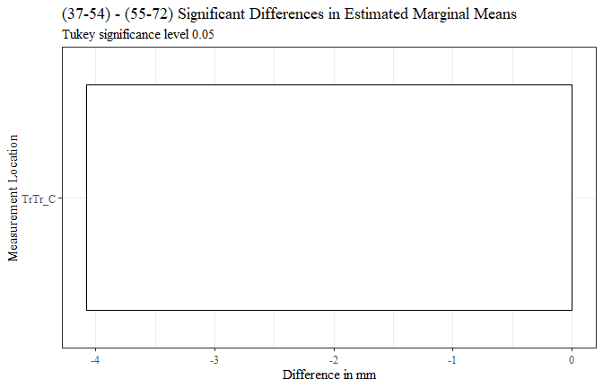

m_v_o$measure <- fct_reorder(m_v_o$measure, m_v_o$prop_diff, .desc=FALSE)  
  
m_v_o %>%   
 ggplot(aes(x=prop_diff, y= measure))+  
 geom_bar(stat="identity", color= "black", fill = "white")+  
 scale_x_continuous(labels = scales::percent)+  
 theme_bw()+theme(text=element_text(family= "Times New Roman"))+  
 labs(title="(37-54) - (55-72) Significant Differences in Estimated Marginal Means",  
 subtitle= "Tukey significance level 0.05",  
 y="Measurement Location",  
 x="Percent Difference from Total Measurement Mean")

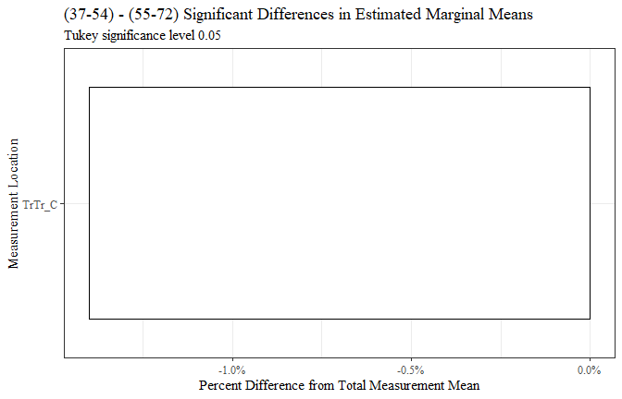

m_v_o <- m_v_o[c(8, 2, 6, 9, 10)]  
  
m_v_o <- m_v_o %>%   
 mutate(across(where(is.numeric), round, digits=3))  
  
  
flextable(m_v_o) %>%  
 my_ft_theme()%>%   
 bold(part = "header") %>%   
 set_caption("(37-54) - (55-72) Significant Differences in Estimated Marginal Means") %>%   
 fit_to_width(7.5) %>%   
 autofit()

**Table** : (37-54) - (55-72) Significant Differences in Estimated Marginal Means

| **measure** | **estimate** | **p.value** | **measure_means** | **prop_diff** |
| --- | --- | --- | --- | --- |
| TrTr_C | -4.076 | 1.2277e-02 | 281.198 | -0.014 |

o_v_m <- m_v_o  
  
o_v_m$estimate <- o_v_m$estimate*(-1)  
o_v_m$prop_diff <- o_v_m$prop_diff*(-1)  
  
  
  
  
  
  
o_v_m$measure <- fct_reorder(o_v_m$measure, o_v_m$estimate, .desc=TRUE)  
  
o_v_m %>%   
 ggplot(aes(x=estimate, y= measure))+  
 geom_bar(stat="identity", color= "black", fill = "white")+  
 theme_bw()+theme(text=element_text(family= "Times New Roman"))+  
 labs(title="(55-72) - (37-54) Significant Differences in Estimated Marginal Means",  
 subtitle= "Tukey significance level 0.05",  
 y="Measurement Location",  
 x="Difference in mm")

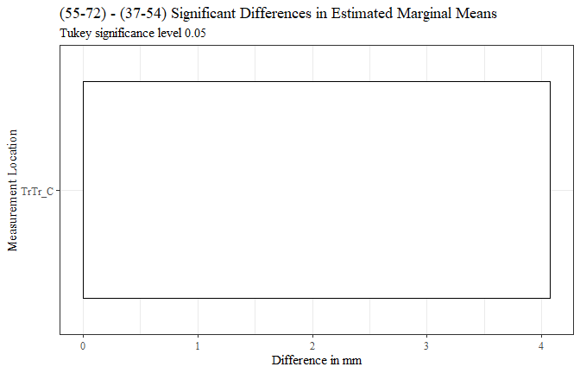

o_v_m$measure <- fct_reorder(o_v_m$measure, o_v_m$prop_diff, .desc=TRUE)  
  
o_v_m %>%   
 ggplot(aes(x=prop_diff, y= measure))+  
 geom_bar(stat="identity", color= "black", fill = "white")+  
 scale_x_continuous(labels = scales::percent)+  
 theme_bw()+theme(text=element_text(family= "Times New Roman"))+  
 labs(title="(55-72) - (37-54) Significant Differences in Estimated Marginal Means",  
 subtitle= "Tukey significance level 0.05",  
 y="Measurement Location",  
 x="Percent Difference from Total Measurement Mean")

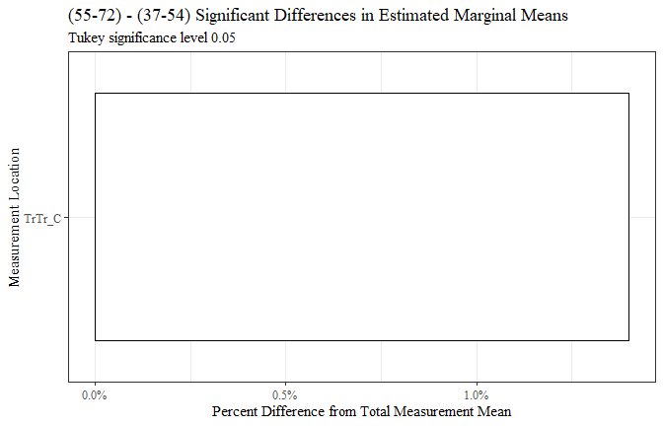

flextable(o_v_m) %>%  
 my_ft_theme()%>%   
 bold(part = "header") %>%   
 set_caption("(55-72) - (37-54) Significant Differences in Estimated Marginal Means") %>%   
 fit_to_width(7.5) %>%   
 autofit()

**Table** : (55-72) - (37-54) Significant Differences in Estimated Marginal Means

| **measure** | **estimate** | **p.value** | **measure_means** | **prop_diff** |
| --- | --- | --- | --- | --- |
| TrTr_C | 4.076 | 1.2277e-02 | 281.198 | 0.014 |

RACE/ETHNICITY

race_means_data$measure <- fct_reorder(race_means_data$measure, race_means_data$emmean, .desc=FALSE)  
  
race_means_data %>%   
 ggplot(aes(x=race_eth, y=emmean, fill=measure))+  
 geom_bar(position=position_dodge(), stat="identity")+  
 geom_errorbar(aes(ymin=lower.CL, ymax=upper.CL), width=0.2, position=position_dodge(0.9))+  
 theme(axis.text.x = element_text(angle = 45, vjust=0.7))+  
 theme_bw()+theme(text=element_text(family= "Times New Roman"))+  
 labs(title="Estimated Marginal Means",  
 subtitle= "All races/ethnicities in MANOVA",  
 y="Emmean in mm",  
 x="Age",  
 fill="Measurement")

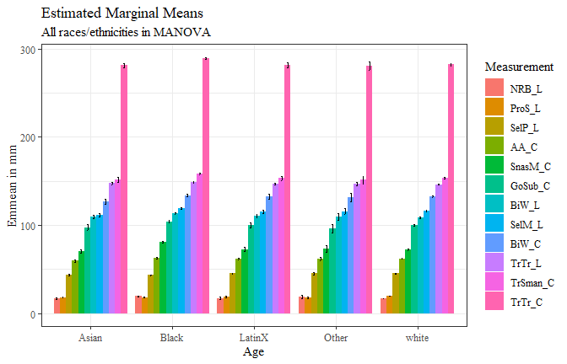

#race_means_data$measure <- fct_reorder(race_means_data$measure, race_means_data$emmean, .desc=FALSE)  
  
race_means_data %>%   
 ggplot(aes(x=measure, y=emmean, fill=race_eth))+  
 geom_bar(position=position_dodge(), stat="identity")+  
 geom_errorbar(aes(ymin=lower.CL, ymax=upper.CL), width=0.2, position=position_dodge(0.9))+  
 theme_bw()+  
 theme(axis.text.x = element_text(angle = 45, vjust=0.7))+  
 theme(text=element_text(family= "Times New Roman"))+  
 labs(title="Estimated Marginal Means",  
 subtitle= "All races/ethnicities in MANOVA",  
 y="Emmean in mm",  
 x="Measurement",  
 fill="Race/Ethnicity")

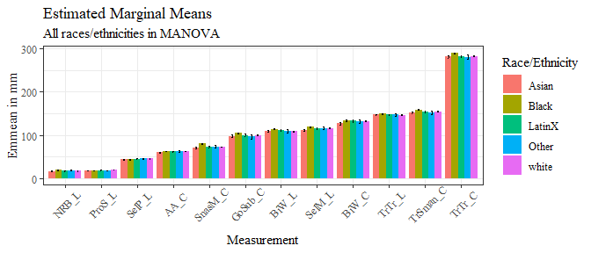

sig_race_est <- race_est_data %>%   
 filter(signif=="TRUE")  
  
sig_race_est <- sig_race_est %>%   
 mutate(across(where(is.numeric), round, digits=3))

sig_race_est$measure <- fct_reorder(sig_race_est$measure, sig_race_est$estimate, .desc=FALSE)  
  
sig_race_est %>%   
 ggplot(aes(x=estimate, y= measure, fill=contrast))+  
 geom_bar(position=position_dodge(), stat="identity")+  
 theme_bw()+theme(text=element_text(family= "Times New Roman"))+  
 labs(title="Age Significant Differences in Estimated Marginal Means",  
 subtitle= "Tukey significance level 0.05",  
 y="Measurement Location",  
 x="Difference in mm")

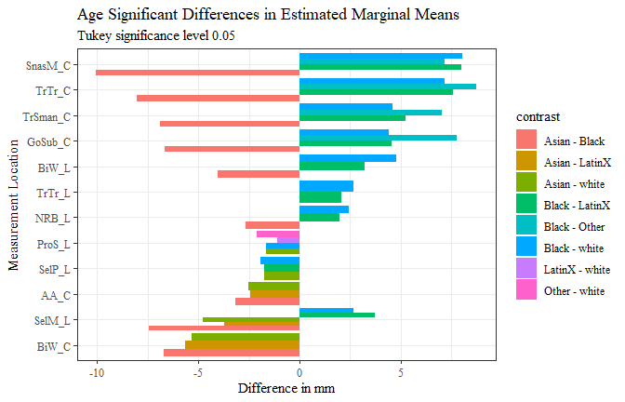

race_est_data1 <- full_join(sig_race_est, measure_means, by="measure")

race_est_data1$prop_diff <- (race_est_data1$estimate/race_est_data1$measure_means)  
  
race_est_data1 <- race_est_data1 %>%   
 mutate(across(where(is.numeric), round, digits=3))  
  
race_est_data1$percent_diff <- percent(race_est_data1$prop_diff)

race1 <- race_est_data1 %>%   
 filter(contrast == "Asian - Black")  
  
  
race1$measure <- fct_reorder(race1$measure, race1$estimate, .desc=FALSE)  
  
race1 %>%   
 ggplot(aes(x=estimate, y= measure, label=estimate))+  
 geom_bar(stat="identity", color= "black", fill = "white")+  
 geom_text(hjust=-0.15, position = position_dodge(.9), size = 3, family= "Times New Roman")+  
 scale_x_continuous(expand = expansion(mult = 0.1))+  
 theme_bw()+theme(text=element_text(family= "Times New Roman"))+  
 labs(title="Asian - Black Significant Differences in Estimated Marginal Means",  
 subtitle= "Tukey significance level 0.05",  
 y="Measurement Location",  
 x="Difference in mm")

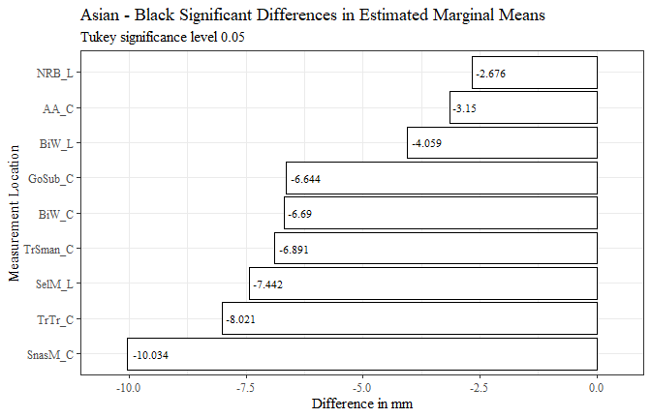

race1$measure <- fct_reorder(race1$measure, race1$prop_diff, .desc=FALSE)  
  
race1 %>%   
 ggplot(aes(x=prop_diff, y= measure, label=percent_diff))+  
 geom_bar(stat="identity", color= "black", fill = "white")+  
 geom_text(hjust=-0.15, position = position_dodge(.9), size = 3, family= "Times New Roman")+  
 scale_x_continuous(labels = scales::percent,  
 expand = expansion(mult = 0.1))+  
 theme_bw()+theme(text=element_text(family= "Times New Roman"))+  
 labs(title="Asian - Black Significant Differences in Estimated Marginal Mean",  
 subtitle= "Tukey significance level 0.05",  
 y="Measurement Location",  
 x="Percent Difference from Total Measurement Mean")

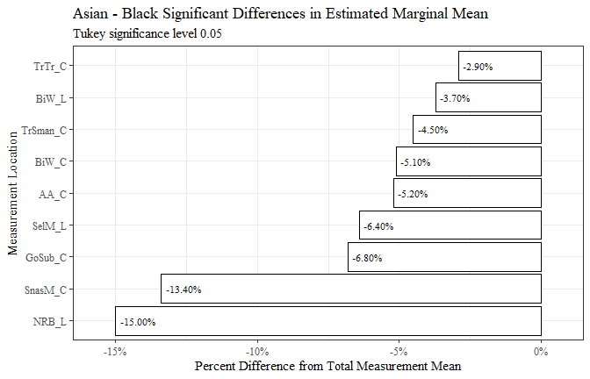

race1 <- race1[c(8, 2, 6, 9, 10)]  
  
race1 <- race1 %>%   
 mutate(across(where(is.numeric), round, digits=3))  
  
  
flextable(race1) %>%  
 my_ft_theme()%>%   
 bold(part = "header") %>%   
 set_caption("Asian - Black Significant Differences in Estimated Marginal Means") %>%   
 fit_to_width(7.5) %>%   
 autofit()

**Table** : Asian - Black Significant Differences in Estimated Marginal Means

| **measure** | **estimate** | **p.value** | **measure_means** | **prop_diff** |
| --- | --- | --- | --- | --- |
| AA_C | -3.150 | 7.1779e-06 | 60.894 | -0.052 |
| BiW_L | -4.059 | 2.6345e-03 | 110.519 | -0.037 |
| BiW_C | -6.690 | 3.7629e-05 | 132.450 | -0.051 |
| GoSub_C | -6.644 | 1.8392e-04 | 97.873 | -0.068 |
| NRB_L | -2.676 | 1.3729e-05 | 17.857 | -0.150 |
| SelM_L | -7.442 | 3.7907e-12 | 116.259 | -0.064 |
| SnasM_C | -10.034 | 1.6447e-12 | 74.956 | -0.134 |
| TrSman_C | -6.891 | 2.8966e-06 | 152.212 | -0.045 |
| TrTr_C | -8.021 | 1.8603e-07 | 281.198 | -0.029 |

race1.1 <- race1  
  
race1.1$estimate <- race1.1$estimate*(-1)  
race1.1$prop_diff <- race1.1$prop_diff*(-1)  
  
race1.1$percent_diff <- percent(race1.1$prop_diff)  
  
  
race1.1$measure <- fct_reorder(race1.1$measure, race1.1$estimate, .desc=TRUE)  
  
race1.1 %>%   
 ggplot(aes(x=estimate, y= measure, label=estimate))+  
 geom_bar(stat="identity", color= "black", fill = "white")+  
 geom_text(hjust=1.1, position = position_dodge(.9), size = 3, family= "Times New Roman")+  
 scale_x_continuous(expand = expansion(mult = 0.1))+  
 theme_bw()+theme(text=element_text(family= "Times New Roman"))+  
 labs(title="Black - Asian Significant Differences in Estimated Marginal Means",  
 subtitle= "Tukey significance level 0.05",  
 y="Measurement Location",  
 x="Difference in mm")

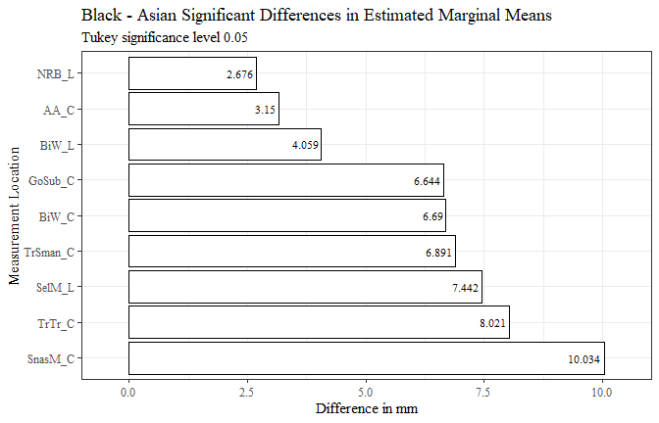

race1.1$measure <- fct_reorder(race1.1$measure, race1.1$prop_diff, .desc=TRUE)  
  
race1.1 %>%   
 ggplot(aes(x=prop_diff, y= measure, label=percent_diff))+  
 geom_bar(stat="identity", color= "black", fill = "white")+  
 geom_text(hjust=1.1, position = position_dodge(.9), size = 3, family= "Times New Roman")+  
 scale_x_continuous(labels = scales::percent,  
 expand = expansion(mult = 0.1))+  
 theme_bw()+theme(text=element_text(family= "Times New Roman"))+  
 labs(title="Black - Asian Significant Differences in Estimated Marginal Means",  
 subtitle= "Tukey significance level 0.05",  
 y="Measurement Location",  
 x="Percent Difference from Total Measurement Mean")

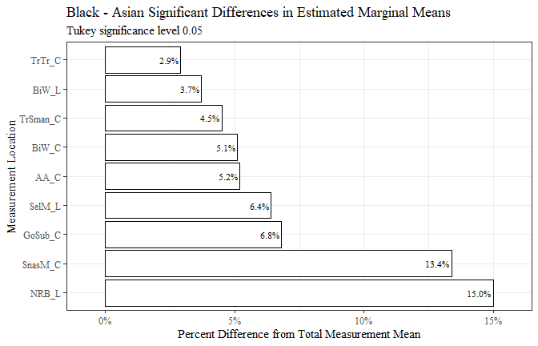

race1.1 <- race1.1[-c(6)]  
  
flextable(race1.1) %>%  
 my_ft_theme()%>%   
 bold(part = "header") %>%   
 set_caption("Black - Asian Significant Differences in Estimated Marginal Means") %>%   
 fit_to_width(7.5) %>%   
 autofit()

**Table** : Black - Asian Significant Differences in Estimated Marginal Means

| **measure** | **estimate** | **p.value** | **measure_means** | **prop_diff** |
| --- | --- | --- | --- | --- |
| AA_C | 3.150 | 7.1779e-06 | 60.894 | 0.052 |
| BiW_L | 4.059 | 2.6345e-03 | 110.519 | 0.037 |
| BiW_C | 6.690 | 3.7629e-05 | 132.450 | 0.051 |
| GoSub_C | 6.644 | 1.8392e-04 | 97.873 | 0.068 |
| NRB_L | 2.676 | 1.3729e-05 | 17.857 | 0.150 |
| SelM_L | 7.442 | 3.7907e-12 | 116.259 | 0.064 |
| SnasM_C | 10.034 | 1.6447e-12 | 74.956 | 0.134 |
| TrSman_C | 6.891 | 2.8966e-06 | 152.212 | 0.045 |
| TrTr_C | 8.021 | 1.8603e-07 | 281.198 | 0.029 |

race2 <- race_est_data1 %>%   
 filter(contrast == "Asian - LatinX")  
  
  
  
race2$measure <- fct_reorder(race2$measure, race2$estimate, .desc=FALSE)  
  
race2 %>%   
 ggplot(aes(x=estimate, y= measure, label=estimate))+  
 geom_bar(stat="identity", color= "black", fill = "white")+  
 geom_text(hjust=-0.15, position = position_dodge(.9), size = 5, family="Times New Roman")+  
 scale_x_continuous(expand = expansion(mult = 0.1))+  
 theme_bw()+theme(text=element_text(family= "Times New Roman"))+  
 labs(title="Asian - LatinX Significant Differences in Estimated Marginal Means",  
 subtitle= "Tukey significance level 0.05",  
 y="Measurement Location",  
 x="Difference in mm")

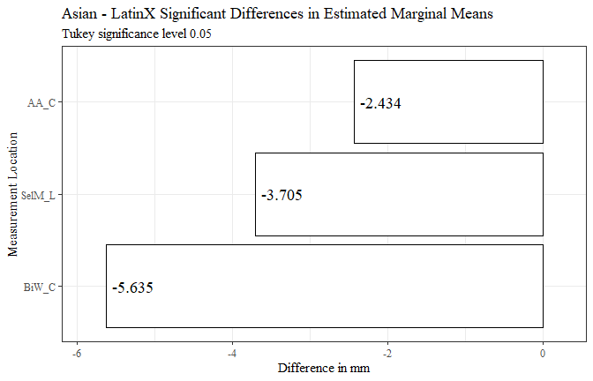

race2$measure <- fct_reorder(race2$measure, race2$prop_diff, .desc=FALSE)  
  
race2 %>%   
 ggplot(aes(x=prop_diff, y= measure, label=percent_diff))+  
 geom_bar(stat="identity", color= "black", fill = "white")+  
 geom_text(hjust=-0.15, position = position_dodge(.9), size = 5, family= "Times New Roman")+  
 scale_x_continuous(labels = scales::percent,  
 expand = expansion(mult = 0.1))+  
 theme_bw()+theme(text=element_text(family= "Times New Roman"))+  
 labs(title="Asian - LatinX Significant Differences in Estimated Marginal Means",  
 subtitle= "Tukey significance level 0.05",  
 y="Measurement Location",  
 x="Percent Difference from Total Measurement Mean")

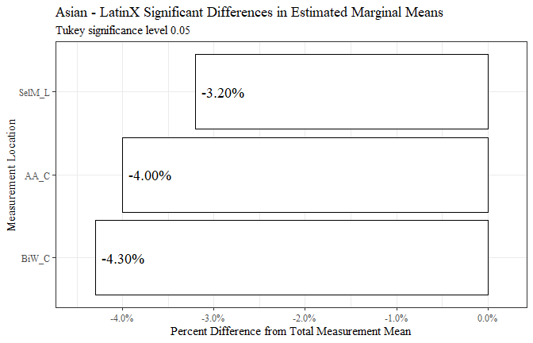

race2 <- race2[c(8, 2, 6, 9, 10)]  
  
race2 <- race2 %>%   
 mutate(across(where(is.numeric), round, digits=3))  
  
  
flextable(race2) %>%  
 my_ft_theme()%>%   
 bold(part = "header") %>%   
 set_caption("Asian - LatinX Significant Differences in Estimated Marginal Means") %>%   
 fit_to_width(7.5) %>%   
 autofit()

**Table** : Asian - LatinX Significant Differences in Estimated Marginal Means

| **measure** | **estimate** | **p.value** | **measure_means** | **prop_diff** |
| --- | --- | --- | --- | --- |
| AA_C | -2.434 | 2.3429e-02 | 60.894 | -0.040 |
| BiW_C | -5.635 | 2.0224e-02 | 132.450 | -0.043 |
| SelM_L | -3.705 | 3.3894e-02 | 116.259 | -0.032 |

race2.1 <- race2  
  
race2.1$estimate <- race2.1$estimate*(-1)  
race2.1$prop_diff <- race2.1$prop_diff*(-1)  
  
race2.1$percent_diff <- percent(race2.1$prop_diff)  
  
  
  
race2.1$measure <- fct_reorder(race2.1$measure, race2.1$estimate, .desc=TRUE)  
  
race2.1 %>%   
 ggplot(aes(x=estimate, y= measure, label=estimate))+  
 geom_bar(stat="identity", color= "black", fill = "white")+  
 geom_text(hjust=1.1, position = position_dodge(.9), size = 5, family="Times New Roman")+  
 scale_x_continuous(expand = expansion(mult = 0.1))+  
 theme_bw()+theme(text=element_text(family= "Times New Roman"))+  
 labs(title="LatinX - Asian Significant Differences in Estimated Marginal Means",  
 subtitle= "Tukey significance level 0.05",  
 y="Measurement Location",  
 x="Difference in mm")

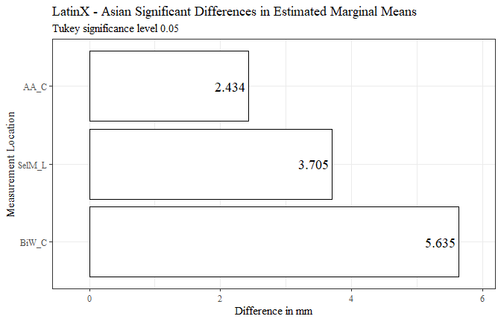

race2.1$measure <- fct_reorder(race2.1$measure, race2.1$prop_diff, .desc=TRUE)  
  
race2.1 %>%   
 ggplot(aes(x=prop_diff, y= measure, label=percent_diff))+  
 geom_bar(stat="identity", color= "black", fill = "white")+  
 geom_text(hjust=1.1, position = position_dodge(.9), size = 5, family= "Times New Roman")+  
 scale_x_continuous(labels = scales::percent,  
 expand = expansion(mult = 0.1))+  
 theme_bw()+theme(text=element_text(family= "Times New Roman"))+  
 labs(title="LatinX - Asian Significant Differences in Estimated Marginal Means",  
 subtitle= "Tukey significance level 0.05",  
 y="Measurement Location",  
 x="Percent Difference from Total Measurement Mean")

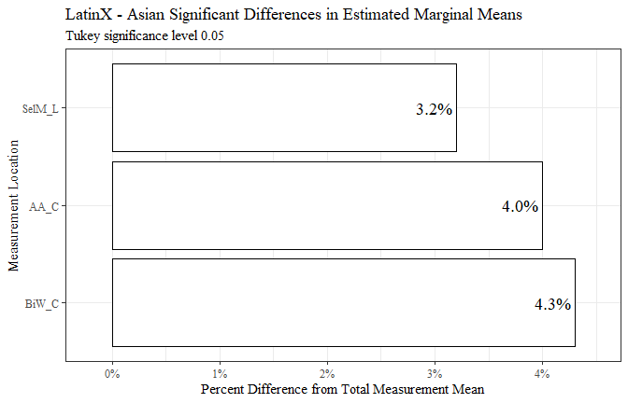

race2.1 <- race2.1[-c(6)]  
  
  
flextable(race2.1) %>%  
 my_ft_theme()%>%   
 bold(part = "header") %>%   
 set_caption("LatinX - Asian Significant Differences in Estimated Marginal Means") %>%   
 fit_to_width(7.5) %>%   
 autofit()

**Table** : LatinX - Asian Significant Differences in Estimated Marginal Means

| **measure** | **estimate** | **p.value** | **measure_means** | **prop_diff** |
| --- | --- | --- | --- | --- |
| AA_C | 2.434 | 2.3429e-02 | 60.894 | 0.040 |
| BiW_C | 5.635 | 2.0224e-02 | 132.450 | 0.043 |
| SelM_L | 3.705 | 3.3894e-02 | 116.259 | 0.032 |

race3 <- race_est_data1 %>%   
 filter(contrast == "Asian - white")  
  
race3$measure <- fct_reorder(race3$measure, race3$estimate, .desc=FALSE)  
  
race3 %>%   
 ggplot(aes(x=estimate, y= measure, label=estimate))+  
 geom_bar(stat="identity", color= "black", fill = "white")+  
 geom_text(hjust=-0.15, position = position_dodge(.9), size = 4, family="Times New Roman")+  
 scale_x_continuous(expand = expansion(mult = 0.1))+  
 theme_bw()+theme(text=element_text(family= "Times New Roman"))+  
 labs(title="Asian - white Significant Differences in Estimated Marginal Means",  
 subtitle= "Tukey significance level 0.05",  
 y="Measurement Location",  
 x="Difference in mm")

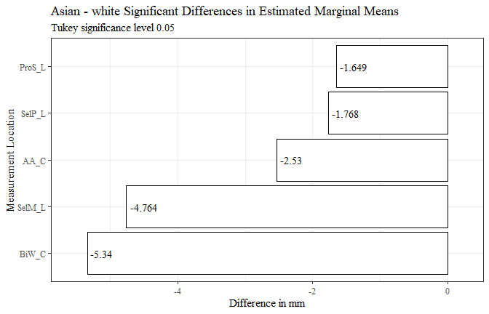

race3$measure <- fct_reorder(race3$measure, race3$prop_diff, .desc=FALSE)  
  
race3 %>%   
 ggplot(aes(x=prop_diff, y= measure, label=percent_diff))+  
 geom_bar(stat="identity", color= "black", fill = "white")+  
 geom_text(hjust=-0.15, position = position_dodge(.9), size = 4, family= "Times New Roman")+  
 scale_x_continuous(labels = scales::percent,  
 expand = expansion(mult = 0.1))+  
 theme_bw()+theme(text=element_text(family= "Times New Roman"))+  
 labs(title="Asian - white Significant Differences in Estimated Marginal Means",  
 subtitle= "Tukey significance level 0.05",  
 y="Measurement Location",  
 x="Percent Difference from Total Measurement Mean")

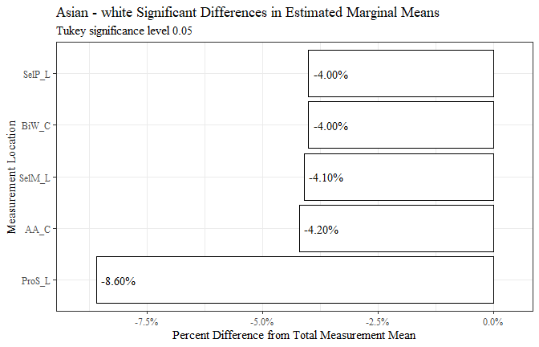

race3 <- race3[c(8, 2, 6, 9, 10)]  
  
race3 <- race3 %>%   
 mutate(across(where(is.numeric), round, digits=3))  
  
  
flextable(race3) %>%  
 my_ft_theme()%>%   
 bold(part = "header") %>%   
 set_caption("Asian - white Significant Differences in Estimated Marginal Means") %>%   
 fit_to_width(7.5) %>%   
 autofit()

**Table** : Asian - white Significant Differences in Estimated Marginal Means

| **measure** | **estimate** | **p.value** | **measure_means** | **prop_diff** |
| --- | --- | --- | --- | --- |
| AA_C | -2.530 | 2.8701e-04 | 60.894 | -0.042 |
| BiW_C | -5.340 | 1.0340e-03 | 132.450 | -0.040 |
| ProS_L | -1.649 | 1.7970e-08 | 19.094 | -0.086 |
| SelP_L | -1.768 | 5.9902e-04 | 44.327 | -0.040 |
| SelM_L | -4.764 | 7.4964e-06 | 116.259 | -0.041 |

race3.1 <- race3  
  
race3.1$estimate <- race3.1$estimate*(-1)  
race3.1$prop_diff <- race3.1$prop_diff*(-1)  
  
  
race3.1$percent_diff <- percent(race3.1$prop_diff)  
  
  
  
race3.1$measure <- fct_reorder(race3.1$measure, race3.1$estimate, .desc=TRUE)  
  
race3.1 %>%   
 ggplot(aes(x=estimate, y= measure, label=estimate))+  
 geom_bar(stat="identity", color= "black", fill = "white")+  
 geom_text(hjust=1.1, position = position_dodge(.9), size = 4, family="Times New Roman")+  
 scale_x_continuous(expand = expansion(mult = 0.1))+  
 theme_bw()+theme(text=element_text(family= "Times New Roman"))+  
 labs(title="white - Asian Significant Differences in Estimated Marginal Means",  
 subtitle= "Tukey significance level 0.05",  
 y="Measurement Location",  
 x="Difference in mm")

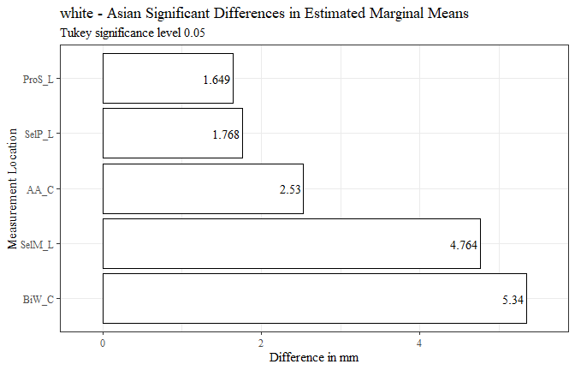

race3.1$measure <- fct_reorder(race3.1$measure, race3.1$prop_diff, .desc=TRUE)  
  
race3.1 %>%   
 ggplot(aes(x=prop_diff, y= measure, label=percent_diff))+  
 geom_bar(stat="identity", color= "black", fill = "white")+  
 geom_text(hjust=1.1, position = position_dodge(.9), size = 4, family= "Times New Roman")+  
 scale_x_continuous(labels = scales::percent,  
 expand = expansion(mult = 0.1))+  
 theme_bw()+theme(text=element_text(family= "Times New Roman"))+  
 labs(title="white - Asian Significant Differences in Estimated Marginal Means",  
 subtitle= "Tukey significance level 0.05",  
 y="Measurement Location",  
 x="Percent Difference from Total Measurement Mean")

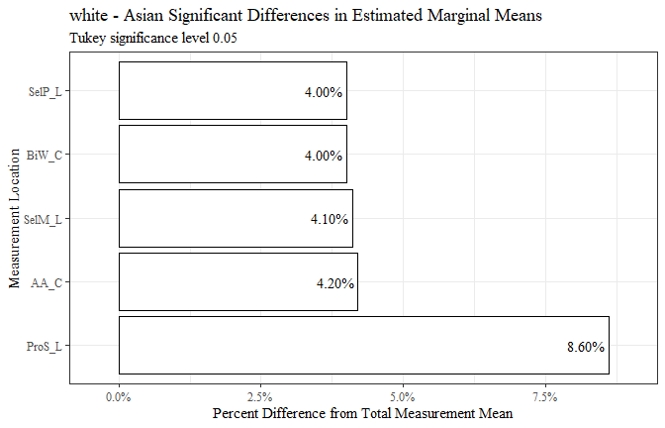

flextable(race3.1) %>%  
 my_ft_theme()%>%   
 bold(part = "header") %>%   
 set_caption("white - Asian Significant Differences in Estimated Marginal Means") %>%   
 fit_to_width(7.5) %>%   
 autofit()

**Table** : white - Asian Significant Differences in Estimated Marginal Means

| **measure** | **estimate** | **p.value** | **measure_means** | **prop_diff** | **percent_diff** |
| --- | --- | --- | --- | --- | --- |
| AA_C | 2.530 | 2.8701e-04 | 60.894 | 0.042 | 4.20% |
| BiW_C | 5.340 | 1.0340e-03 | 132.450 | 0.040 | 4.00% |
| ProS_L | 1.649 | 1.7970e-08 | 19.094 | 0.086 | 8.60% |
| SelP_L | 1.768 | 5.9902e-04 | 44.327 | 0.040 | 4.00% |
| SelM_L | 4.764 | 7.4964e-06 | 116.259 | 0.041 | 4.10% |

race4 <- race_est_data1 %>%   
 filter(contrast == "Black - LatinX")  
  
race4$measure <- fct_reorder(race4$measure, race4$estimate, .desc=TRUE)  
  
race4 %>%   
 ggplot(aes(x=estimate, y= measure, label=estimate))+  
 geom_bar(stat="identity", color= "black", fill = "white")+  
 geom_text(hjust=1.1, position = position_dodge(.9), size = 3, family="Times New Roman")+  
 scale_x_continuous(expand = expansion(mult = 0.1))+  
 theme_bw()+theme(text=element_text(family= "Times New Roman"))+  
 labs(title="Black - LatinX Significant Differences in Estimated Marginal Means",  
 subtitle= "Tukey significance level 0.05",  
 y="Measurement Location",  
 x="Difference in mm")

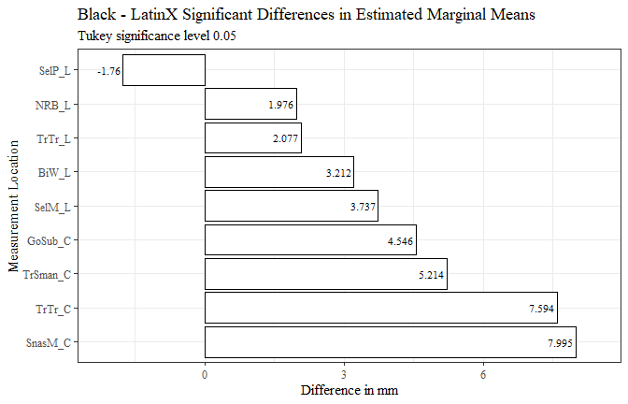

race4$measure <- fct_reorder(race4$measure, race4$prop_diff, .desc=TRUE)  
  
race4 %>%   
 ggplot(aes(x=prop_diff, y= measure, label=percent_diff))+  
 geom_bar(stat="identity", color= "black", fill = "white")+  
 geom_text(hjust=1.1, position = position_dodge(.9), size = 3, family= "Times New Roman")+  
 scale_x_continuous(labels = scales::percent,  
 expand = expansion(mult = 0.1))+  
 theme_bw()+theme(text=element_text(family= "Times New Roman"))+  
 labs(title="Black - LatinX Significant Differences in Estimated Marginal Means",  
 subtitle= "Tukey significance level 0.05",  
 y="Measurement Location",  
 x="Percent Difference from Total Measurement Mean")

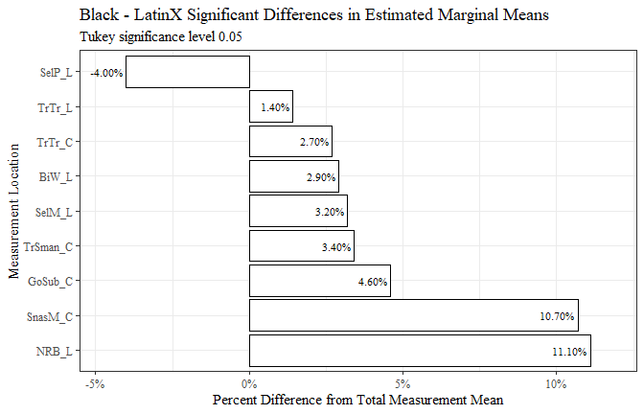

race4 <- race4[c(8, 2, 6, 9, 10)]  
  
race4 <- race4 %>%   
 mutate(across(where(is.numeric), round, digits=3))  
  
  
flextable(race4) %>%  
 my_ft_theme()%>%   
 bold(part = "header") %>%   
 set_caption("Black - LatinX Significant Differences in Estimated Marginal Means") %>%   
 fit_to_width(7.5) %>%   
 autofit()

**Table** : Black - LatinX Significant Differences in Estimated Marginal Means

| **measure** | **estimate** | **p.value** | **measure_means** | **prop_diff** |
| --- | --- | --- | --- | --- |
| BiW_L | 3.212 | 2.8430e-02 | 110.519 | 0.029 |
| GoSub_C | 4.546 | 2.3847e-02 | 97.873 | 0.046 |
| NRB_L | 1.976 | 2.5953e-03 | 17.857 | 0.111 |
| SelP_L | -1.760 | 1.0301e-03 | 44.327 | -0.040 |
| SelM_L | 3.737 | 1.5110e-03 | 116.259 | 0.032 |
| SnasM_C | 7.995 | 2.1127e-11 | 74.956 | 0.107 |
| TrSman_C | 5.214 | 7.2486e-04 | 152.212 | 0.034 |
| TrTr_C | 7.594 | 5.8989e-07 | 281.198 | 0.027 |
| TrTr_L | 2.077 | 2.2532e-02 | 145.681 | 0.014 |

race5 <- race_est_data1 %>%   
 filter(contrast == "Black - Other")  
  
race5$measure <- fct_reorder(race5$measure, race5$estimate, .desc=TRUE)  
  
race5 %>%   
 ggplot(aes(x=estimate, y= measure, label=estimate))+  
 geom_bar(stat="identity", color= "black", fill = "white")+  
 geom_text(hjust=1.1, position = position_dodge(.9), size = 5, family="Times New Roman")+  
 scale_x_continuous(expand = expansion(mult = 0.1))+  
 theme_bw()+theme(text=element_text(family= "Times New Roman"))+  
 labs(title="Black - Other Significant Differences in Estimated Marginal Means",  
 subtitle= "Tukey significance level 0.05",  
 y="Measurement Location",  
 x="Difference in mm")

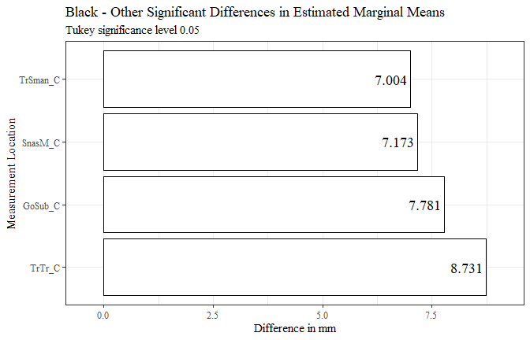

race5$measure <- fct_reorder(race5$measure, race5$prop_diff, .desc=TRUE)  
  
race5 %>%   
 ggplot(aes(x=prop_diff, y= measure, label=percent_diff))+  
 geom_bar(stat="identity", color= "black", fill = "white")+  
 geom_text(hjust=1.1, position = position_dodge(.9), size = 5, family= "Times New Roman")+  
 scale_x_continuous(labels = scales::percent,  
 expand = expansion(mult = 0.1))+  
 theme_bw()+theme(text=element_text(family= "Times New Roman"))+  
 labs(title="Black - Other Significant Differences in Estimated Marginal Means",  
 subtitle= "Tukey significance level 0.05",  
 y="Measurement Location",  
 x="Percent Difference from Total Measurement Mean")

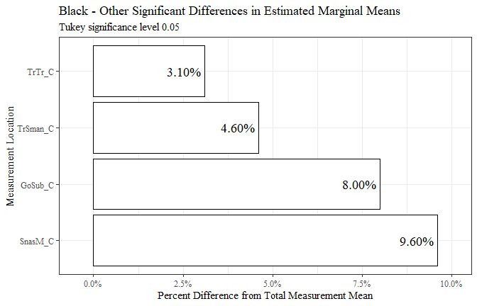

race5 <- race5[c(8, 2, 6, 9, 10)]  
  
race5 <- race5 %>%   
 mutate(across(where(is.numeric), round, digits=3))  
  
  
flextable(race5) %>%  
 my_ft_theme()%>%   
 bold(part = "header") %>%   
 set_caption("Black - Other Significant Differences in Estimated Marginal Means") %>%   
 fit_to_width(7.5) %>%   
 autofit()

**Table** : Black - Other Significant Differences in Estimated Marginal Means

| **measure** | **estimate** | **p.value** | **measure_means** | **prop_diff** |
| --- | --- | --- | --- | --- |
| GoSub_C | 7.781 | 2.1891e-02 | 97.873 | 0.080 |
| SnasM_C | 7.173 | 1.6979e-03 | 74.956 | 0.096 |
| TrSman_C | 7.004 | 1.4717e-02 | 152.212 | 0.046 |
| TrTr_C | 8.731 | 2.1323e-03 | 281.198 | 0.031 |

race6 <- race_est_data1 %>%   
 filter(contrast == "Black - white")  
  
  
race6$measure <- fct_reorder(race6$measure, race6$estimate, .desc=TRUE)  
  
race6 %>%   
 ggplot(aes(x=estimate, y= measure, label=estimate))+  
 geom_bar(stat="identity", color= "black", fill = "white")+  
 geom_text(hjust=1.1, position = position_dodge(.9), size = 3, family="Times New Roman")+  
 scale_x_continuous(expand = expansion(mult = 0.1))+  
 theme_bw()+theme(text=element_text(family= "Times New Roman"))+  
 labs(title="Black - white Significant Differences in Estimated Marginal Means",  
 subtitle= "Tukey significance level 0.05",  
 y="Measurement Location",  
 x="Difference in mm")

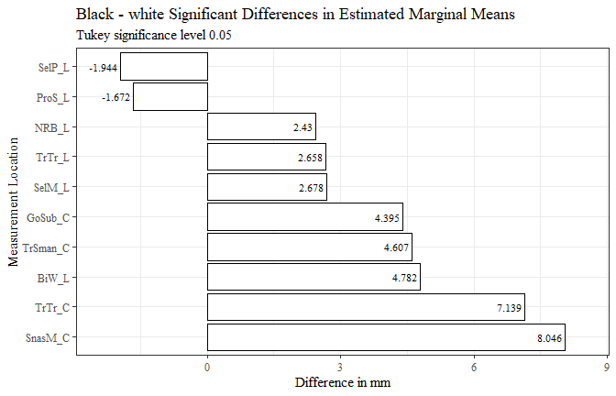

race6$measure <- fct_reorder(race6$measure, race6$prop_diff, .desc=TRUE)  
  
race6 %>%   
 ggplot(aes(x=prop_diff, y= measure, label=percent_diff))+  
 geom_bar(stat="identity", color= "black", fill = "white")+  
 geom_text(hjust=1.1, position = position_dodge(.9), size = 3, family= "Times New Roman")+  
 scale_x_continuous(labels = scales::percent,  
 expand = expansion(mult = 0.1))+  
 theme_bw()+theme(text=element_text(family= "Times New Roman"))+  
 labs(title="Black - white Significant Differences in Estimated Marginal Means",  
 subtitle= "Tukey significance level 0.05",  
 y="Measurement Location",  
 x="Percent Difference from Total Measurement Mean")

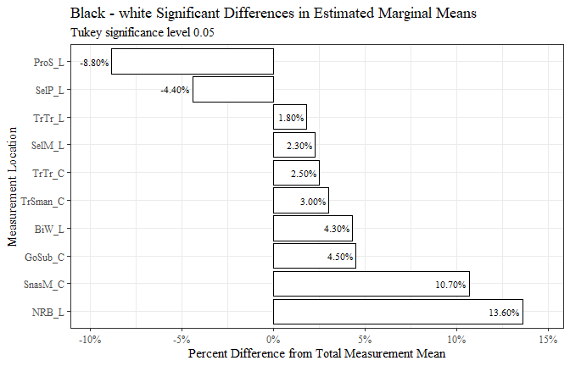

race6 <- race6[c(8, 2, 6, 9, 10)]  
  
race6 <- race6 %>%   
 mutate(across(where(is.numeric), round, digits=3))  
  
  
flextable(race6) %>%  
 my_ft_theme()%>%   
 bold(part = "header") %>%   
 set_caption("Black - white Significant Differences in Estimated Marginal Means") %>%   
 fit_to_width(7.5) %>%   
 autofit()

**Table** : Black - white Significant Differences in Estimated Marginal Means

| **measure** | **estimate** | **p.value** | **measure_means** | **prop_diff** |
| --- | --- | --- | --- | --- |
| BiW_L | 4.782 | 1.6549e-12 | 110.519 | 0.043 |
| GoSub_C | 4.395 | 1.6216e-08 | 97.873 | 0.045 |
| NRB_L | 2.430 | 1.6522e-12 | 17.857 | 0.136 |
| ProS_L | -1.672 | 1.6044e-12 | 19.094 | -0.088 |
| SelP_L | -1.944 | 1.6489e-12 | 44.327 | -0.044 |
| SelM_L | 2.678 | 1.4767e-07 | 116.259 | 0.023 |
| SnasM_C | 8.046 | 1.6044e-12 | 74.956 | 0.107 |
| TrSman_C | 4.607 | 4.5137e-12 | 152.212 | 0.030 |
| TrTr_C | 7.139 | 1.6478e-12 | 281.198 | 0.025 |
| TrTr_L | 2.658 | 1.6780e-12 | 145.681 | 0.018 |

race7 <- race_est_data1 %>%   
 filter(contrast == "LatinX - white")  
  
  
  
race7$measure <- fct_reorder(race7$measure, race7$estimate, .desc=FALSE)  
  
race7 %>%   
 ggplot(aes(x=estimate, y= measure, label=estimate))+  
 geom_bar(stat="identity", color= "black", fill = "white")+  
 geom_text(hjust=1.1, position = position_dodge(.9), size = 3, family="Times New Roman")+  
 scale_x_continuous(expand = expansion(mult = 0.1))+  
 theme_bw()+theme(text=element_text(family= "Times New Roman"))+  
 labs(title="LatinX - white Significant Differences in Estimated Marginal Means",  
 subtitle= "Tukey significance level 0.05",  
 y="Measurement Location",  
 x="Difference in mm")

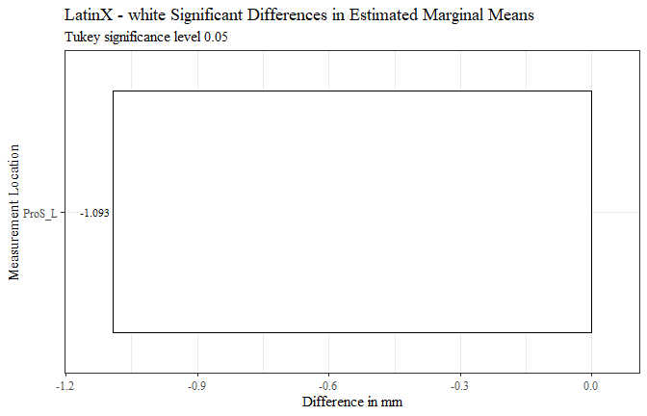

race7$measure <- fct_reorder(race7$measure, race7$prop_diff, .desc=FALSE)  
  
race7 %>%   
 ggplot(aes(x=prop_diff, y= measure, label=percent_diff))+  
 geom_bar(stat="identity", color= "black", fill = "white")+  
 geom_text(hjust=1.1, position = position_dodge(.9), size = 3, family= "Times New Roman")+  
 scale_x_continuous(labels = scales::percent,  
 expand = expansion(mult = 0.1))+  
 theme_bw()+theme(text=element_text(family= "Times New Roman"))+  
 labs(title="LatinX - white Significant Differences in Estimated Marginal Means",  
 subtitle= "Tukey significance level 0.05",  
 y="Measurement Location",  
 x="Percent Difference from Total Measurement Mean")

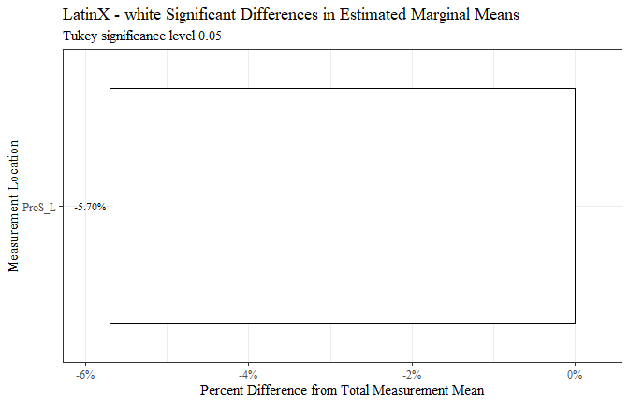

race7 <- race7[c(8, 2, 6, 9, 10)]  
  
race7 <- race7 %>%   
 mutate(across(where(is.numeric), round, digits=3))  
  
  
flextable(race7) %>%  
 my_ft_theme()%>%   
 bold(part = "header") %>%   
 set_caption("LatinX - white Significant Differences in Estimated Marginal Means") %>%   
 fit_to_width(7.5) %>%   
 autofit()

**Table** : LatinX - white Significant Differences in Estimated Marginal Means

| **measure** | **estimate** | **p.value** | **measure_means** | **prop_diff** |
| --- | --- | --- | --- | --- |
| ProS_L | -1.093 | 4.3766e-04 | 19.094 | -0.057 |

race8 <- race_est_data1 %>%   
 filter(contrast == "Other - white")  
  
  
  
race8$measure <- fct_reorder(race8$measure, race8$estimate, .desc=FALSE)  
  
race8 %>%   
 ggplot(aes(x=estimate, y= measure, label=estimate))+  
 geom_bar(stat="identity", color= "black", fill = "white")+  
 geom_text(hjust=1.1, position = position_dodge(.9), size = 3, family="Times New Roman")+  
 scale_x_continuous(expand = expansion(mult = 0.1))+  
 theme_bw()+theme(text=element_text(family= "Times New Roman"))+  
 labs(title="Other - white Significant Differences in Estimated Marginal Means",  
 subtitle= "Tukey significance level 0.05",  
 y="Measurement Location",  
 x="Difference in mm")

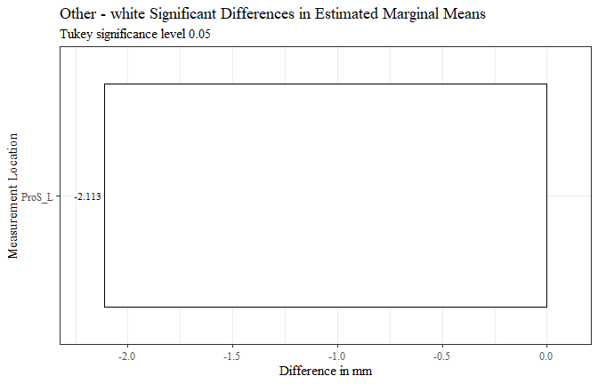

race8$measure <- fct_reorder(race8$measure, race8$prop_diff, .desc=FALSE)  
  
race8 %>%   
 ggplot(aes(x=prop_diff, y= measure, label=percent_diff))+  
 geom_bar(stat="identity", color= "black", fill = "white")+  
 geom_text(hjust=1.1, position = position_dodge(.9), size = 3, family= "Times New Roman")+  
 scale_x_continuous(labels = scales::percent,  
 expand = expansion(mult = 0.1))+  
 theme_bw()+theme(text=element_text(family= "Times New Roman"))+  
 labs(title="Other - white Significant Differences in Estimated Marginal Means",  
 subtitle= "Tukey significance level 0.05",  
 y="Measurement Location",  
 x="Percent Difference from Total Measurement Mean")

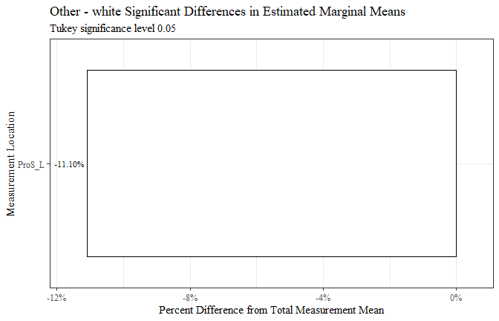

race8 <- race8[c(8, 2, 6, 9, 10)]  
  
race8 <- race8 %>%   
 mutate(across(where(is.numeric), round, digits=3))  
  
  
flextable(race8) %>%  
 my_ft_theme()%>%   
 bold(part = "header") %>%   
 set_caption("Other - white Significant Differences in Estimated Marginal Means") %>%   
 fit_to_width(7.5) %>%   
 autofit()

**Table** : Other - white Significant Differences in Estimated Marginal Means

| **measure** | **estimate** | **p.value** | **measure_means** | **prop_diff** |
| --- | --- | --- | --- | --- |
| ProS_L | -2.113 | 6.8428e-05 | 19.094 | -0.111 |