removing outliers

2022-07-26

library(readxl)  
library(tidyverse)

## ── Attaching packages ─────────────────────────────────────── tidyverse 1.3.2 ──  
## ✔ ggplot2 3.3.6 ✔ purrr 0.3.4  
## ✔ tibble 3.1.8 ✔ dplyr 1.0.9  
## ✔ tidyr 1.2.0 ✔ stringr 1.4.0  
## ✔ readr 2.1.2 ✔ forcats 0.5.1  
## ── Conflicts ────────────────────────────────────────── tidyverse_conflicts() ──  
## ✖ dplyr::filter() masks stats::filter()  
## ✖ dplyr::lag() masks stats::lag()

library(writexl)  
library(extrafont)

## Registering fonts with R

library(flextable)

##   
## Attaching package: 'flextable'  
##   
## The following object is masked from 'package:purrr':  
##   
## compose

#times new roman tables  
my_ft_theme <- function(ft, ...) {  
 # Remove vertical cell padding  
 ft <- padding(ft, padding.top = 0, padding.bottom = 0, part = "all")  
   
 # Change font to TNR 11  
 ft <- font(ft, fontname = "Times New Roman", part = "all")  
 ft <- fontsize(ft, part = "all", size = 12)  
 ft  
}

headscan_full<-read_excel("C:\\Users\\19177\\OneDrive - Colostate\\Desktop\\Dissertation\\headscan_dissertation\\headscan_full.xlsx")  
  
headscan_full$AA_C <- headscan_full$AA_C *10  
headscan_full$BGl_C <- headscan_full$BGl_C * 10  
headscan_full$BiW_C <- headscan_full$BiW_C *10  
headscan_full$BiW_L <- headscan_full$BiW_L *10  
headscan_full$ChCh_C <- headscan_full$ChCh_C *10  
headscan_full$GoSub_C <- headscan_full$GoSub_C *10  
headscan_full$NRB_L <- headscan_full$NRB_L *10  
headscan_full$ProA_L <- headscan_full$ProA_L *10  
headscan_full$ProA_C <- headscan_full$ProA_C *10  
headscan_full$ProS_C <- headscan_full$ProS_C *10  
headscan_full$ProS_L <- headscan_full$ProS_L *10  
headscan_full$SelP_C <- headscan_full$SelP_C *10  
headscan_full$SelP_L <- headscan_full$SelP_L *10  
headscan_full$SelDH_C <- headscan_full$SelDH_C *10  
headscan_full$SelM_L <- headscan_full$SelM_L *10  
headscan_full$SnasM_C <- headscan_full$SnasM_C *10  
headscan_full$SmanM_C <- headscan_full$SmanM_C *10  
headscan_full$SmanM_L <- headscan_full$SmanM_L *10  
headscan_full$SnasM_L <- headscan_full$SnasM_L *10  
headscan_full$TrHO_C <- headscan_full$TrHO_C *10  
headscan_full$TrEJ_C <- headscan_full$TrEJ_C *10  
headscan_full$TrGo_C <- headscan_full$TrGo_C *10  
headscan_full$TrSel_C <- headscan_full$TrSel_C *10  
headscan_full$TrSman_C <- headscan_full$TrSman_C *10  
headscan_full$TrSnas_C <- headscan_full$TrSnas_C *10  
headscan_full$TrTr_C <- headscan_full$TrTr_C *10  
headscan_full$TrTr_L <- headscan_full$TrTr_L *10  
  
  
str(headscan_full)

## tibble [2,016 × 33] (S3: tbl_df/tbl/data.frame)  
## $ ID : chr [1:2016] "400-20201012-002" "400-20201012-003" "400-20201012-004" "400-20201012-005" ...  
## $ AA_C : num [1:2016] 65 55 70 58 67 60 59 59 65 65 ...  
## $ BGl_C : num [1:2016] 315 289 293 313 288 306 320 NA 300 277 ...  
## $ BiW_C : num [1:2016] 130 127 143 140 137 130 141 138 143 150 ...  
## $ BiW_L : num [1:2016] 115 108 121 109 104 106 109 111 113 116 ...  
## $ ChCh_C : num [1:2016] 62 64 68 70 70 70 67 69 67 63 ...  
## $ GoSub_C : num [1:2016] 93 93 115 93 103 100 79 106 85 102 ...  
## $ NRB_L : num [1:2016] 17 18 19 21 19 14 17 18 16 17 ...  
## $ ProA_L : num [1:2016] 28 25 31 23 28 28 26 27 32 28 ...  
## $ ProA_C : num [1:2016] 31 27 33 27 31 29 27 29 34 31 ...  
## $ ProS_C : num [1:2016] 18 20 14 13 22 22 19 14 26 24 ...  
## $ ProS_L : num [1:2016] 17 18 14 13 20 20 18 12 24 22 ...  
## $ SelP_C : num [1:2016] 42 41 51 45 47 48 46 42 47 44 ...  
## $ SelP_L : num [1:2016] 42 41 51 44 47 48 46 41 46 44 ...  
## $ SelDH_C : num [1:2016] 15 9 9 11 13 15 9 9 12 14 ...  
## $ SelM_L : num [1:2016] 122 99 130 115 119 126 117 112 117 117 ...  
## $ SnasM_C : num [1:2016] 82 55 84 74 73 80 78 76 64 75 ...  
## $ SmanM_C : num [1:2016] 59 51 45 43 33 34 55 37 61 41 ...  
## $ SmanM_L : num [1:2016] 55 50 45 42 33 34 50 36 59 40 ...  
## $ SnasM_L : num [1:2016] 75 53 78 69 67 76 69 71 62 69 ...  
## $ TrHO_C : num [1:2016] 179 163 169 166 159 162 169 NA 167 166 ...  
## $ TrEJ_C : num [1:2016] 40 32 39 29 46 42 29 32 29 33 ...  
## $ TrGo_C : num [1:2016] 84 57 70 61 68 70 75 61 67 64 ...  
## $ TrSel_C : num [1:2016] 149 138 150 133 140 151 140 138 156 143 ...  
## $ TrSman_C : num [1:2016] 177 145 178 147 157 164 149 159 151 160 ...  
## $ TrSnas_C : num [1:2016] 163 142 167 145 152 157 148 149 157 NA ...  
## $ TrTr_C : num [1:2016] 296 276 292 273 279 300 283 275 307 286 ...  
## $ TrTr_L : num [1:2016] 155 141 156 149 146 146 147 151 157 144 ...  
## $ coder : chr [1:2016] "Kayna" "Kayna" "Kayna" "Kayna" ...  
## $ age : num [1:2016] 31 49 49 34 49 55 26 18 25 27 ...  
## $ gender : chr [1:2016] "Male" "Female" "Male" "Male" ...  
## $ race_eth : chr [1:2016] "Black" "white" "white" "white" ...  
## $ age_group: chr [1:2016] "18-36" "37-54" "37-54" "18-36" ...

#histogram of all GoSub_C values w/ outlier  
ggplot(data=headscan_full, aes(x=GoSub_C))+  
 geom_bar(stat="bin", bins=20, color= "black", fill = "white")+  
 theme_bw()+theme(text=element_text(family= "Times New Roman"))+  
 labs(title="Gonion to Submandibular Contour Measurement Distribution",  
 subtitle= "with outlier",  
 y="Frequency",  
 x="Gonion to Submandibular Contour (cm)")

## Warning: Removed 127 rows containing non-finite values (stat_bin).

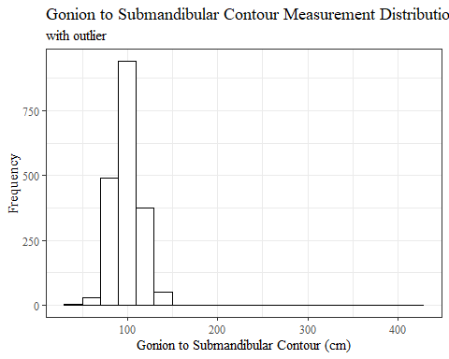

#REMOVING OUTLIER GoSubC  
  
max(headscan_full$GoSub_C, na.rm = TRUE)

## [1] 424

headscan_full1 <- headscan_full %>% mutate(GoSub_C = replace(GoSub_C, GoSub_C>400, NA))  
  
#histogram of all GoSub_C values  
ggplot(data=headscan_full1, aes(x=GoSub_C))+  
 geom_bar(stat="bin", bins=20, color= "black", fill = "white")+  
 theme_bw()+theme(text=element_text(family= "Times New Roman"))+  
 labs(title="Gonion to Submandibular Contour Measurement Distribution",  
 subtitle = "one outlier over 40cm changed to missing values",  
 y="Frequency",  
 x="Gonion to Submandibular Contour (mm)")

## Warning: Removed 128 rows containing non-finite values (stat_bin).

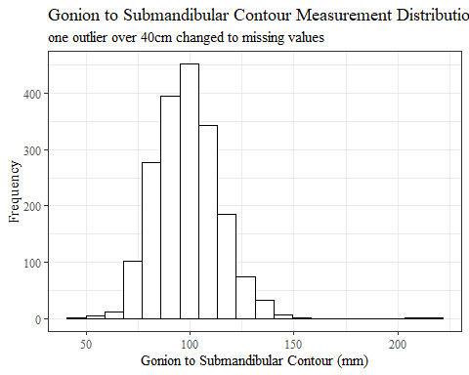

sum(is.na(headscan_full$GoSub_C))

## [1] 127

sum(is.na(headscan_full1$GoSub_C))

## [1] 128

#histogram of all NRB_L values w/ outlier  
ggplot(data=headscan_full, aes(x=NRB_L))+  
 geom_bar(stat="bin", bins=20, color= "black", fill = "white")+  
 theme_bw()+theme(text=element_text(family= "Times New Roman"))+  
 labs(title="Nasal Root Breadth Measurement Distribution",  
 subtitle= "with outliers",  
 y="Frequency",  
 x="Nasal Root Breadth (cm)")

## Warning: Removed 15 rows containing non-finite values (stat_bin).

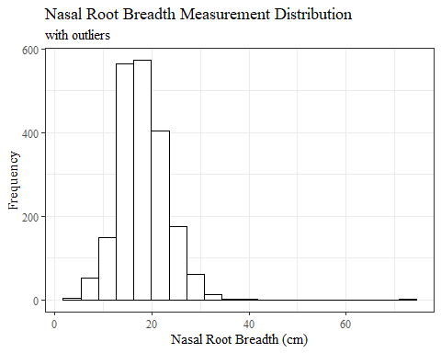

#REMOVING OUTLIER NRB_L  
  
max(headscan_full$NRB_L, na.rm = TRUE)

## [1] 72

headscan_full1 <- headscan_full1 %>% mutate(NRB_L = replace(NRB_L, NRB_L>70, NA))  
  
#histogram of all NRB_L values  
ggplot(data=headscan_full1, aes(x=NRB_L))+  
 geom_bar(stat="bin", bins=20, color= "black", fill = "white")+  
 theme_bw()+theme(text=element_text(family= "Times New Roman"))+  
 labs(title="Nasal Root Breadth Measurement Distribution",  
 subtitle = "one outlier over 7cm changed to missing values",  
 y="Frequency",  
 x="Nasal Root Breadth (mm)")

## Warning: Removed 16 rows containing non-finite values (stat_bin).

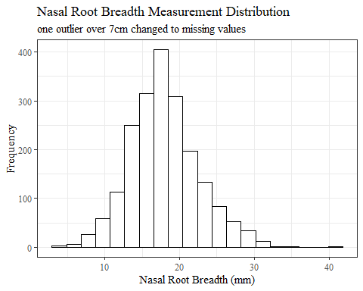

sum(is.na(headscan_full$NRB_L))

## [1] 15

sum(is.na(headscan_full1$NRB_L))

## [1] 16

#histogram of all SelDH_C values w/ outlier  
ggplot(data=headscan_full, aes(x=SelDH_C ))+  
 geom_bar(stat="bin", bins=25, color= "black", fill = "white")+  
 theme_bw()+theme(text=element_text(family= "Times New Roman"))+  
 labs(title="Sellion to Dorsal Hump Contour Measurement Distribution",  
 subtitle = "with outliers",  
 y="Frequency",  
 x="Sellion to Dorsal Hump Contour (cm)")

## Warning: Removed 14 rows containing non-finite values (stat_bin).

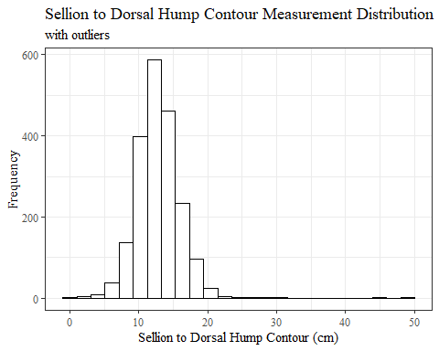

#REMOVING OUTLIER SelDH_C  
  
max(headscan_full$SelDH_C, na.rm = TRUE)

## [1] 50

headscan_full1 <- headscan_full1 %>% mutate(SelDH_C = replace(SelDH_C, SelDH_C>40, NA))  
  
#histogram of all SelDH_C values  
ggplot(data=headscan_full1, aes(x=SelDH_C))+  
 geom_bar(stat="bin", bins=25, color= "black", fill = "white")+  
 theme_bw()+theme(text=element_text(family= "Times New Roman"))+  
 labs(title="Sellion to Dorsal Hump Contour Measurement Distribution",  
 subtitle = "two outliers over 4cm changed to missing values",  
 y="Frequency",  
 x="Sellion to Dorsal Hump Contour (mm)")

## Warning: Removed 16 rows containing non-finite values (stat_bin).

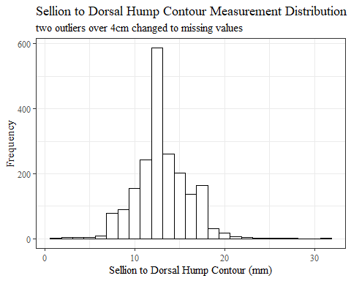

sum(is.na(headscan_full$SelDH_C))

## [1] 14

sum(is.na(headscan_full1$SelDH_C))

## [1] 16

#histogram of all SnasM_C values w/ outlier  
ggplot(data=headscan_full, aes(x=SnasM_C))+  
 geom_bar(stat="bin", bins=25, color= "black", fill = "white")+  
 theme_bw()+theme(text=element_text(family= "Times New Roman"))+  
 labs(title="Subnasale to Menton Contour Measurement Distribution",  
 subtitle = "with outliers",  
 y="Frequency",  
 x="Subnasale to Menton Contour (cm)")

## Warning: Removed 236 rows containing non-finite values (stat_bin).

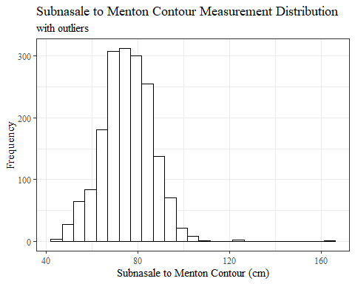

#REMOVING OUTLIER SnasM_C  
  
max(headscan_full$SnasM_C, na.rm = TRUE)

## [1] 163

headscan_full1 <- headscan_full1 %>% mutate(SnasM_C = replace(SnasM_C, SnasM_C>160, NA))  
  
#histogram of all SnasM_C values  
ggplot(data=headscan_full1, aes(x=SnasM_C))+  
 geom_bar(stat="bin", bins=20, color= "black", fill = "white")+  
 theme_bw()+theme(text=element_text(family= "Times New Roman"))+  
 labs(title="Subnasale to Menton Contour Measurement Distribution",  
 subtitle = "one outlier over 16cm changed to missing values",  
 y="Frequency",  
 x="Subnasale to Menton Contour (mm)")

## Warning: Removed 237 rows containing non-finite values (stat_bin).

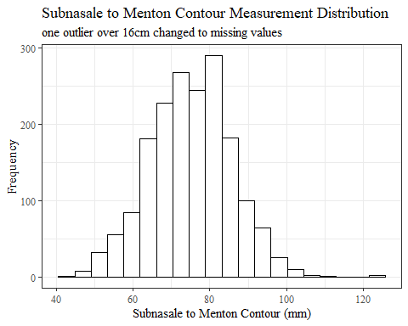

sum(is.na(headscan_full$SnasM_C))

## [1] 236

sum(is.na(headscan_full1$SnasM_C))

## [1] 237

#histogram of all TrGo_C values  
ggplot(data=headscan_full, aes(x=TrGo_C))+  
 geom_bar(stat="bin", bins=30, color= "black", fill = "white")+  
 theme_bw()+theme(text=element_text(family= "Times New Roman"))+  
 labs(title="Tragion to Gonion Contour Measurement Distribution",  
 subtitle = "without outliers removed",  
 y="Frequency",  
 x="Tragion to Gonion Contour (cm)")

## Warning: Removed 80 rows containing non-finite values (stat_bin).

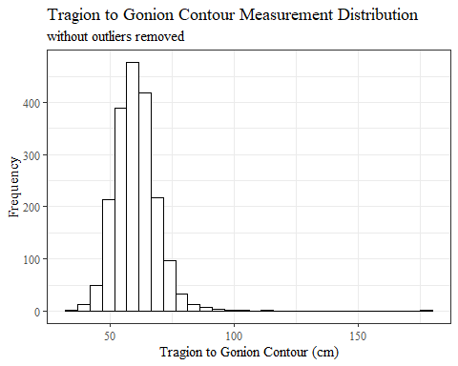

#REMOVING OUTLIER TrGo_C  
  
max(headscan_full$TrGo_C, na.rm = TRUE)

## [1] 178

headscan_full1 <- headscan_full1 %>% mutate(TrGo_C = replace(TrGo_C, TrGo_C>170, NA))  
  
#histogram of all TrGo_C values  
ggplot(data=headscan_full1, aes(x=TrGo_C))+  
 geom_bar(stat="bin", bins=25, color= "black", fill = "white")+  
 theme_bw()+theme(text=element_text(family= "Times New Roman"))+  
 labs(title="Tragion to Gonion Contour Measurement Distribution",  
 subtitle = "one outlier over 17cm changed to missing value",  
 y="Frequency",  
 x="Tragion to Gonion Contour (mm)")

## Warning: Removed 81 rows containing non-finite values (stat_bin).

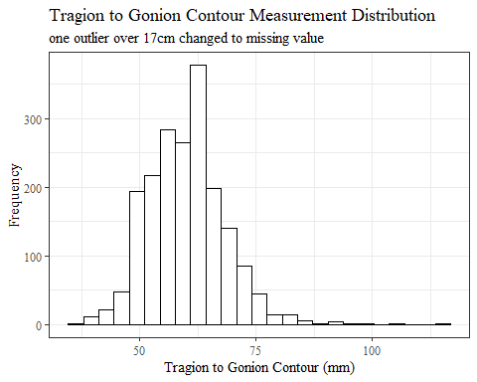

sum(is.na(headscan_full$TrGo_C))

## [1] 80

sum(is.na(headscan_full1$TrGo_C))

## [1] 81

#histogram of all TrSman_C values  
ggplot(data=headscan_full, aes(x=TrSman_C))+  
 geom_bar(stat="bin", bins=35, color= "black", fill = "white")+  
 theme_bw()+theme(text=element_text(family= "Times New Roman"))+  
 labs(title="Tragion to Submandibular Contour Measurement Distribution",  
 subtitle = "with outliers",  
 y="Frequency",  
 x="Tragion to Submandibular Contour (cm)")

## Warning: Removed 132 rows containing non-finite values (stat_bin).

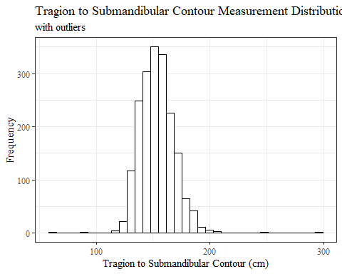

#REMOVING OUTLIER TrSman_C  
  
max(headscan_full$TrSman_C, na.rm = TRUE)

## [1] 298

headscan_full1 <- headscan_full1 %>% mutate(TrSman_C = replace(TrSman_C, TrSman_C>290, NA))  
  
#histogram of all TrSman_C values  
ggplot(data=headscan_full1, aes(x=TrSman_C))+  
 geom_bar(stat="bin", bins=25, color= "black", fill = "white")+  
 theme_bw()+theme(text=element_text(family= "Times New Roman"))+  
 labs(title="Tragion to Submandibular Contour Measurement Distribution",  
 subtitle = "one outlier over 29cm changed to missing value",  
 y="Frequency",  
 x="Tragion to Submandibular Contour (mm)")

## Warning: Removed 133 rows containing non-finite values (stat_bin).

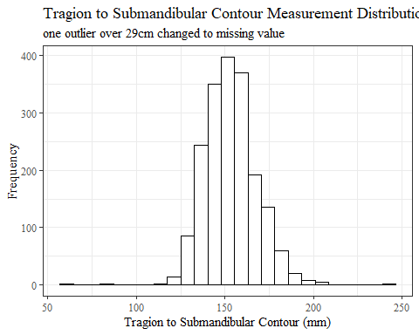

sum(is.na(headscan_full$TrSman_C))

## [1] 132

sum(is.na(headscan_full1$TrSman_C))

## [1] 133

#histogram of all TrSnas_C values  
ggplot(data=headscan_full, aes(x=TrSnas_C))+  
 geom_bar(stat="bin", bins=35, color= "black", fill = "white")+  
 theme_bw()+theme(text=element_text(family= "Times New Roman"))+  
 labs(title="Tragion to Subnasale Contour Measurement Distribution",  
 subtitle = "with outliers",  
 y="Frequency",  
 x="Tragion to Subnasale Contour (cm)")

## Warning: Removed 71 rows containing non-finite values (stat_bin).

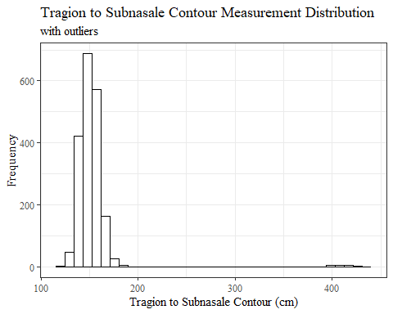

#REMOVING OUTLIER TrSnas_C  
  
max(headscan_full$TrSnas_C, na.rm = TRUE)

## [1] 437

headscan_full1 <- headscan_full1 %>% mutate(TrSnas_C = replace(TrSnas_C, TrSnas_C>350, NA))  
  
#histogram of all TrSnas_C values  
ggplot(data=headscan_full1, aes(x=TrSnas_C))+  
 geom_bar(stat="bin", bins=20, color= "black", fill = "white")+  
 theme_bw()+theme(text=element_text(family= "Times New Roman"))+  
 labs(title="Tragion to Subnasale Contour Measurement Distribution",  
 subtitle = "19 outliers over 35cm changed to missing values",  
 y="Frequency",  
 x="Tragion to Subnasale Contour (mm)")

## Warning: Removed 90 rows containing non-finite values (stat_bin).

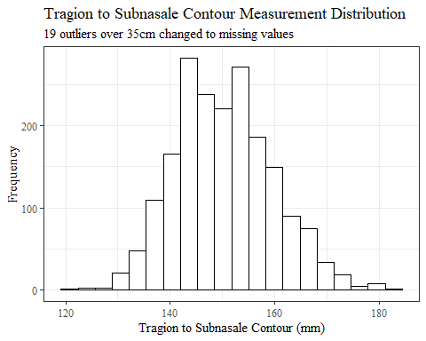

sum(is.na(headscan_full$TrSnas_C))

## [1] 71

sum(is.na(headscan_full1$TrSnas_C))

## [1] 90

str(headscan_full1)

## tibble [2,016 × 33] (S3: tbl_df/tbl/data.frame)  
## $ ID : chr [1:2016] "400-20201012-002" "400-20201012-003" "400-20201012-004" "400-20201012-005" ...  
## $ AA_C : num [1:2016] 65 55 70 58 67 60 59 59 65 65 ...  
## $ BGl_C : num [1:2016] 315 289 293 313 288 306 320 NA 300 277 ...  
## $ BiW_C : num [1:2016] 130 127 143 140 137 130 141 138 143 150 ...  
## $ BiW_L : num [1:2016] 115 108 121 109 104 106 109 111 113 116 ...  
## $ ChCh_C : num [1:2016] 62 64 68 70 70 70 67 69 67 63 ...  
## $ GoSub_C : num [1:2016] 93 93 115 93 103 100 79 106 85 102 ...  
## $ NRB_L : num [1:2016] 17 18 19 21 19 14 17 18 16 17 ...  
## $ ProA_L : num [1:2016] 28 25 31 23 28 28 26 27 32 28 ...  
## $ ProA_C : num [1:2016] 31 27 33 27 31 29 27 29 34 31 ...  
## $ ProS_C : num [1:2016] 18 20 14 13 22 22 19 14 26 24 ...  
## $ ProS_L : num [1:2016] 17 18 14 13 20 20 18 12 24 22 ...  
## $ SelP_C : num [1:2016] 42 41 51 45 47 48 46 42 47 44 ...  
## $ SelP_L : num [1:2016] 42 41 51 44 47 48 46 41 46 44 ...  
## $ SelDH_C : num [1:2016] 15 9 9 11 13 15 9 9 12 14 ...  
## $ SelM_L : num [1:2016] 122 99 130 115 119 126 117 112 117 117 ...  
## $ SnasM_C : num [1:2016] 82 55 84 74 73 80 78 76 64 75 ...  
## $ SmanM_C : num [1:2016] 59 51 45 43 33 34 55 37 61 41 ...  
## $ SmanM_L : num [1:2016] 55 50 45 42 33 34 50 36 59 40 ...  
## $ SnasM_L : num [1:2016] 75 53 78 69 67 76 69 71 62 69 ...  
## $ TrHO_C : num [1:2016] 179 163 169 166 159 162 169 NA 167 166 ...  
## $ TrEJ_C : num [1:2016] 40 32 39 29 46 42 29 32 29 33 ...  
## $ TrGo_C : num [1:2016] 84 57 70 61 68 70 75 61 67 64 ...  
## $ TrSel_C : num [1:2016] 149 138 150 133 140 151 140 138 156 143 ...  
## $ TrSman_C : num [1:2016] 177 145 178 147 157 164 149 159 151 160 ...  
## $ TrSnas_C : num [1:2016] 163 142 167 145 152 157 148 149 157 NA ...  
## $ TrTr_C : num [1:2016] 296 276 292 273 279 300 283 275 307 286 ...  
## $ TrTr_L : num [1:2016] 155 141 156 149 146 146 147 151 157 144 ...  
## $ coder : chr [1:2016] "Kayna" "Kayna" "Kayna" "Kayna" ...  
## $ age : num [1:2016] 31 49 49 34 49 55 26 18 25 27 ...  
## $ gender : chr [1:2016] "Male" "Female" "Male" "Male" ...  
## $ race_eth : chr [1:2016] "Black" "white" "white" "white" ...  
## $ age_group: chr [1:2016] "18-36" "37-54" "37-54" "18-36" ...

outl1 <- subset(headscan_full, GoSub_C>400)   
outl1$vis_out <- "GoSub_C"  
   
outl2 <- subset(headscan_full, NRB_L>70)  
outl2$vis_out <- "NRB_L"  
  
outl3 <- subset(headscan_full, SelDH_C>40)  
outl3$vis_out <- "SelDH_C"  
  
  
outl4 <- subset(headscan_full, SnasM_C>160)  
outl4$vis_out <- "SnasM_C"  
  
outl5 <- subset(headscan_full, TrGo_C>170)  
outl5$vis_out <- "TrGo_C"  
  
outl6 <- subset(headscan_full, TrSman_C>290)  
outl6$vis_out <- "TrSman_C"  
  
outl7 <- subset(headscan_full, TrSnas_C>350)  
outl7$vis_out <- "TrSnas_C"  
  
  
all_vis_out <- rbind(outl1, outl2, outl3, outl4, outl5, outl6, outl7)

sum(is.na(headscan_full))

## [1] 2801

sum(is.na(headscan_full1))

## [1] 2827

all_vis_out1 <- all_vis_out[-c(2:33)]  
   
#Size 12 Table TNR  
flextable(all_vis_out1) %>%  
 my_ft_theme()%>%   
 bold(part = "header") %>%   
 set_caption("Visual Outliers") %>%   
 autofit

**Table** : Visual Outliers

| **ID** | **vis_out** |
| --- | --- |
| 400-20210129-009 | GoSub_C |
| 400-20201123-009 | NRB_L |
| 400-20201202-019 | SelDH_C |
| 400-20210107-021 | SelDH_C |
| 400-20210203-001 | SnasM_C |
| 400-20210120-002 | TrGo_C |
| 400-20210216-006 | TrSman_C |
| 400-20201020-001 | TrSnas_C |
| 400-20201117-012 | TrSnas_C |
| 400-20201214-013 | TrSnas_C |
| 400-20201217-017 | TrSnas_C |
| 400-20201223-003 | TrSnas_C |
| 400-20201203-004 | TrSnas_C |
| 400-20201203-013 | TrSnas_C |
| 400-20201204-009 | TrSnas_C |
| 400-20201204-020 | TrSnas_C |
| 400-20201207-007 | TrSnas_C |
| 400-20201207-011 | TrSnas_C |
| 400-20201207-016 | TrSnas_C |
| 400-20210104-013 | TrSnas_C |
| 400-20210108-017 | TrSnas_C |
| 400-20210114-017 | TrSnas_C |
| 400-20210121-021 | TrSnas_C |
| 400-20210126-002 | TrSnas_C |
| 400-20210128-007 | TrSnas_C |
| 400-20210129-013 | TrSnas_C |

#%>% set_header_labels(values = list(TrTr_L = "Alare/AlareCont"))

#write_xlsx(headscan_full1, "C:\\Users\\19177\\OneDrive - Colostate\\Desktop\\Dissertation\\headscan_dissertation\\headscan_full1.xlsx")  
  
#write_xlsx(all_vis_out1, "C:\\Users\\19177\\OneDrive - Colostate\\Desktop\\Dissertation\\headscan_dissertation\\all_vis_out1.xlsx")