summary stats SA1

library(tidyverse)

## ── Attaching packages ─────────────────────────────────────── tidyverse 1.3.2 ──  
## ✔ ggplot2 3.3.6 ✔ purrr 0.3.4  
## ✔ tibble 3.1.8 ✔ dplyr 1.0.9  
## ✔ tidyr 1.2.0 ✔ stringr 1.4.0  
## ✔ readr 2.1.2 ✔ forcats 0.5.1  
## ── Conflicts ────────────────────────────────────────── tidyverse_conflicts() ──  
## ✖ dplyr::filter() masks stats::filter()  
## ✖ dplyr::lag() masks stats::lag()

library(flextable)

##   
## Attaching package: 'flextable'  
##   
## The following object is masked from 'package:purrr':  
##   
## compose

library(readxl)  
library(extrafont)

## Registering fonts with R

library(forcats)  
library(writexl)

#times new roman tables  
my_ft_theme <- function(ft, ...) {  
 # Remove vertical cell padding  
 ft <- padding(ft, padding.top = 0, padding.bottom = 0, part = "all")  
   
 # Change font to TNR 11  
 ft <- font(ft, fontname = "Times New Roman", part = "all")  
 ft <- fontsize(ft, part = "all", size = 12)  
 ft  
}

headscan_full<-read_excel("C:\\Users\\19177\\OneDrive - Colostate\\Desktop\\Dissertation\\headscan_dissertation\\headscan_full.xlsx")  
headscan_full$coder <- as.factor(headscan_full$coder)  
headscan_full$gender <- as.factor(headscan_full$gender)  
headscan_full$race_eth <- as.factor(headscan_full$race_eth)  
headscan_full$age_group <- as.factor(headscan_full$age_group)  
#reordering factors by frequency  
headscan_full$race_eth <- factor(headscan_full$race_eth, levels = c("white", "Black", "LatinX", "Asian", "Other", "AIAN", "PTNS", "NHOPI"))  
str(headscan_full)

## tibble [2,016 × 33] (S3: tbl_df/tbl/data.frame)  
## $ ID : chr [1:2016] "400-20201012-002" "400-20201012-003" "400-20201012-004" "400-20201012-005" ...  
## $ AA_C : num [1:2016] 6.5 5.5 7 5.8 6.7 6 5.9 5.9 6.5 6.5 ...  
## $ BGl_C : num [1:2016] 31.5 28.9 29.3 31.3 28.8 30.6 32 NA 30 27.7 ...  
## $ BiW_C : num [1:2016] 13 12.7 14.3 14 13.7 13 14.1 13.8 14.3 15 ...  
## $ BiW_L : num [1:2016] 11.5 10.8 12.1 10.9 10.4 10.6 10.9 11.1 11.3 11.6 ...  
## $ ChCh_C : num [1:2016] 6.2 6.4 6.8 7 7 7 6.7 6.9 6.7 6.3 ...  
## $ GoSub_C : num [1:2016] 9.3 9.3 11.5 9.3 10.3 10 7.9 10.6 8.5 10.2 ...  
## $ NRB_L : num [1:2016] 1.7 1.8 1.9 2.1 1.9 1.4 1.7 1.8 1.6 1.7 ...  
## $ ProA_L : num [1:2016] 2.8 2.5 3.1 2.3 2.8 2.8 2.6 2.7 3.2 2.8 ...  
## $ ProA_C : num [1:2016] 3.1 2.7 3.3 2.7 3.1 2.9 2.7 2.9 3.4 3.1 ...  
## $ ProS_C : num [1:2016] 1.8 2 1.4 1.3 2.2 2.2 1.9 1.4 2.6 2.4 ...  
## $ ProS_L : num [1:2016] 1.7 1.8 1.4 1.3 2 2 1.8 1.2 2.4 2.2 ...  
## $ SelP_C : num [1:2016] 4.2 4.1 5.1 4.5 4.7 4.8 4.6 4.2 4.7 4.4 ...  
## $ SelP_L : num [1:2016] 4.2 4.1 5.1 4.4 4.7 4.8 4.6 4.1 4.6 4.4 ...  
## $ SelDH_C : num [1:2016] 1.5 0.9 0.9 1.1 1.3 1.5 0.9 0.9 1.2 1.4 ...  
## $ SelM_L : num [1:2016] 12.2 9.9 13 11.5 11.9 12.6 11.7 11.2 11.7 11.7 ...  
## $ SnasM_C : num [1:2016] 8.2 5.5 8.4 7.4 7.3 8 7.8 7.6 6.4 7.5 ...  
## $ SmanM_C : num [1:2016] 5.9 5.1 4.5 4.3 3.3 3.4 5.5 3.7 6.1 4.1 ...  
## $ SmanM_L : num [1:2016] 5.5 5 4.5 4.2 3.3 3.4 5 3.6 5.9 4 ...  
## $ SnasM_L : num [1:2016] 7.5 5.3 7.8 6.9 6.7 7.6 6.9 7.1 6.2 6.9 ...  
## $ TrHO_C : num [1:2016] 17.9 16.3 16.9 16.6 15.9 16.2 16.9 NA 16.7 16.6 ...  
## $ TrEJ_C : num [1:2016] 4 3.2 3.9 2.9 4.6 4.2 2.9 3.2 2.9 3.3 ...  
## $ TrGo_C : num [1:2016] 8.4 5.7 7 6.1 6.8 7 7.5 6.1 6.7 6.4 ...  
## $ TrSel_C : num [1:2016] 14.9 13.8 15 13.3 14 15.1 14 13.8 15.6 14.3 ...  
## $ TrSman_C : num [1:2016] 17.7 14.5 17.8 14.7 15.7 16.4 14.9 15.9 15.1 16 ...  
## $ TrSnas_C : num [1:2016] 16.3 14.2 16.7 14.5 15.2 15.7 14.8 14.9 15.7 NA ...  
## $ TrTr_C : num [1:2016] 29.6 27.6 29.2 27.3 27.9 30 28.3 27.5 30.7 28.6 ...  
## $ TrTr_L : num [1:2016] 15.5 14.1 15.6 14.9 14.6 14.6 14.7 15.1 15.7 14.4 ...  
## $ coder : Factor w/ 4 levels "Chandler","Isabel",..: 4 4 4 4 4 4 4 4 4 4 ...  
## $ age : num [1:2016] 31 49 49 34 49 55 26 18 25 27 ...  
## $ gender : Factor w/ 4 levels "Female","Male",..: 2 1 2 2 2 2 2 2 2 2 ...  
## $ race_eth : Factor w/ 8 levels "white","Black",..: 2 1 1 1 1 1 2 2 1 1 ...  
## $ age_group: Factor w/ 3 levels "18-36","37-54",..: 1 2 2 1 2 3 1 1 1 1 ...

headscan_full$AA_C <- headscan_full$AA_C *10  
headscan_full$BGl_C <- headscan_full$BGl_C * 10  
headscan_full$BiW_C <- headscan_full$BiW_C *10  
headscan_full$BiW_L <- headscan_full$BiW_L *10  
headscan_full$ChCh_C <- headscan_full$ChCh_C *10  
headscan_full$GoSub_C <- headscan_full$GoSub_C *10  
headscan_full$NRB_L <- headscan_full$NRB_L *10  
headscan_full$ProA_L <- headscan_full$ProA_L *10  
headscan_full$ProA_C <- headscan_full$ProA_C *10  
headscan_full$ProS_C <- headscan_full$ProS_C *10  
headscan_full$ProS_L <- headscan_full$ProS_L *10  
headscan_full$SelP_C <- headscan_full$SelP_C *10  
headscan_full$SelP_L <- headscan_full$SelP_L *10  
headscan_full$SelDH_C <- headscan_full$SelDH_C *10  
headscan_full$SelM_L <- headscan_full$SelM_L *10  
headscan_full$SnasM_C <- headscan_full$SnasM_C *10  
headscan_full$SmanM_C <- headscan_full$SmanM_C *10  
headscan_full$SmanM_L <- headscan_full$SmanM_L *10  
headscan_full$SnasM_L <- headscan_full$SnasM_L *10  
headscan_full$TrHO_C <- headscan_full$TrHO_C *10  
headscan_full$TrEJ_C <- headscan_full$TrEJ_C *10  
headscan_full$TrGo_C <- headscan_full$TrGo_C *10  
headscan_full$TrSel_C <- headscan_full$TrSel_C *10  
headscan_full$TrSman_C <- headscan_full$TrSman_C *10  
headscan_full$TrSnas_C <- headscan_full$TrSnas_C *10  
headscan_full$TrTr_C <- headscan_full$TrTr_C *10  
headscan_full$TrTr_L <- headscan_full$TrTr_L *10  
  
str(headscan_full)

## tibble [2,016 × 33] (S3: tbl_df/tbl/data.frame)  
## $ ID : chr [1:2016] "400-20201012-002" "400-20201012-003" "400-20201012-004" "400-20201012-005" ...  
## $ AA_C : num [1:2016] 65 55 70 58 67 60 59 59 65 65 ...  
## $ BGl_C : num [1:2016] 315 289 293 313 288 306 320 NA 300 277 ...  
## $ BiW_C : num [1:2016] 130 127 143 140 137 130 141 138 143 150 ...  
## $ BiW_L : num [1:2016] 115 108 121 109 104 106 109 111 113 116 ...  
## $ ChCh_C : num [1:2016] 62 64 68 70 70 70 67 69 67 63 ...  
## $ GoSub_C : num [1:2016] 93 93 115 93 103 100 79 106 85 102 ...  
## $ NRB_L : num [1:2016] 17 18 19 21 19 14 17 18 16 17 ...  
## $ ProA_L : num [1:2016] 28 25 31 23 28 28 26 27 32 28 ...  
## $ ProA_C : num [1:2016] 31 27 33 27 31 29 27 29 34 31 ...  
## $ ProS_C : num [1:2016] 18 20 14 13 22 22 19 14 26 24 ...  
## $ ProS_L : num [1:2016] 17 18 14 13 20 20 18 12 24 22 ...  
## $ SelP_C : num [1:2016] 42 41 51 45 47 48 46 42 47 44 ...  
## $ SelP_L : num [1:2016] 42 41 51 44 47 48 46 41 46 44 ...  
## $ SelDH_C : num [1:2016] 15 9 9 11 13 15 9 9 12 14 ...  
## $ SelM_L : num [1:2016] 122 99 130 115 119 126 117 112 117 117 ...  
## $ SnasM_C : num [1:2016] 82 55 84 74 73 80 78 76 64 75 ...  
## $ SmanM_C : num [1:2016] 59 51 45 43 33 34 55 37 61 41 ...  
## $ SmanM_L : num [1:2016] 55 50 45 42 33 34 50 36 59 40 ...  
## $ SnasM_L : num [1:2016] 75 53 78 69 67 76 69 71 62 69 ...  
## $ TrHO_C : num [1:2016] 179 163 169 166 159 162 169 NA 167 166 ...  
## $ TrEJ_C : num [1:2016] 40 32 39 29 46 42 29 32 29 33 ...  
## $ TrGo_C : num [1:2016] 84 57 70 61 68 70 75 61 67 64 ...  
## $ TrSel_C : num [1:2016] 149 138 150 133 140 151 140 138 156 143 ...  
## $ TrSman_C : num [1:2016] 177 145 178 147 157 164 149 159 151 160 ...  
## $ TrSnas_C : num [1:2016] 163 142 167 145 152 157 148 149 157 NA ...  
## $ TrTr_C : num [1:2016] 296 276 292 273 279 300 283 275 307 286 ...  
## $ TrTr_L : num [1:2016] 155 141 156 149 146 146 147 151 157 144 ...  
## $ coder : Factor w/ 4 levels "Chandler","Isabel",..: 4 4 4 4 4 4 4 4 4 4 ...  
## $ age : num [1:2016] 31 49 49 34 49 55 26 18 25 27 ...  
## $ gender : Factor w/ 4 levels "Female","Male",..: 2 1 2 2 2 2 2 2 2 2 ...  
## $ race_eth : Factor w/ 8 levels "white","Black",..: 2 1 1 1 1 1 2 2 1 1 ...  
## $ age_group: Factor w/ 3 levels "18-36","37-54",..: 1 2 2 1 2 3 1 1 1 1 ...

#HTML Table format   
#AACrace_sumstats %>%   
 #kbl(caption = "Alare to Alare Contour SumStats by Race/Ethnicity") %>%   
 #kable_styling(bootstrap_options = c("striped", "hover", "condensed"), full_width = TRUE)

#exploring NA values for measurements  
measureNAsums <- colSums(is.na(headscan_full))  
  
measureNAprops <- colMeans(is.na(headscan_full))  
  
measureNAprops1 <- as.data.frame(measureNAprops)  
measureNAprops1 <- rownames_to_column(measureNAprops1, "measure_name")  
measureNAprops1 <- measureNAprops1 %>% slice(-c(1, 29:33))  
  
measureNAsums1 <- as.data.frame(measureNAsums)  
measureNAsums1 <- rownames_to_column(measureNAsums1, "measure_name")  
measureNAsums1 <- measureNAsums1 %>% slice(-c(1, 29:33))  
  
measureNAs <- inner_join(measureNAprops1, measureNAsums1, by = "measure_name", desc)  
  
measureNAs$measureNAprops<- round(measureNAs$measureNAprops, digits=4)  
  
measureNAs$measure_name <- fct_reorder(measureNAs$measure_name, measureNAs$measureNAsums, .desc=TRUE)  
  
str(measureNAs$measure_name)

## Factor w/ 27 levels "BGl_C","TrHO_C",..: 19 1 20 21 12 9 24 23 22 16 ...

#Size 12 Table TNR  
flextable(measureNAs) %>%  
 my_ft_theme()%>%   
 bold(part = "header") %>%   
 set_caption("NA values for each Measurement Location") %>%   
 autofit() %>%   
 set_header_labels(values = list(measure_name = "Measurement Location",  
 measureNAprops = "Proportion of NA values",  
 measureNAsums = "Count of NA values"))

**Table** : NA values for each Measurement Location

| **Measurement Location** | **Proportion of NA values** | **Count of NA values** |
| --- | --- | --- |
| AA_C | 0.0084 | 17 |
| BGl_C | 0.2579 | 520 |
| BiW_C | 0.0084 | 17 |
| BiW_L | 0.0084 | 17 |
| ChCh_C | 0.0213 | 43 |
| GoSub_C | 0.0630 | 127 |
| NRB_L | 0.0074 | 15 |
| ProA_L | 0.0079 | 16 |
| ProA_C | 0.0079 | 16 |
| ProS_C | 0.0154 | 31 |
| ProS_L | 0.0094 | 19 |
| SelP_C | 0.0074 | 15 |
| SelP_L | 0.0074 | 15 |
| SelDH_C | 0.0069 | 14 |
| SelM_L | 0.1111 | 224 |
| SnasM_C | 0.1171 | 236 |
| SmanM_C | 0.1394 | 281 |
| SmanM_L | 0.1200 | 242 |
| SnasM_L | 0.1116 | 225 |
| TrHO_C | 0.1399 | 282 |
| TrEJ_C | 0.0164 | 33 |
| TrGo_C | 0.0397 | 80 |
| TrSel_C | 0.0154 | 31 |
| TrSman_C | 0.0655 | 132 |
| TrSnas_C | 0.0352 | 71 |
| TrTr_C | 0.0188 | 38 |
| TrTr_L | 0.0169 | 34 |

#boxplot  
#ggplot(data=measureNAs, aes(y=measureNAsums, x=measure_name))+  
 #geom_boxplot(color= "black", fill = "white")+  
 #theme_bw()+theme(text=element_text(family= "Times New Roman"))+  
 #theme(axis.text.x = element_text(angle = 45, vjust=0.7))+  
 #labs(title="Missing Values by Measurement Location",  
 #y="Count of Missing Values",  
 #x="Measure Abbreviation")

#bar chart with counts  
ggplot(data=measureNAs, aes(x=measure_name, y=measureNAsums))+  
 geom_bar(stat= "identity", color= "black", fill = "white")+  
 theme_bw()+theme_bw()+theme(text=element_text(family= "Times New Roman"))+  
 theme(axis.text.x = element_text(angle = 45, vjust=0.7))+  
 labs(title="Missing Values by Measurement Location (Count)",  
 y="Count of Missing Values",  
 x="Measure Abbreviation (see Appendix B)")

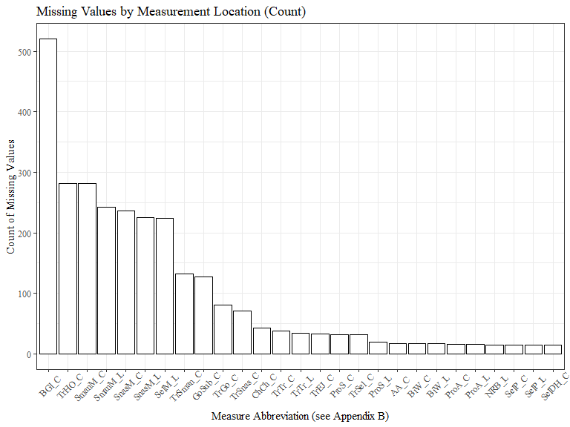

#bar chart with proportions  
ggplot(data=measureNAs, aes(x=measure_name, y=measureNAprops))+  
 geom_bar(stat= "identity", color= "black", fill = "white")+  
 theme_bw()+theme(text=element_text(family= "Times New Roman"))+  
 theme(axis.text.x = element_text(angle = 45, vjust=0.7))+  
 labs(title="Missing Values by Measurement Location (Proportion)",  
 y="Proportion of Missing Values",  
 x="Measure Abbreviation (see Appendix B)")

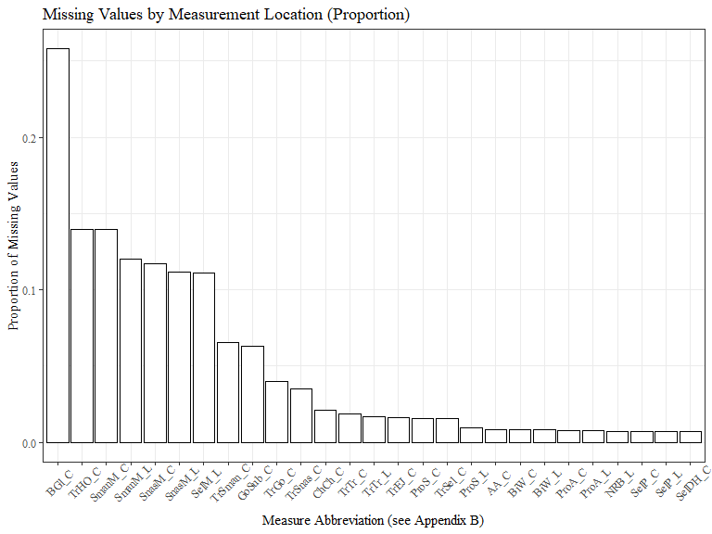

#write_xlsx(measureNAs, "C:\\Users\\19177\\OneDrive - Colostate\\Desktop\\Dissertation\\headscan_dissertation\\measureNAs.xlsx")

AA_C race/eth, gender, age group sumstats

#histogram of all AA_C values  
ggplot(data=headscan_full, aes(x=AA_C))+  
 geom_bar(stat="bin", bins=20, color= "black", fill = "white")+  
 theme_bw()+theme(text=element_text(family= "Times New Roman"))+  
 labs(title="Alare to Alare Contour Measurement Distribution",  
 y="Frequency",  
 x="Alare to Alare Contour (mm)")

## Warning: Removed 17 rows containing non-finite values (stat_bin).

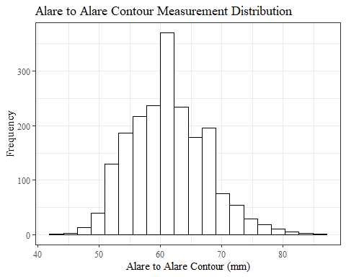

AA_Csumstats <- headscan_full %>%   
 summarise(n = n(), na = sum(is.na(AA_C)),  
 min = min(AA_C, na.rm = TRUE),  
 max = max(AA_C, na.rm = TRUE),  
 mean = mean(AA_C, na.rm = TRUE),  
 mdn = median(AA_C, na.rm = TRUE),  
 sd = sd(AA_C, na.rm = TRUE),  
 se = sd/sqrt(n),  
 percent5th = quantile(AA_C, 0.05, na.rm=TRUE),  
 percent25th = quantile(AA_C, 0.25, na.rm=TRUE),  
 percent50th = quantile(AA_C, 0.50, na.rm=TRUE),  
 percent75th = quantile(AA_C, 0.75, na.rm=TRUE),  
 percent95th = quantile(AA_C, 0.95, na.rm=TRUE))  
   
AA_Csumstats <- round(AA_Csumstats, 2)  
  
#Size 12 Table TNR  
flextable(AA_Csumstats) %>%  
 my_ft_theme()%>%   
 bold(part = "header") %>%   
 set_caption("Alare to Alare Contour SumStats")

**Table** : Alare to Alare Contour SumStats

| **n** | **na** | **min** | **max** | **mean** | **mdn** | **sd** | **se** | **percent5th** | **percent25th** | **percent50th** | **percent75th** | **percent95th** |
| --- | --- | --- | --- | --- | --- | --- | --- | --- | --- | --- | --- | --- |
| 2,016 | 17 | 44 | 87 | 61.25 | 61 | 6.24 | 0.14 | 52 | 57 | 61 | 65 | 72 |

#%>% set_header_labels(values = list(AA_C = "Alare/AlareCont"))  
  
#Autofit Width Table TNR  
flextable(AA_Csumstats) %>%  
 my_ft_theme()%>%   
 bold(part = "header") %>%   
 set_caption("Alare to Alare Contour SumStats") %>%   
 fit_to_width(7.5)

**Table** : Alare to Alare Contour SumStats

| **n** | **na** | **min** | **max** | **mean** | **mdn** | **sd** | **se** | **percent5th** | **percent25th** | **percent50th** | **percent75th** | **percent95th** |
| --- | --- | --- | --- | --- | --- | --- | --- | --- | --- | --- | --- | --- |
| 2,016 | 17 | 44 | 87 | 61.25 | 61 | 6.24 | 0.14 | 52 | 57 | 61 | 65 | 72 |

#%>% set_header_labels(values = list(AA_C = "Alare/AlareCont"))

#AA_C race_eth sumstats  
AA_Crace_sumstats <- headscan_full %>%   
 group_by(race_eth) %>%   
 summarise(n = n(), na = sum(is.na(AA_C)),  
 min = min(AA_C, na.rm = TRUE),  
 max = max(AA_C, na.rm = TRUE),  
 mean = mean(AA_C, na.rm = TRUE),  
 mdn = median(AA_C, na.rm = TRUE),  
 sd = sd(AA_C, na.rm = TRUE),  
 se = sd/sqrt(n),  
 percent5th = quantile(AA_C, 0.05, na.rm=TRUE),  
 percent25th = quantile(AA_C, 0.25, na.rm=TRUE),  
 percent50th = quantile(AA_C, 0.50, na.rm=TRUE),  
 percent75th = quantile(AA_C, 0.75, na.rm=TRUE),  
 percent95th = quantile(AA_C, 0.95, na.rm=TRUE))   
  
AA_Crace_sumstats <- AA_Crace_sumstats %>%   
 mutate(across(where(is.numeric), round, 2))  
  
  
#Size 12 Table TNR  
flextable(AA_Crace_sumstats) %>%  
 my_ft_theme()%>%   
 bold(part = "header") %>%   
 set_caption("Alare to Alare Contour SumStats by Race/Ethnicity")

**Table** : Alare to Alare Contour SumStats by Race/Ethnicity

| **race_eth** | **n** | **na** | **min** | **max** | **mean** | **mdn** | **sd** | **se** | **percent5th** | **percent25th** | **percent50th** | **percent75th** | **percent95th** |
| --- | --- | --- | --- | --- | --- | --- | --- | --- | --- | --- | --- | --- | --- |
| white | 1,239 | 9 | 44 | 83 | 61.10 | 61 | 6.05 | 0.17 | 52.00 | 57.00 | 61 | 65 | 72.00 |
| Black | 548 | 5 | 47 | 87 | 61.93 | 61 | 6.51 | 0.28 | 52.00 | 57.00 | 61 | 66 | 73.90 |
| LatinX | 100 | 1 | 47 | 75 | 61.54 | 62 | 6.28 | 0.63 | 51.90 | 57.00 | 62 | 66 | 72.10 |
| Asian | 91 | 1 | 50 | 77 | 59.14 | 58 | 6.91 | 0.72 | 50.00 | 53.25 | 58 | 63 | 72.55 |
| Other | 21 | 0 | 45 | 73 | 60.81 | 62 | 6.28 | 1.37 | 50.00 | 60.00 | 62 | 63 | 68.00 |
| AIAN | 8 | 1 | 52 | 69 | 60.86 | 61 | 5.79 | 2.05 | 53.50 | 58.00 | 61 | 64 | 68.40 |
| PTNS | 5 | 0 | 59 | 67 | 61.60 | 61 | 3.13 | 1.40 | 59.20 | 60.00 | 61 | 61 | 65.80 |
| NHOPI | 4 | 0 | 56 | 65 | 59.75 | 59 | 4.11 | 2.06 | 56.15 | 56.75 | 59 | 62 | 64.40 |

#%>% set_header_labels(values = list(AA_C = "Alare/AlareCont"))  
  
#Autofit Width Table TNR  
flextable(AA_Crace_sumstats) %>%  
 my_ft_theme()%>%   
 bold(part = "header") %>%   
 set_caption("Alare to Alare Contour SumStats by Race/Ethnicity") %>%   
 fit_to_width(7.5)

**Table** : Alare to Alare Contour SumStats by Race/Ethnicity

| **race_eth** | **n** | **na** | **min** | **max** | **mean** | **mdn** | **sd** | **se** | **percent5th** | **percent25th** | **percent50th** | **percent75th** | **percent95th** |
| --- | --- | --- | --- | --- | --- | --- | --- | --- | --- | --- | --- | --- | --- |
| white | 1,239 | 9 | 44 | 83 | 61.10 | 61 | 6.05 | 0.17 | 52.00 | 57.00 | 61 | 65 | 72.00 |
| Black | 548 | 5 | 47 | 87 | 61.93 | 61 | 6.51 | 0.28 | 52.00 | 57.00 | 61 | 66 | 73.90 |
| LatinX | 100 | 1 | 47 | 75 | 61.54 | 62 | 6.28 | 0.63 | 51.90 | 57.00 | 62 | 66 | 72.10 |
| Asian | 91 | 1 | 50 | 77 | 59.14 | 58 | 6.91 | 0.72 | 50.00 | 53.25 | 58 | 63 | 72.55 |
| Other | 21 | 0 | 45 | 73 | 60.81 | 62 | 6.28 | 1.37 | 50.00 | 60.00 | 62 | 63 | 68.00 |
| AIAN | 8 | 1 | 52 | 69 | 60.86 | 61 | 5.79 | 2.05 | 53.50 | 58.00 | 61 | 64 | 68.40 |
| PTNS | 5 | 0 | 59 | 67 | 61.60 | 61 | 3.13 | 1.40 | 59.20 | 60.00 | 61 | 61 | 65.80 |
| NHOPI | 4 | 0 | 56 | 65 | 59.75 | 59 | 4.11 | 2.06 | 56.15 | 56.75 | 59 | 62 | 64.40 |

#%>% set_header_labels(values = list(AA_C = "Alare/AlareCont"))  
  
#boxplot reorderd by median  
headscan_full %>%   
 ungroup() %>%   
 mutate(race_eth= fct_reorder(race_eth, AA_C, FUN=median, na.rm=TRUE)) %>%   
 ggplot(aes(y=AA_C, x=race_eth))+  
 geom_boxplot(color= "black", fill = "white")+  
 theme_bw()+theme(text=element_text(family= "Times New Roman"))+  
 #theme(axis.text.x = element_text(angle = 20, vjust=0.7))+  
 labs(title="Alare to Alare Contour values by Race/Ethnicity",  
 y="Measurement (mm)",  
 x="Race/Ethnicity")

## Warning: Removed 17 rows containing non-finite values (stat_boxplot).

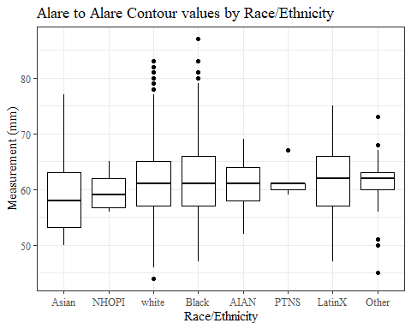

#boxplot not reordered by median  
ggplot(data=headscan_full, aes(y=AA_C, x=race_eth))+  
 geom_boxplot(color= "black", fill = "white")+  
 theme_bw()+theme(text=element_text(family= "Times New Roman"))+  
 #theme(axis.text.x = element_text(angle = 20, vjust=0.7))+  
 labs(title="Alare to Alare Contour values by Race/Ethnicity",  
 y="Measurement (mm)",  
 x="Race/Ethnicity")

## Warning: Removed 17 rows containing non-finite values (stat_boxplot).

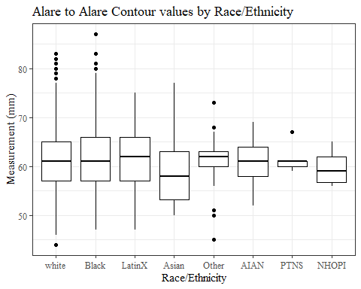

#AA_C gender sumstats  
AA_Cgender_sumstats <- headscan_full %>%   
 group_by(gender) %>%   
 summarise(n = n(), na = sum(is.na(AA_C)),  
 min = min(AA_C, na.rm = TRUE),  
 max = max(AA_C, na.rm = TRUE),  
 mean = mean(AA_C, na.rm = TRUE),  
 mdn = median(AA_C, na.rm = TRUE),  
 sd = sd(AA_C, na.rm = TRUE),  
 se = sd/sqrt(n),  
 percent5th = quantile(AA_C, 0.05, na.rm=TRUE),  
 percent25th = quantile(AA_C, 0.25, na.rm=TRUE),  
 percent50th = quantile(AA_C, 0.50, na.rm=TRUE),  
 percent75th = quantile(AA_C, 0.75, na.rm=TRUE),  
 percent95th = quantile(AA_C, 0.95, na.rm=TRUE))  
  
AA_Cgender_sumstats <- AA_Cgender_sumstats %>%   
 mutate(across(where(is.numeric), round, 2))  
  
#Size 12 Table TNR  
flextable(AA_Cgender_sumstats) %>%  
 my_ft_theme()%>%   
 bold(part = "header") %>%   
 set_caption("Alare to Alare Contour SumStats by Gender")

**Table** : Alare to Alare Contour SumStats by Gender

| **gender** | **n** | **na** | **min** | **max** | **mean** | **mdn** | **sd** | **se** | **percent5th** | **percent25th** | **percent50th** | **percent75th** | **percent95th** |
| --- | --- | --- | --- | --- | --- | --- | --- | --- | --- | --- | --- | --- | --- |
| Female | 1,063 | 12 | 44 | 77 | 58.32 | 58 | 5.00 | 0.15 | 51.0 | 55.00 | 58 | 62.00 | 67.00 |
| Male | 939 | 5 | 47 | 87 | 64.58 | 64 | 5.85 | 0.19 | 56.0 | 60.00 | 64 | 68.00 | 74.35 |
| Non-binary or Other | 5 | 0 | 52 | 68 | 60.80 | 62 | 5.76 | 2.58 | 53.6 | 60.00 | 62 | 62.00 | 66.80 |
| Prefer not to say | 1 | 0 | 61 | 61 | 61.00 | 61 |  |  | 61.0 | 61.00 | 61 | 61.00 | 61.00 |
|  | 8 | 0 | 53 | 66 | 58.62 | 58 | 4.31 | 1.52 | 53.7 | 55.75 | 58 | 60.75 | 64.95 |

#%>% set_header_labels(values = list(AA_C = "Alare/AlareCont"))  
  
#Autofit Width Table TNR  
flextable(AA_Cgender_sumstats) %>%  
 my_ft_theme()%>%   
 bold(part = "header") %>%   
 set_caption("Alare to Alare Contour SumStats by Gender") %>%   
 fit_to_width(7.5)

**Table** : Alare to Alare Contour SumStats by Gender

| **gender** | **n** | **na** | **min** | **max** | **mean** | **mdn** | **sd** | **se** | **percent5th** | **percent25th** | **percent50th** | **percent75th** | **percent95th** |
| --- | --- | --- | --- | --- | --- | --- | --- | --- | --- | --- | --- | --- | --- |
| Female | 1,063 | 12 | 44 | 77 | 58.32 | 58 | 5.00 | 0.15 | 51.0 | 55.00 | 58 | 62.00 | 67.00 |
| Male | 939 | 5 | 47 | 87 | 64.58 | 64 | 5.85 | 0.19 | 56.0 | 60.00 | 64 | 68.00 | 74.35 |
| Non-binary or Other | 5 | 0 | 52 | 68 | 60.80 | 62 | 5.76 | 2.58 | 53.6 | 60.00 | 62 | 62.00 | 66.80 |
| Prefer not to say | 1 | 0 | 61 | 61 | 61.00 | 61 |  |  | 61.0 | 61.00 | 61 | 61.00 | 61.00 |
|  | 8 | 0 | 53 | 66 | 58.62 | 58 | 4.31 | 1.52 | 53.7 | 55.75 | 58 | 60.75 | 64.95 |

#%>% set_header_labels(values = list(AA_C = "Alare/AlareCont"))  
  
#boxplot reorderd by median  
headscan_full %>%   
 ungroup() %>%   
 mutate(gender= fct_reorder(gender, AA_C, FUN=median, na.rm=TRUE)) %>%   
 ggplot(aes(y=AA_C, x=gender))+  
 geom_boxplot(color= "black", fill = "white")+  
 theme_bw()+theme(text=element_text(family= "Times New Roman"))+  
 theme(axis.text.x = element_text(angle = 20, vjust=0.7))+  
 labs(title="Alare to Alare Contour values by Gender",  
 y="Measurement (mm)",  
 x="Gender")

## Warning: Removed 17 rows containing non-finite values (stat_boxplot).

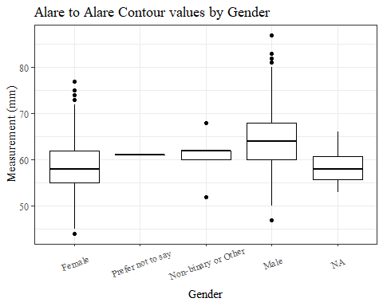

#boxplot not reordered by median  
ggplot(data=headscan_full, aes(y=AA_C, x=gender))+  
 geom_boxplot(color= "black", fill = "white")+  
 theme_bw()+theme(text=element_text(family= "Times New Roman"))+  
 theme(axis.text.x = element_text(angle = 20, vjust=0.7))+  
 labs(title="Alare to Alare Contour values by Gender",  
 y="Measurement (mm)",  
 x="Gender")

## Warning: Removed 17 rows containing non-finite values (stat_boxplot).

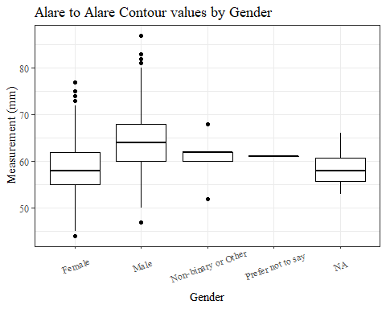

#AA_C age group sumstats  
AA_Cage_sumstats <- headscan_full %>%   
 group_by(age_group) %>%   
 summarise(n = n(), na = sum(is.na(AA_C)),  
 min = min(AA_C, na.rm = TRUE),  
 max = max(AA_C, na.rm = TRUE),  
 mean = mean(AA_C, na.rm = TRUE),  
 mdn = median(AA_C, na.rm = TRUE),  
 sd = sd(AA_C, na.rm = TRUE),  
 se = sd/sqrt(n),  
 percent5th = quantile(AA_C, 0.05, na.rm=TRUE),  
 percent25th = quantile(AA_C, 0.25, na.rm=TRUE),  
 percent50th = quantile(AA_C, 0.50, na.rm=TRUE),  
 percent75th = quantile(AA_C, 0.75, na.rm=TRUE),  
 percent95th = quantile(AA_C, 0.95, na.rm=TRUE))  
  
AA_Cage_sumstats <- AA_Cage_sumstats %>%   
 mutate(across(where(is.numeric), round, 2))  
  
  
#Size 12 Table TNR  
flextable(AA_Cage_sumstats) %>%  
 my_ft_theme()%>%   
 bold(part = "header") %>%   
 set_caption("Alare to Alare Contour SumStats by Age Group")

**Table** : Alare to Alare Contour SumStats by Age Group

| **age_group** | **n** | **na** | **min** | **max** | **mean** | **mdn** | **sd** | **se** | **percent5th** | **percent25th** | **percent50th** | **percent75th** | **percent95th** |
| --- | --- | --- | --- | --- | --- | --- | --- | --- | --- | --- | --- | --- | --- |
| 18-36 | 991 | 6 | 46 | 83 | 60.34 | 60 | 5.93 | 0.19 | 52.0 | 56 | 60 | 64 | 70 |
| 37-54 | 940 | 10 | 44 | 81 | 61.98 | 62 | 6.35 | 0.21 | 52.0 | 57 | 62 | 66 | 73 |
| 55-72 | 84 | 1 | 50 | 87 | 63.88 | 63 | 6.92 | 0.76 | 54.1 | 59 | 63 | 67 | 74 |
|  | 1 | 0 | 64 | 64 | 64.00 | 64 |  |  | 64.0 | 64 | 64 | 64 | 64 |

#%>% set_header_labels(values = list(AA_C = "Alare/AlareCont"))  
  
#Autofit Width Table TNR  
flextable(AA_Cage_sumstats) %>%  
 my_ft_theme()%>%   
 bold(part = "header") %>%   
 set_caption("Alare to Alare Contour SumStats by Age Group") %>%   
 fit_to_width(7.5)

**Table** : Alare to Alare Contour SumStats by Age Group

| **age_group** | **n** | **na** | **min** | **max** | **mean** | **mdn** | **sd** | **se** | **percent5th** | **percent25th** | **percent50th** | **percent75th** | **percent95th** |
| --- | --- | --- | --- | --- | --- | --- | --- | --- | --- | --- | --- | --- | --- |
| 18-36 | 991 | 6 | 46 | 83 | 60.34 | 60 | 5.93 | 0.19 | 52.0 | 56 | 60 | 64 | 70 |
| 37-54 | 940 | 10 | 44 | 81 | 61.98 | 62 | 6.35 | 0.21 | 52.0 | 57 | 62 | 66 | 73 |
| 55-72 | 84 | 1 | 50 | 87 | 63.88 | 63 | 6.92 | 0.76 | 54.1 | 59 | 63 | 67 | 74 |
|  | 1 | 0 | 64 | 64 | 64.00 | 64 |  |  | 64.0 | 64 | 64 | 64 | 64 |

#%>% set_header_labels(values = list(AA_C = "Alare/AlareCont"))  
  
#boxplot reorderd by median  
headscan_full %>%   
 ungroup() %>%   
 mutate(age_group= fct_reorder(age_group, AA_C, FUN=median, na.rm=TRUE)) %>%   
 ggplot(aes(y=AA_C, x=age_group))+  
 geom_boxplot(color= "black", fill = "white")+  
 theme_bw()+theme(text=element_text(family= "Times New Roman"))+  
 #theme(axis.text.x = element_text(angle = 20, vjust=0.7))+  
 labs(title="Alare to Alare Contour values by Age Group",  
 y="Measurement (mm)",  
 x="Age Group")

## Warning: Removed 17 rows containing non-finite values (stat_boxplot).

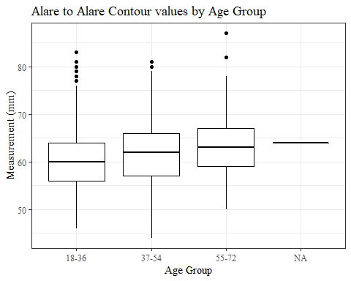

#boxplot not reordered by median  
ggplot(data=headscan_full, aes(y=AA_C, x=age_group))+  
 geom_boxplot(color= "black", fill = "white")+  
 theme_bw()+theme(text=element_text(family= "Times New Roman"))+  
 #theme(axis.text.x = element_text(angle = 20, vjust=0.7))+  
 labs(title="Alare to Alare Contour values by Age Group",  
 y="Measurement (mm)",  
 x="Age Group")

## Warning: Removed 17 rows containing non-finite values (stat_boxplot).



BGl_C race/eth, gender, age group sumstats

#histogram of all BGl_C values  
ggplot(data=headscan_full, aes(x=BGl_C))+  
 geom_bar(stat="bin", bins=20, color= "black", fill = "white")+  
 theme_bw()+theme(text=element_text(family= "Times New Roman"))+  
 labs(title="Back of Head to Glabella Contour Measurement Distribution",  
 y="Frequency",  
 x="Back of Head to Glabella Contour (mm)")

## Warning: Removed 520 rows containing non-finite values (stat_bin).

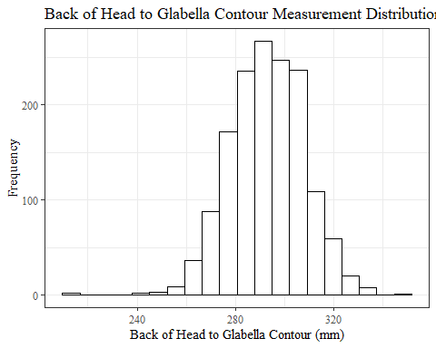

BGl_Csumstats <- headscan_full %>%   
 summarise(n = n(), na = sum(is.na(BGl_C)),  
 min = min(BGl_C, na.rm = TRUE),  
 max = max(BGl_C, na.rm = TRUE),  
 mean = mean(BGl_C, na.rm = TRUE),  
 mdn = median(BGl_C, na.rm = TRUE),  
 sd = sd(BGl_C, na.rm = TRUE),  
 se = sd/sqrt(n),  
 percent5th = quantile(BGl_C, 0.05, na.rm=TRUE),  
 percent25th = quantile(BGl_C, 0.25, na.rm=TRUE),  
 percent50th = quantile(BGl_C, 0.50, na.rm=TRUE),  
 percent75th = quantile(BGl_C, 0.75, na.rm=TRUE),  
 percent95th = quantile(BGl_C, 0.95, na.rm=TRUE))   
  
BGl_Csumstats <- round(BGl_Csumstats, 2)  
  
#Size 12 Table TNR  
flextable(BGl_Csumstats) %>%  
 my_ft_theme()%>%   
 bold(part = "header") %>%   
 set_caption("Back of Head to Glabella Contour SumStats")

**Table** : Back of Head to Glabella Contour SumStats

| **n** | **na** | **min** | **max** | **mean** | **mdn** | **sd** | **se** | **percent5th** | **percent25th** | **percent50th** | **percent75th** | **percent95th** |
| --- | --- | --- | --- | --- | --- | --- | --- | --- | --- | --- | --- | --- |
| 2,016 | 520 | 215 | 350 | 292.83 | 293 | 15.13 | 0.34 | 269 | 283 | 293 | 303 | 318 |

#%>% set_header_labels(values = list(AA_C = "Alare/AlareCont"))  
  
#Autofit Width Table TNR  
flextable(BGl_Csumstats) %>%  
 my_ft_theme()%>%   
 bold(part = "header") %>%   
 set_caption("Back of Head to Glabella Contour SumStats") %>%   
 fit_to_width(7.5)

**Table** : Back of Head to Glabella Contour SumStats

| **n** | **na** | **min** | **max** | **mean** | **mdn** | **sd** | **se** | **percent5th** | **percent25th** | **percent50th** | **percent75th** | **percent95th** |
| --- | --- | --- | --- | --- | --- | --- | --- | --- | --- | --- | --- | --- |
| 2,016 | 520 | 215 | 350 | 292.83 | 293 | 15.13 | 0.34 | 269 | 283 | 293 | 303 | 318 |

#%>% set_header_labels(values = list(AA_C = "Alare/AlareCont"))

#BGl_C race/eth sumstats  
BGl_Crace_sumstats <- headscan_full %>%   
 group_by(race_eth) %>%   
 summarise(n = n(), na = sum(is.na(BGl_C)),  
 min = min(BGl_C, na.rm = TRUE),  
 max = max(BGl_C, na.rm = TRUE),  
 mean = mean(BGl_C, na.rm = TRUE),  
 mdn = median(BGl_C, na.rm = TRUE),  
 sd = sd(BGl_C, na.rm = TRUE),  
 se = sd/sqrt(n),  
 percent5th = quantile(BGl_C, 0.05, na.rm=TRUE),  
 percent25th = quantile(BGl_C, 0.25, na.rm=TRUE),  
 percent50th = quantile(BGl_C, 0.50, na.rm=TRUE),  
 percent75th = quantile(BGl_C, 0.75, na.rm=TRUE),  
 percent95th = quantile(BGl_C, 0.95, na.rm=TRUE))   
  
BGl_Crace_sumstats <- BGl_Crace_sumstats %>%   
 mutate(across(where(is.numeric), round, 2))  
  
  
#Size 12 Table TNR  
flextable(BGl_Crace_sumstats) %>%  
 my_ft_theme()%>%   
 bold(part = "header") %>%   
 set_caption("Back of Head to Glabella Contour SumStats by Race/Ethnicity")

**Table** : Back of Head to Glabella Contour SumStats by Race/Ethnicity

| **race_eth** | **n** | **na** | **min** | **max** | **mean** | **mdn** | **sd** | **se** | **percent5th** | **percent25th** | **percent50th** | **percent75th** | **percent95th** |
| --- | --- | --- | --- | --- | --- | --- | --- | --- | --- | --- | --- | --- | --- |
| white | 1,239 | 271 | 216 | 333 | 291.99 | 292.0 | 14.76 | 0.42 | 269.00 | 282.00 | 292.0 | 303.0 | 316.00 |
| Black | 548 | 197 | 243 | 350 | 297.17 | 296.0 | 14.95 | 0.64 | 274.00 | 285.00 | 296.0 | 308.0 | 323.00 |
| LatinX | 100 | 21 | 262 | 331 | 290.70 | 290.0 | 13.97 | 1.40 | 268.70 | 281.00 | 290.0 | 299.0 | 316.10 |
| Asian | 91 | 17 | 250 | 320 | 285.55 | 285.5 | 14.14 | 1.48 | 264.30 | 276.00 | 285.5 | 296.0 | 306.05 |
| Other | 21 | 6 | 215 | 334 | 288.40 | 289.0 | 26.86 | 5.86 | 252.80 | 279.00 | 289.0 | 301.5 | 324.20 |
| AIAN | 8 | 4 | 284 | 307 | 294.75 | 294.0 | 9.46 | 3.35 | 285.35 | 290.75 | 294.0 | 298.0 | 305.20 |
| PTNS | 5 | 4 | 294 | 294 | 294.00 | 294.0 |  |  | 294.00 | 294.00 | 294.0 | 294.0 | 294.00 |
| NHOPI | 4 | 0 | 296 | 319 | 306.75 | 306.0 | 9.46 | 4.73 | 297.35 | 302.75 | 306.0 | 310.0 | 317.20 |

#%>% set_header_labels(values = list(BGl_C = "Alare/AlareCont"))  
  
#Autofit Width Table TNR  
flextable(BGl_Crace_sumstats) %>%  
 my_ft_theme()%>%   
 bold(part = "header") %>%   
 set_caption("Back of Head to Glabella Contour SumStats by Race/Ethnicity") %>%   
 fit_to_width(7.5)

**Table** : Back of Head to Glabella Contour SumStats by Race/Ethnicity

| **race_eth** | **n** | **na** | **min** | **max** | **mean** | **mdn** | **sd** | **se** | **percent5th** | **percent25th** | **percent50th** | **percent75th** | **percent95th** |
| --- | --- | --- | --- | --- | --- | --- | --- | --- | --- | --- | --- | --- | --- |
| white | 1,239 | 271 | 216 | 333 | 291.99 | 292.0 | 14.76 | 0.42 | 269.00 | 282.00 | 292.0 | 303.0 | 316.00 |
| Black | 548 | 197 | 243 | 350 | 297.17 | 296.0 | 14.95 | 0.64 | 274.00 | 285.00 | 296.0 | 308.0 | 323.00 |
| LatinX | 100 | 21 | 262 | 331 | 290.70 | 290.0 | 13.97 | 1.40 | 268.70 | 281.00 | 290.0 | 299.0 | 316.10 |
| Asian | 91 | 17 | 250 | 320 | 285.55 | 285.5 | 14.14 | 1.48 | 264.30 | 276.00 | 285.5 | 296.0 | 306.05 |
| Other | 21 | 6 | 215 | 334 | 288.40 | 289.0 | 26.86 | 5.86 | 252.80 | 279.00 | 289.0 | 301.5 | 324.20 |
| AIAN | 8 | 4 | 284 | 307 | 294.75 | 294.0 | 9.46 | 3.35 | 285.35 | 290.75 | 294.0 | 298.0 | 305.20 |
| PTNS | 5 | 4 | 294 | 294 | 294.00 | 294.0 |  |  | 294.00 | 294.00 | 294.0 | 294.0 | 294.00 |
| NHOPI | 4 | 0 | 296 | 319 | 306.75 | 306.0 | 9.46 | 4.73 | 297.35 | 302.75 | 306.0 | 310.0 | 317.20 |

#%>% set_header_labels(values = list(BGl_C = "Alare/AlareCont"))  
  
#boxplot reorderd by median  
headscan_full %>%   
 ungroup() %>%   
 mutate(race_eth= fct_reorder(race_eth, BGl_C, FUN=median, na.rm=TRUE)) %>%   
 ggplot(aes(y=BGl_C, x=race_eth))+  
 geom_boxplot(color= "black", fill = "white")+  
 theme_bw()+theme(text=element_text(family= "Times New Roman"))+  
 #theme(axis.text.x = element_text(angle = 20, vjust=0.7))+  
 labs(title="Back of Head to Glabella Contour values by Race/Ethnicity",  
 y="Measurement (mm)",  
 x="Race/Ethnicity")

## Warning: Removed 520 rows containing non-finite values (stat_boxplot).

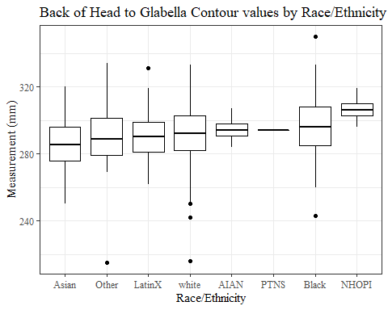

#boxplot not reordered by median  
ggplot(data=headscan_full, aes(y=BGl_C, x=race_eth))+  
 geom_boxplot(color= "black", fill = "white")+  
 theme_bw()+theme(text=element_text(family= "Times New Roman"))+  
 #theme(axis.text.x = element_text(angle = 20, vjust=0.7))+  
 labs(title="Back of Head to Glabella Contour values by Race/Ethnicity",  
 y="Measurement (mm)",  
 x="Race/Ethnicity")

## Warning: Removed 520 rows containing non-finite values (stat_boxplot).

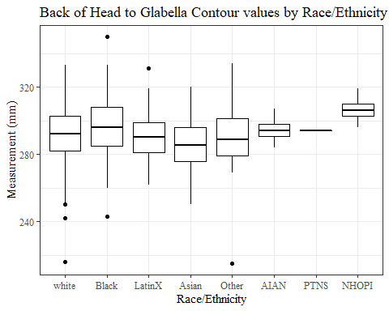

#BGl_C gender sumstats  
BGl_Cgender_sumstats <- headscan_full %>%   
 group_by(gender) %>%   
 summarise(n = n(), na = sum(is.na(BGl_C)),  
 min = min(BGl_C, na.rm = TRUE),  
 max = max(BGl_C, na.rm = TRUE),  
 mean = mean(BGl_C, na.rm = TRUE),  
 mdn = median(BGl_C, na.rm = TRUE),  
 sd = sd(BGl_C, na.rm = TRUE),  
 se = sd/sqrt(n),  
 percent5th = quantile(BGl_C, 0.05, na.rm=TRUE),  
 percent25th = quantile(BGl_C, 0.25, na.rm=TRUE),  
 percent50th = quantile(BGl_C, 0.50, na.rm=TRUE),  
 percent75th = quantile(BGl_C, 0.75, na.rm=TRUE),  
 percent95th = quantile(BGl_C, 0.95, na.rm=TRUE))

## Warning in min(BGl_C, na.rm = TRUE): no non-missing arguments to min; returning  
## Inf

## Warning in max(BGl_C, na.rm = TRUE): no non-missing arguments to max; returning  
## -Inf

BGl_Cgender_sumstats <- BGl_Cgender_sumstats %>%   
 mutate(across(where(is.numeric), round, 2))  
  
#Size 12 Table TNR  
flextable(BGl_Cgender_sumstats) %>%  
 my_ft_theme()%>%   
 bold(part = "header") %>%   
 set_caption("Back of Head to Glabella Contour SumStats by Gender")

**Table** : Back of Head to Glabella Contour SumStats by Gender

| **gender** | **n** | **na** | **min** | **max** | **mean** | **mdn** | **sd** | **se** | **percent5th** | **percent25th** | **percent50th** | **percent75th** | **percent95th** |
| --- | --- | --- | --- | --- | --- | --- | --- | --- | --- | --- | --- | --- | --- |
| Female | 1,063 | 454 | 242 | 332 | 286.40 | 286 | 13.72 | 0.42 | 264.40 | 278.00 | 286 | 295.00 | 310.00 |
| Male | 939 | 61 | 215 | 350 | 297.45 | 298 | 14.36 | 0.47 | 275.00 | 288.00 | 298 | 307.00 | 320.00 |
| Non-binary or Other | 5 | 0 | 268 | 289 | 277.60 | 273 | 9.69 | 4.33 | 268.60 | 271.00 | 273 | 287.00 | 288.60 |
| Prefer not to say | 1 | 1 | Inf | -Inf |  |  |  |  |  |  |  |  |  |
|  | 8 | 4 | 269 | 281 | 275.50 | 276 | 5.92 | 2.09 | 269.45 | 271.25 | 276 | 280.25 | 280.85 |

#%>% set_header_labels(values = list(BGl_C = "Alare/AlareCont"))  
  
#Autofit Width Table TNR  
flextable(BGl_Cgender_sumstats) %>%  
 my_ft_theme()%>%   
 bold(part = "header") %>%   
 set_caption("Back of Head to Glabella Contour SumStats by Gender") %>%   
 fit_to_width(7.5)

**Table** : Back of Head to Glabella Contour SumStats by Gender

| **gender** | **n** | **na** | **min** | **max** | **mean** | **mdn** | **sd** | **se** | **percent5th** | **percent25th** | **percent50th** | **percent75th** | **percent95th** |
| --- | --- | --- | --- | --- | --- | --- | --- | --- | --- | --- | --- | --- | --- |
| Female | 1,063 | 454 | 242 | 332 | 286.40 | 286 | 13.72 | 0.42 | 264.40 | 278.00 | 286 | 295.00 | 310.00 |
| Male | 939 | 61 | 215 | 350 | 297.45 | 298 | 14.36 | 0.47 | 275.00 | 288.00 | 298 | 307.00 | 320.00 |
| Non-binary or Other | 5 | 0 | 268 | 289 | 277.60 | 273 | 9.69 | 4.33 | 268.60 | 271.00 | 273 | 287.00 | 288.60 |
| Prefer not to say | 1 | 1 | Inf | -Inf |  |  |  |  |  |  |  |  |  |
|  | 8 | 4 | 269 | 281 | 275.50 | 276 | 5.92 | 2.09 | 269.45 | 271.25 | 276 | 280.25 | 280.85 |

#%>% set_header_labels(values = list(BGl_C = "Alare/AlareCont"))  
  
#boxplot reorderd by median  
headscan_full %>%   
 ungroup() %>%   
 mutate(gender= fct_reorder(gender, BGl_C, FUN=median, na.rm=TRUE)) %>%   
 ggplot(aes(y=BGl_C, x=gender))+  
 geom_boxplot(color= "black", fill = "white")+  
 theme_bw()+theme(text=element_text(family= "Times New Roman"))+  
 theme(axis.text.x = element_text(angle = 20, vjust=0.7))+  
 labs(title="Back of Head to Glabella Contour values by Gender",  
 y="Measurement (mm)",  
 x="Gender")

## Warning: Removed 520 rows containing non-finite values (stat_boxplot).

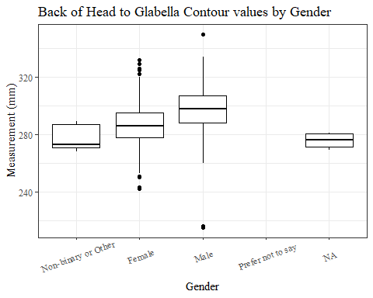

#boxplot not reordered by median  
ggplot(data=headscan_full, aes(y=BGl_C, x=gender))+  
 geom_boxplot(color= "black", fill = "white")+  
 theme_bw()+theme(text=element_text(family= "Times New Roman"))+  
 theme(axis.text.x = element_text(angle = 20, vjust=0.7))+  
 labs(title="Back of Head to Glabella Contour values by Gender",  
 y="Measurement (mm)",  
 x="Gender")

## Warning: Removed 520 rows containing non-finite values (stat_boxplot).

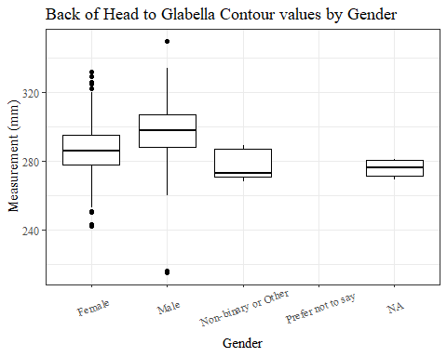

#BGl_C age group sumstats  
BGl_Cage_sumstats <- headscan_full %>%   
 group_by(age_group) %>%   
 summarise(n = n(), na = sum(is.na(BGl_C)),  
 min = min(BGl_C, na.rm = TRUE),  
 max = max(BGl_C, na.rm = TRUE),  
 mean = mean(BGl_C, na.rm = TRUE),  
 mdn = median(BGl_C, na.rm = TRUE),  
 sd = sd(BGl_C, na.rm = TRUE),  
 se = sd/sqrt(n),  
 percent5th = quantile(BGl_C, 0.05, na.rm=TRUE),  
 percent25th = quantile(BGl_C, 0.25, na.rm=TRUE),  
 percent50th = quantile(BGl_C, 0.50, na.rm=TRUE),  
 percent75th = quantile(BGl_C, 0.75, na.rm=TRUE),  
 percent95th = quantile(BGl_C, 0.95, na.rm=TRUE))  
  
BGl_Cage_sumstats <- BGl_Cage_sumstats %>%   
 mutate(across(where(is.numeric), round, 2))  
  
  
#Size 12 Table TNR  
flextable(BGl_Cage_sumstats) %>%  
 my_ft_theme()%>%   
 bold(part = "header") %>%   
 set_caption("Back of Head to Glabella Contour SumStats by Age Group")

**Table** : Back of Head to Glabella Contour SumStats by Age Group

| **age_group** | **n** | **na** | **min** | **max** | **mean** | **mdn** | **sd** | **se** | **percent5th** | **percent25th** | **percent50th** | **percent75th** | **percent95th** |
| --- | --- | --- | --- | --- | --- | --- | --- | --- | --- | --- | --- | --- | --- |
| 18-36 | 991 | 264 | 215 | 350 | 293.39 | 294 | 15.31 | 0.49 | 269.3 | 283.00 | 294 | 304 | 318.00 |
| 37-54 | 940 | 240 | 243 | 333 | 291.96 | 292 | 14.96 | 0.49 | 269.0 | 281.75 | 292 | 302 | 317.05 |
| 55-72 | 84 | 16 | 242 | 330 | 295.69 | 295 | 14.57 | 1.59 | 277.0 | 286.50 | 295 | 305 | 320.95 |
|  | 1 | 0 | 299 | 299 | 299.00 | 299 |  |  | 299.0 | 299.00 | 299 | 299 | 299.00 |

#%>% set_header_labels(values = list(BGl_C = "Alare/AlareCont"))  
  
#Autofit Width Table TNR  
flextable(BGl_Cage_sumstats) %>%  
 my_ft_theme()%>%   
 bold(part = "header") %>%   
 set_caption("Back of Head to Glabella Contour SumStats by Age Group") %>%   
 fit_to_width(7.5)

**Table** : Back of Head to Glabella Contour SumStats by Age Group

| **age_group** | **n** | **na** | **min** | **max** | **mean** | **mdn** | **sd** | **se** | **percent5th** | **percent25th** | **percent50th** | **percent75th** | **percent95th** |
| --- | --- | --- | --- | --- | --- | --- | --- | --- | --- | --- | --- | --- | --- |
| 18-36 | 991 | 264 | 215 | 350 | 293.39 | 294 | 15.31 | 0.49 | 269.3 | 283.00 | 294 | 304 | 318.00 |
| 37-54 | 940 | 240 | 243 | 333 | 291.96 | 292 | 14.96 | 0.49 | 269.0 | 281.75 | 292 | 302 | 317.05 |
| 55-72 | 84 | 16 | 242 | 330 | 295.69 | 295 | 14.57 | 1.59 | 277.0 | 286.50 | 295 | 305 | 320.95 |
|  | 1 | 0 | 299 | 299 | 299.00 | 299 |  |  | 299.0 | 299.00 | 299 | 299 | 299.00 |

#%>% set_header_labels(values = list(BGl_C = "Alare/AlareCont"))  
  
  
#boxplot reorderd by median  
headscan_full %>%   
 ungroup() %>%   
 mutate(age_group= fct_reorder(age_group, BGl_C, FUN=median, na.rm=TRUE)) %>%   
 ggplot(aes(y=BGl_C, x=age_group))+  
 geom_boxplot(color= "black", fill = "white")+  
 theme_bw()+theme(text=element_text(family= "Times New Roman"))+  
 #theme(axis.text.x = element_text(angle = 20, vjust=0.7))+  
 labs(title="Back of Head to Glabella Contour values by Age Group",  
 y="Measurement (mm)",  
 x="Age Group")

## Warning: Removed 520 rows containing non-finite values (stat_boxplot).

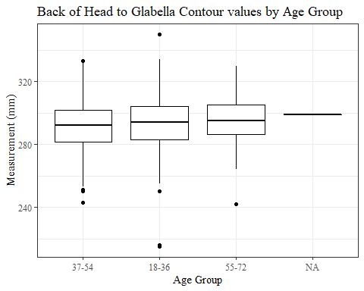

#boxplot not reordered by median  
ggplot(data=headscan_full, aes(y=BGl_C, x=age_group))+  
 geom_boxplot(color= "black", fill = "white")+  
 theme_bw()+theme(text=element_text(family= "Times New Roman"))+  
 #theme(axis.text.x = element_text(angle = 20, vjust=0.7))+  
 labs(title="Back of Head to Glabella Contour values by Age Group",  
 y="Measurement (mm)",  
 x="Age Group")

## Warning: Removed 520 rows containing non-finite values (stat_boxplot).

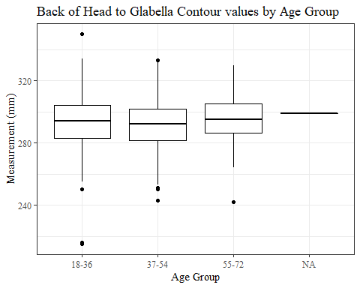

BiW_L

#histogram of all BiW_L values  
ggplot(data=headscan_full, aes(x=BiW_L))+  
 geom_bar(stat="bin", bins=20, color= "black", fill = "white")+  
 theme_bw()+theme(text=element_text(family= "Times New Roman"))+  
 labs(title="Bizygomatic Width Linear Measurement Distribution",  
 y="Frequency",  
 x="Bizygomatic Width Linear (mm)")

## Warning: Removed 17 rows containing non-finite values (stat_bin).

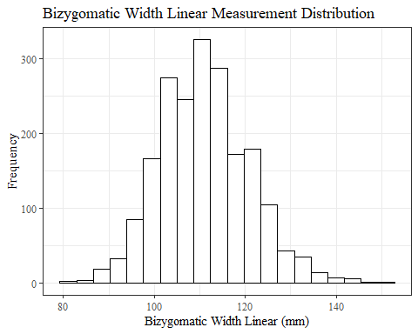

BiW_Lsumstats <- headscan_full %>%   
 summarise(n = n(), na = sum(is.na(BiW_L)),  
 min = min(BiW_L, na.rm = TRUE),  
 max = max(BiW_L, na.rm = TRUE),  
 mean = mean(BiW_L, na.rm = TRUE),  
 mdn = median(BiW_L, na.rm = TRUE),  
 sd = sd(BiW_L, na.rm = TRUE),  
 se = sd/sqrt(n),  
 percent5th = quantile(BiW_L, 0.05, na.rm=TRUE),  
 percent25th = quantile(BiW_L, 0.25, na.rm=TRUE),  
 percent50th = quantile(BiW_L, 0.50, na.rm=TRUE),  
 percent75th = quantile(BiW_L, 0.75, na.rm=TRUE),  
 percent95th = quantile(BiW_L, 0.95, na.rm=TRUE))   
  
BiW_Lsumstats <- round(BiW_Lsumstats, 2)  
  
#Size 12 Table TNR  
flextable(BiW_Lsumstats) %>%  
 my_ft_theme()%>%   
 bold(part = "header") %>%   
 set_caption("Bizygomatic Width Linear SumStats")

**Table** : Bizygomatic Width Linear SumStats

| **n** | **na** | **min** | **max** | **mean** | **mdn** | **sd** | **se** | **percent5th** | **percent25th** | **percent50th** | **percent75th** | **percent95th** |
| --- | --- | --- | --- | --- | --- | --- | --- | --- | --- | --- | --- | --- |
| 2,016 | 17 | 82 | 152 | 111.2 | 111 | 9.78 | 0.22 | 96 | 104 | 111 | 118 | 128 |

#%>% set_header_labels(values = list(BiW_L = "Alare/AlareCont"))  
  
#Autofit Width Table TNR  
flextable(BiW_Lsumstats) %>%  
 my_ft_theme()%>%   
 bold(part = "header") %>%   
 set_caption("Bizygomatic Width Linear SumStats") %>%   
 fit_to_width(7.5)

**Table** : Bizygomatic Width Linear SumStats

| **n** | **na** | **min** | **max** | **mean** | **mdn** | **sd** | **se** | **percent5th** | **percent25th** | **percent50th** | **percent75th** | **percent95th** |
| --- | --- | --- | --- | --- | --- | --- | --- | --- | --- | --- | --- | --- |
| 2,016 | 17 | 82 | 152 | 111.2 | 111 | 9.78 | 0.22 | 96 | 104 | 111 | 118 | 128 |

#%>% set_header_labels(values = list(BiW_L = "Alare/AlareCont"))

#BiW_L race/eth sumstats  
BiW_Lrace_sumstats <- headscan_full %>%   
 group_by(race_eth) %>%   
 summarise(n = n(), na = sum(is.na(BiW_L)),  
 min = min(BiW_L, na.rm = TRUE),  
 max = max(BiW_L, na.rm = TRUE),  
 mean = mean(BiW_L, na.rm = TRUE),  
 mdn = median(BiW_L, na.rm = TRUE),  
 sd = sd(BiW_L, na.rm = TRUE),  
 se = sd/sqrt(n),  
 percent5th = quantile(BiW_L, 0.05, na.rm=TRUE),  
 percent25th = quantile(BiW_L, 0.25, na.rm=TRUE),  
 percent50th = quantile(BiW_L, 0.50, na.rm=TRUE),  
 percent75th = quantile(BiW_L, 0.75, na.rm=TRUE),  
 percent95th = quantile(BiW_L, 0.95, na.rm=TRUE))   
  
BiW_Lrace_sumstats <- BiW_Lrace_sumstats %>%   
 mutate(across(where(is.numeric), round, 2))  
  
  
#Size 12 Table TNR  
flextable(BiW_Lrace_sumstats) %>%  
 my_ft_theme()%>%   
 bold(part = "header") %>%   
 set_caption("Bizygomatic Width Linear SumStats by Race/Ethnicity")

**Table** : Bizygomatic Width Linear SumStats by Race/Ethnicity

| **race_eth** | **n** | **na** | **min** | **max** | **mean** | **mdn** | **sd** | **se** | **percent5th** | **percent25th** | **percent50th** | **percent75th** | **percent95th** |
| --- | --- | --- | --- | --- | --- | --- | --- | --- | --- | --- | --- | --- | --- |
| white | 1,239 | 8 | 82 | 152 | 109.75 | 109 | 9.42 | 0.27 | 95.0 | 103.0 | 109 | 116 | 126.0 |
| Black | 548 | 5 | 91 | 148 | 114.55 | 114 | 9.87 | 0.42 | 100.0 | 108.0 | 114 | 121 | 132.0 |
| LatinX | 100 | 1 | 87 | 138 | 111.60 | 111 | 9.66 | 0.97 | 96.9 | 104.5 | 111 | 119 | 126.3 |
| Asian | 91 | 2 | 92 | 140 | 110.88 | 111 | 9.64 | 1.01 | 94.0 | 105.0 | 111 | 118 | 125.0 |
| Other | 21 | 0 | 97 | 129 | 108.29 | 109 | 9.67 | 2.11 | 97.0 | 98.0 | 109 | 113 | 126.0 |
| AIAN | 8 | 1 | 101 | 117 | 108.00 | 106 | 6.30 | 2.23 | 101.3 | 104.0 | 106 | 112 | 116.7 |
| PTNS | 5 | 0 | 102 | 125 | 113.40 | 113 | 10.11 | 4.52 | 102.6 | 105.0 | 113 | 122 | 124.4 |
| NHOPI | 4 | 0 | 110 | 122 | 116.50 | 117 | 5.00 | 2.50 | 110.9 | 114.5 | 117 | 119 | 121.4 |

#%>% set_header_labels(values = list(BiW_L = "Alare/AlareCont"))  
  
#Autofit Width Table TNR  
flextable(BiW_Lrace_sumstats) %>%  
 my_ft_theme()%>%   
 bold(part = "header") %>%   
 set_caption("Bizygomatic Width Linear SumStats by Race/Ethnicity") %>%   
 fit_to_width(7.5)

**Table** : Bizygomatic Width Linear SumStats by Race/Ethnicity

| **race_eth** | **n** | **na** | **min** | **max** | **mean** | **mdn** | **sd** | **se** | **percent5th** | **percent25th** | **percent50th** | **percent75th** | **percent95th** |
| --- | --- | --- | --- | --- | --- | --- | --- | --- | --- | --- | --- | --- | --- |
| white | 1,239 | 8 | 82 | 152 | 109.75 | 109 | 9.42 | 0.27 | 95.0 | 103.0 | 109 | 116 | 126.0 |
| Black | 548 | 5 | 91 | 148 | 114.55 | 114 | 9.87 | 0.42 | 100.0 | 108.0 | 114 | 121 | 132.0 |
| LatinX | 100 | 1 | 87 | 138 | 111.60 | 111 | 9.66 | 0.97 | 96.9 | 104.5 | 111 | 119 | 126.3 |
| Asian | 91 | 2 | 92 | 140 | 110.88 | 111 | 9.64 | 1.01 | 94.0 | 105.0 | 111 | 118 | 125.0 |
| Other | 21 | 0 | 97 | 129 | 108.29 | 109 | 9.67 | 2.11 | 97.0 | 98.0 | 109 | 113 | 126.0 |
| AIAN | 8 | 1 | 101 | 117 | 108.00 | 106 | 6.30 | 2.23 | 101.3 | 104.0 | 106 | 112 | 116.7 |
| PTNS | 5 | 0 | 102 | 125 | 113.40 | 113 | 10.11 | 4.52 | 102.6 | 105.0 | 113 | 122 | 124.4 |
| NHOPI | 4 | 0 | 110 | 122 | 116.50 | 117 | 5.00 | 2.50 | 110.9 | 114.5 | 117 | 119 | 121.4 |

#%>% set_header_labels(values = list(BiW_L = "Alare/AlareCont"))  
  
#boxplot reorderd by median  
headscan_full %>%   
 ungroup() %>%   
 mutate(race_eth= fct_reorder(race_eth, BiW_L, FUN=median, na.rm=TRUE)) %>%   
 ggplot(aes(y=BiW_L, x=race_eth))+  
 geom_boxplot(color= "black", fill = "white")+  
 theme_bw()+theme(text=element_text(family= "Times New Roman"))+  
 #theme(axis.text.x = element_text(angle = 20, vjust=0.7))+  
 labs(title="Bizygomatic Width Linear values by Race/Ethnicity",  
 y="Measurement (mm)",  
 x="Race/Ethnicity")

## Warning: Removed 17 rows containing non-finite values (stat_boxplot).

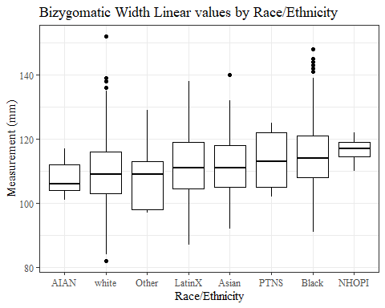

#boxplot not reordered by median  
ggplot(data=headscan_full, aes(y=BiW_L, x=race_eth))+  
 geom_boxplot(color= "black", fill = "white")+  
 theme_bw()+theme(text=element_text(family= "Times New Roman"))+  
 #theme(axis.text.x = element_text(angle = 20, vjust=0.7))+  
 labs(title="Bizygomatic Width Linear values by Race/Ethnicity",  
 y="Measurement (mm)",  
 x="Race/Ethnicity")

## Warning: Removed 17 rows containing non-finite values (stat_boxplot).

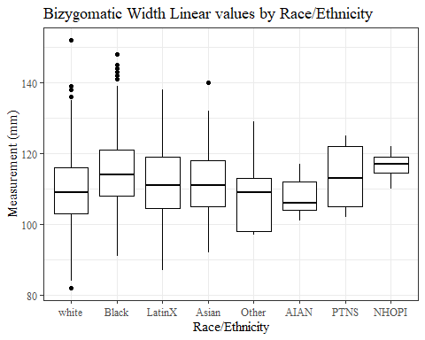

#BiW_L gender sumstats  
BiW_Lgender_sumstats <- headscan_full %>%   
 group_by(gender) %>%   
 summarise(n = n(), na = sum(is.na(BiW_L)),  
 min = min(BiW_L, na.rm = TRUE),  
 max = max(BiW_L, na.rm = TRUE),  
 mean = mean(BiW_L, na.rm = TRUE),  
 mdn = median(BiW_L, na.rm = TRUE),  
 sd = sd(BiW_L, na.rm = TRUE),  
 se = sd/sqrt(n),  
 percent5th = quantile(BiW_L, 0.05, na.rm=TRUE),  
 percent25th = quantile(BiW_L, 0.25, na.rm=TRUE),  
 percent50th = quantile(BiW_L, 0.50, na.rm=TRUE),  
 percent75th = quantile(BiW_L, 0.75, na.rm=TRUE),  
 percent95th = quantile(BiW_L, 0.95, na.rm=TRUE))  
  
BiW_Lgender_sumstats <- BiW_Lgender_sumstats %>%   
 mutate(across(where(is.numeric), round, 2))  
  
#Size 12 Table TNR  
flextable(BiW_Lgender_sumstats) %>%  
 my_ft_theme()%>%   
 bold(part = "header") %>%   
 set_caption("Bizygomatic Width Linear SumStats by Gender")

**Table** : Bizygomatic Width Linear SumStats by Gender

| **gender** | **n** | **na** | **min** | **max** | **mean** | **mdn** | **sd** | **se** | **percent5th** | **percent25th** | **percent50th** | **percent75th** | **percent95th** |
| --- | --- | --- | --- | --- | --- | --- | --- | --- | --- | --- | --- | --- | --- |
| Female | 1,063 | 12 | 82 | 142 | 109.08 | 108 | 9.47 | 0.29 | 94.00 | 102 | 108 | 116.0 | 125.00 |
| Male | 939 | 5 | 86 | 152 | 113.66 | 113 | 9.54 | 0.31 | 99.00 | 107 | 113 | 119.0 | 130.35 |
| Non-binary or Other | 5 | 0 | 91 | 107 | 98.60 | 99 | 6.07 | 2.71 | 91.80 | 95 | 99 | 101.0 | 105.80 |
| Prefer not to say | 1 | 0 | 113 | 113 | 113.00 | 113 |  |  | 113.00 | 113 | 113 | 113.0 | 113.00 |
|  | 8 | 0 | 96 | 122 | 110.25 | 113 | 8.78 | 3.10 | 97.75 | 104 | 113 | 115.5 | 120.25 |

#%>% set_header_labels(values = list(BiW_L = "Alare/AlareCont"))  
  
#Autofit Width Table TNR  
flextable(BiW_Lgender_sumstats) %>%  
 my_ft_theme()%>%   
 bold(part = "header") %>%   
 set_caption("Bizygomatic Width Linear SumStats by Gender") %>%   
 fit_to_width(7.5)

**Table** : Bizygomatic Width Linear SumStats by Gender

| **gender** | **n** | **na** | **min** | **max** | **mean** | **mdn** | **sd** | **se** | **percent5th** | **percent25th** | **percent50th** | **percent75th** | **percent95th** |
| --- | --- | --- | --- | --- | --- | --- | --- | --- | --- | --- | --- | --- | --- |
| Female | 1,063 | 12 | 82 | 142 | 109.08 | 108 | 9.47 | 0.29 | 94.00 | 102 | 108 | 116.0 | 125.00 |
| Male | 939 | 5 | 86 | 152 | 113.66 | 113 | 9.54 | 0.31 | 99.00 | 107 | 113 | 119.0 | 130.35 |
| Non-binary or Other | 5 | 0 | 91 | 107 | 98.60 | 99 | 6.07 | 2.71 | 91.80 | 95 | 99 | 101.0 | 105.80 |
| Prefer not to say | 1 | 0 | 113 | 113 | 113.00 | 113 |  |  | 113.00 | 113 | 113 | 113.0 | 113.00 |
|  | 8 | 0 | 96 | 122 | 110.25 | 113 | 8.78 | 3.10 | 97.75 | 104 | 113 | 115.5 | 120.25 |

#%>% set_header_labels(values = list(BiW_L = "Alare/AlareCont"))  
  
#boxplot reorderd by median  
headscan_full %>%   
 ungroup() %>%   
 mutate(gender= fct_reorder(gender, BiW_L, FUN=median, na.rm=TRUE)) %>%   
 ggplot(aes(y=BiW_L, x=gender))+  
 geom_boxplot(color= "black", fill = "white")+  
 theme_bw()+theme(text=element_text(family= "Times New Roman"))+  
 theme(axis.text.x = element_text(angle = 20, vjust=0.7))+  
 labs(title="Bizygomatic Width Linear values by Gender",  
 y="Measurement (mm)",  
 x="Gender")

## Warning: Removed 17 rows containing non-finite values (stat_boxplot).

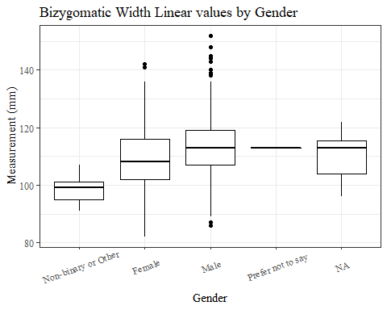

#boxplot not reordered by median  
ggplot(data=headscan_full, aes(y=BiW_L, x=gender))+  
 geom_boxplot(color= "black", fill = "white")+  
 theme_bw()+theme(text=element_text(family= "Times New Roman"))+  
 theme(axis.text.x = element_text(angle = 20, vjust=0.7))+  
 labs(title="Bizygomatic Width Linear values by Gender",  
 y="Measurement (mm)",  
 x="Gender")

## Warning: Removed 17 rows containing non-finite values (stat_boxplot).

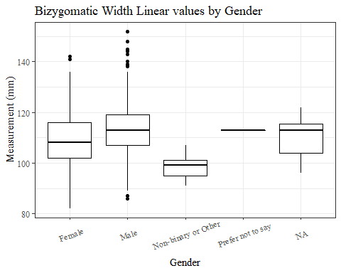

#BiW_L age group sumstats  
BiW_Lage_sumstats <- headscan_full %>%   
 group_by(age_group) %>%   
 summarise(n = n(), na = sum(is.na(BiW_L)),  
 min = min(BiW_L, na.rm = TRUE),  
 max = max(BiW_L, na.rm = TRUE),  
 mean = mean(BiW_L, na.rm = TRUE),  
 mdn = median(BiW_L, na.rm = TRUE),  
 sd = sd(BiW_L, na.rm = TRUE),  
 se = sd/sqrt(n),  
 percent5th = quantile(BiW_L, 0.05, na.rm=TRUE),  
 percent25th = quantile(BiW_L, 0.25, na.rm=TRUE),  
 percent50th = quantile(BiW_L, 0.50, na.rm=TRUE),  
 percent75th = quantile(BiW_L, 0.75, na.rm=TRUE),  
 percent95th = quantile(BiW_L, 0.95, na.rm=TRUE))  
  
BiW_Lage_sumstats <- BiW_Lage_sumstats %>%   
 mutate(across(where(is.numeric), round, 2))  
  
  
#Size 12 Table TNR  
flextable(BiW_Lage_sumstats) %>%  
 my_ft_theme()%>%   
 bold(part = "header") %>%   
 set_caption("Bizygomatic Width Linear SumStats by Age Group")

**Table** : Bizygomatic Width Linear SumStats by Age Group

| **age_group** | **n** | **na** | **min** | **max** | **mean** | **mdn** | **sd** | **se** | **percent5th** | **percent25th** | **percent50th** | **percent75th** | **percent95th** |
| --- | --- | --- | --- | --- | --- | --- | --- | --- | --- | --- | --- | --- | --- |
| 18-36 | 991 | 6 | 84 | 145 | 111.55 | 111 | 9.84 | 0.31 | 97.00 | 104 | 111 | 118.0 | 129.0 |
| 37-54 | 940 | 9 | 82 | 152 | 110.98 | 111 | 9.74 | 0.32 | 95.00 | 105 | 111 | 118.0 | 126.5 |
| 55-72 | 84 | 2 | 87 | 134 | 109.51 | 109 | 9.30 | 1.02 | 95.05 | 103 | 109 | 115.5 | 126.0 |
|  | 1 | 0 | 103 | 103 | 103.00 | 103 |  |  | 103.00 | 103 | 103 | 103.0 | 103.0 |

#%>% set_header_labels(values = list(BiW_L = "Alare/AlareCont"))  
  
#Autofit Width Table TNR  
flextable(BiW_Lage_sumstats) %>%  
 my_ft_theme()%>%   
 bold(part = "header") %>%   
 set_caption("Bizygomatic Width Linear SumStats by Age Group") %>%   
 fit_to_width(7.5)

**Table** : Bizygomatic Width Linear SumStats by Age Group

| **age_group** | **n** | **na** | **min** | **max** | **mean** | **mdn** | **sd** | **se** | **percent5th** | **percent25th** | **percent50th** | **percent75th** | **percent95th** |
| --- | --- | --- | --- | --- | --- | --- | --- | --- | --- | --- | --- | --- | --- |
| 18-36 | 991 | 6 | 84 | 145 | 111.55 | 111 | 9.84 | 0.31 | 97.00 | 104 | 111 | 118.0 | 129.0 |
| 37-54 | 940 | 9 | 82 | 152 | 110.98 | 111 | 9.74 | 0.32 | 95.00 | 105 | 111 | 118.0 | 126.5 |
| 55-72 | 84 | 2 | 87 | 134 | 109.51 | 109 | 9.30 | 1.02 | 95.05 | 103 | 109 | 115.5 | 126.0 |
|  | 1 | 0 | 103 | 103 | 103.00 | 103 |  |  | 103.00 | 103 | 103 | 103.0 | 103.0 |

#%>% set_header_labels(values = list(BiW_L = "Alare/AlareCont"))  
  
#boxplot reorderd by median  
headscan_full %>%   
 ungroup() %>%   
 mutate(age_group= fct_reorder(age_group, BiW_L, FUN=median, na.rm=TRUE)) %>%   
 ggplot(aes(y=BiW_L, x=age_group))+  
 geom_boxplot(color= "black", fill = "white")+  
 theme_bw()+theme(text=element_text(family= "Times New Roman"))+  
 #theme(axis.text.x = element_text(angle = 20, vjust=0.7))+  
 labs(title="Bizygomatic Width Linear values by Age Group",  
 y="Measurement (mm)",  
 x="Age Group")

## Warning: Removed 17 rows containing non-finite values (stat_boxplot).

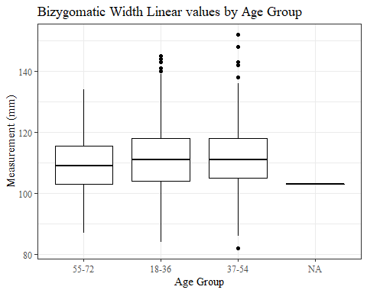

#boxplot not reordered by median  
ggplot(data=headscan_full, aes(y=BiW_L, x=age_group))+  
 geom_boxplot(color= "black", fill = "white")+  
 theme_bw()+theme(text=element_text(family= "Times New Roman"))+  
 #theme(axis.text.x = element_text(angle = 20, vjust=0.7))+  
 labs(title="Bizygomatic Width Linear values by Age Group",  
 y="Measurement (mm)",  
 x="Age Group")

## Warning: Removed 17 rows containing non-finite values (stat_boxplot).

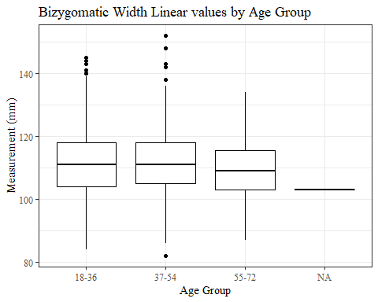

BiW_C

#histogram of all BiW_C values  
ggplot(data=headscan_full, aes(x=BiW_C))+  
 geom_bar(stat="bin", bins=20, color= "black", fill = "white")+  
 theme_bw()+theme(text=element_text(family= "Times New Roman"))+  
 labs(title="Bizygomatic Width Contour Measurement Distribution",  
 y="Frequency",  
 x="Bizygomatic Width Contour (mm)")

## Warning: Removed 17 rows containing non-finite values (stat_bin).

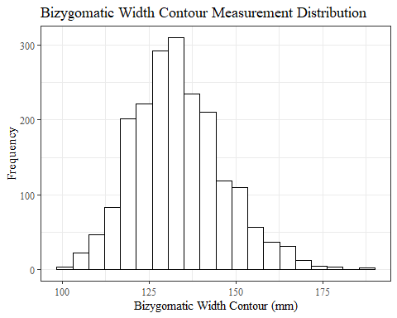

BiW_Csumstats <- headscan_full %>%   
 summarise(n = n(), na = sum(is.na(BiW_C)),  
 min = min(BiW_C, na.rm = TRUE),  
 max = max(BiW_C, na.rm = TRUE),  
 mean = mean(BiW_C, na.rm = TRUE),  
 mdn = median(BiW_C, na.rm = TRUE),  
 sd = sd(BiW_C, na.rm = TRUE),  
 se = sd/sqrt(n),  
 percent5th = quantile(BiW_C, 0.05, na.rm=TRUE),  
 percent25th = quantile(BiW_C, 0.25, na.rm=TRUE),  
 percent50th = quantile(BiW_C, 0.50, na.rm=TRUE),  
 percent75th = quantile(BiW_C, 0.75, na.rm=TRUE),  
 percent95th = quantile(BiW_C, 0.95, na.rm=TRUE))   
  
BiW_Csumstats <- BiW_Csumstats %>%   
 mutate(across(where(is.numeric), round, 2))  
  
  
#Size 12 Table TNR  
flextable(BiW_Csumstats) %>%  
 my_ft_theme()%>%   
 bold(part = "header") %>%   
 set_caption("Bizygomatic Width Contour SumStats")

**Table** : Bizygomatic Width Contour SumStats

| **n** | **na** | **min** | **max** | **mean** | **mdn** | **sd** | **se** | **percent5th** | **percent25th** | **percent50th** | **percent75th** | **percent95th** |
| --- | --- | --- | --- | --- | --- | --- | --- | --- | --- | --- | --- | --- |
| 2,016 | 17 | 101 | 188 | 133.44 | 133 | 12.92 | 0.29 | 114 | 124 | 133 | 141 | 156.1 |

#%>% set_header_labels(values = list(BiW_C = "Alare/AlareCont"))  
  
#Autofit Width Table TNR  
flextable(BiW_Csumstats) %>%  
 my_ft_theme()%>%   
 bold(part = "header") %>%   
 set_caption("Bizygomatic Width Contour SumStats") %>%   
 fit_to_width(7.5)

**Table** : Bizygomatic Width Contour SumStats

| **n** | **na** | **min** | **max** | **mean** | **mdn** | **sd** | **se** | **percent5th** | **percent25th** | **percent50th** | **percent75th** | **percent95th** |
| --- | --- | --- | --- | --- | --- | --- | --- | --- | --- | --- | --- | --- |
| 2,016 | 17 | 101 | 188 | 133.44 | 133 | 12.92 | 0.29 | 114 | 124 | 133 | 141 | 156.1 |

#%>% set_header_labels(values = list(BiW_C = "Alare/AlareCont"))

#BiW_C race/eth sumstats  
BiW_Crace_sumstats <- headscan_full %>%   
 group_by(race_eth) %>%   
 summarise(n = n(), na = sum(is.na(BiW_C)),  
 min = min(BiW_C, na.rm = TRUE),  
 max = max(BiW_C, na.rm = TRUE),  
 mean = mean(BiW_C, na.rm = TRUE),  
 mdn = median(BiW_C, na.rm = TRUE),  
 sd = sd(BiW_C, na.rm = TRUE),  
 se = sd/sqrt(n),  
 percent5th = quantile(BiW_C, 0.05, na.rm=TRUE),  
 percent25th = quantile(BiW_C, 0.25, na.rm=TRUE),  
 percent50th = quantile(BiW_C, 0.50, na.rm=TRUE),  
 percent75th = quantile(BiW_C, 0.75, na.rm=TRUE),  
 percent95th = quantile(BiW_C, 0.95, na.rm=TRUE))   
  
BiW_Crace_sumstats <- BiW_Crace_sumstats %>%   
 mutate(across(where(is.numeric), round, 2))  
  
  
#Size 12 Table TNR  
flextable(BiW_Crace_sumstats) %>%  
 my_ft_theme()%>%   
 bold(part = "header") %>%   
 set_caption("Bizygomatic Width Contour SumStats by Race/Ethnicity")

**Table** : Bizygomatic Width Contour SumStats by Race/Ethnicity

| **race_eth** | **n** | **na** | **min** | **max** | **mean** | **mdn** | **sd** | **se** | **percent5th** | **percent25th** | **percent50th** | **percent75th** | **percent95th** |
| --- | --- | --- | --- | --- | --- | --- | --- | --- | --- | --- | --- | --- | --- |
| white | 1,239 | 8 | 101 | 188 | 133.19 | 133.0 | 12.79 | 0.36 | 114.00 | 124.00 | 133.0 | 141.00 | 155.00 |
| Black | 548 | 5 | 106 | 187 | 134.80 | 134.0 | 13.32 | 0.57 | 116.00 | 125.00 | 134.0 | 143.00 | 160.00 |
| LatinX | 100 | 1 | 106 | 171 | 133.88 | 131.0 | 13.00 | 1.30 | 119.00 | 124.00 | 131.0 | 142.00 | 156.10 |
| Asian | 91 | 2 | 105 | 156 | 128.69 | 130.0 | 11.41 | 1.20 | 111.00 | 120.00 | 130.0 | 135.00 | 148.00 |
| Other | 21 | 0 | 114 | 156 | 130.76 | 130.0 | 12.12 | 2.64 | 116.00 | 120.00 | 130.0 | 138.00 | 150.00 |
| AIAN | 8 | 1 | 115 | 145 | 128.43 | 124.0 | 9.74 | 3.45 | 117.70 | 124.00 | 124.0 | 133.50 | 142.00 |
| PTNS | 5 | 0 | 125 | 145 | 135.40 | 138.0 | 8.20 | 3.67 | 125.80 | 129.00 | 138.0 | 140.00 | 144.00 |
| NHOPI | 4 | 0 | 120 | 155 | 141.00 | 144.5 | 16.06 | 8.03 | 122.55 | 132.75 | 144.5 | 152.75 | 154.55 |

#%>% set_header_labels(values = list(BiW_C = "Alare/AlareCont"))  
  
#Autofit Width Table TNR  
flextable(BiW_Crace_sumstats) %>%  
 my_ft_theme()%>%   
 bold(part = "header") %>%   
 set_caption("Bizygomatic Width Contour SumStats by Race/Ethnicity") %>%   
 fit_to_width(7.5)

**Table** : Bizygomatic Width Contour SumStats by Race/Ethnicity

| **race_eth** | **n** | **na** | **min** | **max** | **mean** | **mdn** | **sd** | **se** | **percent5th** | **percent25th** | **percent50th** | **percent75th** | **percent95th** |
| --- | --- | --- | --- | --- | --- | --- | --- | --- | --- | --- | --- | --- | --- |
| white | 1,239 | 8 | 101 | 188 | 133.19 | 133.0 | 12.79 | 0.36 | 114.00 | 124.00 | 133.0 | 141.00 | 155.00 |
| Black | 548 | 5 | 106 | 187 | 134.80 | 134.0 | 13.32 | 0.57 | 116.00 | 125.00 | 134.0 | 143.00 | 160.00 |
| LatinX | 100 | 1 | 106 | 171 | 133.88 | 131.0 | 13.00 | 1.30 | 119.00 | 124.00 | 131.0 | 142.00 | 156.10 |
| Asian | 91 | 2 | 105 | 156 | 128.69 | 130.0 | 11.41 | 1.20 | 111.00 | 120.00 | 130.0 | 135.00 | 148.00 |
| Other | 21 | 0 | 114 | 156 | 130.76 | 130.0 | 12.12 | 2.64 | 116.00 | 120.00 | 130.0 | 138.00 | 150.00 |
| AIAN | 8 | 1 | 115 | 145 | 128.43 | 124.0 | 9.74 | 3.45 | 117.70 | 124.00 | 124.0 | 133.50 | 142.00 |
| PTNS | 5 | 0 | 125 | 145 | 135.40 | 138.0 | 8.20 | 3.67 | 125.80 | 129.00 | 138.0 | 140.00 | 144.00 |
| NHOPI | 4 | 0 | 120 | 155 | 141.00 | 144.5 | 16.06 | 8.03 | 122.55 | 132.75 | 144.5 | 152.75 | 154.55 |

#%>% set_header_labels(values = list(BiW_C = "Alare/AlareCont"))  
  
#boxplot reorderd by median  
headscan_full %>%   
 ungroup() %>%   
 mutate(race_eth= fct_reorder(race_eth, BiW_C, FUN=median, na.rm=TRUE)) %>%   
 ggplot(aes(y=BiW_C, x=race_eth))+  
 geom_boxplot(color= "black", fill = "white")+  
 theme_bw()+theme(text=element_text(family= "Times New Roman"))+  
 #theme(axis.text.x = element_text(angle = 20, vjust=0.7))+  
 labs(title="Bizygomatic Width Contour values by Race/Ethnicity",  
 y="Measurement (mm)",  
 x="Race/Ethnicity")

## Warning: Removed 17 rows containing non-finite values (stat_boxplot).

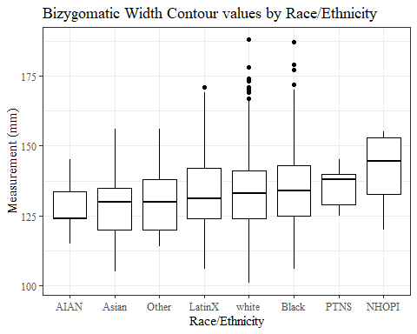

#boxplot not reordered by median  
ggplot(data=headscan_full, aes(y=BiW_C, x=race_eth))+  
 geom_boxplot(color= "black", fill = "white")+  
 theme_bw()+theme(text=element_text(family= "Times New Roman"))+  
 #theme(axis.text.x = element_text(angle = 20, vjust=0.7))+  
 labs(title="Bizygomatic Width Contour values by Race/Ethnicity",  
 y="Measurement (mm)",  
 x="Race/Ethnicity")

## Warning: Removed 17 rows containing non-finite values (stat_boxplot).

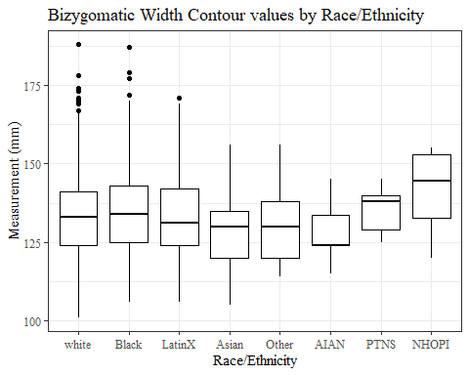

#BiW_C gender sumstats  
BiW_Cgender_sumstats <- headscan_full %>%   
 group_by(gender) %>%   
 summarise(n = n(), na = sum(is.na(BiW_C)),  
 min = min(BiW_C, na.rm = TRUE),  
 max = max(BiW_C, na.rm = TRUE),  
 mean = mean(BiW_C, na.rm = TRUE),  
 mdn = median(BiW_C, na.rm = TRUE),  
 sd = sd(BiW_C, na.rm = TRUE),  
 se = sd/sqrt(n),  
 percent5th = quantile(BiW_C, 0.05, na.rm=TRUE),  
 percent25th = quantile(BiW_C, 0.25, na.rm=TRUE),  
 percent50th = quantile(BiW_C, 0.50, na.rm=TRUE),  
 percent75th = quantile(BiW_C, 0.75, na.rm=TRUE),  
 percent95th = quantile(BiW_C, 0.95, na.rm=TRUE))  
  
BiW_Cgender_sumstats <- BiW_Cgender_sumstats %>%   
 mutate(across(where(is.numeric), round, 2))  
  
#Size 12 Table TNR  
flextable(BiW_Cgender_sumstats) %>%  
 my_ft_theme()%>%   
 bold(part = "header") %>%   
 set_caption("Bizygomatic Width Contour SumStats by Gender")

**Table** : Bizygomatic Width Contour SumStats by Gender

| **gender** | **n** | **na** | **min** | **max** | **mean** | **mdn** | **sd** | **se** | **percent5th** | **percent25th** | **percent50th** | **percent75th** | **percent95th** |
| --- | --- | --- | --- | --- | --- | --- | --- | --- | --- | --- | --- | --- | --- |
| Female | 1,063 | 12 | 101 | 165 | 129.00 | 127 | 11.86 | 0.36 | 111.0 | 121.00 | 127 | 137 | 150.00 |
| Male | 939 | 5 | 105 | 188 | 138.55 | 137 | 12.15 | 0.40 | 121.0 | 131.00 | 137 | 145 | 162.00 |
| Non-binary or Other | 5 | 0 | 116 | 125 | 117.80 | 116 | 4.02 | 1.80 | 116.0 | 116.00 | 116 | 116 | 123.20 |
| Prefer not to say | 1 | 0 | 140 | 140 | 140.00 | 140 |  |  | 140.0 | 140.00 | 140 | 140 | 140.00 |
|  | 8 | 0 | 110 | 151 | 130.25 | 130 | 14.78 | 5.23 | 112.8 | 118.75 | 130 | 138 | 150.65 |

#%>% set_header_labels(values = list(BiW_C = "Alare/AlareCont"))  
  
#Autofit Width Table TNR  
flextable(BiW_Cgender_sumstats) %>%  
 my_ft_theme()%>%   
 bold(part = "header") %>%   
 set_caption("Bizygomatic Width Contour SumStats by Gender") %>%   
 fit_to_width(7.5)

**Table** : Bizygomatic Width Contour SumStats by Gender

| **gender** | **n** | **na** | **min** | **max** | **mean** | **mdn** | **sd** | **se** | **percent5th** | **percent25th** | **percent50th** | **percent75th** | **percent95th** |
| --- | --- | --- | --- | --- | --- | --- | --- | --- | --- | --- | --- | --- | --- |
| Female | 1,063 | 12 | 101 | 165 | 129.00 | 127 | 11.86 | 0.36 | 111.0 | 121.00 | 127 | 137 | 150.00 |
| Male | 939 | 5 | 105 | 188 | 138.55 | 137 | 12.15 | 0.40 | 121.0 | 131.00 | 137 | 145 | 162.00 |
| Non-binary or Other | 5 | 0 | 116 | 125 | 117.80 | 116 | 4.02 | 1.80 | 116.0 | 116.00 | 116 | 116 | 123.20 |
| Prefer not to say | 1 | 0 | 140 | 140 | 140.00 | 140 |  |  | 140.0 | 140.00 | 140 | 140 | 140.00 |
|  | 8 | 0 | 110 | 151 | 130.25 | 130 | 14.78 | 5.23 | 112.8 | 118.75 | 130 | 138 | 150.65 |

#%>% set_header_labels(values = list(BiW_C = "Alare/AlareCont"))  
  
#boxplot reorderd by median  
headscan_full %>%   
 ungroup() %>%   
 mutate(gender= fct_reorder(gender, BiW_C, FUN=median, na.rm=TRUE)) %>%   
 ggplot(aes(y=BiW_C, x=gender))+  
 geom_boxplot(color= "black", fill = "white")+  
 theme_bw()+theme(text=element_text(family= "Times New Roman"))+  
 theme(axis.text.x = element_text(angle = 20, vjust=0.7))+  
 labs(title="Bizygomatic Width Contour values by Gender",  
 y="Measurement (mm)",  
 x="Gender")

## Warning: Removed 17 rows containing non-finite values (stat_boxplot).

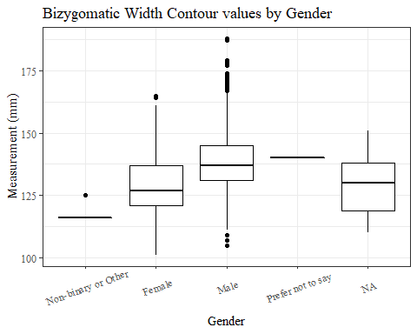

#boxplot not reordered by median  
ggplot(data=headscan_full, aes(y=BiW_C, x=gender))+  
 geom_boxplot(color= "black", fill = "white")+  
 theme_bw()+theme(text=element_text(family= "Times New Roman"))+  
 theme(axis.text.x = element_text(angle = 20, vjust=0.7))+  
 labs(title="Bizygomatic Width Contour values by Gender",  
 y="Measurement (mm)",  
 x="Gender")

## Warning: Removed 17 rows containing non-finite values (stat_boxplot).

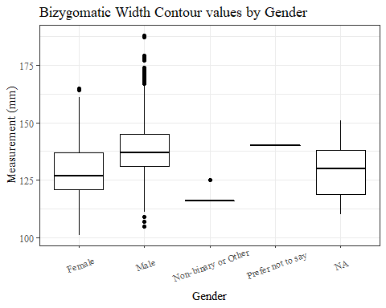

#BiW_C age group sumstats  
BiW_Cage_sumstats <- headscan_full %>%   
 group_by(age_group) %>%   
 summarise(n = n(), na = sum(is.na(BiW_C)),  
 min = min(BiW_C, na.rm = TRUE),  
 max = max(BiW_C, na.rm = TRUE),  
 mean = mean(BiW_C, na.rm = TRUE),  
 mdn = median(BiW_C, na.rm = TRUE),  
 sd = sd(BiW_C, na.rm = TRUE),  
 se = sd/sqrt(n),  
 percent5th = quantile(BiW_C, 0.05, na.rm=TRUE),  
 percent25th = quantile(BiW_C, 0.25, na.rm=TRUE),  
 percent50th = quantile(BiW_C, 0.50, na.rm=TRUE),  
 percent75th = quantile(BiW_C, 0.75, na.rm=TRUE),  
 percent95th = quantile(BiW_C, 0.95, na.rm=TRUE))  
  
BiW_Cage_sumstats <- BiW_Cage_sumstats %>%   
 mutate(across(where(is.numeric), round, 2))  
  
  
#Size 12 Table TNR  
flextable(BiW_Cage_sumstats) %>%  
 my_ft_theme()%>%   
 bold(part = "header") %>%   
 set_caption("Bizygomatic Width Contour SumStats by Age Group")

**Table** : Bizygomatic Width Contour SumStats by Age Group

| **age_group** | **n** | **na** | **min** | **max** | **mean** | **mdn** | **sd** | **se** | **percent5th** | **percent25th** | **percent50th** | **percent75th** | **percent95th** |
| --- | --- | --- | --- | --- | --- | --- | --- | --- | --- | --- | --- | --- | --- |
| 18-36 | 991 | 6 | 102 | 179 | 133.73 | 133 | 12.78 | 0.41 | 115.00 | 125 | 133 | 141 | 157.00 |
| 37-54 | 940 | 9 | 101 | 188 | 133.22 | 132 | 13.06 | 0.43 | 113.00 | 124 | 132 | 141 | 156.00 |
| 55-72 | 84 | 2 | 107 | 164 | 132.61 | 131 | 13.12 | 1.43 | 114.05 | 123 | 131 | 139 | 158.85 |
|  | 1 | 0 | 124 | 124 | 124.00 | 124 |  |  | 124.00 | 124 | 124 | 124 | 124.00 |

#%>% set_header_labels(values = list(BiW_C = "Alare/AlareCont"))  
  
#Autofit Width Table TNR  
flextable(BiW_Cage_sumstats) %>%  
 my_ft_theme()%>%   
 bold(part = "header") %>%   
 set_caption("Bizygomatic Width Contour SumStats by Age Group") %>%   
 fit_to_width(7.5)

**Table** : Bizygomatic Width Contour SumStats by Age Group

| **age_group** | **n** | **na** | **min** | **max** | **mean** | **mdn** | **sd** | **se** | **percent5th** | **percent25th** | **percent50th** | **percent75th** | **percent95th** |
| --- | --- | --- | --- | --- | --- | --- | --- | --- | --- | --- | --- | --- | --- |
| 18-36 | 991 | 6 | 102 | 179 | 133.73 | 133 | 12.78 | 0.41 | 115.00 | 125 | 133 | 141 | 157.00 |
| 37-54 | 940 | 9 | 101 | 188 | 133.22 | 132 | 13.06 | 0.43 | 113.00 | 124 | 132 | 141 | 156.00 |
| 55-72 | 84 | 2 | 107 | 164 | 132.61 | 131 | 13.12 | 1.43 | 114.05 | 123 | 131 | 139 | 158.85 |
|  | 1 | 0 | 124 | 124 | 124.00 | 124 |  |  | 124.00 | 124 | 124 | 124 | 124.00 |

#%>% set_header_labels(values = list(BiW_C = "Alare/AlareCont"))  
  
#boxplot reorderd by median  
headscan_full %>%   
 ungroup() %>%   
 mutate(age_group= fct_reorder(age_group, BiW_C, FUN=median, na.rm=TRUE)) %>%   
 ggplot(aes(y=BiW_C, x=age_group))+  
 geom_boxplot(color= "black", fill = "white")+  
 theme_bw()+theme(text=element_text(family= "Times New Roman"))+  
 #theme(axis.text.x = element_text(angle = 20, vjust=0.7))+  
 labs(title="Bizygomatic Width Contour values by Age Group",  
 y="Measurement (mm)",  
 x="Age Group")

## Warning: Removed 17 rows containing non-finite values (stat_boxplot).

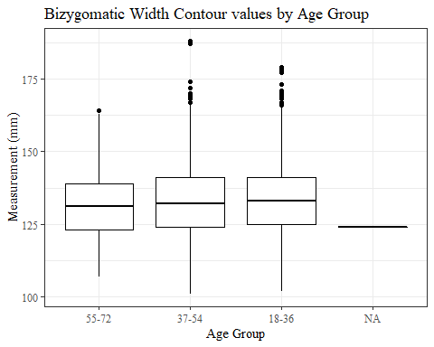

#boxplot not reordered by median  
ggplot(data=headscan_full, aes(y=BiW_C, x=age_group))+  
 geom_boxplot(color= "black", fill = "white")+  
 theme_bw()+theme(text=element_text(family= "Times New Roman"))+  
 #theme(axis.text.x = element_text(angle = 20, vjust=0.7))+  
 labs(title="Bizygomatic Width Contour values by Age Group",  
 y="Measurement (mm)",  
 x="Age Group")

## Warning: Removed 17 rows containing non-finite values (stat_boxplot).

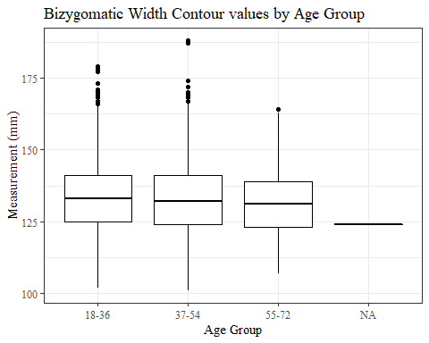

ChCh_C

#histogram of all ChCh_C values  
ggplot(data=headscan_full, aes(x=ChCh_C))+  
 geom_bar(stat="bin", bins=20, color= "black", fill = "white")+  
 theme_bw()+theme(text=element_text(family= "Times New Roman"))+  
 labs(title="Chellion to Chellion Contour Measurement Distribution",  
 y="Frequency",  
 x="Chellion to Chellion Contour (mm)")

## Warning: Removed 43 rows containing non-finite values (stat_bin).

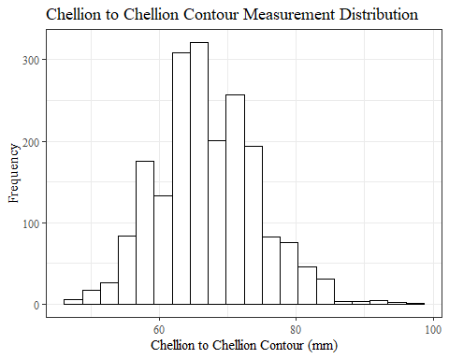

ChCh_Csumstats <- headscan_full %>%   
 summarise(n = n(), na = sum(is.na(ChCh_C)),  
 min = min(ChCh_C, na.rm = TRUE),  
 max = max(ChCh_C, na.rm = TRUE),  
 mean = mean(ChCh_C, na.rm = TRUE),  
 mdn = median(ChCh_C, na.rm = TRUE),  
 sd = sd(ChCh_C, na.rm = TRUE),  
 se = sd/sqrt(n),  
 percent5th = quantile(ChCh_C, 0.05, na.rm=TRUE),  
 percent25th = quantile(ChCh_C, 0.25, na.rm=TRUE),  
 percent50th = quantile(ChCh_C, 0.50, na.rm=TRUE),  
 percent75th = quantile(ChCh_C, 0.75, na.rm=TRUE),  
 percent95th = quantile(ChCh_C, 0.95, na.rm=TRUE))   
  
ChCh_Csumstats <- round(ChCh_Csumstats, 2)  
  
  
#Size 12 Table TNR  
flextable(ChCh_Csumstats) %>%  
 my_ft_theme()%>%   
 bold(part = "header") %>%   
 set_caption("Chellion Chellion Contour SumStats")

**Table** : Chellion Chellion Contour SumStats

| **n** | **na** | **min** | **max** | **mean** | **mdn** | **sd** | **se** | **percent5th** | **percent25th** | **percent50th** | **percent75th** | **percent95th** |
| --- | --- | --- | --- | --- | --- | --- | --- | --- | --- | --- | --- | --- |
| 2,016 | 43 | 47 | 97 | 67.05 | 67 | 7.43 | 0.17 | 55 | 62 | 67 | 72 | 80 |

#%>% set_header_labels(values = list(ChCh_C = "Alare/AlareCont"))  
  
#Autofit Width Table TNR  
flextable(ChCh_Csumstats) %>%  
 my_ft_theme()%>%   
 bold(part = "header") %>%   
 set_caption("Chellion Chellion Contour SumStats") %>%   
 fit_to_width(7.5)

**Table** : Chellion Chellion Contour SumStats

| **n** | **na** | **min** | **max** | **mean** | **mdn** | **sd** | **se** | **percent5th** | **percent25th** | **percent50th** | **percent75th** | **percent95th** |
| --- | --- | --- | --- | --- | --- | --- | --- | --- | --- | --- | --- | --- |
| 2,016 | 43 | 47 | 97 | 67.05 | 67 | 7.43 | 0.17 | 55 | 62 | 67 | 72 | 80 |

#%>% set_header_labels(values = list(ChCh_C = "Alare/AlareCont"))

#ChCh_C race/eth sumstats  
ChCh_Crace_sumstats <- headscan_full %>%   
 group_by(race_eth) %>%   
 summarise(n = n(), na = sum(is.na(ChCh_C)),  
 min = min(ChCh_C, na.rm = TRUE),  
 max = max(ChCh_C, na.rm = TRUE),  
 mean = mean(ChCh_C, na.rm = TRUE),  
 mdn = median(ChCh_C, na.rm = TRUE),  
 sd = sd(ChCh_C, na.rm = TRUE),  
 se = sd/sqrt(n),  
 percent5th = quantile(ChCh_C, 0.05, na.rm=TRUE),  
 percent25th = quantile(ChCh_C, 0.25, na.rm=TRUE),  
 percent50th = quantile(ChCh_C, 0.50, na.rm=TRUE),  
 percent75th = quantile(ChCh_C, 0.75, na.rm=TRUE),  
 percent95th = quantile(ChCh_C, 0.95, na.rm=TRUE))   
  
ChCh_Crace_sumstats <- ChCh_Crace_sumstats %>%   
 mutate(across(where(is.numeric), round, 2))  
  
  
#Size 12 Table TNR  
flextable(ChCh_Crace_sumstats) %>%  
 my_ft_theme()%>%   
 bold(part = "header") %>%   
 set_caption("Chellion Chellion Contour SumStats by Race/Ethnicity")

**Table** : Chellion Chellion Contour SumStats by Race/Ethnicity

| **race_eth** | **n** | **na** | **min** | **max** | **mean** | **mdn** | **sd** | **se** | **percent5th** | **percent25th** | **percent50th** | **percent75th** | **percent95th** |
| --- | --- | --- | --- | --- | --- | --- | --- | --- | --- | --- | --- | --- | --- |
| white | 1,239 | 33 | 47 | 95 | 65.30 | 65.0 | 6.90 | 0.20 | 54.00 | 61.00 | 65.0 | 70.00 | 77.00 |
| Black | 548 | 6 | 51 | 97 | 71.23 | 71.0 | 7.14 | 0.31 | 60.00 | 66.00 | 71.0 | 76.00 | 83.00 |
| LatinX | 100 | 2 | 48 | 84 | 67.14 | 67.0 | 6.50 | 0.65 | 58.00 | 62.00 | 67.0 | 72.00 | 78.00 |
| Asian | 91 | 1 | 48 | 84 | 64.84 | 65.0 | 7.09 | 0.74 | 53.45 | 60.00 | 65.0 | 69.00 | 75.55 |
| Other | 21 | 0 | 56 | 84 | 67.33 | 67.0 | 6.51 | 1.42 | 59.00 | 64.00 | 67.0 | 70.00 | 78.00 |
| AIAN | 8 | 1 | 61 | 81 | 67.57 | 65.0 | 6.97 | 2.47 | 61.00 | 63.00 | 65.0 | 70.00 | 77.70 |
| PTNS | 5 | 0 | 58 | 84 | 68.60 | 67.0 | 9.86 | 4.41 | 59.00 | 63.00 | 67.0 | 71.00 | 81.40 |
| NHOPI | 4 | 0 | 61 | 76 | 68.50 | 68.5 | 8.10 | 4.05 | 61.15 | 61.75 | 68.5 | 75.25 | 75.85 |

#%>% set_header_labels(values = list(ChCh_C = "Alare/AlareCont"))  
  
#Autofit Width Table TNR  
flextable(ChCh_Crace_sumstats) %>%  
 my_ft_theme()%>%   
 bold(part = "header") %>%   
 set_caption("Chellion Chellion Contour SumStats by Race/Ethnicity") %>%   
 fit_to_width(7.5)

**Table** : Chellion Chellion Contour SumStats by Race/Ethnicity

| **race_eth** | **n** | **na** | **min** | **max** | **mean** | **mdn** | **sd** | **se** | **percent5th** | **percent25th** | **percent50th** | **percent75th** | **percent95th** |
| --- | --- | --- | --- | --- | --- | --- | --- | --- | --- | --- | --- | --- | --- |
| white | 1,239 | 33 | 47 | 95 | 65.30 | 65.0 | 6.90 | 0.20 | 54.00 | 61.00 | 65.0 | 70.00 | 77.00 |
| Black | 548 | 6 | 51 | 97 | 71.23 | 71.0 | 7.14 | 0.31 | 60.00 | 66.00 | 71.0 | 76.00 | 83.00 |
| LatinX | 100 | 2 | 48 | 84 | 67.14 | 67.0 | 6.50 | 0.65 | 58.00 | 62.00 | 67.0 | 72.00 | 78.00 |
| Asian | 91 | 1 | 48 | 84 | 64.84 | 65.0 | 7.09 | 0.74 | 53.45 | 60.00 | 65.0 | 69.00 | 75.55 |
| Other | 21 | 0 | 56 | 84 | 67.33 | 67.0 | 6.51 | 1.42 | 59.00 | 64.00 | 67.0 | 70.00 | 78.00 |
| AIAN | 8 | 1 | 61 | 81 | 67.57 | 65.0 | 6.97 | 2.47 | 61.00 | 63.00 | 65.0 | 70.00 | 77.70 |
| PTNS | 5 | 0 | 58 | 84 | 68.60 | 67.0 | 9.86 | 4.41 | 59.00 | 63.00 | 67.0 | 71.00 | 81.40 |
| NHOPI | 4 | 0 | 61 | 76 | 68.50 | 68.5 | 8.10 | 4.05 | 61.15 | 61.75 | 68.5 | 75.25 | 75.85 |

#%>% set_header_labels(values = list(ChCh_C = "Alare/AlareCont"))  
  
#boxplot reorderd by median  
headscan_full %>%   
 ungroup() %>%   
 mutate(race_eth= fct_reorder(race_eth, ChCh_C, FUN=median, na.rm=TRUE)) %>%   
 ggplot(aes(y=ChCh_C, x=race_eth))+  
 geom_boxplot(color= "black", fill = "white")+  
 theme_bw()+theme(text=element_text(family= "Times New Roman"))+  
 #theme(axis.text.x = element_text(angle = 20, vjust=0.7))+  
 labs(title="Chellion to Chellion Contour values by Race/Ethnicity",  
 y="Measurement (mm)",  
 x="Race/Ethnicity")

## Warning: Removed 43 rows containing non-finite values (stat_boxplot).

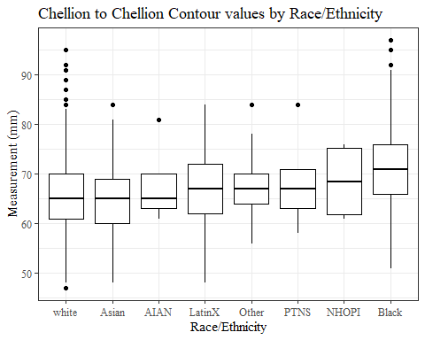

#boxplot not reordered by median  
ggplot(data=headscan_full, aes(y=ChCh_C, x=race_eth))+  
 geom_boxplot(color= "black", fill = "white")+  
 theme_bw()+theme(text=element_text(family= "Times New Roman"))+  
 #theme(axis.text.x = element_text(angle = 20, vjust=0.7))+  
 labs(title="Chellion to Chellion Contour values by Race/Ethnicity",  
 y="Measurement (mm)",  
 x="Race/Ethnicity")

## Warning: Removed 43 rows containing non-finite values (stat_boxplot).

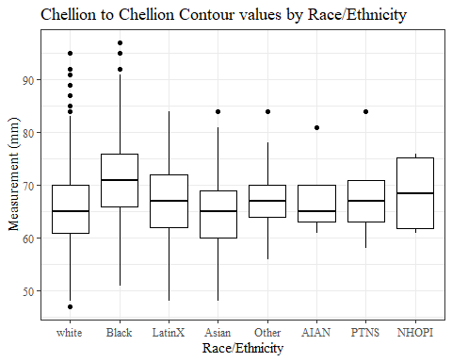

#ChCh_C gender sumstats  
ChCh_Cgender_sumstats <- headscan_full %>%   
 group_by(gender) %>%   
 summarise(n = n(), na = sum(is.na(ChCh_C)),  
 min = min(ChCh_C, na.rm = TRUE),  
 max = max(ChCh_C, na.rm = TRUE),  
 mean = mean(ChCh_C, na.rm = TRUE),  
 mdn = median(ChCh_C, na.rm = TRUE),  
 sd = sd(ChCh_C, na.rm = TRUE),  
 se = sd/sqrt(n),  
 percent5th = quantile(ChCh_C, 0.05, na.rm=TRUE),  
 percent25th = quantile(ChCh_C, 0.25, na.rm=TRUE),  
 percent50th = quantile(ChCh_C, 0.50, na.rm=TRUE),  
 percent75th = quantile(ChCh_C, 0.75, na.rm=TRUE),  
 percent95th = quantile(ChCh_C, 0.95, na.rm=TRUE))  
  
ChCh_Cgender_sumstats <- ChCh_Cgender_sumstats %>%   
 mutate(across(where(is.numeric), round, 2))  
  
#Size 12 Table TNR  
flextable(ChCh_Cgender_sumstats) %>%  
 my_ft_theme()%>%   
 bold(part = "header") %>%   
 set_caption("Chellion to Chellion Contour SumStats by Gender")

**Table** : Chellion to Chellion Contour SumStats by Gender

| **gender** | **n** | **na** | **min** | **max** | **mean** | **mdn** | **sd** | **se** | **percent5th** | **percent25th** | **percent50th** | **percent75th** | **percent95th** |
| --- | --- | --- | --- | --- | --- | --- | --- | --- | --- | --- | --- | --- | --- |
| Female | 1,063 | 19 | 47 | 97 | 65.22 | 65 | 7.24 | 0.22 | 54.0 | 60.0 | 65 | 70.00 | 78.0 |
| Male | 939 | 24 | 48 | 95 | 69.13 | 69 | 7.09 | 0.23 | 58.0 | 64.0 | 69 | 74.00 | 81.0 |
| Non-binary or Other | 5 | 0 | 54 | 74 | 67.40 | 72 | 8.47 | 3.79 | 56.0 | 64.0 | 72 | 73.00 | 73.8 |
| Prefer not to say | 1 | 0 | 67 | 67 | 67.00 | 67 |  |  | 67.0 | 67.0 | 67 | 67.00 | 67.0 |
|  | 8 | 0 | 58 | 80 | 67.12 | 68 | 7.14 | 2.52 | 58.7 | 61.5 | 68 | 69.75 | 77.2 |

#%>% set_header_labels(values = list(ChCh_C = "Alare/AlareCont"))  
  
#Autofit Width Table TNR  
flextable(ChCh_Cgender_sumstats) %>%  
 my_ft_theme()%>%   
 bold(part = "header") %>%   
 set_caption("Chellion to Chellion Contour SumStats by Gender") %>%   
 fit_to_width(7.5)

**Table** : Chellion to Chellion Contour SumStats by Gender

| **gender** | **n** | **na** | **min** | **max** | **mean** | **mdn** | **sd** | **se** | **percent5th** | **percent25th** | **percent50th** | **percent75th** | **percent95th** |
| --- | --- | --- | --- | --- | --- | --- | --- | --- | --- | --- | --- | --- | --- |
| Female | 1,063 | 19 | 47 | 97 | 65.22 | 65 | 7.24 | 0.22 | 54.0 | 60.0 | 65 | 70.00 | 78.0 |
| Male | 939 | 24 | 48 | 95 | 69.13 | 69 | 7.09 | 0.23 | 58.0 | 64.0 | 69 | 74.00 | 81.0 |
| Non-binary or Other | 5 | 0 | 54 | 74 | 67.40 | 72 | 8.47 | 3.79 | 56.0 | 64.0 | 72 | 73.00 | 73.8 |
| Prefer not to say | 1 | 0 | 67 | 67 | 67.00 | 67 |  |  | 67.0 | 67.0 | 67 | 67.00 | 67.0 |
|  | 8 | 0 | 58 | 80 | 67.12 | 68 | 7.14 | 2.52 | 58.7 | 61.5 | 68 | 69.75 | 77.2 |

#%>% set_header_labels(values = list(ChCh_C = "Alare/AlareCont"))  
  
#boxplot reorderd by median  
headscan_full %>%   
 ungroup() %>%   
 mutate(gender= fct_reorder(gender, ChCh_C, FUN=median, na.rm=TRUE)) %>%   
 ggplot(aes(y=ChCh_C, x=gender))+  
 geom_boxplot(color= "black", fill = "white")+  
 theme_bw()+theme(text=element_text(family= "Times New Roman"))+  
 theme(axis.text.x = element_text(angle = 20, vjust=0.7))+  
 labs(title="Chellion to Chellion Contour values by Gender",  
 y="Measurement (mm)",  
 x="Gender")

## Warning: Removed 43 rows containing non-finite values (stat_boxplot).

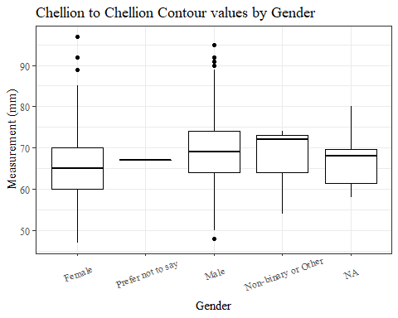

#boxplot not reordered by median  
ggplot(data=headscan_full, aes(y=ChCh_C, x=gender))+  
 geom_boxplot(color= "black", fill = "white")+  
 theme_bw()+theme(text=element_text(family= "Times New Roman"))+  
 theme(axis.text.x = element_text(angle = 20, vjust=0.7))+  
 labs(title="Chellion to Chellion Contour values by Gender",  
 y="Measurement (mm)",  
 x="Gender")

## Warning: Removed 43 rows containing non-finite values (stat_boxplot).

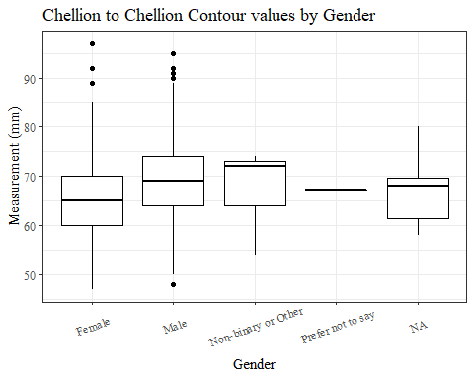

#ChCh_C age group sumstats  
ChCh_Cage_sumstats <- headscan_full %>%   
 group_by(age_group) %>%   
 summarise(n = n(), na = sum(is.na(ChCh_C)),  
 min = min(ChCh_C, na.rm = TRUE),  
 max = max(ChCh_C, na.rm = TRUE),  
 mean = mean(ChCh_C, na.rm = TRUE),  
 mdn = median(ChCh_C, na.rm = TRUE),  
 sd = sd(ChCh_C, na.rm = TRUE),  
 se = sd/sqrt(n),  
 percent5th = quantile(ChCh_C, 0.05, na.rm=TRUE),  
 percent25th = quantile(ChCh_C, 0.25, na.rm=TRUE),  
 percent50th = quantile(ChCh_C, 0.50, na.rm=TRUE),  
 percent75th = quantile(ChCh_C, 0.75, na.rm=TRUE),  
 percent95th = quantile(ChCh_C, 0.95, na.rm=TRUE))  
  
ChCh_Cage_sumstats <- ChCh_Cage_sumstats %>%   
 mutate(across(where(is.numeric), round, 2))  
  
  
#Size 12 Table TNR  
flextable(ChCh_Cage_sumstats) %>%  
 my_ft_theme()%>%   
 bold(part = "header") %>%   
 set_caption("Chellion to Chellion Contour SumStats by Age Group")

**Table** : Chellion to Chellion Contour SumStats by Age Group

| **age_group** | **n** | **na** | **min** | **max** | **mean** | **mdn** | **sd** | **se** | **percent5th** | **percent25th** | **percent50th** | **percent75th** | **percent95th** |
| --- | --- | --- | --- | --- | --- | --- | --- | --- | --- | --- | --- | --- | --- |
| 18-36 | 991 | 17 | 47 | 85 | 65.82 | 66.0 | 6.89 | 0.22 | 55.00 | 61 | 66.0 | 70 | 78.00 |
| 37-54 | 940 | 24 | 47 | 97 | 68.08 | 67.5 | 7.67 | 0.25 | 56.00 | 63 | 67.5 | 73 | 81.00 |
| 55-72 | 84 | 2 | 54 | 91 | 69.99 | 70.0 | 8.34 | 0.91 | 56.05 | 64 | 70.0 | 76 | 82.95 |
|  | 1 | 0 | 75 | 75 | 75.00 | 75.0 |  |  | 75.00 | 75 | 75.0 | 75 | 75.00 |

#%>% set_header_labels(values = list(ChCh_C = "Alare/AlareCont"))  
  
#Autofit Width Table TNR  
flextable(ChCh_Cage_sumstats) %>%  
 my_ft_theme()%>%   
 bold(part = "header") %>%   
 set_caption("Chellion to Chellion Contour SumStats by Age Group") %>%   
 fit_to_width(7.5)

**Table** : Chellion to Chellion Contour SumStats by Age Group

| **age_group** | **n** | **na** | **min** | **max** | **mean** | **mdn** | **sd** | **se** | **percent5th** | **percent25th** | **percent50th** | **percent75th** | **percent95th** |
| --- | --- | --- | --- | --- | --- | --- | --- | --- | --- | --- | --- | --- | --- |
| 18-36 | 991 | 17 | 47 | 85 | 65.82 | 66.0 | 6.89 | 0.22 | 55.00 | 61 | 66.0 | 70 | 78.00 |
| 37-54 | 940 | 24 | 47 | 97 | 68.08 | 67.5 | 7.67 | 0.25 | 56.00 | 63 | 67.5 | 73 | 81.00 |
| 55-72 | 84 | 2 | 54 | 91 | 69.99 | 70.0 | 8.34 | 0.91 | 56.05 | 64 | 70.0 | 76 | 82.95 |
|  | 1 | 0 | 75 | 75 | 75.00 | 75.0 |  |  | 75.00 | 75 | 75.0 | 75 | 75.00 |

#%>% set_header_labels(values = list(ChCh_C = "Alare/AlareCont"))  
  
#boxplot reorderd by median  
headscan_full %>%   
 ungroup() %>%   
 mutate(age_group= fct_reorder(age_group, ChCh_C, FUN=median, na.rm=TRUE)) %>%   
 ggplot(aes(y=ChCh_C, x=age_group))+  
 geom_boxplot(color= "black", fill = "white")+  
 theme_bw()+theme(text=element_text(family= "Times New Roman"))+  
 #theme(axis.text.x = element_text(angle = 20, vjust=0.7))+  
 labs(title="Chellion to Chellion Contour values by Age Group",  
 y="Measurement (mm)",  
 x="Age Group")

## Warning: Removed 43 rows containing non-finite values (stat_boxplot).

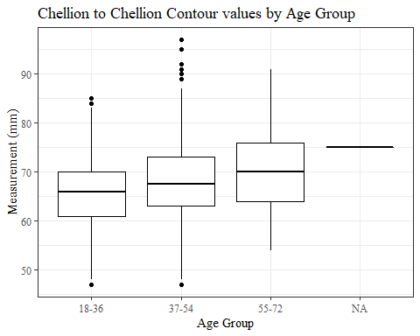

#boxplot not reordered by median  
ggplot(data=headscan_full, aes(y=ChCh_C, x=age_group))+  
 geom_boxplot(color= "black", fill = "white")+  
 theme_bw()+theme(text=element_text(family= "Times New Roman"))+  
 #theme(axis.text.x = element_text(angle = 20, vjust=0.7))+  
 labs(title="Chellion to Chellion Contour values by Age Group",  
 y="Measurement (mm)",  
 x="Age Group")

## Warning: Removed 43 rows containing non-finite values (stat_boxplot).



GoSub_C WITHOUT Outlier Removed!!!!

#histogram of all GoSub_C values  
ggplot(data=headscan_full, aes(x=GoSub_C))+  
 geom_bar(stat="bin", bins=20, color= "black", fill = "white")+  
 theme_bw()+theme(text=element_text(family= "Times New Roman"))+  
 labs(title="Gonion to Submandibular Contour Measurement Distribution",  
 subtitle= "without outlier removed",  
 y="Frequency",  
 x="Gonion to Submandibular Contour (mm)")

## Warning: Removed 127 rows containing non-finite values (stat_bin).

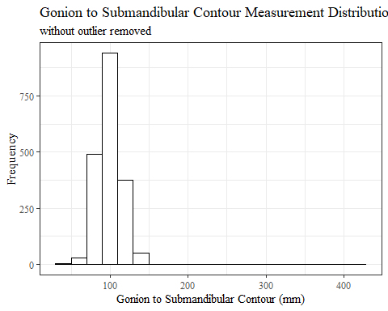

GoSub_Csumstats <- headscan_full %>%   
 summarise(n = n(), na = sum(is.na(GoSub_C)),  
 min = min(GoSub_C, na.rm = TRUE),  
 max = max(GoSub_C, na.rm = TRUE),  
 mean = mean(GoSub_C, na.rm = TRUE),  
 mdn = median(GoSub_C, na.rm = TRUE),  
 sd = sd(GoSub_C, na.rm = TRUE),  
 se = sd/sqrt(n),  
 percent5th = quantile(GoSub_C, 0.05, na.rm=TRUE),  
 percent25th = quantile(GoSub_C, 0.25, na.rm=TRUE),  
 percent50th = quantile(GoSub_C, 0.50, na.rm=TRUE),  
 percent75th = quantile(GoSub_C, 0.75, na.rm=TRUE),  
 percent95th = quantile(GoSub_C, 0.95, na.rm=TRUE))   
  
GoSub_Csumstats <- round(GoSub_Csumstats, 2)  
  
#Size 12 Table TNR  
flextable(GoSub_Csumstats) %>%  
 my_ft_theme()%>%   
 bold(part = "header") %>%   
 set_caption("Gonion to Submandibular Contour SumStats w/o outlier removed")

**Table** : Gonion to Submandibular Contour SumStats w/o outlier removed

| **n** | **na** | **min** | **max** | **mean** | **mdn** | **sd** | **se** | **percent5th** | **percent25th** | **percent50th** | **percent75th** | **percent95th** |
| --- | --- | --- | --- | --- | --- | --- | --- | --- | --- | --- | --- | --- |
| 2,016 | 127 | 45 | 424 | 99.05 | 99 | 17.16 | 0.38 | 75 | 88 | 99 | 108 | 125 |

#%>% set_header_labels(values = list(GoSub_C = "Alare/AlareCont"))  
  
#Autofit Width Table TNR  
flextable(GoSub_Csumstats) %>%  
 my_ft_theme()%>%   
 bold(part = "header") %>%   
 set_caption("Gonion to Submandibular Contour SumStats w/o outlier removed") %>%   
 fit_to_width(7.5)

**Table** : Gonion to Submandibular Contour SumStats w/o outlier removed

| **n** | **na** | **min** | **max** | **mean** | **mdn** | **sd** | **se** | **percent5th** | **percent25th** | **percent50th** | **percent75th** | **percent95th** |
| --- | --- | --- | --- | --- | --- | --- | --- | --- | --- | --- | --- | --- |
| 2,016 | 127 | 45 | 424 | 99.05 | 99 | 17.16 | 0.38 | 75 | 88 | 99 | 108 | 125 |

#%>% set_header_labels(values = list(GoSub_C = "Alare/AlareCont"))

#GoSub_C race/eth sumstats  
GoSub_Crace_sumstats <- headscan_full %>%   
 group_by(race_eth) %>%   
 summarise(n = n(), na = sum(is.na(GoSub_C)),  
 min = min(GoSub_C, na.rm = TRUE),  
 max = max(GoSub_C, na.rm = TRUE),  
 mean = mean(GoSub_C, na.rm = TRUE),  
 mdn = median(GoSub_C, na.rm = TRUE),  
 sd = sd(GoSub_C, na.rm = TRUE),  
 se = sd/sqrt(n),  
 percent5th = quantile(GoSub_C, 0.05, na.rm=TRUE),  
 percent25th = quantile(GoSub_C, 0.25, na.rm=TRUE),  
 percent50th = quantile(GoSub_C, 0.50, na.rm=TRUE),  
 percent75th = quantile(GoSub_C, 0.75, na.rm=TRUE),  
 percent95th = quantile(GoSub_C, 0.95, na.rm=TRUE))   
  
GoSub_Crace_sumstats <- GoSub_Crace_sumstats %>%   
 mutate(across(where(is.numeric), round, 2))  
  
  
#Size 12 Table TNR  
flextable(GoSub_Crace_sumstats) %>%  
 my_ft_theme()%>%   
 bold(part = "header") %>%   
 set_caption("Gonion to Submandibular Contour SumStats by Race/Ethnicity w/o outlier removed")

**Table** : Gonion to Submandibular Contour SumStats by Race/Ethnicity w/o outlier removed

| **race_eth** | **n** | **na** | **min** | **max** | **mean** | **mdn** | **sd** | **se** | **percent5th** | **percent25th** | **percent50th** | **percent75th** | **percent95th** |
| --- | --- | --- | --- | --- | --- | --- | --- | --- | --- | --- | --- | --- | --- |
| white | 1,239 | 71 | 45 | 424 | 98.11 | 97 | 18.53 | 0.53 | 74.0 | 87 | 97 | 107.0 | 124.65 |
| Black | 548 | 39 | 63 | 146 | 102.33 | 102 | 14.29 | 0.61 | 78.0 | 93 | 102 | 112.0 | 125.60 |
| LatinX | 100 | 9 | 67 | 132 | 97.47 | 98 | 13.65 | 1.37 | 76.0 | 88 | 98 | 104.0 | 119.00 |
| Asian | 91 | 2 | 71 | 137 | 95.61 | 94 | 14.40 | 1.51 | 74.8 | 85 | 94 | 106.0 | 120.20 |
| Other | 21 | 4 | 73 | 126 | 100.00 | 96 | 14.35 | 3.13 | 78.6 | 90 | 96 | 109.0 | 121.20 |
| AIAN | 8 | 1 | 71 | 111 | 89.86 | 94 | 14.02 | 4.96 | 73.1 | 79 | 94 | 97.5 | 107.40 |
| PTNS | 5 | 0 | 69 | 134 | 93.20 | 91 | 24.93 | 11.15 | 70.8 | 78 | 91 | 94.0 | 126.00 |
| NHOPI | 4 | 1 | 75 | 96 | 86.67 | 89 | 10.69 | 5.35 | 76.4 | 82 | 89 | 92.5 | 95.30 |

#%>% set_header_labels(values = list(GoSub_C = "Alare/AlareCont"))  
  
#Autofit Width Table TNR  
flextable(GoSub_Crace_sumstats) %>%  
 my_ft_theme()%>%   
 bold(part = "header") %>%   
 set_caption("Gonion to Submandibular Contour SumStats by Race/Ethnicity w/o outlier removed") %>%   
 fit_to_width(7.5)

**Table** : Gonion to Submandibular Contour SumStats by Race/Ethnicity w/o outlier removed

| **race_eth** | **n** | **na** | **min** | **max** | **mean** | **mdn** | **sd** | **se** | **percent5th** | **percent25th** | **percent50th** | **percent75th** | **percent95th** |
| --- | --- | --- | --- | --- | --- | --- | --- | --- | --- | --- | --- | --- | --- |
| white | 1,239 | 71 | 45 | 424 | 98.11 | 97 | 18.53 | 0.53 | 74.0 | 87 | 97 | 107.0 | 124.65 |
| Black | 548 | 39 | 63 | 146 | 102.33 | 102 | 14.29 | 0.61 | 78.0 | 93 | 102 | 112.0 | 125.60 |
| LatinX | 100 | 9 | 67 | 132 | 97.47 | 98 | 13.65 | 1.37 | 76.0 | 88 | 98 | 104.0 | 119.00 |
| Asian | 91 | 2 | 71 | 137 | 95.61 | 94 | 14.40 | 1.51 | 74.8 | 85 | 94 | 106.0 | 120.20 |
| Other | 21 | 4 | 73 | 126 | 100.00 | 96 | 14.35 | 3.13 | 78.6 | 90 | 96 | 109.0 | 121.20 |
| AIAN | 8 | 1 | 71 | 111 | 89.86 | 94 | 14.02 | 4.96 | 73.1 | 79 | 94 | 97.5 | 107.40 |
| PTNS | 5 | 0 | 69 | 134 | 93.20 | 91 | 24.93 | 11.15 | 70.8 | 78 | 91 | 94.0 | 126.00 |
| NHOPI | 4 | 1 | 75 | 96 | 86.67 | 89 | 10.69 | 5.35 | 76.4 | 82 | 89 | 92.5 | 95.30 |

#%>% set_header_labels(values = list(GoSub_C = "Alare/AlareCont"))  
  
#boxplot reorderd by median  
headscan_full %>%   
 ungroup() %>%   
 mutate(race_eth= fct_reorder(race_eth, GoSub_C, FUN=median, na.rm=TRUE)) %>%   
 ggplot(aes(y=GoSub_C, x=race_eth))+  
 geom_boxplot(color= "black", fill = "white")+  
 theme_bw()+theme(text=element_text(family= "Times New Roman"))+  
 #theme(axis.text.x = element_text(angle = 20, vjust=0.7))+  
 labs(title="Gonion to Submandibular Contour values by Race/Ethnicity",  
 subtitle= "without outlier removed",  
 y="Measurement (mm)",  
 x="Race/Ethnicity")

## Warning: Removed 127 rows containing non-finite values (stat_boxplot).

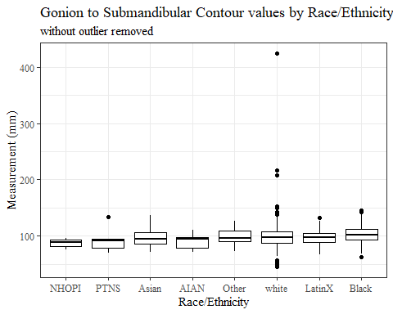

#boxplot not reordered by median  
ggplot(data=headscan_full, aes(y=GoSub_C, x=race_eth))+  
 geom_boxplot(color= "black", fill = "white")+  
 theme_bw()+theme(text=element_text(family= "Times New Roman"))+  
 #theme(axis.text.x = element_text(angle = 20, vjust=0.7))+  
 labs(title="Gonion to Submandibular Contour values by Race/Ethnicity",  
 subtitle= "without outlier removed",  
 y="Measurement (mm)",  
 x="Race/Ethnicity")

## Warning: Removed 127 rows containing non-finite values (stat_boxplot).

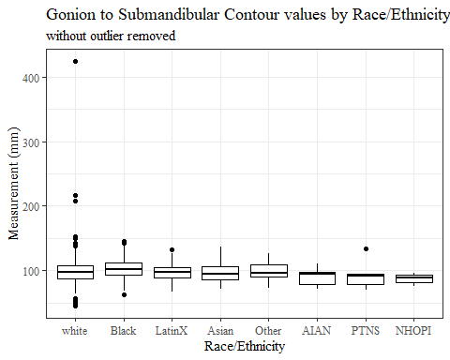

#GoSub_C gender sumstats  
GoSub_Cgender_sumstats <- headscan_full %>%   
 group_by(gender) %>%   
 summarise(n = n(), na = sum(is.na(GoSub_C)),  
 min = min(GoSub_C, na.rm = TRUE),  
 max = max(GoSub_C, na.rm = TRUE),  
 mean = mean(GoSub_C, na.rm = TRUE),  
 mdn = median(GoSub_C, na.rm = TRUE),  
 sd = sd(GoSub_C, na.rm = TRUE),  
 se = sd/sqrt(n),  
 percent5th = quantile(GoSub_C, 0.05, na.rm=TRUE),  
 percent25th = quantile(GoSub_C, 0.25, na.rm=TRUE),  
 percent50th = quantile(GoSub_C, 0.50, na.rm=TRUE),  
 percent75th = quantile(GoSub_C, 0.75, na.rm=TRUE),  
 percent95th = quantile(GoSub_C, 0.95, na.rm=TRUE))  
  
GoSub_Cgender_sumstats <- GoSub_Cgender_sumstats %>%   
 mutate(across(where(is.numeric), round, 2))  
  
#Size 12 Table TNR  
flextable(GoSub_Cgender_sumstats) %>%  
 my_ft_theme()%>%   
 bold(part = "header") %>%   
 set_caption("Gonion to Submandibular Contour SumStats by Gender w/o outlier removed")

**Table** : Gonion to Submandibular Contour SumStats by Gender w/o outlier removed

| **gender** | **n** | **na** | **min** | **max** | **mean** | **mdn** | **sd** | **se** | **percent5th** | **percent25th** | **percent50th** | **percent75th** | **percent95th** |
| --- | --- | --- | --- | --- | --- | --- | --- | --- | --- | --- | --- | --- | --- |
| Female | 1,063 | 26 | 45 | 208 | 93.67 | 93 | 13.92 | 0.43 | 72.00 | 84 | 93 | 103.00 | 117.00 |
| Male | 939 | 101 | 52 | 424 | 105.70 | 105 | 18.46 | 0.60 | 83.00 | 96 | 105 | 114.00 | 130.00 |
| Non-binary or Other | 5 | 0 | 72 | 114 | 97.20 | 104 | 16.10 | 7.20 | 76.00 | 92 | 104 | 104.00 | 112.00 |
| Prefer not to say | 1 | 0 | 134 | 134 | 134.00 | 134 |  |  | 134.00 | 134 | 134 | 134.00 | 134.00 |
|  | 8 | 0 | 82 | 112 | 98.12 | 97 | 9.43 | 3.34 | 85.85 | 93 | 97 | 104.75 | 110.25 |

#%>% set_header_labels(values = list(GoSub_C = "Alare/AlareCont"))  
  
#Autofit Width Table TNR  
flextable(GoSub_Cgender_sumstats) %>%  
 my_ft_theme()%>%   
 bold(part = "header") %>%   
 set_caption("Gonion to Submandibular Contour SumStats by Gender w/o outlier removed") %>%   
 fit_to_width(7.5)

**Table** : Gonion to Submandibular Contour SumStats by Gender w/o outlier removed

| **gender** | **n** | **na** | **min** | **max** | **mean** | **mdn** | **sd** | **se** | **percent5th** | **percent25th** | **percent50th** | **percent75th** | **percent95th** |
| --- | --- | --- | --- | --- | --- | --- | --- | --- | --- | --- | --- | --- | --- |
| Female | 1,063 | 26 | 45 | 208 | 93.67 | 93 | 13.92 | 0.43 | 72.00 | 84 | 93 | 103.00 | 117.00 |
| Male | 939 | 101 | 52 | 424 | 105.70 | 105 | 18.46 | 0.60 | 83.00 | 96 | 105 | 114.00 | 130.00 |
| Non-binary or Other | 5 | 0 | 72 | 114 | 97.20 | 104 | 16.10 | 7.20 | 76.00 | 92 | 104 | 104.00 | 112.00 |
| Prefer not to say | 1 | 0 | 134 | 134 | 134.00 | 134 |  |  | 134.00 | 134 | 134 | 134.00 | 134.00 |
|  | 8 | 0 | 82 | 112 | 98.12 | 97 | 9.43 | 3.34 | 85.85 | 93 | 97 | 104.75 | 110.25 |

#%>% set_header_labels(values = list(GoSub_C = "Alare/AlareCont"))  
  
#boxplot reorderd by median  
headscan_full %>%   
 ungroup() %>%   
 mutate(gender= fct_reorder(gender, GoSub_C, FUN=median, na.rm=TRUE)) %>%   
 ggplot(aes(y=GoSub_C, x=gender))+  
 geom_boxplot(color= "black", fill = "white")+  
 theme_bw()+theme(text=element_text(family= "Times New Roman"))+  
 theme(axis.text.x = element_text(angle = 20, vjust=0.7))+  
 labs(title="Gonion to Submandibular Contour values by Gender",  
 subtitle= "without outlier removed",  
 y="Measurement (mm)",  
 x="Gender")

## Warning: Removed 127 rows containing non-finite values (stat_boxplot).

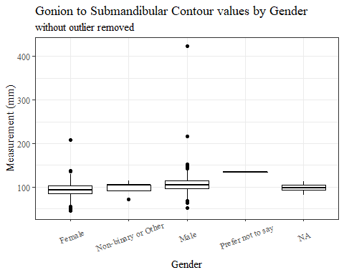

#boxplot not reordered by median  
ggplot(data=headscan_full, aes(y=GoSub_C, x=gender))+  
 geom_boxplot(color= "black", fill = "white")+  
 theme_bw()+theme(text=element_text(family= "Times New Roman"))+  
 theme(axis.text.x = element_text(angle = 20, vjust=0.7))+  
 labs(title="Gonion to Submandibular Contour values by Gender",  
 subtitle= "without outlier removed",  
 y="Measurement (mm)",  
 x="Gender")

## Warning: Removed 127 rows containing non-finite values (stat_boxplot).

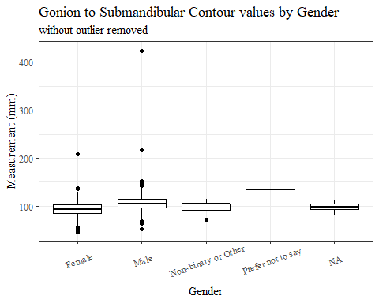

#GoSub_C age group sumstats  
GoSub_Cage_sumstats <- headscan_full %>%   
 group_by(age_group) %>%   
 summarise(n = n(), na = sum(is.na(GoSub_C)),  
 min = min(GoSub_C, na.rm = TRUE),  
 max = max(GoSub_C, na.rm = TRUE),  
 mean = mean(GoSub_C, na.rm = TRUE),  
 mdn = median(GoSub_C, na.rm = TRUE),  
 sd = sd(GoSub_C, na.rm = TRUE),  
 se = sd/sqrt(n),  
 percent5th = quantile(GoSub_C, 0.05, na.rm=TRUE),  
 percent25th = quantile(GoSub_C, 0.25, na.rm=TRUE),  
 percent50th = quantile(GoSub_C, 0.50, na.rm=TRUE),  
 percent75th = quantile(GoSub_C, 0.75, na.rm=TRUE),  
 percent95th = quantile(GoSub_C, 0.95, na.rm=TRUE))  
  
GoSub_Cage_sumstats <- GoSub_Cage_sumstats %>%   
 mutate(across(where(is.numeric), round, 2))  
  
  
#Size 12 Table TNR  
flextable(GoSub_Cage_sumstats) %>%  
 my_ft_theme()%>%   
 bold(part = "header") %>%   
 set_caption("Gonion to Submandibular Contour SumStats by Age Group w/o outlier removed")

**Table** : Gonion to Submandibular Contour SumStats by Age Group w/o outlier removed

| **age_group** | **n** | **na** | **min** | **max** | **mean** | **mdn** | **sd** | **se** | **percent5th** | **percent25th** | **percent50th** | **percent75th** | **percent95th** |
| --- | --- | --- | --- | --- | --- | --- | --- | --- | --- | --- | --- | --- | --- |
| 18-36 | 991 | 59 | 49 | 146 | 95.16 | 95 | 14.33 | 0.46 | 73.0 | 85 | 95 | 105 | 121.0 |
| 37-54 | 940 | 65 | 45 | 424 | 102.55 | 102 | 19.13 | 0.62 | 77.7 | 93 | 102 | 112 | 127.3 |
| 55-72 | 84 | 3 | 65 | 145 | 106.01 | 106 | 14.14 | 1.54 | 84.0 | 97 | 106 | 116 | 129.0 |
|  | 1 | 0 | 101 | 101 | 101.00 | 101 |  |  | 101.0 | 101 | 101 | 101 | 101.0 |

#%>% set_header_labels(values = list(GoSub_C = "Alare/AlareCont"))  
  
#Autofit Width Table TNR  
flextable(GoSub_Cage_sumstats) %>%  
 my_ft_theme()%>%   
 bold(part = "header") %>%   
 set_caption("Gonion to Submandibular Contour SumStats by Age Group w/o outlier removed") %>%   
 fit_to_width(7.5)

**Table** : Gonion to Submandibular Contour SumStats by Age Group w/o outlier removed

| **age_group** | **n** | **na** | **min** | **max** | **mean** | **mdn** | **sd** | **se** | **percent5th** | **percent25th** | **percent50th** | **percent75th** | **percent95th** |
| --- | --- | --- | --- | --- | --- | --- | --- | --- | --- | --- | --- | --- | --- |
| 18-36 | 991 | 59 | 49 | 146 | 95.16 | 95 | 14.33 | 0.46 | 73.0 | 85 | 95 | 105 | 121.0 |
| 37-54 | 940 | 65 | 45 | 424 | 102.55 | 102 | 19.13 | 0.62 | 77.7 | 93 | 102 | 112 | 127.3 |
| 55-72 | 84 | 3 | 65 | 145 | 106.01 | 106 | 14.14 | 1.54 | 84.0 | 97 | 106 | 116 | 129.0 |
|  | 1 | 0 | 101 | 101 | 101.00 | 101 |  |  | 101.0 | 101 | 101 | 101 | 101.0 |

#%>% set_header_labels(values = list(GoSub_C = "Alare/AlareCont"))  
  
#boxplot reorderd by median  
headscan_full %>%   
 ungroup() %>%   
 mutate(age_group= fct_reorder(age_group, GoSub_C, FUN=median, na.rm=TRUE)) %>%   
 ggplot(aes(y=GoSub_C, x=age_group))+  
 geom_boxplot(color= "black", fill = "white")+  
 theme_bw()+theme(text=element_text(family= "Times New Roman"))+  
 #theme(axis.text.x = element_text(angle = 20, vjust=0.7))+  
 labs(title="Gonion to Submandibular Contour values by Age Group",  
 subtitle= "without outlier removed",  
 y="Measurement (mm)",  
 x="Age Group")

## Warning: Removed 127 rows containing non-finite values (stat_boxplot).

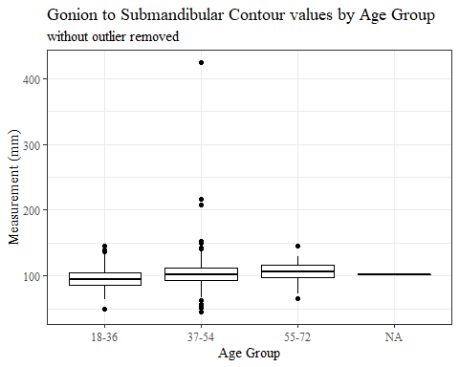

#boxplot not reordered by median  
ggplot(data=headscan_full, aes(y=GoSub_C, x=age_group))+  
 geom_boxplot(color= "black", fill = "white")+  
 theme_bw()+theme(text=element_text(family= "Times New Roman"))+  
 #theme(axis.text.x = element_text(angle = 20, vjust=0.7))+  
 labs(title="Gonion to Submandibular Contour values by Age Group",  
 subtitle= "without outlier removed",  
 y="Measurement (mm)",  
 x="Age Group")

## Warning: Removed 127 rows containing non-finite values (stat_boxplot).



GoSub_C WITH Outlier Removed!!!!

#REMOVING OUTLIER GoSubC  
  
max(headscan_full$GoSub_C, na.rm = TRUE)

## [1] 424

#400-20210129-009  
  
#CODE TO REMOVE OUTLIER, use later to remove from headscan_full  
GoSub_no_out <- headscan_full %>% mutate(GoSub_C = replace(GoSub_C, GoSub_C>400, NA))

#histogram of all GoSub_C values  
ggplot(data=GoSub_no_out, aes(x=GoSub_C))+  
 geom_bar(stat="bin", bins=20, color= "black", fill = "white")+  
 theme_bw()+theme(text=element_text(family= "Times New Roman"))+  
 labs(title="Gonion to Submandibular Contour Measurement Distribution",  
 y="Frequency",  
 x="Gonion to Submandibular Contour (mm)")

## Warning: Removed 128 rows containing non-finite values (stat_bin).

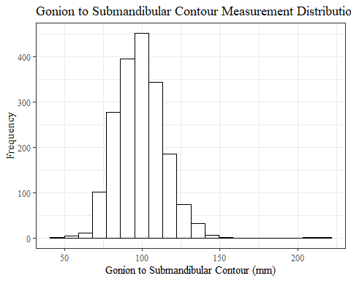

GoSub_Csumstats1 <- GoSub_no_out %>%   
 summarise(n = n(), na = sum(is.na(GoSub_C)),  
 min = min(GoSub_C, na.rm = TRUE),  
 max = max(GoSub_C, na.rm = TRUE),  
 mean = mean(GoSub_C, na.rm = TRUE),  
 mdn = median(GoSub_C, na.rm = TRUE),  
 sd = sd(GoSub_C, na.rm = TRUE),  
 se = sd/sqrt(n),  
 percent5th = quantile(GoSub_C, 0.05, na.rm=TRUE),  
 percent25th = quantile(GoSub_C, 0.25, na.rm=TRUE),  
 percent50th = quantile(GoSub_C, 0.50, na.rm=TRUE),  
 percent75th = quantile(GoSub_C, 0.75, na.rm=TRUE),  
 percent95th = quantile(GoSub_C, 0.95, na.rm=TRUE))   
  
GoSub_Csumstats1 <- round(GoSub_Csumstats1, 2)  
  
#Size 12 Table TNR  
flextable(GoSub_Csumstats1) %>%  
 my_ft_theme()%>%   
 bold(part = "header") %>%   
 set_caption("Gonion to Submandibular Contour SumStats")

**Table** : Gonion to Submandibular Contour SumStats

| **n** | **na** | **min** | **max** | **mean** | **mdn** | **sd** | **se** | **percent5th** | **percent25th** | **percent50th** | **percent75th** | **percent95th** |
| --- | --- | --- | --- | --- | --- | --- | --- | --- | --- | --- | --- | --- |
| 2,016 | 128 | 45 | 217 | 98.88 | 99 | 15.45 | 0.34 | 75 | 88 | 99 | 108 | 125 |

#%>% set_header_labels(values = list(GoSub_C = "Alare/AlareCont"))  
  
#Autofit Width Table TNR  
flextable(GoSub_Csumstats1) %>%  
 my_ft_theme()%>%   
 bold(part = "header") %>%   
 set_caption("Gonion to Submandibular Contour SumStats") %>%   
 fit_to_width(7.5)

**Table** : Gonion to Submandibular Contour SumStats

| **n** | **na** | **min** | **max** | **mean** | **mdn** | **sd** | **se** | **percent5th** | **percent25th** | **percent50th** | **percent75th** | **percent95th** |
| --- | --- | --- | --- | --- | --- | --- | --- | --- | --- | --- | --- | --- |
| 2,016 | 128 | 45 | 217 | 98.88 | 99 | 15.45 | 0.34 | 75 | 88 | 99 | 108 | 125 |

#%>% set_header_labels(values = list(GoSub_C = "Alare/AlareCont"))

#GoSub_C race/eth sumstats  
GoSub_Crace_sumstats1 <- GoSub_no_out %>%   
 group_by(race_eth) %>%   
 summarise(n = n(), na = sum(is.na(GoSub_C)),  
 min = min(GoSub_C, na.rm = TRUE),  
 max = max(GoSub_C, na.rm = TRUE),  
 mean = mean(GoSub_C, na.rm = TRUE),  
 mdn = median(GoSub_C, na.rm = TRUE),  
 sd = sd(GoSub_C, na.rm = TRUE),  
 se = sd/sqrt(n),  
 percent5th = quantile(GoSub_C, 0.05, na.rm=TRUE),  
 percent25th = quantile(GoSub_C, 0.25, na.rm=TRUE),  
 percent50th = quantile(GoSub_C, 0.50, na.rm=TRUE),  
 percent75th = quantile(GoSub_C, 0.75, na.rm=TRUE),  
 percent95th = quantile(GoSub_C, 0.95, na.rm=TRUE))   
  
GoSub_Crace_sumstats1 <- GoSub_Crace_sumstats1 %>%   
 mutate(across(where(is.numeric), round, 2))  
  
  
#Size 12 Table TNR  
flextable(GoSub_Crace_sumstats1) %>%  
 my_ft_theme()%>%   
 bold(part = "header") %>%   
 set_caption("Gonion to Submandibular Contour SumStats by Race/Ethnicity")

**Table** : Gonion to Submandibular Contour SumStats by Race/Ethnicity

| **race_eth** | **n** | **na** | **min** | **max** | **mean** | **mdn** | **sd** | **se** | **percent5th** | **percent25th** | **percent50th** | **percent75th** | **percent95th** |
| --- | --- | --- | --- | --- | --- | --- | --- | --- | --- | --- | --- | --- | --- |
| white | 1,239 | 72 | 45 | 217 | 97.83 | 97 | 15.89 | 0.45 | 74.0 | 87 | 97 | 107.0 | 124.0 |
| Black | 548 | 39 | 63 | 146 | 102.33 | 102 | 14.29 | 0.61 | 78.0 | 93 | 102 | 112.0 | 125.6 |
| LatinX | 100 | 9 | 67 | 132 | 97.47 | 98 | 13.65 | 1.37 | 76.0 | 88 | 98 | 104.0 | 119.0 |
| Asian | 91 | 2 | 71 | 137 | 95.61 | 94 | 14.40 | 1.51 | 74.8 | 85 | 94 | 106.0 | 120.2 |
| Other | 21 | 4 | 73 | 126 | 100.00 | 96 | 14.35 | 3.13 | 78.6 | 90 | 96 | 109.0 | 121.2 |
| AIAN | 8 | 1 | 71 | 111 | 89.86 | 94 | 14.02 | 4.96 | 73.1 | 79 | 94 | 97.5 | 107.4 |
| PTNS | 5 | 0 | 69 | 134 | 93.20 | 91 | 24.93 | 11.15 | 70.8 | 78 | 91 | 94.0 | 126.0 |
| NHOPI | 4 | 1 | 75 | 96 | 86.67 | 89 | 10.69 | 5.35 | 76.4 | 82 | 89 | 92.5 | 95.3 |

#%>% set_header_labels(values = list(GoSub_C = "Alare/AlareCont"))  
  
#Autofit Width Table TNR  
flextable(GoSub_Crace_sumstats1) %>%  
 my_ft_theme()%>%   
 bold(part = "header") %>%   
 set_caption("Gonion to Submandibular Contour SumStats by Race/Ethnicity") %>%   
 fit_to_width(7.5)

**Table** : Gonion to Submandibular Contour SumStats by Race/Ethnicity

| **race_eth** | **n** | **na** | **min** | **max** | **mean** | **mdn** | **sd** | **se** | **percent5th** | **percent25th** | **percent50th** | **percent75th** | **percent95th** |
| --- | --- | --- | --- | --- | --- | --- | --- | --- | --- | --- | --- | --- | --- |
| white | 1,239 | 72 | 45 | 217 | 97.83 | 97 | 15.89 | 0.45 | 74.0 | 87 | 97 | 107.0 | 124.0 |
| Black | 548 | 39 | 63 | 146 | 102.33 | 102 | 14.29 | 0.61 | 78.0 | 93 | 102 | 112.0 | 125.6 |
| LatinX | 100 | 9 | 67 | 132 | 97.47 | 98 | 13.65 | 1.37 | 76.0 | 88 | 98 | 104.0 | 119.0 |
| Asian | 91 | 2 | 71 | 137 | 95.61 | 94 | 14.40 | 1.51 | 74.8 | 85 | 94 | 106.0 | 120.2 |
| Other | 21 | 4 | 73 | 126 | 100.00 | 96 | 14.35 | 3.13 | 78.6 | 90 | 96 | 109.0 | 121.2 |
| AIAN | 8 | 1 | 71 | 111 | 89.86 | 94 | 14.02 | 4.96 | 73.1 | 79 | 94 | 97.5 | 107.4 |
| PTNS | 5 | 0 | 69 | 134 | 93.20 | 91 | 24.93 | 11.15 | 70.8 | 78 | 91 | 94.0 | 126.0 |
| NHOPI | 4 | 1 | 75 | 96 | 86.67 | 89 | 10.69 | 5.35 | 76.4 | 82 | 89 | 92.5 | 95.3 |

#%>% set_header_labels(values = list(GoSub_C = "Alare/AlareCont"))  
  
#boxplot reorderd by median  
GoSub_no_out %>%   
 ungroup() %>%   
 mutate(race_eth= fct_reorder(race_eth, GoSub_C, FUN=median, na.rm=TRUE)) %>%   
 ggplot(aes(y=GoSub_C, x=race_eth))+  
 geom_boxplot(color= "black", fill = "white")+  
 theme_bw()+theme(text=element_text(family= "Times New Roman"))+  
 #theme(axis.text.x = element_text(angle = 20, vjust=0.7))+  
 labs(title="Gonion to Submandibular Contour values by Race/Ethnicity",  
 y="Measurement (mm)",  
 x="Race/Ethnicity")

## Warning: Removed 128 rows containing non-finite values (stat_boxplot).

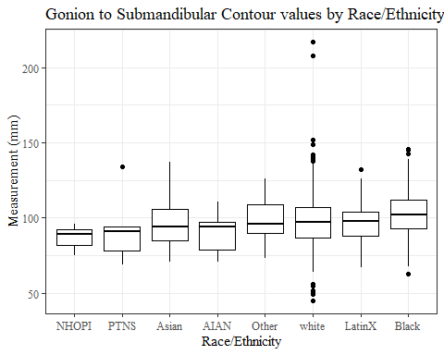

#boxplot not reordered by median  
ggplot(data=GoSub_no_out, aes(y=GoSub_C, x=race_eth))+  
 geom_boxplot(color= "black", fill = "white")+  
 theme_bw()+theme(text=element_text(family= "Times New Roman"))+  
 #theme(axis.text.x = element_text(angle = 20, vjust=0.7))+  
 labs(title="Gonion to Submandibular Contour values by Race/Ethnicity",  
 y="Measurement (mm)",  
 x="Race/Ethnicity")

## Warning: Removed 128 rows containing non-finite values (stat_boxplot).

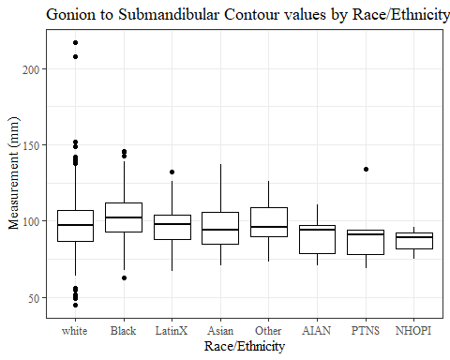

#GoSub_C gender sumstats  
GoSub_Cgender_sumstats1 <- GoSub_no_out %>%   
 group_by(gender) %>%   
 summarise(n = n(), na = sum(is.na(GoSub_C)),  
 min = min(GoSub_C, na.rm = TRUE),  
 max = max(GoSub_C, na.rm = TRUE),  
 mean = mean(GoSub_C, na.rm = TRUE),  
 mdn = median(GoSub_C, na.rm = TRUE),  
 sd = sd(GoSub_C, na.rm = TRUE),  
 se = sd/sqrt(n),  
 percent5th = quantile(GoSub_C, 0.05, na.rm=TRUE),  
 percent25th = quantile(GoSub_C, 0.25, na.rm=TRUE),  
 percent50th = quantile(GoSub_C, 0.50, na.rm=TRUE),  
 percent75th = quantile(GoSub_C, 0.75, na.rm=TRUE),  
 percent95th = quantile(GoSub_C, 0.95, na.rm=TRUE))  
  
GoSub_Cgender_sumstats1 <- GoSub_Cgender_sumstats1 %>%   
 mutate(across(where(is.numeric), round, 2))  
  
#Size 12 Table TNR  
flextable(GoSub_Cgender_sumstats1) %>%  
 my_ft_theme()%>%   
 bold(part = "header") %>%   
 set_caption("Gonion to Submandibular Contour SumStats by Gender")

**Table** : Gonion to Submandibular Contour SumStats by Gender

| **gender** | **n** | **na** | **min** | **max** | **mean** | **mdn** | **sd** | **se** | **percent5th** | **percent25th** | **percent50th** | **percent75th** | **percent95th** |
| --- | --- | --- | --- | --- | --- | --- | --- | --- | --- | --- | --- | --- | --- |
| Female | 1,063 | 26 | 45 | 208 | 93.67 | 93 | 13.92 | 0.43 | 72.00 | 84 | 93 | 103.00 | 117.00 |
| Male | 939 | 102 | 52 | 217 | 105.32 | 105 | 14.82 | 0.48 | 83.00 | 96 | 105 | 114.00 | 130.00 |
| Non-binary or Other | 5 | 0 | 72 | 114 | 97.20 | 104 | 16.10 | 7.20 | 76.00 | 92 | 104 | 104.00 | 112.00 |
| Prefer not to say | 1 | 0 | 134 | 134 | 134.00 | 134 |  |  | 134.00 | 134 | 134 | 134.00 | 134.00 |
|  | 8 | 0 | 82 | 112 | 98.12 | 97 | 9.43 | 3.34 | 85.85 | 93 | 97 | 104.75 | 110.25 |

#%>% set_header_labels(values = list(GoSub_C = "Alare/AlareCont"))  
  
#Autofit Width Table TNR  
flextable(GoSub_Cgender_sumstats1) %>%  
 my_ft_theme()%>%   
 bold(part = "header") %>%   
 set_caption("Gonion to Submandibular Contour SumStats by Gender") %>%   
 fit_to_width(7.5)

**Table** : Gonion to Submandibular Contour SumStats by Gender

| **gender** | **n** | **na** | **min** | **max** | **mean** | **mdn** | **sd** | **se** | **percent5th** | **percent25th** | **percent50th** | **percent75th** | **percent95th** |
| --- | --- | --- | --- | --- | --- | --- | --- | --- | --- | --- | --- | --- | --- |
| Female | 1,063 | 26 | 45 | 208 | 93.67 | 93 | 13.92 | 0.43 | 72.00 | 84 | 93 | 103.00 | 117.00 |
| Male | 939 | 102 | 52 | 217 | 105.32 | 105 | 14.82 | 0.48 | 83.00 | 96 | 105 | 114.00 | 130.00 |
| Non-binary or Other | 5 | 0 | 72 | 114 | 97.20 | 104 | 16.10 | 7.20 | 76.00 | 92 | 104 | 104.00 | 112.00 |
| Prefer not to say | 1 | 0 | 134 | 134 | 134.00 | 134 |  |  | 134.00 | 134 | 134 | 134.00 | 134.00 |
|  | 8 | 0 | 82 | 112 | 98.12 | 97 | 9.43 | 3.34 | 85.85 | 93 | 97 | 104.75 | 110.25 |

#%>% set_header_labels(values = list(GoSub_C = "Alare/AlareCont"))  
  
#boxplot reorderd by median  
GoSub_no_out %>%   
 ungroup() %>%   
 mutate(gender= fct_reorder(gender, GoSub_C, FUN=median, na.rm=TRUE)) %>%   
 ggplot(aes(y=GoSub_C, x=gender))+  
 geom_boxplot(color= "black", fill = "white")+  
 theme_bw()+theme(text=element_text(family= "Times New Roman"))+  
 theme(axis.text.x = element_text(angle = 20, vjust=0.7))+  
 labs(title="Gonion to Submandibular Contour values by Gender",  
 y="Measurement (mm)",  
 x="Gender")

## Warning: Removed 128 rows containing non-finite values (stat_boxplot).

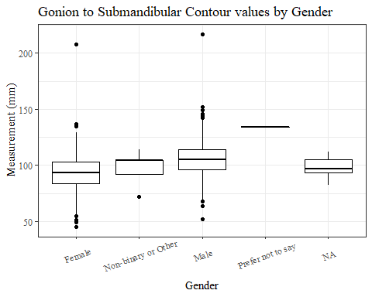

#boxplot not reordered by median  
ggplot(data=GoSub_no_out, aes(y=GoSub_C, x=gender))+  
 geom_boxplot(color= "black", fill = "white")+  
 theme_bw()+theme(text=element_text(family= "Times New Roman"))+  
 theme(axis.text.x = element_text(angle = 20, vjust=0.7))+  
 labs(title="Gonion to Submandibular Contour values by Gender",  
 y="Measurement (mm)",  
 x="Gender")

## Warning: Removed 128 rows containing non-finite values (stat_boxplot).

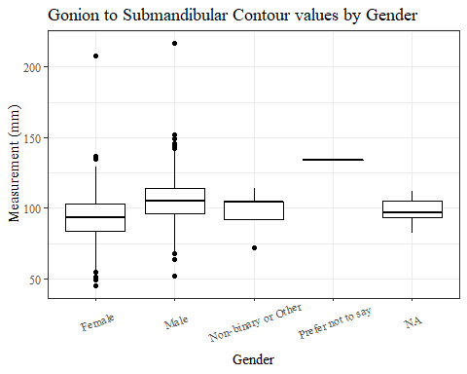

#GoSub_C age group sumstats  
GoSub_Cage_sumstats1 <- GoSub_no_out %>%   
 group_by(age_group) %>%   
 summarise(n = n(), na = sum(is.na(GoSub_C)),  
 min = min(GoSub_C, na.rm = TRUE),  
 max = max(GoSub_C, na.rm = TRUE),  
 mean = mean(GoSub_C, na.rm = TRUE),  
 mdn = median(GoSub_C, na.rm = TRUE),  
 sd = sd(GoSub_C, na.rm = TRUE),  
 se = sd/sqrt(n),  
 percent5th = quantile(GoSub_C, 0.05, na.rm=TRUE),  
 percent25th = quantile(GoSub_C, 0.25, na.rm=TRUE),  
 percent50th = quantile(GoSub_C, 0.50, na.rm=TRUE),  
 percent75th = quantile(GoSub_C, 0.75, na.rm=TRUE),  
 percent95th = quantile(GoSub_C, 0.95, na.rm=TRUE))  
  
GoSub_Cage_sumstats1 <- GoSub_Cage_sumstats1 %>%   
 mutate(across(where(is.numeric), round, 2))  
  
  
#Size 12 Table TNR  
flextable(GoSub_Cage_sumstats1) %>%  
 my_ft_theme()%>%   
 bold(part = "header") %>%   
 set_caption("Gonion to Submandibular Contour SumStats by Age Group")

**Table** : Gonion to Submandibular Contour SumStats by Age Group

| **age_group** | **n** | **na** | **min** | **max** | **mean** | **mdn** | **sd** | **se** | **percent5th** | **percent25th** | **percent50th** | **percent75th** | **percent95th** |
| --- | --- | --- | --- | --- | --- | --- | --- | --- | --- | --- | --- | --- | --- |
| 18-36 | 991 | 59 | 49 | 146 | 95.16 | 95 | 14.33 | 0.46 | 73.00 | 85 | 95 | 105 | 121 |
| 37-54 | 940 | 66 | 45 | 217 | 102.18 | 102 | 15.74 | 0.51 | 77.65 | 93 | 102 | 112 | 127 |
| 55-72 | 84 | 3 | 65 | 145 | 106.01 | 106 | 14.14 | 1.54 | 84.00 | 97 | 106 | 116 | 129 |
|  | 1 | 0 | 101 | 101 | 101.00 | 101 |  |  | 101.00 | 101 | 101 | 101 | 101 |

#%>% set_header_labels(values = list(GoSub_C = "Alare/AlareCont"))  
  
#Autofit Width Table TNR  
flextable(GoSub_Cage_sumstats1) %>%  
 my_ft_theme()%>%   
 bold(part = "header") %>%   
 set_caption("Gonion to Submandibular Contour SumStats by Age Group") %>%   
 fit_to_width(7.5)

**Table** : Gonion to Submandibular Contour SumStats by Age Group

| **age_group** | **n** | **na** | **min** | **max** | **mean** | **mdn** | **sd** | **se** | **percent5th** | **percent25th** | **percent50th** | **percent75th** | **percent95th** |
| --- | --- | --- | --- | --- | --- | --- | --- | --- | --- | --- | --- | --- | --- |
| 18-36 | 991 | 59 | 49 | 146 | 95.16 | 95 | 14.33 | 0.46 | 73.00 | 85 | 95 | 105 | 121 |
| 37-54 | 940 | 66 | 45 | 217 | 102.18 | 102 | 15.74 | 0.51 | 77.65 | 93 | 102 | 112 | 127 |
| 55-72 | 84 | 3 | 65 | 145 | 106.01 | 106 | 14.14 | 1.54 | 84.00 | 97 | 106 | 116 | 129 |
|  | 1 | 0 | 101 | 101 | 101.00 | 101 |  |  | 101.00 | 101 | 101 | 101 | 101 |

#%>% set_header_labels(values = list(GoSub_C = "Alare/AlareCont"))  
  
#boxplot reorderd by median  
GoSub_no_out %>%   
 ungroup() %>%   
 mutate(age_group= fct_reorder(age_group, GoSub_C, FUN=median, na.rm=TRUE)) %>%   
 ggplot(aes(y=GoSub_C, x=age_group))+  
 geom_boxplot(color= "black", fill = "white")+  
 theme_bw()+theme(text=element_text(family= "Times New Roman"))+  
 #theme(axis.text.x = element_text(angle = 20, vjust=0.7))+  
 labs(title="Gonion to Submandibular Contour values by Age Group",  
 y="Measurement (mm)",  
 x="Age Group")

## Warning: Removed 128 rows containing non-finite values (stat_boxplot).

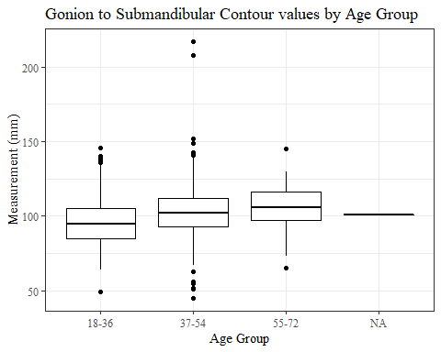

#boxplot not reordered by median  
ggplot(data=GoSub_no_out, aes(y=GoSub_C, x=age_group))+  
 geom_boxplot(color= "black", fill = "white")+  
 theme_bw()+theme(text=element_text(family= "Times New Roman"))+  
 #theme(axis.text.x = element_text(angle = 20, vjust=0.7))+  
 labs(title="Gonion to Submandibular Contour values by Age Group",  
 y="Measurement (mm)",  
 x="Age Group")

## Warning: Removed 128 rows containing non-finite values (stat_boxplot).



NRB_L WIHTOUT outlier removed

#histogram of all NRB_L values  
ggplot(data=headscan_full, aes(x=NRB_L))+  
 geom_bar(stat="bin", bins=20, color= "black", fill = "white")+  
 theme_bw()+theme(text=element_text(family= "Times New Roman"))+  
 labs(title="Nasal Root Breadth Measurement Distribution",  
 subtitle= "without outlier removed",  
 y="Frequency",  
 x="Nasal Root Breadth (mm)")

## Warning: Removed 15 rows containing non-finite values (stat_bin).

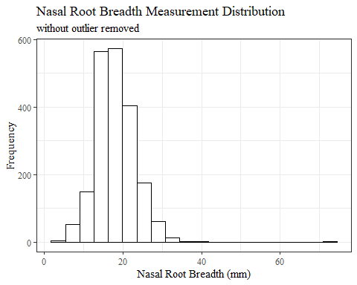

NRB_Lsumstats <- headscan_full %>%   
 summarise(n = n(), na = sum(is.na(NRB_L)),  
 min = min(NRB_L, na.rm = TRUE),  
 max = max(NRB_L, na.rm = TRUE),  
 mean = mean(NRB_L, na.rm = TRUE),  
 mdn = median(NRB_L, na.rm = TRUE),  
 sd = sd(NRB_L, na.rm = TRUE),  
 se = sd/sqrt(n),  
 percent5th = quantile(NRB_L, 0.05, na.rm=TRUE),  
 percent25th = quantile(NRB_L, 0.25, na.rm=TRUE),  
 percent50th = quantile(NRB_L, 0.50, na.rm=TRUE),  
 percent75th = quantile(NRB_L, 0.75, na.rm=TRUE),  
 percent95th = quantile(NRB_L, 0.95, na.rm=TRUE))   
  
  
NRB_Lsumstats <- round(NRB_Lsumstats, 2)  
  
#Size 12 Table TNR  
flextable(NRB_Lsumstats) %>%  
 my_ft_theme()%>%   
 bold(part = "header") %>%   
 set_caption("Nasal Root Breadth SumStats w/o outlier removed")

**Table** : Nasal Root Breadth SumStats w/o outlier removed

| **n** | **na** | **min** | **max** | **mean** | **mdn** | **sd** | **se** | **percent5th** | **percent25th** | **percent50th** | **percent75th** | **percent95th** |
| --- | --- | --- | --- | --- | --- | --- | --- | --- | --- | --- | --- | --- |
| 2,016 | 15 | 3 | 72 | 17.98 | 18 | 4.89 | 0.11 | 11 | 15 | 18 | 21 | 27 |

#%>% set_header_labels(values = list(NRB_L = "Alare/AlareCont"))  
  
#Autofit Width Table TNR  
flextable(NRB_Lsumstats) %>%  
 my_ft_theme()%>%   
 bold(part = "header") %>%   
 set_caption("Nasal Root Breadth SumStats w/o outlier removed") %>%   
 fit_to_width(7.5)

**Table** : Nasal Root Breadth SumStats w/o outlier removed

| **n** | **na** | **min** | **max** | **mean** | **mdn** | **sd** | **se** | **percent5th** | **percent25th** | **percent50th** | **percent75th** | **percent95th** |
| --- | --- | --- | --- | --- | --- | --- | --- | --- | --- | --- | --- | --- |
| 2,016 | 15 | 3 | 72 | 17.98 | 18 | 4.89 | 0.11 | 11 | 15 | 18 | 21 | 27 |

#%>% set_header_labels(values = list(NRB_L = "Alare/AlareCont"))

#NRB_L race/eth sumstats  
NRB_Lrace_sumstats <- headscan_full %>%   
 group_by(race_eth) %>%   
 summarise(n = n(), na = sum(is.na(NRB_L)),  
 min = min(NRB_L, na.rm = TRUE),  
 max = max(NRB_L, na.rm = TRUE),  
 mean = mean(NRB_L, na.rm = TRUE),  
 mdn = median(NRB_L, na.rm = TRUE),  
 sd = sd(NRB_L, na.rm = TRUE),  
 se = sd/sqrt(n),  
 percent5th = quantile(NRB_L, 0.05, na.rm=TRUE),  
 percent25th = quantile(NRB_L, 0.25, na.rm=TRUE),  
 percent50th = quantile(NRB_L, 0.50, na.rm=TRUE),  
 percent75th = quantile(NRB_L, 0.75, na.rm=TRUE),  
 percent95th = quantile(NRB_L, 0.95, na.rm=TRUE))   
  
NRB_Lrace_sumstats <- NRB_Lrace_sumstats %>%   
 mutate(across(where(is.numeric), round, 2))  
  
  
#Size 12 Table TNR  
flextable(NRB_Lrace_sumstats) %>%  
 my_ft_theme()%>%   
 bold(part = "header") %>%   
 set_caption("Nasal Root Breadth SumStats by Race/Ethnicity w/o outlier removed")

**Table** : Nasal Root Breadth SumStats by Race/Ethnicity w/o outlier removed

| **race_eth** | **n** | **na** | **min** | **max** | **mean** | **mdn** | **sd** | **se** | **percent5th** | **percent25th** | **percent50th** | **percent75th** | **percent95th** |
| --- | --- | --- | --- | --- | --- | --- | --- | --- | --- | --- | --- | --- | --- |
| white | 1,239 | 8 | 3 | 72 | 17.30 | 17 | 4.68 | 0.13 | 10.0 | 14.0 | 17 | 20.0 | 25.0 |
| Black | 548 | 4 | 7 | 35 | 19.75 | 19 | 4.92 | 0.21 | 12.0 | 17.0 | 19 | 23.0 | 29.0 |
| LatinX | 100 | 1 | 8 | 29 | 17.48 | 17 | 4.41 | 0.44 | 11.0 | 14.0 | 17 | 20.0 | 25.1 |
| Asian | 91 | 1 | 8 | 31 | 16.61 | 16 | 4.98 | 0.52 | 10.0 | 13.0 | 16 | 19.0 | 26.0 |
| Other | 21 | 0 | 8 | 30 | 20.00 | 20 | 5.47 | 1.19 | 14.0 | 17.0 | 20 | 21.0 | 29.0 |
| AIAN | 8 | 1 | 8 | 28 | 18.14 | 18 | 6.20 | 2.19 | 10.1 | 15.5 | 18 | 21.0 | 25.9 |
| PTNS | 5 | 0 | 13 | 25 | 20.60 | 21 | 4.98 | 2.23 | 14.2 | 19.0 | 21 | 25.0 | 25.0 |
| NHOPI | 4 | 0 | 11 | 21 | 15.00 | 14 | 4.32 | 2.16 | 11.3 | 12.5 | 14 | 16.5 | 20.1 |

#%>% set_header_labels(values = list(NRB_L = "Alare/AlareCont"))  
  
#Autofit Width Table TNR  
flextable(NRB_Lrace_sumstats) %>%  
 my_ft_theme()%>%   
 bold(part = "header") %>%   
 set_caption("Nasal Root Breadth SumStats by Race/Ethnicity w/o outlier removed") %>%   
 fit_to_width(7.5)

**Table** : Nasal Root Breadth SumStats by Race/Ethnicity w/o outlier removed

| **race_eth** | **n** | **na** | **min** | **max** | **mean** | **mdn** | **sd** | **se** | **percent5th** | **percent25th** | **percent50th** | **percent75th** | **percent95th** |
| --- | --- | --- | --- | --- | --- | --- | --- | --- | --- | --- | --- | --- | --- |
| white | 1,239 | 8 | 3 | 72 | 17.30 | 17 | 4.68 | 0.13 | 10.0 | 14.0 | 17 | 20.0 | 25.0 |
| Black | 548 | 4 | 7 | 35 | 19.75 | 19 | 4.92 | 0.21 | 12.0 | 17.0 | 19 | 23.0 | 29.0 |
| LatinX | 100 | 1 | 8 | 29 | 17.48 | 17 | 4.41 | 0.44 | 11.0 | 14.0 | 17 | 20.0 | 25.1 |
| Asian | 91 | 1 | 8 | 31 | 16.61 | 16 | 4.98 | 0.52 | 10.0 | 13.0 | 16 | 19.0 | 26.0 |
| Other | 21 | 0 | 8 | 30 | 20.00 | 20 | 5.47 | 1.19 | 14.0 | 17.0 | 20 | 21.0 | 29.0 |
| AIAN | 8 | 1 | 8 | 28 | 18.14 | 18 | 6.20 | 2.19 | 10.1 | 15.5 | 18 | 21.0 | 25.9 |
| PTNS | 5 | 0 | 13 | 25 | 20.60 | 21 | 4.98 | 2.23 | 14.2 | 19.0 | 21 | 25.0 | 25.0 |
| NHOPI | 4 | 0 | 11 | 21 | 15.00 | 14 | 4.32 | 2.16 | 11.3 | 12.5 | 14 | 16.5 | 20.1 |

#%>% set_header_labels(values = list(NRB_L = "Alare/AlareCont"))  
  
#boxplot reorderd by median  
headscan_full %>%   
 ungroup() %>%   
 mutate(race_eth= fct_reorder(race_eth, NRB_L, FUN=median, na.rm=TRUE)) %>%   
 ggplot(aes(y=NRB_L, x=race_eth))+  
 geom_boxplot(color= "black", fill = "white")+  
 theme_bw()+theme(text=element_text(family= "Times New Roman"))+  
 #theme(axis.text.x = element_text(angle = 20, vjust=0.7))+  
 labs(title="Nasal Root Breadth values by Race/Ethncity",  
 subtitle= "without outlier removed",  
 y="Measurement (mm)",  
 x="Race/Ethnicity")

## Warning: Removed 15 rows containing non-finite values (stat_boxplot).

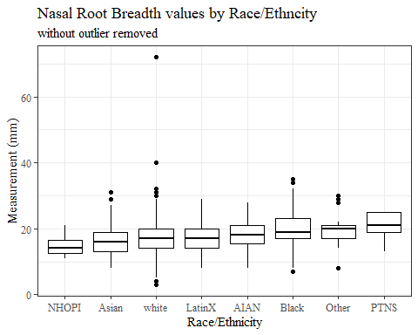

#boxplot not reordered by median  
ggplot(data=headscan_full, aes(y=NRB_L, x=race_eth))+  
 geom_boxplot(color= "black", fill = "white")+  
 theme_bw()+theme(text=element_text(family= "Times New Roman"))+  
 #theme(axis.text.x = element_text(angle = 20, vjust=0.7))+  
 labs(title="Nasal Root Breadth values by Race/Ethncity",  
 subtitle= "without outlier removed",  
 y="Measurement (mm)",  
 x="Race/Ethncity")

## Warning: Removed 15 rows containing non-finite values (stat_boxplot).

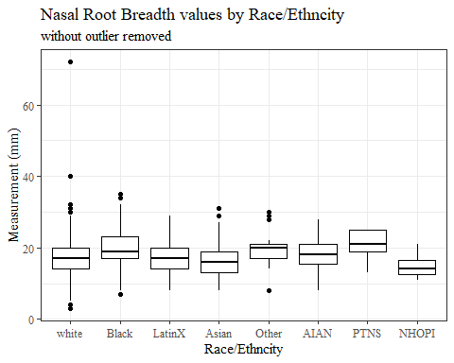

#NRB_L gender sumstats  
NRB_Lgender_sumstats <- headscan_full %>%   
 group_by(gender) %>%   
 summarise(n = n(), na = sum(is.na(NRB_L)),  
 min = min(NRB_L, na.rm = TRUE),  
 max = max(NRB_L, na.rm = TRUE),  
 mean = mean(NRB_L, na.rm = TRUE),  
 mdn = median(NRB_L, na.rm = TRUE),  
 sd = sd(NRB_L, na.rm = TRUE),  
 se = sd/sqrt(n),  
 percent5th = quantile(NRB_L, 0.05, na.rm=TRUE),  
 percent25th = quantile(NRB_L, 0.25, na.rm=TRUE),  
 percent50th = quantile(NRB_L, 0.50, na.rm=TRUE),  
 percent75th = quantile(NRB_L, 0.75, na.rm=TRUE),  
 percent95th = quantile(NRB_L, 0.95, na.rm=TRUE))  
  
NRB_Lgender_sumstats <- NRB_Lgender_sumstats %>%   
 mutate(across(where(is.numeric), round, 2))  
  
#Size 12 Table TNR  
flextable(NRB_Lgender_sumstats) %>%  
 my_ft_theme()%>%   
 bold(part = "header") %>%   
 set_caption("Nasal Root Breadth SumStats by Gender w/o outlier removed")

**Table** : Nasal Root Breadth SumStats by Gender w/o outlier removed

| **gender** | **n** | **na** | **min** | **max** | **mean** | **mdn** | **sd** | **se** | **percent5th** | **percent25th** | **percent50th** | **percent75th** | **percent95th** |
| --- | --- | --- | --- | --- | --- | --- | --- | --- | --- | --- | --- | --- | --- |
| Female | 1,063 | 9 | 4 | 32 | 18.17 | 18 | 4.76 | 0.15 | 10.0 | 15.00 | 18 | 21 | 27.00 |
| Male | 939 | 6 | 3 | 72 | 17.79 | 17 | 5.04 | 0.16 | 11.0 | 15.00 | 17 | 20 | 27.00 |
| Non-binary or Other | 5 | 0 | 8 | 20 | 14.20 | 13 | 5.17 | 2.31 | 8.6 | 11.00 | 13 | 19 | 19.80 |
| Prefer not to say | 1 | 0 | 19 | 19 | 19.00 | 19 |  |  | 19.0 | 19.00 | 19 | 19 | 19.00 |
|  | 8 | 0 | 14 | 19 | 17.00 | 17 | 1.51 | 0.53 | 14.7 | 16.75 | 17 | 18 | 18.65 |

#%>% set_header_labels(values = list(NRB_L = "Alare/AlareCont"))  
  
#Autofit Width Table TNR  
flextable(NRB_Lgender_sumstats) %>%  
 my_ft_theme()%>%   
 bold(part = "header") %>%   
 set_caption("Nasal Root Breadth SumStats by Gender w/o outlier removed") %>%   
 fit_to_width(7.5)

**Table** : Nasal Root Breadth SumStats by Gender w/o outlier removed

| **gender** | **n** | **na** | **min** | **max** | **mean** | **mdn** | **sd** | **se** | **percent5th** | **percent25th** | **percent50th** | **percent75th** | **percent95th** |
| --- | --- | --- | --- | --- | --- | --- | --- | --- | --- | --- | --- | --- | --- |
| Female | 1,063 | 9 | 4 | 32 | 18.17 | 18 | 4.76 | 0.15 | 10.0 | 15.00 | 18 | 21 | 27.00 |
| Male | 939 | 6 | 3 | 72 | 17.79 | 17 | 5.04 | 0.16 | 11.0 | 15.00 | 17 | 20 | 27.00 |
| Non-binary or Other | 5 | 0 | 8 | 20 | 14.20 | 13 | 5.17 | 2.31 | 8.6 | 11.00 | 13 | 19 | 19.80 |
| Prefer not to say | 1 | 0 | 19 | 19 | 19.00 | 19 |  |  | 19.0 | 19.00 | 19 | 19 | 19.00 |
|  | 8 | 0 | 14 | 19 | 17.00 | 17 | 1.51 | 0.53 | 14.7 | 16.75 | 17 | 18 | 18.65 |

#%>% set_header_labels(values = list(NRB_L = "Alare/AlareCont"))  
  
#boxplot reorderd by median  
headscan_full %>%   
 ungroup() %>%   
 mutate(gender= fct_reorder(gender, NRB_L, FUN=median, na.rm=TRUE)) %>%   
 ggplot(aes(y=NRB_L, x=gender))+  
 geom_boxplot(color= "black", fill = "white")+  
 theme_bw()+theme(text=element_text(family= "Times New Roman"))+  
 theme(axis.text.x = element_text(angle = 20, vjust=0.7))+  
 labs(title="Nasal Root Breadth values by Gender",  
 subtitle= "without outlier removed",  
 y="Measurement (mm)",  
 x="Gender")

## Warning: Removed 15 rows containing non-finite values (stat_boxplot).

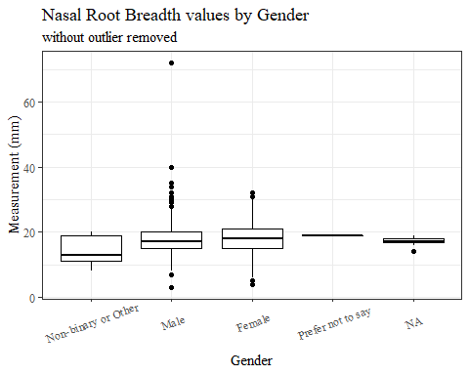

#boxplot not reordered by median  
ggplot(data=headscan_full, aes(y=NRB_L, x=gender))+  
 geom_boxplot(color= "black", fill = "white")+  
 theme_bw()+theme(text=element_text(family= "Times New Roman"))+  
 theme(axis.text.x = element_text(angle = 20, vjust=0.7))+  
 labs(title="Nasal Root Breadth values by Gender",  
 subtitle= "without outlier removed",  
 y="Measurement (mm)",  
 x="Gender")

## Warning: Removed 15 rows containing non-finite values (stat_boxplot).

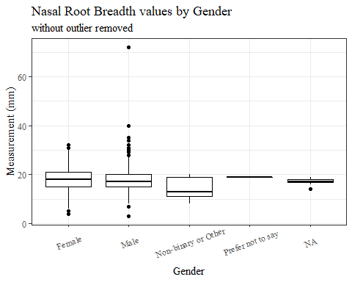

#NRB_L age group sumstats  
NRB_Lage_sumstats <- headscan_full %>%   
 group_by(age_group) %>%   
 summarise(n = n(), na = sum(is.na(NRB_L)),  
 min = min(NRB_L, na.rm = TRUE),  
 max = max(NRB_L, na.rm = TRUE),  
 mean = mean(NRB_L, na.rm = TRUE),  
 mdn = median(NRB_L, na.rm = TRUE),  
 sd = sd(NRB_L, na.rm = TRUE),  
 se = sd/sqrt(n),  
 percent5th = quantile(NRB_L, 0.05, na.rm=TRUE),  
 percent25th = quantile(NRB_L, 0.25, na.rm=TRUE),  
 percent50th = quantile(NRB_L, 0.50, na.rm=TRUE),  
 percent75th = quantile(NRB_L, 0.75, na.rm=TRUE),  
 percent95th = quantile(NRB_L, 0.95, na.rm=TRUE))  
  
NRB_Lage_sumstats <- NRB_Lage_sumstats %>%   
 mutate(across(where(is.numeric), round, 2))  
  
  
#Size 12 Table TNR  
flextable(NRB_Lage_sumstats) %>%  
 my_ft_theme()%>%   
 bold(part = "header") %>%   
 set_caption("Nasal Root Breadth SumStats by Age Group w/o outlier removed")

**Table** : Nasal Root Breadth SumStats by Age Group w/o outlier removed

| **age_group** | **n** | **na** | **min** | **max** | **mean** | **mdn** | **sd** | **se** | **percent5th** | **percent25th** | **percent50th** | **percent75th** | **percent95th** |
| --- | --- | --- | --- | --- | --- | --- | --- | --- | --- | --- | --- | --- | --- |
| 18-36 | 991 | 6 | 4 | 72 | 18.19 | 18 | 5.04 | 0.16 | 11.0 | 15 | 18 | 21.0 | 27 |
| 37-54 | 940 | 8 | 3 | 35 | 17.82 | 18 | 4.69 | 0.15 | 10.0 | 15 | 18 | 20.0 | 26 |
| 55-72 | 84 | 1 | 8 | 32 | 17.42 | 17 | 5.26 | 0.57 | 9.1 | 14 | 17 | 19.5 | 28 |
|  | 1 | 0 | 13 | 13 | 13.00 | 13 |  |  | 13.0 | 13 | 13 | 13.0 | 13 |

#%>% set_header_labels(values = list(NRB_L = "Alare/AlareCont"))  
  
#Autofit Width Table TNR  
flextable(NRB_Lage_sumstats) %>%  
 my_ft_theme()%>%   
 bold(part = "header") %>%   
 set_caption("Nasal Root Breadth SumStats by Age Group w/o outlier removed") %>%   
 fit_to_width(7.5)

**Table** : Nasal Root Breadth SumStats by Age Group w/o outlier removed

| **age_group** | **n** | **na** | **min** | **max** | **mean** | **mdn** | **sd** | **se** | **percent5th** | **percent25th** | **percent50th** | **percent75th** | **percent95th** |
| --- | --- | --- | --- | --- | --- | --- | --- | --- | --- | --- | --- | --- | --- |
| 18-36 | 991 | 6 | 4 | 72 | 18.19 | 18 | 5.04 | 0.16 | 11.0 | 15 | 18 | 21.0 | 27 |
| 37-54 | 940 | 8 | 3 | 35 | 17.82 | 18 | 4.69 | 0.15 | 10.0 | 15 | 18 | 20.0 | 26 |
| 55-72 | 84 | 1 | 8 | 32 | 17.42 | 17 | 5.26 | 0.57 | 9.1 | 14 | 17 | 19.5 | 28 |
|  | 1 | 0 | 13 | 13 | 13.00 | 13 |  |  | 13.0 | 13 | 13 | 13.0 | 13 |

#%>% set_header_labels(values = list(NRB_L = "Alare/AlareCont"))  
  
#boxplot reorderd by median  
headscan_full %>%   
 ungroup() %>%   
 mutate(age_group= fct_reorder(age_group, NRB_L, FUN=median, na.rm=TRUE)) %>%   
 ggplot(aes(y=NRB_L, x=age_group))+  
 geom_boxplot(color= "black", fill = "white")+  
 theme_bw()+theme(text=element_text(family= "Times New Roman"))+  
 #theme(axis.text.x = element_text(angle = 20, vjust=0.7))+  
 labs(title="Nasal Root Breadth values by Age Group",  
 subtitle= "without outlier removed",  
 y="Measurement (mm)",  
 x="Age Group")

## Warning: Removed 15 rows containing non-finite values (stat_boxplot).

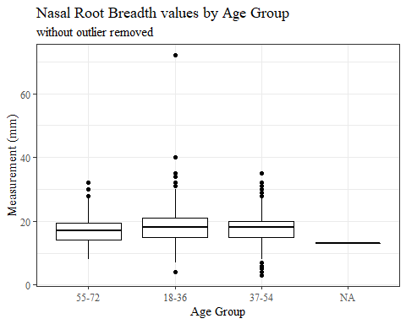

#boxplot not reordered by median  
ggplot(data=headscan_full, aes(y=NRB_L, x=age_group))+  
 geom_boxplot(color= "black", fill = "white")+  
 theme_bw()+theme(text=element_text(family= "Times New Roman"))+  
 #theme(axis.text.x = element_text(angle = 20, vjust=0.7))+  
 labs(title="Nasal Root Breadth values by Age Group",  
 subtitle= "without outlier removed",  
 y="Measurement (mm)",  
 x="Age Group")

## Warning: Removed 15 rows containing non-finite values (stat_boxplot).

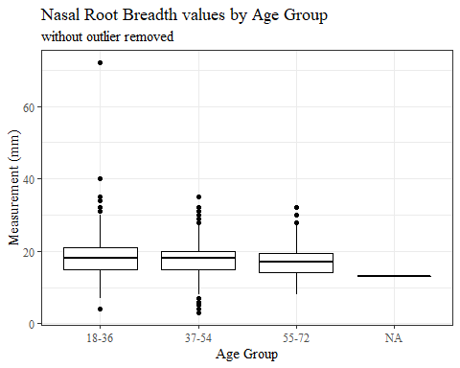

NRB_L WITH Outlier removed

#REMOVING OUTLIER NRB_L  
  
max(headscan_full$NRB_L, na.rm = TRUE)

## [1] 72

#CODE TO REMOVE OUTLIER, use later to remove from headscan_full  
NRB_L_no_out <- headscan_full %>% mutate(NRB_L = replace(NRB_L, NRB_L>70, NA))

#histogram of all NRB_L values  
ggplot(data=NRB_L_no_out, aes(x=NRB_L))+  
 geom_bar(stat="bin", bins=20, color= "black", fill = "white")+  
 theme_bw()+theme(text=element_text(family= "Times New Roman"))+  
 labs(title="Nasal Root Breadth Measurement Distribution",  
 y="Frequency",  
 x="Nasal Root Breadth (mm)")

## Warning: Removed 16 rows containing non-finite values (stat_bin).

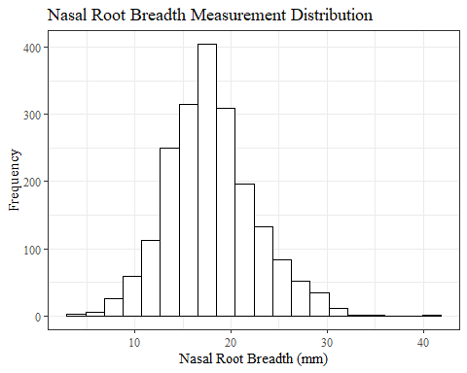

NRB_Lsumstats1 <- NRB_L_no_out %>%   
 summarise(n = n(), na = sum(is.na(NRB_L)),  
 min = min(NRB_L, na.rm = TRUE),  
 max = max(NRB_L, na.rm = TRUE),  
 mean = mean(NRB_L, na.rm = TRUE),  
 mdn = median(NRB_L, na.rm = TRUE),  
 sd = sd(NRB_L, na.rm = TRUE),  
 se = sd/sqrt(n),  
 percent5th = quantile(NRB_L, 0.05, na.rm=TRUE),  
 percent25th = quantile(NRB_L, 0.25, na.rm=TRUE),  
 percent50th = quantile(NRB_L, 0.50, na.rm=TRUE),  
 percent75th = quantile(NRB_L, 0.75, na.rm=TRUE),  
 percent95th = quantile(NRB_L, 0.95, na.rm=TRUE))   
  
NRB_Lsumstats1 <- round(NRB_Lsumstats1, 2)  
  
  
#Size 12 Table TNR  
flextable(NRB_Lsumstats1) %>%  
 my_ft_theme()%>%   
 bold(part = "header") %>%   
 set_caption("Nasal Root Breadth SumStats")

**Table** : Nasal Root Breadth SumStats

| **n** | **na** | **min** | **max** | **mean** | **mdn** | **sd** | **se** | **percent5th** | **percent25th** | **percent50th** | **percent75th** | **percent95th** |
| --- | --- | --- | --- | --- | --- | --- | --- | --- | --- | --- | --- | --- |
| 2,016 | 16 | 3 | 40 | 17.95 | 18 | 4.74 | 0.11 | 11 | 15 | 18 | 21 | 27 |

#%>% set_header_labels(values = list(NRB_L = "Alare/AlareCont"))  
  
#Autofit Width Table TNR  
flextable(NRB_Lsumstats1) %>%  
 my_ft_theme()%>%   
 bold(part = "header") %>%   
 set_caption("Nasal Root Breadth SumStats") %>%   
 fit_to_width(7.5)

**Table** : Nasal Root Breadth SumStats

| **n** | **na** | **min** | **max** | **mean** | **mdn** | **sd** | **se** | **percent5th** | **percent25th** | **percent50th** | **percent75th** | **percent95th** |
| --- | --- | --- | --- | --- | --- | --- | --- | --- | --- | --- | --- | --- |
| 2,016 | 16 | 3 | 40 | 17.95 | 18 | 4.74 | 0.11 | 11 | 15 | 18 | 21 | 27 |

#%>% set_header_labels(values = list(NRB_L = "Alare/AlareCont"))

#NRB_L race/eth sumstats  
NRB_Lrace_sumstats1 <- NRB_L_no_out %>%   
 group_by(race_eth) %>%   
 summarise(n = n(), na = sum(is.na(NRB_L)),  
 min = min(NRB_L, na.rm = TRUE),  
 max = max(NRB_L, na.rm = TRUE),  
 mean = mean(NRB_L, na.rm = TRUE),  
 mdn = median(NRB_L, na.rm = TRUE),  
 sd = sd(NRB_L, na.rm = TRUE),  
 se = sd/sqrt(n),  
 percent5th = quantile(NRB_L, 0.05, na.rm=TRUE),  
 percent25th = quantile(NRB_L, 0.25, na.rm=TRUE),  
 percent50th = quantile(NRB_L, 0.50, na.rm=TRUE),  
 percent75th = quantile(NRB_L, 0.75, na.rm=TRUE),  
 percent95th = quantile(NRB_L, 0.95, na.rm=TRUE))   
  
NRB_Lrace_sumstats1 <- NRB_Lrace_sumstats1 %>%   
 mutate(across(where(is.numeric), round, 2))  
  
  
#Size 12 Table TNR  
flextable(NRB_Lrace_sumstats1) %>%  
 my_ft_theme()%>%   
 bold(part = "header") %>%   
 set_caption("Nasal Root Breadth SumStats by Race/Ethnicity")

**Table** : Nasal Root Breadth SumStats by Race/Ethnicity

| **race_eth** | **n** | **na** | **min** | **max** | **mean** | **mdn** | **sd** | **se** | **percent5th** | **percent25th** | **percent50th** | **percent75th** | **percent95th** |
| --- | --- | --- | --- | --- | --- | --- | --- | --- | --- | --- | --- | --- | --- |
| white | 1,239 | 9 | 3 | 40 | 17.26 | 17 | 4.42 | 0.13 | 10.0 | 14.0 | 17 | 20.0 | 25.0 |
| Black | 548 | 4 | 7 | 35 | 19.75 | 19 | 4.92 | 0.21 | 12.0 | 17.0 | 19 | 23.0 | 29.0 |
| LatinX | 100 | 1 | 8 | 29 | 17.48 | 17 | 4.41 | 0.44 | 11.0 | 14.0 | 17 | 20.0 | 25.1 |
| Asian | 91 | 1 | 8 | 31 | 16.61 | 16 | 4.98 | 0.52 | 10.0 | 13.0 | 16 | 19.0 | 26.0 |
| Other | 21 | 0 | 8 | 30 | 20.00 | 20 | 5.47 | 1.19 | 14.0 | 17.0 | 20 | 21.0 | 29.0 |
| AIAN | 8 | 1 | 8 | 28 | 18.14 | 18 | 6.20 | 2.19 | 10.1 | 15.5 | 18 | 21.0 | 25.9 |
| PTNS | 5 | 0 | 13 | 25 | 20.60 | 21 | 4.98 | 2.23 | 14.2 | 19.0 | 21 | 25.0 | 25.0 |
| NHOPI | 4 | 0 | 11 | 21 | 15.00 | 14 | 4.32 | 2.16 | 11.3 | 12.5 | 14 | 16.5 | 20.1 |

#%>% set_header_labels(values = list(NRB_L = "Alare/AlareCont"))  
  
#Autofit Width Table TNR  
flextable(NRB_Lrace_sumstats1) %>%  
 my_ft_theme()%>%   
 bold(part = "header") %>%   
 set_caption("Nasal Root Breadth SumStats by Race/Ethnicity") %>%   
 fit_to_width(7.5)

**Table** : Nasal Root Breadth SumStats by Race/Ethnicity

| **race_eth** | **n** | **na** | **min** | **max** | **mean** | **mdn** | **sd** | **se** | **percent5th** | **percent25th** | **percent50th** | **percent75th** | **percent95th** |
| --- | --- | --- | --- | --- | --- | --- | --- | --- | --- | --- | --- | --- | --- |
| white | 1,239 | 9 | 3 | 40 | 17.26 | 17 | 4.42 | 0.13 | 10.0 | 14.0 | 17 | 20.0 | 25.0 |
| Black | 548 | 4 | 7 | 35 | 19.75 | 19 | 4.92 | 0.21 | 12.0 | 17.0 | 19 | 23.0 | 29.0 |
| LatinX | 100 | 1 | 8 | 29 | 17.48 | 17 | 4.41 | 0.44 | 11.0 | 14.0 | 17 | 20.0 | 25.1 |
| Asian | 91 | 1 | 8 | 31 | 16.61 | 16 | 4.98 | 0.52 | 10.0 | 13.0 | 16 | 19.0 | 26.0 |
| Other | 21 | 0 | 8 | 30 | 20.00 | 20 | 5.47 | 1.19 | 14.0 | 17.0 | 20 | 21.0 | 29.0 |
| AIAN | 8 | 1 | 8 | 28 | 18.14 | 18 | 6.20 | 2.19 | 10.1 | 15.5 | 18 | 21.0 | 25.9 |
| PTNS | 5 | 0 | 13 | 25 | 20.60 | 21 | 4.98 | 2.23 | 14.2 | 19.0 | 21 | 25.0 | 25.0 |
| NHOPI | 4 | 0 | 11 | 21 | 15.00 | 14 | 4.32 | 2.16 | 11.3 | 12.5 | 14 | 16.5 | 20.1 |

#%>% set_header_labels(values = list(NRB_L = "Alare/AlareCont"))  
  
#boxplot reorderd by median  
NRB_L_no_out %>%   
 ungroup() %>%   
 mutate(race_eth= fct_reorder(race_eth, NRB_L, FUN=median, na.rm=TRUE)) %>%   
 ggplot(aes(y=NRB_L, x=race_eth))+  
 geom_boxplot(color= "black", fill = "white")+  
 theme_bw()+theme(text=element_text(family= "Times New Roman"))+  
 #theme(axis.text.x = element_text(angle = 20, vjust=0.7))+  
 labs(title="Nasal Root Breadth values by Race/Ethncity",  
 y="Measurement (mm)",  
 x="Race/Ethnicity")

## Warning: Removed 16 rows containing non-finite values (stat_boxplot).

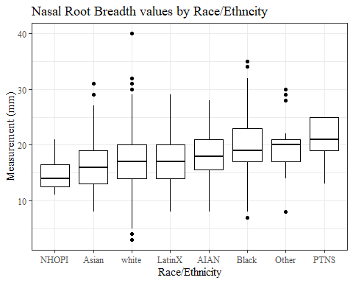

#boxplot not reordered by median  
ggplot(data=NRB_L_no_out, aes(y=NRB_L, x=race_eth))+  
 geom_boxplot(color= "black", fill = "white")+  
 theme_bw()+theme(text=element_text(family= "Times New Roman"))+  
 #theme(axis.text.x = element_text(angle = 20, vjust=0.7))+  
 labs(title="Nasal Root Breadth values by Race/Ethncity",  
 y="Measurement (mm)",  
 x="Race/Ethncity")

## Warning: Removed 16 rows containing non-finite values (stat_boxplot).

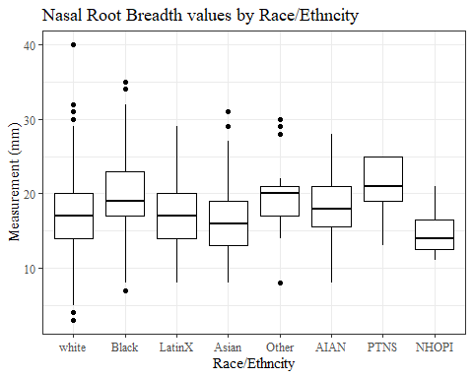

#NRB_L gender sumstats  
NRB_Lgender_sumstats1 <- NRB_L_no_out %>%   
 group_by(gender) %>%   
 summarise(n = n(), na = sum(is.na(NRB_L)),  
 min = min(NRB_L, na.rm = TRUE),  
 max = max(NRB_L, na.rm = TRUE),  
 mean = mean(NRB_L, na.rm = TRUE),  
 mdn = median(NRB_L, na.rm = TRUE),  
 sd = sd(NRB_L, na.rm = TRUE),  
 se = sd/sqrt(n),  
 percent5th = quantile(NRB_L, 0.05, na.rm=TRUE),  
 percent25th = quantile(NRB_L, 0.25, na.rm=TRUE),  
 percent50th = quantile(NRB_L, 0.50, na.rm=TRUE),  
 percent75th = quantile(NRB_L, 0.75, na.rm=TRUE),  
 percent95th = quantile(NRB_L, 0.95, na.rm=TRUE))  
  
NRB_Lgender_sumstats1 <- NRB_Lgender_sumstats1 %>%   
 mutate(across(where(is.numeric), round, 2))  
  
#Size 12 Table TNR  
flextable(NRB_Lgender_sumstats1) %>%  
 my_ft_theme()%>%   
 bold(part = "header") %>%   
 set_caption("Nasal Root Breadth SumStats by Gender")

**Table** : Nasal Root Breadth SumStats by Gender

| **gender** | **n** | **na** | **min** | **max** | **mean** | **mdn** | **sd** | **se** | **percent5th** | **percent25th** | **percent50th** | **percent75th** | **percent95th** |
| --- | --- | --- | --- | --- | --- | --- | --- | --- | --- | --- | --- | --- | --- |
| Female | 1,063 | 9 | 4 | 32 | 18.17 | 18 | 4.76 | 0.15 | 10.0 | 15.00 | 18 | 21 | 27.00 |
| Male | 939 | 7 | 3 | 40 | 17.74 | 17 | 4.72 | 0.15 | 11.0 | 14.75 | 17 | 20 | 26.45 |
| Non-binary or Other | 5 | 0 | 8 | 20 | 14.20 | 13 | 5.17 | 2.31 | 8.6 | 11.00 | 13 | 19 | 19.80 |
| Prefer not to say | 1 | 0 | 19 | 19 | 19.00 | 19 |  |  | 19.0 | 19.00 | 19 | 19 | 19.00 |
|  | 8 | 0 | 14 | 19 | 17.00 | 17 | 1.51 | 0.53 | 14.7 | 16.75 | 17 | 18 | 18.65 |

#%>% set_header_labels(values = list(NRB_L = "Alare/AlareCont"))  
  
#Autofit Width Table TNR  
flextable(NRB_Lgender_sumstats1) %>%  
 my_ft_theme()%>%   
 bold(part = "header") %>%   
 set_caption("Nasal Root Breadth SumStats by Gender") %>%   
 fit_to_width(7.5)

**Table** : Nasal Root Breadth SumStats by Gender

| **gender** | **n** | **na** | **min** | **max** | **mean** | **mdn** | **sd** | **se** | **percent5th** | **percent25th** | **percent50th** | **percent75th** | **percent95th** |
| --- | --- | --- | --- | --- | --- | --- | --- | --- | --- | --- | --- | --- | --- |
| Female | 1,063 | 9 | 4 | 32 | 18.17 | 18 | 4.76 | 0.15 | 10.0 | 15.00 | 18 | 21 | 27.00 |
| Male | 939 | 7 | 3 | 40 | 17.74 | 17 | 4.72 | 0.15 | 11.0 | 14.75 | 17 | 20 | 26.45 |
| Non-binary or Other | 5 | 0 | 8 | 20 | 14.20 | 13 | 5.17 | 2.31 | 8.6 | 11.00 | 13 | 19 | 19.80 |
| Prefer not to say | 1 | 0 | 19 | 19 | 19.00 | 19 |  |  | 19.0 | 19.00 | 19 | 19 | 19.00 |
|  | 8 | 0 | 14 | 19 | 17.00 | 17 | 1.51 | 0.53 | 14.7 | 16.75 | 17 | 18 | 18.65 |

#%>% set_header_labels(values = list(NRB_L = "Alare/AlareCont"))  
  
#boxplot reorderd by median  
NRB_L_no_out %>%   
 ungroup() %>%   
 mutate(gender= fct_reorder(gender, NRB_L, FUN=median, na.rm=TRUE)) %>%   
 ggplot(aes(y=NRB_L, x=gender))+  
 geom_boxplot(color= "black", fill = "white")+  
 theme_bw()+theme(text=element_text(family= "Times New Roman"))+  
 theme(axis.text.x = element_text(angle = 20, vjust=0.7))+  
 labs(title="Nasal Root Breadth values by Gender",  
 y="Measurement (mm)",  
 x="Gender")

## Warning: Removed 16 rows containing non-finite values (stat_boxplot).

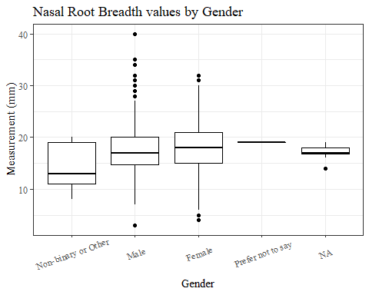

#boxplot not reordered by median  
ggplot(data=NRB_L_no_out, aes(y=NRB_L, x=gender))+  
 geom_boxplot(color= "black", fill = "white")+  
 theme_bw()+theme(text=element_text(family= "Times New Roman"))+  
 theme(axis.text.x = element_text(angle = 20, vjust=0.7))+  
 labs(title="Nasal Root Breadth values by Gender",  
 y="Measurement (mm)",  
 x="Gender")

## Warning: Removed 16 rows containing non-finite values (stat_boxplot).

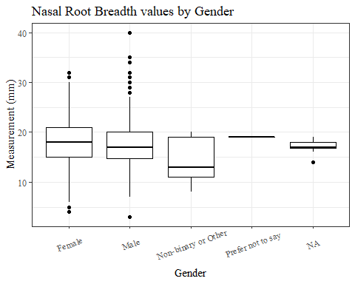

#NRB_L age group sumstats  
NRB_Lage_sumstats1 <- NRB_L_no_out %>%   
 group_by(age_group) %>%   
 summarise(n = n(), na = sum(is.na(NRB_L)),  
 min = min(NRB_L, na.rm = TRUE),  
 max = max(NRB_L, na.rm = TRUE),  
 mean = mean(NRB_L, na.rm = TRUE),  
 mdn = median(NRB_L, na.rm = TRUE),  
 sd = sd(NRB_L, na.rm = TRUE),  
 se = sd/sqrt(n),  
 percent5th = quantile(NRB_L, 0.05, na.rm=TRUE),  
 percent25th = quantile(NRB_L, 0.25, na.rm=TRUE),  
 percent50th = quantile(NRB_L, 0.50, na.rm=TRUE),  
 percent75th = quantile(NRB_L, 0.75, na.rm=TRUE),  
 percent95th = quantile(NRB_L, 0.95, na.rm=TRUE))  
  
NRB_Lage_sumstats1 <- NRB_Lage_sumstats1 %>%   
 mutate(across(where(is.numeric), round, 2))  
  
  
#Size 12 Table TNR  
flextable(NRB_Lage_sumstats1) %>%  
 my_ft_theme()%>%   
 bold(part = "header") %>%   
 set_caption("Nasal Root Breadth SumStats by Age Group")

**Table** : Nasal Root Breadth SumStats by Age Group

| **age_group** | **n** | **na** | **min** | **max** | **mean** | **mdn** | **sd** | **se** | **percent5th** | **percent25th** | **percent50th** | **percent75th** | **percent95th** |
| --- | --- | --- | --- | --- | --- | --- | --- | --- | --- | --- | --- | --- | --- |
| 18-36 | 991 | 7 | 4 | 40 | 18.13 | 18 | 4.74 | 0.15 | 11.0 | 15 | 18 | 21.0 | 27 |
| 37-54 | 940 | 8 | 3 | 35 | 17.82 | 18 | 4.69 | 0.15 | 10.0 | 15 | 18 | 20.0 | 26 |
| 55-72 | 84 | 1 | 8 | 32 | 17.42 | 17 | 5.26 | 0.57 | 9.1 | 14 | 17 | 19.5 | 28 |
|  | 1 | 0 | 13 | 13 | 13.00 | 13 |  |  | 13.0 | 13 | 13 | 13.0 | 13 |

#%>% set_header_labels(values = list(NRB_L = "Alare/AlareCont"))  
  
#Autofit Width Table TNR  
flextable(NRB_Lage_sumstats1) %>%  
 my_ft_theme()%>%   
 bold(part = "header") %>%   
 set_caption("Nasal Root Breadth SumStats by Age Group") %>%   
 fit_to_width(7.5)

**Table** : Nasal Root Breadth SumStats by Age Group

| **age_group** | **n** | **na** | **min** | **max** | **mean** | **mdn** | **sd** | **se** | **percent5th** | **percent25th** | **percent50th** | **percent75th** | **percent95th** |
| --- | --- | --- | --- | --- | --- | --- | --- | --- | --- | --- | --- | --- | --- |
| 18-36 | 991 | 7 | 4 | 40 | 18.13 | 18 | 4.74 | 0.15 | 11.0 | 15 | 18 | 21.0 | 27 |
| 37-54 | 940 | 8 | 3 | 35 | 17.82 | 18 | 4.69 | 0.15 | 10.0 | 15 | 18 | 20.0 | 26 |
| 55-72 | 84 | 1 | 8 | 32 | 17.42 | 17 | 5.26 | 0.57 | 9.1 | 14 | 17 | 19.5 | 28 |
|  | 1 | 0 | 13 | 13 | 13.00 | 13 |  |  | 13.0 | 13 | 13 | 13.0 | 13 |

#%>% set_header_labels(values = list(NRB_L = "Alare/AlareCont"))  
  
#boxplot reorderd by median  
NRB_L_no_out %>%   
 ungroup() %>%   
 mutate(age_group= fct_reorder(age_group, NRB_L, FUN=median, na.rm=TRUE)) %>%   
 ggplot(aes(y=NRB_L, x=age_group))+  
 geom_boxplot(color= "black", fill = "white")+  
 theme_bw()+theme(text=element_text(family= "Times New Roman"))+  
 #theme(axis.text.x = element_text(angle = 20, vjust=0.7))+  
 labs(title="Nasal Root Breadth values by Age Group",  
 y="Measurement (mm)",  
 x="Age Group")

## Warning: Removed 16 rows containing non-finite values (stat_boxplot).

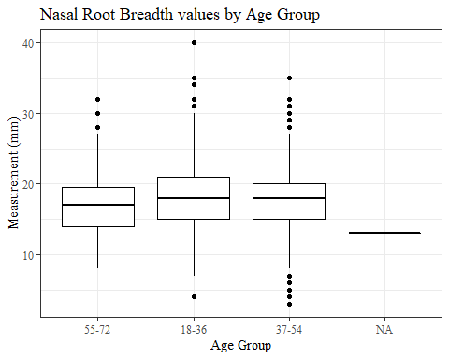

#boxplot not reordered by median  
ggplot(data=NRB_L_no_out, aes(y=NRB_L, x=age_group))+  
 geom_boxplot(color= "black", fill = "white")+  
 theme_bw()+theme(text=element_text(family= "Times New Roman"))+  
 #theme(axis.text.x = element_text(angle = 20, vjust=0.7))+  
 labs(title="Nasal Root Breadth values by Age Group",  
 y="Measurement (mm)",  
 x="Age Group")

## Warning: Removed 16 rows containing non-finite values (stat_boxplot).

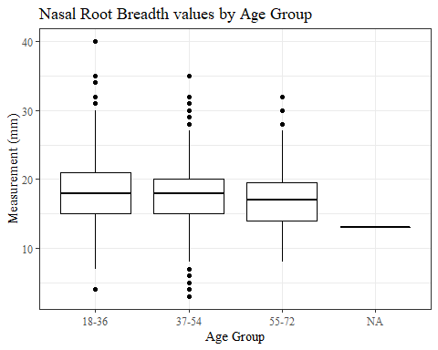

ProA_L

#histogram of all ProA_L values  
ggplot(data=headscan_full, aes(x=ProA_L))+  
 geom_bar(stat="bin", bins=20, color= "black", fill = "white")+  
 theme_bw()+theme(text=element_text(family= "Times New Roman"))+  
 labs(title="Pronasale to Alare Length Measurement Distribution",  
 y="Frequency",  
 x="Pronasale Alare Length (mm)")

## Warning: Removed 16 rows containing non-finite values (stat_bin).

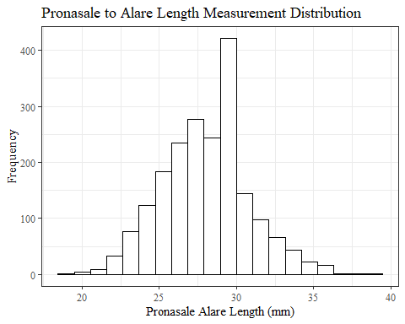

ProA_Lsumstats <- headscan_full %>%   
 summarise(n = n(), na = sum(is.na(ProA_L)),  
 min = min(ProA_L, na.rm = TRUE),  
 max = max(ProA_L, na.rm = TRUE),  
 mean = mean(ProA_L, na.rm = TRUE),  
 mdn = median(ProA_L, na.rm = TRUE),  
 sd = sd(ProA_L, na.rm = TRUE),  
 se = sd/sqrt(n),  
 percent5th = quantile(ProA_L, 0.05, na.rm=TRUE),  
 percent25th = quantile(ProA_L, 0.25, na.rm=TRUE),  
 percent50th = quantile(ProA_L, 0.50, na.rm=TRUE),  
 percent75th = quantile(ProA_L, 0.75, na.rm=TRUE),  
 percent95th = quantile(ProA_L, 0.95, na.rm=TRUE))   
  
  
ProA_Lsumstats <- round(ProA_Lsumstats, 2)  
  
#Size 12 Table TNR  
flextable(ProA_Lsumstats) %>%  
 my_ft_theme()%>%   
 bold(part = "header") %>%   
 set_caption("Pronasale to Alare Length SumStats")

**Table** : Pronasale to Alare Length SumStats

| **n** | **na** | **min** | **max** | **mean** | **mdn** | **sd** | **se** | **percent5th** | **percent25th** | **percent50th** | **percent75th** | **percent95th** |
| --- | --- | --- | --- | --- | --- | --- | --- | --- | --- | --- | --- | --- |
| 2,016 | 16 | 19 | 39 | 27.94 | 28 | 3.03 | 0.07 | 23 | 26 | 28 | 30 | 33 |

#%>% set_header_labels(values = list(ProA_L = "Alare/AlareCont"))  
  
#Autofit Width Table TNR  
flextable(ProA_Lsumstats) %>%  
 my_ft_theme()%>%   
 bold(part = "header") %>%   
 set_caption("Pronasale to Alare Length SumStats") %>%   
 fit_to_width(7.5)

**Table** : Pronasale to Alare Length SumStats

| **n** | **na** | **min** | **max** | **mean** | **mdn** | **sd** | **se** | **percent5th** | **percent25th** | **percent50th** | **percent75th** | **percent95th** |
| --- | --- | --- | --- | --- | --- | --- | --- | --- | --- | --- | --- | --- |
| 2,016 | 16 | 19 | 39 | 27.94 | 28 | 3.03 | 0.07 | 23 | 26 | 28 | 30 | 33 |

#%>% set_header_labels(values = list(ProA_L = "Alare/AlareCont"))

#ProA_L race/eth sumstats  
ProA_Lrace_sumstats <- headscan_full %>%   
 group_by(race_eth) %>%   
 summarise(n = n(), na = sum(is.na(ProA_L)),  
 min = min(ProA_L, na.rm = TRUE),  
 max = max(ProA_L, na.rm = TRUE),  
 mean = mean(ProA_L, na.rm = TRUE),  
 mdn = median(ProA_L, na.rm = TRUE),  
 sd = sd(ProA_L, na.rm = TRUE),  
 se = sd/sqrt(n),  
 percent5th = quantile(ProA_L, 0.05, na.rm=TRUE),  
 percent25th = quantile(ProA_L, 0.25, na.rm=TRUE),  
 percent50th = quantile(ProA_L, 0.50, na.rm=TRUE),  
 percent75th = quantile(ProA_L, 0.75, na.rm=TRUE),  
 percent95th = quantile(ProA_L, 0.95, na.rm=TRUE))   
  
ProA_Lrace_sumstats <- ProA_Lrace_sumstats %>%   
 mutate(across(where(is.numeric), round, 2))  
  
  
#Size 12 Table TNR  
flextable(ProA_Lrace_sumstats) %>%  
 my_ft_theme()%>%   
 bold(part = "header") %>%   
 set_caption("Pronasale to Alare Length SumStats by Race/Ethnicity")

**Table** : Pronasale to Alare Length SumStats by Race/Ethnicity

| **race_eth** | **n** | **na** | **min** | **max** | **mean** | **mdn** | **sd** | **se** | **percent5th** | **percent25th** | **percent50th** | **percent75th** | **percent95th** |
| --- | --- | --- | --- | --- | --- | --- | --- | --- | --- | --- | --- | --- | --- |
| white | 1,239 | 8 | 19 | 37 | 27.83 | 28.0 | 2.96 | 0.08 | 23.0 | 26.0 | 28.0 | 30.00 | 33.00 |
| Black | 548 | 5 | 20 | 39 | 28.34 | 28.0 | 3.13 | 0.13 | 23.1 | 26.0 | 28.0 | 30.00 | 34.00 |
| LatinX | 100 | 1 | 22 | 34 | 28.08 | 28.0 | 3.05 | 0.30 | 23.0 | 26.0 | 28.0 | 30.00 | 33.10 |
| Asian | 91 | 1 | 22 | 36 | 27.12 | 27.0 | 3.18 | 0.33 | 23.0 | 25.0 | 27.0 | 29.00 | 33.00 |
| Other | 21 | 0 | 21 | 32 | 27.81 | 28.0 | 2.94 | 0.64 | 21.0 | 27.0 | 28.0 | 30.00 | 31.00 |
| AIAN | 8 | 1 | 22 | 32 | 27.29 | 27.0 | 3.04 | 1.07 | 23.2 | 26.5 | 27.0 | 28.50 | 31.10 |
| PTNS | 5 | 0 | 26 | 32 | 28.00 | 27.0 | 2.55 | 1.14 | 26.0 | 26.0 | 27.0 | 29.00 | 31.40 |
| NHOPI | 4 | 0 | 26 | 30 | 27.25 | 26.5 | 1.89 | 0.95 | 26.0 | 26.0 | 26.5 | 27.75 | 29.55 |

#%>% set_header_labels(values = list(ProA_L = "Alare/AlareCont"))  
  
#Autofit Width Table TNR  
flextable(ProA_Lrace_sumstats) %>%  
 my_ft_theme()%>%   
 bold(part = "header") %>%   
 set_caption("Pronasale to Alare Length SumStats by Race/Ethnicity") %>%   
 fit_to_width(7.5)

**Table** : Pronasale to Alare Length SumStats by Race/Ethnicity

| **race_eth** | **n** | **na** | **min** | **max** | **mean** | **mdn** | **sd** | **se** | **percent5th** | **percent25th** | **percent50th** | **percent75th** | **percent95th** |
| --- | --- | --- | --- | --- | --- | --- | --- | --- | --- | --- | --- | --- | --- |
| white | 1,239 | 8 | 19 | 37 | 27.83 | 28.0 | 2.96 | 0.08 | 23.0 | 26.0 | 28.0 | 30.00 | 33.00 |
| Black | 548 | 5 | 20 | 39 | 28.34 | 28.0 | 3.13 | 0.13 | 23.1 | 26.0 | 28.0 | 30.00 | 34.00 |
| LatinX | 100 | 1 | 22 | 34 | 28.08 | 28.0 | 3.05 | 0.30 | 23.0 | 26.0 | 28.0 | 30.00 | 33.10 |
| Asian | 91 | 1 | 22 | 36 | 27.12 | 27.0 | 3.18 | 0.33 | 23.0 | 25.0 | 27.0 | 29.00 | 33.00 |
| Other | 21 | 0 | 21 | 32 | 27.81 | 28.0 | 2.94 | 0.64 | 21.0 | 27.0 | 28.0 | 30.00 | 31.00 |
| AIAN | 8 | 1 | 22 | 32 | 27.29 | 27.0 | 3.04 | 1.07 | 23.2 | 26.5 | 27.0 | 28.50 | 31.10 |
| PTNS | 5 | 0 | 26 | 32 | 28.00 | 27.0 | 2.55 | 1.14 | 26.0 | 26.0 | 27.0 | 29.00 | 31.40 |
| NHOPI | 4 | 0 | 26 | 30 | 27.25 | 26.5 | 1.89 | 0.95 | 26.0 | 26.0 | 26.5 | 27.75 | 29.55 |

#%>% set_header_labels(values = list(ProA_L = "Alare/AlareCont"))  
  
#boxplot reorderd by median  
headscan_full %>%   
 ungroup() %>%   
 mutate(race_eth= fct_reorder(race_eth, ProA_L, FUN=median, na.rm=TRUE)) %>%   
 ggplot(aes(y=ProA_L, x=race_eth))+  
 geom_boxplot(color= "black", fill = "white")+  
 theme_bw()+theme(text=element_text(family= "Times New Roman"))+  
 #theme(axis.text.x = element_text(angle = 20, vjust=0.7))+  
 labs(title="Pronasale to Alare Length values by Race/Ethnicity",  
 y="Measurement (mm)",  
 x="Race/Ethnicity")

## Warning: Removed 16 rows containing non-finite values (stat_boxplot).

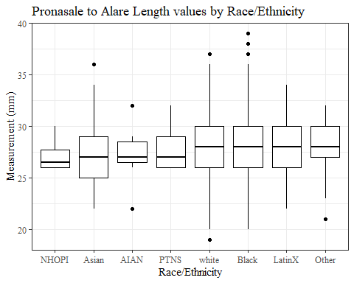

#boxplot not reordered by median  
ggplot(data=headscan_full, aes(y=ProA_L, x=race_eth))+  
 geom_boxplot(color= "black", fill = "white")+  
 theme_bw()+theme(text=element_text(family= "Times New Roman"))+  
 #theme(axis.text.x = element_text(angle = 20, vjust=0.7))+  
 labs(title="Pronasale to Alare Length values by Race/Ethnicity",  
 y="Measurement (mm)",  
 x="Race/Ethnicity")

## Warning: Removed 16 rows containing non-finite values (stat_boxplot).

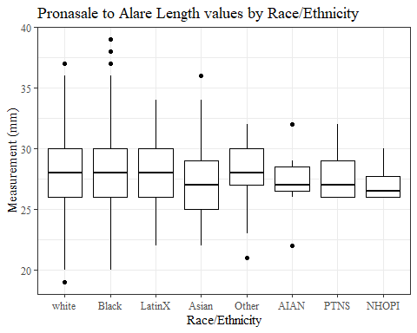

#ProA_L gender sumstats  
ProA_Lgender_sumstats <- headscan_full %>%   
 group_by(gender) %>%   
 summarise(n = n(), na = sum(is.na(ProA_L)),  
 min = min(ProA_L, na.rm = TRUE),  
 max = max(ProA_L, na.rm = TRUE),  
 mean = mean(ProA_L, na.rm = TRUE),  
 mdn = median(ProA_L, na.rm = TRUE),  
 sd = sd(ProA_L, na.rm = TRUE),  
 se = sd/sqrt(n),  
 percent5th = quantile(ProA_L, 0.05, na.rm=TRUE),  
 percent25th = quantile(ProA_L, 0.25, na.rm=TRUE),  
 percent50th = quantile(ProA_L, 0.50, na.rm=TRUE),  
 percent75th = quantile(ProA_L, 0.75, na.rm=TRUE),  
 percent95th = quantile(ProA_L, 0.95, na.rm=TRUE))  
  
ProA_Lgender_sumstats <- ProA_Lgender_sumstats %>%   
 mutate(across(where(is.numeric), round, 2))  
  
#Size 12 Table TNR  
flextable(ProA_Lgender_sumstats) %>%  
 my_ft_theme()%>%   
 bold(part = "header") %>%   
 set_caption("Pronasale to Alare Length SumStats by Gender")

**Table** : Pronasale to Alare Length SumStats by Gender

| **gender** | **n** | **na** | **min** | **max** | **mean** | **mdn** | **sd** | **se** | **percent5th** | **percent25th** | **percent50th** | **percent75th** | **percent95th** |
| --- | --- | --- | --- | --- | --- | --- | --- | --- | --- | --- | --- | --- | --- |
| Female | 1,063 | 11 | 19 | 36 | 26.48 | 26 | 2.49 | 0.08 | 23.0 | 25.00 | 26 | 28.00 | 31.00 |
| Male | 939 | 5 | 23 | 39 | 29.62 | 30 | 2.70 | 0.09 | 26.0 | 28.00 | 30 | 31.00 | 34.00 |
| Non-binary or Other | 5 | 0 | 23 | 28 | 26.80 | 28 | 2.17 | 0.97 | 23.8 | 27.00 | 28 | 28.00 | 28.00 |
| Prefer not to say | 1 | 0 | 26 | 26 | 26.00 | 26 |  |  | 26.0 | 26.00 | 26 | 26.00 | 26.00 |
|  | 8 | 0 | 22 | 30 | 25.50 | 25 | 2.33 | 0.82 | 22.7 | 24.75 | 25 | 26.25 | 28.95 |

#%>% set_header_labels(values = list(ProA_L = "Alare/AlareCont"))  
  
#Autofit Width Table TNR  
flextable(ProA_Lgender_sumstats) %>%  
 my_ft_theme()%>%   
 bold(part = "header") %>%   
 set_caption("Pronasale to Alare Length SumStats by Gender") %>%   
 fit_to_width(7.5)

**Table** : Pronasale to Alare Length SumStats by Gender

| **gender** | **n** | **na** | **min** | **max** | **mean** | **mdn** | **sd** | **se** | **percent5th** | **percent25th** | **percent50th** | **percent75th** | **percent95th** |
| --- | --- | --- | --- | --- | --- | --- | --- | --- | --- | --- | --- | --- | --- |
| Female | 1,063 | 11 | 19 | 36 | 26.48 | 26 | 2.49 | 0.08 | 23.0 | 25.00 | 26 | 28.00 | 31.00 |
| Male | 939 | 5 | 23 | 39 | 29.62 | 30 | 2.70 | 0.09 | 26.0 | 28.00 | 30 | 31.00 | 34.00 |
| Non-binary or Other | 5 | 0 | 23 | 28 | 26.80 | 28 | 2.17 | 0.97 | 23.8 | 27.00 | 28 | 28.00 | 28.00 |
| Prefer not to say | 1 | 0 | 26 | 26 | 26.00 | 26 |  |  | 26.0 | 26.00 | 26 | 26.00 | 26.00 |
|  | 8 | 0 | 22 | 30 | 25.50 | 25 | 2.33 | 0.82 | 22.7 | 24.75 | 25 | 26.25 | 28.95 |

#%>% set_header_labels(values = list(ProA_L = "Alare/AlareCont"))  
  
#boxplot reorderd by median  
headscan_full %>%   
 ungroup() %>%   
 mutate(gender= fct_reorder(gender, ProA_L, FUN=median, na.rm=TRUE)) %>%   
 ggplot(aes(y=ProA_L, x=gender))+  
 geom_boxplot(color= "black", fill = "white")+  
 theme_bw()+theme(text=element_text(family= "Times New Roman"))+  
 theme(axis.text.x = element_text(angle = 20, vjust=0.7))+  
 labs(title="Pronasale to Alare Length values by Gender",  
 y="Measurement (mm)",  
 x="Gender")

## Warning: Removed 16 rows containing non-finite values (stat_boxplot).

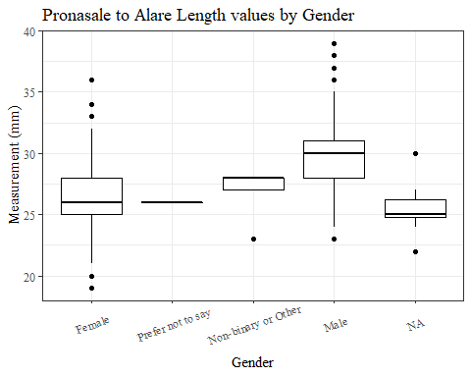

#boxplot not reordered by median  
ggplot(data=headscan_full, aes(y=ProA_L, x=gender))+  
 geom_boxplot(color= "black", fill = "white")+  
 theme_bw()+theme(text=element_text(family= "Times New Roman"))+  
 theme(axis.text.x = element_text(angle = 20, vjust=0.7))+  
 labs(title="Pronasale to Alare Length values by Gender",  
 y="Measurement (mm)",  
 x="Gender")

## Warning: Removed 16 rows containing non-finite values (stat_boxplot).

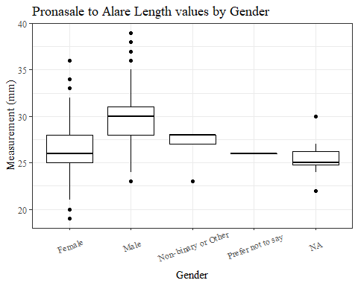

#ProA_L age group sumstats  
ProA_Lage_sumstats <- headscan_full %>%   
 group_by(age_group) %>%   
 summarise(n = n(), na = sum(is.na(ProA_L)),  
 min = min(ProA_L, na.rm = TRUE),  
 max = max(ProA_L, na.rm = TRUE),  
 mean = mean(ProA_L, na.rm = TRUE),  
 mdn = median(ProA_L, na.rm = TRUE),  
 sd = sd(ProA_L, na.rm = TRUE),  
 se = sd/sqrt(n),  
 percent5th = quantile(ProA_L, 0.05, na.rm=TRUE),  
 percent25th = quantile(ProA_L, 0.25, na.rm=TRUE),  
 percent50th = quantile(ProA_L, 0.50, na.rm=TRUE),  
 percent75th = quantile(ProA_L, 0.75, na.rm=TRUE),  
 percent95th = quantile(ProA_L, 0.95, na.rm=TRUE))  
  
ProA_Lage_sumstats <- ProA_Lage_sumstats %>%   
 mutate(across(where(is.numeric), round, 2))  
  
  
#Size 12 Table TNR  
flextable(ProA_Lage_sumstats) %>%  
 my_ft_theme()%>%   
 bold(part = "header") %>%   
 set_caption("Pronasale Alare Length SumStats by Age Group")

**Table** : Pronasale Alare Length SumStats by Age Group

| **age_group** | **n** | **na** | **min** | **max** | **mean** | **mdn** | **sd** | **se** | **percent5th** | **percent25th** | **percent50th** | **percent75th** | **percent95th** |
| --- | --- | --- | --- | --- | --- | --- | --- | --- | --- | --- | --- | --- | --- |
| 18-36 | 991 | 6 | 20 | 37 | 27.56 | 27 | 2.87 | 0.09 | 23.0 | 26 | 27 | 30 | 32.0 |
| 37-54 | 940 | 9 | 19 | 38 | 28.26 | 28 | 3.12 | 0.10 | 23.5 | 26 | 28 | 30 | 34.0 |
| 55-72 | 84 | 1 | 22 | 39 | 28.99 | 29 | 3.20 | 0.35 | 25.0 | 27 | 29 | 31 | 34.9 |
|  | 1 | 0 | 25 | 25 | 25.00 | 25 |  |  | 25.0 | 25 | 25 | 25 | 25.0 |

#%>% set_header_labels(values = list(ProA_L = "Alare/AlareCont"))  
  
#Autofit Width Table TNR  
flextable(ProA_Lage_sumstats) %>%  
 my_ft_theme()%>%   
 bold(part = "header") %>%   
 set_caption("Pronasale to Alare Length SumStats by Age Group") %>%   
 fit_to_width(7.5)

**Table** : Pronasale to Alare Length SumStats by Age Group

| **age_group** | **n** | **na** | **min** | **max** | **mean** | **mdn** | **sd** | **se** | **percent5th** | **percent25th** | **percent50th** | **percent75th** | **percent95th** |
| --- | --- | --- | --- | --- | --- | --- | --- | --- | --- | --- | --- | --- | --- |
| 18-36 | 991 | 6 | 20 | 37 | 27.56 | 27 | 2.87 | 0.09 | 23.0 | 26 | 27 | 30 | 32.0 |
| 37-54 | 940 | 9 | 19 | 38 | 28.26 | 28 | 3.12 | 0.10 | 23.5 | 26 | 28 | 30 | 34.0 |
| 55-72 | 84 | 1 | 22 | 39 | 28.99 | 29 | 3.20 | 0.35 | 25.0 | 27 | 29 | 31 | 34.9 |
|  | 1 | 0 | 25 | 25 | 25.00 | 25 |  |  | 25.0 | 25 | 25 | 25 | 25.0 |

#%>% set_header_labels(values = list(ProA_L = "Alare/AlareCont"))  
  
#boxplot reorderd by median  
headscan_full %>%   
 ungroup() %>%   
 mutate(age_group= fct_reorder(age_group, ProA_L, FUN=median, na.rm=TRUE)) %>%   
 ggplot(aes(y=ProA_L, x=age_group))+  
 geom_boxplot(color= "black", fill = "white")+  
 theme_bw()+theme(text=element_text(family= "Times New Roman"))+  
 #theme(axis.text.x = element_text(angle = 20, vjust=0.7))+  
 labs(title="Pronasale to Alare Length values by Age Group",  
 y="Measurement (mm)",  
 x="Age Group")

## Warning: Removed 16 rows containing non-finite values (stat_boxplot).

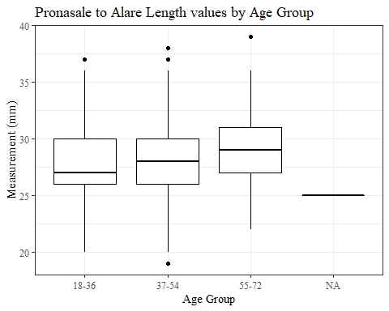

#boxplot not reordered by median  
ggplot(data=headscan_full, aes(y=ProA_L, x=age_group))+  
 geom_boxplot(color= "black", fill = "white")+  
 theme_bw()+theme(text=element_text(family= "Times New Roman"))+  
 #theme(axis.text.x = element_text(angle = 20, vjust=0.7))+  
 labs(title="Pronasale to Alare Length values by Age Group",  
 y="Measurement (mm)",  
 x="Age Group")

## Warning: Removed 16 rows containing non-finite values (stat_boxplot).



ProA_C

#histogram of all ProA_C values  
ggplot(data=headscan_full, aes(x=ProA_C))+  
 geom_bar(stat="bin", bins=20, color= "black", fill = "white")+  
 theme_bw()+theme(text=element_text(family= "Times New Roman"))+  
 labs(title="Pronasale to Alare Contour Measurement Distribution",  
 y="Frequency",  
 x="Pronasale to Alare Contour (mm)")

## Warning: Removed 16 rows containing non-finite values (stat_bin).

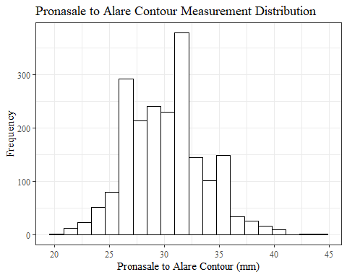

ProA_Csumstats <- headscan_full %>%   
 summarise(n = n(), na = sum(is.na(ProA_C)),  
 min = min(ProA_C, na.rm = TRUE),  
 max = max(ProA_C, na.rm = TRUE),  
 mean = mean(ProA_C, na.rm = TRUE),  
 mdn = median(ProA_C, na.rm = TRUE),  
 sd = sd(ProA_C, na.rm = TRUE),  
 se = sd/sqrt(n),  
 percent5th = quantile(ProA_C, 0.05, na.rm=TRUE),  
 percent25th = quantile(ProA_C, 0.25, na.rm=TRUE),  
 percent50th = quantile(ProA_C, 0.50, na.rm=TRUE),  
 percent75th = quantile(ProA_C, 0.75, na.rm=TRUE),  
 percent95th = quantile(ProA_C, 0.95, na.rm=TRUE))   
  
ProA_Csumstats <- round(ProA_Csumstats, 2)  
  
#Size 12 Table TNR  
flextable(ProA_Csumstats) %>%  
 my_ft_theme()%>%   
 bold(part = "header") %>%   
 set_caption("Pronasale to Alare Contour SumStats")

**Table** : Pronasale to Alare Contour SumStats

| **n** | **na** | **min** | **max** | **mean** | **mdn** | **sd** | **se** | **percent5th** | **percent25th** | **percent50th** | **percent75th** | **percent95th** |
| --- | --- | --- | --- | --- | --- | --- | --- | --- | --- | --- | --- | --- |
| 2,016 | 16 | 20 | 44 | 30.12 | 30 | 3.5 | 0.08 | 25 | 28 | 30 | 32 | 36 |

#%>% set_header_Cabels(values = list(ProA_C = "Alare/AlareCont"))  
  
#Autofit Width Table TNR  
flextable(ProA_Csumstats) %>%  
 my_ft_theme()%>%   
 bold(part = "header") %>%   
 set_caption("Pronasale to Alare Contour SumStats") %>%   
 fit_to_width(7.5)

**Table** : Pronasale to Alare Contour SumStats

| **n** | **na** | **min** | **max** | **mean** | **mdn** | **sd** | **se** | **percent5th** | **percent25th** | **percent50th** | **percent75th** | **percent95th** |
| --- | --- | --- | --- | --- | --- | --- | --- | --- | --- | --- | --- | --- |
| 2,016 | 16 | 20 | 44 | 30.12 | 30 | 3.5 | 0.08 | 25 | 28 | 30 | 32 | 36 |

#%>% set_header_Cabels(values = list(ProA_C = "Alare/AlareCont"))

#ProA_C race/eth sumstats  
ProA_Crace_sumstats <- headscan_full %>%   
 group_by(race_eth) %>%   
 summarise(n = n(), na = sum(is.na(ProA_C)),  
 min = min(ProA_C, na.rm = TRUE),  
 max = max(ProA_C, na.rm = TRUE),  
 mean = mean(ProA_C, na.rm = TRUE),  
 mdn = median(ProA_C, na.rm = TRUE),  
 sd = sd(ProA_C, na.rm = TRUE),  
 se = sd/sqrt(n),  
 percent5th = quantile(ProA_C, 0.05, na.rm=TRUE),  
 percent25th = quantile(ProA_C, 0.25, na.rm=TRUE),  
 percent50th = quantile(ProA_C, 0.50, na.rm=TRUE),  
 percent75th = quantile(ProA_C, 0.75, na.rm=TRUE),  
 percent95th = quantile(ProA_C, 0.95, na.rm=TRUE))   
  
ProA_Crace_sumstats <- ProA_Crace_sumstats %>%   
 mutate(across(where(is.numeric), round, 2))  
  
  
#Size 12 Table TNR  
flextable(ProA_Crace_sumstats) %>%  
 my_ft_theme()%>%   
 bold(part = "header") %>%   
 set_caption("Pronasale to Alare Contour SumStats by Race/Ethnicity")

**Table** : Pronasale to Alare Contour SumStats by Race/Ethnicity

| **race_eth** | **n** | **na** | **min** | **max** | **mean** | **mdn** | **sd** | **se** | **percent5th** | **percent25th** | **percent50th** | **percent75th** | **percent95th** |
| --- | --- | --- | --- | --- | --- | --- | --- | --- | --- | --- | --- | --- | --- |
| white | 1,239 | 8 | 20 | 41 | 30.09 | 30.0 | 3.43 | 0.10 | 25.00 | 28.00 | 30.0 | 32.00 | 36.00 |
| Black | 548 | 5 | 21 | 44 | 30.34 | 30.0 | 3.64 | 0.16 | 25.00 | 28.00 | 30.0 | 33.00 | 37.00 |
| LatinX | 100 | 1 | 24 | 38 | 30.25 | 30.0 | 3.41 | 0.34 | 24.90 | 28.00 | 30.0 | 33.00 | 36.00 |
| Asian | 91 | 1 | 22 | 40 | 29.08 | 28.5 | 3.62 | 0.38 | 24.00 | 26.00 | 28.5 | 31.00 | 35.00 |
| Other | 21 | 0 | 22 | 35 | 29.76 | 30.0 | 3.55 | 0.77 | 22.00 | 29.00 | 30.0 | 32.00 | 35.00 |
| AIAN | 8 | 1 | 23 | 34 | 29.29 | 29.0 | 3.55 | 1.25 | 24.50 | 28.00 | 29.0 | 31.50 | 33.40 |
| PTNS | 5 | 0 | 27 | 35 | 30.60 | 30.0 | 3.05 | 1.36 | 27.40 | 29.00 | 30.0 | 32.00 | 34.40 |
| NHOPI | 4 | 0 | 27 | 34 | 29.50 | 28.5 | 3.11 | 1.55 | 27.15 | 27.75 | 28.5 | 30.25 | 33.25 |

#%>% set_header_Cabels(values = list(ProA_C = "Alare/AlareCont"))  
  
#Autofit Width Table TNR  
flextable(ProA_Crace_sumstats) %>%  
 my_ft_theme()%>%   
 bold(part = "header") %>%   
 set_caption("Pronasale to Alare Contour SumStats by Race/Ethnicity") %>%   
 fit_to_width(7.5)

**Table** : Pronasale to Alare Contour SumStats by Race/Ethnicity

| **race_eth** | **n** | **na** | **min** | **max** | **mean** | **mdn** | **sd** | **se** | **percent5th** | **percent25th** | **percent50th** | **percent75th** | **percent95th** |
| --- | --- | --- | --- | --- | --- | --- | --- | --- | --- | --- | --- | --- | --- |
| white | 1,239 | 8 | 20 | 41 | 30.09 | 30.0 | 3.43 | 0.10 | 25.00 | 28.00 | 30.0 | 32.00 | 36.00 |
| Black | 548 | 5 | 21 | 44 | 30.34 | 30.0 | 3.64 | 0.16 | 25.00 | 28.00 | 30.0 | 33.00 | 37.00 |
| LatinX | 100 | 1 | 24 | 38 | 30.25 | 30.0 | 3.41 | 0.34 | 24.90 | 28.00 | 30.0 | 33.00 | 36.00 |
| Asian | 91 | 1 | 22 | 40 | 29.08 | 28.5 | 3.62 | 0.38 | 24.00 | 26.00 | 28.5 | 31.00 | 35.00 |
| Other | 21 | 0 | 22 | 35 | 29.76 | 30.0 | 3.55 | 0.77 | 22.00 | 29.00 | 30.0 | 32.00 | 35.00 |
| AIAN | 8 | 1 | 23 | 34 | 29.29 | 29.0 | 3.55 | 1.25 | 24.50 | 28.00 | 29.0 | 31.50 | 33.40 |
| PTNS | 5 | 0 | 27 | 35 | 30.60 | 30.0 | 3.05 | 1.36 | 27.40 | 29.00 | 30.0 | 32.00 | 34.40 |
| NHOPI | 4 | 0 | 27 | 34 | 29.50 | 28.5 | 3.11 | 1.55 | 27.15 | 27.75 | 28.5 | 30.25 | 33.25 |

#%>% set_header_Cabels(values = list(ProA_C = "Alare/AlareCont"))  
  
#boxplot reorderd by median  
headscan_full %>%   
 ungroup() %>%   
 mutate(race_eth= fct_reorder(race_eth, ProA_C, FUN=median, na.rm=TRUE)) %>%   
 ggplot(aes(y=ProA_C, x=race_eth))+  
 geom_boxplot(color= "black", fill = "white")+  
 theme_bw()+theme(text=element_text(family= "Times New Roman"))+  
 #theme(axis.text.x = element_text(angle = 20, vjust=0.7))+  
 labs(title="Pronasale to Alare Contour values by Race/Ethnicity",  
 y="Measurement (mm)",  
 x="Race/Ethnicity")

## Warning: Removed 16 rows containing non-finite values (stat_boxplot).

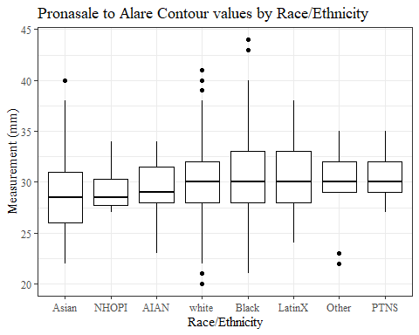

#boxplot not reordered by median  
ggplot(data=headscan_full, aes(y=ProA_C, x=race_eth))+  
 geom_boxplot(color= "black", fill = "white")+  
 theme_bw()+theme(text=element_text(family= "Times New Roman"))+  
 #theme(axis.text.x = element_text(angle = 20, vjust=0.7))+  
 labs(title="Pronasale to Alare Contour values by Race/Ethnicity",  
 y="Measurement (mm)",  
 x="Race/Ethnicity")

## Warning: Removed 16 rows containing non-finite values (stat_boxplot).

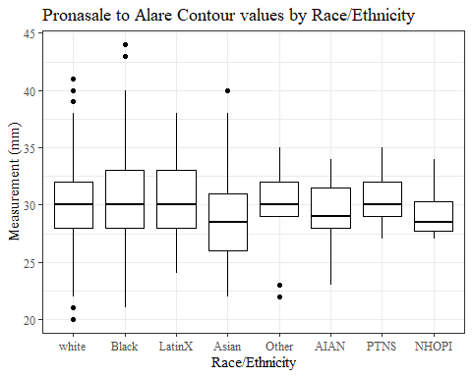

#ProA_C gender sumstats  
ProA_Cgender_sumstats <- headscan_full %>%   
 group_by(gender) %>%   
 summarise(n = n(), na = sum(is.na(ProA_C)),  
 min = min(ProA_C, na.rm = TRUE),  
 max = max(ProA_C, na.rm = TRUE),  
 mean = mean(ProA_C, na.rm = TRUE),  
 mdn = median(ProA_C, na.rm = TRUE),  
 sd = sd(ProA_C, na.rm = TRUE),  
 se = sd/sqrt(n),  
 percent5th = quantile(ProA_C, 0.05, na.rm=TRUE),  
 percent25th = quantile(ProA_C, 0.25, na.rm=TRUE),  
 percent50th = quantile(ProA_C, 0.50, na.rm=TRUE),  
 percent75th = quantile(ProA_C, 0.75, na.rm=TRUE),  
 percent95th = quantile(ProA_C, 0.95, na.rm=TRUE))  
  
ProA_Cgender_sumstats <- ProA_Cgender_sumstats %>%   
 mutate(across(where(is.numeric), round, 2))  
  
#Size 12 Table TNR  
flextable(ProA_Cgender_sumstats) %>%  
 my_ft_theme()%>%   
 bold(part = "header") %>%   
 set_caption("Pronasale to Alare Contour SumStats by Gender")

**Table** : Pronasale to Alare Contour SumStats by Gender

| **gender** | **n** | **na** | **min** | **max** | **mean** | **mdn** | **sd** | **se** | **percent5th** | **percent25th** | **percent50th** | **percent75th** | **percent95th** |
| --- | --- | --- | --- | --- | --- | --- | --- | --- | --- | --- | --- | --- | --- |
| Female | 1,063 | 11 | 20 | 41 | 28.51 | 28.0 | 2.94 | 0.09 | 24.00 | 27 | 28.0 | 30.00 | 34.0 |
| Male | 939 | 5 | 23 | 44 | 31.95 | 32.0 | 3.17 | 0.10 | 27.00 | 30 | 32.0 | 34.00 | 38.0 |
| Non-binary or Other | 5 | 0 | 25 | 31 | 29.20 | 30.0 | 2.49 | 1.11 | 25.80 | 29 | 30.0 | 31.00 | 31.0 |
| Prefer not to say | 1 | 0 | 27 | 27 | 27.00 | 27.0 |  |  | 27.00 | 27 | 27.0 | 27.00 | 27.0 |
|  | 8 | 0 | 23 | 33 | 27.50 | 27.5 | 2.88 | 1.02 | 24.05 | 26 | 27.5 | 28.25 | 31.6 |

#%>% set_header_Cabels(values = list(ProA_C = "Alare/AlareCont"))  
  
#Autofit Width Table TNR  
flextable(ProA_Cgender_sumstats) %>%  
 my_ft_theme()%>%   
 bold(part = "header") %>%   
 set_caption("Pronasale to Alare Contour SumStats by Gender") %>%   
 fit_to_width(7.5)

**Table** : Pronasale to Alare Contour SumStats by Gender

| **gender** | **n** | **na** | **min** | **max** | **mean** | **mdn** | **sd** | **se** | **percent5th** | **percent25th** | **percent50th** | **percent75th** | **percent95th** |
| --- | --- | --- | --- | --- | --- | --- | --- | --- | --- | --- | --- | --- | --- |
| Female | 1,063 | 11 | 20 | 41 | 28.51 | 28.0 | 2.94 | 0.09 | 24.00 | 27 | 28.0 | 30.00 | 34.0 |
| Male | 939 | 5 | 23 | 44 | 31.95 | 32.0 | 3.17 | 0.10 | 27.00 | 30 | 32.0 | 34.00 | 38.0 |
| Non-binary or Other | 5 | 0 | 25 | 31 | 29.20 | 30.0 | 2.49 | 1.11 | 25.80 | 29 | 30.0 | 31.00 | 31.0 |
| Prefer not to say | 1 | 0 | 27 | 27 | 27.00 | 27.0 |  |  | 27.00 | 27 | 27.0 | 27.00 | 27.0 |
|  | 8 | 0 | 23 | 33 | 27.50 | 27.5 | 2.88 | 1.02 | 24.05 | 26 | 27.5 | 28.25 | 31.6 |

#%>% set_header_Cabels(values = list(ProA_C = "Alare/AlareCont"))  
  
#boxplot reorderd by median  
headscan_full %>%   
 ungroup() %>%   
 mutate(gender= fct_reorder(gender, ProA_C, FUN=median, na.rm=TRUE)) %>%   
 ggplot(aes(y=ProA_C, x=gender))+  
 geom_boxplot(color= "black", fill = "white")+  
 theme_bw()+theme(text=element_text(family= "Times New Roman"))+  
 theme(axis.text.x = element_text(angle = 20, vjust=0.7))+  
 labs(title="Pronasale to Alare Contour values by Gender",  
 y="Measurement (mm)",  
 x="Gender")

## Warning: Removed 16 rows containing non-finite values (stat_boxplot).

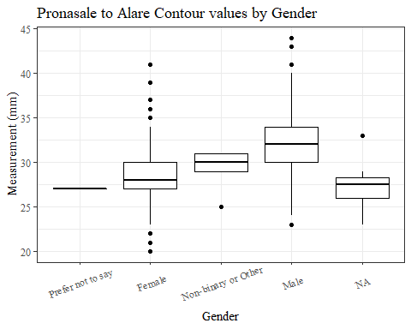

#boxplot not reordered by median  
ggplot(data=headscan_full, aes(y=ProA_C, x=gender))+  
 geom_boxplot(color= "black", fill = "white")+  
 theme_bw()+theme(text=element_text(family= "Times New Roman"))+  
 theme(axis.text.x = element_text(angle = 20, vjust=0.7))+  
 labs(title="Pronasale to Alare Contour values by Gender",  
 y="Measurement (mm)",  
 x="Gender")

## Warning: Removed 16 rows containing non-finite values (stat_boxplot).

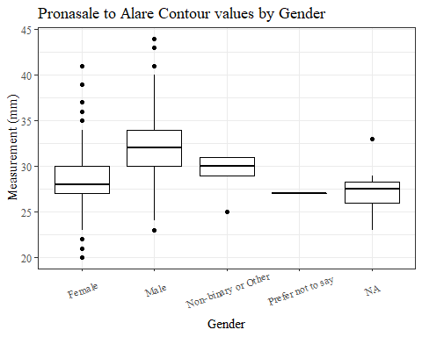

#ProA_C age group sumstats  
ProA_Cage_sumstats <- headscan_full %>%   
 group_by(age_group) %>%   
 summarise(n = n(), na = sum(is.na(ProA_C)),  
 min = min(ProA_C, na.rm = TRUE),  
 max = max(ProA_C, na.rm = TRUE),  
 mean = mean(ProA_C, na.rm = TRUE),  
 mdn = median(ProA_C, na.rm = TRUE),  
 sd = sd(ProA_C, na.rm = TRUE),  
 se = sd/sqrt(n),  
 percent5th = quantile(ProA_C, 0.05, na.rm=TRUE),  
 percent25th = quantile(ProA_C, 0.25, na.rm=TRUE),  
 percent50th = quantile(ProA_C, 0.50, na.rm=TRUE),  
 percent75th = quantile(ProA_C, 0.75, na.rm=TRUE),  
 percent95th = quantile(ProA_C, 0.95, na.rm=TRUE))  
  
ProA_Cage_sumstats <- ProA_Cage_sumstats %>%   
 mutate(across(where(is.numeric), round, 2))  
  
  
#Size 12 Table TNR  
flextable(ProA_Cage_sumstats) %>%  
 my_ft_theme()%>%   
 bold(part = "header") %>%   
 set_caption("Pronasale to Alare Contour SumStats by Age Group")

**Table** : Pronasale to Alare Contour SumStats by Age Group

| **age_group** | **n** | **na** | **min** | **max** | **mean** | **mdn** | **sd** | **se** | **percent5th** | **percent25th** | **percent50th** | **percent75th** | **percent95th** |
| --- | --- | --- | --- | --- | --- | --- | --- | --- | --- | --- | --- | --- | --- |
| 18-36 | 991 | 6 | 21 | 41 | 29.66 | 29 | 3.34 | 0.11 | 24 | 27 | 29 | 32.0 | 35 |
| 37-54 | 940 | 9 | 20 | 43 | 30.51 | 30 | 3.59 | 0.12 | 25 | 28 | 30 | 33.0 | 37 |
| 55-72 | 84 | 1 | 23 | 44 | 31.13 | 31 | 3.60 | 0.39 | 26 | 29 | 31 | 33.5 | 37 |
|  | 1 | 0 | 27 | 27 | 27.00 | 27 |  |  | 27 | 27 | 27 | 27.0 | 27 |

#%>% set_header_Cabels(values = list(ProA_C = "Alare/AlareCont"))  
  
#Autofit Width Table TNR  
flextable(ProA_Cage_sumstats) %>%  
 my_ft_theme()%>%   
 bold(part = "header") %>%   
 set_caption("Pronasale to Alare Contour SumStats by Age Group") %>%   
 fit_to_width(7.5)

**Table** : Pronasale to Alare Contour SumStats by Age Group

| **age_group** | **n** | **na** | **min** | **max** | **mean** | **mdn** | **sd** | **se** | **percent5th** | **percent25th** | **percent50th** | **percent75th** | **percent95th** |
| --- | --- | --- | --- | --- | --- | --- | --- | --- | --- | --- | --- | --- | --- |
| 18-36 | 991 | 6 | 21 | 41 | 29.66 | 29 | 3.34 | 0.11 | 24 | 27 | 29 | 32.0 | 35 |
| 37-54 | 940 | 9 | 20 | 43 | 30.51 | 30 | 3.59 | 0.12 | 25 | 28 | 30 | 33.0 | 37 |
| 55-72 | 84 | 1 | 23 | 44 | 31.13 | 31 | 3.60 | 0.39 | 26 | 29 | 31 | 33.5 | 37 |
|  | 1 | 0 | 27 | 27 | 27.00 | 27 |  |  | 27 | 27 | 27 | 27.0 | 27 |

#%>% set_header_Cabels(values = list(ProA_C = "Alare/AlareCont"))  
  
#boxplot reorderd by median  
headscan_full %>%   
 ungroup() %>%   
 mutate(age_group= fct_reorder(age_group, ProA_C, FUN=median, na.rm=TRUE)) %>%   
 ggplot(aes(y=ProA_C, x=gender))+  
 geom_boxplot(color= "black", fill = "white")+  
 theme_bw()+theme(text=element_text(family= "Times New Roman"))+  
 #theme(axis.text.x = element_text(angle = 20, vjust=0.7))+  
 labs(title="Pronasale to Alare Contour values by Age Group",  
 y="Measurement (mm)",  
 x="Age Group")

## Warning: Removed 16 rows containing non-finite values (stat_boxplot).

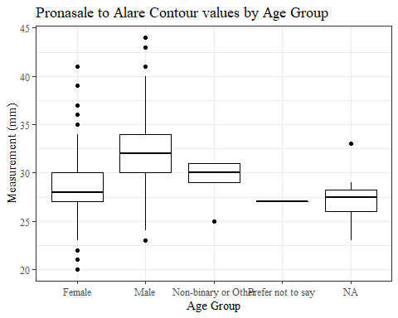

#boxplot not reordered by median  
ggplot(data=headscan_full, aes(y=ProA_C, x=age_group))+  
 geom_boxplot(color= "black", fill = "white")+  
 theme_bw()+theme(text=element_text(family= "Times New Roman"))+  
 #theme(axis.text.x = element_text(angle = 20, vjust=0.7))+  
 labs(title="Pronasale to Alare Contour values by Age Group",  
 y="Measurement (mm)",  
 x="Age Group")

## Warning: Removed 16 rows containing non-finite values (stat_boxplot).

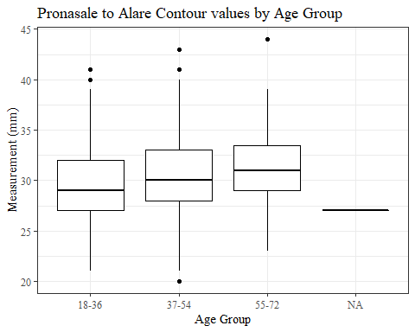

ProS_L

#histogram of all ProS_L values  
ggplot(data=headscan_full, aes(x=ProS_L))+  
 geom_bar(stat="bin", bins=25, color= "black", fill = "white")+  
 theme_bw()+theme(text=element_text(family= "Times New Roman"))+  
 labs(title="Pronasale to Subnasale Length Measurement Distribution",  
 y="Frequency",  
 x="Pronasale to Subnasale Length (mm)")

## Warning: Removed 19 rows containing non-finite values (stat_bin).

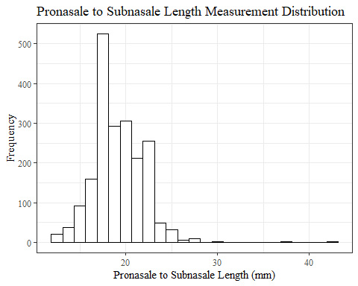

ProS_Lsumstats <- headscan_full %>%   
 summarise(n = n(), na = sum(is.na(ProS_L)),  
 min = min(ProS_L, na.rm = TRUE),  
 max = max(ProS_L, na.rm = TRUE),  
 mean = mean(ProS_L, na.rm = TRUE),  
 mdn = median(AA_C, na.rm = TRUE),  
 sd = sd(ProS_L, na.rm = TRUE),  
 se = sd/sqrt(n),  
 percent5th = quantile(ProS_L, 0.05, na.rm=TRUE),  
 percent25th = quantile(ProS_L, 0.25, na.rm=TRUE),  
 percent50th = quantile(ProS_L, 0.50, na.rm=TRUE),  
 percent75th = quantile(ProS_L, 0.75, na.rm=TRUE),  
 percent95th = quantile(ProS_L, 0.95, na.rm=TRUE))   
  
ProS_Lsumstats <- round(ProS_Lsumstats, 2)  
  
#Size 12 Table TNR  
flextable(ProS_Lsumstats) %>%  
 my_ft_theme()%>%   
 bold(part = "header") %>%   
 set_caption("Pronasale to Subnasale Length SumStats")

**Table** : Pronasale to Subnasale Length SumStats

| **n** | **na** | **min** | **max** | **mean** | **mdn** | **sd** | **se** | **percent5th** | **percent25th** | **percent50th** | **percent75th** | **percent95th** |
| --- | --- | --- | --- | --- | --- | --- | --- | --- | --- | --- | --- | --- |
| 2,016 | 19 | 12 | 42 | 19.16 | 61 | 2.7 | 0.06 | 15 | 17 | 19 | 21 | 23 |

#%>% set_header_labels(values = list(ProS_L = "Subnasale/SubnasaleCont"))  
  
#Autofit Width Table TNR  
flextable(ProS_Lsumstats) %>%  
 my_ft_theme()%>%   
 bold(part = "header") %>%   
 set_caption("Pronasale to Subnasale Length SumStats") %>%   
 fit_to_width(7.5)

**Table** : Pronasale to Subnasale Length SumStats

| **n** | **na** | **min** | **max** | **mean** | **mdn** | **sd** | **se** | **percent5th** | **percent25th** | **percent50th** | **percent75th** | **percent95th** |
| --- | --- | --- | --- | --- | --- | --- | --- | --- | --- | --- | --- | --- |
| 2,016 | 19 | 12 | 42 | 19.16 | 61 | 2.7 | 0.06 | 15 | 17 | 19 | 21 | 23 |

#%>% set_header_labels(values = list(ProS_L = "Subnasale/SubnasaleCont"))

#ProS_L race/eth sumstats  
ProS_Lrace_sumstats <- headscan_full %>%   
 group_by(race_eth) %>%   
 summarise(n = n(), na = sum(is.na(ProS_L)),  
 min = min(ProS_L, na.rm = TRUE),  
 max = max(ProS_L, na.rm = TRUE),  
 mean = mean(ProS_L, na.rm = TRUE),  
 mdn = median(AA_C, na.rm = TRUE),  
 sd = sd(ProS_L, na.rm = TRUE),  
 se = sd/sqrt(n),  
 percent5th = quantile(ProS_L, 0.05, na.rm=TRUE),  
 percent25th = quantile(ProS_L, 0.25, na.rm=TRUE),  
 percent50th = quantile(ProS_L, 0.50, na.rm=TRUE),  
 percent75th = quantile(ProS_L, 0.75, na.rm=TRUE),  
 percent95th = quantile(ProS_L, 0.95, na.rm=TRUE))   
  
ProS_Lrace_sumstats <- ProS_Lrace_sumstats %>%   
 mutate(across(where(is.numeric), round, 2))  
  
  
#Size 12 Table TNR  
flextable(ProS_Lrace_sumstats) %>%  
 my_ft_theme()%>%   
 bold(part = "header") %>%   
 set_caption("Pronasale to Subnasale Length SumStats by Race/Ethnicity")

**Table** : Pronasale to Subnasale Length SumStats by Race/Ethnicity

| **race_eth** | **n** | **na** | **min** | **max** | **mean** | **mdn** | **sd** | **se** | **percent5th** | **percent25th** | **percent50th** | **percent75th** | **percent95th** |
| --- | --- | --- | --- | --- | --- | --- | --- | --- | --- | --- | --- | --- | --- |
| white | 1,239 | 11 | 13 | 30 | 19.70 | 61 | 2.54 | 0.07 | 16 | 18.0 | 20 | 21.0 | 24.0 |
| Black | 548 | 5 | 12 | 42 | 18.19 | 61 | 2.73 | 0.12 | 14 | 16.5 | 18 | 20.0 | 22.0 |
| LatinX | 100 | 1 | 13 | 25 | 18.78 | 62 | 2.31 | 0.23 | 15 | 17.0 | 19 | 20.0 | 22.0 |
| Asian | 91 | 1 | 13 | 42 | 18.41 | 58 | 3.26 | 0.34 | 15 | 17.0 | 18 | 20.0 | 22.0 |
| Other | 21 | 0 | 12 | 22 | 18.05 | 62 | 2.58 | 0.56 | 13 | 16.0 | 19 | 19.0 | 22.0 |
| AIAN | 8 | 1 | 17 | 19 | 18.00 | 61 | 0.82 | 0.29 | 17 | 17.5 | 18 | 18.5 | 19.0 |
| PTNS | 5 | 0 | 16 | 19 | 17.00 | 61 | 1.22 | 0.55 | 16 | 16.0 | 17 | 17.0 | 18.6 |
| NHOPI | 4 | 0 | 16 | 24 | 19.00 | 59 | 3.83 | 1.91 | 16 | 16.0 | 18 | 21.0 | 23.4 |

#%>% set_header_labels(values = list(ProS_L = "Subnasale/SubnasaleCont"))  
  
#Autofit Width Table TNR  
flextable(ProS_Lrace_sumstats) %>%  
 my_ft_theme()%>%   
 bold(part = "header") %>%   
 set_caption("Pronasale to Subnasale Length SumStats by Race/Ethnicity") %>%   
 fit_to_width(7.5)

**Table** : Pronasale to Subnasale Length SumStats by Race/Ethnicity

| **race_eth** | **n** | **na** | **min** | **max** | **mean** | **mdn** | **sd** | **se** | **percent5th** | **percent25th** | **percent50th** | **percent75th** | **percent95th** |
| --- | --- | --- | --- | --- | --- | --- | --- | --- | --- | --- | --- | --- | --- |
| white | 1,239 | 11 | 13 | 30 | 19.70 | 61 | 2.54 | 0.07 | 16 | 18.0 | 20 | 21.0 | 24.0 |
| Black | 548 | 5 | 12 | 42 | 18.19 | 61 | 2.73 | 0.12 | 14 | 16.5 | 18 | 20.0 | 22.0 |
| LatinX | 100 | 1 | 13 | 25 | 18.78 | 62 | 2.31 | 0.23 | 15 | 17.0 | 19 | 20.0 | 22.0 |
| Asian | 91 | 1 | 13 | 42 | 18.41 | 58 | 3.26 | 0.34 | 15 | 17.0 | 18 | 20.0 | 22.0 |
| Other | 21 | 0 | 12 | 22 | 18.05 | 62 | 2.58 | 0.56 | 13 | 16.0 | 19 | 19.0 | 22.0 |
| AIAN | 8 | 1 | 17 | 19 | 18.00 | 61 | 0.82 | 0.29 | 17 | 17.5 | 18 | 18.5 | 19.0 |
| PTNS | 5 | 0 | 16 | 19 | 17.00 | 61 | 1.22 | 0.55 | 16 | 16.0 | 17 | 17.0 | 18.6 |
| NHOPI | 4 | 0 | 16 | 24 | 19.00 | 59 | 3.83 | 1.91 | 16 | 16.0 | 18 | 21.0 | 23.4 |

#%>% set_header_labels(values = list(ProS_L = "Subnasale/SubnasaleCont"))  
  
#boxplot reorderd by median  
headscan_full %>%   
 ungroup() %>%   
 mutate(race_eth= fct_reorder(race_eth, ProS_L, FUN=median, na.rm=TRUE)) %>%   
 ggplot(aes(y=ProS_L, x=race_eth))+  
 geom_boxplot(color= "black", fill = "white")+  
 theme_bw()+theme(text=element_text(family= "Times New Roman"))+  
 #theme(axis.text.x = element_text(angle = 20, vjust=0.7))+  
 labs(title="Pronasale to Subnasale Length values by Race/Ethnicity",  
 y="Measurement (mm)",  
 x="Race/Ethnicity")

## Warning: Removed 19 rows containing non-finite values (stat_boxplot).

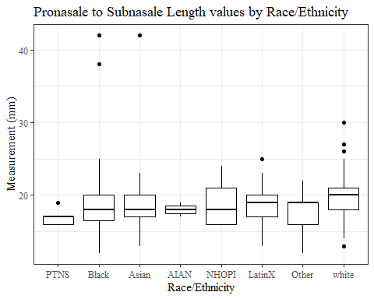

#boxplot not reordered by median  
ggplot(data=headscan_full, aes(y=ProS_L, x=race_eth))+  
 geom_boxplot(color= "black", fill = "white")+  
 theme_bw()+theme(text=element_text(family= "Times New Roman"))+  
 #theme(axis.text.x = element_text(angle = 20, vjust=0.7))+  
 labs(title="Pronasale to Subnasale Length values by Race/Ethnicity",  
 y="Measurement (mm)",  
 x="Race/Ethnicity")

## Warning: Removed 19 rows containing non-finite values (stat_boxplot).

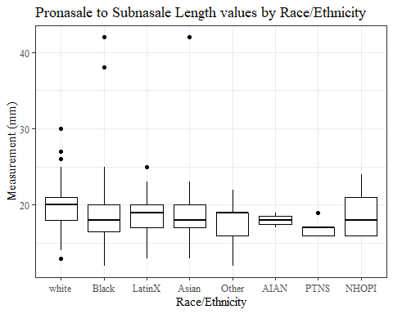

#ProS_L gender sumstats  
ProS_Lgender_sumstats <- headscan_full %>%   
 group_by(gender) %>%   
 summarise(n = n(), na = sum(is.na(ProS_L)),  
 min = min(ProS_L, na.rm = TRUE),  
 max = max(ProS_L, na.rm = TRUE),  
 mean = mean(ProS_L, na.rm = TRUE),  
 mdn = median(ProS_L, na.rm = TRUE),  
 sd = sd(ProS_L, na.rm = TRUE),  
 se = sd/sqrt(n),  
 percent5th = quantile(ProS_L, 0.05, na.rm=TRUE),  
 percent25th = quantile(ProS_L, 0.25, na.rm=TRUE),  
 percent50th = quantile(ProS_L, 0.50, na.rm=TRUE),  
 percent75th = quantile(ProS_L, 0.75, na.rm=TRUE),  
 percent95th = quantile(ProS_L, 0.95, na.rm=TRUE))  
  
ProS_Lgender_sumstats <- ProS_Lgender_sumstats %>%   
 mutate(across(where(is.numeric), round, 2))  
  
#Size 12 Table TNR  
flextable(ProS_Lgender_sumstats) %>%  
 my_ft_theme()%>%   
 bold(part = "header") %>%   
 set_caption("Pronasale to Subnasale Length SumStats by Gender")

**Table** : Pronasale to Subnasale Length SumStats by Gender

| **gender** | **n** | **na** | **min** | **max** | **mean** | **mdn** | **sd** | **se** | **percent5th** | **percent25th** | **percent50th** | **percent75th** | **percent95th** |
| --- | --- | --- | --- | --- | --- | --- | --- | --- | --- | --- | --- | --- | --- |
| Female | 1,063 | 11 | 12 | 42 | 18.74 | 19 | 2.74 | 0.08 | 15.00 | 17.00 | 19 | 20 | 23.0 |
| Male | 939 | 8 | 12 | 30 | 19.65 | 20 | 2.58 | 0.08 | 16.00 | 18.00 | 20 | 21 | 24.0 |
| Non-binary or Other | 5 | 0 | 15 | 20 | 17.80 | 18 | 1.79 | 0.80 | 15.60 | 18.00 | 18 | 18 | 19.6 |
| Prefer not to say | 1 | 0 | 17 | 17 | 17.00 | 17 |  |  | 17.00 | 17.00 | 17 | 17 | 17.0 |
|  | 8 | 0 | 14 | 21 | 17.75 | 17 | 2.87 | 1.01 | 14.35 | 15.75 | 17 | 21 | 21.0 |

#%>% set_header_labels(values = list(ProS_L = "Subnasale/SubnasaleCont"))  
  
#Autofit Width Table TNR  
flextable(ProS_Lgender_sumstats) %>%  
 my_ft_theme()%>%   
 bold(part = "header") %>%   
 set_caption("Pronasale to Subnasale Length SumStats by Gender") %>%   
 fit_to_width(7.5)

**Table** : Pronasale to Subnasale Length SumStats by Gender

| **gender** | **n** | **na** | **min** | **max** | **mean** | **mdn** | **sd** | **se** | **percent5th** | **percent25th** | **percent50th** | **percent75th** | **percent95th** |
| --- | --- | --- | --- | --- | --- | --- | --- | --- | --- | --- | --- | --- | --- |
| Female | 1,063 | 11 | 12 | 42 | 18.74 | 19 | 2.74 | 0.08 | 15.00 | 17.00 | 19 | 20 | 23.0 |
| Male | 939 | 8 | 12 | 30 | 19.65 | 20 | 2.58 | 0.08 | 16.00 | 18.00 | 20 | 21 | 24.0 |
| Non-binary or Other | 5 | 0 | 15 | 20 | 17.80 | 18 | 1.79 | 0.80 | 15.60 | 18.00 | 18 | 18 | 19.6 |
| Prefer not to say | 1 | 0 | 17 | 17 | 17.00 | 17 |  |  | 17.00 | 17.00 | 17 | 17 | 17.0 |
|  | 8 | 0 | 14 | 21 | 17.75 | 17 | 2.87 | 1.01 | 14.35 | 15.75 | 17 | 21 | 21.0 |

#%>% set_header_labels(values = list(ProS_L = "Subnasale/SubnasaleCont"))  
  
#boxplot reorderd by median  
headscan_full %>%   
 ungroup() %>%   
 mutate(gender= fct_reorder(gender, ProS_L, FUN=median, na.rm=TRUE)) %>%   
 ggplot(aes(y=ProS_L, x=gender))+  
 geom_boxplot(color= "black", fill = "white")+  
 theme_bw()+theme(text=element_text(family= "Times New Roman"))+  
 theme(axis.text.x = element_text(angle = 20, vjust=0.7))+  
 labs(title="Pronasale to Subnasale Length values by Gender",  
 y="Measurement (mm)",  
 x="Gender")

## Warning: Removed 19 rows containing non-finite values (stat_boxplot).

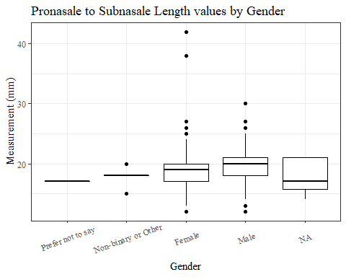

#boxplot not reordered by median  
ggplot(data=headscan_full, aes(y=ProS_L, x=gender))+  
 geom_boxplot(color= "black", fill = "white")+  
 theme_bw()+theme(text=element_text(family= "Times New Roman"))+  
 theme(axis.text.x = element_text(angle = 20, vjust=0.7))+  
 labs(title="Pronasale to Subnasale Length values by Gender",  
 y="Measurement (mm)",  
 x="Gender")

## Warning: Removed 19 rows containing non-finite values (stat_boxplot).

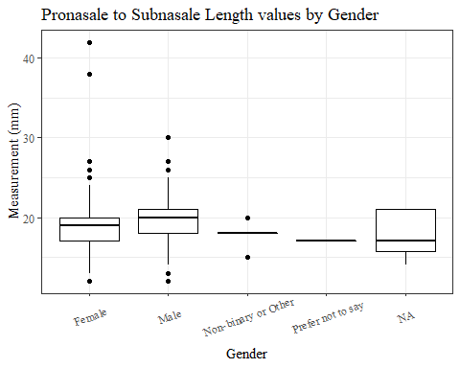

#ProS_L age group sumstats  
ProS_Lage_sumstats <- headscan_full %>%   
 group_by(age_group) %>%   
 summarise(n = n(), na = sum(is.na(ProS_L)),  
 min = min(ProS_L, na.rm = TRUE),  
 max = max(ProS_L, na.rm = TRUE),  
 mean = mean(ProS_L, na.rm = TRUE),  
 mdn = median(ProS_L, na.rm = TRUE),  
 sd = sd(ProS_L, na.rm = TRUE),  
 se = sd/sqrt(n),  
 percent5th = quantile(ProS_L, 0.05, na.rm=TRUE),  
 percent25th = quantile(ProS_L, 0.25, na.rm=TRUE),  
 percent50th = quantile(ProS_L, 0.50, na.rm=TRUE),  
 percent75th = quantile(ProS_L, 0.75, na.rm=TRUE),  
 percent95th = quantile(ProS_L, 0.95, na.rm=TRUE))  
  
ProS_Lage_sumstats <- ProS_Lage_sumstats %>%   
 mutate(across(where(is.numeric), round, 2))  
  
  
#Size 12 Table TNR  
flextable(ProS_Lage_sumstats) %>%  
 my_ft_theme()%>%   
 bold(part = "header") %>%   
 set_caption("Pronasale Subnasale Length SumStats by Age Group")

**Table** : Pronasale Subnasale Length SumStats by Age Group

| **age_group** | **n** | **na** | **min** | **max** | **mean** | **mdn** | **sd** | **se** | **percent5th** | **percent25th** | **percent50th** | **percent75th** | **percent95th** |
| --- | --- | --- | --- | --- | --- | --- | --- | --- | --- | --- | --- | --- | --- |
| 18-36 | 991 | 6 | 12 | 30 | 18.74 | 19 | 2.45 | 0.08 | 15 | 17 | 19 | 20 | 23 |
| 37-54 | 940 | 11 | 12 | 42 | 19.54 | 19 | 2.91 | 0.09 | 15 | 18 | 19 | 21 | 24 |
| 55-72 | 84 | 2 | 13 | 26 | 19.80 | 20 | 2.44 | 0.27 | 16 | 18 | 20 | 21 | 24 |
|  | 1 | 0 | 23 | 23 | 23.00 | 23 |  |  | 23 | 23 | 23 | 23 | 23 |

#%>% set_header_labels(values = list(ProS_L = "Subnasale/SubnasaleCont"))  
  
#Autofit Width Table TNR  
flextable(ProS_Lage_sumstats) %>%  
 my_ft_theme()%>%   
 bold(part = "header") %>%   
 set_caption("Pronasale Subnasale Length SumStats by Age Group") %>%   
 fit_to_width(7.5)

**Table** : Pronasale Subnasale Length SumStats by Age Group

| **age_group** | **n** | **na** | **min** | **max** | **mean** | **mdn** | **sd** | **se** | **percent5th** | **percent25th** | **percent50th** | **percent75th** | **percent95th** |
| --- | --- | --- | --- | --- | --- | --- | --- | --- | --- | --- | --- | --- | --- |
| 18-36 | 991 | 6 | 12 | 30 | 18.74 | 19 | 2.45 | 0.08 | 15 | 17 | 19 | 20 | 23 |
| 37-54 | 940 | 11 | 12 | 42 | 19.54 | 19 | 2.91 | 0.09 | 15 | 18 | 19 | 21 | 24 |
| 55-72 | 84 | 2 | 13 | 26 | 19.80 | 20 | 2.44 | 0.27 | 16 | 18 | 20 | 21 | 24 |
|  | 1 | 0 | 23 | 23 | 23.00 | 23 |  |  | 23 | 23 | 23 | 23 | 23 |

#%>% set_header_labels(values = list(ProS_L = "Subnasale/SubnasaleCont"))  
  
#boxplot reorderd by median  
headscan_full %>%   
 ungroup() %>%   
 mutate(age_group= fct_reorder(age_group, ProS_L, FUN=median, na.rm=TRUE)) %>%   
 ggplot(aes(y=ProS_L, x=age_group))+  
 geom_boxplot(color= "black", fill = "white")+  
 theme_bw()+theme(text=element_text(family= "Times New Roman"))+  
 theme(axis.text.x = element_text(angle = 20, vjust=0.7))+  
 labs(title="Pronasale to Subnasale Length values by Age Group",  
 y="Measurement (mm)",  
 x="Age Group")

## Warning: Removed 19 rows containing non-finite values (stat_boxplot).

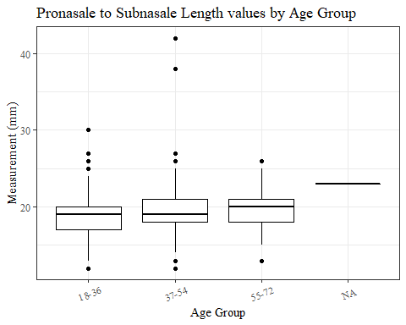

#boxplot not reordered by median  
ggplot(data=headscan_full, aes(y=ProS_L, x=age_group))+  
 geom_boxplot(color= "black", fill = "white")+  
 theme_bw()+theme(text=element_text(family= "Times New Roman"))+  
 theme(axis.text.x = element_text(angle = 20, vjust=0.7))+  
 labs(title="Pronasale to Subnasale Length values by Age Group",  
 y="Measurement (mm)",  
 x="Age Group")

## Warning: Removed 19 rows containing non-finite values (stat_boxplot).



ProS_C

#histogram of all ProS_C values  
ggplot(data=headscan_full, aes(x=ProS_C))+  
 geom_bar(stat="bin", bins=25, color= "black", fill = "white")+  
 theme_bw()+theme(text=element_text(family= "Times New Roman"))+  
 labs(title="Pronasale to Subnasale Contour Measurement Distribution",  
 y="Frequency",  
 x="Pronasale to Subnasale Contour (mm)")

## Warning: Removed 31 rows containing non-finite values (stat_bin).

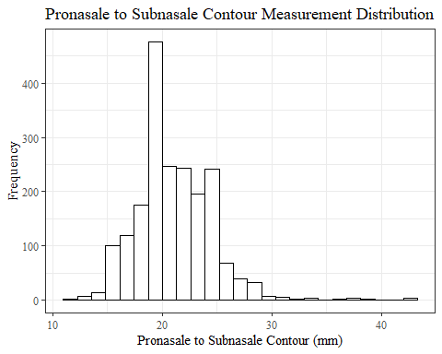

ProS_Csumstats <- headscan_full %>%   
 summarise(n = n(), na = sum(is.na(ProS_C)),  
 min = min(ProS_C, na.rm = TRUE),  
 max = max(ProS_C, na.rm = TRUE),  
 mean = mean(ProS_C, na.rm = TRUE),  
 mdn = median(ProS_C, na.rm = TRUE),  
 sd = sd(ProS_C, na.rm = TRUE),  
 se = sd/sqrt(n),  
 percent5th = quantile(ProS_C, 0.05, na.rm=TRUE),  
 percent25th = quantile(ProS_C, 0.25, na.rm=TRUE),  
 percent50th = quantile(ProS_C, 0.50, na.rm=TRUE),  
 percent75th = quantile(ProS_C, 0.75, na.rm=TRUE),  
 percent95th = quantile(ProS_C, 0.95, na.rm=TRUE))   
  
ProS_Csumstats <- round(ProS_Csumstats, 2)  
  
#Size 12 Table TNR  
flextable(ProS_Csumstats) %>%  
 my_ft_theme()%>%   
 bold(part = "header") %>%   
 set_caption("Pronasale to Subnasale Contour SumStats")

**Table** : Pronasale to Subnasale Contour SumStats

| **n** | **na** | **min** | **max** | **mean** | **mdn** | **sd** | **se** | **percent5th** | **percent25th** | **percent50th** | **percent75th** | **percent95th** |
| --- | --- | --- | --- | --- | --- | --- | --- | --- | --- | --- | --- | --- |
| 2,016 | 31 | 12 | 43 | 21.1 | 21 | 3.35 | 0.07 | 16 | 19 | 21 | 23 | 26 |

#%>% set_header_Cabels(values = list(ProS_C = "Subnasale/SubnasaleCont"))  
  
#Autofit Width Table TNR  
flextable(ProS_Csumstats) %>%  
 my_ft_theme()%>%   
 bold(part = "header") %>%   
 set_caption("Pronasale to Subnasale Contour SumStats") %>%   
 fit_to_width(7.5)

**Table** : Pronasale to Subnasale Contour SumStats

| **n** | **na** | **min** | **max** | **mean** | **mdn** | **sd** | **se** | **percent5th** | **percent25th** | **percent50th** | **percent75th** | **percent95th** |
| --- | --- | --- | --- | --- | --- | --- | --- | --- | --- | --- | --- | --- |
| 2,016 | 31 | 12 | 43 | 21.1 | 21 | 3.35 | 0.07 | 16 | 19 | 21 | 23 | 26 |

#%>% set_header_Cabels(values = list(ProS_C = "Subnasale/SubnasaleCont"))

#ProS_C race/eth sumstats  
ProS_Crace_sumstats <- headscan_full %>%   
 group_by(race_eth) %>%   
 summarise(n = n(), na = sum(is.na(ProS_C)),  
 min = min(ProS_C, na.rm = TRUE),  
 max = max(ProS_C, na.rm = TRUE),  
 mean = mean(ProS_C, na.rm = TRUE),  
 mdn = median(ProS_C, na.rm = TRUE),  
 sd = sd(ProS_C, na.rm = TRUE),  
 se = sd/sqrt(n),  
 percent5th = quantile(ProS_C, 0.05, na.rm=TRUE),  
 percent25th = quantile(ProS_C, 0.25, na.rm=TRUE),  
 percent50th = quantile(ProS_C, 0.50, na.rm=TRUE),  
 percent75th = quantile(ProS_C, 0.75, na.rm=TRUE),  
 percent95th = quantile(ProS_C, 0.95, na.rm=TRUE))   
  
ProS_Crace_sumstats <- ProS_Crace_sumstats %>%   
 mutate(across(where(is.numeric), round, 2))  
  
  
#Size 12 Table TNR  
flextable(ProS_Crace_sumstats) %>%  
 my_ft_theme()%>%   
 bold(part = "header") %>%   
 set_caption("Pronasale to Subnasale Contour SumStats by Race/Ethnicity")

**Table** : Pronasale to Subnasale Contour SumStats by Race/Ethnicity

| **race_eth** | **n** | **na** | **min** | **max** | **mean** | **mdn** | **sd** | **se** | **percent5th** | **percent25th** | **percent50th** | **percent75th** | **percent95th** |
| --- | --- | --- | --- | --- | --- | --- | --- | --- | --- | --- | --- | --- | --- |
| white | 1,239 | 21 | 13 | 43 | 21.64 | 22.0 | 3.11 | 0.09 | 17.00 | 19.00 | 22.0 | 24.0 | 27.00 |
| Black | 548 | 7 | 12 | 42 | 20.20 | 20.0 | 3.64 | 0.16 | 15.00 | 18.00 | 20.0 | 22.0 | 25.00 |
| LatinX | 100 | 1 | 14 | 29 | 20.70 | 20.0 | 2.88 | 0.29 | 16.00 | 19.00 | 20.0 | 22.0 | 25.00 |
| Asian | 91 | 1 | 14 | 42 | 20.18 | 20.0 | 3.73 | 0.39 | 16.00 | 18.00 | 20.0 | 22.0 | 25.55 |
| Other | 21 | 0 | 13 | 26 | 19.62 | 21.0 | 3.12 | 0.68 | 13.00 | 18.00 | 21.0 | 21.0 | 24.00 |
| AIAN | 8 | 1 | 19 | 23 | 20.29 | 20.0 | 1.25 | 0.44 | 19.30 | 20.00 | 20.0 | 20.0 | 22.10 |
| PTNS | 5 | 0 | 17 | 21 | 18.40 | 18.0 | 1.52 | 0.68 | 17.20 | 18.00 | 18.0 | 18.0 | 20.40 |
| NHOPI | 4 | 0 | 17 | 29 | 21.75 | 20.5 | 5.50 | 2.75 | 17.15 | 17.75 | 20.5 | 24.5 | 28.10 |

#%>% set_header_Cabels(values = list(ProS_C = "Subnasale/SubnasaleCont"))  
  
#Autofit Width Table TNR  
flextable(ProS_Crace_sumstats) %>%  
 my_ft_theme()%>%   
 bold(part = "header") %>%   
 set_caption("Pronasale to Subnasale Contour SumStats by Race/Ethnicity") %>%   
 fit_to_width(7.5)

**Table** : Pronasale to Subnasale Contour SumStats by Race/Ethnicity

| **race_eth** | **n** | **na** | **min** | **max** | **mean** | **mdn** | **sd** | **se** | **percent5th** | **percent25th** | **percent50th** | **percent75th** | **percent95th** |
| --- | --- | --- | --- | --- | --- | --- | --- | --- | --- | --- | --- | --- | --- |
| white | 1,239 | 21 | 13 | 43 | 21.64 | 22.0 | 3.11 | 0.09 | 17.00 | 19.00 | 22.0 | 24.0 | 27.00 |
| Black | 548 | 7 | 12 | 42 | 20.20 | 20.0 | 3.64 | 0.16 | 15.00 | 18.00 | 20.0 | 22.0 | 25.00 |
| LatinX | 100 | 1 | 14 | 29 | 20.70 | 20.0 | 2.88 | 0.29 | 16.00 | 19.00 | 20.0 | 22.0 | 25.00 |
| Asian | 91 | 1 | 14 | 42 | 20.18 | 20.0 | 3.73 | 0.39 | 16.00 | 18.00 | 20.0 | 22.0 | 25.55 |
| Other | 21 | 0 | 13 | 26 | 19.62 | 21.0 | 3.12 | 0.68 | 13.00 | 18.00 | 21.0 | 21.0 | 24.00 |
| AIAN | 8 | 1 | 19 | 23 | 20.29 | 20.0 | 1.25 | 0.44 | 19.30 | 20.00 | 20.0 | 20.0 | 22.10 |
| PTNS | 5 | 0 | 17 | 21 | 18.40 | 18.0 | 1.52 | 0.68 | 17.20 | 18.00 | 18.0 | 18.0 | 20.40 |
| NHOPI | 4 | 0 | 17 | 29 | 21.75 | 20.5 | 5.50 | 2.75 | 17.15 | 17.75 | 20.5 | 24.5 | 28.10 |

#%>% set_header_Cabels(values = list(ProS_C = "Subnasale/SubnasaleCont"))  
  
#boxplot reorderd by median  
headscan_full %>%   
 ungroup() %>%   
 mutate(race_eth= fct_reorder(race_eth, ProS_C, FUN=median, na.rm=TRUE)) %>%   
 ggplot(aes(y=ProS_C, x=race_eth))+  
 geom_boxplot(color= "black", fill = "white")+  
 theme_bw()+theme(text=element_text(family= "Times New Roman"))+  
 #theme(axis.text.x = element_text(angle = 20, vjust=0.7))+  
 labs(title="Pronasale to Subnasale Contour values by Race/Ethnicity",  
 y="Measurement (mm)",  
 x="Race/Ethnicity")

## Warning: Removed 31 rows containing non-finite values (stat_boxplot).

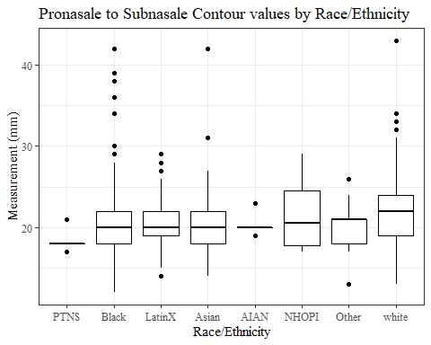

#boxplot not reordered by median  
ggplot(data=headscan_full, aes(y=ProS_C, x=race_eth))+  
 geom_boxplot(color= "black", fill = "white")+  
 theme_bw()+theme(text=element_text(family= "Times New Roman"))+  
 #theme(axis.text.x = element_text(angle = 20, vjust=0.7))+  
 labs(title="Pronasale to Subnasale Contour values by Race/Ethnicity",  
 y="Measurement (mm)",  
 x="Race/Ethnicity")

## Warning: Removed 31 rows containing non-finite values (stat_boxplot).

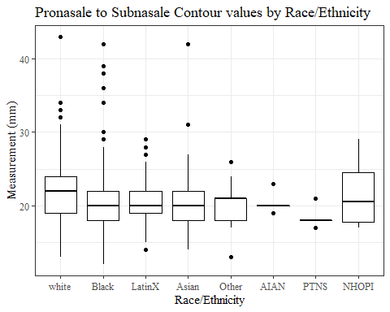

#ProS_C gender sumstats  
ProS_Cgender_sumstats <- headscan_full %>%   
 group_by(gender) %>%   
 summarise(n = n(), na = sum(is.na(ProS_C)),  
 min = min(ProS_C, na.rm = TRUE),  
 max = max(ProS_C, na.rm = TRUE),  
 mean = mean(ProS_C, na.rm = TRUE),  
 mdn = median(ProS_C, na.rm = TRUE),  
 sd = sd(ProS_C, na.rm = TRUE),  
 se = sd/sqrt(n),  
 percent5th = quantile(ProS_C, 0.05, na.rm=TRUE),  
 percent25th = quantile(ProS_C, 0.25, na.rm=TRUE),  
 percent50th = quantile(ProS_C, 0.50, na.rm=TRUE),  
 percent75th = quantile(ProS_C, 0.75, na.rm=TRUE),  
 percent95th = quantile(ProS_C, 0.95, na.rm=TRUE))  
  
ProS_Cgender_sumstats <- ProS_Cgender_sumstats %>%   
 mutate(across(where(is.numeric), round, 2))  
  
#Size 12 Table TNR  
flextable(ProS_Cgender_sumstats) %>%  
 my_ft_theme()%>%   
 bold(part = "header") %>%   
 set_caption("Pronasale to Subnasale Contour SumStats by Gender")

**Table** : Pronasale to Subnasale Contour SumStats by Gender

| **gender** | **n** | **na** | **min** | **max** | **mean** | **mdn** | **sd** | **se** | **percent5th** | **percent25th** | **percent50th** | **percent75th** | **percent95th** |
| --- | --- | --- | --- | --- | --- | --- | --- | --- | --- | --- | --- | --- | --- |
| Female | 1,063 | 12 | 13 | 42 | 20.46 | 20 | 3.16 | 0.10 | 16.00 | 18.00 | 20 | 22 | 25.00 |
| Male | 939 | 19 | 12 | 43 | 21.86 | 22 | 3.41 | 0.11 | 17.00 | 20.00 | 22 | 24 | 27.00 |
| Non-binary or Other | 5 | 0 | 17 | 20 | 19.00 | 19 | 1.22 | 0.55 | 17.40 | 19.00 | 19 | 20 | 20.00 |
| Prefer not to say | 1 | 0 | 18 | 18 | 18.00 | 18 |  |  | 18.00 | 18.00 | 18 | 18 | 18.00 |
|  | 8 | 0 | 15 | 24 | 19.50 | 19 | 3.46 | 1.22 | 15.35 | 16.75 | 19 | 23 | 23.65 |

#%>% set_header_Cabels(values = list(ProS_C = "Subnasale/SubnasaleCont"))  
  
#Autofit Width Table TNR  
flextable(ProS_Cgender_sumstats) %>%  
 my_ft_theme()%>%   
 bold(part = "header") %>%   
 set_caption("Pronasale to Subnasale Contour SumStats by Gender") %>%   
 fit_to_width(7.5)

**Table** : Pronasale to Subnasale Contour SumStats by Gender

| **gender** | **n** | **na** | **min** | **max** | **mean** | **mdn** | **sd** | **se** | **percent5th** | **percent25th** | **percent50th** | **percent75th** | **percent95th** |
| --- | --- | --- | --- | --- | --- | --- | --- | --- | --- | --- | --- | --- | --- |
| Female | 1,063 | 12 | 13 | 42 | 20.46 | 20 | 3.16 | 0.10 | 16.00 | 18.00 | 20 | 22 | 25.00 |
| Male | 939 | 19 | 12 | 43 | 21.86 | 22 | 3.41 | 0.11 | 17.00 | 20.00 | 22 | 24 | 27.00 |
| Non-binary or Other | 5 | 0 | 17 | 20 | 19.00 | 19 | 1.22 | 0.55 | 17.40 | 19.00 | 19 | 20 | 20.00 |
| Prefer not to say | 1 | 0 | 18 | 18 | 18.00 | 18 |  |  | 18.00 | 18.00 | 18 | 18 | 18.00 |
|  | 8 | 0 | 15 | 24 | 19.50 | 19 | 3.46 | 1.22 | 15.35 | 16.75 | 19 | 23 | 23.65 |

#%>% set_header_Cabels(values = list(ProS_C = "Subnasale/SubnasaleCont"))  
  
#boxplot reorderd by median  
headscan_full %>%   
 ungroup() %>%   
 mutate(gender= fct_reorder(gender, ProS_C, FUN=median, na.rm=TRUE)) %>%   
 ggplot(aes(y=ProS_C, x=gender))+  
 geom_boxplot(color= "black", fill = "white")+  
 theme_bw()+theme(text=element_text(family= "Times New Roman"))+  
 theme(axis.text.x = element_text(angle = 20, vjust=0.7))+  
 labs(title="Pronasale to Subnasale Contour values by Gender",  
 y="Measurement (mm)",  
 x="Gender")

## Warning: Removed 31 rows containing non-finite values (stat_boxplot).

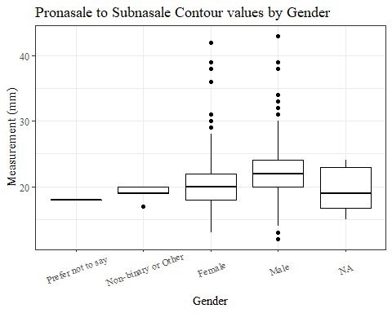

#boxplot not reordered by median  
ggplot(data=headscan_full, aes(y=ProS_C, x=gender))+  
 geom_boxplot(color= "black", fill = "white")+  
 theme_bw()+theme(text=element_text(family= "Times New Roman"))+  
 theme(axis.text.x = element_text(angle = 20, vjust=0.7))+  
 labs(title="Pronasale to Subnasale Contour values by Gender",  
 y="Measurement (mm)",  
 x="Gender")

## Warning: Removed 31 rows containing non-finite values (stat_boxplot).

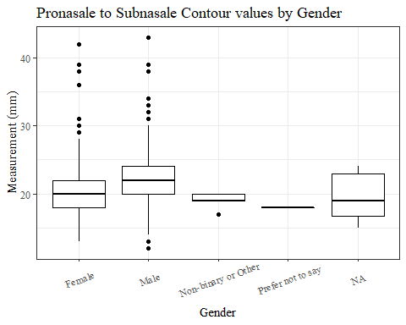

#ProS_C age group sumstats  
ProS_Cage_sumstats <- headscan_full %>%   
 group_by(age_group) %>%   
 summarise(n = n(), na = sum(is.na(ProS_C)),  
 min = min(ProS_C, na.rm = TRUE),  
 max = max(ProS_C, na.rm = TRUE),  
 mean = mean(ProS_C, na.rm = TRUE),  
 mdn = median(ProS_C, na.rm = TRUE),  
 sd = sd(ProS_C, na.rm = TRUE),  
 se = sd/sqrt(n),  
 percent5th = quantile(ProS_C, 0.05, na.rm=TRUE),  
 percent25th = quantile(ProS_C, 0.25, na.rm=TRUE),  
 percent50th = quantile(ProS_C, 0.50, na.rm=TRUE),  
 percent75th = quantile(ProS_C, 0.75, na.rm=TRUE),  
 percent95th = quantile(ProS_C, 0.95, na.rm=TRUE))  
  
ProS_Cage_sumstats <- ProS_Cage_sumstats %>%   
 mutate(across(where(is.numeric), round, 2))  
  
  
#Size 12 Table TNR  
flextable(ProS_Cage_sumstats) %>%  
 my_ft_theme()%>%   
 bold(part = "header") %>%   
 set_caption("Pronasale to Subnasale Contour SumStats by Age Group")

**Table** : Pronasale to Subnasale Contour SumStats by Age Group

| **age_group** | **n** | **na** | **min** | **max** | **mean** | **mdn** | **sd** | **se** | **percent5th** | **percent25th** | **percent50th** | **percent75th** | **percent95th** |
| --- | --- | --- | --- | --- | --- | --- | --- | --- | --- | --- | --- | --- | --- |
| 18-36 | 991 | 12 | 13 | 43 | 20.57 | 20 | 3.13 | 0.10 | 16 | 18 | 20 | 22 | 25 |
| 37-54 | 940 | 16 | 12 | 42 | 21.60 | 21 | 3.52 | 0.11 | 16 | 19 | 21 | 23 | 27 |
| 55-72 | 84 | 3 | 15 | 32 | 21.80 | 22 | 2.93 | 0.32 | 17 | 20 | 22 | 24 | 27 |
|  | 1 | 0 | 25 | 25 | 25.00 | 25 |  |  | 25 | 25 | 25 | 25 | 25 |

#%>% set_header_Cabels(values = list(ProS_C = "Subnasale/SubnasaleCont"))  
  
#Autofit Width Table TNR  
flextable(ProS_Cage_sumstats) %>%  
 my_ft_theme()%>%   
 bold(part = "header") %>%   
 set_caption("Pronasale to Subnasale Contour SumStats by Age Group") %>%   
 fit_to_width(7.5)

**Table** : Pronasale to Subnasale Contour SumStats by Age Group

| **age_group** | **n** | **na** | **min** | **max** | **mean** | **mdn** | **sd** | **se** | **percent5th** | **percent25th** | **percent50th** | **percent75th** | **percent95th** |
| --- | --- | --- | --- | --- | --- | --- | --- | --- | --- | --- | --- | --- | --- |
| 18-36 | 991 | 12 | 13 | 43 | 20.57 | 20 | 3.13 | 0.10 | 16 | 18 | 20 | 22 | 25 |
| 37-54 | 940 | 16 | 12 | 42 | 21.60 | 21 | 3.52 | 0.11 | 16 | 19 | 21 | 23 | 27 |
| 55-72 | 84 | 3 | 15 | 32 | 21.80 | 22 | 2.93 | 0.32 | 17 | 20 | 22 | 24 | 27 |
|  | 1 | 0 | 25 | 25 | 25.00 | 25 |  |  | 25 | 25 | 25 | 25 | 25 |

#%>% set_header_Cabels(values = list(ProS_C = "Subnasale/SubnasaleCont"))  
  
#boxplot reorderd by median  
headscan_full %>%   
 ungroup() %>%   
 mutate(age_group= fct_reorder(age_group, ProS_C, FUN=median, na.rm=TRUE)) %>%   
 ggplot(aes(y=ProS_C, x=age_group))+  
 geom_boxplot(color= "black", fill = "white")+  
 theme_bw()+theme(text=element_text(family= "Times New Roman"))+  
 #theme(axis.text.x = element_text(angle = 20, vjust=0.7))+  
 labs(title="Pronasale to Subnasale Contour values by Age Group",  
 y="Measurement (mm)",  
 x="Age Group")

## Warning: Removed 31 rows containing non-finite values (stat_boxplot).

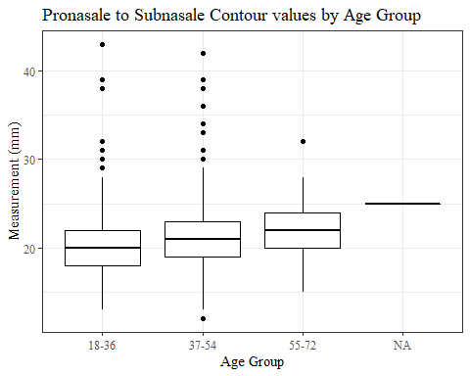

#boxplot not reordered by median  
ggplot(data=headscan_full, aes(y=ProS_C, x=age_group))+  
 geom_boxplot(color= "black", fill = "white")+  
 theme_bw()+theme(text=element_text(family= "Times New Roman"))+  
 #theme(axis.text.x = element_text(angle = 20, vjust=0.7))+  
 labs(title="Pronasale to Subnasale Contour values by Age Group",  
 y="Measurement (mm)",  
 x="Age Group")

## Warning: Removed 31 rows containing non-finite values (stat_boxplot).



SelP_L

#histogram of all SelP_L values  
ggplot(data=headscan_full, aes(x=SelP_L))+  
 geom_bar(stat="bin", bins=25, color= "black", fill = "white")+  
 theme_bw()+theme(text=element_text(family= "Times New Roman"))+  
 labs(title="Sellion to Pronasale Length Measurement Distribution",  
 y="Frequency",  
 x="Sellion to Pronasale Length (mm)")

## Warning: Removed 15 rows containing non-finite values (stat_bin).

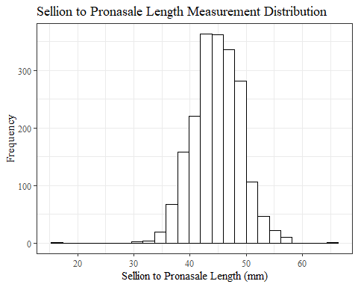

SelP_Lsumstats <- headscan_full %>%   
 summarise(n = n(), na = sum(is.na(SelP_L)),  
 min = min(SelP_L, na.rm = TRUE),  
 max = max(SelP_L, na.rm = TRUE),  
 mean = mean(SelP_L, na.rm = TRUE),  
 mdn = median(SelP_L, na.rm = TRUE),  
 sd = sd(SelP_L, na.rm = TRUE),  
 se = sd/sqrt(n),  
 percent5th = quantile(SelP_L, 0.05, na.rm=TRUE),  
 percent25th = quantile(SelP_L, 0.25, na.rm=TRUE),  
 percent50th = quantile(SelP_L, 0.50, na.rm=TRUE),  
 percent75th = quantile(SelP_L, 0.75, na.rm=TRUE),  
 percent95th = quantile(SelP_L, 0.95, na.rm=TRUE))   
  
SelP_Lsumstats <- round(SelP_Lsumstats, 2)  
  
#Size 12 Table TNR  
flextable(SelP_Lsumstats) %>%  
 my_ft_theme()%>%   
 bold(part = "header") %>%   
 set_caption("Sellion to Pronasale Length SumStats")

**Table** : Sellion to Pronasale Length SumStats

| **n** | **na** | **min** | **max** | **mean** | **mdn** | **sd** | **se** | **percent5th** | **percent25th** | **percent50th** | **percent75th** | **percent95th** |
| --- | --- | --- | --- | --- | --- | --- | --- | --- | --- | --- | --- | --- |
| 2,016 | 15 | 16 | 65 | 44.53 | 44 | 4.41 | 0.1 | 38 | 42 | 44 | 47 | 52 |

#%>% set_header_Cabels(values = list(SelP_L = "Sellion/SellionCont"))  
  
#Autofit Width Table TNR  
flextable(SelP_Lsumstats) %>%  
 my_ft_theme()%>%   
 bold(part = "header") %>%   
 set_caption("Sellion to Pronasale Length SumStats") %>%   
 fit_to_width(7.5)

**Table** : Sellion to Pronasale Length SumStats

| **n** | **na** | **min** | **max** | **mean** | **mdn** | **sd** | **se** | **percent5th** | **percent25th** | **percent50th** | **percent75th** | **percent95th** |
| --- | --- | --- | --- | --- | --- | --- | --- | --- | --- | --- | --- | --- |
| 2,016 | 15 | 16 | 65 | 44.53 | 44 | 4.41 | 0.1 | 38 | 42 | 44 | 47 | 52 |

#%>% set_header_Cabels(values = list(SelP_L = "Sellion/SellionCont"))

#SelP_L race/eth sumstats  
SelP_Lrace_sumstats <- headscan_full %>%   
 group_by(race_eth) %>%   
 summarise(n = n(), na = sum(is.na(SelP_L)),  
 min = min(SelP_L, na.rm = TRUE),  
 max = max(SelP_L, na.rm = TRUE),  
 mean = mean(SelP_L, na.rm = TRUE),  
 mdn = median(SelP_L, na.rm = TRUE),  
 sd = sd(SelP_L, na.rm = TRUE),  
 se = sd/sqrt(n),  
 percent5th = quantile(SelP_L, 0.05, na.rm=TRUE),  
 percent25th = quantile(SelP_L, 0.25, na.rm=TRUE),  
 percent50th = quantile(SelP_L, 0.50, na.rm=TRUE),  
 percent75th = quantile(SelP_L, 0.75, na.rm=TRUE),  
 percent95th = quantile(SelP_L, 0.95, na.rm=TRUE))   
  
SelP_Lrace_sumstats <- SelP_Lrace_sumstats %>%   
 mutate(across(where(is.numeric), round, 2))  
  
  
#Size 12 Table TNR  
flextable(SelP_Lrace_sumstats) %>%  
 my_ft_theme()%>%   
 bold(part = "header") %>%   
 set_caption("Sellion to Pronasale Length SumStats by Race/Ethnicity")

**Table** : Sellion to Pronasale Length SumStats by Race/Ethnicity

| **race_eth** | **n** | **na** | **min** | **max** | **mean** | **mdn** | **sd** | **se** | **percent5th** | **percent25th** | **percent50th** | **percent75th** | **percent95th** |
| --- | --- | --- | --- | --- | --- | --- | --- | --- | --- | --- | --- | --- | --- |
| white | 1,239 | 7 | 16 | 65 | 45.07 | 45 | 4.47 | 0.13 | 38.00 | 42.00 | 45 | 48.0 | 53.0 |
| Black | 548 | 5 | 30 | 57 | 43.26 | 43 | 4.19 | 0.18 | 36.10 | 40.50 | 43 | 46.0 | 50.0 |
| LatinX | 100 | 1 | 34 | 54 | 45.30 | 45 | 3.88 | 0.39 | 38.90 | 43.00 | 45 | 48.0 | 52.0 |
| Asian | 91 | 1 | 36 | 54 | 43.73 | 44 | 3.92 | 0.41 | 38.45 | 41.00 | 44 | 46.0 | 51.0 |
| Other | 21 | 0 | 37 | 55 | 45.57 | 46 | 3.85 | 0.84 | 41.00 | 44.00 | 46 | 47.0 | 51.0 |
| AIAN | 8 | 1 | 37 | 52 | 45.57 | 47 | 5.26 | 1.86 | 37.90 | 43.00 | 47 | 48.5 | 51.1 |
| PTNS | 5 | 0 | 40 | 45 | 42.40 | 42 | 1.82 | 0.81 | 40.40 | 42.00 | 42 | 43.0 | 44.6 |
| NHOPI | 4 | 0 | 39 | 48 | 43.75 | 44 | 3.69 | 1.84 | 39.75 | 42.75 | 44 | 45.0 | 47.4 |

#%>% set_header_Cabels(values = list(SelP_L = "Sellion/SellionCont"))  
  
#Autofit Width Table TNR  
flextable(SelP_Lrace_sumstats) %>%  
 my_ft_theme()%>%   
 bold(part = "header") %>%   
 set_caption("Sellion to Pronasale Length SumStats by Race/Ethnicity") %>%   
 fit_to_width(7.5)

**Table** : Sellion to Pronasale Length SumStats by Race/Ethnicity

| **race_eth** | **n** | **na** | **min** | **max** | **mean** | **mdn** | **sd** | **se** | **percent5th** | **percent25th** | **percent50th** | **percent75th** | **percent95th** |
| --- | --- | --- | --- | --- | --- | --- | --- | --- | --- | --- | --- | --- | --- |
| white | 1,239 | 7 | 16 | 65 | 45.07 | 45 | 4.47 | 0.13 | 38.00 | 42.00 | 45 | 48.0 | 53.0 |
| Black | 548 | 5 | 30 | 57 | 43.26 | 43 | 4.19 | 0.18 | 36.10 | 40.50 | 43 | 46.0 | 50.0 |
| LatinX | 100 | 1 | 34 | 54 | 45.30 | 45 | 3.88 | 0.39 | 38.90 | 43.00 | 45 | 48.0 | 52.0 |
| Asian | 91 | 1 | 36 | 54 | 43.73 | 44 | 3.92 | 0.41 | 38.45 | 41.00 | 44 | 46.0 | 51.0 |
| Other | 21 | 0 | 37 | 55 | 45.57 | 46 | 3.85 | 0.84 | 41.00 | 44.00 | 46 | 47.0 | 51.0 |
| AIAN | 8 | 1 | 37 | 52 | 45.57 | 47 | 5.26 | 1.86 | 37.90 | 43.00 | 47 | 48.5 | 51.1 |
| PTNS | 5 | 0 | 40 | 45 | 42.40 | 42 | 1.82 | 0.81 | 40.40 | 42.00 | 42 | 43.0 | 44.6 |
| NHOPI | 4 | 0 | 39 | 48 | 43.75 | 44 | 3.69 | 1.84 | 39.75 | 42.75 | 44 | 45.0 | 47.4 |

#%>% set_header_Cabels(values = list(SelP_L = "Sellion/SellionCont"))  
  
#boxplot reorderd by median  
headscan_full %>%   
 ungroup() %>%   
 mutate(race_eth= fct_reorder(race_eth, SelP_L, FUN=median, na.rm=TRUE)) %>%   
 ggplot(aes(y=SelP_L, x=race_eth))+  
 geom_boxplot(color= "black", fill = "white")+  
 theme_bw()+theme(text=element_text(family= "Times New Roman"))+  
 #theme(axis.text.x = element_text(angle = 20, vjust=0.7))+  
 labs(title="Sellion to Pronasale Length values by Race/Ethnicity",  
 y="Measurement (mm)",  
 x="Race/Ethnicity")

## Warning: Removed 15 rows containing non-finite values (stat_boxplot).

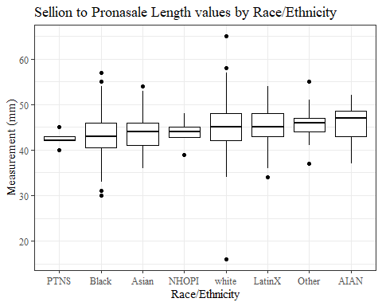

#boxplot not reordered by median  
ggplot(data=headscan_full, aes(y=SelP_L, x=race_eth))+  
 geom_boxplot(color= "black", fill = "white")+  
 theme_bw()+theme(text=element_text(family= "Times New Roman"))+  
 #theme(axis.text.x = element_text(angle = 20, vjust=0.7))+  
 labs(title="Sellion to Pronasale Length values by Race/Ethnicity",  
 y="Measurement (mm)",  
 x="Race/Ethnicity")

## Warning: Removed 15 rows containing non-finite values (stat_boxplot).

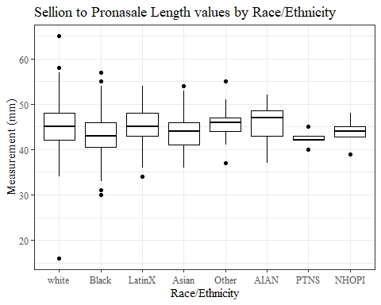

#SelP_L gender sumstats  
SelP_Lgender_sumstats <- headscan_full %>%   
 group_by(gender) %>%   
 summarise(n = n(), na = sum(is.na(SelP_L)),  
 min = min(SelP_L, na.rm = TRUE),  
 max = max(SelP_L, na.rm = TRUE),  
 mean = mean(SelP_L, na.rm = TRUE),  
 mdn = median(SelP_L, na.rm = TRUE),  
 sd = sd(SelP_L, na.rm = TRUE),  
 se = sd/sqrt(n),  
 percent5th = quantile(SelP_L, 0.05, na.rm=TRUE),  
 percent25th = quantile(SelP_L, 0.25, na.rm=TRUE),  
 percent50th = quantile(SelP_L, 0.50, na.rm=TRUE),  
 percent75th = quantile(SelP_L, 0.75, na.rm=TRUE),  
 percent95th = quantile(SelP_L, 0.95, na.rm=TRUE))  
  
SelP_Lgender_sumstats <- SelP_Lgender_sumstats %>%   
 mutate(across(where(is.numeric), round, 2))  
  
#Size 12 Table TNR  
flextable(SelP_Lgender_sumstats) %>%  
 my_ft_theme()%>%   
 bold(part = "header") %>%   
 set_caption("Sellion to Pronasale Length SumStats by Gender")

**Table** : Sellion to Pronasale Length SumStats by Gender

| **gender** | **n** | **na** | **min** | **max** | **mean** | **mdn** | **sd** | **se** | **percent5th** | **percent25th** | **percent50th** | **percent75th** | **percent95th** |
| --- | --- | --- | --- | --- | --- | --- | --- | --- | --- | --- | --- | --- | --- |
| Female | 1,063 | 10 | 16 | 57 | 42.85 | 43 | 3.87 | 0.12 | 37.00 | 40.0 | 43 | 45.0 | 49.0 |
| Male | 939 | 5 | 31 | 65 | 46.48 | 46 | 4.15 | 0.14 | 40.00 | 44.0 | 46 | 49.0 | 53.0 |
| Non-binary or Other | 5 | 0 | 36 | 52 | 40.60 | 38 | 6.47 | 2.89 | 36.40 | 38.0 | 38 | 39.0 | 49.4 |
| Prefer not to say | 1 | 0 | 40 | 40 | 40.00 | 40 |  |  | 40.00 | 40.0 | 40 | 40.0 | 40.0 |
|  | 8 | 0 | 37 | 51 | 41.25 | 40 | 4.33 | 1.53 | 37.35 | 39.5 | 40 | 41.5 | 48.2 |

#%>% set_header_Cabels(values = list(SelP_L = "Sellion/SellionCont"))  
  
#Autofit Width Table TNR  
flextable(SelP_Lgender_sumstats) %>%  
 my_ft_theme()%>%   
 bold(part = "header") %>%   
 set_caption("Sellion to Pronasale Length SumStats by Gender") %>%   
 fit_to_width(7.5)

**Table** : Sellion to Pronasale Length SumStats by Gender

| **gender** | **n** | **na** | **min** | **max** | **mean** | **mdn** | **sd** | **se** | **percent5th** | **percent25th** | **percent50th** | **percent75th** | **percent95th** |
| --- | --- | --- | --- | --- | --- | --- | --- | --- | --- | --- | --- | --- | --- |
| Female | 1,063 | 10 | 16 | 57 | 42.85 | 43 | 3.87 | 0.12 | 37.00 | 40.0 | 43 | 45.0 | 49.0 |
| Male | 939 | 5 | 31 | 65 | 46.48 | 46 | 4.15 | 0.14 | 40.00 | 44.0 | 46 | 49.0 | 53.0 |
| Non-binary or Other | 5 | 0 | 36 | 52 | 40.60 | 38 | 6.47 | 2.89 | 36.40 | 38.0 | 38 | 39.0 | 49.4 |
| Prefer not to say | 1 | 0 | 40 | 40 | 40.00 | 40 |  |  | 40.00 | 40.0 | 40 | 40.0 | 40.0 |
|  | 8 | 0 | 37 | 51 | 41.25 | 40 | 4.33 | 1.53 | 37.35 | 39.5 | 40 | 41.5 | 48.2 |

#%>% set_header_Cabels(values = list(SelP_L = "Sellion/SellionCont"))  
  
#boxplot reorderd by median  
headscan_full %>%   
 ungroup() %>%   
 mutate(gender= fct_reorder(gender, SelP_L, FUN=median, na.rm=TRUE)) %>%   
 ggplot(aes(y=SelP_L, x=gender))+  
 geom_boxplot(color= "black", fill = "white")+  
 theme_bw()+theme(text=element_text(family= "Times New Roman"))+  
 theme(axis.text.x = element_text(angle = 20, vjust=0.7))+  
 labs(title="Sellion to Pronasale Length values by Gender",  
 y="Measurement (mm)",  
 x="Gender")

## Warning: Removed 15 rows containing non-finite values (stat_boxplot).

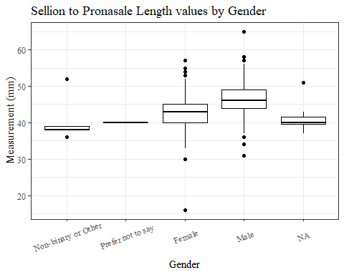

#boxplot not reordered by median  
ggplot(data=headscan_full, aes(y=SelP_L, x=gender))+  
 geom_boxplot(color= "black", fill = "white")+  
 theme_bw()+theme(text=element_text(family= "Times New Roman"))+  
 theme(axis.text.x = element_text(angle = 20, vjust=0.7))+  
 labs(title="Sellion to Pronasale Length values by Gender",  
 y="Measurement (mm)",  
 x="Gender")

## Warning: Removed 15 rows containing non-finite values (stat_boxplot).

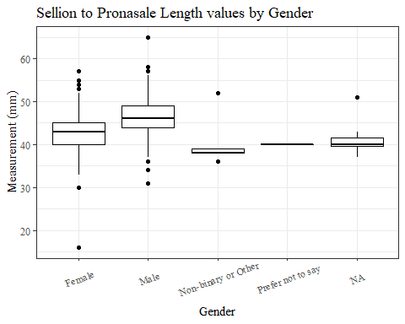

#SelP_L age group sumstats  
SelP_Lage_sumstats <- headscan_full %>%   
 group_by(age_group) %>%   
 summarise(n = n(), na = sum(is.na(SelP_L)),  
 min = min(SelP_L, na.rm = TRUE),  
 max = max(SelP_L, na.rm = TRUE),  
 mean = mean(SelP_L, na.rm = TRUE),  
 mdn = median(SelP_L, na.rm = TRUE),  
 sd = sd(SelP_L, na.rm = TRUE),  
 se = sd/sqrt(n),  
 percent5th = quantile(SelP_L, 0.05, na.rm=TRUE),  
 percent25th = quantile(SelP_L, 0.25, na.rm=TRUE),  
 percent50th = quantile(SelP_L, 0.50, na.rm=TRUE),  
 percent75th = quantile(SelP_L, 0.75, na.rm=TRUE),  
 percent95th = quantile(SelP_L, 0.95, na.rm=TRUE))  
  
SelP_Lage_sumstats <- SelP_Lage_sumstats %>%   
 mutate(across(where(is.numeric), round, 2))  
  
  
#Size 12 Table TNR  
flextable(SelP_Lage_sumstats) %>%  
 my_ft_theme()%>%   
 bold(part = "header") %>%   
 set_caption("Sellion to Pronasale Length SumStats by Age Group")

**Table** : Sellion to Pronasale Length SumStats by Age Group

| **age_group** | **n** | **na** | **min** | **max** | **mean** | **mdn** | **sd** | **se** | **percent5th** | **percent25th** | **percent50th** | **percent75th** | **percent95th** |
| --- | --- | --- | --- | --- | --- | --- | --- | --- | --- | --- | --- | --- | --- |
| 18-36 | 991 | 5 | 31 | 57 | 44.35 | 44 | 4.21 | 0.13 | 38 | 42 | 44 | 47 | 51 |
| 37-54 | 940 | 9 | 16 | 65 | 44.65 | 45 | 4.60 | 0.15 | 37 | 42 | 45 | 47 | 53 |
| 55-72 | 84 | 1 | 37 | 58 | 45.31 | 45 | 4.37 | 0.48 | 40 | 42 | 45 | 47 | 53 |
|  | 1 | 0 | 43 | 43 | 43.00 | 43 |  |  | 43 | 43 | 43 | 43 | 43 |

#%>% set_header_Cabels(values = list(SelP_L = "Sellion/SellionCont"))  
  
#Autofit Width Table TNR  
flextable(SelP_Lage_sumstats) %>%  
 my_ft_theme()%>%   
 bold(part = "header") %>%   
 set_caption("Sellion to Pronasale Length SumStats by Age Group") %>%   
 fit_to_width(7.5)

**Table** : Sellion to Pronasale Length SumStats by Age Group

| **age_group** | **n** | **na** | **min** | **max** | **mean** | **mdn** | **sd** | **se** | **percent5th** | **percent25th** | **percent50th** | **percent75th** | **percent95th** |
| --- | --- | --- | --- | --- | --- | --- | --- | --- | --- | --- | --- | --- | --- |
| 18-36 | 991 | 5 | 31 | 57 | 44.35 | 44 | 4.21 | 0.13 | 38 | 42 | 44 | 47 | 51 |
| 37-54 | 940 | 9 | 16 | 65 | 44.65 | 45 | 4.60 | 0.15 | 37 | 42 | 45 | 47 | 53 |
| 55-72 | 84 | 1 | 37 | 58 | 45.31 | 45 | 4.37 | 0.48 | 40 | 42 | 45 | 47 | 53 |
|  | 1 | 0 | 43 | 43 | 43.00 | 43 |  |  | 43 | 43 | 43 | 43 | 43 |

#%>% set_header_Cabels(values = list(SelP_L = "Sellion/SellionCont"))  
  
#boxplot reorderd by median  
headscan_full %>%   
 ungroup() %>%   
 mutate(age_group= fct_reorder(age_group, SelP_L, FUN=median, na.rm=TRUE)) %>%   
 ggplot(aes(y=SelP_L, x=age_group))+  
 geom_boxplot(color= "black", fill = "white")+  
 theme_bw()+theme(text=element_text(family= "Times New Roman"))+  
 #theme(axis.text.x = element_text(angle = 20, vjust=0.7))+  
 labs(title="Sellion to Pronasale Length values by Age Group",  
 y="Measurement (mm)",  
 x="Age Group")

## Warning: Removed 15 rows containing non-finite values (stat_boxplot).

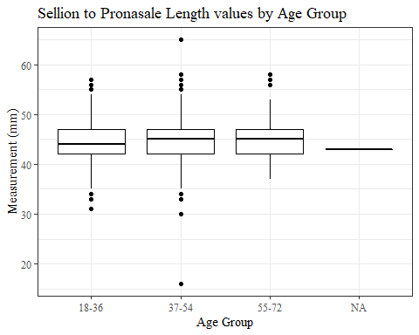

#boxplot not reordered by median  
ggplot(data=headscan_full, aes(y=SelP_L, x=age_group))+  
 geom_boxplot(color= "black", fill = "white")+  
 theme_bw()+theme(text=element_text(family= "Times New Roman"))+  
 #theme(axis.text.x = element_text(angle = 20, vjust=0.7))+  
 labs(title="Sellion to Pronasale Length values by Age Group",  
 y="Measurement (mm)",  
 x="Age Group")

## Warning: Removed 15 rows containing non-finite values (stat_boxplot).



SelP_C

#histogram of all SelP_C values  
ggplot(data=headscan_full, aes(x=SelP_C ))+  
 geom_bar(stat="bin", bins=25, color= "black", fill = "white")+  
 theme_bw()+theme(text=element_text(family= "Times New Roman"))+  
 labs(title="Sellion to Pronasale Contour Measurement Distribution",  
 y="Frequency",  
 x="Sellion to Pronasale Contour (mm)")

## Warning: Removed 15 rows containing non-finite values (stat_bin).

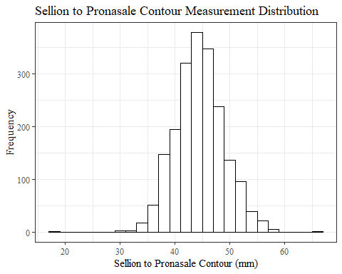

#SelP_C race/eth sumstats  
SelP_Csumstats <- headscan_full %>%   
 summarise(n = n(), na = sum(is.na(SelP_C)),  
 min = min(SelP_C, na.rm = TRUE),  
 max = max(SelP_C, na.rm = TRUE),  
 mean = mean(SelP_C, na.rm = TRUE),  
 mdn = median(SelP_C, na.rm = TRUE),  
 sd = sd(SelP_C, na.rm = TRUE),  
 se = sd/sqrt(n),  
 percent5th = quantile(SelP_C, 0.05, na.rm=TRUE),  
 percent25th = quantile(SelP_C, 0.25, na.rm=TRUE),  
 percent50th = quantile(SelP_C, 0.50, na.rm=TRUE),  
 percent75th = quantile(SelP_C, 0.75, na.rm=TRUE),  
 percent95th = quantile(SelP_C, 0.95, na.rm=TRUE))   
  
SelP_Csumstats <- round(SelP_Csumstats, 2)  
  
#Size 12 Table TNR  
flextable(SelP_Csumstats) %>%  
 my_ft_theme()%>%   
 bold(part = "header") %>%   
 set_caption("Sellion to Pronasale Contour SumStats")

**Table** : Sellion to Pronasale Contour SumStats

| **n** | **na** | **min** | **max** | **mean** | **mdn** | **sd** | **se** | **percent5th** | **percent25th** | **percent50th** | **percent75th** | **percent95th** |
| --- | --- | --- | --- | --- | --- | --- | --- | --- | --- | --- | --- | --- |
| 2,016 | 15 | 18 | 66 | 45.01 | 45 | 4.49 | 0.1 | 38 | 42 | 45 | 48 | 53 |

#%>% set_header_Cabels(values = list(SelP_C = "Sellion/SellionCont"))  
  
#Autofit Width Table TNR  
flextable(SelP_Csumstats) %>%  
 my_ft_theme()%>%   
 bold(part = "header") %>%   
 set_caption("Sellion to Pronasale Contour SumStats") %>%   
 fit_to_width(7.5)

**Table** : Sellion to Pronasale Contour SumStats

| **n** | **na** | **min** | **max** | **mean** | **mdn** | **sd** | **se** | **percent5th** | **percent25th** | **percent50th** | **percent75th** | **percent95th** |
| --- | --- | --- | --- | --- | --- | --- | --- | --- | --- | --- | --- | --- |
| 2,016 | 15 | 18 | 66 | 45.01 | 45 | 4.49 | 0.1 | 38 | 42 | 45 | 48 | 53 |

#%>% set_header_Cabels(values = list(SelP_C = "Sellion/SellionCont"))

#SelP_C race/eth sumstats  
SelP_Crace_sumstats <- headscan_full %>%   
 group_by(race_eth) %>%   
 summarise(n = n(), na = sum(is.na(SelP_C)),  
 min = min(SelP_C, na.rm = TRUE),  
 max = max(SelP_C, na.rm = TRUE),  
 mean = mean(SelP_C, na.rm = TRUE),  
 mdn = median(SelP_C, na.rm = TRUE),  
 sd = sd(SelP_C, na.rm = TRUE),  
 se = sd/sqrt(n),  
 percent5th = quantile(SelP_C, 0.05, na.rm=TRUE),  
 percent25th = quantile(SelP_C, 0.25, na.rm=TRUE),  
 percent50th = quantile(SelP_C, 0.50, na.rm=TRUE),  
 percent75th = quantile(SelP_C, 0.75, na.rm=TRUE),  
 percent95th = quantile(SelP_C, 0.95, na.rm=TRUE))   
  
SelP_Crace_sumstats <- SelP_Crace_sumstats %>%   
 mutate(across(where(is.numeric), round, 2))  
  
  
#Size 12 Table TNR  
flextable(SelP_Crace_sumstats) %>%  
 my_ft_theme()%>%   
 bold(part = "header") %>%   
 set_caption("Sellion to Pronasale Contour SumStats by Race/Ethnicity")

**Table** : Sellion to Pronasale Contour SumStats by Race/Ethnicity

| **race_eth** | **n** | **na** | **min** | **max** | **mean** | **mdn** | **sd** | **se** | **percent5th** | **percent25th** | **percent50th** | **percent75th** | **percent95th** |
| --- | --- | --- | --- | --- | --- | --- | --- | --- | --- | --- | --- | --- | --- |
| white | 1,239 | 7 | 18 | 66 | 45.52 | 45 | 4.56 | 0.13 | 38.0 | 43.0 | 45 | 48.00 | 53.0 |
| Black | 548 | 5 | 30 | 58 | 43.78 | 44 | 4.28 | 0.18 | 37.0 | 41.0 | 44 | 47.00 | 51.0 |
| LatinX | 100 | 1 | 34 | 55 | 45.83 | 46 | 3.96 | 0.40 | 39.0 | 43.0 | 46 | 49.00 | 52.1 |
| Asian | 91 | 1 | 36 | 55 | 44.21 | 44 | 4.09 | 0.43 | 39.0 | 41.0 | 44 | 46.75 | 51.0 |
| Other | 21 | 0 | 38 | 55 | 46.19 | 46 | 3.94 | 0.86 | 41.0 | 44.0 | 46 | 48.00 | 52.0 |
| AIAN | 8 | 1 | 37 | 52 | 46.14 | 48 | 5.52 | 1.95 | 37.9 | 43.5 | 48 | 49.50 | 51.4 |
| PTNS | 5 | 0 | 41 | 46 | 43.00 | 43 | 1.87 | 0.84 | 41.2 | 42.0 | 43 | 43.00 | 45.4 |
| NHOPI | 4 | 0 | 40 | 48 | 44.00 | 44 | 3.27 | 1.63 | 40.6 | 43.0 | 44 | 45.00 | 47.4 |

#%>% set_header_Cabels(values = list(SelP_C = "Sellion/SellionCont"))  
  
#Autofit Width Table TNR  
flextable(SelP_Crace_sumstats) %>%  
 my_ft_theme()%>%   
 bold(part = "header") %>%   
 set_caption("Sellion to Pronasale Contour SumStats by Race/Ethnicity") %>%   
 fit_to_width(7.5)

**Table** : Sellion to Pronasale Contour SumStats by Race/Ethnicity

| **race_eth** | **n** | **na** | **min** | **max** | **mean** | **mdn** | **sd** | **se** | **percent5th** | **percent25th** | **percent50th** | **percent75th** | **percent95th** |
| --- | --- | --- | --- | --- | --- | --- | --- | --- | --- | --- | --- | --- | --- |
| white | 1,239 | 7 | 18 | 66 | 45.52 | 45 | 4.56 | 0.13 | 38.0 | 43.0 | 45 | 48.00 | 53.0 |
| Black | 548 | 5 | 30 | 58 | 43.78 | 44 | 4.28 | 0.18 | 37.0 | 41.0 | 44 | 47.00 | 51.0 |
| LatinX | 100 | 1 | 34 | 55 | 45.83 | 46 | 3.96 | 0.40 | 39.0 | 43.0 | 46 | 49.00 | 52.1 |
| Asian | 91 | 1 | 36 | 55 | 44.21 | 44 | 4.09 | 0.43 | 39.0 | 41.0 | 44 | 46.75 | 51.0 |
| Other | 21 | 0 | 38 | 55 | 46.19 | 46 | 3.94 | 0.86 | 41.0 | 44.0 | 46 | 48.00 | 52.0 |
| AIAN | 8 | 1 | 37 | 52 | 46.14 | 48 | 5.52 | 1.95 | 37.9 | 43.5 | 48 | 49.50 | 51.4 |
| PTNS | 5 | 0 | 41 | 46 | 43.00 | 43 | 1.87 | 0.84 | 41.2 | 42.0 | 43 | 43.00 | 45.4 |
| NHOPI | 4 | 0 | 40 | 48 | 44.00 | 44 | 3.27 | 1.63 | 40.6 | 43.0 | 44 | 45.00 | 47.4 |

#%>% set_header_Cabels(values = list(SelP_C = "Sellion/SellionCont"))  
  
#boxplot reorderd by median  
headscan_full %>%   
 ungroup() %>%   
 mutate(race_eth= fct_reorder(race_eth, SelP_C, FUN=median, na.rm=TRUE)) %>%   
 ggplot(aes(y=SelP_C, x=race_eth))+  
 geom_boxplot(color= "black", fill = "white")+  
 theme_bw()+theme(text=element_text(family= "Times New Roman"))+  
 #theme(axis.text.x = element_text(angle = 20, vjust=0.7))+  
 labs(title="Sellion to Pronasale Contour values by Race/Ethnicity",  
 y="Measurement (mm)",  
 x="Race/Ethnicity")

## Warning: Removed 15 rows containing non-finite values (stat_boxplot).

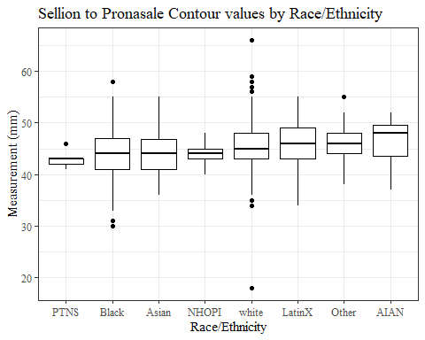

#boxplot not reordered by median  
ggplot(data=headscan_full, aes(y=SelP_C, x=race_eth))+  
 geom_boxplot(color= "black", fill = "white")+  
 theme_bw()+theme(text=element_text(family= "Times New Roman"))+  
 #theme(axis.text.x = element_text(angle = 20, vjust=0.7))+  
 labs(title="Sellion to Pronasale Contour values by Race/Ethnicity",  
 y="Measurement (mm)",  
 x="Race/Ethnicity")

## Warning: Removed 15 rows containing non-finite values (stat_boxplot).

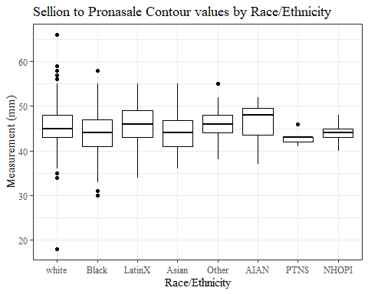

#SelP_C gender sumstats  
SelP_Cgender_sumstats <- headscan_full %>%   
 group_by(gender) %>%   
 summarise(n = n(), na = sum(is.na(SelP_C)),  
 min = min(SelP_C, na.rm = TRUE),  
 max = max(SelP_C, na.rm = TRUE),  
 mean = mean(SelP_C, na.rm = TRUE),  
 mdn = median(SelP_C, na.rm = TRUE),  
 sd = sd(SelP_C, na.rm = TRUE),  
 se = sd/sqrt(n),  
 percent5th = quantile(SelP_C, 0.05, na.rm=TRUE),  
 percent25th = quantile(SelP_C, 0.25, na.rm=TRUE),  
 percent50th = quantile(SelP_C, 0.50, na.rm=TRUE),  
 percent75th = quantile(SelP_C, 0.75, na.rm=TRUE),  
 percent95th = quantile(SelP_C, 0.95, na.rm=TRUE))  
  
SelP_Cgender_sumstats <- SelP_Cgender_sumstats %>%   
 mutate(across(where(is.numeric), round, 2))  
  
#Size 12 Table TNR  
flextable(SelP_Cgender_sumstats) %>%  
 my_ft_theme()%>%   
 bold(part = "header") %>%   
 set_caption("Sellion to Pronasale Contour SumStats by Gender")

**Table** : Sellion to Pronasale Contour SumStats by Gender

| **gender** | **n** | **na** | **min** | **max** | **mean** | **mdn** | **sd** | **se** | **percent5th** | **percent25th** | **percent50th** | **percent75th** | **percent95th** |
| --- | --- | --- | --- | --- | --- | --- | --- | --- | --- | --- | --- | --- | --- |
| Female | 1,063 | 10 | 18 | 58 | 43.26 | 43 | 3.93 | 0.12 | 37.0 | 41.0 | 43 | 46.00 | 49.0 |
| Male | 939 | 5 | 31 | 66 | 47.03 | 47 | 4.22 | 0.14 | 40.0 | 44.0 | 47 | 50.00 | 54.0 |
| Non-binary or Other | 5 | 0 | 36 | 53 | 41.20 | 39 | 6.72 | 3.01 | 36.6 | 39.0 | 39 | 39.00 | 50.2 |
| Prefer not to say | 1 | 0 | 41 | 41 | 41.00 | 41 |  |  | 41.0 | 41.0 | 41 | 41.00 | 41.0 |
|  | 8 | 0 | 38 | 51 | 41.50 | 40 | 4.21 | 1.49 | 38.0 | 39.5 | 40 | 42.25 | 48.2 |

#%>% set_header_Cabels(values = list(SelP_C = "Sellion/SellionCont"))  
  
#Autofit Width Table TNR  
flextable(SelP_Cgender_sumstats) %>%  
 my_ft_theme()%>%   
 bold(part = "header") %>%   
 set_caption("Sellion to Pronasale Contour SumStats by Gender") %>%   
 fit_to_width(7.5)

**Table** : Sellion to Pronasale Contour SumStats by Gender

| **gender** | **n** | **na** | **min** | **max** | **mean** | **mdn** | **sd** | **se** | **percent5th** | **percent25th** | **percent50th** | **percent75th** | **percent95th** |
| --- | --- | --- | --- | --- | --- | --- | --- | --- | --- | --- | --- | --- | --- |
| Female | 1,063 | 10 | 18 | 58 | 43.26 | 43 | 3.93 | 0.12 | 37.0 | 41.0 | 43 | 46.00 | 49.0 |
| Male | 939 | 5 | 31 | 66 | 47.03 | 47 | 4.22 | 0.14 | 40.0 | 44.0 | 47 | 50.00 | 54.0 |
| Non-binary or Other | 5 | 0 | 36 | 53 | 41.20 | 39 | 6.72 | 3.01 | 36.6 | 39.0 | 39 | 39.00 | 50.2 |
| Prefer not to say | 1 | 0 | 41 | 41 | 41.00 | 41 |  |  | 41.0 | 41.0 | 41 | 41.00 | 41.0 |
|  | 8 | 0 | 38 | 51 | 41.50 | 40 | 4.21 | 1.49 | 38.0 | 39.5 | 40 | 42.25 | 48.2 |

#%>% set_header_Cabels(values = list(SelP_C = "Sellion/SellionCont"))  
  
#boxplot reorderd by median  
headscan_full %>%   
 ungroup() %>%   
 mutate(gender= fct_reorder(gender, SelP_C, FUN=median, na.rm=TRUE)) %>%   
 ggplot(aes(y=SelP_C, x=gender))+  
 geom_boxplot(color= "black", fill = "white")+  
 theme_bw()+theme(text=element_text(family= "Times New Roman"))+  
 theme(axis.text.x = element_text(angle = 20, vjust=0.7))+  
 labs(title="Sellion to Pronasale Contour values by Gender",  
 y="Measurement (mm)",  
 x="Gender")

## Warning: Removed 15 rows containing non-finite values (stat_boxplot).

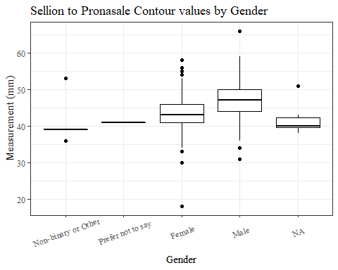

#boxplot not reordered by median  
ggplot(data=headscan_full, aes(y=SelP_C, x=gender))+  
 geom_boxplot(color= "black", fill = "white")+  
 theme_bw()+theme(text=element_text(family= "Times New Roman"))+  
 theme(axis.text.x = element_text(angle = 20, vjust=0.7))+  
 labs(title="Sellion to Pronasale Contour values by Gender",  
 y="Measurement (mm)",  
 x="Gender")

## Warning: Removed 15 rows containing non-finite values (stat_boxplot).

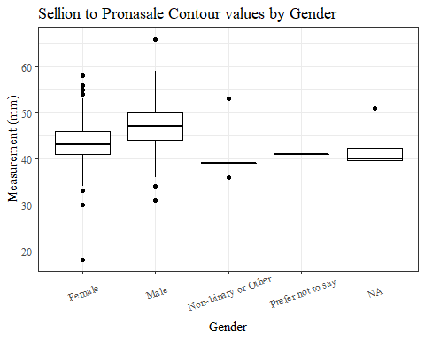

#SelP_C age group sumstats  
SelP_Cage_sumstats <- headscan_full %>%   
 group_by(age_group) %>%   
 summarise(n = n(), na = sum(is.na(SelP_C)),  
 min = min(SelP_C, na.rm = TRUE),  
 max = max(SelP_C, na.rm = TRUE),  
 mean = mean(SelP_C, na.rm = TRUE),  
 mdn = median(SelP_C, na.rm = TRUE),  
 sd = sd(SelP_C, na.rm = TRUE),  
 se = sd/sqrt(n),  
 percent5th = quantile(SelP_C, 0.05, na.rm=TRUE),  
 percent25th = quantile(SelP_C, 0.25, na.rm=TRUE),  
 percent50th = quantile(SelP_C, 0.50, na.rm=TRUE),  
 percent75th = quantile(SelP_C, 0.75, na.rm=TRUE),  
 percent95th = quantile(SelP_C, 0.95, na.rm=TRUE))  
  
SelP_Cage_sumstats <- SelP_Cage_sumstats %>%   
 mutate(across(where(is.numeric), round, 2))  
  
  
#Size 12 Table TNR  
flextable(SelP_Cage_sumstats) %>%  
 my_ft_theme()%>%   
 bold(part = "header") %>%   
 set_caption("Sellion to Pronasale Contour SumStats by Age Group")

**Table** : Sellion to Pronasale Contour SumStats by Age Group

| **age_group** | **n** | **na** | **min** | **max** | **mean** | **mdn** | **sd** | **se** | **percent5th** | **percent25th** | **percent50th** | **percent75th** | **percent95th** |
| --- | --- | --- | --- | --- | --- | --- | --- | --- | --- | --- | --- | --- | --- |
| 18-36 | 991 | 5 | 31 | 58 | 44.81 | 45 | 4.31 | 0.14 | 38.0 | 42 | 45 | 48 | 52.0 |
| 37-54 | 940 | 9 | 18 | 66 | 45.14 | 45 | 4.68 | 0.15 | 38.0 | 42 | 45 | 48 | 53.0 |
| 55-72 | 84 | 1 | 38 | 58 | 45.89 | 45 | 4.40 | 0.48 | 40.1 | 43 | 45 | 48 | 53.9 |
|  | 1 | 0 | 43 | 43 | 43.00 | 43 |  |  | 43.0 | 43 | 43 | 43 | 43.0 |

#%>% set_header_Cabels(values = list(SelP_C = "Sellion/SellionCont"))  
  
#Autofit Width Table TNR  
flextable(SelP_Cage_sumstats) %>%  
 my_ft_theme()%>%   
 bold(part = "header") %>%   
 set_caption("Sellion to Pronasale Contour SumStats by Age Group") %>%   
 fit_to_width(7.5)

**Table** : Sellion to Pronasale Contour SumStats by Age Group

| **age_group** | **n** | **na** | **min** | **max** | **mean** | **mdn** | **sd** | **se** | **percent5th** | **percent25th** | **percent50th** | **percent75th** | **percent95th** |
| --- | --- | --- | --- | --- | --- | --- | --- | --- | --- | --- | --- | --- | --- |
| 18-36 | 991 | 5 | 31 | 58 | 44.81 | 45 | 4.31 | 0.14 | 38.0 | 42 | 45 | 48 | 52.0 |
| 37-54 | 940 | 9 | 18 | 66 | 45.14 | 45 | 4.68 | 0.15 | 38.0 | 42 | 45 | 48 | 53.0 |
| 55-72 | 84 | 1 | 38 | 58 | 45.89 | 45 | 4.40 | 0.48 | 40.1 | 43 | 45 | 48 | 53.9 |
|  | 1 | 0 | 43 | 43 | 43.00 | 43 |  |  | 43.0 | 43 | 43 | 43 | 43.0 |

#%>% set_header_Cabels(values = list(SelP_C = "Sellion/SellionCont"))  
  
#boxplot reorderd by median  
headscan_full %>%   
 ungroup() %>%   
 mutate(age_group= fct_reorder(age_group, SelP_C, FUN=median, na.rm=TRUE)) %>%   
 ggplot(aes(y=SelP_C, x=age_group))+  
 geom_boxplot(color= "black", fill = "white")+  
 theme_bw()+theme(text=element_text(family= "Times New Roman"))+  
 #theme(axis.text.x = element_text(angle = 20, vjust=0.7))+  
 labs(title="Sellion to Pronasale Contour values by Age Group",  
 y="Measurement (mm)",  
 x="Age Group")

## Warning: Removed 15 rows containing non-finite values (stat_boxplot).

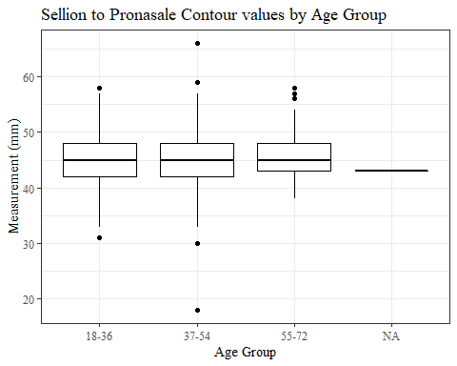

#boxplot not reordered by median  
ggplot(data=headscan_full, aes(y=SelP_C, x=age_group))+  
 geom_boxplot(color= "black", fill = "white")+  
 theme_bw()+theme(text=element_text(family= "Times New Roman"))+  
 #theme(axis.text.x = element_text(angle = 20, vjust=0.7))+  
 labs(title="Sellion to Pronasale Contour values by Age Group",  
 y="Measurement (mm)",  
 x="Age Group")

## Warning: Removed 15 rows containing non-finite values (stat_boxplot).



SelDH_C with outliers

#histogram of all SelDH_C values  
ggplot(data=headscan_full, aes(x=SelDH_C ))+  
 geom_bar(stat="bin", bins=25, color= "black", fill = "white")+  
 theme_bw()+theme(text=element_text(family= "Times New Roman"))+  
 labs(title="Sellion to Dorsal Hump Contour Measurement Distribution",  
 subtitle = "without outliers removed",  
 y="Frequency",  
 x="Sellion to Dorsal Hump Contour (mm)")

## Warning: Removed 14 rows containing non-finite values (stat_bin).

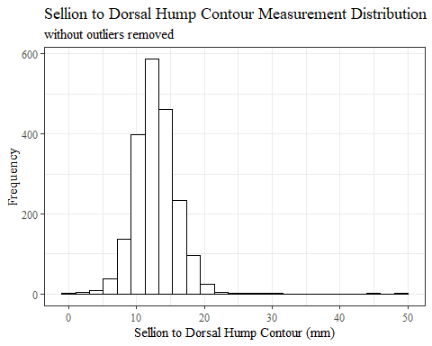

SelDH_Csumstats <- headscan_full %>%   
 summarise(n = n(), na = sum(is.na(SelDH_C)),  
 min = min(SelDH_C, na.rm = TRUE),  
 max = max(SelDH_C, na.rm = TRUE),  
 mean = mean(SelDH_C, na.rm = TRUE),  
 mdn = median(SelDH_C, na.rm = TRUE),  
 sd = sd(SelDH_C, na.rm = TRUE),  
 se = sd/sqrt(n),  
 percent5th = quantile(SelDH_C, 0.05, na.rm=TRUE),  
 percent25th = quantile(SelDH_C, 0.25, na.rm=TRUE),  
 percent50th = quantile(SelDH_C, 0.50, na.rm=TRUE),  
 percent75th = quantile(SelDH_C, 0.75, na.rm=TRUE),  
 percent95th = quantile(SelDH_C, 0.95, na.rm=TRUE))   
  
SelDH_Csumstats <- round(SelDH_Csumstats, 2)  
  
#Size 12 Table TNR  
flextable(SelDH_Csumstats) %>%  
 my_ft_theme()%>%   
 bold(part = "header") %>%   
 set_caption("Sellion to Dorsal Hump Contour SumStats w/o outlier removed")

**Table** : Sellion to Dorsal Hump Contour SumStats w/o outlier removed

| **n** | **na** | **min** | **max** | **mean** | **mdn** | **sd** | **se** | **percent5th** | **percent25th** | **percent50th** | **percent75th** | **percent95th** |
| --- | --- | --- | --- | --- | --- | --- | --- | --- | --- | --- | --- | --- |
| 2,016 | 14 | 1 | 50 | 13.08 | 13 | 3.14 | 0.07 | 9 | 11 | 13 | 15 | 18 |

#%>% set_header_Cabels(values = list(SelDH_C = "Sellion/SellionCont"))  
  
#Autofit Width Table TNR  
flextable(SelDH_Csumstats) %>%  
 my_ft_theme()%>%   
 bold(part = "header") %>%   
 set_caption("Sellion to Dorsal Hump Contour SumStats w/o outlier removed") %>%   
 fit_to_width(7.5)

**Table** : Sellion to Dorsal Hump Contour SumStats w/o outlier removed

| **n** | **na** | **min** | **max** | **mean** | **mdn** | **sd** | **se** | **percent5th** | **percent25th** | **percent50th** | **percent75th** | **percent95th** |
| --- | --- | --- | --- | --- | --- | --- | --- | --- | --- | --- | --- | --- |
| 2,016 | 14 | 1 | 50 | 13.08 | 13 | 3.14 | 0.07 | 9 | 11 | 13 | 15 | 18 |

#%>% set_header_Cabels(values = list(SelDH_C = "Sellion/SellionCont"))

#SelDH_C race/eth sumstats  
SelDH_Crace_sumstats <- headscan_full %>%   
 group_by(race_eth) %>%   
 summarise(n = n(), na = sum(is.na(SelDH_C)),  
 min = min(SelDH_C, na.rm = TRUE),  
 max = max(SelDH_C, na.rm = TRUE),  
 mean = mean(SelDH_C, na.rm = TRUE),  
 mdn = median(SelDH_C, na.rm = TRUE),  
 sd = sd(SelDH_C, na.rm = TRUE),  
 se = sd/sqrt(n),  
 percent5th = quantile(SelDH_C, 0.05, na.rm=TRUE),  
 percent25th = quantile(SelDH_C, 0.25, na.rm=TRUE),  
 percent50th = quantile(SelDH_C, 0.50, na.rm=TRUE),  
 percent75th = quantile(SelDH_C, 0.75, na.rm=TRUE),  
 percent95th = quantile(SelDH_C, 0.95, na.rm=TRUE))   
  
SelDH_Crace_sumstats <- SelDH_Crace_sumstats %>%   
 mutate(across(where(is.numeric), round, 2))  
  
  
#Size 12 Table TNR  
flextable(SelDH_Crace_sumstats) %>%  
 my_ft_theme()%>%   
 bold(part = "header") %>%   
 set_caption("Sellion to Dorsal Hump Contour SumStats by Race/Ethnicity w/o outlier removed")

**Table** : Sellion to Dorsal Hump Contour SumStats by Race/Ethnicity w/o outlier removed

| **race_eth** | **n** | **na** | **min** | **max** | **mean** | **mdn** | **sd** | **se** | **percent5th** | **percent25th** | **percent50th** | **percent75th** | **percent95th** |
| --- | --- | --- | --- | --- | --- | --- | --- | --- | --- | --- | --- | --- | --- |
| white | 1,239 | 7 | 1 | 50 | 13.32 | 13.0 | 3.14 | 0.09 | 9.00 | 11.0 | 13.0 | 15.0 | 18.0 |
| Black | 548 | 4 | 3 | 24 | 12.46 | 12.0 | 2.82 | 0.12 | 8.00 | 11.0 | 12.0 | 14.0 | 17.0 |
| LatinX | 100 | 1 | 7 | 45 | 13.75 | 13.0 | 4.20 | 0.42 | 8.90 | 12.0 | 13.0 | 15.0 | 18.0 |
| Asian | 91 | 1 | 8 | 20 | 13.03 | 13.0 | 2.62 | 0.27 | 9.45 | 11.0 | 13.0 | 14.0 | 18.0 |
| Other | 21 | 0 | 8 | 28 | 12.86 | 12.0 | 4.30 | 0.94 | 9.00 | 10.0 | 12.0 | 15.0 | 16.0 |
| AIAN | 8 | 1 | 2 | 15 | 11.43 | 14.0 | 4.76 | 1.68 | 3.80 | 10.5 | 14.0 | 14.0 | 14.7 |
| PTNS | 5 | 0 | 4 | 15 | 10.80 | 12.0 | 4.09 | 1.83 | 5.40 | 11.0 | 12.0 | 12.0 | 14.4 |
| NHOPI | 4 | 0 | 12 | 17 | 14.00 | 13.5 | 2.45 | 1.22 | 12.00 | 12.0 | 13.5 | 15.5 | 16.7 |

#%>% set_header_Cabels(values = list(SelDH_C = "Sellion/SellionCont"))  
  
#Autofit Width Table TNR  
flextable(SelDH_Crace_sumstats) %>%  
 my_ft_theme()%>%   
 bold(part = "header") %>%   
 set_caption("Sellion to Dorsal Hump Contour SumStats by Race/Ethnicity w/o outlier removed") %>%   
 fit_to_width(7.5)

**Table** : Sellion to Dorsal Hump Contour SumStats by Race/Ethnicity w/o outlier removed

| **race_eth** | **n** | **na** | **min** | **max** | **mean** | **mdn** | **sd** | **se** | **percent5th** | **percent25th** | **percent50th** | **percent75th** | **percent95th** |
| --- | --- | --- | --- | --- | --- | --- | --- | --- | --- | --- | --- | --- | --- |
| white | 1,239 | 7 | 1 | 50 | 13.32 | 13.0 | 3.14 | 0.09 | 9.00 | 11.0 | 13.0 | 15.0 | 18.0 |
| Black | 548 | 4 | 3 | 24 | 12.46 | 12.0 | 2.82 | 0.12 | 8.00 | 11.0 | 12.0 | 14.0 | 17.0 |
| LatinX | 100 | 1 | 7 | 45 | 13.75 | 13.0 | 4.20 | 0.42 | 8.90 | 12.0 | 13.0 | 15.0 | 18.0 |
| Asian | 91 | 1 | 8 | 20 | 13.03 | 13.0 | 2.62 | 0.27 | 9.45 | 11.0 | 13.0 | 14.0 | 18.0 |
| Other | 21 | 0 | 8 | 28 | 12.86 | 12.0 | 4.30 | 0.94 | 9.00 | 10.0 | 12.0 | 15.0 | 16.0 |
| AIAN | 8 | 1 | 2 | 15 | 11.43 | 14.0 | 4.76 | 1.68 | 3.80 | 10.5 | 14.0 | 14.0 | 14.7 |
| PTNS | 5 | 0 | 4 | 15 | 10.80 | 12.0 | 4.09 | 1.83 | 5.40 | 11.0 | 12.0 | 12.0 | 14.4 |
| NHOPI | 4 | 0 | 12 | 17 | 14.00 | 13.5 | 2.45 | 1.22 | 12.00 | 12.0 | 13.5 | 15.5 | 16.7 |

#%>% set_header_Cabels(values = list(SelDH_C = "Sellion/SellionCont"))  
  
#boxplot reorderd by median  
headscan_full %>%   
 ungroup() %>%   
 mutate(race_eth= fct_reorder(race_eth, SelDH_C, FUN=median, na.rm=TRUE)) %>%   
 ggplot(aes(y=SelDH_C, x=race_eth))+  
 geom_boxplot(color= "black", fill = "white")+  
 theme_bw()+theme(text=element_text(family= "Times New Roman"))+  
 #theme(axis.text.x = element_text(angle = 20, vjust=0.7))+  
 labs(title="Sellion to Dorsal Hump Contour values by Race/Ethnicity",  
 subtitle = "without outliers removed",  
 y="Measurement (mm)",  
 x="Race/Ethnicity")

## Warning: Removed 14 rows containing non-finite values (stat_boxplot).

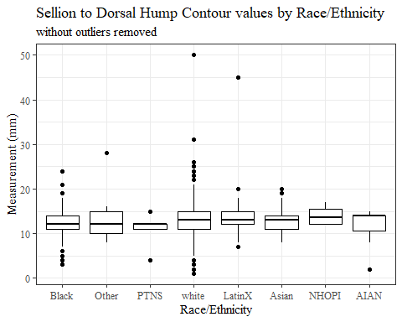

#boxplot not reordered by median  
ggplot(data=headscan_full, aes(y=SelDH_C, x=race_eth))+  
 geom_boxplot(color= "black", fill = "white")+  
 theme_bw()+theme(text=element_text(family= "Times New Roman"))+  
 #theme(axis.text.x = element_text(angle = 20, vjust=0.7))+  
 labs(title="Sellion to Dorsal Hump Contour values by Race/Ethnicity",  
 subtitle = "without outliers removed",  
 y="Measurement (mm)",  
 x="Race/Ethnicity")

## Warning: Removed 14 rows containing non-finite values (stat_boxplot).

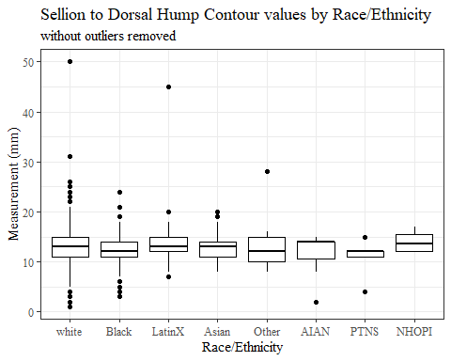

#SelDH_C gender sumstats  
SelDH_Cgender_sumstats <- headscan_full %>%   
 group_by(gender) %>%   
 summarise(n = n(), na = sum(is.na(SelDH_C)),  
 min = min(SelDH_C, na.rm = TRUE),  
 max = max(SelDH_C, na.rm = TRUE),  
 mean = mean(SelDH_C, na.rm = TRUE),  
 mdn = median(SelDH_C, na.rm = TRUE),  
 sd = sd(SelDH_C, na.rm = TRUE),  
 se = sd/sqrt(n),  
 percent5th = quantile(SelDH_C, 0.05, na.rm=TRUE),  
 percent25th = quantile(SelDH_C, 0.25, na.rm=TRUE),  
 percent50th = quantile(SelDH_C, 0.50, na.rm=TRUE),  
 percent75th = quantile(SelDH_C, 0.75, na.rm=TRUE),  
 percent95th = quantile(SelDH_C, 0.95, na.rm=TRUE))  
  
SelDH_Cgender_sumstats <- SelDH_Cgender_sumstats %>%   
 mutate(across(where(is.numeric), round, 2))  
  
#Size 12 Table TNR  
flextable(SelDH_Cgender_sumstats) %>%  
 my_ft_theme()%>%   
 bold(part = "header") %>%   
 set_caption("Sellion to Dorsal Hump Contour SumStats by Gender w/o outlier removed")

**Table** : Sellion to Dorsal Hump Contour SumStats by Gender w/o outlier removed

| **gender** | **n** | **na** | **min** | **max** | **mean** | **mdn** | **sd** | **se** | **percent5th** | **percent25th** | **percent50th** | **percent75th** | **percent95th** |
| --- | --- | --- | --- | --- | --- | --- | --- | --- | --- | --- | --- | --- | --- |
| Female | 1,063 | 9 | 1 | 50 | 12.59 | 13.0 | 3.14 | 0.10 | 8.0 | 11 | 13.0 | 14.00 | 17 |
| Male | 939 | 5 | 4 | 31 | 13.69 | 14.0 | 3.02 | 0.10 | 9.0 | 12 | 14.0 | 15.00 | 18 |
| Non-binary or Other | 5 | 0 | 8 | 14 | 9.80 | 9.0 | 2.39 | 1.07 | 8.2 | 9 | 9.0 | 9.00 | 13 |
| Prefer not to say | 1 | 0 | 12 | 12 | 12.00 | 12.0 |  |  | 12.0 | 12 | 12.0 | 12.00 | 12 |
|  | 8 | 0 | 6 | 14 | 9.75 | 8.5 | 2.96 | 1.05 | 6.7 | 8 | 8.5 | 11.75 | 14 |

#%>% set_header_Cabels(values = list(SelDH_C = "Sellion/SellionCont"))  
  
#Autofit Width Table TNR  
flextable(SelDH_Cgender_sumstats) %>%  
 my_ft_theme()%>%   
 bold(part = "header") %>%   
 set_caption("Sellion to Dorsal Hump Contour SumStats by Gender w/o outlier removed") %>%   
 fit_to_width(7.5)

**Table** : Sellion to Dorsal Hump Contour SumStats by Gender w/o outlier removed

| **gender** | **n** | **na** | **min** | **max** | **mean** | **mdn** | **sd** | **se** | **percent5th** | **percent25th** | **percent50th** | **percent75th** | **percent95th** |
| --- | --- | --- | --- | --- | --- | --- | --- | --- | --- | --- | --- | --- | --- |
| Female | 1,063 | 9 | 1 | 50 | 12.59 | 13.0 | 3.14 | 0.10 | 8.0 | 11 | 13.0 | 14.00 | 17 |
| Male | 939 | 5 | 4 | 31 | 13.69 | 14.0 | 3.02 | 0.10 | 9.0 | 12 | 14.0 | 15.00 | 18 |
| Non-binary or Other | 5 | 0 | 8 | 14 | 9.80 | 9.0 | 2.39 | 1.07 | 8.2 | 9 | 9.0 | 9.00 | 13 |
| Prefer not to say | 1 | 0 | 12 | 12 | 12.00 | 12.0 |  |  | 12.0 | 12 | 12.0 | 12.00 | 12 |
|  | 8 | 0 | 6 | 14 | 9.75 | 8.5 | 2.96 | 1.05 | 6.7 | 8 | 8.5 | 11.75 | 14 |

#%>% set_header_Cabels(values = list(SelDH_C = "Sellion/SellionCont"))  
  
#boxplot reorderd by median  
headscan_full %>%   
 ungroup() %>%   
 mutate(gender= fct_reorder(gender, SelDH_C, FUN=median, na.rm=TRUE)) %>%   
 ggplot(aes(y=SelDH_C, x=gender))+  
 geom_boxplot(color= "black", fill = "white")+  
 theme_bw()+theme(text=element_text(family= "Times New Roman"))+  
 theme(axis.text.x = element_text(angle = 20, vjust=0.7))+  
 labs(title="Sellion to Dorsal Hump Contour values by Gender",  
 subtitle = "without outliers removed",  
 y="Measurement (mm)",  
 x="Gender")

## Warning: Removed 14 rows containing non-finite values (stat_boxplot).

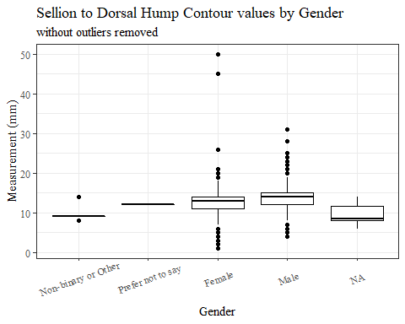

#boxplot not reordered by median  
ggplot(data=headscan_full, aes(y=SelDH_C, x=gender))+  
 geom_boxplot(color= "black", fill = "white")+  
 theme_bw()+theme(text=element_text(family= "Times New Roman"))+  
 theme(axis.text.x = element_text(angle = 20, vjust=0.7))+  
 labs(title="Sellion to Dorsal Hump Contour values by Gender",  
 subtitle = "without outliers removed",  
 y="Measurement (mm)",  
 x="Gender")

## Warning: Removed 14 rows containing non-finite values (stat_boxplot).

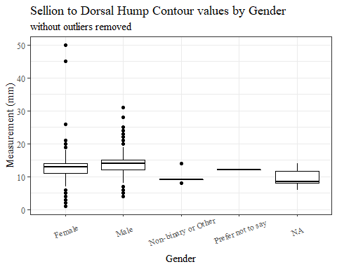

#SelDH_C age group sumstats  
SelDH_Cage_sumstats <- headscan_full %>%   
 group_by(age_group) %>%   
 summarise(n = n(), na = sum(is.na(SelDH_C)),  
 min = min(SelDH_C, na.rm = TRUE),  
 max = max(SelDH_C, na.rm = TRUE),  
 mean = mean(SelDH_C, na.rm = TRUE),  
 mdn = median(SelDH_C, na.rm = TRUE),  
 sd = sd(SelDH_C, na.rm = TRUE),  
 se = sd/sqrt(n),  
 percent5th = quantile(SelDH_C, 0.05, na.rm=TRUE),  
 percent25th = quantile(SelDH_C, 0.25, na.rm=TRUE),  
 percent50th = quantile(SelDH_C, 0.50, na.rm=TRUE),  
 percent75th = quantile(SelDH_C, 0.75, na.rm=TRUE),  
 percent95th = quantile(SelDH_C, 0.95, na.rm=TRUE))  
  
SelDH_Cage_sumstats <- SelDH_Cage_sumstats %>%   
 mutate(across(where(is.numeric), round, 2))  
  
  
#Size 12 Table TNR  
flextable(SelDH_Cage_sumstats) %>%  
 my_ft_theme()%>%   
 bold(part = "header") %>%   
 set_caption("Sellion to Dorsal Hump Contour SumStats by Age Group w/o outlier removed")

**Table** : Sellion to Dorsal Hump Contour SumStats by Age Group w/o outlier removed

| **age_group** | **n** | **na** | **min** | **max** | **mean** | **mdn** | **sd** | **se** | **percent5th** | **percent25th** | **percent50th** | **percent75th** | **percent95th** |
| --- | --- | --- | --- | --- | --- | --- | --- | --- | --- | --- | --- | --- | --- |
| 18-36 | 991 | 5 | 2 | 28 | 13.06 | 13 | 2.81 | 0.09 | 9.0 | 11 | 13 | 15 | 18 |
| 37-54 | 940 | 8 | 1 | 50 | 13.10 | 13 | 3.47 | 0.11 | 8.0 | 11 | 13 | 15 | 18 |
| 55-72 | 84 | 1 | 6 | 21 | 13.04 | 13 | 3.16 | 0.34 | 7.1 | 11 | 13 | 15 | 18 |
|  | 1 | 0 | 13 | 13 | 13.00 | 13 |  |  | 13.0 | 13 | 13 | 13 | 13 |

#%>% set_header_Cabels(values = list(SelDH_C = "Sellion/SellionCont"))  
  
#Autofit Width Table TNR  
flextable(SelDH_Cage_sumstats) %>%  
 my_ft_theme()%>%   
 bold(part = "header") %>%   
 set_caption("Sellion to Dorsal Hump Contour SumStats by Age Group w/o outlier removed") %>%   
 fit_to_width(7.5)

**Table** : Sellion to Dorsal Hump Contour SumStats by Age Group w/o outlier removed

| **age_group** | **n** | **na** | **min** | **max** | **mean** | **mdn** | **sd** | **se** | **percent5th** | **percent25th** | **percent50th** | **percent75th** | **percent95th** |
| --- | --- | --- | --- | --- | --- | --- | --- | --- | --- | --- | --- | --- | --- |
| 18-36 | 991 | 5 | 2 | 28 | 13.06 | 13 | 2.81 | 0.09 | 9.0 | 11 | 13 | 15 | 18 |
| 37-54 | 940 | 8 | 1 | 50 | 13.10 | 13 | 3.47 | 0.11 | 8.0 | 11 | 13 | 15 | 18 |
| 55-72 | 84 | 1 | 6 | 21 | 13.04 | 13 | 3.16 | 0.34 | 7.1 | 11 | 13 | 15 | 18 |
|  | 1 | 0 | 13 | 13 | 13.00 | 13 |  |  | 13.0 | 13 | 13 | 13 | 13 |

#%>% set_header_Cabels(values = list(SelDH_C = "Sellion/SellionCont"))  
  
#boxplot reorderd by median  
headscan_full %>%   
 ungroup() %>%   
 mutate(age_group= fct_reorder(age_group, SelDH_C, FUN=median, na.rm=TRUE)) %>%   
 ggplot(aes(y=SelDH_C, x=age_group))+  
 geom_boxplot(color= "black", fill = "white")+  
 theme_bw()+theme(text=element_text(family= "Times New Roman"))+  
 #theme(axis.text.x = element_text(angle = 20, vjust=0.7))+  
 labs(title="Sellion to Dorsal Hump Length values by Age Group",  
 subtitle = "without outliers removed",  
 y="Measurement (mm)",  
 x="Age Group")

## Warning: Removed 14 rows containing non-finite values (stat_boxplot).

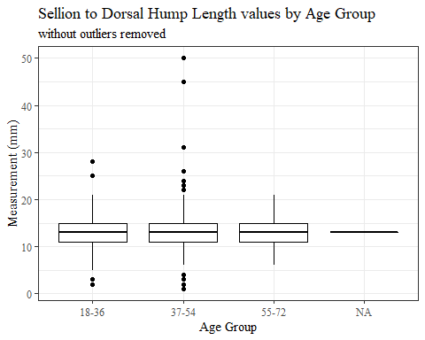

#boxplot not reordered by median  
ggplot(data=headscan_full, aes(y=SelDH_C, x=age_group))+  
 geom_boxplot(color= "black", fill = "white")+  
 theme_bw()+theme(text=element_text(family= "Times New Roman"))+  
 #theme(axis.text.x = element_text(angle = 20, vjust=0.7))+  
 labs(title="Sellion to Dorsal Hump Length values by Age Group",  
 subtitle = "without outliers removed",  
 y="Measurement (mm)",  
 x="Age Group")

## Warning: Removed 14 rows containing non-finite values (stat_boxplot).



SelDH_C without outliers

max(headscan_full$SelDH_C, na.rm = TRUE)

## [1] 50

#CODE TO REMOVE OUTLIER, use later to remove from headscan_full  
SelDH_C_no_out <- headscan_full %>% mutate(SelDH_C = replace(SelDH_C, SelDH_C>40, NA))

#histogram of all SelDH_C values  
ggplot(data=SelDH_C_no_out, aes(x=SelDH_C))+  
 geom_bar(stat="bin", bins=25, color= "black", fill = "white")+  
 theme_bw()+theme(text=element_text(family= "Times New Roman"))+  
 labs(title="Sellion to Dorsal Hump Contour Measurement Distribution",  
 y="Frequency",  
 x="Sellion to Dorsal Hump Contour (mm)")

## Warning: Removed 16 rows containing non-finite values (stat_bin).

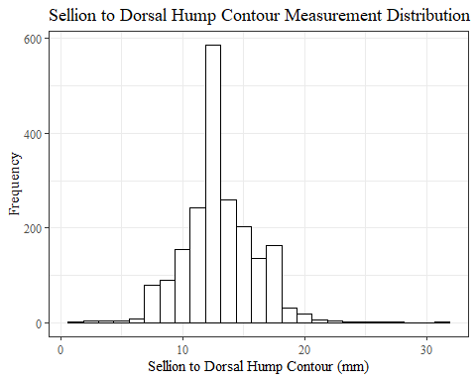

SelDH_Csumstats1 <- SelDH_C_no_out %>%   
 summarise(n = n(), na = sum(is.na(SelDH_C)),  
 min = min(SelDH_C, na.rm = TRUE),  
 max = max(SelDH_C, na.rm = TRUE),  
 mean = mean(SelDH_C, na.rm = TRUE),  
 mdn = median(SelDH_C, na.rm = TRUE),  
 sd = sd(SelDH_C, na.rm = TRUE),  
 se = sd/sqrt(n),  
 percent5th = quantile(SelDH_C, 0.05, na.rm=TRUE),  
 percent25th = quantile(SelDH_C, 0.25, na.rm=TRUE),  
 percent50th = quantile(SelDH_C, 0.50, na.rm=TRUE),  
 percent75th = quantile(SelDH_C, 0.75, na.rm=TRUE),  
 percent95th = quantile(SelDH_C, 0.95, na.rm=TRUE))   
  
SelDH_Csumstats1 <- round(SelDH_Csumstats1, 2)  
  
#Size 12 Table TNR  
flextable(SelDH_Csumstats1) %>%  
 my_ft_theme()%>%   
 bold(part = "header") %>%   
 set_caption("Sellion to Dorsal Hump Contour SumStats")

**Table** : Sellion to Dorsal Hump Contour SumStats

| **n** | **na** | **min** | **max** | **mean** | **mdn** | **sd** | **se** | **percent5th** | **percent25th** | **percent50th** | **percent75th** | **percent95th** |
| --- | --- | --- | --- | --- | --- | --- | --- | --- | --- | --- | --- | --- |
| 2,016 | 16 | 1 | 31 | 13.05 | 13 | 2.95 | 0.07 | 8.95 | 11 | 13 | 15 | 18 |

#%>% set_header_Cabels(values = list(SelDH_C = "Sellion/SellionCont"))  
  
#Autofit Width Table TNR  
flextable(SelDH_Csumstats1) %>%  
 my_ft_theme()%>%   
 bold(part = "header") %>%   
 set_caption("Sellion to Dorsal Hump Contour SumStats") %>%   
 fit_to_width(7.5)

**Table** : Sellion to Dorsal Hump Contour SumStats

| **n** | **na** | **min** | **max** | **mean** | **mdn** | **sd** | **se** | **percent5th** | **percent25th** | **percent50th** | **percent75th** | **percent95th** |
| --- | --- | --- | --- | --- | --- | --- | --- | --- | --- | --- | --- | --- |
| 2,016 | 16 | 1 | 31 | 13.05 | 13 | 2.95 | 0.07 | 8.95 | 11 | 13 | 15 | 18 |

#%>% set_header_Cabels(values = list(SelDH_C = "Sellion/SellionCont"))

#SelDH_C race/eth sumstats  
SelDH_Crace_sumstats1 <- SelDH_C_no_out %>%   
 group_by(race_eth) %>%   
 summarise(n = n(), na = sum(is.na(SelDH_C)),  
 min = min(SelDH_C, na.rm = TRUE),  
 max = max(SelDH_C, na.rm = TRUE),  
 mean = mean(SelDH_C, na.rm = TRUE),  
 mdn = median(SelDH_C, na.rm = TRUE),  
 sd = sd(SelDH_C, na.rm = TRUE),  
 se = sd/sqrt(n),  
 percent5th = quantile(SelDH_C, 0.05, na.rm=TRUE),  
 percent25th = quantile(SelDH_C, 0.25, na.rm=TRUE),  
 percent50th = quantile(SelDH_C, 0.50, na.rm=TRUE),  
 percent75th = quantile(SelDH_C, 0.75, na.rm=TRUE),  
 percent95th = quantile(SelDH_C, 0.95, na.rm=TRUE))   
  
SelDH_Crace_sumstats1 <- SelDH_Crace_sumstats1 %>%   
 mutate(across(where(is.numeric), round, 2))  
  
  
#Size 12 Table TNR  
flextable(SelDH_Crace_sumstats1) %>%  
 my_ft_theme()%>%   
 bold(part = "header") %>%   
 set_caption("Sellion to Dorsal Hump Contour SumStats by Race/Ethnicity")

**Table** : Sellion to Dorsal Hump Contour SumStats by Race/Ethnicity

| **race_eth** | **n** | **na** | **min** | **max** | **mean** | **mdn** | **sd** | **se** | **percent5th** | **percent25th** | **percent50th** | **percent75th** | **percent95th** |
| --- | --- | --- | --- | --- | --- | --- | --- | --- | --- | --- | --- | --- | --- |
| white | 1,239 | 8 | 1 | 31 | 13.29 | 13.0 | 2.96 | 0.08 | 9.00 | 11.0 | 13.0 | 15.0 | 18.0 |
| Black | 548 | 4 | 3 | 24 | 12.46 | 12.0 | 2.82 | 0.12 | 8.00 | 11.0 | 12.0 | 14.0 | 17.0 |
| LatinX | 100 | 2 | 7 | 20 | 13.43 | 13.0 | 2.77 | 0.28 | 8.85 | 12.0 | 13.0 | 15.0 | 18.0 |
| Asian | 91 | 1 | 8 | 20 | 13.03 | 13.0 | 2.62 | 0.27 | 9.45 | 11.0 | 13.0 | 14.0 | 18.0 |
| Other | 21 | 0 | 8 | 28 | 12.86 | 12.0 | 4.30 | 0.94 | 9.00 | 10.0 | 12.0 | 15.0 | 16.0 |
| AIAN | 8 | 1 | 2 | 15 | 11.43 | 14.0 | 4.76 | 1.68 | 3.80 | 10.5 | 14.0 | 14.0 | 14.7 |
| PTNS | 5 | 0 | 4 | 15 | 10.80 | 12.0 | 4.09 | 1.83 | 5.40 | 11.0 | 12.0 | 12.0 | 14.4 |
| NHOPI | 4 | 0 | 12 | 17 | 14.00 | 13.5 | 2.45 | 1.22 | 12.00 | 12.0 | 13.5 | 15.5 | 16.7 |

#%>% set_header_Cabels(values = list(SelDH_C = "Sellion/SellionCont"))  
  
#Autofit Width Table TNR  
flextable(SelDH_Crace_sumstats1) %>%  
 my_ft_theme()%>%   
 bold(part = "header") %>%   
 set_caption("Sellion to Dorsal Hump Contour SumStats by Race/Ethnicity") %>%   
 fit_to_width(7.5)

**Table** : Sellion to Dorsal Hump Contour SumStats by Race/Ethnicity

| **race_eth** | **n** | **na** | **min** | **max** | **mean** | **mdn** | **sd** | **se** | **percent5th** | **percent25th** | **percent50th** | **percent75th** | **percent95th** |
| --- | --- | --- | --- | --- | --- | --- | --- | --- | --- | --- | --- | --- | --- |
| white | 1,239 | 8 | 1 | 31 | 13.29 | 13.0 | 2.96 | 0.08 | 9.00 | 11.0 | 13.0 | 15.0 | 18.0 |
| Black | 548 | 4 | 3 | 24 | 12.46 | 12.0 | 2.82 | 0.12 | 8.00 | 11.0 | 12.0 | 14.0 | 17.0 |
| LatinX | 100 | 2 | 7 | 20 | 13.43 | 13.0 | 2.77 | 0.28 | 8.85 | 12.0 | 13.0 | 15.0 | 18.0 |
| Asian | 91 | 1 | 8 | 20 | 13.03 | 13.0 | 2.62 | 0.27 | 9.45 | 11.0 | 13.0 | 14.0 | 18.0 |
| Other | 21 | 0 | 8 | 28 | 12.86 | 12.0 | 4.30 | 0.94 | 9.00 | 10.0 | 12.0 | 15.0 | 16.0 |
| AIAN | 8 | 1 | 2 | 15 | 11.43 | 14.0 | 4.76 | 1.68 | 3.80 | 10.5 | 14.0 | 14.0 | 14.7 |
| PTNS | 5 | 0 | 4 | 15 | 10.80 | 12.0 | 4.09 | 1.83 | 5.40 | 11.0 | 12.0 | 12.0 | 14.4 |
| NHOPI | 4 | 0 | 12 | 17 | 14.00 | 13.5 | 2.45 | 1.22 | 12.00 | 12.0 | 13.5 | 15.5 | 16.7 |

#%>% set_header_Cabels(values = list(SelDH_C = "Sellion/SellionCont"))  
  
#boxplot reorderd by median  
SelDH_C_no_out %>%   
 ungroup() %>%   
 mutate(race_eth= fct_reorder(race_eth, SelDH_C, FUN=median, na.rm=TRUE)) %>%   
 ggplot(aes(y=SelDH_C, x=race_eth))+  
 geom_boxplot(color= "black", fill = "white")+  
 theme_bw()+theme(text=element_text(family= "Times New Roman"))+  
 #theme(axis.text.x = element_text(angle = 20, vjust=0.7))+  
 labs(title="Sellion to Dorsal Hump Contour values by Race/Ethnicity",  
 y="Measurement (mm)",  
 x="Race/Ethnicity")

## Warning: Removed 16 rows containing non-finite values (stat_boxplot).

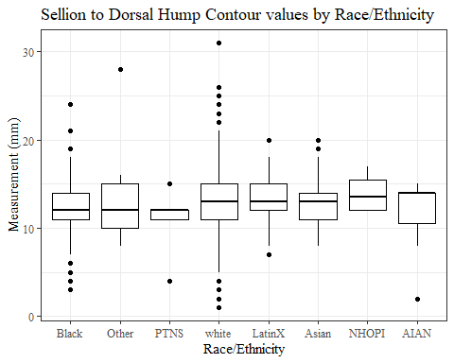

#boxplot not reordered by median  
ggplot(data=SelDH_C_no_out, aes(y=SelDH_C, x=race_eth))+  
 geom_boxplot(color= "black", fill = "white")+  
 theme_bw()+theme(text=element_text(family= "Times New Roman"))+  
 #theme(axis.text.x = element_text(angle = 20, vjust=0.7))+  
 labs(title="Sellion to Dorsal Hump Contour values by Race/Ethnicity",  
 y="Measurement (mm)",  
 x="Race/Ethnicity")

## Warning: Removed 16 rows containing non-finite values (stat_boxplot).

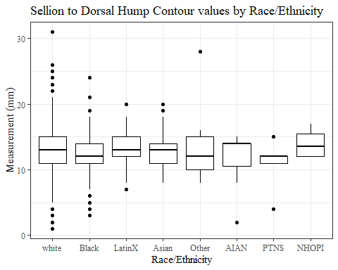

#SelDH_C gender sumstats  
SelDH_Cgender_sumstats1 <- SelDH_C_no_out %>%   
 group_by(gender) %>%   
 summarise(n = n(), na = sum(is.na(SelDH_C)),  
 min = min(SelDH_C, na.rm = TRUE),  
 max = max(SelDH_C, na.rm = TRUE),  
 mean = mean(SelDH_C, na.rm = TRUE),  
 mdn = median(SelDH_C, na.rm = TRUE),  
 sd = sd(SelDH_C, na.rm = TRUE),  
 se = sd/sqrt(n),  
 percent5th = quantile(SelDH_C, 0.05, na.rm=TRUE),  
 percent25th = quantile(SelDH_C, 0.25, na.rm=TRUE),  
 percent50th = quantile(SelDH_C, 0.50, na.rm=TRUE),  
 percent75th = quantile(SelDH_C, 0.75, na.rm=TRUE),  
 percent95th = quantile(SelDH_C, 0.95, na.rm=TRUE))  
  
SelDH_Cgender_sumstats1 <- SelDH_Cgender_sumstats1 %>%   
 mutate(across(where(is.numeric), round, 2))  
  
#Size 12 Table TNR  
flextable(SelDH_Cgender_sumstats1) %>%  
 my_ft_theme()%>%   
 bold(part = "header") %>%   
 set_caption("Sellion to Dorsal Hump Contour SumStats by Gender")

**Table** : Sellion to Dorsal Hump Contour SumStats by Gender

| **gender** | **n** | **na** | **min** | **max** | **mean** | **mdn** | **sd** | **se** | **percent5th** | **percent25th** | **percent50th** | **percent75th** | **percent95th** |
| --- | --- | --- | --- | --- | --- | --- | --- | --- | --- | --- | --- | --- | --- |
| Female | 1,063 | 11 | 1 | 26 | 12.52 | 13.0 | 2.75 | 0.08 | 8.0 | 11 | 13.0 | 14.00 | 17 |
| Male | 939 | 5 | 4 | 31 | 13.69 | 14.0 | 3.02 | 0.10 | 9.0 | 12 | 14.0 | 15.00 | 18 |
| Non-binary or Other | 5 | 0 | 8 | 14 | 9.80 | 9.0 | 2.39 | 1.07 | 8.2 | 9 | 9.0 | 9.00 | 13 |
| Prefer not to say | 1 | 0 | 12 | 12 | 12.00 | 12.0 |  |  | 12.0 | 12 | 12.0 | 12.00 | 12 |
|  | 8 | 0 | 6 | 14 | 9.75 | 8.5 | 2.96 | 1.05 | 6.7 | 8 | 8.5 | 11.75 | 14 |

#%>% set_header_Cabels(values = list(SelDH_C = "Sellion/SellionCont"))  
  
#Autofit Width Table TNR  
flextable(SelDH_Cgender_sumstats1) %>%  
 my_ft_theme()%>%   
 bold(part = "header") %>%   
 set_caption("Sellion to Dorsal Hump Contour SumStats by Gender") %>%   
 fit_to_width(7.5)

**Table** : Sellion to Dorsal Hump Contour SumStats by Gender

| **gender** | **n** | **na** | **min** | **max** | **mean** | **mdn** | **sd** | **se** | **percent5th** | **percent25th** | **percent50th** | **percent75th** | **percent95th** |
| --- | --- | --- | --- | --- | --- | --- | --- | --- | --- | --- | --- | --- | --- |
| Female | 1,063 | 11 | 1 | 26 | 12.52 | 13.0 | 2.75 | 0.08 | 8.0 | 11 | 13.0 | 14.00 | 17 |
| Male | 939 | 5 | 4 | 31 | 13.69 | 14.0 | 3.02 | 0.10 | 9.0 | 12 | 14.0 | 15.00 | 18 |
| Non-binary or Other | 5 | 0 | 8 | 14 | 9.80 | 9.0 | 2.39 | 1.07 | 8.2 | 9 | 9.0 | 9.00 | 13 |
| Prefer not to say | 1 | 0 | 12 | 12 | 12.00 | 12.0 |  |  | 12.0 | 12 | 12.0 | 12.00 | 12 |
|  | 8 | 0 | 6 | 14 | 9.75 | 8.5 | 2.96 | 1.05 | 6.7 | 8 | 8.5 | 11.75 | 14 |

#%>% set_header_Cabels(values = list(SelDH_C = "Sellion/SellionCont"))  
  
#boxplot reorderd by median  
SelDH_C_no_out %>%   
 ungroup() %>%   
 mutate(gender= fct_reorder(gender, SelDH_C, FUN=median, na.rm=TRUE)) %>%   
 ggplot(aes(y=SelDH_C, x=gender))+  
 geom_boxplot(color= "black", fill = "white")+  
 theme_bw()+theme(text=element_text(family= "Times New Roman"))+  
 theme(axis.text.x = element_text(angle = 20, vjust=0.7))+  
 labs(title="Sellion to Dorsal Hump Contour values by Gender",  
 y="Measurement (mm)",  
 x="Gender")

## Warning: Removed 16 rows containing non-finite values (stat_boxplot).

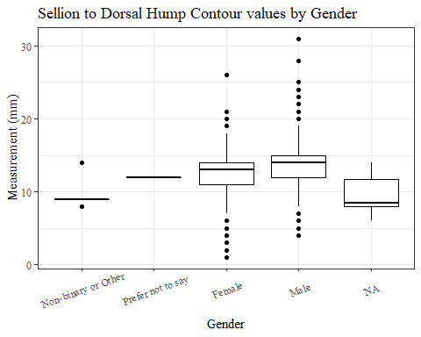

#boxplot not reordered by median  
ggplot(data=SelDH_C_no_out, aes(y=SelDH_C, x=gender))+  
 geom_boxplot(color= "black", fill = "white")+  
 theme_bw()+theme(text=element_text(family= "Times New Roman"))+  
 theme(axis.text.x = element_text(angle = 20, vjust=0.7))+  
 labs(title="Sellion to Dorsal Hump Contour values by Gender",  
 y="Measurement (mm)",  
 x="Gender")

## Warning: Removed 16 rows containing non-finite values (stat_boxplot).

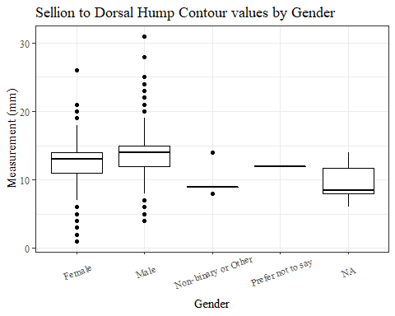

#SelDH_C age group sumstats  
SelDH_Cage_sumstats1 <- SelDH_C_no_out %>%   
 group_by(age_group) %>%   
 summarise(n = n(), na = sum(is.na(SelDH_C)),  
 min = min(SelDH_C, na.rm = TRUE),  
 max = max(SelDH_C, na.rm = TRUE),  
 mean = mean(SelDH_C, na.rm = TRUE),  
 mdn = median(SelDH_C, na.rm = TRUE),  
 sd = sd(SelDH_C, na.rm = TRUE),  
 se = sd/sqrt(n),  
 percent5th = quantile(SelDH_C, 0.05, na.rm=TRUE),  
 percent25th = quantile(SelDH_C, 0.25, na.rm=TRUE),  
 percent50th = quantile(SelDH_C, 0.50, na.rm=TRUE),  
 percent75th = quantile(SelDH_C, 0.75, na.rm=TRUE),  
 percent95th = quantile(SelDH_C, 0.95, na.rm=TRUE))  
  
SelDH_Cage_sumstats1 <- SelDH_Cage_sumstats1 %>%   
 mutate(across(where(is.numeric), round, 2))  
  
  
#Size 12 Table TNR  
flextable(SelDH_Cage_sumstats1) %>%  
 my_ft_theme()%>%   
 bold(part = "header") %>%   
 set_caption("Sellion to Dorsal Hump Contour SumStats by Age Group")

**Table** : Sellion to Dorsal Hump Contour SumStats by Age Group

| **age_group** | **n** | **na** | **min** | **max** | **mean** | **mdn** | **sd** | **se** | **percent5th** | **percent25th** | **percent50th** | **percent75th** | **percent95th** |
| --- | --- | --- | --- | --- | --- | --- | --- | --- | --- | --- | --- | --- | --- |
| 18-36 | 991 | 5 | 2 | 28 | 13.06 | 13 | 2.81 | 0.09 | 9.0 | 11 | 13 | 15 | 18 |
| 37-54 | 940 | 10 | 1 | 31 | 13.03 | 13 | 3.08 | 0.10 | 8.0 | 11 | 13 | 15 | 18 |
| 55-72 | 84 | 1 | 6 | 21 | 13.04 | 13 | 3.16 | 0.34 | 7.1 | 11 | 13 | 15 | 18 |
|  | 1 | 0 | 13 | 13 | 13.00 | 13 |  |  | 13.0 | 13 | 13 | 13 | 13 |

#%>% set_header_Cabels(values = list(SelDH_C = "Sellion/SellionCont"))  
  
#Autofit Width Table TNR  
flextable(SelDH_Cage_sumstats1) %>%  
 my_ft_theme()%>%   
 bold(part = "header") %>%   
 set_caption("Sellion to Dorsal Hump Contour SumStats by Age Group") %>%   
 fit_to_width(7.5)

**Table** : Sellion to Dorsal Hump Contour SumStats by Age Group

| **age_group** | **n** | **na** | **min** | **max** | **mean** | **mdn** | **sd** | **se** | **percent5th** | **percent25th** | **percent50th** | **percent75th** | **percent95th** |
| --- | --- | --- | --- | --- | --- | --- | --- | --- | --- | --- | --- | --- | --- |
| 18-36 | 991 | 5 | 2 | 28 | 13.06 | 13 | 2.81 | 0.09 | 9.0 | 11 | 13 | 15 | 18 |
| 37-54 | 940 | 10 | 1 | 31 | 13.03 | 13 | 3.08 | 0.10 | 8.0 | 11 | 13 | 15 | 18 |
| 55-72 | 84 | 1 | 6 | 21 | 13.04 | 13 | 3.16 | 0.34 | 7.1 | 11 | 13 | 15 | 18 |
|  | 1 | 0 | 13 | 13 | 13.00 | 13 |  |  | 13.0 | 13 | 13 | 13 | 13 |

#%>% set_header_Cabels(values = list(SelDH_C = "Sellion/SellionCont"))  
  
#boxplot reorderd by median  
SelDH_C_no_out %>%   
 ungroup() %>%   
 mutate(age_group= fct_reorder(age_group, SelDH_C, FUN=median, na.rm=TRUE)) %>%   
 ggplot(aes(y=SelDH_C, x=age_group))+  
 geom_boxplot(color= "black", fill = "white")+  
 theme_bw()+theme(text=element_text(family= "Times New Roman"))+  
 #theme(axis.text.x = element_text(angle = 20, vjust=0.7))+  
 labs(title="Sellion to Dorsal Hump Contour values by Age Group",  
 y="Measurement (mm)",  
 x="Age Group")

## Warning: Removed 16 rows containing non-finite values (stat_boxplot).

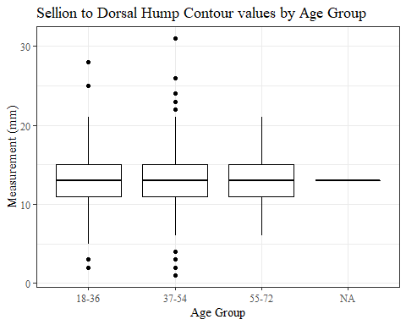

#boxplot not reordered by median  
ggplot(data=SelDH_C_no_out, aes(y=SelDH_C, x=age_group))+  
 geom_boxplot(color= "black", fill = "white")+  
 theme_bw()+theme(text=element_text(family= "Times New Roman"))+  
 #theme(axis.text.x = element_text(angle = 20, vjust=0.7))+  
 labs(title="Sellion to Dorsal Hump Contour values by Age Group",  
 y="Measurement (mm)",  
 x="Age Group")

## Warning: Removed 16 rows containing non-finite values (stat_boxplot).



SelM_L

#histogram of all SelM_L values  
ggplot(data=headscan_full, aes(x=SelM_L))+  
 geom_bar(stat="bin", bins=22, color= "black", fill = "white")+  
 theme_bw()+theme(text=element_text(family= "Times New Roman"))+  
 labs(title="Sellion to Menton Linear Measurement Distribution",  
 y="Frequency",  
 x="Sellion to Menton Linear (mm)")

## Warning: Removed 224 rows containing non-finite values (stat_bin).

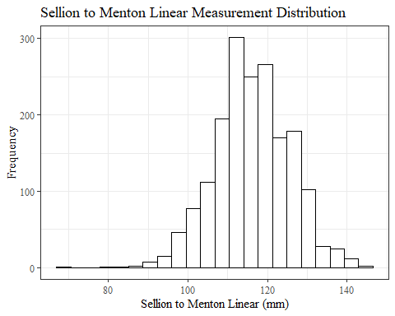

SelM_Lsumstats <- headscan_full %>%   
 summarise(n = n(), na = sum(is.na(SelM_L)),  
 min = min(SelM_L, na.rm = TRUE),  
 max = max(SelM_L, na.rm = TRUE),  
 mean = mean(SelM_L, na.rm = TRUE),  
 mdn = median(SelM_L, na.rm = TRUE),  
 sd = sd(SelM_L, na.rm = TRUE),  
 se = sd/sqrt(n),  
 percent5th = quantile(SelM_L, 0.05, na.rm=TRUE),  
 percent25th = quantile(SelM_L, 0.25, na.rm=TRUE),  
 percent50th = quantile(SelM_L, 0.50, na.rm=TRUE),  
 percent75th = quantile(SelM_L, 0.75, na.rm=TRUE),  
 percent95th = quantile(SelM_L, 0.95, na.rm=TRUE))   
  
SelM_Lsumstats <- round(SelM_Lsumstats, 2)  
  
#Size 12 Table TNR  
flextable(SelM_Lsumstats) %>%  
 my_ft_theme()%>%   
 bold(part = "header") %>%   
 set_caption("Sellion to Menton Length SumStats")

**Table** : Sellion to Menton Length SumStats

| **n** | **na** | **min** | **max** | **mean** | **mdn** | **sd** | **se** | **percent5th** | **percent25th** | **percent50th** | **percent75th** | **percent95th** |
| --- | --- | --- | --- | --- | --- | --- | --- | --- | --- | --- | --- | --- |
| 2,016 | 224 | 69 | 145 | 116.24 | 116 | 9.4 | 0.21 | 101 | 110 | 116 | 123 | 131 |

#%>% set_header_Cabels(values = list(SelM_L = "Sellion/SellionCont"))  
  
#Autofit Width Table TNR  
flextable(SelM_Lsumstats) %>%  
 my_ft_theme()%>%   
 bold(part = "header") %>%   
 set_caption("Sellion to Menton Length SumStats") %>%   
 fit_to_width(7.5)

**Table** : Sellion to Menton Length SumStats

| **n** | **na** | **min** | **max** | **mean** | **mdn** | **sd** | **se** | **percent5th** | **percent25th** | **percent50th** | **percent75th** | **percent95th** |
| --- | --- | --- | --- | --- | --- | --- | --- | --- | --- | --- | --- | --- |
| 2,016 | 224 | 69 | 145 | 116.24 | 116 | 9.4 | 0.21 | 101 | 110 | 116 | 123 | 131 |

#%>% set_header_Cabels(values = list(SelM_L = "Sellion/SellionCont"))

#SelM_L race/eth sumstats  
SelM_Lrace_sumstats <- headscan_full %>%   
 group_by(race_eth) %>%   
 summarise(n = n(), na = sum(is.na(SelM_L)),  
 min = min(SelM_L, na.rm = TRUE),  
 max = max(SelM_L, na.rm = TRUE),  
 mean = mean(SelM_L, na.rm = TRUE),  
 mdn = median(SelM_L, na.rm = TRUE),  
 sd = sd(SelM_L, na.rm = TRUE),  
 se = sd/sqrt(n),  
 percent5th = quantile(SelM_L, 0.05, na.rm=TRUE),  
 percent25th = quantile(SelM_L, 0.25, na.rm=TRUE),  
 percent50th = quantile(SelM_L, 0.50, na.rm=TRUE),  
 percent75th = quantile(SelM_L, 0.75, na.rm=TRUE),  
 percent95th = quantile(SelM_L, 0.95, na.rm=TRUE))   
  
SelM_Lrace_sumstats <- SelM_Lrace_sumstats %>%   
 mutate(across(where(is.numeric), round, 2))  
  
  
#Size 12 Table TNR  
flextable(SelM_Lrace_sumstats) %>%  
 my_ft_theme()%>%   
 bold(part = "header") %>%   
 set_caption("Sellion to Menton Length SumStats by Race/Ethnicity")

**Table** : Sellion to Menton Length SumStats by Race/Ethnicity

| **race_eth** | **n** | **na** | **min** | **max** | **mean** | **mdn** | **sd** | **se** | **percent5th** | **percent25th** | **percent50th** | **percent75th** | **percent95th** |
| --- | --- | --- | --- | --- | --- | --- | --- | --- | --- | --- | --- | --- | --- |
| white | 1,239 | 135 | 69 | 145 | 115.68 | 115.0 | 9.33 | 0.27 | 100.00 | 110.00 | 115.0 | 122.00 | 131.00 |
| Black | 548 | 70 | 91 | 142 | 118.51 | 118.0 | 9.00 | 0.38 | 102.00 | 112.00 | 118.0 | 125.00 | 132.00 |
| LatinX | 100 | 8 | 84 | 142 | 115.85 | 116.0 | 10.72 | 1.07 | 98.00 | 109.00 | 116.0 | 122.00 | 134.90 |
| Asian | 91 | 4 | 88 | 132 | 111.86 | 111.0 | 8.66 | 0.91 | 97.00 | 107.50 | 111.0 | 117.50 | 126.00 |
| Other | 21 | 5 | 105 | 126 | 114.44 | 113.0 | 5.84 | 1.27 | 107.25 | 111.00 | 113.0 | 116.75 | 123.75 |
| AIAN | 8 | 2 | 99 | 137 | 115.50 | 111.5 | 13.44 | 4.75 | 101.50 | 109.25 | 111.5 | 122.00 | 134.00 |
| PTNS | 5 | 0 | 102 | 126 | 115.80 | 117.0 | 8.90 | 3.98 | 104.40 | 114.00 | 117.0 | 120.00 | 124.80 |
| NHOPI | 4 | 0 | 98 | 122 | 115.00 | 120.0 | 11.37 | 5.69 | 101.30 | 114.50 | 120.0 | 120.50 | 121.70 |

#%>% set_header_Cabels(values = list(SelM_L = "Sellion/SellionCont"))  
  
#Autofit Width Table TNR  
flextable(SelM_Lrace_sumstats) %>%  
 my_ft_theme()%>%   
 bold(part = "header") %>%   
 set_caption("Sellion to Menton Length SumStats by Race/Ethnicity") %>%   
 fit_to_width(7.5)

**Table** : Sellion to Menton Length SumStats by Race/Ethnicity

| **race_eth** | **n** | **na** | **min** | **max** | **mean** | **mdn** | **sd** | **se** | **percent5th** | **percent25th** | **percent50th** | **percent75th** | **percent95th** |
| --- | --- | --- | --- | --- | --- | --- | --- | --- | --- | --- | --- | --- | --- |
| white | 1,239 | 135 | 69 | 145 | 115.68 | 115.0 | 9.33 | 0.27 | 100.00 | 110.00 | 115.0 | 122.00 | 131.00 |
| Black | 548 | 70 | 91 | 142 | 118.51 | 118.0 | 9.00 | 0.38 | 102.00 | 112.00 | 118.0 | 125.00 | 132.00 |
| LatinX | 100 | 8 | 84 | 142 | 115.85 | 116.0 | 10.72 | 1.07 | 98.00 | 109.00 | 116.0 | 122.00 | 134.90 |
| Asian | 91 | 4 | 88 | 132 | 111.86 | 111.0 | 8.66 | 0.91 | 97.00 | 107.50 | 111.0 | 117.50 | 126.00 |
| Other | 21 | 5 | 105 | 126 | 114.44 | 113.0 | 5.84 | 1.27 | 107.25 | 111.00 | 113.0 | 116.75 | 123.75 |
| AIAN | 8 | 2 | 99 | 137 | 115.50 | 111.5 | 13.44 | 4.75 | 101.50 | 109.25 | 111.5 | 122.00 | 134.00 |
| PTNS | 5 | 0 | 102 | 126 | 115.80 | 117.0 | 8.90 | 3.98 | 104.40 | 114.00 | 117.0 | 120.00 | 124.80 |
| NHOPI | 4 | 0 | 98 | 122 | 115.00 | 120.0 | 11.37 | 5.69 | 101.30 | 114.50 | 120.0 | 120.50 | 121.70 |

#%>% set_header_Cabels(values = list(SelM_L = "Sellion/SellionCont"))  
  
#boxplot reorderd by median  
headscan_full %>%   
 ungroup() %>%   
 mutate(race_eth= fct_reorder(race_eth, SelM_L, FUN=median, na.rm=TRUE)) %>%   
 ggplot(aes(y=SelM_L, x=race_eth))+  
 geom_boxplot(color= "black", fill = "white")+  
 theme_bw()+theme(text=element_text(family= "Times New Roman"))+  
 #theme(axis.text.x = element_text(angle = 20, vjust=0.7))+  
 labs(title="Sellion to Menton Length values by Race/Ethnicity",  
 y="Measurement (mm)",  
 x="Race/Ethnicity")

## Warning: Removed 224 rows containing non-finite values (stat_boxplot).

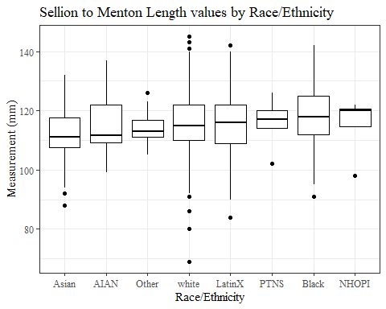

#boxplot not reordered by median  
ggplot(data=headscan_full, aes(y=SelM_L, x=race_eth))+  
 geom_boxplot(color= "black", fill = "white")+  
 theme_bw()+theme(text=element_text(family= "Times New Roman"))+  
 #theme(axis.text.x = element_text(angle = 20, vjust=0.7))+  
 labs(title="Sellion to Menton Length values by Race/Ethnicity",  
 y="Measurement (mm)",  
 x="Race/Ethnicity")

## Warning: Removed 224 rows containing non-finite values (stat_boxplot).

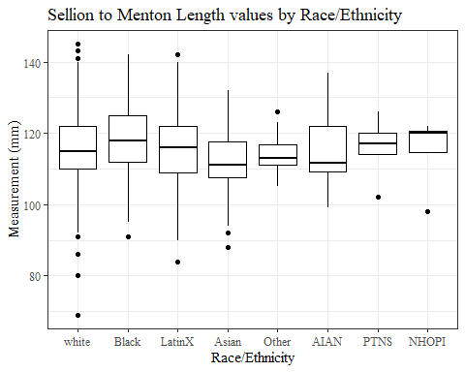

#SelM_L gender sumstats  
SelM_Lgender_sumstats <- headscan_full %>%   
 group_by(gender) %>%   
 summarise(n = n(), na = sum(is.na(SelM_L)),  
 min = min(SelM_L, na.rm = TRUE),  
 max = max(SelM_L, na.rm = TRUE),  
 mean = mean(SelM_L, na.rm = TRUE),  
 mdn = median(SelM_L, na.rm = TRUE),  
 sd = sd(SelM_L, na.rm = TRUE),  
 se = sd/sqrt(n),  
 percent5th = quantile(SelM_L, 0.05, na.rm=TRUE),  
 percent25th = quantile(SelM_L, 0.25, na.rm=TRUE),  
 percent50th = quantile(SelM_L, 0.50, na.rm=TRUE),  
 percent75th = quantile(SelM_L, 0.75, na.rm=TRUE),  
 percent95th = quantile(SelM_L, 0.95, na.rm=TRUE))  
  
SelM_Lgender_sumstats <- SelM_Lgender_sumstats %>%   
 mutate(across(where(is.numeric), round, 2))  
  
#Size 12 Table TNR  
flextable(SelM_Lgender_sumstats) %>%  
 my_ft_theme()%>%   
 bold(part = "header") %>%   
 set_caption("Sellion to Menton Length SumStats by Gender")

**Table** : Sellion to Menton Length SumStats by Gender

| **gender** | **n** | **na** | **min** | **max** | **mean** | **mdn** | **sd** | **se** | **percent5th** | **percent25th** | **percent50th** | **percent75th** | **percent95th** |
| --- | --- | --- | --- | --- | --- | --- | --- | --- | --- | --- | --- | --- | --- |
| Female | 1,063 | 17 | 69 | 140 | 113.10 | 114 | 8.28 | 0.25 | 99.00 | 108.00 | 114 | 118.0 | 126.00 |
| Male | 939 | 207 | 93 | 145 | 120.81 | 121 | 8.98 | 0.29 | 106.00 | 115.00 | 121 | 127.0 | 135.45 |
| Non-binary or Other | 5 | 0 | 80 | 116 | 106.40 | 114 | 15.18 | 6.79 | 85.40 | 107.00 | 114 | 115.0 | 115.80 |
| Prefer not to say | 1 | 0 | 126 | 126 | 126.00 | 126 |  |  | 126.00 | 126.00 | 126 | 126.0 | 126.00 |
|  | 8 | 0 | 103 | 128 | 114.50 | 112 | 8.72 | 3.08 | 104.75 | 108.75 | 112 | 121.5 | 126.25 |

#%>% set_header_Cabels(values = list(SelM_L = "Sellion/SellionCont"))  
  
#Autofit Width Table TNR  
flextable(SelM_Lgender_sumstats) %>%  
 my_ft_theme()%>%   
 bold(part = "header") %>%   
 set_caption("Sellion to Menton Length SumStats by Gender") %>%   
 fit_to_width(7.5)

**Table** : Sellion to Menton Length SumStats by Gender

| **gender** | **n** | **na** | **min** | **max** | **mean** | **mdn** | **sd** | **se** | **percent5th** | **percent25th** | **percent50th** | **percent75th** | **percent95th** |
| --- | --- | --- | --- | --- | --- | --- | --- | --- | --- | --- | --- | --- | --- |
| Female | 1,063 | 17 | 69 | 140 | 113.10 | 114 | 8.28 | 0.25 | 99.00 | 108.00 | 114 | 118.0 | 126.00 |
| Male | 939 | 207 | 93 | 145 | 120.81 | 121 | 8.98 | 0.29 | 106.00 | 115.00 | 121 | 127.0 | 135.45 |
| Non-binary or Other | 5 | 0 | 80 | 116 | 106.40 | 114 | 15.18 | 6.79 | 85.40 | 107.00 | 114 | 115.0 | 115.80 |
| Prefer not to say | 1 | 0 | 126 | 126 | 126.00 | 126 |  |  | 126.00 | 126.00 | 126 | 126.0 | 126.00 |
|  | 8 | 0 | 103 | 128 | 114.50 | 112 | 8.72 | 3.08 | 104.75 | 108.75 | 112 | 121.5 | 126.25 |

#%>% set_header_Cabels(values = list(SelM_L = "Sellion/SellionCont"))  
  
#boxplot reorderd by median  
headscan_full %>%   
 ungroup() %>%   
 mutate(gender= fct_reorder(gender, SelM_L, FUN=median, na.rm=TRUE)) %>%   
 ggplot(aes(y=SelM_L, x=gender))+  
 geom_boxplot(color= "black", fill = "white")+  
 theme_bw()+theme(text=element_text(family= "Times New Roman"))+  
 theme(axis.text.x = element_text(angle = 20, vjust=0.7))+  
 labs(title="Sellion to Menton Length values by Gender",  
 y="Measurement (mm)",  
 x="Gender")

## Warning: Removed 224 rows containing non-finite values (stat_boxplot).

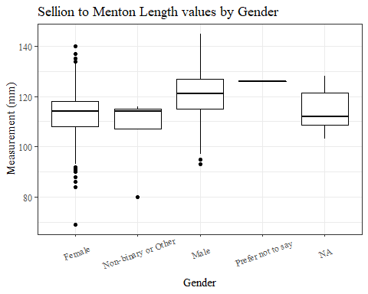

#boxplot not reordered by median  
ggplot(data=headscan_full, aes(y=SelM_L, x=gender))+  
 geom_boxplot(color= "black", fill = "white")+  
 theme_bw()+theme(text=element_text(family= "Times New Roman"))+  
 theme(axis.text.x = element_text(angle = 20, vjust=0.7))+  
 labs(title="Sellion to Menton Length values by Gender",  
 y="Measurement (mm)",  
 x="Gender")

## Warning: Removed 224 rows containing non-finite values (stat_boxplot).

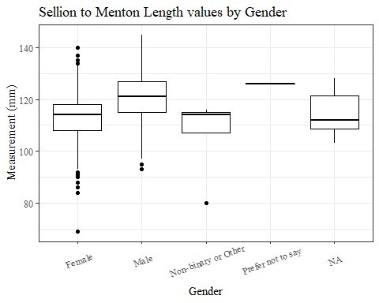

#SelM_L age group sumstats  
SelM_Lage_sumstats <- headscan_full %>%   
 group_by(age_group) %>%   
 summarise(n = n(), na = sum(is.na(SelM_L)),  
 min = min(SelM_L, na.rm = TRUE),  
 max = max(SelM_L, na.rm = TRUE),  
 mean = mean(SelM_L, na.rm = TRUE),  
 mdn = median(SelM_L, na.rm = TRUE),  
 sd = sd(SelM_L, na.rm = TRUE),  
 se = sd/sqrt(n),  
 percent5th = quantile(SelM_L, 0.05, na.rm=TRUE),  
 percent25th = quantile(SelM_L, 0.25, na.rm=TRUE),  
 percent50th = quantile(SelM_L, 0.50, na.rm=TRUE),  
 percent75th = quantile(SelM_L, 0.75, na.rm=TRUE),  
 percent95th = quantile(SelM_L, 0.95, na.rm=TRUE))  
  
SelM_Lage_sumstats <- SelM_Lage_sumstats %>%   
 mutate(across(where(is.numeric), round, 2))  
  
  
#Size 12 Table TNR  
flextable(SelM_Lage_sumstats) %>%  
 my_ft_theme()%>%   
 bold(part = "header") %>%   
 set_caption("Sellion to Menton Length SumStats by Age Group")

**Table** : Sellion to Menton Length SumStats by Age Group

| **age_group** | **n** | **na** | **min** | **max** | **mean** | **mdn** | **sd** | **se** | **percent5th** | **percent25th** | **percent50th** | **percent75th** | **percent95th** |
| --- | --- | --- | --- | --- | --- | --- | --- | --- | --- | --- | --- | --- | --- |
| 18-36 | 991 | 120 | 80 | 143 | 115.74 | 116 | 9.08 | 0.29 | 101.0 | 110 | 116 | 122.0 | 131.0 |
| 37-54 | 940 | 99 | 69 | 142 | 116.80 | 117 | 9.64 | 0.31 | 101.0 | 111 | 117 | 123.0 | 132.0 |
| 55-72 | 84 | 5 | 86 | 145 | 115.89 | 117 | 10.14 | 1.11 | 97.9 | 111 | 117 | 123.5 | 128.2 |
|  | 1 | 0 | 113 | 113 | 113.00 | 113 |  |  | 113.0 | 113 | 113 | 113.0 | 113.0 |

#%>% set_header_Cabels(values = list(SelM_L = "Sellion/SellionCont"))  
  
#Autofit Width Table TNR  
flextable(SelM_Lage_sumstats) %>%  
 my_ft_theme()%>%   
 bold(part = "header") %>%   
 set_caption("Sellion to Menton Length SumStats by Age Group") %>%   
 fit_to_width(7.5)

**Table** : Sellion to Menton Length SumStats by Age Group

| **age_group** | **n** | **na** | **min** | **max** | **mean** | **mdn** | **sd** | **se** | **percent5th** | **percent25th** | **percent50th** | **percent75th** | **percent95th** |
| --- | --- | --- | --- | --- | --- | --- | --- | --- | --- | --- | --- | --- | --- |
| 18-36 | 991 | 120 | 80 | 143 | 115.74 | 116 | 9.08 | 0.29 | 101.0 | 110 | 116 | 122.0 | 131.0 |
| 37-54 | 940 | 99 | 69 | 142 | 116.80 | 117 | 9.64 | 0.31 | 101.0 | 111 | 117 | 123.0 | 132.0 |
| 55-72 | 84 | 5 | 86 | 145 | 115.89 | 117 | 10.14 | 1.11 | 97.9 | 111 | 117 | 123.5 | 128.2 |
|  | 1 | 0 | 113 | 113 | 113.00 | 113 |  |  | 113.0 | 113 | 113 | 113.0 | 113.0 |

#%>% set_header_Cabels(values = list(SelM_L = "Sellion/SellionCont"))  
  
#boxplot reorderd by median  
headscan_full %>%   
 ungroup() %>%   
 mutate(age_group= fct_reorder(age_group, SelM_L, FUN=median, na.rm=TRUE)) %>%   
 ggplot(aes(y=SelM_L, x=age_group))+  
 geom_boxplot(color= "black", fill = "white")+  
 theme_bw()+theme(text=element_text(family= "Times New Roman"))+  
 #theme(axis.text.x = element_text(angle = 20, vjust=0.7))+  
 labs(title="Sellion to Menton Length values by Age Group",  
 y="Measurement (mm)",  
 x="Age Group")

## Warning: Removed 224 rows containing non-finite values (stat_boxplot).

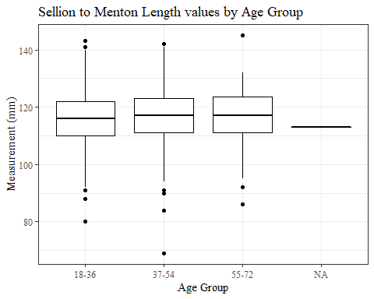

#boxplot not reordered by median  
ggplot(data=headscan_full, aes(y=SelM_L, x=age_group))+  
 geom_boxplot(color= "black", fill = "white")+  
 theme_bw()+theme(text=element_text(family= "Times New Roman"))+  
 #theme(axis.text.x = element_text(angle = 20, vjust=0.7))+  
 labs(title="Sellion to Menton Length values by Age Group",  
 y="Measurement (mm)",  
 x="Age Group")

## Warning: Removed 224 rows containing non-finite values (stat_boxplot).



SnasM_L

#histogram of all SnasM_L values  
ggplot(data=headscan_full, aes(x=SnasM_L))+  
 geom_bar(stat="bin", bins=25, color= "black", fill = "white")+  
 theme_bw()+theme(text=element_text(family= "Times New Roman"))+  
 labs(title="Subnasale to Menton Length Measurement Distribution",  
 y="Frequency",  
 x="Subnasale to Menton Length (mm)")

## Warning: Removed 225 rows containing non-finite values (stat_bin).

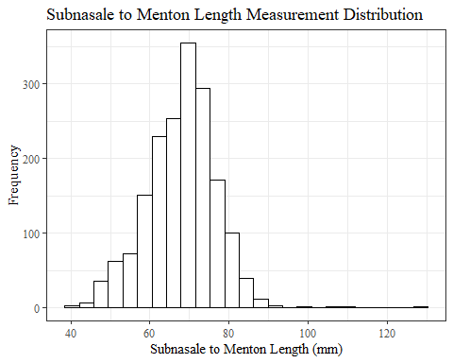

SnasM_Lsumstats <- headscan_full %>%   
 summarise(n = n(), na = sum(is.na(SnasM_L)),  
 min = min(SnasM_L, na.rm = TRUE),  
 max = max(SnasM_L, na.rm = TRUE),  
 mean = mean(SnasM_L, na.rm = TRUE),  
 mdn = median(SnasM_L, na.rm = TRUE),  
 sd = sd(SnasM_L, na.rm = TRUE),  
 se = sd/sqrt(n),  
 percent5th = quantile(SnasM_L, 0.05, na.rm=TRUE),  
 percent25th = quantile(SnasM_L, 0.25, na.rm=TRUE),  
 percent50th = quantile(SnasM_L, 0.50, na.rm=TRUE),  
 percent75th = quantile(SnasM_L, 0.75, na.rm=TRUE),  
 percent95th = quantile(SnasM_L, 0.95, na.rm=TRUE))   
  
SnasM_Lsumstats <- round(SnasM_Lsumstats, 2)  
  
#Size 12 Table TNR  
flextable(SnasM_Lsumstats) %>%  
 my_ft_theme()%>%   
 bold(part = "header") %>%   
 set_caption("Subnasale to Menton Length SumStats")

**Table** : Subnasale to Menton Length SumStats

| **n** | **na** | **min** | **max** | **mean** | **mdn** | **sd** | **se** | **percent5th** | **percent25th** | **percent50th** | **percent75th** | **percent95th** |
| --- | --- | --- | --- | --- | --- | --- | --- | --- | --- | --- | --- | --- |
| 2,016 | 225 | 40 | 128 | 67.93 | 68 | 8.66 | 0.19 | 52 | 63 | 68 | 74 | 81 |

#%>% set_header_Cabels(values = list(SnasM_L = "Subnasale/SubnasaleCont"))  
  
#Autofit Width Table TNR  
flextable(SnasM_Lsumstats) %>%  
 my_ft_theme()%>%   
 bold(part = "header") %>%   
 set_caption("Subnasale to Menton Length SumStats") %>%   
 fit_to_width(7.5)

**Table** : Subnasale to Menton Length SumStats

| **n** | **na** | **min** | **max** | **mean** | **mdn** | **sd** | **se** | **percent5th** | **percent25th** | **percent50th** | **percent75th** | **percent95th** |
| --- | --- | --- | --- | --- | --- | --- | --- | --- | --- | --- | --- | --- |
| 2,016 | 225 | 40 | 128 | 67.93 | 68 | 8.66 | 0.19 | 52 | 63 | 68 | 74 | 81 |

#%>% set_header_Cabels(values = list(SnasM_L = "Subnasale/SubnasaleCont"))

#SnasM_L race/eth sumstats  
SnasM_Lrace_sumstats <- headscan_full %>%   
 group_by(race_eth) %>%   
 summarise(n = n(), na = sum(is.na(SnasM_L)),  
 min = min(SnasM_L, na.rm = TRUE),  
 max = max(SnasM_L, na.rm = TRUE),  
 mean = mean(SnasM_L, na.rm = TRUE),  
 mdn = median(SnasM_L, na.rm = TRUE),  
 sd = sd(SnasM_L, na.rm = TRUE),  
 se = sd/sqrt(n),  
 percent5th = quantile(SnasM_L, 0.05, na.rm=TRUE),  
 percent25th = quantile(SnasM_L, 0.25, na.rm=TRUE),  
 percent50th = quantile(SnasM_L, 0.50, na.rm=TRUE),  
 percent75th = quantile(SnasM_L, 0.75, na.rm=TRUE),  
 percent95th = quantile(SnasM_L, 0.95, na.rm=TRUE))   
  
SnasM_Lrace_sumstats <- SnasM_Lrace_sumstats %>%   
 mutate(across(where(is.numeric), round, 2))  
  
  
#Size 12 Table TNR  
flextable(SnasM_Lrace_sumstats) %>%  
 my_ft_theme()%>%   
 bold(part = "header") %>%   
 set_caption("Subnasale to Menton Length SumStats by Race/Ethnicity")

**Table** : Subnasale to Menton Length SumStats by Race/Ethnicity

| **race_eth** | **n** | **na** | **min** | **max** | **mean** | **mdn** | **sd** | **se** | **percent5th** | **percent25th** | **percent50th** | **percent75th** | **percent95th** |
| --- | --- | --- | --- | --- | --- | --- | --- | --- | --- | --- | --- | --- | --- |
| white | 1,239 | 136 | 41 | 128 | 66.96 | 67.0 | 8.29 | 0.24 | 52.00 | 62.00 | 67.0 | 72.00 | 79.00 |
| Black | 548 | 70 | 46 | 111 | 71.03 | 72.0 | 8.32 | 0.36 | 56.00 | 66.00 | 72.0 | 77.00 | 83.00 |
| LatinX | 100 | 8 | 43 | 90 | 67.30 | 68.0 | 9.65 | 0.96 | 49.55 | 62.00 | 68.0 | 73.25 | 82.45 |
| Asian | 91 | 4 | 40 | 105 | 64.26 | 64.0 | 9.64 | 1.01 | 50.00 | 58.50 | 64.0 | 71.00 | 78.40 |
| Other | 21 | 5 | 52 | 78 | 66.56 | 66.5 | 6.55 | 1.43 | 56.50 | 64.75 | 66.5 | 71.25 | 75.75 |
| AIAN | 8 | 2 | 54 | 83 | 65.00 | 61.5 | 10.77 | 3.81 | 55.00 | 58.25 | 61.5 | 70.00 | 80.25 |
| PTNS | 5 | 0 | 59 | 81 | 70.60 | 72.0 | 8.44 | 3.78 | 60.40 | 66.00 | 72.0 | 75.00 | 79.80 |
| NHOPI | 4 | 0 | 46 | 78 | 65.75 | 69.5 | 14.06 | 7.03 | 49.00 | 61.00 | 69.5 | 74.25 | 77.25 |

#%>% set_header_Cabels(values = list(SnasM_L = "Subnasale/SubnasaleCont"))  
  
#Autofit Width Table TNR  
flextable(SnasM_Lrace_sumstats) %>%  
 my_ft_theme()%>%   
 bold(part = "header") %>%   
 set_caption("Subnasale to Menton Length SumStats by Race/Ethnicity") %>%   
 fit_to_width(7.5)

**Table** : Subnasale to Menton Length SumStats by Race/Ethnicity

| **race_eth** | **n** | **na** | **min** | **max** | **mean** | **mdn** | **sd** | **se** | **percent5th** | **percent25th** | **percent50th** | **percent75th** | **percent95th** |
| --- | --- | --- | --- | --- | --- | --- | --- | --- | --- | --- | --- | --- | --- |
| white | 1,239 | 136 | 41 | 128 | 66.96 | 67.0 | 8.29 | 0.24 | 52.00 | 62.00 | 67.0 | 72.00 | 79.00 |
| Black | 548 | 70 | 46 | 111 | 71.03 | 72.0 | 8.32 | 0.36 | 56.00 | 66.00 | 72.0 | 77.00 | 83.00 |
| LatinX | 100 | 8 | 43 | 90 | 67.30 | 68.0 | 9.65 | 0.96 | 49.55 | 62.00 | 68.0 | 73.25 | 82.45 |
| Asian | 91 | 4 | 40 | 105 | 64.26 | 64.0 | 9.64 | 1.01 | 50.00 | 58.50 | 64.0 | 71.00 | 78.40 |
| Other | 21 | 5 | 52 | 78 | 66.56 | 66.5 | 6.55 | 1.43 | 56.50 | 64.75 | 66.5 | 71.25 | 75.75 |
| AIAN | 8 | 2 | 54 | 83 | 65.00 | 61.5 | 10.77 | 3.81 | 55.00 | 58.25 | 61.5 | 70.00 | 80.25 |
| PTNS | 5 | 0 | 59 | 81 | 70.60 | 72.0 | 8.44 | 3.78 | 60.40 | 66.00 | 72.0 | 75.00 | 79.80 |
| NHOPI | 4 | 0 | 46 | 78 | 65.75 | 69.5 | 14.06 | 7.03 | 49.00 | 61.00 | 69.5 | 74.25 | 77.25 |

#%>% set_header_Cabels(values = list(SnasM_L = "Subnasale/SubnasaleCont"))  
  
#boxplot reorderd by median  
headscan_full %>%   
 ungroup() %>%   
 mutate(race_eth= fct_reorder(race_eth, SnasM_L, FUN=median, na.rm=TRUE)) %>%   
 ggplot(aes(y=SnasM_L, x=race_eth))+  
 geom_boxplot(color= "black", fill = "white")+  
 theme_bw()+theme(text=element_text(family= "Times New Roman"))+  
 #theme(axis.text.x = element_text(angle = 20, vjust=0.7))+  
 labs(title="Subnasale to Menton Length values by Race/Ethnicity",  
 y="Measurement (mm)",  
 x="Race/Ethnicity")

## Warning: Removed 225 rows containing non-finite values (stat_boxplot).

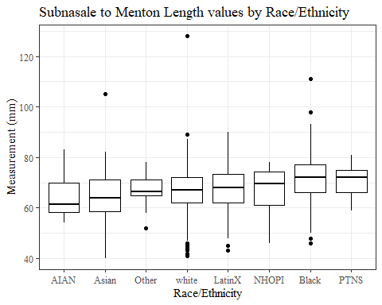

#boxplot not reordered by median  
ggplot(data=headscan_full, aes(y=SnasM_L, x=race_eth))+  
 geom_boxplot(color= "black", fill = "white")+  
 theme_bw()+theme(text=element_text(family= "Times New Roman"))+  
 #theme(axis.text.x = element_text(angle = 20, vjust=0.7))+  
 labs(title="Subnasale to Menton Length values by Race/Ethnicity",  
 y="Measurement (mm)",  
 x="Race/Ethnicity")

## Warning: Removed 225 rows containing non-finite values (stat_boxplot).

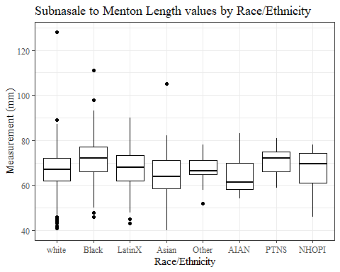

#SnasM_L gender sumstats  
SnasM_Lgender_sumstats <- headscan_full %>%   
 group_by(gender) %>%   
 summarise(n = n(), na = sum(is.na(SnasM_L)),  
 min = min(SnasM_L, na.rm = TRUE),  
 max = max(SnasM_L, na.rm = TRUE),  
 mean = mean(SnasM_L, na.rm = TRUE),  
 mdn = median(SnasM_L, na.rm = TRUE),  
 sd = sd(SnasM_L, na.rm = TRUE),  
 se = sd/sqrt(n),  
 percent5th = quantile(SnasM_L, 0.05, na.rm=TRUE),  
 percent25th = quantile(SnasM_L, 0.25, na.rm=TRUE),  
 percent50th = quantile(SnasM_L, 0.50, na.rm=TRUE),  
 percent75th = quantile(SnasM_L, 0.75, na.rm=TRUE),  
 percent95th = quantile(SnasM_L, 0.95, na.rm=TRUE))  
  
SnasM_Lgender_sumstats <- SnasM_Lgender_sumstats %>%   
 mutate(across(where(is.numeric), round, 2))  
  
#Size 12 Table TNR  
flextable(SnasM_Lgender_sumstats) %>%  
 my_ft_theme()%>%   
 bold(part = "header") %>%   
 set_caption("Subnasale to Menton Length SumStats by Gender")

**Table** : Subnasale to Menton Length SumStats by Gender

| **gender** | **n** | **na** | **min** | **max** | **mean** | **mdn** | **sd** | **se** | **percent5th** | **percent25th** | **percent50th** | **percent75th** | **percent95th** |
| --- | --- | --- | --- | --- | --- | --- | --- | --- | --- | --- | --- | --- | --- |
| Female | 1,063 | 17 | 40 | 111 | 66.24 | 67 | 8.09 | 0.25 | 51.00 | 62.0 | 67 | 72.00 | 78.00 |
| Male | 939 | 208 | 42 | 128 | 70.38 | 71 | 8.84 | 0.29 | 55.00 | 65.0 | 71 | 76.00 | 83.00 |
| Non-binary or Other | 5 | 0 | 41 | 74 | 62.20 | 70 | 14.25 | 6.37 | 43.60 | 54.0 | 70 | 72.00 | 73.60 |
| Prefer not to say | 1 | 0 | 81 | 81 | 81.00 | 81 |  |  | 81.00 | 81.0 | 81 | 81.00 | 81.00 |
|  | 8 | 0 | 57 | 78 | 68.00 | 67 | 8.33 | 2.95 | 58.05 | 61.5 | 67 | 76.25 | 77.65 |

#%>% set_header_Cabels(values = list(SnasM_L = "Subnasale/SubnasaleCont"))  
  
#Autofit Width Table TNR  
flextable(SnasM_Lgender_sumstats) %>%  
 my_ft_theme()%>%   
 bold(part = "header") %>%   
 set_caption("Subnasale to Menton Length SumStats by Gender") %>%   
 fit_to_width(7.5)

**Table** : Subnasale to Menton Length SumStats by Gender

| **gender** | **n** | **na** | **min** | **max** | **mean** | **mdn** | **sd** | **se** | **percent5th** | **percent25th** | **percent50th** | **percent75th** | **percent95th** |
| --- | --- | --- | --- | --- | --- | --- | --- | --- | --- | --- | --- | --- | --- |
| Female | 1,063 | 17 | 40 | 111 | 66.24 | 67 | 8.09 | 0.25 | 51.00 | 62.0 | 67 | 72.00 | 78.00 |
| Male | 939 | 208 | 42 | 128 | 70.38 | 71 | 8.84 | 0.29 | 55.00 | 65.0 | 71 | 76.00 | 83.00 |
| Non-binary or Other | 5 | 0 | 41 | 74 | 62.20 | 70 | 14.25 | 6.37 | 43.60 | 54.0 | 70 | 72.00 | 73.60 |
| Prefer not to say | 1 | 0 | 81 | 81 | 81.00 | 81 |  |  | 81.00 | 81.0 | 81 | 81.00 | 81.00 |
|  | 8 | 0 | 57 | 78 | 68.00 | 67 | 8.33 | 2.95 | 58.05 | 61.5 | 67 | 76.25 | 77.65 |

#%>% set_header_Cabels(values = list(SnasM_L = "Subnasale/SubnasaleCont"))  
  
#boxplot reorderd by median  
headscan_full %>%   
 ungroup() %>%   
 mutate(gender= fct_reorder(gender, SnasM_L, FUN=median, na.rm=TRUE)) %>%   
 ggplot(aes(y=SnasM_L, x=gender))+  
 geom_boxplot(color= "black", fill = "white")+  
 theme_bw()+theme(text=element_text(family= "Times New Roman"))+  
 theme(axis.text.x = element_text(angle = 20, vjust=0.7))+  
 labs(title="Subnasale to Menton Length values by Gender",  
 y="Measurement (mm)",  
 x="Gender")

## Warning: Removed 225 rows containing non-finite values (stat_boxplot).

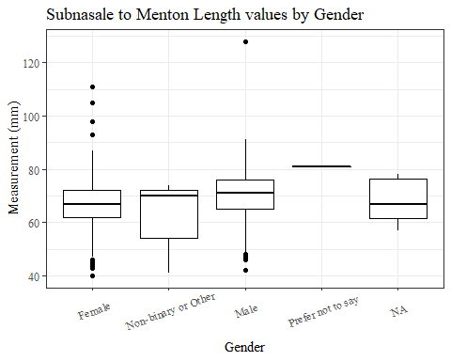

#boxplot not reordered by median  
ggplot(data=headscan_full, aes(y=SnasM_L, x=gender))+  
 geom_boxplot(color= "black", fill = "white")+  
 theme_bw()+theme(text=element_text(family= "Times New Roman"))+  
 theme(axis.text.x = element_text(angle = 20, vjust=0.7))+  
 labs(title="Subnasale to Menton Length values by Gender",  
 y="Measurement (mm)",  
 x="Gender")

## Warning: Removed 225 rows containing non-finite values (stat_boxplot).

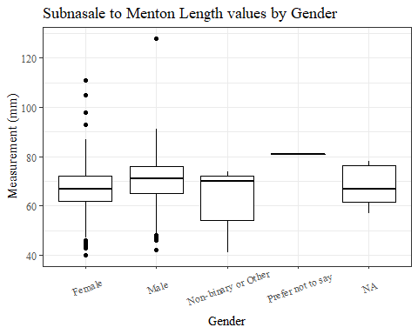

#SnasM_L age group sumstats  
SnasM_Lage_sumstats <- headscan_full %>%   
 group_by(age_group) %>%   
 summarise(n = n(), na = sum(is.na(SnasM_L)),  
 min = min(SnasM_L, na.rm = TRUE),  
 max = max(SnasM_L, na.rm = TRUE),  
 mean = mean(SnasM_L, na.rm = TRUE),  
 mdn = median(SnasM_L, na.rm = TRUE),  
 sd = sd(SnasM_L, na.rm = TRUE),  
 se = sd/sqrt(n),  
 percent5th = quantile(SnasM_L, 0.05, na.rm=TRUE),  
 percent25th = quantile(SnasM_L, 0.25, na.rm=TRUE),  
 percent50th = quantile(SnasM_L, 0.50, na.rm=TRUE),  
 percent75th = quantile(SnasM_L, 0.75, na.rm=TRUE),  
 percent95th = quantile(SnasM_L, 0.95, na.rm=TRUE))  
  
SnasM_Lage_sumstats <- SnasM_Lage_sumstats %>%   
 mutate(across(where(is.numeric), round, 2))  
  
  
#Size 12 Table TNR  
flextable(SnasM_Lage_sumstats) %>%  
 my_ft_theme()%>%   
 bold(part = "header") %>%   
 set_caption("Subnasale to Menton Length SumStats by Age Group")

**Table** : Subnasale to Menton Length SumStats by Age Group

| **age_group** | **n** | **na** | **min** | **max** | **mean** | **mdn** | **sd** | **se** | **percent5th** | **percent25th** | **percent50th** | **percent75th** | **percent95th** |
| --- | --- | --- | --- | --- | --- | --- | --- | --- | --- | --- | --- | --- | --- |
| 18-36 | 991 | 120 | 40 | 128 | 67.85 | 68 | 8.68 | 0.28 | 52.0 | 63.00 | 68 | 74 | 81.00 |
| 37-54 | 940 | 99 | 43 | 111 | 68.18 | 68 | 8.65 | 0.28 | 53.0 | 63.00 | 68 | 74 | 81.00 |
| 55-72 | 84 | 6 | 43 | 82 | 66.21 | 67 | 8.56 | 0.93 | 51.7 | 61.25 | 67 | 73 | 77.15 |
|  | 1 | 0 | 64 | 64 | 64.00 | 64 |  |  | 64.0 | 64.00 | 64 | 64 | 64.00 |

#%>% set_header_Cabels(values = list(SnasM_L = "Subnasale/SubnasaleCont"))  
  
#Autofit Width Table TNR  
flextable(SnasM_Lage_sumstats) %>%  
 my_ft_theme()%>%   
 bold(part = "header") %>%   
 set_caption("Subnasale to Menton Length SumStats by Age Group") %>%   
 fit_to_width(7.5)

**Table** : Subnasale to Menton Length SumStats by Age Group

| **age_group** | **n** | **na** | **min** | **max** | **mean** | **mdn** | **sd** | **se** | **percent5th** | **percent25th** | **percent50th** | **percent75th** | **percent95th** |
| --- | --- | --- | --- | --- | --- | --- | --- | --- | --- | --- | --- | --- | --- |
| 18-36 | 991 | 120 | 40 | 128 | 67.85 | 68 | 8.68 | 0.28 | 52.0 | 63.00 | 68 | 74 | 81.00 |
| 37-54 | 940 | 99 | 43 | 111 | 68.18 | 68 | 8.65 | 0.28 | 53.0 | 63.00 | 68 | 74 | 81.00 |
| 55-72 | 84 | 6 | 43 | 82 | 66.21 | 67 | 8.56 | 0.93 | 51.7 | 61.25 | 67 | 73 | 77.15 |
|  | 1 | 0 | 64 | 64 | 64.00 | 64 |  |  | 64.0 | 64.00 | 64 | 64 | 64.00 |

#%>% set_header_Cabels(values = list(SnasM_L = "Subnasale/SubnasaleCont"))  
  
#boxplot reorderd by median  
headscan_full %>%   
 ungroup() %>%   
 mutate(age_group= fct_reorder(age_group, SnasM_L, FUN=median, na.rm=TRUE)) %>%   
 ggplot(aes(y=SnasM_L, x=age_group))+  
 geom_boxplot(color= "black", fill = "white")+  
 theme_bw()+theme(text=element_text(family= "Times New Roman"))+  
 #theme(axis.text.x = element_text(angle = 20, vjust=0.7))+  
 labs(title="Subnasale to Menton Length values by Age Group",  
 y="Measurement (mm)",  
 x="Age Group")

## Warning: Removed 225 rows containing non-finite values (stat_boxplot).

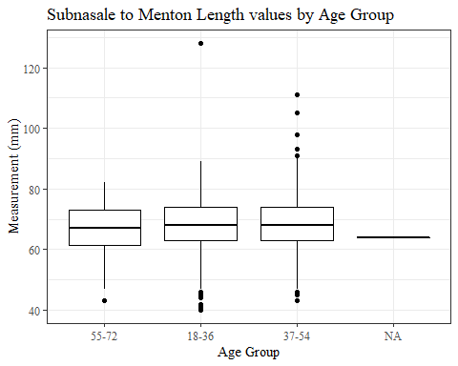

#boxplot not reordered by median  
ggplot(data=headscan_full, aes(y=SnasM_L, x=age_group))+  
 geom_boxplot(color= "black", fill = "white")+  
 theme_bw()+theme(text=element_text(family= "Times New Roman"))+  
 #theme(axis.text.x = element_text(angle = 20, vjust=0.7))+  
 labs(title="Subnasale to Menton Length values by Age Group",  
 y="Measurement (mm)",  
 x="Age Group")

## Warning: Removed 225 rows containing non-finite values (stat_boxplot).

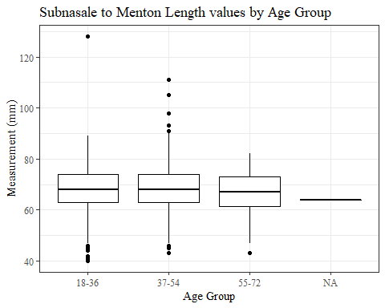

SnasM_C without outliers removed

#histogram of all SnasM_C values  
ggplot(data=headscan_full, aes(x=SnasM_C))+  
 geom_bar(stat="bin", bins=25, color= "black", fill = "white")+  
 theme_bw()+theme(text=element_text(family= "Times New Roman"))+  
 labs(title="Subnasale to Menton Contour Measurement Distribution",  
 subtitle = "without outlier removed",  
 y="Frequency",  
 x="Subnasale to Menton Contour (mm)")

## Warning: Removed 236 rows containing non-finite values (stat_bin).

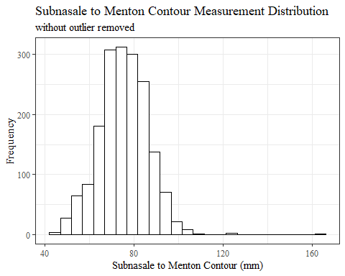

SnasM_Csumstats <- headscan_full %>%   
 summarise(n = n(), na = sum(is.na(SnasM_C)),  
 min = min(SnasM_C, na.rm = TRUE),  
 max = max(SnasM_C, na.rm = TRUE),  
 mean = mean(SnasM_C, na.rm = TRUE),  
 mdn = median(SnasM_C, na.rm = TRUE),  
 sd = sd(SnasM_C, na.rm = TRUE),  
 se = sd/sqrt(n),  
 percent5th = quantile(SnasM_C, 0.05, na.rm=TRUE),  
 percent25th = quantile(SnasM_C, 0.25, na.rm=TRUE),  
 percent50th = quantile(SnasM_C, 0.50, na.rm=TRUE),  
 percent75th = quantile(SnasM_C, 0.75, na.rm=TRUE),  
 percent95th = quantile(SnasM_C, 0.95, na.rm=TRUE))   
  
SnasM_Csumstats <- round(SnasM_Csumstats, 2)  
  
#Size 12 Table TNR  
flextable(SnasM_Csumstats) %>%  
 my_ft_theme()%>%   
 bold(part = "header") %>%   
 set_caption("Subnasale to Menton Contour SumStats w/o outlier removed")

**Table** : Subnasale to Menton Contour SumStats w/o outlier removed

| **n** | **na** | **min** | **max** | **mean** | **mdn** | **sd** | **se** | **percent5th** | **percent25th** | **percent50th** | **percent75th** | **percent95th** |
| --- | --- | --- | --- | --- | --- | --- | --- | --- | --- | --- | --- | --- |
| 2,016 | 236 | 44 | 163 | 75.1 | 75 | 10.81 | 0.24 | 57 | 68 | 75 | 82 | 92 |

#%>% set_header_Cabels(values = list(SnasM_C = "Subnasale/SubnasaleCont"))  
  
#Autofit Width Table TNR  
flextable(SnasM_Csumstats) %>%  
 my_ft_theme()%>%   
 bold(part = "header") %>%   
 set_caption("Subnasale to Menton Contour SumStats w/o outlier removed") %>%   
 fit_to_width(7.5)

**Table** : Subnasale to Menton Contour SumStats w/o outlier removed

| **n** | **na** | **min** | **max** | **mean** | **mdn** | **sd** | **se** | **percent5th** | **percent25th** | **percent50th** | **percent75th** | **percent95th** |
| --- | --- | --- | --- | --- | --- | --- | --- | --- | --- | --- | --- | --- |
| 2,016 | 236 | 44 | 163 | 75.1 | 75 | 10.81 | 0.24 | 57 | 68 | 75 | 82 | 92 |

#%>% set_header_Cabels(values = list(SnasM_C = "Subnasale/SubnasaleCont"))

#SnasM_C race/eth sumstats  
SnasM_Crace_sumstats <- headscan_full %>%   
 group_by(race_eth) %>%   
 summarise(n = n(), na = sum(is.na(SnasM_C)),  
 min = min(SnasM_C, na.rm = TRUE),  
 max = max(SnasM_C, na.rm = TRUE),  
 mean = mean(SnasM_C, na.rm = TRUE),  
 mdn = median(SnasM_C, na.rm = TRUE),  
 sd = sd(SnasM_C, na.rm = TRUE),  
 se = sd/sqrt(n),  
 percent5th = quantile(SnasM_C, 0.05, na.rm=TRUE),  
 percent25th = quantile(SnasM_C, 0.25, na.rm=TRUE),  
 percent50th = quantile(SnasM_C, 0.50, na.rm=TRUE),  
 percent75th = quantile(SnasM_C, 0.75, na.rm=TRUE),  
 percent95th = quantile(SnasM_C, 0.95, na.rm=TRUE))   
  
SnasM_Crace_sumstats <- SnasM_Crace_sumstats %>%   
 mutate(across(where(is.numeric), round, 2))  
  
  
#Size 12 Table TNR  
flextable(SnasM_Crace_sumstats) %>%  
 my_ft_theme()%>%   
 bold(part = "header") %>%   
 set_caption("Subnasale to Menton Contour SumStats by Race/Ethnicity w/o outlier removed")

**Table** : Subnasale to Menton Contour SumStats by Race/Ethnicity w/o outlier removed

| **race_eth** | **n** | **na** | **min** | **max** | **mean** | **mdn** | **sd** | **se** | **percent5th** | **percent25th** | **percent50th** | **percent75th** | **percent95th** |
| --- | --- | --- | --- | --- | --- | --- | --- | --- | --- | --- | --- | --- | --- |
| white | 1,239 | 144 | 44 | 163 | 72.89 | 73.0 | 10.09 | 0.29 | 56.00 | 67.00 | 73.0 | 79.00 | 89.00 |
| Black | 548 | 71 | 54 | 124 | 81.09 | 82.0 | 10.03 | 0.43 | 63.00 | 75.00 | 82.0 | 87.00 | 96.20 |
| LatinX | 100 | 9 | 50 | 97 | 73.64 | 74.0 | 10.98 | 1.10 | 54.50 | 67.00 | 74.0 | 82.00 | 92.50 |
| Asian | 91 | 5 | 46 | 125 | 72.16 | 71.5 | 11.66 | 1.22 | 55.50 | 65.25 | 71.5 | 78.75 | 91.50 |
| Other | 21 | 5 | 59 | 85 | 72.12 | 71.5 | 7.31 | 1.60 | 59.75 | 69.00 | 71.5 | 76.50 | 82.75 |
| AIAN | 8 | 2 | 58 | 93 | 71.50 | 66.0 | 13.85 | 4.90 | 59.00 | 62.50 | 66.0 | 80.00 | 90.75 |
| PTNS | 5 | 0 | 62 | 90 | 79.80 | 86.0 | 11.41 | 5.10 | 64.60 | 75.00 | 86.0 | 86.00 | 89.20 |
| NHOPI | 4 | 0 | 62 | 85 | 74.75 | 76.0 | 10.69 | 5.34 | 63.20 | 68.00 | 76.0 | 82.75 | 84.55 |

#%>% set_header_Cabels(values = list(SnasM_C = "Subnasale/SubnasaleCont"))  
  
#Autofit Width Table TNR  
flextable(SnasM_Crace_sumstats) %>%  
 my_ft_theme()%>%   
 bold(part = "header") %>%   
 set_caption("Subnasale to Menton Contour SumStats by Race/Ethnicity w/o outlier removed") %>%   
 fit_to_width(7.5)

**Table** : Subnasale to Menton Contour SumStats by Race/Ethnicity w/o outlier removed

| **race_eth** | **n** | **na** | **min** | **max** | **mean** | **mdn** | **sd** | **se** | **percent5th** | **percent25th** | **percent50th** | **percent75th** | **percent95th** |
| --- | --- | --- | --- | --- | --- | --- | --- | --- | --- | --- | --- | --- | --- |
| white | 1,239 | 144 | 44 | 163 | 72.89 | 73.0 | 10.09 | 0.29 | 56.00 | 67.00 | 73.0 | 79.00 | 89.00 |
| Black | 548 | 71 | 54 | 124 | 81.09 | 82.0 | 10.03 | 0.43 | 63.00 | 75.00 | 82.0 | 87.00 | 96.20 |
| LatinX | 100 | 9 | 50 | 97 | 73.64 | 74.0 | 10.98 | 1.10 | 54.50 | 67.00 | 74.0 | 82.00 | 92.50 |
| Asian | 91 | 5 | 46 | 125 | 72.16 | 71.5 | 11.66 | 1.22 | 55.50 | 65.25 | 71.5 | 78.75 | 91.50 |
| Other | 21 | 5 | 59 | 85 | 72.12 | 71.5 | 7.31 | 1.60 | 59.75 | 69.00 | 71.5 | 76.50 | 82.75 |
| AIAN | 8 | 2 | 58 | 93 | 71.50 | 66.0 | 13.85 | 4.90 | 59.00 | 62.50 | 66.0 | 80.00 | 90.75 |
| PTNS | 5 | 0 | 62 | 90 | 79.80 | 86.0 | 11.41 | 5.10 | 64.60 | 75.00 | 86.0 | 86.00 | 89.20 |
| NHOPI | 4 | 0 | 62 | 85 | 74.75 | 76.0 | 10.69 | 5.34 | 63.20 | 68.00 | 76.0 | 82.75 | 84.55 |

#%>% set_header_Cabels(values = list(SnasM_C = "Subnasale/SubnasaleCont"))  
  
#boxplot reorderd by median  
headscan_full %>%   
 ungroup() %>%   
 mutate(race_eth= fct_reorder(race_eth, SnasM_C, FUN=median, na.rm=TRUE)) %>%   
 ggplot(aes(y=SnasM_C, x=race_eth))+  
 geom_boxplot(color= "black", fill = "white")+  
 theme_bw()+theme(text=element_text(family= "Times New Roman"))+  
 #theme(axis.text.x = element_text(angle = 20, vjust=0.7))+  
 labs(title="Subnasale to Menton Contour values by Race/Ethnicity",  
 subtitle = "without outlier removed",  
 y="Measurement (mm)",  
 x="Race/Ethnicity")

## Warning: Removed 236 rows containing non-finite values (stat_boxplot).

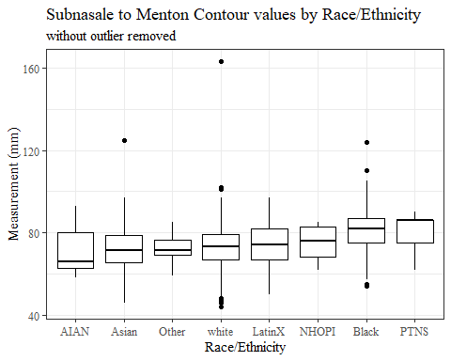

#boxplot not reordered by median  
ggplot(data=headscan_full, aes(y=SnasM_C, x=race_eth))+  
 geom_boxplot(color= "black", fill = "white")+  
 theme_bw()+theme(text=element_text(family= "Times New Roman"))+  
 #theme(axis.text.x = element_text(angle = 20, vjust=0.7))+  
 labs(title="Subnasale to Menton Contour values by Race/Ethnicity",  
 subtitle = "without outlier removed",  
 y="Measurement (mm)",  
 x="Race/Ethnicity")

## Warning: Removed 236 rows containing non-finite values (stat_boxplot).

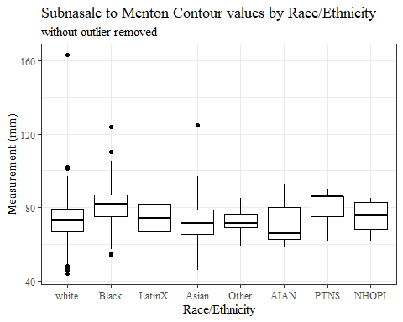

#SnasM_C gender sumstats  
SnasM_Cgender_sumstats <- headscan_full %>%   
 group_by(gender) %>%   
 summarise(n = n(), na = sum(is.na(SnasM_C)),  
 min = min(SnasM_C, na.rm = TRUE),  
 max = max(SnasM_C, na.rm = TRUE),  
 mean = mean(SnasM_C, na.rm = TRUE),  
 mdn = median(SnasM_C, na.rm = TRUE),  
 sd = sd(SnasM_C, na.rm = TRUE),  
 se = sd/sqrt(n),  
 percent5th = quantile(SnasM_C, 0.05, na.rm=TRUE),  
 percent25th = quantile(SnasM_C, 0.25, na.rm=TRUE),  
 percent50th = quantile(SnasM_C, 0.50, na.rm=TRUE),  
 percent75th = quantile(SnasM_C, 0.75, na.rm=TRUE),  
 percent95th = quantile(SnasM_C, 0.95, na.rm=TRUE))  
  
SnasM_Cgender_sumstats <- SnasM_Cgender_sumstats %>%   
 mutate(across(where(is.numeric), round, 2))  
  
#Size 12 Table TNR  
flextable(SnasM_Cgender_sumstats) %>%  
 my_ft_theme()%>%   
 bold(part = "header") %>%   
 set_caption("Subnasale to Menton Contour SumStats by Gender")

**Table** : Subnasale to Menton Contour SumStats by Gender

| **gender** | **n** | **na** | **min** | **max** | **mean** | **mdn** | **sd** | **se** | **percent5th** | **percent25th** | **percent50th** | **percent75th** | **percent95th** |
| --- | --- | --- | --- | --- | --- | --- | --- | --- | --- | --- | --- | --- | --- |
| Female | 1,063 | 23 | 46 | 125 | 73.02 | 73 | 10.05 | 0.31 | 55.0 | 67.0 | 73 | 80.00 | 88.00 |
| Male | 939 | 213 | 46 | 163 | 78.11 | 79 | 11.14 | 0.36 | 60.0 | 71.0 | 79 | 85.00 | 94.75 |
| Non-binary or Other | 5 | 0 | 44 | 81 | 67.20 | 75 | 16.07 | 7.19 | 46.6 | 57.0 | 75 | 79.00 | 80.60 |
| Prefer not to say | 1 | 0 | 90 | 90 | 90.00 | 90 |  |  | 90.0 | 90.0 | 90 | 90.00 | 90.00 |
|  | 8 | 0 | 64 | 87 | 75.50 | 75 | 8.38 | 2.96 | 64.7 | 70.5 | 75 | 80.75 | 86.65 |

#%>% set_header_Cabels(values = list(SnasM_C = "Subnasale/SubnasaleCont"))  
  
#Autofit Width Table TNR  
flextable(SnasM_Cgender_sumstats) %>%  
 my_ft_theme()%>%   
 bold(part = "header") %>%   
 set_caption("Subnasale to Menton Contour SumStats by Gender") %>%   
 fit_to_width(7.5)

**Table** : Subnasale to Menton Contour SumStats by Gender

| **gender** | **n** | **na** | **min** | **max** | **mean** | **mdn** | **sd** | **se** | **percent5th** | **percent25th** | **percent50th** | **percent75th** | **percent95th** |
| --- | --- | --- | --- | --- | --- | --- | --- | --- | --- | --- | --- | --- | --- |
| Female | 1,063 | 23 | 46 | 125 | 73.02 | 73 | 10.05 | 0.31 | 55.0 | 67.0 | 73 | 80.00 | 88.00 |
| Male | 939 | 213 | 46 | 163 | 78.11 | 79 | 11.14 | 0.36 | 60.0 | 71.0 | 79 | 85.00 | 94.75 |
| Non-binary or Other | 5 | 0 | 44 | 81 | 67.20 | 75 | 16.07 | 7.19 | 46.6 | 57.0 | 75 | 79.00 | 80.60 |
| Prefer not to say | 1 | 0 | 90 | 90 | 90.00 | 90 |  |  | 90.0 | 90.0 | 90 | 90.00 | 90.00 |
|  | 8 | 0 | 64 | 87 | 75.50 | 75 | 8.38 | 2.96 | 64.7 | 70.5 | 75 | 80.75 | 86.65 |

#%>% set_header_Cabels(values = list(SnasM_C = "Subnasale/SubnasaleCont"))  
  
#boxplot reorderd by median  
headscan_full %>%   
 ungroup() %>%   
 mutate(gender= fct_reorder(gender, SnasM_C, FUN=median, na.rm=TRUE)) %>%   
 ggplot(aes(y=SnasM_C, x=gender))+  
 geom_boxplot(color= "black", fill = "white")+  
 theme_bw()+theme(text=element_text(family= "Times New Roman"))+  
 #theme(axis.text.x = element_text(angle = 20, vjust=0.7))+  
 labs(title="Subnasale to Menton Contour values by Gender",  
 subtitle = "without outlier removed",  
 y="Measurement (mm)",  
 x="Gender")

## Warning: Removed 236 rows containing non-finite values (stat_boxplot).

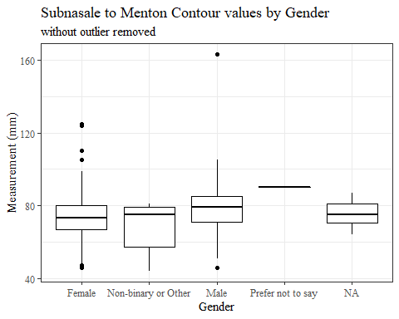

#boxplot not reordered by median  
ggplot(data=headscan_full, aes(y=SnasM_C, x=gender))+  
 geom_boxplot(color= "black", fill = "white")+  
 theme_bw()+theme(text=element_text(family= "Times New Roman"))+  
 #theme(axis.text.x = element_text(angle = 20, vjust=0.7))+  
 labs(title="Subnasale to Menton Contour values by Gender",  
 subtitle = "without outlier removed",  
 y="Measurement (mm)",  
 x="Gender")

## Warning: Removed 236 rows containing non-finite values (stat_boxplot).

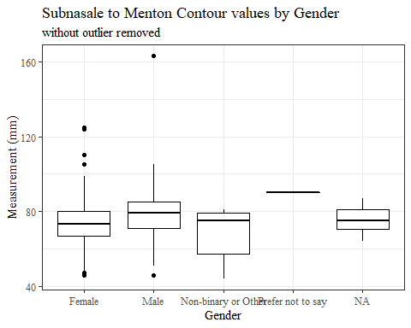

#SnasM_C age group sumstats  
SnasM_Cage_sumstats <- headscan_full %>%   
 group_by(age_group) %>%   
 summarise(n = n(), na = sum(is.na(SnasM_C)),  
 min = min(SnasM_C, na.rm = TRUE),  
 max = max(SnasM_C, na.rm = TRUE),  
 mean = mean(SnasM_C, na.rm = TRUE),  
 sd = sd(SnasM_C, na.rm = TRUE),  
 se = sd/sqrt(n),  
 percent5th = quantile(SnasM_C, 0.05, na.rm=TRUE),  
 percent25th = quantile(SnasM_C, 0.25, na.rm=TRUE),  
 percent50th = quantile(SnasM_C, 0.50, na.rm=TRUE),  
 percent75th = quantile(SnasM_C, 0.75, na.rm=TRUE),  
 percent95th = quantile(SnasM_C, 0.95, na.rm=TRUE))  
  
SnasM_Cage_sumstats <- SnasM_Cage_sumstats %>%   
 mutate(across(where(is.numeric), round, 2))  
  
  
#Size 12 Table TNR  
flextable(SnasM_Cage_sumstats) %>%  
 my_ft_theme()%>%   
 bold(part = "header") %>%   
 set_caption("Subnasale to Menton Contour SumStats by Age Group w/o outlier removed")

**Table** : Subnasale to Menton Contour SumStats by Age Group w/o outlier removed

| **age_group** | **n** | **na** | **min** | **max** | **mean** | **sd** | **se** | **percent5th** | **percent25th** | **percent50th** | **percent75th** | **percent95th** |
| --- | --- | --- | --- | --- | --- | --- | --- | --- | --- | --- | --- | --- |
| 18-36 | 991 | 124 | 44 | 163 | 74.98 | 10.78 | 0.34 | 57 | 68 | 75.0 | 82 | 92.00 |
| 37-54 | 940 | 106 | 47 | 125 | 75.38 | 10.82 | 0.35 | 57 | 69 | 75.0 | 83 | 93.00 |
| 55-72 | 84 | 6 | 49 | 102 | 73.50 | 11.13 | 1.21 | 53 | 66 | 71.5 | 82 | 88.45 |
|  | 1 | 0 | 71 | 71 | 71.00 |  |  | 71 | 71 | 71.0 | 71 | 71.00 |

#%>% set_header_Cabels(values = list(SnasM_C = "Subnasale/SubnasaleCont"))  
  
#Autofit Width Table TNR  
flextable(SnasM_Cage_sumstats) %>%  
 my_ft_theme()%>%   
 bold(part = "header") %>%   
 set_caption("Subnasale to Menton Contour SumStats by Age Group w/o outlier removed") %>%   
 fit_to_width(7.5)

**Table** : Subnasale to Menton Contour SumStats by Age Group w/o outlier removed

| **age_group** | **n** | **na** | **min** | **max** | **mean** | **sd** | **se** | **percent5th** | **percent25th** | **percent50th** | **percent75th** | **percent95th** |
| --- | --- | --- | --- | --- | --- | --- | --- | --- | --- | --- | --- | --- |
| 18-36 | 991 | 124 | 44 | 163 | 74.98 | 10.78 | 0.34 | 57 | 68 | 75.0 | 82 | 92.00 |
| 37-54 | 940 | 106 | 47 | 125 | 75.38 | 10.82 | 0.35 | 57 | 69 | 75.0 | 83 | 93.00 |
| 55-72 | 84 | 6 | 49 | 102 | 73.50 | 11.13 | 1.21 | 53 | 66 | 71.5 | 82 | 88.45 |
|  | 1 | 0 | 71 | 71 | 71.00 |  |  | 71 | 71 | 71.0 | 71 | 71.00 |

#%>% set_header_Cabels(values = list(SnasM_C = "Subnasale/SubnasaleCont"))  
  
#boxplot reorderd by median  
headscan_full %>%   
 ungroup() %>%   
 mutate(age_group= fct_reorder(age_group, SnasM_C, FUN=median, na.rm=TRUE)) %>%   
 ggplot(aes(y=SnasM_C, x=age_group))+  
 geom_boxplot(color= "black", fill = "white")+  
 theme_bw()+theme(text=element_text(family= "Times New Roman"))+  
 #theme(axis.text.x = element_text(angle = 20, vjust=0.7))+  
 labs(title="Subnasale to Menton Contour values by Age Group",  
 subtitle = "without outlier removed",  
 y="Measurement (mm)",  
 x="Age Group")

## Warning: Removed 236 rows containing non-finite values (stat_boxplot).

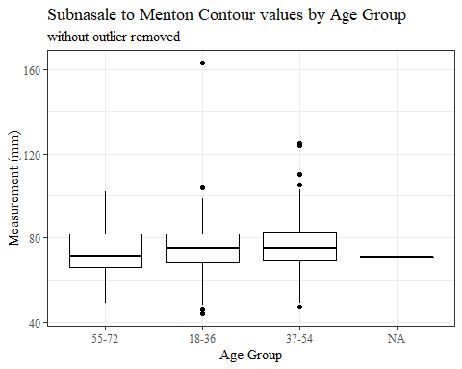

#boxplot not reordered by median  
ggplot(data=headscan_full, aes(y=SnasM_C, x=age_group))+  
 geom_boxplot(color= "black", fill = "white")+  
 theme_bw()+theme(text=element_text(family= "Times New Roman"))+  
 #theme(axis.text.x = element_text(angle = 20, vjust=0.7))+  
 labs(title="Subnasale to Menton Contour values by Age Group",  
 subtitle = "without outlier removed",  
 y="Measurement (mm)",  
 x="Age Group")

## Warning: Removed 236 rows containing non-finite values (stat_boxplot).

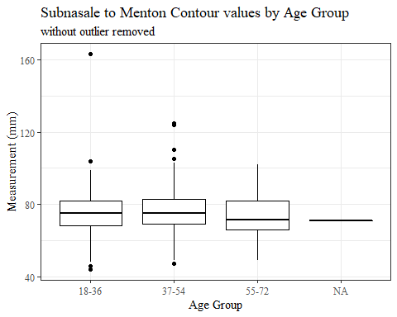

SnasM_C with outlier removed

#REMOVING OUTLIER SnasM_C  
  
max(headscan_full$SnasM_C, na.rm = TRUE)

## [1] 163

#CODE TO REMOVE OUTLIER, use later to remove from headscan_full  
SnasM_C_no_out <- headscan_full %>% mutate(SnasM_C = replace(SnasM_C, SnasM_C>160, NA))

#histogram of all SnasM_C values  
ggplot(data=SnasM_C_no_out, aes(x=SnasM_C))+  
 geom_bar(stat="bin", bins=20, color= "black", fill = "white")+  
 theme_bw()+theme(text=element_text(family= "Times New Roman"))+  
 labs(title="Subnasale to Menton Contour Measurement Distribution",  
 y="Frequency",  
 x="Subnasale to Menton Contour (mm)")

## Warning: Removed 237 rows containing non-finite values (stat_bin).

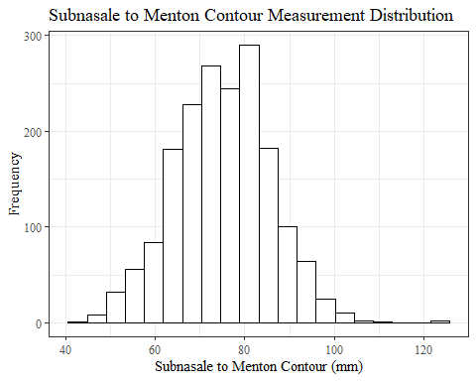

SnasM_Csumstats1 <- SnasM_C_no_out %>%   
 summarise(n = n(), na = sum(is.na(SnasM_C)),  
 min = min(SnasM_C, na.rm = TRUE),  
 max = max(SnasM_C, na.rm = TRUE),  
 mean = mean(SnasM_C, na.rm = TRUE),  
 mdn = median(SnasM_C, na.rm = TRUE),  
 sd = sd(SnasM_C, na.rm = TRUE),  
 se = sd/sqrt(n),  
 percent5th = quantile(SnasM_C, 0.05, na.rm=TRUE),  
 percent25th = quantile(SnasM_C, 0.25, na.rm=TRUE),  
 percent50th = quantile(SnasM_C, 0.50, na.rm=TRUE),  
 percent75th = quantile(SnasM_C, 0.75, na.rm=TRUE),  
 percent95th = quantile(SnasM_C, 0.95, na.rm=TRUE))   
  
SnasM_Csumstats1 <- round(SnasM_Csumstats1, 2)  
  
#Size 12 Table TNR  
flextable(SnasM_Csumstats1) %>%  
 my_ft_theme()%>%   
 bold(part = "header") %>%   
 set_caption("Subnasale to Menton Contour SumStats")

**Table** : Subnasale to Menton Contour SumStats

| **n** | **na** | **min** | **max** | **mean** | **mdn** | **sd** | **se** | **percent5th** | **percent25th** | **percent50th** | **percent75th** | **percent95th** |
| --- | --- | --- | --- | --- | --- | --- | --- | --- | --- | --- | --- | --- |
| 2,016 | 237 | 44 | 125 | 75.05 | 75 | 10.61 | 0.24 | 57 | 68 | 75 | 82 | 92 |

#%>% set_header_Cabels(values = list(SnasM_C = "Subnasale/SubnasaleCont"))  
  
#Autofit Width Table TNR  
flextable(SnasM_Csumstats1) %>%  
 my_ft_theme()%>%   
 bold(part = "header") %>%   
 set_caption("Subnasale to Menton Contour SumStats") %>%   
 fit_to_width(7.5)

**Table** : Subnasale to Menton Contour SumStats

| **n** | **na** | **min** | **max** | **mean** | **mdn** | **sd** | **se** | **percent5th** | **percent25th** | **percent50th** | **percent75th** | **percent95th** |
| --- | --- | --- | --- | --- | --- | --- | --- | --- | --- | --- | --- | --- |
| 2,016 | 237 | 44 | 125 | 75.05 | 75 | 10.61 | 0.24 | 57 | 68 | 75 | 82 | 92 |

#%>% set_header_Cabels(values = list(SnasM_C = "Subnasale/SubnasaleCont"))

#SnasM_C race/eth sumstats  
SnasM_Crace_sumstats1 <- SnasM_C_no_out %>%   
 group_by(race_eth) %>%   
 summarise(n = n(), na = sum(is.na(SnasM_C)),  
 min = min(SnasM_C, na.rm = TRUE),  
 max = max(SnasM_C, na.rm = TRUE),  
 mean = mean(SnasM_C, na.rm = TRUE),  
 mdn = median(SnasM_C, na.rm = TRUE),  
 sd = sd(SnasM_C, na.rm = TRUE),  
 se = sd/sqrt(n),  
 percent5th = quantile(SnasM_C, 0.05, na.rm=TRUE),  
 percent25th = quantile(SnasM_C, 0.25, na.rm=TRUE),  
 percent50th = quantile(SnasM_C, 0.50, na.rm=TRUE),  
 percent75th = quantile(SnasM_C, 0.75, na.rm=TRUE),  
 percent95th = quantile(SnasM_C, 0.95, na.rm=TRUE))   
  
SnasM_Crace_sumstats1 <- SnasM_Crace_sumstats1 %>%   
 mutate(across(where(is.numeric), round, 2))  
  
  
#Size 12 Table TNR  
flextable(SnasM_Crace_sumstats1) %>%  
 my_ft_theme()%>%   
 bold(part = "header") %>%   
 set_caption("Subnasale to Menton Contour SumStats by Race/Ethnicity")

**Table** : Subnasale to Menton Contour SumStats by Race/Ethnicity

| **race_eth** | **n** | **na** | **min** | **max** | **mean** | **mdn** | **sd** | **se** | **percent5th** | **percent25th** | **percent50th** | **percent75th** | **percent95th** |
| --- | --- | --- | --- | --- | --- | --- | --- | --- | --- | --- | --- | --- | --- |
| white | 1,239 | 145 | 44 | 102 | 72.81 | 73.0 | 9.72 | 0.28 | 56.00 | 67.00 | 73.0 | 79.00 | 89.00 |
| Black | 548 | 71 | 54 | 124 | 81.09 | 82.0 | 10.03 | 0.43 | 63.00 | 75.00 | 82.0 | 87.00 | 96.20 |
| LatinX | 100 | 9 | 50 | 97 | 73.64 | 74.0 | 10.98 | 1.10 | 54.50 | 67.00 | 74.0 | 82.00 | 92.50 |
| Asian | 91 | 5 | 46 | 125 | 72.16 | 71.5 | 11.66 | 1.22 | 55.50 | 65.25 | 71.5 | 78.75 | 91.50 |
| Other | 21 | 5 | 59 | 85 | 72.12 | 71.5 | 7.31 | 1.60 | 59.75 | 69.00 | 71.5 | 76.50 | 82.75 |
| AIAN | 8 | 2 | 58 | 93 | 71.50 | 66.0 | 13.85 | 4.90 | 59.00 | 62.50 | 66.0 | 80.00 | 90.75 |
| PTNS | 5 | 0 | 62 | 90 | 79.80 | 86.0 | 11.41 | 5.10 | 64.60 | 75.00 | 86.0 | 86.00 | 89.20 |
| NHOPI | 4 | 0 | 62 | 85 | 74.75 | 76.0 | 10.69 | 5.34 | 63.20 | 68.00 | 76.0 | 82.75 | 84.55 |

#%>% set_header_Cabels(values = list(SnasM_C = "Subnasale/SubnasaleCont"))  
  
#Autofit Width Table TNR  
flextable(SnasM_Crace_sumstats1) %>%  
 my_ft_theme()%>%   
 bold(part = "header") %>%   
 set_caption("Subnasale to Menton Contour SumStats by Race/Ethnicity") %>%   
 fit_to_width(7.5)

**Table** : Subnasale to Menton Contour SumStats by Race/Ethnicity

| **race_eth** | **n** | **na** | **min** | **max** | **mean** | **mdn** | **sd** | **se** | **percent5th** | **percent25th** | **percent50th** | **percent75th** | **percent95th** |
| --- | --- | --- | --- | --- | --- | --- | --- | --- | --- | --- | --- | --- | --- |
| white | 1,239 | 145 | 44 | 102 | 72.81 | 73.0 | 9.72 | 0.28 | 56.00 | 67.00 | 73.0 | 79.00 | 89.00 |
| Black | 548 | 71 | 54 | 124 | 81.09 | 82.0 | 10.03 | 0.43 | 63.00 | 75.00 | 82.0 | 87.00 | 96.20 |
| LatinX | 100 | 9 | 50 | 97 | 73.64 | 74.0 | 10.98 | 1.10 | 54.50 | 67.00 | 74.0 | 82.00 | 92.50 |
| Asian | 91 | 5 | 46 | 125 | 72.16 | 71.5 | 11.66 | 1.22 | 55.50 | 65.25 | 71.5 | 78.75 | 91.50 |
| Other | 21 | 5 | 59 | 85 | 72.12 | 71.5 | 7.31 | 1.60 | 59.75 | 69.00 | 71.5 | 76.50 | 82.75 |
| AIAN | 8 | 2 | 58 | 93 | 71.50 | 66.0 | 13.85 | 4.90 | 59.00 | 62.50 | 66.0 | 80.00 | 90.75 |
| PTNS | 5 | 0 | 62 | 90 | 79.80 | 86.0 | 11.41 | 5.10 | 64.60 | 75.00 | 86.0 | 86.00 | 89.20 |
| NHOPI | 4 | 0 | 62 | 85 | 74.75 | 76.0 | 10.69 | 5.34 | 63.20 | 68.00 | 76.0 | 82.75 | 84.55 |

#%>% set_header_Cabels(values = list(SnasM_C = "Subnasale/SubnasaleCont"))  
  
#boxplot reorderd by median  
SnasM_C_no_out %>%   
 ungroup() %>%   
 mutate(race_eth= fct_reorder(race_eth, SnasM_C, FUN=median, na.rm=TRUE)) %>%   
 ggplot(aes(y=SnasM_C, x=race_eth))+  
 geom_boxplot(color= "black", fill = "white")+  
 theme_bw()+theme(text=element_text(family= "Times New Roman"))+  
 #theme(axis.text.x = element_text(angle = 20, vjust=0.7))+  
 labs(title="Subnasale to Menton Contour values by Race/Ethnicity",  
 y="Measurement (mm)",  
 x="Race/Ethnicity")

## Warning: Removed 237 rows containing non-finite values (stat_boxplot).

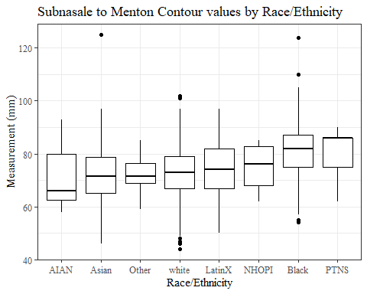

#boxplot not reordered by median  
ggplot(data=SnasM_C_no_out, aes(y=SnasM_C, x=race_eth))+  
 geom_boxplot(color= "black", fill = "white")+  
 theme_bw()+theme(text=element_text(family= "Times New Roman"))+  
 #theme(axis.text.x = element_text(angle = 20, vjust=0.7))+  
 labs(title="Subnasale to Menton Contour values by Race/Ethnicity",  
 y="Measurement (mm)",  
 x="Race/Ethnicity")

## Warning: Removed 237 rows containing non-finite values (stat_boxplot).

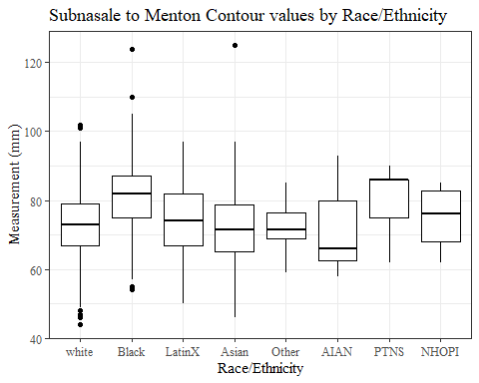

#SnasM_C gender sumstats  
SnasM_Cgender_sumstats1 <- SnasM_C_no_out %>%   
 group_by(gender) %>%   
 summarise(n = n(), na = sum(is.na(SnasM_C)),  
 min = min(SnasM_C, na.rm = TRUE),  
 max = max(SnasM_C, na.rm = TRUE),  
 mean = mean(SnasM_C, na.rm = TRUE),  
 mdn = median(SnasM_C, na.rm = TRUE),  
 sd = sd(SnasM_C, na.rm = TRUE),  
 se = sd/sqrt(n),  
 percent5th = quantile(SnasM_C, 0.05, na.rm=TRUE),  
 percent25th = quantile(SnasM_C, 0.25, na.rm=TRUE),  
 percent50th = quantile(SnasM_C, 0.50, na.rm=TRUE),  
 percent75th = quantile(SnasM_C, 0.75, na.rm=TRUE),  
 percent95th = quantile(SnasM_C, 0.95, na.rm=TRUE))  
  
SnasM_Cgender_sumstats1 <- SnasM_Cgender_sumstats1 %>%   
 mutate(across(where(is.numeric), round, 2))  
  
#Size 12 Table TNR  
flextable(SnasM_Cgender_sumstats1) %>%  
 my_ft_theme()%>%   
 bold(part = "header") %>%   
 set_caption("Subnasale to Menton Contour SumStats by Gender")

**Table** : Subnasale to Menton Contour SumStats by Gender

| **gender** | **n** | **na** | **min** | **max** | **mean** | **mdn** | **sd** | **se** | **percent5th** | **percent25th** | **percent50th** | **percent75th** | **percent95th** |
| --- | --- | --- | --- | --- | --- | --- | --- | --- | --- | --- | --- | --- | --- |
| Female | 1,063 | 23 | 46 | 125 | 73.02 | 73 | 10.05 | 0.31 | 55.0 | 67.0 | 73 | 80.00 | 88.00 |
| Male | 939 | 214 | 46 | 105 | 77.99 | 79 | 10.69 | 0.35 | 60.0 | 71.0 | 79 | 85.00 | 94.00 |
| Non-binary or Other | 5 | 0 | 44 | 81 | 67.20 | 75 | 16.07 | 7.19 | 46.6 | 57.0 | 75 | 79.00 | 80.60 |
| Prefer not to say | 1 | 0 | 90 | 90 | 90.00 | 90 |  |  | 90.0 | 90.0 | 90 | 90.00 | 90.00 |
|  | 8 | 0 | 64 | 87 | 75.50 | 75 | 8.38 | 2.96 | 64.7 | 70.5 | 75 | 80.75 | 86.65 |

#%>% set_header_Cabels(values = list(SnasM_C = "Subnasale/SubnasaleCont"))  
  
#Autofit Width Table TNR  
flextable(SnasM_Cgender_sumstats1) %>%  
 my_ft_theme()%>%   
 bold(part = "header") %>%   
 set_caption("Subnasale to Menton Contour SumStats by Gender") %>%   
 fit_to_width(7.5)

**Table** : Subnasale to Menton Contour SumStats by Gender

| **gender** | **n** | **na** | **min** | **max** | **mean** | **mdn** | **sd** | **se** | **percent5th** | **percent25th** | **percent50th** | **percent75th** | **percent95th** |
| --- | --- | --- | --- | --- | --- | --- | --- | --- | --- | --- | --- | --- | --- |
| Female | 1,063 | 23 | 46 | 125 | 73.02 | 73 | 10.05 | 0.31 | 55.0 | 67.0 | 73 | 80.00 | 88.00 |
| Male | 939 | 214 | 46 | 105 | 77.99 | 79 | 10.69 | 0.35 | 60.0 | 71.0 | 79 | 85.00 | 94.00 |
| Non-binary or Other | 5 | 0 | 44 | 81 | 67.20 | 75 | 16.07 | 7.19 | 46.6 | 57.0 | 75 | 79.00 | 80.60 |
| Prefer not to say | 1 | 0 | 90 | 90 | 90.00 | 90 |  |  | 90.0 | 90.0 | 90 | 90.00 | 90.00 |
|  | 8 | 0 | 64 | 87 | 75.50 | 75 | 8.38 | 2.96 | 64.7 | 70.5 | 75 | 80.75 | 86.65 |

#%>% set_header_Cabels(values = list(SnasM_C = "Subnasale/SubnasaleCont"))  
  
#boxplot reorderd by median  
SnasM_C_no_out %>%   
 ungroup() %>%   
 mutate(gender= fct_reorder(gender, SnasM_C, FUN=median, na.rm=TRUE)) %>%   
 ggplot(aes(y=SnasM_C, x=gender))+  
 geom_boxplot(color= "black", fill = "white")+  
 theme_bw()+theme(text=element_text(family= "Times New Roman"))+  
 #theme(axis.text.x = element_text(angle = 20, vjust=0.7))+  
 labs(title="Subnasale to Menton Contour values by Gender",  
 y="Measurement (mm)",  
 x="Gender")

## Warning: Removed 237 rows containing non-finite values (stat_boxplot).

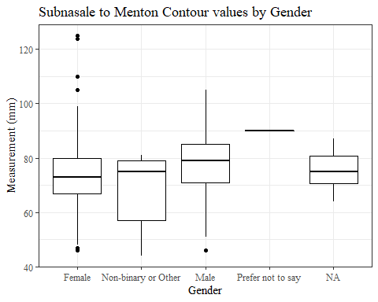

#boxplot not reordered by median  
ggplot(data=SnasM_C_no_out, aes(y=SnasM_C, x=gender))+  
 geom_boxplot(color= "black", fill = "white")+  
 theme_bw()+theme(text=element_text(family= "Times New Roman"))+  
 #theme(axis.text.x = element_text(angle = 20, vjust=0.7))+  
 labs(title="Subnasale to Menton Contour values by Gender",  
 y="Measurement (mm)",  
 x="Gender")

## Warning: Removed 237 rows containing non-finite values (stat_boxplot).

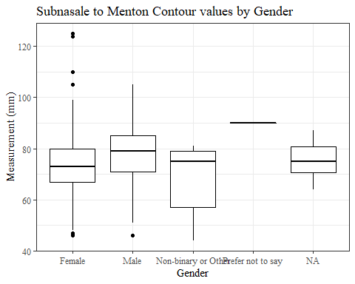

#SnasM_C age group sumstats  
SnasM_Cage_sumstats1 <- SnasM_C_no_out %>%   
 group_by(age_group) %>%   
 summarise(n = n(), na = sum(is.na(SnasM_C)),  
 min = min(SnasM_C, na.rm = TRUE),  
 max = max(SnasM_C, na.rm = TRUE),  
 mean = mean(SnasM_C, na.rm = TRUE),  
 sd = sd(SnasM_C, na.rm = TRUE),  
 se = sd/sqrt(n),  
 percent5th = quantile(SnasM_C, 0.05, na.rm=TRUE),  
 percent25th = quantile(SnasM_C, 0.25, na.rm=TRUE),  
 percent50th = quantile(SnasM_C, 0.50, na.rm=TRUE),  
 percent75th = quantile(SnasM_C, 0.75, na.rm=TRUE),  
 percent95th = quantile(SnasM_C, 0.95, na.rm=TRUE))  
  
SnasM_Cage_sumstats1 <- SnasM_Cage_sumstats1 %>%   
 mutate(across(where(is.numeric), round, 2))  
  
  
#Size 12 Table TNR  
flextable(SnasM_Cage_sumstats1) %>%  
 my_ft_theme()%>%   
 bold(part = "header") %>%   
 set_caption("Subnasale to Menton Contour SumStats by Age Group")

**Table** : Subnasale to Menton Contour SumStats by Age Group

| **age_group** | **n** | **na** | **min** | **max** | **mean** | **sd** | **se** | **percent5th** | **percent25th** | **percent50th** | **percent75th** | **percent95th** |
| --- | --- | --- | --- | --- | --- | --- | --- | --- | --- | --- | --- | --- |
| 18-36 | 991 | 125 | 44 | 104 | 74.88 | 10.36 | 0.33 | 57 | 68 | 75.0 | 82 | 92.00 |
| 37-54 | 940 | 106 | 47 | 125 | 75.38 | 10.82 | 0.35 | 57 | 69 | 75.0 | 83 | 93.00 |
| 55-72 | 84 | 6 | 49 | 102 | 73.50 | 11.13 | 1.21 | 53 | 66 | 71.5 | 82 | 88.45 |
|  | 1 | 0 | 71 | 71 | 71.00 |  |  | 71 | 71 | 71.0 | 71 | 71.00 |

#%>% set_header_Cabels(values = list(SnasM_C = "Subnasale/SubnasaleCont"))  
  
#Autofit Width Table TNR  
flextable(SnasM_Cage_sumstats1) %>%  
 my_ft_theme()%>%   
 bold(part = "header") %>%   
 set_caption("Subnasale to Menton Contour SumStats by Age Group") %>%   
 fit_to_width(7.5)

**Table** : Subnasale to Menton Contour SumStats by Age Group

| **age_group** | **n** | **na** | **min** | **max** | **mean** | **sd** | **se** | **percent5th** | **percent25th** | **percent50th** | **percent75th** | **percent95th** |
| --- | --- | --- | --- | --- | --- | --- | --- | --- | --- | --- | --- | --- |
| 18-36 | 991 | 125 | 44 | 104 | 74.88 | 10.36 | 0.33 | 57 | 68 | 75.0 | 82 | 92.00 |
| 37-54 | 940 | 106 | 47 | 125 | 75.38 | 10.82 | 0.35 | 57 | 69 | 75.0 | 83 | 93.00 |
| 55-72 | 84 | 6 | 49 | 102 | 73.50 | 11.13 | 1.21 | 53 | 66 | 71.5 | 82 | 88.45 |
|  | 1 | 0 | 71 | 71 | 71.00 |  |  | 71 | 71 | 71.0 | 71 | 71.00 |

#%>% set_header_Cabels(values = list(SnasM_C = "Subnasale/SubnasaleCont"))  
  
#boxplot reorderd by median  
SnasM_C_no_out %>%   
 ungroup() %>%   
 mutate(age_group= fct_reorder(age_group, SnasM_C, FUN=median, na.rm=TRUE)) %>%   
 ggplot(aes(y=SnasM_C, x=age_group))+  
 geom_boxplot(color= "black", fill = "white")+  
 theme_bw()+theme(text=element_text(family= "Times New Roman"))+  
 #theme(axis.text.x = element_text(angle = 20, vjust=0.7))+  
 labs(title="Subnasale to Menton Contour values by Age Group",  
 y="Measurement (mm)",  
 x="Age Group")

## Warning: Removed 237 rows containing non-finite values (stat_boxplot).

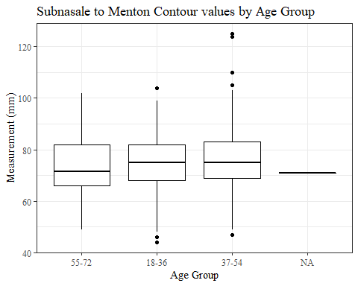

#boxplot not reordered by median  
ggplot(data=SnasM_C_no_out, aes(y=SnasM_C, x=age_group))+  
 geom_boxplot(color= "black", fill = "white")+  
 theme_bw()+theme(text=element_text(family= "Times New Roman"))+  
 #theme(axis.text.x = element_text(angle = 20, vjust=0.7))+  
 labs(title="Subnasale to Menton Contour values by Age Group",  
 y="Measurement (mm)",  
 x="Age Group")

## Warning: Removed 237 rows containing non-finite values (stat_boxplot).

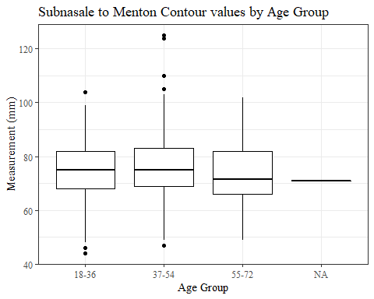

TrHO_C

#histogram of all TrHO_C values  
ggplot(data=headscan_full, aes(x=TrHO_C))+  
 geom_bar(stat="bin", bins=20, color= "black", fill = "white")+  
 theme_bw()+theme(text=element_text(family= "Times New Roman"))+  
 labs(title="Top of Head to Otobasion Contour Measurement Distribution",  
 y="Frequency",  
 x="Top of Head to Otobasion Contour (mm)")

## Warning: Removed 282 rows containing non-finite values (stat_bin).

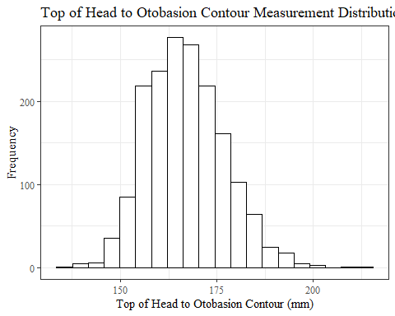

TrHO_Csumstats <- headscan_full %>%   
 summarise(n = n(), na = sum(is.na(TrHO_C)),  
 min = min(TrHO_C, na.rm = TRUE),  
 max = max(TrHO_C, na.rm = TRUE),  
 mean = mean(TrHO_C, na.rm = TRUE),  
 mdn = median(TrHO_C, na.rm = TRUE),  
 sd = sd(TrHO_C, na.rm = TRUE),  
 se = sd/sqrt(n),  
 percent5th = quantile(TrHO_C, 0.05, na.rm=TRUE),  
 percent25th = quantile(TrHO_C, 0.25, na.rm=TRUE),  
 percent50th = quantile(TrHO_C, 0.50, na.rm=TRUE),  
 percent75th = quantile(TrHO_C, 0.75, na.rm=TRUE),  
 percent95th = quantile(TrHO_C, 0.95, na.rm=TRUE))   
  
TrHO_Csumstats <- TrHO_Csumstats %>%   
 mutate(across(where(is.numeric), round, 2))  
  
  
#Size 12 Table TNR  
flextable(TrHO_Csumstats) %>%  
 my_ft_theme()%>%   
 bold(part = "header") %>%   
 set_caption("Top of Head to Otobasion Contour SumStats")

**Table** : Top of Head to Otobasion Contour SumStats

| **n** | **na** | **min** | **max** | **mean** | **mdn** | **sd** | **se** | **percent5th** | **percent25th** | **percent50th** | **percent75th** | **percent95th** |
| --- | --- | --- | --- | --- | --- | --- | --- | --- | --- | --- | --- | --- |
| 2,016 | 282 | 135 | 213 | 166.98 | 167 | 10 | 0.22 | 152 | 160 | 167 | 173 | 184 |

#%>% set_header_Cabels(values = list(TrHO_C = "Subnasale/SubnasaleCont"))  
  
#Autofit Width Table TNR  
flextable(TrHO_Csumstats) %>%  
 my_ft_theme()%>%   
 bold(part = "header") %>%   
 set_caption("Top of Head to Otobasion Contour SumStats") %>%   
 fit_to_width(7.5)

**Table** : Top of Head to Otobasion Contour SumStats

| **n** | **na** | **min** | **max** | **mean** | **mdn** | **sd** | **se** | **percent5th** | **percent25th** | **percent50th** | **percent75th** | **percent95th** |
| --- | --- | --- | --- | --- | --- | --- | --- | --- | --- | --- | --- | --- |
| 2,016 | 282 | 135 | 213 | 166.98 | 167 | 10 | 0.22 | 152 | 160 | 167 | 173 | 184 |

#%>% set_header_Cabels(values = list(TrHO_C = "Subnasale/SubnasaleCont"))

#TrHO_C race/eth sumstats  
TrHO_Crace_sumstats <- headscan_full %>%   
 group_by(race_eth) %>%   
 summarise(n = n(), na = sum(is.na(TrHO_C)),  
 min = min(TrHO_C, na.rm = TRUE),  
 max = max(TrHO_C, na.rm = TRUE),  
 mean = mean(TrHO_C, na.rm = TRUE),  
 mdn = median(TrHO_C, na.rm = TRUE),  
 sd = sd(TrHO_C, na.rm = TRUE),  
 se = sd/sqrt(n),  
 percent5th = quantile(TrHO_C, 0.05, na.rm=TRUE),  
 percent25th = quantile(TrHO_C, 0.25, na.rm=TRUE),  
 percent50th = quantile(TrHO_C, 0.50, na.rm=TRUE),  
 percent75th = quantile(TrHO_C, 0.75, na.rm=TRUE),  
 percent95th = quantile(TrHO_C, 0.95, na.rm=TRUE))   
  
TrHO_Crace_sumstats <- TrHO_Crace_sumstats %>%   
 mutate(across(where(is.numeric), round, 2))  
  
  
#Size 12 Table TNR  
flextable(TrHO_Crace_sumstats) %>%  
 my_ft_theme()%>%   
 bold(part = "header") %>%   
 set_caption("Top of Head to Otobasion Contour SumStats by Race/Ethnicity")

**Table** : Top of Head to Otobasion Contour SumStats by Race/Ethnicity

| **race_eth** | **n** | **na** | **min** | **max** | **mean** | **mdn** | **sd** | **se** | **percent5th** | **percent25th** | **percent50th** | **percent75th** | **percent95th** |
| --- | --- | --- | --- | --- | --- | --- | --- | --- | --- | --- | --- | --- | --- |
| white | 1,239 | 116 | 135 | 213 | 166.19 | 166.0 | 9.71 | 0.28 | 152.00 | 159.00 | 166.0 | 172.00 | 183.00 |
| Black | 548 | 138 | 141 | 203 | 168.11 | 168.0 | 10.85 | 0.46 | 151.00 | 160.00 | 168.0 | 175.00 | 185.00 |
| LatinX | 100 | 11 | 150 | 196 | 168.34 | 167.0 | 10.11 | 1.01 | 155.00 | 161.00 | 167.0 | 174.00 | 185.60 |
| Asian | 91 | 9 | 151 | 188 | 169.96 | 169.0 | 7.90 | 0.83 | 156.05 | 165.00 | 169.0 | 175.75 | 182.90 |
| Other | 21 | 3 | 142 | 184 | 167.50 | 167.5 | 10.11 | 2.21 | 154.75 | 162.25 | 167.5 | 174.75 | 184.00 |
| AIAN | 8 | 1 | 153 | 182 | 167.00 | 167.0 | 12.15 | 4.30 | 153.60 | 156.00 | 167.0 | 177.50 | 180.80 |
| PTNS | 5 | 4 | 181 | 181 | 181.00 | 181.0 |  |  | 181.00 | 181.00 | 181.0 | 181.00 | 181.00 |
| NHOPI | 4 | 0 | 166 | 179 | 173.25 | 174.0 | 5.38 | 2.69 | 167.20 | 172.00 | 174.0 | 175.25 | 178.25 |

#%>% set_header_Cabels(values = list(TrHO_C = "Subnasale/SubnasaleCont"))  
  
#Autofit Width Table TNR  
flextable(TrHO_Crace_sumstats) %>%  
 my_ft_theme()%>%   
 bold(part = "header") %>%   
 set_caption("Top of Head to Otobasion Contour SumStats by Race/Ethnicity") %>%   
 fit_to_width(7.5)

**Table** : Top of Head to Otobasion Contour SumStats by Race/Ethnicity

| **race_eth** | **n** | **na** | **min** | **max** | **mean** | **mdn** | **sd** | **se** | **percent5th** | **percent25th** | **percent50th** | **percent75th** | **percent95th** |
| --- | --- | --- | --- | --- | --- | --- | --- | --- | --- | --- | --- | --- | --- |
| white | 1,239 | 116 | 135 | 213 | 166.19 | 166.0 | 9.71 | 0.28 | 152.00 | 159.00 | 166.0 | 172.00 | 183.00 |
| Black | 548 | 138 | 141 | 203 | 168.11 | 168.0 | 10.85 | 0.46 | 151.00 | 160.00 | 168.0 | 175.00 | 185.00 |
| LatinX | 100 | 11 | 150 | 196 | 168.34 | 167.0 | 10.11 | 1.01 | 155.00 | 161.00 | 167.0 | 174.00 | 185.60 |
| Asian | 91 | 9 | 151 | 188 | 169.96 | 169.0 | 7.90 | 0.83 | 156.05 | 165.00 | 169.0 | 175.75 | 182.90 |
| Other | 21 | 3 | 142 | 184 | 167.50 | 167.5 | 10.11 | 2.21 | 154.75 | 162.25 | 167.5 | 174.75 | 184.00 |
| AIAN | 8 | 1 | 153 | 182 | 167.00 | 167.0 | 12.15 | 4.30 | 153.60 | 156.00 | 167.0 | 177.50 | 180.80 |
| PTNS | 5 | 4 | 181 | 181 | 181.00 | 181.0 |  |  | 181.00 | 181.00 | 181.0 | 181.00 | 181.00 |
| NHOPI | 4 | 0 | 166 | 179 | 173.25 | 174.0 | 5.38 | 2.69 | 167.20 | 172.00 | 174.0 | 175.25 | 178.25 |

#%>% set_header_Cabels(values = list(TrHO_C = "Subnasale/SubnasaleCont"))  
  
#boxplot reorderd by median  
headscan_full %>%   
 ungroup() %>%   
 mutate(race_eth= fct_reorder(race_eth, TrHO_C, FUN=median, na.rm=TRUE)) %>%   
 ggplot(aes(y=TrHO_C, x=race_eth))+  
 geom_boxplot(color= "black", fill = "white")+  
 theme_bw()+theme(text=element_text(family= "Times New Roman"))+  
 #theme(axis.text.x = element_text(angle = 20, vjust=0.7))+  
 labs(title="Top of Head to Otobasion Contour values by Race/Ethnicity",  
 y="Measurement (mm)",  
 x="Race/Ethnicity")

## Warning: Removed 282 rows containing non-finite values (stat_boxplot).

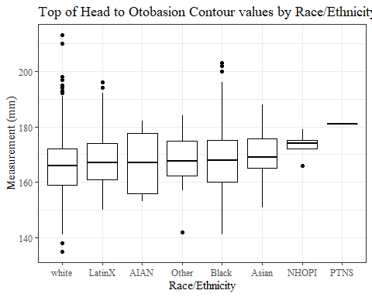

#boxplot not reordered by median  
ggplot(data=headscan_full, aes(y=TrHO_C, x=race_eth))+  
 geom_boxplot(color= "black", fill = "white")+  
 theme_bw()+theme(text=element_text(family= "Times New Roman"))+  
 #theme(axis.text.x = element_text(angle = 20, vjust=0.7))+  
 labs(title="Top of Head to Otobasion Contour values by Race/Ethnicity",  
 y="Measurement (mm)",  
 x="Race/Ethnicity")

## Warning: Removed 282 rows containing non-finite values (stat_boxplot).

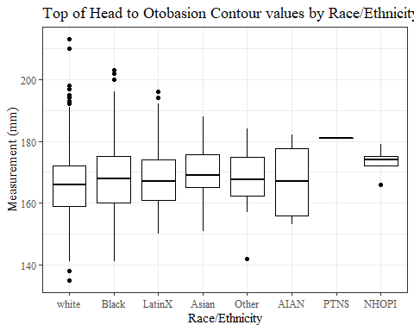

#TrHO_C gender sumstats  
TrHO_Cgender_sumstats <- headscan_full %>%   
 group_by(gender) %>%   
 summarise(n = n(), na = sum(is.na(TrHO_C)),  
 min = min(TrHO_C, na.rm = TRUE),  
 max = max(TrHO_C, na.rm = TRUE),  
 mean = mean(TrHO_C, na.rm = TRUE),  
 mdn = median(TrHO_C, na.rm = TRUE),  
 sd = sd(TrHO_C, na.rm = TRUE),  
 se = sd/sqrt(n),  
 percent5th = quantile(TrHO_C, 0.05, na.rm=TRUE),  
 percent25th = quantile(TrHO_C, 0.25, na.rm=TRUE),  
 percent50th = quantile(TrHO_C, 0.50, na.rm=TRUE),  
 percent75th = quantile(TrHO_C, 0.75, na.rm=TRUE),  
 percent95th = quantile(TrHO_C, 0.95, na.rm=TRUE))

## Warning in min(TrHO_C, na.rm = TRUE): no non-missing arguments to min; returning  
## Inf

## Warning in max(TrHO_C, na.rm = TRUE): no non-missing arguments to max; returning  
## -Inf

TrHO_Cgender_sumstats <- TrHO_Cgender_sumstats %>%   
 mutate(across(where(is.numeric), round, 2))  
  
#Size 12 Table TNR  
flextable(TrHO_Cgender_sumstats) %>%  
 my_ft_theme()%>%   
 bold(part = "header") %>%   
 set_caption("Top of Head to Otobasion Contour SumStats by Gender")

**Table** : Top of Head to Otobasion Contour SumStats by Gender

| **gender** | **n** | **na** | **min** | **max** | **mean** | **mdn** | **sd** | **se** | **percent5th** | **percent25th** | **percent50th** | **percent75th** | **percent95th** |
| --- | --- | --- | --- | --- | --- | --- | --- | --- | --- | --- | --- | --- | --- |
| Female | 1,063 | 214 | 135 | 202 | 164.41 | 164 | 9.94 | 0.30 | 151.0 | 157 | 164 | 170 | 182.0 |
| Male | 939 | 64 | 141 | 213 | 169.45 | 169 | 9.43 | 0.31 | 154.0 | 163 | 169 | 175 | 185.0 |
| Non-binary or Other | 5 | 0 | 156 | 184 | 172.00 | 175 | 10.42 | 4.66 | 158.6 | 169 | 175 | 176 | 182.4 |
| Prefer not to say | 1 | 1 | Inf | -Inf |  |  |  |  |  |  |  |  |  |
|  | 8 | 3 | 159 | 175 | 165.40 | 164 | 6.35 | 2.24 | 159.4 | 161 | 164 | 168 | 173.6 |

#%>% set_header_Cabels(values = list(TrHO_C = "Subnasale/SubnasaleCont"))  
  
#Autofit Width Table TNR  
flextable(TrHO_Cgender_sumstats) %>%  
 my_ft_theme()%>%   
 bold(part = "header") %>%   
 set_caption("Top of Head to Otobasion Contour SumStats by Gender") %>%   
 fit_to_width(7.5)

**Table** : Top of Head to Otobasion Contour SumStats by Gender

| **gender** | **n** | **na** | **min** | **max** | **mean** | **mdn** | **sd** | **se** | **percent5th** | **percent25th** | **percent50th** | **percent75th** | **percent95th** |
| --- | --- | --- | --- | --- | --- | --- | --- | --- | --- | --- | --- | --- | --- |
| Female | 1,063 | 214 | 135 | 202 | 164.41 | 164 | 9.94 | 0.30 | 151.0 | 157 | 164 | 170 | 182.0 |
| Male | 939 | 64 | 141 | 213 | 169.45 | 169 | 9.43 | 0.31 | 154.0 | 163 | 169 | 175 | 185.0 |
| Non-binary or Other | 5 | 0 | 156 | 184 | 172.00 | 175 | 10.42 | 4.66 | 158.6 | 169 | 175 | 176 | 182.4 |
| Prefer not to say | 1 | 1 | Inf | -Inf |  |  |  |  |  |  |  |  |  |
|  | 8 | 3 | 159 | 175 | 165.40 | 164 | 6.35 | 2.24 | 159.4 | 161 | 164 | 168 | 173.6 |

#%>% set_header_Cabels(values = list(TrHO_C = "Subnasale/SubnasaleCont"))  
  
#boxplot reorderd by median  
headscan_full %>%   
 ungroup() %>%   
 mutate(gender= fct_reorder(gender, TrHO_C, FUN=median, na.rm=TRUE)) %>%   
 ggplot(aes(y=TrHO_C, x=gender))+  
 geom_boxplot(color= "black", fill = "white")+  
 theme_bw()+theme(text=element_text(family= "Times New Roman"))+  
 theme(axis.text.x = element_text(angle = 20, vjust=0.7))+  
 labs(title="Top of Head to Otobasion Contour values by Gender",  
 y="Measurement (mm)",  
 x="Gender")

## Warning: Removed 282 rows containing non-finite values (stat_boxplot).

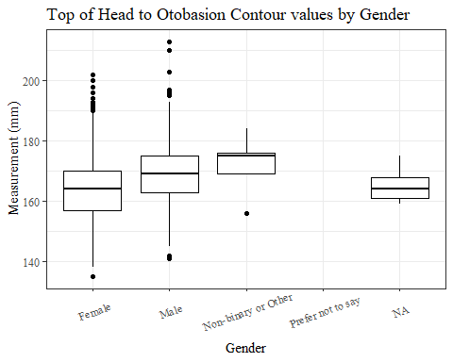

#boxplot not reordered by median  
ggplot(data=headscan_full, aes(y=TrHO_C, x=gender))+  
 geom_boxplot(color= "black", fill = "white")+  
 theme_bw()+theme(text=element_text(family= "Times New Roman"))+  
 theme(axis.text.x = element_text(angle = 20, vjust=0.7))+  
 labs(title="Top of Head to Otobasion Contour values by Gender",  
 y="Measurement (mm)",  
 x="Gender")

## Warning: Removed 282 rows containing non-finite values (stat_boxplot).



#TrHO_C age group sumstats  
TrHO_Cage_sumstats <- headscan_full %>%   
 group_by(age_group) %>%   
 summarise(n = n(), na = sum(is.na(TrHO_C)),  
 min = min(TrHO_C, na.rm = TRUE),  
 max = max(TrHO_C, na.rm = TRUE),  
 mean = mean(TrHO_C, na.rm = TRUE),  
 mdn = median(TrHO_C, na.rm = TRUE),  
 sd = sd(TrHO_C, na.rm = TRUE),  
 se = sd/sqrt(n),  
 percent5th = quantile(TrHO_C, 0.05, na.rm=TRUE),  
 percent25th = quantile(TrHO_C, 0.25, na.rm=TRUE),  
 percent50th = quantile(TrHO_C, 0.50, na.rm=TRUE),  
 percent75th = quantile(TrHO_C, 0.75, na.rm=TRUE),  
 percent95th = quantile(TrHO_C, 0.95, na.rm=TRUE))  
  
TrHO_Cage_sumstats <- TrHO_Cage_sumstats %>%   
 mutate(across(where(is.numeric), round, 2))  
  
  
#Size 12 Table TNR  
flextable(TrHO_Cage_sumstats) %>%  
 my_ft_theme()%>%   
 bold(part = "header") %>%   
 set_caption("Top of Head to Otobasion Contour SumStats by Age Group")

**Table** : Top of Head to Otobasion Contour SumStats by Age Group

| **age_group** | **n** | **na** | **min** | **max** | **mean** | **mdn** | **sd** | **se** | **percent5th** | **percent25th** | **percent50th** | **percent75th** | **percent95th** |
| --- | --- | --- | --- | --- | --- | --- | --- | --- | --- | --- | --- | --- | --- |
| 18-36 | 991 | 152 | 135 | 213 | 168.04 | 167.0 | 10.13 | 0.32 | 153.00 | 161 | 167.0 | 175 | 184.1 |
| 37-54 | 940 | 122 | 138 | 210 | 165.84 | 166.0 | 9.68 | 0.32 | 151.00 | 159 | 166.0 | 172 | 182.0 |
| 55-72 | 84 | 8 | 147 | 192 | 167.43 | 166.5 | 10.83 | 1.18 | 150.75 | 161 | 166.5 | 174 | 186.0 |
|  | 1 | 0 | 169 | 169 | 169.00 | 169.0 |  |  | 169.00 | 169 | 169.0 | 169 | 169.0 |

#%>% set_header_Cabels(values = list(TrHO_C = "Subnasale/SubnasaleCont"))  
  
#Autofit Width Table TNR  
flextable(TrHO_Cage_sumstats) %>%  
 my_ft_theme()%>%   
 bold(part = "header") %>%   
 set_caption("Top of Head to Otobasion Contour SumStats by Age Group") %>%   
 fit_to_width(7.5)

**Table** : Top of Head to Otobasion Contour SumStats by Age Group

| **age_group** | **n** | **na** | **min** | **max** | **mean** | **mdn** | **sd** | **se** | **percent5th** | **percent25th** | **percent50th** | **percent75th** | **percent95th** |
| --- | --- | --- | --- | --- | --- | --- | --- | --- | --- | --- | --- | --- | --- |
| 18-36 | 991 | 152 | 135 | 213 | 168.04 | 167.0 | 10.13 | 0.32 | 153.00 | 161 | 167.0 | 175 | 184.1 |
| 37-54 | 940 | 122 | 138 | 210 | 165.84 | 166.0 | 9.68 | 0.32 | 151.00 | 159 | 166.0 | 172 | 182.0 |
| 55-72 | 84 | 8 | 147 | 192 | 167.43 | 166.5 | 10.83 | 1.18 | 150.75 | 161 | 166.5 | 174 | 186.0 |
|  | 1 | 0 | 169 | 169 | 169.00 | 169.0 |  |  | 169.00 | 169 | 169.0 | 169 | 169.0 |

#%>% set_header_Cabels(values = list(TrHO_C = "Subnasale/SubnasaleCont"))  
  
#boxplot reorderd by median  
headscan_full %>%   
 ungroup() %>%   
 mutate(age_group= fct_reorder(age_group, TrHO_C, FUN=median, na.rm=TRUE)) %>%   
 ggplot(aes(y=TrHO_C, x=age_group))+  
 geom_boxplot(color= "black", fill = "white")+  
 theme_bw()+theme(text=element_text(family= "Times New Roman"))+  
 #theme(axis.text.x = element_text(angle = 20, vjust=0.7))+  
 labs(title="Top of Head to Otobasion Contour values by Age Group",  
 y="Measurement (mm)",  
 x="Age Group")

## Warning: Removed 282 rows containing non-finite values (stat_boxplot).

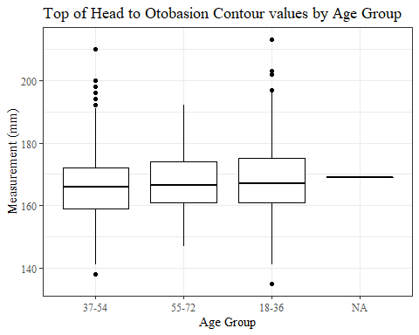

#boxplot not reordered by median  
ggplot(data=headscan_full, aes(y=TrHO_C, x=age_group))+  
 geom_boxplot(color= "black", fill = "white")+  
 theme_bw()+theme(text=element_text(family= "Times New Roman"))+  
 #theme(axis.text.x = element_text(angle = 20, vjust=0.7))+  
 labs(title="Top of Head to Otobasion Contour values by Age Group",  
 y="Measurement (mm)",  
 x="Age Group")

## Warning: Removed 282 rows containing non-finite values (stat_boxplot).

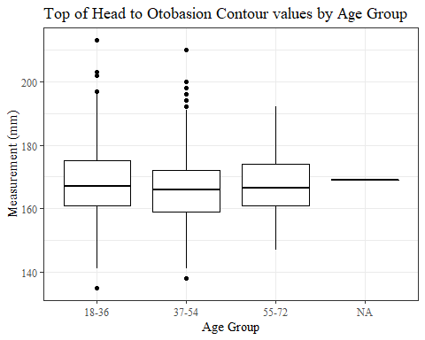

TrEJ_C

#histogram of all TrEJ_C values  
ggplot(data=headscan_full, aes(x=TrEJ_C))+  
 geom_bar(stat="bin", bins=20, color= "black", fill = "white")+  
 theme_bw()+theme(text=element_text(family= "Times New Roman"))+  
 labs(title="Tragion to Earlobe Juncture Contour Measurement Distribution",  
 y="Frequency",  
 x="Tragion to Earlobe Juncture Contour (mm)")

## Warning: Removed 33 rows containing non-finite values (stat_bin).

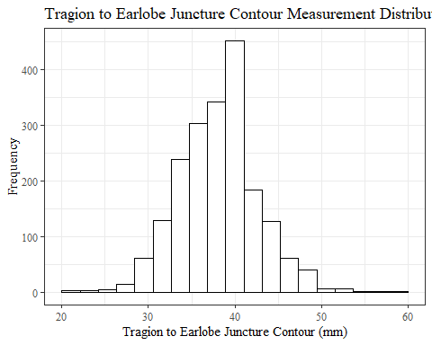

TrEJ_Csumstats <- headscan_full %>%   
 summarise(n = n(), na = sum(is.na(TrEJ_C)),  
 min = min(TrEJ_C, na.rm = TRUE),  
 max = max(TrEJ_C, na.rm = TRUE),  
 mean = mean(TrEJ_C, na.rm = TRUE),  
 mdn = median(TrEJ_C, na.rm = TRUE),  
 sd = sd(TrEJ_C, na.rm = TRUE),  
 se = sd/sqrt(n),  
 percent5th = quantile(TrEJ_C, 0.05, na.rm=TRUE),  
 percent25th = quantile(TrEJ_C, 0.25, na.rm=TRUE),  
 percent50th = quantile(TrEJ_C, 0.50, na.rm=TRUE),  
 percent75th = quantile(TrEJ_C, 0.75, na.rm=TRUE),  
 percent95th = quantile(TrEJ_C, 0.95, na.rm=TRUE))   
  
TrEJ_Csumstats <- round(TrEJ_Csumstats, 2)  
  
  
#Size 12 Table TNR  
flextable(TrEJ_Csumstats) %>%  
 my_ft_theme()%>%   
 bold(part = "header") %>%   
 set_caption("Tragion to Earlobe Juncture Contour SumStats")

**Table** : Tragion to Earlobe Juncture Contour SumStats

| **n** | **na** | **min** | **max** | **mean** | **mdn** | **sd** | **se** | **percent5th** | **percent25th** | **percent50th** | **percent75th** | **percent95th** |
| --- | --- | --- | --- | --- | --- | --- | --- | --- | --- | --- | --- | --- |
| 2,016 | 33 | 20 | 60 | 38.03 | 38 | 4.69 | 0.1 | 31 | 35 | 38 | 41 | 46 |

#%>% set_header_Cabels(values = list(TrEJ_C = "Subnasale/SubnasaleCont"))  
  
#Autofit Width Table TNR  
flextable(TrEJ_Csumstats) %>%  
 my_ft_theme()%>%   
 bold(part = "header") %>%   
 set_caption("Tragion to Earlobe Juncture Contour SumStats") %>%   
 fit_to_width(7.5)

**Table** : Tragion to Earlobe Juncture Contour SumStats

| **n** | **na** | **min** | **max** | **mean** | **mdn** | **sd** | **se** | **percent5th** | **percent25th** | **percent50th** | **percent75th** | **percent95th** |
| --- | --- | --- | --- | --- | --- | --- | --- | --- | --- | --- | --- | --- |
| 2,016 | 33 | 20 | 60 | 38.03 | 38 | 4.69 | 0.1 | 31 | 35 | 38 | 41 | 46 |

#%>% set_header_Cabels(values = list(TrEJ_C = "Subnasale/SubnasaleCont"))

#TrEJ_C race/eth sumstats  
TrEJ_Crace_sumstats <- headscan_full %>%   
 group_by(race_eth) %>%   
 summarise(n = n(), na = sum(is.na(TrEJ_C)),  
 min = min(TrEJ_C, na.rm = TRUE),  
 max = max(TrEJ_C, na.rm = TRUE),  
 mean = mean(TrEJ_C, na.rm = TRUE),  
 mdn = median(TrEJ_C, na.rm = TRUE),  
 sd = sd(TrEJ_C, na.rm = TRUE),  
 se = sd/sqrt(n),  
 percent5th = quantile(TrEJ_C, 0.05, na.rm=TRUE),  
 percent25th = quantile(TrEJ_C, 0.25, na.rm=TRUE),  
 percent50th = quantile(TrEJ_C, 0.50, na.rm=TRUE),  
 percent75th = quantile(TrEJ_C, 0.75, na.rm=TRUE),  
 percent95th = quantile(TrEJ_C, 0.95, na.rm=TRUE))   
  
TrEJ_Crace_sumstats <- TrEJ_Crace_sumstats %>%   
 mutate(across(where(is.numeric), round, 2))  
  
  
#Size 12 Table TNR  
flextable(TrEJ_Crace_sumstats) %>%  
 my_ft_theme()%>%   
 bold(part = "header") %>%   
 set_caption("Tragion to Earlobe Juncture Contour SumStats by Race/Ethnicity")

**Table** : Tragion to Earlobe Juncture Contour SumStats by Race/Ethnicity

| **race_eth** | **n** | **na** | **min** | **max** | **mean** | **mdn** | **sd** | **se** | **percent5th** | **percent25th** | **percent50th** | **percent75th** | **percent95th** |
| --- | --- | --- | --- | --- | --- | --- | --- | --- | --- | --- | --- | --- | --- |
| white | 1,239 | 17 | 20 | 60 | 38.41 | 38.0 | 4.58 | 0.13 | 32.0 | 35.00 | 38.0 | 41.00 | 46.00 |
| Black | 548 | 10 | 22 | 54 | 36.68 | 36.5 | 4.65 | 0.20 | 30.0 | 34.00 | 36.5 | 40.00 | 44.00 |
| LatinX | 100 | 1 | 28 | 52 | 39.63 | 39.0 | 4.47 | 0.45 | 33.9 | 37.00 | 39.0 | 43.00 | 48.00 |
| Asian | 91 | 2 | 28 | 54 | 39.44 | 39.0 | 4.42 | 0.46 | 32.8 | 37.00 | 39.0 | 42.00 | 48.00 |
| Other | 21 | 1 | 30 | 51 | 37.65 | 35.0 | 6.19 | 1.35 | 30.0 | 33.00 | 35.0 | 43.25 | 46.25 |
| AIAN | 8 | 2 | 34 | 44 | 38.50 | 39.0 | 4.14 | 1.46 | 34.0 | 34.75 | 39.0 | 41.00 | 43.25 |
| PTNS | 5 | 0 | 28 | 44 | 36.40 | 36.0 | 6.07 | 2.71 | 29.2 | 34.00 | 36.0 | 40.00 | 43.20 |
| NHOPI | 4 | 0 | 31 | 48 | 37.00 | 34.5 | 7.62 | 3.81 | 31.3 | 32.50 | 34.5 | 39.00 | 46.20 |

#%>% set_header_Cabels(values = list(TrEJ_C = "Subnasale/SubnasaleCont"))  
  
#Autofit Width Table TNR  
flextable(TrEJ_Crace_sumstats) %>%  
 my_ft_theme()%>%   
 bold(part = "header") %>%   
 set_caption("Tragion to Earlobe Juncture Contour SumStats by Race/Ethnicity") %>%   
 fit_to_width(7.5)

**Table** : Tragion to Earlobe Juncture Contour SumStats by Race/Ethnicity

| **race_eth** | **n** | **na** | **min** | **max** | **mean** | **mdn** | **sd** | **se** | **percent5th** | **percent25th** | **percent50th** | **percent75th** | **percent95th** |
| --- | --- | --- | --- | --- | --- | --- | --- | --- | --- | --- | --- | --- | --- |
| white | 1,239 | 17 | 20 | 60 | 38.41 | 38.0 | 4.58 | 0.13 | 32.0 | 35.00 | 38.0 | 41.00 | 46.00 |
| Black | 548 | 10 | 22 | 54 | 36.68 | 36.5 | 4.65 | 0.20 | 30.0 | 34.00 | 36.5 | 40.00 | 44.00 |
| LatinX | 100 | 1 | 28 | 52 | 39.63 | 39.0 | 4.47 | 0.45 | 33.9 | 37.00 | 39.0 | 43.00 | 48.00 |
| Asian | 91 | 2 | 28 | 54 | 39.44 | 39.0 | 4.42 | 0.46 | 32.8 | 37.00 | 39.0 | 42.00 | 48.00 |
| Other | 21 | 1 | 30 | 51 | 37.65 | 35.0 | 6.19 | 1.35 | 30.0 | 33.00 | 35.0 | 43.25 | 46.25 |
| AIAN | 8 | 2 | 34 | 44 | 38.50 | 39.0 | 4.14 | 1.46 | 34.0 | 34.75 | 39.0 | 41.00 | 43.25 |
| PTNS | 5 | 0 | 28 | 44 | 36.40 | 36.0 | 6.07 | 2.71 | 29.2 | 34.00 | 36.0 | 40.00 | 43.20 |
| NHOPI | 4 | 0 | 31 | 48 | 37.00 | 34.5 | 7.62 | 3.81 | 31.3 | 32.50 | 34.5 | 39.00 | 46.20 |

#%>% set_header_Cabels(values = list(TrEJ_C = "Subnasale/SubnasaleCont"))  
  
#boxplot reorderd by median  
headscan_full %>%   
 ungroup() %>%   
 mutate(race_eth= fct_reorder(race_eth, TrEJ_C, FUN=median, na.rm=TRUE)) %>%   
 ggplot(aes(y=TrEJ_C, x=race_eth))+  
 geom_boxplot(color= "black", fill = "white")+  
 theme_bw()+theme(text=element_text(family= "Times New Roman"))+  
 #theme(axis.text.x = element_text(angle = 20, vjust=0.7))+  
 labs(title="Tragion to Earlobe Juncture Contour values by Race/Ethnicity",  
 y="Measurement (mm)",  
 x="Race/Ethnicity")

## Warning: Removed 33 rows containing non-finite values (stat_boxplot).

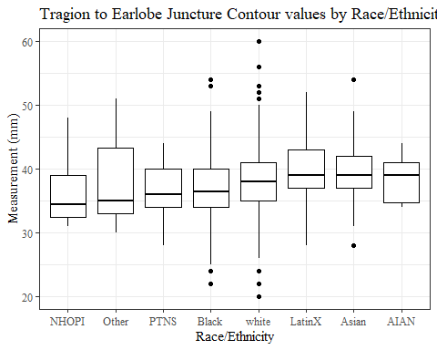

#boxplot not reordered by median  
ggplot(data=headscan_full, aes(y=TrEJ_C, x=race_eth))+  
 geom_boxplot(color= "black", fill = "white")+  
 theme_bw()+theme(text=element_text(family= "Times New Roman"))+  
 #theme(axis.text.x = element_text(angle = 20, vjust=0.7))+  
 labs(title="Tragion to Earlobe Juncture Contour values by Race/Ethnicity",  
 y="Measurement (mm)",  
 x="Race/Ethnicity")

## Warning: Removed 33 rows containing non-finite values (stat_boxplot).

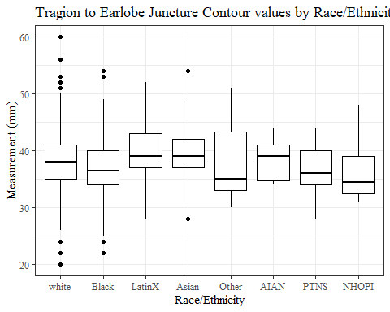

#TrEJ_C gender sumstats  
TrEJ_Cgender_sumstats <- headscan_full %>%   
 group_by(gender) %>%   
 summarise(n = n(), na = sum(is.na(TrEJ_C)),  
 min = min(TrEJ_C, na.rm = TRUE),  
 max = max(TrEJ_C, na.rm = TRUE),  
 mean = mean(TrEJ_C, na.rm = TRUE),  
 mdn = median(TrEJ_C, na.rm = TRUE),  
 sd = sd(TrEJ_C, na.rm = TRUE),  
 se = sd/sqrt(n),  
 percent5th = quantile(TrEJ_C, 0.05, na.rm=TRUE),  
 percent25th = quantile(TrEJ_C, 0.25, na.rm=TRUE),  
 percent50th = quantile(TrEJ_C, 0.50, na.rm=TRUE),  
 percent75th = quantile(TrEJ_C, 0.75, na.rm=TRUE),  
 percent95th = quantile(TrEJ_C, 0.95, na.rm=TRUE))  
  
TrEJ_Cgender_sumstats <- TrEJ_Cgender_sumstats %>%   
 mutate(across(where(is.numeric), round, 2))  
  
#Size 12 Table TNR  
flextable(TrEJ_Cgender_sumstats) %>%  
 my_ft_theme()%>%   
 bold(part = "header") %>%   
 set_caption("Tragion to Earlobe Juncture Contour SumStats by Gender")

**Table** : Tragion to Earlobe Juncture Contour SumStats by Gender

| **gender** | **n** | **na** | **min** | **max** | **mean** | **mdn** | **sd** | **se** | **percent5th** | **percent25th** | **percent50th** | **percent75th** | **percent95th** |
| --- | --- | --- | --- | --- | --- | --- | --- | --- | --- | --- | --- | --- | --- |
| Female | 1,063 | 23 | 22 | 53 | 37.35 | 37.0 | 4.39 | 0.13 | 30.00 | 34.00 | 37.0 | 40 | 44.0 |
| Male | 939 | 10 | 20 | 60 | 38.80 | 39.0 | 4.91 | 0.16 | 31.00 | 35.00 | 39.0 | 42 | 47.0 |
| Non-binary or Other | 5 | 0 | 33 | 45 | 37.80 | 36.0 | 5.07 | 2.27 | 33.20 | 34.00 | 36.0 | 41 | 44.2 |
| Prefer not to say | 1 | 0 | 36 | 36 | 36.00 | 36.0 |  |  | 36.00 | 36.00 | 36.0 | 36 | 36.0 |
|  | 8 | 0 | 31 | 44 | 36.62 | 36.5 | 4.72 | 1.67 | 31.35 | 32.75 | 36.5 | 40 | 42.6 |

#%>% set_header_Cabels(values = list(TrEJ_C = "Subnasale/SubnasaleCont"))  
  
#Autofit Width Table TNR  
flextable(TrEJ_Cgender_sumstats) %>%  
 my_ft_theme()%>%   
 bold(part = "header") %>%   
 set_caption("Tragion to Earlobe Juncture Contour SumStats by Gender") %>%   
 fit_to_width(7.5)

**Table** : Tragion to Earlobe Juncture Contour SumStats by Gender

| **gender** | **n** | **na** | **min** | **max** | **mean** | **mdn** | **sd** | **se** | **percent5th** | **percent25th** | **percent50th** | **percent75th** | **percent95th** |
| --- | --- | --- | --- | --- | --- | --- | --- | --- | --- | --- | --- | --- | --- |
| Female | 1,063 | 23 | 22 | 53 | 37.35 | 37.0 | 4.39 | 0.13 | 30.00 | 34.00 | 37.0 | 40 | 44.0 |
| Male | 939 | 10 | 20 | 60 | 38.80 | 39.0 | 4.91 | 0.16 | 31.00 | 35.00 | 39.0 | 42 | 47.0 |
| Non-binary or Other | 5 | 0 | 33 | 45 | 37.80 | 36.0 | 5.07 | 2.27 | 33.20 | 34.00 | 36.0 | 41 | 44.2 |
| Prefer not to say | 1 | 0 | 36 | 36 | 36.00 | 36.0 |  |  | 36.00 | 36.00 | 36.0 | 36 | 36.0 |
|  | 8 | 0 | 31 | 44 | 36.62 | 36.5 | 4.72 | 1.67 | 31.35 | 32.75 | 36.5 | 40 | 42.6 |

#%>% set_header_Cabels(values = list(TrEJ_C = "Subnasale/SubnasaleCont"))  
  
#boxplot reorderd by median  
headscan_full %>%   
 ungroup() %>%   
 mutate(gender= fct_reorder(gender, TrEJ_C, FUN=median, na.rm=TRUE)) %>%   
 ggplot(aes(y=TrEJ_C, x=gender))+  
 geom_boxplot(color= "black", fill = "white")+  
 theme_bw()+theme(text=element_text(family= "Times New Roman"))+  
 theme(axis.text.x = element_text(angle = 20, vjust=0.7))+  
 labs(title="Tragion to Earlobe Juncture Contour values by Gender",  
 y="Measurement (mm)",  
 x="Gender")

## Warning: Removed 33 rows containing non-finite values (stat_boxplot).

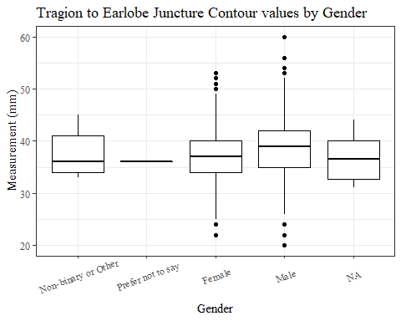

#boxplot not reordered by median  
ggplot(data=headscan_full, aes(y=TrEJ_C, x=gender))+  
 geom_boxplot(color= "black", fill = "white")+  
 theme_bw()+theme(text=element_text(family= "Times New Roman"))+  
 theme(axis.text.x = element_text(angle = 20, vjust=0.7))+  
 labs(title="Tragion to Earlobe Juncture Contour values by Gender",  
 y="Measurement (mm)",  
 x="Gender")

## Warning: Removed 33 rows containing non-finite values (stat_boxplot).

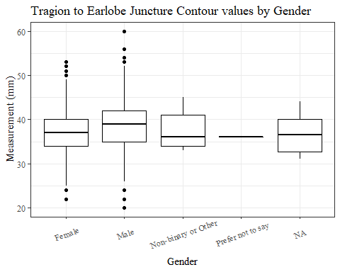

#TrEJ_C age group sumstats  
TrEJ_Cage_sumstats <- headscan_full %>%   
 group_by(age_group) %>%   
 summarise(n = n(), na = sum(is.na(TrEJ_C)),  
 min = min(TrEJ_C, na.rm = TRUE),  
 max = max(TrEJ_C, na.rm = TRUE),  
 mean = mean(TrEJ_C, na.rm = TRUE),  
 mdn = median(TrEJ_C, na.rm = TRUE),  
 sd = sd(TrEJ_C, na.rm = TRUE),  
 se = sd/sqrt(n),  
 percent5th = quantile(TrEJ_C, 0.05, na.rm=TRUE),  
 percent25th = quantile(TrEJ_C, 0.25, na.rm=TRUE),  
 percent50th = quantile(TrEJ_C, 0.50, na.rm=TRUE),  
 percent75th = quantile(TrEJ_C, 0.75, na.rm=TRUE),  
 percent95th = quantile(TrEJ_C, 0.95, na.rm=TRUE))  
  
TrEJ_Cage_sumstats <- TrEJ_Cage_sumstats %>%   
 mutate(across(where(is.numeric), round, 2))  
  
  
#Size 12 Table TNR  
flextable(TrEJ_Cage_sumstats) %>%  
 my_ft_theme()%>%   
 bold(part = "header") %>%   
 set_caption("Tragion to Earlobe Juncture Contour SumStats by Age Group")

**Table** : Tragion to Earlobe Juncture Contour SumStats by Age Group

| **age_group** | **n** | **na** | **min** | **max** | **mean** | **mdn** | **sd** | **se** | **percent5th** | **percent25th** | **percent50th** | **percent75th** | **percent95th** |
| --- | --- | --- | --- | --- | --- | --- | --- | --- | --- | --- | --- | --- | --- |
| 18-36 | 991 | 12 | 22 | 56 | 37.48 | 37 | 4.59 | 0.15 | 30 | 34 | 37 | 40 | 45 |
| 37-54 | 940 | 19 | 20 | 60 | 38.43 | 38 | 4.72 | 0.15 | 31 | 35 | 38 | 41 | 46 |
| 55-72 | 84 | 2 | 29 | 52 | 40.09 | 40 | 4.66 | 0.51 | 34 | 36 | 40 | 43 | 48 |
|  | 1 | 0 | 33 | 33 | 33.00 | 33 |  |  | 33 | 33 | 33 | 33 | 33 |

#%>% set_header_Cabels(values = list(TrEJ_C = "Subnasale/SubnasaleCont"))  
  
#Autofit Width Table TNR  
flextable(TrEJ_Cage_sumstats) %>%  
 my_ft_theme()%>%   
 bold(part = "header") %>%   
 set_caption("Tragion to Earlobe Juncture Contour SumStats by Age Group") %>%   
 fit_to_width(7.5)

**Table** : Tragion to Earlobe Juncture Contour SumStats by Age Group

| **age_group** | **n** | **na** | **min** | **max** | **mean** | **mdn** | **sd** | **se** | **percent5th** | **percent25th** | **percent50th** | **percent75th** | **percent95th** |
| --- | --- | --- | --- | --- | --- | --- | --- | --- | --- | --- | --- | --- | --- |
| 18-36 | 991 | 12 | 22 | 56 | 37.48 | 37 | 4.59 | 0.15 | 30 | 34 | 37 | 40 | 45 |
| 37-54 | 940 | 19 | 20 | 60 | 38.43 | 38 | 4.72 | 0.15 | 31 | 35 | 38 | 41 | 46 |
| 55-72 | 84 | 2 | 29 | 52 | 40.09 | 40 | 4.66 | 0.51 | 34 | 36 | 40 | 43 | 48 |
|  | 1 | 0 | 33 | 33 | 33.00 | 33 |  |  | 33 | 33 | 33 | 33 | 33 |

#%>% set_header_Cabels(values = list(TrEJ_C = "Subnasale/SubnasaleCont"))  
  
#boxplot reorderd by median  
headscan_full %>%   
 ungroup() %>%   
 mutate(age_group= fct_reorder(age_group, TrEJ_C, FUN=median, na.rm=TRUE)) %>%   
 ggplot(aes(y=TrEJ_C, x=age_group))+  
 geom_boxplot(color= "black", fill = "white")+  
 theme_bw()+theme(text=element_text(family= "Times New Roman"))+  
 theme(axis.text.x = element_text(angle = 20, vjust=0.7))+  
 labs(title="Tragion to Earlobe Juncture Contour values by Age Group",  
 y="Measurement (mm)",  
 x="Age Group")

## Warning: Removed 33 rows containing non-finite values (stat_boxplot).

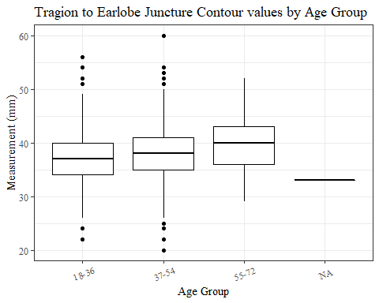

#boxplot not reordered by median  
ggplot(data=headscan_full, aes(y=TrEJ_C, x=age_group))+  
 geom_boxplot(color= "black", fill = "white")+  
 theme_bw()+theme(text=element_text(family= "Times New Roman"))+  
 theme(axis.text.x = element_text(angle = 20, vjust=0.7))+  
 labs(title="Tragion to Earlobe Juncture Contour values by Age Group",  
 y="Measurement (mm)",  
 x="Age Group")

## Warning: Removed 33 rows containing non-finite values (stat_boxplot).



TrGo_C without outliers removed

#histogram of all TrGo_C values  
ggplot(data=headscan_full, aes(x=TrGo_C))+  
 geom_bar(stat="bin", bins=30, color= "black", fill = "white")+  
 theme_bw()+theme(text=element_text(family= "Times New Roman"))+  
 labs(title="Tragion to Gonion Contour Measurement Distribution",  
 subtitle = "without outliers removed",  
 y="Frequency",  
 x="Tragion to Gonion Contour (mm)")

## Warning: Removed 80 rows containing non-finite values (stat_bin).

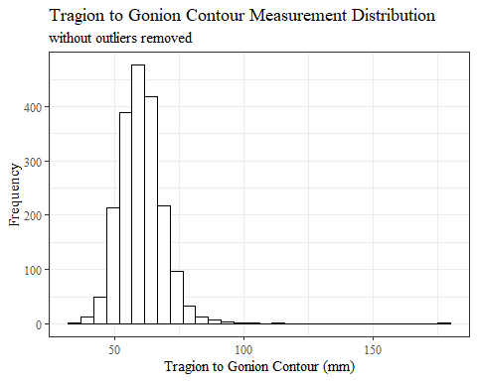

TrGo_Csumstats <- headscan_full %>%   
 summarise(n = n(), na = sum(is.na(TrGo_C)),  
 min = min(TrGo_C, na.rm = TRUE),  
 max = max(TrGo_C, na.rm = TRUE),  
 mean = mean(TrGo_C, na.rm = TRUE),  
 mdn = median(TrGo_C, na.rm = TRUE),  
 sd = sd(TrGo_C, na.rm = TRUE),  
 se = sd/sqrt(n),  
 percent5th = quantile(TrGo_C, 0.05, na.rm=TRUE),  
 percent25th = quantile(TrGo_C, 0.25, na.rm=TRUE),  
 percent50th = quantile(TrGo_C, 0.50, na.rm=TRUE),  
 percent75th = quantile(TrGo_C, 0.75, na.rm=TRUE),  
 percent95th = quantile(TrGo_C, 0.95, na.rm=TRUE))   
  
TrGo_Csumstats <- round(TrGo_Csumstats, 2)  
  
#Size 12 Table TNR  
flextable(TrGo_Csumstats) %>%  
 my_ft_theme()%>%   
 bold(part = "header") %>%   
 set_caption("Tragion to Gonion Contour SumStats w/o outlier removed")

**Table** : Tragion to Gonion Contour SumStats w/o outlier removed

| **n** | **na** | **min** | **max** | **mean** | **mdn** | **sd** | **se** | **percent5th** | **percent25th** | **percent50th** | **percent75th** | **percent95th** |
| --- | --- | --- | --- | --- | --- | --- | --- | --- | --- | --- | --- | --- |
| 2,016 | 80 | 35 | 178 | 60.09 | 60 | 8.77 | 0.2 | 48 | 54 | 60 | 65 | 74 |

#%>% set_header_Cabels(values = list(TrGo_C = "Subnasale/SubnasaleCont"))  
  
#Autofit Width Table TNR  
flextable(TrGo_Csumstats) %>%  
 my_ft_theme()%>%   
 bold(part = "header") %>%   
 set_caption("Tragion to Gonion Contour SumStats w/o outlier removed") %>%   
 fit_to_width(7.5)

**Table** : Tragion to Gonion Contour SumStats w/o outlier removed

| **n** | **na** | **min** | **max** | **mean** | **mdn** | **sd** | **se** | **percent5th** | **percent25th** | **percent50th** | **percent75th** | **percent95th** |
| --- | --- | --- | --- | --- | --- | --- | --- | --- | --- | --- | --- | --- |
| 2,016 | 80 | 35 | 178 | 60.09 | 60 | 8.77 | 0.2 | 48 | 54 | 60 | 65 | 74 |

#%>% set_header_Cabels(values = list(TrGo_C = "Subnasale/SubnasaleCont"))

#TrGo_C race/eth sumstats  
TrGo_Crace_sumstats <- headscan_full %>%   
 group_by(race_eth) %>%   
 summarise(n = n(), na = sum(is.na(TrGo_C)),  
 min = min(TrGo_C, na.rm = TRUE),  
 max = max(TrGo_C, na.rm = TRUE),  
 mean = mean(TrGo_C, na.rm = TRUE),  
 mdn = median(TrGo_C, na.rm = TRUE),  
 sd = sd(TrGo_C, na.rm = TRUE),  
 se = sd/sqrt(n),  
 percent5th = quantile(TrGo_C, 0.05, na.rm=TRUE),  
 percent25th = quantile(TrGo_C, 0.25, na.rm=TRUE),  
 percent50th = quantile(TrGo_C, 0.50, na.rm=TRUE),  
 percent75th = quantile(TrGo_C, 0.75, na.rm=TRUE),  
 percent95th = quantile(TrGo_C, 0.95, na.rm=TRUE))   
  
TrGo_Crace_sumstats <- TrGo_Crace_sumstats %>%   
 mutate(across(where(is.numeric), round, 2))  
  
  
#Size 12 Table TNR  
flextable(TrGo_Crace_sumstats) %>%  
 my_ft_theme()%>%   
 bold(part = "header") %>%   
 set_caption("Tragion to Gonion Contour SumStats by Race/Ethnicity w/o outlier removed")

**Table** : Tragion to Gonion Contour SumStats by Race/Ethnicity w/o outlier removed

| **race_eth** | **n** | **na** | **min** | **max** | **mean** | **mdn** | **sd** | **se** | **percent5th** | **percent25th** | **percent50th** | **percent75th** | **percent95th** |
| --- | --- | --- | --- | --- | --- | --- | --- | --- | --- | --- | --- | --- | --- |
| white | 1,239 | 53 | 35 | 178 | 60.11 | 60.0 | 9.19 | 0.26 | 48.00 | 54.00 | 60.0 | 65.00 | 74.00 |
| Black | 548 | 17 | 35 | 96 | 59.77 | 59.0 | 8.08 | 0.35 | 48.00 | 54.00 | 59.0 | 64.50 | 73.00 |
| LatinX | 100 | 4 | 41 | 83 | 60.43 | 61.0 | 7.27 | 0.73 | 49.50 | 56.00 | 61.0 | 64.25 | 73.00 |
| Asian | 91 | 2 | 44 | 87 | 61.39 | 60.0 | 8.42 | 0.88 | 48.80 | 55.00 | 60.0 | 66.00 | 76.00 |
| Other | 21 | 3 | 43 | 76 | 57.11 | 56.5 | 8.32 | 1.82 | 45.55 | 51.75 | 56.5 | 61.75 | 67.50 |
| AIAN | 8 | 1 | 56 | 70 | 61.14 | 60.0 | 5.11 | 1.81 | 56.30 | 57.50 | 60.0 | 63.50 | 68.80 |
| PTNS | 5 | 0 | 58 | 81 | 69.60 | 70.0 | 9.02 | 4.03 | 59.20 | 64.00 | 70.0 | 75.00 | 79.80 |
| NHOPI | 4 | 0 | 49 | 71 | 62.00 | 64.0 | 9.27 | 4.64 | 51.25 | 60.25 | 64.0 | 65.75 | 69.95 |

#%>% set_header_Cabels(values = list(TrGo_C = "Subnasale/SubnasaleCont"))  
  
#Autofit Width Table TNR  
flextable(TrGo_Crace_sumstats) %>%  
 my_ft_theme()%>%   
 bold(part = "header") %>%   
 set_caption("Tragion to Gonion Contour SumStats by Race/Ethnicity w/o outlier removed") %>%   
 fit_to_width(7.5)

**Table** : Tragion to Gonion Contour SumStats by Race/Ethnicity w/o outlier removed

| **race_eth** | **n** | **na** | **min** | **max** | **mean** | **mdn** | **sd** | **se** | **percent5th** | **percent25th** | **percent50th** | **percent75th** | **percent95th** |
| --- | --- | --- | --- | --- | --- | --- | --- | --- | --- | --- | --- | --- | --- |
| white | 1,239 | 53 | 35 | 178 | 60.11 | 60.0 | 9.19 | 0.26 | 48.00 | 54.00 | 60.0 | 65.00 | 74.00 |
| Black | 548 | 17 | 35 | 96 | 59.77 | 59.0 | 8.08 | 0.35 | 48.00 | 54.00 | 59.0 | 64.50 | 73.00 |
| LatinX | 100 | 4 | 41 | 83 | 60.43 | 61.0 | 7.27 | 0.73 | 49.50 | 56.00 | 61.0 | 64.25 | 73.00 |
| Asian | 91 | 2 | 44 | 87 | 61.39 | 60.0 | 8.42 | 0.88 | 48.80 | 55.00 | 60.0 | 66.00 | 76.00 |
| Other | 21 | 3 | 43 | 76 | 57.11 | 56.5 | 8.32 | 1.82 | 45.55 | 51.75 | 56.5 | 61.75 | 67.50 |
| AIAN | 8 | 1 | 56 | 70 | 61.14 | 60.0 | 5.11 | 1.81 | 56.30 | 57.50 | 60.0 | 63.50 | 68.80 |
| PTNS | 5 | 0 | 58 | 81 | 69.60 | 70.0 | 9.02 | 4.03 | 59.20 | 64.00 | 70.0 | 75.00 | 79.80 |
| NHOPI | 4 | 0 | 49 | 71 | 62.00 | 64.0 | 9.27 | 4.64 | 51.25 | 60.25 | 64.0 | 65.75 | 69.95 |

#%>% set_header_Cabels(values = list(TrGo_C = "Subnasale/SubnasaleCont"))  
  
#boxplot reorderd by median  
headscan_full %>%   
 ungroup() %>%   
 mutate(race_eth= fct_reorder(race_eth, TrGo_C, FUN=median, na.rm=TRUE)) %>%   
 ggplot(aes(y=TrGo_C, x=race_eth))+  
 geom_boxplot(color= "black", fill = "white")+  
 theme_bw()+theme(text=element_text(family= "Times New Roman"))+  
 #theme(axis.text.x = element_text(angle = 20, vjust=0.7))+  
 labs(title="Tragion to Gonion Contour values by Race/Ethnicity",  
 subtitle = "without outliers removed",  
 y="Measurement (mm)",  
 x="Race/Ethnicity")

## Warning: Removed 80 rows containing non-finite values (stat_boxplot).

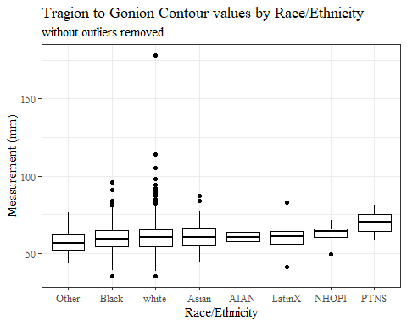

#boxplot not reordered by median  
ggplot(data=headscan_full, aes(y=TrGo_C, x=race_eth))+  
 geom_boxplot(color= "black", fill = "white")+  
 theme_bw()+theme(text=element_text(family= "Times New Roman"))+  
 #theme(axis.text.x = element_text(angle = 20, vjust=0.7))+  
 labs(title="Tragion to Gonion Contour values by Race/Ethnicity",  
 subtitle = "without outliers removed",  
 y="Measurement (mm)",  
 x="Race/Ethnicity")

## Warning: Removed 80 rows containing non-finite values (stat_boxplot).

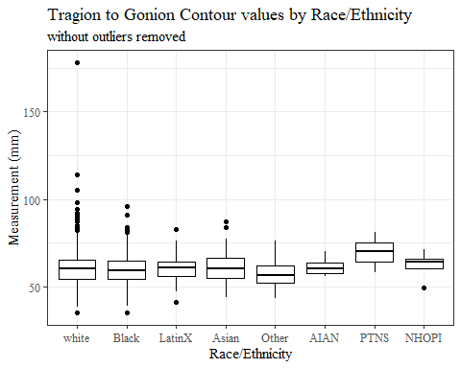

#TrGo_C gender sumstats  
TrGo_Cgender_sumstats <- headscan_full %>%   
 group_by(gender) %>%   
 summarise(n = n(), na = sum(is.na(TrGo_C)),  
 min = min(TrGo_C, na.rm = TRUE),  
 max = max(TrGo_C, na.rm = TRUE),  
 mean = mean(TrGo_C, na.rm = TRUE),  
 mdn = median(TrGo_C, na.rm = TRUE),  
 sd = sd(TrGo_C, na.rm = TRUE),  
 se = sd/sqrt(n),  
 percent5th = quantile(TrGo_C, 0.05, na.rm=TRUE),  
 percent25th = quantile(TrGo_C, 0.25, na.rm=TRUE),  
 percent50th = quantile(TrGo_C, 0.50, na.rm=TRUE),  
 percent75th = quantile(TrGo_C, 0.75, na.rm=TRUE),  
 percent95th = quantile(TrGo_C, 0.95, na.rm=TRUE))  
  
TrGo_Cgender_sumstats <- TrGo_Cgender_sumstats %>%   
 mutate(across(where(is.numeric), round, 2))  
  
#Size 12 Table TNR  
flextable(TrGo_Cgender_sumstats) %>%  
 my_ft_theme()%>%   
 bold(part = "header") %>%   
 set_caption("Tragion to Gonion Contour SumStats by Gender w/o outlier removed")

**Table** : Tragion to Gonion Contour SumStats by Gender w/o outlier removed

| **gender** | **n** | **na** | **min** | **max** | **mean** | **mdn** | **sd** | **se** | **percent5th** | **percent25th** | **percent50th** | **percent75th** | **percent95th** |
| --- | --- | --- | --- | --- | --- | --- | --- | --- | --- | --- | --- | --- | --- |
| Female | 1,063 | 24 | 35 | 98 | 58.24 | 58 | 7.69 | 0.24 | 47.0 | 53 | 58 | 63 | 70.00 |
| Male | 939 | 56 | 35 | 178 | 62.32 | 62 | 9.45 | 0.31 | 49.0 | 56 | 62 | 67 | 76.00 |
| Non-binary or Other | 5 | 0 | 45 | 59 | 53.80 | 55 | 5.40 | 2.42 | 46.6 | 53 | 55 | 57 | 58.60 |
| Prefer not to say | 1 | 0 | 58 | 58 | 58.00 | 58 |  |  | 58.0 | 58 | 58 | 58 | 58.00 |
|  | 8 | 0 | 52 | 73 | 58.38 | 55 | 8.05 | 2.85 | 52.0 | 52 | 55 | 62 | 71.25 |

#%>% set_header_Cabels(values = list(TrGo_C = "Subnasale/SubnasaleCont"))  
  
#Autofit Width Table TNR  
flextable(TrGo_Cgender_sumstats) %>%  
 my_ft_theme()%>%   
 bold(part = "header") %>%   
 set_caption("Tragion to Gonion Contour SumStats by Gender w/o outlier removed") %>%   
 fit_to_width(7.5)

**Table** : Tragion to Gonion Contour SumStats by Gender w/o outlier removed

| **gender** | **n** | **na** | **min** | **max** | **mean** | **mdn** | **sd** | **se** | **percent5th** | **percent25th** | **percent50th** | **percent75th** | **percent95th** |
| --- | --- | --- | --- | --- | --- | --- | --- | --- | --- | --- | --- | --- | --- |
| Female | 1,063 | 24 | 35 | 98 | 58.24 | 58 | 7.69 | 0.24 | 47.0 | 53 | 58 | 63 | 70.00 |
| Male | 939 | 56 | 35 | 178 | 62.32 | 62 | 9.45 | 0.31 | 49.0 | 56 | 62 | 67 | 76.00 |
| Non-binary or Other | 5 | 0 | 45 | 59 | 53.80 | 55 | 5.40 | 2.42 | 46.6 | 53 | 55 | 57 | 58.60 |
| Prefer not to say | 1 | 0 | 58 | 58 | 58.00 | 58 |  |  | 58.0 | 58 | 58 | 58 | 58.00 |
|  | 8 | 0 | 52 | 73 | 58.38 | 55 | 8.05 | 2.85 | 52.0 | 52 | 55 | 62 | 71.25 |

#%>% set_header_Cabels(values = list(TrGo_C = "Subnasale/SubnasaleCont"))  
  
#boxplot reorderd by median  
headscan_full %>%   
 ungroup() %>%   
 mutate(gender= fct_reorder(gender, TrGo_C, FUN=median, na.rm=TRUE)) %>%   
 ggplot(aes(y=TrGo_C, x=gender))+  
 geom_boxplot(color= "black", fill = "white")+  
 theme_bw()+theme(text=element_text(family= "Times New Roman"))+  
 theme(axis.text.x = element_text(angle = 20, vjust=0.7))+  
 labs(title="Tragion to Gonion Contour values by Gender",  
 subtitle = "without outliers removed",  
 y="Measurement (mm)",  
 x="Gender")

## Warning: Removed 80 rows containing non-finite values (stat_boxplot).

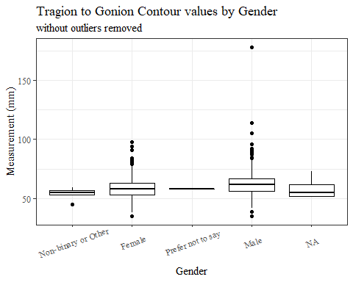

#boxplot not reordered by median  
ggplot(data=headscan_full, aes(y=TrGo_C, x=gender))+  
 geom_boxplot(color= "black", fill = "white")+  
 theme_bw()+theme(text=element_text(family= "Times New Roman"))+  
 theme(axis.text.x = element_text(angle = 20, vjust=0.7))+  
 labs(title="Tragion to Gonion Contour values by Gender",  
 subtitle = "without outliers removed",  
 y="Measurement (mm)",  
 x="Gender")

## Warning: Removed 80 rows containing non-finite values (stat_boxplot).

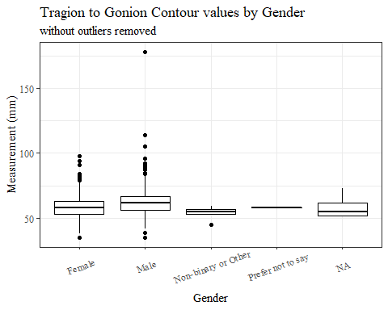

#TrGo_C age group sumstats  
TrGo_Cage_sumstats <- headscan_full %>%   
 group_by(age_group) %>%   
 summarise(n = n(), na = sum(is.na(TrGo_C)),  
 min = min(TrGo_C, na.rm = TRUE),  
 max = max(TrGo_C, na.rm = TRUE),  
 mean = mean(TrGo_C, na.rm = TRUE),  
 mdn = median(TrGo_C, na.rm = TRUE),  
 sd = sd(TrGo_C, na.rm = TRUE),  
 se = sd/sqrt(n),  
 percent5th = quantile(TrGo_C, 0.05, na.rm=TRUE),  
 percent25th = quantile(TrGo_C, 0.25, na.rm=TRUE),  
 percent50th = quantile(TrGo_C, 0.50, na.rm=TRUE),  
 percent75th = quantile(TrGo_C, 0.75, na.rm=TRUE),  
 percent95th = quantile(TrGo_C, 0.95, na.rm=TRUE))  
  
TrGo_Cage_sumstats <- TrGo_Cage_sumstats %>%   
 mutate(across(where(is.numeric), round, 2))  
  
  
#Size 12 Table TNR  
flextable(TrGo_Cage_sumstats) %>%  
 my_ft_theme()%>%   
 bold(part = "header") %>%   
 set_caption("Tragion to Gonion Contour SumStats by Age Group w/o outlier removed")

**Table** : Tragion to Gonion Contour SumStats by Age Group w/o outlier removed

| **age_group** | **n** | **na** | **min** | **max** | **mean** | **mdn** | **sd** | **se** | **percent5th** | **percent25th** | **percent50th** | **percent75th** | **percent95th** |
| --- | --- | --- | --- | --- | --- | --- | --- | --- | --- | --- | --- | --- | --- |
| 18-36 | 991 | 33 | 38 | 92 | 60.07 | 60 | 8.10 | 0.26 | 48 | 54.00 | 60 | 65.00 | 74.00 |
| 37-54 | 940 | 45 | 35 | 114 | 59.94 | 60 | 8.62 | 0.28 | 47 | 54.00 | 60 | 65.00 | 73.30 |
| 55-72 | 84 | 2 | 41 | 178 | 62.06 | 61 | 15.44 | 1.69 | 48 | 55.25 | 61 | 65.75 | 75.95 |
|  | 1 | 0 | 62 | 62 | 62.00 | 62 |  |  | 62 | 62.00 | 62 | 62.00 | 62.00 |

#%>% set_header_Cabels(values = list(TrGo_C = "Subnasale/SubnasaleCont"))  
  
#Autofit Width Table TNR  
flextable(TrGo_Cage_sumstats) %>%  
 my_ft_theme()%>%   
 bold(part = "header") %>%   
 set_caption("Tragion to Gonion Contour SumStats by Age Group w/o outlier removed") %>%   
 fit_to_width(7.5)

**Table** : Tragion to Gonion Contour SumStats by Age Group w/o outlier removed

| **age_group** | **n** | **na** | **min** | **max** | **mean** | **mdn** | **sd** | **se** | **percent5th** | **percent25th** | **percent50th** | **percent75th** | **percent95th** |
| --- | --- | --- | --- | --- | --- | --- | --- | --- | --- | --- | --- | --- | --- |
| 18-36 | 991 | 33 | 38 | 92 | 60.07 | 60 | 8.10 | 0.26 | 48 | 54.00 | 60 | 65.00 | 74.00 |
| 37-54 | 940 | 45 | 35 | 114 | 59.94 | 60 | 8.62 | 0.28 | 47 | 54.00 | 60 | 65.00 | 73.30 |
| 55-72 | 84 | 2 | 41 | 178 | 62.06 | 61 | 15.44 | 1.69 | 48 | 55.25 | 61 | 65.75 | 75.95 |
|  | 1 | 0 | 62 | 62 | 62.00 | 62 |  |  | 62 | 62.00 | 62 | 62.00 | 62.00 |

#%>% set_header_Cabels(values = list(TrGo_C = "Subnasale/SubnasaleCont"))  
  
#boxplot reorderd by median  
headscan_full %>%   
 ungroup() %>%   
 mutate(age_group= fct_reorder(age_group, TrGo_C, FUN=median, na.rm=TRUE)) %>%   
 ggplot(aes(y=TrGo_C, x=age_group))+  
 geom_boxplot(color= "black", fill = "white")+  
 theme_bw()+theme(text=element_text(family= "Times New Roman"))+  
 #theme(axis.text.x = element_text(angle = 20, vjust=0.7))+  
 labs(title="Tragion to Gonion Contour values by Age Group",  
 subtitle = "without outliers removed",  
 y="Measurement (mm)",  
 x="Age Group")

## Warning: Removed 80 rows containing non-finite values (stat_boxplot).

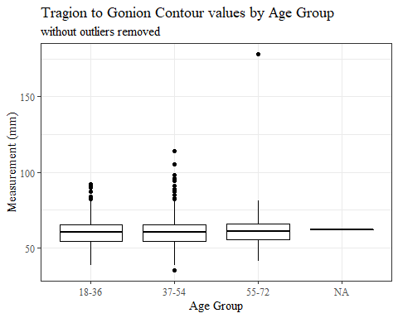

#boxplot not reordered by median  
ggplot(data=headscan_full, aes(y=TrGo_C, x=age_group))+  
 geom_boxplot(color= "black", fill = "white")+  
 theme_bw()+theme(text=element_text(family= "Times New Roman"))+  
 #theme(axis.text.x = element_text(angle = 20, vjust=0.7))+  
 labs(title="Tragion to Gonion Contour values by Age Group",  
 subtitle = "without outliers removed",  
 y="Measurement (mm)",  
 x="Age Group")

## Warning: Removed 80 rows containing non-finite values (stat_boxplot).



TrGo_C with outliers removed

max(headscan_full$TrGo_C, na.rm = TRUE)

## [1] 178

#CODE TO REMOVE OUTLIER, use later to remove from headscan_full  
TrGo_C_no_out <- headscan_full %>% mutate(TrGo_C = replace(TrGo_C, TrGo_C>170, NA))

#histogram of all TrGo_C values  
ggplot(data=TrGo_C_no_out, aes(x=TrGo_C))+  
 geom_bar(stat="bin", bins=25, color= "black", fill = "white")+  
 theme_bw()+theme(text=element_text(family= "Times New Roman"))+  
 labs(title="Tragion to Gonion Contour Measurement Distribution",  
 y="Frequency",  
 x="Tragion to Gonion Contour (mm)")

## Warning: Removed 81 rows containing non-finite values (stat_bin).

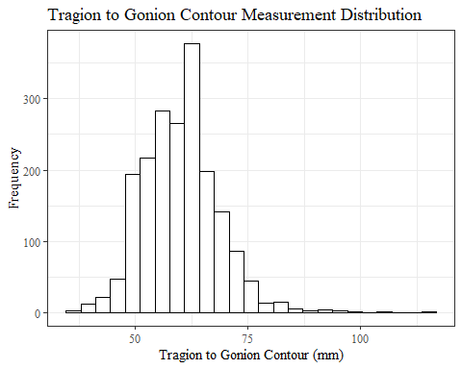

TrGo_Csumstats1 <- TrGo_C_no_out %>%   
 summarise(n = n(), na = sum(is.na(TrGo_C)),  
 min = min(TrGo_C, na.rm = TRUE),  
 max = max(TrGo_C, na.rm = TRUE),  
 mean = mean(TrGo_C, na.rm = TRUE),  
 mdn = median(TrGo_C, na.rm = TRUE),  
 sd = sd(TrGo_C, na.rm = TRUE),  
 se = sd/sqrt(n),  
 percent5th = quantile(TrGo_C, 0.05, na.rm=TRUE),  
 percent25th = quantile(TrGo_C, 0.25, na.rm=TRUE),  
 percent50th = quantile(TrGo_C, 0.50, na.rm=TRUE),  
 percent75th = quantile(TrGo_C, 0.75, na.rm=TRUE),  
 percent95th = quantile(TrGo_C, 0.95, na.rm=TRUE))   
  
  
TrGo_Csumstats1 <- round(TrGo_Csumstats1, 2)  
  
  
#Size 12 Table TNR  
flextable(TrGo_Csumstats1) %>%  
 my_ft_theme()%>%   
 bold(part = "header") %>%   
 set_caption("Tragion to Gonion Contour SumStats")

**Table** : Tragion to Gonion Contour SumStats

| **n** | **na** | **min** | **max** | **mean** | **mdn** | **sd** | **se** | **percent5th** | **percent25th** | **percent50th** | **percent75th** | **percent95th** |
| --- | --- | --- | --- | --- | --- | --- | --- | --- | --- | --- | --- | --- |
| 2,016 | 81 | 35 | 114 | 60.03 | 60 | 8.35 | 0.19 | 48 | 54 | 60 | 65 | 74 |

#%>% set_header_Cabels(values = list(TrGo_C = "Subnasale/SubnasaleCont"))  
  
#Autofit Width Table TNR  
flextable(TrGo_Csumstats1) %>%  
 my_ft_theme()%>%   
 bold(part = "header") %>%   
 set_caption("Tragion to Gonion Contour SumStats") %>%   
 fit_to_width(7.5)

**Table** : Tragion to Gonion Contour SumStats

| **n** | **na** | **min** | **max** | **mean** | **mdn** | **sd** | **se** | **percent5th** | **percent25th** | **percent50th** | **percent75th** | **percent95th** |
| --- | --- | --- | --- | --- | --- | --- | --- | --- | --- | --- | --- | --- |
| 2,016 | 81 | 35 | 114 | 60.03 | 60 | 8.35 | 0.19 | 48 | 54 | 60 | 65 | 74 |

#%>% set_header_Cabels(values = list(TrGo_C = "Subnasale/SubnasaleCont"))

#TrGo_C race/eth sumstats  
TrGo_Crace_sumstats1 <- TrGo_C_no_out %>%   
 group_by(race_eth) %>%   
 summarise(n = n(), na = sum(is.na(TrGo_C)),  
 min = min(TrGo_C, na.rm = TRUE),  
 max = max(TrGo_C, na.rm = TRUE),  
 mean = mean(TrGo_C, na.rm = TRUE),  
 mdn = median(TrGo_C, na.rm = TRUE),  
 sd = sd(TrGo_C, na.rm = TRUE),  
 se = sd/sqrt(n),  
 percent5th = quantile(TrGo_C, 0.05, na.rm=TRUE),  
 percent25th = quantile(TrGo_C, 0.25, na.rm=TRUE),  
 percent50th = quantile(TrGo_C, 0.50, na.rm=TRUE),  
 percent75th = quantile(TrGo_C, 0.75, na.rm=TRUE),  
 percent95th = quantile(TrGo_C, 0.95, na.rm=TRUE))   
  
TrGo_Crace_sumstats1 <- TrGo_Crace_sumstats1 %>%   
 mutate(across(where(is.numeric), round, 2))  
  
  
#Size 12 Table TNR  
flextable(TrGo_Crace_sumstats1) %>%  
 my_ft_theme()%>%   
 bold(part = "header") %>%   
 set_caption("Tragion to Gonion Contour SumStats by Race/Ethnicity")

**Table** : Tragion to Gonion Contour SumStats by Race/Ethnicity

| **race_eth** | **n** | **na** | **min** | **max** | **mean** | **mdn** | **sd** | **se** | **percent5th** | **percent25th** | **percent50th** | **percent75th** | **percent95th** |
| --- | --- | --- | --- | --- | --- | --- | --- | --- | --- | --- | --- | --- | --- |
| white | 1,239 | 54 | 35 | 114 | 60.01 | 60.0 | 8.54 | 0.24 | 48.00 | 54.00 | 60.0 | 65.00 | 74.00 |
| Black | 548 | 17 | 35 | 96 | 59.77 | 59.0 | 8.08 | 0.35 | 48.00 | 54.00 | 59.0 | 64.50 | 73.00 |
| LatinX | 100 | 4 | 41 | 83 | 60.43 | 61.0 | 7.27 | 0.73 | 49.50 | 56.00 | 61.0 | 64.25 | 73.00 |
| Asian | 91 | 2 | 44 | 87 | 61.39 | 60.0 | 8.42 | 0.88 | 48.80 | 55.00 | 60.0 | 66.00 | 76.00 |
| Other | 21 | 3 | 43 | 76 | 57.11 | 56.5 | 8.32 | 1.82 | 45.55 | 51.75 | 56.5 | 61.75 | 67.50 |
| AIAN | 8 | 1 | 56 | 70 | 61.14 | 60.0 | 5.11 | 1.81 | 56.30 | 57.50 | 60.0 | 63.50 | 68.80 |
| PTNS | 5 | 0 | 58 | 81 | 69.60 | 70.0 | 9.02 | 4.03 | 59.20 | 64.00 | 70.0 | 75.00 | 79.80 |
| NHOPI | 4 | 0 | 49 | 71 | 62.00 | 64.0 | 9.27 | 4.64 | 51.25 | 60.25 | 64.0 | 65.75 | 69.95 |

#%>% set_header_Cabels(values = list(TrGo_C = "Subnasale/SubnasaleCont"))  
  
#Autofit Width Table TNR  
flextable(TrGo_Crace_sumstats1) %>%  
 my_ft_theme()%>%   
 bold(part = "header") %>%   
 set_caption("Tragion to Gonion Contour SumStats by Race/Ethnicity") %>%   
 fit_to_width(7.5)

**Table** : Tragion to Gonion Contour SumStats by Race/Ethnicity

| **race_eth** | **n** | **na** | **min** | **max** | **mean** | **mdn** | **sd** | **se** | **percent5th** | **percent25th** | **percent50th** | **percent75th** | **percent95th** |
| --- | --- | --- | --- | --- | --- | --- | --- | --- | --- | --- | --- | --- | --- |
| white | 1,239 | 54 | 35 | 114 | 60.01 | 60.0 | 8.54 | 0.24 | 48.00 | 54.00 | 60.0 | 65.00 | 74.00 |
| Black | 548 | 17 | 35 | 96 | 59.77 | 59.0 | 8.08 | 0.35 | 48.00 | 54.00 | 59.0 | 64.50 | 73.00 |
| LatinX | 100 | 4 | 41 | 83 | 60.43 | 61.0 | 7.27 | 0.73 | 49.50 | 56.00 | 61.0 | 64.25 | 73.00 |
| Asian | 91 | 2 | 44 | 87 | 61.39 | 60.0 | 8.42 | 0.88 | 48.80 | 55.00 | 60.0 | 66.00 | 76.00 |
| Other | 21 | 3 | 43 | 76 | 57.11 | 56.5 | 8.32 | 1.82 | 45.55 | 51.75 | 56.5 | 61.75 | 67.50 |
| AIAN | 8 | 1 | 56 | 70 | 61.14 | 60.0 | 5.11 | 1.81 | 56.30 | 57.50 | 60.0 | 63.50 | 68.80 |
| PTNS | 5 | 0 | 58 | 81 | 69.60 | 70.0 | 9.02 | 4.03 | 59.20 | 64.00 | 70.0 | 75.00 | 79.80 |
| NHOPI | 4 | 0 | 49 | 71 | 62.00 | 64.0 | 9.27 | 4.64 | 51.25 | 60.25 | 64.0 | 65.75 | 69.95 |

#%>% set_header_Cabels(values = list(TrGo_C = "Subnasale/SubnasaleCont"))  
  
#boxplot reorderd by median  
TrGo_C_no_out %>%   
 ungroup() %>%   
 mutate(race_eth= fct_reorder(race_eth, TrGo_C, FUN=median, na.rm=TRUE)) %>%   
 ggplot(aes(y=TrGo_C, x=race_eth))+  
 geom_boxplot(color= "black", fill = "white")+  
 theme_bw()+theme(text=element_text(family= "Times New Roman"))+  
 #theme(axis.text.x = element_text(angle = 20, vjust=0.7))+  
 labs(title="Tragion to Gonion Contour values by Race/Ethnicity",  
 y="Measurement (mm)",  
 x="Race/Ethnicity")

## Warning: Removed 81 rows containing non-finite values (stat_boxplot).

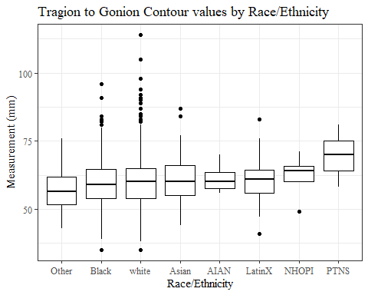

#boxplot not reordered by median  
ggplot(data=TrGo_C_no_out, aes(y=TrGo_C, x=race_eth))+  
 geom_boxplot(color= "black", fill = "white")+  
 theme_bw()+theme(text=element_text(family= "Times New Roman"))+  
 #theme(axis.text.x = element_text(angle = 20, vjust=0.7))+  
 labs(title="Tragion to Gonion Contour values by Race/Ethnicity",  
 y="Measurement (mm)",  
 x="Race/Ethnicity")

## Warning: Removed 81 rows containing non-finite values (stat_boxplot).

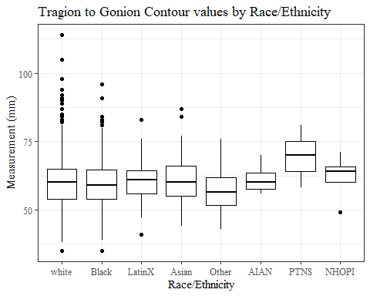

#TrGo_C gender sumstats  
TrGo_Cgender_sumstats1 <- TrGo_C_no_out %>%   
 group_by(gender) %>%   
 summarise(n = n(), na = sum(is.na(TrGo_C)),  
 min = min(TrGo_C, na.rm = TRUE),  
 max = max(TrGo_C, na.rm = TRUE),  
 mean = mean(TrGo_C, na.rm = TRUE),  
 mdn = median(TrGo_C, na.rm = TRUE),  
 sd = sd(TrGo_C, na.rm = TRUE),  
 se = sd/sqrt(n),  
 percent5th = quantile(TrGo_C, 0.05, na.rm=TRUE),  
 percent25th = quantile(TrGo_C, 0.25, na.rm=TRUE),  
 percent50th = quantile(TrGo_C, 0.50, na.rm=TRUE),  
 percent75th = quantile(TrGo_C, 0.75, na.rm=TRUE),  
 percent95th = quantile(TrGo_C, 0.95, na.rm=TRUE))  
  
TrGo_Cgender_sumstats1 <- TrGo_Cgender_sumstats1 %>%   
 mutate(across(where(is.numeric), round, 2))  
  
#Size 12 Table TNR  
flextable(TrGo_Cgender_sumstats1) %>%  
 my_ft_theme()%>%   
 bold(part = "header") %>%   
 set_caption("Tragion to Gonion Contour SumStats by Gender")

**Table** : Tragion to Gonion Contour SumStats by Gender

| **gender** | **n** | **na** | **min** | **max** | **mean** | **mdn** | **sd** | **se** | **percent5th** | **percent25th** | **percent50th** | **percent75th** | **percent95th** |
| --- | --- | --- | --- | --- | --- | --- | --- | --- | --- | --- | --- | --- | --- |
| Female | 1,063 | 24 | 35 | 98 | 58.24 | 58 | 7.69 | 0.24 | 47.0 | 53 | 58 | 63 | 70.00 |
| Male | 939 | 57 | 35 | 114 | 62.19 | 62 | 8.61 | 0.28 | 49.0 | 56 | 62 | 67 | 76.00 |
| Non-binary or Other | 5 | 0 | 45 | 59 | 53.80 | 55 | 5.40 | 2.42 | 46.6 | 53 | 55 | 57 | 58.60 |
| Prefer not to say | 1 | 0 | 58 | 58 | 58.00 | 58 |  |  | 58.0 | 58 | 58 | 58 | 58.00 |
|  | 8 | 0 | 52 | 73 | 58.38 | 55 | 8.05 | 2.85 | 52.0 | 52 | 55 | 62 | 71.25 |

#%>% set_header_Cabels(values = list(TrGo_C = "Subnasale/SubnasaleCont"))  
  
#Autofit Width Table TNR  
flextable(TrGo_Cgender_sumstats1) %>%  
 my_ft_theme()%>%   
 bold(part = "header") %>%   
 set_caption("Tragion to Gonion Contour SumStats by Gender") %>%   
 fit_to_width(7.5)

**Table** : Tragion to Gonion Contour SumStats by Gender

| **gender** | **n** | **na** | **min** | **max** | **mean** | **mdn** | **sd** | **se** | **percent5th** | **percent25th** | **percent50th** | **percent75th** | **percent95th** |
| --- | --- | --- | --- | --- | --- | --- | --- | --- | --- | --- | --- | --- | --- |
| Female | 1,063 | 24 | 35 | 98 | 58.24 | 58 | 7.69 | 0.24 | 47.0 | 53 | 58 | 63 | 70.00 |
| Male | 939 | 57 | 35 | 114 | 62.19 | 62 | 8.61 | 0.28 | 49.0 | 56 | 62 | 67 | 76.00 |
| Non-binary or Other | 5 | 0 | 45 | 59 | 53.80 | 55 | 5.40 | 2.42 | 46.6 | 53 | 55 | 57 | 58.60 |
| Prefer not to say | 1 | 0 | 58 | 58 | 58.00 | 58 |  |  | 58.0 | 58 | 58 | 58 | 58.00 |
|  | 8 | 0 | 52 | 73 | 58.38 | 55 | 8.05 | 2.85 | 52.0 | 52 | 55 | 62 | 71.25 |

#%>% set_header_Cabels(values = list(TrGo_C = "Subnasale/SubnasaleCont"))  
  
#boxplot reorderd by median  
TrGo_C_no_out %>%   
 ungroup() %>%   
 mutate(gender= fct_reorder(gender, TrGo_C, FUN=median, na.rm=TRUE)) %>%   
 ggplot(aes(y=TrGo_C, x=gender))+  
 geom_boxplot(color= "black", fill = "white")+  
 theme_bw()+theme(text=element_text(family= "Times New Roman"))+  
 theme(axis.text.x = element_text(angle = 20, vjust=0.7))+  
 labs(title="Tragion to Gonion Contour values by Gender",  
 y="Measurement (mm)",  
 x="Gender")

## Warning: Removed 81 rows containing non-finite values (stat_boxplot).

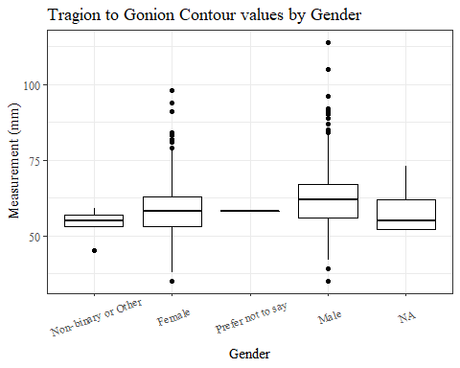

#boxplot not reordered by median  
ggplot(data=TrGo_C_no_out, aes(y=TrGo_C, x=gender))+  
 geom_boxplot(color= "black", fill = "white")+  
 theme_bw()+theme(text=element_text(family= "Times New Roman"))+  
 theme(axis.text.x = element_text(angle = 20, vjust=0.7))+  
 labs(title="Tragion to Gonion Contour values by Gender",  
 y="Measurement (mm)",  
 x="Gender")

## Warning: Removed 81 rows containing non-finite values (stat_boxplot).

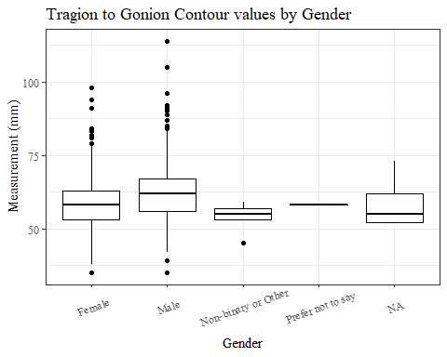

#TrGo_C age group sumstats  
TrGo_Cage_sumstats1 <- TrGo_C_no_out %>%   
 group_by(age_group) %>%   
 summarise(n = n(), na = sum(is.na(TrGo_C)),  
 min = min(TrGo_C, na.rm = TRUE),  
 max = max(TrGo_C, na.rm = TRUE),  
 mean = mean(TrGo_C, na.rm = TRUE),  
 mdn = median(TrGo_C, na.rm = TRUE),  
 sd = sd(TrGo_C, na.rm = TRUE),  
 se = sd/sqrt(n),  
 percent5th = quantile(TrGo_C, 0.05, na.rm=TRUE),  
 percent25th = quantile(TrGo_C, 0.25, na.rm=TRUE),  
 percent50th = quantile(TrGo_C, 0.50, na.rm=TRUE),  
 percent75th = quantile(TrGo_C, 0.75, na.rm=TRUE),  
 percent95th = quantile(TrGo_C, 0.95, na.rm=TRUE))  
  
TrGo_Cage_sumstats1 <- TrGo_Cage_sumstats1 %>%   
 mutate(across(where(is.numeric), round, 2))  
  
  
#Size 12 Table TNR  
flextable(TrGo_Cage_sumstats1) %>%  
 my_ft_theme()%>%   
 bold(part = "header") %>%   
 set_caption("Tragion to Gonion Contour SumStats by Age Group")

**Table** : Tragion to Gonion Contour SumStats by Age Group

| **age_group** | **n** | **na** | **min** | **max** | **mean** | **mdn** | **sd** | **se** | **percent5th** | **percent25th** | **percent50th** | **percent75th** | **percent95th** |
| --- | --- | --- | --- | --- | --- | --- | --- | --- | --- | --- | --- | --- | --- |
| 18-36 | 991 | 33 | 38 | 92 | 60.07 | 60 | 8.10 | 0.26 | 48 | 54 | 60 | 65 | 74.0 |
| 37-54 | 940 | 45 | 35 | 114 | 59.94 | 60 | 8.62 | 0.28 | 47 | 54 | 60 | 65 | 73.3 |
| 55-72 | 84 | 3 | 41 | 81 | 60.63 | 61 | 8.45 | 0.92 | 48 | 55 | 61 | 65 | 75.0 |
|  | 1 | 0 | 62 | 62 | 62.00 | 62 |  |  | 62 | 62 | 62 | 62 | 62.0 |

#%>% set_header_Cabels(values = list(TrGo_C = "Subnasale/SubnasaleCont"))  
  
#Autofit Width Table TNR  
flextable(TrGo_Cage_sumstats1) %>%  
 my_ft_theme()%>%   
 bold(part = "header") %>%   
 set_caption("Tragion to Gonion Contour SumStats by Age Group") %>%   
 fit_to_width(7.5)

**Table** : Tragion to Gonion Contour SumStats by Age Group

| **age_group** | **n** | **na** | **min** | **max** | **mean** | **mdn** | **sd** | **se** | **percent5th** | **percent25th** | **percent50th** | **percent75th** | **percent95th** |
| --- | --- | --- | --- | --- | --- | --- | --- | --- | --- | --- | --- | --- | --- |
| 18-36 | 991 | 33 | 38 | 92 | 60.07 | 60 | 8.10 | 0.26 | 48 | 54 | 60 | 65 | 74.0 |
| 37-54 | 940 | 45 | 35 | 114 | 59.94 | 60 | 8.62 | 0.28 | 47 | 54 | 60 | 65 | 73.3 |
| 55-72 | 84 | 3 | 41 | 81 | 60.63 | 61 | 8.45 | 0.92 | 48 | 55 | 61 | 65 | 75.0 |
|  | 1 | 0 | 62 | 62 | 62.00 | 62 |  |  | 62 | 62 | 62 | 62 | 62.0 |

#%>% set_header_Cabels(values = list(TrGo_C = "Subnasale/SubnasaleCont"))  
  
#boxplot reorderd by median  
TrGo_C_no_out %>%   
 ungroup() %>%   
 mutate(age_group= fct_reorder(age_group, TrGo_C, FUN=median, na.rm=TRUE)) %>%   
 ggplot(aes(y=TrGo_C, x=age_group))+  
 geom_boxplot(color= "black", fill = "white")+  
 theme_bw()+theme(text=element_text(family= "Times New Roman"))+  
 #theme(axis.text.x = element_text(angle = 20, vjust=0.7))+  
 labs(title="Tragion to Gonion Contour values by Age Group",  
 y="Measurement (mm)",  
 x="Age Group")

## Warning: Removed 81 rows containing non-finite values (stat_boxplot).

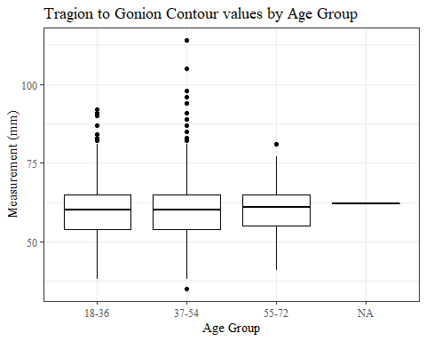

#boxplot not reordered by median  
ggplot(data=TrGo_C_no_out, aes(y=TrGo_C, x=age_group))+  
 geom_boxplot(color= "black", fill = "white")+  
 theme_bw()+theme(text=element_text(family= "Times New Roman"))+  
 #theme(axis.text.x = element_text(angle = 20, vjust=0.7))+  
 labs(title="Tragion to Gonion Contour values by Age Group",  
 y="Measurement (mm)",  
 x="Age Group")

## Warning: Removed 81 rows containing non-finite values (stat_boxplot).



TrSel_C

#histogram of all TrSel_C values  
ggplot(data=headscan_full, aes(x=TrSel_C))+  
 geom_bar(stat="bin", bins=20, color= "black", fill = "white")+  
 theme_bw()+theme(text=element_text(family= "Times New Roman"))+  
 labs(title="Tragion to Sellion Contour Measurement Distribution",  
 y="Frequency",  
 x="Tragion to Sellion Contour (mm)")

## Warning: Removed 31 rows containing non-finite values (stat_bin).

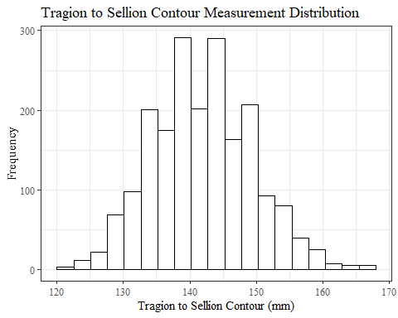

TrSel_Csumstats <- headscan_full %>%   
 summarise(n = n(), na = sum(is.na(TrSel_C)),  
 min = min(TrSel_C, na.rm = TRUE),  
 max = max(TrSel_C, na.rm = TRUE),  
 mean = mean(TrSel_C, na.rm = TRUE),  
 mdn = median(TrSel_C, na.rm = TRUE),  
 sd = sd(TrSel_C, na.rm = TRUE),  
 se = sd/sqrt(n),  
 percent5th = quantile(TrSel_C, 0.05, na.rm=TRUE),  
 percent25th = quantile(TrSel_C, 0.25, na.rm=TRUE),  
 percent50th = quantile(TrSel_C, 0.50, na.rm=TRUE),  
 percent75th = quantile(TrSel_C, 0.75, na.rm=TRUE),  
 percent95th = quantile(TrSel_C, 0.95, na.rm=TRUE))   
  
TrSel_Csumstats <- round(TrSel_Csumstats, 2)  
  
#Size 12 Table TNR  
flextable(TrSel_Csumstats) %>%  
 my_ft_theme()%>%   
 bold(part = "header") %>%   
 set_caption("Tragion to Sellion Contour SumStats")

**Table** : Tragion to Sellion Contour SumStats

| **n** | **na** | **min** | **max** | **mean** | **mdn** | **sd** | **se** | **percent5th** | **percent25th** | **percent50th** | **percent75th** | **percent95th** |
| --- | --- | --- | --- | --- | --- | --- | --- | --- | --- | --- | --- | --- |
| 2,016 | 31 | 120 | 168 | 141.96 | 142 | 7.48 | 0.17 | 130 | 137 | 142 | 147 | 155 |

#%>% set_header_Cabels(values = list(TrSel_C = "Subnasale/SubnasaleCont"))  
  
#Autofit Width Table TNR  
flextable(TrSel_Csumstats) %>%  
 my_ft_theme()%>%   
 bold(part = "header") %>%   
 set_caption("Tragion to Sellion Contour SumStats") %>%   
 fit_to_width(7.5)

**Table** : Tragion to Sellion Contour SumStats

| **n** | **na** | **min** | **max** | **mean** | **mdn** | **sd** | **se** | **percent5th** | **percent25th** | **percent50th** | **percent75th** | **percent95th** |
| --- | --- | --- | --- | --- | --- | --- | --- | --- | --- | --- | --- | --- |
| 2,016 | 31 | 120 | 168 | 141.96 | 142 | 7.48 | 0.17 | 130 | 137 | 142 | 147 | 155 |

#%>% set_header_Cabels(values = list(TrSel_C = "Subnasale/SubnasaleCont"))

#TrSel_C race/eth sumstats  
TrSel_Crace_sumstats <- headscan_full %>%   
 group_by(race_eth) %>%   
 summarise(n = n(), na = sum(is.na(TrSel_C)),  
 min = min(TrSel_C, na.rm = TRUE),  
 max = max(TrSel_C, na.rm = TRUE),  
 mean = mean(TrSel_C, na.rm = TRUE),  
 mdn = median(TrSel_C, na.rm = TRUE),  
 sd = sd(TrSel_C, na.rm = TRUE),  
 se = sd/sqrt(n),  
 percent5th = quantile(TrSel_C, 0.05, na.rm=TRUE),  
 percent25th = quantile(TrSel_C, 0.25, na.rm=TRUE),  
 percent50th = quantile(TrSel_C, 0.50, na.rm=TRUE),  
 percent75th = quantile(TrSel_C, 0.75, na.rm=TRUE),  
 percent95th = quantile(TrSel_C, 0.95, na.rm=TRUE))   
  
TrSel_Crace_sumstats <- TrSel_Crace_sumstats %>%   
 mutate(across(where(is.numeric), round, 2))  
  
  
#Size 12 Table TNR  
flextable(TrSel_Crace_sumstats) %>%  
 my_ft_theme()%>%   
 bold(part = "header") %>%   
 set_caption("Tragion to Sellion Contour SumStats by Race/Ethnicity")

**Table** : Tragion to Sellion Contour SumStats by Race/Ethnicity

| **race_eth** | **n** | **na** | **min** | **max** | **mean** | **mdn** | **sd** | **se** | **percent5th** | **percent25th** | **percent50th** | **percent75th** | **percent95th** |
| --- | --- | --- | --- | --- | --- | --- | --- | --- | --- | --- | --- | --- | --- |
| white | 1,239 | 18 | 120 | 168 | 140.81 | 141.0 | 7.26 | 0.21 | 130.00 | 136.00 | 141.0 | 146 | 153.00 |
| Black | 548 | 7 | 124 | 168 | 144.77 | 145.0 | 7.28 | 0.31 | 133.00 | 140.00 | 145.0 | 149 | 157.00 |
| LatinX | 100 | 1 | 125 | 162 | 141.15 | 141.0 | 7.32 | 0.73 | 129.00 | 137.00 | 141.0 | 146 | 151.10 |
| Asian | 91 | 3 | 122 | 165 | 141.56 | 140.0 | 7.80 | 0.82 | 132.00 | 136.00 | 140.0 | 147 | 155.30 |
| Other | 21 | 1 | 129 | 162 | 142.40 | 143.0 | 7.68 | 1.68 | 130.90 | 138.25 | 143.0 | 145 | 151.55 |
| AIAN | 8 | 1 | 133 | 145 | 137.29 | 136.0 | 4.15 | 1.47 | 133.30 | 134.50 | 136.0 | 139 | 143.50 |
| PTNS | 5 | 0 | 135 | 150 | 143.00 | 145.0 | 5.96 | 2.66 | 135.80 | 139.00 | 145.0 | 146 | 149.20 |
| NHOPI | 4 | 0 | 142 | 148 | 145.75 | 146.5 | 2.87 | 1.44 | 142.45 | 144.25 | 146.5 | 148 | 148.00 |

#%>% set_header_Cabels(values = list(TrSel_C = "Subnasale/SubnasaleCont"))  
  
#Autofit Width Table TNR  
flextable(TrSel_Crace_sumstats) %>%  
 my_ft_theme()%>%   
 bold(part = "header") %>%   
 set_caption("Tragion to Sellion Contour SumStats by Race/Ethnicity") %>%   
 fit_to_width(7.5)

**Table** : Tragion to Sellion Contour SumStats by Race/Ethnicity

| **race_eth** | **n** | **na** | **min** | **max** | **mean** | **mdn** | **sd** | **se** | **percent5th** | **percent25th** | **percent50th** | **percent75th** | **percent95th** |
| --- | --- | --- | --- | --- | --- | --- | --- | --- | --- | --- | --- | --- | --- |
| white | 1,239 | 18 | 120 | 168 | 140.81 | 141.0 | 7.26 | 0.21 | 130.00 | 136.00 | 141.0 | 146 | 153.00 |
| Black | 548 | 7 | 124 | 168 | 144.77 | 145.0 | 7.28 | 0.31 | 133.00 | 140.00 | 145.0 | 149 | 157.00 |
| LatinX | 100 | 1 | 125 | 162 | 141.15 | 141.0 | 7.32 | 0.73 | 129.00 | 137.00 | 141.0 | 146 | 151.10 |
| Asian | 91 | 3 | 122 | 165 | 141.56 | 140.0 | 7.80 | 0.82 | 132.00 | 136.00 | 140.0 | 147 | 155.30 |
| Other | 21 | 1 | 129 | 162 | 142.40 | 143.0 | 7.68 | 1.68 | 130.90 | 138.25 | 143.0 | 145 | 151.55 |
| AIAN | 8 | 1 | 133 | 145 | 137.29 | 136.0 | 4.15 | 1.47 | 133.30 | 134.50 | 136.0 | 139 | 143.50 |
| PTNS | 5 | 0 | 135 | 150 | 143.00 | 145.0 | 5.96 | 2.66 | 135.80 | 139.00 | 145.0 | 146 | 149.20 |
| NHOPI | 4 | 0 | 142 | 148 | 145.75 | 146.5 | 2.87 | 1.44 | 142.45 | 144.25 | 146.5 | 148 | 148.00 |

#%>% set_header_Cabels(values = list(TrSel_C = "Subnasale/SubnasaleCont"))  
  
#boxplot reorderd by median  
headscan_full %>%   
 ungroup() %>%   
 mutate(race_eth= fct_reorder(race_eth, TrSel_C, FUN=median, na.rm=TRUE)) %>%   
 ggplot(aes(y=TrSel_C, x=race_eth))+  
 geom_boxplot(color= "black", fill = "white")+  
 theme_bw()+theme(text=element_text(family= "Times New Roman"))+  
 #theme(axis.text.x = element_text(angle = 20, vjust=0.7))+  
 labs(title="Tragion to Sellion Contour values by Race/Ethnicity",  
 y="Measurement (mm)",  
 x="Race/Ethnicity")

## Warning: Removed 31 rows containing non-finite values (stat_boxplot).

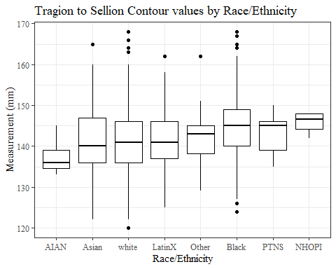

#boxplot not reordered by median  
ggplot(data=headscan_full, aes(y=TrSel_C, x=race_eth))+  
 geom_boxplot(color= "black", fill = "white")+  
 theme_bw()+theme(text=element_text(family= "Times New Roman"))+  
 #theme(axis.text.x = element_text(angle = 20, vjust=0.7))+  
 labs(title="Tragion to Sellion Contour values by Race/Ethnicity",  
 y="Measurement (mm)",  
 x="Race/Ethnicity")

## Warning: Removed 31 rows containing non-finite values (stat_boxplot).

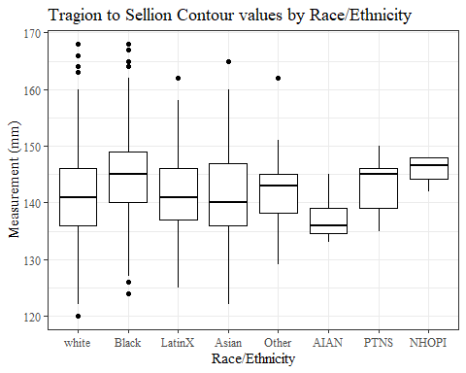

#TrSel_C gender sumstats  
TrSel_Cgender_sumstats <- headscan_full %>%   
 group_by(gender) %>%   
 summarise(n = n(), na = sum(is.na(TrSel_C)),  
 min = min(TrSel_C, na.rm = TRUE),  
 max = max(TrSel_C, na.rm = TRUE),  
 mean = mean(TrSel_C, na.rm = TRUE),  
 mdn = median(TrSel_C, na.rm = TRUE),  
 sd = sd(TrSel_C, na.rm = TRUE),  
 se = sd/sqrt(n),  
 percent5th = quantile(TrSel_C, 0.05, na.rm=TRUE),  
 percent25th = quantile(TrSel_C, 0.25, na.rm=TRUE),  
 percent50th = quantile(TrSel_C, 0.50, na.rm=TRUE),  
 percent75th = quantile(TrSel_C, 0.75, na.rm=TRUE),  
 percent95th = quantile(TrSel_C, 0.95, na.rm=TRUE))  
  
TrSel_Cgender_sumstats <- TrSel_Cgender_sumstats %>%   
 mutate(across(where(is.numeric), round, 2))  
  
#Size 12 Table TNR  
flextable(TrSel_Cgender_sumstats) %>%  
 my_ft_theme()%>%   
 bold(part = "header") %>%   
 set_caption("Tragion to Sellion Contour SumStats by Gender")

**Table** : Tragion to Sellion Contour SumStats by Gender

| **gender** | **n** | **na** | **min** | **max** | **mean** | **mdn** | **sd** | **se** | **percent5th** | **percent25th** | **percent50th** | **percent75th** | **percent95th** |
| --- | --- | --- | --- | --- | --- | --- | --- | --- | --- | --- | --- | --- | --- |
| Female | 1,063 | 22 | 120 | 168 | 138.63 | 138 | 6.66 | 0.20 | 129.00 | 134 | 138 | 143.00 | 150.00 |
| Male | 939 | 9 | 125 | 168 | 145.72 | 146 | 6.55 | 0.21 | 135.00 | 141 | 146 | 150.00 | 156.55 |
| Non-binary or Other | 5 | 0 | 130 | 144 | 139.00 | 140 | 5.29 | 2.37 | 132.00 | 140 | 140 | 141.00 | 143.40 |
| Prefer not to say | 1 | 0 | 146 | 146 | 146.00 | 146 |  |  | 146.00 | 146 | 146 | 146.00 | 146.00 |
|  | 8 | 0 | 135 | 145 | 140.38 | 141 | 3.38 | 1.19 | 135.35 | 139 | 141 | 142.25 | 144.30 |

#%>% set_header_Cabels(values = list(TrSel_C = "Subnasale/SubnasaleCont"))  
  
#Autofit Width Table TNR  
flextable(TrSel_Cgender_sumstats) %>%  
 my_ft_theme()%>%   
 bold(part = "header") %>%   
 set_caption("Tragion to Sellion Contour SumStats by Gender") %>%   
 fit_to_width(7.5)

**Table** : Tragion to Sellion Contour SumStats by Gender

| **gender** | **n** | **na** | **min** | **max** | **mean** | **mdn** | **sd** | **se** | **percent5th** | **percent25th** | **percent50th** | **percent75th** | **percent95th** |
| --- | --- | --- | --- | --- | --- | --- | --- | --- | --- | --- | --- | --- | --- |
| Female | 1,063 | 22 | 120 | 168 | 138.63 | 138 | 6.66 | 0.20 | 129.00 | 134 | 138 | 143.00 | 150.00 |
| Male | 939 | 9 | 125 | 168 | 145.72 | 146 | 6.55 | 0.21 | 135.00 | 141 | 146 | 150.00 | 156.55 |
| Non-binary or Other | 5 | 0 | 130 | 144 | 139.00 | 140 | 5.29 | 2.37 | 132.00 | 140 | 140 | 141.00 | 143.40 |
| Prefer not to say | 1 | 0 | 146 | 146 | 146.00 | 146 |  |  | 146.00 | 146 | 146 | 146.00 | 146.00 |
|  | 8 | 0 | 135 | 145 | 140.38 | 141 | 3.38 | 1.19 | 135.35 | 139 | 141 | 142.25 | 144.30 |

#%>% set_header_Cabels(values = list(TrSel_C = "Subnasale/SubnasaleCont"))  
  
#boxplot reorderd by median  
headscan_full %>%   
 ungroup() %>%   
 mutate(gender= fct_reorder(gender, TrSel_C, FUN=median, na.rm=TRUE)) %>%   
 ggplot(aes(y=TrSel_C, x=gender))+  
 geom_boxplot(color= "black", fill = "white")+  
 theme_bw()+theme(text=element_text(family= "Times New Roman"))+  
 #theme(axis.text.x = element_text(angle = 20, vjust=0.7))+  
 labs(title="Tragion to Sellion Contour values by Gender",  
 y="Measurement (mm)",  
 x="Gender")

## Warning: Removed 31 rows containing non-finite values (stat_boxplot).

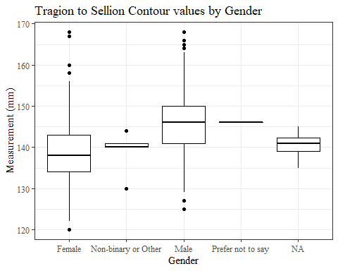

#boxplot not reordered by median  
ggplot(data=headscan_full, aes(y=TrSel_C, x=gender))+  
 geom_boxplot(color= "black", fill = "white")+  
 theme_bw()+theme(text=element_text(family= "Times New Roman"))+  
 #theme(axis.text.x = element_text(angle = 20, vjust=0.7))+  
 labs(title="Tragion to Sellion Contour values by Gender",  
 y="Measurement (mm)",  
 x="Gender")

## Warning: Removed 31 rows containing non-finite values (stat_boxplot).

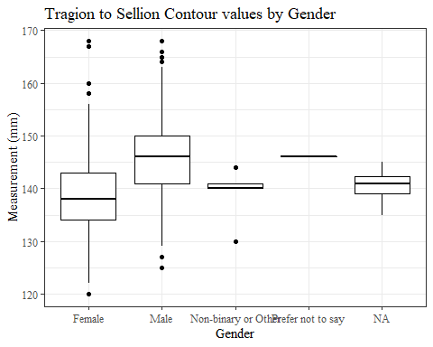

#TrSel_C age group sumstats  
TrSel_Cage_sumstats <- headscan_full %>%   
 group_by(age_group) %>%   
 summarise(n = n(), na = sum(is.na(TrSel_C)),  
 min = min(TrSel_C, na.rm = TRUE),  
 max = max(TrSel_C, na.rm = TRUE),  
 mean = mean(TrSel_C, na.rm = TRUE),  
 mdn = median(TrSel_C, na.rm = TRUE),  
 sd = sd(TrSel_C, na.rm = TRUE),  
 se = sd/sqrt(n),  
 percent5th = quantile(TrSel_C, 0.05, na.rm=TRUE),  
 percent25th = quantile(TrSel_C, 0.25, na.rm=TRUE),  
 percent50th = quantile(TrSel_C, 0.50, na.rm=TRUE),  
 percent75th = quantile(TrSel_C, 0.75, na.rm=TRUE),  
 percent95th = quantile(TrSel_C, 0.95, na.rm=TRUE))  
  
TrSel_Cage_sumstats <- TrSel_Cage_sumstats %>%   
 mutate(across(where(is.numeric), round, 2))  
  
  
#Size 12 Table TNR  
flextable(TrSel_Cage_sumstats) %>%  
 my_ft_theme()%>%   
 bold(part = "header") %>%   
 set_caption("Tragion to Sellion Contour SumStats by Age Group")

**Table** : Tragion to Sellion Contour SumStats by Age Group

| **age_group** | **n** | **na** | **min** | **max** | **mean** | **mdn** | **sd** | **se** | **percent5th** | **percent25th** | **percent50th** | **percent75th** | **percent95th** |
| --- | --- | --- | --- | --- | --- | --- | --- | --- | --- | --- | --- | --- | --- |
| 18-36 | 991 | 13 | 122 | 168 | 141.69 | 142 | 7.54 | 0.24 | 130 | 137 | 142 | 147 | 155.0 |
| 37-54 | 940 | 17 | 120 | 168 | 142.04 | 142 | 7.44 | 0.24 | 131 | 136 | 142 | 147 | 155.0 |
| 55-72 | 84 | 1 | 127 | 160 | 144.22 | 146 | 6.87 | 0.75 | 134 | 138 | 146 | 149 | 154.8 |
|  | 1 | 0 | 145 | 145 | 145.00 | 145 |  |  | 145 | 145 | 145 | 145 | 145.0 |

#%>% set_header_Cabels(values = list(TrSel_C = "Subnasale/SubnasaleCont"))  
  
#Autofit Width Table TNR  
flextable(TrSel_Cage_sumstats) %>%  
 my_ft_theme()%>%   
 bold(part = "header") %>%   
 set_caption("Tragion to Sellion Contour SumStats by Age Group") %>%   
 fit_to_width(7.5)

**Table** : Tragion to Sellion Contour SumStats by Age Group

| **age_group** | **n** | **na** | **min** | **max** | **mean** | **mdn** | **sd** | **se** | **percent5th** | **percent25th** | **percent50th** | **percent75th** | **percent95th** |
| --- | --- | --- | --- | --- | --- | --- | --- | --- | --- | --- | --- | --- | --- |
| 18-36 | 991 | 13 | 122 | 168 | 141.69 | 142 | 7.54 | 0.24 | 130 | 137 | 142 | 147 | 155.0 |
| 37-54 | 940 | 17 | 120 | 168 | 142.04 | 142 | 7.44 | 0.24 | 131 | 136 | 142 | 147 | 155.0 |
| 55-72 | 84 | 1 | 127 | 160 | 144.22 | 146 | 6.87 | 0.75 | 134 | 138 | 146 | 149 | 154.8 |
|  | 1 | 0 | 145 | 145 | 145.00 | 145 |  |  | 145 | 145 | 145 | 145 | 145.0 |

#%>% set_header_Cabels(values = list(TrSel_C = "Subnasale/SubnasaleCont"))  
  
#boxplot reorderd by median  
headscan_full %>%   
 ungroup() %>%   
 mutate(age_group= fct_reorder(age_group, TrSel_C, FUN=median, na.rm=TRUE)) %>%   
 ggplot(aes(y=TrSel_C, x=age_group))+  
 geom_boxplot(color= "black", fill = "white")+  
 theme_bw()+theme(text=element_text(family= "Times New Roman"))+  
 #theme(axis.text.x = element_text(angle = 20, vjust=0.7))+  
 labs(title="Tragion to Sellion Contour values by Age Group",  
 y="Measurement (mm)",  
 x="Age Group")

## Warning: Removed 31 rows containing non-finite values (stat_boxplot).

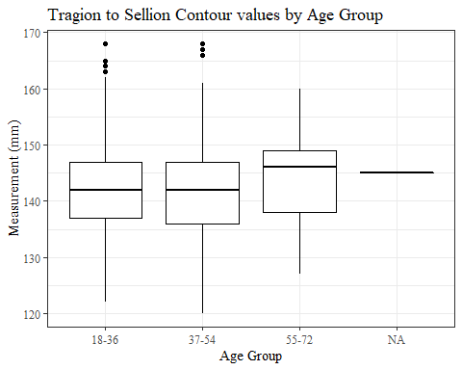

#boxplot not reordered by median  
ggplot(data=headscan_full, aes(y=TrSel_C, x=age_group))+  
 geom_boxplot(color= "black", fill = "white")+  
 theme_bw()+theme(text=element_text(family= "Times New Roman"))+  
 #theme(axis.text.x = element_text(angle = 20, vjust=0.7))+  
 labs(title="Tragion to Sellion Contour values by Age Group",  
 y="Measurement (mm)",  
 x="Age Group")

## Warning: Removed 31 rows containing non-finite values (stat_boxplot).



TrSman_C without outlier removed

#histogram of all TrSman_C values  
ggplot(data=headscan_full, aes(x=TrSman_C))+  
 geom_bar(stat="bin", bins=35, color= "black", fill = "white")+  
 theme_bw()+theme(text=element_text(family= "Times New Roman"))+  
 labs(title="Tragion to Submandibular Contour Measurement Distribution",  
 subtitle = "without outliers removed",  
 y="Frequency",  
 x="Tragion to Submandibular Contour (mm)")

## Warning: Removed 132 rows containing non-finite values (stat_bin).

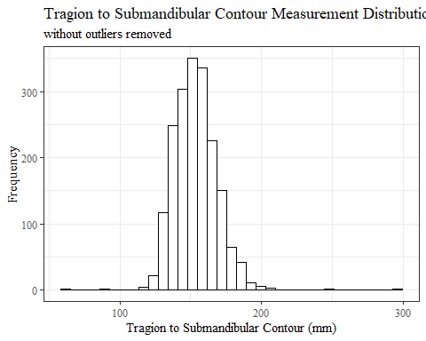

TrSman_Csumstats <- headscan_full %>%   
 summarise(n = n(), na = sum(is.na(TrSman_C)),  
 min = min(TrSman_C, na.rm = TRUE),  
 max = max(TrSman_C, na.rm = TRUE),  
 mean = mean(TrSman_C, na.rm = TRUE),  
 mdn = median(TrSman_C, na.rm = TRUE),  
 sd = sd(TrSman_C, na.rm = TRUE),  
 se = sd/sqrt(n),  
 percent5th = quantile(TrSman_C, 0.05, na.rm=TRUE),  
 percent25th = quantile(TrSman_C, 0.25, na.rm=TRUE),  
 percent50th = quantile(TrSman_C, 0.50, na.rm=TRUE),  
 percent75th = quantile(TrSman_C, 0.75, na.rm=TRUE),  
 percent95th = quantile(TrSman_C, 0.95, na.rm=TRUE))   
  
TrSman_Csumstats <- round(TrSman_Csumstats, 2)  
  
#Size 12 Table TNR  
flextable(TrSman_Csumstats) %>%  
 my_ft_theme()%>%   
 bold(part = "header") %>%   
 set_caption("Tragion to Submandibular Contour SumStats w/o outlier removed")

**Table** : Tragion to Submandibular Contour SumStats w/o outlier removed

| **n** | **na** | **min** | **max** | **mean** | **mdn** | **sd** | **se** | **percent5th** | **percent25th** | **percent50th** | **percent75th** | **percent95th** |
| --- | --- | --- | --- | --- | --- | --- | --- | --- | --- | --- | --- | --- |
| 2,016 | 132 | 64 | 298 | 153.4 | 152 | 14.8 | 0.33 | 132 | 143 | 152 | 162 | 178 |

#%>% set_header_Cabels(values = list(TrSman_C = "Subnasale/SubnasaleCont"))  
  
#Autofit Width Table TNR  
flextable(TrSman_Csumstats) %>%  
 my_ft_theme()%>%   
 bold(part = "header") %>%   
 set_caption("Tragion to Submandibular Contour SumStats w/o outlier removed") %>%   
 fit_to_width(7.5)

**Table** : Tragion to Submandibular Contour SumStats w/o outlier removed

| **n** | **na** | **min** | **max** | **mean** | **mdn** | **sd** | **se** | **percent5th** | **percent25th** | **percent50th** | **percent75th** | **percent95th** |
| --- | --- | --- | --- | --- | --- | --- | --- | --- | --- | --- | --- | --- |
| 2,016 | 132 | 64 | 298 | 153.4 | 152 | 14.8 | 0.33 | 132 | 143 | 152 | 162 | 178 |

#%>% set_header_Cabels(values = list(TrSman_C = "Subnasale/SubnasaleCont"))

#TrSman_C race/eth sumstats  
TrSman_Crace_sumstats <- headscan_full %>%   
 group_by(race_eth) %>%   
 summarise(n = n(), na = sum(is.na(TrSman_C)),  
 min = min(TrSman_C, na.rm = TRUE),  
 max = max(TrSman_C, na.rm = TRUE),  
 mean = mean(TrSman_C, na.rm = TRUE),  
 mdn = median(TrSman_C, na.rm = TRUE),  
 sd = sd(TrSman_C, na.rm = TRUE),  
 se = sd/sqrt(n),  
 percent5th = quantile(TrSman_C, 0.05, na.rm=TRUE),  
 percent25th = quantile(TrSman_C, 0.25, na.rm=TRUE),  
 percent50th = quantile(TrSman_C, 0.50, na.rm=TRUE),  
 percent75th = quantile(TrSman_C, 0.75, na.rm=TRUE),  
 percent95th = quantile(TrSman_C, 0.95, na.rm=TRUE))   
  
TrSman_Crace_sumstats <- TrSman_Crace_sumstats %>%   
 mutate(across(where(is.numeric), round, 2))  
  
  
#Size 12 Table TNR  
flextable(TrSman_Crace_sumstats) %>%  
 my_ft_theme()%>%   
 bold(part = "header") %>%   
 set_caption("Tragion to Submandibular Contour SumStats by Race/Ethnicity w/o outlier removed")

**Table** : Tragion to Submandibular Contour SumStats by Race/Ethnicity w/o outlier removed

| **race_eth** | **n** | **na** | **min** | **max** | **mean** | **mdn** | **sd** | **se** | **percent5th** | **percent25th** | **percent50th** | **percent75th** | **percent95th** |
| --- | --- | --- | --- | --- | --- | --- | --- | --- | --- | --- | --- | --- | --- |
| white | 1,239 | 72 | 64 | 298 | 152.31 | 151.0 | 15.58 | 0.44 | 131.0 | 142.0 | 151.0 | 161.00 | 178.70 |
| Black | 548 | 45 | 122 | 201 | 156.78 | 156.0 | 12.65 | 0.54 | 138.0 | 148.0 | 156.0 | 165.50 | 178.90 |
| LatinX | 100 | 4 | 126 | 195 | 153.07 | 150.5 | 14.70 | 1.47 | 132.0 | 142.0 | 150.5 | 162.25 | 176.75 |
| Asian | 91 | 4 | 122 | 196 | 150.31 | 150.0 | 13.67 | 1.43 | 130.0 | 140.5 | 150.0 | 158.00 | 173.10 |
| Other | 21 | 5 | 132 | 165 | 150.00 | 150.5 | 9.91 | 2.16 | 133.5 | 146.0 | 150.5 | 156.75 | 162.00 |
| AIAN | 8 | 1 | 130 | 169 | 144.43 | 146.0 | 13.88 | 4.91 | 130.9 | 133.0 | 146.0 | 150.00 | 164.20 |
| PTNS | 5 | 0 | 139 | 181 | 155.80 | 154.0 | 15.83 | 7.08 | 140.6 | 147.0 | 154.0 | 158.00 | 176.40 |
| NHOPI | 4 | 1 | 143 | 151 | 147.67 | 149.0 | 4.16 | 2.08 | 143.6 | 146.0 | 149.0 | 150.00 | 150.80 |

#%>% set_header_Cabels(values = list(TrSman_C = "Subnasale/SubnasaleCont"))  
  
#Autofit Width Table TNR  
flextable(TrSman_Crace_sumstats) %>%  
 my_ft_theme()%>%   
 bold(part = "header") %>%   
 set_caption("Tragion to Submandibular Contour SumStats by Race/Ethnicity w/o outlier removed") %>%   
 fit_to_width(7.5)

**Table** : Tragion to Submandibular Contour SumStats by Race/Ethnicity w/o outlier removed

| **race_eth** | **n** | **na** | **min** | **max** | **mean** | **mdn** | **sd** | **se** | **percent5th** | **percent25th** | **percent50th** | **percent75th** | **percent95th** |
| --- | --- | --- | --- | --- | --- | --- | --- | --- | --- | --- | --- | --- | --- |
| white | 1,239 | 72 | 64 | 298 | 152.31 | 151.0 | 15.58 | 0.44 | 131.0 | 142.0 | 151.0 | 161.00 | 178.70 |
| Black | 548 | 45 | 122 | 201 | 156.78 | 156.0 | 12.65 | 0.54 | 138.0 | 148.0 | 156.0 | 165.50 | 178.90 |
| LatinX | 100 | 4 | 126 | 195 | 153.07 | 150.5 | 14.70 | 1.47 | 132.0 | 142.0 | 150.5 | 162.25 | 176.75 |
| Asian | 91 | 4 | 122 | 196 | 150.31 | 150.0 | 13.67 | 1.43 | 130.0 | 140.5 | 150.0 | 158.00 | 173.10 |
| Other | 21 | 5 | 132 | 165 | 150.00 | 150.5 | 9.91 | 2.16 | 133.5 | 146.0 | 150.5 | 156.75 | 162.00 |
| AIAN | 8 | 1 | 130 | 169 | 144.43 | 146.0 | 13.88 | 4.91 | 130.9 | 133.0 | 146.0 | 150.00 | 164.20 |
| PTNS | 5 | 0 | 139 | 181 | 155.80 | 154.0 | 15.83 | 7.08 | 140.6 | 147.0 | 154.0 | 158.00 | 176.40 |
| NHOPI | 4 | 1 | 143 | 151 | 147.67 | 149.0 | 4.16 | 2.08 | 143.6 | 146.0 | 149.0 | 150.00 | 150.80 |

#%>% set_header_Cabels(values = list(TrSman_C = "Subnasale/SubnasaleCont"))  
  
#boxplot reorderd by median  
headscan_full %>%   
 ungroup() %>%   
 mutate(race_eth= fct_reorder(race_eth, TrSman_C, FUN=median, na.rm=TRUE)) %>%   
 ggplot(aes(y=TrSman_C, x=race_eth))+  
 geom_boxplot(color= "black", fill = "white")+  
 theme_bw()+theme(text=element_text(family= "Times New Roman"))+  
 #theme(axis.text.x = element_text(angle = 20, vjust=0.7))+  
 labs(title="Tragion to Submandibular Contour values by Race/Ethnicity",  
 subtitle = "without outliers removed",  
 y="Measurement (mm)",  
 x="Race/Ethnicity")

## Warning: Removed 132 rows containing non-finite values (stat_boxplot).

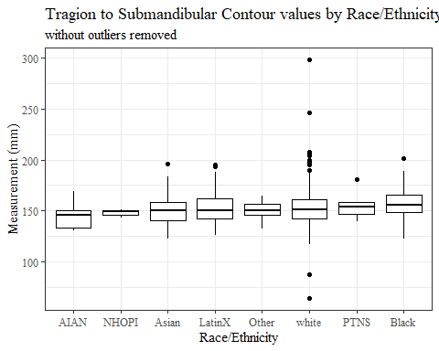

#boxplot not reordered by median  
ggplot(data=headscan_full, aes(y=TrSman_C, x=race_eth))+  
 geom_boxplot(color= "black", fill = "white")+  
 theme_bw()+theme(text=element_text(family= "Times New Roman"))+  
 #theme(axis.text.x = element_text(angle = 20, vjust=0.7))+  
 labs(title="Tragion to Submandibular Contour values by Race/Ethnicity",  
 subtitle = "without outliers removed",  
 y="Measurement (mm)",  
 x="Race/Ethnicity")

## Warning: Removed 132 rows containing non-finite values (stat_boxplot).

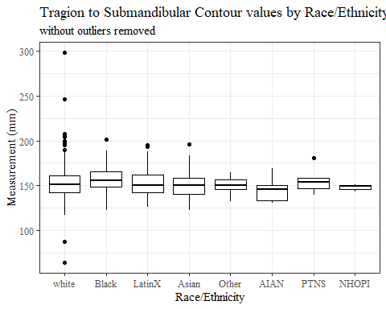

#TrSman_C gender sumstats  
TrSman_Cgender_sumstats <- headscan_full %>%   
 group_by(gender) %>%   
 summarise(n = n(), na = sum(is.na(TrSman_C)),  
 min = min(TrSman_C, na.rm = TRUE),  
 max = max(TrSman_C, na.rm = TRUE),  
 mean = mean(TrSman_C, na.rm = TRUE),  
 mdn = median(TrSman_C, na.rm = TRUE),  
 sd = sd(TrSman_C, na.rm = TRUE),  
 se = sd/sqrt(n),  
 percent5th = quantile(TrSman_C, 0.05, na.rm=TRUE),  
 percent25th = quantile(TrSman_C, 0.25, na.rm=TRUE),  
 percent50th = quantile(TrSman_C, 0.50, na.rm=TRUE),  
 percent75th = quantile(TrSman_C, 0.75, na.rm=TRUE),  
 percent95th = quantile(TrSman_C, 0.95, na.rm=TRUE))  
  
TrSman_Cgender_sumstats <- TrSman_Cgender_sumstats %>%   
 mutate(across(where(is.numeric), round, 2))  
  
#Size 12 Table TNR  
flextable(TrSman_Cgender_sumstats) %>%  
 my_ft_theme()%>%   
 bold(part = "header") %>%   
 set_caption("Tragion to Submandibular Contour SumStats by Gender w/o outlier removed")

**Table** : Tragion to Submandibular Contour SumStats by Gender w/o outlier removed

| **gender** | **n** | **na** | **min** | **max** | **mean** | **mdn** | **sd** | **se** | **percent5th** | **percent25th** | **percent50th** | **percent75th** | **percent95th** |
| --- | --- | --- | --- | --- | --- | --- | --- | --- | --- | --- | --- | --- | --- |
| Female | 1,063 | 32 | 87 | 195 | 146.82 | 145 | 11.88 | 0.36 | 130.00 | 139.00 | 145 | 154.00 | 167.50 |
| Male | 939 | 100 | 64 | 298 | 161.52 | 160 | 14.00 | 0.46 | 142.90 | 153.00 | 160 | 169.00 | 184.00 |
| Non-binary or Other | 5 | 0 | 119 | 161 | 143.20 | 147 | 17.21 | 7.70 | 121.80 | 133.00 | 147 | 156.00 | 160.00 |
| Prefer not to say | 1 | 0 | 181 | 181 | 181.00 | 181 |  |  | 181.00 | 181.00 | 181 | 181.00 | 181.00 |
|  | 8 | 0 | 143 | 175 | 152.25 | 149 | 10.19 | 3.60 | 144.05 | 146.75 | 149 | 152.75 | 169.05 |

#%>% set_header_Cabels(values = list(TrSman_C = "Subnasale/SubnasaleCont"))  
  
#Autofit Width Table TNR  
flextable(TrSman_Cgender_sumstats) %>%  
 my_ft_theme()%>%   
 bold(part = "header") %>%   
 set_caption("Tragion to Submandibular Contour SumStats by Gender w/o outlier removed") %>%   
 fit_to_width(7.5)

**Table** : Tragion to Submandibular Contour SumStats by Gender w/o outlier removed

| **gender** | **n** | **na** | **min** | **max** | **mean** | **mdn** | **sd** | **se** | **percent5th** | **percent25th** | **percent50th** | **percent75th** | **percent95th** |
| --- | --- | --- | --- | --- | --- | --- | --- | --- | --- | --- | --- | --- | --- |
| Female | 1,063 | 32 | 87 | 195 | 146.82 | 145 | 11.88 | 0.36 | 130.00 | 139.00 | 145 | 154.00 | 167.50 |
| Male | 939 | 100 | 64 | 298 | 161.52 | 160 | 14.00 | 0.46 | 142.90 | 153.00 | 160 | 169.00 | 184.00 |
| Non-binary or Other | 5 | 0 | 119 | 161 | 143.20 | 147 | 17.21 | 7.70 | 121.80 | 133.00 | 147 | 156.00 | 160.00 |
| Prefer not to say | 1 | 0 | 181 | 181 | 181.00 | 181 |  |  | 181.00 | 181.00 | 181 | 181.00 | 181.00 |
|  | 8 | 0 | 143 | 175 | 152.25 | 149 | 10.19 | 3.60 | 144.05 | 146.75 | 149 | 152.75 | 169.05 |

#%>% set_header_Cabels(values = list(TrSman_C = "Subnasale/SubnasaleCont"))  
  
#boxplot reorderd by median  
headscan_full %>%   
 ungroup() %>%   
 mutate(gender= fct_reorder(gender, TrSman_C, FUN=median, na.rm=TRUE)) %>%   
 ggplot(aes(y=TrSman_C, x=gender))+  
 geom_boxplot(color= "black", fill = "white")+  
 theme_bw()+theme(text=element_text(family= "Times New Roman"))+  
 theme(axis.text.x = element_text(angle = 20, vjust=0.7))+  
 labs(title="Tragion to Submandibular Contour values by Gender",  
 subtitle = "without outliers removed",  
 y="Measurement (mm)",  
 x="Gender")

## Warning: Removed 132 rows containing non-finite values (stat_boxplot).

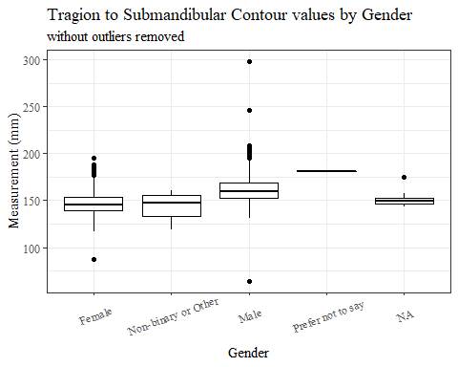

#boxplot not reordered by median  
ggplot(data=headscan_full, aes(y=TrSman_C, x=gender))+  
 geom_boxplot(color= "black", fill = "white")+  
 theme_bw()+theme(text=element_text(family= "Times New Roman"))+  
 theme(axis.text.x = element_text(angle = 20, vjust=0.7))+  
 labs(title="Tragion to Submandibular Contour values by Gender",  
 subtitle = "without outliers removed",  
 y="Measurement (mm)",  
 x="Gender")

## Warning: Removed 132 rows containing non-finite values (stat_boxplot).

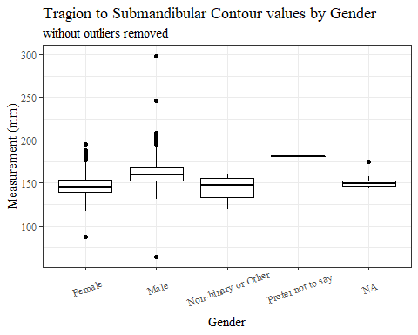

#TrSman_C age group sumstats  
TrSman_Cage_sumstats <- headscan_full %>%   
 group_by(age_group) %>%   
 summarise(n = n(), na = sum(is.na(TrSman_C)),  
 min = min(TrSman_C, na.rm = TRUE),  
 max = max(TrSman_C, na.rm = TRUE),  
 mean = mean(TrSman_C, na.rm = TRUE),  
 mdn = median(TrSman_C, na.rm = TRUE),  
 sd = sd(TrSman_C, na.rm = TRUE),  
 se = sd/sqrt(n),  
 percent5th = quantile(TrSman_C, 0.05, na.rm=TRUE),  
 percent25th = quantile(TrSman_C, 0.25, na.rm=TRUE),  
 percent50th = quantile(TrSman_C, 0.50, na.rm=TRUE),  
 percent75th = quantile(TrSman_C, 0.75, na.rm=TRUE),  
 percent95th = quantile(TrSman_C, 0.95, na.rm=TRUE))  
  
TrSman_Cage_sumstats <- TrSman_Cage_sumstats %>%   
 mutate(across(where(is.numeric), round, 2))  
  
  
#Size 12 Table TNR  
flextable(TrSman_Cage_sumstats) %>%  
 my_ft_theme()%>%   
 bold(part = "header") %>%   
 set_caption("Tragion to Submandibular Contour SumStats by Age Group w/o outlier removed")

**Table** : Tragion to Submandibular Contour SumStats by Age Group w/o outlier removed

| **age_group** | **n** | **na** | **min** | **max** | **mean** | **mdn** | **sd** | **se** | **percent5th** | **percent25th** | **percent50th** | **percent75th** | **percent95th** |
| --- | --- | --- | --- | --- | --- | --- | --- | --- | --- | --- | --- | --- | --- |
| 18-36 | 991 | 67 | 119 | 205 | 150.22 | 149 | 13.48 | 0.43 | 131.00 | 140.00 | 149 | 159.00 | 174.00 |
| 37-54 | 940 | 63 | 87 | 298 | 156.31 | 155 | 15.29 | 0.50 | 136.00 | 146.00 | 155 | 165.00 | 182.00 |
| 55-72 | 84 | 2 | 64 | 189 | 157.98 | 159 | 16.36 | 1.79 | 137.05 | 149.25 | 159 | 167.75 | 176.95 |
|  | 1 | 0 | 158 | 158 | 158.00 | 158 |  |  | 158.00 | 158.00 | 158 | 158.00 | 158.00 |

#%>% set_header_Cabels(values = list(TrSman_C = "Subnasale/SubnasaleCont"))  
  
#Autofit Width Table TNR  
flextable(TrSman_Cage_sumstats) %>%  
 my_ft_theme()%>%   
 bold(part = "header") %>%   
 set_caption("Tragion to Submandibular Contour SumStats by Age Group w/o outlier removed") %>%   
 fit_to_width(7.5)

**Table** : Tragion to Submandibular Contour SumStats by Age Group w/o outlier removed

| **age_group** | **n** | **na** | **min** | **max** | **mean** | **mdn** | **sd** | **se** | **percent5th** | **percent25th** | **percent50th** | **percent75th** | **percent95th** |
| --- | --- | --- | --- | --- | --- | --- | --- | --- | --- | --- | --- | --- | --- |
| 18-36 | 991 | 67 | 119 | 205 | 150.22 | 149 | 13.48 | 0.43 | 131.00 | 140.00 | 149 | 159.00 | 174.00 |
| 37-54 | 940 | 63 | 87 | 298 | 156.31 | 155 | 15.29 | 0.50 | 136.00 | 146.00 | 155 | 165.00 | 182.00 |
| 55-72 | 84 | 2 | 64 | 189 | 157.98 | 159 | 16.36 | 1.79 | 137.05 | 149.25 | 159 | 167.75 | 176.95 |
|  | 1 | 0 | 158 | 158 | 158.00 | 158 |  |  | 158.00 | 158.00 | 158 | 158.00 | 158.00 |

#%>% set_header_Cabels(values = list(TrSman_C = "Subnasale/SubnasaleCont"))  
  
#boxplot reorderd by median  
headscan_full %>%   
 ungroup() %>%   
 mutate(age_group= fct_reorder(age_group, TrSman_C, FUN=median, na.rm=TRUE)) %>%   
 ggplot(aes(y=TrSman_C, x=age_group))+  
 geom_boxplot(color= "black", fill = "white")+  
 theme_bw()+theme(text=element_text(family= "Times New Roman"))+  
 #theme(axis.text.x = element_text(angle = 20, vjust=0.7))+  
 labs(title="Tragion to Submandibular Contour values by Age Group",  
 subtitle = "without outliers removed",  
 y="Measurement (mm)",  
 x="Age Group")

## Warning: Removed 132 rows containing non-finite values (stat_boxplot).

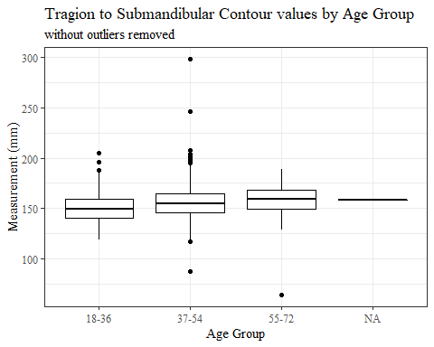

#boxplot not reordered by median  
ggplot(data=headscan_full, aes(y=TrSman_C, x=age_group))+  
 geom_boxplot(color= "black", fill = "white")+  
 theme_bw()+theme(text=element_text(family= "Times New Roman"))+  
 #theme(axis.text.x = element_text(angle = 20, vjust=0.7))+  
 labs(title="Tragion to Submandibular Contour values by Age Group",  
 subtitle = "without outliers removed",  
 y="Measurement (mm)",  
 x="Age Group")

## Warning: Removed 132 rows containing non-finite values (stat_boxplot).



TrSman_C with outlier removed

max(headscan_full$TrSman_C, na.rm = TRUE)

## [1] 298

#CODE TO REMOVE OUTLIER, use later to remove from headscan_full  
TrSman_C_no_out <- headscan_full %>% mutate(TrSman_C = replace(TrSman_C, TrSman_C>290, NA))

#histogram of all TrSman_C values  
ggplot(data=TrSman_C_no_out, aes(x=TrSman_C))+  
 geom_bar(stat="bin", bins=25, color= "black", fill = "white")+  
 theme_bw()+theme(text=element_text(family= "Times New Roman"))+  
 labs(title="Tragion to Submandibular Contour Measurement Distribution",  
 y="Frequency",  
 x="Tragion to Submandibular Contour (mm)")

## Warning: Removed 133 rows containing non-finite values (stat_bin).

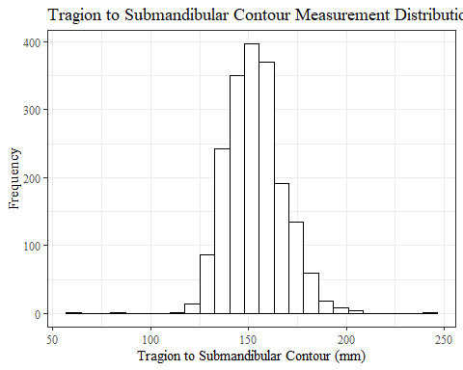

TrSman_Csumstats1 <- TrSman_C_no_out %>%   
 summarise(n = n(), na = sum(is.na(TrSman_C)),  
 min = min(TrSman_C, na.rm = TRUE),  
 max = max(TrSman_C, na.rm = TRUE),  
 mean = mean(TrSman_C, na.rm = TRUE),  
 mdn = median(TrSman_C, na.rm = TRUE),  
 sd = sd(TrSman_C, na.rm = TRUE),  
 se = sd/sqrt(n),  
 percent5th = quantile(TrSman_C, 0.05, na.rm=TRUE),  
 percent25th = quantile(TrSman_C, 0.25, na.rm=TRUE),  
 percent50th = quantile(TrSman_C, 0.50, na.rm=TRUE),  
 percent75th = quantile(TrSman_C, 0.75, na.rm=TRUE),  
 percent95th = quantile(TrSman_C, 0.95, na.rm=TRUE))   
  
TrSman_Csumstats1 <- round(TrSman_Csumstats1, 2)  
  
#Size 12 Table TNR  
flextable(TrSman_Csumstats1) %>%  
 my_ft_theme()%>%   
 bold(part = "header") %>%   
 set_caption("Tragion to Submandibular Contour SumStats")

**Table** : Tragion to Submandibular Contour SumStats

| **n** | **na** | **min** | **max** | **mean** | **mdn** | **sd** | **se** | **percent5th** | **percent25th** | **percent50th** | **percent75th** | **percent95th** |
| --- | --- | --- | --- | --- | --- | --- | --- | --- | --- | --- | --- | --- |
| 2,016 | 133 | 64 | 246 | 153.32 | 152 | 14.43 | 0.32 | 132 | 143 | 152 | 162 | 178 |

#%>% set_header_Cabels(values = list(TrSman_C = "Subnasale/SubnasaleCont"))  
  
#Autofit Width Table TNR  
flextable(TrSman_Csumstats1) %>%  
 my_ft_theme()%>%   
 bold(part = "header") %>%   
 set_caption("Tragion to Submandibular Contour SumStats") %>%   
 fit_to_width(7.5)

**Table** : Tragion to Submandibular Contour SumStats

| **n** | **na** | **min** | **max** | **mean** | **mdn** | **sd** | **se** | **percent5th** | **percent25th** | **percent50th** | **percent75th** | **percent95th** |
| --- | --- | --- | --- | --- | --- | --- | --- | --- | --- | --- | --- | --- |
| 2,016 | 133 | 64 | 246 | 153.32 | 152 | 14.43 | 0.32 | 132 | 143 | 152 | 162 | 178 |

#%>% set_header_Cabels(values = list(TrSman_C = "Subnasale/SubnasaleCont"))

#TrSman_C race/eth sumstats  
TrSman_Crace_sumstats1 <- TrSman_C_no_out %>%   
 group_by(race_eth) %>%   
 summarise(n = n(), na = sum(is.na(TrSman_C)),  
 min = min(TrSman_C, na.rm = TRUE),  
 max = max(TrSman_C, na.rm = TRUE),  
 mean = mean(TrSman_C, na.rm = TRUE),  
 mdn = median(TrSman_C, na.rm = TRUE),  
 sd = sd(TrSman_C, na.rm = TRUE),  
 se = sd/sqrt(n),  
 percent5th = quantile(TrSman_C, 0.05, na.rm=TRUE),  
 percent25th = quantile(TrSman_C, 0.25, na.rm=TRUE),  
 percent50th = quantile(TrSman_C, 0.50, na.rm=TRUE),  
 percent75th = quantile(TrSman_C, 0.75, na.rm=TRUE),  
 percent95th = quantile(TrSman_C, 0.95, na.rm=TRUE))   
  
TrSman_Crace_sumstats1 <- TrSman_Crace_sumstats1 %>%   
 mutate(across(where(is.numeric), round, 2))  
  
  
#Size 12 Table TNR  
flextable(TrSman_Crace_sumstats1) %>%  
 my_ft_theme()%>%   
 bold(part = "header") %>%   
 set_caption("Tragion to Submandibular Contour SumStats by Race/Ethnicity")

**Table** : Tragion to Submandibular Contour SumStats by Race/Ethnicity

| **race_eth** | **n** | **na** | **min** | **max** | **mean** | **mdn** | **sd** | **se** | **percent5th** | **percent25th** | **percent50th** | **percent75th** | **percent95th** |
| --- | --- | --- | --- | --- | --- | --- | --- | --- | --- | --- | --- | --- | --- |
| white | 1,239 | 73 | 64 | 246 | 152.18 | 151.0 | 14.99 | 0.43 | 131.0 | 142.0 | 151.0 | 161.00 | 178.00 |
| Black | 548 | 45 | 122 | 201 | 156.78 | 156.0 | 12.65 | 0.54 | 138.0 | 148.0 | 156.0 | 165.50 | 178.90 |
| LatinX | 100 | 4 | 126 | 195 | 153.07 | 150.5 | 14.70 | 1.47 | 132.0 | 142.0 | 150.5 | 162.25 | 176.75 |
| Asian | 91 | 4 | 122 | 196 | 150.31 | 150.0 | 13.67 | 1.43 | 130.0 | 140.5 | 150.0 | 158.00 | 173.10 |
| Other | 21 | 5 | 132 | 165 | 150.00 | 150.5 | 9.91 | 2.16 | 133.5 | 146.0 | 150.5 | 156.75 | 162.00 |
| AIAN | 8 | 1 | 130 | 169 | 144.43 | 146.0 | 13.88 | 4.91 | 130.9 | 133.0 | 146.0 | 150.00 | 164.20 |
| PTNS | 5 | 0 | 139 | 181 | 155.80 | 154.0 | 15.83 | 7.08 | 140.6 | 147.0 | 154.0 | 158.00 | 176.40 |
| NHOPI | 4 | 1 | 143 | 151 | 147.67 | 149.0 | 4.16 | 2.08 | 143.6 | 146.0 | 149.0 | 150.00 | 150.80 |

#%>% set_header_Cabels(values = list(TrSman_C = "Subnasale/SubnasaleCont"))  
  
#Autofit Width Table TNR  
flextable(TrSman_Crace_sumstats1) %>%  
 my_ft_theme()%>%   
 bold(part = "header") %>%   
 set_caption("Tragion to Submandibular Contour SumStats by Race/Ethnicity") %>%   
 fit_to_width(7.5)

**Table** : Tragion to Submandibular Contour SumStats by Race/Ethnicity

| **race_eth** | **n** | **na** | **min** | **max** | **mean** | **mdn** | **sd** | **se** | **percent5th** | **percent25th** | **percent50th** | **percent75th** | **percent95th** |
| --- | --- | --- | --- | --- | --- | --- | --- | --- | --- | --- | --- | --- | --- |
| white | 1,239 | 73 | 64 | 246 | 152.18 | 151.0 | 14.99 | 0.43 | 131.0 | 142.0 | 151.0 | 161.00 | 178.00 |
| Black | 548 | 45 | 122 | 201 | 156.78 | 156.0 | 12.65 | 0.54 | 138.0 | 148.0 | 156.0 | 165.50 | 178.90 |
| LatinX | 100 | 4 | 126 | 195 | 153.07 | 150.5 | 14.70 | 1.47 | 132.0 | 142.0 | 150.5 | 162.25 | 176.75 |
| Asian | 91 | 4 | 122 | 196 | 150.31 | 150.0 | 13.67 | 1.43 | 130.0 | 140.5 | 150.0 | 158.00 | 173.10 |
| Other | 21 | 5 | 132 | 165 | 150.00 | 150.5 | 9.91 | 2.16 | 133.5 | 146.0 | 150.5 | 156.75 | 162.00 |
| AIAN | 8 | 1 | 130 | 169 | 144.43 | 146.0 | 13.88 | 4.91 | 130.9 | 133.0 | 146.0 | 150.00 | 164.20 |
| PTNS | 5 | 0 | 139 | 181 | 155.80 | 154.0 | 15.83 | 7.08 | 140.6 | 147.0 | 154.0 | 158.00 | 176.40 |
| NHOPI | 4 | 1 | 143 | 151 | 147.67 | 149.0 | 4.16 | 2.08 | 143.6 | 146.0 | 149.0 | 150.00 | 150.80 |

#%>% set_header_Cabels(values = list(TrSman_C = "Subnasale/SubnasaleCont"))  
  
#boxplot reorderd by median  
TrSman_C_no_out %>%   
 ungroup() %>%   
 mutate(race_eth= fct_reorder(race_eth, TrSman_C, FUN=median, na.rm=TRUE)) %>%   
 ggplot(aes(y=TrSman_C, x=race_eth))+  
 geom_boxplot(color= "black", fill = "white")+  
 theme_bw()+theme(text=element_text(family= "Times New Roman"))+  
 #theme(axis.text.x = element_text(angle = 20, vjust=0.7))+  
 labs(title="Tragion to Submandibular Contour values by Race/Ethnicity",  
 y="Measurement (mm)",  
 x="Race/Ethnicity")

## Warning: Removed 133 rows containing non-finite values (stat_boxplot).

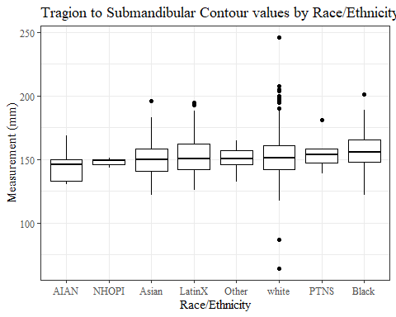

#boxplot not reordered by median  
ggplot(data=TrSman_C_no_out, aes(y=TrSman_C, x=race_eth))+  
 geom_boxplot(color= "black", fill = "white")+  
 theme_bw()+theme(text=element_text(family= "Times New Roman"))+  
 #theme(axis.text.x = element_text(angle = 20, vjust=0.7))+  
 labs(title="Tragion to Submandibular Contour values by Race/Ethnicity",  
 y="Measurement (mm)",  
 x="Race/Ethnicity")

## Warning: Removed 133 rows containing non-finite values (stat_boxplot).

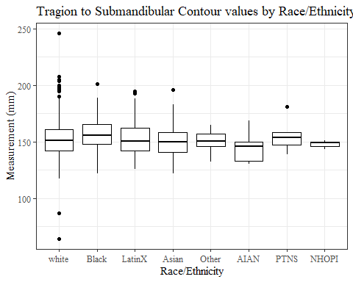

#TrSman_C gender sumstats  
TrSman_Cgender_sumstats1 <- TrSman_C_no_out %>%   
 group_by(gender) %>%   
 summarise(n = n(), na = sum(is.na(TrSman_C)),  
 min = min(TrSman_C, na.rm = TRUE),  
 max = max(TrSman_C, na.rm = TRUE),  
 mean = mean(TrSman_C, na.rm = TRUE),  
 mdn = median(TrSman_C, na.rm = TRUE),  
 sd = sd(TrSman_C, na.rm = TRUE),  
 se = sd/sqrt(n),  
 percent5th = quantile(TrSman_C, 0.05, na.rm=TRUE),  
 percent25th = quantile(TrSman_C, 0.25, na.rm=TRUE),  
 percent50th = quantile(TrSman_C, 0.50, na.rm=TRUE),  
 percent75th = quantile(TrSman_C, 0.75, na.rm=TRUE),  
 percent95th = quantile(TrSman_C, 0.95, na.rm=TRUE))  
  
TrSman_Cgender_sumstats1 <- TrSman_Cgender_sumstats1 %>%   
 mutate(across(where(is.numeric), round, 2))  
  
#Size 12 Table TNR  
flextable(TrSman_Cgender_sumstats1) %>%  
 my_ft_theme()%>%   
 bold(part = "header") %>%   
 set_caption("Tragion to Submandibular Contour SumStats by Gender")

**Table** : Tragion to Submandibular Contour SumStats by Gender

| **gender** | **n** | **na** | **min** | **max** | **mean** | **mdn** | **sd** | **se** | **percent5th** | **percent25th** | **percent50th** | **percent75th** | **percent95th** |
| --- | --- | --- | --- | --- | --- | --- | --- | --- | --- | --- | --- | --- | --- |
| Female | 1,063 | 32 | 87 | 195 | 146.82 | 145 | 11.88 | 0.36 | 130.00 | 139.00 | 145 | 154.00 | 167.50 |
| Male | 939 | 101 | 64 | 246 | 161.36 | 160 | 13.19 | 0.43 | 142.85 | 153.00 | 160 | 169.00 | 184.00 |
| Non-binary or Other | 5 | 0 | 119 | 161 | 143.20 | 147 | 17.21 | 7.70 | 121.80 | 133.00 | 147 | 156.00 | 160.00 |
| Prefer not to say | 1 | 0 | 181 | 181 | 181.00 | 181 |  |  | 181.00 | 181.00 | 181 | 181.00 | 181.00 |
|  | 8 | 0 | 143 | 175 | 152.25 | 149 | 10.19 | 3.60 | 144.05 | 146.75 | 149 | 152.75 | 169.05 |

#%>% set_header_Cabels(values = list(TrSman_C = "Subnasale/SubnasaleCont"))  
  
#Autofit Width Table TNR  
flextable(TrSman_Cgender_sumstats1) %>%  
 my_ft_theme()%>%   
 bold(part = "header") %>%   
 set_caption("Tragion to Submandibular Contour SumStats by Gender") %>%   
 fit_to_width(7.5)

**Table** : Tragion to Submandibular Contour SumStats by Gender

| **gender** | **n** | **na** | **min** | **max** | **mean** | **mdn** | **sd** | **se** | **percent5th** | **percent25th** | **percent50th** | **percent75th** | **percent95th** |
| --- | --- | --- | --- | --- | --- | --- | --- | --- | --- | --- | --- | --- | --- |
| Female | 1,063 | 32 | 87 | 195 | 146.82 | 145 | 11.88 | 0.36 | 130.00 | 139.00 | 145 | 154.00 | 167.50 |
| Male | 939 | 101 | 64 | 246 | 161.36 | 160 | 13.19 | 0.43 | 142.85 | 153.00 | 160 | 169.00 | 184.00 |
| Non-binary or Other | 5 | 0 | 119 | 161 | 143.20 | 147 | 17.21 | 7.70 | 121.80 | 133.00 | 147 | 156.00 | 160.00 |
| Prefer not to say | 1 | 0 | 181 | 181 | 181.00 | 181 |  |  | 181.00 | 181.00 | 181 | 181.00 | 181.00 |
|  | 8 | 0 | 143 | 175 | 152.25 | 149 | 10.19 | 3.60 | 144.05 | 146.75 | 149 | 152.75 | 169.05 |

#%>% set_header_Cabels(values = list(TrSman_C = "Subnasale/SubnasaleCont"))  
  
#boxplot reorderd by median  
TrSman_C_no_out %>%   
 ungroup() %>%   
 mutate(gender= fct_reorder(gender, TrSman_C, FUN=median, na.rm=TRUE)) %>%   
 ggplot(aes(y=TrSman_C, x=gender))+  
 geom_boxplot(color= "black", fill = "white")+  
 theme_bw()+theme(text=element_text(family= "Times New Roman"))+  
 theme(axis.text.x = element_text(angle = 20, vjust=0.7))+  
 labs(title="Tragion to Submandibular Contour values by Gender",  
 y="Measurement (mm)",  
 x="Gender")

## Warning: Removed 133 rows containing non-finite values (stat_boxplot).

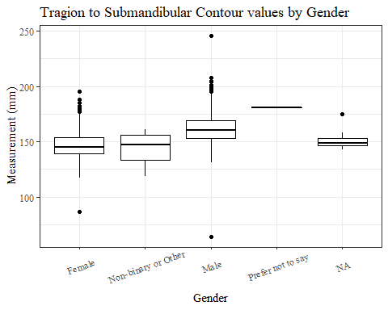

#boxplot not reordered by median  
ggplot(data=TrSman_C_no_out, aes(y=TrSman_C, x=gender))+  
 geom_boxplot(color= "black", fill = "white")+  
 theme_bw()+theme(text=element_text(family= "Times New Roman"))+  
 theme(axis.text.x = element_text(angle = 20, vjust=0.7))+  
 labs(title="Tragion to Submandibular Contour values by Gender",  
 y="Measurement (mm)",  
 x="Gender")

## Warning: Removed 133 rows containing non-finite values (stat_boxplot).

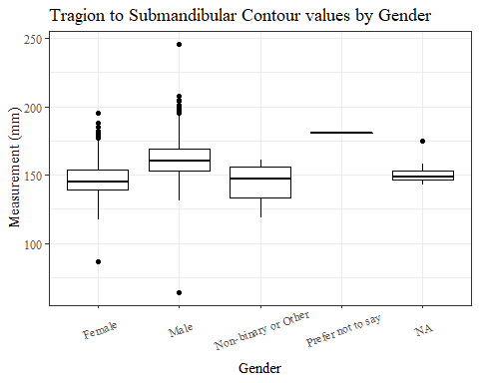

#TrSman_C age group sumstats  
TrSman_Cage_sumstats1 <- TrSman_C_no_out %>%   
 group_by(age_group) %>%   
 summarise(n = n(), na = sum(is.na(TrSman_C)),  
 min = min(TrSman_C, na.rm = TRUE),  
 max = max(TrSman_C, na.rm = TRUE),  
 mean = mean(TrSman_C, na.rm = TRUE),  
 mdn = median(TrSman_C, na.rm = TRUE),  
 sd = sd(TrSman_C, na.rm = TRUE),  
 se = sd/sqrt(n),  
 percent5th = quantile(TrSman_C, 0.05, na.rm=TRUE),  
 percent25th = quantile(TrSman_C, 0.25, na.rm=TRUE),  
 percent50th = quantile(TrSman_C, 0.50, na.rm=TRUE),  
 percent75th = quantile(TrSman_C, 0.75, na.rm=TRUE),  
 percent95th = quantile(TrSman_C, 0.95, na.rm=TRUE))  
  
TrSman_Cage_sumstats1 <- TrSman_Cage_sumstats1 %>%   
 mutate(across(where(is.numeric), round, 2))  
  
  
#Size 12 Table TNR  
flextable(TrSman_Cage_sumstats1) %>%  
 my_ft_theme()%>%   
 bold(part = "header") %>%   
 set_caption("Tragion to Submandibular Contour SumStats by Age Group")

**Table** : Tragion to Submandibular Contour SumStats by Age Group

| **age_group** | **n** | **na** | **min** | **max** | **mean** | **mdn** | **sd** | **se** | **percent5th** | **percent25th** | **percent50th** | **percent75th** | **percent95th** |
| --- | --- | --- | --- | --- | --- | --- | --- | --- | --- | --- | --- | --- | --- |
| 18-36 | 991 | 67 | 119 | 205 | 150.22 | 149 | 13.48 | 0.43 | 131.00 | 140.00 | 149 | 159.00 | 174.00 |
| 37-54 | 940 | 64 | 87 | 246 | 156.15 | 155 | 14.53 | 0.47 | 136.00 | 146.00 | 155 | 165.00 | 181.25 |
| 55-72 | 84 | 2 | 64 | 189 | 157.98 | 159 | 16.36 | 1.79 | 137.05 | 149.25 | 159 | 167.75 | 176.95 |
|  | 1 | 0 | 158 | 158 | 158.00 | 158 |  |  | 158.00 | 158.00 | 158 | 158.00 | 158.00 |

#%>% set_header_Cabels(values = list(TrSman_C = "Subnasale/SubnasaleCont"))  
  
#Autofit Width Table TNR  
flextable(TrSman_Cage_sumstats1) %>%  
 my_ft_theme()%>%   
 bold(part = "header") %>%   
 set_caption("Tragion to Submandibular Contour SumStats by Age Group") %>%   
 fit_to_width(7.5)

**Table** : Tragion to Submandibular Contour SumStats by Age Group

| **age_group** | **n** | **na** | **min** | **max** | **mean** | **mdn** | **sd** | **se** | **percent5th** | **percent25th** | **percent50th** | **percent75th** | **percent95th** |
| --- | --- | --- | --- | --- | --- | --- | --- | --- | --- | --- | --- | --- | --- |
| 18-36 | 991 | 67 | 119 | 205 | 150.22 | 149 | 13.48 | 0.43 | 131.00 | 140.00 | 149 | 159.00 | 174.00 |
| 37-54 | 940 | 64 | 87 | 246 | 156.15 | 155 | 14.53 | 0.47 | 136.00 | 146.00 | 155 | 165.00 | 181.25 |
| 55-72 | 84 | 2 | 64 | 189 | 157.98 | 159 | 16.36 | 1.79 | 137.05 | 149.25 | 159 | 167.75 | 176.95 |
|  | 1 | 0 | 158 | 158 | 158.00 | 158 |  |  | 158.00 | 158.00 | 158 | 158.00 | 158.00 |

#%>% set_header_Cabels(values = list(TrSman_C = "Subnasale/SubnasaleCont"))  
  
#boxplot reorderd by median  
TrSman_C_no_out %>%   
 ungroup() %>%   
 mutate(age_group= fct_reorder(age_group, TrSman_C, FUN=median, na.rm=TRUE)) %>%   
 ggplot(aes(y=TrSman_C, x=age_group))+  
 geom_boxplot(color= "black", fill = "white")+  
 theme_bw()+theme(text=element_text(family= "Times New Roman"))+  
 #theme(axis.text.x = element_text(angle = 20, vjust=0.7))+  
 labs(title="Tragion to Submandibular Contour values by Age Group",  
 y="Measurement (mm)",  
 x="Age Group")

## Warning: Removed 133 rows containing non-finite values (stat_boxplot).

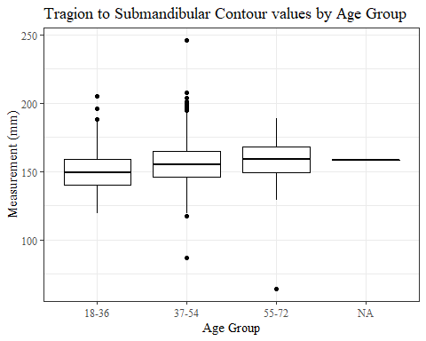

#boxplot not reordered by median  
ggplot(data=TrSman_C_no_out, aes(y=TrSman_C, x=age_group))+  
 geom_boxplot(color= "black", fill = "white")+  
 theme_bw()+theme(text=element_text(family= "Times New Roman"))+  
 #theme(axis.text.x = element_text(angle = 20, vjust=0.7))+  
 labs(title="Tragion to Submandibular Contour values by Age Group",  
 y="Measurement (mm)",  
 x="Age Group")

## Warning: Removed 133 rows containing non-finite values (stat_boxplot).



TrSnas_C without outliers removed

#histogram of all TrSnas_C values  
ggplot(data=headscan_full, aes(x=TrSnas_C))+  
 geom_bar(stat="bin", bins=35, color= "black", fill = "white")+  
 theme_bw()+theme(text=element_text(family= "Times New Roman"))+  
 labs(title="Tragion to Subnasale Contour Measurement Distribution",  
 subtitle = "without outliers removed",  
 y="Frequency",  
 x="Tragion to Subnasale Contour (mm)")

## Warning: Removed 71 rows containing non-finite values (stat_bin).

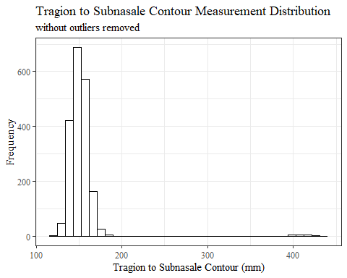

TrSnas_Csumstats <- headscan_full %>%   
 summarise(n = n(), na = sum(is.na(TrSnas_C)),  
 min = min(TrSnas_C, na.rm = TRUE),  
 max = max(TrSnas_C, na.rm = TRUE),  
 mean = mean(TrSnas_C, na.rm = TRUE),  
 mdn = median(TrSnas_C, na.rm = TRUE),  
 sd = sd(TrSnas_C, na.rm = TRUE),  
 se = sd/sqrt(n),  
 percent5th = quantile(TrSnas_C, 0.05, na.rm=TRUE),  
 percent25th = quantile(TrSnas_C, 0.25, na.rm=TRUE),  
 percent50th = quantile(TrSnas_C, 0.50, na.rm=TRUE),  
 percent75th = quantile(TrSnas_C, 0.75, na.rm=TRUE),  
 percent95th = quantile(TrSnas_C, 0.95, na.rm=TRUE))   
  
TrSnas_Csumstats <- round(TrSnas_Csumstats, 2)  
  
#Size 12 Table TNR  
flextable(TrSnas_Csumstats) %>%  
 my_ft_theme()%>%   
 bold(part = "header") %>%   
 set_caption("Tragion to Subnasale Contour SumStats w/o outliers removed")

**Table** : Tragion to Subnasale Contour SumStats w/o outliers removed

| **n** | **na** | **min** | **max** | **mean** | **mdn** | **sd** | **se** | **percent5th** | **percent25th** | **percent50th** | **percent75th** | **percent95th** |
| --- | --- | --- | --- | --- | --- | --- | --- | --- | --- | --- | --- | --- |
| 2,016 | 71 | 122 | 437 | 152.9 | 150 | 27.23 | 0.61 | 136 | 144 | 150 | 157 | 167.8 |

#%>% set_header_Cabels(values = list(TrSnas_C = "Subnasale/SubnasaleCont"))  
  
#Autofit Width Table TNR  
flextable(TrSnas_Csumstats) %>%  
 my_ft_theme()%>%   
 bold(part = "header") %>%   
 set_caption("Tragion to Subnasale Contour SumStats w/o outliers removed") %>%   
 fit_to_width(7.5)

**Table** : Tragion to Subnasale Contour SumStats w/o outliers removed

| **n** | **na** | **min** | **max** | **mean** | **mdn** | **sd** | **se** | **percent5th** | **percent25th** | **percent50th** | **percent75th** | **percent95th** |
| --- | --- | --- | --- | --- | --- | --- | --- | --- | --- | --- | --- | --- |
| 2,016 | 71 | 122 | 437 | 152.9 | 150 | 27.23 | 0.61 | 136 | 144 | 150 | 157 | 167.8 |

#%>% set_header_Cabels(values = list(TrSnas_C = "Subnasale/SubnasaleCont"))

#TrSnas_C race/eth sumstats  
TrSnas_Crace_sumstats <- headscan_full %>%   
 group_by(race_eth) %>%   
 summarise(n = n(), na = sum(is.na(TrSnas_C)),  
 min = min(TrSnas_C, na.rm = TRUE),  
 max = max(TrSnas_C, na.rm = TRUE),  
 mean = mean(TrSnas_C, na.rm = TRUE),  
 mdn = median(TrSnas_C, na.rm = TRUE),  
 sd = sd(TrSnas_C, na.rm = TRUE),  
 se = sd/sqrt(n),  
 percent5th = quantile(TrSnas_C, 0.05, na.rm=TRUE),  
 percent25th = quantile(TrSnas_C, 0.25, na.rm=TRUE),  
 percent50th = quantile(TrSnas_C, 0.50, na.rm=TRUE),  
 percent75th = quantile(TrSnas_C, 0.75, na.rm=TRUE),  
 percent95th = quantile(TrSnas_C, 0.95, na.rm=TRUE))   
  
TrSnas_Crace_sumstats <- TrSnas_Crace_sumstats %>%   
 mutate(across(where(is.numeric), round, 2))  
  
  
#Size 12 Table TNR  
flextable(TrSnas_Crace_sumstats) %>%  
 my_ft_theme()%>%   
 bold(part = "header") %>%   
 set_caption("Tragion to Subnasale Contour SumStats by Race/Ethnicity w/o outlier removed")

**Table** : Tragion to Subnasale Contour SumStats by Race/Ethnicity w/o outlier removed

| **race_eth** | **n** | **na** | **min** | **max** | **mean** | **mdn** | **sd** | **se** | **percent5th** | **percent25th** | **percent50th** | **percent75th** | **percent95th** |
| --- | --- | --- | --- | --- | --- | --- | --- | --- | --- | --- | --- | --- | --- |
| white | 1,239 | 57 | 122 | 437 | 152.65 | 148.0 | 34.20 | 0.97 | 135.05 | 142.00 | 148.0 | 155.00 | 166.00 |
| Black | 548 | 8 | 131 | 181 | 154.98 | 155.0 | 8.34 | 0.36 | 142.00 | 149.00 | 155.0 | 160.00 | 169.00 |
| LatinX | 100 | 2 | 131 | 169 | 149.37 | 148.0 | 8.21 | 0.82 | 136.85 | 144.00 | 148.0 | 156.75 | 161.15 |
| Asian | 91 | 2 | 129 | 172 | 148.49 | 147.0 | 9.64 | 1.01 | 135.40 | 142.00 | 147.0 | 154.00 | 166.60 |
| Other | 21 | 1 | 135 | 172 | 151.55 | 150.0 | 8.83 | 1.93 | 140.70 | 145.75 | 150.0 | 158.50 | 163.45 |
| AIAN | 8 | 1 | 138 | 160 | 146.00 | 144.0 | 6.90 | 2.44 | 139.50 | 143.00 | 144.0 | 147.00 | 156.40 |
| PTNS | 5 | 0 | 142 | 162 | 152.80 | 152.0 | 7.69 | 3.44 | 143.60 | 150.00 | 152.0 | 158.00 | 161.20 |
| NHOPI | 4 | 0 | 150 | 155 | 152.00 | 151.5 | 2.45 | 1.22 | 150.00 | 150.00 | 151.5 | 153.50 | 154.70 |

#%>% set_header_Cabels(values = list(TrSnas_C = "Subnasale/SubnasaleCont"))  
  
#Autofit Width Table TNR  
flextable(TrSnas_Crace_sumstats) %>%  
 my_ft_theme()%>%   
 bold(part = "header") %>%   
 set_caption("Tragion to Subnasale Contour SumStats by Race/Ethnicity w/o outlier removed") %>%   
 fit_to_width(7.5)

**Table** : Tragion to Subnasale Contour SumStats by Race/Ethnicity w/o outlier removed

| **race_eth** | **n** | **na** | **min** | **max** | **mean** | **mdn** | **sd** | **se** | **percent5th** | **percent25th** | **percent50th** | **percent75th** | **percent95th** |
| --- | --- | --- | --- | --- | --- | --- | --- | --- | --- | --- | --- | --- | --- |
| white | 1,239 | 57 | 122 | 437 | 152.65 | 148.0 | 34.20 | 0.97 | 135.05 | 142.00 | 148.0 | 155.00 | 166.00 |
| Black | 548 | 8 | 131 | 181 | 154.98 | 155.0 | 8.34 | 0.36 | 142.00 | 149.00 | 155.0 | 160.00 | 169.00 |
| LatinX | 100 | 2 | 131 | 169 | 149.37 | 148.0 | 8.21 | 0.82 | 136.85 | 144.00 | 148.0 | 156.75 | 161.15 |
| Asian | 91 | 2 | 129 | 172 | 148.49 | 147.0 | 9.64 | 1.01 | 135.40 | 142.00 | 147.0 | 154.00 | 166.60 |
| Other | 21 | 1 | 135 | 172 | 151.55 | 150.0 | 8.83 | 1.93 | 140.70 | 145.75 | 150.0 | 158.50 | 163.45 |
| AIAN | 8 | 1 | 138 | 160 | 146.00 | 144.0 | 6.90 | 2.44 | 139.50 | 143.00 | 144.0 | 147.00 | 156.40 |
| PTNS | 5 | 0 | 142 | 162 | 152.80 | 152.0 | 7.69 | 3.44 | 143.60 | 150.00 | 152.0 | 158.00 | 161.20 |
| NHOPI | 4 | 0 | 150 | 155 | 152.00 | 151.5 | 2.45 | 1.22 | 150.00 | 150.00 | 151.5 | 153.50 | 154.70 |

#%>% set_header_Cabels(values = list(TrSnas_C = "Subnasale/SubnasaleCont"))  
  
#boxplot reorderd by median  
headscan_full %>%   
 ungroup() %>%   
 mutate(race_eth= fct_reorder(race_eth, TrSnas_C, FUN=median, na.rm=TRUE)) %>%   
 ggplot(aes(y=TrSnas_C, x=race_eth))+  
 geom_boxplot(color= "black", fill = "white")+  
 theme_bw()+theme(text=element_text(family= "Times New Roman"))+  
 #theme(axis.text.x = element_text(angle = 20, vjust=0.7))+  
 labs(title="Tragion to Subnasale Contour values by Race/Ethnicity",  
 subtitle = "without outliers removed",  
 y="Measurement (mm)",  
 x="Race/Ethnicity")

## Warning: Removed 71 rows containing non-finite values (stat_boxplot).

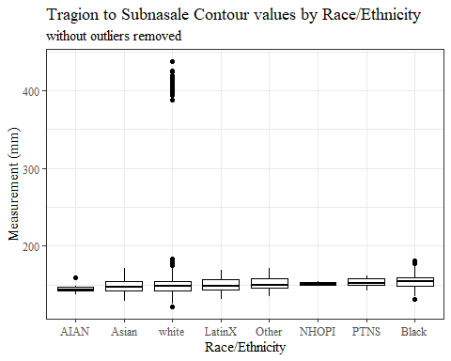

#boxplot not reordered by median  
ggplot(data=headscan_full, aes(y=TrSnas_C, x=race_eth))+  
 geom_boxplot(color= "black", fill = "white")+  
 theme_bw()+theme(text=element_text(family= "Times New Roman"))+  
 #theme(axis.text.x = element_text(angle = 20, vjust=0.7))+  
 labs(title="Tragion to Subnasale Contour values by Race/Ethnicity",  
 subtitle = "without outliers removed",  
 y="Measurement (mm)",  
 x="Race/Ethnicity")

## Warning: Removed 71 rows containing non-finite values (stat_boxplot).

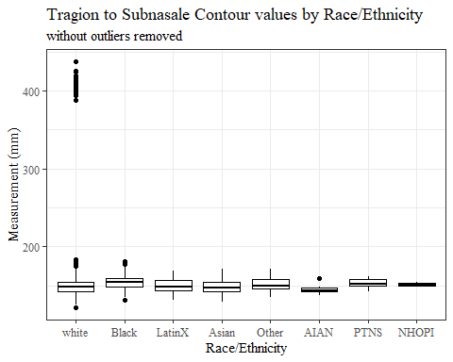

#TrSnas_C gender sumstats  
TrSnas_Cgender_sumstats <- headscan_full %>%   
 group_by(gender) %>%   
 summarise(n = n(), na = sum(is.na(TrSnas_C)),  
 min = min(TrSnas_C, na.rm = TRUE),  
 max = max(TrSnas_C, na.rm = TRUE),  
 mean = mean(TrSnas_C, na.rm = TRUE),  
 mdn = median(TrSnas_C, na.rm = TRUE),  
 sd = sd(TrSnas_C, na.rm = TRUE),  
 se = sd/sqrt(n),  
 percent5th = quantile(TrSnas_C, 0.05, na.rm=TRUE),  
 percent25th = quantile(TrSnas_C, 0.25, na.rm=TRUE),  
 percent50th = quantile(TrSnas_C, 0.50, na.rm=TRUE),  
 percent75th = quantile(TrSnas_C, 0.75, na.rm=TRUE),  
 percent95th = quantile(TrSnas_C, 0.95, na.rm=TRUE))  
  
TrSnas_Cgender_sumstats <- TrSnas_Cgender_sumstats %>%   
 mutate(across(where(is.numeric), round, 2))  
  
#Size 12 Table TNR  
flextable(TrSnas_Cgender_sumstats) %>%  
 my_ft_theme()%>%   
 bold(part = "header") %>%   
 set_caption("Tragion to Subnasale Contour SumStats by Gender w/o outlier removed")

**Table** : Tragion to Subnasale Contour SumStats by Gender w/o outlier removed

| **gender** | **n** | **na** | **min** | **max** | **mean** | **mdn** | **sd** | **se** | **percent5th** | **percent25th** | **percent50th** | **percent75th** | **percent95th** |
| --- | --- | --- | --- | --- | --- | --- | --- | --- | --- | --- | --- | --- | --- |
| Female | 1,063 | 36 | 122 | 420 | 149.03 | 145 | 27.99 | 0.86 | 135.0 | 140 | 145 | 151.00 | 162.00 |
| Male | 939 | 35 | 127 | 437 | 157.38 | 155 | 25.86 | 0.84 | 142.0 | 149 | 155 | 161.00 | 170.00 |
| Non-binary or Other | 5 | 0 | 136 | 151 | 146.00 | 147 | 5.96 | 2.66 | 138.0 | 146 | 147 | 150.00 | 150.80 |
| Prefer not to say | 1 | 0 | 152 | 152 | 152.00 | 152 |  |  | 152.0 | 152 | 152 | 152.00 | 152.00 |
|  | 8 | 0 | 141 | 157 | 148.12 | 149 | 5.46 | 1.93 | 141.7 | 143 | 149 | 151.25 | 155.25 |

#%>% set_header_Cabels(values = list(TrSnas_C = "Subnasale/SubnasaleCont"))  
  
#Autofit Width Table TNR  
flextable(TrSnas_Cgender_sumstats) %>%  
 my_ft_theme()%>%   
 bold(part = "header") %>%   
 set_caption("Tragion to Subnasale Contour SumStats by Gender w/o outlier removed") %>%   
 fit_to_width(7.5)

**Table** : Tragion to Subnasale Contour SumStats by Gender w/o outlier removed

| **gender** | **n** | **na** | **min** | **max** | **mean** | **mdn** | **sd** | **se** | **percent5th** | **percent25th** | **percent50th** | **percent75th** | **percent95th** |
| --- | --- | --- | --- | --- | --- | --- | --- | --- | --- | --- | --- | --- | --- |
| Female | 1,063 | 36 | 122 | 420 | 149.03 | 145 | 27.99 | 0.86 | 135.0 | 140 | 145 | 151.00 | 162.00 |
| Male | 939 | 35 | 127 | 437 | 157.38 | 155 | 25.86 | 0.84 | 142.0 | 149 | 155 | 161.00 | 170.00 |
| Non-binary or Other | 5 | 0 | 136 | 151 | 146.00 | 147 | 5.96 | 2.66 | 138.0 | 146 | 147 | 150.00 | 150.80 |
| Prefer not to say | 1 | 0 | 152 | 152 | 152.00 | 152 |  |  | 152.0 | 152 | 152 | 152.00 | 152.00 |
|  | 8 | 0 | 141 | 157 | 148.12 | 149 | 5.46 | 1.93 | 141.7 | 143 | 149 | 151.25 | 155.25 |

#%>% set_header_Cabels(values = list(TrSnas_C = "Subnasale/SubnasaleCont"))  
  
#boxplot reorderd by median  
headscan_full %>%   
 ungroup() %>%   
 mutate(gender= fct_reorder(gender, TrSnas_C, FUN=median, na.rm=TRUE)) %>%   
 ggplot(aes(y=TrSnas_C, x=gender))+  
 geom_boxplot(color= "black", fill = "white")+  
 theme_bw()+theme(text=element_text(family= "Times New Roman"))+  
 theme(axis.text.x = element_text(angle = 20, vjust=0.7))+  
 labs(title="Tragion to Subnasale Contour values by Gender",  
 subtitle = "without outliers removed",  
 y="Measurement (mm)",  
 x="Gender")

## Warning: Removed 71 rows containing non-finite values (stat_boxplot).

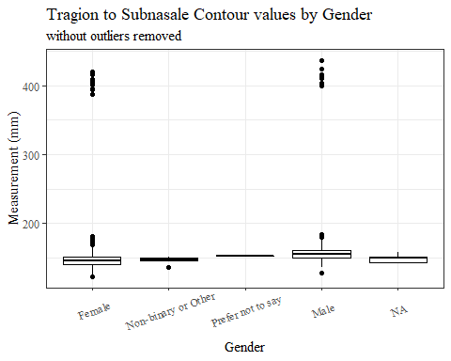

#boxplot not reordered by median  
ggplot(data=headscan_full, aes(y=TrSnas_C, x=gender))+  
 geom_boxplot(color= "black", fill = "white")+  
 theme_bw()+theme(text=element_text(family= "Times New Roman"))+  
 theme(axis.text.x = element_text(angle = 20, vjust=0.7))+  
 labs(title="Tragion to Subnasale Contour values by Gender",  
 subtitle = "without outliers removed",  
 y="Measurement (mm)",  
 x="Gender")

## Warning: Removed 71 rows containing non-finite values (stat_boxplot).

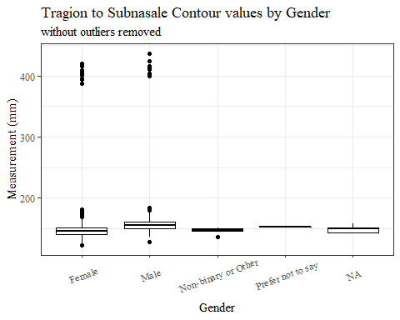

#TrSnas_C age group sumstats  
TrSnas_Cage_sumstats <- headscan_full %>%   
 group_by(age_group) %>%   
 summarise(n = n(), na = sum(is.na(TrSnas_C)),  
 min = min(TrSnas_C, na.rm = TRUE),  
 max = max(TrSnas_C, na.rm = TRUE),  
 mean = mean(TrSnas_C, na.rm = TRUE),  
 mdn = median(TrSnas_C, na.rm = TRUE),  
 sd = sd(TrSnas_C, na.rm = TRUE),  
 se = sd/sqrt(n),  
 percent5th = quantile(TrSnas_C, 0.05, na.rm=TRUE),  
 percent25th = quantile(TrSnas_C, 0.25, na.rm=TRUE),  
 percent50th = quantile(TrSnas_C, 0.50, na.rm=TRUE),  
 percent75th = quantile(TrSnas_C, 0.75, na.rm=TRUE),  
 percent95th = quantile(TrSnas_C, 0.95, na.rm=TRUE))  
  
TrSnas_Cage_sumstats <- TrSnas_Cage_sumstats %>%   
 mutate(across(where(is.numeric), round, 2))  
  
  
#Size 12 Table TNR  
flextable(TrSnas_Cage_sumstats) %>%  
 my_ft_theme()%>%   
 bold(part = "header") %>%   
 set_caption("Tragion to Subnasale Contour SumStats by Age Group w/o outlier removed")

**Table** : Tragion to Subnasale Contour SumStats by Age Group w/o outlier removed

| **age_group** | **n** | **na** | **min** | **max** | **mean** | **mdn** | **sd** | **se** | **percent5th** | **percent25th** | **percent50th** | **percent75th** | **percent95th** |
| --- | --- | --- | --- | --- | --- | --- | --- | --- | --- | --- | --- | --- | --- |
| 18-36 | 991 | 31 | 129 | 437 | 152.23 | 149 | 27.37 | 0.87 | 136 | 143 | 149 | 156 | 167 |
| 37-54 | 940 | 37 | 122 | 411 | 153.21 | 150 | 26.68 | 0.87 | 136 | 144 | 150 | 157 | 168 |
| 55-72 | 84 | 3 | 130 | 425 | 157.56 | 155 | 31.33 | 3.42 | 142 | 147 | 155 | 160 | 170 |
|  | 1 | 0 | 147 | 147 | 147.00 | 147 |  |  | 147 | 147 | 147 | 147 | 147 |

#%>% set_header_Cabels(values = list(TrSnas_C = "Subnasale/SubnasaleCont"))  
  
#Autofit Width Table TNR  
flextable(TrSnas_Cage_sumstats) %>%  
 my_ft_theme()%>%   
 bold(part = "header") %>%   
 set_caption("Tragion to Subnasale Contour SumStats by Age Group w/o outlier removed") %>%   
 fit_to_width(7.5)

**Table** : Tragion to Subnasale Contour SumStats by Age Group w/o outlier removed

| **age_group** | **n** | **na** | **min** | **max** | **mean** | **mdn** | **sd** | **se** | **percent5th** | **percent25th** | **percent50th** | **percent75th** | **percent95th** |
| --- | --- | --- | --- | --- | --- | --- | --- | --- | --- | --- | --- | --- | --- |
| 18-36 | 991 | 31 | 129 | 437 | 152.23 | 149 | 27.37 | 0.87 | 136 | 143 | 149 | 156 | 167 |
| 37-54 | 940 | 37 | 122 | 411 | 153.21 | 150 | 26.68 | 0.87 | 136 | 144 | 150 | 157 | 168 |
| 55-72 | 84 | 3 | 130 | 425 | 157.56 | 155 | 31.33 | 3.42 | 142 | 147 | 155 | 160 | 170 |
|  | 1 | 0 | 147 | 147 | 147.00 | 147 |  |  | 147 | 147 | 147 | 147 | 147 |

#%>% set_header_Cabels(values = list(TrSnas_C = "Subnasale/SubnasaleCont"))  
  
#boxplot reorderd by median  
headscan_full %>%   
 ungroup() %>%   
 mutate(age_group= fct_reorder(age_group, TrSnas_C, FUN=median, na.rm=TRUE)) %>%   
 ggplot(aes(y=TrSnas_C, x=age_group))+  
 geom_boxplot(color= "black", fill = "white")+  
 theme_bw()+theme(text=element_text(family= "Times New Roman"))+  
 #theme(axis.text.x = element_text(angle = 20, vjust=0.7))+  
 labs(title="Tragion to Subnasale Contour values by Age Group",  
 subtitle = "without outliers removed",  
 y="Measurement (mm)",  
 x="Age Group")

## Warning: Removed 71 rows containing non-finite values (stat_boxplot).

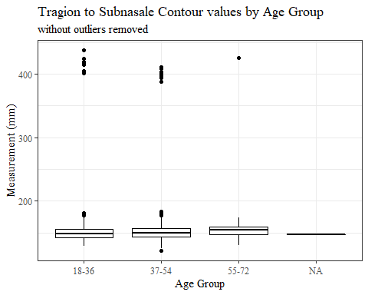

#boxplot not reordered by median  
ggplot(data=headscan_full, aes(y=TrSnas_C, x=age_group))+  
 geom_boxplot(color= "black", fill = "white")+  
 theme_bw()+theme(text=element_text(family= "Times New Roman"))+  
 #theme(axis.text.x = element_text(angle = 20, vjust=0.7))+  
 labs(title="Tragion to Subnasale Contour values by Age Group",  
 subtitle = "without outliers removed",  
 y="Measurement (mm)",  
 x="Age Group")

## Warning: Removed 71 rows containing non-finite values (stat_boxplot).

 TrSnas_C with outliers removed

max(headscan_full$TrSnas_C, na.rm = TRUE)

## [1] 437

#CODE TO REMOVE OUTLIER, use later to remove from headscan_full  
TrSnas_C_no_out <- headscan_full %>% mutate(TrSnas_C = replace(TrSnas_C, TrSnas_C>300, NA))

#histogram of all TrSnas_C values  
ggplot(data=TrSnas_C_no_out, aes(x=TrSnas_C))+  
 geom_bar(stat="bin", bins=20, color= "black", fill = "white")+  
 theme_bw()+theme(text=element_text(family= "Times New Roman"))+  
 labs(title="Tragion to Subnasale Contour Measurement Distribution",  
 y="Frequency",  
 x="Tragion to Subnasale Contour (mm)")

## Warning: Removed 90 rows containing non-finite values (stat_bin).

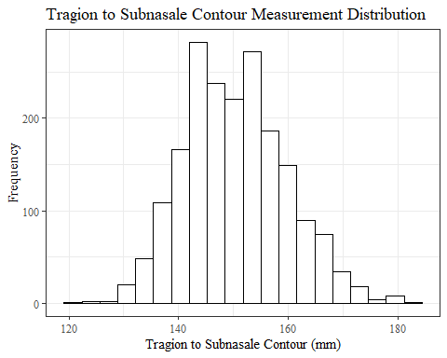

TrSnas_Csumstats1 <- TrSnas_C_no_out %>%   
 summarise(n = n(), na = sum(is.na(TrSnas_C)),  
 min = min(TrSnas_C, na.rm = TRUE),  
 max = max(TrSnas_C, na.rm = TRUE),  
 mean = mean(TrSnas_C, na.rm = TRUE),  
 mdn = median(TrSnas_C, na.rm = TRUE),  
 sd = sd(TrSnas_C, na.rm = TRUE),  
 se = sd/sqrt(n),  
 percent5th = quantile(TrSnas_C, 0.05, na.rm=TRUE),  
 percent25th = quantile(TrSnas_C, 0.25, na.rm=TRUE),  
 percent50th = quantile(TrSnas_C, 0.50, na.rm=TRUE),  
 percent75th = quantile(TrSnas_C, 0.75, na.rm=TRUE),  
 percent95th = quantile(TrSnas_C, 0.95, na.rm=TRUE))   
  
TrSnas_Csumstats1 <- round(TrSnas_Csumstats1, 2)  
  
#Size 12 Table TNR  
flextable(TrSnas_Csumstats1) %>%  
 my_ft_theme()%>%   
 bold(part = "header") %>%   
 set_caption("Tragion to Subnasale Contour SumStats")

**Table** : Tragion to Subnasale Contour SumStats

| **n** | **na** | **min** | **max** | **mean** | **mdn** | **sd** | **se** | **percent5th** | **percent25th** | **percent50th** | **percent75th** | **percent95th** |
| --- | --- | --- | --- | --- | --- | --- | --- | --- | --- | --- | --- | --- |
| 2,016 | 90 | 122 | 184 | 150.36 | 150 | 9.34 | 0.21 | 136 | 144 | 150 | 157 | 167 |

#%>% set_header_Cabels(values = list(TrSnas_C = "Subnasale/SubnasaleCont"))  
  
#Autofit Width Table TNR  
flextable(TrSnas_Csumstats1) %>%  
 my_ft_theme()%>%   
 bold(part = "header") %>%   
 set_caption("Tragion to Subnasale Contour SumStats") %>%   
 fit_to_width(7.5)

**Table** : Tragion to Subnasale Contour SumStats

| **n** | **na** | **min** | **max** | **mean** | **mdn** | **sd** | **se** | **percent5th** | **percent25th** | **percent50th** | **percent75th** | **percent95th** |
| --- | --- | --- | --- | --- | --- | --- | --- | --- | --- | --- | --- | --- |
| 2,016 | 90 | 122 | 184 | 150.36 | 150 | 9.34 | 0.21 | 136 | 144 | 150 | 157 | 167 |

#%>% set_header_Cabels(values = list(TrSnas_C = "Subnasale/SubnasaleCont"))

#TrSnas_C race/eth sumstats  
TrSnas_Crace_sumstats1 <- TrSnas_C_no_out %>%   
 group_by(race_eth) %>%   
 summarise(n = n(), na = sum(is.na(TrSnas_C)),  
 min = min(TrSnas_C, na.rm = TRUE),  
 max = max(TrSnas_C, na.rm = TRUE),  
 mean = mean(TrSnas_C, na.rm = TRUE),  
 mdn = median(TrSnas_C, na.rm = TRUE),  
 sd = sd(TrSnas_C, na.rm = TRUE),  
 se = sd/sqrt(n),  
 percent5th = quantile(TrSnas_C, 0.05, na.rm=TRUE),  
 percent25th = quantile(TrSnas_C, 0.25, na.rm=TRUE),  
 percent50th = quantile(TrSnas_C, 0.50, na.rm=TRUE),  
 percent75th = quantile(TrSnas_C, 0.75, na.rm=TRUE),  
 percent95th = quantile(TrSnas_C, 0.95, na.rm=TRUE))   
  
TrSnas_Crace_sumstats1 <- TrSnas_Crace_sumstats1 %>%   
 mutate(across(where(is.numeric), round, 2))  
  
  
#Size 12 Table TNR  
flextable(TrSnas_Crace_sumstats1) %>%  
 my_ft_theme()%>%   
 bold(part = "header") %>%   
 set_caption("Tragion to Subnasale Contour SumStats by Race/Ethnicity")

**Table** : Tragion to Subnasale Contour SumStats by Race/Ethnicity

| **race_eth** | **n** | **na** | **min** | **max** | **mean** | **mdn** | **sd** | **se** | **percent5th** | **percent25th** | **percent50th** | **percent75th** | **percent95th** |
| --- | --- | --- | --- | --- | --- | --- | --- | --- | --- | --- | --- | --- | --- |
| white | 1,239 | 76 | 122 | 184 | 148.44 | 147.0 | 9.15 | 0.26 | 135.00 | 142.00 | 147.0 | 155.00 | 164.00 |
| Black | 548 | 8 | 131 | 181 | 154.98 | 155.0 | 8.34 | 0.36 | 142.00 | 149.00 | 155.0 | 160.00 | 169.00 |
| LatinX | 100 | 2 | 131 | 169 | 149.37 | 148.0 | 8.21 | 0.82 | 136.85 | 144.00 | 148.0 | 156.75 | 161.15 |
| Asian | 91 | 2 | 129 | 172 | 148.49 | 147.0 | 9.64 | 1.01 | 135.40 | 142.00 | 147.0 | 154.00 | 166.60 |
| Other | 21 | 1 | 135 | 172 | 151.55 | 150.0 | 8.83 | 1.93 | 140.70 | 145.75 | 150.0 | 158.50 | 163.45 |
| AIAN | 8 | 1 | 138 | 160 | 146.00 | 144.0 | 6.90 | 2.44 | 139.50 | 143.00 | 144.0 | 147.00 | 156.40 |
| PTNS | 5 | 0 | 142 | 162 | 152.80 | 152.0 | 7.69 | 3.44 | 143.60 | 150.00 | 152.0 | 158.00 | 161.20 |
| NHOPI | 4 | 0 | 150 | 155 | 152.00 | 151.5 | 2.45 | 1.22 | 150.00 | 150.00 | 151.5 | 153.50 | 154.70 |

#%>% set_header_Cabels(values = list(TrSnas_C = "Subnasale/SubnasaleCont"))  
  
#Autofit Width Table TNR  
flextable(TrSnas_Crace_sumstats1) %>%  
 my_ft_theme()%>%   
 bold(part = "header") %>%   
 set_caption("Tragion to Subnasale Contour SumStats by Race/Ethnicity") %>%   
 fit_to_width(7.5)

**Table** : Tragion to Subnasale Contour SumStats by Race/Ethnicity

| **race_eth** | **n** | **na** | **min** | **max** | **mean** | **mdn** | **sd** | **se** | **percent5th** | **percent25th** | **percent50th** | **percent75th** | **percent95th** |
| --- | --- | --- | --- | --- | --- | --- | --- | --- | --- | --- | --- | --- | --- |
| white | 1,239 | 76 | 122 | 184 | 148.44 | 147.0 | 9.15 | 0.26 | 135.00 | 142.00 | 147.0 | 155.00 | 164.00 |
| Black | 548 | 8 | 131 | 181 | 154.98 | 155.0 | 8.34 | 0.36 | 142.00 | 149.00 | 155.0 | 160.00 | 169.00 |
| LatinX | 100 | 2 | 131 | 169 | 149.37 | 148.0 | 8.21 | 0.82 | 136.85 | 144.00 | 148.0 | 156.75 | 161.15 |
| Asian | 91 | 2 | 129 | 172 | 148.49 | 147.0 | 9.64 | 1.01 | 135.40 | 142.00 | 147.0 | 154.00 | 166.60 |
| Other | 21 | 1 | 135 | 172 | 151.55 | 150.0 | 8.83 | 1.93 | 140.70 | 145.75 | 150.0 | 158.50 | 163.45 |
| AIAN | 8 | 1 | 138 | 160 | 146.00 | 144.0 | 6.90 | 2.44 | 139.50 | 143.00 | 144.0 | 147.00 | 156.40 |
| PTNS | 5 | 0 | 142 | 162 | 152.80 | 152.0 | 7.69 | 3.44 | 143.60 | 150.00 | 152.0 | 158.00 | 161.20 |
| NHOPI | 4 | 0 | 150 | 155 | 152.00 | 151.5 | 2.45 | 1.22 | 150.00 | 150.00 | 151.5 | 153.50 | 154.70 |

#%>% set_header_Cabels(values = list(TrSnas_C = "Subnasale/SubnasaleCont"))  
  
#boxplot reorderd by median  
TrSnas_C_no_out %>%   
 ungroup() %>%   
 mutate(race_eth= fct_reorder(race_eth, TrSnas_C, FUN=median, na.rm=TRUE)) %>%   
 ggplot(aes(y=TrSnas_C, x=race_eth))+  
 geom_boxplot(color= "black", fill = "white")+  
 theme_bw()+theme(text=element_text(family= "Times New Roman"))+  
 #theme(axis.text.x = element_text(angle = 20, vjust=0.7))+  
 labs(title="Tragion to Subnasale Contour values by Race/Ethnicity",  
 y="Measurement (mm)",  
 x="Race/Ethnicity")

## Warning: Removed 90 rows containing non-finite values (stat_boxplot).

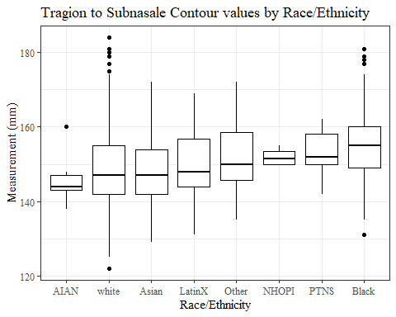

#boxplot not reordered by median  
ggplot(data=TrSnas_C_no_out, aes(y=TrSnas_C, x=race_eth))+  
 geom_boxplot(color= "black", fill = "white")+  
 theme_bw()+theme(text=element_text(family= "Times New Roman"))+  
 #theme(axis.text.x = element_text(angle = 20, vjust=0.7))+  
 labs(title="Tragion to Subnasale Contour values by Race/Ethnicity",  
 y="Measurement (mm)",  
 x="Race/Ethnicity")

## Warning: Removed 90 rows containing non-finite values (stat_boxplot).

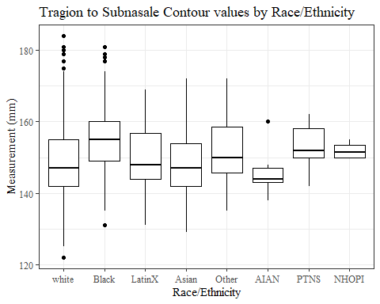

#TrSnas_C gender sumstats  
TrSnas_Cgender_sumstats1 <- TrSnas_C_no_out %>%   
 group_by(gender) %>%   
 summarise(n = n(), na = sum(is.na(TrSnas_C)),  
 min = min(TrSnas_C, na.rm = TRUE),  
 max = max(TrSnas_C, na.rm = TRUE),  
 mean = mean(TrSnas_C, na.rm = TRUE),  
 mdn = median(TrSnas_C, na.rm = TRUE),  
 sd = sd(TrSnas_C, na.rm = TRUE),  
 se = sd/sqrt(n),  
 percent5th = quantile(TrSnas_C, 0.05, na.rm=TRUE),  
 percent25th = quantile(TrSnas_C, 0.25, na.rm=TRUE),  
 percent50th = quantile(TrSnas_C, 0.50, na.rm=TRUE),  
 percent75th = quantile(TrSnas_C, 0.75, na.rm=TRUE),  
 percent95th = quantile(TrSnas_C, 0.95, na.rm=TRUE))  
  
TrSnas_Cgender_sumstats1 <- TrSnas_Cgender_sumstats1 %>%   
 mutate(across(where(is.numeric), round, 2))  
  
#Size 12 Table TNR  
flextable(TrSnas_Cgender_sumstats1) %>%  
 my_ft_theme()%>%   
 bold(part = "header") %>%   
 set_caption("Tragion to Subnasale Contour SumStats by Gender")

**Table** : Tragion to Subnasale Contour SumStats by Gender

| **gender** | **n** | **na** | **min** | **max** | **mean** | **mdn** | **sd** | **se** | **percent5th** | **percent25th** | **percent50th** | **percent75th** | **percent95th** |
| --- | --- | --- | --- | --- | --- | --- | --- | --- | --- | --- | --- | --- | --- |
| Female | 1,063 | 47 | 122 | 181 | 146.25 | 145 | 8.32 | 0.26 | 135.0 | 140 | 145 | 151.00 | 161.00 |
| Male | 939 | 43 | 127 | 184 | 155.07 | 155 | 8.20 | 0.27 | 142.0 | 149 | 155 | 160.00 | 169.00 |
| Non-binary or Other | 5 | 0 | 136 | 151 | 146.00 | 147 | 5.96 | 2.66 | 138.0 | 146 | 147 | 150.00 | 150.80 |
| Prefer not to say | 1 | 0 | 152 | 152 | 152.00 | 152 |  |  | 152.0 | 152 | 152 | 152.00 | 152.00 |
|  | 8 | 0 | 141 | 157 | 148.12 | 149 | 5.46 | 1.93 | 141.7 | 143 | 149 | 151.25 | 155.25 |

#%>% set_header_Cabels(values = list(TrSnas_C = "Subnasale/SubnasaleCont"))  
  
#Autofit Width Table TNR  
flextable(TrSnas_Cgender_sumstats1) %>%  
 my_ft_theme()%>%   
 bold(part = "header") %>%   
 set_caption("Tragion to Subnasale Contour SumStats by Gender") %>%   
 fit_to_width(7.5)

**Table** : Tragion to Subnasale Contour SumStats by Gender

| **gender** | **n** | **na** | **min** | **max** | **mean** | **mdn** | **sd** | **se** | **percent5th** | **percent25th** | **percent50th** | **percent75th** | **percent95th** |
| --- | --- | --- | --- | --- | --- | --- | --- | --- | --- | --- | --- | --- | --- |
| Female | 1,063 | 47 | 122 | 181 | 146.25 | 145 | 8.32 | 0.26 | 135.0 | 140 | 145 | 151.00 | 161.00 |
| Male | 939 | 43 | 127 | 184 | 155.07 | 155 | 8.20 | 0.27 | 142.0 | 149 | 155 | 160.00 | 169.00 |
| Non-binary or Other | 5 | 0 | 136 | 151 | 146.00 | 147 | 5.96 | 2.66 | 138.0 | 146 | 147 | 150.00 | 150.80 |
| Prefer not to say | 1 | 0 | 152 | 152 | 152.00 | 152 |  |  | 152.0 | 152 | 152 | 152.00 | 152.00 |
|  | 8 | 0 | 141 | 157 | 148.12 | 149 | 5.46 | 1.93 | 141.7 | 143 | 149 | 151.25 | 155.25 |

#%>% set_header_Cabels(values = list(TrSnas_C = "Subnasale/SubnasaleCont"))  
  
#boxplot reorderd by median  
TrSnas_C_no_out %>%   
 ungroup() %>%   
 mutate(gender= fct_reorder(gender, TrSnas_C, FUN=median, na.rm=TRUE)) %>%   
 ggplot(aes(y=TrSnas_C, x=gender))+  
 geom_boxplot(color= "black", fill = "white")+  
 theme_bw()+theme(text=element_text(family= "Times New Roman"))+  
 theme(axis.text.x = element_text(angle = 20, vjust=0.7))+  
 labs(title="Tragion to Subnasale Contour values by Gender",  
 y="Measurement (mm)",  
 x="Gender")

## Warning: Removed 90 rows containing non-finite values (stat_boxplot).

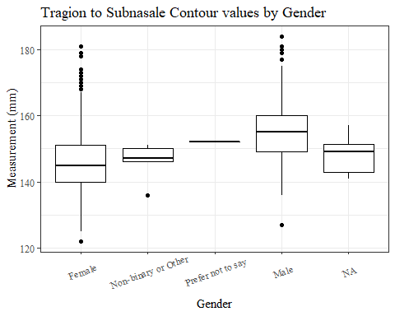

#boxplot not reordered by median  
ggplot(data=TrSnas_C_no_out, aes(y=TrSnas_C, x=gender))+  
 geom_boxplot(color= "black", fill = "white")+  
 theme_bw()+theme(text=element_text(family= "Times New Roman"))+  
 theme(axis.text.x = element_text(angle = 20, vjust=0.7))+  
 labs(title="Tragion to Subnasale Contour values by Gender",  
 y="Measurement (mm)",  
 x="Gender")

## Warning: Removed 90 rows containing non-finite values (stat_boxplot).

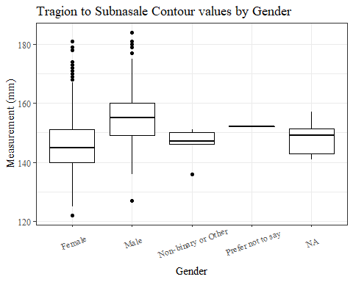

#TrSnas_C age group sumstats  
TrSnas_Cage_sumstats1 <- TrSnas_C_no_out %>%   
 group_by(age_group) %>%   
 summarise(n = n(), na = sum(is.na(TrSnas_C)),  
 min = min(TrSnas_C, na.rm = TRUE),  
 max = max(TrSnas_C, na.rm = TRUE),  
 mean = mean(TrSnas_C, na.rm = TRUE),  
 mdn = median(TrSnas_C, na.rm = TRUE),  
 sd = sd(TrSnas_C, na.rm = TRUE),  
 se = sd/sqrt(n),  
 percent5th = quantile(TrSnas_C, 0.05, na.rm=TRUE),  
 percent25th = quantile(TrSnas_C, 0.25, na.rm=TRUE),  
 percent50th = quantile(TrSnas_C, 0.50, na.rm=TRUE),  
 percent75th = quantile(TrSnas_C, 0.75, na.rm=TRUE),  
 percent95th = quantile(TrSnas_C, 0.95, na.rm=TRUE))  
  
TrSnas_Cage_sumstats1 <- TrSnas_Cage_sumstats1 %>%   
 mutate(across(where(is.numeric), round, 2))  
  
  
#Size 12 Table TNR  
flextable(TrSnas_Cage_sumstats1) %>%  
 my_ft_theme()%>%   
 bold(part = "header") %>%   
 set_caption("Tragion to Subnasale Contour SumStats by Age Group")

**Table** : Tragion to Subnasale Contour SumStats by Age Group

| **age_group** | **n** | **na** | **min** | **max** | **mean** | **mdn** | **sd** | **se** | **percent5th** | **percent25th** | **percent50th** | **percent75th** | **percent95th** |
| --- | --- | --- | --- | --- | --- | --- | --- | --- | --- | --- | --- | --- | --- |
| 18-36 | 991 | 40 | 129 | 181 | 149.72 | 149 | 9.13 | 0.29 | 136.00 | 143 | 149 | 156 | 166.0 |
| 37-54 | 940 | 46 | 122 | 184 | 150.71 | 150 | 9.52 | 0.31 | 136.00 | 144 | 150 | 157 | 167.0 |
| 55-72 | 84 | 4 | 130 | 174 | 154.21 | 155 | 8.79 | 0.96 | 141.85 | 147 | 155 | 160 | 168.1 |
|  | 1 | 0 | 147 | 147 | 147.00 | 147 |  |  | 147.00 | 147 | 147 | 147 | 147.0 |

#%>% set_header_Cabels(values = list(TrSnas_C = "Subnasale/SubnasaleCont"))  
  
#Autofit Width Table TNR  
flextable(TrSnas_Cage_sumstats1) %>%  
 my_ft_theme()%>%   
 bold(part = "header") %>%   
 set_caption("Tragion to Subnasale Contour SumStats by Age Group") %>%   
 fit_to_width(7.5)

**Table** : Tragion to Subnasale Contour SumStats by Age Group

| **age_group** | **n** | **na** | **min** | **max** | **mean** | **mdn** | **sd** | **se** | **percent5th** | **percent25th** | **percent50th** | **percent75th** | **percent95th** |
| --- | --- | --- | --- | --- | --- | --- | --- | --- | --- | --- | --- | --- | --- |
| 18-36 | 991 | 40 | 129 | 181 | 149.72 | 149 | 9.13 | 0.29 | 136.00 | 143 | 149 | 156 | 166.0 |
| 37-54 | 940 | 46 | 122 | 184 | 150.71 | 150 | 9.52 | 0.31 | 136.00 | 144 | 150 | 157 | 167.0 |
| 55-72 | 84 | 4 | 130 | 174 | 154.21 | 155 | 8.79 | 0.96 | 141.85 | 147 | 155 | 160 | 168.1 |
|  | 1 | 0 | 147 | 147 | 147.00 | 147 |  |  | 147.00 | 147 | 147 | 147 | 147.0 |

#%>% set_header_Cabels(values = list(TrSnas_C = "Subnasale/SubnasaleCont"))  
  
#boxplot reorderd by median  
TrSnas_C_no_out %>%   
 ungroup() %>%   
 mutate(age_group= fct_reorder(age_group, TrSnas_C, FUN=median, na.rm=TRUE)) %>%   
 ggplot(aes(y=TrSnas_C, x=age_group))+  
 geom_boxplot(color= "black", fill = "white")+  
 theme_bw()+theme(text=element_text(family= "Times New Roman"))+  
 #theme(axis.text.x = element_text(angle = 20, vjust=0.7))+  
 labs(title="Tragion to Subnasale Length values by Age Group",  
 y="Measurement (mm)",  
 x="Age Group")

## Warning: Removed 90 rows containing non-finite values (stat_boxplot).

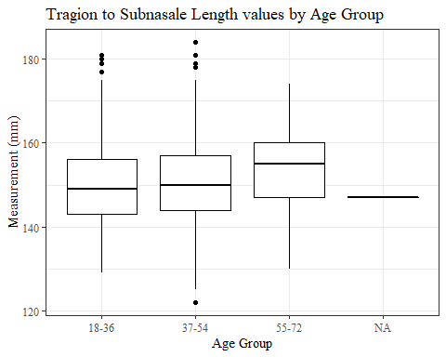

#boxplot not reordered by median  
ggplot(data=TrSnas_C_no_out, aes(y=TrSnas_C, x=age_group))+  
 geom_boxplot(color= "black", fill = "white")+  
 theme_bw()+theme(text=element_text(family= "Times New Roman"))+  
 #theme(axis.text.x = element_text(angle = 20, vjust=0.7))+  
 labs(title="Tragion to Subnasale Length values by Age Group",  
 y="Measurement (mm)",  
 x="Age Group")

## Warning: Removed 90 rows containing non-finite values (stat_boxplot).



TrTr_C

#histogram of all TrTr_C values  
ggplot(data=headscan_full, aes(x=TrTr_C))+  
 geom_bar(stat="bin", bins=20, color= "black", fill = "white")+  
 theme_bw()+theme(text=element_text(family= "Times New Roman"))+  
 labs(title="Tragion to Tragion Contour Measurement Distribution",  
 y="Frequency",  
 x="Tragion to Tragion Contour (mm)")

## Warning: Removed 38 rows containing non-finite values (stat_bin).

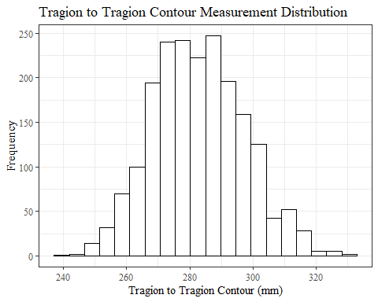

TrTr_Csumstats <- headscan_full %>%   
 summarise(n = n(), na = sum(is.na(TrTr_C)),  
 min = min(TrTr_C, na.rm = TRUE),  
 max = max(TrTr_C, na.rm = TRUE),  
 mean = mean(TrTr_C, na.rm = TRUE),  
 mdn = median(TrTr_C, na.rm = TRUE),  
 sd = sd(TrTr_C, na.rm = TRUE),  
 se = sd/sqrt(n),  
 percent5th = quantile(TrTr_C, 0.05, na.rm=TRUE),  
 percent25th = quantile(TrTr_C, 0.25, na.rm=TRUE),  
 percent50th = quantile(TrTr_C, 0.50, na.rm=TRUE),  
 percent75th = quantile(TrTr_C, 0.75, na.rm=TRUE),  
 percent95th = quantile(TrTr_C, 0.95, na.rm=TRUE))   
  
TrTr_Csumstats <- round(TrTr_Csumstats, 2)  
  
#Size 12 Table TNR  
flextable(TrTr_Csumstats) %>%  
 my_ft_theme()%>%   
 bold(part = "header") %>%   
 set_caption("Tragion to Tragion Contour SumStats")

**Table** : Tragion to Tragion Contour SumStats

| **n** | **na** | **min** | **max** | **mean** | **mdn** | **sd** | **se** | **percent5th** | **percent25th** | **percent50th** | **percent75th** | **percent95th** |
| --- | --- | --- | --- | --- | --- | --- | --- | --- | --- | --- | --- | --- |
| 2,016 | 38 | 241 | 332 | 282.71 | 282 | 14.34 | 0.32 | 261 | 272.25 | 282 | 293 | 308 |

#%>% set_header_Cabels(values = list(TrTr_C = "Tragion/TragionCont"))  
  
#Autofit Width Table TNR  
flextable(TrTr_Csumstats) %>%  
 my_ft_theme()%>%   
 bold(part = "header") %>%   
 set_caption("Tragion to Tragion Contour SumStats") %>%   
 fit_to_width(7.5)

**Table** : Tragion to Tragion Contour SumStats

| **n** | **na** | **min** | **max** | **mean** | **mdn** | **sd** | **se** | **percent5th** | **percent25th** | **percent50th** | **percent75th** | **percent95th** |
| --- | --- | --- | --- | --- | --- | --- | --- | --- | --- | --- | --- | --- |
| 2,016 | 38 | 241 | 332 | 282.71 | 282 | 14.34 | 0.32 | 261 | 272.25 | 282 | 293 | 308 |

#%>% set_header_Cabels(values = list(TrTr_C = "Tragion/TragionCont"))

#TrTr_C race/eth sumstats  
TrTr_Crace_sumstats <- headscan_full %>%   
 group_by(race_eth) %>%   
 summarise(n = n(), na = sum(is.na(TrTr_C)),  
 min = min(TrTr_C, na.rm = TRUE),  
 max = max(TrTr_C, na.rm = TRUE),  
 mean = mean(TrTr_C, na.rm = TRUE),  
 mdn = median(TrTr_C, na.rm = TRUE),  
 sd = sd(TrTr_C, na.rm = TRUE),  
 se = sd/sqrt(n),  
 percent5th = quantile(TrTr_C, 0.05, na.rm=TRUE),  
 percent25th = quantile(TrTr_C, 0.25, na.rm=TRUE),  
 percent50th = quantile(TrTr_C, 0.50, na.rm=TRUE),  
 percent75th = quantile(TrTr_C, 0.75, na.rm=TRUE),  
 percent95th = quantile(TrTr_C, 0.95, na.rm=TRUE))   
  
TrTr_Crace_sumstats <- TrTr_Crace_sumstats %>%   
 mutate(across(where(is.numeric), round, 2))  
  
  
#Size 12 Table TNR  
flextable(TrTr_Crace_sumstats) %>%  
 my_ft_theme()%>%   
 bold(part = "header") %>%   
 set_caption("Tragion to Tragion Contour SumStats by Race/Ethnicity")

**Table** : Tragion to Tragion Contour SumStats by Race/Ethnicity

| **race_eth** | **n** | **na** | **min** | **max** | **mean** | **mdn** | **sd** | **se** | **percent5th** | **percent25th** | **percent50th** | **percent75th** | **percent95th** |
| --- | --- | --- | --- | --- | --- | --- | --- | --- | --- | --- | --- | --- | --- |
| white | 1,239 | 23 | 241 | 332 | 280.66 | 280.0 | 13.81 | 0.39 | 260.00 | 271.00 | 280.0 | 290.00 | 304.00 |
| Black | 548 | 9 | 248 | 329 | 288.06 | 288.0 | 14.15 | 0.60 | 265.00 | 278.00 | 288.0 | 297.00 | 312.00 |
| LatinX | 100 | 1 | 250 | 317 | 280.62 | 279.0 | 14.11 | 1.41 | 257.90 | 272.50 | 279.0 | 290.00 | 302.50 |
| Asian | 91 | 3 | 243 | 325 | 281.16 | 278.0 | 15.20 | 1.59 | 261.00 | 271.00 | 278.0 | 291.25 | 309.00 |
| Other | 21 | 1 | 253 | 314 | 282.80 | 283.5 | 14.59 | 3.18 | 264.40 | 275.50 | 283.5 | 289.75 | 303.55 |
| AIAN | 8 | 1 | 265 | 296 | 273.00 | 267.0 | 11.21 | 3.96 | 265.30 | 266.50 | 267.0 | 275.00 | 290.90 |
| PTNS | 5 | 0 | 269 | 298 | 283.80 | 285.0 | 12.68 | 5.67 | 269.80 | 273.00 | 285.0 | 294.00 | 297.20 |
| NHOPI | 4 | 0 | 283 | 297 | 289.25 | 288.5 | 6.85 | 3.42 | 283.15 | 283.75 | 288.5 | 294.00 | 296.40 |

#%>% set_header_Cabels(values = list(TrTr_C = "Tragion/TragionCont"))  
  
#Autofit Width Table TNR  
flextable(TrTr_Crace_sumstats) %>%  
 my_ft_theme()%>%   
 bold(part = "header") %>%   
 set_caption("Tragion to Tragion Contour SumStats by Race/Ethnicity") %>%   
 fit_to_width(7.5)

**Table** : Tragion to Tragion Contour SumStats by Race/Ethnicity

| **race_eth** | **n** | **na** | **min** | **max** | **mean** | **mdn** | **sd** | **se** | **percent5th** | **percent25th** | **percent50th** | **percent75th** | **percent95th** |
| --- | --- | --- | --- | --- | --- | --- | --- | --- | --- | --- | --- | --- | --- |
| white | 1,239 | 23 | 241 | 332 | 280.66 | 280.0 | 13.81 | 0.39 | 260.00 | 271.00 | 280.0 | 290.00 | 304.00 |
| Black | 548 | 9 | 248 | 329 | 288.06 | 288.0 | 14.15 | 0.60 | 265.00 | 278.00 | 288.0 | 297.00 | 312.00 |
| LatinX | 100 | 1 | 250 | 317 | 280.62 | 279.0 | 14.11 | 1.41 | 257.90 | 272.50 | 279.0 | 290.00 | 302.50 |
| Asian | 91 | 3 | 243 | 325 | 281.16 | 278.0 | 15.20 | 1.59 | 261.00 | 271.00 | 278.0 | 291.25 | 309.00 |
| Other | 21 | 1 | 253 | 314 | 282.80 | 283.5 | 14.59 | 3.18 | 264.40 | 275.50 | 283.5 | 289.75 | 303.55 |
| AIAN | 8 | 1 | 265 | 296 | 273.00 | 267.0 | 11.21 | 3.96 | 265.30 | 266.50 | 267.0 | 275.00 | 290.90 |
| PTNS | 5 | 0 | 269 | 298 | 283.80 | 285.0 | 12.68 | 5.67 | 269.80 | 273.00 | 285.0 | 294.00 | 297.20 |
| NHOPI | 4 | 0 | 283 | 297 | 289.25 | 288.5 | 6.85 | 3.42 | 283.15 | 283.75 | 288.5 | 294.00 | 296.40 |

#%>% set_header_Cabels(values = list(TrTr_C = "Tragion/TragionCont"))  
  
#boxplot reorderd by median  
headscan_full %>%   
 ungroup() %>%   
 mutate(race_eth= fct_reorder(race_eth, TrTr_C, FUN=median, na.rm=TRUE)) %>%   
 ggplot(aes(y=TrTr_C, x=race_eth))+  
 geom_boxplot(color= "black", fill = "white")+  
 theme_bw()+theme(text=element_text(family= "Times New Roman"))+  
 #theme(axis.text.x = element_text(angle = 20, vjust=0.7))+  
 labs(title="Tragion to Tragion Contour values by Race/Ethnicity",  
 y="Measurement (mm)",  
 x="Race/Ethnicity")

## Warning: Removed 38 rows containing non-finite values (stat_boxplot).

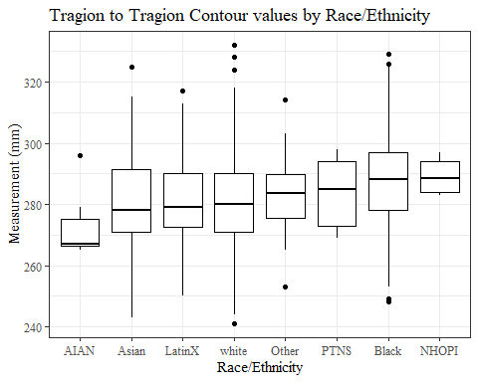

#boxplot not reordered by median  
ggplot(data=headscan_full, aes(y=TrTr_C, x=race_eth))+  
 geom_boxplot(color= "black", fill = "white")+  
 theme_bw()+theme(text=element_text(family= "Times New Roman"))+  
 #theme(axis.text.x = element_text(angle = 20, vjust=0.7))+  
 labs(title="Tragion to Tragion Contour values by Race/Ethnicity",  
 y="Measurement (mm)",  
 x="Race/Ethnicity")

## Warning: Removed 38 rows containing non-finite values (stat_boxplot).

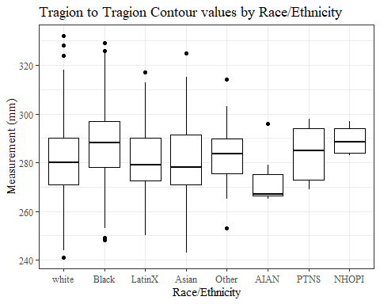

#TrTr_C gender sumstats  
TrTr_Cgender_sumstats <- headscan_full %>%   
 group_by(gender) %>%   
 summarise(n = n(), na = sum(is.na(TrTr_C)),  
 min = min(TrTr_C, na.rm = TRUE),  
 max = max(TrTr_C, na.rm = TRUE),  
 mean = mean(TrTr_C, na.rm = TRUE),  
 mdn = median(TrTr_C, na.rm = TRUE),  
 sd = sd(TrTr_C, na.rm = TRUE),  
 se = sd/sqrt(n),  
 percent5th = quantile(TrTr_C, 0.05, na.rm=TRUE),  
 percent25th = quantile(TrTr_C, 0.25, na.rm=TRUE),  
 percent50th = quantile(TrTr_C, 0.50, na.rm=TRUE),  
 percent75th = quantile(TrTr_C, 0.75, na.rm=TRUE),  
 percent95th = quantile(TrTr_C, 0.95, na.rm=TRUE))  
  
TrTr_Cgender_sumstats <- TrTr_Cgender_sumstats %>%   
 mutate(across(where(is.numeric), round, 2))  
  
#Size 12 Table TNR  
flextable(TrTr_Cgender_sumstats) %>%  
 my_ft_theme()%>%   
 bold(part = "header") %>%   
 set_caption("Tragion to Tragion Contour SumStats by Gender")

**Table** : Tragion to Tragion Contour SumStats by Gender

| **gender** | **n** | **na** | **min** | **max** | **mean** | **mdn** | **sd** | **se** | **percent5th** | **percent25th** | **percent50th** | **percent75th** | **percent95th** |
| --- | --- | --- | --- | --- | --- | --- | --- | --- | --- | --- | --- | --- | --- |
| Female | 1,063 | 26 | 241 | 329 | 275.77 | 275.0 | 12.34 | 0.38 | 257.0 | 267.0 | 275.0 | 283 | 297.2 |
| Male | 939 | 12 | 254 | 332 | 290.53 | 290.0 | 12.33 | 0.40 | 271.0 | 282.0 | 290.0 | 299 | 312.0 |
| Non-binary or Other | 5 | 0 | 260 | 288 | 277.20 | 278.0 | 10.45 | 4.67 | 263.6 | 278.0 | 278.0 | 282 | 286.8 |
| Prefer not to say | 1 | 0 | 294 | 294 | 294.00 | 294.0 |  |  | 294.0 | 294.0 | 294.0 | 294 | 294.0 |
|  | 8 | 0 | 270 | 302 | 279.12 | 277.5 | 10.52 | 3.72 | 270.0 | 271.5 | 277.5 | 281 | 295.7 |

#%>% set_header_Cabels(values = list(TrTr_C = "Tragion/TragionCont"))  
  
#Autofit Width Table TNR  
flextable(TrTr_Cgender_sumstats) %>%  
 my_ft_theme()%>%   
 bold(part = "header") %>%   
 set_caption("Tragion to Tragion Contour SumStats by Gender") %>%   
 fit_to_width(7.5)

**Table** : Tragion to Tragion Contour SumStats by Gender

| **gender** | **n** | **na** | **min** | **max** | **mean** | **mdn** | **sd** | **se** | **percent5th** | **percent25th** | **percent50th** | **percent75th** | **percent95th** |
| --- | --- | --- | --- | --- | --- | --- | --- | --- | --- | --- | --- | --- | --- |
| Female | 1,063 | 26 | 241 | 329 | 275.77 | 275.0 | 12.34 | 0.38 | 257.0 | 267.0 | 275.0 | 283 | 297.2 |
| Male | 939 | 12 | 254 | 332 | 290.53 | 290.0 | 12.33 | 0.40 | 271.0 | 282.0 | 290.0 | 299 | 312.0 |
| Non-binary or Other | 5 | 0 | 260 | 288 | 277.20 | 278.0 | 10.45 | 4.67 | 263.6 | 278.0 | 278.0 | 282 | 286.8 |
| Prefer not to say | 1 | 0 | 294 | 294 | 294.00 | 294.0 |  |  | 294.0 | 294.0 | 294.0 | 294 | 294.0 |
|  | 8 | 0 | 270 | 302 | 279.12 | 277.5 | 10.52 | 3.72 | 270.0 | 271.5 | 277.5 | 281 | 295.7 |

#%>% set_header_Cabels(values = list(TrTr_C = "Tragion/TragionCont"))  
  
#boxplot reorderd by median  
headscan_full %>%   
 ungroup() %>%   
 mutate(gender= fct_reorder(gender, TrTr_C, FUN=median, na.rm=TRUE)) %>%   
 ggplot(aes(y=TrTr_C, x=gender))+  
 geom_boxplot(color= "black", fill = "white")+  
 theme_bw()+theme(text=element_text(family= "Times New Roman"))+  
 theme(axis.text.x = element_text(angle = 20, vjust=0.7))+  
 labs(title="Tragion to Tragion Contour values by Gender",  
 y="Measurement (mm)",  
 x="Gender")

## Warning: Removed 38 rows containing non-finite values (stat_boxplot).

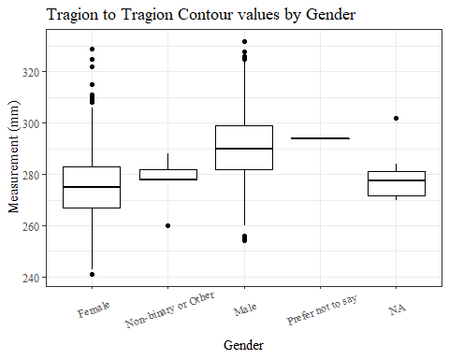

#boxplot not reordered by median  
ggplot(data=headscan_full, aes(y=TrTr_C, x=gender))+  
 geom_boxplot(color= "black", fill = "white")+  
 theme_bw()+theme(text=element_text(family= "Times New Roman"))+  
 theme(axis.text.x = element_text(angle = 20, vjust=0.7))+  
 labs(title="Tragion to Tragion Contour values by Gender",  
 y="Measurement (mm)",  
 x="Gender")

## Warning: Removed 38 rows containing non-finite values (stat_boxplot).

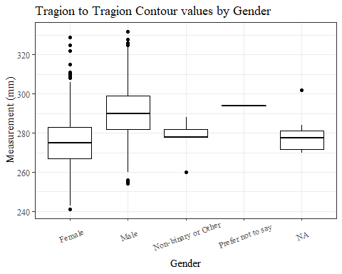

#TrTr_C age group sumstats  
TrTr_Cage_sumstats <- headscan_full %>%   
 group_by(age_group) %>%   
 summarise(n = n(), na = sum(is.na(TrTr_C)),  
 min = min(TrTr_C, na.rm = TRUE),  
 max = max(TrTr_C, na.rm = TRUE),  
 mean = mean(TrTr_C, na.rm = TRUE),  
 mdn = median(TrTr_C, na.rm = TRUE),  
 sd = sd(TrTr_C, na.rm = TRUE),  
 se = sd/sqrt(n),  
 percent5th = quantile(TrTr_C, 0.05, na.rm=TRUE),  
 percent25th = quantile(TrTr_C, 0.25, na.rm=TRUE),  
 percent50th = quantile(TrTr_C, 0.50, na.rm=TRUE),  
 percent75th = quantile(TrTr_C, 0.75, na.rm=TRUE),  
 percent95th = quantile(TrTr_C, 0.95, na.rm=TRUE))  
  
TrTr_Cage_sumstats <- TrTr_Cage_sumstats %>%   
 mutate(across(where(is.numeric), round, 2))  
  
  
#Size 12 Table TNR  
flextable(TrTr_Cage_sumstats) %>%  
 my_ft_theme()%>%   
 bold(part = "header") %>%   
 set_caption("Tragion to Tragion Contour SumStats by Age Group")

**Table** : Tragion to Tragion Contour SumStats by Age Group

| **age_group** | **n** | **na** | **min** | **max** | **mean** | **mdn** | **sd** | **se** | **percent5th** | **percent25th** | **percent50th** | **percent75th** | **percent95th** |
| --- | --- | --- | --- | --- | --- | --- | --- | --- | --- | --- | --- | --- | --- |
| 18-36 | 991 | 18 | 241 | 326 | 282.23 | 282 | 14.38 | 0.46 | 260.0 | 272 | 282 | 292.0 | 307.0 |
| 37-54 | 940 | 19 | 244 | 332 | 282.78 | 282 | 14.33 | 0.47 | 261.0 | 272 | 282 | 293.0 | 308.0 |
| 55-72 | 84 | 1 | 255 | 317 | 287.63 | 288 | 13.26 | 1.45 | 266.1 | 278 | 288 | 297.5 | 308.9 |
|  | 1 | 0 | 283 | 283 | 283.00 | 283 |  |  | 283.0 | 283 | 283 | 283.0 | 283.0 |

#%>% set_header_Cabels(values = list(TrTr_C = "Tragion/TragionCont"))  
  
#Autofit Width Table TNR  
flextable(TrTr_Cage_sumstats) %>%  
 my_ft_theme()%>%   
 bold(part = "header") %>%   
 set_caption("Tragion to Tragion Contour SumStats by Age Group") %>%   
 fit_to_width(7.5)

**Table** : Tragion to Tragion Contour SumStats by Age Group

| **age_group** | **n** | **na** | **min** | **max** | **mean** | **mdn** | **sd** | **se** | **percent5th** | **percent25th** | **percent50th** | **percent75th** | **percent95th** |
| --- | --- | --- | --- | --- | --- | --- | --- | --- | --- | --- | --- | --- | --- |
| 18-36 | 991 | 18 | 241 | 326 | 282.23 | 282 | 14.38 | 0.46 | 260.0 | 272 | 282 | 292.0 | 307.0 |
| 37-54 | 940 | 19 | 244 | 332 | 282.78 | 282 | 14.33 | 0.47 | 261.0 | 272 | 282 | 293.0 | 308.0 |
| 55-72 | 84 | 1 | 255 | 317 | 287.63 | 288 | 13.26 | 1.45 | 266.1 | 278 | 288 | 297.5 | 308.9 |
|  | 1 | 0 | 283 | 283 | 283.00 | 283 |  |  | 283.0 | 283 | 283 | 283.0 | 283.0 |

#%>% set_header_Cabels(values = list(TrTr_C = "Tragion/TragionCont"))  
  
#boxplot reorderd by median  
headscan_full %>%   
 ungroup() %>%   
 mutate(age_group= fct_reorder(age_group, TrTr_C, FUN=median, na.rm=TRUE)) %>%   
 ggplot(aes(y=TrTr_C, x=age_group))+  
 geom_boxplot(color= "black", fill = "white")+  
 theme_bw()+theme(text=element_text(family= "Times New Roman"))+  
 #theme(axis.text.x = element_text(angle = 20, vjust=0.7))+  
 labs(title="Tragion to Tragion Contour values by Age Group",  
 y="Measurement (mm)",  
 x="Age Group")

## Warning: Removed 38 rows containing non-finite values (stat_boxplot).

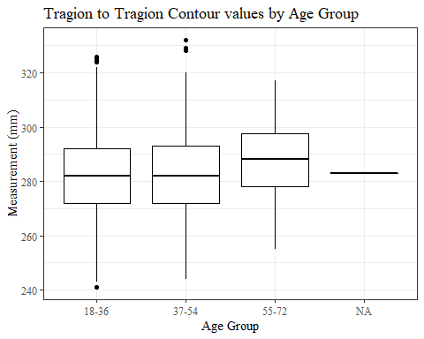

#boxplot not reordered by median  
ggplot(data=headscan_full, aes(y=TrTr_C, x=age_group))+  
 geom_boxplot(color= "black", fill = "white")+  
 theme_bw()+theme(text=element_text(family= "Times New Roman"))+  
 #theme(axis.text.x = element_text(angle = 20, vjust=0.7))+  
 labs(title="Tragion to Tragion Contour values by Age Group",  
 y="Measurement (mm)",  
 x="Age Group")

## Warning: Removed 38 rows containing non-finite values (stat_boxplot).



TrTr_L

#histogram of all TrTr_L values  
ggplot(data=headscan_full, aes(x=TrTr_L))+  
 geom_bar(stat="bin", bins=20, color= "black", fill = "white")+  
 theme_bw()+theme(text=element_text(family= "Times New Roman"))+  
 labs(title="Tragion to Tragion Linear Measurement Distribution",  
 y="Frequency",  
 x="Tragion to Tragion Linear (mm)")

## Warning: Removed 34 rows containing non-finite values (stat_bin).

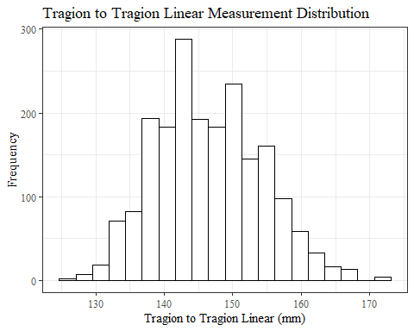

TrTr_Lsumstats <- headscan_full %>%   
 summarise(n = n(), na = sum(is.na(TrTr_L)),  
 min = min(TrTr_L, na.rm = TRUE),  
 max = max(TrTr_L, na.rm = TRUE),  
 mean = mean(TrTr_L, na.rm = TRUE),  
 mdn = median(TrTr_L, na.rm = TRUE),  
 sd = sd(TrTr_L, na.rm = TRUE),  
 se = sd/sqrt(n),  
 percent5th = quantile(TrTr_L, 0.05, na.rm=TRUE),  
 percent25th = quantile(TrTr_L, 0.25, na.rm=TRUE),  
 percent50th = quantile(TrTr_L, 0.50, na.rm=TRUE),  
 percent75th = quantile(TrTr_L, 0.75, na.rm=TRUE),  
 percent95th = quantile(TrTr_L, 0.95, na.rm=TRUE))   
  
TrTr_Lsumstats <- round(TrTr_Lsumstats, 2)  
  
#Size 12 Table TNR  
flextable(TrTr_Lsumstats) %>%  
 my_ft_theme()%>%   
 bold(part = "header") %>%   
 set_caption("Tragion to Tragion Linear SumStats")

**Table** : Tragion to Tragion Linear SumStats

| **n** | **na** | **min** | **max** | **mean** | **mdn** | **sd** | **se** | **percent5th** | **percent25th** | **percent50th** | **percent75th** | **percent95th** |
| --- | --- | --- | --- | --- | --- | --- | --- | --- | --- | --- | --- | --- |
| 2,016 | 34 | 127 | 173 | 146.5 | 146 | 7.73 | 0.17 | 135 | 141 | 146 | 152 | 160 |

#%>% set_header_Labels(values = list(TrTr_L = "Tragion/TragionCont"))  
  
#Autofit Width Table TNR  
flextable(TrTr_Lsumstats) %>%  
 my_ft_theme()%>%   
 bold(part = "header") %>%   
 set_caption("Tragion to Tragion Linear SumStats") %>%   
 fit_to_width(7.5)

**Table** : Tragion to Tragion Linear SumStats

| **n** | **na** | **min** | **max** | **mean** | **mdn** | **sd** | **se** | **percent5th** | **percent25th** | **percent50th** | **percent75th** | **percent95th** |
| --- | --- | --- | --- | --- | --- | --- | --- | --- | --- | --- | --- | --- |
| 2,016 | 34 | 127 | 173 | 146.5 | 146 | 7.73 | 0.17 | 135 | 141 | 146 | 152 | 160 |

#%>% set_header_Labels(values = list(TrTr_L = "Tragion/TragionCont"))

#TrTr_L race/eth sumstats  
TrTr_Lrace_sumstats <- headscan_full %>%   
 group_by(race_eth) %>%   
 summarise(n = n(), na = sum(is.na(TrTr_L)),  
 min = min(TrTr_L, na.rm = TRUE),  
 max = max(TrTr_L, na.rm = TRUE),  
 mean = mean(TrTr_L, na.rm = TRUE),  
 mdn = median(TrTr_L, na.rm = TRUE),  
 sd = sd(TrTr_L, na.rm = TRUE),  
 se = sd/sqrt(n),  
 percent5th = quantile(TrTr_L, 0.05, na.rm=TRUE),  
 percent25th = quantile(TrTr_L, 0.25, na.rm=TRUE),  
 percent50th = quantile(TrTr_L, 0.50, na.rm=TRUE),  
 percent75th = quantile(TrTr_L, 0.75, na.rm=TRUE),  
 percent95th = quantile(TrTr_L, 0.95, na.rm=TRUE))   
  
TrTr_Lrace_sumstats <- TrTr_Lrace_sumstats %>%   
 mutate(across(where(is.numeric), round, 2))  
  
  
#Size 12 Table TNR  
flextable(TrTr_Lrace_sumstats) %>%  
 my_ft_theme()%>%   
 bold(part = "header") %>%   
 set_caption("Tragion to Tragion Linear SumStats by Race/Ethnicity")

**Table** : Tragion to Tragion Linear SumStats by Race/Ethnicity

| **race_eth** | **n** | **na** | **min** | **max** | **mean** | **mdn** | **sd** | **se** | **percent5th** | **percent25th** | **percent50th** | **percent75th** | **percent95th** |
| --- | --- | --- | --- | --- | --- | --- | --- | --- | --- | --- | --- | --- | --- |
| white | 1,239 | 20 | 127 | 173 | 145.49 | 145.0 | 7.58 | 0.22 | 134.0 | 140.0 | 145.0 | 151.00 | 158.00 |
| Black | 548 | 9 | 130 | 172 | 148.47 | 148.0 | 7.57 | 0.32 | 137.0 | 143.0 | 148.0 | 154.00 | 161.10 |
| LatinX | 100 | 1 | 132 | 171 | 146.90 | 147.0 | 7.54 | 0.75 | 135.0 | 141.5 | 147.0 | 151.00 | 158.10 |
| Asian | 91 | 2 | 129 | 167 | 147.56 | 148.0 | 8.67 | 0.91 | 135.4 | 140.0 | 148.0 | 153.00 | 161.00 |
| Other | 21 | 1 | 138 | 159 | 147.45 | 146.0 | 6.56 | 1.43 | 139.9 | 142.0 | 146.0 | 151.75 | 158.05 |
| AIAN | 8 | 1 | 132 | 157 | 141.86 | 140.0 | 7.99 | 2.82 | 133.8 | 138.5 | 140.0 | 143.50 | 154.00 |
| PTNS | 5 | 0 | 137 | 156 | 147.80 | 153.0 | 8.64 | 3.87 | 137.6 | 140.0 | 153.0 | 153.00 | 155.40 |
| NHOPI | 4 | 0 | 153 | 160 | 156.50 | 156.5 | 3.11 | 1.55 | 153.3 | 154.5 | 156.5 | 158.50 | 159.70 |

#%>% set_header_Labels(values = list(TrTr_L = "Tragion/TragionCont"))  
  
#Autofit Width Table TNR  
flextable(TrTr_Lrace_sumstats) %>%  
 my_ft_theme()%>%   
 bold(part = "header") %>%   
 set_caption("Tragion to Tragion Linear SumStats by Race/Ethnicity") %>%   
 fit_to_width(7.5)

**Table** : Tragion to Tragion Linear SumStats by Race/Ethnicity

| **race_eth** | **n** | **na** | **min** | **max** | **mean** | **mdn** | **sd** | **se** | **percent5th** | **percent25th** | **percent50th** | **percent75th** | **percent95th** |
| --- | --- | --- | --- | --- | --- | --- | --- | --- | --- | --- | --- | --- | --- |
| white | 1,239 | 20 | 127 | 173 | 145.49 | 145.0 | 7.58 | 0.22 | 134.0 | 140.0 | 145.0 | 151.00 | 158.00 |
| Black | 548 | 9 | 130 | 172 | 148.47 | 148.0 | 7.57 | 0.32 | 137.0 | 143.0 | 148.0 | 154.00 | 161.10 |
| LatinX | 100 | 1 | 132 | 171 | 146.90 | 147.0 | 7.54 | 0.75 | 135.0 | 141.5 | 147.0 | 151.00 | 158.10 |
| Asian | 91 | 2 | 129 | 167 | 147.56 | 148.0 | 8.67 | 0.91 | 135.4 | 140.0 | 148.0 | 153.00 | 161.00 |
| Other | 21 | 1 | 138 | 159 | 147.45 | 146.0 | 6.56 | 1.43 | 139.9 | 142.0 | 146.0 | 151.75 | 158.05 |
| AIAN | 8 | 1 | 132 | 157 | 141.86 | 140.0 | 7.99 | 2.82 | 133.8 | 138.5 | 140.0 | 143.50 | 154.00 |
| PTNS | 5 | 0 | 137 | 156 | 147.80 | 153.0 | 8.64 | 3.87 | 137.6 | 140.0 | 153.0 | 153.00 | 155.40 |
| NHOPI | 4 | 0 | 153 | 160 | 156.50 | 156.5 | 3.11 | 1.55 | 153.3 | 154.5 | 156.5 | 158.50 | 159.70 |

#%>% set_header_Labels(values = list(TrTr_L = "Tragion/TragionCont"))  
  
#boxplot reorderd by median  
headscan_full %>%   
 ungroup() %>%   
 mutate(race_eth= fct_reorder(race_eth, TrTr_L, FUN=median, na.rm=TRUE)) %>%   
 ggplot(aes(y=TrTr_L, x=race_eth))+  
 geom_boxplot(color= "black", fill = "white")+  
 theme_bw()+theme(text=element_text(family= "Times New Roman"))+  
 #theme(axis.text.x = element_text(angle = 20, vjust=0.7))+  
 labs(title="Tragion to Tragion Linear values by Race/Ethnicity",  
 y="Measurement (mm)",  
 x="Race/Ethnicity")

## Warning: Removed 34 rows containing non-finite values (stat_boxplot).

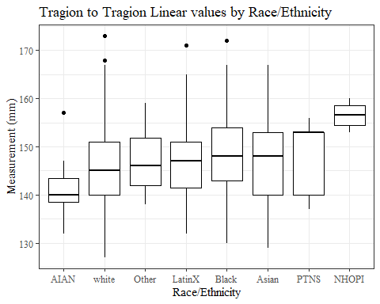

#boxplot not reordered by median  
ggplot(data=headscan_full, aes(y=TrTr_L, x=race_eth))+  
 geom_boxplot(color= "black", fill = "white")+  
 theme_bw()+theme(text=element_text(family= "Times New Roman"))+  
 #theme(axis.text.x = element_text(angle = 20, vjust=0.7))+  
 labs(title="Tragion to Tragion Linear values by Race/Ethnicity",  
 y="Measurement (mm)",  
 x="Race/Ethnicity")

## Warning: Removed 34 rows containing non-finite values (stat_boxplot).

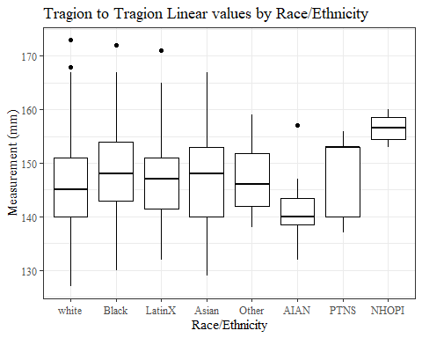

#TrTr_L gender sumstats  
TrTr_Lgender_sumstats <- headscan_full %>%   
 group_by(gender) %>%   
 summarise(n = n(), na = sum(is.na(TrTr_L)),  
 min = min(TrTr_L, na.rm = TRUE),  
 max = max(TrTr_L, na.rm = TRUE),  
 mean = mean(TrTr_L, na.rm = TRUE),  
 mdn = median(TrTr_L, na.rm = TRUE),  
 sd = sd(TrTr_L, na.rm = TRUE),  
 se = sd/sqrt(n),  
 percent5th = quantile(TrTr_L, 0.05, na.rm=TRUE),  
 percent25th = quantile(TrTr_L, 0.25, na.rm=TRUE),  
 percent50th = quantile(TrTr_L, 0.50, na.rm=TRUE),  
 percent75th = quantile(TrTr_L, 0.75, na.rm=TRUE),  
 percent95th = quantile(TrTr_L, 0.95, na.rm=TRUE))  
  
TrTr_Lgender_sumstats <- TrTr_Lgender_sumstats %>%   
 mutate(across(where(is.numeric), round, 2))  
  
#Size 12 Table TNR  
flextable(TrTr_Lgender_sumstats) %>%  
 my_ft_theme()%>%   
 bold(part = "header") %>%   
 set_caption("Tragion to Tragion Linear SumStats by Gender")

**Table** : Tragion to Tragion Linear SumStats by Gender

| **gender** | **n** | **na** | **min** | **max** | **mean** | **mdn** | **sd** | **se** | **percent5th** | **percent25th** | **percent50th** | **percent75th** | **percent95th** |
| --- | --- | --- | --- | --- | --- | --- | --- | --- | --- | --- | --- | --- | --- |
| Female | 1,063 | 23 | 127 | 165 | 141.87 | 142 | 5.83 | 0.18 | 133.0 | 138.00 | 142 | 145.00 | 152.0 |
| Male | 939 | 11 | 132 | 173 | 151.72 | 152 | 6.18 | 0.20 | 142.0 | 147.00 | 152 | 156.00 | 162.0 |
| Non-binary or Other | 5 | 0 | 139 | 149 | 143.20 | 141 | 4.15 | 1.85 | 139.4 | 141.00 | 141 | 146.00 | 148.4 |
| Prefer not to say | 1 | 0 | 153 | 153 | 153.00 | 153 |  |  | 153.0 | 153.00 | 153 | 153.00 | 153.0 |
|  | 8 | 0 | 138 | 150 | 144.50 | 144 | 3.82 | 1.35 | 139.4 | 142.75 | 144 | 147.25 | 149.3 |

#%>% set_header_Labels(values = list(TrTr_L = "Tragion/TragionCont"))  
  
#Autofit Width Table TNR  
flextable(TrTr_Lgender_sumstats) %>%  
 my_ft_theme()%>%   
 bold(part = "header") %>%   
 set_caption("Tragion to Tragion Linear SumStats by Gender") %>%   
 fit_to_width(7.5)

**Table** : Tragion to Tragion Linear SumStats by Gender

| **gender** | **n** | **na** | **min** | **max** | **mean** | **mdn** | **sd** | **se** | **percent5th** | **percent25th** | **percent50th** | **percent75th** | **percent95th** |
| --- | --- | --- | --- | --- | --- | --- | --- | --- | --- | --- | --- | --- | --- |
| Female | 1,063 | 23 | 127 | 165 | 141.87 | 142 | 5.83 | 0.18 | 133.0 | 138.00 | 142 | 145.00 | 152.0 |
| Male | 939 | 11 | 132 | 173 | 151.72 | 152 | 6.18 | 0.20 | 142.0 | 147.00 | 152 | 156.00 | 162.0 |
| Non-binary or Other | 5 | 0 | 139 | 149 | 143.20 | 141 | 4.15 | 1.85 | 139.4 | 141.00 | 141 | 146.00 | 148.4 |
| Prefer not to say | 1 | 0 | 153 | 153 | 153.00 | 153 |  |  | 153.0 | 153.00 | 153 | 153.00 | 153.0 |
|  | 8 | 0 | 138 | 150 | 144.50 | 144 | 3.82 | 1.35 | 139.4 | 142.75 | 144 | 147.25 | 149.3 |

#%>% set_header_Labels(values = list(TrTr_L = "Tragion/TragionCont"))  
  
#boxplot reorderd by median  
headscan_full %>%   
 ungroup() %>%   
 mutate(gender= fct_reorder(gender, TrTr_L, FUN=median, na.rm=TRUE)) %>%   
 ggplot(aes(y=TrTr_L, x=gender))+  
 geom_boxplot(color= "black", fill = "white")+  
 theme_bw()+theme(text=element_text(family= "Times New Roman"))+  
 theme(axis.text.x = element_text(angle = 20, vjust=0.7))+  
 labs(title="Tragion to Tragion Linear values by Gender",  
 y="Measurement (mm)",  
 x="Gender")

## Warning: Removed 34 rows containing non-finite values (stat_boxplot).

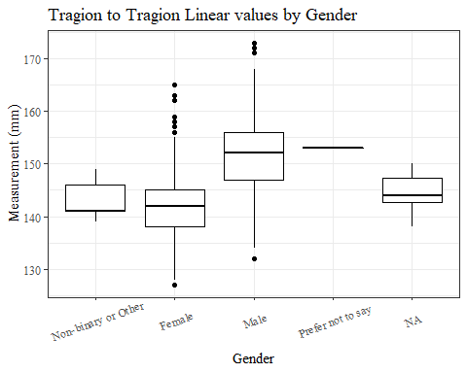

#boxplot not reordered by median  
ggplot(data=headscan_full, aes(y=TrTr_L, x=gender))+  
 geom_boxplot(color= "black", fill = "white")+  
 theme_bw()+theme(text=element_text(family= "Times New Roman"))+  
 theme(axis.text.x = element_text(angle = 20, vjust=0.7))+  
 labs(title="Tragion to Tragion Linear values by Gender",  
 y="Measurement (mm)",  
 x="Gender")

## Warning: Removed 34 rows containing non-finite values (stat_boxplot).

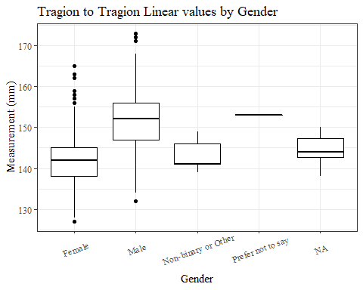

#TrTr_L age group sumstats  
TrTr_Lage_sumstats <- headscan_full %>%   
 group_by(age_group) %>%   
 summarise(n = n(), na = sum(is.na(TrTr_L)),  
 min = min(TrTr_L, na.rm = TRUE),  
 max = max(TrTr_L, na.rm = TRUE),  
 mean = mean(TrTr_L, na.rm = TRUE),  
 mdn = median(TrTr_L, na.rm = TRUE),  
 sd = sd(TrTr_L, na.rm = TRUE),  
 se = sd/sqrt(n),  
 percent5th = quantile(TrTr_L, 0.05, na.rm=TRUE),  
 percent25th = quantile(TrTr_L, 0.25, na.rm=TRUE),  
 percent50th = quantile(TrTr_L, 0.50, na.rm=TRUE),  
 percent75th = quantile(TrTr_L, 0.75, na.rm=TRUE),  
 percent95th = quantile(TrTr_L, 0.95, na.rm=TRUE))  
  
TrTr_Lage_sumstats <- TrTr_Lage_sumstats %>%   
 mutate(across(where(is.numeric), round, 2))  
  
  
#Size 12 Table TNR  
flextable(TrTr_Lage_sumstats) %>%  
 my_ft_theme()%>%   
 bold(part = "header") %>%   
 set_caption("Tragion to Tragion Linear SumStats by Age Group")

**Table** : Tragion to Tragion Linear SumStats by Age Group

| **age_group** | **n** | **na** | **min** | **max** | **mean** | **mdn** | **sd** | **se** | **percent5th** | **percent25th** | **percent50th** | **percent75th** | **percent95th** |
| --- | --- | --- | --- | --- | --- | --- | --- | --- | --- | --- | --- | --- | --- |
| 18-36 | 991 | 15 | 127 | 167 | 146.35 | 146 | 7.68 | 0.24 | 134.0 | 141 | 146 | 152 | 160.00 |
| 37-54 | 940 | 18 | 127 | 173 | 146.42 | 146 | 7.69 | 0.25 | 135.0 | 141 | 146 | 152 | 159.95 |
| 55-72 | 84 | 1 | 132 | 172 | 149.19 | 149 | 8.49 | 0.93 | 136.1 | 143 | 149 | 156 | 161.90 |
|  | 1 | 0 | 147 | 147 | 147.00 | 147 |  |  | 147.0 | 147 | 147 | 147 | 147.00 |

#%>% set_header_Labels(values = list(TrTr_L = "Tragion/TragionCont"))  
  
#Autofit Width Table TNR  
flextable(TrTr_Lage_sumstats) %>%  
 my_ft_theme()%>%   
 bold(part = "header") %>%   
 set_caption("Tragion to Tragion Linear SumStats by Age Group") %>%   
 fit_to_width(7.5)

**Table** : Tragion to Tragion Linear SumStats by Age Group

| **age_group** | **n** | **na** | **min** | **max** | **mean** | **mdn** | **sd** | **se** | **percent5th** | **percent25th** | **percent50th** | **percent75th** | **percent95th** |
| --- | --- | --- | --- | --- | --- | --- | --- | --- | --- | --- | --- | --- | --- |
| 18-36 | 991 | 15 | 127 | 167 | 146.35 | 146 | 7.68 | 0.24 | 134.0 | 141 | 146 | 152 | 160.00 |
| 37-54 | 940 | 18 | 127 | 173 | 146.42 | 146 | 7.69 | 0.25 | 135.0 | 141 | 146 | 152 | 159.95 |
| 55-72 | 84 | 1 | 132 | 172 | 149.19 | 149 | 8.49 | 0.93 | 136.1 | 143 | 149 | 156 | 161.90 |
|  | 1 | 0 | 147 | 147 | 147.00 | 147 |  |  | 147.0 | 147 | 147 | 147 | 147.00 |

#%>% set_header_Labels(values = list(TrTr_L = "Tragion/TragionCont"))  
  
#boxplot reorderd by median  
headscan_full %>%   
 ungroup() %>%   
 mutate(age_group= fct_reorder(age_group, TrTr_L, FUN=median, na.rm=TRUE)) %>%   
 ggplot(aes(y=TrTr_L, x=age_group))+  
 geom_boxplot(color= "black", fill = "white")+  
 theme_bw()+theme(text=element_text(family= "Times New Roman"))+  
 #theme(axis.text.x = element_text(angle = 20, vjust=0.7))+  
 labs(title="Tragion to Tragion Length values by Age Group",  
 y="Measurement (mm)",  
 x="Age Group")

## Warning: Removed 34 rows containing non-finite values (stat_boxplot).

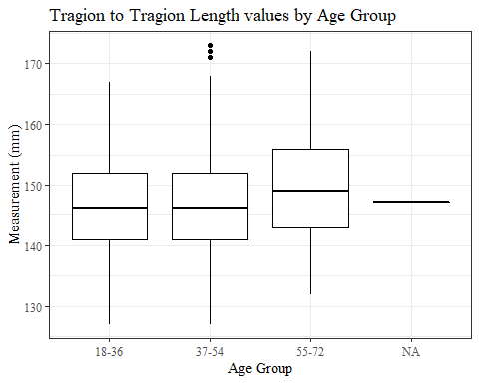

#boxplot not reordered by median  
ggplot(data=headscan_full, aes(y=TrTr_L, x=age_group))+  
 geom_boxplot(color= "black", fill = "white")+  
 theme_bw()+theme(text=element_text(family= "Times New Roman"))+  
 #theme(axis.text.x = element_text(angle = 20, vjust=0.7))+  
 labs(title="Tragion to Tragion Length values by Age Group",  
 y="Measurement (mm)",  
 x="Age Group")

## Warning: Removed 34 rows containing non-finite values (stat_boxplot).

