ELEC 475: Computer Vision with Deep Learning (Fall 2026)

Lab 2 Post-Lab: Full AlexNet,

Normalization Study, & Data Augmentation
Kayne Lee: 20350003
Mark Wang: 20340138
GitHub: https://github.com/kayne-lee/elec-475
October 22, 2026

Architectural Specifications
All models take a 3×64×64 input. Parameter counts are for the 10-class head; the 200-class Tiny ImageNet head adds (in_features + 1) × 190 parameters to the final layer.

Formulas
Output size: O = ⌊(I - K + 2P) / S⌋ + 1
Parameters: Conv (K·K·C_{in} + 1)·C_{out}, Linear (N_{in} + 1)·N_{out}, BatchNorm2d 2·C
Receptive field: RF_{l} = RF_{l-1} + (K_{l} - 1)·J_{l-1}, J_{l} = J_{l-1}·S_{l}, RF₀ = J₀ = 1

Base LeNet-5
Two unpadded 5×5 convolutions with Tanh and 2×2 average pooling, followed by three fully connected layers. 338,486 parameters.
Table 1: Base LeNet-5.
Layer | Configuration | Output | Params | RF (px)
Conv1 + Tanh | 5×5, s1, p0, 6 filters | 6×60×60 | 456 | 5
AvgPool1 | 2×2, s2 | 6×30×30 | 0 | 6
Conv2 + Tanh | 5×5, s1, p0, 16 filters | 16×26×26 | 2,416 | 14
AvgPool2 | 2×2, s2 | 16×13×13 | 0 | 16
Flatten |  | 2,704 | 0
FC1 + Tanh | 2,704 → 120 | 120 | 324,600
FC2 + Tanh | 120 → 84 | 84 | 10,164
FC3 | 84 → 10 | 10 | 850

Modernized LeNet
Same filter counts as LeNet-5, with ReLU, padding 2 and 3×3 overlapping max pooling (stride 2). 446,006 parameters.
Table 2: Modernized LeNet.
Layer | Configuration | Output | Params | RF (px)
Conv1 + ReLU | 5×5, s1, p2, 6 filters | 6×64×64 | 456 | 5
MaxPool1 | 3×3, s2 | 6×31×31 | 0 | 7
Conv2 + ReLU | 5×5, s1, p2, 16 filters | 16×31×31 | 2,416 | 15
MaxPool2 | 3×3, s2 | 16×15×15 | 0 | 19
Flatten |  | 3,600 | 0
FC1 + ReLU | 3,600 → 120 | 120 | 432,120
FC2 + ReLU | 120 → 84 | 84 | 10,164
FC3 | 84 → 10 | 10 | 850

AlexNet-64
Five convolutional stages, each Conv → Norm → ReLU, three 3×3 overlapping max pools, and a classifier with Dropout (p = 0.5). Norm is None, LRN (size 5, α = 1e-4, β = 0.75, k = 2, applied after ReLU) or BatchNorm2d. 6,611,402 parameters with BatchNorm2d (2,560 from BN), 6,608,842 without.
Table 3: AlexNet-64.
Layer | Configuration | Output | Params | RF (px)
Conv1 → Norm → ReLU | 5×5, s2, p2, 64 filters | 64×32×32 | 4,864 | 5
MaxPool1 | 3×3, s2 | 64×15×15 | 0 | 9
Conv2 → Norm → ReLU | 5×5, s1, p2, 192 filters | 192×15×15 | 307,392 | 25
MaxPool2 | 3×3, s2 | 192×7×7 | 0 | 33
Conv3 → Norm → ReLU | 3×3, s1, p1, 384 filters | 384×7×7 | 663,936 | 49
Conv4 → Norm → ReLU | 3×3, s1, p1, 384 filters | 384×7×7 | 1,327,488 | 65
Conv5 → Norm → ReLU | 3×3, s1, p1, 256 filters | 256×7×7 | 884,992 | 81
MaxPool3 | 3×3, s2 | 256×3×3 | 0 | 97
Flatten |  | 2,304 | 0
Dropout → FC1 → ReLU | p = 0.5, 2,304 → 1,024 | 1,024 | 2,360,320
Dropout → FC2 → ReLU | p = 0.5, 1,024 → 1,024 | 1,024 | 1,049,600
FC3 | 1,024 → 10 | 10 | 10,250

PyTorch Model Zoo AlexNet
torchvision AlexNet (designed for 224×224 input) with the final layer replaced for 10 classes. No normalization; AdaptiveAvgPool2d(6, 6) before the classifier. 57,044,810 parameters.
Table 4: PyTorch Zoo AlexNet with a 64×64 input.
Layer | Configuration | Output | Params | RF (px)
Conv1 + ReLU | 11×11, s4, p2, 64 filters | 64×15×15 | 23,296 | 11
MaxPool1 | 3×3, s2 | 64×7×7 | 0 | 19
Conv2 + ReLU | 5×5, s1, p2, 192 filters | 192×7×7 | 307,392 | 51
MaxPool2 | 3×3, s2 | 192×3×3 | 0 | 67
Conv3 + ReLU | 3×3, s1, p1, 384 filters | 384×3×3 | 663,936 | 99
Conv4 + ReLU | 3×3, s1, p1, 256 filters | 256×3×3 | 884,992 | 131
Conv5 + ReLU | 3×3, s1, p1, 256 filters | 256×3×3 | 590,080 | 163
MaxPool3 | 3×3, s2 | 256×1×1 | 0 | 195
AdaptiveAvgPool2d | output 6×6 | 256×6×6 | 0
Flatten |  | 9,216 | 0
Dropout → FC1 → ReLU | p = 0.5, 9,216 → 4,096 | 4,096 | 37,752,832
Dropout → FC2 → ReLU | p = 0.5, 4,096 → 4,096 | 4,096 | 16,781,312
FC3 | 4,096 → 10 | 10 | 40,970

Summary
Table 5: Architecture comparison (10-class head).
Model | Conv depth | Params | Conv / FC share | Final RF (px) | Activation / Pooling / Norm
Base LeNet-5 | 2 | 0.34 M | 0.8% / 99.2% | 16 | Tanh / Avg 2×2 s2 / None
Modernized LeNet | 2 | 0.45 M | 0.6% / 99.4% | 19 | ReLU / Max 3×3 s2 / None
AlexNet-64 | 5 | 6.61 M | 48% / 52% | 97 | ReLU / Max 3×3 s2 / None, LRN or BN
Zoo AlexNet | 5 | 57.04 M | 4.3% / 95.7% | 195 | ReLU / Max 3×3 s2 + AdaptiveAvg / None

Empirical Results & Figures

Master Ablation Tables
Table 6: Architectural configuration and computational complexity (Table 7.3a).
Model | Conv depth | Normalization & Regularization | Data Aug. | Params (M) | FLOPs (M) | Mean Epoch Time (s) | Latency (ms)
1. Base LeNet-5 | 2 | None | None | 0.338 | 7.17 | 40.6 | 0.12
2. Modernized LeNet | 2 | None (ReLU + Overlapping MaxPool) | None | 0.446 | 9.19 | 44.9 | 0.15
3. AlexNet (No Norm) | 5 | Dropout (p = 0.5) | None | 6.609 | 436.70 | 179.5 | 1.32
4. AlexNet + LRN | 5 | LRN + Dropout (p = 0.5) | None | 6.609 | 436.70 | 226.3 | 2.22
5. AlexNet + BatchNorm | 5 | BatchNorm2d + Dropout (p = 0.5) | None | 6.611 | 437.97 | 180.3 | 1.24
6. AlexNet + BN + Aug | 5 | BatchNorm2d + Dropout (p = 0.5) | PyTorch Aug | 6.611 | 437.97 | 183.3 | 1.24
7. PyTorch Zoo AlexNet | 5 | PyTorch Zoo (AdaptiveAvgPool2d) | None | 57.045 | 188.20 | 108.4 | 3.54

Epoch time: mean over all epochs on CIFAR-10. All training and latency measurements on CPU (batch size 128 for training, 1 for latency).
Params and FLOPs exceed the handout's reference values (≈6.3 M and ≈250 MFLOPs for AlexNet-64): summing Table 3 layer by layer gives 6.61 M, and FLOPs are counted as 2 × MACs, so the difference is in the reference values.
Table 7: Predictive performance across datasets, best validation epoch (Table 7.3b).
Model | CIFAR-10 Val Acc (%) | CIFAR-10 Val Macro F1 (%) | Tiny ImageNet Val Acc (%) | Tiny ImageNet Val Macro F1 (%)
1. Base LeNet-5 | 55.67 | 55.49 | 11.64 | 9.82
2. Modernized LeNet | 66.71 | 66.77 | 20.59 | 18.53
3. AlexNet (No Norm) | 74.03 | 74.16 | 17.39 | 14.98
4. AlexNet + LRN | 72.70 | 72.76 | 15.72 | 13.07
5. AlexNet + BatchNorm | 78.78 | 78.86 | 29.78 | 28.32
6. AlexNet + BN + Aug | 82.74 | 82.12 | 29.90 | 28.38
7. PyTorch Zoo AlexNet | 65.96 | 66.04 | 20.86 | 18.62

All runs: Adam, lr = 1e-3, batch size 128, 10 epochs, seed 42, except row 6 CIFAR-10 (15 epochs) and row 7 Tiny ImageNet (lr = 1e-4, see Table 8).

Extended Ablation Exploration
Table 8: Extended ablations, best validation accuracy. Δ = Variant - Baseline (percentage points).
Experiment | Dataset | Baseline | Variant | Baseline Acc (%) | Variant Acc (%) | Δ (pp)
Activation & pooling | CIFAR-10 | Base LeNet-5 | Modernized LeNet | 55.67 | 66.71 | +11.04
Activation & pooling | Tiny ImageNet | Base LeNet-5 | Modernized LeNet | 11.64 | 20.59 | +8.95
Normalization | CIFAR-10 | AlexNet (No Norm) | AlexNet + BN | 74.03 | 78.78 | +4.75
Normalization | CIFAR-10 | AlexNet (No Norm) | AlexNet + LRN | 74.03 | 72.70 | -1.33
Normalization | Tiny ImageNet | AlexNet (No Norm) | AlexNet + BN | 17.39 | 29.78 | +12.39
Normalization | Tiny ImageNet | AlexNet (No Norm) | AlexNet + LRN | 17.39 | 15.72 | -1.67
Augmentation (15 epochs) | CIFAR-10 | AlexNet + BN | AlexNet + BN + Aug | 80.44 | 82.74 | +2.30
Augmentation (10 epochs) | Tiny ImageNet | AlexNet + BN | AlexNet + BN + Aug | 29.78 | 29.90 | +0.12
Learning rate | Tiny ImageNet | Zoo AlexNet, lr 1e-3 | Zoo AlexNet, lr 1e-4 | 0.57 | 20.86 | +20.29

Generalization Gap
Table 9: Generalization gap of AlexNet + BN on CIFAR-10, final epoch (15). Δ = Train Acc - Val Acc.
Run | Train Acc (%) | Val Acc (%) | Δ (pp) | Best Val Macro F1 (%)
Without augmentation | 90.20 | 80.44 | 9.76 | 80.82
With augmentation | 84.56 | 80.24 | 4.32 | 82.12

Multi-Seed Evaluation
Table 10: AlexNet + BN on CIFAR-10, 10 epochs, no augmentation, best validation epoch.
Seed | Val Acc (%) | Val Macro F1 (%)
42 | 78.78 | 78.86
123 | 79.25 | 79.31
999 | 80.49 | 80.48
Mean ± Std | 79.51 ± 0.88 | 79.55 ± 0.84

Training Curves
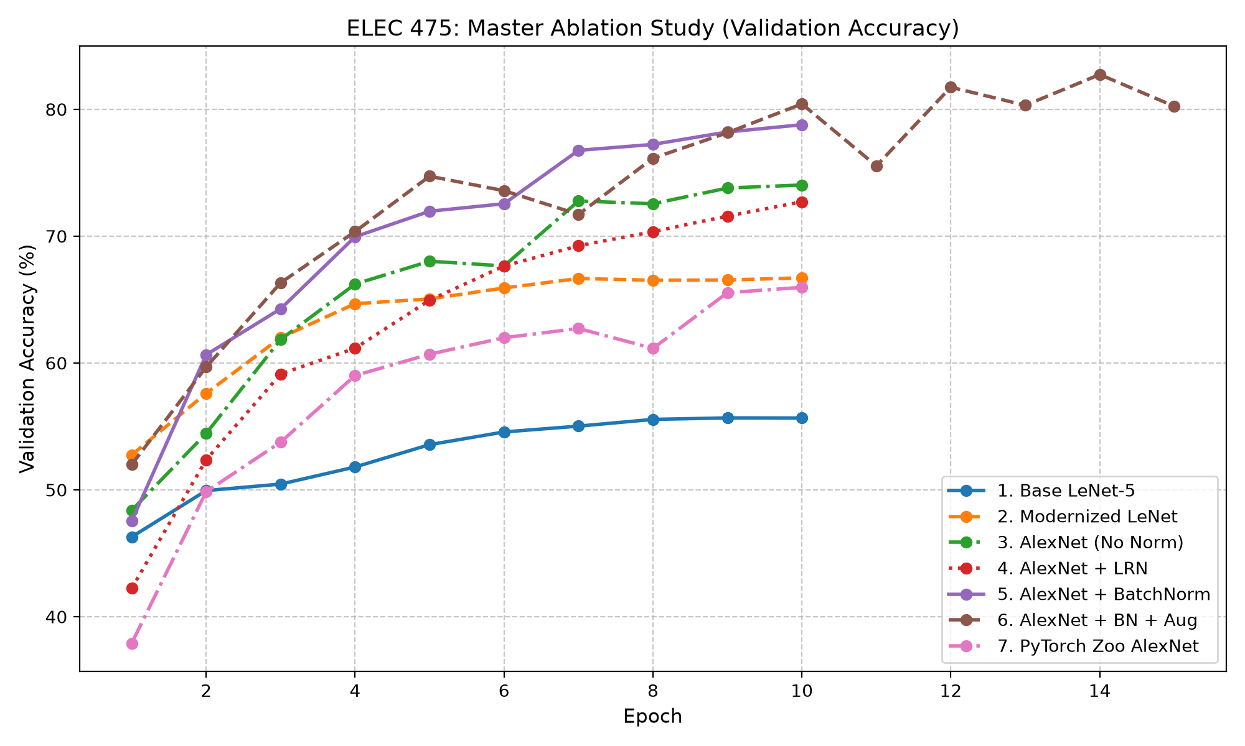
Figure 1: Validation accuracy per epoch for all CIFAR-10 models.
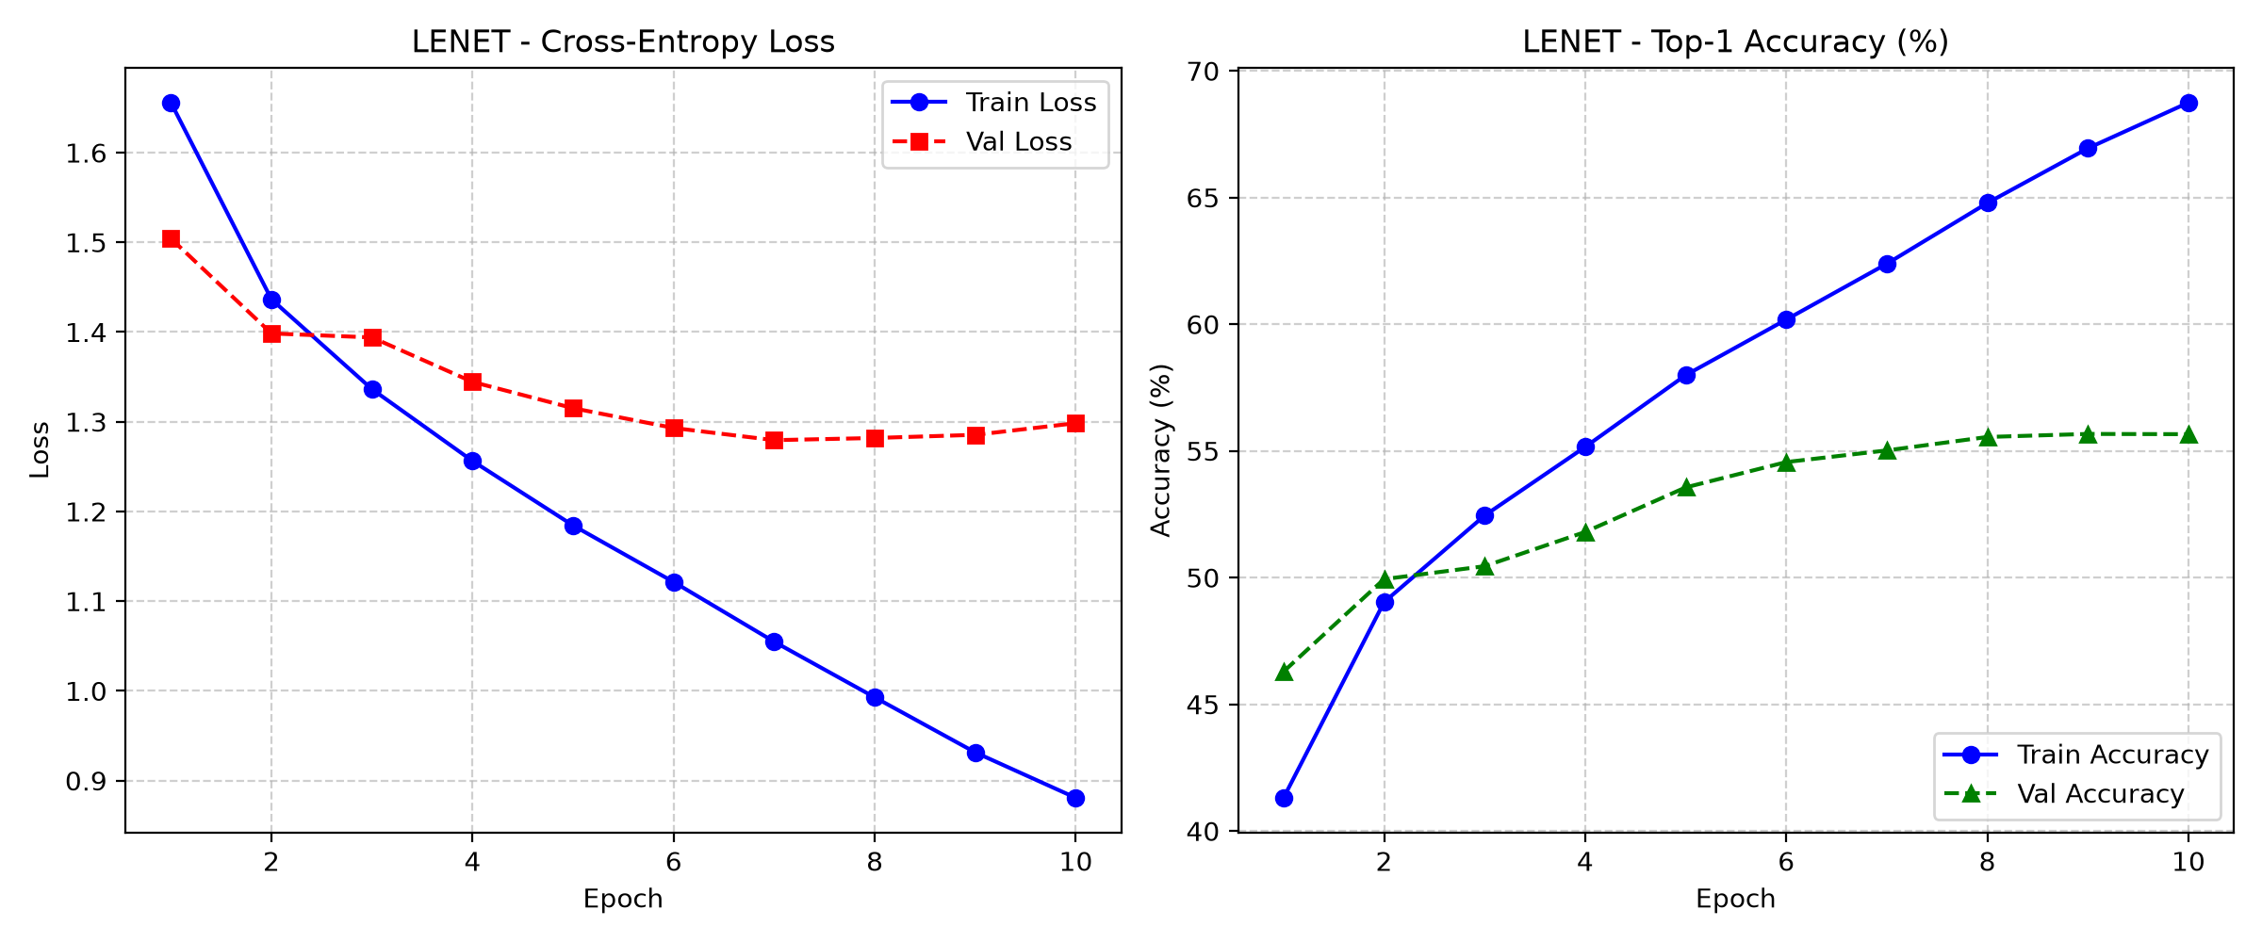
Figure 2: Base LeNet-5, CIFAR-10.
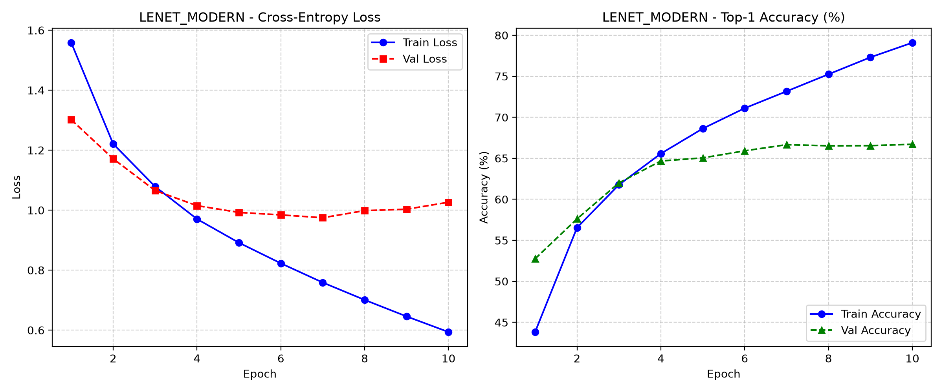
Figure 3: Modernized LeNet, CIFAR-10.
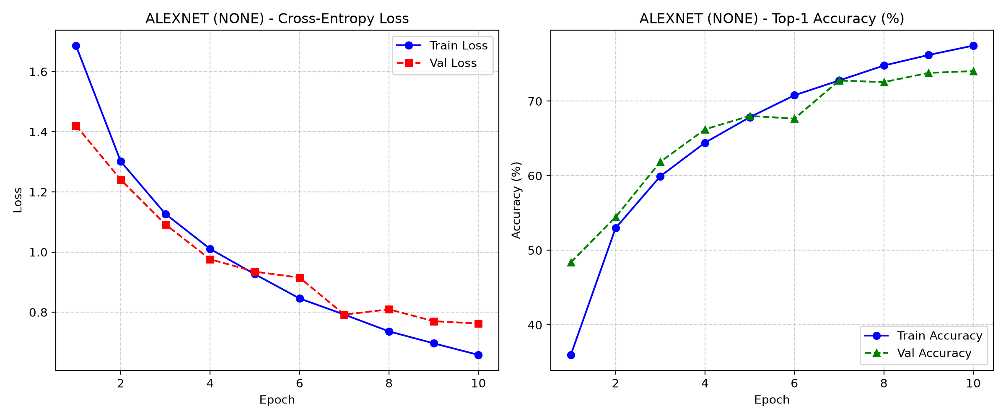
Figure 4: AlexNet (No Norm), CIFAR-10.
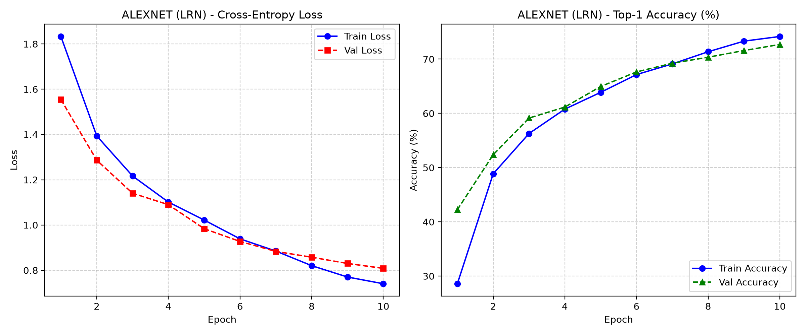
Figure 5: AlexNet + LRN, CIFAR-10.
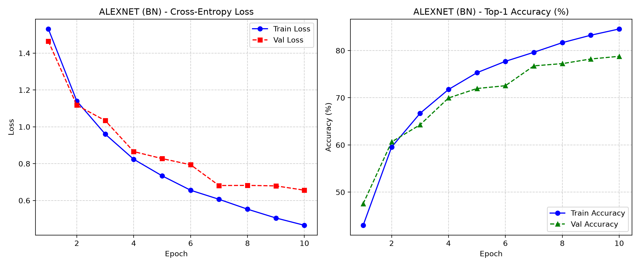
Figure 6: AlexNet + BatchNorm, CIFAR-10.
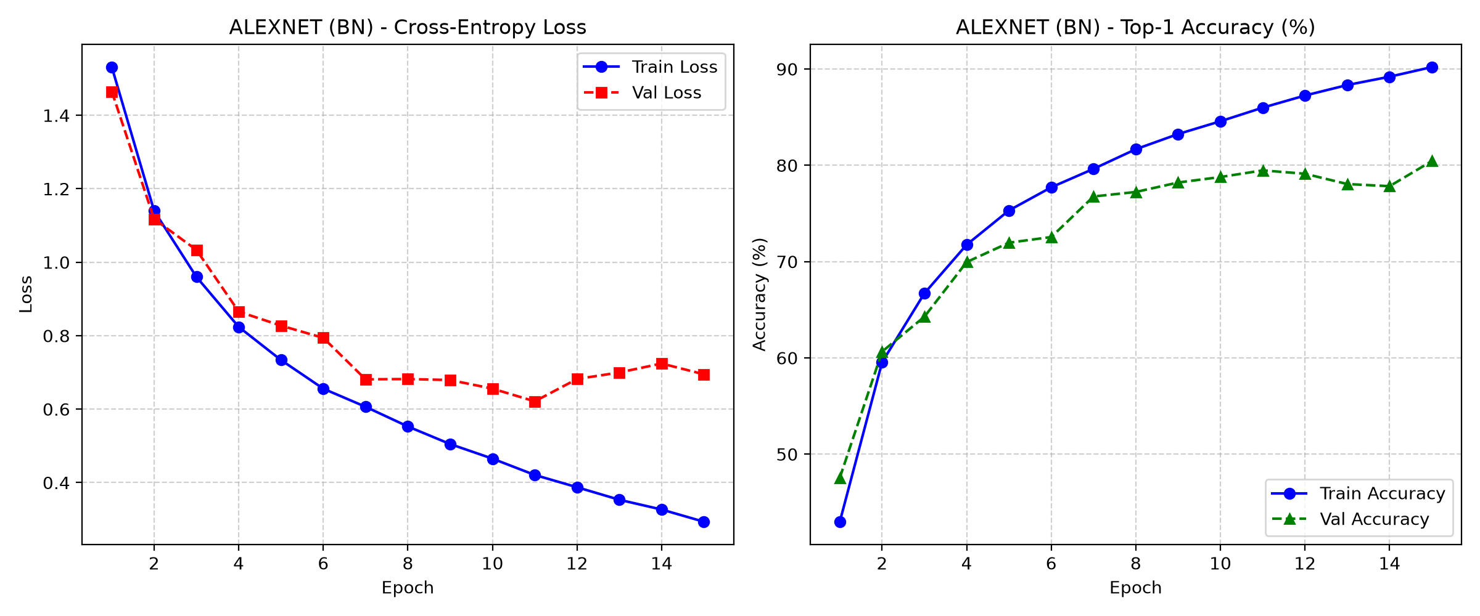
Figure 7: AlexNet + BN without augmentation, CIFAR-10, 15 epochs.
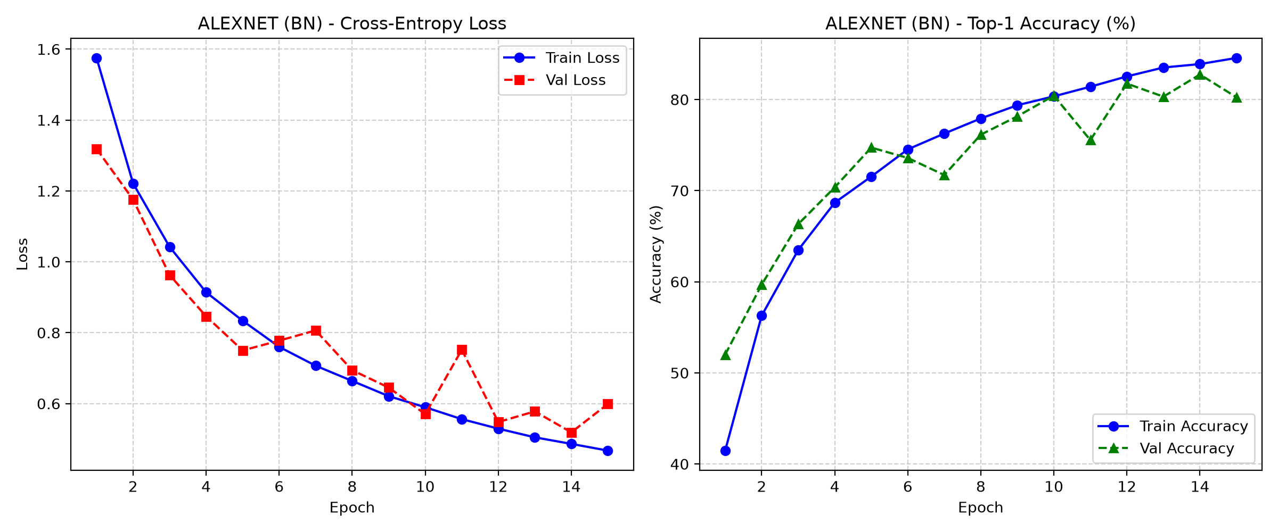
Figure 8: AlexNet + BN with augmentation, CIFAR-10, 15 epochs.
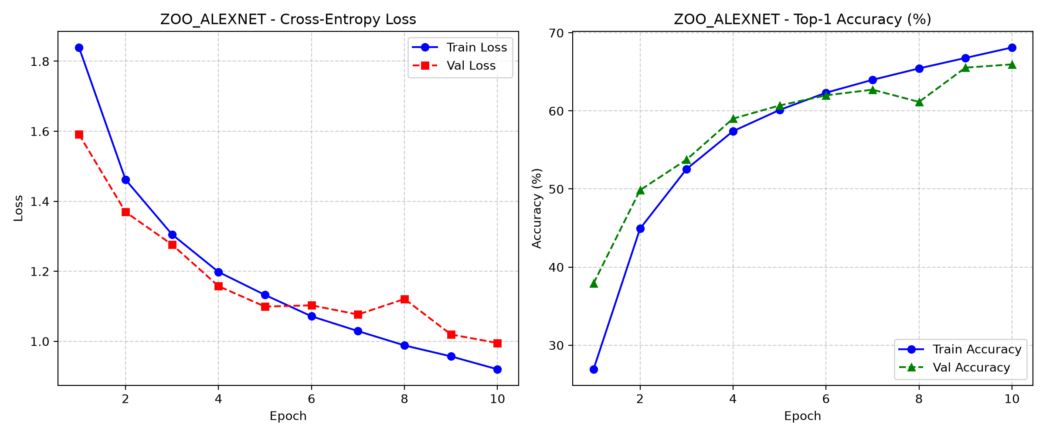
Figure 9: PyTorch Zoo AlexNet, CIFAR-10.
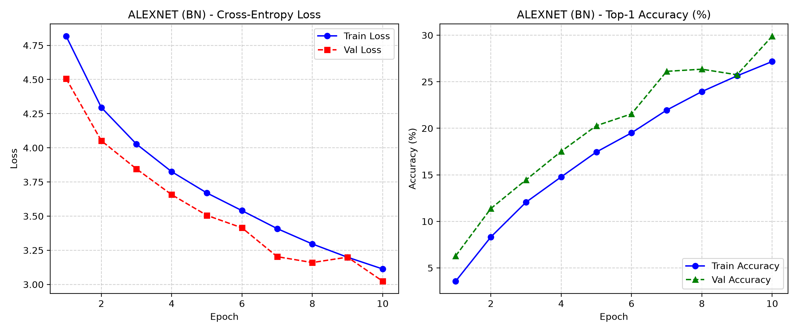
Figure 10: AlexNet + BN + Aug, Tiny ImageNet.
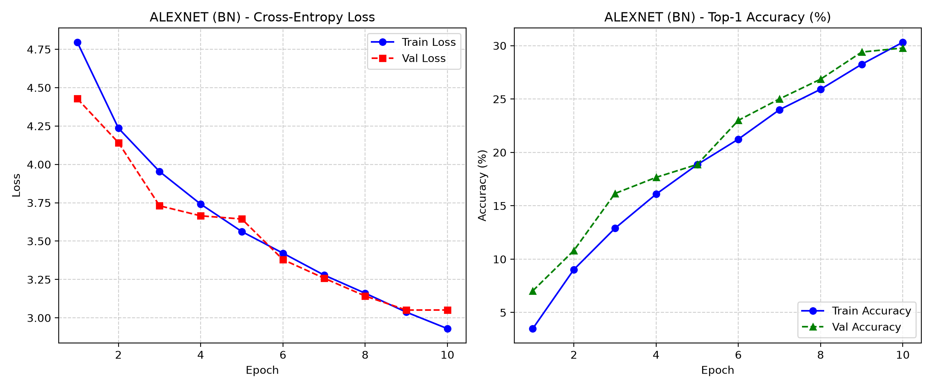
Figure 11: AlexNet + BN, Tiny ImageNet.
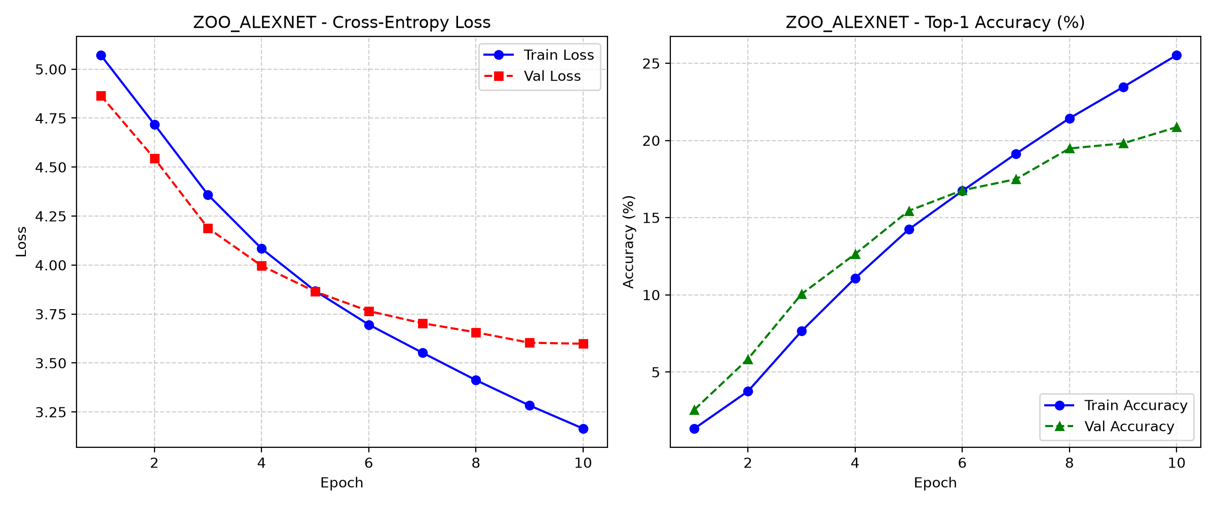
Figure 12: PyTorch Zoo AlexNet, Tiny ImageNet, lr = 1e-4.
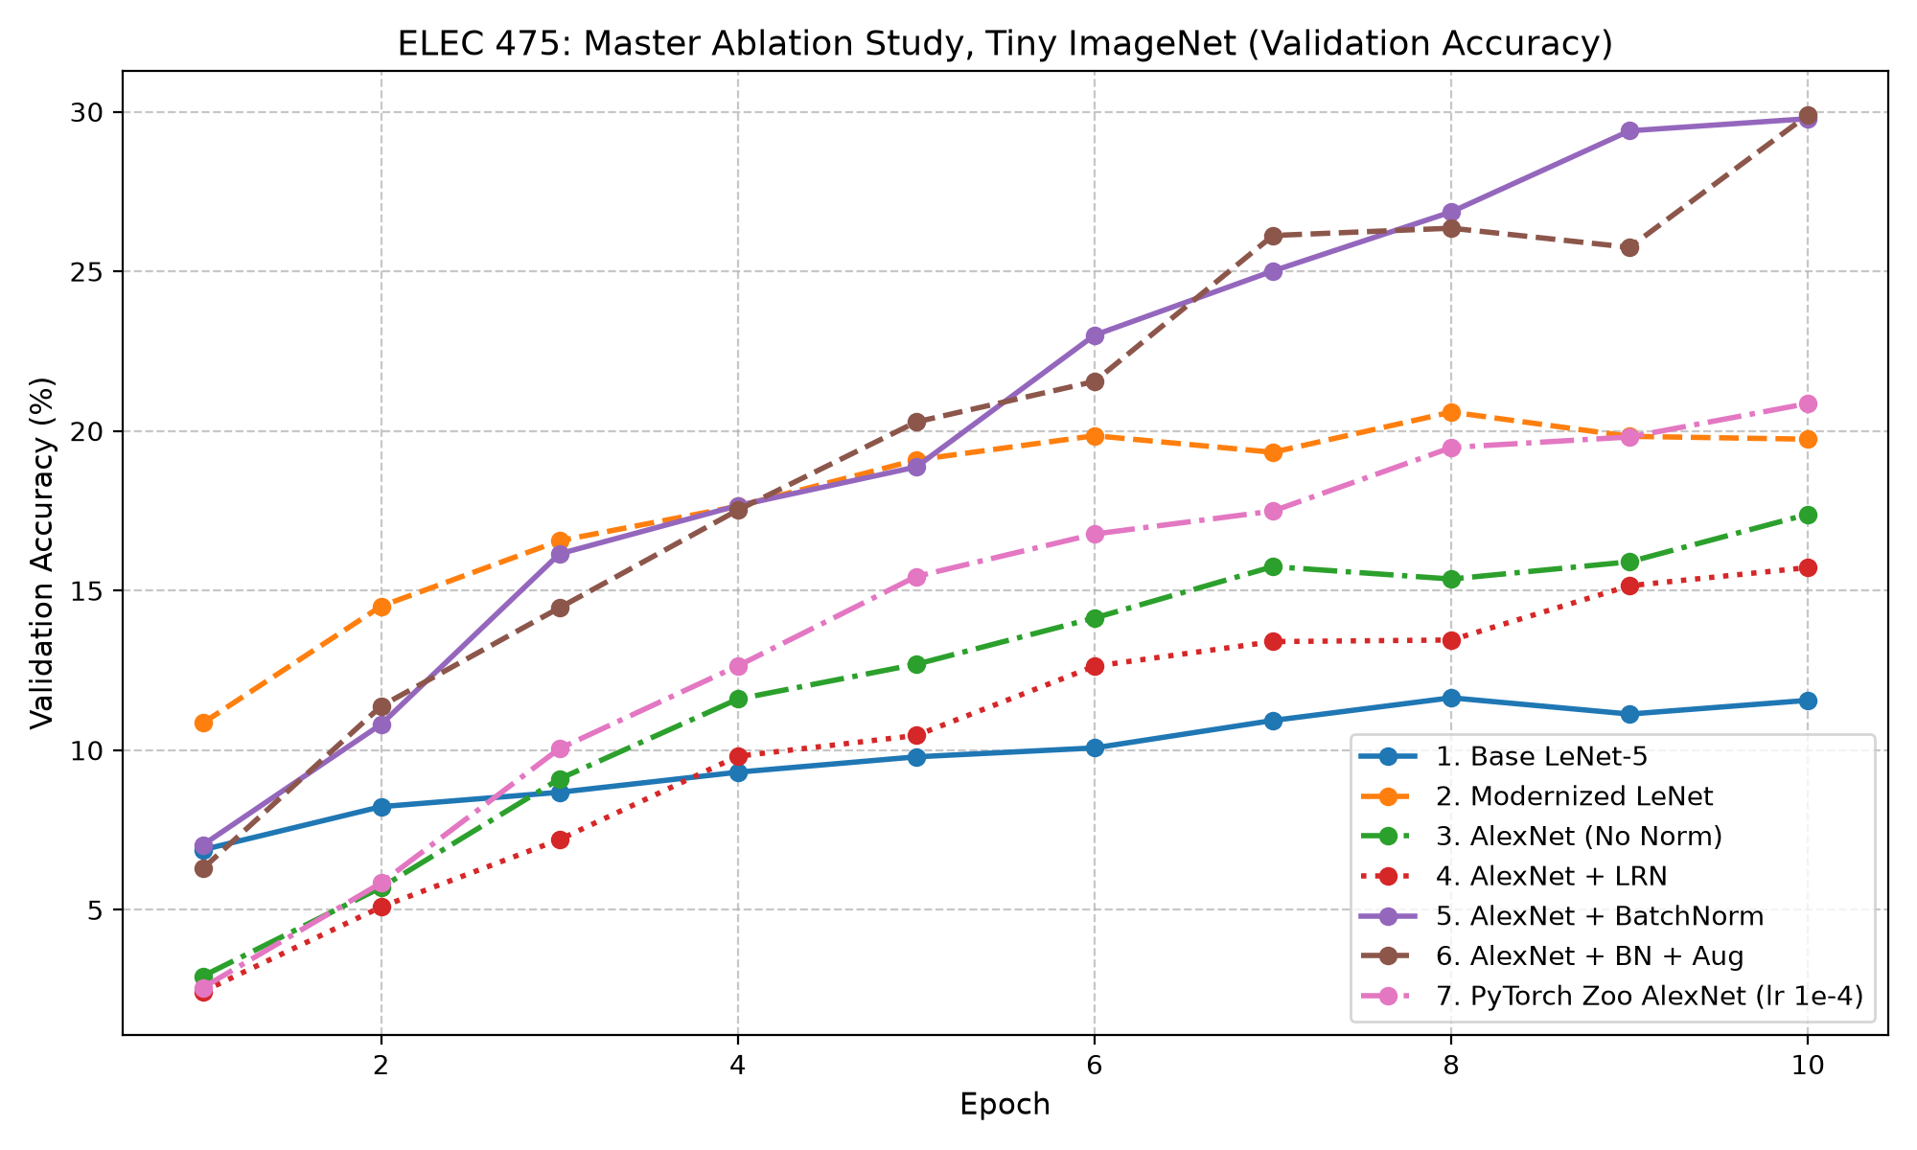
Figure 13: Validation accuracy per epoch for all Tiny ImageNet models.

Model Complexity Benchmark
Output of python compare_models.py --dataset cifar10:
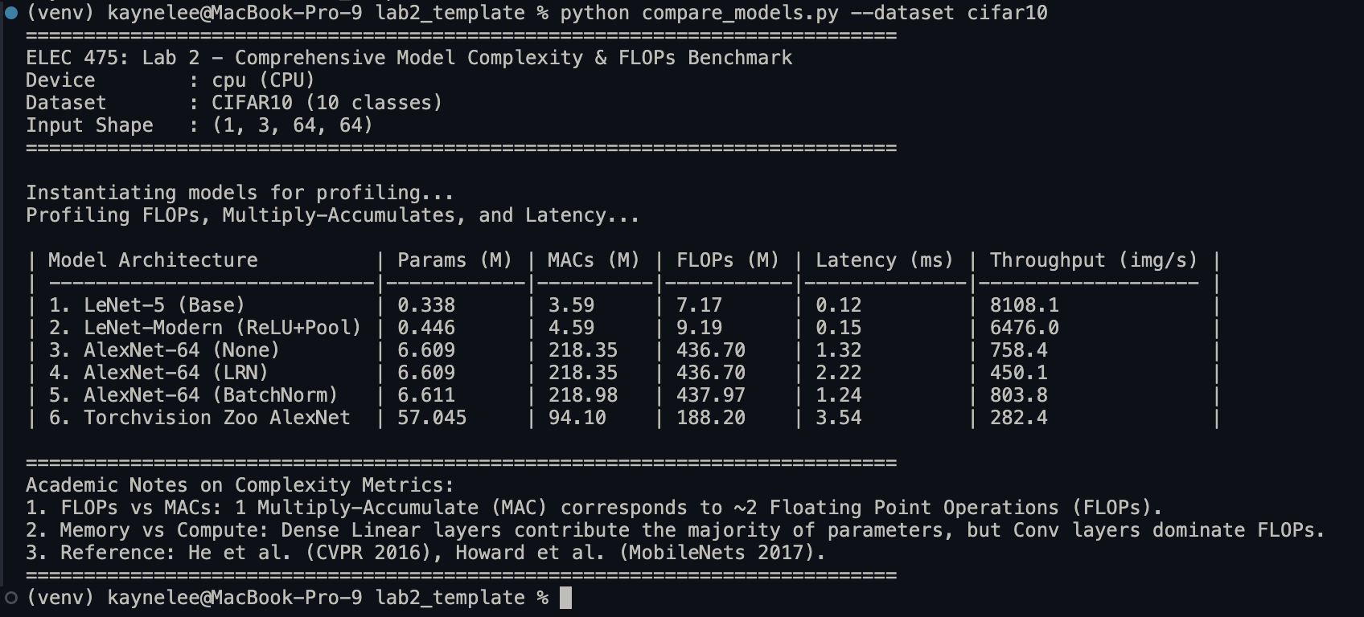
Figure 14: Output of compare_models.py on CIFAR-10 (CPU)

Transform Diagnostic
Output of python demo_transforms.py:
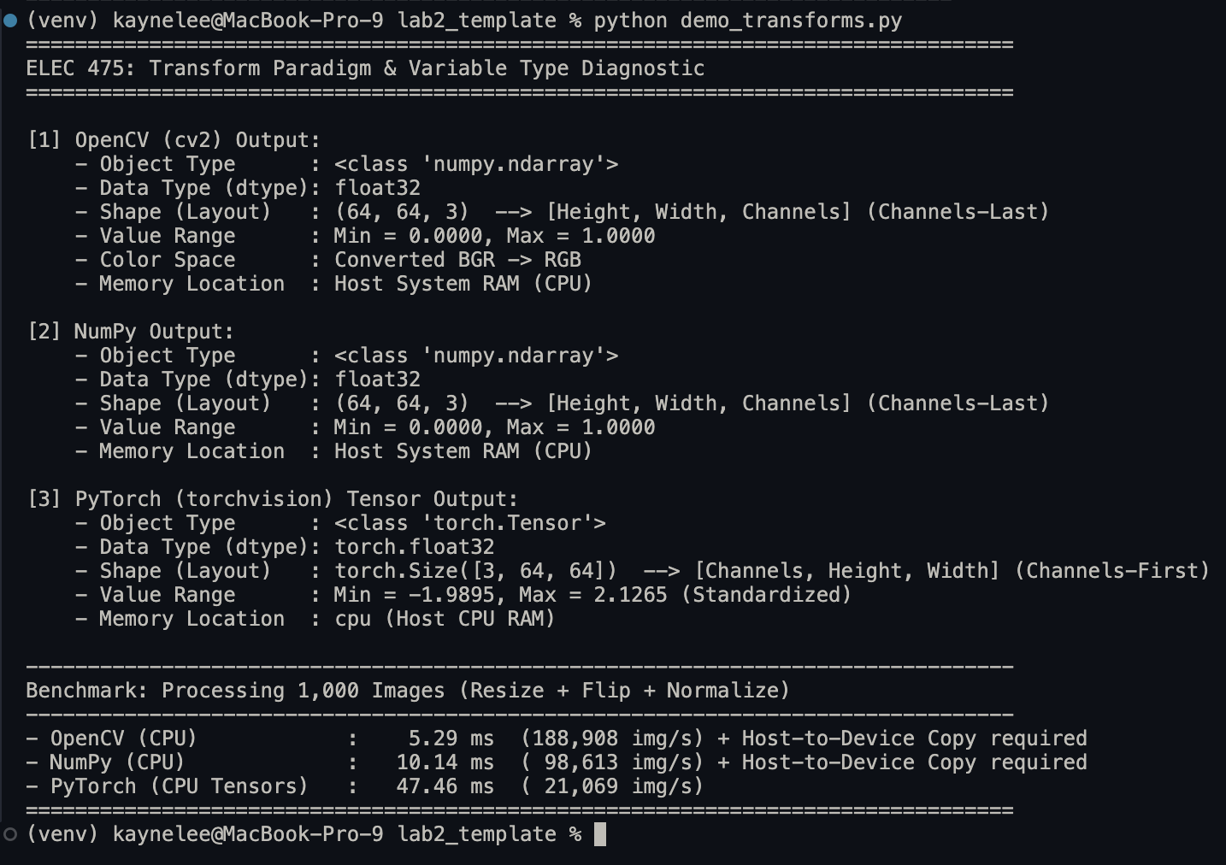
Figure 15: Output of demo_transforms.py.

Exploratory Data Analysis
Table 11: Dataset summary and per-channel normalization statistics.
Dataset | Classes | Train images | Val images | Train per class | Imbalance ratio | Mean (R, G, B) | Std (R, G, B)
CIFAR-10 | 10 | 50,000 | 10,000 | 5,000 | 1.00 | 0.491, 0.482, 0.447 | 0.247, 0.244, 0.262
Tiny ImageNet | 200 | 100,000 | 10,000 | 500 | 1.00 | 0.480, 0.448, 0.398 | 0.276, 0.269, 0.282

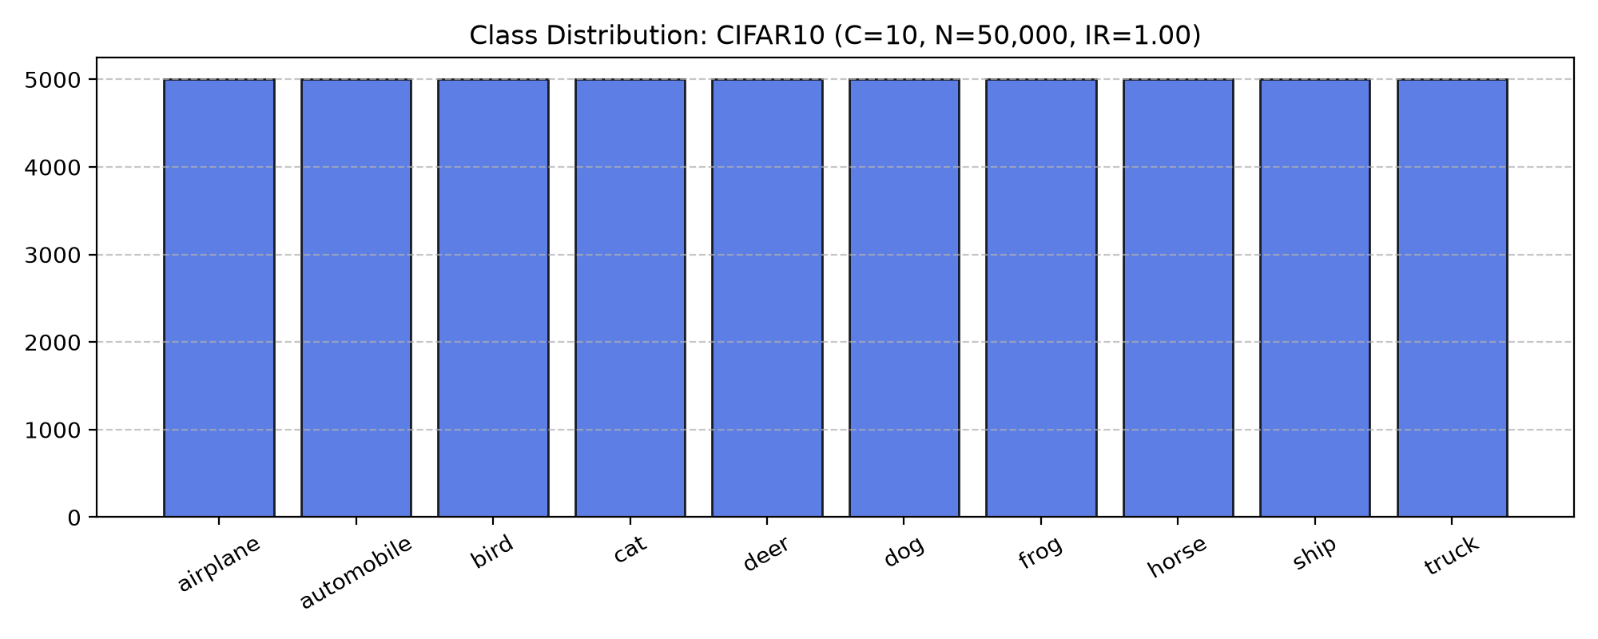
Figure 16: CIFAR-10 class distribution.
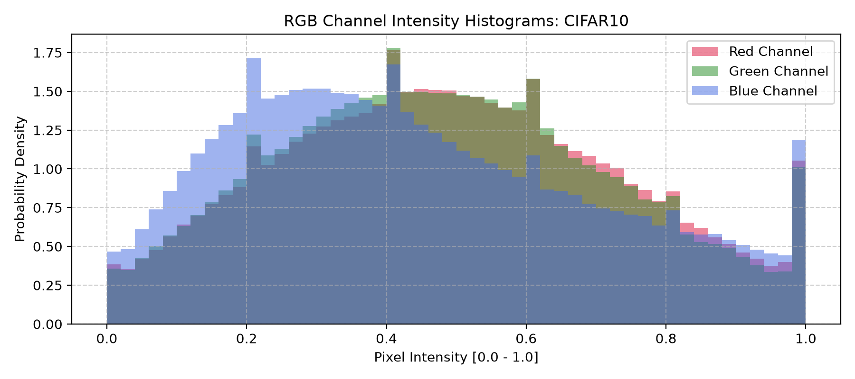
Figure 17: CIFAR-10 RGB channel distributions.
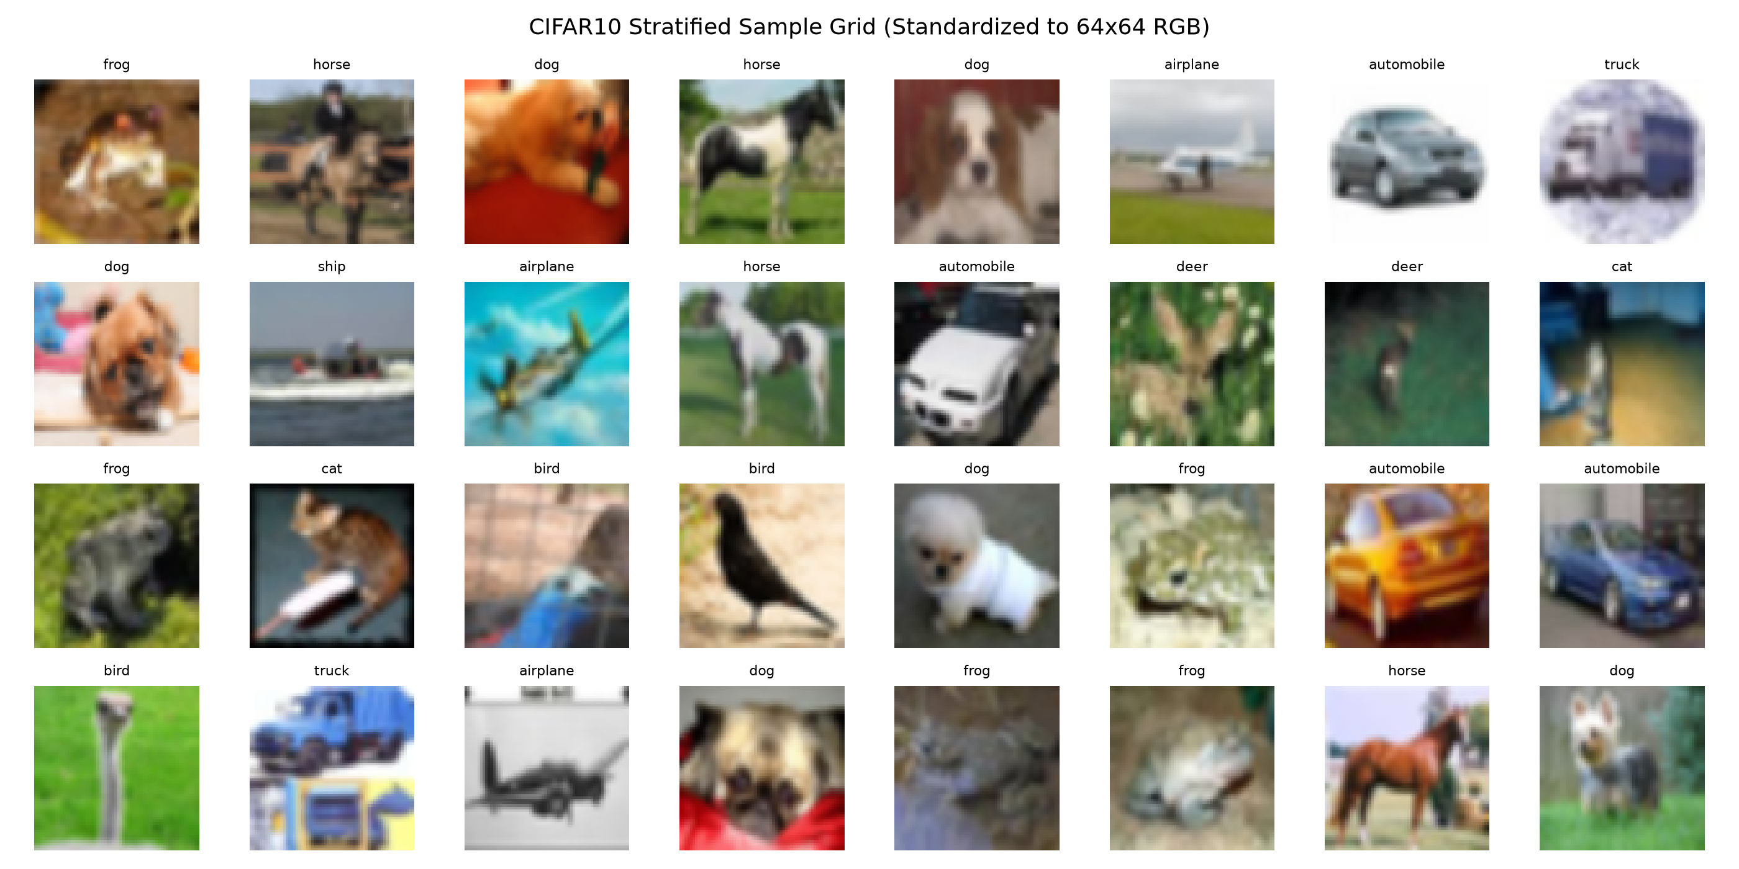
Figure 18: CIFAR-10 sample images.
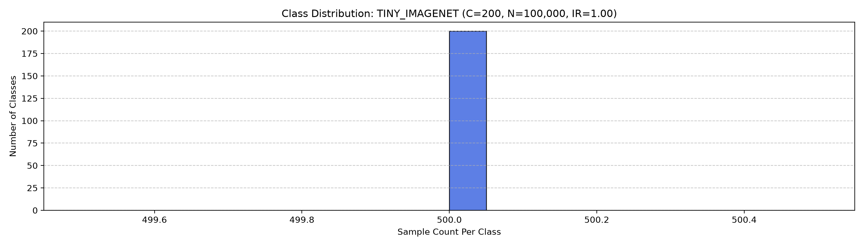
Figure 19: Tiny ImageNet class distribution.
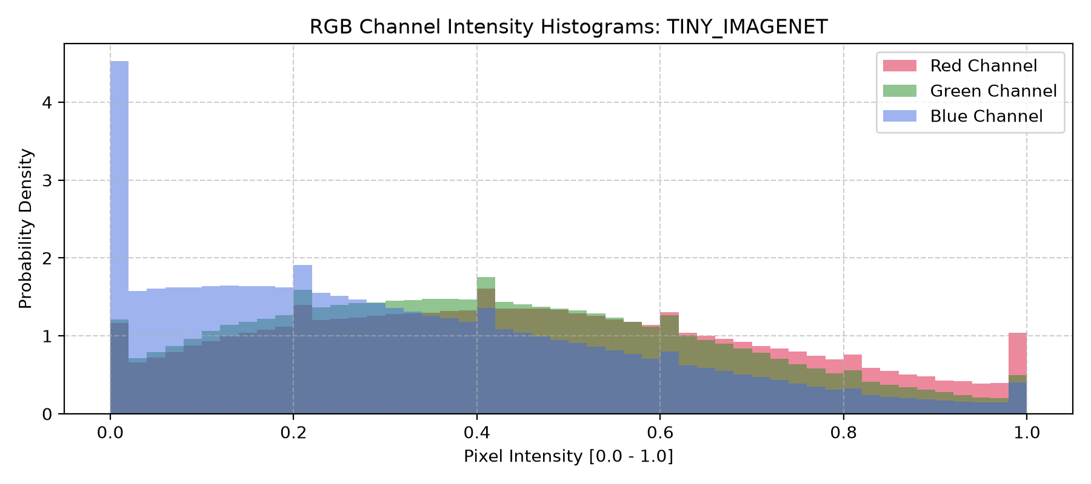
Figure 20: Tiny ImageNet RGB channel distributions.
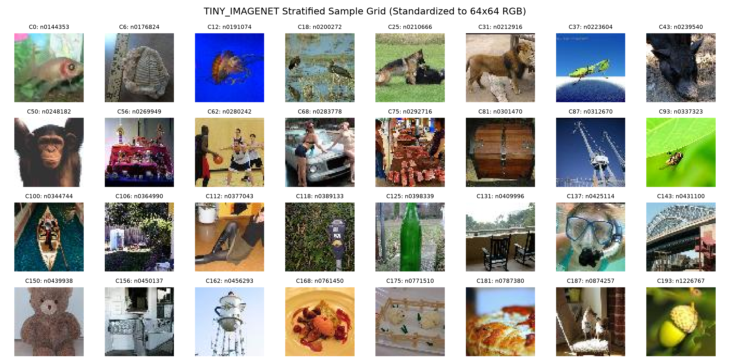
Figure 21: Tiny ImageNet sample images.

Technical Analysis & Discussion

Normalization Study
Performance improvement: Yes. BN reached 78.78% accuracy and 78.86% macro F1, against 74.03% / 74.16% with no normalization and 72.70% / 72.76% with LRN. BN rescales each channel's pre-activations to zero mean and unit variance over the mini-batch, which reduces internal covariate shift between layers and smooths the loss landscape, so Adam can make larger effective steps without diverging.
Computational overhead: Yes for LRN, negligible for BN. BN adds 0.3% FLOPs and 0.8 s per epoch; LRN adds no counted FLOPs but increases epoch time by 26% (226.3 s vs. 179.5 s) and latency by 68% (2.22 ms vs. 1.32 ms), because its cross-channel window is memory-bound. LRN costs time and lowers accuracy, while BN improves accuracy by 4.75 pp at almost no cost.
Convergence stability: All three training losses decrease almost monotonically (Figures 4 to 6). BN converges fastest and to the lowest validation loss (0.66, vs. 0.76 for no normalization and 0.81 for LRN); LRN is slowest. The BN result is stable across seeds (79.51 ± 0.88%, Table 10).

Data Augmentation
Generalization gap reduction: Yes. Δ fell from 9.76 pp (90.20% train, 80.44% val) to 4.32 pp (84.56% train, 80.24% val) at epoch 15 (Table 9).
Validation metric improvement: Yes. Best accuracy rose from 80.44% to 82.74% and macro F1 from 80.82% to 82.12%. Random crops, flips and colour jitter keep the label but change position, orientation and lighting, so the filters must learn features of the object rather than memorize training images. Without augmentation, validation loss rises after epoch 11 (Figure 7); with augmentation it reaches its minimum (0.52) at epoch 14 (Figure 8).

Tiny ImageNet Benchmark
Above random chance: Yes. 29.90% accuracy, about 60 times the 0.5% chance level.
Cross-dataset comparison: 29.90% / 28.38% F1 on Tiny ImageNet vs. 82.74% / 82.12% on CIFAR-10. Tiny ImageNet has 200 classes instead of 10, only 500 training images per class instead of 5,000, and many visually similar fine-grained classes.
Overfitting trajectory: No. Tiny ImageNet validation loss is still decreasing at epoch 10 (4.51 to 3.02, Figure 10), and training accuracy (27.18%) is below validation accuracy (29.90%) because dropout and augmentation are active only during training. The model is underfitting, whereas CIFAR-10 without augmentation started to overfit.

Model Variations
LeNet-5 to Modernized LeNet: +11.04 pp on CIFAR-10. ReLU avoids Tanh saturation and overlapping max pooling keeps the strongest responses and larger feature maps.
LeNet to AlexNet-64: Five stages and a 97 px receptive field covering the whole input, compared with 16 to 19 px for LeNet, allow features that describe entire objects.
Zoo AlexNet vs. AlexNet-64: 65.96% vs. 74.03% to 78.78% on CIFAR-10 despite 8.6 times more parameters. Its 11×11 stride-4 first layer and pooling reduce a 64×64 input to 1×1 before the classifier, so AdaptiveAvgPool2d only repeats 256 values. Without normalization it also failed to train on Tiny ImageNet at lr = 1e-3 (0.57%, Table 8).

Conclusion
BatchNorm had the largest effect: +4.75 pp on CIFAR-10 and +12.39 pp on Tiny ImageNet over no normalization, at almost no extra cost, while LRN was slower and less accurate. ReLU and overlapping max pooling added 11.04 pp to LeNet. Data augmentation cut the generalization gap from 9.76 to 4.32 pp and gave the best CIFAR-10 result (82.74%). The Zoo AlexNet, despite 8.6 times more parameters, underperformed because its design for 224×224 inputs collapses a 64×64 image to 1×1. Tiny ImageNet models were still underfitting after 10 epochs, so longer training would likely improve them.

