**Installation Procedure**

Cloning of the repository => https://github.com/kaynetpc/voting.git

You can either clone via this link above or simple navigate to the links and download file as zip file 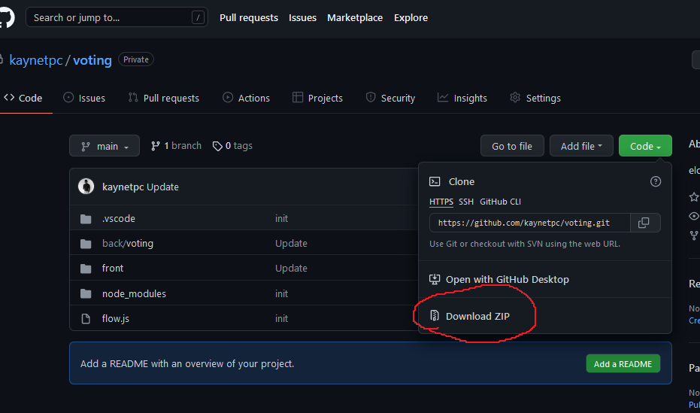

After a successful download unzip file and open the root folder via any IDE (VS_code recommended) <https://bit.ly/3qy5556> .

**RUNING BACK_END**

Make sure you have Java runtime on your machine of at least version 14. Or higher (<https://www.java.com/en/download/help/windows_manual_download.html>)

XAMP or WAMP server need to be installed on your machine (https://www.apachefriends.org/download.html)

Then start MSQL and APACHE (check image below start A and B the click on C while running)

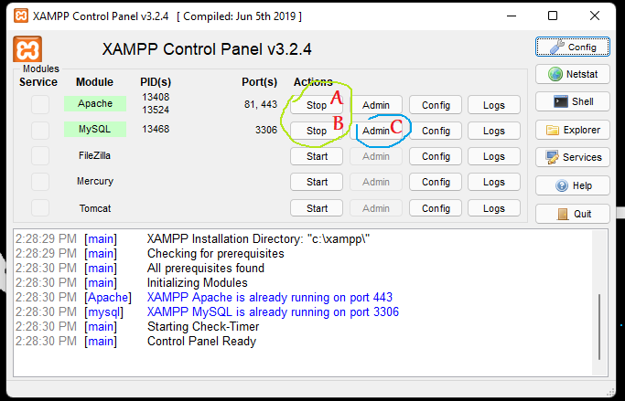

This will open your browser follow the procedure below to create database name “voting”

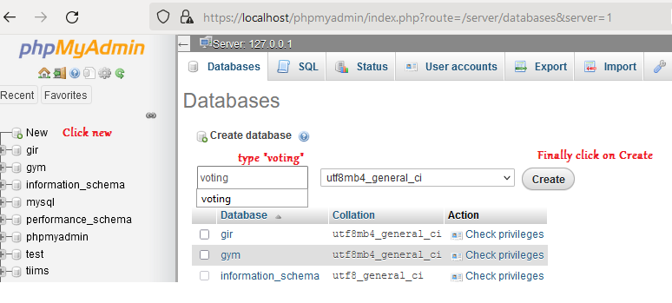

Navigate to *voting\back\voting\src\main\java\com\kaynetpc\voting*

Then right click on **VotingApplication.java** file, select run java

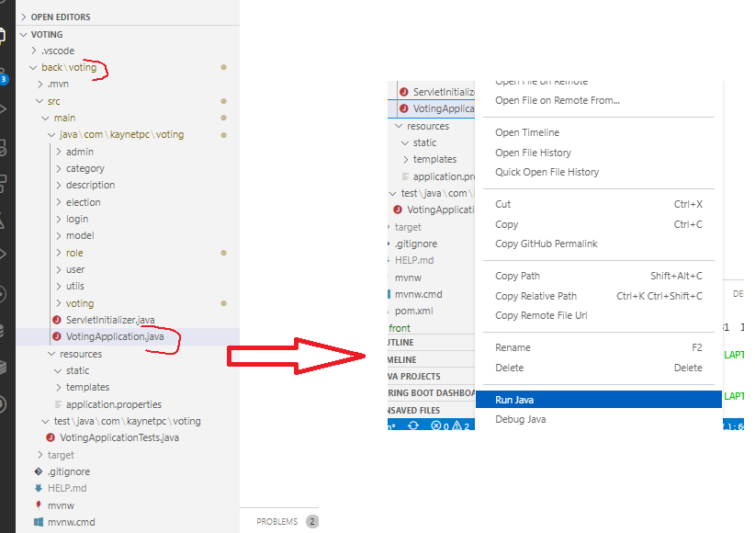

Running UI

Make sure you have internet on your machine for dependency installation

Installation

Navigate to voting\front

Doable click on “Install Dependencies”,

After a success.

Double click on “start”.

Admin username is “Admin”.

Password is “Pass”.

Create new user via the register button

Create Election Levels like e.g. Federal level, state and like using the admin panel

Next Create Election Posts so Contestants can pick post attached to the level created earlier

Next Create Election User the “Create election” button; (e.g. “2022/2023 SUG Presidential election”) under selected level and post specifies earlier.

Next Initialize user roles by clicking on “Role List” then toggle “initialize Default Roles” button at the bottom left of the screen.

Next Assign role to user using “Role Assign” button select user type and roles you want them to have access to.

**HOW to Vote**

Navigate to view all contestants and on the action column select vote candidate then click on vote now to vote

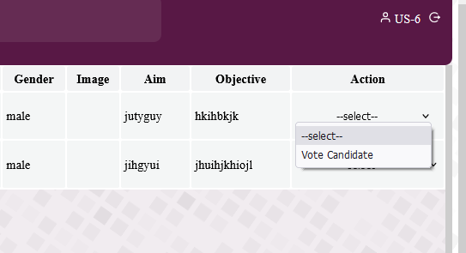

Lastly You can view all user, all contestant all vote, vote count, elections, profile, vote bar chart preview, vote pie chat preview grouped by respective posts running elections for.

On the voting list click on the eyes icon located at the top right corner of the list to view starts.