SMARTCUT: A WEB-BASED SERVICE-ORIENTED BARBERSHOP OPERATIONS AND CUSTOMER ENGAGEMENT MANAGEMENT SYSTEM

A Capstone Project
Presented to the
Faculty of College of Computer Studies
Laguna State Polytechnic University
Siniloan (Host) Campus

BACHELOR OF SCIENCE IN INFORMATION TECHNOLOGY

Authors
BAUTISTA, ANGELO A.
MANCILLA, EROLD JHON D.
NOVENO, LENNARD DION M.

Co-Author
FOR-IAN V. SANDOVAL

2026
TABLE OF CONTENTS

 | Page No.
Cover Page | 01
Table of Contents | 02
Chapter 1 – Introduction | 03
Research Objectives | 06
Conceptual Framework | 08
Scope and Limitations of the Study | 10
Chapter 2 – Review of Related Literatures and Systems | 12
Related Literatures | 12
Related Systems | 16
Synthesis | 18
Chapter 3 – Methodology | 20
Research Design | 20
Population of the Study | 20
Sampling Design | 21
Data Collection | 21
Project Design | 21
References | 27

CHAPTER I
INTRODUCTION
The continuous development of digital technology has significantly changed how service-based businesses operate, especially small enterprises. Today, many businesses use web-based platforms, automation, and digital tools to simplify their operations and build stronger connections with their customers (Kuramshina et al., 2025). Features such as online booking, real-time notifications, and intuitive digital interfaces allow services to provided faster and with greater convenience for customers (Chaudhuri et al., 2024). In the personal grooming sector, these advancements have reshaped how barbershops manage their daily operations and interact with clients, helping them offer a more streamlined service experience (Flavián et al., 2024). However, despite these advancements, many traditional barbershops still depend on manual processes, showing a clear gap between the availability of modern technology and its actual use in the industry (Saperiyanto, 2024).
Service-based businesses such as salons and barbershops commonly face challenges like long waiting times, and poor communication with customers. Studies show that relying on manual booking often leads to scheduling conflicts and lower customer satisfaction (Choudhary et al., 2025; Saini et al., 2025). In addition, the absence of integrated systems for managing appointments and customer information makes it difficult for businesses to improve their operations and service quality (Hui & Teo, 2024). Studies also show that implementing automated appointment systems can greatly minimize errors (Jebamani et al., 2021). Even with these benefits, many businesses still struggle to use these technologies.
In developing countries like the Philippines, barbershops experience similar operational challenges. Many establishments still rely on walk-in and manual queue management, which often leads to overcrowding and uncertain waiting times (Nunag et al., 2023). Customer satisfaction and loyalty are also important concerns in barbershop businesses, as service quality and customer experience (Alfiandi & Sumiyati, 2025). In addition, studies show that customer expectations are continuously increasing, as more clients look for convenience, faster service, and digital interactions (Angali et al., 2025; Krishnan & Yasin, 2024). However, despite this growing demand for digital solutions, many local barbershops have yet to adopt such technologies, resulting in a noticeable gap between what customers expect and the services actually provided.
Barbershops commonly face specific operational challenges such as lack of real-time service updates, and limited ways to interact with customers. In many cases, customers still need to physically visit the shop just to secure a slot, which can be inconvenient and time-consuming (AVUÇLU & TAPTAL, 2024). The absence of a system that shows barber availability makes it difficult for customers to choose their preferred barber, which can affect their satisfaction (Ibrahim, 2025). While some barbershops have started adopting digital systems, these are often focused mainly on basic reservation and customer management functions, (Almaarij et al., 2025). with limited integration of advanced features that could further enhance service and customer experience These issues highlight the need for a more modern and integrated solution that can improve both operations and customer experience.
Moreover, customer engagement and loyalty management continue to be major challenges in barbershop operations. Many establishments still rely on manual and inconsistent methods to track customer visit history, which often results in weak customer relationship management (Khairawati, 2020). Without proper digital tools, it becomes difficult for barbershops to manage customer information and improve service delivery (Cheong & Saringat, 2023). Studies also show that the lack of data-driven tools prevents businesses from analyzing important information such as peak hours, service trends, and customer behavior (Fuente et al., 2023). As a result, this limited use of data affects the competitiveness and growth of barbershops in today’s increasingly digital marketplace (Setyawati & Hariri, 2021).
To address these challenges, this study proposes SmartCut: a web-based service-oriented barbershop operations and customer engagement management system. The system allows users to book services based on specific barbers and monitor queue status in real time. It also includes a recommendation system that suggests suitable barbershops and barbers based on factors such as location, price, availability, ratings, and barber specialization. In addition, the platform supports customer feedback, service history tracking, and a digital loyalty tracking system that automatically records customer visits and rewards repeat clients. Furthermore, barbershops can update and manage their services and pricing through the system, ensuring service information. The platform also provides dashboards for monitoring peak hours and service analytics, supports walk-in and home service requests, and integrates notification, cancellation, and secure online payment features to allow customers to conveniently pay for services through digital methods. Through these functionalities, SmartCut aims to enhance customer experience, and provide data-driven insights for barbershop management.

RESEARCH OBJECTIVES

General Objective
This study aimed to develop a “SmartCut: a web-based service-oriented barbershop operations and customer engagement management system”

Specific Objectives

- To design and develop a web-based appointment scheduling and booking module that enables customers to conveniently reserve barbershop services, supports real-time barber availability, and appointment and queue management.
- To implement a customer management system that maintains customer profiles, service histories, and visit records to improve personalized customer engagement and service delivery.
- To develop a recommendation system that suggests suitable barbershops and barbers based on location, price, availability, ratings, and barber specialization to support informed decision-making.
- To design and integrate a digital loyalty tracking system, analytics dashboard, real-time notifications, cancellation features, service management, and a secure online payment system to strengthen customer retention.
- To conduct system testing procedures to verify the functionality, reliability, usability, and performance of the SmartCut system.
- To evaluate the developed system in terms of usability, user satisfaction, ease of use, and ease of learning using appropriate evaluation instruments with selected respondents.
CONCEPTUAL FRAMEWORK

Figure 1 illustrates the conceptual framework of the SmartCut a structured and integrated approach to modernize barbershop operations through digital technology. The system involves key actors Customers/Clients, Barbers, Barbershop Staff, Barbershop Owner/Manager, and the System Administrator who interact based on their roles. Customers initiate the process through booking appointments, making payments, and providing feedback via the Customer Service module, which supports online booking, real-time queue management, notifications, cancellations, and profile tracking. Barbers manage their availability, confirm appointments, and upload services through the Barbershop Management module, while staff handle walk-in customers, home service requests, and queue monitoring to ensure smooth operations. The Owner/Manager oversees business functions such as managing barbers and updating services and pricing, supported by the Admin Control Panel where the System Administrator enforces role-based access, manages users, and generates reports. All data is stored in a centralized database to ensure accessibility. The system also integrates a Recommendations and Analytics module that provides personalized suggestions based on factors like location, price, availability, ratings, peak hours, and customer history, along with a Customer Retention and Loyalty component that enhances engagement and long-term retention. These processes result in scheduling and queue management, improved customer satisfaction, real-time operational monitoring, data-driven decision-making, personalized recommendations, increased customer loyalty, and enhanced service quality and business performance.

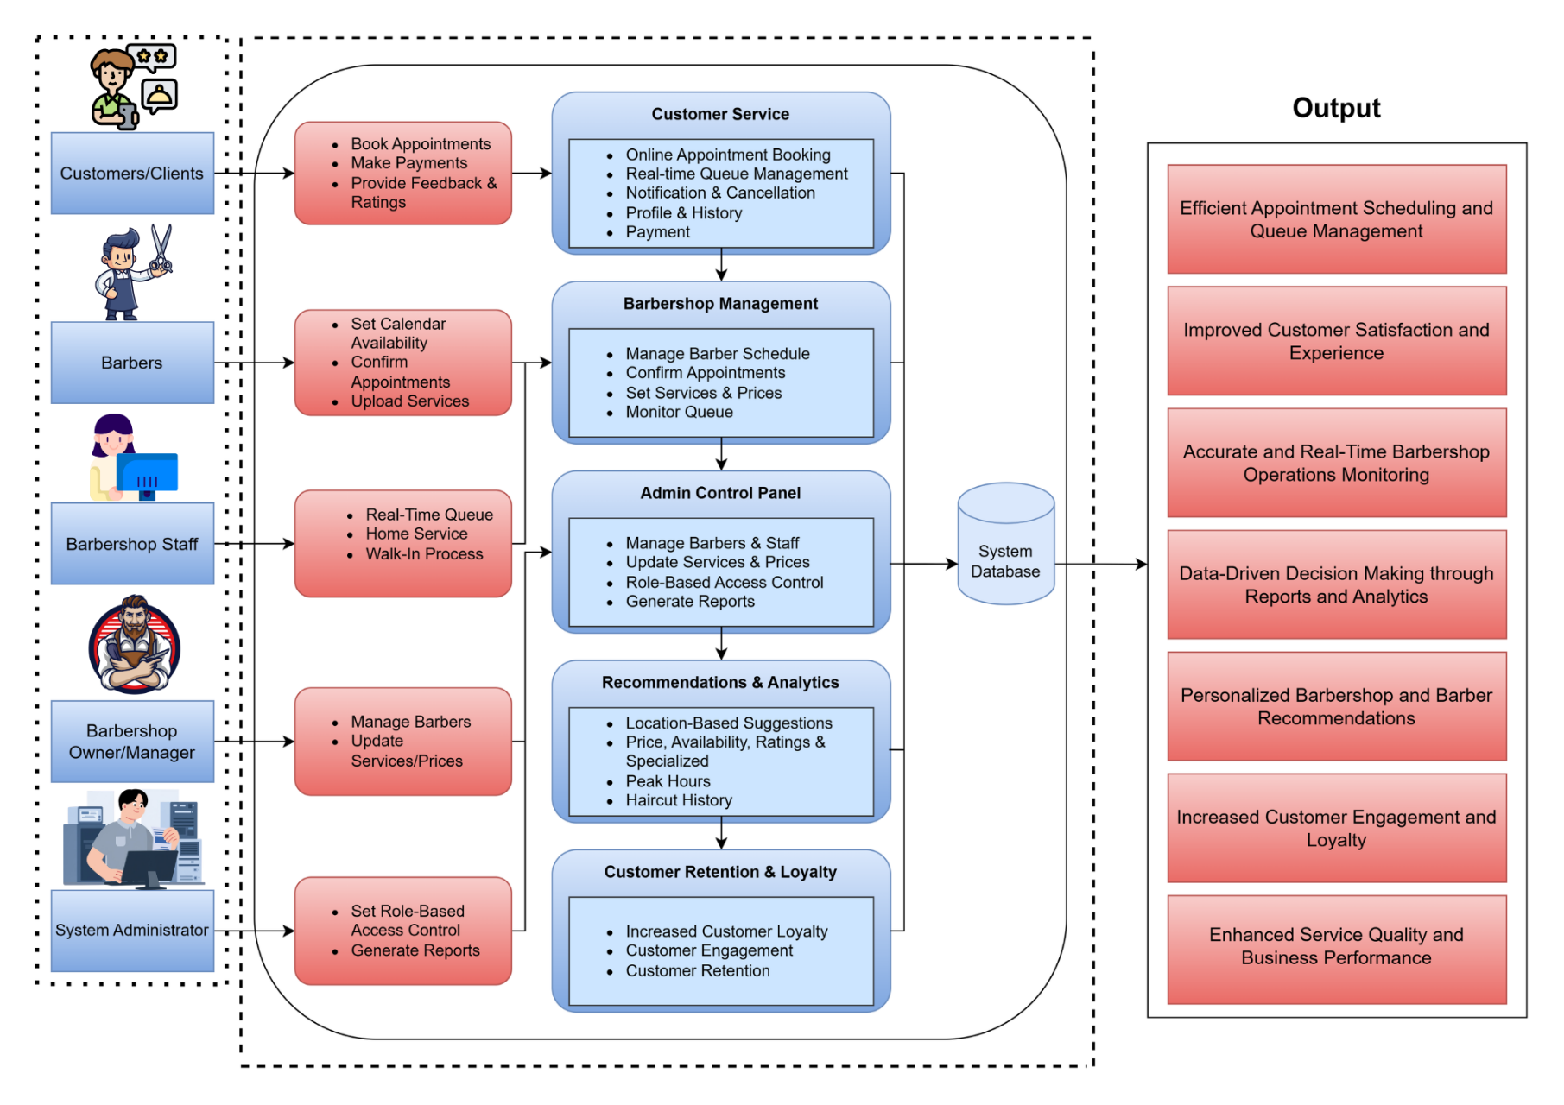

Figure 1. SmartCut Conceptual Framework

SCOPE AND LIMITATIONS
This study focuses on the development of SmartCut, a web-based platform that streamlines barbershop operations while enhancing customer engagement and service experience. The system enables customers to book appointments, check real-time barber availability, and monitor queue status to reduce waiting time and improve service. It also includes, a digital loyalty system to strengthen customer retention. In addition, the platform offers a recommendation feature that suggests suitable barbers and services based on factors such as location, price, availability, ratings, and specialization. It also integrated a service and price management, barber scheduling, walk-in and home service handling, notification and cancellation features, secure online payment integration, and analytics dashboards for tracking peak hours and service trends.
Despite its benefits, the system has several limitations. SmartCut is limited to a web-based platform and does not include a dedicated mobile application, which may affect accessibility for some users. The recommendation feature relies on predefined criteria and available data, which may limit the accuracy and personalization of suggestions. The system also depends on stable internet connectivity, making it less effective in areas with poor network access. Additionally, while it supports secure online payments, it relies on third-party payment gateways that may be subject to external limitations. Advanced technologies such as artificial intelligence-based predictive analytics, facial recognition, and automated service optimization are not included in the current scope. Furthermore, the platform is specifically designed for barbershop operations and may require further modification to be adapted for other service-based businesses.
CHAPTER II
REVIEW OF RELATED LITERATURE AND SYSTEMS

This chapter summarizes the relevant literature and studies to prepare the researchers with the knowledge and tools needed for the present study. Indeed, the researchers highlight significant evidence indicating the relevance and applicability of digital technologies, appointment management systems, customer engagement platforms, and data-driven solutions in improving barbershop operations and service delivery.

Review of Related Literature

Digital Transformation in Service-Based Businesses

Appointment Scheduling and Queue Management Systems

Barbershop Operations in the Philippine Context

Customer Interaction and Real-Time Service Systems

Customer Engagement, Loyalty, and Data-Driven Systems

Synthesis

Review of Related System

Booksy for Barbers
Booksy is a widely used appointment scheduling and management platform designed for service-based businesses such as barbershops, salons, and beauty clinics. The system allows customers to book grooming services online by selecting their preferred barber, service type, and appointment schedule. It also provides business owners with tools for managing customer profiles, tracking daily appointments, and generating business analytics reports.
According to Booksy (2023), digital booking platforms help service-based businesses streamline appointment scheduling, reduce customer waiting times, and improve operational. The system also integrates features such as automated reminders, customer reviews, and marketing tools that enable barbershops to increase customer engagement. However, while Booksy provides strong appointment management capabilities, the system primarily focuses on booking functions and does not include advanced features such as queue monitoring or intelligent service recommendations that could further enhance barbershop operations.

Squire
Squire is a barbershop management platform specifically developed to support barbershop businesses in managing their daily operations. The system provides appointment booking, point-of-sale integration, staff management, customer tracking, and business analytics tools. It allows barbershop owners to manage employee schedules, monitor revenue, and analyze customer behavior through data-driven dashboards.
Research by Squire Technologies (2023) indicates that digital management systems can significantly improve service by reducing administrative workload and enabling barbershop owners to make informed business decisions. Squire also integrates payment processing and marketing features, which allow barbershops to promote services and manage loyalty programs. Despite these advantages, the platform is often designed for large barbershop businesses and may require higher operational costs for small independent barbershops.

Barberly
Barberly is an online appointment scheduling system designed specifically for barbershops. The system provides tools for customers to book services such as haircuts, beard trims, and grooming packages through a digital scheduling interface. Barbers can manage appointments, view daily schedules, and receive notifications regarding upcoming bookings.
According to Barberly (2022), digital scheduling platforms improve the customer experience by allowing clients to conveniently book appointments without visiting the barbershop physically. The system also helps reduce scheduling conflicts and improves time management for barbers. However, Barberly mainly focuses on booking functionality and lacks advanced features such as customer analytics, loyalty management systems, and business performance monitoring.

Fresha
Fresha is a cloud-based management platform used by businesses in the beauty and grooming industries, including barbershops. The system provides appointment booking, staff management, inventory tracking, payment processing, and marketing tools. It also allows businesses to maintain customer records and analyze service performance through built-in reporting features.
According to Fresha (2024), digital management platforms help grooming businesses automate administrative tasks and improve customer retention through online booking and marketing automation. The platform also enables businesses to manage multiple employees and services in a centralized dashboard. However, since Fresha is designed for the broader beauty and wellness industry, it may not provide specialized features tailored specifically for barbershop operations.
Table 1. Related System Comparison Matrix

Features | Booksy | Squire | Barberly | Fresha | SMARTCUT
Online Appointment Booking | ✔ | ✔ | ✔ | ✔ | ✔
Customer Record Management | ✔ | ✔ | ✔ | ✔ | ✔
Service Management | ✔ | ✔ | ✔ | ✔ | ✔
Customer Service History Tracking | ✖ | ✔ | ✖ | ✔ | ✔
Automated Loyalty Tracking | ✖ | ✖ | ✖ | ✔ | ✔
Customer Engagement Tools | ✔ | ✔ | ✖ | ✔ | ✔
Operational Monitoring | ✖ | ✖ | ✖ | ✖ | ✔

Synthesis

The review of related literature and related systems highlights the increasing role of digital technologies in improving service management within barbershops and grooming businesses. Previous studies emphasize that information systems such as online appointment booking, customer relationship management, and digital business platforms enhance , reduce waiting times, and improve customer satisfaction. Existing systems such as Booksy, Squire, Barberly, and Fresha demonstrate how digital platforms can support appointment scheduling, customer management, and business analytics. However, many of these systems primarily focus on general booking functions and may lack specialized features tailored for barbershop operations, such as real-time queue monitoring, integrated loyalty management, and intelligent service recommendations. In addition, many small barbershops still rely on manual scheduling or social media messaging, which can lead to scheduling conflicts. Therefore, the proposed SmartCut system aims to address these gaps by developing a comprehensive barbershop management platform that integrates appointment scheduling, customer engagement tools, and operational monitoring features to improve service and enhance the customer experience.
CHAPTER III
METHODOLOGY
In this chapter, the proponents outline the proposal's system guidelines. Constructing a system or a model requires integrated research of different concepts and theories.

Research Design
This study utilized the descriptive-developmental research design. The descriptive method was used to gather information about the current processes and challenges experienced by barbershops in managing appointments, customer records, and loyalty programs. Meanwhile, the developmental approach focused on designing and developing the SmartCut web-based platform, which integrates barbershop management features and an automated loyalty tracking system. The system aims to improve service functionality, customer management, and customer retention by digitizing scheduling, service records, and reward tracking.

Population of the Study
The population of the study consisted of barbershop staff, barbers, and customers who regularly avail barbershop services. These participants were selected because they are the primary users and beneficiaries of the proposed SmartCut system. The staff and barbers provided insights regarding operational challenges, while customers provided feedback on service convenience and loyalty program features. Their responses helped determine the system requirements and evaluate the usability of the developed platform.

Sampling Design
The study used purposive sampling to select participants who are knowledgeable and experienced with barbershop services. The respondents included barbershop staff responsible for managing appointments and customer transactions, as well as customers who frequently visit the barbershop. This sampling method allowed the researchers to collect relevant and meaningful data from individuals who can provide correct insights into the existing management process.

Data Collection
Data were collected using surveys, interviews, and observation. Surveys were distributed to customers to gather information regarding their experiences with appointment scheduling, service satisfaction, and loyalty programs. Interviews were conducted with barbershop staff to identify operational problems and system requirements. Observation was also used to analyze the current workflow of the barbershop, including how appointments are handled and how customer records are managed. The collected data served as the basis for the design and development of the SmartCut system.

Project Design
The SmartCut system was designed using a web-based development approach. The system includes modules for appointment scheduling, customer record management, service management, and an automated loyalty tracking system. The development process involved planning the system architecture, designing the user interface, and implementing the functionalities using web technologies. The platform allows barbershop staff to manage appointments and services while enabling customers to track their loyalty rewards and service history.

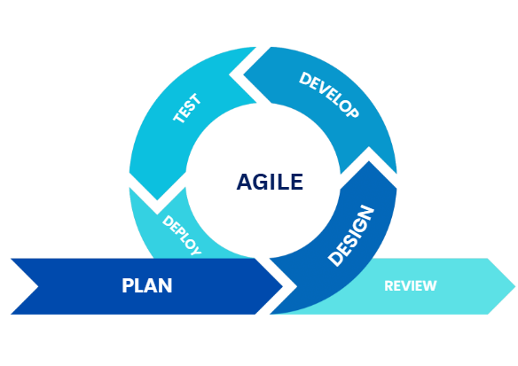

Figure 2. Agile Methodology

Through Agile methodology, the system was gradually improved based on the feedback gathered from users during development and testing. This flexible approach allowed the researchers to modify features, improve usability, and ensure that the system meets the needs of both barbershop staff and customers. The Agile development process used in this study consists of six phases: Plan Phase, Design Phase, Develop Phase, Testing Phase, Deployment Phase, and Review Phase.

Plan Phase
The Plan Phase served as the foundation of the SmartCut system development. During this stage, the researchers identified the objectives, scope, and major features that the system should include. Information gathered from surveys, interviews, and observations conducted with barbershop staff and customers was carefully analyzed in order to understand the current problems experienced in managing barbershop operations.
The researchers observed that many barbershops still rely on manual processes for managing appointments, customer records, and loyalty programs. These manual methods often result in scheduling conflicts, difficulty in tracking repeat customers. Based on these findings, the researchers defined the primary goals of the SmartCut system which include improving appointment management, organizing customer data, and implementing an automated loyalty tracking system to encourage customer retention.
In this phase, the researchers also determined the system requirements and functionalities needed for the platform. These include modules for appointment scheduling, customer account management, service management, loyalty points tracking, and administrative monitoring. A development plan and timeline were also created to guide the researchers throughout the system development process.

Design Phase
The Design Phase focused on planning the structure and appearance of the SmartCut platform. In this stage, the researchers created the system architecture, database design, and user interface layout to ensure that the system would function properly and be easy to use for both administrators and customers.
The researchers developed system diagrams and design prototypes to visualize how the system components would interact with each other. The database structure was designed to store important information such as customer profiles, appointment schedules, services offered, and loyalty points accumulated by each customer. These data structures ensure that the system can be manage and retrieve information when needed.
The user interface design was carefully planned to provide a simple and user-friendly experience. Wireframes and layout designs were created to illustrate the appearance of the system pages, including the homepage, appointment booking page, loyalty dashboard, and administrator management panel. The design phase ensured that the SmartCut platform would be organized, visually clear, and easy to navigate for users.

Develop Phase
During the Develop Phase, the researchers began the actual implementation of the SmartCut system by converting the design plans into a fully functional web-based platform. The system was developed using appropriate web development technologies and programming languages suitable for building an online management platform.
In this phase the researchers created the different modules of the system, including the appointment scheduling feature, customer management system, service management module, and the automated loyalty tracking system. Each module was developed separately and later integrated to ensure that all system components work together properly.
The appointment scheduling module allows customers to book services online and choose their preferred time slots. The customer management module stores and organizes customer information and service history. Meanwhile, the automated loyalty tracking feature records the number of visits or services availed by customers and automatically assigns loyalty points that can later be redeemed for rewards. Throughout this phase, the researchers continuously reviewed the system features to ensure that the platform functions according to the design specifications.

Testing Phase
The Testing Phase was conducted to verify that the SmartCut system operates correctly and meets the requirements defined during the planning stage. Various testing methods were performed to identify system errors, improve system performance, and ensure that all functionalities work as intended.
Functional testing was performed to check whether each system feature operates properly. This includes verifying the appointment booking process, checking whether customer information is correctly stored in the database, and confirming that the loyalty tracking system properly calculates and records reward points.
Usability testing was also conducted by allowing selected users, including barbershop staff and customers, to interact with the system. These users were asked to perform tasks such as booking appointments, viewing service history, and checking loyalty points. Their feedback was collected to determine whether the system interface was easy to understand and navigate. Any issues or improvements identified during testing were addressed before proceeding to the next phase.

Deployment Phase
The Deployment Phase involved implementing the completed SmartCut system and making it accessible to users. During this stage, the system was prepared for actual use by installing it on a web server and ensuring that it can be accessed through a web browser.
The researchers ensured that the system was properly configured and that all modules function correctly in the live environment. Basic instructions were also provided to users on how to navigate the system, book appointments, manage services, and track loyalty rewards.
This phase allowed the barbershop staff and customers to begin using the system for managing appointments, recording customer information, and tracking loyalty rewards. The deployment of the SmartCut platform aimed to replace manual management processes with a more proper and automated digital solution.

Review Phase
The Review Phase served as the final stage of the Agile development process. In this phase, the researchers evaluated the performance, usability, of the SmartCut system based on user feedback and system testing results.
Users who interacted with the system were asked to provide feedback regarding its functionality, ease of use, reliability, and usefulness in managing barbershop services. Their responses were collected through evaluation forms and analyzed to determine the strengths and areas for improvement of the system.
The feedback gathered during this phase helped the researchers identify possible enhancements that could further improve the SmartCut platform. These insights may be used for future system updates and improvements to ensure that the platform continues to meet the needs of both barbershop staff and customers.

REFERENCES

Alfiandi, V. A., & Sumiyati, S. (2025). Customer Satisfaction and Loyalty of Mcross
Barbershop. Journal La Sociale, 6(2), 580-590. https://doi.org/10.37899/journal-la-sociale.v6i2.1992

Almaarij, M. A. F., Mansyuri, U., & Arief, R. (2025). Design of Reservation and Customer Management Information System at Polka Barbershop Using Laravel Framework. Brilliance: Research of Artificial Intelligence, 5(1), 500-509. https://doi.org/10.47709/brilliance.v5i1.5914

Angali, F. W., Yasin, V., & Yulianto, A. B. (2025). Web-based booking application for services
and care products at Lia Salon. Jurnal Mandiri IT, 14(1), 108-118. https://doi.org/10.35335/mandiri.v14i1.432

AVUÇLU, E., & TAPTAL, K. (2024). An advanced online appointment system for hairdressers
and barbers to communicate seamlessly with their customers. Selcuk University Journal of Engineering Sciences, 23(2), 42-47.

Chaudhuri, A., Titus, R., & Chaudhuri, A. (2024). Impact of technology on customer
experience in the metaverse era. Journal of Management and Public Policy, 15(4), 28-47.

Cheong, W. F., & Saringat, M. Z. (2023). Barbershop Service Booking on Application for Hair Emotion Matrix Saloon. Applied Information Technology And Computer Science, 4(1), 981-996. https://publisher.uthm.edu.my/periodicals/index.php/aitcs/article/view/7411

Choudhary, R., Akhtar, E., Akhtar, M., Choudhary, N. R., & Rashid, A. (2025). OPTIMIZING
SALON SERVICES: REDUCING SCHEDULING ERRORS AND WAIT TIMES THROUGH AUTOMATION. Spectrum of Engineering Sciences, 1239-1257.

Flavián, C., Tussyadiah, I. P., & Orús, C. (2024). How immersive technologies are redefining
the customer journey. Guest editorial. International Journal of Contemporary Hospitality Management, 36(11), 3557-3565. https://doi.org/10.1108/IJCHM-11-2024-215

Fuente, M. A. M. D., Facunla, J. A., De Guzman, H. N. F., Jacinto, E. F., Hilario, J. B., Olipas, C. N. P., & Cunanan, A. I. (2023). Project Clinik: A cross-platform scheduling and appointment reservation system. Formosa Journal of Computer and Information Science, 2(1), 13-24. https://doi.org/10.55927/fjcis.v2i1.4077

Hui, L. Y., & Teo, P. C. (2024). An implementation of digital platform to enhance the appointment scheduling system. Journal of E-Government, International Journal of Academic Research in Business & Social Sciences, 14(2). http://dx.doi.org/10.6007/IJARBSS/v14-i2/20635

Ibrahim, A. I. (2025). GS Barbershop Service Management System. Applied Information
Technology And Computer Science, 6(2), 1725-1743. https://publisher.uthm.edu.my/periodicals/index.php/aitcs/article/view/20377

Jebamani, B. J. A., Murugeswari, R., & Nagaraj, P. (2021). Online appointment management system in hospitals using distributed resource allocation algorithm. In Sentimental Analysis and Deep Learning: Proceedings of ICSADL 2021 (pp. 291-301). Singapore: Springer Singapore.

Khairawati, S. (2020). Effect of customer loyalty program on customer satisfaction and its
impact on customer loyalty. International journal of research in business and social science, 9(1), 15-23.

Krishnan, S., & Yasin, S. M. (2024). Barber Booking Mobile Application. Applied Information
Technology And Computer Science, 5(1), 905-921.

Kuramshina, A., Lysenkova, S., Grigorenko, V., & Elovoi, S. (2025, April). Business Processes
of Modern Organization of Services in the Context of Digitalization of Business. In Computer Science On-line Conference (pp. 163-170). Cham: Springer Nature Switzerland.

Nunag, J. O. M., Paderes, N. C. S., Paner, K. N. G., Retirado, M. D., Rosete, S. B., Sanchez,
R. K. R., & Navarro, M. M. Utilizing Multiple Server Queuing System of Barbershop
Service Firm in Bagong Silang Caloocan City. https://doi.org/10.46254/AP05.20240183

Saini, H., Rani, R., & Chakraborty, S. (2025, June). Enhancing Salon Management Using Infix:
Digital Appointment Scheduling System. In 2025 International Conference on Electronics, AI and Computing (EAIC) (pp. 1-8). IEEE. 10.1109/EAIC66483.2025.11101468

Saperiyanto, K. (2024, December). Barbershop Business Strategy In The Era Of Marketing
Revolution 5.0. In Bengkulu International Conference on Economics, Management, Business and Accounting (BICEMBA) (Vol. 2, pp. 867-874). https://doi.org/10.33369/bicemba.2.2024.93

Setyawati, E., & Hariri, H. (2021). Web-based management information system for services development: a literature review. International Journal of Current Science Research and Review, 4(3), 175-185 https://ijcsrr.org/single-view/?id=3565&pid=3516

