COLLEGE OF COMPUTER STUDIES

SwineTrack: A Web and Mobile-Based System with Predictive and Prescriptive Analytics for Swine Disease Monitoring and Profiling

Aurin, Lorenzo
Javier, Khymm Tyrone A.
Religioso, Ron Enrick

INTRODUCTION
The swine industry is considered very important in the Philippine economy and food security. One of the most consumed meats in the country is pork, which plays a major role in the rural livelihoods of people, smallholder farming systems, provincial economies. The livestock sector, especially the swine production, contributes a significant portion of the agricultural gross value added, which offers job and income source to thousands of backyard and commercial swine growers (Philippine Statistics Authority [PSA], 2023). But frequent cases of swine diseases have greatly upset pig production and supply to the market, causing economical losses and decreased the profitability of farms and instability of prices at the local markets. The example of the 2019 outbreak of African Swine Fever (ASF) that caused largescale culling and a sharp reduction in the national pig herd, thus influencing pork supply and raising retail prices (Food and Agriculture Organization [FAO], 2022).
Swine diseases are very threatening to pig farming and may be grouped under various categories depending on the causative agents. Viral diseases like African Swine Fever (ASF), Porcine Reproductive and Respiratory Syndrome (PRRS), and Classical Swine Fever cause a high burden of disease and in the first instance, (ASF) there is no commercially viable vaccine or effective treatment (FAO, 2022). These viral infections are quickly transmitted during direct contacts, in contaminated feed, transport vehicles, and poor disposal of infected carcasses. Salmonellosis, Erysipelas, and Swine Dysentery are examples of bacterial infections that have lowered productivity, weight loss and problems with reproduction, and spurred more concerns about antimicrobial resistance (World Organisation for Animal Health [WOAH], 2023). The parasitism diseases like internal worms and mange infestation effects growth performance, feed efficiency, and general health of the herd, especially in backyard farm where there is poor biosecurity. Different disease categories have unique patterns of transmission, clinical manifestations, and management needs, and it is critical to have an overall disease monitoring system when implementing effective disease management, and sustainable livestock production.
The absence of systematic disease monitoring leads to trickle-down problems among various stakeholders of the swine industry. Farmers lose money because they fail to notice disease outbreaks and thus lose some of their herds and customers as well as suffer loss of opportunity to report and to expensive emergency treatments. The FAO (2022) states that early detection and subsequent underreporting are among the main causes that raise the prevalence and economic cost of transboundary disease outbreaks. Uninspected and unmonitored entry of diseased animals into the meat supply chain also exposes consumers to the risk of food safety problems. The absence of traceability systems with weak links lowers the capability of identifying infection origin and isolation of contaminated products. Local Government Units (LGUs) and Provincial Agriculture Offices (PAOs) fail to exercise timely control measures when the cases of the disease are not reported, and the cases are transmitted across farm boundaries and municipalities. Moreover, unregulated meat shipment and transportation allow inter-regional transmission of disease when infected pork products are transported without due authorization or bio safety measures in the high-risk to disease-free regions. The combination of these problems shows that the use of integrated surveillance systems to track the presence of the disease, movements of animals, and their trading risk in the whole swine production chain is a vital requirement.
The current technological solutions illustrate how digital systems may be used to assist in livestock monitoring and agricultural governance. To illustrate, livestock health status, biosecurity, reproductive performance and farm profiling information can be recorded by means of a web-based livestock information application like SALAZAR-IS. Digital agricultural systems rely on algorithmic data recording, central databases, and decision support functionalities, to allow local agricultural units to track the conditions of animals and address disease challenges in an appropriate manner (World Bank, 2021). Also, there are scientific disease monitoring websites, such as Swine Health Information Center Disease Monitoring Reports, which feature near real time epidemiological information to facilitate response towards infectious diseases. These platforms help to spread outbreak alerts, perform trend analysis and make evidence-based policy decisions faster, proving that data-driven disease control strategies can be realized.
In spite of these advances, there is still a large gap in integrated systems oriented towards prescriptive decision-making. The existing tools are mainly focused on surveillance, reporting, and data visualization but not automated guidance and risk-based recommendations. Although dashboards can help show infection numbers and case locations, the built-in intelligence needed to recommend a specific control action due to the severity of the disease, its geographical concentration, and the risk of transmission may be lacking. The future of agricultural informatics underscores the importance of predictive and prescriptive analytics that does not just tell what is occurring but also prescribes what should be done (Russell and Norvig, 2021).
To fill this void, this paper suggests SwineTrack: A Web and Mobile-Based Swine Profiling and Prescriptive Disease Monitoring, a system that combines swine farm profiling, real-time disease reporting, geographic visualization, risk mapping and automated action recommendations. Integrating surveillance with prescriptive analytics, the system will help the Local Agriculture Offices in planning the disease control systems, managing permits, biosecurity enforcement, and immediate outbreak mitigation measures. Finally, the proposed system will aim to improve both livestock health governance, increase food security, and mitigate losses in the Philippine swine industry.

General Objectives
This study aimed to develop a web and mobile-based solution named SwineTrack that incorporates predictive and prescriptive analytics in swine profiling, disease monitoring, and making decisions based on data to serve the needs of agricultural offices.

Specific Objectives
This study's specific goals are as follows:
- To develop a swine profiling module that registers backyard and commercial farms, including farm location, owner details, and swine population.
- To design a disease reporting and monitoring system for swine health management.
a. disease reporting module with classification of high-risk viral diseases and common diseases.
b. map-based monitoring feature displaying reported cases per municipality and province.
c. meat movement permit management system with review and approval workflows for agricultural offices.
- To implement predictive and prescriptive analytics for disease outbreak management.
a. ARIMA (Autoregressive Integrated Moving Average) predictive model for forecasting disease outbreak trends and risk levels per municipality and province.
b. rule-based prescriptive analytics system generating automated countermeasure recommendations including quarantine protocols, movement restrictions, and biosecurity measures.
c. GIS mapping system for spatial visualization of disease hotspots with color-coded risk indicators.
- To integrate role-based access control with distinct user permissions for farm owners, MAO administrators, and PAO monitors.
- To evaluate the system's usability using the System Usability Scale (SUS).

Conceptual Framework
The diagram depicts the concept scheme of the system that combines predictive and prescriptive analytics in monitoring swine diseases. The architecture comprises three key layers. The user interface layer, analytics processing layer, and data storage layer.
The user interface layer serves three distinct user types with role-specific access. Farm owners (backyard and commercial) access the Farm Owner Portal for farm registration, disease reporting with classification options (high-risk viral diseases: African Swine Fever, PRRS, Classical Swine Fever or common bacterial and parasitic diseases), disease map view with color-coded risk indicators, and transport permit requests for meat movement. MAO Administrators possess full system access through the MAO Admin Menu, enabling them to manage farm registrations, maintain records, validate disease cases, categorize risk levels, review and approve transport requests, generate reports, and perform system administration functions. PAO Monitors have read-only access to the Reporting and Monitoring module, allowing oversight of disease statistics, outbreak trends, and analytics dashboards without operational modification capabilities.
The core of SwineTrack is the analytics processing layer, comprising five integrated modules. The Predictive Analytics module implements the ARIMA (Autoregressive Integrated Moving Average) time series forecasting model with three components: the Autoregressive (AR) component analyzes past disease patterns, the Integration (I) component stabilizes data trends through differencing, and the Moving Average (MA) component captures forecast accuracy from residual errors. This model processes historical disease data to predict future outbreaks, assess risk levels per municipality and province, and analyze disease propagation patterns. The Prescriptive Analytics module applies a rule-based decision engine that evaluates risk assessments and automatically generates action plans including quarantine protocols for affected farms, movement restrictions on meat transport from high-risk regions, biosecurity measures such as disinfection and visitor control, and supply chain warnings for potential market disruptions. The GIS Mapping System integrates Mapbox or Leaflet for spatial visualization, displaying disease hotspots with three color-coded risk levels: green for low-risk areas, yellow for moderate-risk zones, and red for high-risk outbreak regions. Hotspot detection algorithms cluster geographic disease patterns to identify emerging threats. The Permit Management module enforces a three-stage approval workflow, request submission, validation against disease status, and approval or rejection implementing routing controls that prevent meat transport between contaminated and disease-free areas based on real-time risk assessments. The Reporting and Monitoring module provides an analytics dashboard with real-time statistics and trend charts, disease statistics analysis, automated report generation in PDF and Excel formats, and provincial/municipal-level monitoring capabilities for agricultural offices.
The data storage layer uses a centralized database (MySQL or MongoDB) holding all system information including farm registrations, disease reports, predictive forecasts, prescriptive recommendations, permit requests, and map interactions. The system ensures real-time data synchronization, secure data transmission through the backend framework (Node.js with Express or PHP), and cross-platform accessibility via component-based frontend architecture (React or Angular for web, React Native or Ionic for mobile). This integrated architecture enables proactive disease management through data-driven predictions and automated guidance to agricultural offices.
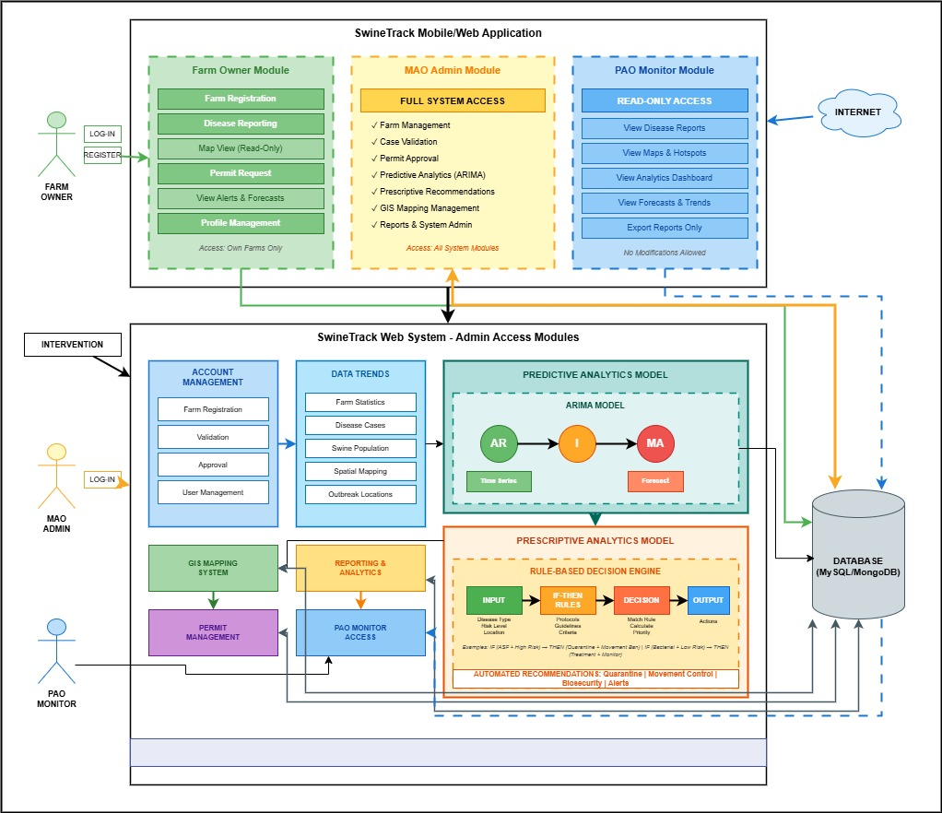
Figure 1: Conceptual Framework of SwineTrack

Scope and Limitation of the Study
SwineTrack is a mobile and web-based system that monitors and profiles swine disease in Philippine. The system allows farm owners to create farm accounts (backyard and commercial), report incidences of disease categorized as being of high-risk (African Swine Fever, PRRS, Classical Swine Fever) or common (bacterial and parasitic infections) disease involvement, to see the areas with disease hotspots on a map with color-coded risk factors per municipality and province and request meat movement permits. In the case of agricultural offices (MAO/PAO), the system provides farm verification, disease case validation and risk classification, permit approvals or rejections based on the area disease status, predictive analytics through ARIMA model to predict the disease outbreak patterns and prescriptive analytics where automated countermeasures recommendations including quarantine protocols, movement restrictions, and biosecurity measures are generated. The supply monitoring is supported by the system, and reports based on the collected data are created to guide data-driven decision-making.
The system must have a steady internet connection on web and mobile platforms to get real time data and map coverage. Predictive accuracy is a property of the historical disease data available and of the quality of these data available; in regions where disease is not well recorded or recorded haphazardly, the prediction will be less accurate. The system is prescriptive and recommends on the basis of established rules and based on the amount of forecasted risk but this does not bypass professional diagnosis and therapy in the veterinary field. Classification of diseases is restricted to preclassifications (viral, bacterial, parasitic) and does not cover the entire swine diseases. MAO / PAO is not automated to permit approval and it has to be reviewed manually by personnel. Limited to Philippines relying on local map and data. Accuracy in location is based on GPS position recorded on the site and device performance.
Review of Related Literature
Livestock Disease Surveillance Systems
Surveillance of animal diseases plays a crucial role in detecting, responding fast, and containing animal disease outbreaks across borders. The Australian Centre for International Agricultural Research (ACIAR) in cooperation with the University of the Philippines Los Baanos (2024), in its One Health research initiative, posits that enhancing the surveillance systems of livestock diseases in the Philippines is an essential approach to addressing the priority animal diseases in the country, including African Swine Fever (ASF). The initiative focuses on evidence-based surveillance enhances, improving the diagnostic capability, strengthening the farm-level biosecurity, and reinforcing coordination between the active veterinary authorities and the local government entities. The paper identifies that disjointed reporting systems and laggard farm-level communications are the key contributors to the inability to contain the outbreak, contributing to the loss of additional revenue and disease spread. Enhanced surveillance systems can, thus, not just help control the disease, but also increase the governance of livestock and the Civil Economic Development of rural regions (ACIAR & UPLB, 2024).
In the same way, the National Animal Health Reporting System (NAHRS) of the United States shows how the proper reporting systems that provide organized data over diseases can enhance effective surveillance and prompt action. The NAHRS gathers, examines and shares animal health information with state and federal government stakeholders, which allows realtime interaction among veterinary laboratories, producers and policymakers (United States Department of Agriculture [USDA], 2023). The system will play a critical role in proper, standardized and timely circulation of outbreak warnings with the assistance of commonized reporting guidelines and central databases. Such illustration of synergized reporting that has been deployed aids in providing understanding of how multi-level governance frameworks can reduce the response rate and enhance biosecurity adherence among livestock farmers.
Along with national reporting systems, international organizations that deal with animal health dwell on integrated surveillance systems. According to World Organisation for Animal Health (WOAH, 2023), effective disease surveillances must rely on passive diseases surveillance (all initiated by a farmer) and active surveillance (inspections and sampled by the government). WOAH continues to affirm that risk-based surveillance is essential to making sure that those zones and risk groups of people that are most vulnerable are prioritized to ensure that higher rates of detecting them and resulting in optimal resource allocation. The world reveals itself to confirm that the surveillance has ceased to be the collection of facts and has become the continuous cycle of detection, analysis, response and prevention. Development of digital systems to combine farm profiling, geographic mapping, and automated alert mechanisms can be theoretically based on such organized structures.
Digital livestock management systems have been introduced as an effective method of disease monitoring and guiding decision-making. SALAZAR-IS, an online information livestock application, assists in documenting a livestock health condition, / biosecurity levels, and indicators of reproductive performance. The system enables the agricultural officers to monitor trends and detect any abnormalities in the conditions of herds through the use of algorithm-driven data recording and centralized storage. The World Bank (2021) states that digital agriculture tools enhance the extent of livestock control based on transparency, traceability, and efficiency by improving real-time information exchange and reducing the volume of paperwork. Such systems allow local agricultural units to better observe the conditions of animals and to respond quickly to any new disease threat.
Moreover, the Swine Health Information Center offers Disease Monitoring Reports, which present close real-time epidemiological news of new swine diseases. These reports put together laboratory findings, field findings, and specialists analysis to plan a response plan based on evidence (Swine Health Information Center, 2023). The platform quantifies the fact that digital reporting tools may be used in predictive text to find patterns, geographical concentrations and seasonal disease motifs. Such systems increase cooperation between a farm owner, veterinarians, and regulatory organs by incorporating the accessibility of the data and simplifying the reports work.
Besides, a study on precision livestock farming emphasizes the importance of sensor-based surveillance and data analytics in the process of disease detection. Berkckmans (2017) states that automated monitoring technologies, including temperature sensors, movement trackers, and analytics of feeding behavior, may identify changes in physiological parameters of the disease early, when they are not evident to the naked eye. These technologies enable early intervention that reduces the numbers of mortality and economic losses. Such systems may require an increased investment into infrastructure, yet they prove the increased role of data-driven decision-making in livestock health management.
The relevance of the other related study by FAO (2022) on digital animal disease surveillance in Southeast Asia highlights the significance of mobile-based reporting systems among the rural farmers. The researchers concluded that mobile applications increased reporting rates by a significant margin and decreased delays in reporting suspected cases. Combining geographic information systems (GIS) with disease reporting, authorities could see the outbreak hotspots and implement more specific containment actions more effectively. This result advances the argument that can interconnect web and mobile technologies can enhance traceability of disease occurrence, risk assessment, and better coordination of emergency response.

Swine Disease Background and Classification
Understanding the nature of swine diseases is fundamental to developing effective monitoring systems. Swine diseases can be broadly classified into three major categories based on their causative agents: viral, bacterial, and parasitic infections. Each category presents distinct challenges in terms of transmission dynamics, clinical manifestations, and control strategies.
Viral diseases represent the most devastating threats to swine populations worldwide. African Swine Fever (ASF) stands out as the most economically destructive, with no available vaccine or treatment options. Dixon et al. (2020) published comprehensive research in Annual Review of Animal Biosciences explaining that ASF is caused by a large DNA virus of the Asfarviridae family that can survive in various environmental conditions and remain infectious in frozen meat for extended periods. The virus spreads through direct contact with infected pigs, consumption of contaminated feed or swill, and mechanical transmission via fomites such as vehicles, equipment, and clothing. The clinical signs include high fever, hemorrhagic lesions in internal organs, respiratory distress, and sudden death, with mortality rates reaching up to 100% in acute outbreaks. This extreme pathogenicity explains why ASF is classified as a high-risk disease requiring immediate reporting and strict containment measures.
Similarly, Porcine Reproductive and Respiratory Syndrome (PRRS) causes significant economic losses through reproductive failure and respiratory problems in pigs. Nan et al. (2021) published findings in Viruses demonstrating that PRRS virus affects the immune system by targeting macrophages in the lungs and lymphoid tissues, resulting in abortion storms in sows, weak-born piglets with low survival rates, and increased mortality in nursery pigs that become susceptible to secondary bacterial infections. Classical Swine Fever (CSF), another highly contagious viral disease, shares similar transmission routes with ASF but is caused by a pestivirus. Postel et al. (2021) emphasized in a review article that these viral diseases require distinct surveillance approaches due to their rapid spread and devastating economic impact, with some outbreaks leading to complete depopulation of herds and trade restrictions that affect entire regions.
Bacterial diseases, while generally more treatable than viral infections, still pose considerable challenges to swine health management and can significantly impact farm profitability. Swine erysipelas, caused by Erysipelothrix rhusiopathiae, can manifest in acute, subacute, or chronic forms affecting multiple organ systems. Opriessnig et al. (2020) documented in a comprehensive chapter on swine erysipelas that this bacterial pathogen causes diamond-shaped skin lesions, arthritis in growing pigs, and heart valve infections that can lead to sudden death. The bacteria can persist in contaminated soil and feces for extended periods, making environmental control challenging. It is also zoonotic, meaning it can infect humans who handle infected animals, particularly farmers and slaughterhouse workers. Salmonellosis, particularly caused by Salmonella choleraesuis and Salmonella typhimurium, leads to enteritis, septicemia, and pneumonia that reduce growth performance. Argüello et al. (2022) conducted field research documenting that salmonella infections are of particular concern due to their public health implications through contaminated pork products and the growing problem of antimicrobial resistance that limits treatment options. Swine dysentery, caused by Brachyspira hyodysenteriae, results in severe mucohemorrhagic diarrhea characterized by blood and mucus in feces. Hampson and Burrough (2019) note that this disease can spread rapidly through contaminated feces, shared equipment, and mechanical vectors like rodents and flies, causing significant economic losses through reduced growth rates and increased mortality. These bacterial diseases are categorized separately from viral threats because they typically respond to targeted antibiotic treatment when detected early, though antibiotic resistance is becoming an increasingly important concern.
Parasitic diseases, though often considered less severe than viral or bacterial infections, significantly impact growth performance and production efficiency across swine operations. Internal parasites like Ascaris suum (large roundworm) and Trichuris suis (whipworm) are particularly prevalent in outdoor and poorly managed pig operations where biosecurity is limited. Krücken et al. (2021) conducted field studies across European pig farms showing that heavy parasite burdens lead to reduced feed conversion ratios, impaired weight gain, and increased susceptibility to secondary infections due to intestinal damage. The parasites damage the intestinal lining through their feeding activities and migration through tissues,causing malabsorption of nutrients, chronic inflammation, and sometimes liver damage. External parasites such as Sarcoptes scabiei var. suis cause mange, resulting in intense itching, skin lesions, poor body condition, and reduced productivity. Mullen et al. (2020) emphasized that mange is highly contagious through direct contact between pigs and through contaminated housing, making it a persistent problem in backyard farms and older facilities with inadequate biosecurity and hygiene protocols. While parasitic diseases rarely cause acute mortality like viral infections, their cumulative economic impact through reduced productivity, increased feed costs, and treatment expenses justifies their inclusion in comprehensive disease monitoring systems.
The classification of diseases into these three categories serves practical purposes in surveillance system design and outbreak response planning. Viral diseases typically require the most urgent response protocols due to their high contagiosity, lack of effective treatments, and potential for causing catastrophic herd losses. Bacterial diseases necessitate careful antimicrobial stewardship to maintain treatment efficacy alongside implementation of biosecurity measures to prevent spread. Parasitic diseases often indicate deficiencies in farm management and hygiene practices that require corrective interventions such as deworming protocols and facility improvements. By understanding the biological basis for each disease category, digital monitoring systems can implement appropriate risk assessment algorithms, generate targeted prescriptive recommendations aligned with the specific nature of the detected threat, and help agricultural authorities allocate resources more efficiently.

Geographic Information Systems for Disease Monitoring
Geographic Information Systems (GIS) have become essential tools for visualizing, analyzing, and managing disease spread patterns in livestock populations. According to the Philippine Council for Agriculture, Aquatic and Natural Resources Research and Development (PCAARRD-DOST, 2024), locally developed technologies are being introduced to address critical issues related to African Swine Fever, including surveillance platforms that incorporate geographic mapping to monitor disease distribution across municipalities and provinces. Such GIS-based systems aid agricultural authorities to trace the spatial clustering of outbreaks, locate the high-risk areas and introduce containment options like movement prohibition and zoning procedures. GIS improves situational awareness by converting raw case data into visual maps, which improves strategic planning at the provincial and national level.
The Food and Agriculture Organization of the United Nations (FAO, 2022) notes that the efficiency of the response to outbreaks is notably higher in the presence of spatial mapping tools because they provide authorities with an opportunity to track disease hotspots in real time. GIS-based dashboards may show the density of infections, mortality rates, and spread zones, directing rather general and resource-consuming control indicators. The FAO highlights that the use of GIS to combine traces made by animals movement is useful in enhancing traceability and minimizing cross-regional contamination. Integration is especially important in the countries where the spread of livestock between the provinces often occurs and can help spread diseases quickly.
Likewise, World Organisation of Animal Public Health (WOAH, 2023) points out that transboundary animal disease can be managed through spatial epidemiology. With the help of GIS tools, the veterinary authorities can analyze the environment, the density of farms, and transport systems that contribute to the transmission of diseases. Through such patterns of outbreak occurrence efforts policymakers can explosively apply zoning and compartmentalization policies to ensure disease-free zones. This spatial risk-based policy will allocate the scarce veterinary resources effectively without causing much inconvenience to trade and production.
Also a study on spatial epidemiology conducted by Pfeiffer et al. (2008) clarifies that GIS improves disease monitoring as it facilitates the statistical analysis of both spatial clusters and time trends. The researchers show that using a correlation of geographical information and epidemiological indicators can better early diagnose and predict outbreak. Inter-agencies also foster collaboration and harmonious reaction as GIS systems enable the sharing of data between institutions. Such conclusions support the need to consider the inclusion of GIS in web and mobile-based livestock monitoring systems as an enhancement of evidence-based decision making.
In addition, mobile GIS applications have widened the scope of field veterinarians and local agricultural officers to access disease mapping tools. World Bank (2021) states that mobile incorporated GIS systems enable on-site data entry, automatic geotagging, and instant synchronization with centralized databases. This real time ability lowers reporting time and increases transparency. GIS-based systems can enhance preemptive biosecurity measures and awareness of communities by equipping the farm owners and field officers with the spatial understanding of how livestock disease outbreaks are managed.

Prescriptive Systems in Agriculture
Prescriptive systems offer practical advice, depending on the analysis of data, advising the user of the optimal decisions made in complex operational settings. As Russell and Norvig (2021) state, prescriptive analytics goes further than descriptive and predictive models by prescribing certain actions based on logical rules, optimization algorithms, and decision model. Such systems are used in agricultural environments to analyze available data and make automated recommendations to either reduce risks or enhance productivity. In contrast to predictive systems, which are deployed to predict possible outcomes, prescriptive systems propose immediate interventions, which can prove to be highly advantageous in the emergencies, like disease outbreaks.
Within the livestock disease control system, prescriptive system may advise quarantine measures, restriction of movement, culling methods (where indicated), along with vaccination plans (where advised) or improvement of biosecurity depending on the severity and geospatial extent or detail of an outbreak. Of decision-support tools including rule-based recommendations, the Food and Agriculture Organization of the United Nations said they are associated with better response to emergencies (FAO, 2022). The automated guidance decreases the need to rely on human interpretation of surveillance data as well as allows the consistent application of control measures on a municipal scale.
In the same way, the World Bank (2021) reiterates that digital decision-support systems can benefit agricultural governance because it alleviates human error and enhances transparency. Prescriptive systems rely on artificial response protocols too, prescribed to national standards of veterinary practice, thus reducing differences at the local level. This uniformity is especially helpful in decentralized types of governance, where agricultural departments possess different degrees of technical skills.
A study done by Berckmans (2017) also describes the specifics of precision livestock farming, which states that anomalies in animal behavior are discovered by automated advisory systems that provide appropriate corrective recommendations, such as isolation or veterinary care. These prescribing notifications diminish the transmission of illness and minimize monetary damage through early intervention. Rule-based prescriptive systems offer viable and sound solutions in situations where predictive modeling is at a disadvantage because of inadequate historical data to aid in mitigating risks in an immediate manner.
Further, Sharda et al. (2018) point out that prescriptive analytics combines optimization methods and simulation models to decide on the best course of action between numerous options. When it comes to swine disease outbreaks, those systems can assess parameters, including rate of infection, farm density and transportation routes to provide specific and generalized containment plans. Through automation of these recommendations, the agricultural offices can save a lot of time in decision-making in response to emergencies.
The prescriptive decision-support tools are especially attractive in the environment with limited resources where the expert veterinary epidemiologists can be limited. These systems reduce knowledge gaps between local staff and guarantee evidence-based responses even on a municipal scale since they ingest expert knowledge into algorithmic rules. Prescriptive systems boost the institutional capability and improve resilience to frequent outbreaks of livestock diseases through automation and standardization.
Altogether, the literature review contributes to the incorporation of prescriptive analytics into livestock surveillance systems. The integration of GIS-based spatial surveillance, and action propositions, developed an end-to-end decision-support landscape that could help enhance the quality of outbreak containment, reduce the impact on the economy, and reinforce swine health policy.

Time-Series Forecasting and Predictive Analytics for Disease Monitoring
Time-series forecasting models in predictive analytics have shown that they can predict disease outbreaks and can contribute to proactive intervention measures. Time-series models examine the historical records of the data points that have been recorded periodically and stipulates the trends, seasonal patterns, and other cyclical variations that can lead to future outbreaks. Epidemic forecasting with the Autoregressive Integrated Moving Average (ARIMA) model has gained widespread application because the model is able to exploit both the temporal dependencies and non-stationary characteristics of the disease occurrence data. In the scientific article released in the journal BMC Medical Informatics and Decision Making (Kane et al., 2014), ARIMA models have good predictive accuracy in terms of infectious disease surveillance datasets, with mean absolute percentage errors at or below 10 percent within the short-term forecasts. The research indicated that the effectiveness of ARIMA is most effective in cases where uniform past data are offered and when tuning of parameters through autocorrelation and partial autocorrelation is performed. These results indicate that forecasting can be maximized only when structured data collection systems are used.
Mwiine et al. (2021) used a time-series analysis to predict the outbreak of foot-and-mouth disease in cattle populations in the Uganda context of livestock disease prediction. The research was published in Tropical Animal Health and Production and the authors concluded that when the models applied included environmental seasonal variables (rainfalls and changes in temperatures) the Seasonal ARIMA (SARIMA) models could forecast the peaks of the outbreaks with about 85% accuracy. The study showed that seasonal adjustments contribute greatly to forecasting accuracy, especially that of diseases that are climatically dependent. Predicting probable outbreaks, the veterinary authorities could pre-position vaccines, introduce field staff, and increase biosecurity disease surveillance in high-risk districts. This proactive resource distribution demonstrates that predictive analytics changes concepts of disease management as a reactionary straightjacket to a proactive strategy.
In a similar vein, Wang et al. (2018) used machine learning and ARIMA to forecast the spread of African Swine Fever in China in a study published in Preventive Veterinary Medicine. Comparative analysis showed that ARIMA models performed better than the simple regression models in the case of non-stationary outbreak data in more than one province. The researchers emphasized that to be able to make reliable predictions, the datasets must include at least 2436 months and that the accuracy of the models can be enhanced with the help of spatial variables, including the population density of pigs and the connectivity of the transport network. Such a combination of both temporal and spatial helps to create more robust livestock disease control decision-support systems.
Moreover, Zhang et al. (2019) applied ARIMA models to predict swine influenza development in various Asian areas and discovered hybrid ARIMA models that included exogenous variables (ARIMAC) outperformed individual models in terms of prediction. Their results indicate that the incorporation of outside predictors (i.e. farm density, frequency of movement of animal life, substance that is biosecurity compliant) makes the models more credible and effective in identifying outbreaks. The research supports the notion that foreseeing systems should integrate epidemiological statistics and other environmental and management-related evaluations in order to create valid forecasts.
Furthermore, Chae et al. note that machine learning algorithms like support vector machine (SVM) or neural networks can be used to complement conventional ARIMA models in livestock disease surveillance (2016). ARIMA is very effective in short-term linear forecasting, but hybrid models containing machine learning algorithms can do away with nonlinear transmission effects and sudden epidemic saturation. The authors concluded that using a combination of statistical and computational techniques led to more successful earlywarning systems especially in complex agricultural systems with variable production cycles.
The Food and Agriculture Organization of the United Nations (FAO, 2022) also adds that predictive analytics can most effectively be implemented as part of centralized digital surveillance systems. Automated dashboards on forecasting allow agricultural offices to model potential outbreak trends, assess the amount of risks, and model intervention scenarios prior to the widespread. With the help of such systems, the institution has a better readiness because fewer delays in decisions and a quick reaction to quarantine, transport restrictions, or increased farm inspections guarantee better responses.

Prescriptive Analytics and Decision Support Systems in Agriculture
Prescriptive analytics extends beyond prediction by recommending specific actions to optimize outcomes based on data-driven insights. Unlike predictive models that forecast what might happen, prescriptive systems determine what should be done in response to predicted scenarios. Lepenioti et al. (2020) explained in an exhaustive review published in the Information Systems Frontiers prescriptive analytics tests how optimization algorithms, simulations models, artificial intelligence and rule-reasoning help to formulate actionable recommendations in multi-faceted decision-making contexts. The authors point out that prescriptive systems are especially useful in high-stakes and time-intensive areas as they help to minimize uncertainty and lead the users to evidence-based decisions. In agriculture, prescriptive systems help farmers and agricultural officers decide on the best planting dates, resource allocation plans, pest control measures and livestock disease management plans. These systems are able to convert raw data into action plans by introducing expertise information and work specifications into algorithmic systems.
Rule-based decision support systems (DSS) in particular have proven to be of great importance in the area of livestock disease management by standardizing response procedures and saving time in decision-making during outbreaks. In Preventive Veterinary Medicine, Rojo-Gimeno et al. (2016) tested a decision support system developed to address livestock disease control in European pig farms. This system used if-then principles, based on variables in the characteristics of the disease, herd population, level of biosecurity compliance, and level of risk by geographic area. Depending on these inputs, the system produced individualized intervention measures such as quarantine period, restriction of movement, and culling limit, and vaccination advice where necessary. The results showed that farms that operated with the prescriptive DSS contained about 40 percent fewer diseases than farms that were guided by reactive management methods only. These better results were explained by the accelerated initiation of the relevant countermeasures and the systematic compliance with the recommended guidelines.
Equally, Food and Agriculture Organization of the United Nations (FAO, 2022) highlights that digital-supported formal frameworks of outbreak response have shown to be highly effective in enhancing containment. The FAO indicates that prescriptive systems contribute to compliance with national veterinary standards especially in decentralized forms of governance whereby local agricultural units might lack uniformity in terms of technical expertise. Prescriptive tools lower discrepancies and enhance interregional patterns in disease management and control between provinces and municipalities by automating action recommendations based on policy standards.
The combination of prescriptive analytics with the Geographic Information System (GIS) also contributes more to decision-making considering the integration of spatial risks factors. In a study published in Transboundary and Emerging Diseases, Machado et al. (2019) created a spatial decision support system to control African Swine Fever in Brazil. Their system integrated proactive risk mapping and prescriptive recommendations in which transportation networks, the livestock market links and quarantine capacity were considered. Upon simulated conditions suggesting high likelihood of infection in particular municipalities, the platform automatically created site-specific advice like creating control zones with transitioning radii, an absence of pig movements in high-risk transport pathways, and exercising vigilant facilities in vulnerable municipalities. The researchers found that the application of spatial intelligence in context of prescriptive logic optimizes the efficiency of outbreak responses and minimizes unwarranted economic interference.
Additionally, Sharda et al. (2018) describe that prescriptive analytics systems uses optimization models and simulations to consider a variety of alternative actions, then prescribe the most effective interventions. In the context of agricultural disease control, it implies the evaluation of alternative containment approaches such as partial culling versus full depopulating the herd, depending on estimated economic cost, rate of transmission and recovery period. Their study underscores that not only do prescriptive DSS enhance the efficiency of operations, but also support transparent and accountable decision-making, as recommendations are based on quantifiable parameters rather than subjective judgment.
A different recent study, which can be taken as a relevant one, selected in this set, can be found by Berckmans (2017), who conducted a study1 on precision livestock farming, which shows how automated advisory mechanisms may produce real-time guidance based on continuous monitoring data. In case any abnormalities in feeding behaviour, body temperature, or the level of activity are identified, the system presents prescriptive warnings based on the possible options of isolation, veterinary check-up, or modification of the environment. Even though widest use is in commercial livestock operations, this example shows how sensor-generated data coupled with rule-based decision engines may be used to amplify livestock disease prevention and welfare outcomes.
Moreover, the World Bank (2021) emphasises that digital prescriptive systems enhance agricultural governance by decreasing the delay in responses and has uniform control measures. In resource-restricted conditions, where availability of veterinary epidemiologists might be limited, the incorporation of information on expert rules in automated systems fills knowledge gaps in municipal agricultural officers. These systems boost institutional resilience and make them prepared to face subsequent epidemics of livestock diseases.

METHODOLOGY
The proponents will utilize the Agile Software Development Life Cycle (SDLC), specifically the Scrum framework, as the methodology for developing SwineTrack. The Scrum approach was chosen because it supports iterative development through time-boxed sprints, allows for continuous stakeholder feedback, and accommodates changing requirements throughout the development process. This methodology is particularly suitable for this project given the need to regularly consult with Municipal Agriculture Office (MAO) personnel who serve as the primary system administrators, and Provincial Agriculture Office (PAO) personnel who require monitoring capabilities. The development process will be organized into six major phases: Planning, Analysis, Design, Implementation, Testing and Integration, and Maintenance, all executed within the Scrum framework's sprint structure.

Software Development Model

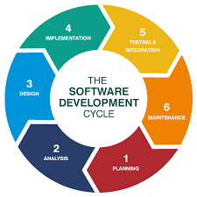
Figure 2: Software Development Life Cycle

The Scrum framework provides a structured yet flexible approach for building SwineTrack, ensuring each development phase receives adequate attention before transitioning to subsequent stages. This methodology emphasizes collaboration between the development team and stakeholders, with regular sprint reviews and retrospectives to assess progress and incorporate feedback. The iterative nature of Scrum helps maintain system quality, manage development resources efficiently, and deliver a reliable platform that addresses the practical needs of farm owners, MAO administrators, and PAO monitoring personnel.
Planning
The planning phase establishes the project's foundation by defining scope, objectives, and required resources for development. The proponents will form a Scrum team consisting of developers, a product owner representing the agricultural offices, and a Scrum master to facilitate the process. Initial planning meetings will be conducted with MAO personnel to understand their current procedures for monitoring swine diseases and managing meat movement permits, as they will serve as the primary administrators of the system. Additional consultations with PAO personnel will identify their monitoring and reporting needs, as their role focuses on oversight rather than operational management. During these sessions, the team will document existing workflows, pain points in manual record-keeping, and desired system capabilities. The product backlog will be created during this phase, listing all features such as farm registration, disease reporting with classification options, interactive map monitoring, permit management workflows, predictive analytics for outbreak forecasting, and prescriptive recommendations for disease control measures.
The planning phase also involves evaluating and selecting the technical stack that best suits the project requirements and team expertise. For the frontend interface, the team will choose between React or Angular based on factors such as component reusability, learning curve, and ecosystem support. React offers a simpler learning curve with its component-based architecture and large community support, while Angular provides a comprehensive framework with built-in features like dependency injection and two-way data binding. Web development will target modern browsers, while mobile applications will be developed for both Android and iOS platforms using React Native if React is chosen, or Ionic framework if Angular is selected.
The backend technology selection involves choosing between Node.js with Express.js or PHP as the server-side framework. Node.js with Express provides JavaScript consistency across the full stack, asynchronous processing for handling concurrent requests, and extensive npm package ecosystem. PHP offers mature frameworks like Laravel or Symfony with robust security features, established hosting compatibility, and strong database integration capabilities. The team will evaluate both options considering performance requirements, deployment environment constraints, and developer proficiency.
For database management, the choice lies between MySQL or MongoDB. MySQL is a relational database that provides ACID compliance, structured schema enforcement, complex query support through SQL, and widespread hosting availability. MongoDB is a NoSQL document database offering flexible schema design, horizontal scalability, JSON-like document storage aligning with JavaScript objects, and simpler data modeling for hierarchical information. The decision will consider data relationships complexity, expected scale, query patterns, and backup requirements.
Version control will be managed through Git with repository hosting on GitHub or GitLab for collaborative development and code history tracking. The user interface design will be prototyped using Figma, allowing stakeholders to visualize screens and workflows before actual development begins. For quality assurance, testing frameworks appropriate to the chosen technology stack will be implemented: Jest or Mocha for JavaScript-based backends, PHPUnit for PHP backends, and corresponding frontend testing libraries. Once development is complete, the web application will be deployed through appropriate hosting services supporting the chosen backend technology, while mobile applications will be distributed via Google Play Console for Android and Apple App Store for iOS devices. The project timeline will be divided into two-week sprints, with a total estimated duration of four to five months to complete all features and conduct thorough testing.
Analysis
The Analysis phase involves gathering detailed requirements and defining system specifications. The team conducts stakeholder interviews with farm owners, MAO personnel, and PAO representatives to understand their operational workflows and information needs. Farm owners require straightforward disease reporting capabilities with minimal technical complexity, while MAO staff need comprehensive administrative tools for data validation, permit processing, and farm management. PAO personnel require read-only access to monitoring dashboards showing disease trends and outbreak patterns across jurisdictions.
Functional requirements are documented specifying three user roles with distinct permissions: Farm Owners perform basic CRUD operations on their farms and disease reports; MAO Administrators have full system access including validation, approval, and management functions; PAO Monitors have view-only access to reports and analytics. Non-functional requirements address system performance (API response times under 2 seconds), security (role-based access control, encrypted data transmission), and usability (intuitive interfaces requiring minimal training). Technology stack selection considers team expertise, project timeline, and system requirements—evaluating frontend options (React vs Angular), backend frameworks (Node.js/Express vs PHP/Laravel), and database solutions (MySQL vs MongoDB) based on specific criteria like learning curve, ecosystem maturity, and scalability needs.
Design
The design phase transforms analyzed requirements into visual mockups and technical architecture plans that guide the implementation work. Using Figma as the primary design tool, the proponents will create comprehensive wireframes and high-fidelity mockups for farm owner, MAO administrator, and PAO monitoring interfaces across web and mobile platforms. The design process begins with low-fidelity sketches to establish basic layouts and information hierarchy, followed by iterative refinement sessions with stakeholders to incorporate feedback before final designs are approved. The user interface design prioritizes simplicity and role-appropriate functionality, recognizing that each user group has different technical proficiency levels and operational needs.
The farm owner interface will feature a simplified dashboard displaying their farm status, disease alert notifications in their vicinity, current risk level indicators for their municipality, and status of any pending permit requests they submitted. The farm registration flow includes guided step-by-step forms with inline validation to ensure complete information collection, along with an embedded map component allowing users to pinpoint their exact farm location by dropping a marker, entering coordinates, or using GPS auto-detection on mobile devices. Disease reporting screens present clear classification options through radio buttons or dropdown menus, distinguishing between viral, bacterial, and parasitic diseases, with additional fields for entering affected animal counts, describing observable symptoms in plain language, and uploading photographic evidence captured directly from mobile cameras. The permit request form collects origin and destination details through autocomplete dropdowns, shipment quantity, intended transport date via calendar picker, and vehicle information, with clear instructions about required documentation and expected approval timeframes.
The MAO administrator interface emphasizes operational efficiency for processing high volumes of farm registrations, disease validations, and permit requests. A task-based dashboard displays pending items requiring action, organized by priority with urgent disease reports flagged prominently. Quick filter and sort controls help administrators locate specific cases by date, municipality, disease type, or applicant name. When reviewing a disease report, a detailed view shows all farmer-submitted information, the farm's historical disease records, nearby disease activity within a radius for epidemiological context, and current automated risk assessment from the predictive module. Action buttons allow administrators to validate reports, adjust risk categorizations with justification notes, flag cases for field veterinary investigation, or mark as false reports. The permit review interface displays the applicant's farm compliance status, recent disease history at source location, disease prevalence along the proposed transport route visualized on an integrated map, and destination area risk levels to support informed approval decisions. Batch processing capabilities enable administrators to handle multiple similar requests efficiently when appropriate.
The PAO monitoring interface provides strategic oversight through comprehensive analytics dashboards and reporting tools without operational management functions. The main dashboard presents provincial-level statistics showing total registered farms, active disease cases by municipality with bar charts or heatmaps, permit application volumes and approval rates tracked over time, and comparison metrics between different municipalities to identify areas needing additional support or resources. Interactive filtering allows PAO users to drill down into specific time periods, municipalities, or disease types for detailed analysis. Report generation features produce PDF or Excel exports summarizing disease trends, outbreak response effectiveness, permit processing times, and farm registration growth, formatted appropriately for provincial officials and policy makers. Map visualizations display the entire province with municipality-level color coding based on aggregated risk assessments, allowing quick identification of high-risk areas requiring attention.
The system architecture design defines how different components interact to deliver functionality appropriate to the chosen technology stack. If the relational database approach (MySQL) is selected, the architecture will implement a three-tier MVC (Model-View-Controller) pattern where the presentation layer (React or Angular components) communicates with the application layer (Node.js/Express or PHP controllers handling business logic) which interacts with the data layer (MySQL database with normalized tables and foreign key relationships). Database schema will include tables for users, farms, disease_reports, permits, predictions, and prescriptions with properly defined relationships through primary and foreign keys. SQL queries will leverage joins for retrieving related data across tables.
If the document database approach (MongoDB) is selected, the architecture will implement a similar three-tier pattern but with document-oriented data modeling where the presentation layer communicates with the application layer which interacts with MongoDB collections storing JSON-like documents. Collections will include users, farms, diseaseReports, permits, predictions, and prescriptions with embedded sub documents where appropriate and document references for relationships requiring flexibility. Queries will use MongoDB's aggregation pipeline for complex data retrieval and transformations.
Regardless of database choice, the system will implement RESTful API principles with standardized endpoints following /api/resource patterns, JSON request and response payloads, appropriate HTTP methods (GET, POST, PUT, DELETE), and consistent error handling with meaningful status codes. Authentication will use JWT (JSON Web Tokens) for stateless session management, with tokens containing user ID and role information for authorization checks. Role-based access control middleware will enforce permission restrictions ensuring farmers cannot access administrative functions, MAO administrators cannot modify PAO-level settings, and PAO users remain limited to read-only operations.
The map visualization component design specifies how disease cases will be represented geographically using mapping libraries appropriate to the frontend framework choice. Mapbox GL JS or Leaflet will be integrated to display an interactive map of the Philippines. Each municipality will be rendered as a polygon feature with color-coded fill based on current risk levels: green indicating low risk with zero or minimal recent cases, yellow representing moderate risk with sporadic cases under monitoring, and red signaling high risk requiring immediate containment actions. Individual farm locations with active disease reports will be marked with custom pin icons that display information popups on click, showing disease type, affected animal count, report date, and validation status. The map includes zoom and pan controls, search functionality to quickly locate specific municipalities, and legend explaining the color-coding scheme.
Implementation
Implementation follows parallel development tracks managed through Scrum sprints. The frontend team chooses between React and Angular based on team familiarity and component reusability needs, developing responsive interfaces for disease reporting, farm management, and admin dashboards. The backend team selects Node.js or PHP to build RESTful APIs handling authentication, CRUD operations, and business logic. Database implementation uses MySQL for structured relational data or MongoDB for flexible schema requirements, storing user accounts, farm profiles, disease records, and permit applications.
Core feature development proceeds incrementally, authentication and user management first, followed by farm registration and disease reporting modules, then predictive analytics integration using ARIMA models for outbreak forecasting. The prescriptive analytics engine implements rule-based decision logic generating recommendations based on disease type, severity, and geographic patterns. Geographic visualization integrates Mapbox or Leaflet for interactive disease mapping. The system implements role-specific access controls ensuring farm owners access only their data, MAO administrators manage all operations, and PAO monitors view reports without modification capabilities. Version control through Git enables collaborative development with regular code reviews maintaining quality standards.
Testing and Integration
The testing phase validates system functionality, usability, and reliability through multiple evaluation methods. Functional testing verifies core features including disease reporting accuracy, permit approval workflows, and predictive model outputs. Performance testing measures response times and system stability under load with 100 concurrent users. Usability evaluation employs the System Usability Scale (SUS) questionnaire with farm owners and MAO/PAO personnel, targeting scores above 70 to ensure intuitive navigation and clear workflows.
Security testing validates authentication controls, role-based access restrictions, and protection against common vulnerabilities (SQL injection, XSS). Compatibility testing ensures functionality across major browsers (Chrome, Firefox, Safari, Edge) and mobile devices (Android 10+, iOS 14+). Unit testing uses Jest to achieve 80% code coverage on critical functions including authentication, ARIMA calculations, and database operations. Integration testing validates complete workflows from user registration through disease reporting to admin approval processes.
Identified issues are documented in GitHub Issues, categorized by severity, and resolved through iterative bug fixing with regression testing ensuring fixes don't introduce new problems. User feedback from testing sessions informs final refinements before deployment.

Maintenance
The maintenance phase involves ongoing support and updates after system deployment. Monitoring system performance and addressing any technical issues that arise. Updating disease classifications and prescriptive recommendations based on new Department of Agriculture guidelines. Adding new features or improvements based on user feedback. Ensuring database backups are performed regularly to prevent data loss. Updating the system to maintain compatibility with new operating system versions and browsers. Providing technical support to MAO/PAO offices and farm owners. Performing security updates to protect against potential vulnerabilities. Analyzing system usage data to identify areas for optimization and improvement.

REFERENCES
Australian Centre for International Agricultural Research, & University of the Philippines Los Baños. (2024). Strengthening livestock disease surveillance systems in the Philippines: A One Health approach. ACIAR. https://www.aciar.gov.au
Food and Agriculture Organization of the United Nations. (2022a). African swine fever (ASF) situation in Asia and the Pacific. FAO Animal Production and Health Division. https://www.fao.org
Food and Agriculture Organization of the United Nations. (2022b). Digital animal disease surveillance and response in Southeast Asia. FAO Animal Production and Health Division. https://www.fao.org
Lepenioti, K., Bousdekis, A., Apostolou, D., & Mentzas, G. (2020). Prescriptive analytics: Literature review and research challenges. Information Systems Frontiers, 22(3), 633–654. https://doi.org/10.1007/s10796-019-09914-1
Machado, G., Korennoy, F., Alvarez, J., Picasso-Risso, C., Perez, A., & VanderWaal, K. (2019). Mapping changes in the spatiotemporal distribution of lumpy skin disease virus. Transboundary and Emerging Diseases, 66(5), 2045–2057. https://doi.org/10.1111/tbed.13253
Machado, G., Vilalta, C., Recamonde-Mendoza, M., Corzo, C., & Torremorell, M. (2019). Identifying outbreaks of African swine fever using a spatial decision support system. Transboundary and Emerging Diseases, 66(2), 927–938. https://doi.org/10.1111/tbed.13070
Mwiine, F. N., Ayebazibwe, C., Olaho-Mukani, W., Alexandersen, S., Tjørnehøj, K., & Muwanika, V. B. (2021). Time series analysis and forecasting of foot-and-mouth disease outbreaks in cattle in Uganda. Tropical Animal Health and Production, 53(1), 1–10. https://doi.org/10.1007/s11250-020-02502-4
National Animal Health Reporting System. (n.d.). In Wikipedia. https://en.wikipedia.org/wiki/National_Animal_Health_Reporting_System
Philippine Council for Agriculture, Aquatic and Natural Resources Research and Development. (2024). Pinoy-made technologies to combat African swine fever. PCAARRDDOST. https://www.pcaarrd.dost.gov.ph
Philippine Statistics Authority. (2023). Performance of Philippine agriculture: Livestock and poultry subsector. PSA. https://psa.gov.ph
Russell, S., & Norvig, P. (2021). Artificial intelligence: A modern approach (4th ed.). Pearson.
Salazar Information Systems for Agriculture. (n.d.). About Salazar ISA. https://salazaris.com/about
Swine Health Information Center. (2023). Swine disease monitoring reports. https://www.swinehealth.org
The Pig Site. (n.d.). Strengthening livestock disease surveillance in the Philippines. https://www.thepigsite.com/articles/strengthening-livestock-disease-surveillancein-the-philippines
United States Department of Agriculture. (2023). National Animal Health Reporting System (NAHRS). USDA Animal and Plant Health Inspection Service. https://www.aphis.usda.gov
World Bank. (2021). Digital agriculture transformation: Knowledge and policy note. World Bank Group. https://www.worldbank.org
World Organisation for Animal Health. (2023). Terrestrial animal health code and disease information database. WOAH. https://www.woah.org
Zhang, X., Liu, Y., Yang, M., Zhang, T., Young, A. A., & Li, X. (2019). Comparative study of four time series methods in forecasting typhoid fever incidence in China. PLoS ONE, 14(5), e0216485. https://doi.org/10.1371/journal.pone.0216485
Liang, R., Lu, Y., Qu, X., Su, Q., Li, C., Xia, S., Liu, Y., Zhang, Q., Cao, X., Chen, Q., & Niu, B. (2020). Prediction for global African swine fever outbreaks based on a combination of random forest algorithms and meteorological data. Transboundary and Emerging Diseases, 67(2), 935–946. https://doi.org/10.1111/tbed.13424
Tiwari, S., Dhakal, T., Kim, T.-S., Lee, D.-H., Jang, G.-S., & Oh, Y. (2022). Climate change influences the spread of African swine fever virus. Veterinary Sciences, 9(11), 606. https://doi.org/10.3390/vetsci9110606
Zakharova, O. I., & Liskova, E. A. (2025). Risk factors for African swine fever in wild boar in Russia: Application of regression for classification algorithms. Animals, 15(4), 510. https://doi.org/10.3390/ani15040510
Hye, A. (2025). Market analytics in the U.S. livestock and poultry industry: Using business intelligence for strategic decision-making. International Journal of Business and Economics Insights, 5(3), 170–204. https://doi.org/10.63125/xwxydb43
Engdawork, A., & Negussie, H. (2025). Advances in animal disease surveillance and information systems and their role in disease control and prevention: Implications in Ethiopia. Veterinary Medicine and Science, 11(6), e70701. https://doi.org/10.1002/vms3.70701
Neethirajan, S., & Kemp, B. (2021). Digital livestock farming. Sensing and Bio-Sensing Research, 32, 100408. https://doi.org/10.1016/j.sbsr.2021.100408
Džermeikaitė, K., Bačėninaitė, D., & Antanaitis, R. (2023). Innovations in cattle farming: Application of innovative technologies and sensors in the diagnosis of diseases. Animals, 13(5), 780. https://doi.org/10.3390/ani13050780
Saravanakumar, V., & Arvinth, N. (2024). Precision livestock monitoring using IoT and AIdriven behavioral analytics for early disease detection in dairy cattle. National Journal of Animal Health and Sustainable Livestock, 2(1), 40-46. https://doi.org/10.31893/aasrresearch.njahsl.224
Mehmedi, B., Iatrou, A.M., Yildiz, R., Lamont, K., da Costa, M.R., De Nardi, M., Allepuz, A., Niine, T., Niemi, J.K., & Saegerman, C. (2025). Economic perspectives on farm biosecurity: Stakeholder challenges and livestock species considerations. Agriculture, 15(21), 2288. https://doi.org/10.3390/agriculture15212288
Youssef, D.M., Wieland, B., Knight, G.M., Lines, J., & Naylor, N.R. (2021). The effectiveness of biosecurity interventions in reducing the transmission of bacteria from livestock to humans at the farm level: A systematic literature review. Zoonoses and Public Health, 68(6), 549-562. https://doi.org/10.1111/zph.12807
Osawe, O.W., & Läpple, D. (2022). Economic analysis of biosecurity adoption in dairy farming: Evidence from Ireland. Journal of Animal Science, 100(9), skac218. https://doi.org/10.1093/jas/skac218
Bucini, G., Clark, E.M., Merrill, S.C., Langle-Chimal, O., Zia, A., Koliba, C., Cheney, N., Wiltshire, S., Trinity, L., & Smith, J.M. (2023). Connecting livestock disease dynamics to human learning and biosecurity decisions. Frontiers in Veterinary Science, 9, 1067364. https://doi.org/10.3389/fvets.2022.1067364
Fountain, J., Brookes, V.J., Kirkeby, C., Manyweathers, J., Maru, Y., & Hernandez-Jover, M. (2022). One size does not fit all: Exploring the economic and non-economic outcomes of onfarm biosecurity for bovine viral diarrhoea virus in Australian beef production. Preventive Veterinary Medicine, 208, 105758. https://doi.org/10.1016/j.prevetmed.2022.105758
Morris, G., Ehlers, S., & Shutske, J. (2023). U.S. small-scale livestock operation approach to biosecurity. Agriculture, 13(11), 2086. https://doi.org/10.3390/agriculture13112086
Dixon, L. K., Stahl, K., Jori, F., Vial, L., & Pfeiffer, D. U. (2020). African swine fever epidemiology and control. Annual Review of Animal Biosciences, 8, 221-246. https://doi.org/10.1146/annurev-animal-021419-083741
Nan, H., Lan, J., Tian, M., Dong, S., Tian, J., Liu, L., Xu, X., & Chen, H. (2021). The network of interactions among porcine reproductive and respiratory syndrome virus non-structural proteins. Viruses, 13(12), 2417. https://doi.org/10.3390/v13122417
Postel, A., Austermann-Busch, S., Petrov, A., Moennig, V., & Becher, P. (2021). Epidemiology, diagnosis and control of classical swine fever: Recent developments and future challenges. Transboundary and Emerging Diseases, 68(1), 5-22. https://doi.org/10.1111/tbed.13622
Opriessnig, T., Coutinho, T. A., & Halbur, P. G. (2020). Swine erysipelas. In J. J. Zimmerman, L. A. Karriker, A. Ramirez, K. J. Schwartz, G. W. Stevenson, & J. Zhang (Eds.), Diseases of Swine (11th ed., pp. 835-843). Wiley-Blackwell. https://doi.org/10.1002/9781119350927.ch52
Hampson, D. J., & Burrough, E. R. (2019). Swine dysentery and brachyspiral colitis. In J. J. Zimmerman, L. A. Karriker, A. Ramirez, K. J. Schwartz, & G. W. Stevenson (Eds.), Diseases of Swine (11th ed., pp. 951-970). Wiley-Blackwell. https://doi.org/10.1002/9781119350927.ch61

STORYBOARD
LOGIN PAGE


ADMIN MAO DASHBOARD W/ PREDICTIVE ANALYTICS
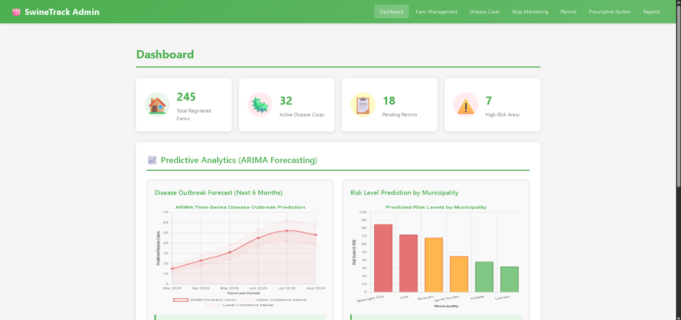
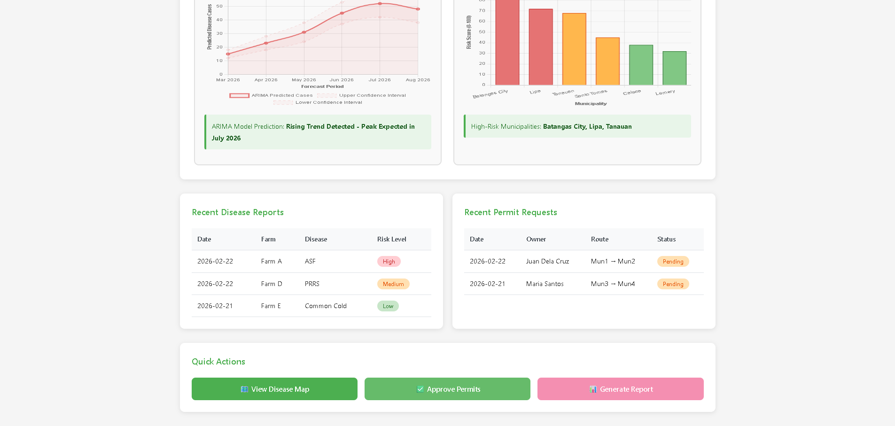

ADMIN MAO FARM MANAGEMENT
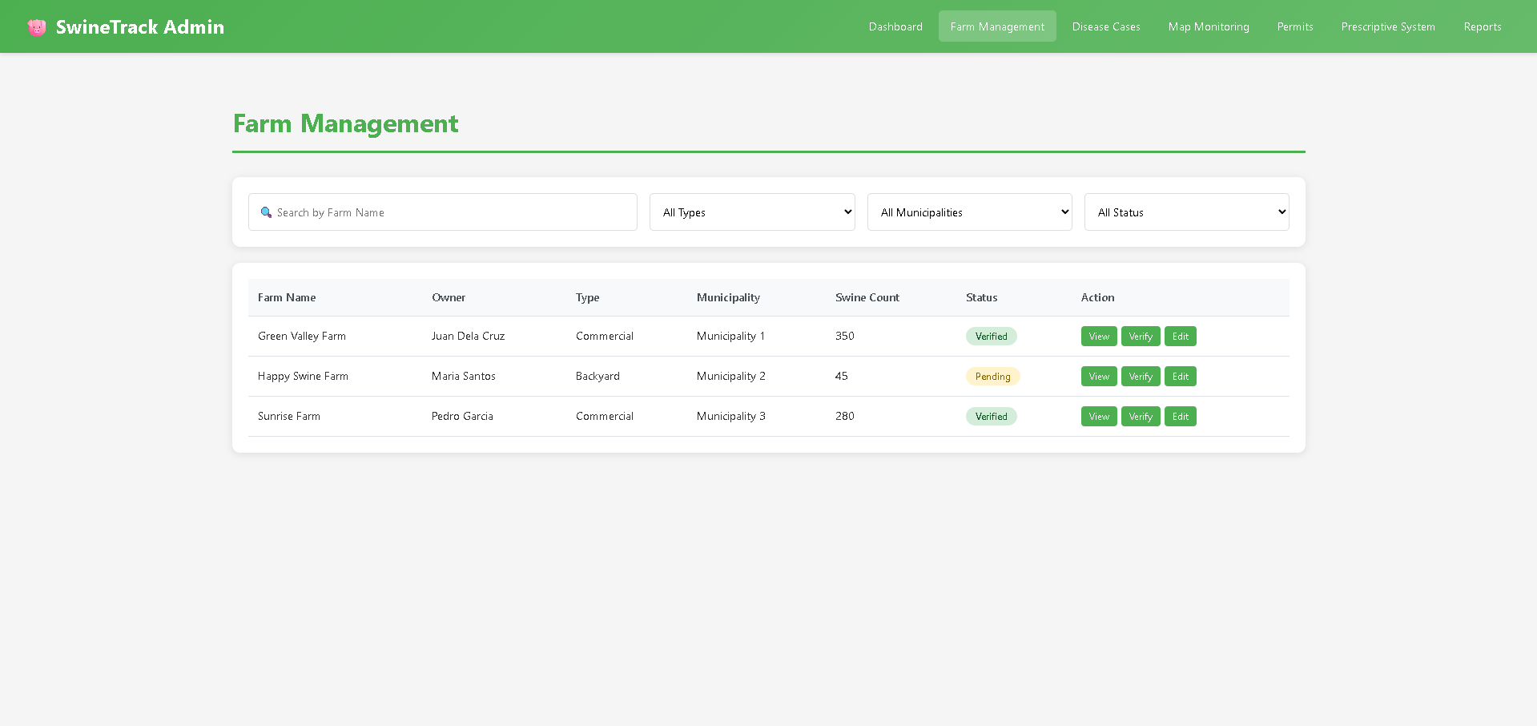
ADMIN MAO DISEASE CASE MANAGEMENT
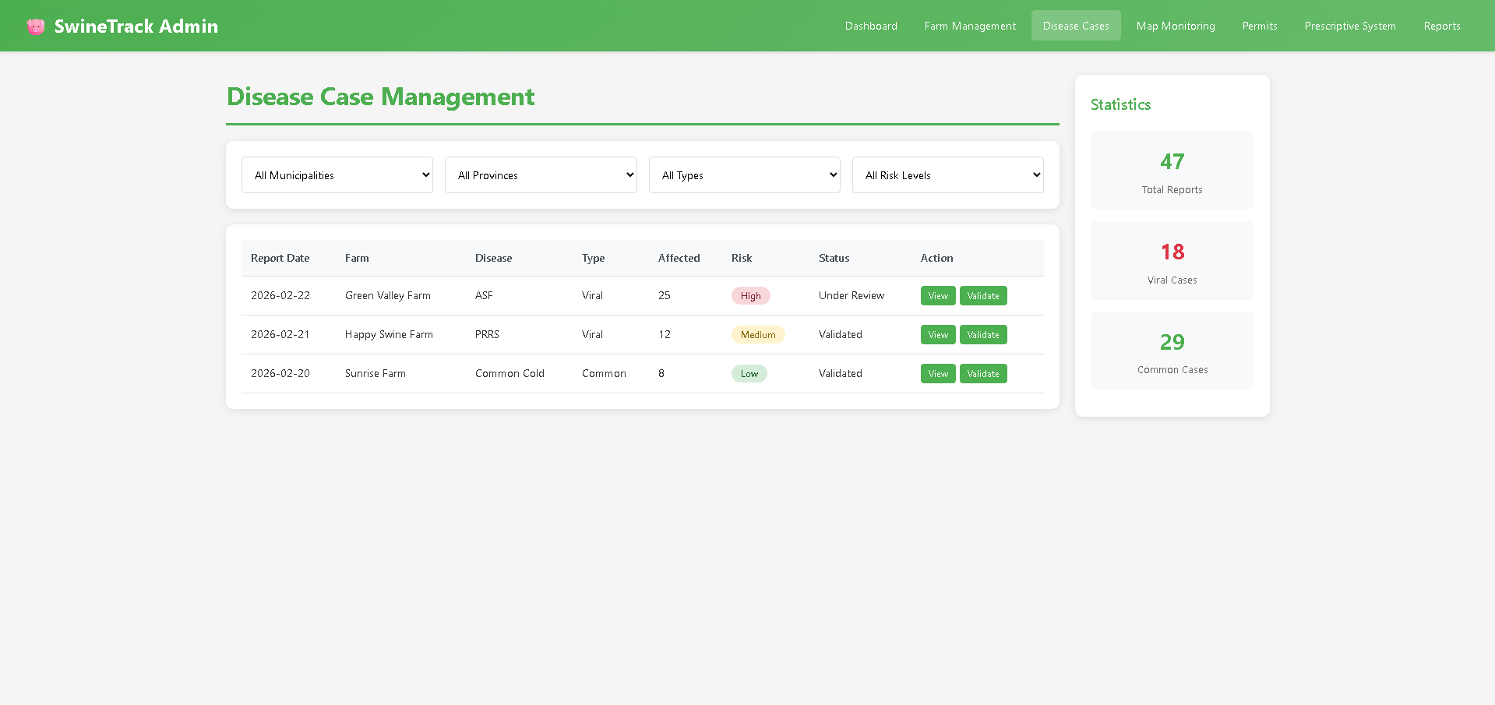

ADMIN MAO MAP MONITORING
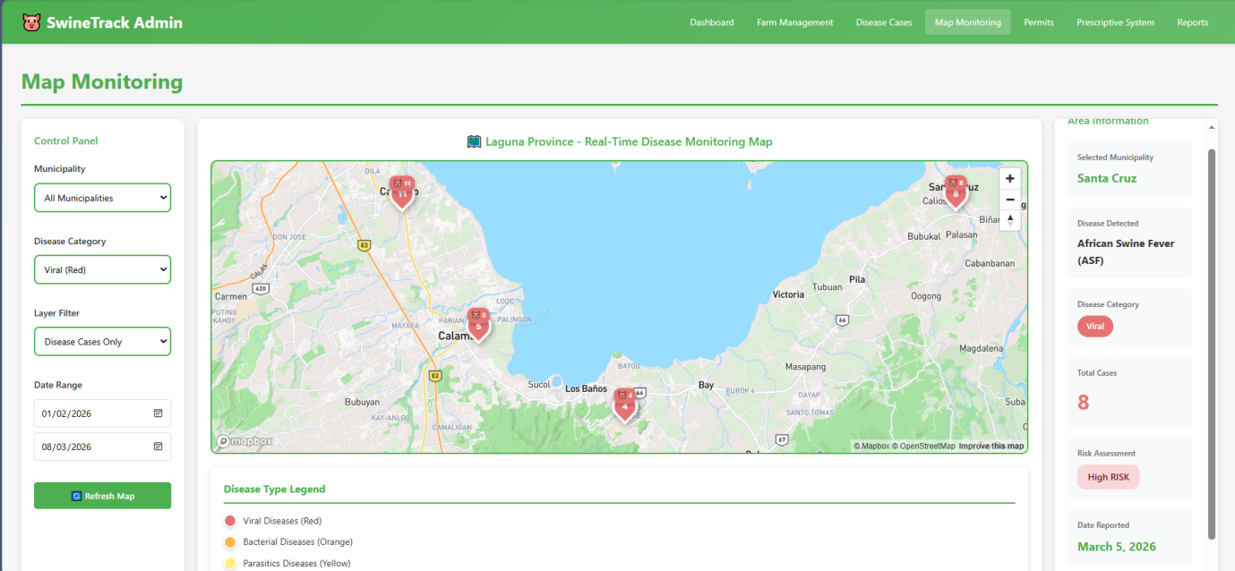

ADMIN MAO PERMIT MANAGEMENT
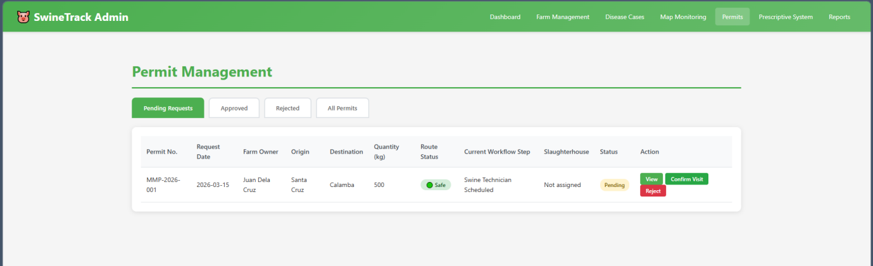
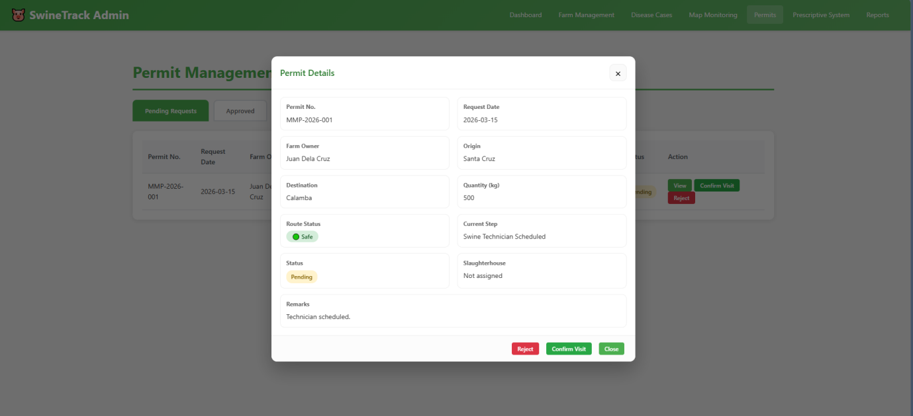

ADMIN MAO PRESCRIPTIVE SYSTEM AND RECOMMENDATION
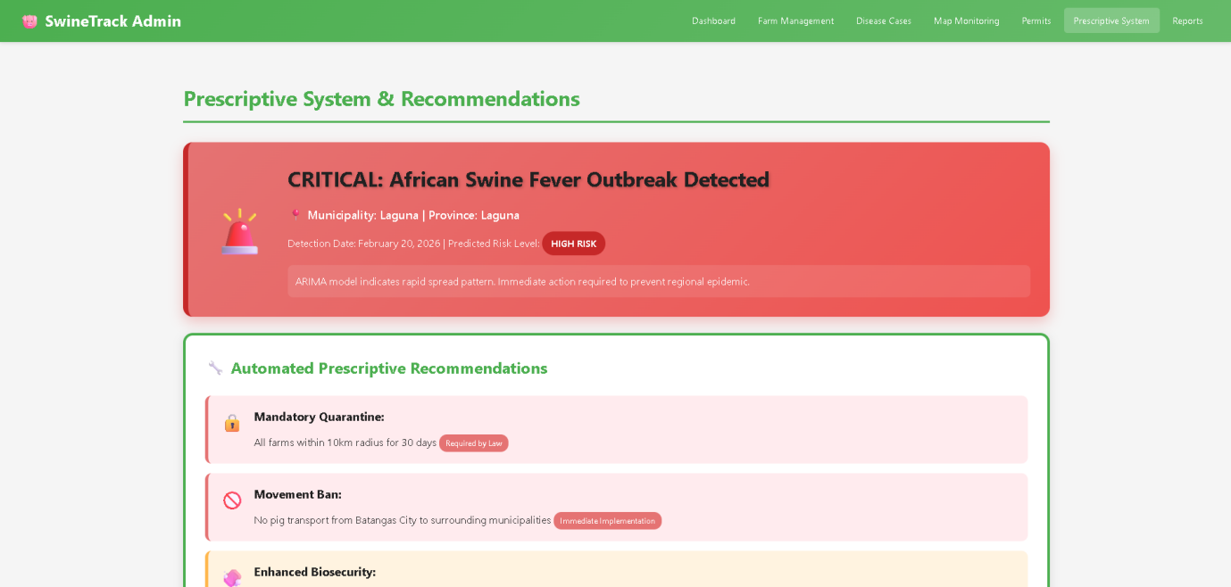
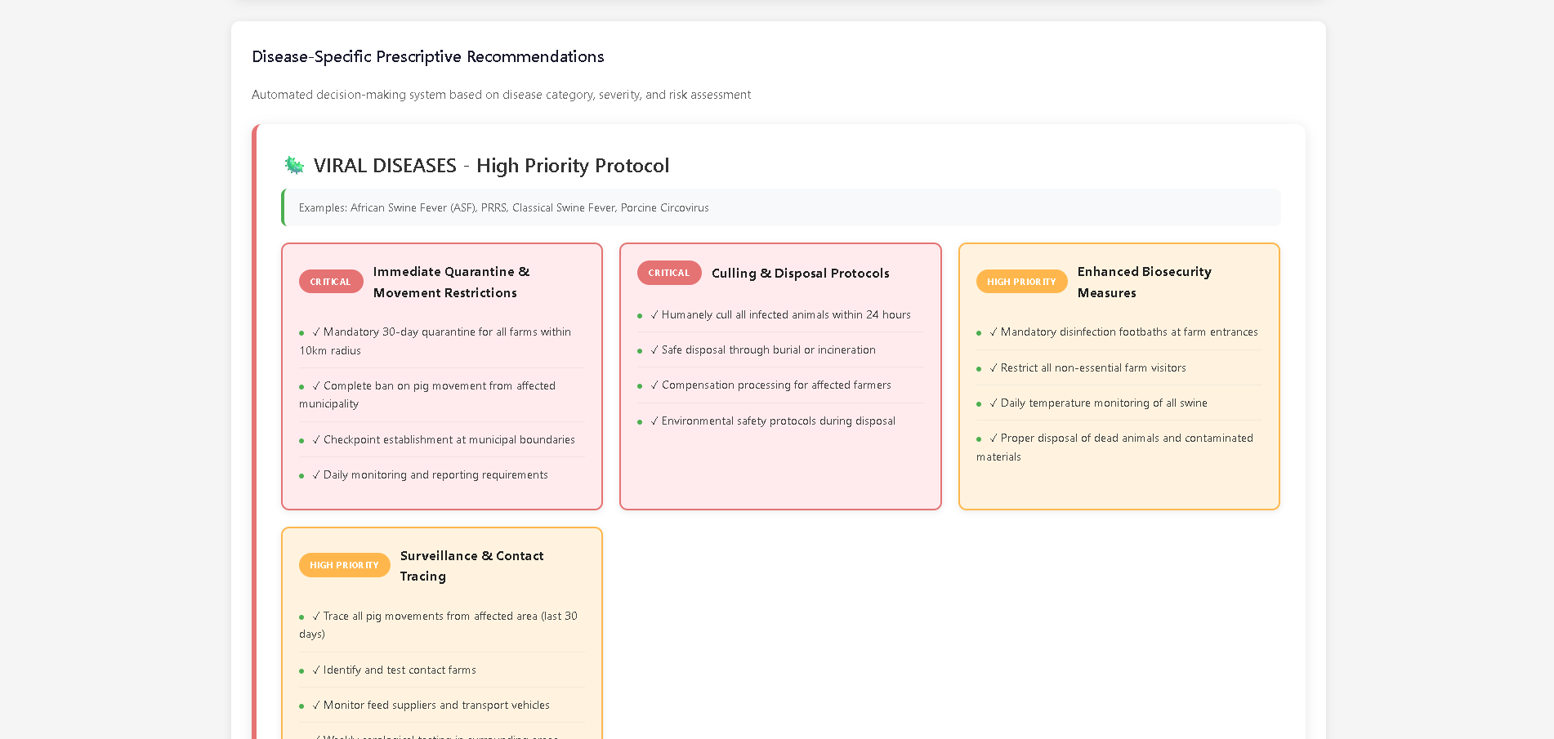
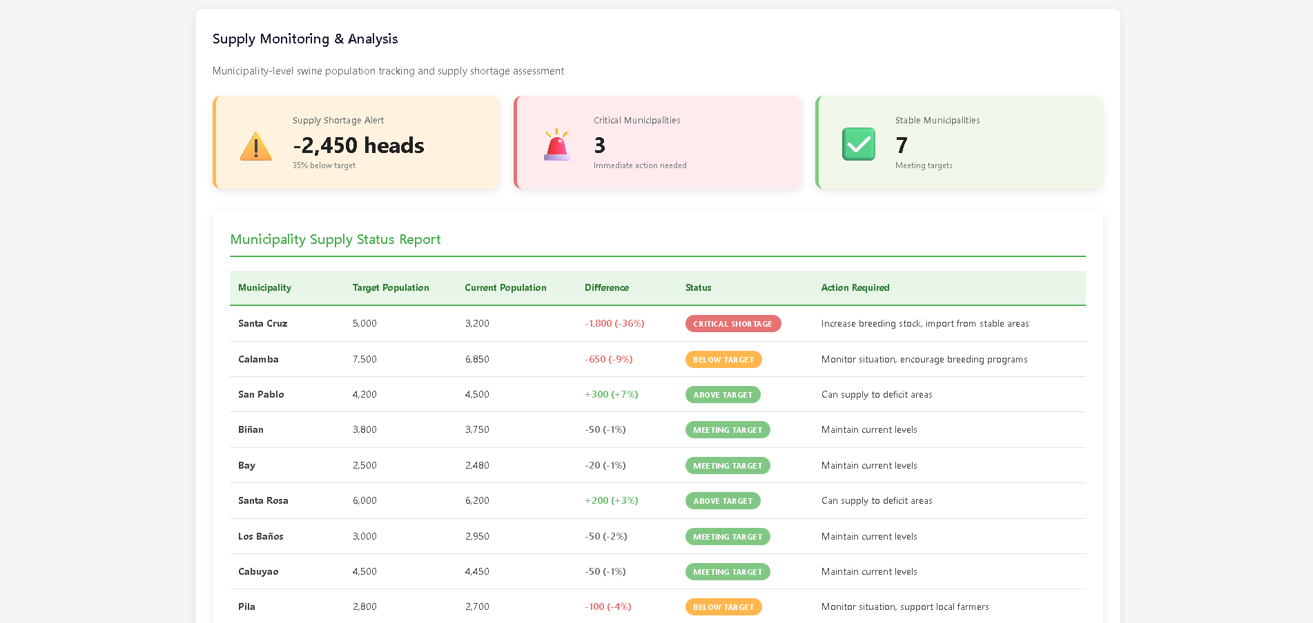
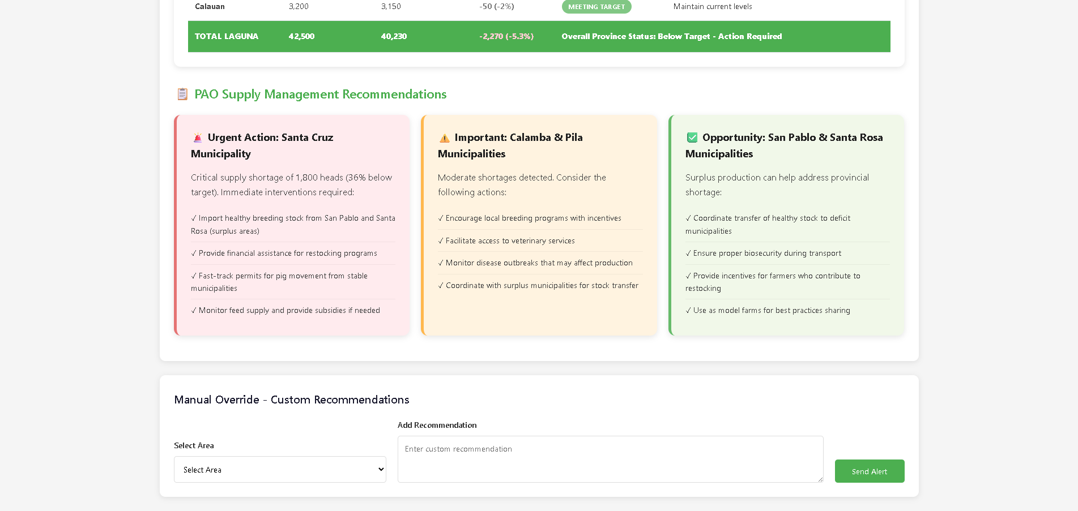

ADMIN MAO REPORTS AND ANALYTICS
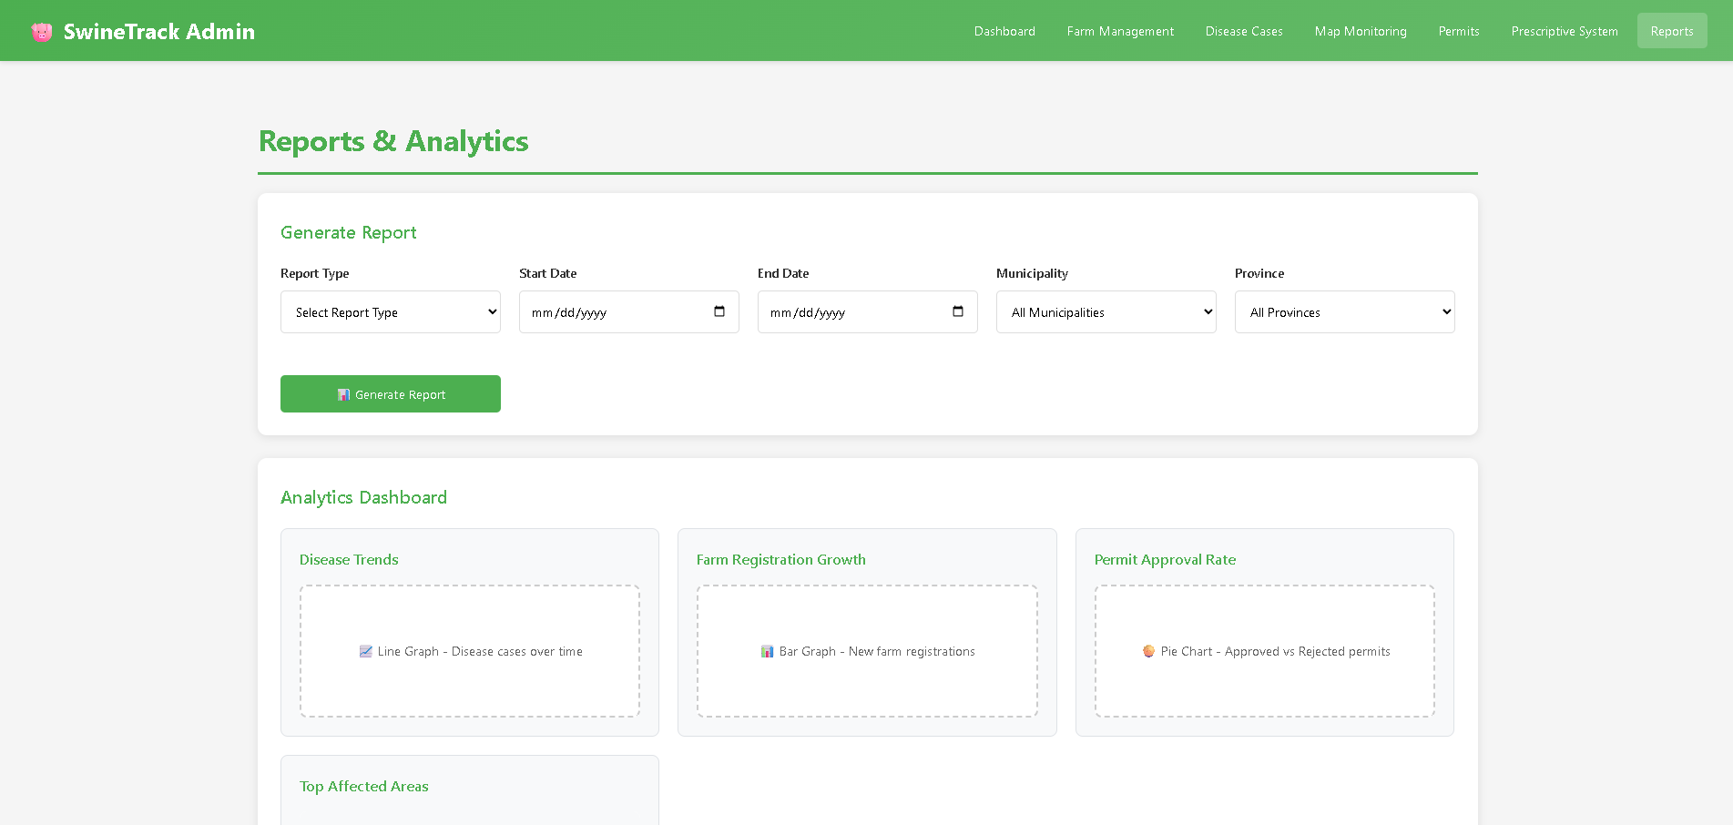

FARMER – FARM REGISTRATION
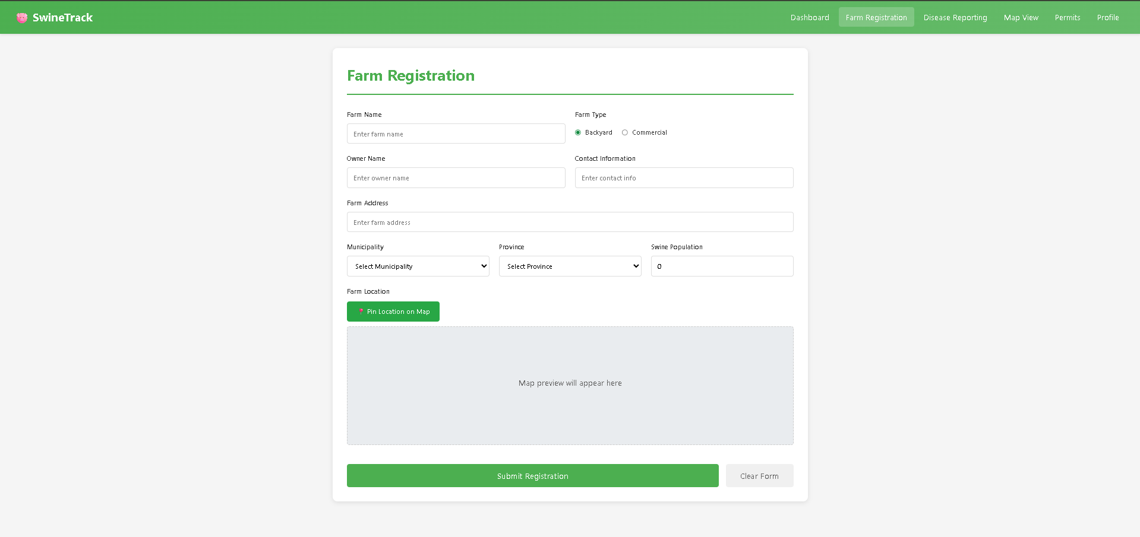

FARMER DISEASE REPORTING
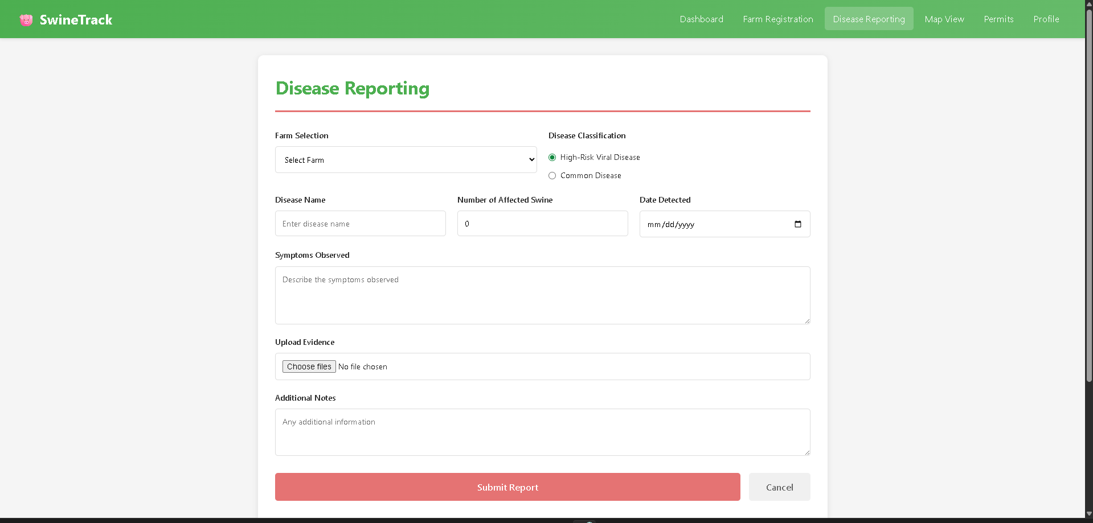

FARMER – MAP VIEW
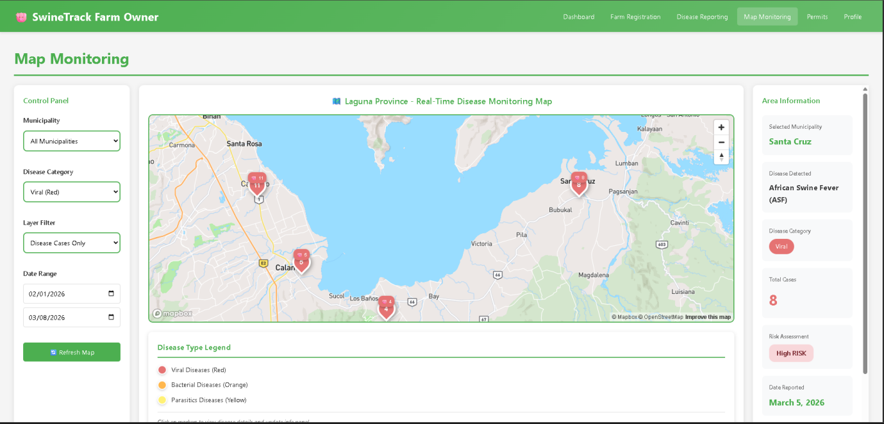

FARMER – PERMIT
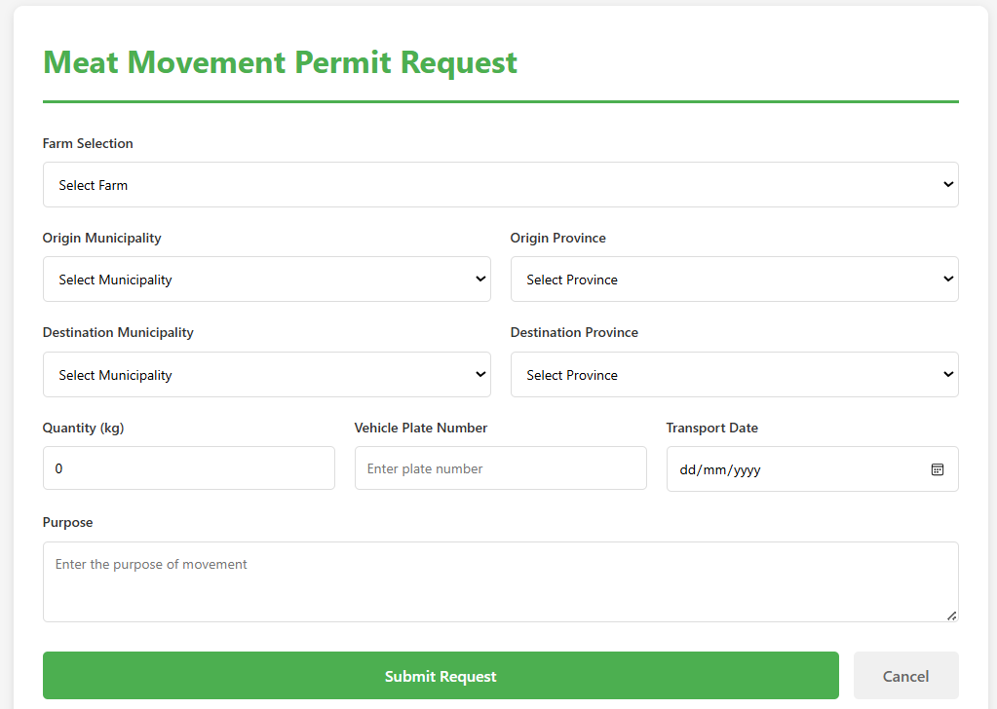
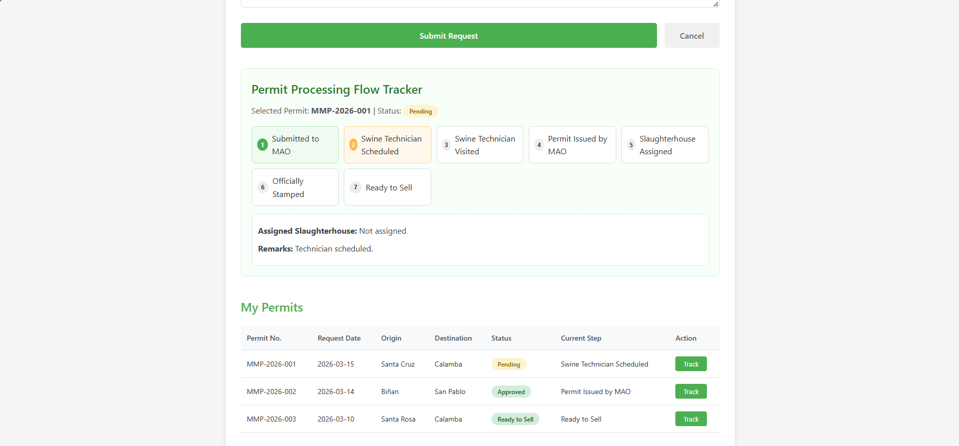

FARMER – PROFILE
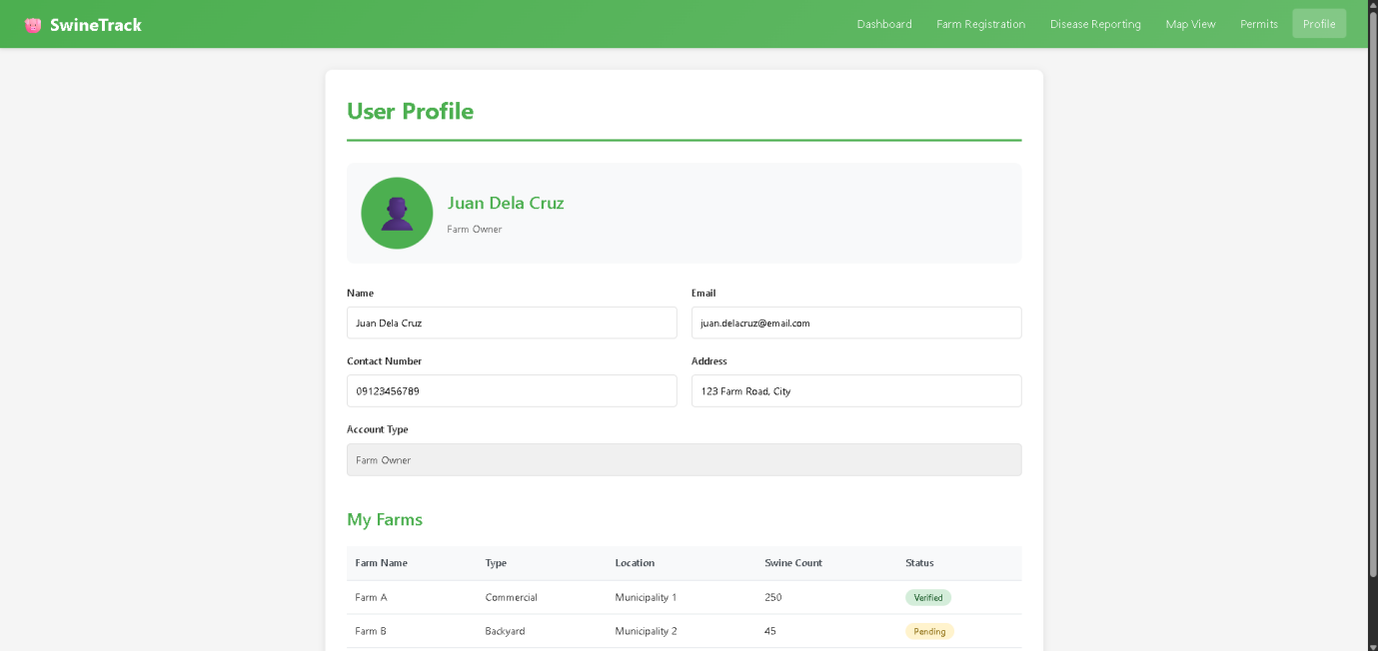

PAO DASHBOARD
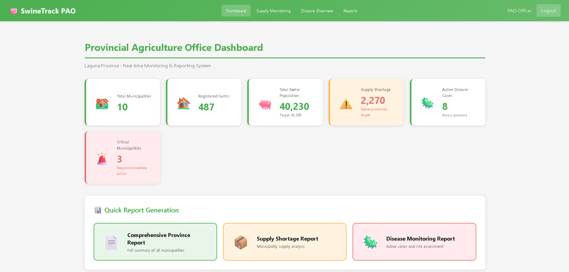
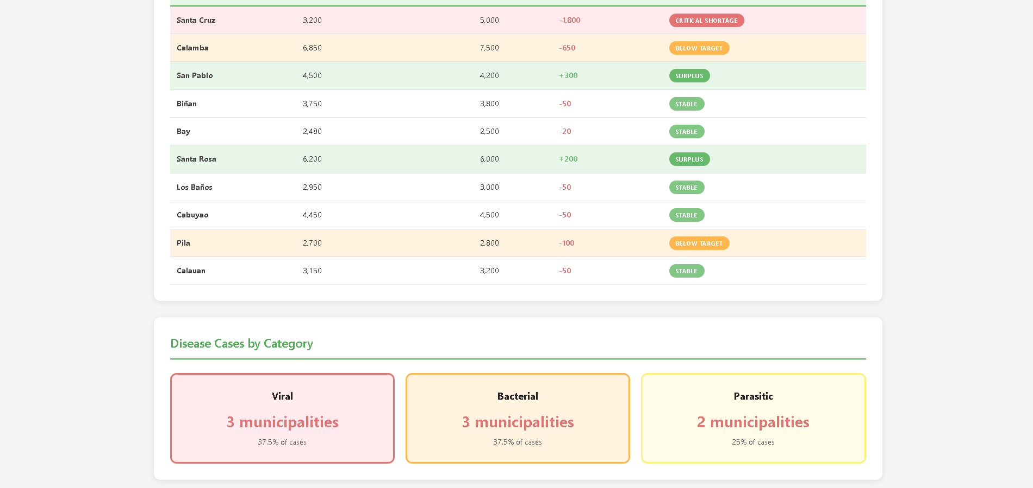

PAO SUPPLY MONITORING
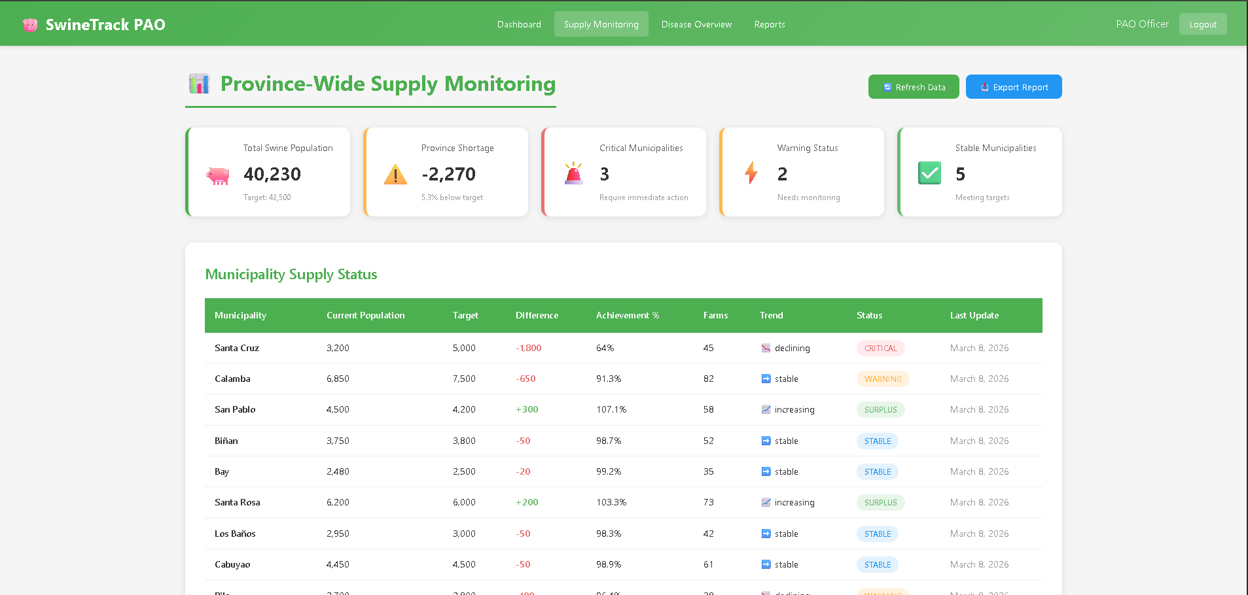
PAO DIEASE OVERVIEW
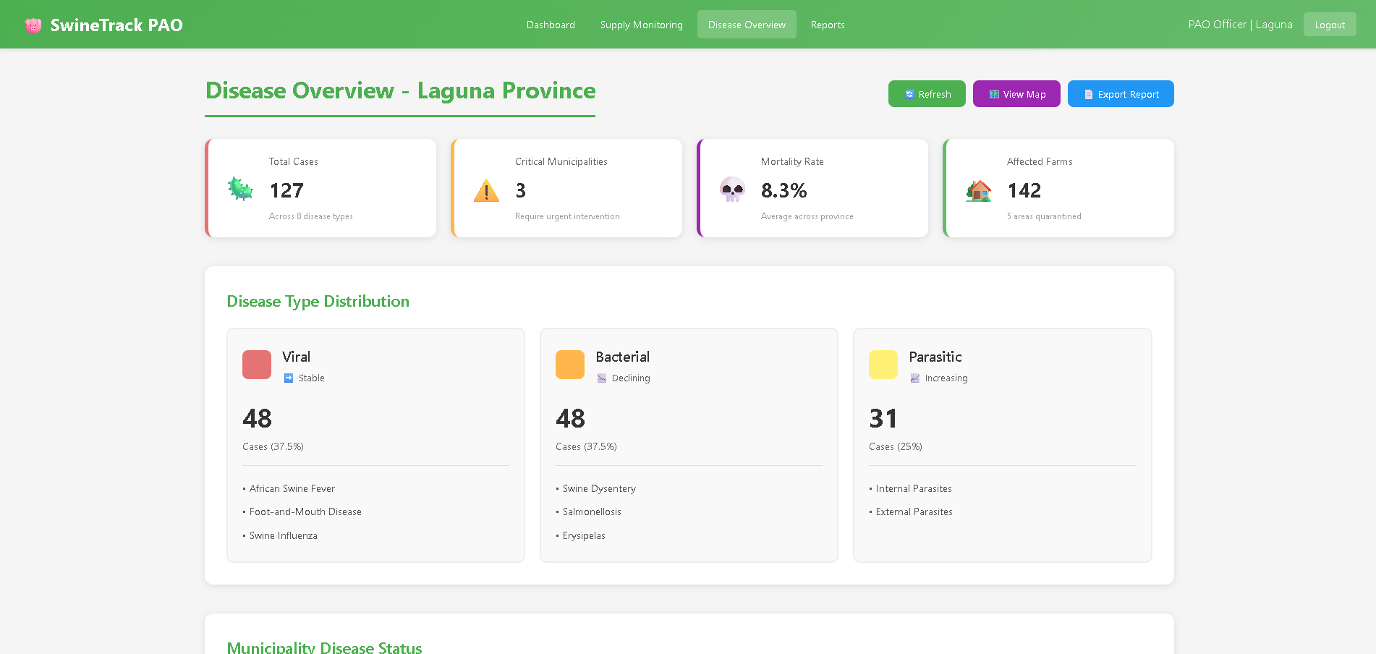
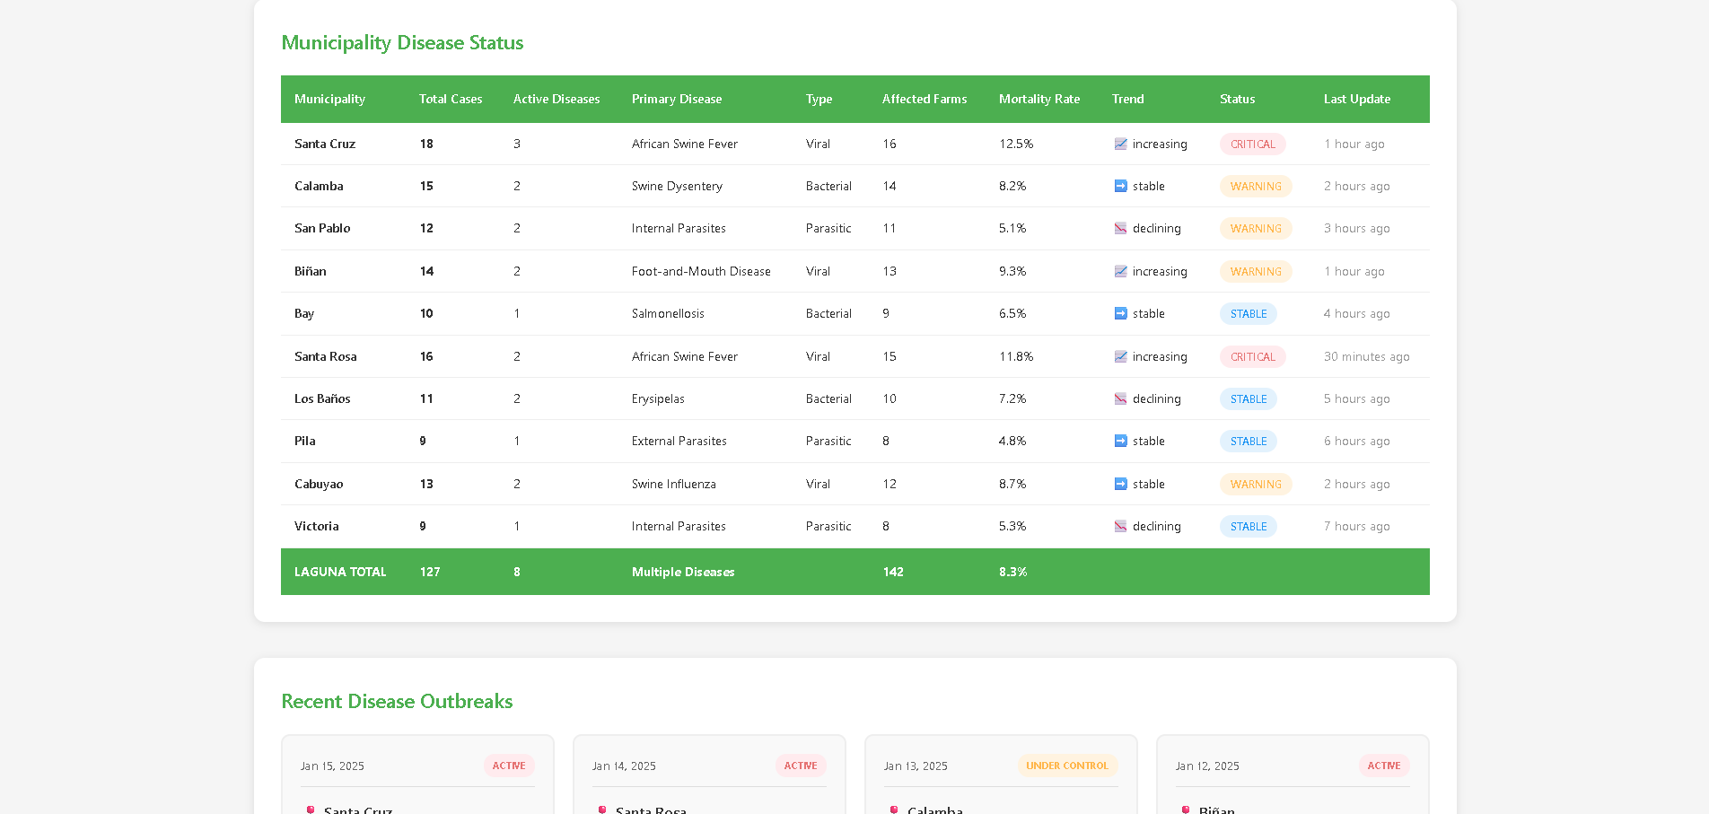
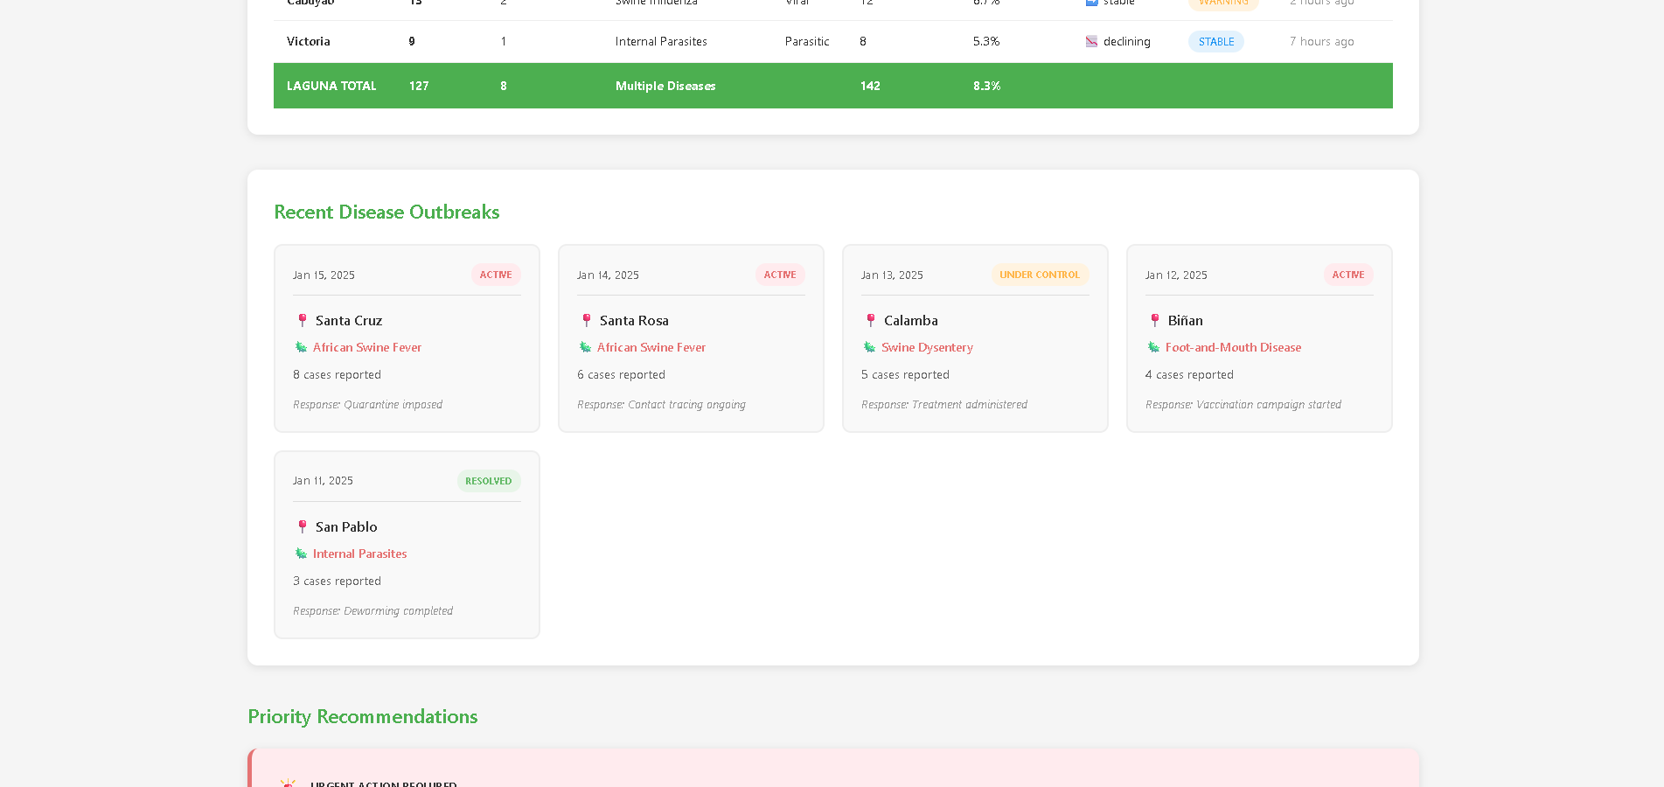

PAO MAP MONITORING
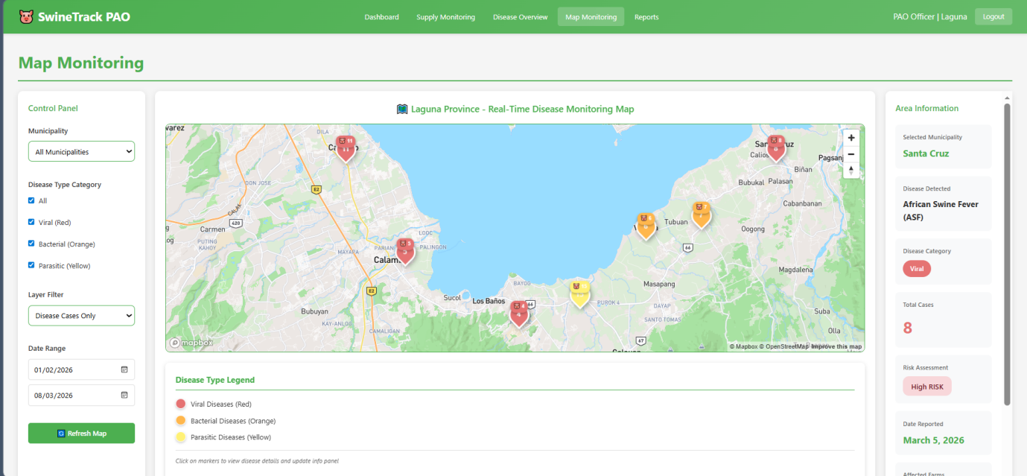

PAO REPORTS
