[NOTICE DATE]

[COUNTERPARTY LEGAL NAME]
[ADDRESS LINE 1]
[CITY, STATE ZIP]
Attention: [CONTACT NAME], [CONTACT TITLE]

Sent via [DELIVERY METHOD] and via email to: [COUNTERPARTY EMAIL]

Re: [NOTICE TYPE] — [AGREEMENT TITLE] dated [AGREEMENT EFFECTIVE DATE]

{{GREETING LINE}}

{{BODY OF NOTICE}}

Sincerely,

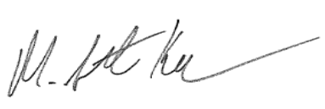

Scott Kerr
Senior Vice President, General Counsel
Q2 Software, Inc.

