3.3 Counter Core
Counter Divider:
Configurable Timer Speed: Counter increments based on system clock by default (div_val=0) or a scaled clock defined by TCR.div_en and TCR.div_val[3:0].
Configuration Locking: Dynamic updates to div_en and div_val are strictly blocked while timer_en is HIGH.
Error Handling: Triggers an error response if write access to prescaler registers occurs during active counting.
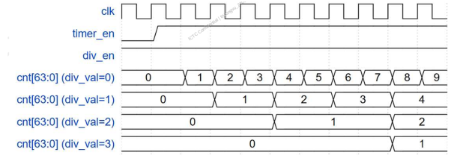
FIGURE: WAVEFORM OF COUNTER_DIVIDER
Timer Activation (timer_en): The counter cnt[63:0] remains idle at 0 and starts incrementing only after timer_en transitions HIGH.
Division Rate Formula: The counter increment rate is scaled by div_val, where the counter increments once every div_val + 1 clock cycles.
Default Speed (div_val = 0): The counter increments at full speed on every single clk cycle.
Prescaled Speed Examples:
- div_val = 1: Increments every 2 clock cycles (1/2 system clock frequency).
- div_val = 2: Increments every 3 clock cycles (1/3 system clock frequency).
- div_val = 3: Increments every 4 clock cycles (1/4 system clock frequency).
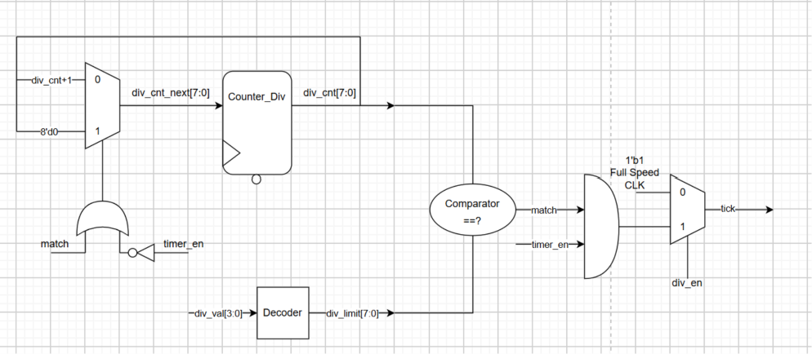
FIGURE: LOGIC DIAGRAM OF COUNTER_DIVIDER
Descriptions:
Prescaled Tick Generation: Generates a single-clock-cycle tick pulse based on the configured division setting (div_val) to control the main counter increment rate without creating a separate clock domain.
Dual-Mode Operation: Supports both full-speed system clock counting (div_en = 0, forcing continuous tick = 1) and prescaled counting (div_en = 1, outputting periodic tick pulses).
Automatic Hardware Reset: Automatically clears the 8-bit prescaler counter (div_cnt) back to 8'd0 whenever a limit match occurs or when timer_en drops LOW (0).
Counter Core:
64-bit Count-Up Architecture: Implements a 64-bit count-up counter that operates either at full system clock speed (default mode) or a prescaled rate configured via TCR.div_en and TCR.div_val.
Hardware Auto-Clear on Disable: Automatically resets the 64-bit counter register (TDR) to its initial value (64'h0) by hardware when timer_en transitions from HIGH to LOW (H → L).
Hardware Debug Halt Support: Fully supports debug halted mode, freezing the counter value when halt_ack is active during debug mode without clearing the register.
Automatic Recovery: Resumes normal count-up operation seamlessly from its initial state once timer_en is re-asserted.
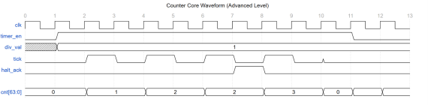
FIGURE: WAVEFORM OF COUNTER_CORE
Timer Enable & Start: The counter cnt[63:0] remains idle at 0 while timer_en is LOW, and begins counting only after timer_en transitions HIGH at cycle 1.
Prescaled Counting (div_val = 1): With div_val = 1, the tick signal asserts every 2 clock cycles, causing cnt[63:0] to increment (0 -> 1 -> 2) strictly on active ticks.
Debug Halt Override: At cycle 7, halt_ack is asserted alongside tick, freezing cnt[63:0] at value 2 and preventing the increment.
Resume Counting: Once halt_ack drops back to 0 at cycle 8, the next valid tick pulse resumes counting, advancing cnt[63:0] from 2 -> 3.
Hardware Auto-Clear: When timer_en transitions LOW at cycle 11, hardware automatically clears cnt[63:0] back to 0.
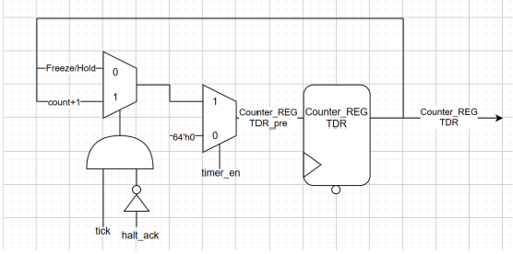
FIGURE: LOGIC DIAGRAM OF COUNTER_CORE
Descriptions:
Cascaded Priority Control: Uses a two-stage MUX pipeline where module enable (timer_en) holds top priority over counting (tick) and debug halt (halt_ack) conditions.
Hardware Auto-Clear (timer_en): When timer_en is LOW (0), the stage-2 MUX selects 64'h0, forcing Counter_REG TDR to reset to its initial value.
Conditional Increment Logic: Increments the counter (count + 1) via the stage-1 MUX only when tick is active and debug halt is negated (tick & ~halt_ack = 1).
Freeze & Hold State: Holds the current count value by feeding TDR output back into the input whenever halt_ack = 1 (debug mode) or tick = 0 (prescaling delay).

