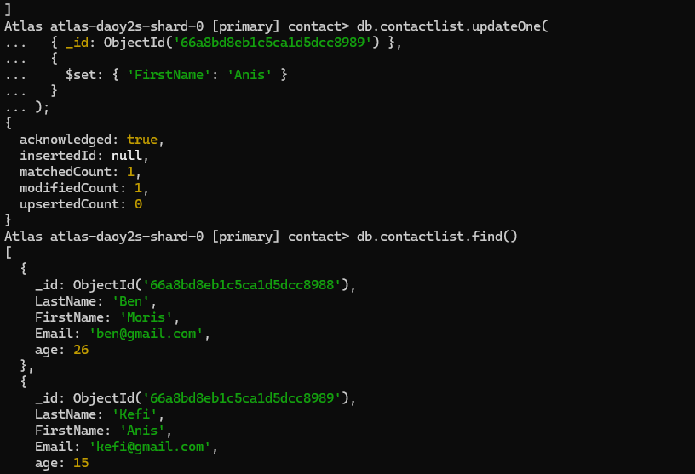

]

Atlas atlas-daoy2s-shard-0 [primary] contact> db.contactlist.updateOne( { _id: ObjectId('66a8bd8eb1c5ca1d5dcc8989') },

{

$set: { 'FirstName': 'Anis' }

}

);

{

acknowledged: true,

insertedId: null,

matchedCount: 1,

**modifiedCount: 1,**

}

upsertedCount: 0

**Atlas atlas-daoy2s-shard-0 [primary] contact> db.contactlist.find()**

[

{

},

{

_id: ObjectId('66a8bd8eb1c5ca1d5dcc8988'),

LastName:

'Ben',

FirstName: 'Moris',

Email: 'ben@gmail.com',

age: 26

_id: ObjectId('66a8bd8eb1c5ca1d5dcc8989'), LastName: 'Kefi',

FirstName: 'Anis',

Email: 'kefi@gmail.com', age: 15