

**RELATIONAL DATABASE (mysql)**

**Children crèche and after school Center**



**April 27, 2018**

**Modelfarm road chilcare**

**IDA Technology & Business Park, Model Farm Road, Cork**

Table of Contents

Introduction 3

Background 3

Entity/Attribute 3

Staff 3

Child 3

Class room 4

Definition of Normalization 4

1NF 4

2NF 4

3NF 4

Unsort data: 5

Attribute 5

1NF 5

**Child** ( 5

2NF 5

**Child Care** 5

**Class room** 5

3NF 5

**Staff** 5

**Child** 5

**Class Room** 5

**Childcare** 5

Entity-Entity Matric 6

Model Farm Road Childcare creche 6

Basic ER Diagram 6

Details ER Diagram 7

Data Dictionary 8

Staff 8

Child 9

Class Room 10

Child Care 10

Data insertion form 11

Staff Form 11

Child Form 12

Class Room form 13

Child Care Form 13

Query 14

Query result 14

Code for creating Staff table 16

Code to insert data on staff table 17

Result after change 18

Child table code creation 18

Child data insertion 19

Class room code for creating table 20

Code to insert data into Classroom 20

Code to create Child_Care Table 21

Child Care data insertion 21

Conclusions 22

Reference 22

# Introduction

## Background

Model Farm Road Childcare is a Montessori and after school day care for children. It is situated at IDA Technology & Business Park, Model Farm Road Cork. Model Farm Road Childcare was established in September 2016, manage by Elaine Birmingham.

Presently, Model Farm Road has 25 teachers, 70 children, 15 rooms 2 cook, one manager. Model Farm Road Childcare is at present using files and a computer to store their data. It is very difficult to keep track of payment for each child on a weekly basis and searching for children’s records can be time consuming.

A database system would give the manager quick access to children’s data and enable them to check records of payment as there would be a payment entry form which will allow entry to database and can be accessed anywhere by an employee.

# Entity/Attribute

## Staff

* Staff-No
* First-Name
* Last-Name
* Address
* Qualification
* Shift
* Job-Title
* Phone
* Work-Hours
* Salary

## Child

* Child-No
* First-Name
* Last-Name
* Address
* Medical-Condition
* Allergy
* Date-of-Birth
* Fees
* Due-fees
* Gender
* Start-Date
* Finished-Date

## Class room

* Class-No
* Class-Type
* Size-of-Room

# Definition of Normalization

Normalization is the process of organizing data in a database. This includes creating tables and establishing relationships between those tables according to rules designed both to protect the data and to make the database more flexible by eliminating redundancy, inconsistency and for security reason.

## 1NF

1NF disallow composite attribute whose values for an individual tuple are not atomic. In 1NF we eliminate duplicate columns from same table and create separate table for each related group of data with its own primary key.

## 2NF

2NF enable to add new rule after satisfying 1NF rule by removing subsets of data type to multiple rows of a table and place them in separate table then create relationships between these table and their predecessor through foreign key.

## 3NF

3NF enable to apply new rules after satisfying 1NF and 2NF. This eliminates functional dependency on non-primary key fields to depend on primary key and reference parent table.

# Unsort data:

## Attribute

**Crèche** (Staff-No, First-Name, Last-Name, Address, Qualification, Shift, Job-Title, Phone, Work-Hours, Salary, Child-No, First-Name, Last-Name, Address, Medical-Condition, Allergy, Date-of-Birth, Fees, Due-fees, Gender, Start-Date, Finished-Date, Parent-Name, Parent-Phone, Class-No, Class-Type, Size-of-Room).

## 1NF

**Child** (Child-No, Staff-No, First-Name, Last-Name, Address, Medical-Condition, Allergy, Date-Of-Birth, Fees, Due-Fees, Gender, Start-Date, Finished-Date, Shift, Qualification, Job-Title, Phone, Work-Hour Salary)

**Child Care** (Child-No, Class-No, Class Type, Room Size)

## 2NF

**Child Care** (Child-No, Class-No)

Child (Child-No, Staff-No, First-Name, Last-Name, Address, Class-No, Medical-Condition, Allergy, Date-of-Birth, Fees, Due-Fees, Start-Date, Finished-Date, Gender, Address, Qualification, Job-Title, Phone, Work-Hour, Salary)

**Class room** (Class-No, Type, Room-Size, Location)

## 3NF

**Staff** (Staff-No, First-Name, Last-Name, Address, Shift, Qualification, Job-Title, Phone, Work-Hours, Salary)

**Child** (Child-No, Staff-No, First-Name, Last-Name Address, Medical-Condition, Allergy, Date-Of-Birth, Fees, Due-Fees, Start-Date, Finished-Date, Gender)

**Class Room** (Class-No, Staff-No, Class Type, Location, Size)

**Childcare** (Child No, Class No)

# Entity-Entity Matric

## Model Farm Road Childcare creche

|  |  |  |  |  |
| --- | --- | --- | --- | --- |
| **Entity Name** | **Staff** | **Child** | **Class Room** | **Child Care** |
| **Staff** |  | **M:1** |  |  |
| **Child** | **1:M** |  |  | **M:1** |
|  |  |  |  | **M:1** |
|  |  | **1:M** | **1:M** |  |

## Basic ER Diagram

Looked after by M:1

|  |
| --- |
| **Child** |

|  |
| --- |
| **Staff** |

Provide with M:1

|  |
| --- |
| **Class Room** |

Minded by M:1

|  |
| --- |
| **Child care** |

## Details ER Diagram

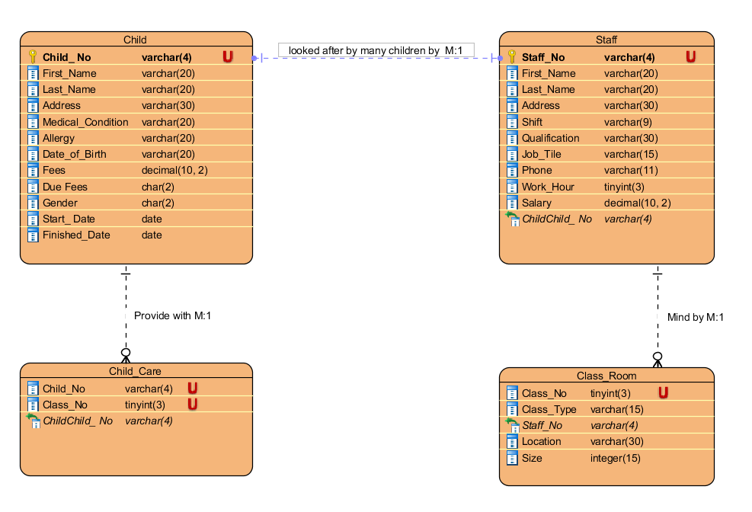

# Data Dictionary

## Staff

|  |  |  |  |  |  |  |
| --- | --- | --- | --- | --- | --- | --- |
| **Attribute**  **Name** | **Description** | **Key** | **Data Type** | **Length** | **Validation/Check** | **Default Value** |
| **Staff No** | **Identifying No of Staff** | **Primary key** | **Varchar** | **4** |  |  |
| **First Name** | **Staff’s First Name** |  | **Varchar** | **20** |  |  |
| **Last Name** | **Staff’s Last Name** |  | **varchar** | **20** |  |  |
| **Address** | **Address of Staff** |  | **varchar** | **30** |  |  |
| **Shift** | **Staff shift** |  | **varchar** | **9** |  |  |
| **Qualification** | **Staff Qualification** |  | **varchar** | **30** | **Level 5, level 6 and HND diploma.** |  |
| **Job Title** | **Staff Job Title** |  | **varchar** | **15** | **Manager, Cook, Supervisor and Cleaner, Junior teacher** |  |
| **Phone** | **Staff Phone No** |  | **varchar** | **11** |  |  |
| **Work Hours** | **Staff Working Hour** |  | **tinyint** |  |  |  |
| **Salary** | **Staff Salary** |  | **decimal** | **(10,2)** |  |  |

## Child

|  |  |  |  |  |  |  |
| --- | --- | --- | --- | --- | --- | --- |
| **Attribute**  **Name** | **Description** | **Key** | **Data Type** | **Length** | **Validation/Check** | **Default Value** |
| **Child No** | **Identifying No of Child** | **Primary key** | **Varchar** | **4** | **Identity (1,1)** |  |
| **First Name** | **Child’s First Name** |  | **Varchar** | **20** |  |  |
| **Last Name** | **Child’s Last Name** |  | **varchar** | **20** |  |  |
| **Address** | **Child Address** |  | **varchar** | **100** |  |  |
| **Medical Condition** | **Identifying Child Medical Condition** |  | **varchar** | **20** |  |  |
| **Allergy** | **Identifying Child Allergy** |  | **varchar** | **20** |  |  |
| **Date-of-Birth** | **Identifying Age of the Child** |  | **Date** |  |  |  |
| **Fees** | **Identifying fees value** |  | **Decimal** |  |  |  |
| **Due Fees** | **Child fee due** |  | **Char** | **‘Y’ ‘N ‘** | **Field** |  |
| **Gender** | **Sex Type** |  | **Char** |  | **‘F’ ‘M‘** |  |
| **Start Date** | **Date** |  | **Date** |  |  |  |
| **Finished Date** | **Date** |  | **Date** |  |  |  |

## Class Room

|  |  |  |  |  |  |  |
| --- | --- | --- | --- | --- | --- | --- |
| **Attribute**  **Name** | **Description** | **Key** | **Data Type** | **Length** | **Validation/Check** | **Default Value** |
| **Class No** | **Identifying No of Class** | **Primary key** | **int** |  | **Identity (1,1)** |  |
| **Class type** | **Identifying type of Class** |  | **Varchar** | **15** |  |  |
| **Size of room** | **Identifying room Size** |  | **varchar** | **15** |  |  |

## Child Care

|  |  |  |  |  |  |  |
| --- | --- | --- | --- | --- | --- | --- |
| **Attribute**  **Name** | **Description** | **Key** | **Data Type** | **Length** | **Validation/Check** | **Default Value** |
| **Child No** | **Identifying No of Child** | **Primary key** | **int** |  | **Must match the child record table** |  |
| **Class No** | **Identifying No of Class** | **Primary key** | **int** |  | **Must match the Class record table** |  |

# Data insertion form

## Staff Form

|  |
| --- |
|  |

## Child Form

|  |
| --- |
|  |

## Class Room form

|  |
| --- |
|  |

## Child Care Form

|  |
| --- |
|  |

# Query

1. To display amount of fees not pay and staff assign to the child.
2. To display name of the staff working morning shift in ascending order
3. Name of child less than 5 years old
4. To display child and staff name working with non-allergy child that not pay fees

## Query result

1. To display amount of fees not pay and staff assign to the child.

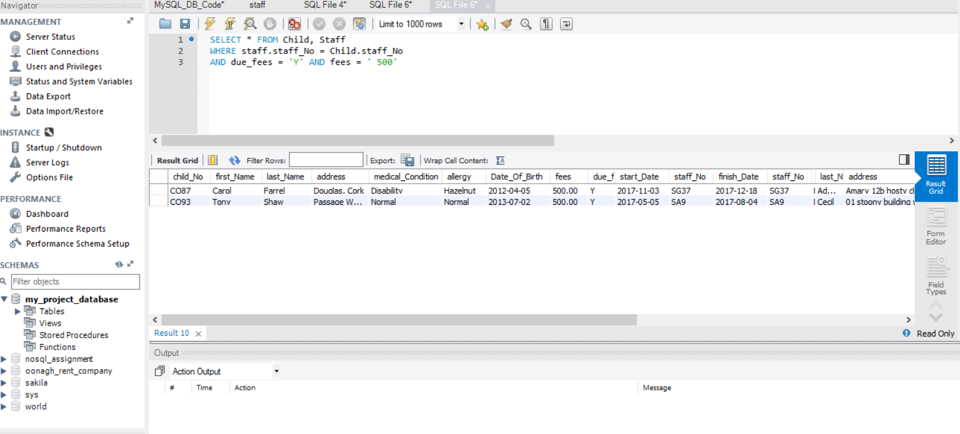

2 .To display name of the staff working morning shift in ascending order

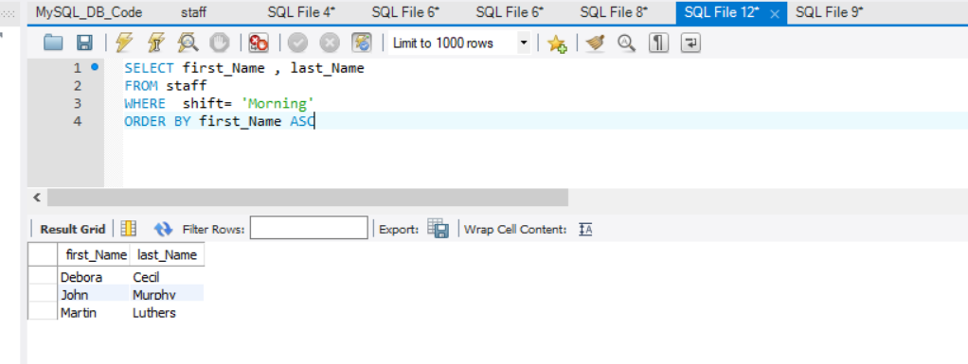

3. Name of child less than 5 years old

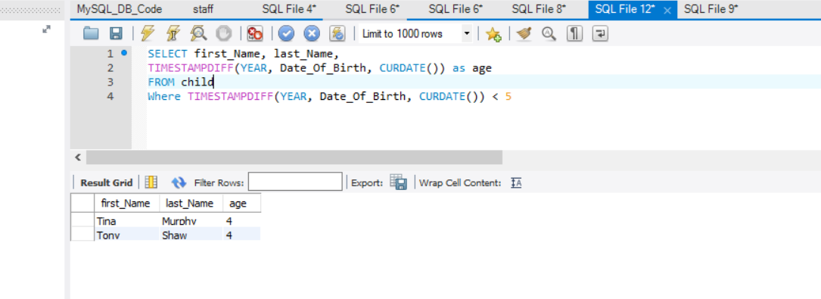

4. To display child and staff name working with non-allergy child that not pay fees

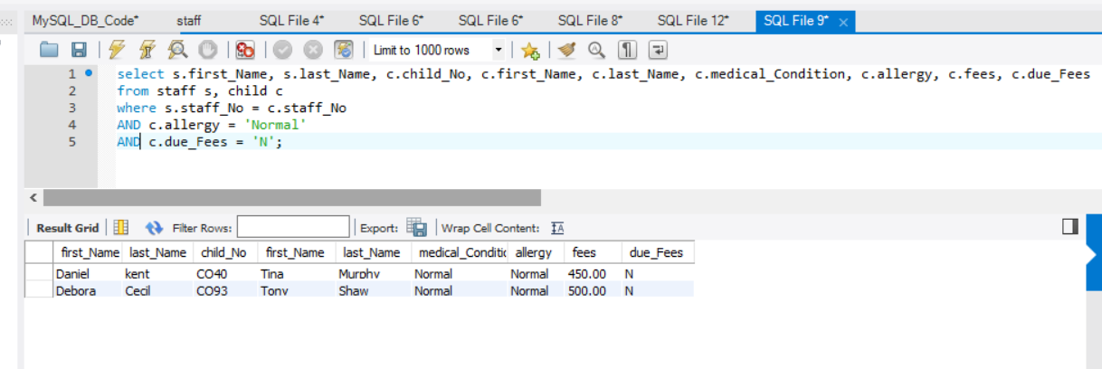

# Code for creating Staff table

CREATE TABLE STAFF(

Staff_No VARCHAR(4) NOT NULL,

First_Name VARCHAR(20),

Last_Name VARCHAR(20),

Address VARCHAR(30),

Shift VARCHAR(9),

Qualification VARCHAR(30),

Job_Title VARCHAR(15),

phone VARCHAR(11),

work_Hours tinyint,

salary DECIMAL,

PRIMARY KEY (staff_No)

);

# Code to insert data on staff table

INSERT INTO STAFF VALUES('SL21', 'Martin', 'Luthers', '12 Eagle valley''Wilton, Cork', 'Morning', 'QQI Level 5', 'Teacher', '087-4363853','17', 30000);

INSERT INTO STAFF VALUES('SG37', 'Faith', 'Aderson', 'Amary 12b hosty close' 'Bishoptown, Cork', 'Evening', 'QQI Level 5', 'Teacher', '021-22563', '18', 12000);

INSERT INTO STAFF VALUES('SG14', 'Daniel', 'kent', 'abey court 16''Model Farm Rd., Cork', 'Evening', 'QQI Level 5', 'Supervisor', '086-6363863', '20', 18000);

INSERT INTO STAFF VALUES('SA9', 'Debora', 'Cecil', '01 stoony building wilton''Laburnum, Cork', 'Morning', 'QQI Level 6', 'Assistant', '085-3639652', '15', 9000);

INSERT INTO STAFF VALUES('SG5', 'Anita', 'Joanna', '43 D Errica house''Ballincollig, Cork', 'Evening', 'QQI Level 7', 'Manager', '086-6398693', '24', 24000);

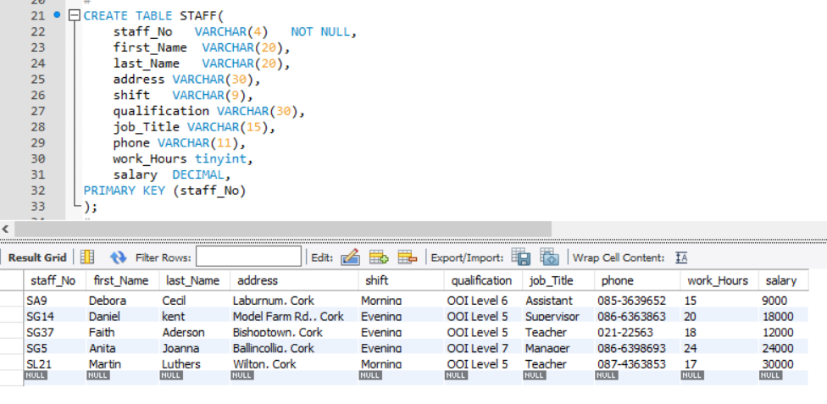

# Result after change

I decided to make changes because address space is too small for some addresses, when am entry data into some tables, then I increase it to varchar (100).

The diagram above show previous data length.

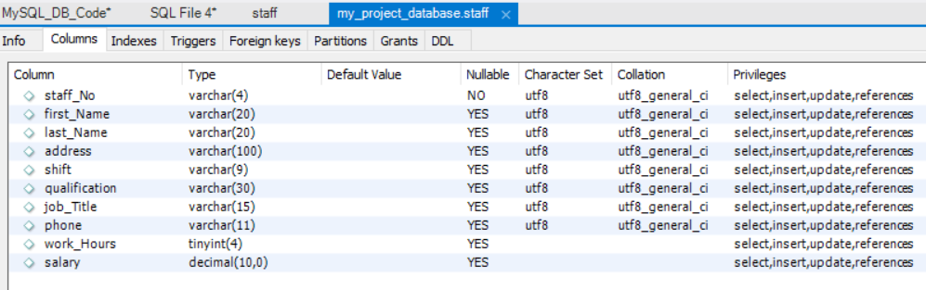

# Child table code creation

CREATE TABLE CHILD(

child_No VARCHAR(4) NOT NULL,

first_Name VARCHAR(20),

last_Name VARCHAR(20),

address VARCHAR(100),

medical_Condition VARCHAR(20),

allergy VARCHAR(20),

Date_Of_Birth DATE,

fees DECIMAL,

due_fees CHAR,

start_Date DATE,

staff_No VARCHAR(4),

finish_Date DATE,

PRIMARY KEY (child_No),

FOREIGN KEY (staff_No) REFERENCES STAFF(staff_No)

);

# Child data insertion

INSERT INTO CHILD VALUES('CO46', 'Joe', 'Keogh', 'Passage West, Cork', 'Asmatic', 'Peanut', '2010-01-10', 45000, 'N', '2017-10-04', 'SL21', '2017-10-07');

INSERT INTO CHILD VALUES('CO87', 'Carol', 'Farrel', 'Douglas, Cork','Disability', 'Hazelnut', '2012-04-05', 50000, 'N', '2017-11-03', 'SG37', '2017-12-18' );

INSERT INTO CHILD VALUES('CO40', 'Tina', 'Murphy', 'Mahon, Cork','Normal', 'Normal', '2014-03-08', 45000, 'Y', '2017-09-08', 'SG14', '2017-12-10');

INSERT INTO CHILD VALUES('CO93', 'Tony', 'Shaw', 'Passage West, Cork','Normal', 'Normal', '2013-07-02', 50000, 'Y', '2017-05-05', 'SA9', '2017-08-04');

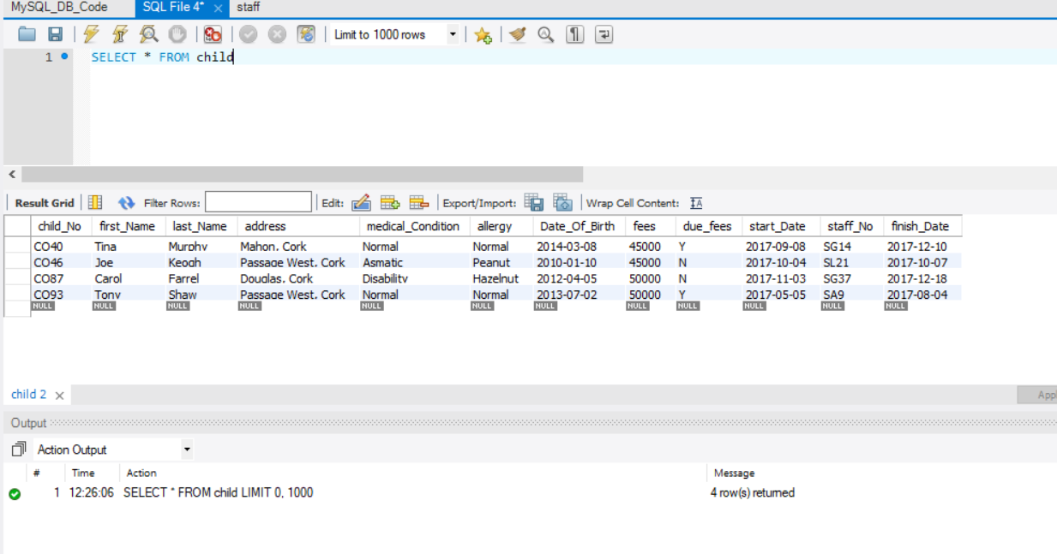

# Class room code for creating table

CREATE TABLE CLASS_ROOM(

class_No tinyint NOT NULL,

staff_No VARCHAR(4),

class_Type VARCHAR(15),

location VARCHAR(30),

size VARCHAR(15),

PRIMARY KEY (class_No),

FOREIGN KEY (staff_No) REFERENCES STAFF(staff_No)

);

# Code to insert data into Classroom

INSERT INTO CLASS_ROOM VALUES(101,'SL21', 'Infant', 'Downstairs', 'Large');

INSERT INTO CLASS_ROOM VALUES(102, 'SG37', 'Middle Age', 'Upstairs', 'Extra Large');

INSERT INTO CLASS_ROOM VALUES(103,'SG14', 'Infant', 'Downstairs', 'Medium');

INSERT INTO CLASS_ROOM VALUES(104, 'SA9', 'Middle Age', 'Upstairs', 'Small');

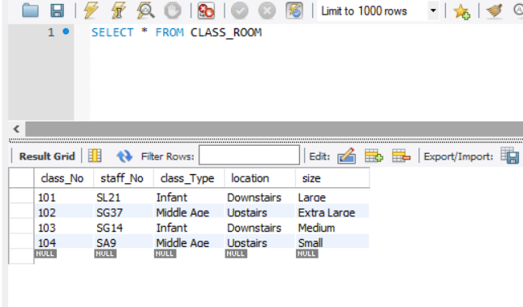

# Code to create Child_Care Table

CREATE TABLE CHILDCARE(

child_No VARCHAR(4),

class_No tinyint,

CONSTRAINT PK_ChildCare PRIMARY KEY (Child_No, Class_No)

FOREIGN KEY (child_No) REFERENCES CHILD(child_No),

FOREIGN KEY (class_No) REFERENCES CLASS_ROOM(class_No)

);

# Child Care data insertion

INSERT INTO CHILDCARE VALUES('CO46', 101);

INSERT INTO CHILDCARE VALUES('CO87', 102);

INSERT INTO CHILDCARE VALUES('CO40', 103);

INSERT INTO CHILDCARE VALUES('CO93', 104);

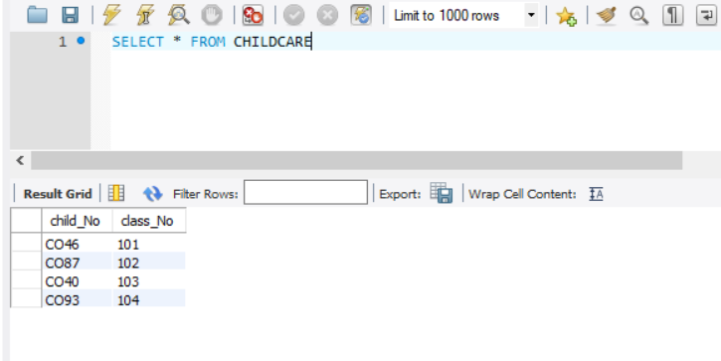

# Conclusions

Following my reviewed, the test I did went smoothly and I had no problems, except for the fact that data grid was difficult to use in layout horizontally. However, the form was still work well. In future, I will like to rearrange form in horizontal as it was done on vertical.

# Reference

Arthur. T 2018, MySQL RDBMS, PowerPoint presentation, Database System Design, Cork Institute of technology Cork. Available from [www.cit.ie](http://www.cit.ie) [ Accessed 2018].

Thomas, C, Carolyn B (2005), ***Database Systems*** *A* Practical Approach to Design, Implementation, and Management: fourth edition, Pearson Education Limited.

***Tutorialsportsimplyeasylearning****:* MYSQL- create Database. Available through tutorialspoint at:

<https://www.tutorialspoint.com/dbms/database_normalization.htm> [accessed 14 April 2018]

Derek Banas, August 29, 2014 MySQL Tutorial [online video] Available at:

<https://www.youtube.com/watch?v=yPu6qV5byu4> [Accessed 18 April 2018]