Exiting database before



1. Creation of bank database with collection staff

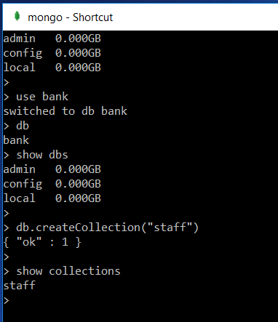

Staff collection

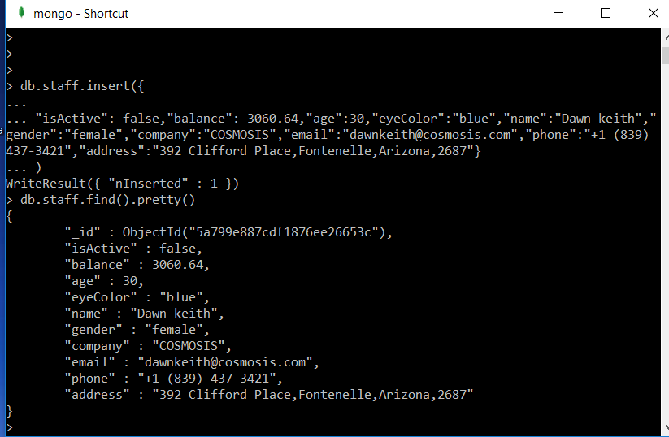

2.

Find all staff members with brown eyes and being active.

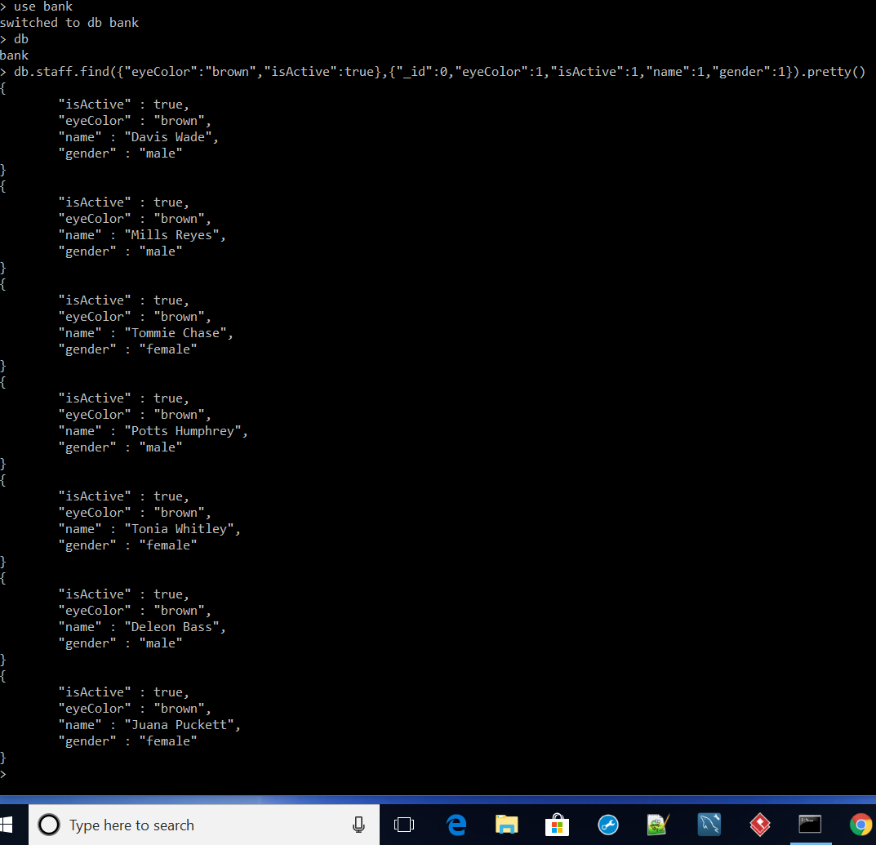

3.

Find all staff members either with green eyes or being active.

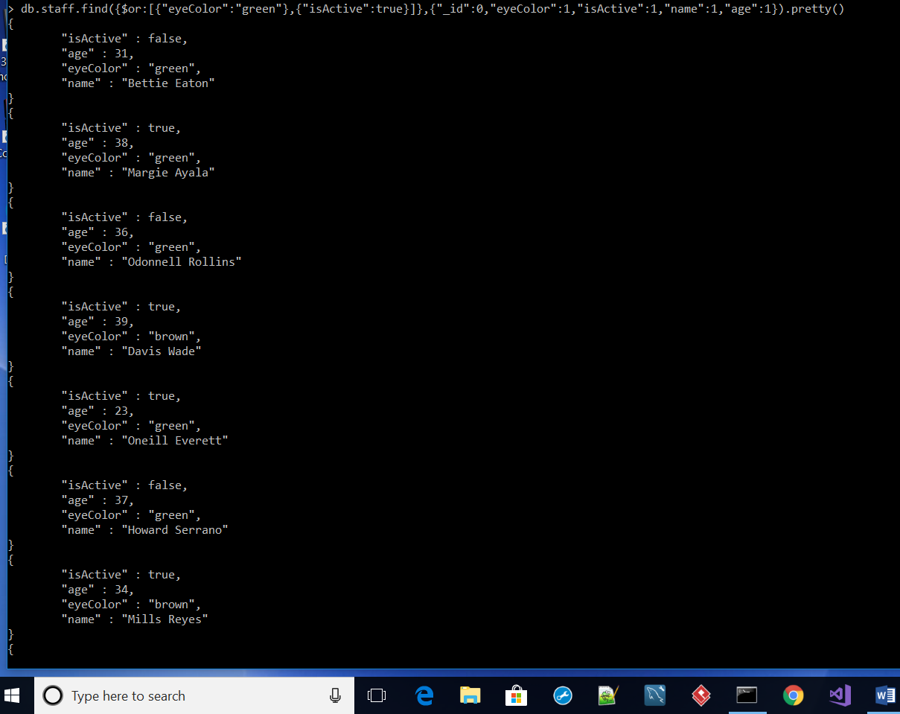

4.

Find all the staff members with blue eyes and balance smaller equal than 1500.

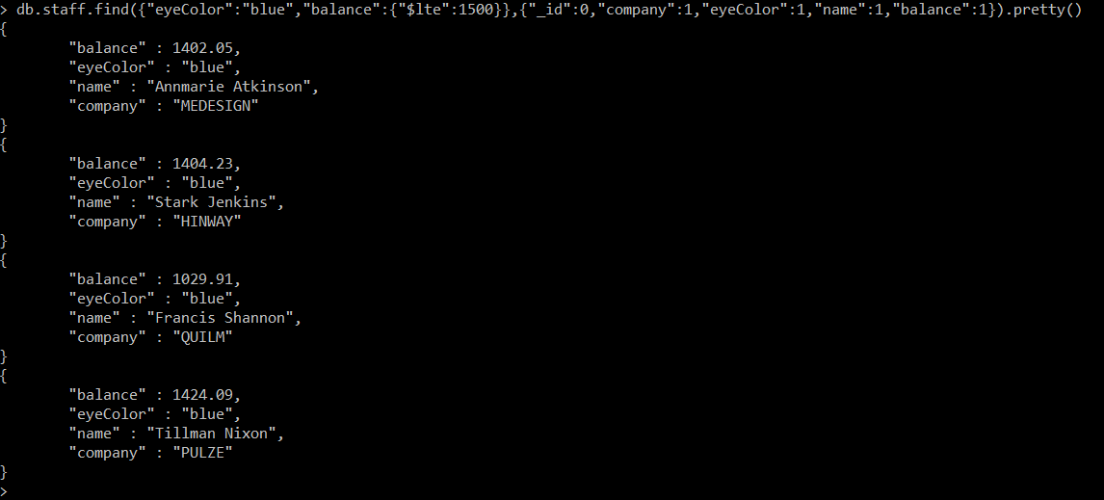

5.

Redo the query 3, but show only the fields name and balance

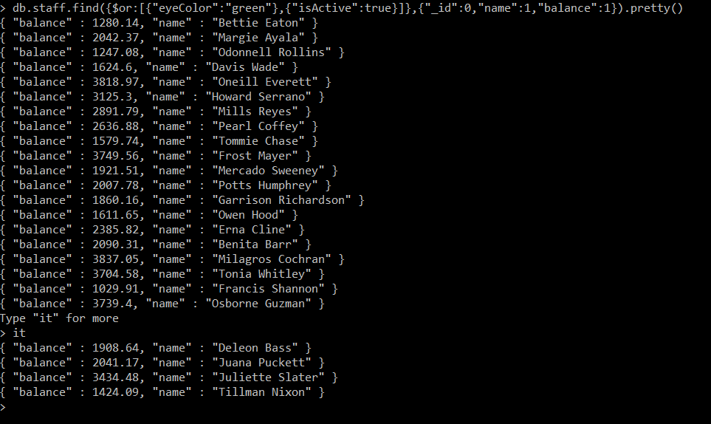

6a

Find the first 5 staff members of the collection whose age is greater than 30

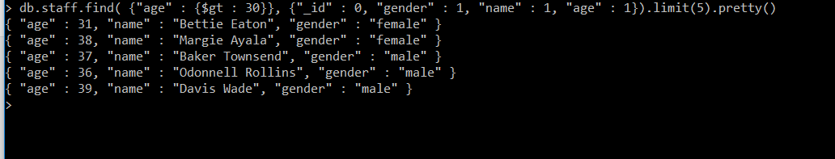

6b

Then, find all the staff members of the collection but the first 2 ones.

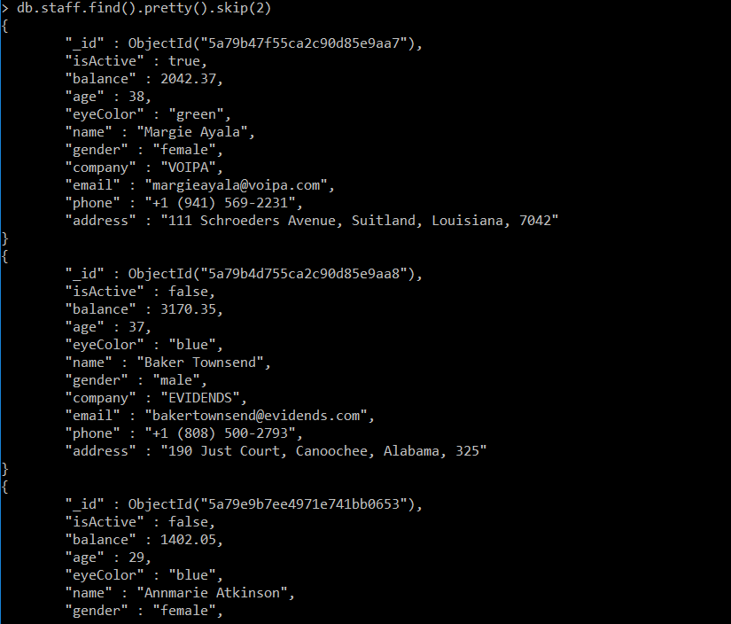

7.

Find the ten youngest staff members.

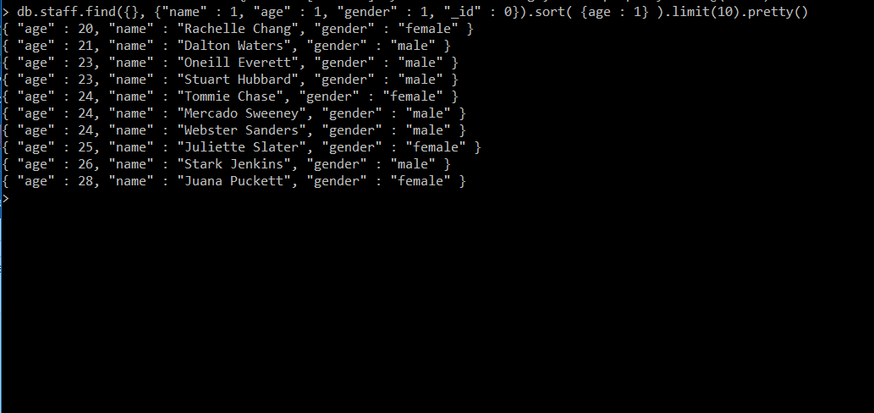

8.

Group the staff members by gender, and find the average balance of each gender.

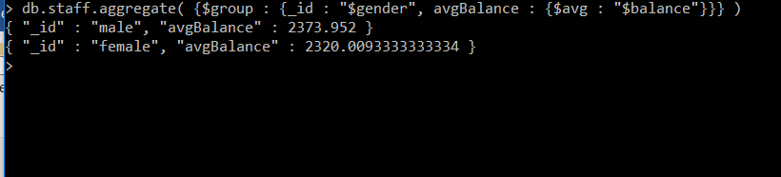

9.

Group the staff members by eye colour, and find how many there are of each kind

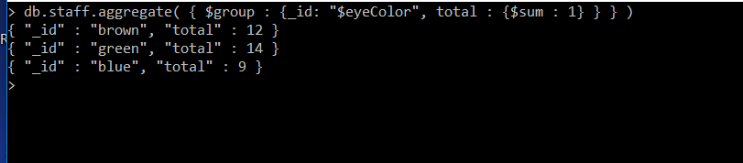

10.

Find the staff members with balance greater than 3000, but instead of returning the elements return the stats of the query. Then, set an index in balance and repeat the query.

Has the number of explored documents decreased?

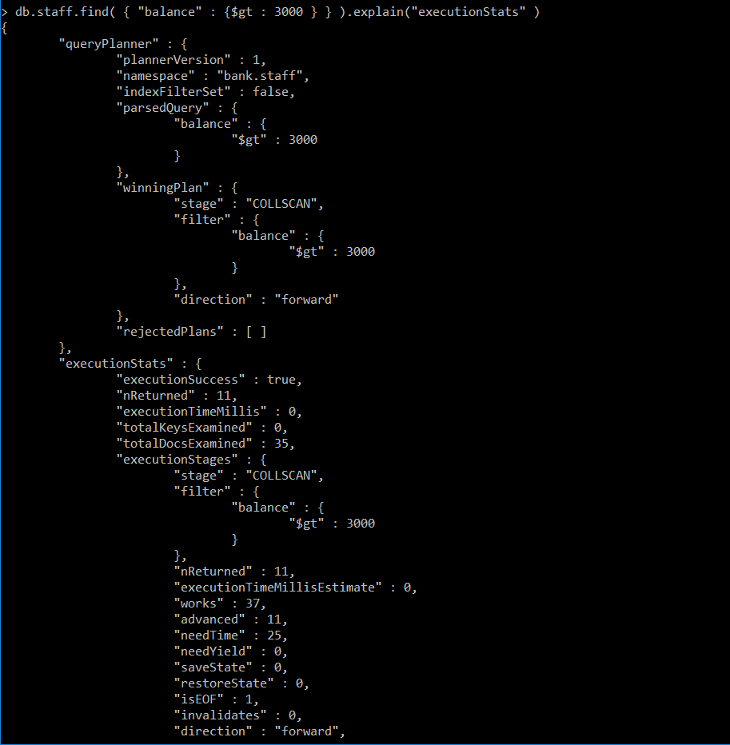

Set an index in balance



Repeat query

