1.

Create nodes for three chefs/cooks

1st



2nd

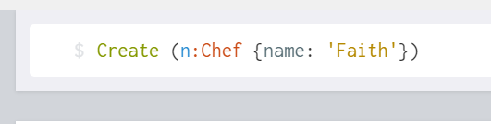

3rd



Three node

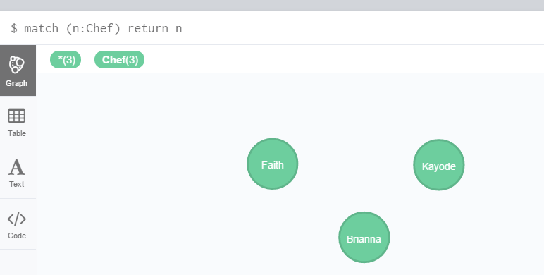

Relationship



Popularity

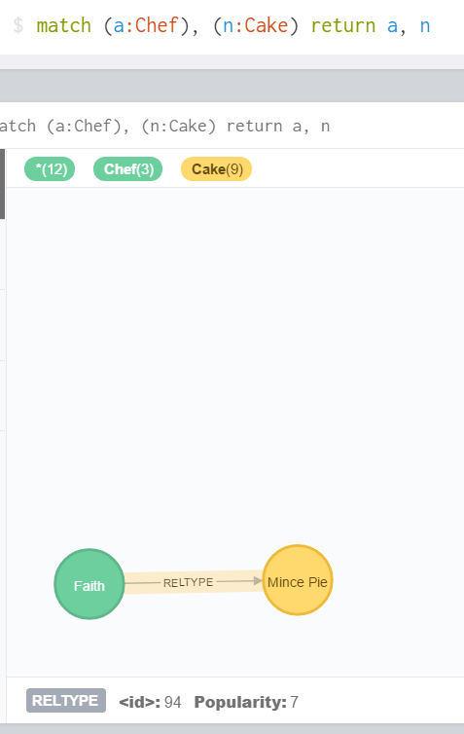

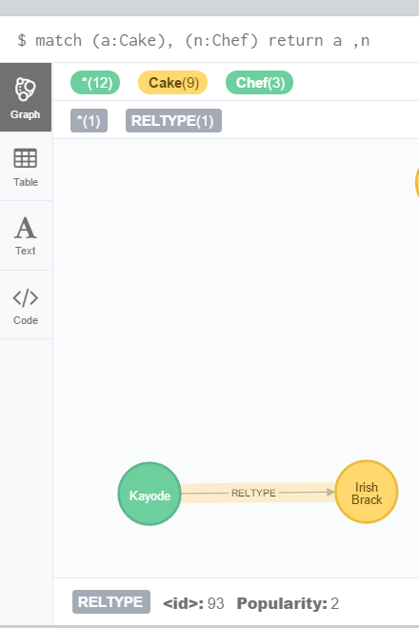

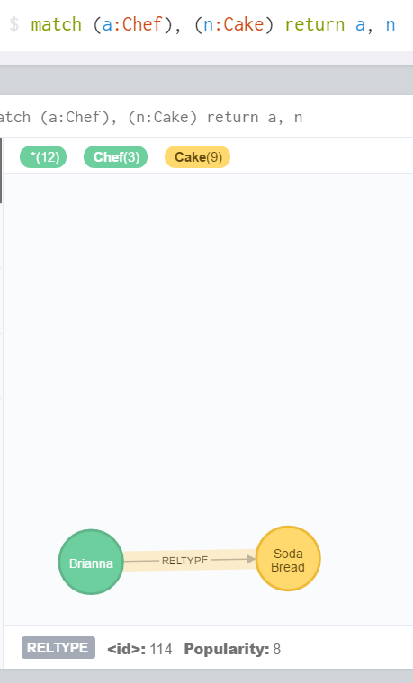

2.

List all the cakes and the ingredients for each cake



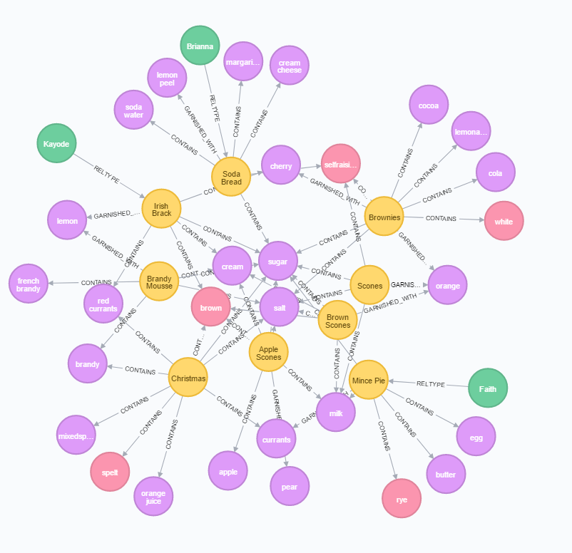

3.

List the ingredients in a brownie recipe.



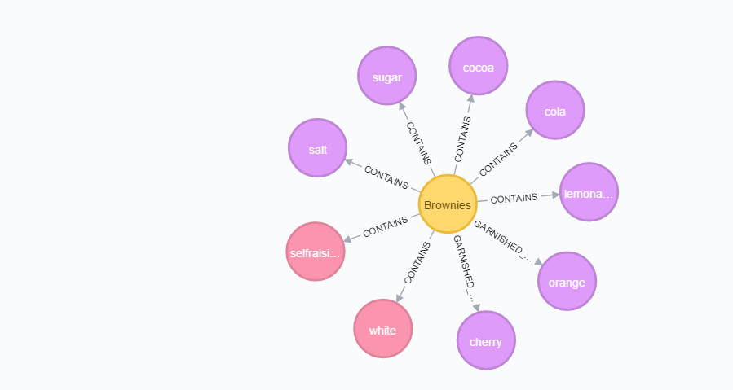

4.

List all the cakes with flour in them.

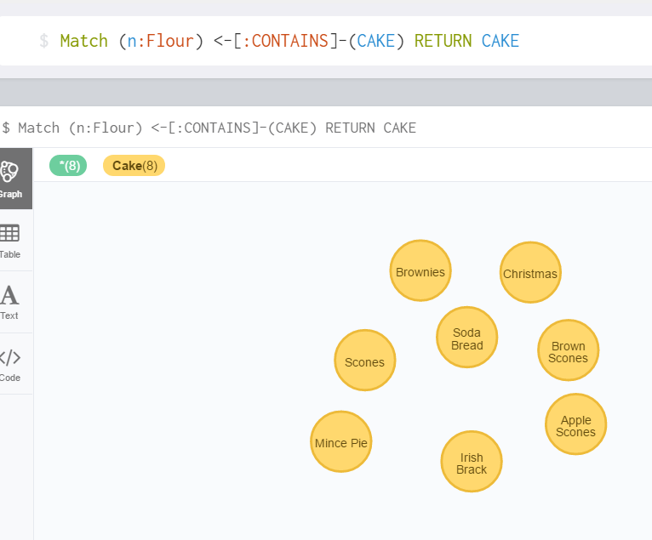

5.

List which Cakes have both Cream and Milk in them

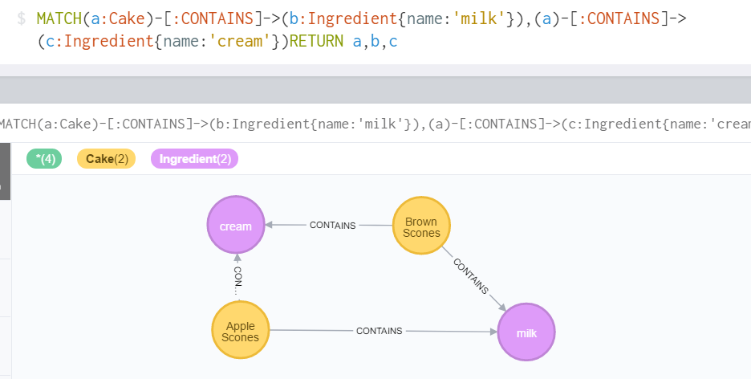

6.

List which recipes are associated with each chef.

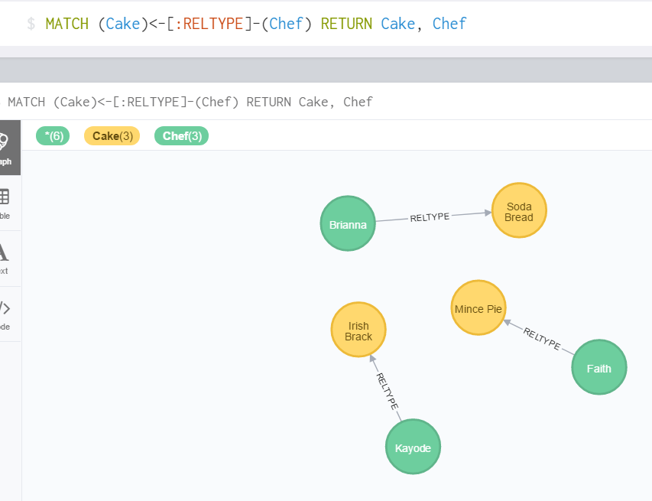

7.

What chef has the most popular recipes?

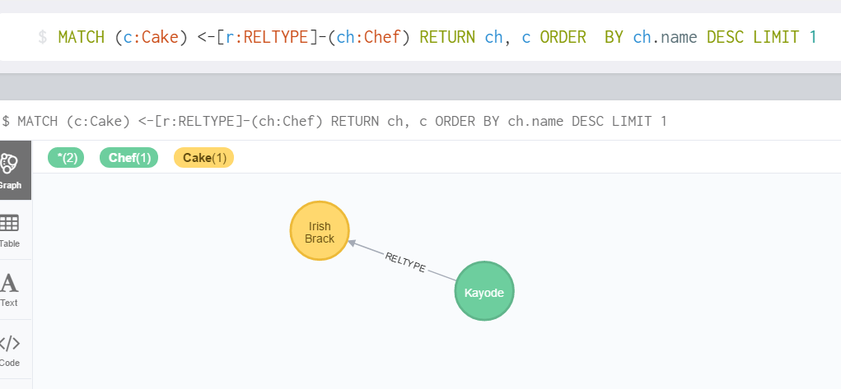

8.

What are the 5 most useful ingredients?

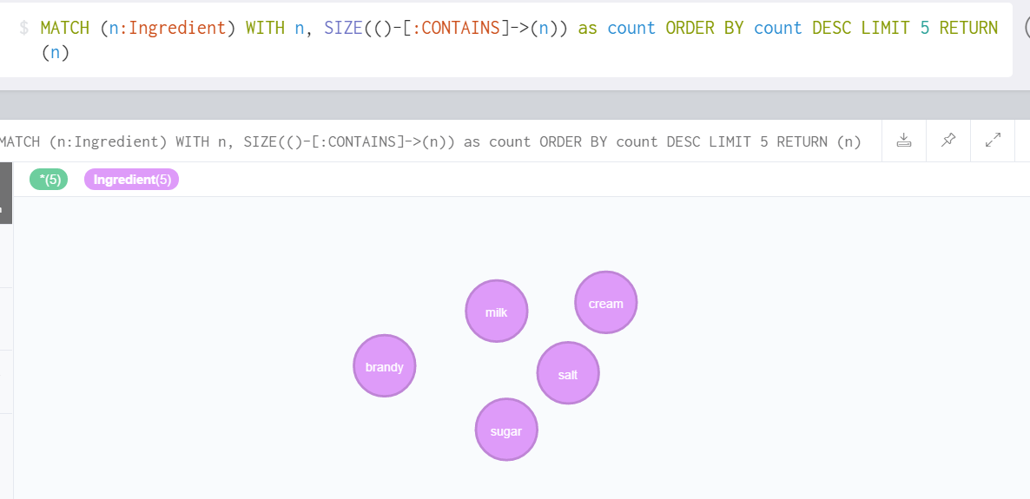

9.

What are the 5 least useful ingredients?

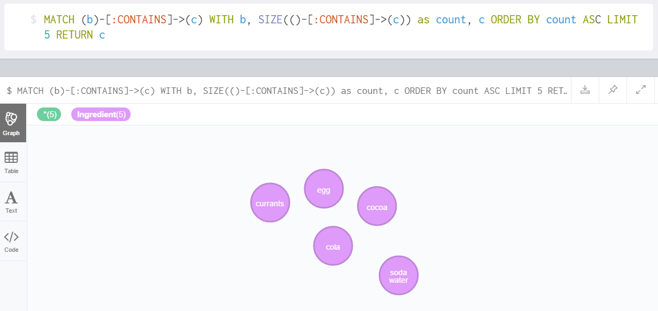

10.

What recipe is the most similar to apple scone – output list of ingredients from other recipes in order of similarity to this recipe?

