**Product Backlog for Medi-Scree**

|  |  |  |  |
| --- | --- | --- | --- |
| **ID** | **User Story** | **Time Estimation** | **Priority** |
| 2 | As a new User I want to create account | 7 | 1 |
| 8 | As an admin I want to verify new customer account and information | 8 | 2 |
| 1 | As a new user I want to login | 6 | 3 |
| 5 | As a User I want to make payment (PayPal) | 3 | 4 |
| 3 | As a returning User I want to view my profile | 4 | 5 |
| 12 | As admin I want to accept or deny incoming customer | 3 | 6 |
| 11 | As admin I want record details of insurance premium | 5 | 7 |
| 4 | As a User I want to run reports establishing levels of risk | 4 | 8 |
| 6 | As a user I want to rating review | 3 | 9 |
| 9 | As an admin I want to create new datasets (aggregating to new patient) | 9 | 10 |
| 17 | As a professional I want to view details of my own patient | 7 | 11 |
| 13 | As admin I want to view customer history | 8 | 12 |
| 7 | As an admin I want to view a customer profile | 6 | 13 |
| 15 | As admin I want to update | 4 | 14 |

Introduction

**Background**

International healthcare insurer company tasked with the development of a bespoken system which predicts the possibility of its members contracting a range of serious medical conditions.

The insurer company want system that will be used for likelihood of future health problems through matching large datasets of patient information with unique individual patient histories.

The database will be used as proactive in analytical healthcare rather than reactive of an individual health challenges.

**Entity/Attribute**

**Patient**

* Patient-No
* GP-No
* First-Name
* Last-Name
* Address
* Profession
* Gender
* Phone-No
* Date-of-birth
* Email
* Patient-Details

**Insurer**

* Insurer-No
* First-Name
* Last-Name
* Phone-No
* Email

**GP**

* GP-No
* First-Name
* Last-Name
* Address
* Phone-No
* Email

**User**

* User-No
* First-Name
* Last-Name
* User-Type

**Login-Detail**

* Login-Detail-No
* Email
* Password

**Definition of Normalization**

Normalization is the process of organizing data in a database. This includes creating tables and establishing relationships between those tables according to rules designed both to protect the data and to make the database more flexible by eliminating redundancy, inconsistency and for security reason.

**1NF**

1NF disallow composite attribute whose values for an individual tuple are not atomic. In 1NF we eliminate duplicate columns from same table and create separate table for each related group of data with its own primary key

**2NF**

2NF enable to add new rule after satisfying 1NF rule by removing subsets of data type to multiple rows of a table and place them in separate table then create relationships between these table and their predecessor through foreign key.

**3NF**

3NF enable to apply new rules after satisfying 1NF and 2NF. This eliminates functional dependency on non-primary key fields to depend on primary key and reference parent table

**Unsort Data**

Attribute

Medi-Screen Insurer System (Patient-No, GP-No, First-Name, Last-Name, Address, Profession, Gender, Phone-No, Date-of-birth, Email, Insurer-No, First-Name, Last-Name, Phone-No, Email, GP-No

First-Name, Last-Name, Address, Phone-No, Office Phone-No, User-No, First-Name, Last-Name, User-Type, Login-Detail-No, Email, Password)

**1NF**

Patient (Patient-No, Insurer-No, First-Name, Last-Name, Phone-No, Email, Address, Profession, Date-of-Birth, GP-No)

Insurer (Patient-No, User-No, Patient-Details, Login-No)

**2NF**

Insurer (Patient-No, User-No)

Insurer (Patient-No, Insurer-No, First-Name, User-No, Last-Name, Phone-No, Email, Address, Profession, Date-of-Birth, GP-No)

GP (GP-No, User-No, Treatment-Type, Condition, Login-No)

**3NF**

Patient (Patient-No, Insurer-No, First-Name, Last-Name Phone-No, Email, Profession)

GP (GP-No, First-Name, Last-Name, Address, Phone-No, Email, Login-No)

Insurer (Insurer-No, Patient-No, Patient-Details, Treatment-Type, Condition)

User (GP-No, Patient-No)

Login-Detail (Login-No, Email, Password)

**Entity Matric**

|  |  |  |  |  |  |
| --- | --- | --- | --- | --- | --- |
| **Entity Name** | **Patient** | **Insurer** | **GP** | **User** | **Login-Detail** |
| **Patient** |  | **M:1** |  | **M:1** | **M:1** |
| **Insurer** | **1:M** |  |  | **M:1** |  |
| **GP** |  |  |  |  | **1:1** |
| **User** |  |  | **M:1** |  |  |
| **Login-Detail** |  |  |  |  |  |

Medi-Screen Database

**Medi-Screen**

**ER Diagram**

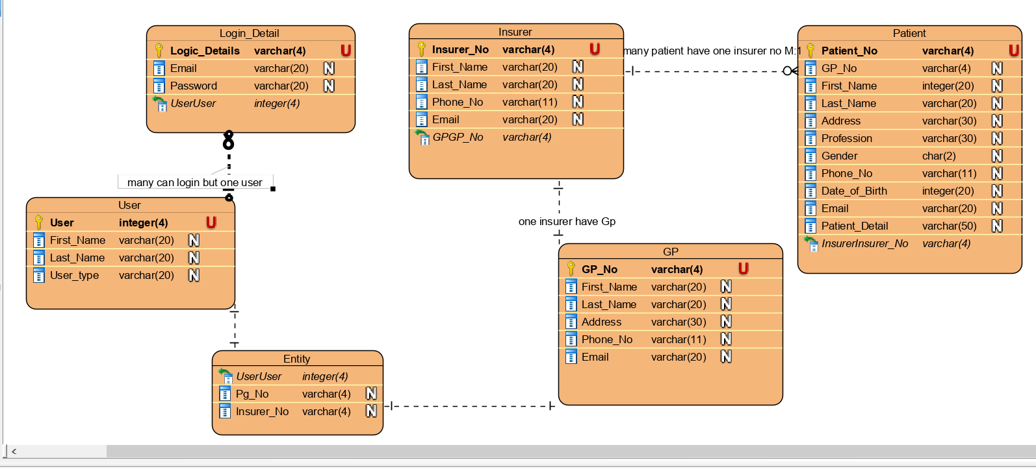

**Patient Code mySql**

CREATE TABLE PATIENT(

Patient_No VARCHAR(4) NOT NULL,

Gp_no VARCHAR(4)

First_Name VARCHAR(20),

Last_Name VARCHAR(20),

Address VARCHAR(30),

Profession VARCHAR(30),

Gender VARCHAR(2),

Phone_No VARCHAR(11),

Date_Of_Birth DATE,

Email VARCHAR(20),

Patient_Details ENUM(50),

PRIMARY KEY (patient_No)

);

INSERT INTO PATIENT VALUES ('PLP1', ‘GPW1’, 'Martin', 'Luthers', '12 Eagle valley''Wilton, Cork', 'GENERAL MEDICINE', ' M ', '087-4363853', ' 2017-11-03 ', ' martingLuthers@gmail.com ',

INSERT INTO PATIENT VALUES('PL22', 'GPM2', 'Aderson', 'Amary' , ' 12b hosty close' 'Bishoptown, Cork', 'Accountant ', 'F ', '021-225633 ', ' 1980-05-04 ' , ' AdersonAmary@gmail.com ', ' Condition very critical ', 0002);

INSERT INTO PATIENT VALUES('PLS3', 'GPT3', 'kent', ' Water ', 'abey court 16''Model Farm Rd., Cork ' , ' flower Vendor ', 'M', '086-6363863', ' 1975-06-05', 'Kentabbey@yahoo.com', 'Condition is very minor treatable ', 0003);

INSERT INTO PATIENT VALUES ('PLA9', 'GPY4', 'Debora', 'Cecil', '01 stoony building wilton''Laburnum, Cork', 'Cleaner', 'F', '085-3639652', '1983-07-11', 'DeboraCecil@gmail.com', 'Urgent Treatment needed', 9008);

INSERT INTO PATIENT VALUES ('PLG5', ‘GLW6’, ‘Anita’, 'Joanna', '43 D Errica house''Ballincollig, Cork', 'Singer ', 'F', '087-2394693', '1973-04-20', '1980-05-08 ', 'AnitaJoanna@gmail.com', 2400);

CREATE TABLE INSURER(

insurer_No VARCHAR(4) NOT NULL,

first_Name VARCHAR(20),

last_Name VARCHAR(20),

Phone_No VARCHAR(11),

Email VARCHAR(20),

PRIMARY KEY (insurer_No),

FOREIGN KEY (patient_No) REFERENCES PATIENT(patient_No)

);

INSERT INTO INSURER VALUES('LO46', 'Joe', 'Keogh', '086-2963453', 'JoeKeogh@gmail.com', ' PLP1');

INSERT INTO INSURER VALUES('LK22', 'Timi ', 'Murphy', '086-2963453', 'TimiMurphy@gmail.com', ' PL22');INSERT INTO INSURER VALUES(' LBM3', 'Jacob ', 'Stave', '086-2963453', ' JacobStave @gmail.com', ' PLS3');INSERT INTO INSURER VALUES(' PLS3', 'Jacob ', 'Stave', '086-2963453', ' JacobStave @gmail.com', ' PLA9');

CREATE TABLE GP(

gp_No VARCHAR(4) NOT NULL,

first_Name VARCHAR(20),

last_Name VARCHAR(20),

Address VARCHAR(30),

Phone_No VARCHAR(11),

Email VARCHAR(20),

PRIMARY KEY (gp_No),

FOREIGN KEY (patient_No) REFERENCES PATIENT(patient_No)

FOREIGN KEY(insurer_No) REFERENCES INSURER(insurer_No),

);

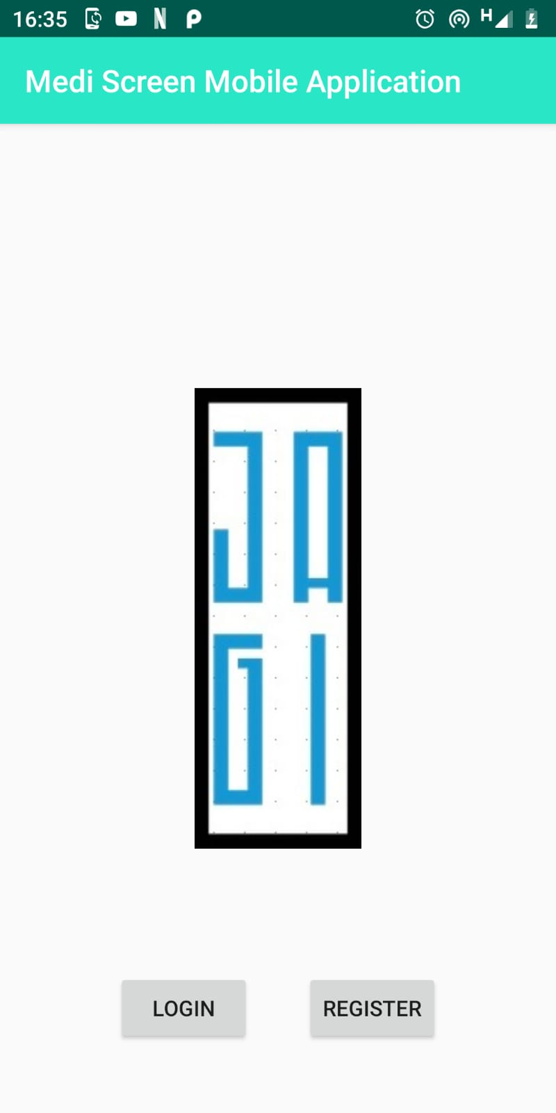

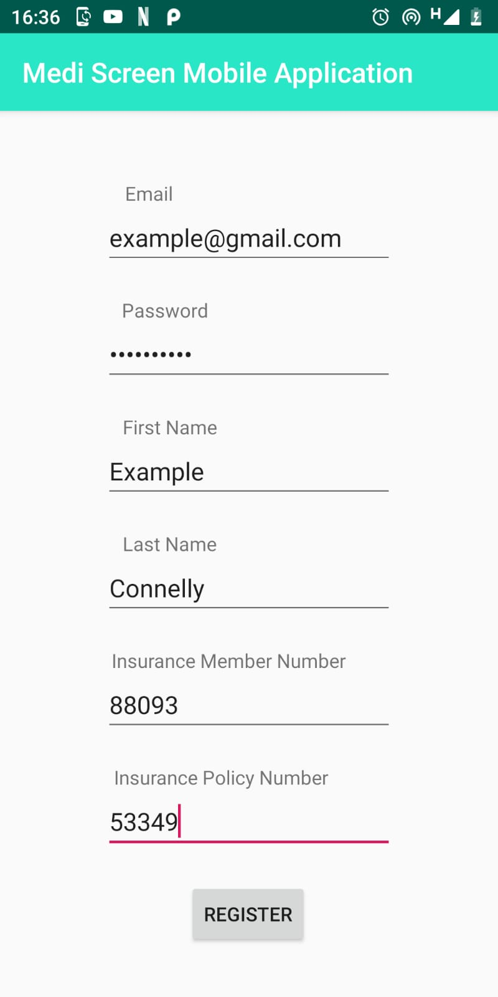

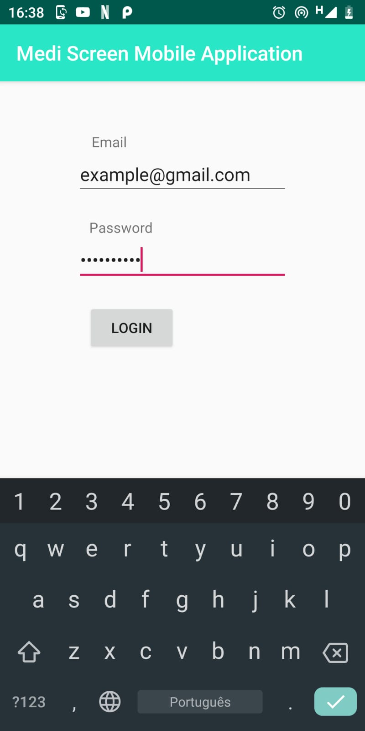

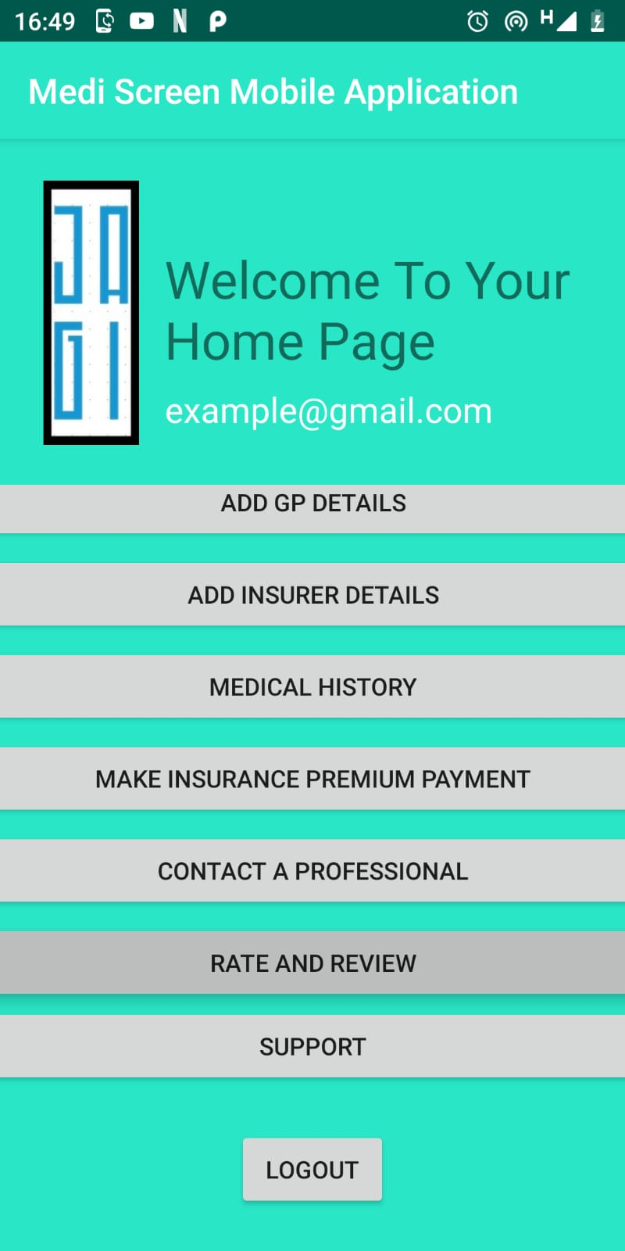

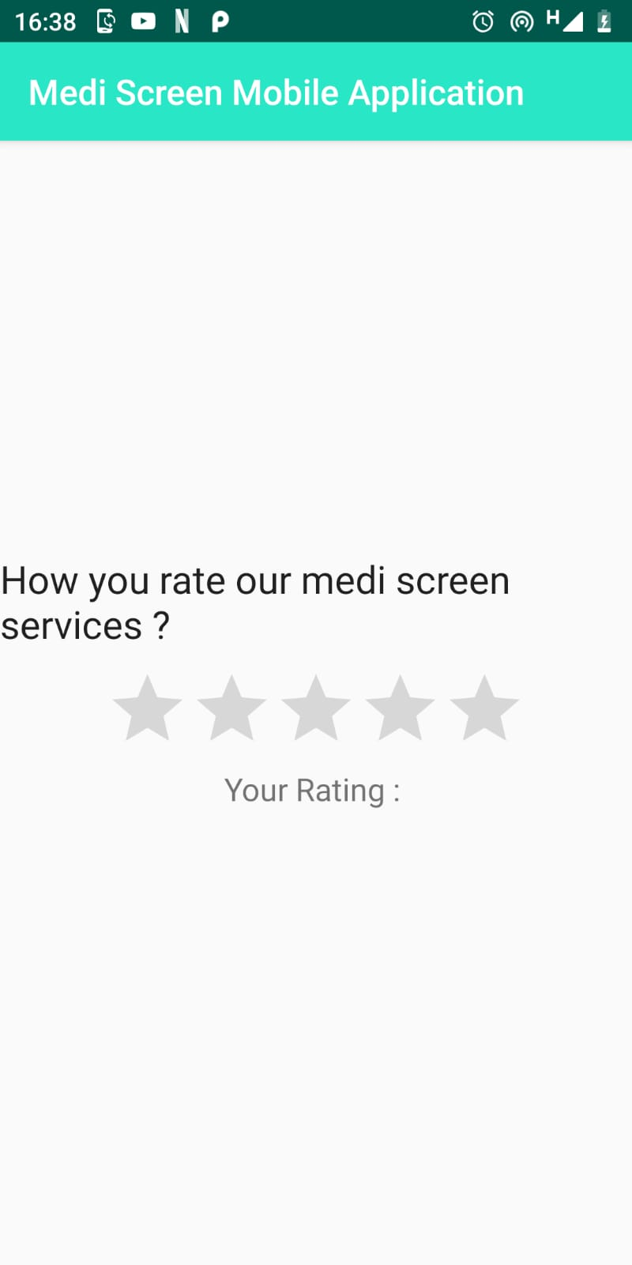

**User story Mobile App**

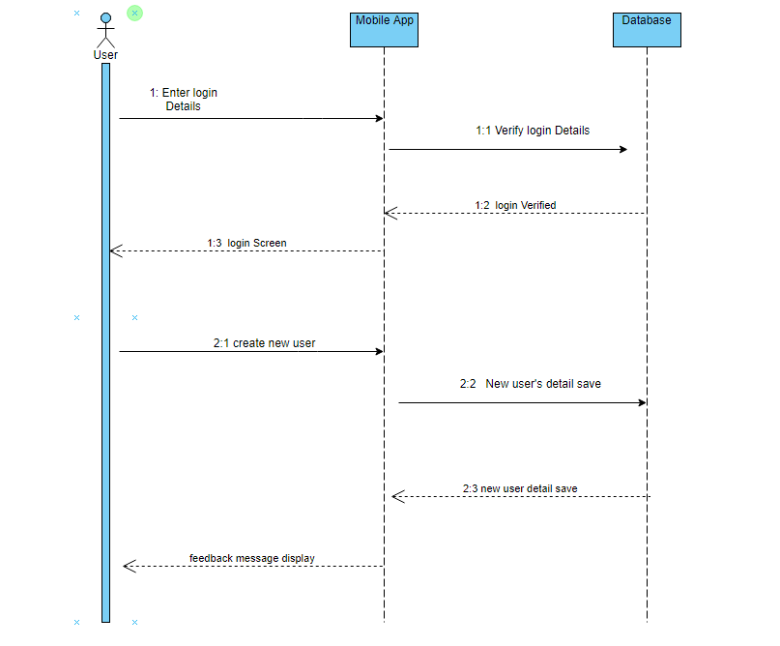

**User story Website**

