AN ANALYSIS OF THE STOCK MARKET

**Introduction**

Analyzing stock market data may be fascinating, and powerful prediction models can offer significant financial rewards as an added motivation. There seems to be an infinite quantity of financial data available online. It might be challenging to locate a sizable, properly organized dataset covering a broad range of businesses. Here, I offer a dataset including the historical stock prices (for the previous five years) of every company currently included in the S&P 500 index.

**Exploratory Data Analysis**

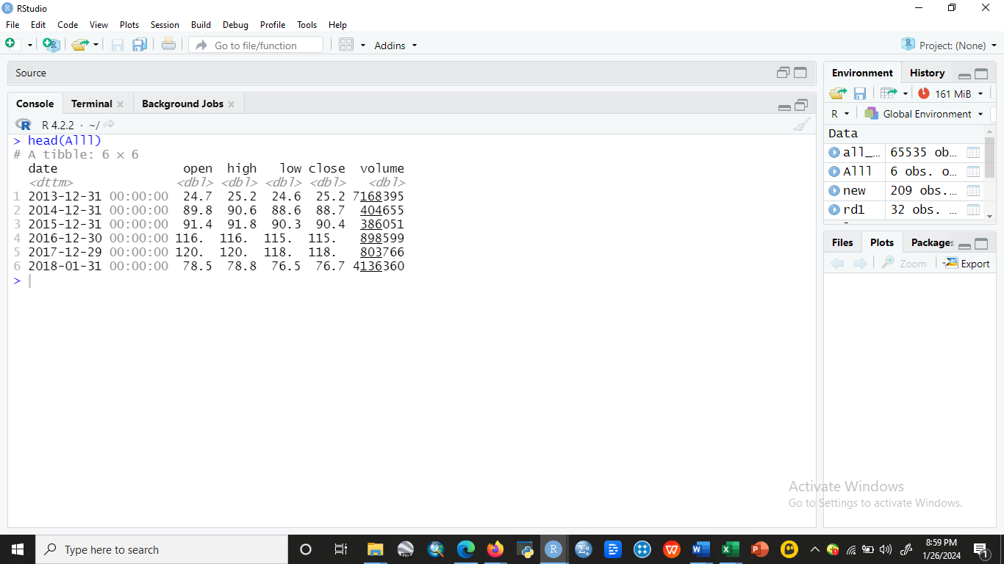

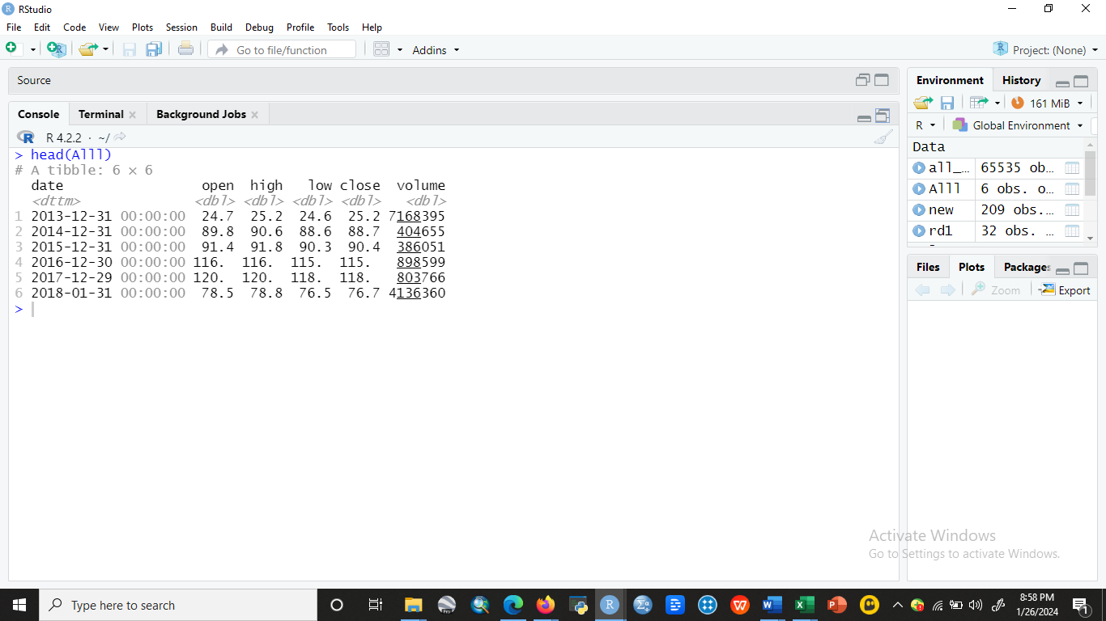

**Figure 2: Exploratory Analysis**

**Source: R output**

**Missing Value**

I applied the “sapply” function to remove all missing values: sapply (Alll, function(x) sum (is. na(x))). It can be seen that there are no missing values in the data set (Figure 1).

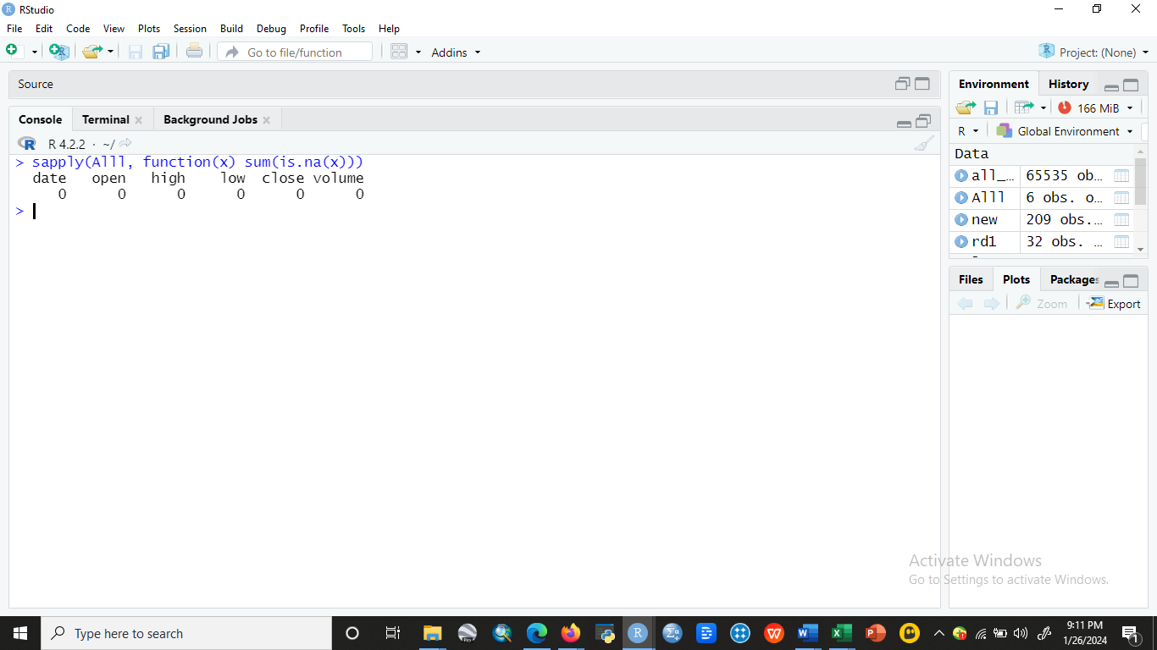

**Figure 1:**



**Figure 1: Missing Value**

**Source: R Studio**

**Descriptive Statistics about the Data**

When describing the distribution of a dataset, descriptive statistics—which do not contain NaN values—summarize the distribution's shape, central tendency, and dispersion (Figure 2).

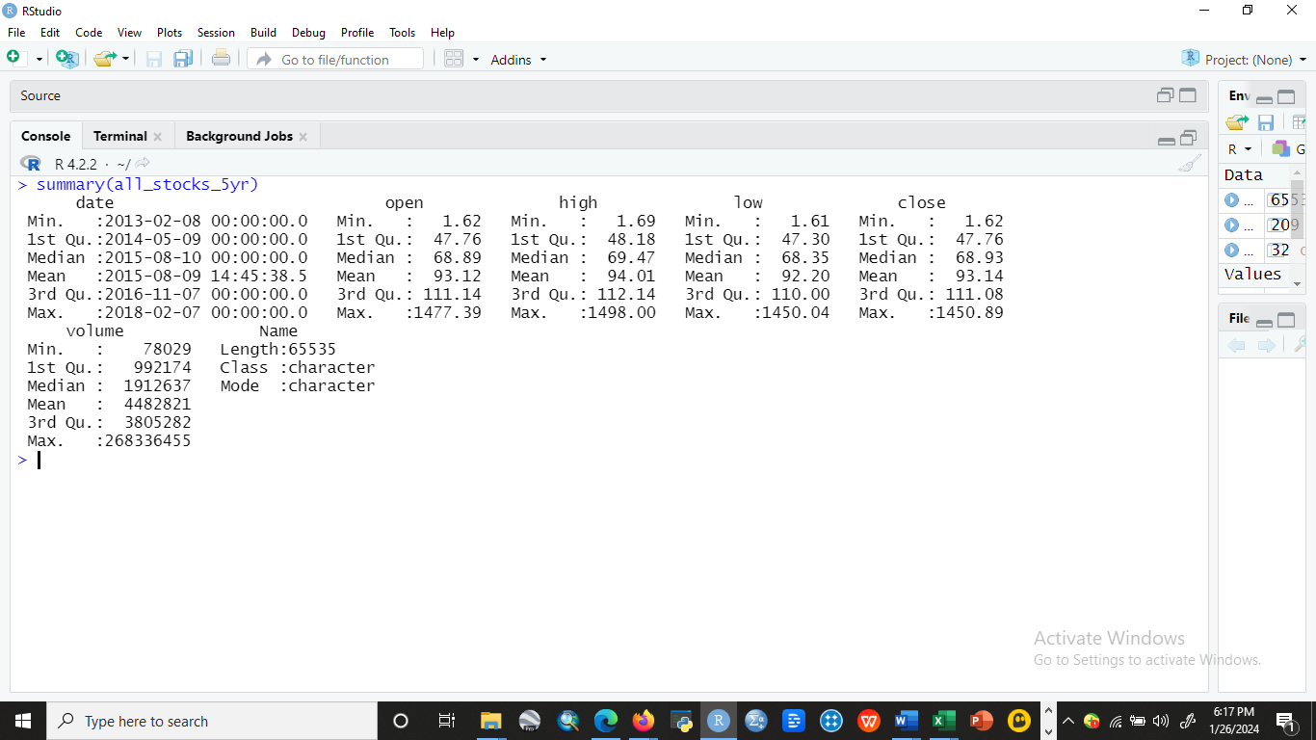

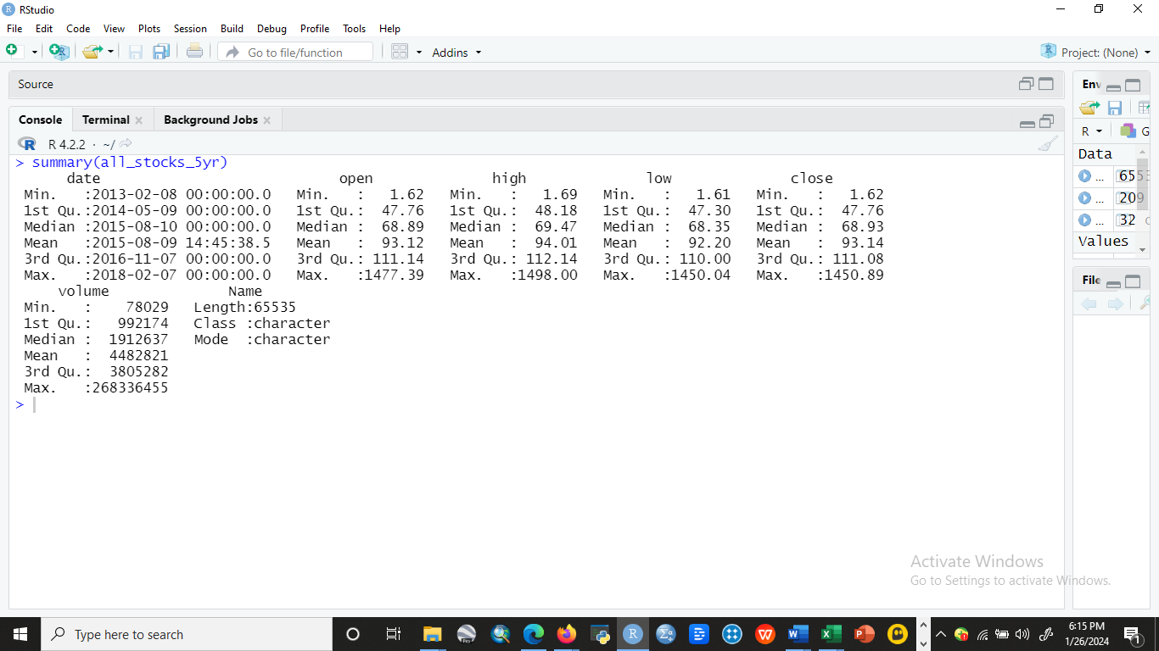

**Figure 2: Summary**

**Source: R Studio**

**Closing Price**

A stock is considered closed when it is traded at its closing price on a regular trading day (Figure 3). The closing price of a stock serves as a benchmark for investors to gauge its performance over time.

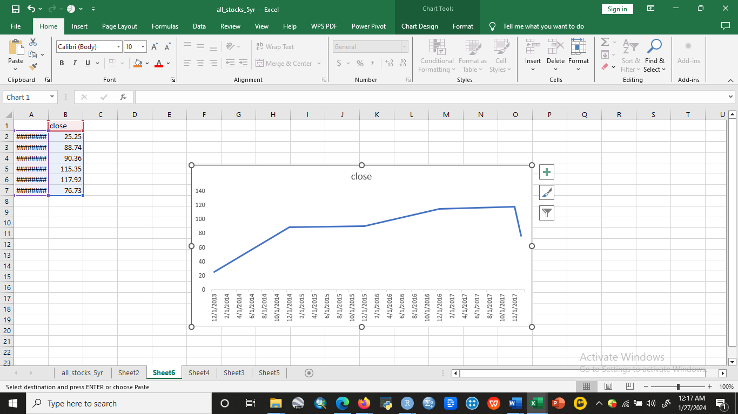

**Figure 3: Summary**

**Source: R Studio**

**Opening Price**

The price at which a security is initially traded at the start of an exchange is known as its opening price (Figure 4). The storyline of the trading day is largely shaped by the starting price.

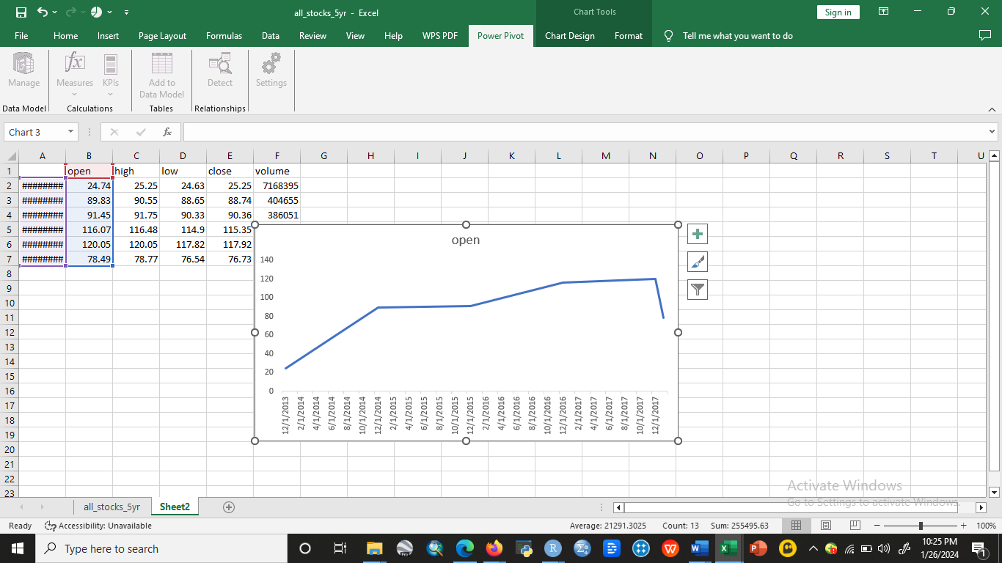

**Figure 4: Opening Price**

**Source: R Studio**

**High Price**

Figure 5 shows the stock value when the price is high

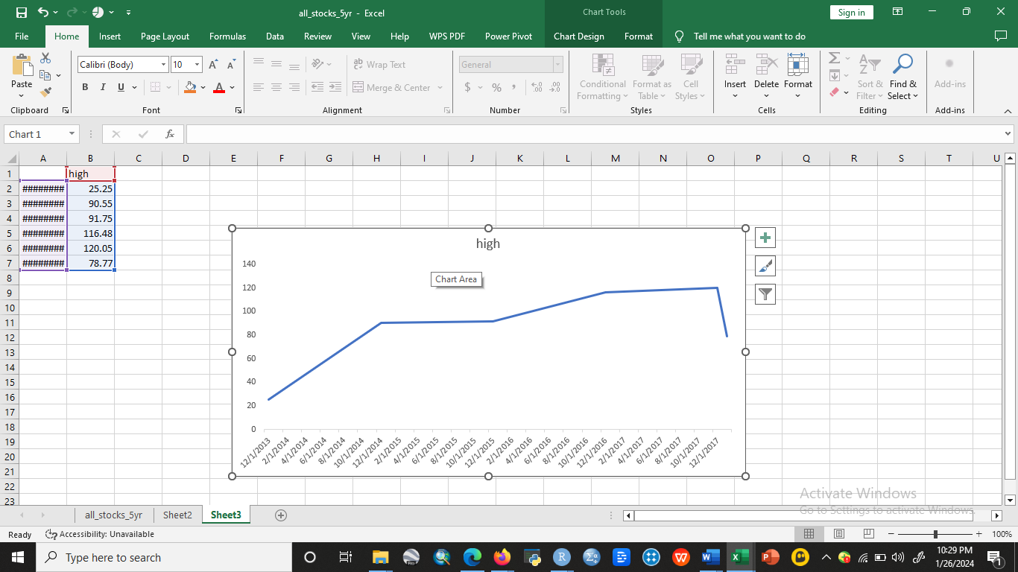

**Figure 5: High Price**

**Source: R Studio**

**Low Price**

Figure 6 shows the stock value when the price is low

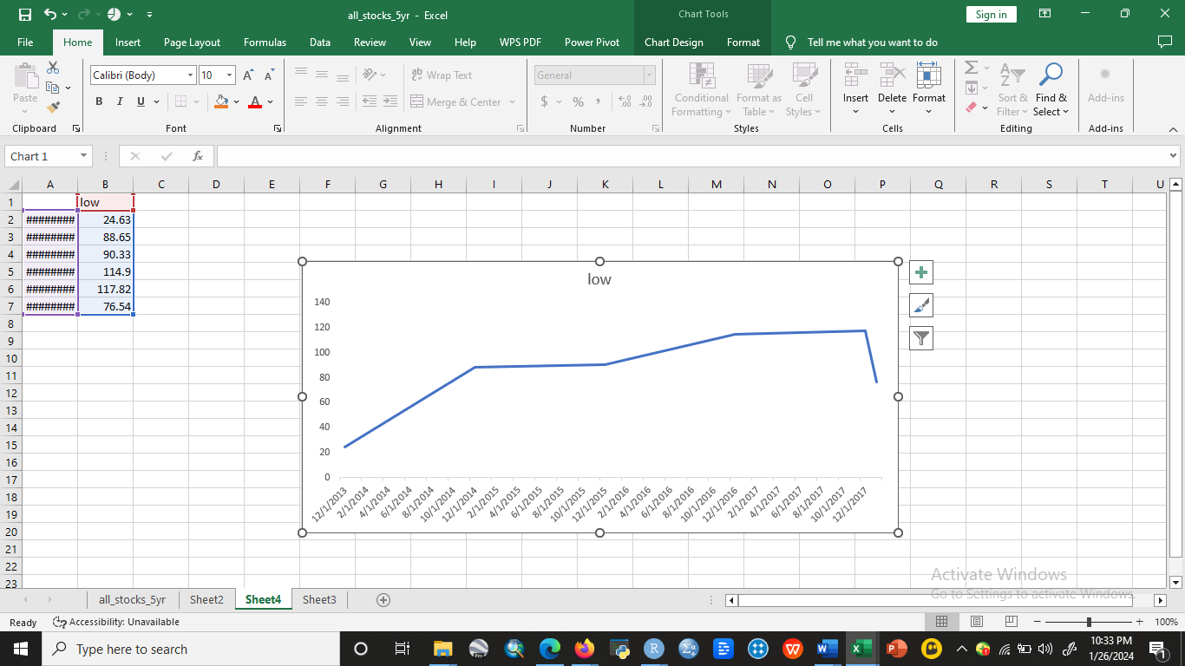

**Figure 6: Low Price**

**Source: R Studio**

**Volume of Sales**

Volume is the amount of an asset or security that changes hands over some time, often over the course of a day (Figure 7). For instance, the stock trading volume would refer to the number of shares of security traded between its daily open and close. Trading volume, and changes in volume with time, are important inputs for technical traders.

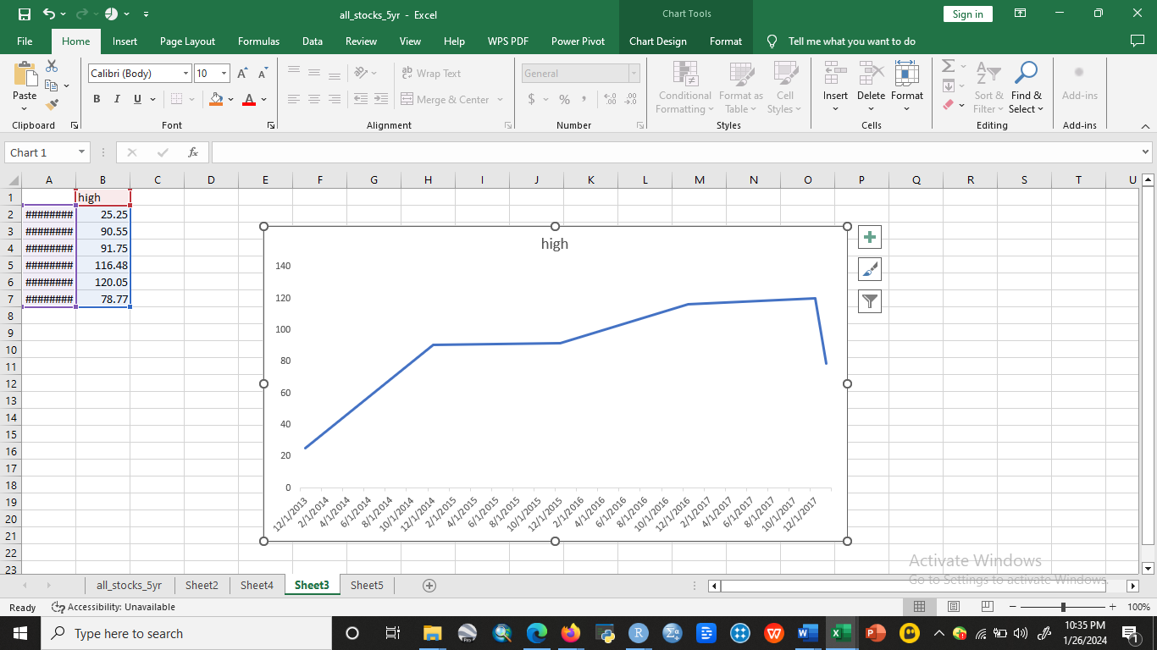

**Figure 7: Volume of Sales**

**Source: R Studio**

**Correlation Analysis**

A correlation coefficient, which must lie between -1.0 and +1.0, shows how much two variables move around one another. Correlation is a measure of connections; nevertheless, it cannot establish causation, that is, whether one item leads to another, or whether a third party is the origin of the link.

**Correlation between Close Price and Volume**

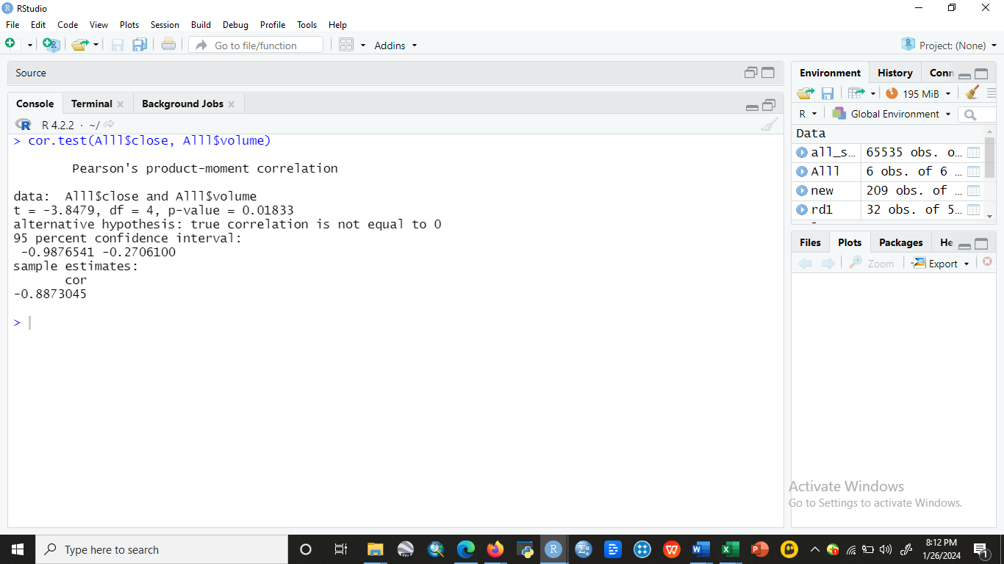

The Pearson correlation was used to examine the relationship between the closing price and the volume of stock (Figure 8). A 95% level of confidence and a 5% level of significance were applied to test the hypothesis. With a p-value of 0.001833, the - 0.887 correlation coefficient between the two variables is strong and negative. This finding indicates that there is a strong negative relationship between closing price and volume.

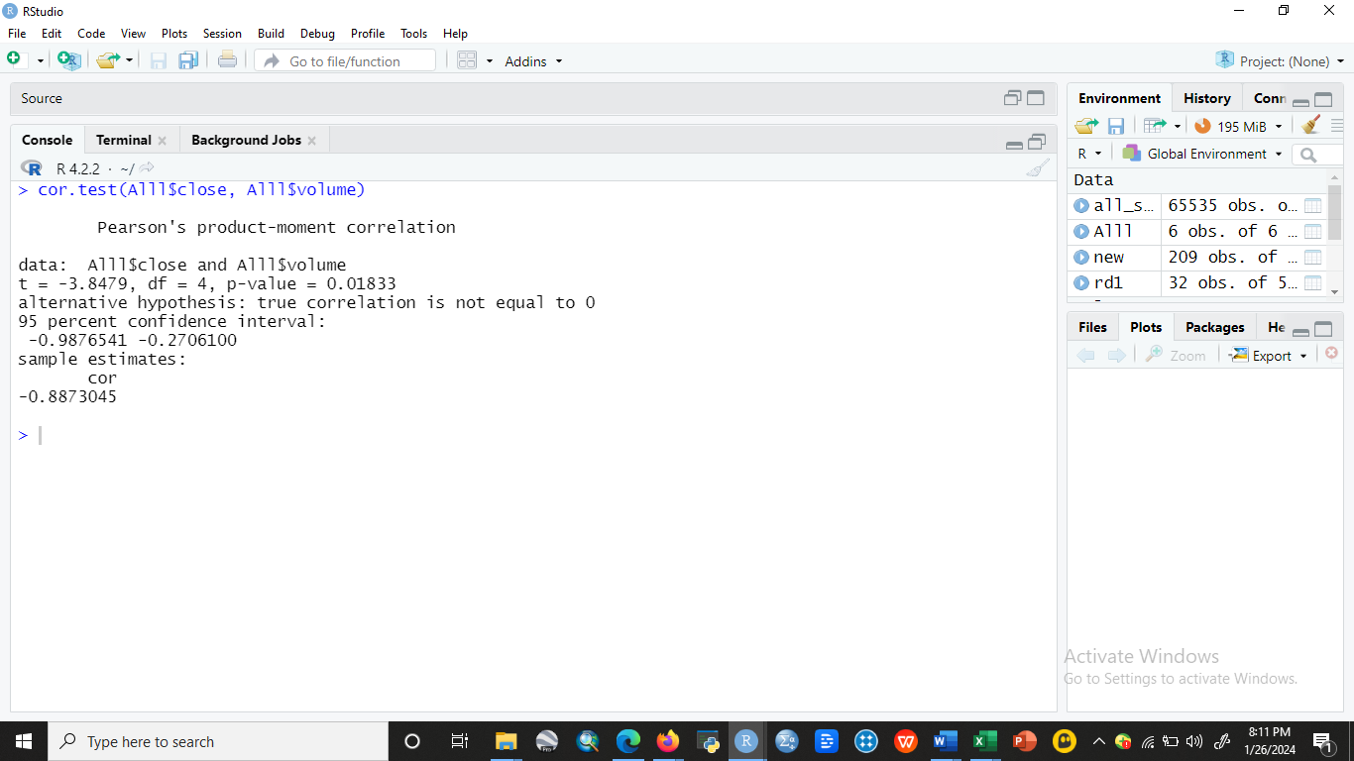

**Figure 8: Correlation between Close Price and Volume**

**Source: R Studio**

**Correlation between Open Stock Price and Volume**

The Pearson correlation was used to examine the relationship between the starting stock price and the volume of shares (Figure 9). A 95% level of confidence and a 5% level of significance were applied to test the hypothesis. With a p-value of 0.01884, the - 0.8857-correlation coefficient between the two variables is strong and negative. This finding implies that there is a strong negative relationship between opening price and volume.

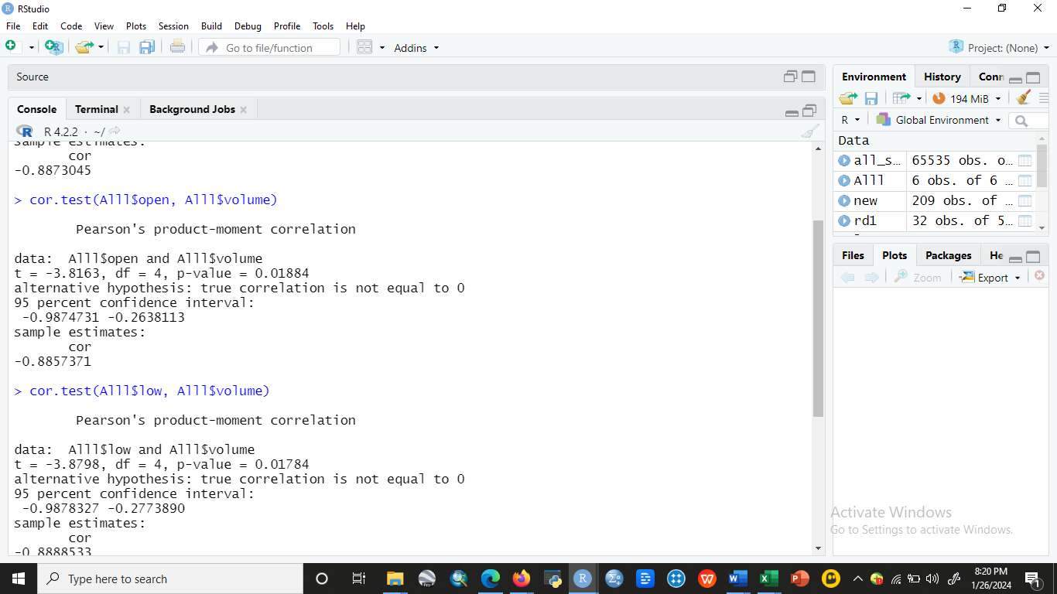

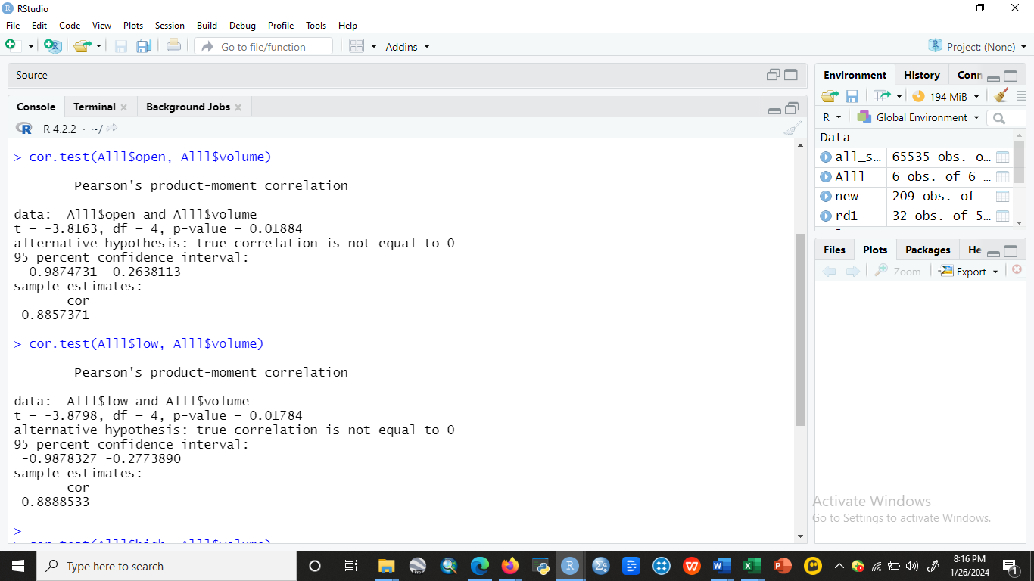

**Figure 9: Correlation between Open Stock Price and Volume**

**Source: R Studio**

**Correlation between Low Stock Price and Volume**

The association between the low stock price and the volume of stock was investigated using the Pearson correlation (Figure 10). To test the hypothesis, a 5% level of significance and a 95% level of confidence were used. The correlation coefficient of -0.887 between the two variables is strong and negative, with a p-value of 0.01784. This result suggests that low stock price and volume have a negative association.



**Correlation Between Low Stock Price and Volume**



**Figure 10: Correlation between Low Stock Price and Volume**

**Source: R Studio**

**Correlation Between High Stock Price and Volume**

The Pearson correlation was used to examine the relationship between the low stock price and the volume of stock (Figure 11). A 95% level of confidence and a 5% level of significance were applied to test the hypothesis. With a p-value of 0.001829, the correlation coefficient of -0.887 between the two variables is strong and negative. This finding implies that there is a negative correlation between High stock price and volume of stock.

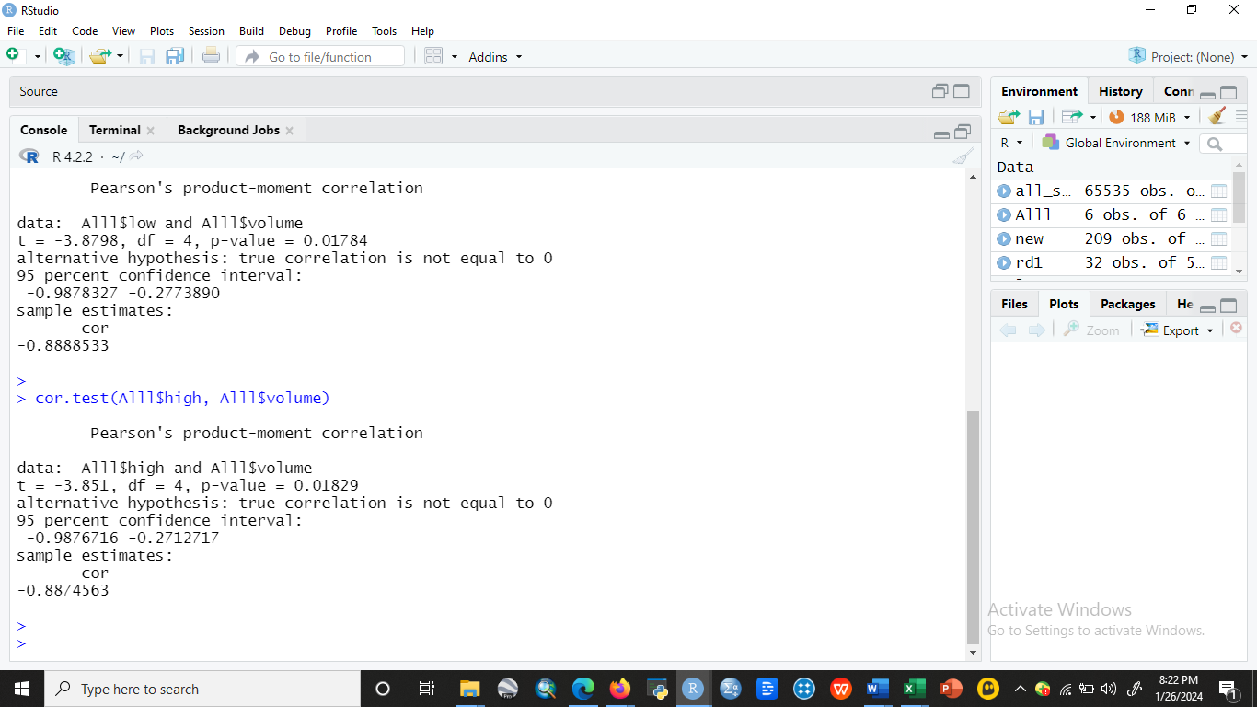

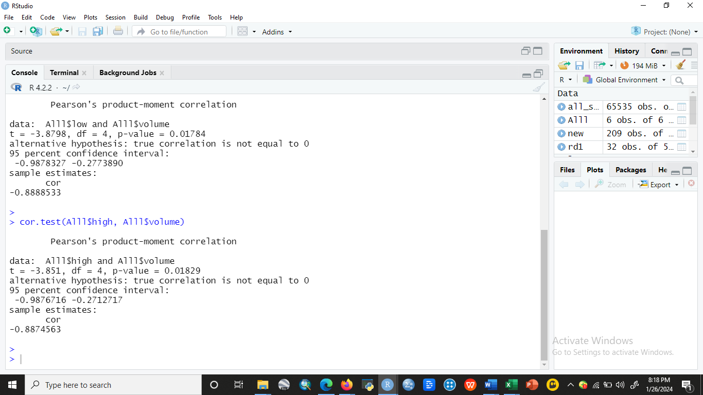

**Figure 11: Correlation Between High Stock Price and Volume**

**Source: R Studio**

**Conclusion**

This result suggests that closing price and volume have a significant negative correlation. This result suggests that opening price and volume have a significant negative correlation. This finding implies a negative correlation between low volume and stock price. This result suggests that the volume of stocks and high stock price have a negative link.

**Code:**

**head (Alll)**

**Correlation Test:**

cor.test(Alll$close, Alll$volume)

cor.test(Alll$open, Alll$volume)

cor.test(Alll$low, Alll$volume)

cor.test(Alll$high, Alll$volume)

**Data Source:**

https://www.kaggle.com/code/faressayah/stock-market-analysis-prediction-using-lstm