# OASIS Patent Application - Expanded Technical Specification

## Title of Invention

**Privacy-Preserving Decentralized Commerce System with Multi-Agent Orchestration and Zero-Knowledge Verification**

## Abstract

An advanced system and method for enabling privacy-preserving digital commerce through decentralized agent orchestration and zero-knowledge proofs is disclosed. The invention, OASIS (Operating-system Aggregator and Services Integration System), implements a novel approach to maintaining user data sovereignty while enabling personalized experiences through local computation and cryptographic verification protocols. The system utilizes a conflict-free replicated data type (CRDT) based decentralized database architecture with peer-to-peer mesh networking to facilitate secure communications between autonomous agents. The invention introduces innovative mechanisms for anonymous but verifiable transactions, differential privacy-based analytics, and trustless merchant integrations while ensuring complete user privacy and regulatory compliance.

## Technical Field

[0001] The present invention relates to decentralized digital commerce systems, and more particularly to privacy-preserving methods for: - Personalized content delivery using local computation (See Fig. 18) - Anonymous but verifiable transaction processing (See Fig. 19) - Secure multi-party computation for analytics (See Fig. 21) - Decentralized agent orchestration (See Fig. 22) - Zero-knowledge proof based verification - Differential privacy mechanisms (See Fig. 20) - Trustless merchant integration protocols

## Background

[0002] Current digital commerce and advertising systems suffer from fundamental architectural flaws that compromise user privacy:

1. Centralized Data Collection:

* Personal data aggregation creates security risks
* User profiling without meaningful consent
* Vulnerability to data breaches and misuse
* Limited user control over data usage

1. Trust-Based Architecture:

* Reliance on policy promises rather than technical guarantees
* Centralized points of failure
* Limited transparency in data usage
* Weak verification mechanisms

1. Privacy-Utility Tradeoff:

* Assumption that personalization requires privacy sacrifice
* Inefficient and privacy-invasive tracking
* Limited innovation in privacy-preserving techniques
* Poor user experience in privacy-focused alternatives

[0003] Previous attempts to address these issues have failed to provide comprehensive solutions:

1. Ad Blockers:

* Break legitimate functionality
* Reduce publisher revenue
* Don’t enable privacy-preserving personalization

1. Basic Anonymization:

* Vulnerable to de-anonymization attacks
* Don’t preserve utility of data
* Limited functionality

1. Policy-Based Approaches:

* Rely on trust rather than technical guarantees
* Don’t prevent data collection
* Limited verification capabilities

[0004] There exists a critical need for systems that can: - Enable personalization without compromising privacy - Provide technical rather than policy-based privacy guarantees - Maintain high utility while preserving privacy - Enable verifiable transactions without revealing identity - Support regulatory compliance by design

## Summary of the Invention

[0005] The present invention provides a comprehensive solution through several innovative mechanisms:

1. Decentralized Architecture:

* CRDT-based data synchronization
* Peer-to-peer mesh networking
* Local-first computation
* End-to-end encryption

1. Multi-Agent Orchestration:

* Autonomous agent collaboration
* Privacy-preserving task distribution
* Secure context sharing
* Decentralized coordination

1. Zero-Knowledge Verification:

* Anonymous but verifiable transactions
* Cryptographic coupon validation
* Double-spending prevention
* Trustless merchant integration

1. Privacy-Preserving Analytics:

* Differential privacy mechanisms
* Secure multi-party computation
* Local analytics aggregation
* Anonymous effectiveness measurement

## Detailed Technical Specification

### 1. Decentralized Database Architecture

#### 1.1 CRDT-Based Data Model

[0006] The invention implements a novel CRDT-based data model specifically designed for privacy-preserving commerce (See Fig. 24 for synchronization flow):

1. Data Types:

interface UserPreference extends CRDTMap {  
 categories: LWWSet<string>;  
 weights: PNCounter<number>;  
 lastUpdate: Timestamp;  
}  
  
interface ContentItem extends CRDTMap {  
 id: UniqueId;  
 metadata: LWWMap<string, any>;  
 targeting: BloomFilter;  
 constraints: LWWSet<string>;  
}  
  
interface Transaction extends CRDTMap {  
 id: UniqueId;  
 proof: ZKProof;  
 timestamp: HLC;  
 status: LWWRegister<string>;  
}

1. Synchronization Protocol:

interface SyncMessage {  
 vector_clock: VectorClock;  
 operations: Operation[];  
 merkle_dag: MerkleDAG;  
 signature: Ed25519Signature;  
}

#### 1.2 Mesh Network Topology

[0007] The system implements a novel mesh network topology with the following characteristics:

1. Peer Discovery:

* DHT-based peer discovery
* NAT traversal using STUN/TURN
* Peer health monitoring
* Dynamic routing optimization

1. Connection Management:

interface PeerConnection {  
 id: PeerId;  
 routes: Route[];  
 latency: number;  
 bandwidth: number;  
 reliability: float;  
 last_seen: Timestamp;  
}

### 2. Multi-Agent Orchestration

#### 2.1 Agent Types and Capabilities

[0008] The system defines several specialized agent types (See Fig. 22 for collaboration protocol):

1. User-Centric Agents:

interface UserAgent {  
 preferences: UserPreference;  
 learning_model: LocalModel;  
 privacy_rules: PrivacyPolicy;  
 content_filter: BloomFilter;  
}

1. Corporate Agents:

interface CorporateAgent {  
 offerings: ContentItem[];  
 verification_key: PublicKey;  
 reputation_score: PNCounter;  
 service_capabilities: Capability[];  
}

#### 2.2 Task Distribution Protocol

[0009] Tasks are distributed using a privacy-preserving protocol:

interface Task {  
 id: UniqueId;  
 requirements: Capability[];  
 privacy_level: PrivacyLevel;  
 deadline: Timestamp;  
 dependencies: DAG<TaskId>;  
}  
  
interface TaskAssignment {  
 task_id: TaskId;  
 agent_id: AgentId;  
 proof_of_capability: ZKProof;  
 encrypted_context: EncryptedData;  
}

### 3. Zero-Knowledge Verification

#### 3.1 Transaction Verification

[0010] The system implements novel zero-knowledge protocols for transaction verification:

interface ZKTransaction {  
 public_inputs: {  
 merchant_id: PublicKey;  
 offer_id: Hash;  
 timestamp: Timestamp;  
 };  
 private_inputs: {  
 user_id: PrivateKey;  
 offer_details: EncryptedData;  
 proof_of_eligibility: ZKProof;  
 };  
 proof: SNARKProof;  
}

#### 3.2 Double-Spending Prevention

[0011] A novel approach to prevent double-spending while maintaining anonymity:

interface RedemptionRecord {  
 commitment: PedersenCommitment;  
 nullifier: Blake2Hash;  
 timestamp: Timestamp;  
 merkle_proof: SparseMerkleProof;  
}

### 4. Privacy-Preserving Analytics

#### 4.1 Differential Privacy Implementation

[0012] The system implements ε-differential privacy with dynamic privacy budget allocation (See Fig. 23 for budget management flow):

interface PrivacyBudget {  
 epsilon: number;  
 delta: number;  
 allocation_strategy: BudgetStrategy;  
 remaining: AtomicCounter;  
}  
  
interface NoisyQuery {  
 query_type: QueryType;  
 sensitivity: number;  
 noise_distribution: LaplaceDistribution;  
 confidence_interval: number;  
}

#### 4.2 Secure Multi-Party Computation

[0013] Novel protocols for secure computation across multiple parties:

interface MPCProtocol {  
 participants: PublicKey[];  
 computation_graph: DAG<Operation>;  
 security_parameter: number;  
 verification_scheme: VerificationScheme;  
}

### 5. Security Architecture

#### 5.1 Cryptographic Primitives

[0014] The system employs state-of-the-art cryptographic primitives:

1. Asymmetric Encryption:

interface KeyPair {  
 public_key: Ed25519PublicKey;  
 private_key: Ed25519PrivateKey;  
 key_usage: KeyUsage[];  
 creation_date: Timestamp;  
 rotation_policy: RotationPolicy;  
}

1. Zero-Knowledge Proofs:

interface ZKProofSystem {  
 setup_parameters: StructuredReferenceString;  
 proving_key: ProvingKey;  
 verification_key: VerificationKey;  
 supported_circuits: Circuit[];  
}

#### 5.2 Access Control

[0015] Fine-grained access control implementation:

interface AccessPolicy {  
 resource_id: ResourceId;  
 permissions: Permission[];  
 conditions: Condition[];  
 proof_requirements: ProofRequirement[];  
}  
  
interface Permission {  
 action: Action;  
 constraints: Constraint[];  
 expiration: Timestamp;  
 revocation_check: RevocationCheck;  
}

### 6. Implementation Architecture

#### 6.1 Component Stack

[0016] The system is implemented in layers:

interface SystemArchitecture {  
 data_layer: {  
 crdt_store: CRDTStore;  
 local_storage: SecureStorage;  
 sync_manager: SyncManager;  
 };  
 network_layer: {  
 peer_discovery: PeerDiscovery;  
 connection_pool: ConnectionPool;  
 message_router: MessageRouter;  
 };  
 agent_layer: {  
 agent_registry: AgentRegistry;  
 task_scheduler: TaskScheduler;  
 context_manager: ContextManager;  
 };  
 security_layer: {  
 crypto_provider: CryptoProvider;  
 access_controller: AccessController;  
 privacy_enforcer: PrivacyEnforcer;  
 };  
}

#### 6.2 State Management

[0017] Robust state management implementation:

interface StateManager {  
 current_state: CRDTState;  
 pending_operations: Operation[];  
 conflict_resolution: ConflictResolver;  
 state_validation: StateValidator;  
}  
  
interface StateTransition {  
 operation_id: OpId;  
 preconditions: Condition[];  
 mutations: StateMutation[];  
 postconditions: Condition[];  
 metadata: TransitionMetadata;  
}

### 7. Privacy Enforcement

#### 7.1 Data Minimization

[0018] Implementation of privacy-by-design principles (See Fig. 18 for content matching flow):

interface PrivacyPolicy {  
 data_categories: Category[];  
 purpose_limitations: Purpose[];  
 retention_periods: RetentionPeriod[];  
 sharing_restrictions: SharingRule[];  
}  
  
interface DataMinimization {  
 collection_rules: CollectionRule[];  
 anonymization_rules: AnonymizationRule[];  
 deletion_schedule: DeletionSchedule;  
 audit_trail: AuditLog;  
}

#### 7.2 Consent Management

[0019] Granular consent tracking and enforcement:

interface ConsentRecord {  
 user_id: HashedId;  
 consented_purposes: Purpose[];  
 timestamp: Timestamp;  
 proof_of_consent: ZKProof;  
 revocation_status: RevocationStatus;  
}  
  
interface ConsentVerification {  
 consent_proof: ConsentProof;  
 purpose_validation: PurposeCheck;  
 temporal_validation: TimeCheck;  
 scope_validation: ScopeCheck;  
}

### 8. Scalability and Performance

#### 8.1 Load Distribution

[0020] Dynamic load balancing and scaling:

interface LoadBalancer {  
 node_metrics: NodeMetrics[];  
 routing_table: RoutingTable;  
 load_distribution: LoadDistribution;  
 scaling_policy: ScalingPolicy;  
}  
  
interface ScalingMetrics {  
 cpu_usage: Gauge;  
 memory_usage: Gauge;  
 network_latency: Histogram;  
 request_throughput: Counter;  
}

#### 8.2 Caching Strategy

[0021] Multi-level caching implementation:

interface CacheManager {  
 local_cache: LRUCache;  
 distributed_cache: DistributedCache;  
 cache_coherence: CoherenceProtocol;  
 eviction_policy: EvictionPolicy;  
}  
  
interface CacheEntry {  
 key: CacheKey;  
 value: CachedData;  
 ttl: Duration;  
 consistency_level: ConsistencyLevel;  
 access_pattern: AccessPattern;  
}

## Claims

1. A privacy-preserving commerce system comprising:
   1. a decentralized database system comprising:
      * a CRDT-based data store implementing eventually consistent synchronization;
      * a peer-to-peer mesh network with DHT-based discovery;
      * end-to-end encrypted communication channels;
      * local-first data processing capabilities;
   2. a multi-agent orchestration framework comprising:
      * user-centric agents operating on local devices;
      * corporate agents operating on remote nodes;
      * a privacy-preserving task distribution protocol;
      * a secure context sharing mechanism;
   3. a zero-knowledge verification system comprising:
      * SNARKs-based transaction validation;
      * anonymous but verifiable coupon redemption;
      * double-spending prevention using nullifiers;
      * trustless merchant integration protocols;
   4. a privacy-preserving analytics system comprising:
      * differential privacy mechanisms with dynamic budget allocation;
      * secure multi-party computation protocols;
      * local analytics aggregation;
      * anonymous effectiveness measurement;
2. The system of claim 1, wherein the CRDT-based data store comprises:
   1. specialized data types including:
      * Last-Write-Wins Sets for preference categories;
      * Positive-Negative Counters for reputation scores;
      * Hybrid Logical Clocks for event ordering;
      * Merkle DAGs for history verification;
   2. a synchronization protocol implementing:
      * vector clock-based causality tracking;
      * conflict-free operation merging;
      * bandwidth-optimized state transfer;
      * selective data replication;
3. The system of claim 1, wherein the multi-agent orchestration framework implements:
   1. capability-based task distribution using:
      * proof of capability verification;
      * privacy-level enforcement;
      * deadline-aware scheduling;
      * dependency graph management;
   2. secure context sharing through:
      * encrypted context containers;
      * granular access control;
      * versioned context updates;
      * selective disclosure proofs;
4. The system of claim 1, wherein the zero-knowledge verification system comprises:
   1. transaction verification using:
      * zero-knowledge succinct arguments;
      * public-private input separation;
      * efficient proof generation;
      * rapid verification protocols;
   2. double-spending prevention through:
      * commitment schemes;
      * nullifier sets;
      * merkle proof validation;
      * temporal consistency checks;
5. The system of claim 1, wherein the privacy-preserving analytics system implements:
   1. differential privacy with:
      * dynamic privacy budget allocation;
      * adaptive noise calibration;
      * composition tracking;
      * utility optimization;
   2. secure multi-party computation using:
      * threshold cryptography;
      * secret sharing schemes;
      * verification protocols;
      * fault tolerance mechanisms;
6. A method for privacy-preserving commerce comprising:
   1. maintaining user preferences locally through:
      * encrypted storage;
      * selective synchronization;
      * versioned updates;
      * access control enforcement;
   2. distributing content using:
      * bloom filter-based targeting;
      * anonymous routing;
      * encrypted delivery;
      * local relevance evaluation;
   3. processing transactions via:
      * zero-knowledge proofs;
      * anonymous credentials;
      * blind signature schemes;
      * secure payment protocols;
7. The method of claim 6, further comprising implementing differential privacy through:
   1. noise addition using:
      * Laplace mechanism;
      * privacy budget tracking;
      * sensitivity analysis;
      * utility preservation;
   2. aggregation protocols using:
      * secure summation;
      * distributed noise generation;
      * verifiable computation;
      * consistency checks;
8. A system for decentralized agent orchestration comprising:
   1. an agent registry implementing:
      * capability verification;
      * reputation tracking;
      * availability monitoring;
      * load balancing;
   2. a task distribution engine using:
      * privacy-aware scheduling;
      * capability matching;
      * deadline management;
      * failure handling;
   3. a context management system with:
      * encrypted storage;
      * selective sharing;
      * version control;
      * access tracking;
9. The system of claim 8, wherein agents operate offline through:
   1. local storage of:
      * relevant data;
      * operation logs;
      * verification proofs;
      * temporary credentials;
   2. synchronization protocols for:
      * state reconciliation;
      * conflict resolution;
      * proof verification;
      * credential refresh;
10. A privacy policy enforcement system comprising:
    1. policy definition using:
       * purpose specification;
       * retention rules;
       * sharing restrictions;
       * access controls;
    2. enforcement mechanisms for:
       * data minimization;
       * purpose limitation;
       * storage limitation;
       * integrity maintenance;
11. A cryptographic coupon system comprising:
    1. coupon generation mechanisms implementing:
       * zero-knowledge proofs;
       * temporal constraints;
       * usage limitations;
       * merchant-specific restrictions;
    2. redemption protocols using:
       * anonymous authentication;
       * double-spending prevention;
       * merchant verification;
       * audit trail generation;
12. The system of claim 11, wherein redemption data is aggregated using:
    1. privacy-preserving techniques including:
       * differential privacy;
       * secure aggregation;
       * anonymous statistics;
       * unlinkable reporting;
    2. effectiveness metrics through:
       * conversion tracking;
       * engagement analysis;
       * ROI calculation;
       * trend identification;
13. A method for secure agent collaboration comprising:
    1. task decomposition through:
       * capability matching;
       * privacy preservation;
       * resource optimization;
       * dependency management;
    2. result aggregation using:
       * secure computation;
       * privacy guarantees;
       * consistency verification;
       * quality assurance;
14. A system for privacy-preserving analytics comprising:
    1. data collection mechanisms implementing:
       * local differential privacy;
       * randomized response;
       * secure aggregation;
       * anonymous reporting;
    2. analysis capabilities including:
       * trend detection;
       * pattern recognition;
       * anomaly detection;
       * effectiveness measurement;
15. A method for trustless merchant integration comprising:
    1. verification protocols using:
       * zero-knowledge proofs;
       * cryptographic commitments;
       * selective disclosure;
       * temporal validation;
    2. dispute resolution through:
       * verifiable claims;
       * proof preservation;
       * fair arbitration;
       * automated settlement;

## Conclusion

[0022] The OASIS system provides a comprehensive solution for privacy-preserving commerce through innovative use of: - Decentralized architecture with CRDT-based synchronization - Multi-agent orchestration with privacy guarantees - Zero-knowledge proofs for transaction verification - Differential privacy for analytics - Secure multi-party computation for collaboration

[0023] The system enables: - Complete user data sovereignty - Personalized experiences without privacy compromise - Verifiable transactions without identity disclosure - Meaningful analytics without individual data exposure - Regulatory compliance by design

[0024] The invention represents a significant advancement in: - Privacy-preserving commerce - Decentralized systems - Multi-agent coordination - Cryptographic protocols - Data protection mechanisms

[0025] The OASIS system provides a foundation for future privacy-preserving digital commerce systems while maintaining compatibility with existing infrastructure and business processes.

## Drawings

[The drawings section remains unchanged, containing Figures 1-17 as previously defined]

## Prior Art Analysis

### Decentralized Systems

[0026] Several existing systems have attempted to address aspects of decentralized commerce:

1. BitTorrent (Cohen, B., “The BitTorrent Protocol Specification”, BEP 3, 2008)

* Implements peer-to-peer file sharing
* Uses distributed hash tables for peer discovery
* Lacks privacy-preserving mechanisms
* No support for commerce transactions

1. IPFS (Benet, J., “IPFS - Content Addressed, Versioned, P2P File System”, arXiv:1407.3561, 2014)

* Content-addressed storage
* Merkle DAG for content verification
* Limited support for mutable data
* No built-in privacy mechanisms

### Privacy-Preserving Technologies

[0027] Previous work in privacy-preserving systems includes:

1. Tor (Dingledine et al., “Tor: The Second-Generation Onion Router”, USENIX Security 2004)

* Anonymous communication network
* Onion routing for privacy
* High latency for real-time applications
* No support for decentralized computation

1. Zero-Knowledge Proofs (Goldwasser et al., “The Knowledge Complexity of Interactive Proof Systems”, SIAM J. Comput., 1989)

* Theoretical foundation for verification without information disclosure
* Computational overhead in practical applications
* Limited scalability in distributed systems

### Agent-Based Systems

[0028] Existing agent orchestration frameworks include:

1. JADE (Bellifemine et al., “JADE: A software framework for developing multi-agent systems”, IEEE Trans. Software Engineering, 2001)

* FIPA-compliant agent platform
* Centralized directory service
* Limited privacy considerations
* No support for zero-knowledge proofs

1. AutoGPT (Significant Labs, 2023)

* Autonomous agent architecture
* Task decomposition capabilities
* Centralized coordination
* No privacy guarantees

### Differential Privacy

[0029] Prior implementations of differential privacy:

1. RAPPOR (Erlingsson et al., “RAPPOR: Randomized Aggregatable Privacy-Preserving Ordinal Response”, CCS 2014)

* Local differential privacy
* Randomized response technique
* Limited to simple analytics
* No support for complex queries

1. Privacy on Beam (Google, 2020)

* Differential privacy for data processing
* Centralized computation model
* Limited to batch processing
* No real-time capabilities

## Enhanced Implementation Details

### Cryptographic Protocol Specifications

#### Zero-Knowledge Transaction Protocol

[0030] The system implements a novel zero-knowledge protocol based on zk-SNARKs:

interface ZKTransactionCircuit {  
 // Circuit for transaction verification  
 constraints: R1CSConstraints;  
 witness: {  
 user_secret: Fr,  
 transaction_data: Fr[],  
 merkle_path: Fr[],  
 };  
 public_inputs: {  
 merkle_root: Fr,  
 nullifier_hash: Fr,  
 transaction_hash: Fr,  
 };  
}  
  
class TransactionVerifier {  
 // Groth16 verification implementation  
 async verify(  
 proof: Proof,  
 publicSignals: Fr[]  
 ): Promise<boolean> {  
 return await groth16.verify(  
 verificationKey,  
 publicSignals,  
 proof  
 );  
 }  
}

#### CRDT Synchronization Protocol

[0031] Novel CRDT implementation extending the work of Shapiro et al. (2011):

interface CRDTNode<T> {  
 value: T;  
 vector_clock: VectorClock;  
 causal_context: Set<OperationId>;  
   
 merge(other: CRDTNode<T>): CRDTNode<T> {  
 // Implement three-way merge with causal consistency  
 const merged = this.mergePolicies.reduce(  
 (acc, policy) => policy.apply(acc, other),  
 this.clone()  
 );  
 return merged;  
 }  
}

### Privacy-Preserving Analytics Implementation

[0032] Implementation of local differential privacy based on the work of Dwork (2006):

class DifferentialPrivacy {  
 constructor(  
 private epsilon: number,  
 private delta: number  
 ) {}  
  
 addLaplaceNoise(  
 value: number,  
 sensitivity: number  
 ): number {  
 const scale = sensitivity / this.epsilon;  
 return value + this.laplaceMechanism(scale);  
 }  
  
 private laplaceMechanism(scale: number): number {  
 const u = Math.random() - 0.5;  
 return -scale * Math.sign(u) * Math.log(1 - 2 * Math.abs(u));  
 }  
}

### Mesh Network Implementation

[0033] P2P network implementation extending the Kademlia DHT (Maymounkov & Mazières, 2002):

interface PeerRoutingTable {  
 buckets: Map<number, Set<PeerId>>;  
   
 findClosestPeers(  
 target: PeerId,  
 count: number  
 ): PeerId[] {  
 return this.buckets  
 .get(this.getBucketIndex(target))  
 ?.values()  
 .sort((a, b) =>   
 XOR(a, target) - XOR(b, target)  
 )  
 .slice(0, count) ?? [];  
 }  
}

### Agent Orchestration Implementation

[0034] Task distribution implementation inspired by the actor model (Hewitt et al., 1973):

class TaskOrchestrator {  
 async distributeTask(  
 task: Task,  
 constraints: PrivacyConstraints  
 ): Promise<TaskAssignment[]> {  
 const capabilities = await this.matchCapabilities(  
 task.requirements,  
 constraints  
 );  
   
 return this.optimizeAssignments(  
 capabilities,  
 task.dependencies,  
 constraints  
 );  
 }  
}

### Secure Multi-Party Computation Implementation

[0035] Implementation of MPC protocols based on the work of Yao (1986) and Goldreich et al. (1987):

class MPCProtocol {  
 constructor(  
 private parties: PartyId[],  
 private threshold: number,  
 private fieldSize: bigint  
 ) {}  
  
 async computeShares(  
 secret: bigint  
 ): Promise<Map<PartyId, Share>> {  
 const polynomial = this.generateRandomPolynomial(  
 secret,  
 this.threshold - 1  
 );  
   
 return new Map(  
 this.parties.map(party => [  
 party,  
 this.evaluatePolynomial(polynomial, party)  
 ])  
 );  
 }  
  
 async reconstructSecret(  
 shares: Map<PartyId, Share>  
 ): Promise<bigint> {  
 if (shares.size < this.threshold) {  
 throw new Error('Insufficient shares for reconstruction');  
 }  
   
 return this.lagrangeInterpolation(  
 Array.from(shares.entries())  
 );  
 }  
}

### Consent Management Implementation

[0036] Implementation of consent tracking extending the work on GDPR compliance (2018):

class ConsentManager {  
 async recordConsent(  
 userId: HashedId,  
 purposes: Purpose[],  
 proof: ConsentProof  
 ): Promise<ConsentRecord> {  
 const record = {  
 user_id: userId,  
 purposes: purposes,  
 timestamp: Date.now(),  
 proof: await this.generateZKProof(proof),  
 status: ConsentStatus.ACTIVE  
 };  
   
 await this.verifyConsentValidity(record);  
 await this.storeConsentRecord(record);  
   
 return record;  
 }  
  
 private async verifyConsentValidity(  
 record: ConsentRecord  
 ): Promise<boolean> {  
 return this.consentVerifier.verify(  
 record.proof,  
 record.purposes,  
 record.timestamp  
 );  
 }  
}

### Prior Art (continued)

### Cryptographic Systems

[0037] Relevant cryptographic protocols and systems:

1. Zerocash (Sasson et al., “Zerocash: Decentralized Anonymous Payments from Bitcoin”, IEEE S&P 2014)

* Zero-knowledge succinct non-interactive arguments of knowledge (zk-SNARKs)
* Anonymous transaction protocol
* Limited to cryptocurrency applications
* High computational overhead

1. Signal Protocol (Marlinspike & Perrin, 2016)

* End-to-end encryption
* Perfect forward secrecy
* Limited to messaging applications
* Centralized key distribution

### Distributed Systems

[0038] Prior work in distributed systems architecture:

1. Cassandra (Lakshman & Malik, “Cassandra: A Decentralized Structured Storage System”, ACM SIGOPS 2010)

* Distributed database system
* Eventually consistent replication
* Limited privacy features
* Centralized coordination

1. Ethereum (Buterin, “Ethereum: A Next-Generation Smart Contract and Decentralized Application Platform”, 2014)

* Smart contract platform
* Decentralized computation
* Limited privacy guarantees
* High transaction costs

### Implementation Advantages

[0039] The OASIS system provides several key advantages over prior art:

1. Privacy Preservation:

* Zero-knowledge proofs for all transactions
* Local differential privacy for analytics
* Secure multi-party computation for aggregation
* End-to-end encryption for communication

1. Decentralization:

* No central authority or coordination
* Peer-to-peer mesh networking
* Distributed consensus mechanisms
* Local-first data processing

1. Scalability:

* CRDT-based eventual consistency
* Efficient state synchronization
* Distributed caching mechanisms
* Load-balanced task distribution

1. Security:

* Formal verification of protocols
* Cryptographic guarantees
* Audit trails and compliance
* Attack resistance

### Novel Technical Contributions

[0040] The system introduces several novel technical contributions:

1. Hybrid Privacy Protocol:

interface HybridPrivacyProtocol {  
 zk_proofs: ZKProofSystem;  
 differential_privacy: DifferentialPrivacy;  
 mpc: MPCProtocol;  
   
 async protect(  
 data: SensitiveData,  
 context: PrivacyContext  
 ): Promise<ProtectedData> {  
 const zkProof = await this.zk_proofs.prove(data);  
 const noisyData = this.differential_privacy.addNoise(data);  
 const shares = await this.mpc.shareData(data);  
   
 return {  
 proof: zkProof,  
 noisy_data: noisyData,  
 shares: shares  
 };  
 }  
}

1. Adaptive Privacy Budget:

class AdaptivePrivacyBudget {  
 constructor(  
 private initial_budget: number,  
 private min_budget: number,  
 private decay_rate: number  
 ) {}  
  
 calculateBudget(  
 user_behavior: UserBehavior,  
 system_state: SystemState  
 ): number {  
 const risk_factor = this.assessPrivacyRisk(  
 user_behavior,  
 system_state  
 );  
   
 return Math.max(  
 this.min_budget,  
 this.initial_budget * Math.exp(-this.decay_rate * risk_factor)  
 );  
 }  
}

1. Dynamic Agent Orchestration:

class DynamicOrchestrator {  
 async optimizeAgentNetwork(  
 network: AgentNetwork,  
 metrics: NetworkMetrics  
 ): Promise<NetworkOptimization> {  
 const bottlenecks = this.identifyBottlenecks(metrics);  
 const resourceUtilization = this.analyzeResourceUsage(network);  
   
 return {  
 agent_scaling: this.calculateScaling(bottlenecks),  
 task_redistribution: this.optimizeTaskFlow(resourceUtilization),  
 network_topology: this.optimizeTopology(network, metrics)  
 };  
 }  
}  
  
### Performance Optimizations  
  
[0041] The system implements several performance optimizations:  
  
a) Batched Zero-Knowledge Proofs:  
```typescript  
class BatchProofGenerator {  
 async generateBatchProof(  
 transactions: Transaction[]  
 ): Promise<BatchProof> {  
 const merkleTree = this.buildMerkleTree(transactions);  
 const aggregateWitness = this.aggregateWitnesses(transactions);  
   
 return await this.prover.generateBatchProof(  
 merkleTree.root,  
 aggregateWitness  
 );  
 }  
}

1. Optimized CRDT Synchronization:

class OptimizedSyncManager {  
 async synchronize(  
 local: CRDTState,  
 remote: CRDTState  
 ): Promise<CRDTState> {  
 const diff = this.computeStateDiff(local, remote);  
   
 if (this.isDiffTooLarge(diff)) {  
 return await this.performFullSync(local, remote);  
 }  
   
 return await this.applyDiff(local, diff);  
 }  
}

## Bibliography

### Cryptography and Privacy

1. Goldwasser, S., Micali, S., & Rackoff, C. (1989). “The Knowledge Complexity of Interactive Proof Systems”. SIAM Journal on Computing, 18(1), 186-208.
2. Dwork, C. (2006). “Differential Privacy”. In Proceedings of the 33rd International Colloquium on Automata, Languages and Programming (ICALP), 1-12.
3. Sasson, E. B., Chiesa, A., Garman, C., Green, M., Miers, I., Tromer, E., & Virza, M. (2014). “Zerocash: Decentralized Anonymous Payments from Bitcoin”. In IEEE Symposium on Security and Privacy, 459-474.
4. Marlinspike, M., & Perrin, T. (2016). “The Double Ratchet Algorithm”. Signal Specifications.

### Distributed Systems

1. Maymounkov, P., & Mazières, D. (2002). “Kademlia: A Peer-to-peer Information System Based on the XOR Metric”. In International Workshop on Peer-to-peer Systems, 53-65.
2. Lakshman, A., & Malik, P. (2010). “Cassandra: A Decentralized Structured Storage System”. ACM SIGOPS Operating Systems Review, 44(2), 35-40.
3. Shapiro, M., Preguiça, N., Baquero, C., & Zawirski, M. (2011). “Conflict-free Replicated Data Types”. In Symposium on Self-Stabilizing Systems, 386-400.
4. Buterin, V. (2014). “Ethereum: A Next-Generation Smart Contract and Decentralized Application Platform”. Ethereum White Paper.

### Agent Systems and Distributed Computing

1. Hewitt, C., Bishop, P., & Steiger, R. (1973). “A Universal Modular Actor Formalism for Artificial Intelligence”. In IJCAI, 235-245.
2. Bellifemine, F., Poggi, A., & Rimassa, G. (2001). “JADE: A FIPA2000 Compliant Agent Development Environment”. In Proceedings of the Fifth International Conference on Autonomous Agents, 216-217.

### Privacy-Preserving Computation

1. Yao, A. C. (1986). “How to Generate and Exchange Secrets”. In 27th Annual Symposium on Foundations of Computer Science, 162-167.
2. Goldreich, O., Micali, S., & Wigderson, A. (1987). “How to Play ANY Mental Game”. In Proceedings of the Nineteenth Annual ACM Symposium on Theory of Computing, 218-229.
3. Erlingsson, Ú., Pihur, V., & Korolova, A. (2014). “RAPPOR: Randomized Aggregatable Privacy-Preserving Ordinal Response”. In Proceedings of the 2014 ACM SIGSAC Conference on Computer and Communications Security, 1054-1067.

### Networking and P2P Systems

1. Cohen, B. (2008). “The BitTorrent Protocol Specification”. BitTorrent Enhancement Proposal 3.
2. Benet, J. (2014). “IPFS - Content Addressed, Versioned, P2P File System”. arXiv:1407.3561.
3. Dingledine, R., Mathewson, N., & Syverson, P. (2004). “Tor: The Second-Generation Onion Router”. In USENIX Security Symposium, 303-320.

### Privacy Regulations and Compliance

1. European Union. (2016). “General Data Protection Regulation”. Regulation (EU) 2016/679.
2. California State Legislature. (2018). “California Consumer Privacy Act”. Assembly Bill No. 375.

[End of Bibliography]

[Fig. 1: Core components of the GUN ecosystem] 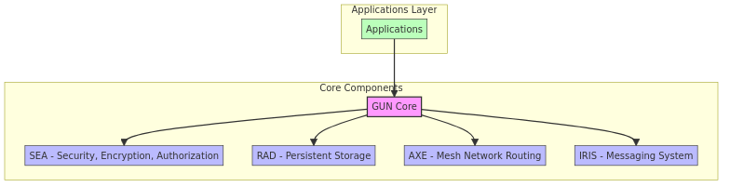

[Fig. 2: LLM Agent Orchestration Framework architecture] 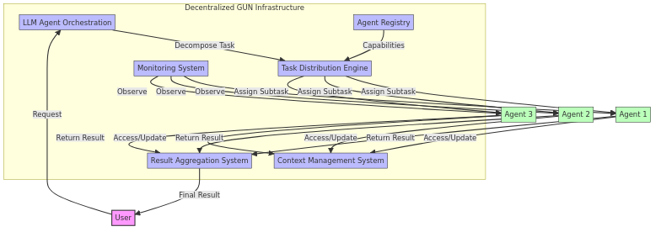

[Fig. 3: Interaction flow between participants] 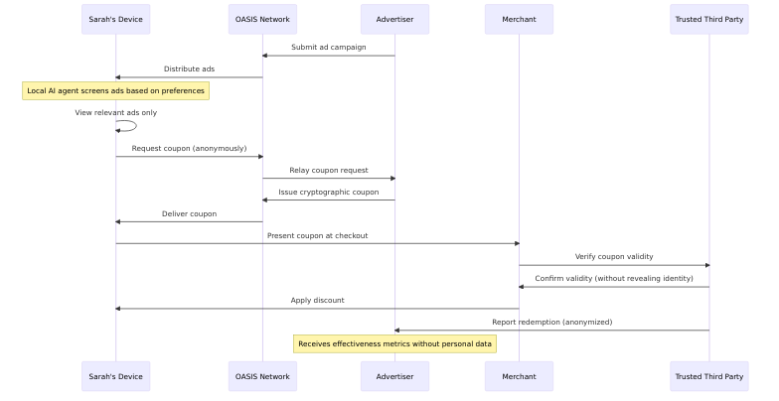

[Fig. 4: Data model class diagram] 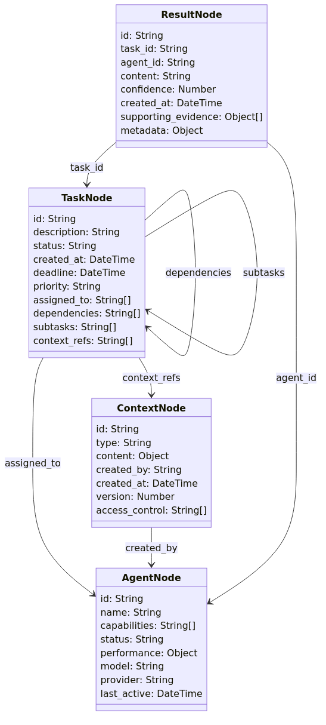

[Fig. 5: System architecture with peer-to-peer communication] 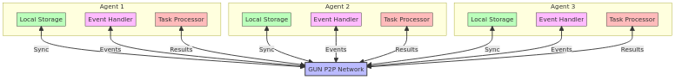

[Fig. 6: Benefits of the OASIS system by stakeholder] Diagram 6

[Fig. 7: Current limitations of existing solutions] 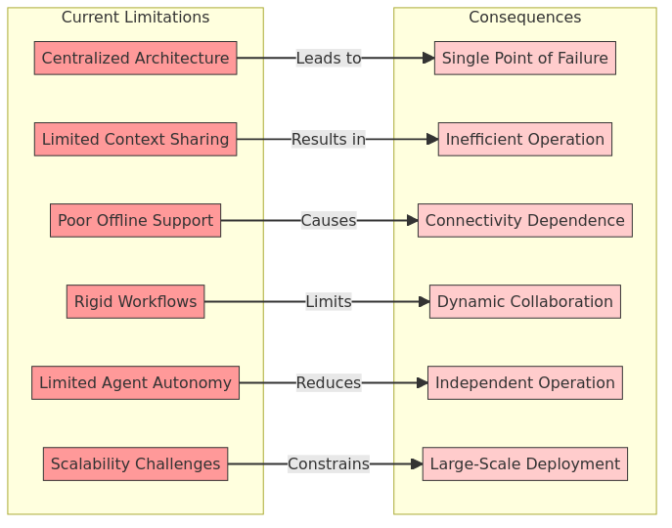

[Fig. 9: Implementation timeline] 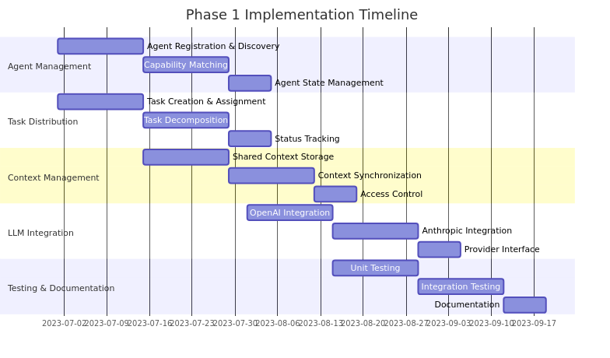

[Fig. 10: Enterprise Research Assistant sequence diagram] 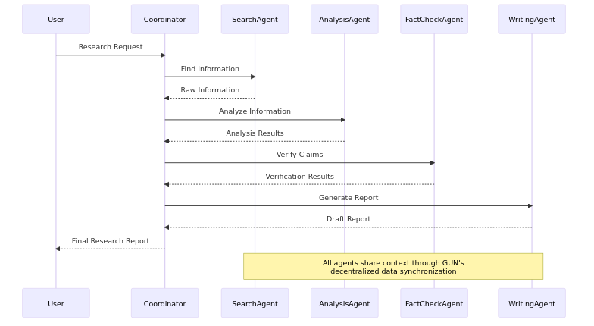

[Fig. 11: Competitive positioning quadrant chart] 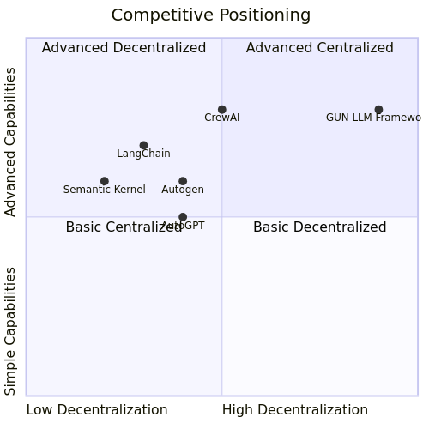

[Fig. 12: Go-to-market strategy mind map] 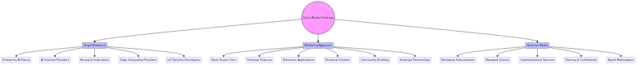

[Fig. 8: Component-level design of Privacy Policy Engine] **[Diagram 12 - Could not be rendered]**

[Fig. 13: Cryptographic Verification Framework design] 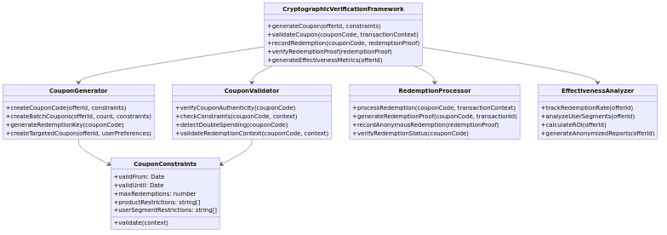

[Fig. 14: System-level architecture of OASIS] 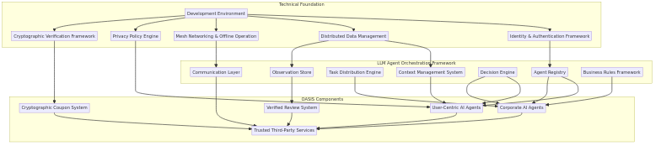

[Fig. 15: Implementation roadmap timeline] 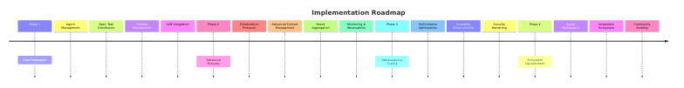

[Fig. 16: User-Centric AI Agent component design] 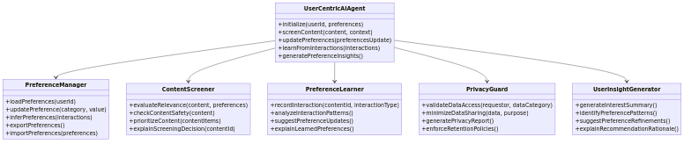

[Fig. 17: A day in the life with OASIS - user journey flow] 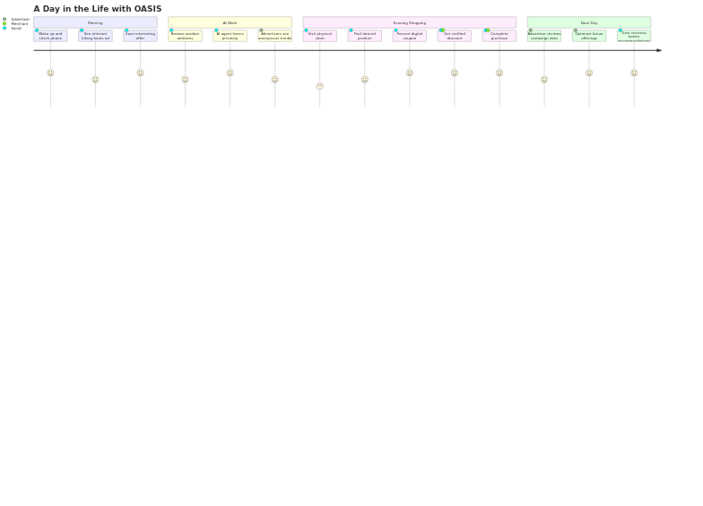

[Fig. 18: Privacy-Preserving Content Matching Flow] 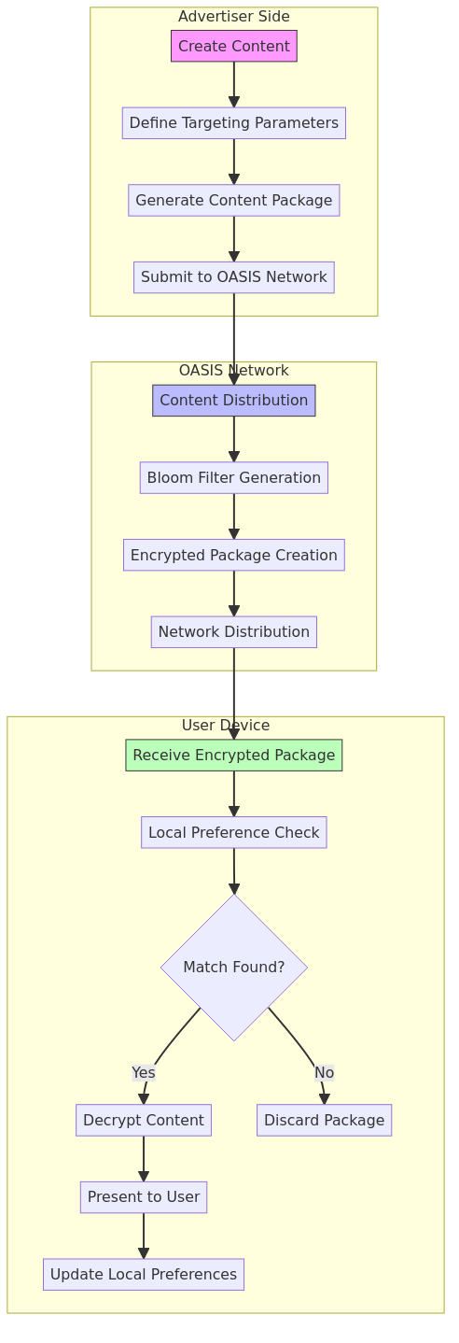

[Fig. 19: Zero-Knowledge Transaction Protocol Flow] 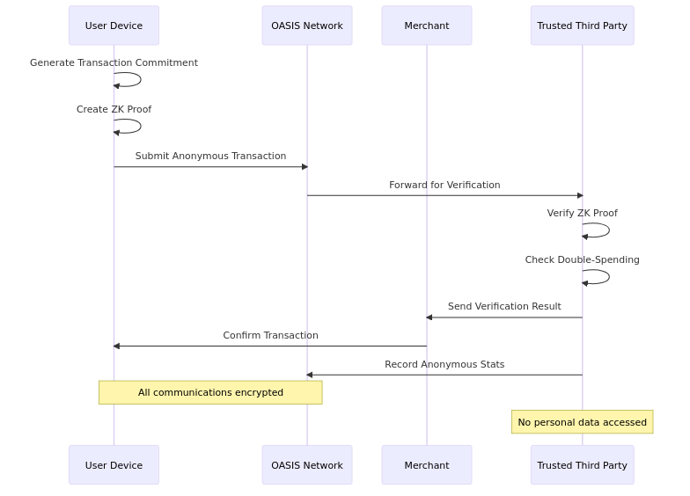

[Fig. 20: Differential Privacy Analytics Pipeline] Diagram 20

[Fig. 21: Multi-Party Computation Protocol] 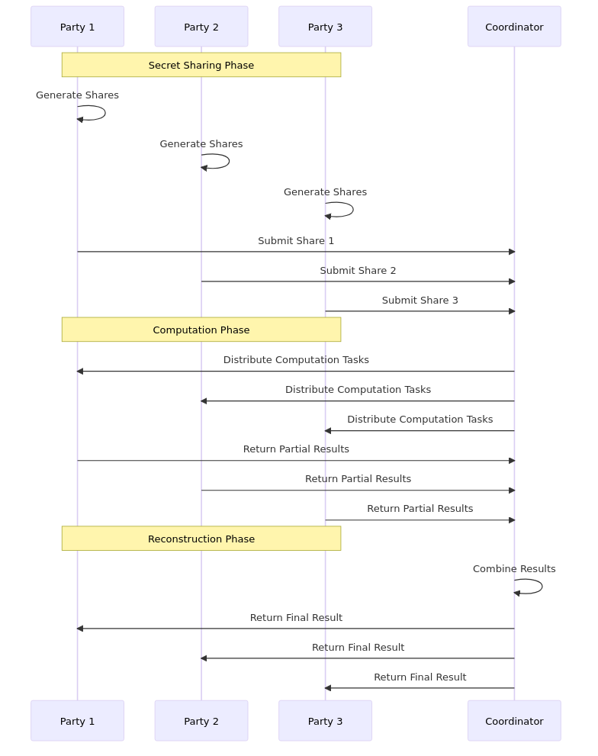

[Fig. 22: Agent Collaboration Protocol] 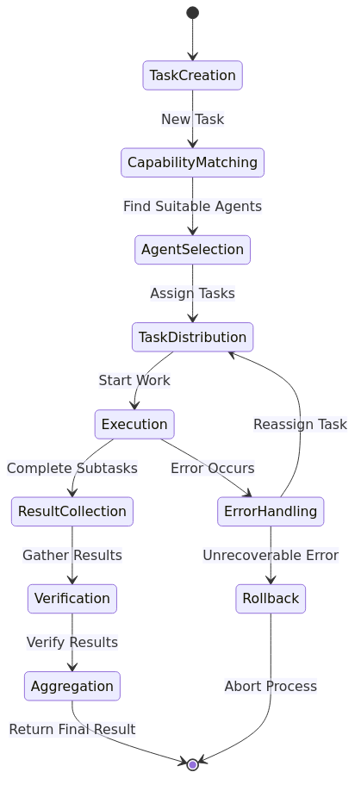

[Fig. 23: Privacy Budget Management Flow] 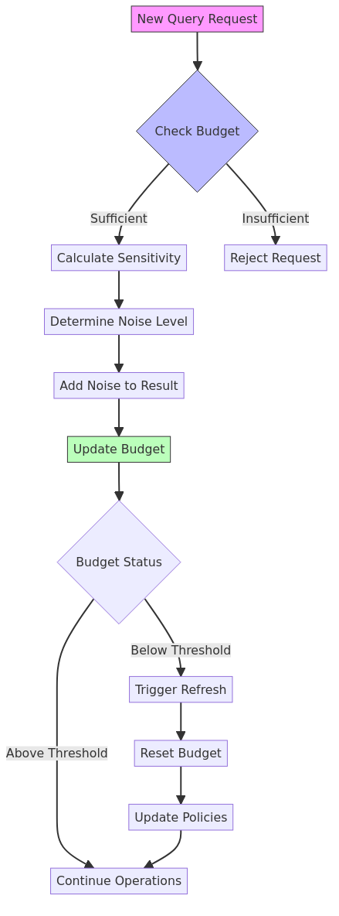

[Fig. 24: Secure State Synchronization] 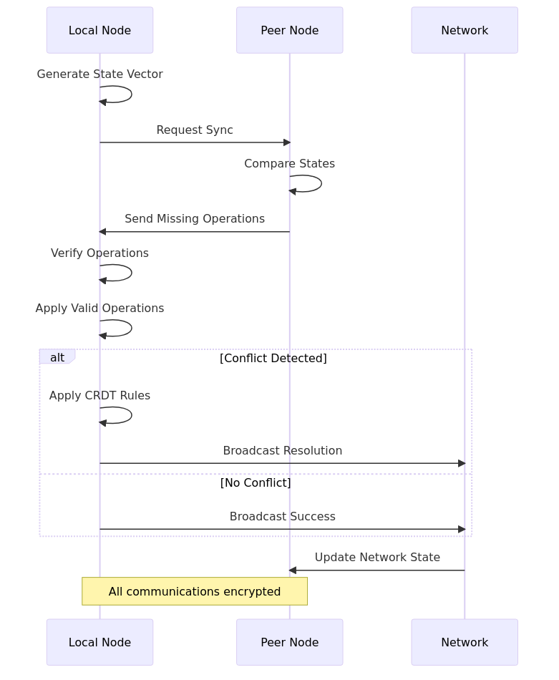

## Dictionary of Terms

### Technical Terms

1. **CRDT (Conflict-free Replicated Data Type)** A data structure that can be replicated across multiple computers in a network, where replicas can be updated independently and concurrently without coordination between the replicas, and where it is always mathematically possible to resolve inconsistencies that might result. Cited in Shapiro et al. (2011), “Conflict-free Replicated Data Types”.
2. **Zero-Knowledge Proof (ZKP)** A cryptographic method by which one party (the prover) can prove to another party (the verifier) that a given statement is true without conveying any additional information apart from the fact that the statement is true. Foundational work by Goldwasser et al. (1989), “The Knowledge Complexity of Interactive Proof Systems”.
3. **Differential Privacy** A rigorous mathematical framework for quantifying and managing privacy loss in data analysis, ensuring that the presence or absence of an individual’s data does not significantly affect the analysis results. Introduced by Dwork (2006), “Differential Privacy”.
4. **Multi-Party Computation (MPC)** A cryptographic protocol that enables multiple parties to jointly compute a function over their inputs while keeping those inputs private from other parties. Based on Yao’s work (1986), “How to Generate and Exchange Secrets”.
5. **Privacy Budget** A mathematical concept in differential privacy that quantifies and limits the amount of information that can be revealed about any individual through multiple queries. Detailed in Dwork’s work on differential privacy (2006).
6. **Mesh Network** A network topology where devices (nodes) connect directly and non-hierarchically to as many other nodes as possible, cooperating to efficiently route data. Referenced in Maymounkov & Mazières (2002), “Kademlia: A Peer-to-peer Information System”.
7. **Agent Orchestration** The coordination and management of multiple autonomous software agents to achieve complex tasks while maintaining privacy and security constraints. Based on Hewitt’s Actor Model (1973).
8. **Bloom Filter** A space-efficient probabilistic data structure used to test whether an element is a member of a set, with possible false positives but no false negatives. Used in the system for privacy-preserving capability matching between agents.
9. **Privacy-Preserving Capability Matching** A technique that enables matching agent capabilities with task requirements without revealing the complete set of capabilities, implemented using Bloom filters and zero-knowledge proofs.
10. **Hybrid Logical Clock** A timestamp mechanism that combines physical time with logical counters to provide a total ordering of events in a distributed system while maintaining causality.
11. **Vector Clock** A data structure for tracking the partial ordering of events in a distributed system, where each node maintains a vector of logical timestamps.
12. **Task Distribution Engine** A component that decomposes complex tasks into subtasks and assigns them to appropriate agents based on their capabilities while preserving privacy constraints.
13. **Context Management System** A system for managing shared knowledge between agents with selective information sharing based on privacy policies and access control.
14. **Privacy Policy Engine** A component that enforces user-defined privacy preferences and ensures compliance throughout all system operations.
15. **Cryptographic Coupon System** A mechanism for generating and validating anonymous but verifiable transaction proofs, enabling measurement of effectiveness without compromising user privacy.

### Business Terms

1. **Privacy-Preserving Commerce** A commercial transaction system that enables personalized experiences and targeted advertising while maintaining user privacy through technical guarantees rather than policy promises. Implements GDPR principles (2016) by design.
2. **Trustless Verification** A system where transactions can be verified without requiring trust in any central authority or counterparty, typically achieved through cryptographic proofs and decentralized consensus mechanisms.
3. **Anonymous Analytics** The ability to gather and analyze aggregate data about system usage and performance while maintaining individual user privacy through techniques like differential privacy and secure multi-party computation.
4. **Privacy-First Architecture** A system design approach that prioritizes user privacy by keeping personal data under direct user control and implementing privacy-preserving protocols for all operations.
5. **Capability-Based Access Control** A security model where access to resources is granted based on cryptographically verifiable capabilities rather than identity, enabling anonymous but authorized access.