# Sample Markdown with Mermaid Diagrams

This is a test file with multiple Mermaid diagrams in different formats.

## Basic Diagram

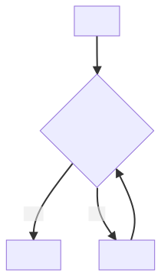

## Complex Diagram

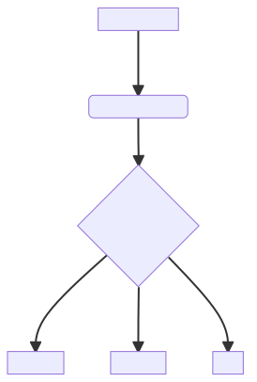

## Alternative Syntax

