
A S S U M P T I O N U N I V E R S I T Y O F T H A I L A N D
Campus Event Management and Booking API
Arjan Dr. CHAYAPOL MOEMENG
Group Members
Thar Lin Htet (6642062)
Honey Linn (6726113)
Mi Hsu Myat Win Wyint (6726115)

Project Overview
The Campus Event Management and Booking API is a backend application that lets university organizations create events and lets students book seats for those events.
Organizers and students will log in using their university Microsoft accounts. Organizers can create events with a venue, schedule, and seat capacity. Students can browse published events and RSVP. When an event is full, new students are added to a waitlist.
The system also checks that every venue address is a real place using a geocoding API, and connects with two other teams in the class through peer APIs: it orders lanyards from the Merchandise Store system for large conferences, and it lets the HelpDesk system check if an event is happening in a room.

Problem Statement
Event sign-ups at university are usually done with Google Forms, chat groups, or paper lists. There is no seat limit control, students can register twice, and venue information is typed by hand so it is often wrong or unclear.
Organizers of big events also have to arrange attendee items like lanyards manually, and the IT helpdesk has no way to know if a broken projector is affecting an event that is happening right now.
A centralized booking system with real authentication, capacity control, and connections to other campus services would solve these problems.

Project Objectives
- Provide a central platform for creating events and booking seats.
- Authenticate users with Microsoft Active Directory (Entra ID).
- Protect endpoints using JWT authentication and Role-Based Access Control.
- Enforce seat capacity, waitlists, and one booking per student per event.
- Validate venue addresses and generate map links using the Geoapify API.
- Order lanyards automatically through the Merchandise team's API for large conferences.
- Expose a protected endpoint so the HelpDesk team can check for active events in a room.
- Store production secrets in Azure Key Vault.
- Deploy on a hardened Linux VPS using Nginx and HTTPS under a new /events path.

Main Features
Organizer
- Log in using a university Microsoft account.
- Create, update, and cancel their own events.
- Set the venue, schedule, and seat capacity.
- Mark an event as a large conference (this triggers the lanyard pre-order).
- View the attendee list and booking count of their own events.
Student
- Log in using a university Microsoft account.
- Browse and search published events.
- RSVP to reserve a seat, or join the waitlist when the event is full.
- Cancel their own bookings and view their booking history.
Administrator
- Manage users and roles.
- Issue and revoke peer API keys.
- View all events and bookings.

Role-Based Access Control
The system will use three roles:
- Student
- Organizer
- Admin
Students can only manage their own bookings. Organizers can only manage events they created (the system checks organizer_id on every update). Admins can manage everything, including users, roles, and peer API keys. Every request must include a JWT, and a middleware checks the role before the request is allowed. The peer endpoint for the HelpDesk team does not use JWT — it is protected by an API key instead.

External API Integration (Geoapify)
The system will use the Geoapify API for geocoding and static maps. Geoapify has a free tier (3,000 requests per day) and does not require a credit card, which fits a student project.
When an organizer creates an event, the backend sends the venue address to the Geoapify Geocoding API. If the address does not resolve to a real place, the event is rejected. If it does, the coordinates are saved and a static map image URL is generated and stored with the venue.
Example input:
Assumption University, Bang Na, Samut Prakan
Example result:
{
"lat": 13.6120,
"lon": 100.8367,
"confidence": 0.95,
"static_map_url": "https://maps.geoapify.com/v1/staticmap?...&marker=..."
}
An organizer can still correct the venue name manually, but the coordinates always come from the geocoder.

Peer API Integration
Our project connects with two other teams, because the class projects call each other in a chain.
API Consumed — Merchandise Store (Option 1)
When an organizer creates an event marked as a large conference, our backend automatically calls the Merchandise team's API to pre-order 50 blank university lanyards for the attendees. We authenticate with the API key that their team issues to us.
POST /orders
x-api-key: MERCH_API_KEY

{ "item": "lanyard", "quantity": 50, "reference": "<eventId>" }
The order reference from their response is saved in our merch_preorders table so we can show the pre-order status.
API Exposed — room check for HelpDesk (Option 2)
The HelpDesk team will call our API to check whether an event is currently happening in a room, so they can mark tickets like "the projector in Room 402 is broken" as URGENT. We generate an API key and issue it only to their team. The key is stored as a hash in our database.
GET /events/api/peer/events/active?room=402
x-api-key: HELPDESK_TEAM_KEY

Response:
{ "active": true, "eventId": 12, "title": "Tech Summit 2026", "endsAt": "2026-11-05T16:00:00Z" }
The request uses a room number because that is what the HelpDesk system knows from the ticket text. Our venues table has a room_number column for this lookup. The exact path will be confirmed with the HelpDesk team before development starts.

Database Schema (ERD)
The database has six tables. A user can be an organizer of events and a student in bookings at the same time, so the User table connects to both. The ApiKey table stores the hashed keys we issue to peer teams.
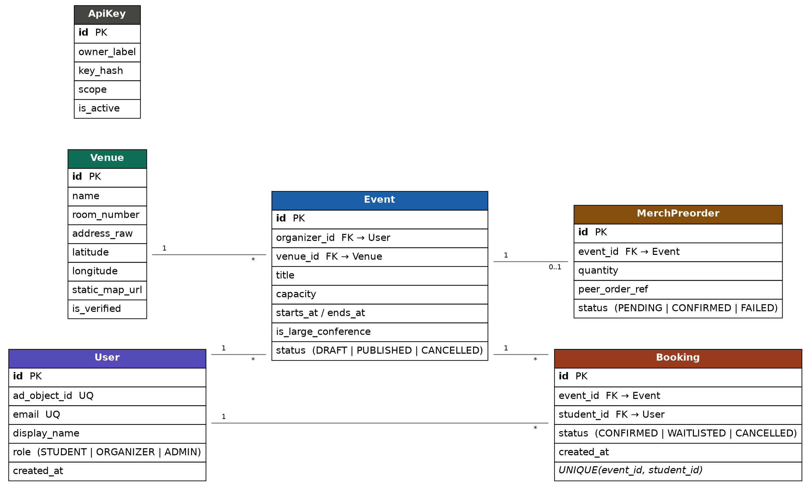
Relationships
- User 1 ───── Many Events (as organizer)
- Venue 1 ───── Many Events
- Event 1 ───── Many Bookings
- User 1 ───── Many Bookings (as student, one booking per event)
- Event 1 ───── 0..1 MerchPreorder (only large conferences)
Prisma schema
We manage the database with Prisma migrations. This is the planned schema:
generator client {
provider = "prisma-client-js"
}

datasource db {
provider = "mysql"
url = env("DATABASE_URL") // injected at runtime from Key Vault
}

enum Role { STUDENT ORGANIZER ADMIN }
enum EventStatus { DRAFT PUBLISHED CANCELLED }
enum BookingStatus { CONFIRMED WAITLISTED CANCELLED }
enum PreorderStatus { PENDING CONFIRMED FAILED }

model User {
id Int @id @default(autoincrement())
adObjectId String @unique @map("ad_object_id") // Entra 'oid' claim
email String @unique
displayName String @map("display_name")
role Role @default(STUDENT)
createdAt DateTime @default(now()) @map("created_at")

eventsOrganized Event[] @relation("Organizer")
bookings Booking[]

@@map("users")
}

model Venue {
id Int @id @default(autoincrement())
name String
roomNumber String? @map("room_number") // e.g. "402" - used by HelpDesk lookup
addressRaw String @map("address_raw")
latitude Float? // set after geocoding
longitude Float?
staticMapUrl String? @map("static_map_url")
isVerified Boolean @default(false) @map("is_verified")

events Event[]
@@map("venues")
}

model Event {
id Int @id @default(autoincrement())
organizerId Int @map("organizer_id")
venueId Int @map("venue_id")
title String
description String? @db.Text
capacity Int
startsAt DateTime @map("starts_at")
endsAt DateTime @map("ends_at")
isLargeConference Boolean @default(false) @map("is_large_conference")
status EventStatus @default(DRAFT)
createdAt DateTime @default(now()) @map("created_at")

organizer User @relation("Organizer", fields: [organizerId], references: [id])
venue Venue @relation(fields: [venueId], references: [id])
bookings Booking[]
preorder MerchPreorder?

@@index([venueId])
@@index([organizerId])
@@map("events")
}

model Booking {
id Int @id @default(autoincrement())
eventId Int @map("event_id")
studentId Int @map("student_id")
status BookingStatus @default(CONFIRMED)
createdAt DateTime @default(now()) @map("created_at")

event Event @relation(fields: [eventId], references: [id])
student User @relation(fields: [studentId], references: [id])

@@unique([eventId, studentId]) // one booking per student per event
@@map("bookings")
}

model MerchPreorder {
id Int @id @default(autoincrement())
eventId Int @unique @map("event_id") // 1:0..1 with Event
quantity Int @default(50)
peerOrderRef String? @map("peer_order_ref") // ref returned by Merch API
status PreorderStatus @default(PENDING)
createdAt DateTime @default(now()) @map("created_at")

event Event @relation(fields: [eventId], references: [id])
@@map("merch_preorders")
}

model ApiKey {
id Int @id @default(autoincrement())
ownerLabel String @map("owner_label") // e.g. "ticketing-team"
keyHash String @map("key_hash") // store hash, never the raw key
scope String // e.g. "room-status:read"
isActive Boolean @default(true) @map("is_active")
createdAt DateTime @default(now()) @map("created_at")

@@map("api_keys")
}

Technology Stack
- Backend: Node.js with Express
- Database: MySQL
- ORM: Prisma ORM with migrations
- Authentication: Microsoft Active Directory (Entra ID, OIDC)
- Authorization: JWT and RBAC
- Secrets Management: Azure Key Vault
- External API: Geoapify (geocoding and static maps)
- Deployment: Azure Linux VPS
- Reverse Proxy: Nginx
- SSL: Let's Encrypt
- Source Control: GitHub
- Automation: Deployment script (PM2 and prisma migrate deploy)

Deployment Plan
The system will be deployed on our existing hardened Azure Linux VM. The backend will run on a private port and will be exposed through Nginx under a separate path:
https://chaotic-hell.eastasia.cloudapp.azure.com/events
The /events route will be a new Nginx location block, so the existing /content (WordPress) and /api (Lab) routes are not affected.
For secrets, we will keep only non-secret settings in a local env file (the Key Vault URL, the port, and the Entra tenant and client IDs). The real secrets — the database URL, JWT secret, Geoapify key, and peer API keys — will be fetched from Azure Key Vault when the app starts, using the VM's managed identity. This way no production secret is ever saved in a .env file or in the GitHub repository. Because the school does not provide class credentials, we will create our own free Entra ID tenant and our own Key Vault for this.

Expected Outcome
The completed system will be a working event booking platform for the university. The project will demonstrate:
- REST API development
- Microsoft Active Directory login
- JWT authentication and Role-Based Access Control
- Prisma ORM and migrations
- Azure Key Vault integration
- Venue validation with a third-party geocoding API
- Peer API communication with two partner teams
- Nginx reverse proxy and HTTPS deployment
- GitHub source control and automated deployment

