**AOS Programming Project –3**

**Contributors:**

HEMANJENI KUNDEM(HXK180032)

KASHYAP PATEL**(kjp170000)**

**File structure:**

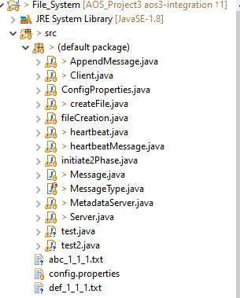

**Main files :**

MetadataServer.java -Contains code for running metadata server

Server.java - Contains code for server (S1...S5)

Client.java - Contains code for Client( C1..C2)

ConfigProperties.java - Configuration settings for client ,servers and metadata servers

CreateFile.java - Utility for creating linux files of 4KB size during creation,append operations

Heartbeat.java - Structure for each heartbeat related to a linux file

HeartBeatMessage.java - Array of Heartbeat messages

Message.java - The structure of messages exchanged between the meta ,servers and clients

MessageType.java - Describes the various messages exchanged between the processes

**Running the application:**

Run the file MetadataServer.java with 0 as CLI argument ,(dc10)

Run the file Server.java with 1,2,3,4,5 as CLI arguments in separate terminals(dc11..dc15)

Run the file Client.java with 6,7 as CLI arguments in separate terminals(dc16,dc17)

**Inputs**

From the client console following commands are given for each operation required for the project

=======================

OPERATION-COMMAND

=======================

<CREATE> - Option **1** in console

<READ> - Option **2** in console

<WRITE>- Option **3** in console

<STOPTHESERVER> - Option **4** in console

<EXIT>- Option **6** in console

**Outputs**

Corresponding files resulting from each operation can be seen in ./files/ directory in each server.

**Prerequisite**

A folder with name ‘./**files/’** containing a few filesin the format **“<filename>_<chunknumber>_<version>_<server>.txt”** should be initially placed at the serverfor initial run.

**Logs**

Logs are created in ./logs/ folder from the current directory