**How is the GUI used?**

In this Project there are some buttons, select boxes and links that user can interact. The first example is in the main page. There are 4 links(instructor,student,Project,department), user can click every of them and find related database.

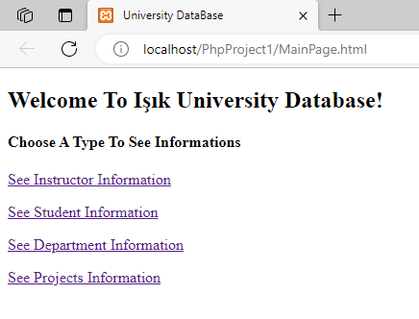

Then, if the user chooses instructor or student s/he goes to a page which s/he can select a social security number. After selecting a ssn user press the “Get ….. details” button to achieve related student/instructor informations. Also in this page there is a link that allow to user go back to main page.

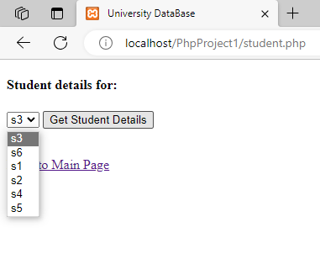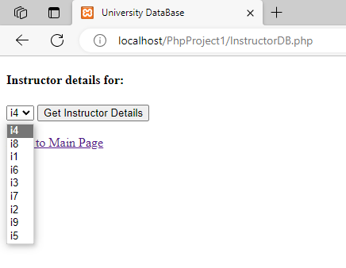

In the instructor information page there is a table which shows exam that instructor delivered. In last row of the table there is link that take the user to the exam point details page. Also there are links that takes user to main page or instructor selecting page. These links are also added the student information page.

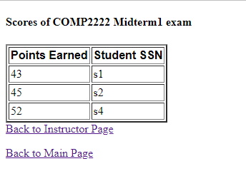

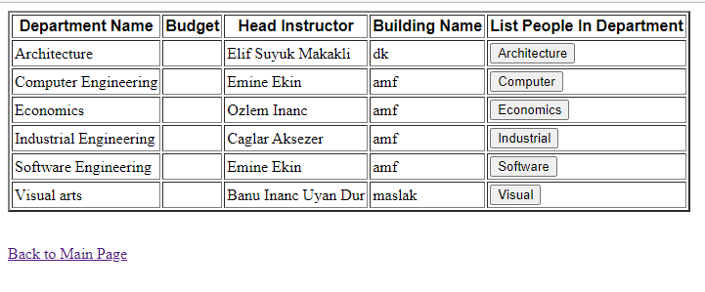

On the Project and department pages there are some buttons on the table which takes the user people list of related Project/department.

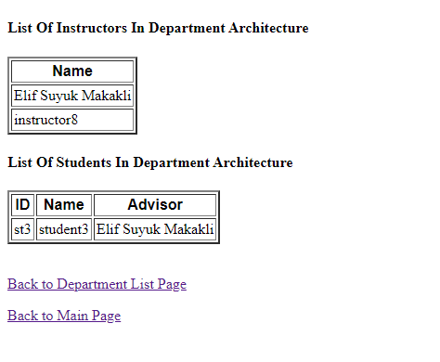

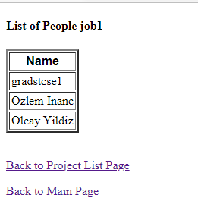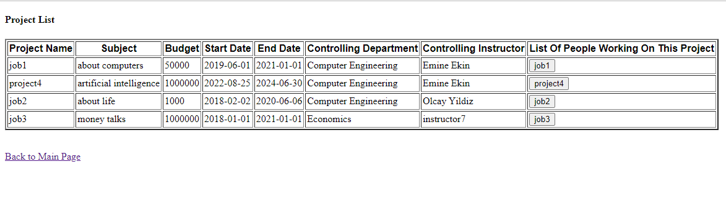

In both people information pages there are links that user can go back to Project list or main page.

**Is the relational schema of your database in 2NF/3NF/BCNF?**

Releational Schema is in 3NF format. Reason behind that is :

In the enrollment table, Primary key is (sssn,semester,courseCode,yearr,sectionId,issn).

**diyagram, çizgi, ekran görüntüsü, dikdörtgen içeren bir resim

Açıklama otomatik olarak oluşturuldu**

(enrollment) 🡪 (sectionn) **semester courseCode yearr sectionId.** Because there is no multivalued attribute it is 1NF. Because of the prime attribute on the RHS, 2NF and 3NF rules also valid. Because of the LHS does not have super key, BCNF rule is not valid.

**ekran görüntüsü, diyagram, dikdörtgen, çizgi içeren bir resim

Açıklama otomatik olarak oluşturuldu**

(enrollment) 🡪 (timeSlot) **day hourr**. Because there is no multivalued attribute it is 1NF. Because of the prime attribute on the RHS, 2NF and 3NF rules also valid. Because of the LHS does not have super key(key is: **ssn semester courseCode yearr sectionId issn**), BCNF rule is not valid.

ekran görüntüsü, diyagram, dikdörtgen, çizgi içeren bir resim

Açıklama otomatik olarak oluşturuldu

(enrollment) 🡪 (student) **ssn**. Because there is no multivalued attribute it is 1NF. Because of the prime attribute on the RHS, 2NF and 3NF rules also valid. Because of the LHS does not have super key(key is: **ssn semester courseCode yearr sectionId issn**), BCNF rule is not valid.

metin, ekran görüntüsü, çizgi, dikdörtgen içeren bir resim

Açıklama otomatik olarak oluşturuldu

(Instructor) 🡪 (student) ssn. Because there is no multivalued attribute it is 1NF. Because of the prime attribute on the RHS, 2NF and 3NF rules also valid. Because of the LHS does not have super key(key is: **ssn**), BCNF rule is not valid.

metin, diyagram, ekran görüntüsü, paralel içeren bir resim

Açıklama otomatik olarak oluşturuldu

In the other tables, there is no violation to 2NF and 3NF. Because in all FD’s, right handside is prime attribute. It means our schema is in 3NF form.

**How would you improve this database?**

We can decompose out tables for to make our schema BCNF form. For example:

**diyagram, çizgi, ekran görüntüsü, dikdörtgen içeren bir resim

Açıklama otomatik olarak oluşturuldu**

(enrollment) 🡪 (sectionn) **semester courseCode yearr sectionId.** We can modify this table as like this:

(enrollment) **semester courseCode yearr sectionId + issn sssn grade** 🡪 (sectionn) **semester courseCode yearr sectionId.**

In this way, our schema satisfy BCNF rule.

Anıl Erdal 21SOFT1021

Ahmet Emre Çakmak 21SOFT1048

Erdem Önal 21COMP1013

Muhammet Eymen Bağlar 21COMP1040