# Project: VGG Convolutional Feature Map Compression

## 1 Introduction

Deep learning image analysis pipelines, like the VGG-16 illustrated below, generates a lot of feature maps that need compression for distributed visual analysis. In this project, we will explore intra and inter compression schemes developed in HW-2 and 3, and see how far can we achieve compression.

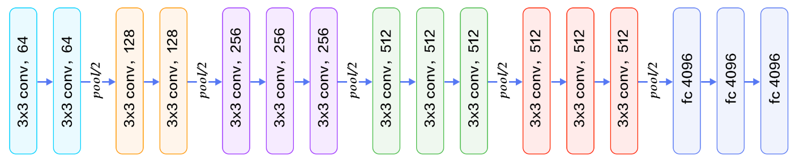

Figure 1. VGG 16 CNN

We pre-computed the CONV2 and CONV3 feature maps for the TinyVOC data set, which consists of 10 classes and 10 images each for a total of 100 images, with size 256x256 pixels, and CONV2 generates 128 feature maps of size 128x128 for each images, and CONV3 generates 256 64x64 feature maps. An example for image “TinyVOC2012/boat/2008_001047.jpg” are shown below, for the first 8 feature maps:

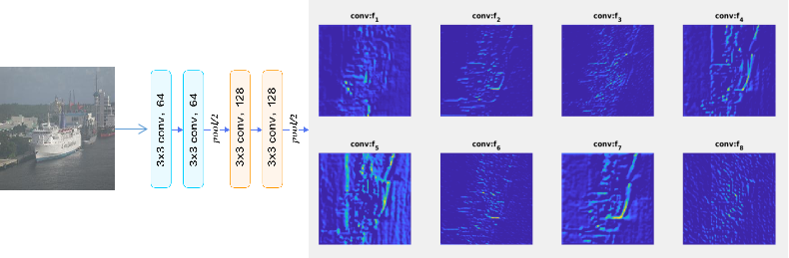

Data set and data loading code are available at:

<https://umkc.box.com/s/tdweqp880ib7v82f9qkinbfbtdkpr9tq>

Below is the MATLAB code to manipulate the data and to plot various bits of information.

|  |
| --- |
|  |

Complete the following tasks for the following 4 images:

|  |
| --- |
| TinyVOC2012/boat/2008_001047.jpg  TinyVOC2012/bottle/2008_001744.jpg  TinyVOC2012/cat/2008_002793.jpg  TinyVOC2012/chair/2008_002148.jpg |

## Problem 1: INTRA Coding [20 pts.]

Treat these feature maps as images, using JPEG/DCT based compression scheme to compress them and plot the first 8 feature maps’ R-D curve as bpp-PSNR. Notice that the feature map has different dynamic range as illustrated below, you will need to normalize its range to [0,1], and map to uint8 representation between 0 and 255, and call imsave() in MATLAB to save it as JPEG file, and compute PSNR and corresponding rate in bpp. Notice that imsave() allows you to specify image quality, use that to control the bpp.

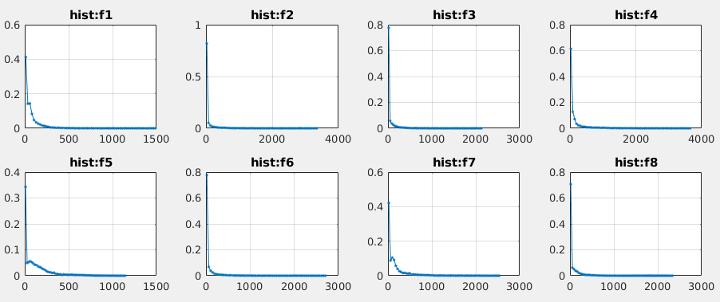

## Problem 2: INTRA Compression [30 pts.]

Use the technique developed in HW-2, using a spatial filter to do INTRA prediction of the pixel values, and plot its histogram before and after the prediction, use uniform quantizer to generate an estimated entropy for different quantizer step size. The input histogram for the first 8 features are shown below:

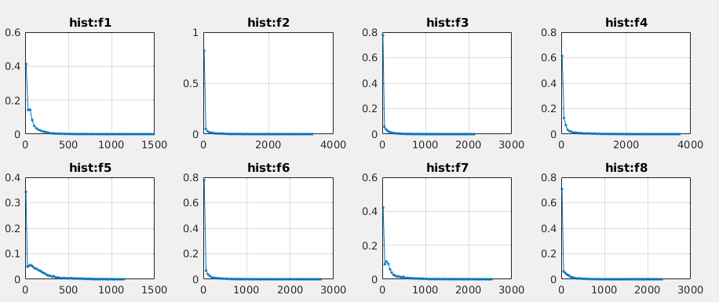

Notice that it is already high concentrated around zero.

## Problem 3: INTER Prediction [50 pts]

Treat feature maps as if they are frames in a sequence, for the first 15 CONV2 features, illustrated below:

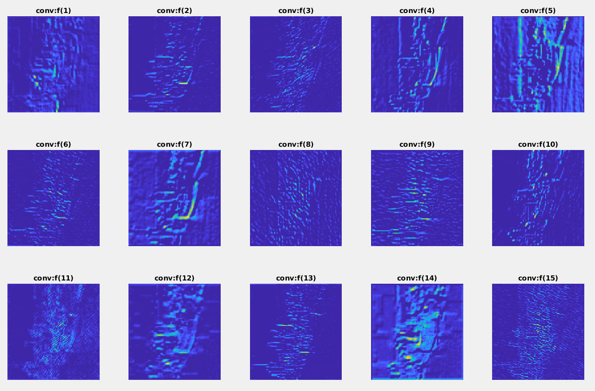

Using the 1/2 pel accuracy 4x4 block size motion compensation scheme developed in HW-3, to find the best motion compensation results for each feature map, as measured by average residual energy in MSE. Notice that for each feature map, you can choose 14 feature maps as references, need to compute which one gives the best prediction.

## Appendix: Visualization of CONV3 Features

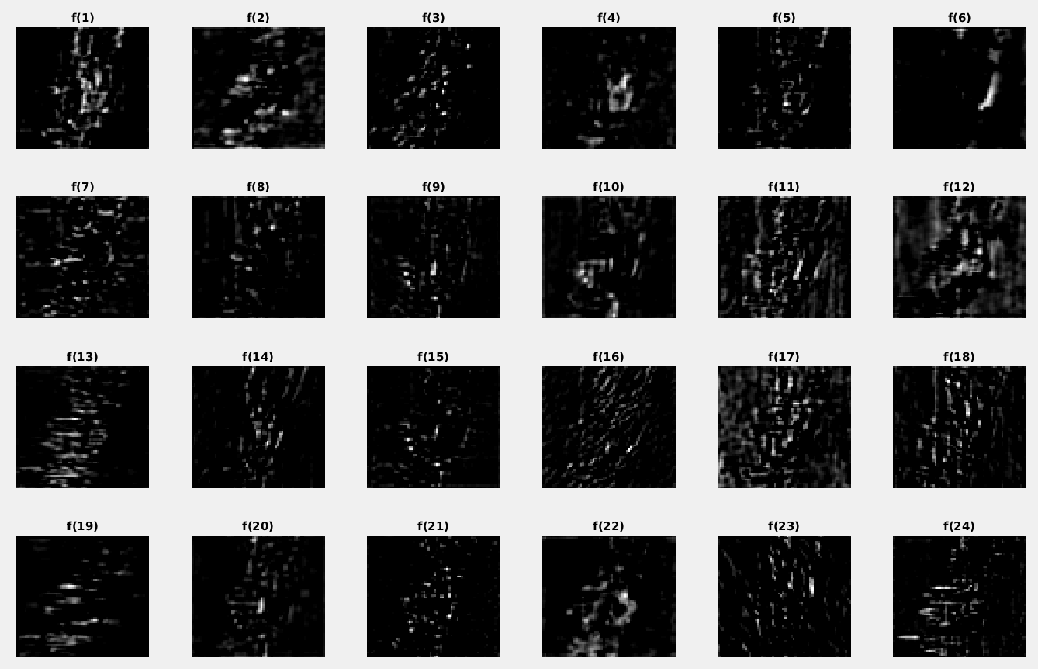

**FIGURE: Feature Maps for the First 24 Feature Channels of Size 64x64**

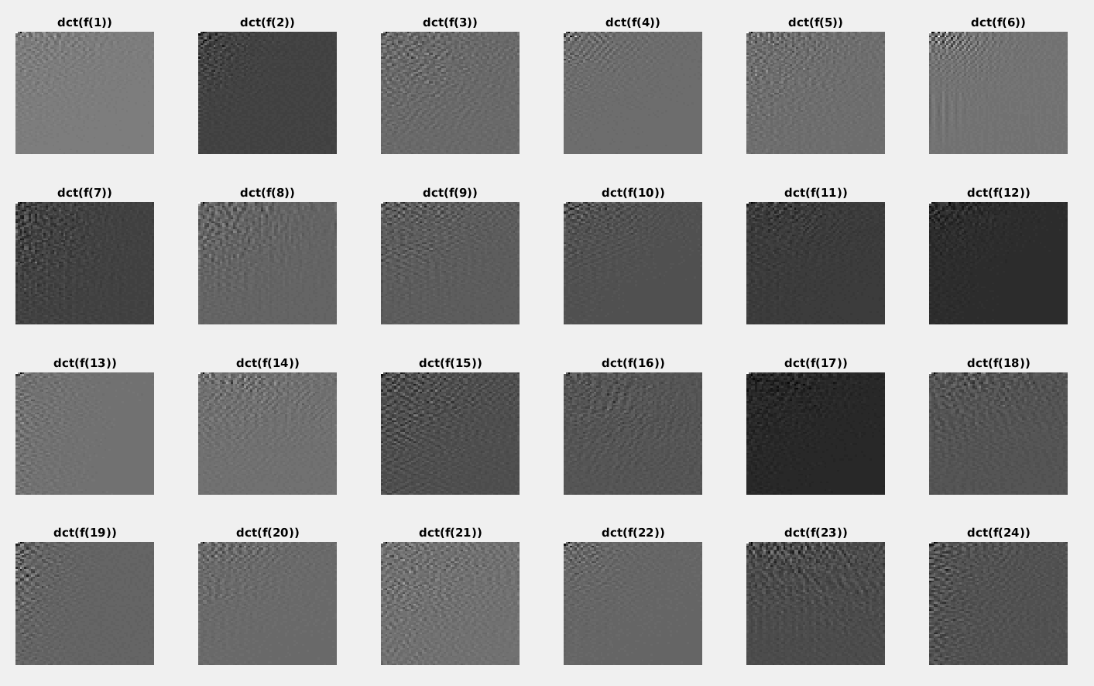

**FIGURE: Visualization of DCT of First 24 Feature Channels**

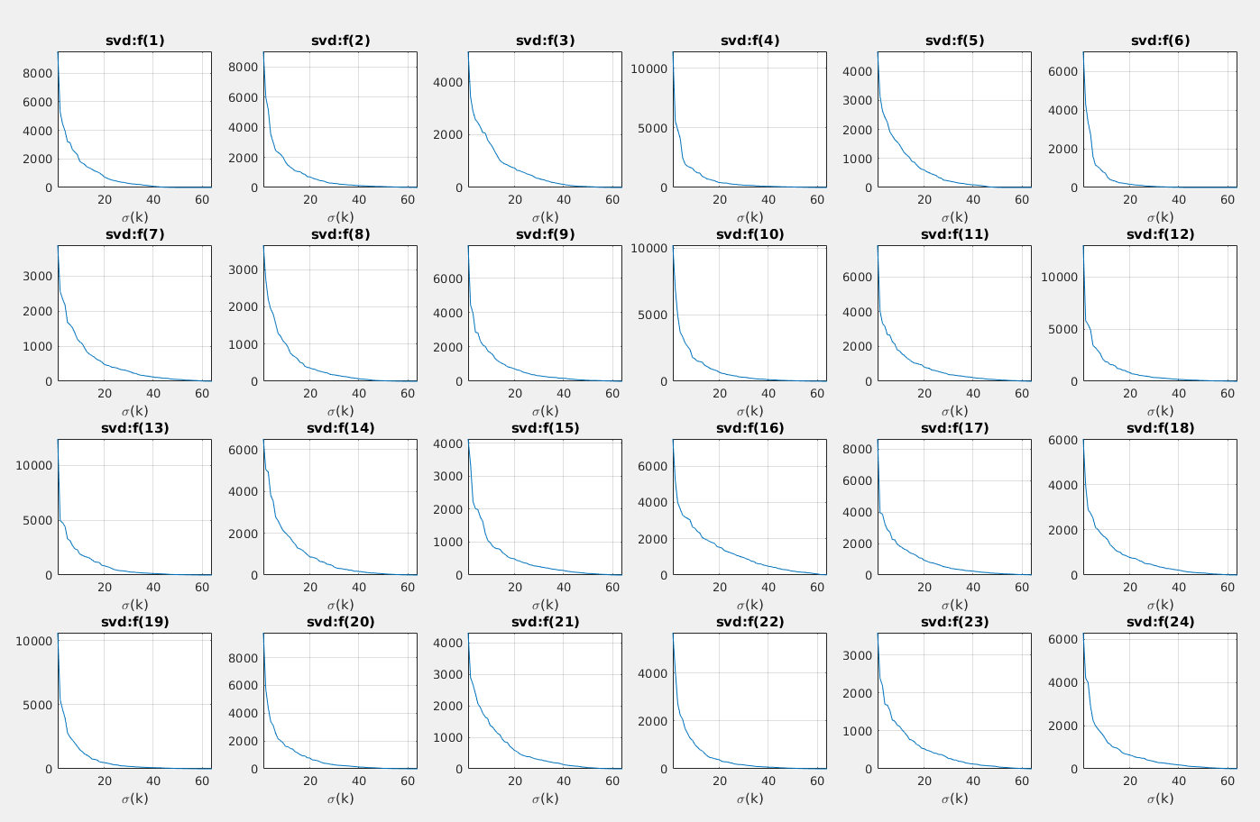

**FIGURE: Visualization of the SVD Decomposition Singular Values:**