In this homework, we will practice hands on experience with using video codec to encode video sequences, and compute its quality of experience (QoE). For the dataset provided by the TUT Finland, let us select the first 2 sequences for the test:

http://ultravideo.cs.tut.fi/#testsequences

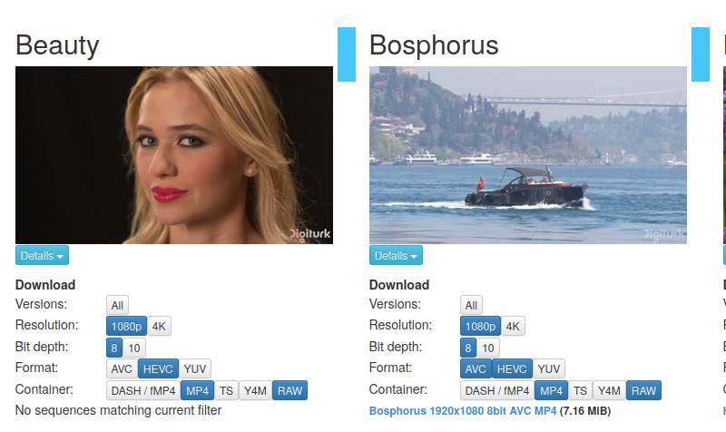

{Hint: use FFMPEG software, sudo apt install ffmpeg on linux will install the package for you. User manual is here: <https://ffmpeg.org/ffmpeg.html> }

1. Obtain the Beauty and Boshphorous sequences in 1080p resolution and 4:2:0 YUV format, encode the first 30 frames in INTRA only format, using HEVC codec, and quantization parameter QP=[22, 25, 28 32], and plot the PSNR of all 30 frames for both sequences (10pts), as well as the SSIM scores (15pts)
2. Code the 2 sequences with IPPPP format, using HEVC codec, with QP=[22, 25, 28, 32], plot and compare the PSNR and SSIM scores. (25 pts)
3. For the 2nd frame in both sequences, compare the SSIM map for QP = 25 for INTRA vs IPPPP coding schemes, and explain your observation (50pts)