Files

Caricamento files di dati

[Files, General] = BCI_LoadFiles(Dat_Files,Mnt_File)

[ signal, states, parameters ] = load_bcidat( varargin )

[Montage]=load_bcimnt(MntFile)

Preconditioning

Protocol

Definizione del Protocollo di Analisi dei dati

[VirtualStates] = BCI_SetProtocol(States, Analysis, varargin)

VirtualStates = BCI_Mu(States, varargin)

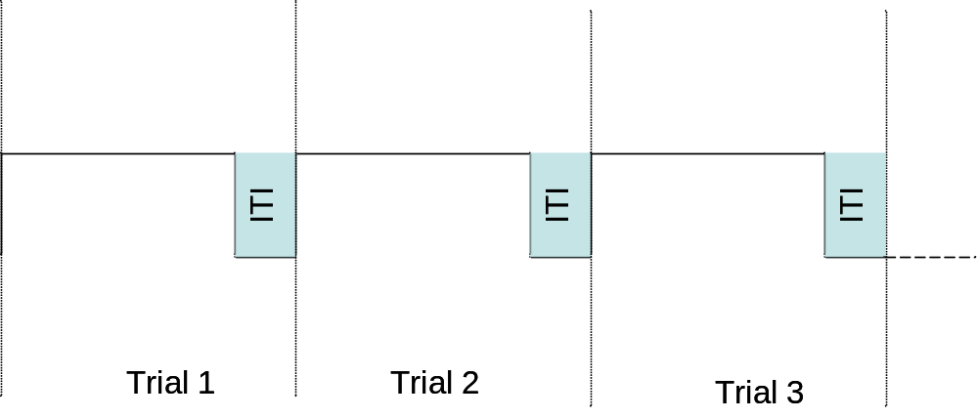

VirtualStates = BCI_P300(States, varargin)

Conditioning

Moduli di condizionamento del segnale

Conditioning = BCI_Conditioning(SpatFilt,Data,Geom)

FilteringData = CarFilt(Data,Geom)

Feature Extractor

Moduli di estrazione delle feature

FeatExtraction = BCI_FeatExtractor(FEMethod,Epocher,FExParams,Data,States)

Epoch_index = BCI_Epocher(Epocher,FExParams,States)

Epoch_matr = MU_Epocher(States,SampEpochLength,EpochOverlap)

Epoch_matr = P300_Epocher(States,SampEpochLength,EpochOverlap)

FeatMatr = IterativeMem(Data,FExParams,EpochIndex)

mem.dll

Regressor = StatesExtractor(States,FExParams,EpochIndex)

Feature Combinator

Statistics

Moduli di Analisi Statistica

StatResults = BCI_StatAnalysis( StatMethod,BCI2k.FeatExtraction )

SignedRSquare = BCI_RSquare(Data,Regressor)

[ressq, sgnR2] = calc_rsqu_f(NDependentVariables,IndependentVariable)

[erg, s]= rsqu_f(q, r, varargin)

[R2, s]= rsquare(X, Y);

Classify

Visualizer

