**Superstore-dataset-dashboarddesign**

# Udacity

## Data Visualization Nanodegree

## Dashboard Design

## Design a Data Dashboard Final Project

## Project Overview

Analyze provided Superstore dataset to create a dashboard to provide a more strategic view of the business to help answer the following questions.

Dashboard published at https://public.tableau.com/app/profile/kay.sun/viz/Superstore-dataset-dashboarddesign_16973735914410/Dashboard1

### Top-level revenue, profit, average profit ratio, and units sold in 2018

### YoY performance by segment (segment refers to Corporate, Consumer, Home Office)

### Monthly trend of the current year by segment (segment refers to Corporate, Consumer, Home Office)

### View category performance

### Best performing sub-category within each customer segment

## Font Hierarchy

### Dashboard title text

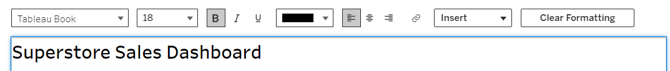

### Body text

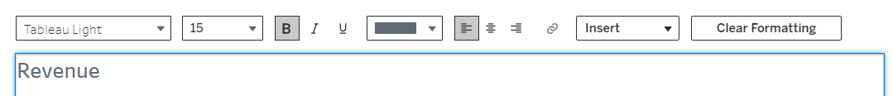

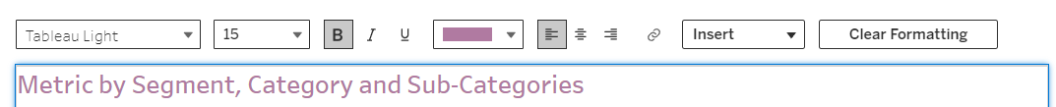

### BAN Text



### Context/instructive text



