# Project: Analyzing a Market Test

## Step 1: Plan Your Analysis

*To perform the correct analysis, you will need to prepare a data set. (500 word limit)*

*Answer the following questions to help you plan out your analysis:*

1. What is the performance metric you’ll use to evaluate the results of your test?

Gross margin as the cost of the advertising needs to be accounted for from the revenue.

1. What is the test period?

12 weeks between 2016 April 29 to 2016 July 21 when new menu and tv ads were ran at the treatment stores in Denver and Chicago.

1. At what level (day, week, month, etc.) should the data be aggregated?

Weekly to capture weekly trends. Daily would be too granular and monthly too coarse given the 12 weeks test period.

## Step 2: Clean Up Your Data

*In this step, you should prepare the data for steps 3 and 4. You should aggregate the transaction data to the appropriate level and filter on the appropriate data ranges. You can assume that there is no missing, incomplete, duplicate, or dirty data. You’re ready to move on to the next step when you have weekly transaction data for all stores.*

## Step 3: Match Treatment and Control Units

*In this step, you should create the trend and seasonality variables, and use them along with you other control variable(s) to match two control units to each treatment unit. Note: Calculate the number of transactions per store per week to calculate trend and seasonality.*

*Apart from trend and seasonality...*

1. What control variables should be considered? Note: Only consider variables in the RoundRoastersStore file.

AvgMonthSales or average monthly sales as the Denver and Chicago stores were chosen since they perform similarly to all other stores.

Specific product, their category and quantities and sizes are different for control and treatment stores due to the new menu.

1. What is the correlation between your each potential control variable and your performance metric?

Pearson correlation, 99.1%, between AvgMonthSales and Sum_Sum_Gross_Margin (weekly gross margin) is very high, while correlation between Sq_Ft and Sum_Sum_Gross_Margin is very low and negative at -2.4%.

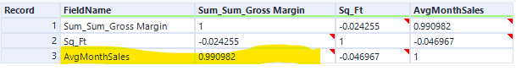

1. What control variables will you use to match treatment and control stores?

The high correlation between AvgMonthSales and Sum_Sum_Gross_Margin indicates AvgMonthSales should be used.

1. Please fill out the table below with your treatment and control stores pairs:

|  |  |  |
| --- | --- | --- |
| Treatment Store | Control Store 1 | Control Store 2 |
| 1664 | 7162 | 8112 |
| 1675 | 1580 | 1807 |
| 1696 | 1964 | 1863 |
| 1700 | 2014 | 1630 |
| 1712 | 8162 | 7434 |
| 2288 | 9081 | 2568 |
| 2293 | 12219 | 9524 |
| 2301 | 3102 | 9238 |
| 2322 | 2409 | 3235 |
| 2341 | 12536 | 2383 |

## Step 4: Analysis and Writeup

*Conduct your A/B analysis and create a short report outlining your results and recommendations. (250 words limit)*

*Answer these questions. Be sure to include visualizations from your analysis:*

1. What is your recommendation - Should the company roll out the updated menu to all stores?

Yes, rolled out new menu to all stores is recommended, since the lift for each West and Central regions as well as overall are above 18% threshold. There are also strong significance for the predictions.

1. What is the lift from the new menu for West and Central regions (include statistical significance)?

For region West, the average lift is 37.7%, expected impact on weekly gross margin is $517.7 and significance level is 99.7%.

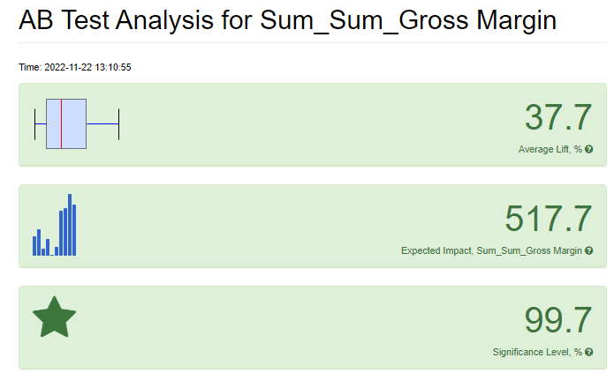

For region Central, the average lift is 46%, expected impact on weekly gross margin is $869.9 and significance level is 99.6%

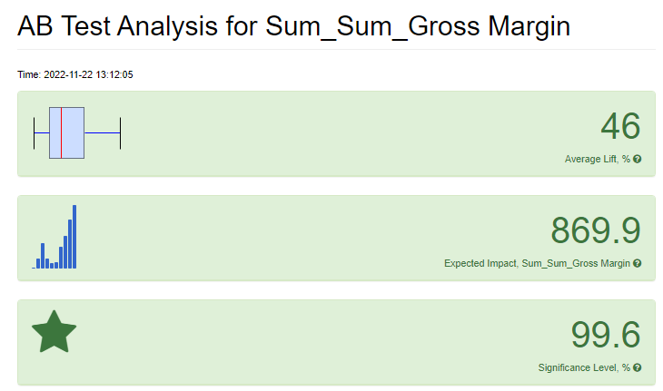

1. What is the lift from the new menu overall?

Overall, the average lift is 41.9% and significance of 100%.

