**Họ tên:** Kiến Đức Trọng

**MSSV:** 21110332

**Bài 01: Cài đặt môi trường và viết app nhận diện thương hiệu**

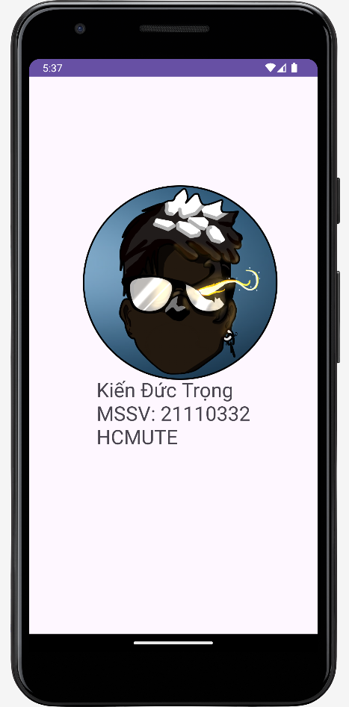

activity_main.xml

|  |
| --- |
| *<?*xml version="1.0" encoding="utf-8"*?>* <androidx.constraintlayout.widget.ConstraintLayout xmlns:android="http://schemas.android.com/apk/res/android"  xmlns:app="http://schemas.android.com/apk/res-auto"  xmlns:tools="http://schemas.android.com/tools"  android:layout_width="match_parent"  android:layout_height="match_parent"  tools:context=".MainActivity">   <TextView  android:id="@+id/name"  android:layout_width="wrap_content"  android:layout_height="wrap_content"  android:text="Kiến Đức Trọng"  android:textSize="75px"  app:layout_constraintBottom_toBottomOf="parent"  app:layout_constraintEnd_toEndOf="parent"  app:layout_constraintStart_toStartOf="parent"  app:layout_constraintTop_toTopOf="parent"  app:layout_constraintVertical_bias="0.619" />   <de.hdodenhof.circleimageview.CircleImageView  android:id="@+id/imageView2"  android:layout_width="273dp"  android:layout_height="265dp"  android:layout_marginStart="69dp"  android:layout_marginTop="148dp"  android:layout_marginEnd="69dp"  android:src="@drawable/ktedited"  app:civ_border_color="#FF000000"  app:civ_border_width="2dp"  app:layout_constraintEnd_toEndOf="parent"  app:layout_constraintHorizontal_bias="0.0"  app:layout_constraintStart_toStartOf="parent"  app:layout_constraintTop_toTopOf="parent" />  </androidx.constraintlayout.widget.ConstraintLayout> |