**Processing Pipeline Title**

(Created by [Your Name] [date])

**Scripts in:** /Path/to/scripts/01_Protocols/Scripts

**Processing times based on:** Mac OS v10.14, SPM12, FSL v6.0

**Step 1: A0_convert_dcms_sort_niis.m**

* Converts T1 and B0 from dicom to nifti and moves the new niftis to the main processing folder.
  + ~2-3sec/subject
* Paths and dicom folder variables will need to be changed
* Outputs: 02_Data/01_Native_T1T2B0

**Step 2: A1_Segment_Coreg_SPM.m**

* Segments T1 into GM, WM, CSF, skull, dura; binarizes GM and WM segments; coregisters T1 to B0 and applies transformation to GM and WM segments
* Paths will need to be changed
* Binarization threshold = 0.95 (can be changed in %paths and variables section of script)
  + ~7-9min/subject
* In-process segment outputs: 03_Analysis/01_Intermediate_Files
* Finalized segment outputs: 03_Analysis/01_Warped_Segments

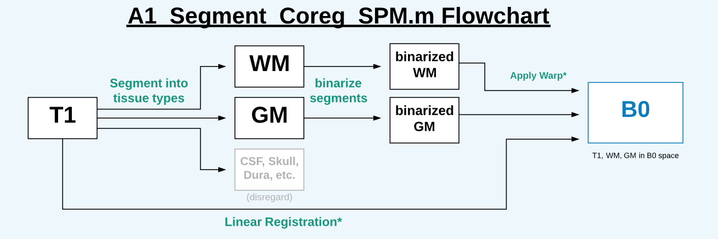

**Step 3: A1a_DKE_Met_Org.sh**

* Copies DKE metrics from main DKE output folder; creates MD mask that will be used later to mask out MD>2
  + ~2-5sec/subjects
* Paths will need to be changed
* Outputs: 02_DKE_Maps

**Step 3: QC Segments**

* Open the original B0 in FSLeyes and overlay the full processed GM and WM segments to ensure that the segments were binarized and warped to B0 space correctly.
  + See examples below.

B0: FA:

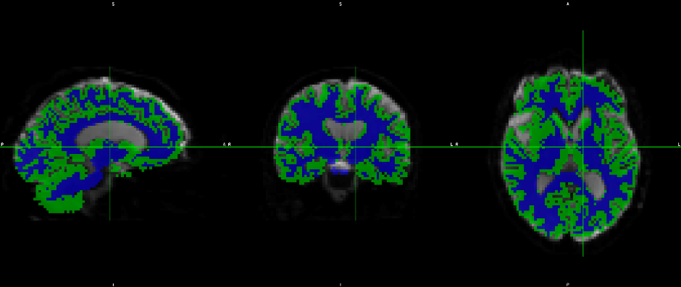 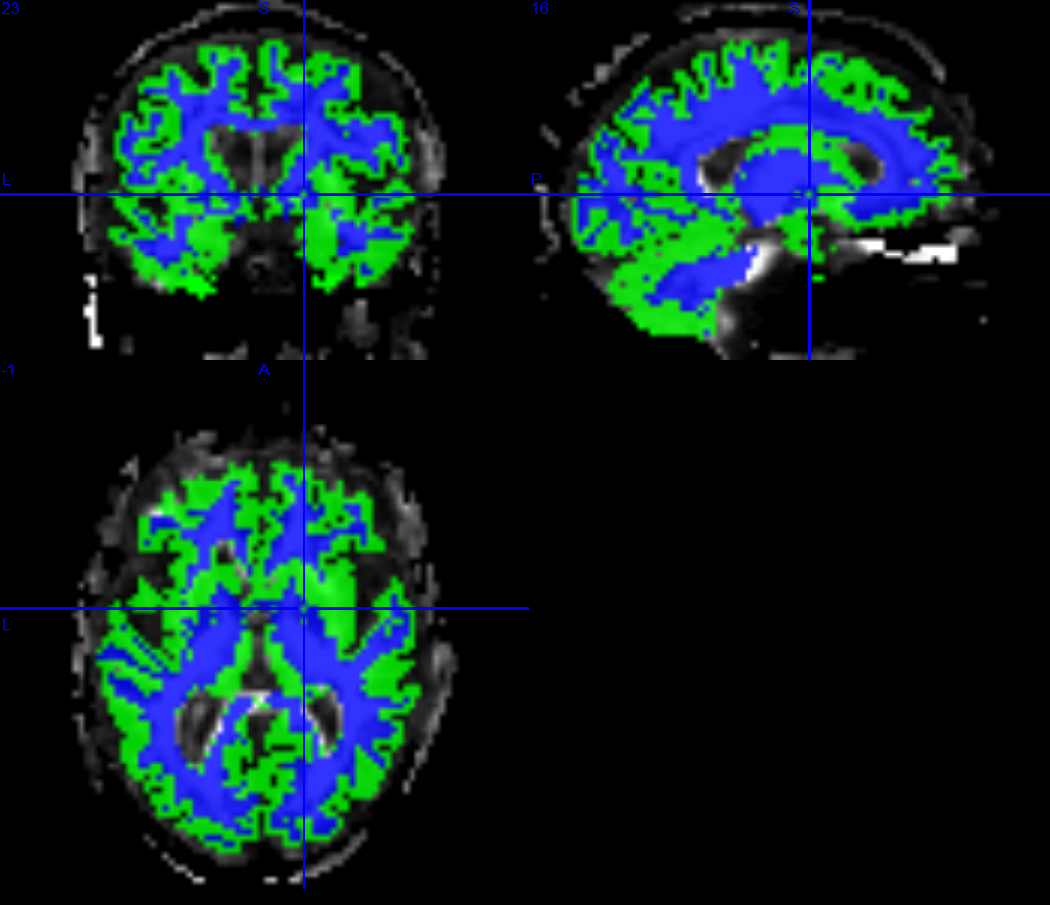

**Step 4: A2_process_histograms.m**

* Masks out MD>2 and outputs bin values across 64 bin locations as *{metric}_{ROI}_total_frequency.txt*
  + ~2-3min/subj
* Outputs: 03_Analysis/03_Histograms_Custom_ROIs/{ROI}/{metric}

**Step 5: A3_combine_total_frequencies.m**

* Combines *total_frequency.txt* tables output by previous step as *All_Bin_Frequencies.txt*
  + 2-4min
* Outputs: 03_Analysis/03_Histograms_Custom_ROIs