**PROTOCOL: MFC Means (2/17/17: MFC Cocaine)**

**Modified by Corinne McGill 12/7/18; 1/04/18**

**SCRIPTS PATH:** /data/cairhive0/studies_large/helpern_share/VAdisetiyo/MFC_Cocaine/Scripts

**I. PROCESS MPR w/FREESURFER & CONVERT OUTPUTS TO REQURIED FORMAT**

**>>vi FSprocess** (Freesurfer scripts, comment out last function)

export SUBJ_ID=$1

export SUBJECTS_DIR=/studies_large/helpern_share/VAdisetiyo/MFC_Cocaine/freesurfer

#this is telling the computer to put output files in the freesurfer folder you created

source /Applications/freesurfer/FreeSurferEnv.sh

#setup freesurfer environment. Path may be different on your computer

recon-all -s $SUBJ_ID –I {path_to_MPRAGE}

#recon-all -s $SUBJ_ID -all &.

**>>./mega1_FSprocess** (‘mega’: batch script - ensure list is current; this script calls the Freesurfer scripts; have to run twice: 1st with all but last function commented, then after confirm no error, run with last function on and second to last function commented)

**>>vi FSprocess**

export SUBJ_ID=$1

export SUBJECTS_DIR=/studies_large/helpern_share/VAdisetiyo/MFC_Cocaine/freesurfer

source /Applications/freesurfer/FreeSurferEnv.sh

#setup freesurfer environment. Path may be different on your computer

#recon-all -s $SUBJ_ID –I {path_to_MPRAGE}

recon-all -s $SUBJ_ID -all &.

**>>./mega1_FSprocess** (after confirm no error, re-run with last function on and second to last function commented out)

Outputs: (…/freesurfer/{ID}/mri/)

aparc+aseg.mgz

aseg.mgz

wmparc.mgz

brainmask.mgz

**>>./mega2_rename**

Outputs: (/freesurfer/‘ID’/mri/)

4003_aseg.mgz

4003_wmparc.mgz

4003_brainmask.mgz.

**>>./mega3_mriconvert**

Outputs: (/freesurfer/‘ID’/mri/)

4003_aparc+aseg.nii

4003_aseg.nii

4003_wmparc.nii

4003_brainmask.nii

**>>./mega4_copy** (copy out all prior files from ‘freesurfer/ID/mri’ folder to ‘Registration_Processing’ folder)

**>>matlab: convert_bit_depth_script.m** (Batch script in ‘Scripts/Processing Scripts’ folder; need to be in same folder as convert_bit_depth.m; NOTE: can run on any version of MATLAB: e.g., R2012a)

Outputs (freesurfer/’ID’/mri):

2b_4003_aparc+aseg.nii

2b_4003_wmparc.nii

**II. QC AND PROCESS MFC MAPS** (Refer to PROTOCOL_Process_MFC1160_2.21.17.docx for current method)

* QC MFC images and choose best 4 averages to process.
  + Deep gray matter structures (high iron) are most important.

GOOD BAD

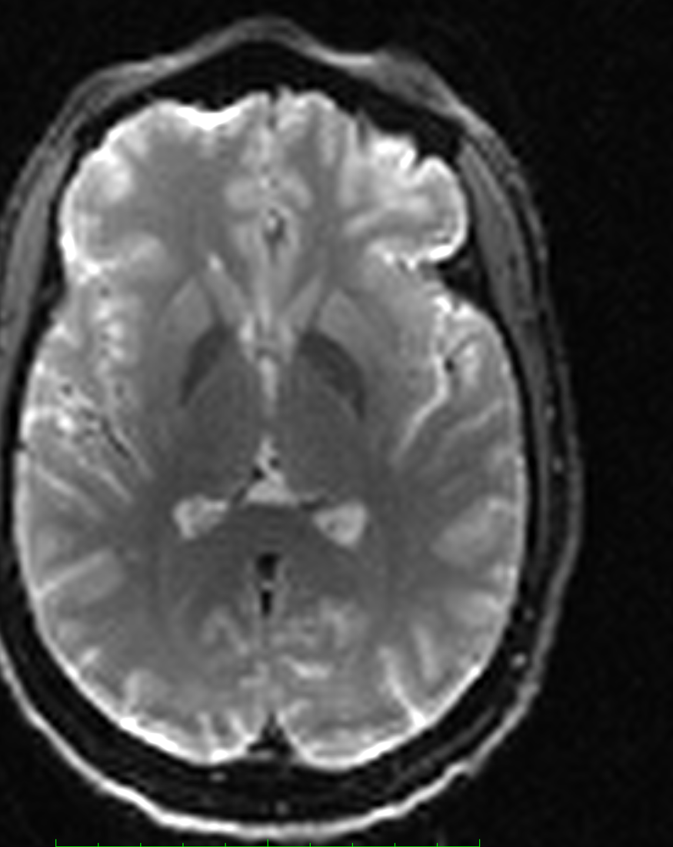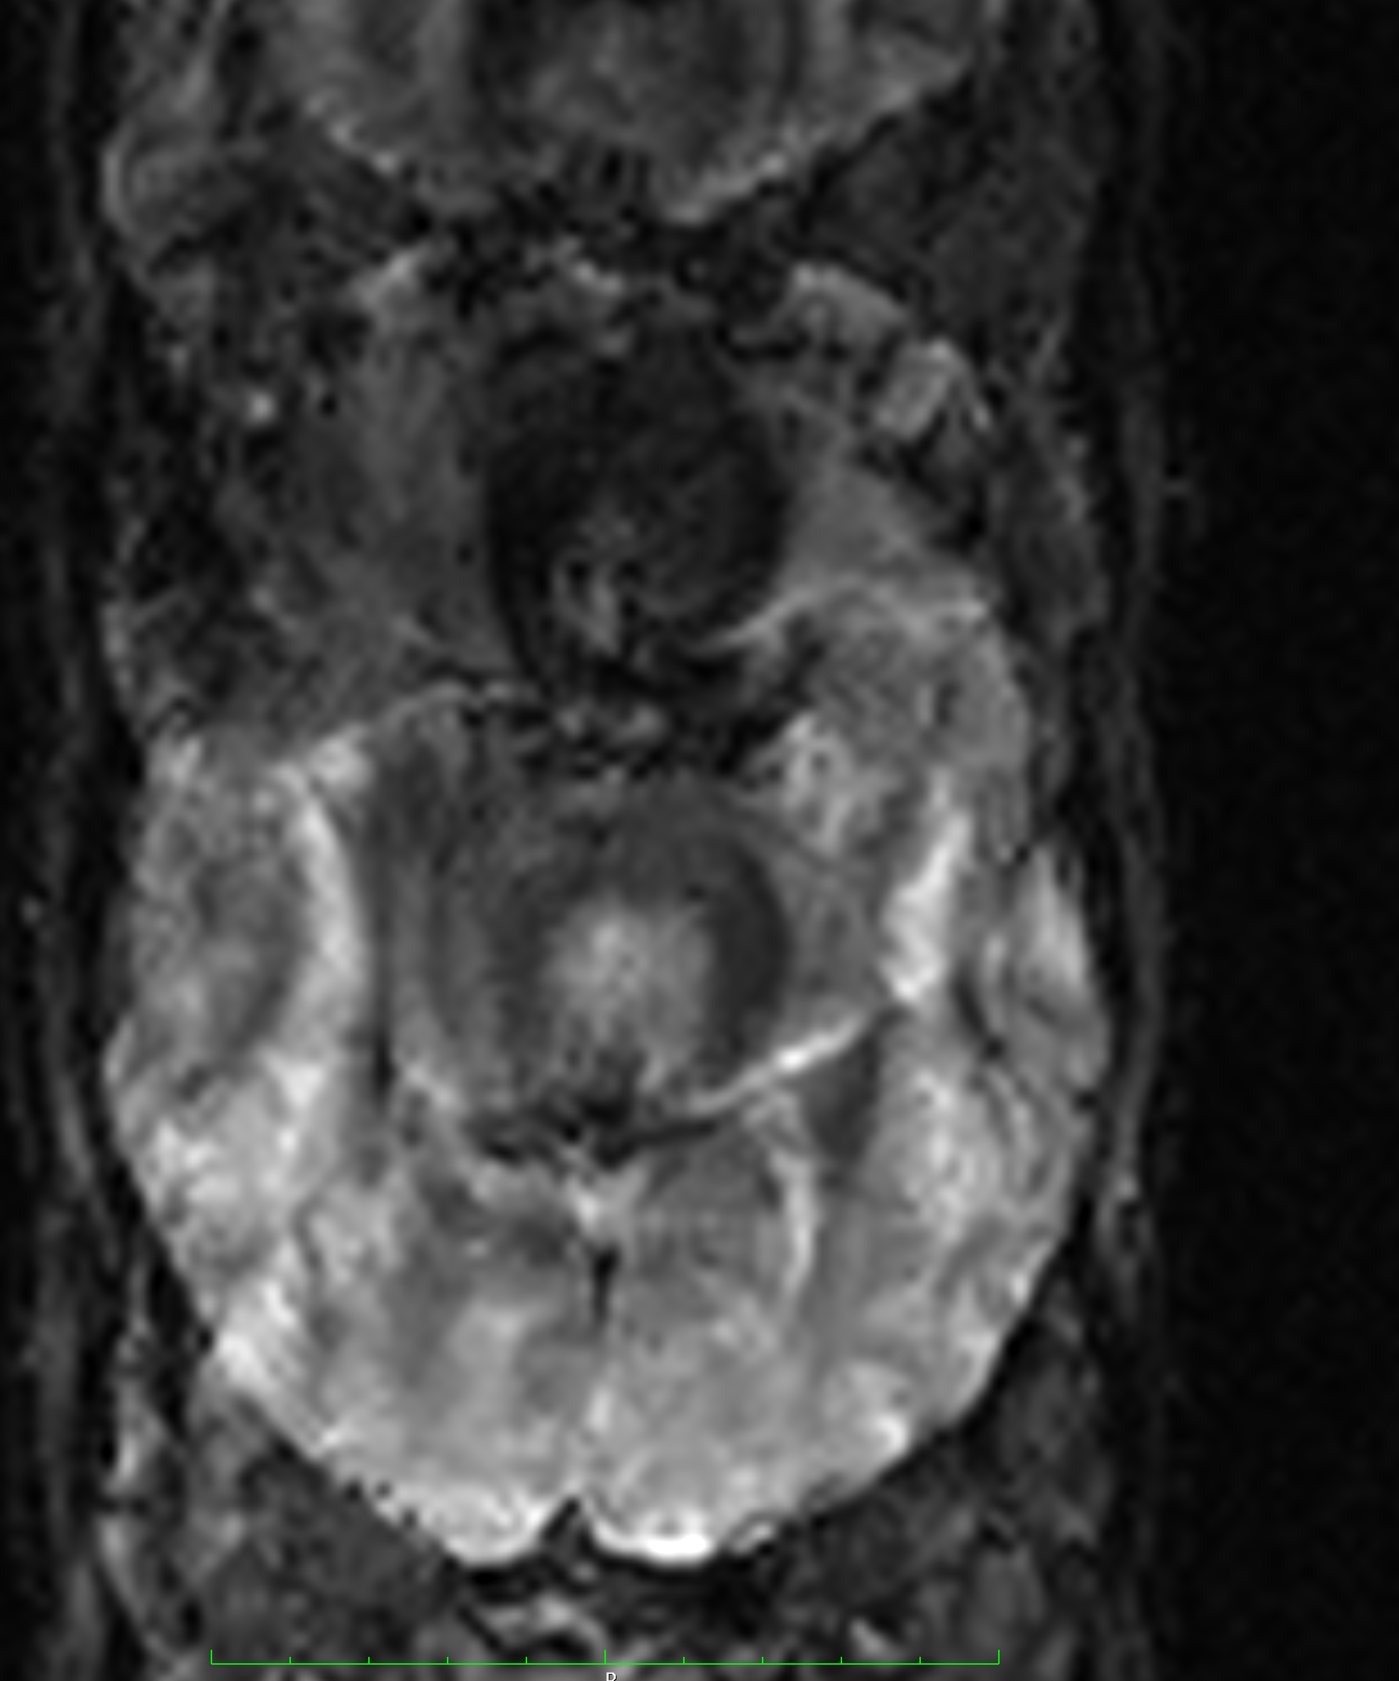

* Organize according to file structure below.

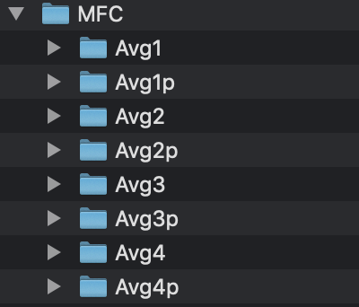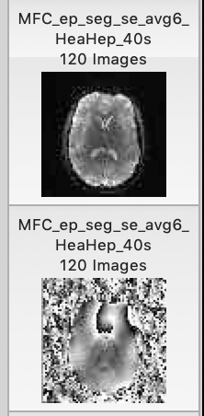

Avg=MFC avg

Avgp=corresponding phase image (sequence right after)

**>>matlab: process_all_subjects_mfc_160_UR.m** (Batch script in ‘Scripts/Processing Scripts’ folder, requires MATLAB R2009b version)

Outputs: (/MFC_Cocaine/ ‘ID’/MFC/MFC_nii)

4003_mask_rejslices.nii

4003_mfc.nii

4003_mfc_macro.nii

4003_mfc_micro.nii

**>>matlab: PROCESS1_create_mic_mac_ratio.m** (Batch script in ‘Scripts/Processing Scripts’ folder; NOTE: can run on any version of MATLAB: e.g., R2012a)

Outputs: (/MFC_Cocaine/ ‘ID’/MFC/MFC_nii)

4003_mic_mac_ratio.nii

4003_mac_larger.nii (binary)

4003_mic_eq_larger.nii (binary)

**III. NORMALIZE MFC MAPS TO COMMON SPACE** (MNI152 space)

Generate transformation matrix taking MFC to Freesurfer (brainmask.nii) space

* Generate linear transformation from MFC (use ‘mfc_1_1.nii’ as 0shift image) to Freesurfer’s T1 (brainmask.nii)
* Generate nonlinear transformation from T1 to MNI

**Apply transformations to the following files:**

4003_mac_larger.nii

4003_mask_rejslices.nii

4003_mfc_macro.nii

4003_mfc_micro.nii

4003_mfc.nii

4003_mic_eq_larger.nii

4003_mic_mac_ratio.nii

2b_4003_aparc+aseg.nii

2b_4003_wmparc.nii

4003_aseg.nii

4003_brainmask.nii

**IV. CREATE & VISUALIZE ROIS FOR ANALYSES**

**>>matlab: individual_CROIS.m** (Batch script in ‘Scripts/Processing Scripts’ folder; NOTE: can run on any version of MATLAB: e.g., R2012a; binary masks in MNI space for each subject)

Outputs:

4003_CombHippo.nii

4003_CombAmygdala.nii

4003_CombCerebellum.nii

4003_CombThalamus.nii

4003_CombCaudate.niim

4003_CombAccumbens.nii

4003_CombPutamen.nii

4003_CombPallidum.nii

**>>matlab: consensus_mask_script_22017.m** (Batch script in ‘Scripts/Processing Scripts’ folder; NOTE: can run on any version of MATLAB: e.g., R2012a)

Outputs: (/MFC_Cocaine/Scripts/)

imgsum_CombHippo.nii

imgsum_CombAmygdala.nii

imgsum_CombCerebellum.nii

imgsum_CombCaudate.nii

imgsum_CombAccumbens.nii

imgsum_CombPutamen.nii

imgsum_CombPallidum.nii

**>>matlab: VISUAL_thresh_mask.m** (OPTIONAL: creates mask of consensus map created in previous script where specific threshold value; Batch script in ‘Scripts/Processing Scripts’ folder; NOTE: can run on any version of MATLAB: e.g., R2012a)

Outputs

Thresh12_imgsum_CombCaudate.nii

Thresh12_imgsum_CombPallidum.nii

Thresh12_imgsum_CombPutamen.nii

Thresh12_imgsum_CombThalamus.nii

Thresh12_imgsum_CombAccumbens.nii

Mask12_imgsum_CombCaudate.nii

Mask12_imgsum_CombPallidum.nii

Mask12_imgsum_CombPutamen.nii

Mask12_imgsum_CombThalamus.nii

Mask12_imgsum_CombAccumbens.nii

**>>matlab: PROCESS2_ROIS_mac_mic.m** (OPTIONAL: creates individual ROIs for the

consensus ROI made in previous script, where the individual has greater macro or micro dominated MFC - for secondary analysis or visualization; Batch script in ‘Scripts/Processing Scripts’ folder; NOTE: can run on any version of MATLAB: e.g., R2012a)

Outputs:

ROI_mac (folder)

ROI_mic (folder)

**V. EXTRACT MEANS FROM ROIS**

**>>matlab: process_histograms_script_ADHD_comb_MFC_anatomical_prob_VA.m**

(Batch scripts in ‘Scripts/Processing Scripts’ folder; NOTE: can run on any version of MATLAB: e.g., R2012a)

Outputs: (/data/cairhive0/studies_large/helpern_share/VAdisetiyo/MFC_Cocaine/Analyses)

Histograms_MFC_sum11_2.21.17/statistics_all_metrics_n11_2.21.17.txt

**>>process_histograms_script_MFC_FS_mac.m** (OPTIONAL: in ‘Scripts/Processing Scripts’ folder) **>>process_histograms_script_MFC_FS_mic.m** (OPTIONAL: in ‘Scripts/Processing Scripts’ folder)