**PROTOCOL: Processing R2* maps**

(Author: Vitria Adisetiyo; Updated: 12/15/17)

(Updated by: Corinne McGill; 08/06/18, 12/07/18)

**I. SAMPLE DATA INFO**

Path: (\\helperndatafs-v.mdc.musc.edu)\helpern_share\Protocols\Sample_Datasets\R2_Star_Dataset_n18.zip

**II. SEQUENCE INFO**

Sequence name (3T Tim Trio): T2_STAR

MRI protocol path: (\\helperndatafs-v.mdc.musc.edu)\users\adisetiyo_v\Projects\KTGF_Project\Protocols\

KTGF_MRI_Protocol_rfMRI_PE.pdf

**III. QC Guidelines**

Most applicable in high iron regions, so focus on those. (i.e. basal ganglia)

**BAD – DO NOT USE USABLE GOOD - USE**

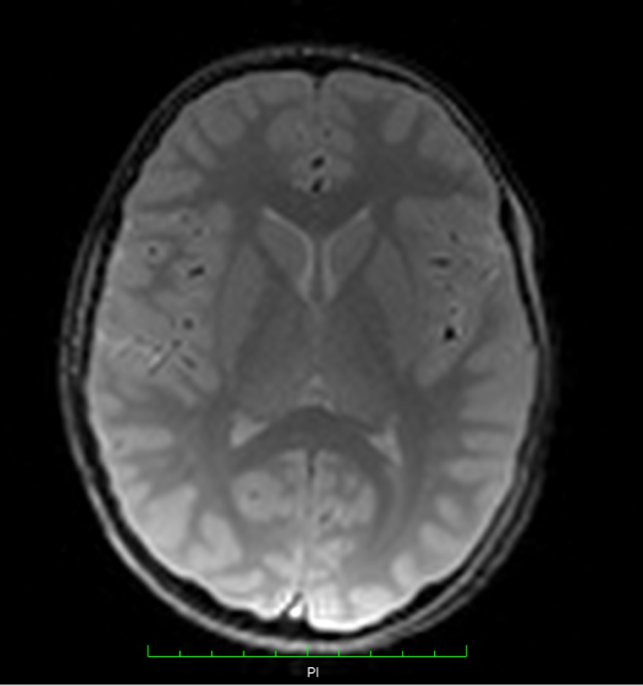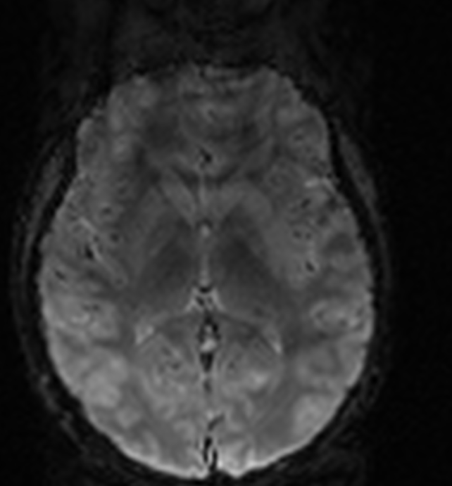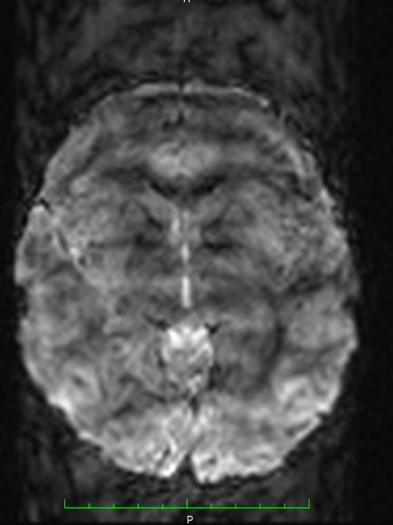

**III. SCRIPT INFO**

Master script path: (\\helperndatafs-v.mdc.musc.edu)\helpern_data\Protocols\BatchScript_Templates

* R2star_nonlinear.m (batch script with functions; NOTE: ensure TE’s in script match sequence protocol)
* Copy template into owns study folder & customize following variables in script:
  + list_subjects
  + paths: folder_base, spm8_path

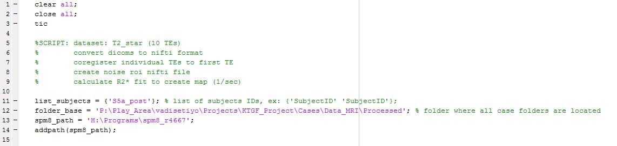

* + indx_TEs (specify number of TEs used in T2* protocol)

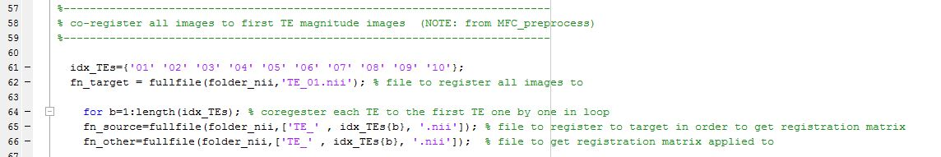

* + Data_TE1 (customize X & Y indices for inplane FOV of T2* protocol; confirm not overlap w/brain)

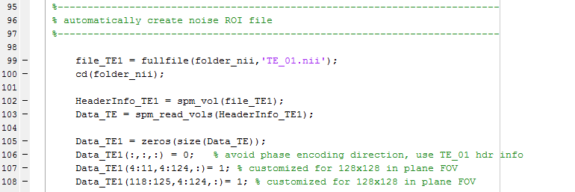 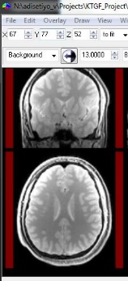

* + TE (specify TE values used in T2* protocol)

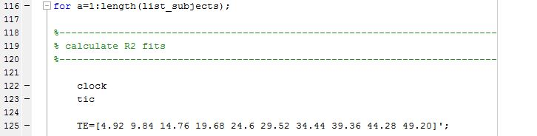

Processing requires:

* MATLAB R2009b (Curve_Fitting_Toolbox21 needed to calc map; registration can run on any version: 2015a, 2009b)
* SPM8

**IV. PROCESSING INFO**

Input structure:

* Case_ID\dicom\T2_star\
  + TE_all (820 dicoms from all 10 TEs in this folder; no subfolders)

Output structure:

* Case_ID\T2_star\
  + SPM_nifti
  + R2star_map_nlin (maps in this folder; R2star map: by_voxel_R2s.nii)

Processing time/case:

* ~4 hours (on my desktop, Matlab R2009b, helpern_data\Programs\spm8_r4667)