**T1 Segmentation with Freesurfer**

**I. Run Script Setup Freesurfer Directories**

* Modify SUBJ_IDs and paths (see below) and run FSprocess_1

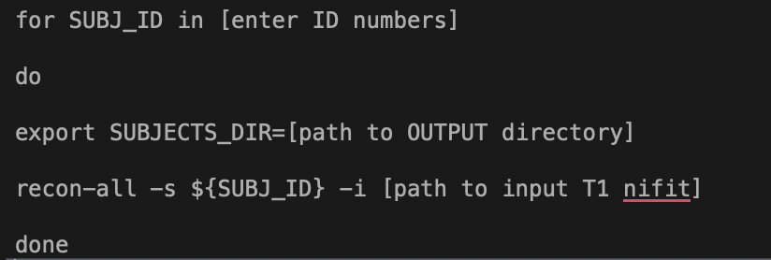

* Outputs:

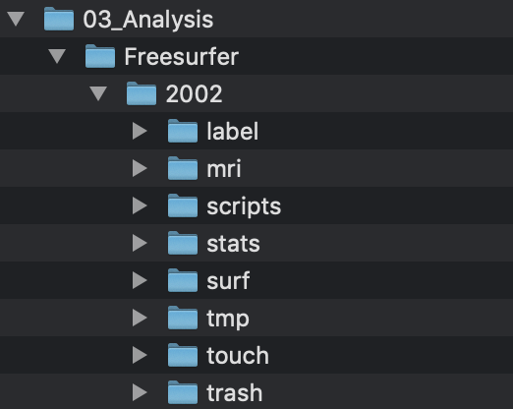

*Folders have been created to house outputs from next step.

**II. Run Script to Segment T1 MPRAGE Files**

* Modify SUBJ_IDs and paths (see below) and run FSprocess_2

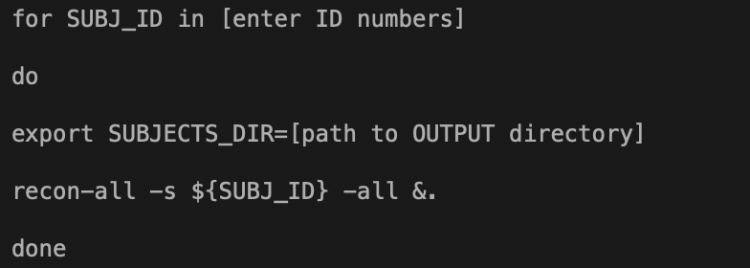

* Outputs:

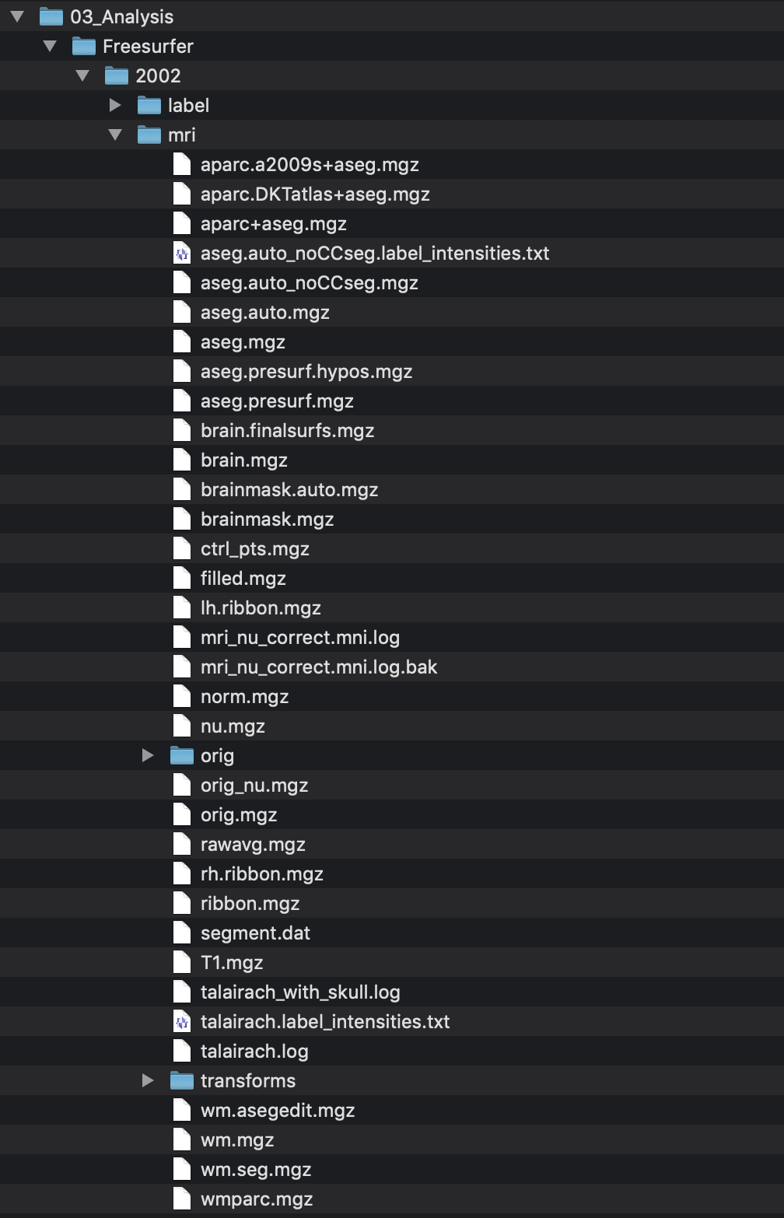

*some of the outputs to expect

All outputs: <https://surfer.nmr.mgh.harvard.edu/fswiki/ReconAllOutputFiles>