**ARTIFACT DETECTION**

**1. QC DKI Images**

* See relative differences in brightness below.

|  |  |
| --- | --- |
| **b-value** | **Example** |
| 0 |  |
| 1000 |  |
| 2000 |  |

* Check for artifacts:
  + Motion Signal Dropout
    - **threshold 0-250**
    - NOTATION: x – if no drops, list slice(s) where there are drops

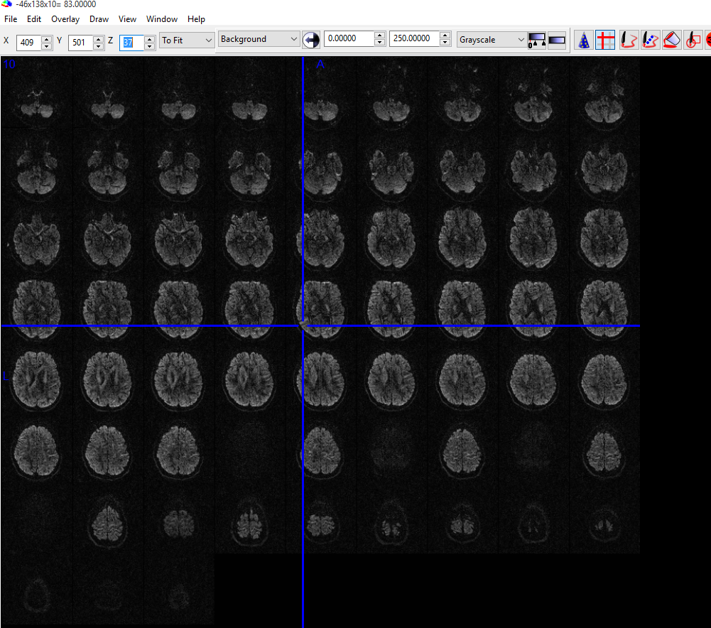

* + Ghosting Artifact
    - **reset threshold 0-100** (go through all volumes)
    - NOTATION: grade level as x-none, 1-minor, 2-moderate, 3-major

Examples: Left (3-major), Right (x-none)

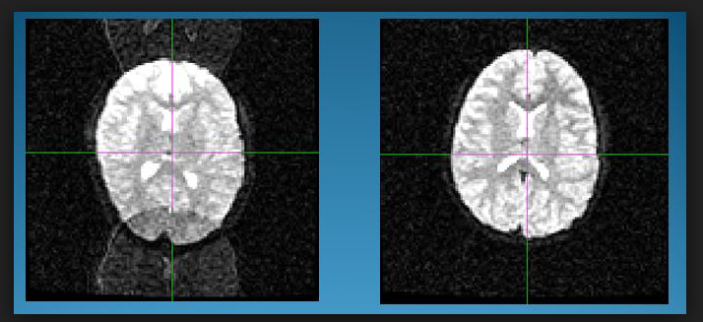

Example: x-none

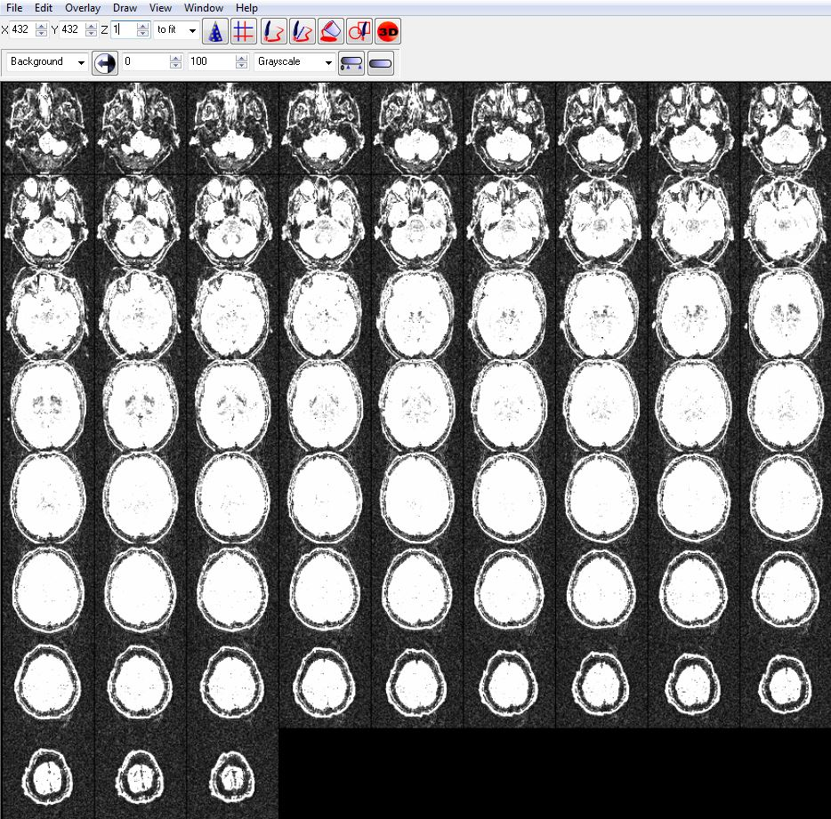

Example: 1-minor

