**Standard DTI-TK Pipeline – Generic – 11/12/20**

**Note**: Many images are scaled down in size to save space and help this document stay organized. Use the zoom function in order to close up on images.

**Note**: Run all scripts manually and change paths when needed.

* **Prepping Tensors for Registration**:
  + Note: All following steps are accomplished via **1_Preproc_Tensor_Prep.sh**
    - It is necessary to run this manually.
  + File Organization: In order to generate tensor files for later registration, the following files are required:
    - The preprocessed nifti, the associated bvec and bval files.
    - A screenshot of a cell phone

      Description automatically generated
    - This is done in 1_Preproce_Tensor_Prep.sh section 1
  + **BET: 1_Preproce_Tensor_Prep.sh section 2**
    - It is necessary to skull strip the preprocessed diffusion nifti output by PyDesigner; this step is **extremely important** as a bad skull strip will negatively affect registration.
    - During this step, dwi_preprocessed.nii files are skull stripped and a mask is created.
    - A screenshot of a cell phone

      Description automatically generated
    - A QC folder is also created with all skull stripped files. If skull stripping is not sufficient, the skull stripping threshold (-f # in the script) can be modified.
      * Depending on the dataset, BET can be highly customized to achieve appropriate skull stripping.
      * Due to the nature of tensor files and default scales in many image viewers, just looking at the skull stripped tensor with default scale settings may be deceptive:
      * A picture containing cat, looking, sitting, screen

        Description automatically generated
      * The above image appears appropriately skull stripped but by overlaying the mask onto it, we see that it is not skull stripped correctly:
      * 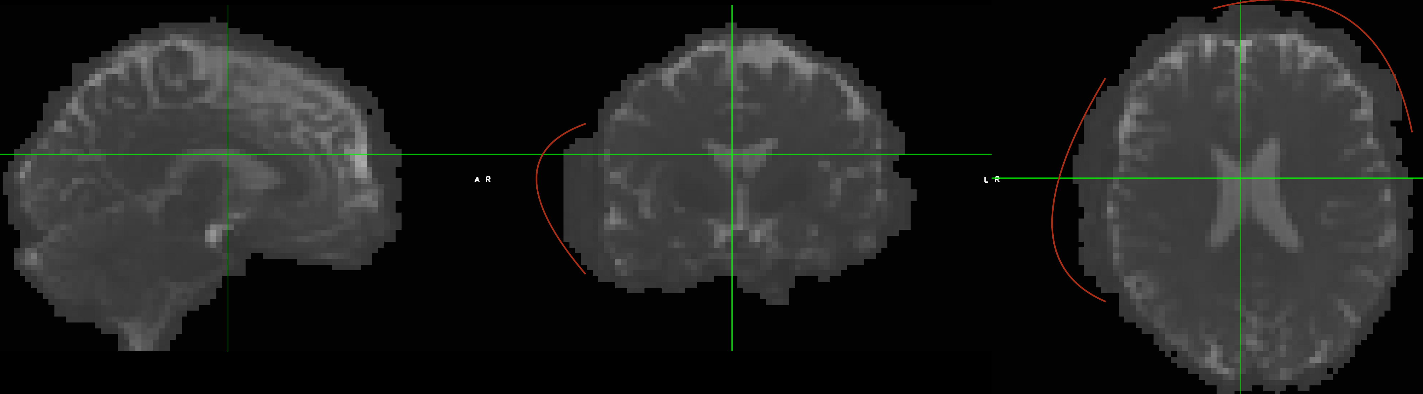
      * Once you refine the BET process, the mask overlay should look more like this:
      * A picture containing cake, table, sitting, white

        Description automatically generated
  + **Tensor Prep: 1_Preproc_Tensor_Prep.sh section 3**
    - 3.a - dtifit – dtifit is an FSL tool that takes preprocessed niftis and associated bvec/bval files and creates tensor.nii files. This step also requires the BET mask created in the previous step.
      * A screenshot of a cell phone

        Description automatically generated
    - 3.b – fsl_to_dtitk – fsl_to_dtitk is a DTI-TK tool that converts FSL output files into DTI-TK format. This step creates many extraneous files. The file required to proceed is called dti_dtitk.nii
      * A picture containing screenshot, screen, sitting, black

        Description automatically generated
      * From the DTI-TK site: “a script that takes a FSL-generated DTI eigensystem volumes (*non-brain tissue already removed*) and converts them into fully DTI-TK compatible DTI volumes, i.e., both in the correct format and [correctly preprocessed](http://dti-tk.sourceforge.net/pmwiki/pmwiki.php?n=Documentation.BeforeReg).”
      * It is possible to check that adjustments have been made to the image by comparing the old image header information with the new image header information  
        A screenshot of a cell phone

        Description automatically generated
* **DTI-TK Image Registration: 2_DTI-TK_Norm.sh**
  + **File Organization: 2_DTI-TK_Norm.sh section 1**
    - Minor file organization
  + **Registration: 2_DTI-TK_Norm.sh section 2**
    - A subj.txt file is created within the 02_Tensor folder to include all subjects, much like the subj.txt file shown above but with all subjects instead of a single subject’s BL and FU
    - The same registration process carried out in the last step is now carried out on between-subject data. The output file list is the same as the output file list above, except it will now include all subject data.
    - QA registration by overlaying registered images after registration is complete.
* **Scalar Map Warping: 3_Scalar_Map_Prep.sh**
  + **File Organization: 3_Scalar_Map_Prep.sh section 1**
    - Scalar maps generated via preprocessing program are copied into a new folder called 01_Scalar_Prep
    - A picture containing street, city, drawing, phone

      Description automatically generated
  + **Within-Subject Scalar Map Warps: 3_Scalar_Map_Prep.sh section 2**
    - Scalar maps have their origin set to 0 0 0 and the transformation matrices that were generated via the within subject tensor registration method are applied to the scalar maps on a subject by subject basis to move the scalar maps into within-subject space.
  + **Between-Subject Scalar Map Warps: 3_Scalar_Map_Prep.sh section 3**
    - The transformation matrices that were generated via the between subject tensor registration method are applied to the scalar maps on a subject by subject basis to move the scalar maps into between-subject space.
  + **File Organization: 3_Scalar_Map_Prep.sh section 4**
    - Scalar maps in between subject space are moved into a new folder called 03_TBSS for further processing
    - Files are organized in folders via metric type:
    - **A picture containing building

      Description automatically generated**
* **TBSS prestats: 4_TBSS_4.sh and 5_TBSS_4B.sh**
  + 4_TBSS_4 copies the stats folder from the DKI folder to the WMM folder and runs tbss_4_prestats with a threshold of 0.4 for WMM skeletonization setup
  + 4_TBSS_4B runs tbss_4_prestats with a threshold of 0.2 for DKI skeletonization setup
  + Both steps generate mean_FA_skeleton_mask and mean_FA_skeleton_mask_dst based on respective thresholds
  + A screenshot of a computer

    Description automatically generated
* **Non-FA files combined and skeletonized: 6_non-FA_all_files.sh**
  + **Non-skeletonized 4D map creation: 6_non-FA_all_files.sh section 1**
    - Fslmerge is used to create 4D niftis of non-skeletonized maps for both DKI and WMM metrics
    - **A picture containing screenshot, sitting, black, screen

      Description automatically generated**
  + **Skeletonized 4D map creation: 6_non-FA_all_files.sh section 2**
    - Tbss_skeleton is used with mean_FA_skeleton_mask_dst to create 4D niftis of skeletonized maps for both DKI and WMM metrics
    - A screenshot of a computer

      Description automatically generated
  + QCing non-skeletonized maps is a good way to QC overall image registration. It is also worthwhile to QC the skeletonized maps to ensure that skeletonization was done appropriately.
  + A picture containing indoor, looking, fruit, sitting

    Description automatically generated