EVIDENCE-DERIVED PROTEOME-WIDE
SUBCELLULAR LOCATION –
A BASIS PARTITIONING FOR
CLASSIFICATION SYSTEMS

A thesis submitted to the faculty of
San Francisco State University
in partial fulfillment of
the Requirements for
the Degree

Master of Science
In
Computer Science:
Computing for Life Sciences

by

Kayven Riese

San Francisco, California

August 2011

Copyright by
Kayven Riese
2011

CERTIFICATION OF APPROVAL

I certify that I have read Evidence-Derived Proteome-Wide Subcelluar Location – A Basis Partitioning For Classification Systems by Kayven Riese, and that in my opinion this work meets the criteria for approving a thesis submitted in partial fulfillment of the requirements for the degree: Master of Science in Computer Science: Computing for Life Sciences at San Francisco State University.

Marguerite C. Murphy, Ph.D.
Professor of Computer Science

Dr. William Tsun-yuk Hsu, Ph.D.
Associate Professor of Computer Science

Hui Yang, Ph.D.
Assistant Professor of Computer Science
Evidence-Derived Proteome-Wide Subcellular Location –
A Basis Partitioning For Classification Systems

Kayven Riese
San Francisco, California
2011

I certify that the Abstract is a correct representation of the content of this thesis.

Chair, Thesis Committee |  | Date

ACKNOWLEDGMENTS

I would like to thank Prof. Marguerite Murphy for believing in me and lending me irreplaceable intellectual support in the process of transforming research and ideas into this finished academic presentation. In addition, it would not have been possible for me to complete this work without the material, editing, and emotional support of Lara V. Thanks to Dr. Petkovic and others in the SFSU Computer Science and Biology Departments who were able to keep me in line confronting hard truths in the nicest possible way. Thanks to Theodore Randolph who suggested that CentOS, a freely distributable OS built from source of Red Hat Linux, with non-free packages altered, might be a good distribution to try, and thanks to Niki and Teague in the main office always doing everything they can to help with bureaucratic details with a smile.

TABLE OF CONTENTS
LIST OF TABLES ix
LIST OF FIGURES x
LIST OF APPENDICES xiii
Chapter 1 : INTRODUCTION 1
1.1 Central Dogma and Subcellular Location (SCL) 1
1.2 UniProt knowledge-base 2
1.3 Cairo Graphics 3
1.4 Organization of this Report 5
Chapter 2 : SURVEY OF RELATED WORK 7
2.1 Transmembrane Proteins (TMPs) and the Fluid Mosaic Model (FMM) 7
2.2 A Study of Computational Membrane Topology 9
2.3 Four and Five SCL Compartment Models 11
2.3.1SUDHL-1 Cell Line Four Compartment Model 11
2.3.2 Human Neutrophil MALDI-ToF MS Four Compartment Model 13
2.3.3 Cancer Data Mining Four Compartment Model 14
2.3.4 Multiple Sclerosis Five Compartment Model 16
2.4 Gene Ontology (GO) Motif References 17
2.4.1 GO Motif Reference for Extracellular Proteins 17
2.4.2 GO Motif References for Nuclear and Cytoplasmic Proteins 18
2.4.3 Additional SCL Prediction Research 18
2.5 Chapter Summary 19
Chapter 3 : TUTORIAL BACKGROUND 21
3.1 Endosymbiotic Hypothesis and SCL details 21
3.2 Chemical Basis of Membrane Biology 23
3.3 Theoretic Basis of SCL Compartment Models 25
3.4 Chapter Summary 26
Chapter 4 : PRELIMINARY DESIGN DECISIONS 28
4.1 Stucture of the UniProt Data 29
4.2 UniProt Data Load Effect on Tested Systems 29
4.3 Cross-Platform Performance Testing 32
4.4 Results of Performance Testing 36
4.5 Chapter Summary 40
Chapter 5 : DESIGN AND IMPLEMENTATION 42
5.1 ProMog.c - UniProt Proteome DeMographic Extraction 45
5.1.1 Extraction of FT Line Fixed Format UniProt Data 45
5.1.2 C Language Regular Expressions (RegEx) 48
5.1.3 UniProt CC Line Data Extraction 52
5.1.4 Database Cross Reference/GO Data Extraction 55
5.1.5 End of Record Tabulation and Partitioning 57
5.2 Cellgram.c - Visualization of Results With Biological Meaning 60
5.2.1 Interoperability of ProMog.c and Cellgram.c Components 61
5.2.2 Initialization of Cairo Surface and Header 61
5.2.3 Drawing a Cellgram.c Cell 65
5.2.4 Sizing Words Using Wolfram Curve Fitting 68
5.2.5 Utilizing Scaling Constants to Render the Nucleus 73
5.2.6 Completion of Cellgram Rendering 82
5.3 Chapter Summary 85
Chapter 6 : EXPERIMENTAL RESULTS 88
6.1 The Changing Face of UniProt 88
6.2 Cellgram Comparisons of Human, Muscle, and Brain 94
6.3 Command Line ProMog Output Details 99
6.4 Chapter Summary 104
Chapter 7 : CONCLUSIONS, RECOMMENDATIONS, AND FUTURE WORK 106
7.1 Conclusions 106
7.2 Recommendations and Future Work 107
REFERENCES 110
Chapter 8 :APPENDICES 114
APPENDIX A: OBTAINING UNIPROT DATA 114
APPENDIX B: INSTALLING ProMog/Cellgram 115

LIST OF TABLES

LIST OF FIGURES

Figure 1-1: ProMog Partitioning of Manually Annotated Human Proteome 5
Figure 2-1: Depiction of Proteins in Lipid Bilayer Membrane 8
Figure 2-2: Examples of TMP Topologies 9
Figure 2-3: Ahram et al Screening of Topology Prediction Software 10
Figure 2-4: Gene Ontology (GO) SCL Profiles of SUDHL-1 Cells 12
Figure 2-5: Four Compartment Model Partitioning of Human Neutrophils 13
Figure 2-6: Functional Partitioning of Human Neutrophils 14
Figure 2-7: Four Compartment Model Prostate Cancer Protein Network 15
Figure 2-8: Multiple Sclerosis Five Compartment Model Network 16
Figure 3-1: Striated Muscle ATP-Sensitive Potassium Channel SCL Functional Diagram 23
Figure 3-2: Cross Sectional Diagram of TMP Structure 24
Figure 4-1: Internal Format of UniProt Data File 29
Figure 4-2: Listing (ls -l) of UniProt Data Files 30
Figure 4-3: Memory Demand Response to "vi uniprot_sprot.dat" 31
Figure 4-4: Equilibrium State of System After Data Load 31
Figure 4-5: System Response to "vi uniprot_sprot.dat" 32
Figure 4-6: Gentoo Linux System Version Information 33
Figure 4-7: CentOS Linux System Version Information 33
Figure 4-8: perf_tests.bash Dynamic Determination of System Information 34
Figure 4-9: perf_tests.bash Distribution Based C Program Invocation 35
Figure 4-10: perf_tests.bash Distribution Based Perl Program Invocation 35
Figure 4-11: Output Files Generated by perf_tests.bash 36
Figure 4-12: Perl/C Performance Comparisons Across Platform 37
Figure 4-13: CentOS read() BLOCKSIZE Optimization Analysis 38
Figure 4-14: CentOS Simple fgets() BLOCKSIZE Optimization Analysis 39
Figure 4-15: Main Loop of demog_gets.c Code 39
Figure 4-16: Runtime Behavior of demog_gets.c 40
Figure 5-1: Detection of Human Organism Species (OS) 46
Figure 5-2: Feature Table (FT) Detection and Flagging of Key Names 46
Figure 5-3: Flagging of DNA_BIND Key Name 47
Figure 5-4: RegEx regex_t Structure Definition 48
Figure 5-5: Initialization of regex_t Variables for Use in ProMog.c 48
Figure 5-6: Compilations of regex_t Type RegEx Variables 49
Figure 5-7: Character String Array Containing Raw RegEx Data 50
Figure 5-8: Compilation of Brain and Muscle Tissue Detecting RegEx's 51
Figure 5-9: Short Example of a CC Line Containing SCL Data 52
Figure 5-10: Management of in_SCL Flag for CC Line Data Extraction 53
Figure 5-11: RegEx Detection of SCL Data During CC Line SCL Block 54
Figure 5-12: Database Cross-Reference (DR) Lines Containing GO Data 55
Figure 5-13: DR Line RegEx Detection and Extraction of GO Data 56
Figure 5-14: End of Record Detection and Human Tabulation 57
Figure 5-15: Partitioning of Human Data From Boolean Flags 58
Figure 5-16: Tabulation of Total Proteins Including Brain and Muscle Portions 59
Figure 5-17: Removal of Signal Peptide False Positives From TMP Tabulator 60
Figure 5-18: Calling Cellgram From ProMog.c 61
Figure 5-19: Creation of Cairo Surface and Coloring of Background 62
Figure 5-20: Variables Needed to Implement Timestamp Collection 63
Figure 5-21: Collecting and Formatting Timestamp for Output Image File 63
Figure 5-22: Using Cairo Graphics Functions to Construct the Header 64
Figure 5-23: Drawing the Plasma Membrane with Cairo Graphics 65
Figure 5-24: Coloring Inside of Cell and Cell Membrane with Cairo Graphics 66
Figure 5-25: Loop Initialization to Draw Hash Marks 67
Figure 5-26: Cairo Code to Draw Minor Hash Marks 68
Figure 5-27: Example of Incorrectly Scaled Cellgram 69
Figure 5-28: Equations Input to Wolfram to be Solved 71
Figure 5-29: Wolfram Output of Solved Equation 71
Figure 5-30: Spreadsheet to Verify Correctness Throughout Domain 72
Figure 5-31: Text Scaling Constants 73
Figure 5-32: Preparation of Nuclear Text Rendering Parameters 74
Figure 5-33: Empirical Control of Location of Nuclear Text Origin 75
Figure 5-34: Empirical Adjustments to Origin and Scaling of "DNA" Text 76
Figure 5-35: Rendering of Nuclear Text Elements 77
Figure 5-36: Initialization of Ratios and Percentage Strings 79
Figure 5-37: Rendering Nuclear Protein Percentage Value 79
Figure 5-38: Rendering of the Nuclear Envelope – Initialization 80
Figure 5-39: Fishtail Effect of Low Nuclear Protein Cellgram Renderings 81
Figure 5-40: Rendering of the Nuclear Envelope – Completion 82
Figure 5-41: Rendering of Soluble (cytosolic) Proteins 82
Figure 5-42: Rendering of Membrane (TMP) Proteins 83
Figure 5-43: Rendering of Extracellular Proteins 84
Figure 6-1: UniProt Front Page as of May 2011 88
Figure 6-2: UniProt/TrEMBL Release Archive as of May 2011 89
Figure 6-3: Changes to SCL Controlled Vocabulary in September of 2009 89
Figure 6-4: May 2011 Release of UniProtKB/Swiss-Prot Verification of Correctness 90
Figure 6-5: Total UniProtKB/Swiss-Prot Cellgram for Resident Database 91
Figure 6-6: Cellgram for UniProtKB/Swiss-Prot Release 2011_05 May 2011 92
Figure 6-7: UniProtKB/TrEMBL Release Statistics Growth of Entries 93
Figure 6-8: Cellgram for Human Proteins From Resident uniprot_sprot.dat 94
Figure 6-9: Human Cellgram from UniProtKB/Swiss-Prot May 2011 Release 95
Figure 6-10: Tabulations of Total Proteins Including Muscle and Brain Fractions 96
Figure 6-11: Cellgram of Muscle Proteome From May 2011 UniProtKB/Swiss-Prot 97
Figure 6-12: UniProtKB/Swiss-Prot May 2011 Brain Cellgram 98
Figure 6-13: Head of Output From ProMog Run 99
Figure 6-14: List of Human CC Line SCL Data Tabulations 100
Figure 6-15: Final Entries in Human Tabulation Report 101
Figure 6-16: Total UniProtKB/Swiss-Prot Command Line Tabulations Report 102
Figure 6-17: Total Proteins Report Completion 103
Figure 7-1: Performance Improvement Using strcmp() 108
Figure 8-1: UniProt Downloads Website 114

LIST OF APPENDICES

INTRODUCTION

Central Dogma and Subcellular Location (SCL)

The complete sequencing of whole genomes has ushered medical research into a new age. The mere tabulation of the long strings that make up the chromosomes' DNA sequences, however, is only a starting point for a full understanding of the impact that a given individual genome will have on biological function at the systemic level. Medical research groups all around the world have been accumulating data for more than half a century, since Watson and Crick determined that DNA was the genetic element in the 1950's, about the biological impact of given DNA sequences. This impact is predominantly realized via what is known as “The Central Dogma of Molecular Biology.” This “dogma” states that DNA begets messenger RNA (mRNA) which in turn begets an individual protein. Collectively the set of proteins that arises from the genome set of DNA sequences for a given organism is known as its proteome. A basic and reasonable assumption of the function of the individual proteins that make up proteomes is that physical associations occur. From the perspective of a protein, which is a particle only a single order of magnitude larger than the atomic, where relevant distances are in the nanometer range, the cellular compartmentalization such as can be viewed with light microscopes such as the nucleus, mitochondria, chloroplasts, and the endoplasmic recticulum become like individual foreign nations in scale. Continuing this analogy, a given protein's national citizenship in this realm will subsequently be denoted as its subcellular location (SCL). Since the data being used is based on medical research annotations, which is in turn based on research evidence, this study is evidence-based.

UniProt knowledge-base

The overall goal of this work is to improve understanding of proteomic SCL data to encompass complete non-redundant proteomic sets in the simplest possible way. The specific goal for the research proposed here is a method for the automatic generation of SCL statistics based on the UniProt protein resource [6].
The UniProt knowledge-base is available online as XML, FASTA, and flatfile (text) formats and is an ever-expanding body of data that is manually annotated by contributors. In the text/flatfile data repositories, the standard format of the datafile encodes data based on different two character line begin codes. A single complete protein record is defined by all lines that fall between the “ID (Identification) line” and the terminator line. The ID line includes entry name, status and sequence length. The terminator line is denoted by a line that has only “//” followed immediately by a carriage return. SCL data was determining using the protein entry fields known as the “CC line,” which denotes a comment block, “FT line” denoting feature table, and the “DR line” denoting database cross-reference, which contained Gene Ontology (GO) references. Taking the lead of Satoh el al [12] and Crockett et al [16], the data from these sources was used to segregate proteins into four basic SCL compartmentalizations, namely nuclear, cytoplasmic (soluble), membrane, and extracellular. This represents a simplification of real biology, but are chemically and functionally important. For the CC line data, 45 case insensitive keywords were found and loaded into an array called REGEX_RAW_ARRAY, with an associated array called NAMES_ARRAY that was used for output. For FT Line data, the existence of the TRANSMEM, LIPID, and INTRAMEM data flags defined by UniProt were used to segregate proteins into the membrane classification, the SIGNAL UniProt flag was used to segregate proteins as extracellular, and the UniProt DNA_BIND flag was used to segregate proteins as nuclear.

Cairo Graphics

Cairo Graphics (http://www.cairographics.org) is a 2D vector graphics library that forms a part of the Gnome Linux Desktop (http://www.gnome.org). It is written in the C programming language, but provides bindings for Python, Perl, C++, C#, and Java. The basic unit of functionality to utilize the Cairo library is known as a Cairo context, which is declared using the cairo_t structure, most commonly in C by creating a pointer variable to cairo_t structures. Then an active context can be obtained by setting that variable to the return value of the function gdk_cairo_create(). A Cairo context used for visualization of the results was produced using Cairo graphics utility cairo_surface_write_to_png(). This library function produces a png graphic file designed to depict the four fractions to plainly illustrate their respective functions, namely, 1) for nuclear proteins: the protection, activation, and processing of DNA and its function, 2) for cytosolic proteins: operations in aqueous intracellular environment, 3) for membrane proteins: management of the interface between intracellular and extracellular environments, and 4) for extracellular proteins: direct interactions with the extracellular environment. Figure 1 shows the results of analysis for total human proteins found in manually annotated and reviewed uniprot_sprot.dat flatfile database. The light green oval region represents the basic unit of life, the cell. Height of words represent the percentage of the total proteome that belong to the respective protein types as dictated by the four compartment model discussed in Chapter 2. The smaller font word "DNA" is included to represent the fact that genomic DNA resides in the nucleus, protected and processed by the first set of proteins. The word "soluble" is used, despite the fact that nuclear and extracellular proteins are also aqueous (water) soluble, to emphasize a fundamental property of proteins, to represent cytosolic proteins. This decision arose from the etymology of the word "cytosol" "cyto-" for "cell and "-sol" for "soluble constituents." Blue was chosen as the font color for its usual designation for water. The word membrane is written in yellow, a color chosen to resemble fats such as butter or oils such as olive oil (oleic acid), and matches the color that represents the border between the inside and outside of the cell because this class of protein actually resides in this oily milieu which does indeed form this barrier. Finally, red font was chosen for extracellular proteins because many examples of extracellular proteins are antibodies and hormones found in the blood.
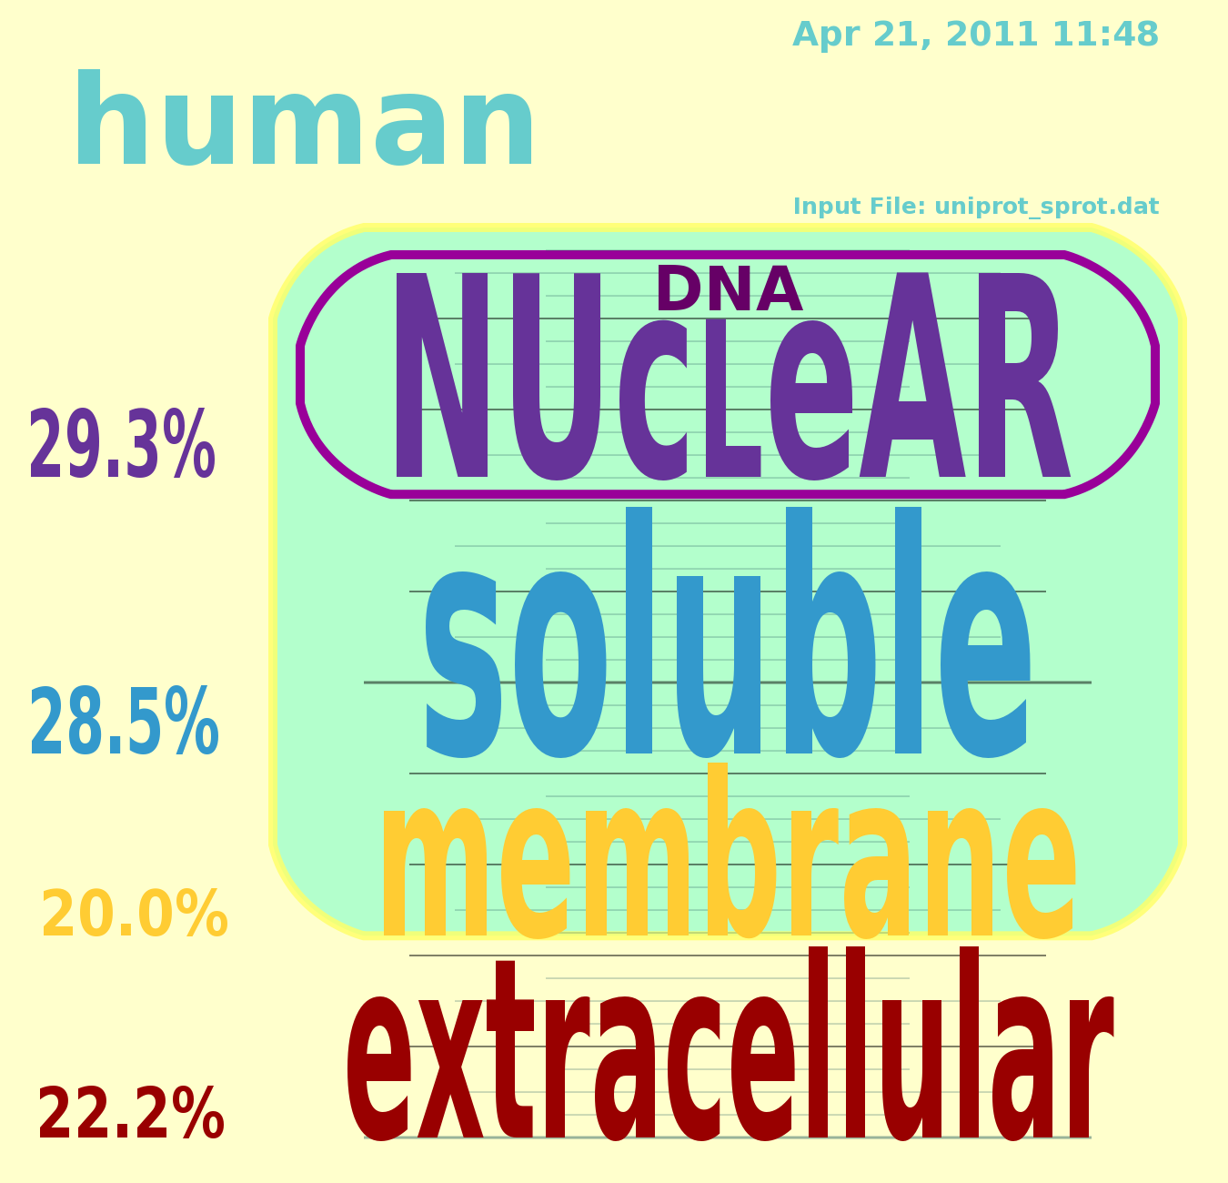Figure 1: ProMog Partitioning of Manually Annotated Human Proteome

Organization of this Report

This report forms a basis in the medical literature and molecular biology for development of this software module set, discusses its theoretic framework, preliminary design decisions, implementation and results of the study. Chapters 2 and 3 cover the basis in biological and medical theory, including compartment models containing 4, 5, and many compartments, the Fluid Mosaic Model (FMM), and Subcellular Compartments (SCLs). Chapters 4 and 5 cover preliminary and final design and implementation, including graphical output, performance analysis, and methodology of various extraction techniques from UniProt. Chapter 6 discusses results of software runs, and Chapter 7 discusses possible improvements.

SURVEY OF RELATED WORK

This chapter discusses some basic molecular biological underpinnings of the report as well as support in the medical literature for the foundation of this study. Section 2.1 describes a very important 1972 theory called the Fluid Mosaic Model (FMM) that forms a major part of understanding molecular biology at the fundamental level, fully as influential as the DNA genetic code. Section 2.2 discusses the theory that drove the work of Ahram et al [1], which was a very important impetus for this study, namely membrane (TMP) topology. Section 2.3 discusses a number of different medical research papers that implement four and five compartment models of SCL.

Transmembrane Proteins (TMPs) and the Fluid Mosaic Model (FMM)

The theory of TMP mechanism in biology dates back to Singer and Nicholson who proposed the Fluid Mosaic Model (FMM) in 1972 [2]. FMM states that TMPs are inserted into the lipid bilayer which has an oily core and can separate two aqueous compartments. The chemistry involved will be discussed in Chapter 3, Section 3.2 Chemical Basis of Molecular Biology. FMM also states that TMPs may be able to diffuse within the membrane, but cannot escape after they are inserted during their formation. Figure 2-1 is taken directly from Singer and Nicholson [2].
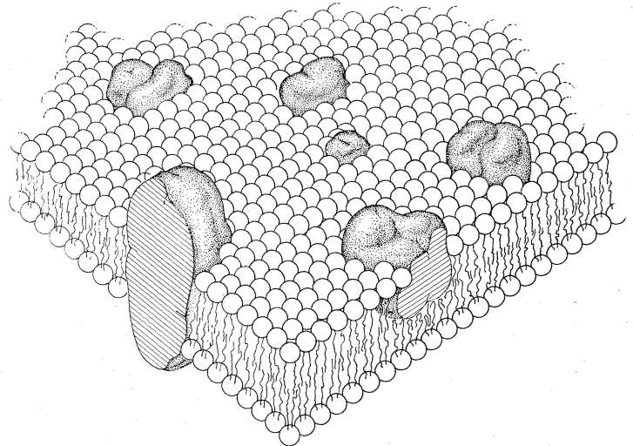Figure 2: Depiction of Proteins in Lipid Bilayer Membrane
Because of the complications involved in x-ray crystallographic analysis of TMPs, which usually have aqueous soluble portions in addition to the lipid soluble regions, they are under-represented in protein 3D structure databases that focus on fully aqueous soluble proteins.

A Study of Computational Membrane Topology

One way to understand the structure of TMPs is called transmembrane topological analysis. In this technique, the protein's linear sequence is divided into segments based on aqueous or lipid solubility. A TMP may have “multiple passes” where an initial region is aqueous soluble on the intracellular face of a membrane, followed by a lipid soluble transmembrane segment, and then another aqueous soluble extracellular region, that loops back into the cell via another transmembrane segment. Figure 2-2 is taken from Madhavan et al [30] – illustration of some possible TMP (Madvan et al [30] denote with “TM proteins”) membrane topologies. The thick black line represents the lipid bi-layer.
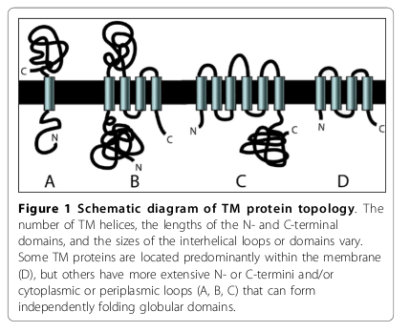Figure 3: Examples of TMP Topologies
A major impetus for this study was the work of Ahram et al [1] which surveyed five softwares that predicted transmembrane topology based on protein sequence, and utilized a sixth to eliminate false positives due to signal peptide detection that would indicate secreted rather than transmembrane protein (TMP). Although an aim of Ahram was the assessment of these prediction methods, no factual report of actual percentage of TMP in the human proteome was offered in the work. Ahram et al did, however, report that less than 1% of TMP 3-dimensional structures were known despite their biological and medical significance.
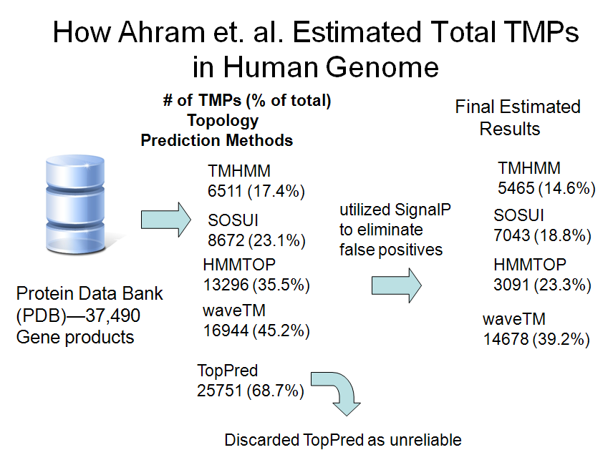
Figure 4: Ahram et al Screening of Topology Prediction Software
Figure 2-3 shows Ahram et al's [1] methodology. A first pass yielded various percentages of TMPs, but the estimates were reduced based on the elimination of false positives that contained the signal peptide, which marks proteins for secretion (becoming part of the extracellular fraction).

Four and Five SCL Compartment Models

Medical research groups such as Satoh el al [12], Tomazella et al [15], and Crockett et al [16] have partitioned proteomic data into SCL compartments, thus simplifying results, including nuclear, extracellular, cytoplasmic, and membrane partitioning in a four compartment model, and adding a mitochondrial compartment in a five compartment model of total protein sets analyzed.

SUDHL-1 Cell Line Four Compartment Model

In the case of Crockett et al [16], cell lysates were separated by SDS-PAGE followed by ion trap MS/MS. The resulting data was compared to UniProt using the SEQUEST software, and the SCL was determined using INTERACT and ProteinProphet softwares. In all, Crockett et al [16] identified 1,105 proteins from their SUDHL-1 cell line and reported discrepancies as pie charts from the three lysate fractions, namely cytoplasmic, membrane, and nuclear protein that were separated using the NE-PER Nuclear and Cytoplasmic Extraction Kit from the Pierce company. This could be explained by movement of proteins between the compartments in the case of nuclear and cytoplasm, but less likely for membrane proteins. They summarized their identified proteins that were multiply detected in a table that reported 553 cytoplasmic protein, 295 membrane proteins, and 274 nuclear proteins. Using the INTERACT software, it was determined that 26 of the cytoplasmic proteins also localized to membranes, 37 of the cytoplasmic proteins also localized as nuclear,19 membrane proteins also localized to the nucleus, and a total of 4 proteins localized to all three compartments.
Figure 2-4 is directly from the work of Crockett et al [16]. Parts A-C utilize the 4 compartment model common among other researchers covered in this chapter, and Part D utilizes a functional partitioning that represents a completely different domain, i.e. proteins partitioned into nucleus, cytoplam, membrane (TMP) or extracellular would be further classified by the more complex partitioning depicted in Part D. Each protein would be at the same time designated by SCL and Part D functional, a member of a partition in each.
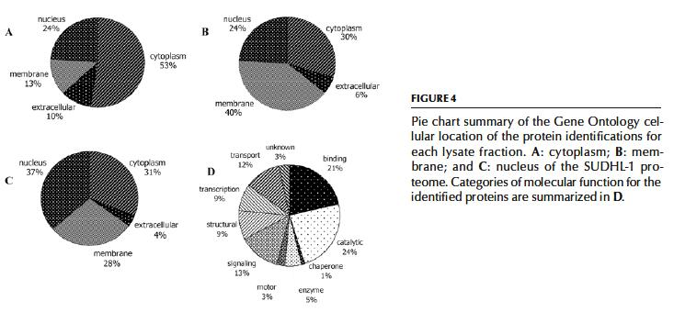Figure 5: Gene Ontology (GO) SCL Profiles of SUDHL-1 Cells

Human Neutrophil MALDI-ToF MS Four Compartment Model

Tomazella et al [15] reported a proteomic analysis of human neutrophils that yielded a 2-D Electrophoresis map of 251 total cellular proteins. MALDI-ToF MS was utilized for subsequent characterization. In a similar fashion to Satoh et al [12] and Crockett et al [16], Tomazella et al [15] reported protein SCL in their Figure 4, part B, which is included here as Figure 2-5, using the simple four compartment model of
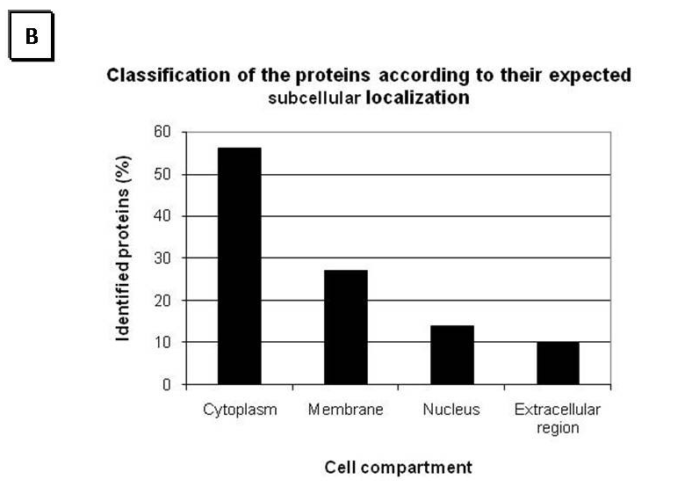Figure 6: Four Compartment Model Partitioning of Human Neutrophils
cytoplasmic, membrane, nucleus, and extracellular region, with the preponderance (>50%) localizing to the cytoplasm, and next (<30%) localizing to membrane, >10% localizing to the nucleus, and finally ~10% localizing to the extracellular region. In addition, however, in their Figure 4 part A, here Figure 2-6 (below), they also reported a more complex functional classification overlay that included 14 partitions.
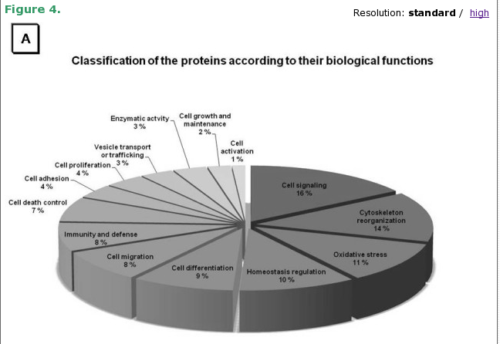Figure 7: Functional Partitioning of Human Neutrophils

Cancer Data Mining Four Compartment Model

Pospisil et al [23] developed a data mining system that included UniProt and Gene Ontology (GO) interoperability to detect extracellular enzymes to be used as cancer treatment targets. They studied a number of additional tools and included text mining of the PubMed text corpus using LSGraph to select relevant entities. Integral to their study was the Ingenuity Pathway Analysis (IPA) knowledge base application. It is built a manually curated knowledge base of functional neighbors that included more than 23,900 mammalian genes and 1.4 million biological findings as of December of 2005. Using IPA and LSGraph they produced a protein network that also conformed to the same four compartment model. The network, their Figure 3 is reproduced in Figure 2-7 below.
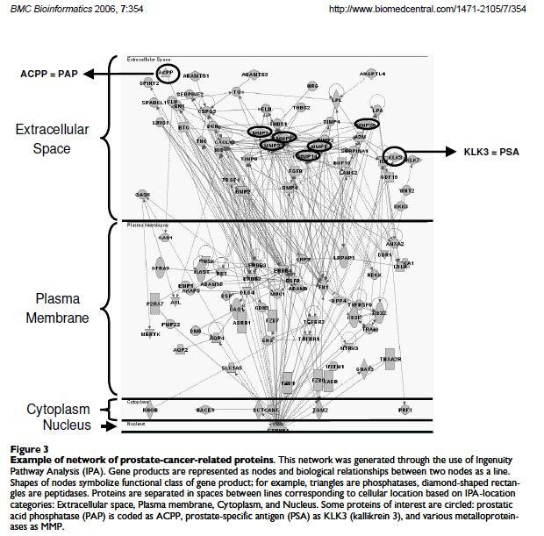Figure 8: Four Compartment Model Prostate Cancer Protein Network

Multiple Sclerosis Five Compartment Model

Satoh et al [12] utilized KEGG, protein analysis through evolutionary relationships (PANTHER) classification, Ingenuity pathways analysis (IPA) and KeyMolnet pathway analysis softwares to study biochemical network interactions using UniProt knowledgebase data. Their Figure 2 is reproduced here as Figure 2-8 below, which depicts the CAP
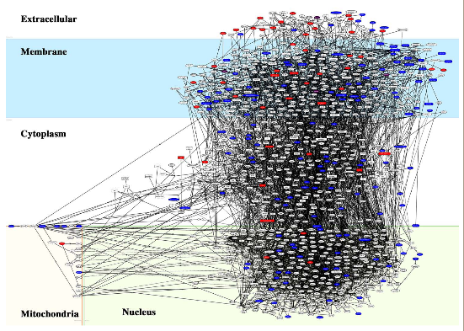Figure 9: Multiple Sclerosis Five Compartment Model Network
proteome containing 1,120 protein nodes with 2,772 molecular interactions produced by KeyMolnet that are depicted across five SCLs, namely extracellular, membrane, cytoplasmic, mitochondrial, and nuclear, is most relevant to this study. Their goal was to study the proteomics of Mulitiple Sclerosis (MS) brain-lesion development through three stages, namely the acute plaque (AP), chronic active plaque (CAP), and chronic plaque (CP) stages. A total of 2,574 proteins were isolated from brain tissue with high confidence from which 258 AP, 416 CAP, and 236 CP proteins were identified.

Gene Ontology (GO) Motif References

Ehrler et al [14] and Lu et al [13] were integral to the improvement of this research beyond obtaining simply a membrane protein census because they revealed root level Gene Ontology (GO) motif references that allowed partitioning of larger sets of proteins without requiring detailed research into the GO hierarchical system.

GO Motif Reference for Extracellular Proteins

Lu et al [13] used the May 2002 release of the Gene Ontology (GO) which contains 37,331 protein sequences that they associated with PROSITE data to automatically annotate future protein function. The authors treat sequence data as a foreign language whose words are composed of important subsequences called motifs, and describe complete proteins as sentences in this language. In their Table 1, “Go Terms and PROSITE patterns for the protein MGI|MGI:97380” they provided at the top of the column “Go Terms and Descriptions” the GO Motif Reference “GO:0005576” which has the description “Extracellular.”

GO Motif References for Nuclear and Cytoplasmic Proteins

Ehrler et al [14] utilized GO and Swiss-prot data to support annotation of four tasks, namely 1) gene and protein named entity boundary detection, 2) passage retrieval, 3) text categorization, and 4) ad hoc information retrieval. GO categorization included two main modules, namely regular expression extraction and vector space classification. The especially useful bit for this work was provided in Table 7, which gave the most frequent GO terms in the Swiss-Prot data set “initial” (DSI), which was applied by Ehrler et al [14] after logistic smoothing.
The most important contribution from Ehrler et al [14] was obtained from their Table 7, “Distribution of the most frequent GO terms in the 640 items Swiss-Prot data set (DSI): cut-off at 14 occurrences.” This table listed the 11 terms that were most frequent in their DSI data set in ranked order according to number of occurrences. From that table, 5 of the top 7 GO terms were used, namely GO:0005634 - nucleus, GO:0007165 – signal transduction, GO:0005737 – cytoplasm, GO:0005886 – plasma membrane, and GO:0016021 – integral to membrane. The utilization of these motif references allowed the partitioning of more than 99.98% of the total proteins, and more than 99.95% of human proteins.

Additional SCL Prediction Research

Huang et al [22] provided a detailed discussion of GO terms, and included GO:0005737 – cytoplasm and GO:0030198 – extracellular in their Table I: Essential GO terms and their definitions.
Manabe et al [17] produced a study that focused on extracellular matrix (ECM) proteins, which form a scaffolding for building tissues out of cells, and have been important in limb and tissue regeneration studies. Because they used a complimentary DNA (cDNA) screening technique from the RIKEN Genomics Sciences Center in Yokahama, which is a stable way to store mRNA, they describe their work as being transcriptome-based. Transcription is the process of copying genetic information from chromosomal DNA to mRNA. A total of > 60,000 RIKEN cDNAs were screened using four criteria, 1) presence of the secretion signal sequence as predicted by PSORT II, 2) absence of transmembrane domains which would indicate membership in a TMP partition, and 3) open reading frame (ORF) of at least 300 amino acids, and 4) functionally unknown.

Chapter Summary

The theory, known as the Fluid Mosaic Model (FMM), that proteins are inserted into cell membranes to become TMPs was first proposed in 1972 by Singer and Nicholson. A facet of the FMM is that TMPs may diffuse in a pseudo-2D fashion remaining bound to lipid membranes that divide biological compartments. One way to understand TMP structure is called membrane topology, which defines how a protein sequence inserts itself multiple times through a membrane with domains that may be localized to either side. Research published by Ahram et al [1] studied five softwares that theoretically predicted TMP topology based on sequence, comparing what percentage of the total genome is predicted to be TMP by those softwares. The goal of this research is to find the correct number that the softwares Ahram et al [1] studied should be shooting for.
A number of medical researchers have studied proteomic data establishing simple 4 and 5 compartment SCL models. Included in this research was Crockett et al [16] that studied a SUDHL-1 cell line four compartment model, Tomazella et al [15] that studied human neutrophils with the same four compartment model, and Pospisil et al [23] utilizing the same model to study cancer. Satoh et al [12] studied Multiple Sclerosis with a five compartment model that added a mitochondrial compartment. Lu et al [13], Huang et al [22], and Ehrler et al [14] provided useful Gene Ontology (GO) 7 digit code references.
Next chapter we discuss basic theory underlying SCL and TMPs. This theory includes the endosybiotic hypothesis and the chemical basis of membrane biology.

TUTORIAL BACKGROUND

In this chapter, we discuss basic molecular biological details that underscore the medical research reviewed in Chapter 2. Section 3.1 discusses the fundamental difference between simpler organisms and more complex ones and the genesis of SCL. Section 3.2 reaches into chemical detail to illustrate the basic nature of TMPs that sets them apart from aqueous (water) soluble proteins. Finally, Section 3.3 explores some possibilities for compartmentalization, and cements the validity of the use of a four or five compartment model.

Endosymbiotic Hypothesis and SCL details

Compartmentalization of cellular biology has been taught at the secondary school level for quite some time and even molecular details are being taught in middle school now in the genomic age. One must pursue biology at higher levels to understand that there is a more primitive main classification of life called prokaryotes. Prokaryotes include auxotrophic bacteria and cyanobacteria. The other main classification includes more complicated forms of life called eukaryotes. Examples of eukaryotes are amoebas and some other single celled organisms but also all higher forms of life. The distinction between eukaryotes and prokaryotes is the existence of a nucleus and any membrane-bound organelles, which by definition, only eukaryotes can have. There is a theory, called the endosymbiotic hypothesis, that proposes eukaryotes were created when one prokaryote that specialized in one type of biochemistry, engulfed another by phagocytosis, but the phagocytosed prokaryote did not get consumed, and instead became a part of the newly created larger cell that now had enhanced functionality. The engulfed prokaryote became the first organelle. Organelles of modern eukaryotes include the nuclear compartment, mitochondria, which are the powerhouse of animal cells, chloroplasts, which in plants are responsible for photosynthesis, and also various simpler membrane bound compartments such as digestive lysosomes and peroxysomes, storage vacuoles, and the the endoplasmic reticulum (ER). The ER has two types, smooth and rough, the latter made so because of ribosomes actively creating proteins from mRNAs. Another organelle is the Golgi Apparatus, which evolves from ER and is the initial part of secretory processes. Finally the sarcoplasmic reticulum (SR) is similar to ER, but is important in calcium balance in contractile cells such as skeletal and cardiac muscle cells. Calcium ion is very important in some hormonal signals and the ability of muscles of all types to contract.
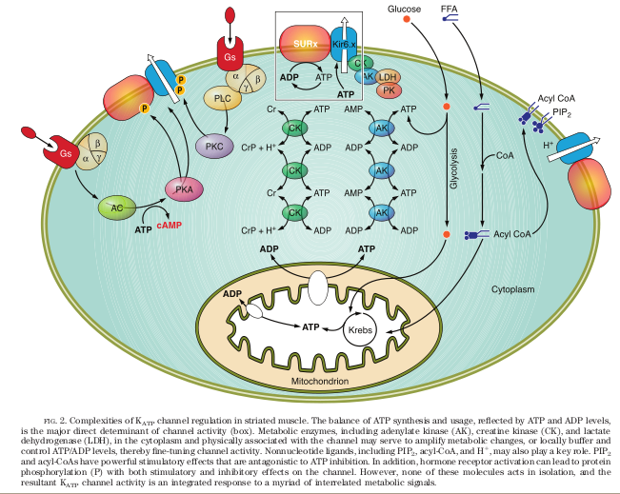Figure 10: Striated Muscle ATP-Sensitive Potassium Channel SCL Functional Diagram

Chemical Basis of Membrane Biology

From a chemical perspective, a far simpler partition scheme should be possible, based on the very simple tenet, “oil and water do not mix.” In chemistry, the common technical terms that are used to describe this are “hydophobic” meaning “water fearing” and “hydrophillic” meaning “water loving.” This chemical partition in fact forms the boundary between life and death, inside versus outside, and self versus non-self in both prokaryotic and eukaryotic organisms. This boundary is known as the lipid bilayer, which refers to lipid, that is, oily small molecule (not protein) biochemicals, that are arranged with their hydrophillic heads on either side of a basically two dimensional space that
convolutes itself in the three dimensional world that cells must live, with a fairly constant width, and hydrophobic tails arranged together, forming a thin oily space that is known as a membrane. The building blocks of protein sequences, amino acids, referred to as “the alphabet” by Lu et al [13] with respect to protein “sentences” and sequence motif “words,” have sufficient chemical diversity of hydrophobic and hydrophillic character so that much work is being done, including Ahram et al [1] who surveyed “topology prediction” programs, which attempt to predict how proteins will act in lipid bilayers.
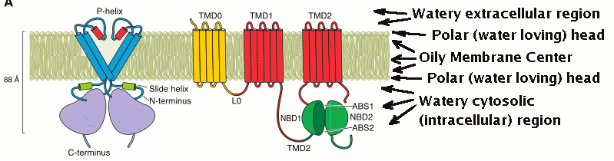Figure 11: Cross Sectional Diagram of TMP Structure

Theoretic Basis of SCL Compartment Models

A two way partitioning scheme of the proteome could be proposed including proteins intimately associated with membranes in one partition and those not so associated in the other. However, the four way partitioning employed by Crockett et al [16] and Tomazella et al [15] that includes four partitions, namely 1) nuclear proteins, 2) cytosolic (soluble) proteins, 3) membrane proteins (TMPs), and 4) extracellular proteins is attractive. Clearly proteins that are retained within the tightly controlled intracellular environment should be contrasted from those that leave the cell to the extracellular environment, while additionally, the nucleus lends itself as the control center of the cell, which makes it a strong candidate for the fourth partition. The fact that Satoh et al [12] add a fifth compartment, the mitochondria, also makes sense because in animals, the mitochondria are the most complex and important organelles, being responsible for energy production. A major complication of the whole idea of partitioning, however, is that proteins may actually translocate between different SCLs. In fact, the Crockett et al [16] finding that 26 proteins from the SUDHL-1 cell line proteome colocate to membrane and cytoplasm, 37 to nucleus and cytoplasm, 19 to nucleus and membrane, and 4 to all three of these SCLs seems to suggest this occurring. A known example of colocation being central to function in biology has to do with the steroid class of hormones. Examples of steroid hormones are the sex hormones progesterone, estrogen, and testosterone, and the stress hormones the glucocortocoids. These hormones are not proteins or peptides, but rather are derivatives of cholesterol, so are related to gene products only indirectly through enzymatic metabolism. Since cholesterol is a very nonpolar, i.e. hydrophobic, molecule with the exception of a small hydroxyl group, all of these hormones readily cross lipid bilayers and are able to diffuse directly to the nucleus. In the nucleus, steroid hormones interact with their receptors and can influence genetic expression more directly than most hormones, which in contrast must interact with extracellular located receptors that utilize 2nd messenger signaling to potentially influence gene expressions the nucleus.

Chapter Summary

Simpler life forms that have little in the way of SCL are known as prokaryotes, while more complex organisms are called eukaryotes. A theory known as the endosymbiotic hypothesis states that eukaryotes arose when one prokaryotic organism engulfed another, but the inner organism retained function and became symbiotic with the outer. Evidence for this includes the fact that mitochondria have their own genomes.
Oil and water do not mix, but TMPs bridge the gap between them and form functional bridges between watery compartments that are separated by an oily membrane. It would be possible to partition proteins into TMPs and non-TMPs, but when studying eukaryotes the largest organelle is the nucleus which in the genomic age is of great interest. Furthermore, many proteins form important intercellular structures such as the extracellular matrix (ECM) which has been implicated as important in limb regeneration. Hence a four compartment model of nuclear, membrane, extracellular and cytosolic is a sensible minimal model. The importance of mitochondria implies they may be included as a fifth compartment.
Next chapter, design decisions leading up to the current software version described by this report will be discussed. The structure of the UniProt data used for the research is first defined, followed by a survey of the effect of its data load on systems used for this research. Cross-platform performance tests are presented as are tests of the performance of C versus Perl, and different C programming methods.

PRELIMINARY DESIGN DECISIONS

A wealth of annotation data that promises to uncover answers lies in a proteomic repository called UniProt. The method to download UniProt and the behavior of an Ubuntu Linux system while processing the data is discussed. Three platforms were tested with early versions that would eventually become the ProMog.c data extraction module, namely Gentoo, Ubuntu, and CentOS Linux distributions. Automation of test runs using a bash script is described. The results show that the C program displays superior performance when compared to a similar Perl program, and the fastest distribution was CentOS. Unbuffered I/O using the read() family of system calls with a stream processing style programming method proved superior to utilizing fgets().

Stucture of the UniProt Data

UniProt data files in text format are a linear list of the various types of data lines such as comment (CC) [3][4], feature table (FT) [3], and keyword (KW) [3], and begins with the identification (ID) line and ends with the terminator signal (//). Figure 4-1 shows the beginning of such a file.

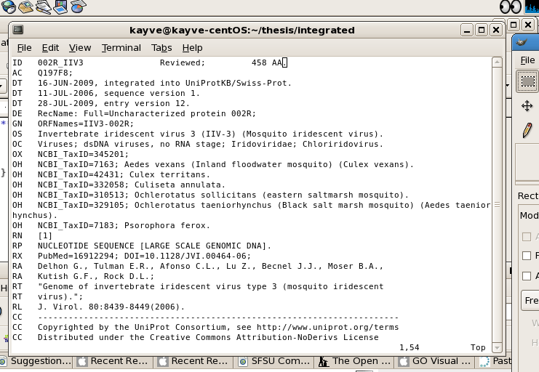Figure 12: Internal Format of UniProt Data File

UniProt Data Load Effect on Tested Systems

As seen in Figure 4-2, the automatically annotated UniProtKB/TrEMBL data file, named uniprot_trembl.dat, contains ~28.86 GB of information. The much smaller UniProtKB/Swiss-Prot manually automated file, called uniprot_sprot.dat, contains ~2.381 GB of information. These files represent a biosphere-wide basic parts list specification of proteomic data. They specify neither small molecule nor gross, nor micro- anatomical assembly of any multicellular or even single celled organism. There is no real time simulation of gene product interaction, no census of copy number information of gene products.
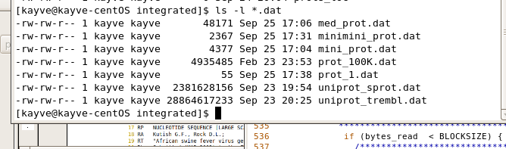Figure 13: Listing (ls -l) of UniProt Data Files
Incidentally, beyond the fact that it is difficult to acquire atomic-scale structural information for TMPs such as the protein assembly factor BamA [33], this is another reason that TMPs are underestimated in importance. There is less structural information known for TMPs and fewer molecular mechanistic details defined than for soluble proteins [30]. In fact, TMPs tend to be expressed in low abundance [31], but because of their location at the boundaries between life and death, this does not diminish their importance. The other much smaller *.dat files seen in the Figure 4-2 listing were created from uniprot_sprot.dat to facilitate testing.
The manually annotated uniprot_sprot.dat file and its fragments were utilzed for development of the ProMog.c/Cellgram.c evidence-derived UniProt data demographic
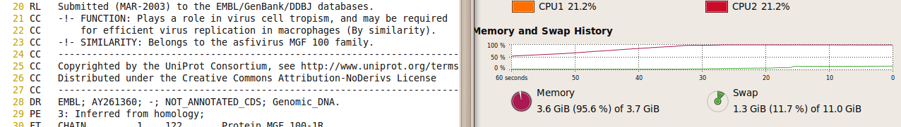Figure 14: Memory Demand Response to "vi uniprot_sprot.dat"
analysis tools. Figures 4-3 above and 4-4 below shows how main memory, CPU and swap
respond after the command “vi uniprot_sprot.dat” is invoked. It takes the system quite some time to display the contents. During parts of the debugging process, however, the regular expression (RegEx) capabilities of the vi editor proved quite helpful. No more than two similar sized files were ever opened at the same time using vi.

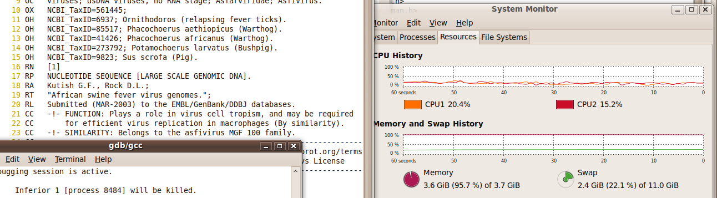Figure 15: Equilibrium State of System After Data Load

Figure 4-5 below shows the state of the system after two uniprot_sprot.dat sized data
files were loaded into memory using the vi editor. Main memory is virtually full, and 2.4GiB of swap is being utilized.
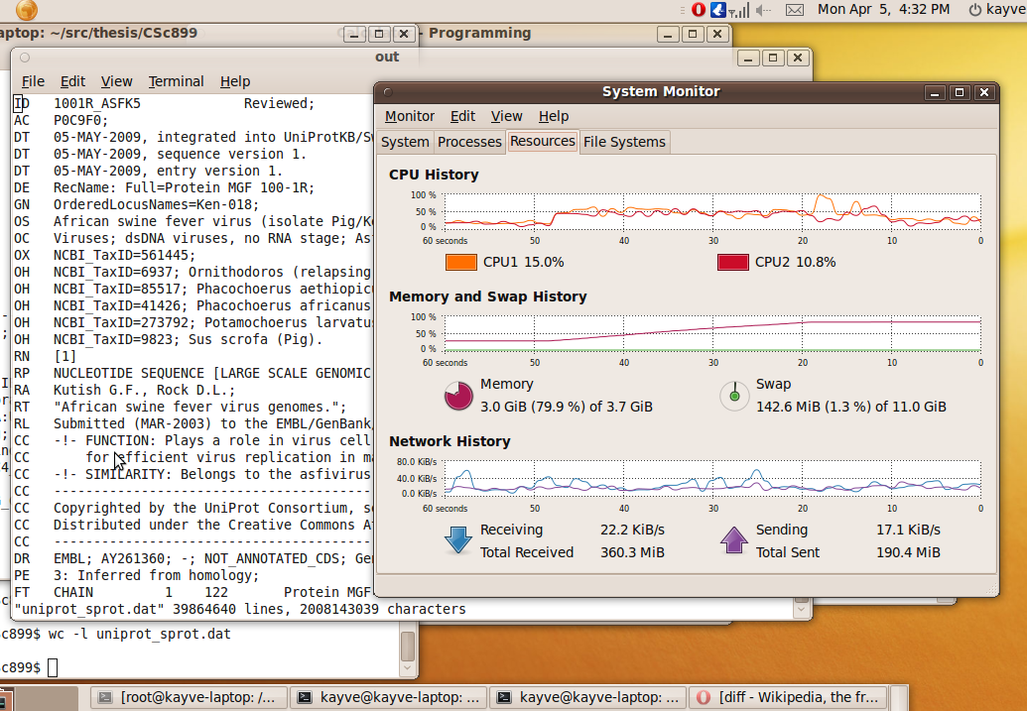Figure 16: System Response to "vi uniprot_sprot.dat"

Cross-Platform Performance Testing

A total of three Linux platforms were used to compare performance of the software developed by this project. These platforms were 1) Gentoo, 2) Ubuntu, and 3) CentOS distributions. All distributions supported the command “uname -a” which shows kernel name, release, and version information as well as machine processor, hardware platform and
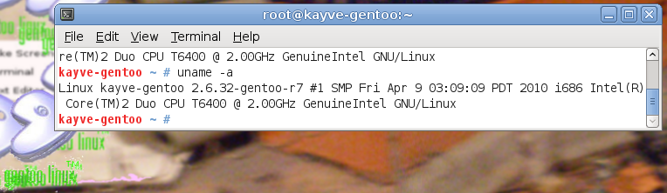Figure 17: Gentoo Linux System Version Information
operating system. Figure 4-6 above shows this command being invoked while running the Gentoo Linux system used for performance testing. Figure 4-7 below shows the same command being invoked on the CentOS system. Since the CentOS system was deployed after the Gentoo system, the Gentoo logos are in the background of the CentOS system. This was simply a stylistic choice.
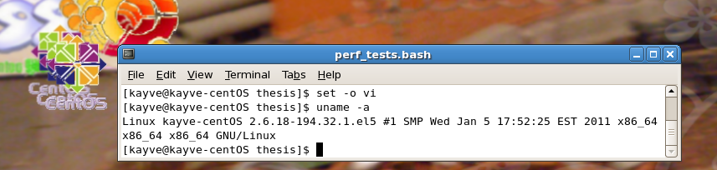Figure 18: CentOS Linux System Version Information
A bash script called perf_tests.bash was created to dynamically detect what system it was running on while it automatically generated data based on repeated runs of the various uniprot_sprot.dat parsing versions that were utilized during this phase of development. This development was found necessary to improve replication of proper benchmark technique. Figure 4-8 below shows that the output directory (output_dir) used for the run was “times_scripted_jun2” and that invoking the command loaded in to the distro variable on the current command line yielded “CentOS release 5.5 (Final).”
Figures 4-9 and 4-10 below show how perf_tests.bash utilize the variables output_dir, out_file, infile, infile_index, options, as well as the three level looping variables i, j, and k to invoke calls to the programs. In the case of Figure 4-9, the call is made to a C program called demog_gets_sf. This C program utilizes the gets() read method, and the “sf” in its filename denotes “script friendly,” implying it had functionality necessarily built into it that enabled it to be called by the bash script. In the case of Figure 4-10, the Perl program dirty_demog_full.pl
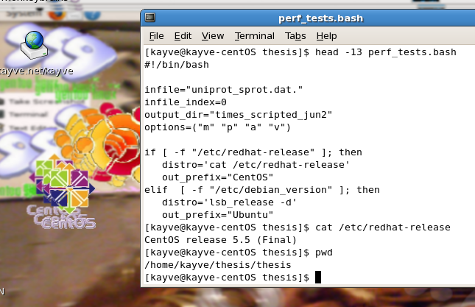Figure 19: perf_tests.bash Dynamic Determination of System Information
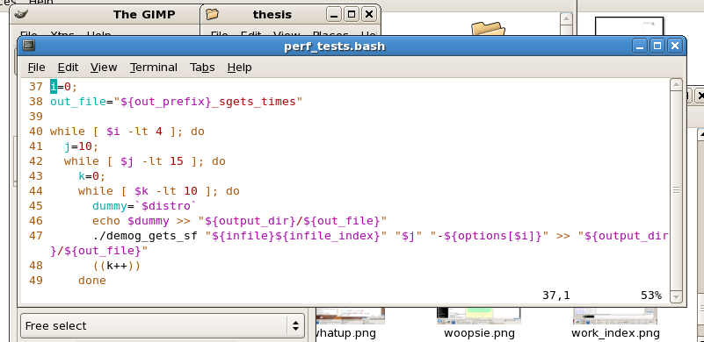Figure 20: perf_tests.bash Distribution Based C Program Invocation
was used with – for the most part – the same parameters, but the loop only had one level because the C program tested different memory allocation methods, which was determined by
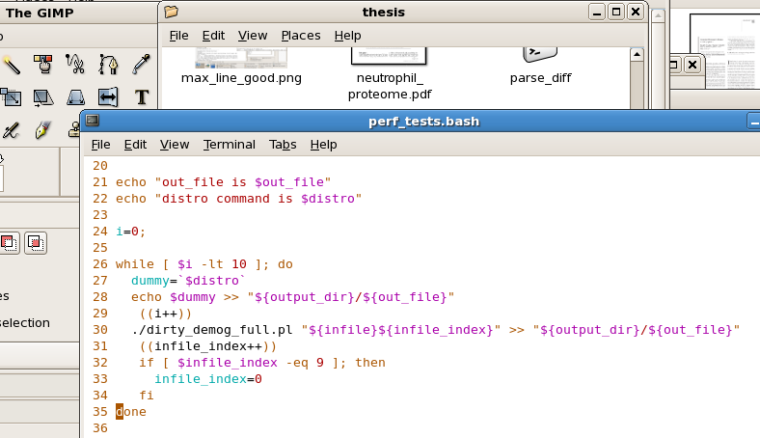Figure 21: perf_tests.bash Distribution Based Perl Program Invocation

the i loop variable, and different BLOCKSIZEs, which was determined in the C program with the argument generated by the j loop variable via the command line argument. Inside the C program, that value was used as the logarithm base 2 for the final BLOCKSIZE.

Results of Performance Testing

Figure 4-11 below shows command line listing and Gnome Places GUI display of the resulting from running the perf_tests.bash script on Gentoo, as well as an Ubuntu Linux system.
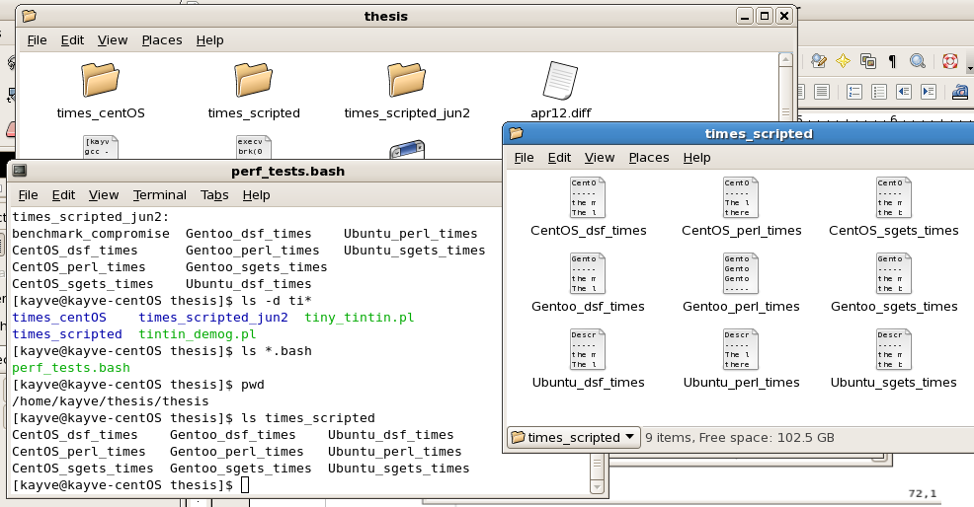Figure 22: Output Files Generated by perf_tests.bash

Figure 4-12 shows the results of running the perf_tests.bash script on CentOS. It demostrated that the CentOS system performed fastest, and C programs outperformed Perl. It
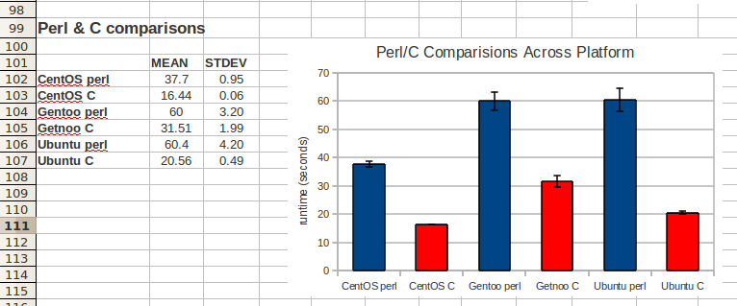Figure 23: Perl/C Performance Comparisons Across Platform
should be noted that because of hardware differences, especially the disk that ran Gentoo, which had a defect that caused audible clunks at times while operating, that this comparison should not serve as a true test of these operating systems. The comparisons between C and Perl, however, as they were performed under the same respective conditions intraplatform, represent a better measure, with the exception of the Gentoo trials, as the defect may have had unknown impact on the test. In any case, the trials were appropriate for making the choice of platform for this research, as the research was to be performed under the exact constellation of conditions that this data presents.

Figure 4-13 shows the results of varying BLOCKSIZE on the performance of a C program known as “Demog.” These results closely match the results given by Figure 3.5 in
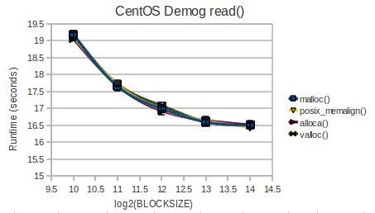Figure 24: CentOS read() BLOCKSIZE Optimization Analysis
Stevens and Rago [34] “Timing results for reading with different buffer sizes on Linux.” We see that BLOCKSIZEs smaller than 214 (16384) bytes lead to eroded performance, but BLOCKSIZEs larger than this are not expected to gain any further performance improvement because cache memory is already optimally filled.
Figure 4-14 below shows a similar BLOCKSIZE analysis for a program version that utilized fgets(). Although the timings are slightly better, the reproducibility is highly irregular. Additionaly, as will be discussed below, the fgets() implementations remained in a rudimentary phase with limited functionality. Meanwhile, the read() version had functionality that was continuing to be expanded.
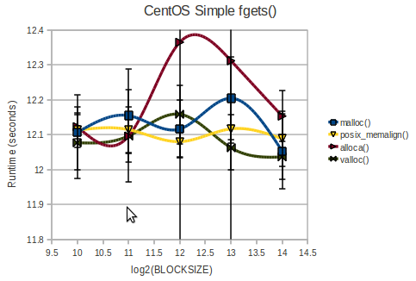Figure 25: CentOS Simple fgets() BLOCKSIZE Optimization Analysis
To verify that a gets() based method would not outperform the read() based method, despite the more complex programming methodology, a test was done with a slightly
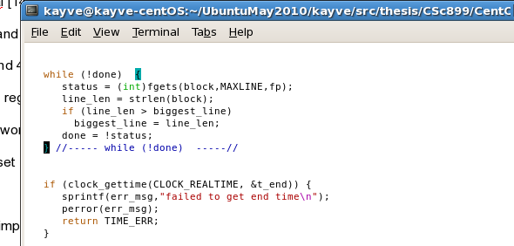Figure 26: Main Loop of demog_gets.c Code
increased functionality program called demog_gets.c, whose main loop is shown in Figure 4-15 above. The program simply found the “biggest_line” length in the uniprot_sprot.dat file.
Merely adding this functionality, as seen in Figure 4-16 below increased
runtime significantly to 38.715 seconds. Therefore, it was determined that the version that utilized a stream programming style and the read() family of system calls for input of uniprot_sprot.dat data would be used for the final version.
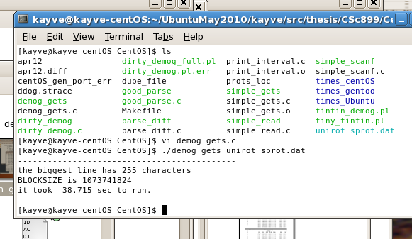Figure 27: Runtime Behavior of demog_gets.c

Chapter Summary

The UniProt dataset contains a large amount of data that, in anticipation of increased functionality of this basic work, calls for high performance computing. This data is composed of protein records that include many various types of data defined by fixed format line initiator codes such as “ID” for identification, “FT” for feature table, and “KW” for keyword. The end of a protein record is signaled with the two character code “//” that appears alone on a data line.
Three Linux platforms were utilized for the research, 1) Gentoo, 2) Ubuntu and 3) CentOS. C programming methods implemented with fgets() and read(), and Perl programming were all tested for performance. To facilitate and improve benchmarking technique, a bash script was created that could detect which system was being run and report this to its output. Of the tested platforms, C programming on CentOS Linux using unbuffered (read() family) I/O was fastest.
Next Chapter will discuss the current version of the program, which includes a Proteomic DeMographic extraction module, ProMog.c, and a biologically meaningful visualization module, Cellgram.c. ProMog.c extracts data from UniProt format files in a number of ways, including fixed format key name driven extraction from FT lines, RegEx detection of Gene Ontology (GO) 7 digit codes found on DR lines, and a slightly more complicated procedure that detects SCL data found in comment blocks on CC lines, which required an additional boolean flag in_SCL that was active while in the comment block, and deactivated by a non-SCL CC line comment block or the UniProt Consortium copyright statement that empirically served as a CC line termination block.

DESIGN AND IMPLEMENTATION

The central impetus of this report is the description of the two modules that are described in detail in this chapter – ProMog.c and Cellgram.c. The name “ProMog” was derived from the concept of “Proteomic DeMographics.” The ProMog.c module extracts protein annotation data from UniProt fixed format data files and determines a census of various protein “populations.” The current version implements the four compartment model that has been discussed in earlier chapters, namely a paritioning of the proteome into nuclear, cytoplasmic, membrane (TMP), and extracellular SCL fractions.
The general organization of the ProMog.c module utilizes a stream programming- like algorithm using blocks of information and manipulating them based on indices that point to pertinent points in the data. It gathers data by setting boolean flags when it encounters data of interest. When the line signal “//” is encountered, indicating the end of a complete protein record, these boolean flags induce the increment of tabulators tied logically to the same entity. Boolean flags collect data on entities that are found in a variety of places, namely fixed format FT line (Feature Table) data, key words found in CC line (Comment block) SCL annotations, and Gene Ontology (GO) numeric codes found on DR lines (Database Cross Reference). The data is output via command line for more detailed examination, and the Cellgram.c module (discussed below) is called to produce a png graphic that reports timestamp, input filename, and percentage totals for the four compartment model.
The Cellgram.c module was conceived based on an earlier graphical representation of genetic data that will be discussed this chapter, where the four “letters” of DNA, namely A, C, G, and T, are written so that font height is in proportion to abundance. A component of the Gnome (GNU Network Object Model Environment) Linux desktop GUI, namely the Cairo 2D Graphics library was used to implement the production of a png image file containing the information passed to Cellgram.c by ProMog.c. The concept of the Cellgram is that the basic unit of life, the cell, contains various compartments that are central to function.
As discussed in a number of places in this report, a simplified four compartment model was used. These four compartments were depicted graphically by drawing a “cell membrane” (also known as a “plasma membrane”) that surrounds the words “nuclear,” “soluble” and “membrane,” and is drawn in yellow to emulate the color of butter or fats such as olive oil, which is largely composed of esters of oleic acid. This is to emphasize that the membrane is indeed made of fatty materials, actually called “fatty acids,” oleic acid being one example of a fatty acid, as well as cholesterol.
The word “extracellular” is written outside the cell membrane to represent the fact that these proteins do indeed leave the cell. The term “soluble” is used for cytosolic proteins, although it is not 100% accurate to do so, to simplify the understanding of the diagrams to the level of basic chemistry. Most nuclear and extracellular proteins are also aqueous (water) soluble. The term “cytosol” does come from “cyto-” for “cell” and “sol” being linked to the fact that areas inside the cell are filled largely with water, and proteins may freely diffuse in three dimensions in that space. The term “soluble” in the diagram is written in blue to represent water.
Finally, an additional membrane is drawn inside the cell to represent the nuclear membrane. This allows the diagram to resemble cells that can be viewed by a standard light microscope found in secondary school biology labs. These cells viewed at magnifications possible with a light microscope have a general appearance of two concentric “circles” (though seldom perfectly circular). This inner circle is the nuclear membrane, which is distinctly different from the plasma membrane so is drawn in a different color. Inside the nuclear membrane resides the chromosomes of the cell, so in the Cellgram the acronym “DNA” is also written inside the nuclear membrane. To represent the management of gene expression and protective function many proteins that reside in the nucleus have, the acronym DNA is drawn surrounded by the word “nuclear” to represent the fourth fraction of the four compartment model.

ProMog.c - UniProt Proteome DeMographic Extraction

The ProMog.c source file module is responsible for extracting UniProt data to determine statistical information about SCL data. ProMog.c then passes its results to Cellgram.c which presents the results in visual form.

Extraction of FT Line Fixed Format UniProt Data

As lines are being read, various pertinent pieces of information are gathered. The information is gathered as boolean flags when they are encountered, and when the end of record signal “//” is seen, only then tabulators that record demographics utilize the boolean flags thereby avoiding double counting. The simplest type of data to collect were found in Feature Table (FT) line. This data is found in a fixed format as described at the URL http://www.expasy.org/sprot/userman.html#FT_line. Therefore, no RegEx was needed to set flags when encountering a protein record with data that would indicate the flag should be set. Figure 5-1 (below) shows the code for flagging a current record as human.
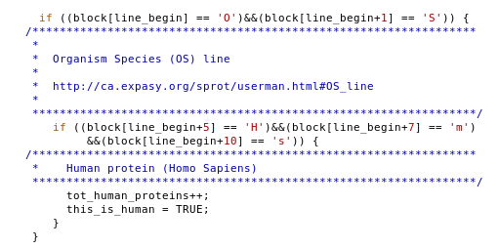Figure 28: Detection of Human Organism Species (OS)
The flag “this_is_human” is set to TRUE, and tot_human_proteins is incremented. Deemed pertinent for this study were the TRANSMEM key name. Figure 5-2 shows the code that detects the fact that the current line (marked by the variable line_begin) is an “FT line,” and then sets boolean flags for the various key names, TRANSMEM, LIPID, INTRAMEM, and SIGNAL.
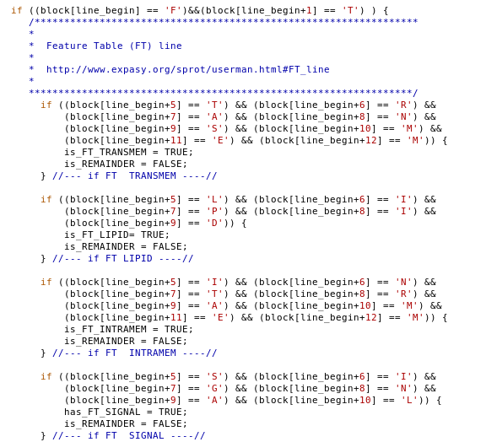Figure 29: Feature Table (FT) Detection and Flagging of Key Names

TRANSMEM indicates that a given protein is inserted into the membrane bilayer and thus must be considered a TMP. LIPID indicates covalent attachment to a lipid. Also closely associated with the membrane, INTRAMEM indicates a region inside a membrane without crossing it. Proteins containing SIGNAL, the secretion signal sequence mentioned in Ahram et al [1], were subtracted from membrane protein count in a similar manner, and should be included in secreted, thus extracellular, protein count. Finally, the DNA_BIND feature is included in the nuclear protein count. Figure 5-3 shows the code that completes the if statement shown in Figure 5-2, and records in another boolean flag the fact that the current line is part of a DNA_BIND protein. Also seen that when any feature is detected, the remainder flag is_REMAINDER is set to FALSE in each case, to signal that one of the pertinent features has been found, so this protein record does not have a NULL annotation for the purposes of this study.

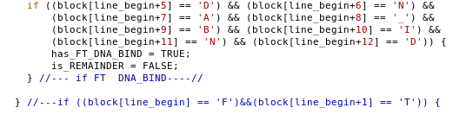Figure 30: Flagging of DNA_BIND Key Name

C Language Regular Expressions (RegEx)

In order to process the CC line data (as well as the GO data which will be discussed below) regular expressions (RegEx) were necessary. In C, regular expressions (RegEx) are implemented using a struct called regex_t. Figure 5-4 shows the system code that defines
the regex_t structure type.
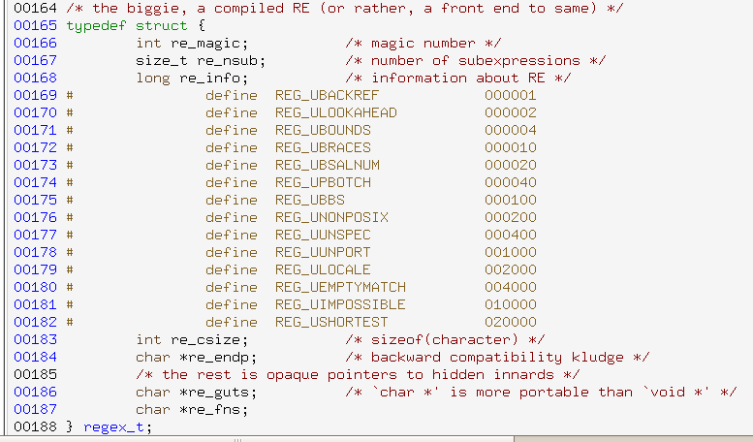Figure 31: RegEx regex_t Structure Definition

In order to utilize C RegEx, variables of type regex_t are declared as in Figure 5-5.
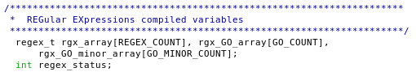Figure 32: Initialization of regex_t Variables for Use in ProMog.c
In order to utilize the variables shown, a system call called regcomp() was required for preliminary complication of the regex_t variables. Figure 5-6 shows loops that filled
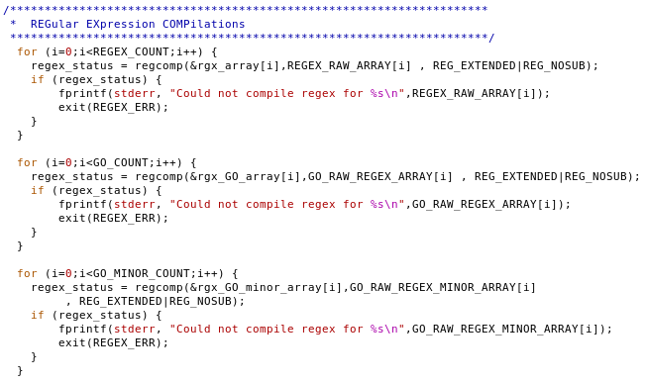Figure 33: Compilations of regex_t Type RegEx Variables
the regex_t type arrays. Data from the character string array REGEX_RAW_ARRAY[] was used to fill the regex_t array rgx_array[], data from GO_RAW_REGEX_ARRAY[] was used to fill the regex_t array rgx_GO_array[], and data from GO_RAW_REGEX_MINOR_ARRAY[] was used to fill the regex_t array rgx_GO_minor_array[].
These precompiled regex_t type arrays contained CC line data (rgx_array), GO data that was deemed of central importance (rgx_GO_array), and data that was found in GO codes that were considered less pertinent for the study, but allowed reduction of “remainder” records (rgx_GO_minor_array). The raw data seen in Figure 5-7 below was
dual in nature. For the CC line data, the array REGEX_RAW_ARRAY contained RegEX strings which was used to compile the regular expressions, while the array NAMES_ARRAY contained user friendly names that were used to print out results at the end of the run. The analogous raw regular expression data for the GO data was contained in the array GO_RAW_REGEX_ARRAY and human friendly output data for the array was contained in GO_NAMES_ARRAY. A similar pair of arrays (not shown in Figure 5-7) was hard coded in the arrays GO_RAW_REGEX_MINOR_ARRAY and GO_NAMES_MINOR_ARRAY for the elimination of non-pertinent data using GO. The variables REGEX_COUNT, GO_COUNT, and GO_MINOR_COUNT (not shown in Figure 5-7) were used to allow loops to iterate through the arrays, and were hard coded at the beginning as well. It is significant to note that the GO regular expressions were numerical codes, and were obtained from Ehrler et al [14] and Lu et al [13], which made these references highly useful, as these regular expressions yielded significant amounts of hits from the data as will be discussed below.
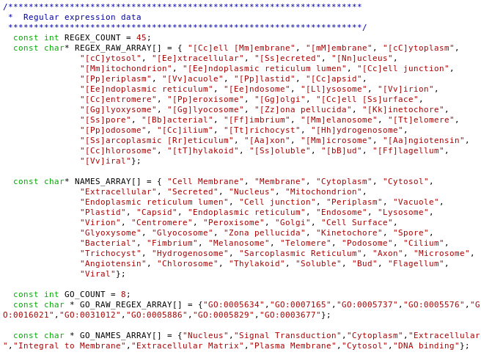
Figure 34: Character String Array Containing Raw RegEx Data
To provide a comparison to illuminate tissue differences, additional RegEx structures were precompiled based on a finding that the location of proteins in brain and muscle tissue were designated with a variable named TISSUE. The code that implements the compilation of the RegEx is seen in Figure 5-8.
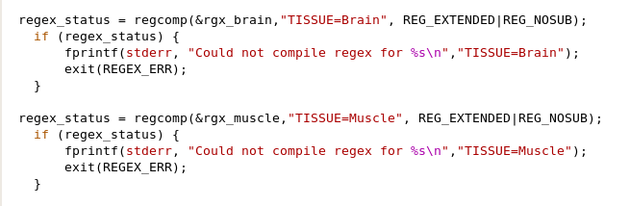Figure 35: Compilation of Brain and Muscle Tissue Detecting RegEx's

UniProt CC Line Data Extraction

Using the CC line data marked with the fixed format SUBCELLULAR LOCATION required slightly more code because the data flagged by this signal may lie on more than one line. The fixed format designator “CC -!-” indicates a CC line, but the additional fixed format designator “SUBCELLULAR LOCATION” is necessary to indicate the ensuing comment line block contains SCL data. Once a CC line is designated in this way, multiple lines will contain SCL data until a different CC line designator, or the end of CC line block UniProt Consortium copyright, is reached. Figure 5-9 shows a short example of a CC line block that illustrates this.
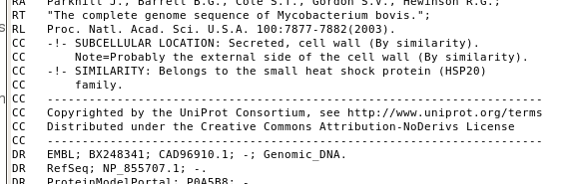Figure 36: Short Example of a CC Line Containing SCL Data
Hence, the methodology employed to extract CC line data was threefold: 1) detect the beginning of a CC line containing SCL data, setting a flag in_SCL to true, 2) detect lines either designating lines that are NOT SCL data, OR are the end of CC block UniProt Consortium comment black, and finally 3) utilize the in_SCL flag for further processing of lines that contain SCL data. Figure 5-10 below shows the code that accomplishes the management of the in_SCL flag to detect CC line SCL data.
An if/else conditional was used, which was possible because of the stream processing nature of the ProMog.c module. If the CC line SCL flag was detected, in_SCL was set. An additional boolean flag has_SCL was also set, which was used for a tabulator counting total records with SCL data, as opposed to extracting SCL data. In the else clause, any detection of the CC line flag “-!-” would indicate the beginning of a block that would contain some CC line data that was NOT SCL data, so in_SCL was unset in this case, but also if the end of CC block was encountered, the last CC line would be a dashed delimiter for the UniProt Consortium copyright block, so that the string “---” served as a
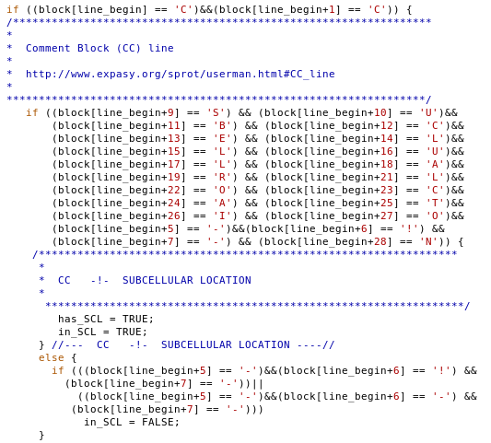Figure 37: Management of in_SCL Flag for CC Line Data Extraction
deterministic flag to unset the in_SCL flag until another CC line SCL fixed format delimiter was encountered.
Unlike existence boolean flags such as those encountered for FT line data extraction and the has_SCL flag, the in_SCL flag was used as a sort of deferred data extractor. Only lines known to be part of a CC line SCL block need be tested for the RegEx loaded into the rgx_array[]. Figure 5-11 above shows the code that utilized the regexec() function to implement a RegEx match function on each precompiled RegEx. An array of boolean existence flags called is_SCL_ARRAY[] was used to record matches, and in a similar fashion for all the data extractions, including aforementioned FT line extractions, the flag is_REMAINDER was unset. The is_REMAINDER flag was used to determine the number of protein records that had no relevant annotations examined in this study.
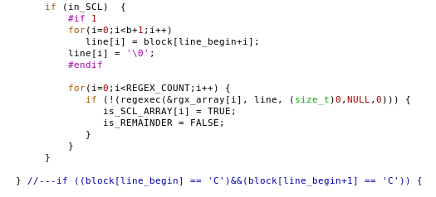Figure 38: RegEx Detection of SCL Data During CC Line SCL Block

Database Cross Reference/GO Data Extraction

GO data was included in protein records using the Database Cross Reference line (http://www.expasy.org/sprot/userman.html#DR_line). Unlike the CC line SCL data, the GO data was found on a single line, and because of the nature of GO data, the simple flagging of the existence of a GO code was sufficient to set tabulator flags. An example of GO data is seen in Figure 5-12.
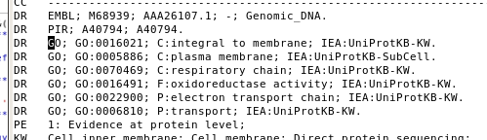Figure 39: Database Cross-Reference (DR) Lines Containing GO Data
RegEx was used to process the GO 7 digit codes, preceded by “GO:” which can be seen as they exist in uniprot_sprot.dat above in Figure 5-12. Comparing this to the raw RegEx data shown in Figure 5-7 on page 50, since a given GO 7 digit code is a complete reference and could be known to be on any DR line, there was no need for a variable such as is_SCL. Thus, the detection of the DR line and extraction of existence data using boolean flags for tabulation could be done all in one step. The code that accomplished this is seen in Figure 5-13 below.
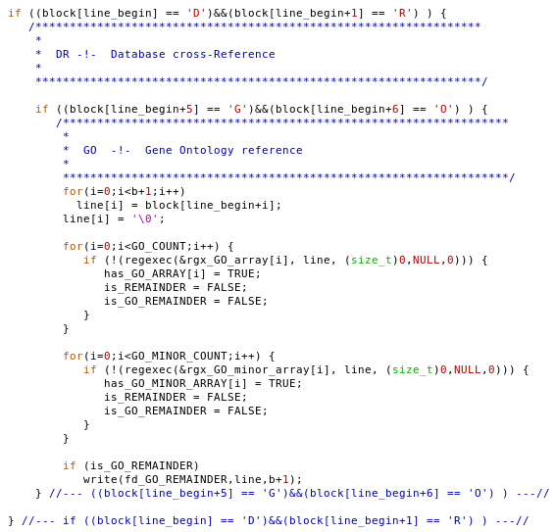Figure 40: DR Line RegEx Detection and Extraction of GO Data
As was the case for the rgx_array[], arrays were used for GO terms. Two arrays were used because rgx_GO_array[] contained more pertinent data, while rgx_GO_minor_array[] was loaded with data that was included mainly to eliminate “remainder” records. The particulars of these data will be discussed in Chapter 6.

End of Record Tabulation and Partitioning

When the protein record terminus “//” is encountered, it is time for tabulation and resetting all the various flags. Figure 5-14 below shows that tot_proteins is incremented,
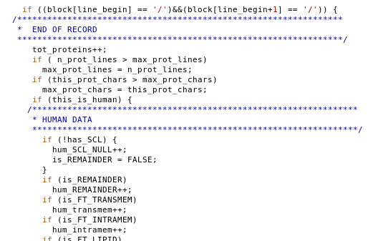Figure 41: End of Record Detection and Human Tabulation
and maximum values are checked for resetting. A major operation is checking the this_is_human flag and incrementing the numerous human tabulator variables based on
flags being set. Figure 5-15 below shows the subsequent code, which tabulates human membrane, cytoplasmic, extracellular, and nuclear proteins based on an analysis of possible codes available in the data. Indexing const int variables were used to index into GO and RegEx arrays, such as CYTOSOL_INDEX. Outside the human detection if statement,

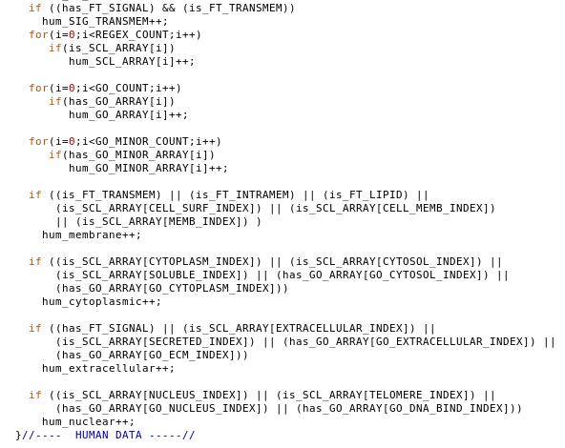Figure 42: Partitioning of Human Data From Boolean Flags
a similar processing was performed, with variables having a prefix “tot” instead of “hum.” Additionally however, total brain and muscle proteins were included for final analysis. Hence tabulators for each of the four compartments focusing on brain and muscle were added, and were tabulated using associated boolean flags sensitive to the strings “TISSUE=brain” or “TISSUE=muscle.” The code that accomplished this is seen in Figure 5-16.
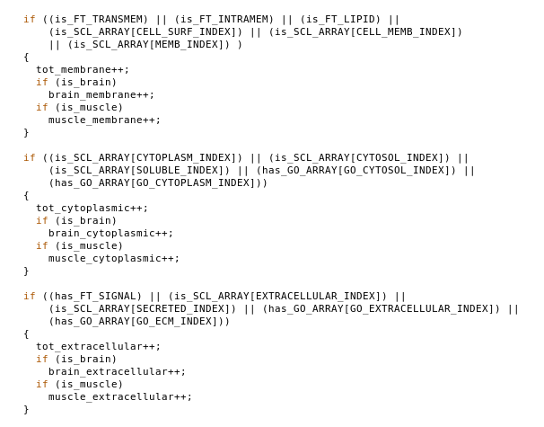Figure 43: Tabulation of Total Proteins Including Brain and Muscle Portions
Finally, following Ahram et al [1], the proteins containing a signal peptide were subtracted from the total membrane proteins as seen in Figure 5-17 below.
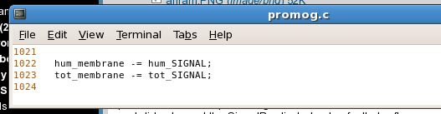Figure 44: Removal of Signal Peptide False Positives From TMP Tabulator

Cellgram.c - Visualization of Results With Biological Meaning

For the simplest possible presentation of results, while at the same time maximizing the amount of biological meaning, the cellgram module was devised using the cairo graphics library. The technique devised here was inspired by work similar to the Schneider Lab (http://www.ccrnp.ncifcrf.gov/~toms/patent/walker/) that depicts DNA sequences with letter height proportional to relative abundance. In this case, letter height corresponds to proportional gene product census, that is, the number of unique proteins that are appropriately categorized according to the four compartment model, i.e. nuclear, soluble (cytosolic), extracellular (ECM and secreted), or TMP (membrane). Note that this study does not take into account any assessment of actual copy number of individual protein gene products. As was discussed earlier, high copy numbers for soluble proteins have contributed to the inappropriate weighting of non-TMP proteins' importance.

Interoperability of ProMog.c and Cellgram.c Components

Although the two modules built for this project were saved in separate files, utilization of the basic C/UNIX utility, make, allowed function calls between modules. The code in ProMog.c that calls the Cellgram functionality is seen in Figure 5-18 below.
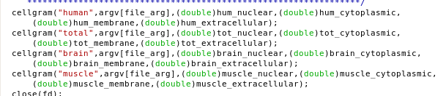Figure 45: Calling Cellgram From ProMog.c

Initialization of Cairo Surface and Header

In order to develop a Cairo graphical image, a necessary prerequisite is the creation of a Cairo surface. The code that accomplishes this is seen in Figure 5-19 below. Creation of aCairo surface requires the declaration of a variable of type cairo_surface_t * and loading the variable with the structure returned by the Cairo library function cairo_image_surface_create() with desired parameters defining the size and format. It also requires the declaration of a second variable of type cairo_t * and loading the return of the library function cairo_create().
Also seen in Figure 5-19 is the utilization of the Cairo library functions cairo_rectangle(), cairo_set_source_rgb(), and cairo_fill(). The first library function, cairo_rectangle(), defines the fact that the entire rectangle of the background is to be filled.
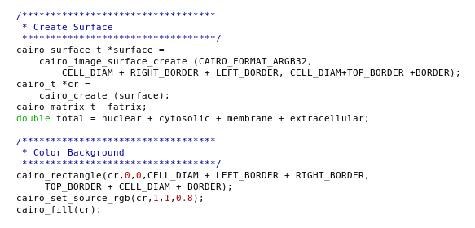Figure 46: Creation of Cairo Surface and Coloring of Background

The second, cairo_set_source_rgb(), defines the parameters for the choice of color, using “rgb” values. “Rgb” stands for red, green, and blue, which are the primary colors of filtered light. The library function cairo_fill() implements the desired fill. Finally, Figure 5-19 shows the declaration and calculation of the value for a variable called “total,” which will serve to determine the height of the words “membrane,” “soluble,” “nuclear,” and “extracellular,” based on proportional relationships to each other as fractions of this calculated total.
Code allowing for the generation of multiple images potentially residing in the same directory is shown in Figure 5-20. The image created by Cellgram.c's Cairo library calls will
receive timestamps printed in a header region that will also contain a major title and the input filename. Naming of the output png image will also receive timestamp information. To accomplish this, a number of variables were created for dealing with time data, including year, month, day, hour and minute. Since runtime of the ProMog.c module exceeds one minute for expected file loads, this will be sufficient to define a unique identifier based on timestamp.
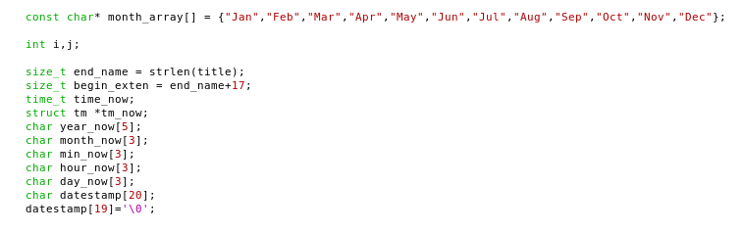Figure 47: Variables Needed to Implement Timestamp Collection

Collection of timestamps in C requires utilizing variables of type time_t, which was named time_now, and a pointer to struct tm, which was called tm_now, whose declarations are also seen in Figure 5-20. Figure 5-21 below shows how the time_now and tm_now variables are utilized to gather current time data, and then how this data is loaded into the char array datestamp[] for use in creating the timestamp on the image. Note that the way the year and month are coded require some adjustments, the year beginning with 0 year implying 1900 and 0 month implying January. The day was not encoded with a 0 based array.
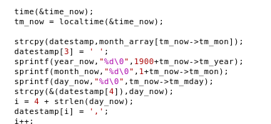Figure 48: Collecting and Formatting Timestamp for Output Image File
Writing text on a Cairo surface is a major part of the Cellgram.c module. A key element in controlling the dimensions of text written to a Cairo surface is the variable struct type cairo_text_extents_t. In Figure 5-22 below, it can be seen that three such structs are declared, namely tx_title, tx_datestamp, and tx_infile_hdr. Library functions cairo_set_font_size() determines the font size, and cairo_text_extents() obtains a loaded cairo_text_extents_t struct. Key members of a cairo_text_extents_t struct are x_advance and y_advance which hold the width and height of the planned text respectively. Figure 5-22 below shows how these struct member variables are used to adjust the look of the header using cairo_move_to(). Finally, a call to cairo_show_text() is required to complete the implementation of the text drawing procedure.
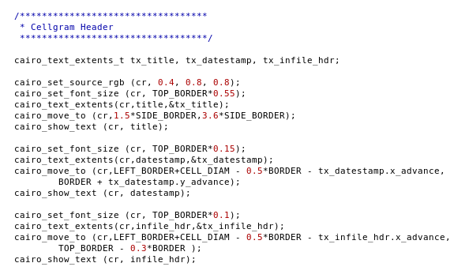Figure 49: Using Cairo Graphics Functions to Construct the Header

Drawing a Cellgram.c Cell

A crucial part of the Cellgram.c diagram is the cell membrane, which will be sized to be proportional to (membrane + soluble + nuclear)/total. To draw a line in Cairo Graphics the first library function necessary is cairo_new_path() which accepts a pointer to the cairo_t variable cr. In a similar fashion to positioning the words on the Cairo surface, cairo_move_to() is again used. New functions necessary to draw the “plasma membrane” include cairo_line_to() and cairo_curve_to(). Comments highlight which code draws top, bottom and left and right sides of the cell membrane. Variable constants are used for the parameters, such as BORDER, and TOP_BORDER. Figure 5-23 shows the implementation of
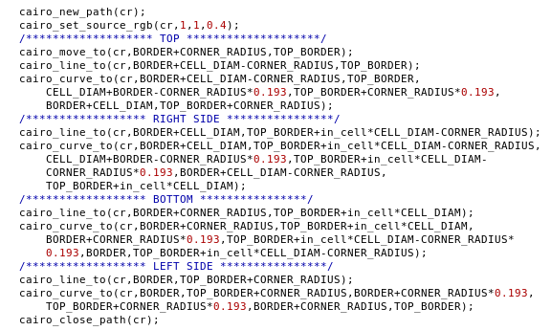Figure 50: Drawing the Plasma Membrane with Cairo Graphics
this procedure. Also shown in Figure 5-23 is the call to cairo_close_path() which is necessary to compose the complete oval figure that will represent the plasma membrane.
The code so far from 5-23 only defines the shape of the cell, but has not actually drawn any of it according to the desired parameters. Figure 5-24 below shows the code that completes drawing the cell. The library function cairo_set_source_rgba() takes the surface pointer cr and four numerical arguments corresponding to red, green, and blue color intensities and an alpha parameter that pertains to transparency. The website http://www.web-source.net/216_color_chart.htm is one good source for translating rgb codes into color, but the Cairo graphics accepts a parameter from 0 to 1, while the codes website uses hexadecimal values so it is required to divide the website values by 256 to obtain the proper fraction.
Cairo Graphics provides some biolerplate code including the rounded rectangle utilized, but adapted for Cellgram.c In Figure 5-24, the first cairo_set_source_rgba() call sets the brush color to what would be denoted on the color codes website as R=102, B=255, G=204 which is the aquamarine color chosen for the inside of the cell. This brush is then used for cairo_fill_preserve() which is used instead of cairo_fill() to avoid losing the shape of the cell, which is needed to subsequently draw the plasma membrane. Another call to cairo_set_source_rgba() sets the color to R=255, G=255, B=102 which is a yellow color for the cell membrane. The function cairo_set_line_width() determines the heaviness of the line, and finally cairo_stroke() actually draws the plasma membrane.
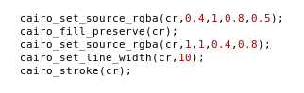Figure 51: Coloring Inside of Cell and Cell Membrane with Cairo Graphics
To aid visualization of percentages, code was added to render faint hash marks that were designed to be similar to the markings on a ruler. Figure 5-25 below shows the beginning of the loop that implements the drawing of these lines. Varying widths of the lines with the library function cairo_set_line_width() allowed for simulation of the "ruler effect." The loop counter i was used to help calculate the position of the lines by iterating 1 to 10 and then the
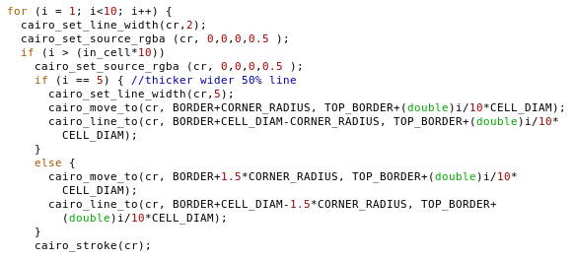Figure 52: Loop Initialization to Draw Hash Marks

value was divided by 10 to get decimal fractions of the CELL_DIAM and an if statement caught the 50% line when i==5 and made that line width 5. Figure 5-26 below shows code that
implemented rendering of minor hash marks. Different line lengths, from BORDER + 3*CORNER_RADIUS to BORDER + CELL_DIAM – 3*CORNER_RADIUS for lines at 2.5%, 7.5%, 12.5%, 17.5% etc. and from BORDER + 2*CORNER_RADIUS to BORDER +
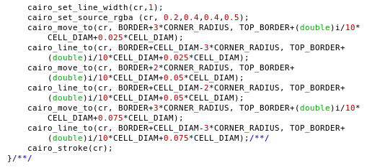Figure 53: Cairo Code to Draw Minor Hash Marks
CELL_DIAM – 2*CORNER_RADIUS for 5%, 15%, 25%, 35%, etc.

Sizing Words Using Wolfram Curve Fitting

A difficulty encountered when attempting to resize the words according their prevalence in the proteome was to render the word so that its width would remain constant with a variable height in order to fit inside the cellgram properly. As will be discussed in the next two sections of this chapter, Cairo Graphics had a facility to accomplish this using a library function called cairo_scale(). However, the problem remained concerning what scaling factors would be used. The solution to this proved to be the most complicated problem of the entire project.
Figure 5-27 shows an early example of part of a Cellgram that had a poorly scaled rendering of the word “NUcleAR.” The natural rendering of text that is sized vertically to fit
larger percentages is going to increase in a proportional way horizontally, which will
Figure 54: Example of Incorrectly Scaled Cellgram
exceed the horizontal bounds of the Cellgram as can be seen in Figure 5-27. The solution therefore, was to determine a scaling factor that will “squish” the word appropriately. The proper amount to “squish,” varied according to the scaling needs. A solution was found by utilizing an online mathematical service at the website http://www.wolframalpha.com/.
To accomplish this, a second order exponential curve fit solving three variables with three equations was derived using the Wolfram Alpha website solve functionality (wolfram.org). The general form of the equations devised were:

Ҽ (A2z + Ax + y) = squish ratio
where A is data taken from the x_advance of the word to be parametrized as will be discussed in detail while examining the actual code for specific examples. The first word that was treated in this way was “nuclear,” and empirically, it was determined that when the word height was such that the width was 200 pixels that no “squish” would be required so the “squish ratio” should be 1. Substituting 200 for A in the equation above gives:

Ҽ (40,000z + 200x + y) = 1
The program was adjusted to determine an upper bound, when nuclear proteins constituted 100% of some hypothetical dataset. It was determined that the natural width of the word “NUcleAR” in this case was 6927 pixels which would require it to be “squished” by 0.13 to fit inside the Cellgram. Using 69272 = 47,983,329, a second equation was derived to be:

Ҽ (47,983,329z + 6927x + y) = 0.13
It was found that solving a first order exponential for two variables was insufficient to cause all intermediate values to conform, so that a third equation was derived from the fact that a width of 4400 required a squish ratio of 0.18 so that the final equation was:
Ҽ (19,360,000z + 4400x + y) = 0.18
Having three equations with three unknowns allowed the use of the Wolfram website to find values for x, y, and z. Inputting in:
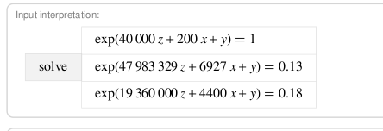Figure 55: Equations Input to Wolfram to be Solved
With this input, the Wolfram website produced this output:
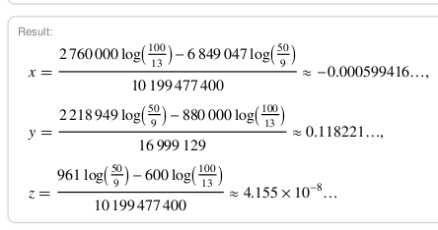Figure 56: Wolfram Output of Solved Equation
Figure 5-30 shows a spreadsheet created to verify that the coefficients would
correctly scale all possible values of the text width throughout the expected domain. The

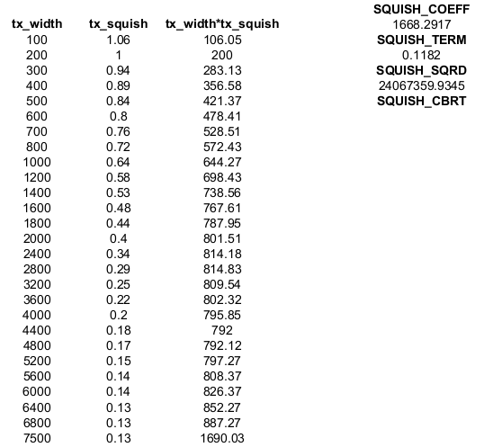Figure 57: Spreadsheet to Verify Correctness Throughout Domain
reciprocal was taken of x – yeilding the “SQUISH_COEFF” to facilitate programming, avoiding tiny fractions opting for large numbers that would be re-inverted on use. Similarly 1/z yielded “SQUISH_SQRD.” From inspection of the spreadsheet table, it can be seen how the constraint point behaved. With tx_width = 200, tx_squish is 1, as demanded by the curve fit. Likewise, at tx_width = 4400, tx_squish is 0.18, and at both tx_width = 6800 and tx_width = 7500, which is expected to be outside the range, tx_squish is 0.13, so it can be reasonably inferred that the curve fit at tx_width = 6927 the constraints will also be met.
Finally, Figure 5-31 shows code that initializes these constants as well as similarly constructed constants for soluble, membrane, and extracellular proteins. The original naming convention of SQUISH_SQRD was shortened to a prefix SQ_SQRD, SQUISH_COEFF to SQ_COEFF, and SQUISH_TERM to SQ_TERM with clearly understandable suffixes appended for all necessary variables. Each different word to be rendered had its own unique constraints (data not shown).
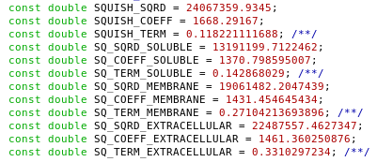Figure 58: Text Scaling Constants

Utilizing Scaling Constants to Render the Nucleus

With the scaling constants defined, it became possible to implement the text rendering utilizing cairo_text_extents_t type variables to assess the natural width of text that was sized to the desired height. It was found that a font size of 1250*(nuclear/total) – 2*NUCLEUS_BUF achieved the desired text effect. Figure 5-32 below shows the declaration of the variables needed to fully define how the rendering of “NUcleAR” would be controlled. To achieve the desired “enveloping” effect of “NUcleAR,” a capital “L” was actually used with a different
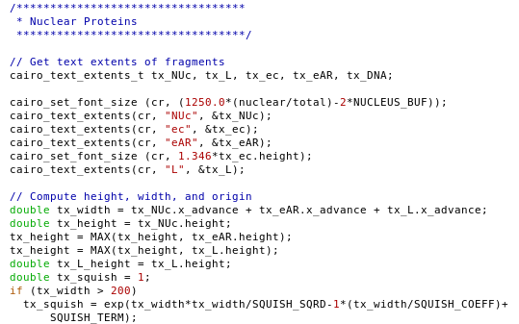Figure 59: Preparation of Nuclear Text Rendering Parameters
font size so that it would size at the same height as the lower case “e” and “c.” The total of all the desired letters' x_advance member variables were summed into the variable tx_width, and as can be seen in the if statement at the bottom of Figure 5-32 was used to calculate the variable tx_squish. Before entering the if statement tx_squish was set to 1 because for tx_width <= 200 a scaling ratio of 1 was appropriate.
Because the rendering of “NUcleAR” was intended to remain within the confines of a nuclear envelope, the rendering of which will be discussed below, it was found necessary to stringently control the sizing of the text extents. As seen in Figure 5-33 below, extensive adjustments were made based on values of the variable “nt_r” which is one of four variables that simplified these calculations. The variables, “nt_r,” “ct_r,” “mt_r,” and “et_r” were set equal to the ratios nuclear/total, cytosolic/total, membrane/total, and extracellular/total respectively. As explained in the comment in Figure 5-33, two variables txo_x and txo_y were
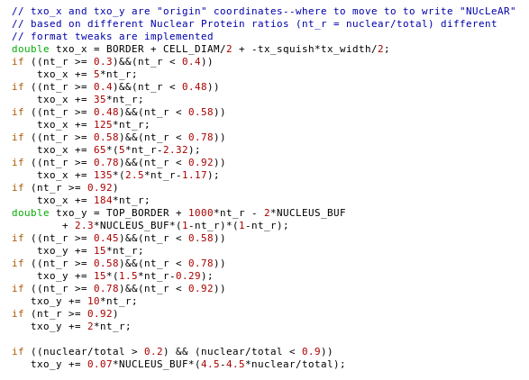Figure 60: Empirical Control of Location of Nuclear Text Origin
adjusted based on small ranges of the nt_r ratio to adjust the placement of the word “NUcleAR.”
Figure 5-34 below shows the compilation and adjustments performed for rendering the text “DNA” that was to be located “enveloped” inside the text “NUcleAR” (which is the reason for the way “NUcleAR” is written partially in lower and partially in upper case). The variable convention prefix “txo_” is maintained for positioning, and a convention “txsq_” is introduced for text scaling. Thus the variable “txsq_DNA” performs the equivalent task for the rendering of “DNA” as the variable “tx_squish” does for “NUcleAR.” For adjustments to positioning variables, the adjustments became more intricate, but are purely empirical. The code was run,
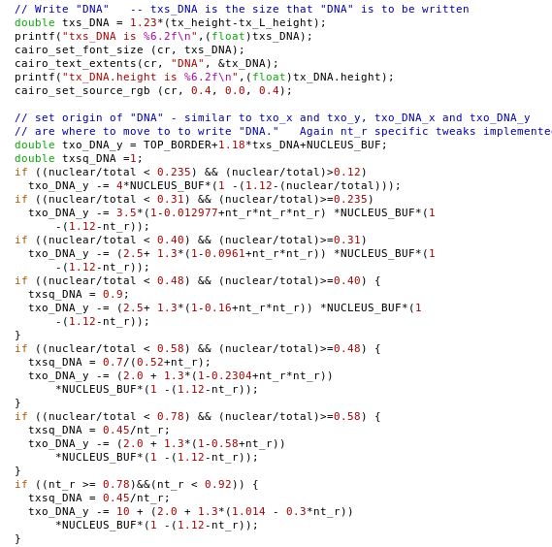Figure 61: Empirical Adjustments to Origin and Scaling of "DNA" Text

and viewing the results, the parameters were changed, and the program was recompiled, and run again. This process was repeated iteratively until the results were satisfactory. As will be discussed in Chapter 7, a future improvement suggested is the employment of the Pango library (www.pango.org/) for the proper positioning of text.
Once all the minute adjustments were complete, then the rendering of the text could be completed, based on the correct adjustments. Figure 5-35 shows the use of the
variables txo_DNA_x and txo_DNA_y supplied as arguments to the cairo_move_to() library function, to properly position the “DNA” text. The second statement shown utilizes txsq_DNA as an argument to the cairo_scale() library function which implements a multiplicative adjustment to the size of the planned lettering. Since txsq_DNA is intended to adjust the horizontal extent, and the vertical extent was empirically normalized by the choice of parameters that was utilized in the call to cairo_set_font_size seen in Figure 5-34 on page 76 which for DNA was calculated using the variable txs_DNA, the third argument for cairo_scale() was set to 1, indicating no vertical adjustment. This was the general form of all calls to cairo_scale() as all vertical extents were assumed normalized a priori.
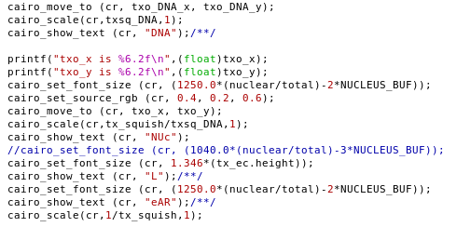Figure 62: Rendering of Nuclear Text Elements
Subsequent code in Figure 5-35 shows utilization of cairo_set_font_size(), cairo_move_to(), and cairo_scale() to determine the parameterization of the extents for rendering “NUcleAR.” For the desired text effect, after rendering the text “DNA,” the letters “NUc” are rendendered with one call to the cairo_show_text() method, and then a capital 'L' is rendered with a cairo_set_font_size() adjustment, because a lower case 'l' would have been tall and overwritten parts of the “DNA” rendering. In order to properly size the “NUc” and subsequent “NUcleAR” text rendering portions, the fact that tx_squish and txsq_DNA are used in a call to cairo_scale(), and a salient point in this implementation is seen by supplying the argument tx_squish/txsq_DNA, since the reciprocal of the parameter un-does the previous scaling. In subsequent code it can be seen that the code cairo_scale(cr,1/tx_squish,1) un-does scaling implemented with the tx_squish variable for future scaling. Although this methodology requires more calls to cairo_scale(), it was felt to be more understandable and robust code, the undoing of the scaling enveloping the code where the scaling is relevant.
Figure 5-36 below shows the initialization of the ratio variables, such as nt_r which was seen utilized in Figures 5-33 on page 75 and 5-34 on page 76, as well as a variable “in_cell,” which is used to determine the size of the plasma membrane rendering, and finally another set of variables of type char, nt_r_string[], ct_r_string[], mt_r_string[], and
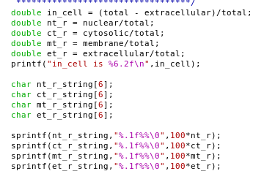Figure 63: Initialization of Ratios and Percentage Strings
et_r_string[], which can be seen by the utilization of sprintf in subsequent code to be percentage equivalents with three significant digits for percentages between 10.0% and 99.9%, of the ratio variables written to a string, formatted as a percentage (e.g. 34.3%). Figure 5-37 shows code that used these string converted percentage variables to report
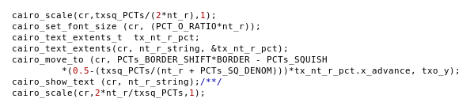Figure 64: Rendering Nuclear Protein Percentage Value
the appropriate percentages in the left margin of the Cellgram. Although the height of the letters was desired to give a feel for the biological function, both author and adviser agreed that the supplemental rendering of the percentages was necessary to achieve adequate accuracy in the reporting of the data. The constants PCTs_BORDER_SHIFT, PCTs_SQUISH, and PCTs_SQ_DENOM avoided additional calculation as was seen in the adjustment of the major text for the Cellgram. The convention of bracketing with cairo_scale() and its reciprocal reversal is seen again in this code.
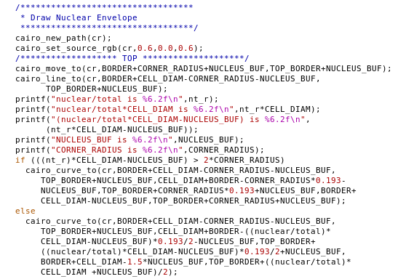Figure 65: Rendering of the Nuclear Envelope – Initialization
Figure 5-38 above shows the code to illustrate the nature of what it is to be a “NUcleAR” protein, the text “DNA” and “NUcleAR.” Figure 5-38 shows the code to render the two tems inside “nuclear envelope” that is itself inside the cell. Unlike what was the case for rendering the plasma membrane, an if statement was needed because if the percentage of nuclear proteins (nt_r) multiplied by the cell border parameters is smaller than twice the CORNER_RADIUS, a fishtail effect occurs, as seen in Figure 5-39. Otherwise, no modifications are necessary to allow the nuclear envelope to be drawn without abnormal looking glitches. Trials with rendering the nuclear envelope without this conditional yielded this rather abnormal fishtail effect behavior. Figure 5-39 shows an
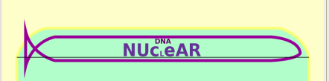Figure 66: Fishtail Effect of Low Nuclear Protein Cellgram Renderings
example of an experimental Cellgram output image that had implemented partial adjustment for a low nt_r ratio on the right side, but had no such adjustment on the left, leading to the fishtail. Figure 5-40 below shows the completion of the nuclear envelope, with the comment showing that the code pertains to the left side of the envelope. Code for the right side and bottom of the nuclear envelope is similar, but only included in the complete code listings.
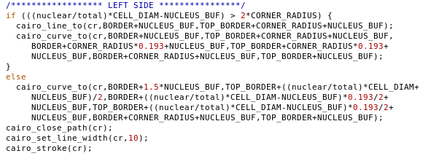Figure 67: Rendering of the Nuclear Envelope – Completion

Completion of Cellgram Rendering
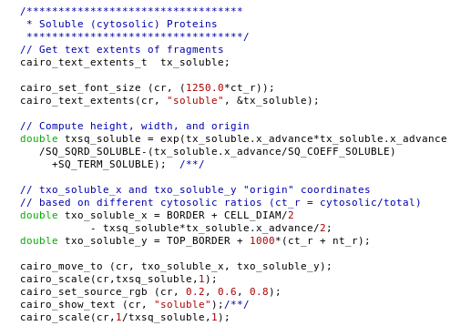Figure 68: Rendering of Soluble (cytosolic) Proteins
Figure 5-41 shows code utilized to render the word “soluble.” Since it was rendered outside the nuclear envelope, and is a small word, no empirical adjustments proved necessary. A review of Figure 5-31 on page 73 will illuminate the utilization of SQ_SRD_SOLUBLE, SQ_COEFF_SOLUBLE, and SQ_TERM_SOLUBLE used here to calculate txsq_soluble. To set the color here, the library function cairo_set_source_rgb() was used that requires no alpha value. The parameters supplied are the equivalent of R=51, G=153, B=204, which is a light blue color chosen to reflect the aqueous (water) solubility dominant in the cytosol. Again the choice to reverse the scaling with the reciprocal of txsq_soluble was chosen here for clarity.
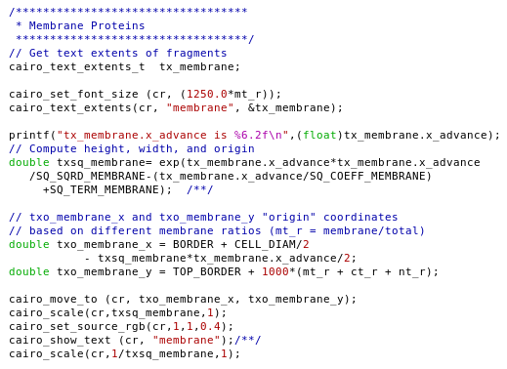Figure 69: Rendering of Membrane (TMP) Proteins
Figure 5-42 above shows the similar code to render the word membrane, designating TMP proteins. Again refer to Figure 5-31 on page 73 for values of the scaling coefficents.
Although extracellular is a rather long word, its rendering also proved to be less than complicated. Of course, the scaling parameters were adjusted accordingly, with a different maximal value for x_advance. The fact that extracellular proteins are outside the plasma membrane facilitated the rendering, as this constraint was removed. Figure below shows the code for the rendering of extracellular.
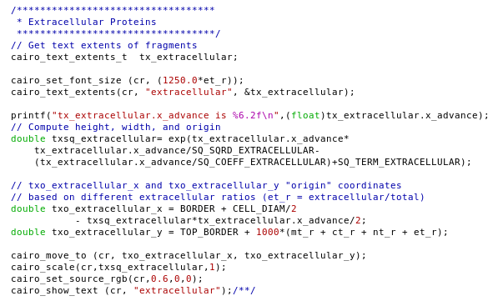Figure 70: Rendering of Extracellular Proteins

Chapter Summary

This project is encompassed by two modules, 1) ProMog.c “Proteomic DeMographics,” which extracts pertinent data from UniProt type format data files to segregate proteins into the four compartment model, and 2) Cellgram.c which produces a png graphical file that is representative of actual biological reality, albeit grossly simplified.
ProMog.c extracts data from UniProt files such as the uniprot_sprot.dat manually annotated file that contains a list of protein records that are defined by a list of informational lines of various types. The type of a line is determined by a fixed format two character identifier that is referred to as the “name” of this type of line, such as “ID line” for a line that begins with “ID.” Each protein record is initiated by this type, the ID (indentification) line which contains Entry name, Swiss-Prot names. TrEMBL entry names, and length of sequence, and always occurs on the first line. The final line of every protein record is a line that contains only “//.” The types of lines that were used to extract data were the FT, DR, and CC lines. The simplest type of data extraction was via the FT (Feature Table) line, which has fixed format key names that indicate peptide subsequence “features.” Precompiled C language RegEx was used for the extraction of data from CC (comment block) and DR (Database cross-Reference) lines. DR lines contained Gene Ontology (GO) 7 digit codes that required simple RegEx detection, while data extracted from CC lines was only from SCL comment blocks that had data across multiple lines. Therefore, this type of CC line SCL data extraction required the use of an additional boolean flag in_SCL that was deactivated by detection of a non-SCL comment block or the UniProt Consortium copyright block. Boolean flags collected data of all these types, and upon detection of the terminator “//” line, the flags activated the increment of tabulators and then everything necessary was reset to prepare for processing the next protein.
Utilization of the make utility allowed interoperability of the ProMog.c module with the Cellgram.c module. The Cellgram.c module utilized the Cairo 2D Graphics library to produce png files representative of the data passed to it by ProMog.c This data included the input file and the amounts of proteins in the four compartment model. The CellGram.c module included a timestamp that was both rendered in a header on the graphic, and utilized to make a unique filename for the graphic file. Cairo facilities include filling, drawing lines and curves, and rendering text according to specified extents. In order to achieve the desired effect, of the “NUcleAR” proteins residing in a nuclear envelope which is inside the cell membrane, and this containing “DNA.” To achieve this, text size was manipulated using the Cairo library function cairo_scale() to distort the text so that it could have a height proportional to the protein fraction as desired, but at the same time stay within horizontal bounds of the plasma membrane. In order to determine the value needed for variables such as tx_squish which controlled the horizontal extent of “NUcleAR,” an online mathematical equation solving resource called Wolfram Alpha was used. Best results were achieved by defining three anchor points, one with a small text size desired, one with the maximal size, and a third somewhere in the middle of the range. These three anchor points were used to construct a system of three equations with three unknowns using an exponential function. The solutions to the respective systems were then loaded in to constants to determine scaling factors.
The next chapter discusses the results of running the combined ProMog.c/Cellgram.c modular system on both the manually annotated UniProtKB/Swiss-Prot flatfile and the much larger UniProtKB/TrEMBL data file. Graphical images were generated for human, total, brain, and muscle proteins. Additionally, raw data output to the command line with full report of all tabulations utilized will be discussed.

EXPERIMENTAL RESULTS

This chapter will report results in three sections: 6.1 examines the changing datasets offered by the UniProt Consortium, 6.2 presents a comparison of Cellgram output, and 6.3 presents detailed data output by ProMog to the command line.

The Changing Face of UniProt

The current most recent release of a UniProt database was May 3, 2011. Data from medical laboratories all over the world is constantly being contributed to UniProt and other online resources. Figure 6-1 shows what their website looks like today.
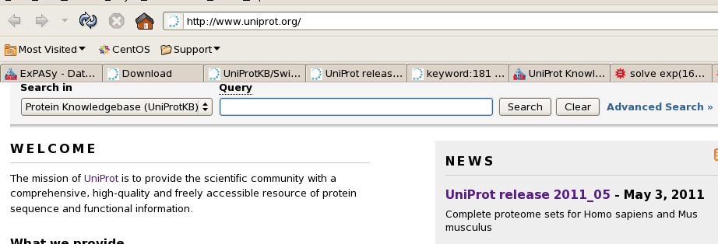Figure 71: UniProt Front Page as of May 2011
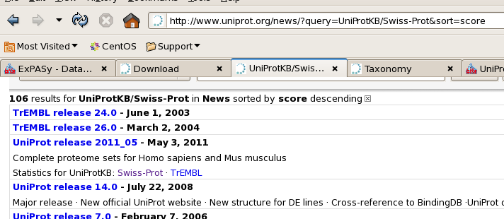Figure 72: UniProt/TrEMBL Release Archive as of May 2011
Figure 6-2 shows a UniProt subpage that gives information on previous releases of the various databases managed by UniProt. There are various versioning systems and changes to controlled vocabulary. Such changes include SCL designations and chemical feature descriptions that include standard chemical nomenclature and amino acid abbreviation complexes. Figure 6-3 shows an example of such an SCL change.
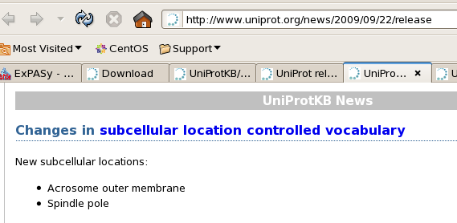Figure 73: Changes to SCL Controlled Vocabulary in September of 2009
The May 3, 2011 UniProtKB/Swiss-Prot manually annotated database (filename uniprot_sprot.dat) was saved, and the old version was moved into an archival directory. ProMog was run and its report of the count of total proteins in the database is a correctness check against the UniProt release notes provided from the website seen in Figure 6-4. The release website reports 528,048 UniProtKB/Swiss-Prot entries and the command line output from the ~/thesis/integrated directory reports 528,048 total proteins.
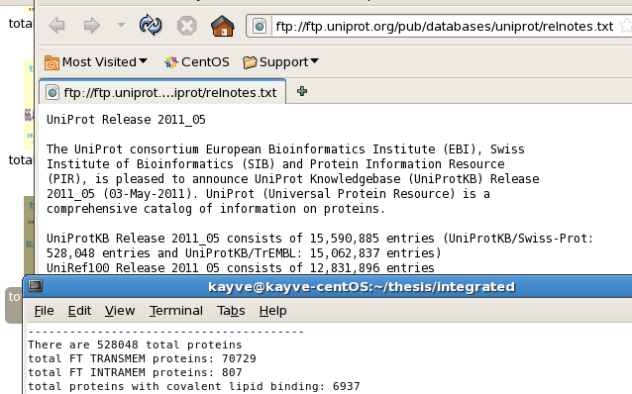Figure 74: May 2011 Release of UniProtKB/Swiss-Prot Verification of Correctness
Cellgrams were produced for both the current UniProt release and the release resident in the current local resources. The results were similar, but not identical. The Cellgrams for the total UniProtKB/Swiss-Prot database from the resident release created on March 24 and the current May 3 release created on May 4 are shown in Figures 6-5 and 6-6 on page 92 respectively.
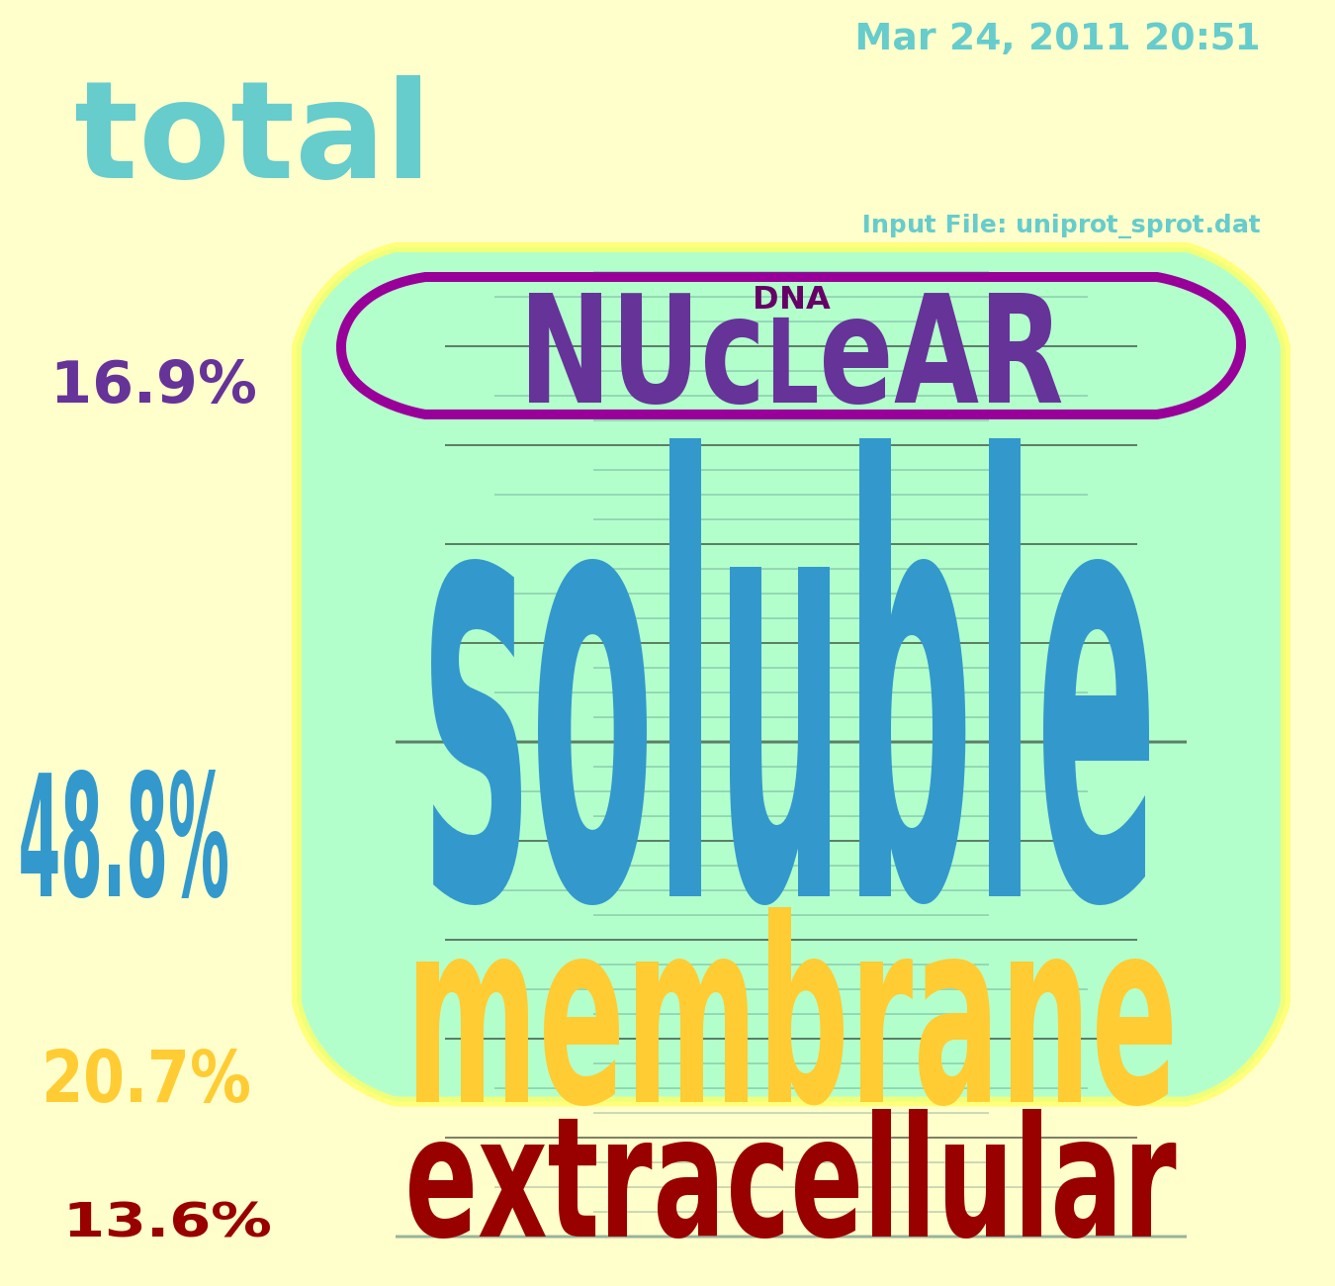Figure 75: Total UniProtKB/Swiss-Prot Cellgram for Resident Database

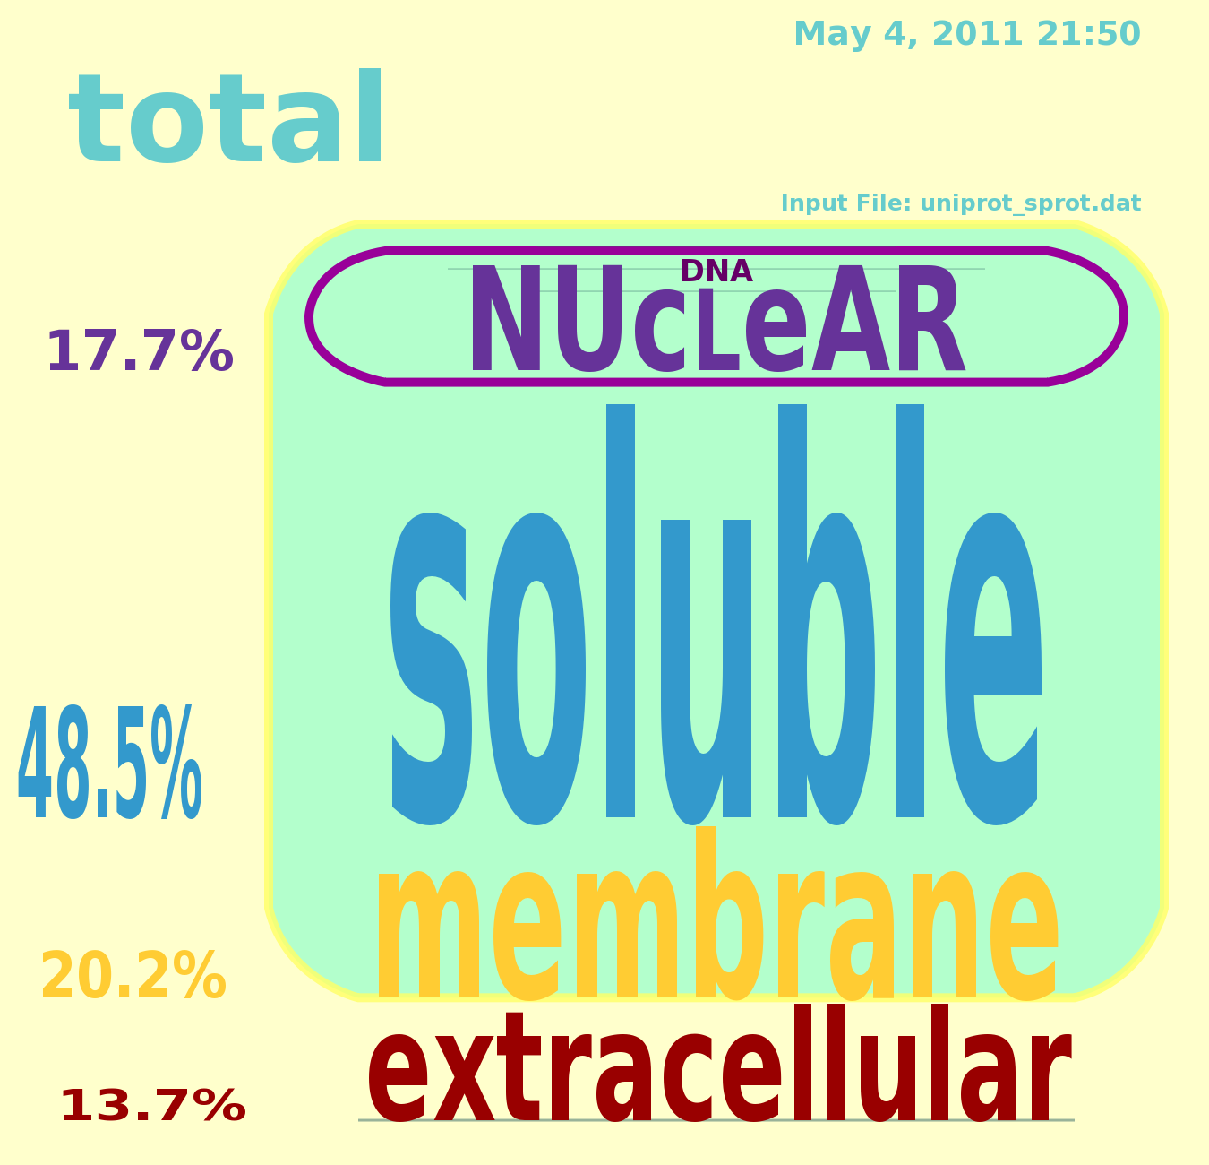Figure 76: Cellgram for UniProtKB/Swiss-Prot Release 2011_05 May 2011
UniProtKB/Swiss-Prot and UniProtKB/TrEMBL do keep a web page of statistical data, but that is not the focus of this project. It has lists of most represented species, taxonomic distribution of sequences, sequence size, length distribution of sequences, various statistics for references, total number of CC lines for each of the subcategories, but SCL CC lines are listed simply as the complete number of comments. It has cross-reference data, and total stoichiometry of amino acids in the database. Figure 6-7 shows the exponential growth of data found in the larger UniProtKB/TrEMBL knowledge base (filename uniprot_trembl.dat). Biotechnology looks to be a growth industry for some time into the future.
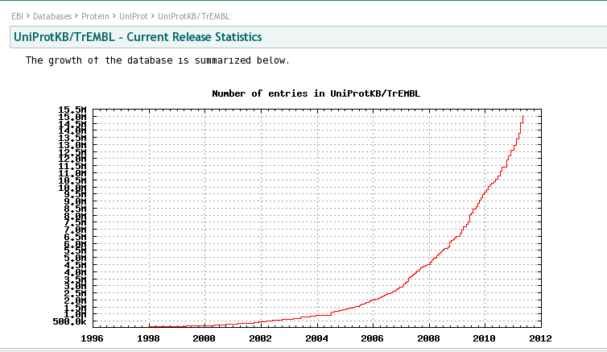Figure 77: UniProtKB/TrEMBL Release Statistics Growth of Entries

Cellgram Comparisons of Human, Muscle, and Brain

Cellgrams produced for the human proteome are distinctly different than that produced for the total UniProt data. The amount of TMPs is similar, but cytosolic (soluble) are quite significantly less, with this difference distributed roughly equally by an increase in both nuclear and extracellular proteins. Figure 6-8 shows data from the resident
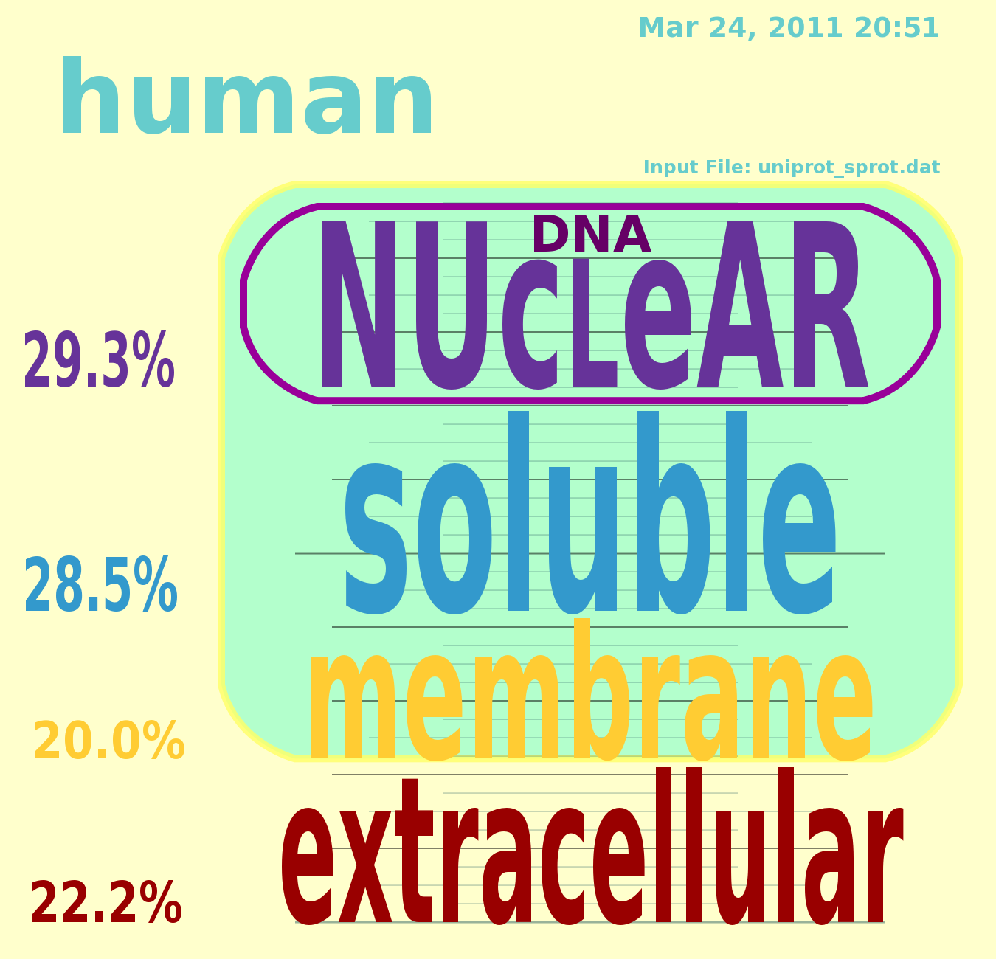Figure 78: Cellgram for Human Proteins From Resident uniprot_sprot.dat
database, while Figure 6-9 shows the equivalent Cellgram for the current release.
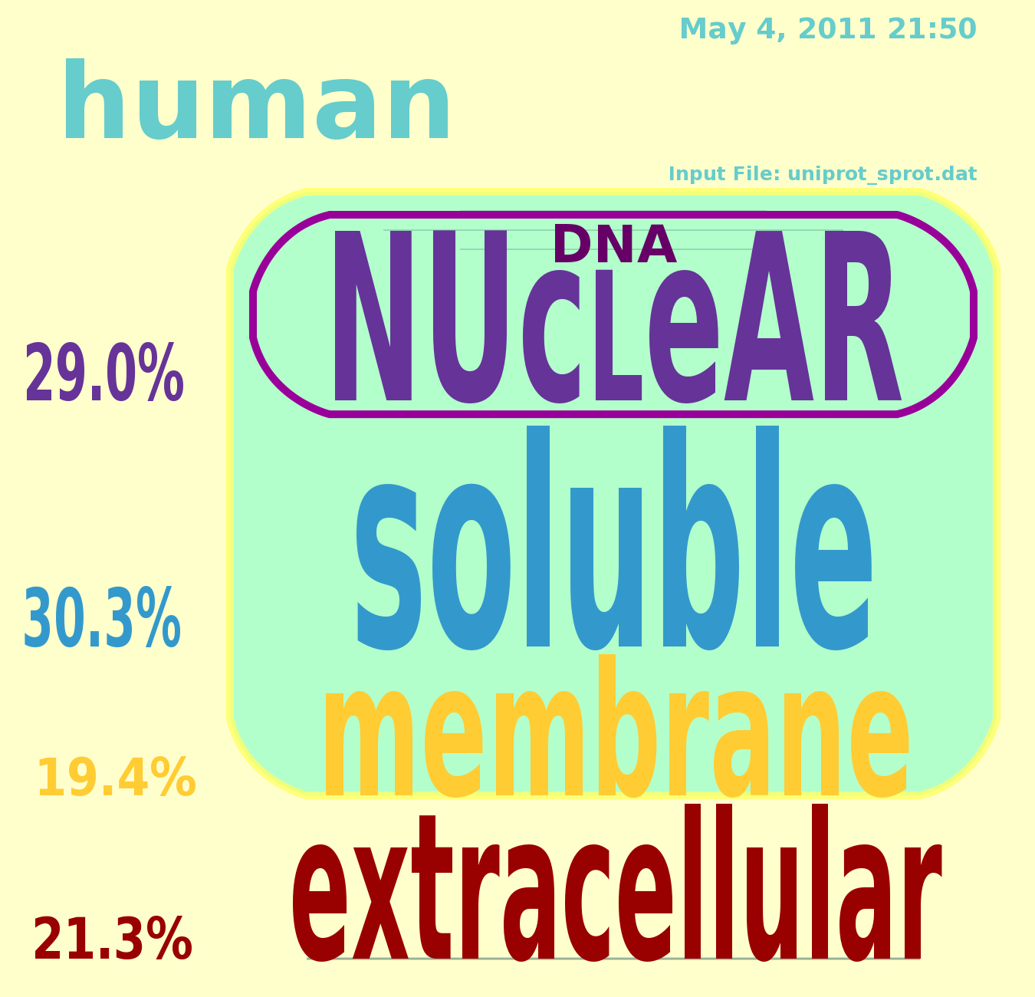Figure 79: Human Cellgram from UniProtKB/Swiss-Prot May 2011 Release
As was discussed in Sections 5.1.2 and 5.1.5, to illustrate the importance of TMPs in specific tissues where they were more functionally relevant (although they are NEVER functionally IRRELEVANT), additional RegExes were included to extract information about the muscle and brain proteome, which for the purposes of this study is the set of proteins in the database with annotation containing either the string “TISSUE=muscle” or “TISSUE=brain.” Running ProMog results in command line output, as has been mentioned, and illustrated in Figure 6-4 on page 90, and included in this output are results of all tabulations. Figure 6-10 shows the results from the May 2011 release of UniProtKB/Swiss-Prot. It can be seen that compared to the total tabulations, the amount of hits for muscle is quite low, at 833 total muscle proteins, but results for brain proteins were much better at 16,119.
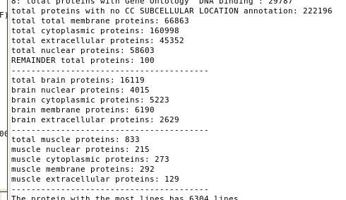Figure 80: Tabulations of Total Proteins Including Muscle and Brain Fractions
In both brain and muscle fractions, there is an increase in TMPs. This could be because they are actually expressed more prevalently in these tissues, or it could be that researchers in these fields tend to emphasize research into TMPs. All the databases are incomplete. Figure 6-11 shows the result of the muscle Cellgram.
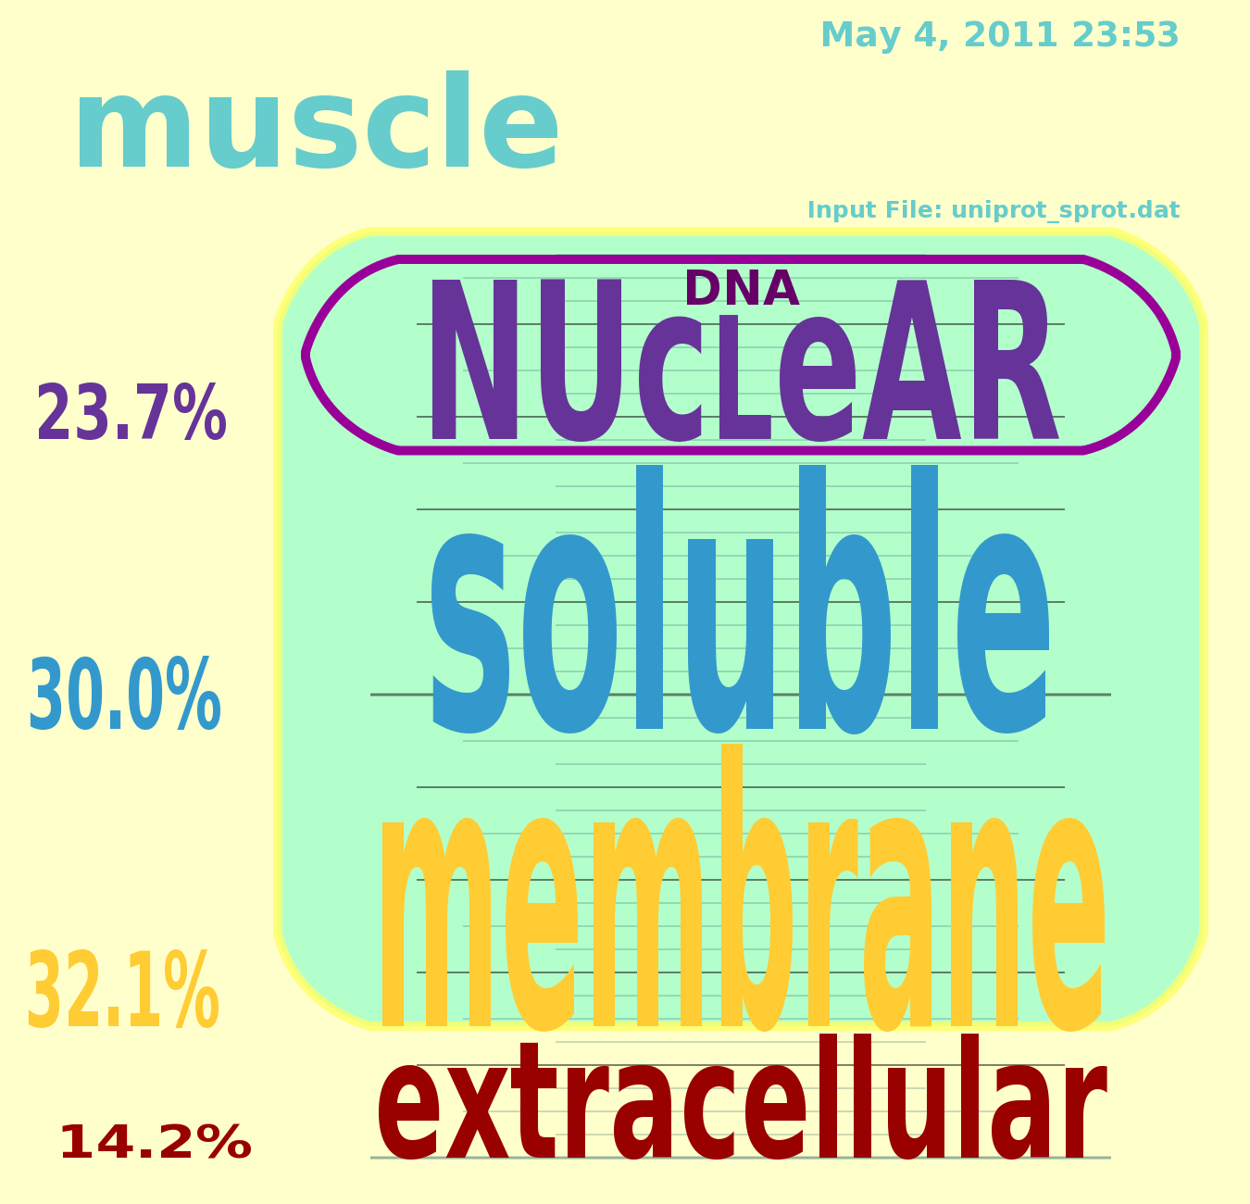Figure 81: Cellgram of Muscle Proteome From May 2011 UniProtKB/Swiss-Prot
Compared to brain, muscle TMP function is likely to be relatively rudimentary, as muscle function is dependent on one main type of neurotransmitter/receptor pair, namely the neuromuscular junction dependent on acetylcholine for activation. Meanwhile, brain function is known to be based on quite a symphony of various neurotransmitter types interacting in diverse ways to inhibit and disinhibit, activate and attenuate each other's function. Figure 6-12 bears this out, showing that this brain fraction has as yet the highest percentage of TMPs, with a whopping 34.3%.
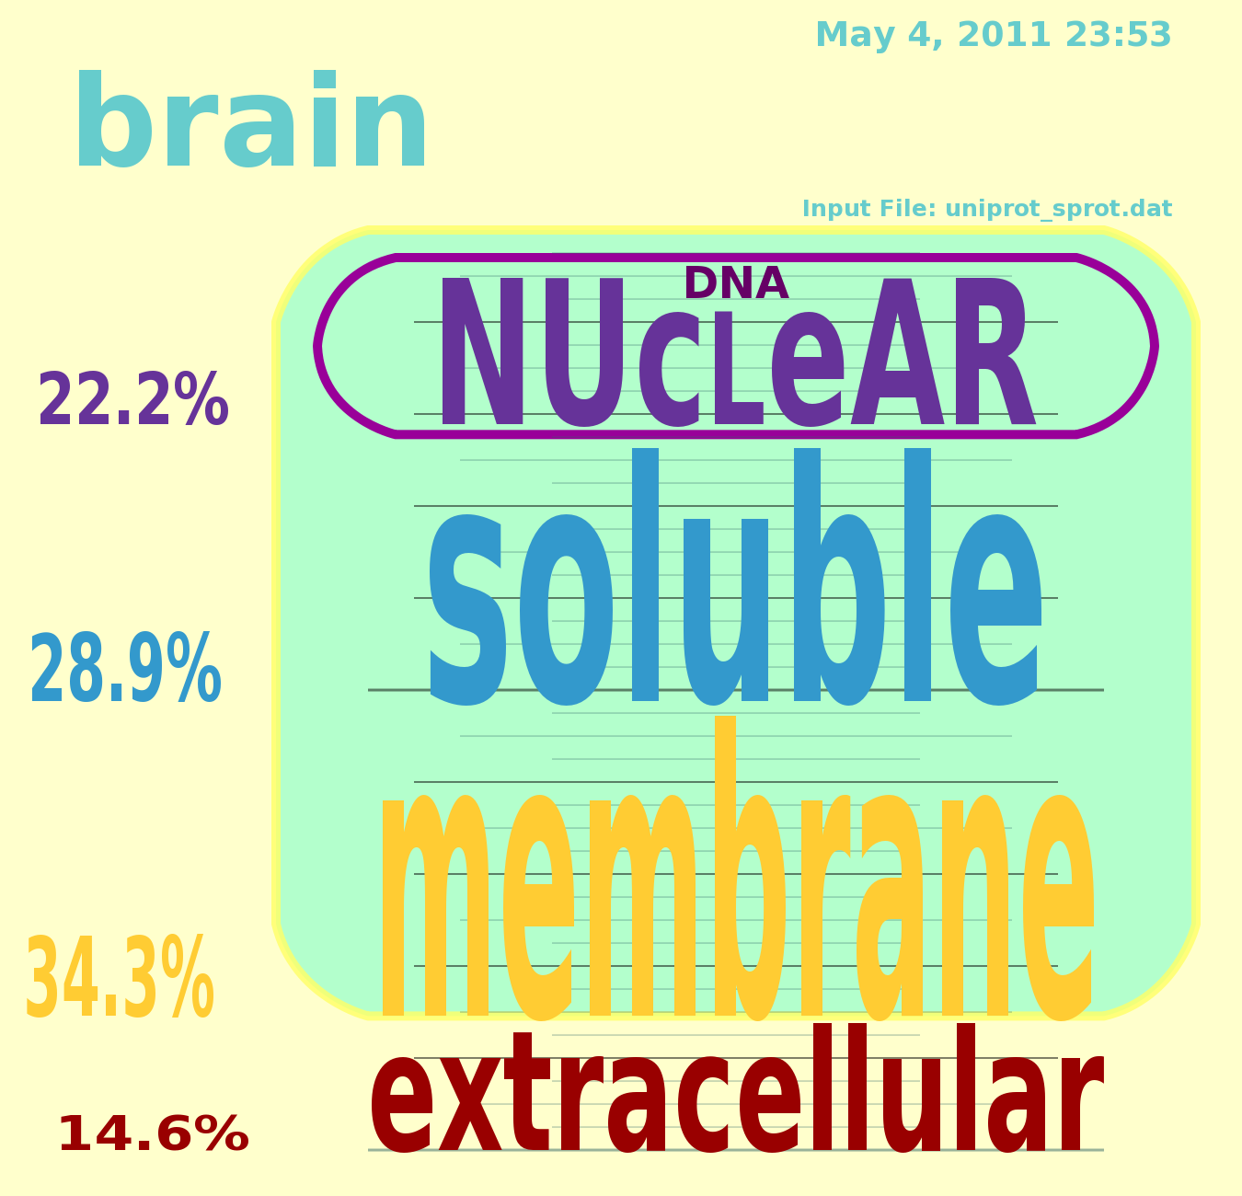Figure 82: UniProtKB/Swiss-Prot May 2011 Brain Cellgram

Command Line ProMog Output Details

In addition to outputting the Cellgram image file, ProMog also utilizes command line output to provide the detailed account of all tabulations. Figure 6-13 shows the beginning of the output from a ProMog run. This run has detected 20,239 human proteins in the file uniprot_sprot.dat. Detailed statistics about the various key names related to
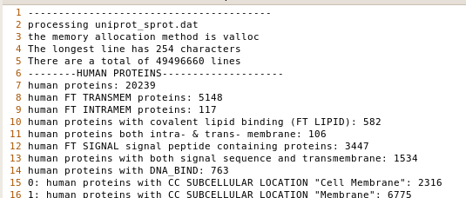Figure 83: Head of Output From ProMog Run
TMPs are also readily available. Included are reports of overlap that were accounted for in the logic of the program to count TMPs correctly. Another FT line element seen is the signal peptide key name “FT SIGNAL.” Proteins with both signal sequence and transmembrane were considered extracellular, following Ahram et al [1].
In order to minimize proteins that were not classified by any SCL designation, many key words were utilized that were not easily partitioned according to the four compartment model. Figure 6-14 shows a significant list of such tabulators. Included are soluble designated key words such as “cytoplasm” and “cytosol,” and extracellular designated keywords such as “Extracellular” and “secreted.” Many designations received no hits in the human protein set, but were seen in the total set.
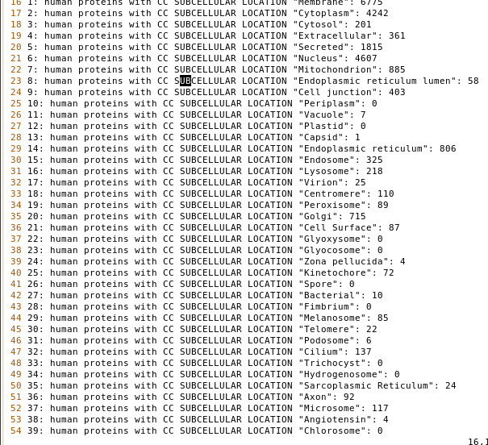Figure 84: List of Human CC Line SCL Data Tabulations
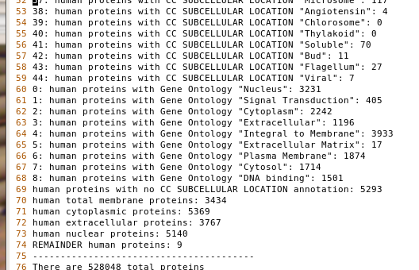Figure 85: Final Entries in Human Tabulation Report
Figure 6-15 above shows the end of the complete list of human tabulations. It is not surprising to find 0 hits for key words such as “thylakoid,” which is a plant structure, but 7 hits for “viral” and from Figure 6-14 from page 100 reporting 25 hits for “Virion” warrants investigation. A likely explanation is some inappropriate classification of a “human parasite” as a “human protein.”
The tabulations for the total proteome contained in the UniProtKB/Swiss-Prot dataset contained fewer “null hits,” such as can be seen in Figure 6-16 below where “Glycosome” reported 0 instances. The total report is identical to the human segment of the report with exception of the word “total,” and of course the tabulator results.

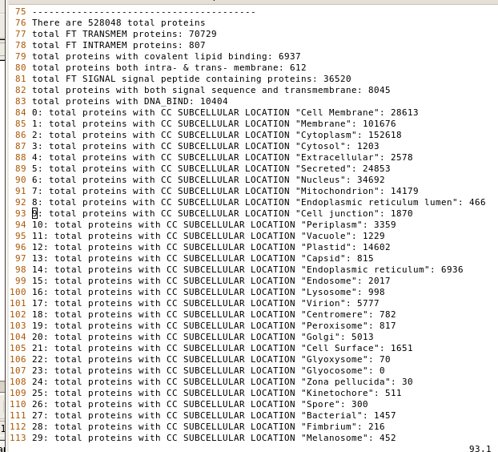Figure 86: Total UniProtKB/Swiss-Prot Command Line Tabulations Report
An iterative process was employed to minimize the “remainder” set of proteins. After the initial obvious key words were implemented, a report was made of proteins not flagged with all key words in the current set that had been accumulated, and from this
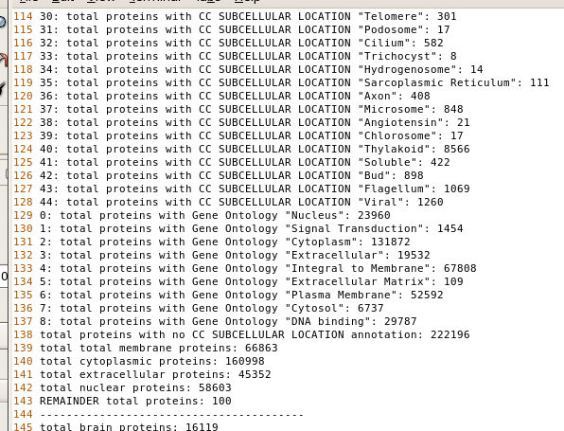Figure 87: Total Proteins Report Completion
report, popular key words were chosen and integrated into the growing set of key words. In this way, total REMAINDER proteins, as reported in the final entry, for human proteins were reduced to 9 of 20,239 or 0.0445%, while for the total UniProtKB/Swiss-Prot set, there were 100 REMAINDER proteins of a set of 528,048 or 0.0189%. It should be noted, however, that not all of these key words were utilized to generate the Cellgrams. For the case of human proteins, the command line report shows 3,434 membrane proteins, 5,369 cytoplasmic (soluble) proteins, 3,767 extracellular proteins and 5,140 nuclear proteins for a total of 17,710 proteins utilized in the Cellgram out of 20,239 total implying that 87.5% of the proteins were included in the Cellgram statistics. In contrast, the total proteome for the UniProtKB/Swiss-Prot manually annotated dataset was much more poorly characterized by the Cellgram, with 66,863 proteins paritioned as membrane, 160,998 proteins characterized as cytoplasmic (soluble), 45,352 as extracellular, and 58,603 as nuclear for a total number of proteins characterized for the total Cellgram of 331,816. Comparing this number to the total number of proteins in the UniProtKB/Swiss-Prot dataset of 528,048 we see that only 62.8% were able to be incorporated into the total Cellgram. Obviously the fact that the study of human proteins is medical research, while non-human proteins is basic research with far less funding and interest and far more data to process explains this fact.

Chapter Summary

The UniProt Consortium is constantly accepting data uploads and constantly recompiling data into new releases of various types, including the UniProtKB/Swiss-Prot manually annotated dataset that was emphasized in this report, and the much larger UniProtKB/TrEMBL dataset that was downloaded for research but utilized with less emphasis because of its larger size slowing down run times and download times, and due to its lack of manual annotation that implied the possibility of bad and duplicate data. The latest major release of both of these datasets was May 3, 2011, which is only 2 days before the writing of this section of the report. New releases include changes in controlled vocabulary as well as addition of new data, and the growth of UniProt/TrEMBL has been rather exponential over the past decade.
Cellgrams were created for total UniProtKB/Swiss-Prot data as well as the fraction therein that was flagged by the Organism Species (OS line) as human, as well as records flagged by the existence of the strings “TISSUE=muscle” and “TISSUE=brain.” The finding was that muscle and brain fractions contained significantly more TMP (membrane) proteins with brain having the highest percentage of membrane proteins with 34.3%.
The ProMog binary outputs data to the command line as well as creating Cellgrams. Using the commmand line output, it was possible to verify that the count of total proteins matched the UniProt website release documentation with 528,048. A large number of various annotations were recorded so that 99.956% of human proteins, and 99.98% of total proteins reported some form of tabulation results. However, not all of these key word reports were used in construction of the Cellgram. For human proteins, 87.5% of proteins were utilized in its construction, while only 62.8% of total proteins were so utilized.

CONCLUSIONS, RECOMMENDATIONS, AND FUTURE WORK

Conclusions

The UniProt Consortium provides an important resource of a heavily cross referenced body of biological data that spans the entire biosphere and cuts across disciplines. It remains, however, a work in progress. The current field of bioinformatics and systems biology includes many sequence based tools, but emphasizing bare sequence in absence of biological milieu, though useful in discovering potential relationships between genes, is not likely in the end to lead to significant theoretical advancement. A serious deficiency in known 3D structures of the proteome is in the area of TMP proteins, which are expressed in low abundance but serve as the gate keepers between life and death.
The work of Ahram et al [1] illustrates the difficulty in relying on sequence, with the disparate findings of the softwares studied in that work. Although compartmental models are decried by some circles, they remain the accurate reality of biological function. Simulation work is well established that seeks real time information of molecular function but this work must simplify what is studied far beyond anything even resembling cell culture systems, which are hundreds of billions of times simpler than organismic realities. Another reality seemingly ignored by many in the computing side of bioinformatics is the current energy wall problem leading to the performance stall of the past decade of computer performance that demands increases in parallelism to gain any improvements, but speed up gains via this avenue have been shown to be questionable. Therefore, in the face of exponential increases in biological data, a move toward high performance systems of the past is emphasized in this work.
There are a number of online biological data resources and this work only scratches the surface. The strength of UniProt is the unifying nature of its cross referencing. It is believed by the author that the ProMog tool might be usefully integrated into other proteomic data processing softwares to improve understanding. The results were illuminating, and the prediction that muscle and brain would prove to have elevated amounts of TMPs proved correct. TMPs are exceedingly important to biological function and are as fundamental as DNA's role of genetic code. With no differentiation between self and not self, there is no self. Without self, there is no existence, and DNA's genetic code becomes irrelevant. TMPs represent that boundary between what is the self, and what is not, so should not be underestimated in importance.

Recommendations and Future Work

Although performance was a priority in the development of the ProMog/Cellgram module pair project, in fact, it may be possible to implement further performance improvements. Use of arrays to compare strings was implemented, not because the author was not aware of the utility strcmp(), but because he was under the mistaken belief that it might be higher performance. In fact, a test was implemented that compared the use of strcmp to detect the string “SUBCELLULAR LOCATION” to the array method implemented in the actual code. Figure 7-1 shows the command line timing results utilizing the performance testing
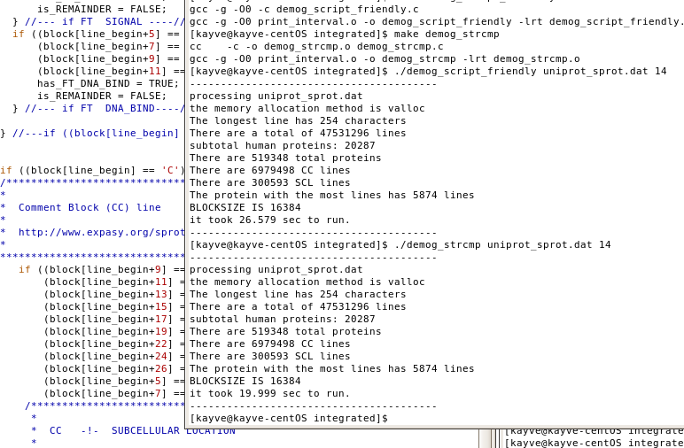Figure 88: Performance Improvement Using strcmp()
program demog_script_friendly with a version that was renamed demog_strcmp that instead utilized strcmp() to accomplish the same task. As can be seen in the figure, this resulted in a significant performance improvement. There are many array based string comparisons done in the current version, although the detection of SCL data in CC lines represented the single largest string that utilized this technique.
Possible additional improvements would include a sub-knowledge base creation tool based on partitionings created by the tool. Integration of the tool into real time proteomic microarray processing systems is another possibility. Further investigation into more database cross referencing to improve the proteome-wide coverage could be a fruitful endeavor. Further development of diverse Cellgram creation modules that would pseudo- realistically diagram additional organelle specific SCL compartmentalization, or simply more complex Cellgrams that relinquished the goal of simplicity in favor of accuracy.
REFERENCES

- Ahram M, Litou ZI, Fang R, and Al-Tawallbeh G; Estimation of membrane proteins in the human proteome; in silico Biology; 6; http://www.bioinfo.de/isb/2006060036/; 0036 2006.
- Singer SJ and Nicolson GL; The Fluid Mosaic Model of the Structure of Cell Membranes; Science 175; 720-731; 1972.
- Apweiler R, Bairoch A, Wu CH, Barker WC, Boeckmann B, Ferro S, Gasteiger E, Huang H, Lopez R, Magrane M, Martin MJ, Natale DA, O'Donovan C, Redaschi N, and Yeh L-SL; Uni-Prot: the Universal Protein knowledgebase; Nucleic Acids Research; Vol. 32, Database Issue D115-D119; DOI:10.1093/nar/gkh131; 2004.
- Bairoch A, Apweiler R, Wu CH, Barker WC, Boeckmann B, Ferro S, Gasteiger E, Huang H, Lopez R, Magrane M, Martin MJ, Natale DA, O'Donovan C, Redaschi N, and Yeh L-SL; The Universal Protein Resource (UniProt); Nucleic Acids Research; Vol. 33, Database Issue; D154-D159; doi:10.1093/nar/gki070; 2005.
- Wu CH, Apweiler R, Beiroch A, Natale DA, Barker WC, Boeckmann B, Ferro S, Gasteiger E, Huang H, Lopez R, Magrane M, Martin MJ, Mazumder R, O'Donovan C, Redaschi N, and Suzek B; The Universal Protein Resource (UniProt): an expandng universe of protein information; Nucleic Acids Research; Vol. 34, Database Issue; D187-D191; doi:10.1093/nar/gkj161; 2006.
- The UniProt Consortium; The Universal Protein Resource (UniProt) 2009; Nucleic Acids Reseach; Vol. 37, Database Issue; D169-D174; doi:10.1093/nar/gkn664; 2008.
- Schneider M, Bairoch A, Wu CH, and Apweiler R; Plant Protein Annotation in the UniProt Knowledgebase; Plant Physiology Vol. 138; pp. 59-66; doi:10.1104/pp.104.058933; www.plantphysiology.org; May 2005.
- Gasteiger E, Jung E, and Bairoch A; SWISS-PROT: Connecting Biomolecular Knowledge Via a Protein Database; Current Issues in Molecular Biology 3(3): 47-55; 2001.
- Leinonen R, Garcia Diez F, Binns D, Fleischmann W, Lopez R, and Apweiler R; UniProt archive; Bioinformatics Vol. 20 no. 17; pages 3236-3237; doi:10.1093/bioinformatics/bth191; 2004.
- Wieser D, Kretschmann E, and Apweiler R; Filtering erroneous protein annotation; Bioinformatics Vol. 20 Suppl. 1; pages i342-i347; DOI: 10.1093/bioinformatics/bth938; 2004.
- Leinonen R; Nardone F, Zhu W, and Apweiler R; UniSave: the UniProtKB Sequence/Annotation Version database; Bioinformatics Vol. 22 no. 10; pages 1284-1285; doi:10.1093/bioinformatics/btl105; 2006.
- Satoh J, Tabunoki H, and Yamamura T; Molecular network of the comprehensive multiple sclerosis brain-lesion proteome; Multiple Sclerosis; 15: 531-541; doi:10.1177/1352458508101943; 2009.
- Lu X, Zhai C, Gopalakrishnan V, and Buchanan BG; Automatic annotation of protein motif function with Gene Ontology terms; BMC Bioinformatics, 5:122; doi:10.1186/1471-2105-5-122; www.biomedcentral.com; 2004.
- Ehrler F, Geissbuhler A, Jimeno A, and Ruch P; Data-poor categorization and passage retrieval for Gene Ontology Annotation in Swiss-Prot; BMC Bioinformatics, 6(Suppl 1):S23; doi:10.1186/1471-2105-6-S1-S23; 2005.
- Tomazella GG, da Silva I, Laure HJ, Rosa JC, Chammas R, Wiker HG, de Souza GA, and Greene LJ; Proteomic analysis of total cellular proteins of human neutrophils; Proteome Science, 7:32; doi:10.1186/1477-5956-7-32; www.proteomesci.com; 2009.
- Crockett DK, Seiler III CE, Elenitoba-Johnson KSJ, and Lin MS; Annotated Proteome of a Human T-Cell Lymphoma; Journal of Biomolecular Techniques Volume 16, Issue 4; pp. 341-346; December 2005.
- Manabe RI, Tsutsui K, Yamada T, Kimura M, Nakano I, Shimono C, Sanzen N, Furutani Y, Fukuda T, Oguri Y, Shimamoto K, Kiyozumi D, Sato Y, Sado Y, Senoo H, Yamashina S, Fukuda S, Kawai J, Sugiura N, Kimata K, Hayashzaki Y, and Sekiguchi K; Transcriptome-based systematic indentification of extracellular matrix proteins; Proceedings of the National Academy of Sciences Vol. 105, no. 35, pp 12849-12854; www.pnas.org/cgi/doi/10.1073/pnas.0803640105; September 2, 2008.
- Doderer M, Yoon K, Salinas J, Kwek S; Protein subcellular localization prediction using a hybrid of similarity search and error-correcting output code techniques that produces interpretable results; In Silico Biology 6, 0040; 2006.
- Hu Z-Z, Mani I, Hermoso V, Liu H, Wu CH; iProLINK: an integrated protein resource for literature mining; Computational Biology and Chemistry 28, pp 409-416; doi:10.1016/j.compbiochem.2004.09.010; 2004.
- Chou K-C and Shen H-B; Euk-mPLoc: A Fusion Classifier for Large-Scale Eukaryotic Protein Subcellular Location Prediction by Incorporating Multiple Sites; Journal of Proteome Research 6, pp1728-1734; doi: 10.1021/pr060635i; 2007.
- Lei Z and Dai Y; Assessing protein similarity with Gene Ontology and its use in subnuclear localization prediction; BMC Bioinformatics 7:491; doi:10.1186/1471-2105-7-491; 2006.
- Huang W-L, Tung C-W, Ho S-W, Hwang S-F, and Ho S-Y; ProLoc-GO: Utilizing informative Gene Ontology terms for sequence-based prediction of protein subcellular localization; BMC Bioinformatics 9:80; doi:10.1186/1471-2105-9-80; 2008.
- Pospisil P, Klyer L, Adelstein SJ, and Kassis AI; A combined approach to data mining of textual and structured data to identify cancer-related targets; BMC Bioinformatics 7:354; doi:10.1186/1471-2105-7-354; 2006.
- Wallentine JC, Kim KK, Seiler III CE, Vaughn CP, Crockett DK, Tripp SR, Elenitoba-Johnson KSJ, and Lim MS; Comprehensive identification of proteins in Hodgkin lymphoma-derived Reed-Sternberg cells by LC-MS/MS; Laboratory Investigation 87; pp1113-1124; doi:10.1038/labinvest.3700672; 2007.
- Chou K-C and Shen H-B; Large-Scale Plant Protein Subcellular Location Prediction; Journal of Cellular Biology 100:665-678; doi: 10.1002/jcb.21096; 2007.
- Cheng BYM, Carbonell JG, and Klein-Seetharaman J; Protein Classification Based on Text Document Classification Techniques; PROTEINS: Structure, Function, and Bioinformatics 58:955-970; doi: 10.1002/prot.20373; 2005.
- Flagg TP, Enkvetchakul D, Koster JC, and Nichols CG; Muscle K_{ATP} Channels: Recent Insights to Energy Sensing and Myoprotection; Physiology Review 90:799-829; doi:10.1152/physrev.00027.2009; 2010.
- Wang P, Hummel E, Osterrieder A, Meyer AJ, Frigerio L, Sparkes I, and Hawes C; KMS1 and KMS2, two plant endoplasmic reticulum proteins involved in the early secretory pathway; The Plant Journal; doi: 10.1111/j.1365-313X.2011.045222.x; 2011.
- Metcalf DG, Moore DT, Wu Y, Kielec KM, Molnar K, Valentine KG, Wand AJ, Bennett JS, and DeGrado WF; NMR analysis of the aIIbb3 cytoplasmic interaction suggests a mechanism for integrin regulation; Proceedings of the National Academy of Sciences vol. 107 no. 52; pp22481-22486; doi:10.1073/pnas.1015545107; supplemantal information at www.pnas.org/lookup/suppl/doi:10.1073/pnas.1015545107/-/DCSupplemental; December 28, 2010.
- Madhavan V, Bhatt F, and Jeffery CJ; Recombinant Expression Screening of P. aeruginosa Bacterial Inner Membrane Proteins; BMC Biotechnology 10:83; www.biomedcentral.com/1472-6750/10/83; 2010.
- Gu B, Zhang J, Wang W, Mo L, Zhou Y, Chen L, Liu Y, and Zhang M; Global Expression of Cell Surface Proteins in Embryonic Stem Cells; PloS one Volume 5 Issue 12; e15795; doi:10.1371/journal.pone.0015795; December 2010.
- Olkhova E, Raba M, Bracher S, Hilger D, and Jung H; Journal of Molecular Biology 406, 59-74; doi:10.1016/j.jmb.2010.11.045; 2011.
- Renault M, Bos MP, Tommassen J, and Baldus M; Solid-State NMR on a Large Multidomain Integral Membrane Protein: The Outer Membrane Assembly Factor BamA;
- Stevens WR and Rago SA; Advanced Programming in the UNIX Environment Second Edition; Addison-Wesley Professional Computing Series; ISBN 0-201-43307-9; 2005.

APPENDICES

APPENDIX A : OBTAINING UNIPROT DATA

The data used for this work was obtained from the Universal Protein Resource (UniProt)/Swiss-Prot consortium [3-9] which is offered for free download in flat file text annotated form, which was used here, as well as fasta and XML formats from http://www.uniprot.org/downloads.
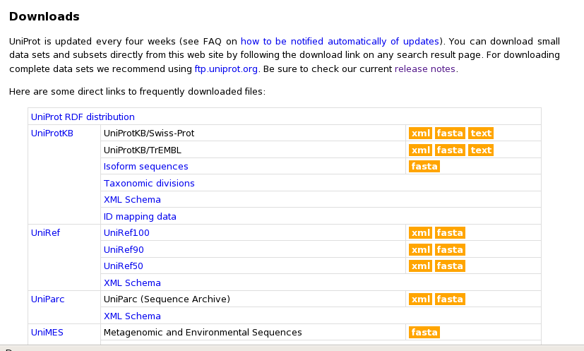Figure 89: UniProt Downloads Website
APPENDIX B : INSTALLING ProMog/Cellgram

