1. er图

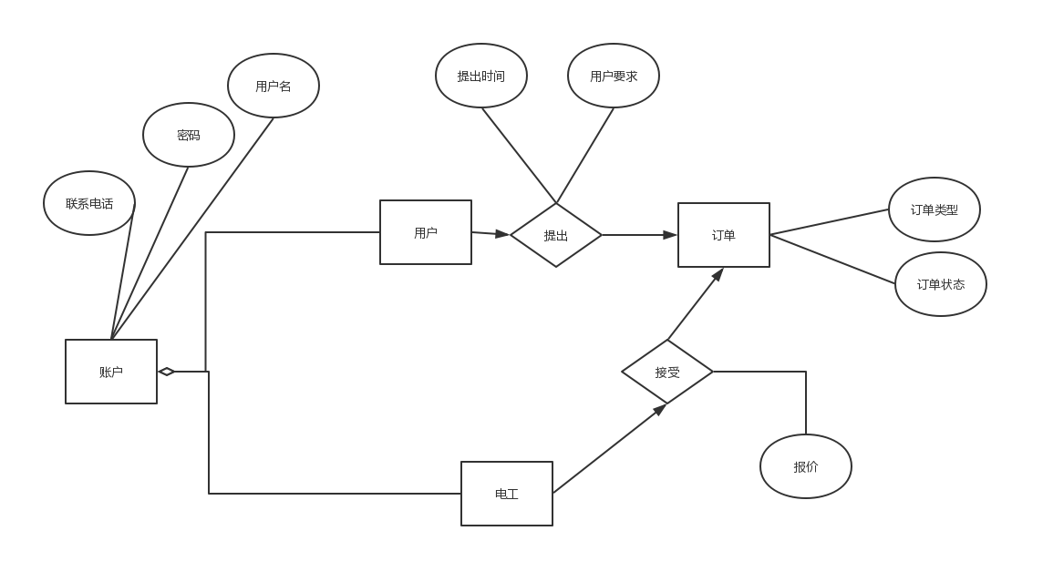

1. 数据库建表

order表

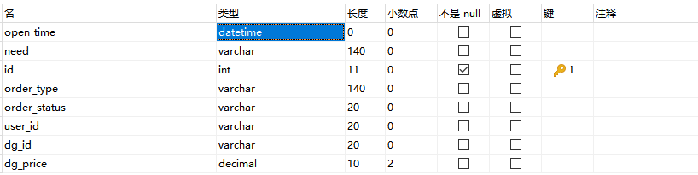

user表

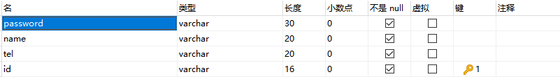

sql文件

/*

Navicat Premium Data Transfer

Source Server : mysql57

Source Server Type : MySQL

Source Server Version : 50710

Source Host : localhost:3306

Source Schema : zdg1

Target Server Type : MySQL

Target Server Version : 50710

File Encoding : 65001

Date: 10/07/2019 11:13:19

*/

SET NAMES utf8mb4;

SET FOREIGN_KEY_CHECKS = 0;

-- ----------------------------

-- Table structure for user

-- ----------------------------

DROP TABLE IF EXISTS `user`;

CREATE TABLE `user` (

`password` varchar(30) CHARACTER SET utf8 COLLATE utf8_general_ci NOT NULL,

`name` varchar(20) CHARACTER SET utf8 COLLATE utf8_general_ci NOT NULL,

`tel` varchar(20) CHARACTER SET utf8 COLLATE utf8_general_ci NOT NULL,

`id` int(16) NOT NULL AUTO_INCREMENT,

`role` varchar(20) CHARACTER SET utf8 COLLATE utf8_general_ci NOT NULL,

PRIMARY KEY (`id`) USING BTREE

) ENGINE = InnoDB AUTO_INCREMENT = 4 CHARACTER SET = utf8 COLLATE = utf8_general_ci ROW_FORMAT = Dynamic;

-- ----------------------------

-- Table structure for wire_order

-- ----------------------------

DROP TABLE IF EXISTS `wire_order`;

CREATE TABLE `wire_order` (

`open_time` datetime(0) NULL DEFAULT NULL,

`need` varchar(140) CHARACTER SET utf8 COLLATE utf8_general_ci NULL DEFAULT NULL,

`id` int(11) NOT NULL AUTO_INCREMENT,

`order_type` varchar(140) CHARACTER SET utf8 COLLATE utf8_general_ci NULL DEFAULT NULL,

`order_status` varchar(20) CHARACTER SET utf8 COLLATE utf8_general_ci NULL DEFAULT NULL,

`user_id` int(20) NULL DEFAULT NULL,

`dg_id` int(20) NULL DEFAULT NULL,

`dg_price` decimal(10, 2) NULL DEFAULT NULL,

PRIMARY KEY (`id`) USING BTREE

) ENGINE = InnoDB AUTO_INCREMENT = 3 CHARACTER SET = utf8 COLLATE = utf8_general_ci ROW_FORMAT = Dynamic;

SET FOREIGN_KEY_CHECKS = 1;

1. 数据流图+ER图

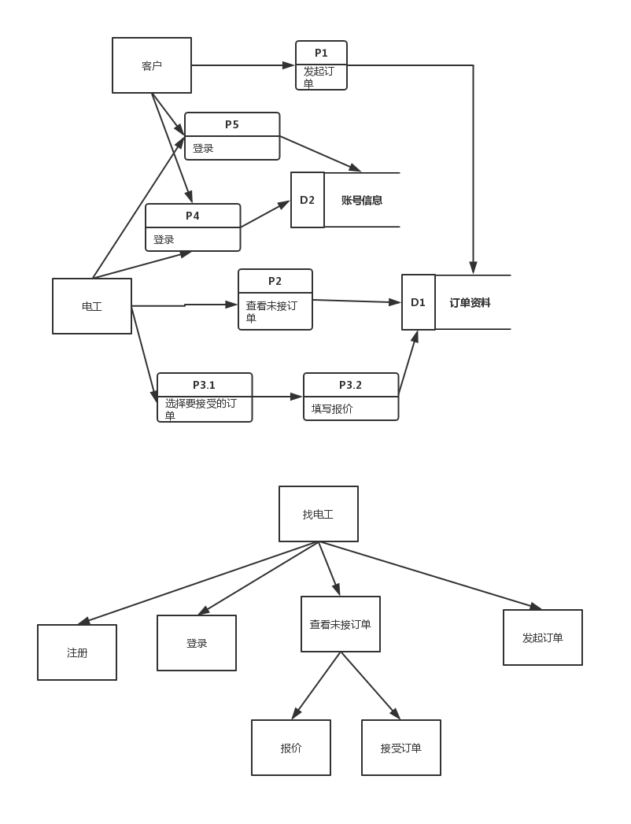

1. 启动webpackapp

初始化：vue init webpack**yourprojectname(项目名)**