BANSAL INSTITUTE OF ENGINEERING AND TECHNOLOGY,
(Affiliated to AKTU, LUCKNOW)
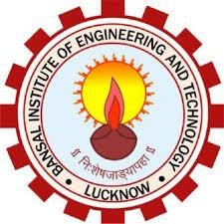
LUCKNOW (UP)

A MINI-PROJECT REPORT
ON
“TECHNICAL SUPPORT”

Submitted by

ABDUL KAYYUM 1842240004

Department of Computer Science and Engineering
BANSAL INSTITUTE OF ENGINEERING AND TECHNOLOGY Lucknow (UP)
2020-21

BANSAL INSTITUTE OF ENGINEERING AND TECHNOLOGY,
(Affiliated to AKTU, LUCKNOW)
LUCKNOW (UP)

CERTIFICATE

Certified that the mini-project work entitled “TECHNICAL SUPPORT” is a bona fide work carried out by
ABDUL KAYYUM 1842240004

The report has been approved as it satisfies the academic requirements in respect of mini-project work prescribed for the course.

……………………
Mr. Kamlesh Kumar
Mini-Project Coordinator

……………...…………………………
Dr. Naveen Prakash
Head of the Department

