Lab #1: Get Started with C# Programming Using Microsoft Visual Studio

# Example-01: How to set up a C# project in Microsoft Visual Studio:

## Output:

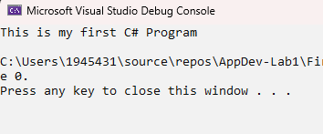

## Errors:

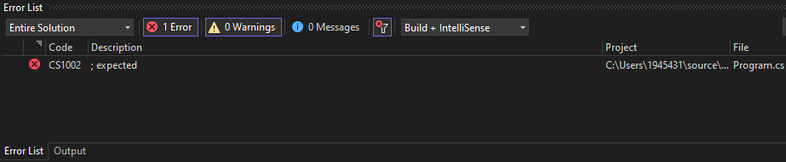

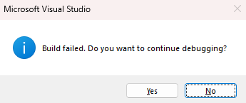

# Example-02: Performing Arithmetic operation

## Output:

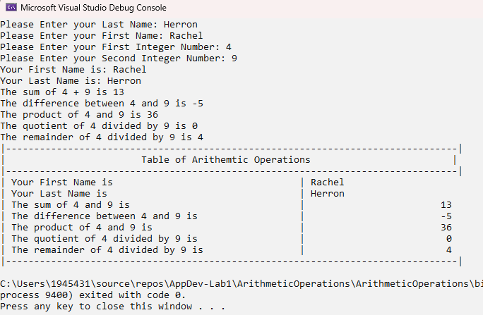

# Example-03: Using the string Data Type

## Output:

