Deliverable 2 - Database Project

Team Members: Rachel Herron, Daveena Patel and Cheng Yu Yang

Changes Made – Deliverable 1

***Crow’s Foot ERD: Initial Conceptual Database Design***

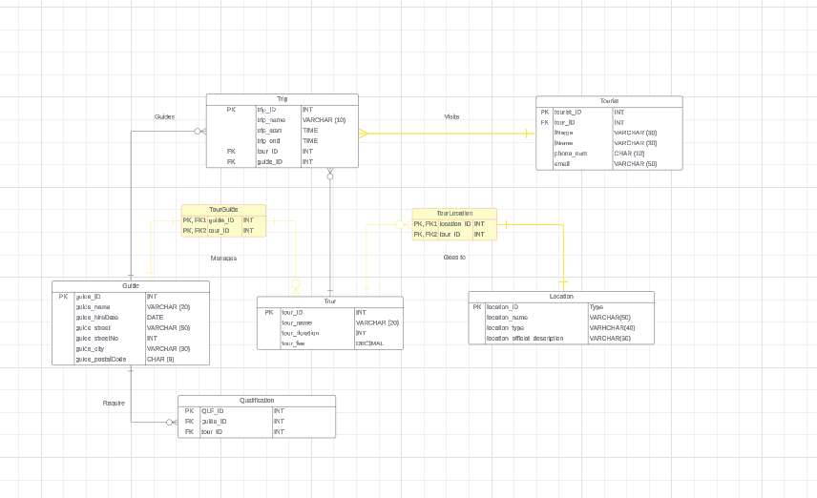***Crow’s Foot ERD: After Mapping the Relationship***

*****Logical Schema***

*Modified Changes:*

After reviewing the comments from Deliverable 1, we made two new tables to fix the N:M relationships. Firstly, we made a table called TourGuide, which has a 1:1 relationship with Guide and a 1:M relationship with Tour. Secondly, we made a table called TourLocation, which has a M:1 relationship with Tour and a 1:1 relationship with Location.

Then we removed any unnecessary foreign keys in our entities. We removed tour_ID in Guide and guide_ID in Tour. We also fixed the relationship for the Tourist entity; we moved the relationship from Tourist to Tour. It got moved to Tourist to Trip, since one tourist will make many trips.

*Normalization Steps:*

*Teamwork Summary:*

*Difficulties We Faced:*