MONITORING AND EVALUATION SYSTEM

BACKGROUND
Because of the resource limitation available in rural areas under which many of the services rendered by the federal government, federal ministries, state ministries, state governments and many Non-governmental organizations (NGO) operates; it is imperative to have a means of remotely posting the results of Program/service assessment to a central database. Detailed below are the various implementation schemes for an Enterprise application which attempts to solve challenges currently being experienced in monitoring and evaluation (M&E) related responsibilities undertaken by many of these agencies. Several options are available each leveraging on the availability of network connection to link the remote device to the central data server.
There are seven characteristics of Data:
1. It must be organized in a desired format
2. It must be timely
3. It must be verifiable
4. It must be useful
5. It must be accurate, cheap, and fast
6. It must be economical
7. It must be accessible

Usually the problem with Monitoring and Evaluation system currently in place in many of the government agencies mentioned above are:
1. No monitoring;
2. Monitoring, but no evaluation; and
3. There is monitoring and evaluation, but there are no timely reports for decision makers in formats very easily adaptable for purpose at hand. That is, breakages in the data collation and aggregation chain.
In the M and E scheme, there are two constraining factors:
1. Data priority; Urgent or not Urgent.
2. Data Quantity- Summary report, concise report and full report. The display area of the device to be used is a constraining factor here.
Although of less importance compared to the two above
3. Network connectivity- GSM or TCP/IP: availability or not availability.
The conditions above are the main delineating factors for classification of modules within the system.
Reports: results of specific observation or inquiry can be in two forms
- Summary report; and
- Detailed or full report.
The parameter for the grouping reports is dependent on the level of details contained in the report. And secondary parameter is the display area of the accompanying device. While mobile phones have limited display area, desktop PCs have much larger display area and thus can accommodate more report.
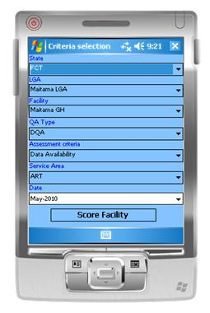
Summary Report
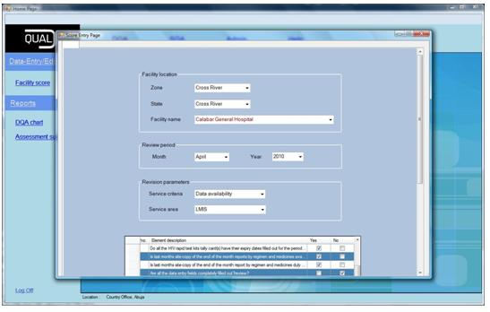
Detailed Report
There are three different types of clients
- Thin client;
- Slim client; and
- Thick client;
The parameter for grouping client is dependent on the technology type being implemented and secondarily by the volume of data which can be processed by the technology type.
1. Thin client:
This client only processes short message services (SMS). The transport protocol for the aggregated data is through the SMS- which entails the sender sending a preformatted SMS to a designated SMS gateway. The SMS gateway on receipt of the message from the client replies the sender with a preconfigured status message: which is either Success or Failure.
The sender gets a success message when the sent message is formatted correctly. The system then updates the central database accordingly with the sent record, and the sender gets a brief report with a brief summary of the committed action.
2. Slim Client:
The slim client is a level of abstraction above the Short Message Service (SMS) protocol. This client leverages the power of phones in the range of internet phones, PDAs and Smart Phones. These phones have the capability to have native windows; J2ME or Android applications installed and can also visit internet web applications forms.
There are two implementations for the slim client:
A. Native application Slim Client:
The native application entails the development of a mobile application client written in either Windows Mobile or J2ME (based on the available SDK) on the sender’s phone. The application contains form fields which links with a SQLite or embedded MySQL database. The sender is first validated and then appropriate job function and responsibility is then loaded for the user based on assigned privilege/role level. Data input is done and the user then synchronized the application through cable or Wi-Fi with a data server when the indicator gatherer returns from operation facilities. Each user of the native application client will need to have the application installed on the cell phone.
B. Wireless/internet application Slim Client:
Unlike the native application entails the development of a mobile application client written in either Windows Mobile or J2ME (based on the available SDK) on the sender’s phone, the wireless slim client requires the development of a mobile web application. The URL of the site can be visited by senders; data can be inputted after user authentication. The application contains form fields validated using client-side validation language like JavaScript, and it links directly to the central database. The sender is first validated and then appropriate job function and responsibility is then loaded for the user based on assigned privilege/role level. There is no need for synchronization because the central data server is updated real-time from the web application. Each user of the web application does not need any installation procedure, except each must have an internet enabled phone.
3. Thick Client
The thick client is a higher level of abstraction above the slim client. This client exists at a level in which in which there is no limit to the volume of data that can be inputted at any point in time, the display size is much larger and thus there is the chance of inputting more detailed report into the application. CRUD operations and extensive reporting functionality can also be achieved through this means. The thick client can also be divided into two:
A. Native application thick client
The native application entails the development of a desktop application client written in either .NET Framework or Java SE on the user’s PC. The application contains form fields which links directly to the central data server. The sender is first validated and then appropriate task function and responsibility is then loaded for the user based on assigned privilege/role level. After data input is done, the system automatically synchronizes database changes through a database service framework running in the backend which then detect changes and updates to the data server. Each user of the native application client will need to have the application installed on individual PC.
B. Web application thick client:
The web application entails the development of a web application client written in either standard Java web framework (Struts, Spring, JSF…) or PHP. The application contains form fields which links to SQLite, embedded MySQL or any other appropriate dedicated database server. The sender is first validated and then appropriate task function and responsibility is then loaded for the user based on assigned privilege/role level. After data input is completed, database update is done in real-time. Each user of the web application does not need to have the web application installed on the PC.

System Requirement
1. SMS module
Thin client: this is also the SMS module.
Requirements:
1. An SMS Gateway will be needed to process all sent messages.
2. To persist sent data a central data server linked directly to the SMS gateway will be needed
3. The SMS Gateway must be configured to auto-reply
-- A success delivery report when the sent text string is properly formatted
-- A failure delivery report (with correct formatting option included) when the text string is wrongly formatted.

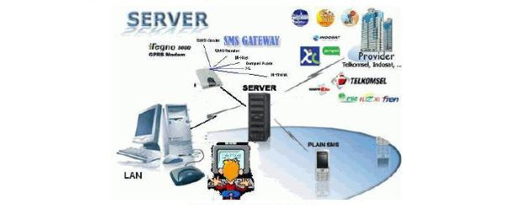

SMS module overview
Slim client
-- Native application Slim Client:
Requirements:
1. Development of a native J2ME or windows mobile application
2. Use of an embedded database to accompany the application // not necessary
3. Database application which remotely synchronizes with the records on the mobile device
4. Since there is no SMS, extra SMS processing cost is not required.

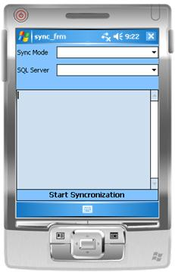
Native application Slim client

-- Wireless/internet application Slim Client:
Requirements:
1. This requires the development of a mobile wireless WAP (Wireless Access Protocol) application written in either Java or PHP.
2. The application will have a web URL with user authentication page; users can visit and post the result of the data collation and aggregation process.
3. The web application links directly to the central server. This makes posted results available in real-time.
4. There is no need to install applications on each user’s device; and maintenance cycle is faster because new updates, bug fixes, etc are quickly distributable.
Thick Client
-- Native application thick client
Requirements:
1. Development of a native windows desktop application written in C#.NET 3.5/4.0 or Java SE // just a desktop or tablet application
2. Use of a dedicated database engine.
3. Database service/update agent which synchronizes record changes with the central database.
4. A network environment (LAN, VPN or Wi-Fi) for propagating changes between independent database applications.

-- Web application thick client //online app
Requirements:
1. Development of a web application written in Java web framework or PHP
2. Use of a central database.
3. Individual PCs must have internet access. // connectivity between the data entry point an central database

Thin client:
The module requires that the system is able to post pre-formatted SMS
Mobile wireless module: native or web app
PC module: native or web app; not too complicated – database service with a native client and configuration in the database which checks for updates and send the records when available.
The System will aid data collation and reporting. This will be a very useful monitoring and evaluation tools for the NGOs and Governments.
GPS location tracking: bundled with the data to aid verification. This extra module will be provided to the government as an extra add-on tools to aid their monitoring and evaluation process.
This will be extra means of generating income for the company since we will need to provide GPS services to the organization.
Assist them in adapting certain operations/paper based tools to mobile application: native or web.

System Components
1. SMS module/Thin client
- High capacity SMS Gateway: Up to 500 SMS/second (on IPSMS connections)
- A lightweight SMS //Data Capture application which runs on the phone- midlet : number of outgoing texts, can perform house-keeping and necessary admin functions; checks the formatting of the posted text message replies the sender with either a success or failure message; and then commits correctly formatted text data to the central server.
- Dedicated lines for SMS, the number will be dependent on the scale of the intended solution.
- A central data server which can be integrated with the SMS Gateway.
- An agreement with the mobile carrier will be necessary to enable the exchange of 2-way SMS traffic.
- // to make cheaper reply using the internet bulk sms service

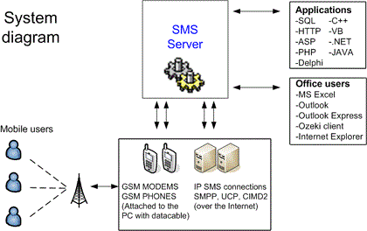
System Diagram for the Thin Client

2. Slim client
2.1 Native application Slim Client (mobile):
- A native application written in either Java ME or Windows mobile (6 or 7).
- The lightweight mobile application should be able to validate input fields, authenticate users, load application module based on the user’s role, persist inputs to an embedded data engine and can synchronize saved data from the embedded data server to the central database engine remotely or through cabling.
- Dedicated mobile phones/PDAs with GPS capabilities (although optional) will be necessary; these mobile devices can be used to run multiple applications under same or several programs.
- A central data server or application which can be synchronized with the native application.
- A backing desktop application will be necessary to offset the limited display available on the mobile devices for the purpose of reporting, presentation and data analysis.
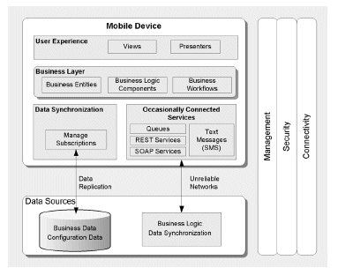
Native mobile application profile

2.2 Wireless/internet application Slim Client (mobile):
- A mobile web application written in either J2EE or PHP.
- The lightweight mobile web application should be able to validate input fields, authenticate users, load application module based on the user’s role, and persist inputs directly to the central database engine remotely or through cabling.
- Dedicated mobile phones/PDAs with GPS capabilities (although optional) will be necessary; these mobile devices can be used to run multiple applications under same or several program areas.
- A backing web application will be necessary to offset the limited display available on the mobile devices for the purpose of reporting, presentation and data analysis.

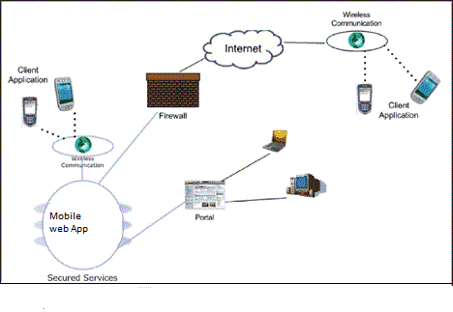
Profile for the mobile web application

3. Thick Client
3.1 Native thick client application
- A native desktop application written in either Java SE or C#.NET (3.5 or 4.0).
- The desktop application can be heavyweight built for large data processing, analysis and reporting directly linked to the database. It should be able to validate input fields, authenticate users, load application module based on the user’s role, persist inputs to a dedicated database and can synchronize saved data from the data server to the central database engine remotely or through cabling via a database service application.
- A windows service program or update agent which detect updates and communicates record updates.
- Many to one to one capability: the client can gather data from either a web or native mobile client through direct cabling or remotely. This component is optional but provides more degree of freedom in the system.
- This application can also be designed to integrate with an SMS client.
- A central data server or application which can be synchronized with the native application remotely or through cabling.

3.2 Thick Web client application
- A web application written in either J2EE or PHP.
- The heavy duty web application should be able to validate input fields, authenticate users, load application module based on the user’s role, and persist inputs directly to the central database engine remotely or through network cabling. It should also be able to carry out extensive reporting, presentation and data analysis functions.
- This web application can also be designed to integrate with a mobile client.
- This application can also be designed to integrate with an SMS client.

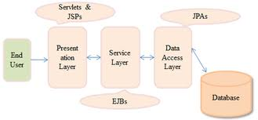
Pattern for the thick web application client

System Limitations
1. Thin client
-- SMS module/Thin client:
This client can become cumbersome to use because of the strict text formatting. Chances of having error in text string is high, thus an effective error handling in the sent text must be implemented; otherwise the system can be massively inoperable.
2. Slim client
-- Native application:
A certain degree of expertise is required in designing and implementing a native mobile application for different device profiles. Limiting device class can solve this problem. Because of the need to manually install and configure every device, deploying and maintenance can become tedious when there are thousands of target devices.
-- Mobile web application:
A certain degree of expertise is required in designing and implementing a mobile web application for different device profiles. Limiting device classes can solve this problem.
3. Thick client
-- Native application:
A certain degree of expertise is required in designing and implementing a native mobile application for different device profiles. There is need to manually install and configure every PC client, deploying and maintenance can become tedious when there are thousands of target PCs.
-- Web application:
A certain degree of expertise is required in designing and implementing a web application for multiple clients on multiple networks.

Analysis Recommendation
The most effective solution that solves the problem being addressed is one which will encompass all the three-tiers. A system that integrates the SMS module with a web client (mobile and PC), will effectively solve the monitoring and evaluation challenges currently being experienced by these agencies.

