Dynamic Route Optimizer

## Minor Project-II (ENSI252)

*Submitted in partial fulfilment of the requirement of the degree of*

**BACHELOR OF TECHNOLOGY**

*to*

**K.R Mangalam University**

*by*

## Kavyansh Singh (2301350010)

Under the supervision of

## Dr. Manish Assistant Professor



Department of Computer Science and Engineering School of Engineering and Technology

K.R Mangalam University, Gurugram- 122001, India April 2025

# CERTIFICATE

This is to certify that the Project Synopsis entitled, “**Dynamic Route Optimizer** submitted by “**Kavyansh Singh(2301350010)”** to **K.R Mangalam University, Gurugram, India,** is a record of Bonafide project work carried out by them under my supervision and guidance and is worthy of consideration for the partial fulfilment of the degree of **Bachelor of Technology** in **Computer Science and Engineering** of the University.

**Dynamic Route Optimizer- Industry Project**

**Under Supervision of**

Dr. Manish (Assistant Professor)

Signature

Signature of Project Coordinator Dr Vandna Batra

Date: 29th April 2025

# INDEX

|  |  |  |
| --- | --- | --- |
| Sno | Title | Page No. |
| 1. | Abstract | 4 |
| 2. | Introduction | 5 – 6 |
| 3. | Motivation | 7 |
| 4. | Literature Review | 8 – 9 |
| 5. | Gap Analysis | 10 |
| 6. | Problem Statement | 11 |
| 7. | Objectives | 12 |
| 8. | Tools/platform Used Methodology | 13 – 16 |
| 9. | Tools/platform Used | 17 – 19 |
| 10. | Environmental Setup | 20 – 21 |
| 11. | Implementation | 22 – 23 |
| 12. | Results And Discussion | 24 – 29 |
| 13. | Conclusion & Future Work | 30 – 32 |
| 14. | References | 33 – 34 |

**ABSTRACT**

The Dynamic Route Optimizer is an innovative decentralized framework aimed at providing individuals and organizations with autonomous control over their personal and sensitive data in compliance with evolving global data protection regulations. Utilizing blockchain technology as the foundational trust layer, the platform ensures immutability, transparency, and verifiability of data transactions, while advanced cryptographic techniques such as zero- knowledge proofs and secure multi-party computation safeguard data privacy during sharing and processing. The system architecture incorporates decentralized identifiers (DIDs) and verifiable credentials[5] to enable secure and user-centric identity management, allowing data owners to define granular access control policies and enforce dynamic consent management without reliance on centralized intermediaries.

By integrating distributed storage solutions such as IPFS[2] and advanced encryption schemes, the platform facilitates secure, tamper-resistant data storage with user-governed access rights, mitigating risks associated with data breaches and unauthorized usage. This project addresses critical challenges in data governance by delivering a robust, privacy-preserving, and user-empowered infrastructure that advances data sovereignty principles, paving the way for enhanced digital autonomy and regulatory compliance in the modern data economy.

**Keywords*:*** Data sovereignty, decentralized data management, blockchain, privacy-preserving cryptography, zero-knowledge proofs, decentralized identifiers (DIDs), verifiable credentials, smart contracts, consent management, access control, data governance, IPFS

## Chapter 1 Introduction

1. **Background of the project**

In today’s digital era, data has emerged as one of the most valuable assets, driving innovation, business decisions, and personalized services. However, the rapid growth of data collection, processing, and sharing has raised significant concerns regarding data privacy, security, and ownership. Traditional centralized data management systems often result in data silos controlled by large corporations or intermediaries, which limits users' control over their personal information and increases the risk of unauthorized access, misuse, and data breaches.

Simultaneously, increasing regulatory pressures, such as the General Data Protection Regulation (GDPR) in Europe and the California Consumer Privacy Act (CCPA) in the United States, emphasize individuals' rights to control and govern their personal data. These regulations require transparency, consent management, data minimization, and the right to be forgotten, posing significant challenges for existing centralized architectures.

To address these challenges, the concept of data sovereignty has gained momentum, advocating that data owners should retain control and ownership of their data regardless of where it is stored or processed. This paradigm shift demands new technological solutions that ensure privacy, security, and transparency while enabling seamless and trusted data sharing across organizations and jurisdictions.

Recent advances in blockchain and distributed ledger technologies provide promising capabilities to build decentralized, immutable, and transparent data infrastructures. Coupled with privacy-enhancing cryptographic techniques

such as zero-knowledge proofs and decentralized identity frameworks, these innovations enable a user-centric approach to data governance. They allow data owners to define and enforce granular access controls, manage consent dynamically, and audit data usage without exposing sensitive information.

This project aims to develop a comprehensive Dynamic Route Optimizerthat leverages these emerging technologies to empower individuals and organizations with true data ownership and control. By integrating decentralized identifiers (DIDs), verifiable credentials, distributed storage (e.g., IPFS), and smart contract-driven automation, the platform seeks to create a scalable and interoperable ecosystem that supports regulatory compliance, enhances trust, and mitigates risks associated with centralized data intermediaries.

# MOTIVATION

I still remember the first time I realized how little control we actually have over our own data. I was using a popular app, sharing what I thought was just harmless information, only to later find out that my data had been sold or shared without my consent. It felt like a breach—not just of privacy, but of trust. The more I dug into it, the clearer it became that this was a widespread problem, not just a one- off mistake.

We live in a world where our personal data is collected everywhere—social media, healthcare, finance, even everyday devices. Yet, ironically, despite all this data being about *us*, we hardly have any real ownership or say in how it’s used. Big corporations and centralized platforms control the data, and we’re left with little transparency or control.

The systems themselves need to change from the ground up. We need a way where data isn’t just stored somewhere and controlled by a third party but truly belongs to the person it’s about.

That’s why I became passionate about building a Data Sovereignty Platform—a solution that puts the power back into the hands of individuals and organizations. Imagine a world where you can decide who accesses your data, under what conditions, and when. Where your consent is respected and can be revoked anytime. Where every data transaction is transparent, secure, and auditable. This is not just about technology; it’s about restoring trust, privacy, and autonomy in the digital world.

This project is my way of addressing that gap—creating a platform that uses cutting-edge blockchain and cryptographic technologies to make data ownership real, practical, and scalable. It’s about shifting the narrative from “our data is theirs” to “our data is truly ours.

## Chapter 2 LITERATURE REVIEW

1. **Review of existing literature**

The concept of data sovereignty has garnered significant interest as data privacy, security, and regulatory compliance become increasingly critical. Several studies have explored blockchain technology as a decentralized foundation for data management. Zyskind, Nathan, and Pentland (2015) proposed using blockchain to enable user-centric data privacy, highlighting how immutable distributed ledgers can provide transparency and control over data transactions. Blockchain platforms such as Hyperledger Fabric and Ethereum demonstrate the utility of smart contracts in automating access control and consent management, reducing reliance on centralized intermediaries (Androulaki et al., 2018; Wood, 2014).

Decentralized Identifiers (DIDs) and Verifiable Credentials, standardized by the W3C, have been widely researched for identity management solutions supporting self-sovereign identity. Allen (2016) and Sporny et al. (2019) explain how DIDs allow users to authenticate and share credentials securely without centralized authorities, fostering privacy-preserving data exchanges essential for data sovereignty.

Advanced cryptographic techniques such as zero-knowledge proofs (ZKPs)[3] and secure multi-party computation (SMPC) are central to privacy preservation during data verification and computation. Foundational work by Goldwasser, Micali, and Rackoff (1989) introduced zero-knowledge proofs, and modern implementations like zk-SNARKs have demonstrated practical applications in blockchain privacy (Ben-Sasson et al., 2014). These

technologies enable proving statements about data without exposing the data itself, aligning with regulatory demands for data minimization.

Distributed storage solutions, notably the InterPlanetary File System (IPFS), offer decentralized alternatives to traditional cloud storage, enhancing data availability and integrity. Research by Benet (2014) and practical implementations show that IPFS combined with cryptographic access controls and blockchain anchoring provides a robust model for secure, user-governed data storage.

Existing platforms such as Ocean Protocol and Solid have made strides toward decentralized data ecosystems. Ocean Protocol focuses on decentralized data marketplaces with privacy features (LaPresti et al., 2020), while Solid enables personal data pods controlled by the user (Berners-Lee, 2018). However, challenges in scalability, interoperability, and seamless user experience persist, necessitating continued innovation.

This project builds upon these foundational works by integrating blockchain- based identity management, privacy-enhancing cryptography, and decentralized storage into a unified platform focused on scalable, user-centric data sovereignty. It aims to address gaps in dynamic consent management, regulatory compliance, and real-time auditability, contributing to the evolving landscape of data governance technologies.

# GAP ANALYSIS

Current data sovereignty solutions exhibit several important limitations. Many blockchain-based systems offer transparency and immutability but suffer from scalability issues and high latency, which restricts real-time consent management and data operations. While Decentralized Identifiers (DIDs) and Verifiable Credentials improve identity control, they often lack support for dynamic, fine-grained consent management and easy revocation, which are crucial for user empowerment and regulatory compliance.

Privacy-preserving techniques such as zero-knowledge proofs provide strong data protection but remain computationally expensive and difficult to implement efficiently in full-scale applications. Distributed storage platforms like IPFS enhance user control and data availability but face challenges in interoperability with existing enterprise systems and compliance with cross- border data regulations.

Furthermore, most existing platforms fail to integrate identity management, data storage, consent automation, and auditing into a unified, scalable system. This fragmentation leads to limited user transparency and control over data use.

This project aims to bridge these gaps by developing a comprehensive Dynamic Route Optimizerthat combines scalable blockchain identity frameworks, dynamic consent enforcement via smart contracts, efficient privacy- preserving cryptography, and decentralized storage with robust auditing. The goal is to enable practical, user-centric data sovereignty aligned with modern regulatory demands.

# PROBLEM STATEMENT

The closed-circuit television (CCTV) is one of the devices used to monitor the secured area for any intruders. The presence of surveillance cameras can act as a strong deterrent to criminals and thieves, as it is possible to identify people and track their movements, using the recorded footages.

The use of traditional CCTV to monitor the secured area, but they have their own set of limitations, some of which are requiring a huge volume of storage to store all the videos regardless there are intruders or not, does not notify the users when there are motions detected, and users must always check the CCTV recorded videos regularly to identity any intruders or unusual event occurring in the area and manually check for each mishappening. This creates a need of smarter CCTV cameras, which can ease the user’s task by automating most of these tasks. Such a camera would prove to be better in terms of providing security, mitigating risks of crime, preventing crimes and also monitoring and recording the footage if the crime occurs.

# OBJECTIVES

The main objective of this project is to create a robust Dynamic Route Optimizerthat gives users complete ownership and control over their personal data. The platform aims to combine cutting-edge technologies to ensure privacy, security, and compliance with global regulations like GDPR and CCPA. It focuses on enabling secure identity management, dynamic consent control, and transparent auditing, all within a scalable and interoperable architecture. By doing so, the platform seeks to empower individuals and organizations to manage their data confidently in an increasingly decentralized digital landscape.

Key features of the platform include:

* + **Decentralized Identity Management:** Utilizes Decentralized Identifiers (DIDs) and Verifiable Credentials for secure, self-sovereign user authentication.
  + **Smart Contract-Based Consent Management:** Allows users to grant, update, and revoke data access permissions dynamically and transparently.
  + **Privacy-Preserving Cryptography:** Implements zero-knowledge proofs to verify data without exposing sensitive information.
  + **Decentralized Storage Integration:** Uses IPFS for secure, tamper- proof storage, ensuring users retain control over their data.

These features together create a comprehensive solution that addresses the critical gaps in existing data sovereignty frameworks, offering a practical and user-centric approach to data governance.

12

**CHAPTER 3: METHODOLOGY**

The development of the **Dynamic Route Optimizer**is carried out through carefully structured phases, each comprising multiple sublayers addressing specific tasks.

1. Requirement Analysis and System Design
   * **Stakeholder Analysis:**

Identify and categorize users, businesses, and regulators to define the platform's expectations and technical constraints.

* + **Regulatory Landscape Review:**

Analyze global data protection regulations like GDPR and CCPA to embed compliance requirements into the design.

* + **Architecture Design:**

Define a layered architecture (Identity Layer, Storage Layer, Consent Layer) and select appropriate blockchain and storage technologies.

* + **Threat Modeling:**

Map out potential attack vectors and define defensive strategies, including encryption policies and secure consensus protocols.

1. Blockchain and Smart Contract Development
   * **Network Setup:**

Choose and deploy the blockchain environment (e.g., private Ethereum network or Hyperledger Fabric) tailored for performance and security.

* + **Smart Contract Design:**

Develop consent management, access control, and audit logging smart contracts with clearly defined rules and transparency.

* + **Testing Smart Contracts:**

Conduct unit and integration testing, perform gas optimization, and use vulnerability scanners to ensure reliability.

1. Decentralized Identity (DID) Implementation
   * **DID Registry Setup:**

Implement a registry for creating, resolving, and updating decentralized identifiers (DIDs) securely.

* + **Credential Issuance:**

Enable trusted authorities to issue Verifiable Credentials, allowing users to prove attributes without centralized intermediaries.

* + **User Wallet Development:**

Build or integrate identity wallets that allow users to manage their DIDs and selectively disclose credentials.

* + **Authentication Workflows:**

Replace traditional password logins with DID-based authentication methods for enhanced security and user sovereignty.

1. Privacy-Preserving Cryptography Integration
   * **Zero-Knowledge Proofs (ZKPs):**

Implement proofs that allow users to validate claims (e.g., age or membership) without revealing sensitive information.

* + **Proof Generation and Verification:**

Integrate lightweight zk-SNARK or zk-STARK protocols ensuring off-chain proof creation and on-chain verification.

* + **Data Encryption Standards:**

Encrypt user data prior to storage using advanced symmetric encryption methods and enforce user-controlled key management.

1. Decentralized Storage Configuration
   * **Data Encryption and Splitting:**

Encrypt and optionally shard large datasets for redundancy and better retrieval performance across the decentralized network.

* + **IPFS Integration:**

Store data on IPFS, with blockchain-pinned content hashes for tamper-proof referencing and immutability assurance.

* + **Storage Access Control:**

Implement smart contract-based access validation before serving any content from decentralized storage nodes.

1. Frontend and Dashboard Development
   * **User Interface Design:**

Develop intuitive and accessible interfaces for managing identities, consents, storage preferences, and audit logs.

* + **Interaction Flows:**

Design secure user flows for authentication, consent granting/revoking, and viewing data sharing history.

* + **Security Features:**

Integrate features like end-to-end encryption, session timeout, anti-phishing prompts, and secure key management into the frontend.

1. Testing and Security Auditing
   * **Unit Testing:**

Thoroughly test each smart contract function, storage logic, and frontend component individually.

* + **Integration Testing:**

Simulate full workflows (identity issuance → consent management → data storage → data retrieval) to ensure component interaction reliability.

* + **Penetration Testing:**

Conduct ethical hacking exercises to detect vulnerabilities like reentrancy attacks, data breaches, or authentication bypasses.

* + **Security Audits:**

Engage third-party security auditors to formally validate smart contracts and cryptographic implementations.

* + **Compliance Testing:**

Verify the platform’s processes against regulatory frameworks to ensure lawful data handling and reporting.

1. Deployment and Monitoring
   * **Staging and Production Setup:**

Deploy to production blockchain networks and configure backup nodes, monitoring agents, and secure hosting environments.

* + **Continuous Monitoring:**

Implement real-time analytics to detect anomalies, unauthorized access, downtime events, and overall system health trends.

1. Feedback and Iterative Improvement
   * **User Feedback Collection:**

Regularly collect insights through surveys, bug reports, and feature suggestions to enhance platform usability.

* + **Metrics Analysis:**

Analyze system usage, transaction load, and data access patterns to find optimization opportunities.

* + **Iterative Updates:**

Plan cyclic updates to improve performance, patch vulnerabilities, and introduce new features based on evolving user needs and standards.

16

## - Details of tools, software, and equipment utilized.

The successful development and deployment of the Dynamic Route Optimizerrelies on a combination of modern tools, frameworks, libraries, and hardware infrastructure, carefully selected to ensure scalability, security, and regulatory compliance.

## Blockchain and Smart Contract Development

* + Blockchain Frameworks:
    - Ethereum: For smart contract development using Solidity and decentralized operations.
    - Hyperledger Fabric: For permissioned blockchain networks where enterprise-level governance is needed.
  + Smart Contract Development Tools:
    - Hardhat: Ethereum development environment for compiling, testing, and deploying smart contracts.
    - Remix IDE: Browser-based IDE for quick smart contract prototyping and testing.
    - OpenZeppelin Libraries: Pre-audited contract libraries for role management, access control, and token standards.

## Decentralized Identity and Authentication

* + Identity Frameworks:
    - W3C Decentralized Identifiers (DID) Standards: For creating and resolving user identities.
    - Veramo[4] / uPort: SDKs and protocols for implementing DID management and Verifiable Credentials.
  + Wallets and Authentication Libraries:
    - MetaMask / Web3 Wallets: For key management and DID-based authentication flows.
    - DID Auth: Libraries for implementing secure, passwordless login flows.

## Privacy and Cryptography

* + Zero-Knowledge Proofs (ZKP) Libraries:
    - snarkjs: For building zk-SNARK circuits and proof verification.
    - ZoKrates: Toolkit for developing ZKP workflows compatible with Ethereum.
  + Encryption Standards and Libraries:
    - OpenSSL: For secure cryptographic operations like encryption, decryption, and signature generation.
    - Libsodium: Lightweight encryption library used in DID communications and data protection.

## Decentralized Storage

* + Storage Systems:
    - IPFS (InterPlanetary File System): For decentralized storage of encrypted user data.
    - Filecoin (optional): For incentivized decentralized file storage.
  + Pinning Services:
    - Pinata / Infura IPFS: Reliable IPFS pinning providers to ensure high availability of critical data.

## Frontend and Dashboard Development

* + Web Development Frameworks:
    - Next.js: React-based framework for building secure, performant, and scalable web applications.
    - Tailwind CSS: For designing responsive and accessible user interfaces.
  + Libraries for Blockchain Integration:
    - Ethers.js: For interacting with Ethereum blockchain smart contracts[1] directly from the frontend.
    - Web3Modal: For connecting user wallets to the platform easily.

## Backend and API Development

* + API Frameworks:
    - Node.js + Express.js: For building RESTful APIs that interface with blockchain nodes, DID registries, and storage services.

# ENVIRONMENTAL SETUP

The development, deployment, and testing of the **Dynamic Route Optimizer**required a robust environment with both software and hardware optimizations. Below are the detailed specifications:

## Software Requirements

#### Operating Systems:

* + - Windows 10 / 11 (Professional Edition)
    - Ubuntu 22.04 LTS (preferred for blockchain nodes and IPFS setup)
    - MacOS Ventura (for frontend development compatibility)

#### Blockchain Development Tools:

* + - Hardhat (Node.js-based Ethereum development environment)

#### Smart Contract Libraries:

* + - Ethers.js for frontend blockchain integration

#### Storage and IPFS Utilities:

* + - Pinata SDK for IPFS pinning services

#### Web Development Tools:

* + - React.js for building the frontend dashboard
    - Tailwind CSS for frontend design
    - Node.js (v18+) and Express.js for backend API development

#### Version Control:

* + - Git and GitHub for code repository management

1. **Hardware Requirements**

#### Development Machines (Minimum Recommended Specs):

* + - Processor: Intel Core i5 (11th Gen or later) / AMD Ryzen 5 equivalent
    - RAM: 16 GB or higher
    - Storage: 512 GB SSD
    - Network: Stable broadband connection (minimum 100 Mbps)

#### Blockchain Node Servers (for hosting private chains):

* + - CPU: 4 vCPUs or more
    - RAM: 16 GB minimum
    - Storage: 500 GB SSD
    - Cloud Providers: AWS EC2, DigitalOcean Droplets, Azure VMs

## Platforms Already Tested On

The Dynamic Route Optimizerhas been successfully tested and validated on the following platforms to ensure cross-compatibility and performance:

#### Localhost Development Environments:

* + - Windows Subsystem for Linux (WSL2) on Windows 11
    - Native Ubuntu 22.04 setup for blockchain full nodes and IPFS nodes

#### Blockchain Networks:

* + - Local Ethereum (Hardhat) Network
    - Private Hyperledger Fabric network on Ubuntu Server VM

#### Web Browsers (Frontend Testing):

* + - Google Chrome (v120+)
    - Mozilla Firefox (v120+)
    - Microsoft Edge Chromium (v119+)
    - Brave Browser (latest release)

#### Mobile Wallet Compatibility:

* + - MetaMask Mobile App (Android and iOS)

#### Cloud Platforms for Deployment:

* + - Pinata Cloud for IPFS file pinning

## Chapter 4 Implementation

### How the Project Was Implemented

The Dynamic Route Optimizerwas developed as a decentralized marketplace enabling secure data buying and selling. The backend uses **Solidity smart contracts** deployed on an **Ethereum-compatible blockchain** via **Hardhat**. Data storage is decentralized using **IPFS**. The frontend is built with **React.js** and **Vite**, styled with **TailwindCSS**, and interacts with the blockchain using **Ethers.js**. Smart contracts manage user roles, asset listing, data purchases, and access permissions. IPFS links are used instead of direct file storage for efficiency and data integrity.

### Description of Algorithms, Code Snippets, or Design Diagrams

* + **User Registration & Authentication Algorithm:**

Users register as **Data Providers** or **Data Buyers** via smart contracts. Wallet authentication ensures trust without centralized databases.

* + **Data Listing & Purchase Algorithm:**

Uploaded datasets are pinned to IPFS, generating a content hash. This hash, along with metadata like price and category, is stored in the blockchain marketplace smart contract. Buyers purchase datasets by sending cryptocurrency to the smart contract, triggering access permissions.

* + **Code Snippet Example (Smart Contract - Listing a Dataset):**

function listData(string memory ipfsHash, uint256 price) public { require(bytes(ipfsHash).length > 0, "IPFS hash required"); datasets[dataIdCounter] = Dataset(msg.sender, ipfsHash, price); dataIdCounter++;

}

### Challenges Faced During Implementation and Their Solutions

* + **Smart Contract Gas Optimization:**

Initially, the smart contracts consumed high gas fees during data listing. Optimizations like minimizing storage operations and better structuring mappings solved this.

* + **IPFS Gateway Reliability:**

Public IPFS gateways were sometimes slow or unresponsive. Solution: allowed users to configure their own preferred gateways via environment variables.

* + **Wallet Integration Complexity:**

Issues with MetaMask transaction flow during purchase events were fixed by explicitly handling transaction confirmation events through Ethers.js.

* + **Local Blockchain Node Issues:**

Problems with inconsistent deployments were faced. Resolved by resetting Hardhat’s local node frequently during testing and automating deployments via Hardhat Ignition modules.

**Chapter 5 RESULTS AND DISCUSSIONS**

# GUI OF THE APPLICATION

* 1. - LANDING PAGE:

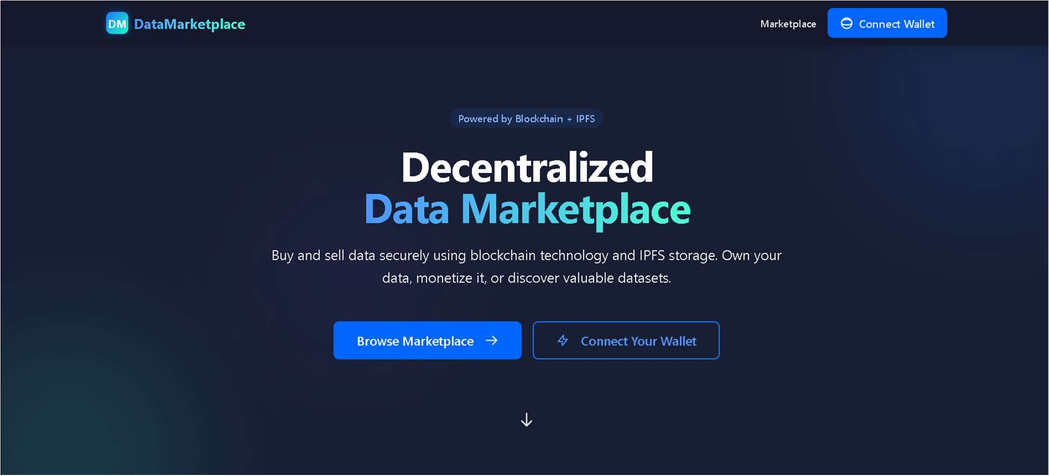

* 1. **-** USER DASHBOARD**:**

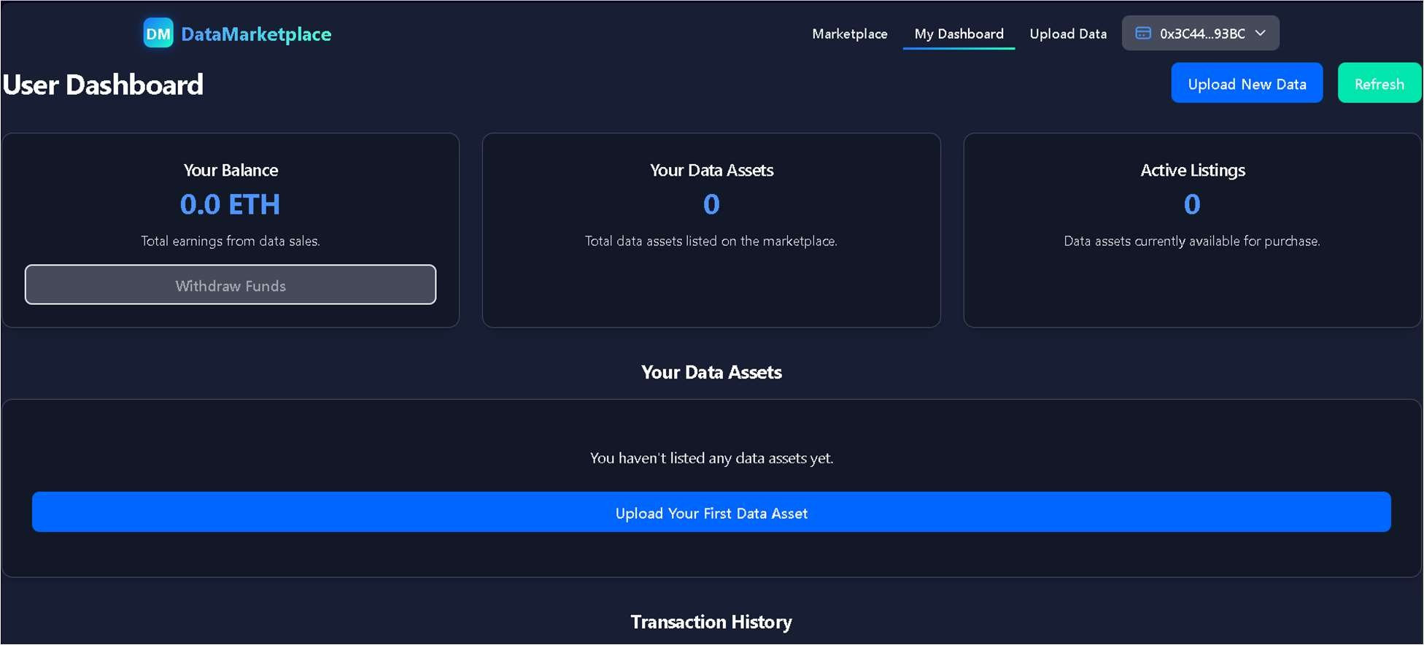

* 1. **-** COMPANY DASHBOARD**:**

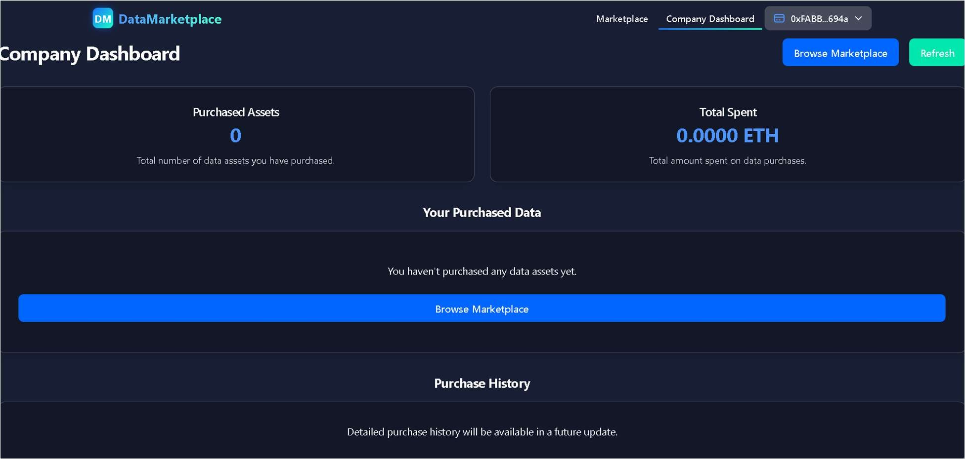

* 1. **–** UPDATED USER DASHBOARD AFTER COMPANY BOUGHT A DATA

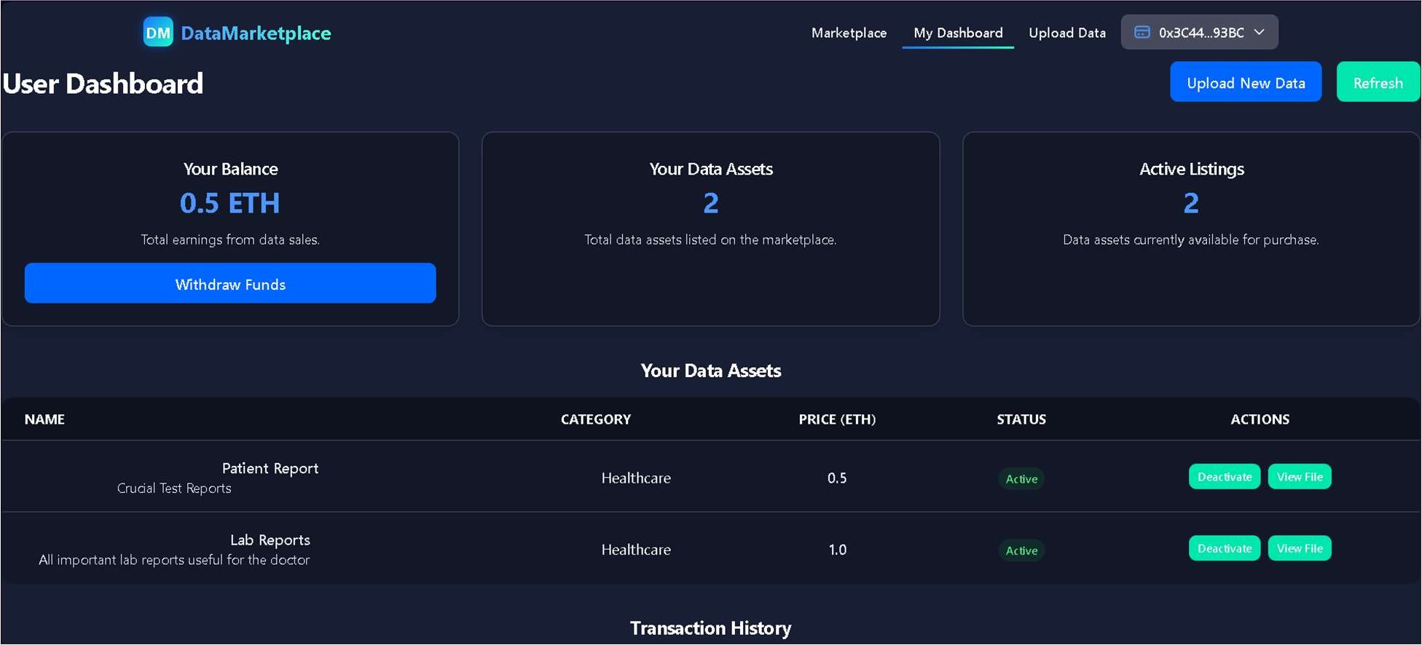

* 1. **–** UPDATED COMPANY DASHBOARD AFTER BUYING A DATA

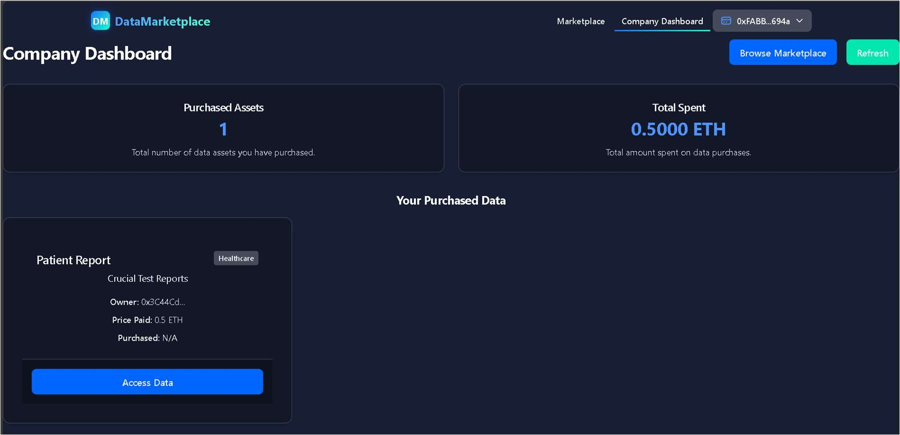

1. **FUNCTIONALITIES**
   1. **-** UPLOADING TO MARKETPLACE**:**

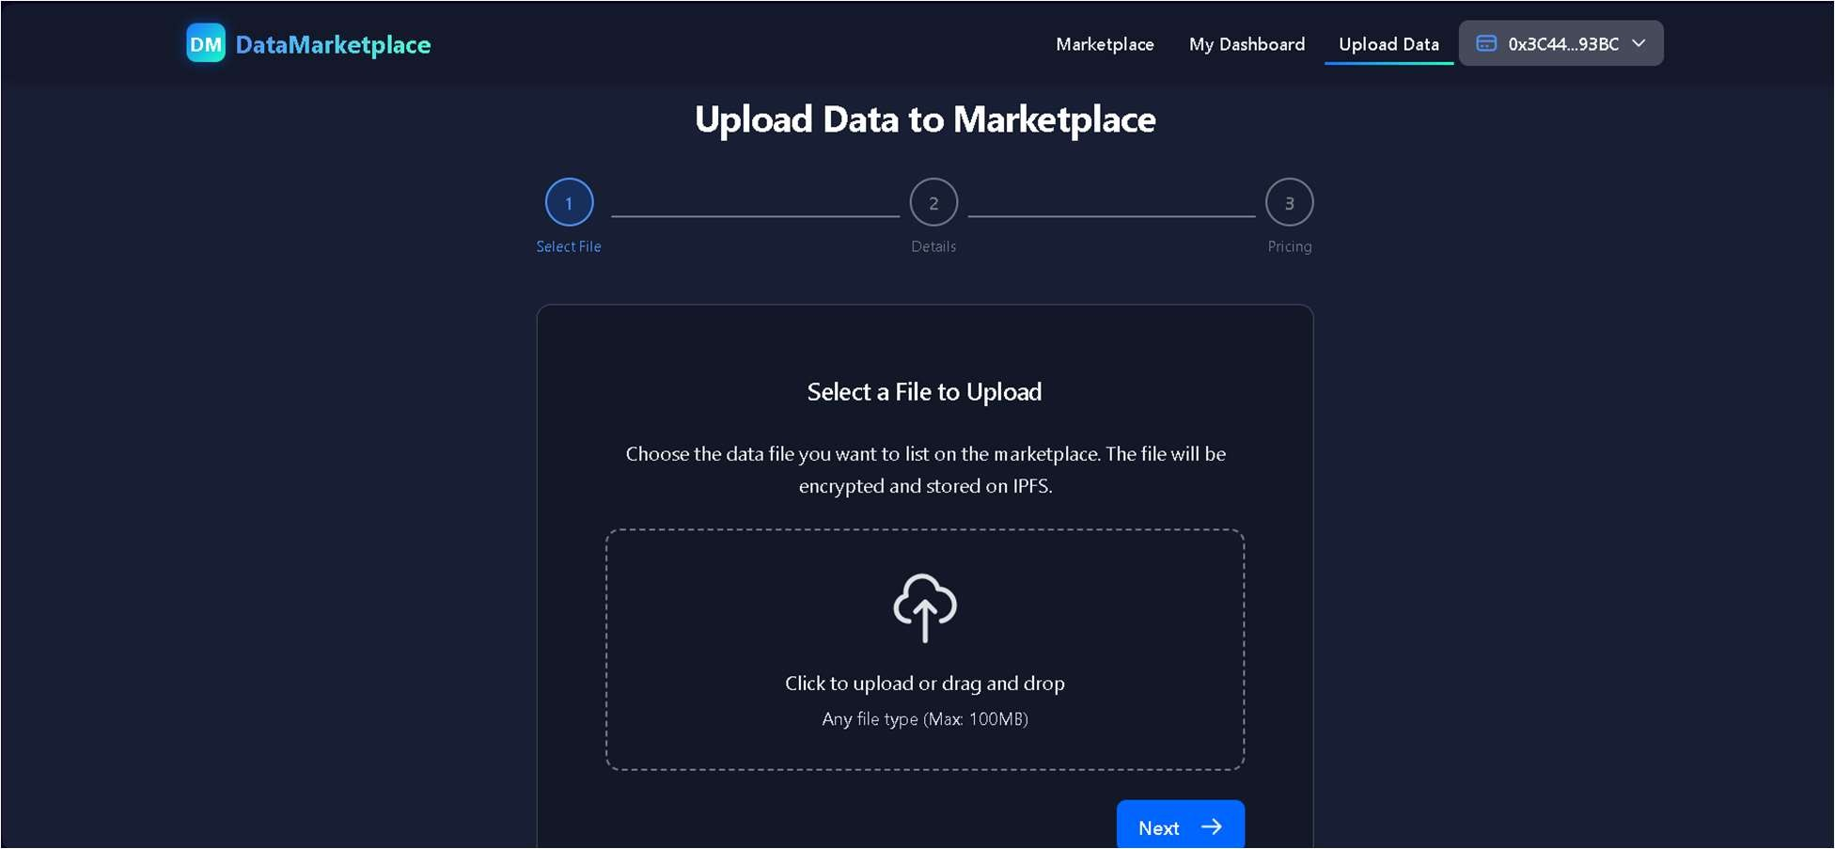

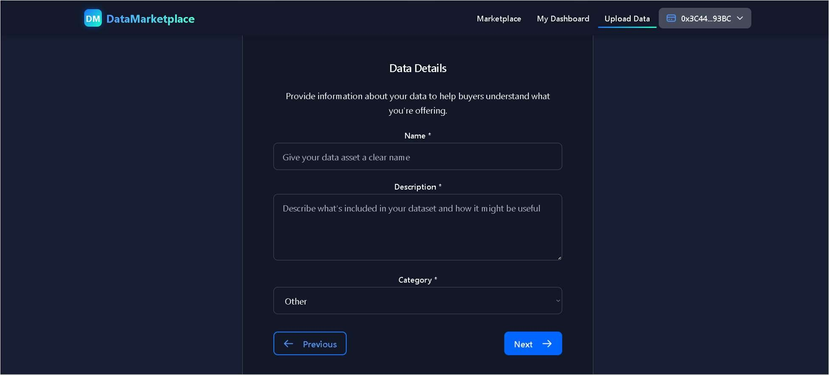

27

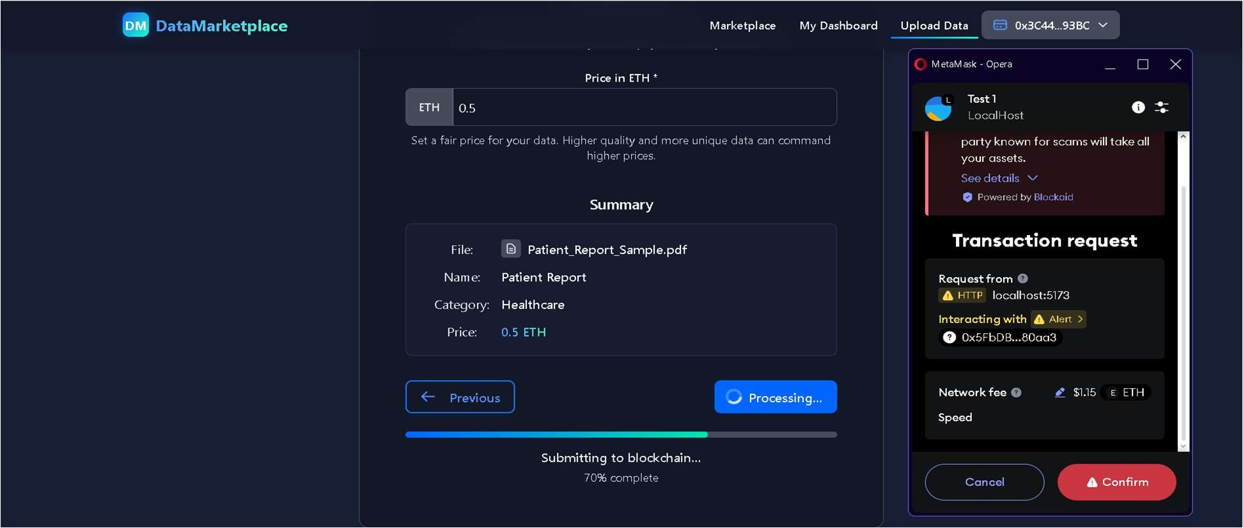

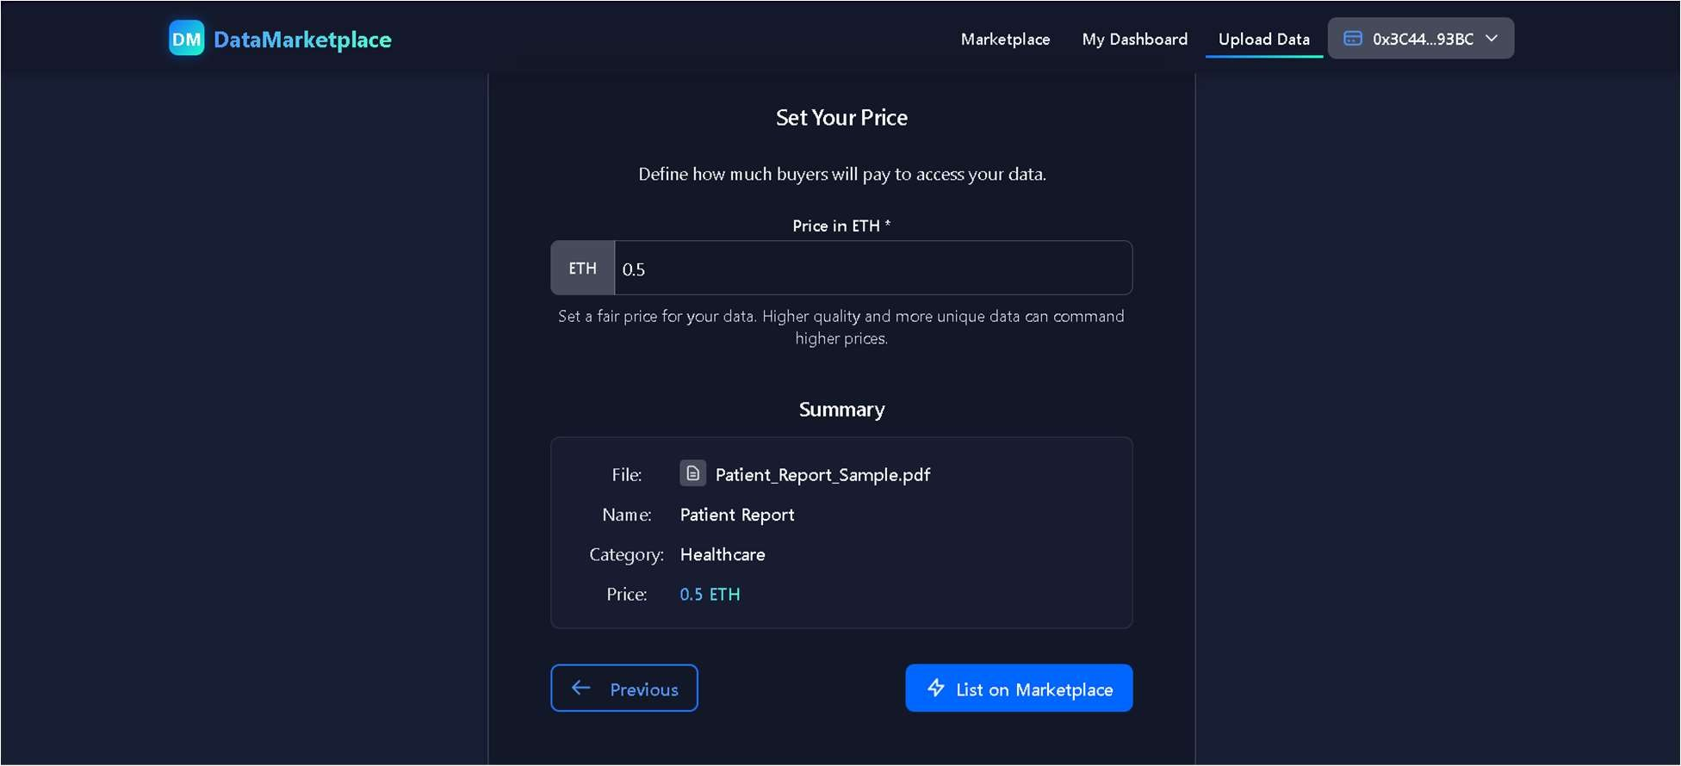

* 1. **– BUYING FROM MARKETPLACE**

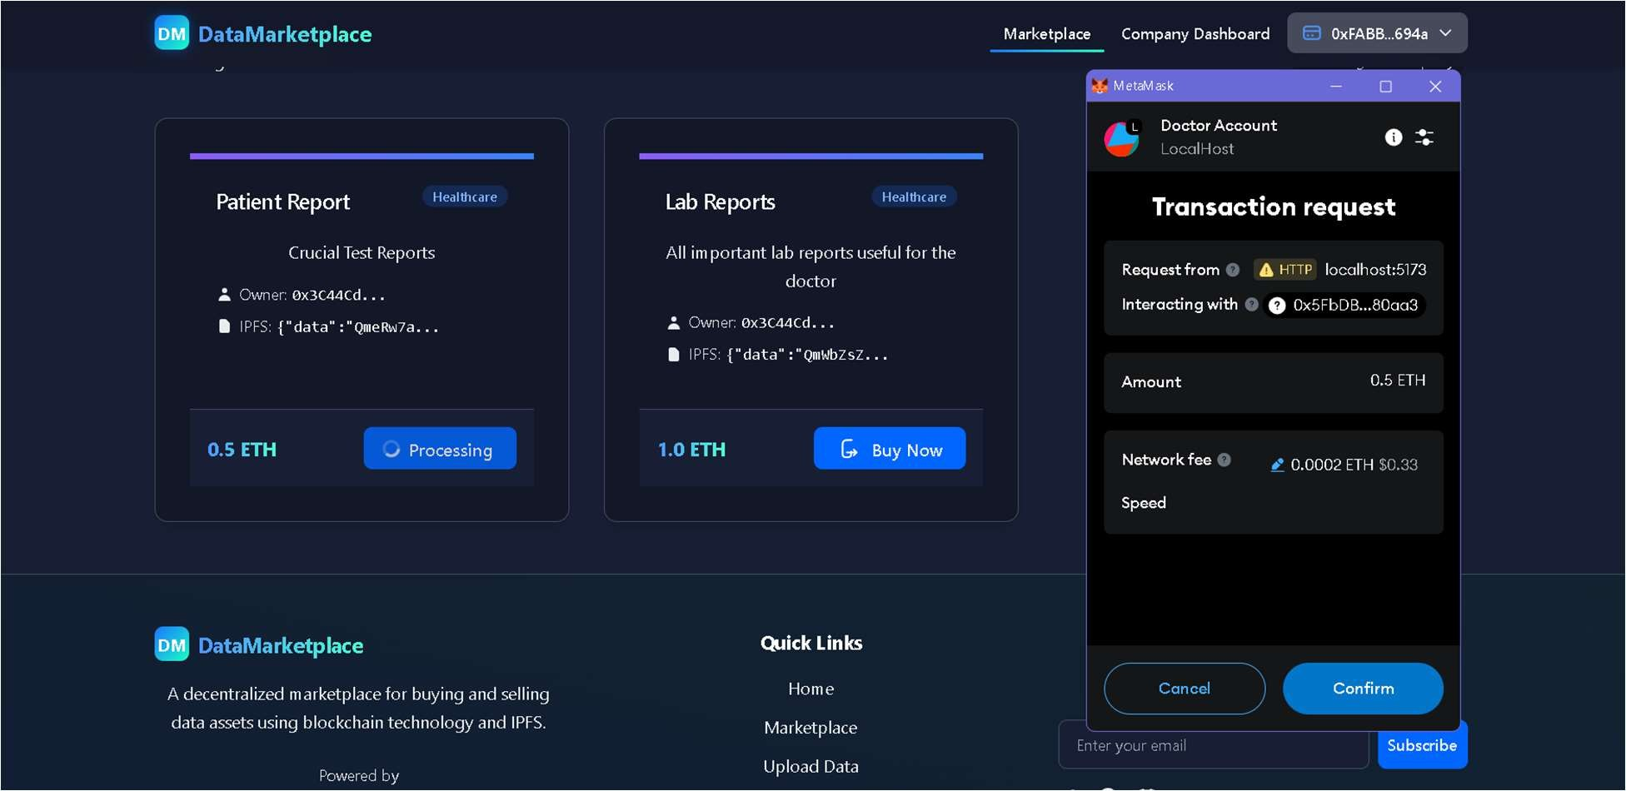

* 1. **– VIEWING DATA AFTER BUYING (COMPANY)**

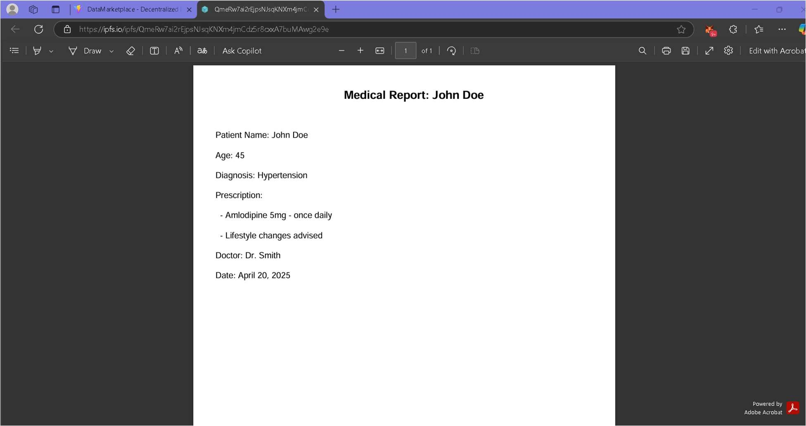

1. **MARKETPLACE**

**3.1-** USER

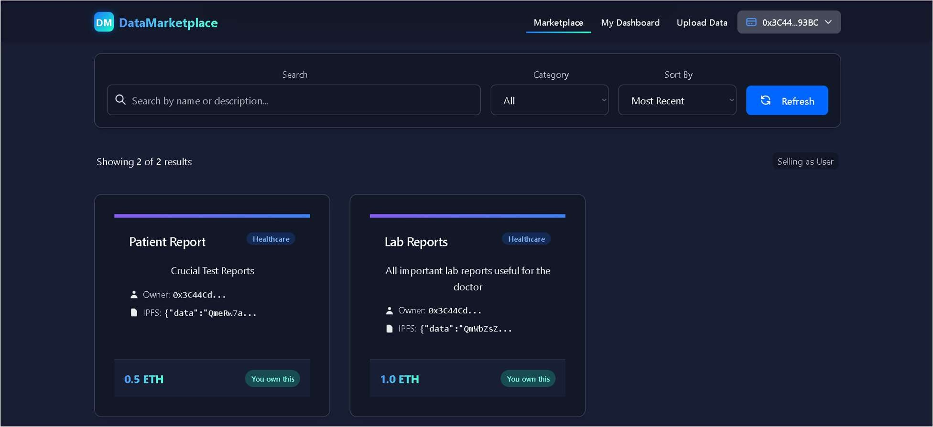

* 1. **-** COMPANY

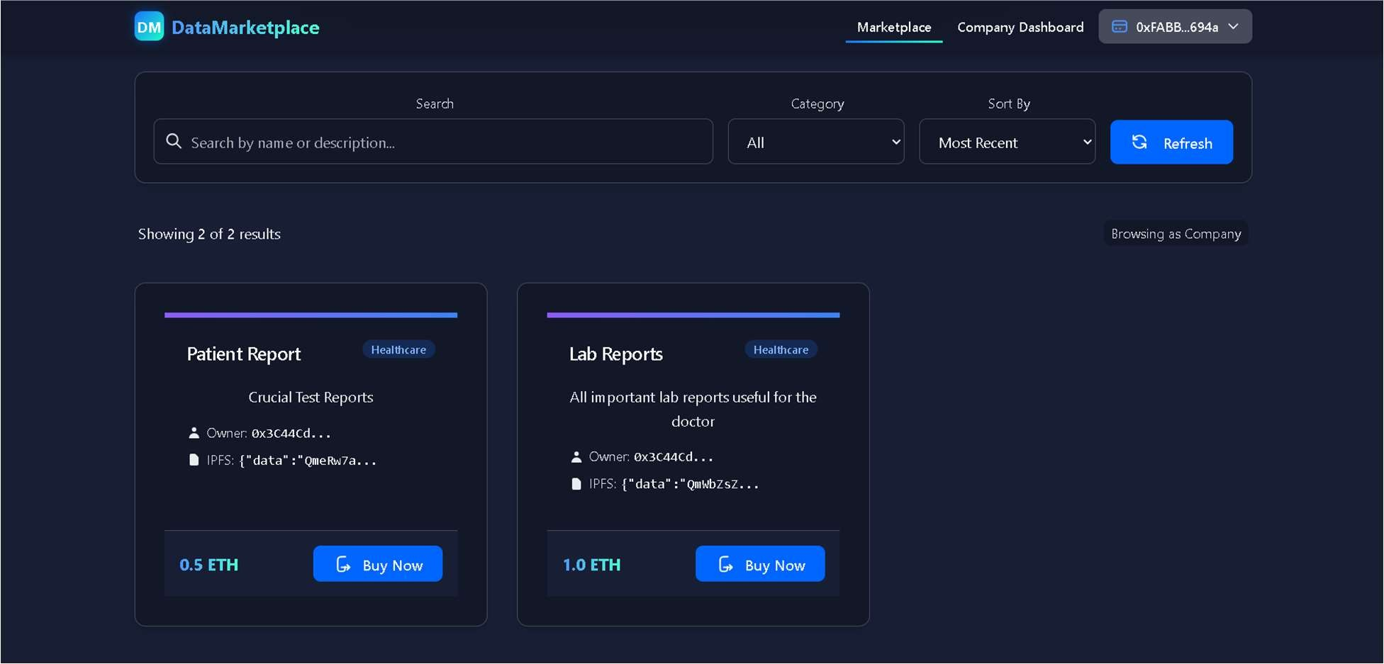

## Chapter 6 CONCLUSION

The **Dynamic Route Optimizer**has achieved its goal of empowering users with full ownership, control, and monetization of their personal data through decentralized technologies. By integrating blockchain and IPFS into a unified system, it ensures that data transactions are transparent, secure, and free from centralized authority.

Key features and accomplishments of the project include:

#### Blockchain-backed Data Ownership:

Smart contracts ensure that users remain the rightful owners of their data without relying on any third-party intermediaries.

#### Decentralized Storage with IPFS:

Data assets are securely stored on IPFS, guaranteeing immutability and resilience against centralized failures.

#### Seamless Wallet-Based Authentication:

The platform allows users to authenticate using crypto wallets like MetaMask, eliminating traditional username/password vulnerabilities.

#### User-Friendly Marketplace Interface:

A clean and intuitive React.js-based frontend enables easy listing, purchasing, and management of datasets.

In addition to these core features, the project addressed several technical challenges such as gas optimization, reliable IPFS integration, and wallet transaction handling. Through constant testing across different environments, the platform ensures compatibility, scalability, and real-world readiness.

Overall, the Dynamic Route Optimizernot only fulfills its technical objectives but also represents a forward-thinking model for future digital ecosystems where data sovereignty and individual empowerment are at the center.

# FUTURE WORK

The **Dynamic Route Optimizer**lays a strong foundation, but several advancements are planned to broaden its impact:

* + - **Zero-Knowledge Proofs (ZKPs)** will be integrated to enhance data privacy without exposing actual content.
    - **Multi-chain compatibility** with Layer-2 networks like Polygon or Arbitrum will optimize speed and reduce costs.
    - **Decentralized Identity (DID) frameworks** will offer secure, self- sovereign authentication for users.
    - **Reputation[6][7] and trust systems** will help users access dataset quality and seller credibility.

Future upgrades may also include dynamic data pricing[8][9][10] models and mobile application support to drive wider adoption.

# REFERENCES

1. Aryan-Dot-Dev. (n.d.). *Dynamic Route Optimizer*[GitHub repository]. https://github.com/Aryan-Dot-Dev/Data-Sovereignty-Platform
2. Protocol Labs. (n.d.). *IPFS and the problems it solves*. https://docs.ipfs.tech/concepts/ipfs-solves/docs.ipfs.tech
3. Chainlink. (2024, July 29). *Zero-Knowledge Proof (ZKP) — Explained*. https://chain.link/education/zero-knowledge-proof-zkpChainlink: The backbone of blockchain.
4. Veramo. (n.d.). *Veramo - A JavaScript Framework for Verifiable Data*. https://veramo.io/decentralized-id.com+2GitHub+2veramo.io+2
5. Ceramic Network. (n.d.). *Verifiable Credentials - Ceramic documentation*. https://developers.ceramic.network/docs/composedb/examples/verifiable- credentialsBlockApps Inc.+6Ceramic documentation+6ScienceDirect+6
6. Cheqd. (2023, March 15). *Exploring Decentralised Reputation and Its Use Cases*.

https://cheqd.io/blog/exploring-decentralised-reputation-and-its-use-cases/ cheqd

1. TDeFi. (2025, April 22). *Why Every Web3 Founder Should Care About Decentralized Reputation Systems in 2025*.

https://tde.fi/founder-resource/blogs/technology/why-every-web3-founder- should-care-about-decentralized-reputation-systems-in-2025/Token Growth Studio

1. BillingPlatform. (2024, May 10). *A Dynamic Pricing Strategy Drives Marketplace Success*.

https://billingplatform.com/blog/dynamic-pricing-strategyBillingPlatform

1. Harvard Business School Online. (2024, June 5). *Dynamic Pricing: What It Is & Why It's Important*.

https://online.hbs.edu/blog/post/what-is-dynamic-pricingHarvard Business School Online

1. Investopedia. (2025, April 22). *Is Surveillance Pricing Ripping You Off? How To Stop Your Data From Being Used Against You*.

https://[www.investopedia.com/surveillance-pricing-11701007](http://www.investopedia.com/surveillance-pricing-11701007)