Databases Final Project Report: Fungitrack

All project files and the history of project commits can be found at: https://github.com/kazagistar/fungitrack
The files have also been uploaded along with this report.
Most of the SQL definitions and queries are in the schema folder, create_all.sql is the file used to create the database, files like pop_* are used to populate the tables after creation. Server code is in files server.py and code for database querying are in other files like *.py. HTML files are in the templates folder, and static images used are in static. Configuration files are like *.json. config_local and config_remote can both be used (copied to config.json). config_remote.json accesses the MySQL database on the school servers while config_local uses a locally hosted sqlite server(buggy since sqlite does not allow multiple insertions). The username and password fields must be filled in manually since that information should not be publicly available in the GitHub repository.

Introduction and Outline
We took the opportunity provided by this assignment to design a database and application for mushroom hunters. One team member, Hunter Lapp, has been growing and hunting mushrooms for some time and would find such a database useful for journaling finds and for identification purposes, along with discovering where mushrooms have been found nearby and what recipes people use for their favorite wild and cultivated mushrooms. Though mushroom hunters can be extremely territorial, there is also a strong community oriented ethos. There are some websites where finds can be documented. www.morelmushroomhunting.net
is a widely used one. However, these sites are often very loose in what they accept as input for species information, making it difficult to categorically see what people are finding without scanning through reports manually. We aimed to add some rigor to this format, as well as adding additional functionality, with the linking and querying power of a well thought out database.

Problem Domain Background
The mini-world that we are addressing has three main parts. There are mushrooms, users, and recipes. Linking mushrooms and users there are mushroom finds. A find stores the id of the user and the mushroom they found, as well as additional information like when and where they found it. Linking recipes and mushrooms there is a table storing which mushrooms appear in which recipes. The four other tables in are database are for storing information used to identify mushrooms: cap shape, spore color, spore surface and gill attatchment. These tables have a set number of attributes, that users cannot change (this is enforced at the application layer), and are linked to the mushroom table with unique IDs.

System Requirements
What follows is a list of steps that can be taken to get the server up and running:

Setup github and git.
- Clone the repo with git clone https://github.com/kazagistar/fungitrack.git.
- Install Python programming language.
- Install pip (python's package manager).
- Run pip install -r requirements.txt to install the requirements.
- Copy config_local.py or config_remote.py to config.py depending on if you want SQLite or MySQL, respectively, and edit it for basic customization.
- Run python server.py. It should track file changes and automatically reload changes in the server.
- Navigate to the webpage
To run the server, python, MySQL-connector-python, Flask, and Flask-WTF are required, in addition to a MySQL or sqlite database, and you need a web browser to view the webpage at localhost:5000.
The server may not work on Windows machines and has not been tested. Additionally, Internet Explorer is not supported (though it may work).

Design Elements
For this project, we used MySQL and sqlite as DBMSes. We used MySQL for its functionality and because the server was set up for us. We used sqlite for testing and development when it was not possible to connect to the school network to gain access to the MySQL server. The relational model makes sense for this project, because although nulls are allowed for most non-key fields, our hope is that most fields will be filled in. An Object Oriented database would also have worked well, but we believe that MySQL was a sensible choice for this application.

The following is an ER diagram for our database:
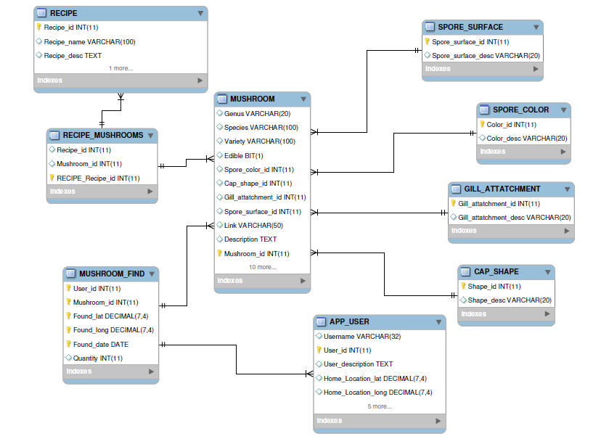
Please note that crows foot notation is used, key values are distinguished by yellow keys next to attributes, and that MUSHROOM_FIND and RECIPE_MUSHROOMS, though they appear as tables in our database, really represent M to N relationships between MUSHROOM and APP_USER and MUSHROOM and RECIPE respectively.
Here is a lower level relational diagram for the database. It is also available as diagram-1.jpg in /report
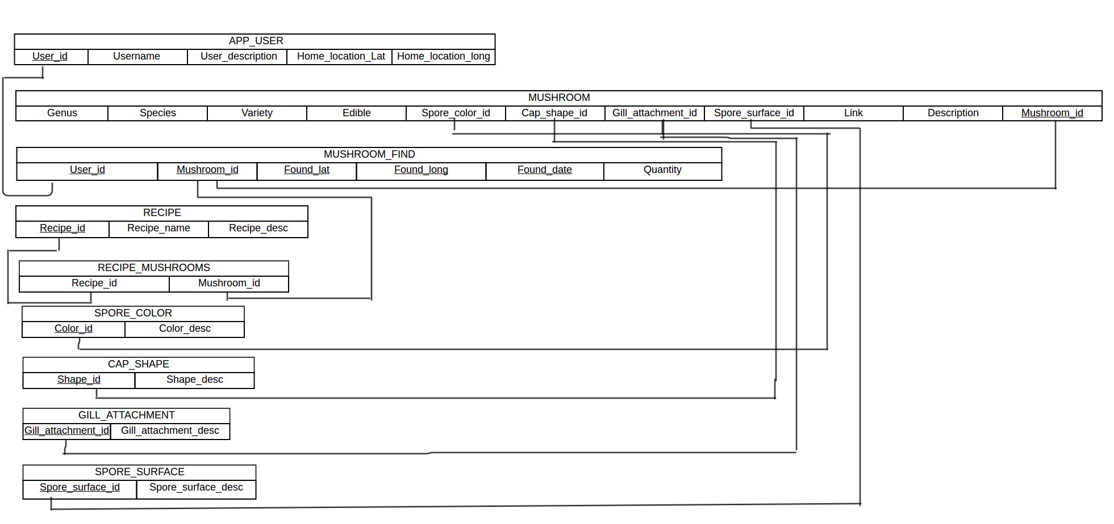

Here is the SQL DDL(it can also be found in /schema/create_all.sql:

CREATE TABLE APP_USER
(
Username VARCHAR(32) UNIQUE,
User_id INTEGER NOT NULL AUTO_INCREMENT,
User_description TEXT,
Home_Location_lat DECIMAL(7,4),
Home_Location_long DECIMAL(7,4),
PRIMARY KEY (User_id)
);

CREATE TABLE MUSHROOM
(
Genus VARCHAR(20),
Species VARCHAR(100),
Variety VARCHAR(100),
Edible BIT,
Spore_color_id INTEGER,
Cap_shape_id INTEGER,
Gill_attatchment_id INTEGER,
Spore_surface_id INTEGER,
Link VARCHAR(255),
Description TEXT,
Mushroom_id INTEGER NOT NULL AUTO_INCREMENT,
PRIMARY KEY(Mushroom_id)
);

CREATE TABLE MUSHROOM_FIND
(
User_id INTEGER,
Mushroom_id INTEGER,
Found_lat DECIMAL(7,4),
Found_long DECIMAL(7,4),
Found_date DATE,
Quantity INTEGER,
PRIMARY KEY (Mushroom_id, User_id, Found_lat, Found_long, Found_date),
FOREIGN KEY (User_id) REFERENCES APP_USER(User_id)
ON DELETE CASCADE,
FOREIGN KEY (Mushroom_id) REFERENCES MUSHROOM(Mushroom_id)
ON DELETE CASCADE
);

CREATE TABLE RECIPE
(
Recipe_id INTEGER NOT NULL AUTO_INCREMENT,
Recipe_name VARCHAR(100),
Recipe_desc TEXT,
PRIMARY KEY(Recipe_id)
);

CREATE TABLE RECIPE_MUSHROOMS
(
Recipe_id INTEGER,
Mushroom_id INTEGER,
FOREIGN KEY (Recipe_id) REFERENCES RECIPE(Recipe_id),
FOREIGN KEY (Mushroom_id) REFERENCES MUSHROOM(Mushroom_id)
);

CREATE TABLE SPORE_COLOR
(
Color_id INTEGER NOT NULL,
Color_desc VARCHAR(20),
PRIMARY KEY(Color_id),
FOREIGN KEY(Color_id) REFERENCES MUSHROOM(Spore_color_id)
);

CREATE TABLE CAP_SHAPE
(
Shape_id INTEGER NOT NULL,
Shape_desc VARCHAR(20),
PRIMARY KEY(Shape_id),
FOREIGN KEY(Shape_id) REFERENCES MUSHROOM(Cap_shape_id)
);

CREATE TABLE GILL_ATTATCHMENT
(
Gill_attatchment_id INTEGER NOT NULL,
Gill_attatchment_desc VARCHAR(20),
PRIMARY KEY(Gill_attatchment_id),
FOREIGN KEY(Gill_attatchment_id) REFERENCES MUSHROOM(Gill_attatchment_id)
);

CREATE TABLE SPORE_SURFACE
(
Spore_surface_id INTEGER NOT NULL,
Spore_surface_desc VARCHAR(20),
PRIMARY KEY(Spore_surface_id),
FOREIGN KEY(Spore_surface_id) REFERENCES MUSHROOM(Spore_surface_id)
);

Application
We decided to implement this project as a website that accesses the MySQL server using python. We were fairly comfortable with python syntax and features, so this seemed like a logical choice. Bootstrap was a good choice for us because it makes nice-looking web pages with little fuss and is mobile-friendly. WTForms provided an easy way to integrate forms and get data for database insertions and queries, and Jinja allowed us to write python-like code to generate templates, which is really nice, and as a bonus it is very performant.

Notable Features and Issues
One of the first issues we ran into was differences between MySQL and sqlite functionalities. For example, AUTO-INCREMENT and Multiple insertions are not possible using sqlite. To get around this we mad a _compat() function that strips away elements that are not supported, but in the end we decided to more or less abandon sqlite support. Additionally there were some weird floating point issues with sqlite that took some time to resolve.
Feature-wise, we used a geolocation API to grab users' latitude and longitude, and implemented a login system with authorization that can be viewed in auth.py. We also made it so the database can be reset and loaded with test information with the addition of the -r flag at runtime (i.e. python server.py -r) or run with a specified config file with the -c flag (i.e. python server.py -c config_local.json).

Requirements Met

Conclusion and Lessons Learned

