- Use Exception handling (imagine that you develop software for monkeys :))

try {  
 //running the method start()  
 driver.start();  
} catch (SQLException throwables) {  
 throwables.printStackTrace();  
}

We have used try catch method

- Your project should not be so simple. it should consist of more than 3-4 classes.

There are (if not to count Main class) 3 classes:  
Database class  
public class Database {...}

public class ElectricityBilling {...}

public class Driver {...}

- Use external data sources: DBMS.  
  
public class Database {  
 //the method that connects java to database  
 public Connection getConnection() {  
 Connection connection = null;  
 //surrounding with try and catch, in order to get an exception if something unexpected happens  
 try {  
 Class.*forName*("org.postgresql.Driver");  
 // Establish the connection  
 connection = DriverManager.*getConnection*("jdbc:postgresql://localhost:5432/newDB", "postgres", "java123");  
 } catch (ClassNotFoundException e) {  
 e.printStackTrace();  
 } catch (SQLException throwables) {  
 throwables.printStackTrace();  
 }  
   
 //returning the value of connection connected to database   
"newDB"  
 return connection;  
 }

- Provide the source code of the application and a detailed report with screenshots.  
1st case:

Calculating total energy consumption through firstChoice() method:  
Which asks how many techniques is connected and what kind of techniques.

Reading techniques from console it compares it with external database data

And gets it’s consumption from database and calculate overall consumption  
_____________________________________________________________________________   
public void firstChoice() throws SQLException {  
 Scanner s = new Scanner(System.*in*);  
 System.*out*.println("How many electrical techniques you want to add?");  
 //getting the number of techniques the user wants to insert  
 int number = s.nextInt();  
 //creating an Arraylist, to store techniques` name there (EX: kettle, fridge and etc.)  
 ArrayList<String> techniques = new ArrayList<>();  
 //creating an Arraylist, to store techniques` consumption value (EX: 10, 250 and etc.)  
 ArrayList<Integer> technique_consumption = new ArrayList<>();  
 //using loop for inserting the n number of items and saving all of them inside the "techniques" array  
 for (int i = 0; i < number; i++) {  
 System.*out*.println("Please type the name of the electrical technique: ");  
 String tempTechnique = s.next();  
 techniques.add(tempTechnique);  
 }  
 //creation of ResultSet object to get data from Database  
 ResultSet rs = null;  
 //writing a query, that will be sent to DB then  
 String query = "SELECT technique_name, technique_consumption FROM techniques WHERE technique_name = ?";  
 //this array is to get the name of exact items that user asked  
 for(int i=0; i<number; i++){  
 //creating a prepared statement, to get only those items, that user inserted  
 try (PreparedStatement ps = database.getConnection().prepareStatement(query)) {  
 ps.setString(1, techniques.get(i));  
 rs = ps.executeQuery();  
 } catch (SQLException throwables) {  
 throwables.printStackTrace();  
 }  
 rs.next();  
 //adding values that we got from query to the array "technique_consumption"  
 technique_consumption.add(rs.getInt("technique_consumption"));  
 }

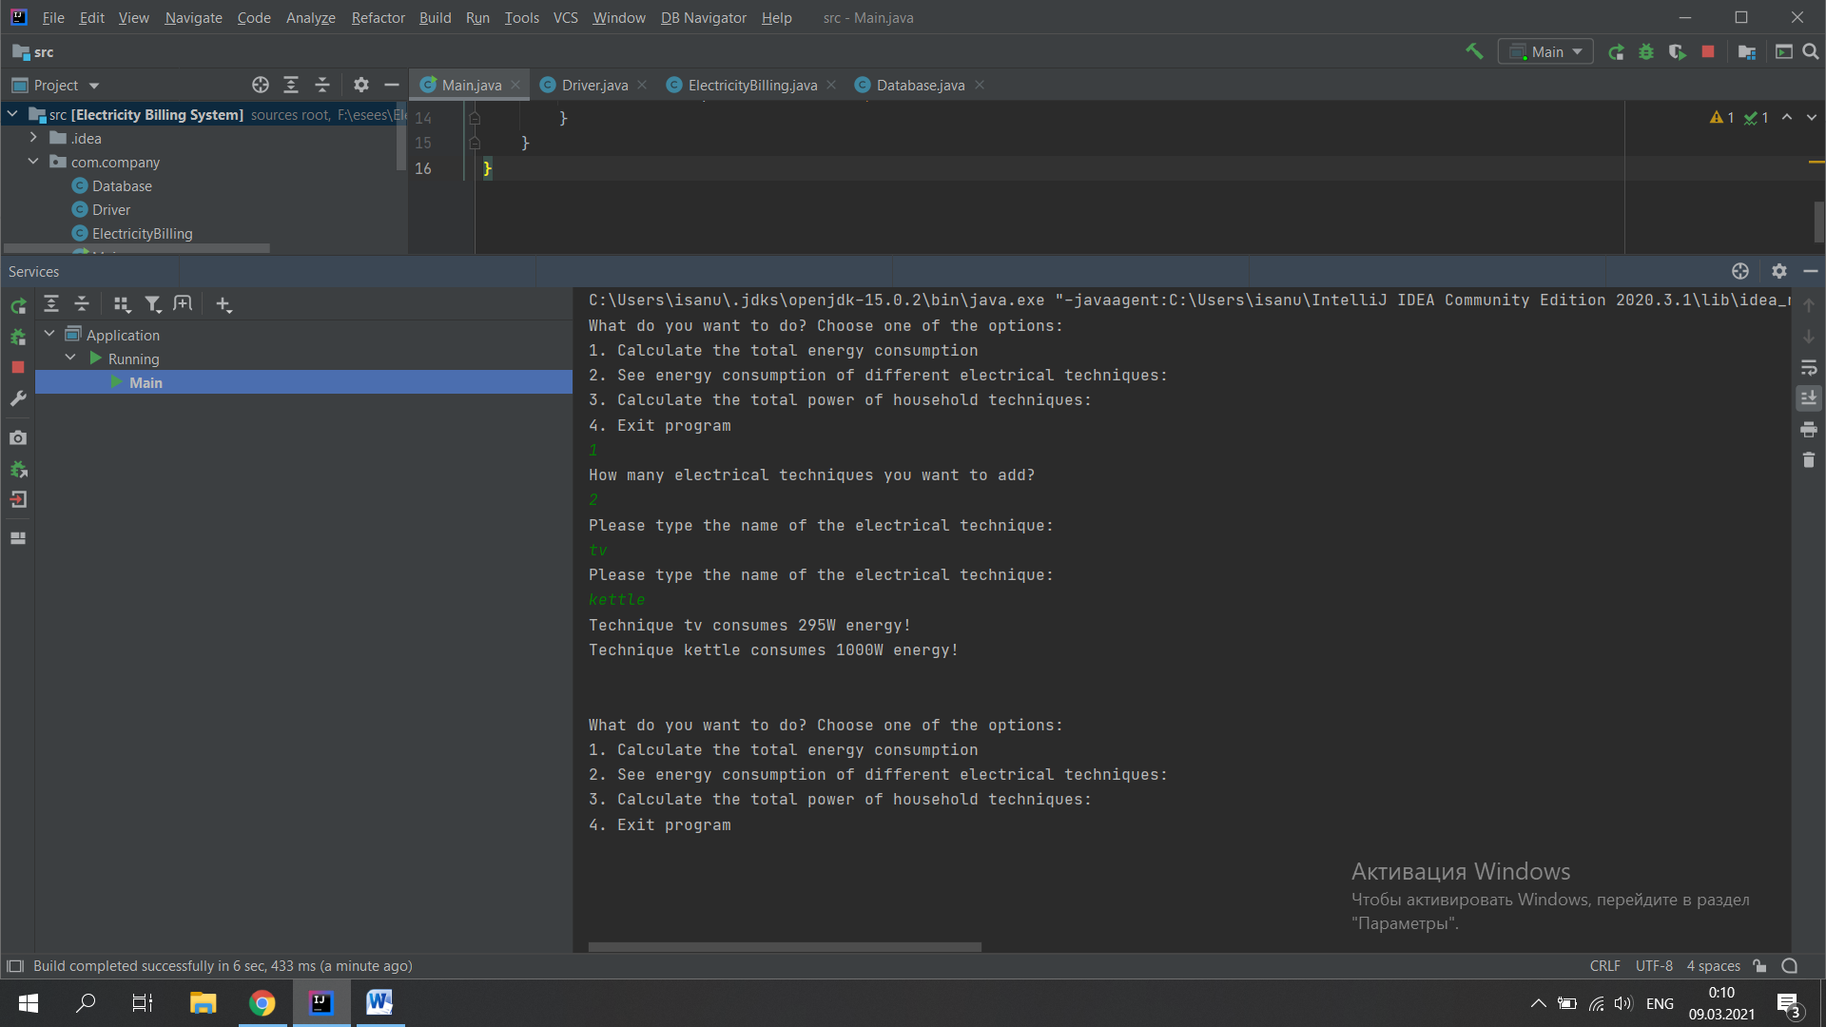  
  
2nd case:  
  
See energy consumption of different electrical techniques through secondChoice() method:  
Which take all techniques and their consumption from database and shows it in console:

public void secondChoice() throws SQLException {  
 //creation of a statement, to implement some statement  
 Statement stmt = database.getConnection().createStatement();  
 //creation of ResultSet to store the output of query execution  
 ResultSet rs = stmt.executeQuery("SELECT * FROM techniques");  
 //loop for outputting all values of ResultSet in specific format  
 while (rs.next()) {  
 String technique_name = rs.getString("technique_name");  
 int technique_consumption = rs.getInt("technique_consumption");  
 System.*out*.println(technique_name + " consumes " + technique_consumption + "W energy!");  
 }  
 //leaving a line (space)  
 System.*out*.println("\n");  
}

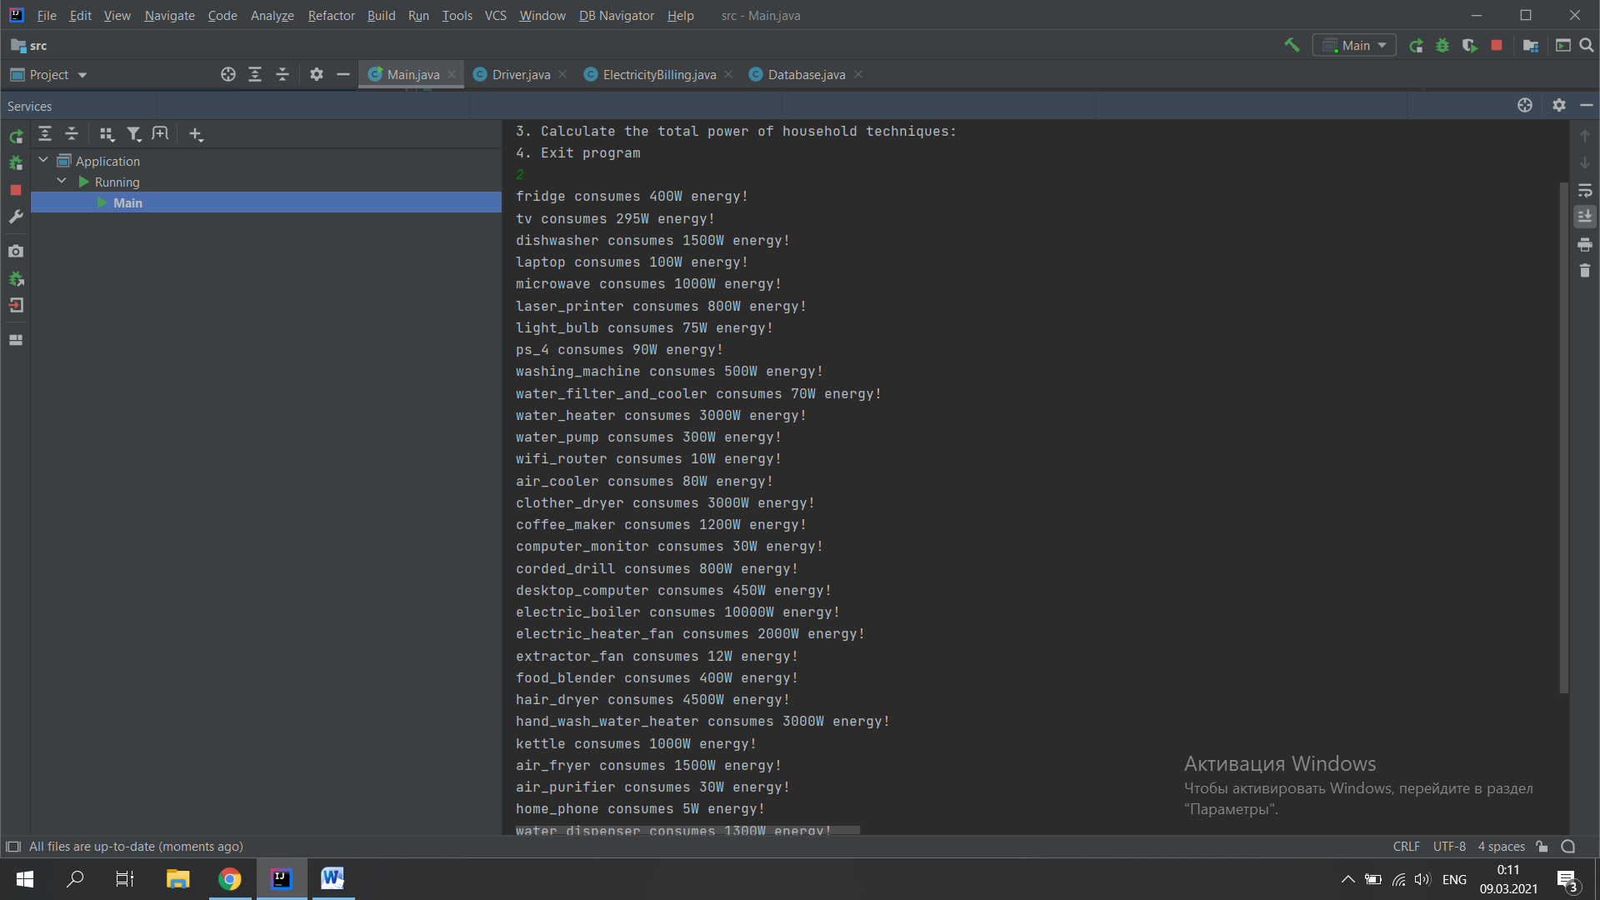  
3rd and 4th case:  
  
3. Calculate the total power of household techniques though thirdChoice() method:  
Which ask how many techniques is connected and what kind of techniques. Reading techniques from console it compares it with external database data And gets it’s consumption from database. It shows power of each technique and calculate the minimal total power of household

public void thirdChoice() {  
 //creation of scanner to read user input  
 Scanner s = new Scanner(System.*in*);  
 System.*out*.println("How many electrical techniques do you have in your house?");  
 //saving the number inputted by user to variable "number"  
 int number = s.nextInt();  
 //creation of array "techniques" to store the names of techniques  
 ArrayList<String> techniques = new ArrayList<>();  
 //creation of array "techniques" to store the names of techniques  
 ArrayList<Double> technique_power = new ArrayList<>();  
 //loop used for receiving the inputted by user values and store it in array "techniques"  
 for (int i = 0; i < number; i++) {  
 System.*out*.println("Please type the name of the electrical technique: ");  
 String tempTechnique = s.next();  
 techniques.add(tempTechnique);  
 }  
 //creating the variable "query" type of string, to store our future query  
 String query = "SELECT technique_name, technique_consumption FROM techniques WHERE technique_name = ?";  
 //creating the variable totalAmpere to use it then  
 Double totalAmpere = 0.0;  
 for (int i = 0; i < number; i++) {  
 try (PreparedStatement ps = database.getConnection().prepareStatement(query)) {  
 ps.setString(1, techniques.get(i));  
 ResultSet rs = ps.executeQuery();  
 while (rs.next()) {  
 double tempPower = rs.getDouble("technique_consumption") / 220;  
 technique_power.add(tempPower);  
 totalAmpere+=tempPower;  
 }  
 rs.close();  
 } catch (SQLException throwables) {  
 throwables.printStackTrace();  
 }  
 }  
 //outputting the list of techniques with its power  
 for (int i = 0; i < number; i++) {  
 System.*out*.println("Technique " + techniques.get(i) + " have power of " + technique_power.get(i) + " amperes!");  
 }  
 //outputting the minimum amount of amperes should support fuse in your house  
 System.*out*.println("The fuse in your house should support at least " + totalAmpere+ " amperes!");  
 //leaving a line (space)  
 System.*out*.println("\n");  
}

4. Exits app:

public void fourthChoice() throws SQLException {  
 System.*out*.println("Thank you for using our Electricity Billing System!");  
 database.getConnection().close();  
}

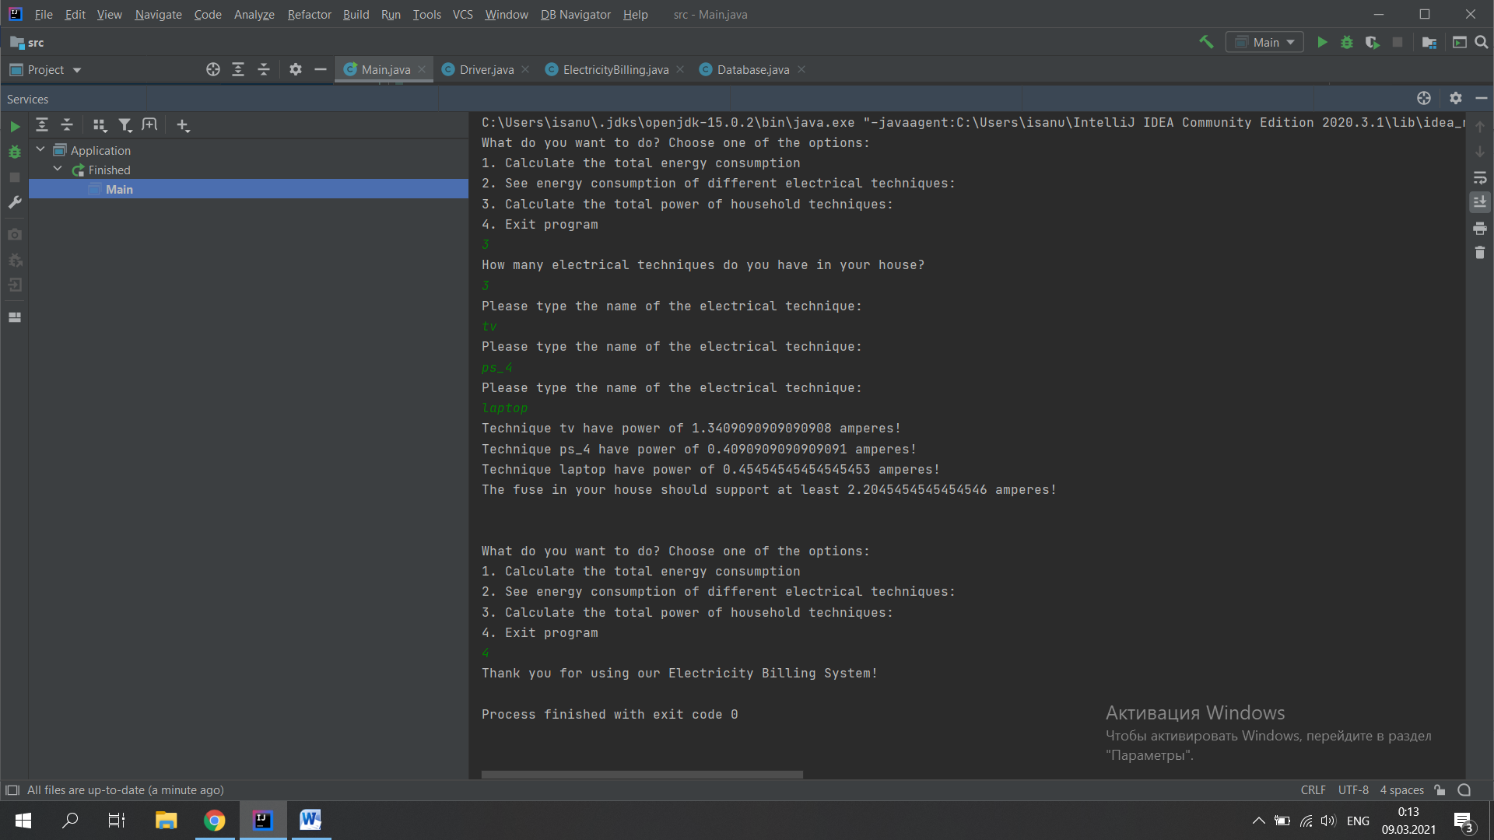

- Comment the whole code:  
_____________________________________________________________________________  
  
package com.company;  
  
import java.sql.SQLException;  
  
public class Main {  
 public static void main(String args[]) {  
 //creation of object "driver" of class "Driver" to implement its method "start()"  
 Driver driver = new Driver();  
 try {  
 //running the method start()  
 driver.start();  
 } catch (SQLException throwables) {  
 throwables.printStackTrace();  
 }  
 }  
}  
_______________________________________________________________________________________________________________________________________________________________________________________________________________________________________

package com.company;  
//importing the libraries to use it then (here we will use SQLException class and Scanner)  
import java.sql.SQLException;  
import java.util.Scanner;  
//class Driver, object of which will be called in main class  
public class Driver {  
 //the only method of class Driver. It will be called from main class and will start the main process of the program  
 public void start() throws SQLException {  
 ElectricityBilling eb = new ElectricityBilling();  
 //creating the scanner to let user insert values by keyboard  
 Scanner s = new Scanner(System.*in*);  
 //using while loop, in order to create an endless loop (this is needed to work with console)  
 while (true) {  
 //these lines of code will appear in console  
 System.*out*.println("What do you want to do? Choose one of the options:");  
 System.*out*.println("1. Calculate the total energy consumption");  
 System.*out*.println("2. See energy consumption of different electrical techniques:");  
 System.*out*.println("3. Calculate the total power of household techniques: ");  
 System.*out*.println("4. Exit program");  
 //getting the number inserted by user  
 int input = s.nextInt();  
 //if user inserts "1"  
 if (input == 1) {  
 //calling the method firstChoice of the object eb  
 eb.firstChoice();  
 continue;  
 }  
 //if user inserts "2"  
 if (input == 2){  
 //calling the method secondChoice of the object eb  
 eb.secondChoice();  
 continue;  
 }  
 //if user inserts "3"  
 if (input == 3){  
 //calling the method h of the object eb  
 eb.thirdChoice();  
 continue;  
 }  
 //if user inserts "4" or anything else  
 else {  
 //calling the method fourthChoice of the object eb  
 eb.fourthChoice();  
 //ending the loop, consequently the function  
 break;  
 }  
 }  
 }  
}

_______________________________________________________________________________________________________________________________________________________________________________________________________________________________________  
  
package com.company;  
//importing specific libraries for using it then(Arrays, Using a console)  
import java.sql.PreparedStatement;  
import java.sql.ResultSet;  
import java.sql.SQLException;  
import java.sql.Statement;  
import java.util.ArrayList;  
import java.util.Scanner;  
  
public class ElectricityBilling {  
 Database database = new Database();  
 public void firstChoice() throws SQLException {  
 Scanner s = new Scanner(System.*in*);  
 System.*out*.println("How many electrical techniques you want to add?");  
 //getting the number of techniques the user wants to insert  
 int number = s.nextInt();  
 //creating an Arraylist, to store techniques` name there (EX: kettle, fridge and etc.)  
 ArrayList<String> techniques = new ArrayList<>();  
 //creating an Arraylist, to store techniques` consumption value (EX: 10, 250 and etc.)  
 ArrayList<Integer> technique_consumption = new ArrayList<>();  
 //using loop for inserting the n number of items and saving all of them inside the "techniques" array  
 for (int i = 0; i < number; i++) {  
 System.*out*.println("Please type the name of the electrical technique: ");  
 String tempTechnique = s.next();  
 techniques.add(tempTechnique);  
 }  
 //creation of ResultSet object to get data from Database  
 ResultSet rs = null;  
 //writing a query, that will be sent to DB then  
 String query = "SELECT technique_name, technique_consumption FROM techniques WHERE technique_name = ?";  
 //this array is to get the name of exact items that user asked  
 for(int i=0; i<number; i++){  
 //creating a prepared statement, to get only those items, that user inserted  
 try (PreparedStatement ps = database.getConnection().prepareStatement(query)) {  
 ps.setString(1, techniques.get(i));  
 rs = ps.executeQuery();  
 } catch (SQLException throwables) {  
 throwables.printStackTrace();  
 }  
 rs.next();  
 //adding values that we got from query to the array "technique_consumption"  
 technique_consumption.add(rs.getInt("technique_consumption"));  
 }  
 //loop for outputting consumption in specific format  
 for (int i = 0; i < number; i++) {  
 System.*out*.println("Technique " + techniques.get(i) + " consumes " + technique_consumption.get(i) + "W energy!");  
 }  
 //leaving a line (space)  
 System.*out*.println("\n");  
 }  
 public void secondChoice() throws SQLException {  
 //creation of a statement, to implement some statement  
 Statement stmt = database.getConnection().createStatement();  
 //creation of ResultSet to store the output of query execution  
 ResultSet rs = stmt.executeQuery("SELECT * FROM techniques");  
 //loop for outputting all values of ResultSet in specific format  
 while (rs.next()) {  
 String technique_name = rs.getString("technique_name");  
 int technique_consumption = rs.getInt("technique_consumption");  
 System.*out*.println(technique_name + " consumes " + technique_consumption + "W energy!");  
 }  
 //leaving a line (space)  
 System.*out*.println("\n");  
 }  
 public void thirdChoice() {  
 //creation of scanner to read user input  
 Scanner s = new Scanner(System.*in*);  
 System.*out*.println("How many electrical techniques do you have in your house?");  
 //saving the number inputted by user to variable "number"  
 int number = s.nextInt();  
 //creation of array "techniques" to store the names of techniques  
 ArrayList<String> techniques = new ArrayList<>();  
 //creation of array "techniques" to store the names of techniques  
 ArrayList<Double> technique_power = new ArrayList<>();  
 //loop used for receiving the inputted by user values and store it in array "techniques"  
 for (int i = 0; i < number; i++) {  
 System.*out*.println("Please type the name of the electrical technique: ");  
 String tempTechnique = s.next();  
 techniques.add(tempTechnique);  
 }  
 //creating the variable "query" type of string, to store our future query  
 String query = "SELECT technique_name, technique_consumption FROM techniques WHERE technique_name = ?";  
 //creating the variable totalAmpere to use it then  
 Double totalAmpere = 0.0;  
 for (int i = 0; i < number; i++) {  
 try (PreparedStatement ps = database.getConnection().prepareStatement(query)) {  
 ps.setString(1, techniques.get(i));  
 ResultSet rs = ps.executeQuery();  
 while (rs.next()) {  
 double tempPower = rs.getDouble("technique_consumption") / 220;  
 technique_power.add(tempPower);  
 totalAmpere+=tempPower;  
 }  
 rs.close();  
 } catch (SQLException throwables) {  
 throwables.printStackTrace();  
 }  
 }  
 //outputting the list of techniques with its power  
 for (int i = 0; i < number; i++) {  
 System.*out*.println("Technique " + techniques.get(i) + " have power of " + technique_power.get(i) + " amperes!");  
 }  
 //outputting the minimum amount of amperes should support fuse in your house  
 System.*out*.println("The fuse in your house should support at least " + totalAmpere+ " amperes!");  
 //leaving a line (space)  
 System.*out*.println("\n");  
 }  
 public void fourthChoice() throws SQLException {  
 System.*out*.println("Thank you for using our Electricity Billing System!");  
 database.getConnection().close();  
 }  
  
  
}

_______________________________________________________________________________________________________________________________________________________________________________________________________________________________________  
  
  
  
package com.company;  
//importing specific library of sql, so that we could use it then  
import java.sql.*;  
//in class Database, most part of the code will be written, in order to keep main class clear  
public class Database {  
 //the method that connects java to database  
 public Connection getConnection() {  
 Connection connection = null;  
 //surrounding with try and catch, in order to get an exception if something unexpected happens  
 try {  
 Class.*forName*("org.postgresql.Driver");  
 // Establish the connection  
 connection = DriverManager.*getConnection*("jdbc:postgresql://localhost:5432/newDB", "postgres", "java123");  
 } catch (ClassNotFoundException e) {  
 e.printStackTrace();  
 } catch (SQLException throwables) {  
 throwables.printStackTrace();  
 }  
  
 //returning the value of connection connected to database "ElectricityBillingSystem"  
 return connection;  
 }  
}