**Tittle page**

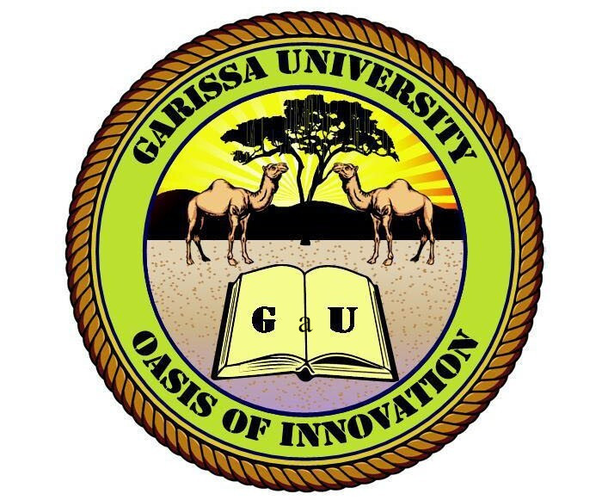

**Name: Noor Hafow Bare**

**Reg Number: S110/p2234/23**

**School of pure and applied science**

**Department of information science**

**Unit Name: LIBRARY & Information literacy skills**

**Unit code: GCC 121**

**Question 1: Critically analyze the role of information literacy in combating misinformation and disinformation in the digital age. Include a discussion on the skills required, the challenges faced, and the strategies to enhance information literacy among different demographics. Introduction**

In the digital age, the prevalence of misinformation and disinformation poses a significant threat to individuals and communities. The rapid spread of false information via digital platforms has intensified these challenges. Information literacy, as a critical skill, empowers individuals to evaluate and use information responsibly, thus playing a vital role in addressing this issue.

**Main Points**

1. **Skills Required for Information Literacy**  
   Information literacy requires:
   * **Critical Thinking**: Assessing the credibility and validity of information.
   * **Digital and Media Literacy**: Navigating and analyzing online and media content.
   * **Research Competence**: Locating, interpreting, and applying reliable information.
2. **Challenges in Combating Misinformation**
   * **Cognitive Biases**: People tend to accept information that aligns with their beliefs.
   * **Algorithmic Amplification**: Platforms often prioritize engagement over accuracy.
   * **Access Disparities**: Unequal access to education and information resources.
   * **Overwhelming Data**: The sheer volume of content complicates discernment.
3. **Strategies to Enhance Information Literacy**
   * **Education Integration**: Incorporate information literacy in school curricula.
   * **Community Outreach**: Engage local communities with workshops and training.
   * **Public Awareness Campaigns**: Raise awareness about the dangers of misinformation.
   * **Stakeholder Collaboration**: Partner with educators, tech companies, and governments.

**Conclusion**

Information literacy is essential for combating the spread of misinformation and disinformation in the digital era. By fostering critical evaluation skills and leveraging collective strategies, societies can build resilience against the manipulation of information. Enhancing these skills across demographics ensures both individual and societal empowerment in a rapidly evolving information landscape.

**Question 2: Evaluate the effectiveness of current information literacy programs in higher education. What are the strengths and weaknesses of these programs, and how can they be improved to better prepare students for the information-rich environment of the 21st century?**

Higher education institutions are pivotal in equipping students with information literacy skills, enabling them to navigate a complex information ecosystem. While many programs are well-structured, there is room for growth to address real-world challenges effectively.

**Main Points**

1. **Strengths of Information Literacy Programs**
   * **Curriculum Integration**: Embedding literacy into coursework improves research capabilities.
   * **Technological Resources**: Access to databases, tools, and libraries enhances learning.
   * **Collaborative Learning**: Encourages teamwork and shared knowledge acquisition.
2. **Weaknesses of Information Literacy Programs**
   * **Inconsistencies**: Implementation varies greatly across institutions.
   * **Limited Real-World Focus**: Programs often emphasize academic skills over practical applications.
   * **Neglect of Digital Literacy**: Insufficient emphasis on navigating modern digital platforms.
3. **Recommendations for Improvement**
   * **Gamification**: Use engaging, interactive methods to teach literacy skills.
   * **Social Media Literacy**: Address the nuances of evaluating social media content.
   * **Continuous Training**: Offer ongoing development for both students and educators.
   * **Tailored Approaches**: Adapt programs to meet diverse student backgrounds and needs.

**Conclusion**

Information literacy programs in higher education have made progress in preparing students for academic success. To ensure these programs address the complexities of the modern information landscape, they must evolve to focus on practical skills, digital literacy, and inclusive methodologies. By embracing innovative strategies, institutions can better prepare students for critical engagement with information in all aspects of life.

**References**

1. American Library Association. (2016). *Framework for Information Literacy for Higher Education*.
2. Vosoughi, S., Roy, D., & Aral, S. (2018). The spread of true and false news online. *Science, 359*(6380), 1146–1151. https://doi.org/10.1126/science.aap9559
3. UNESCO. (2021). *Media and Information Literacy: A Practical Guide for Teachers*.
4. Wineburg, S., & McGrew, S. (2017). Lateral reading: Reading less and learning more when evaluating digital information. *Stanford History Education Group*.
5. Zubiaga, A., Aker, A., Batsheva, K., Lia kata, M., & Procter, R. (2018). Detection and resolution of rumors in social media: A survey. *ACM Computing Surveys, 51*(2), 1–36. https://doi.org/10.1145/3161603