Endpoint 1:

1. Test Status 200

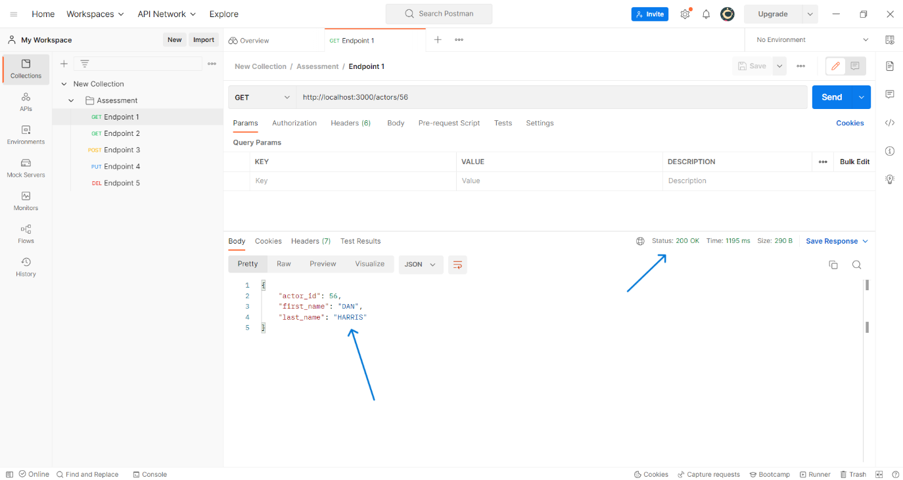

1. Test Case 204

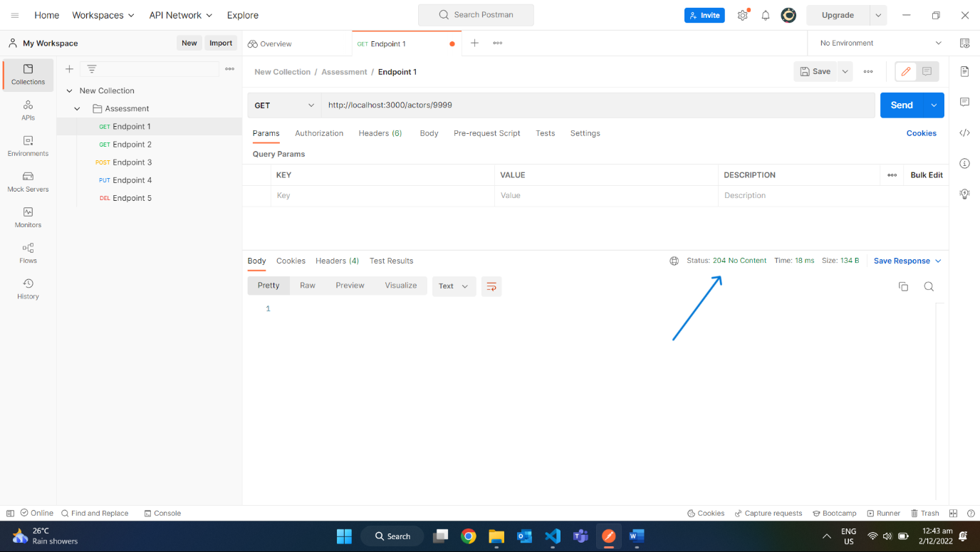

1. Test Case 500 with wrong PW

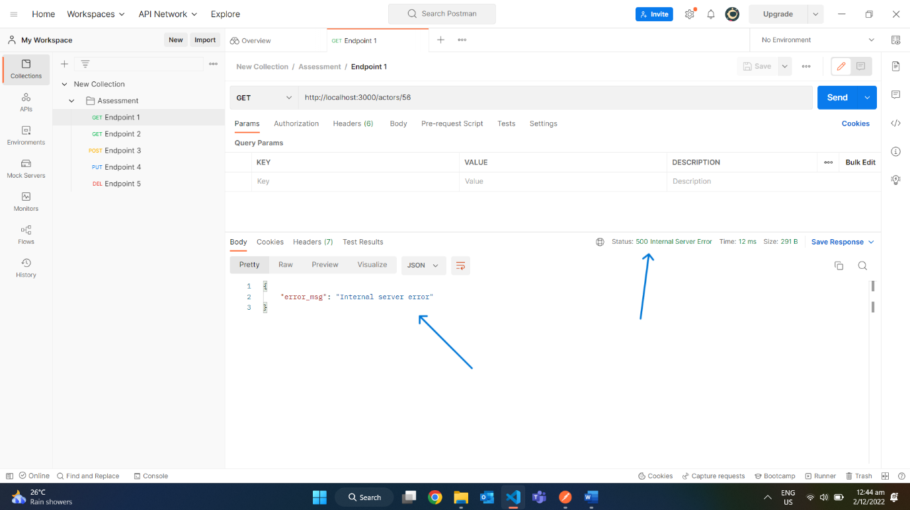

Endpoint 3:

1. Test Status 200

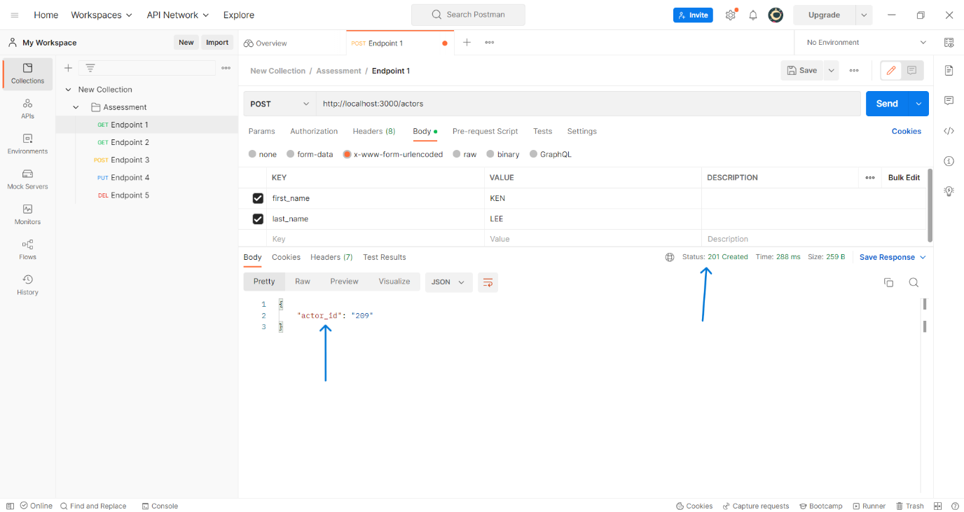

*Double Check if Record Exist Using Endpoint 1’s Get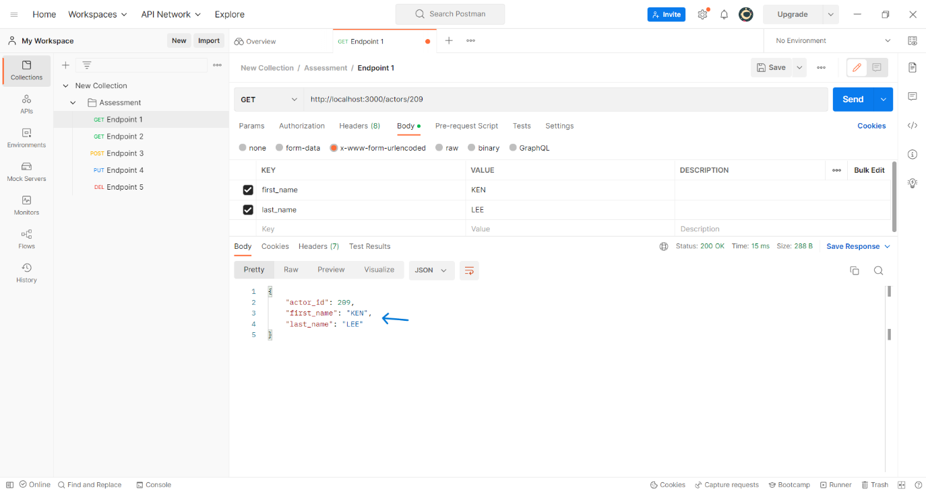

1. Test Case 400

* Missing first_name

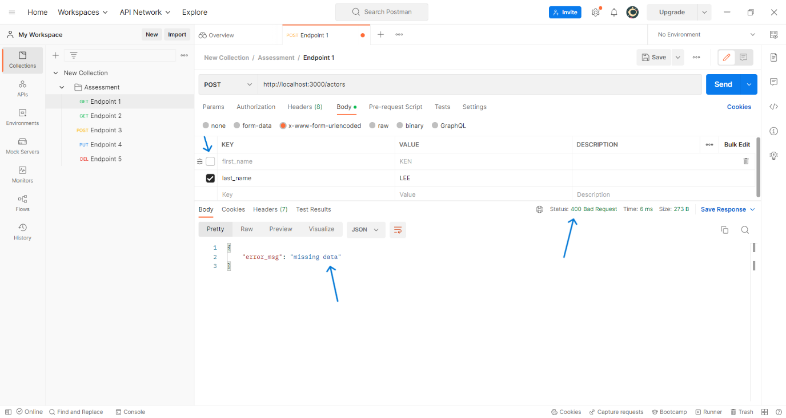

* Missing last_name

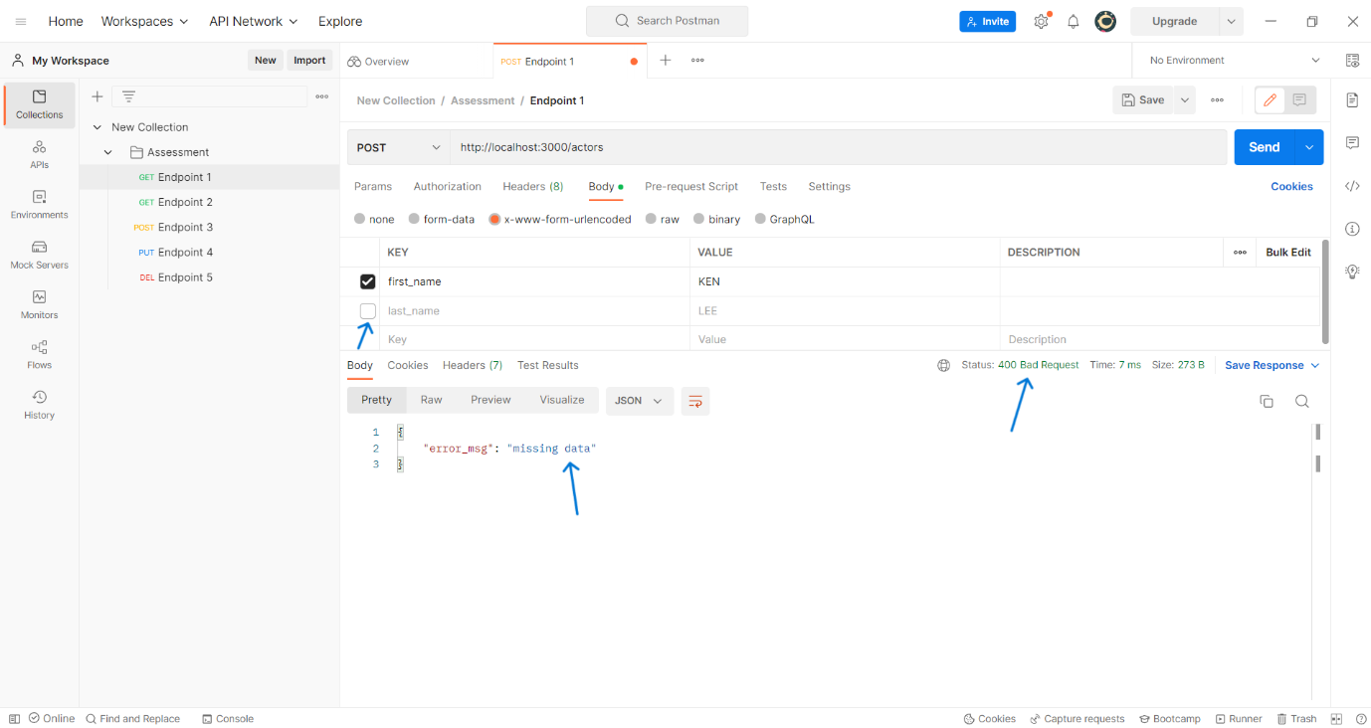

* Missing both first_name and last_name

1. Test Case 500 with wrong PW

