AI4X Conference 2027 abstract template and formatting guidelines
First Author ^{* 1} Presenting Author ^{* 2} Middle Author ² ¹ Last Author ³
*Equal contribution ¹Olympus Academy of Mountaineering, Mytikas, Greece 402 00 ²University of Underwater Studies, Atlantis 341 ³University of Nowhere
Correspondence to: Last Author dropides@void.ai, Middle Author boss@underworld.ai

Introduction
The page limit is two pages, not counting the acknowledgments, references, and appendices. Please do not change the font sizes, margins or line spacing to squeeze more text.
The review is single-blind: the reviewers see the author names, so do not anonymize your submission. At least one author must be listed after “Correspondence to”. ORCID links for the authors will make it easier for the readers to find you, but are not mandatory; to link an iD icon to your record, right-click it and choose Link.
AI4X is non-archival: an accepted abstract is not a formal publication, so you are free to publish the work later in a journal or in conference proceedings.

Working with the template
Use the styles of the template: Heading 1 and Heading 2 number the sections, Unnumbered Heading is for the acknowledgments and references, and Appendix Heading for the appendices. The numbers of the figures, tables, and equations, and the references to them, are fields: after moving things around, select all (Ctrl+A) and press F9 to update them.
The template embeds its font, Source Serif 4, so it looks the same on computers that do not have the font installed. Please submit a PDF, and check in it that the bold and italic text and the equations look right. Fill the title, the authors, and the keywords in File → Info → Properties: they become the PDF metadata, which improves search discoverability.

Substantial section
If you want to, you can split the text into sections. An AI4X abstract is not a journal paper, so there is no hard requirement for the work to be reproducible from the text. At the same time, the reviewers and, ultimately, your fellow attendees look for novelty, significance, and soundness – the abstract must convey what was done, why, and the validation results. It can include equations, such as Equation (1). If the abstract is based on your previously published work, it should be clearly stated and cited.
$\left(\lim_{x→8^{\text{+}}}{\frac{1}{x−8}=∞}\right)⇒\left(\lim_{x→3^{\text{+}}}{\frac{1}{x−3}=ω}\right)$ (1)

Related work
A good way to show novelty is to state the difference from the related work, for example, on protein structure prediction [1], graph neural networks (GNNs) for molecules and materials [2, 3], materials discovery at scale [4], or autonomous laboratories [5]. An overview of the previous state of the field can be found in the AI4X Roadmap from a previous conference edition [6].

Figures and tables
Figure 1 and Table 1 are single-column, but two-column layout can also be used: put the figure or table in a one-column section between two continuous section breaks (Layout → Breaks, Layout → Columns).
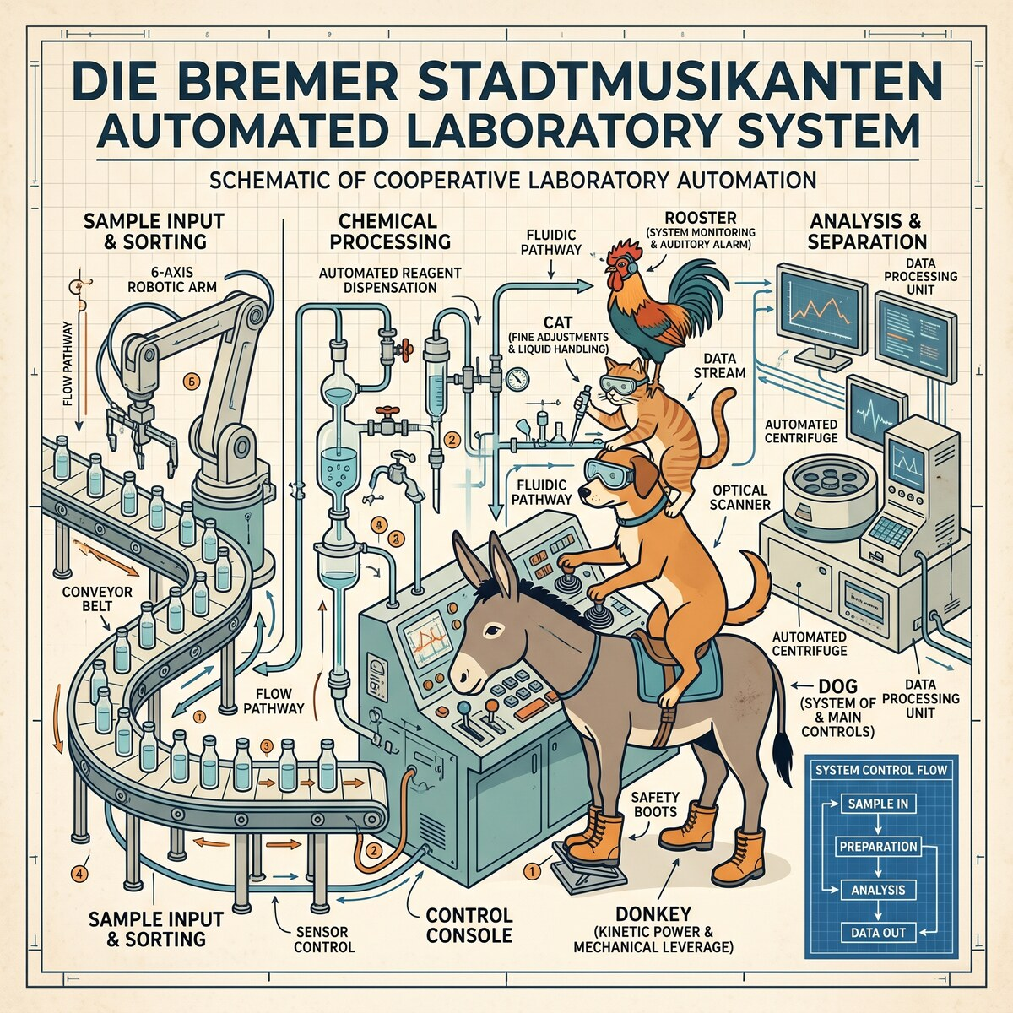
Figure 1: Collaboration was just as important to the success of the study as automation. The illustration was generated with Google Gemini (Nano Banana), and its defects are kept on purpose.
Table 1: Formation energy prediction on a held-out test set: mean absolute error (MAE, mean ± standard deviation over five random seeds), R², and inference time per structure. The best values are in bold; the numbers are illustrative.
Model | MAE ↓  meV/atom | R² ↑ | Time ↓  ms
Random forest | 85 ± 3 | 0.91 | 0.4
GNN | 33 ± 2 | 0.98 | 2.1
Ours | 28 ± 1 | 0.99 | 1.5

AI Acknowledgments
Figure 1 was generated with Google Gemini (Nano Banana), and this Word template was converted from the LaTeX template [8] with Claude Code (Claude Opus 5.5).
At AI4X, we welcome the new AI age and believe that, used well, AI can do much more than produce “AI slop”. You are welcome to share how you used AI to prepare the work, be it grammar checking or doing the study end-to-end. This is not mandatory and is not included in the page limit. Whatever tools you use, the authors are fully responsible for the submission, including any text, code, figures, and references produced with AI; in particular, check that every cited work exists [7]. You can use reference-audit to run the checks yourself on the PDF of your abstract.

Acknowledgments
Acknowledgments and references are not numbered and not included in the page limit – feel free to give credit where it’s due. This Word template follows the AI4X 2027 LaTeX template [8], which is based on the unofficial International Astronautical Congress template [9].

References
[1] John Jumper et al. Highly accurate protein structure prediction with AlphaFold. Nature, 596(7873):583–589, 2021. doi:10.1038/s41586-021-03819-2.
[2] Kristof Schütt, Pieter-Jan Kindermans, Huziel Enoc Sauceda Felix, Stefan Chmiela, Alexandre Tkatchenko, and Klaus-Robert Müller. SchNet: A continuous-filter convolutional neural network for modeling quantum interactions. In Advances in Neural Information Processing Systems, volume 30. Curran Associates, Inc., 2017. URL: https://proceedings.neurips.cc/paper_files/paper/2017/file/303ed4c69846ab36c2904d3ba8573050-Paper.pdf.
[3] Tian Xie and Jeffrey C. Grossman. Crystal graph convolutional neural networks for an accurate and interpretable prediction of material properties. Physical Review Letters, 120(14):145301, 2018. doi:10.1103/PhysRevLett.120.145301.
[4] Amil Merchant, Simon Batzner, Samuel S. Schoenholz, Muratahan Aykol, Gowoon Cheon, and Ekin Dogus Cubuk. Scaling deep learning for materials discovery. Nature, 624(7990):80–85, 2023. doi:10.1038/s41586-023-06735-9.
[5] Benjamin Burger et al. A mobile robotic chemist. Nature, 583(7815):237–241, 2020. doi:10.1038/s41586-020-2442-2.
[6] Stephen G. Dale, Nikita Kazeev, Alastair J. A. Price, Victor Posligua, Stephan Roche, O. Anatole von Lilienfeld, Konstantin S. Novoselov, Xavier Bresson, Gianmarco Mengaldo, Xudong Chen, Terence J. O’Kane, Emily R. Lines, Matthew J. Allen, Amandine E. Debus, Clayton Miller, Jiayu Zhou, Hiroko H. Dodge, David Rousseau, Andrey Ustyuzhanin, Ziyun Yan, Mario Lanza, Fabio Sciarrino, Ryo Yoshida, Zhidong Leong, Teck Leong Tan, Qianxiao Li, Adil Kabylda, Igor Poltavsky, Alexandre Tkatchenko, Sherif Abdulkader Tawfik, Prathami Divakar Kamath, Theo Jaffrelot Inizan, Kristin A. Persson, Bryant Y. Li, Vir Karan, Chenru Duan, Haojun Jia, Qiyuan Zhao, Hiroyuki Hayashi, Atsuto Seko, Isao Tanaka, Omar M. Yaghi, Tim Gould, Bun Chan, Stefan Vuckovic, Tianbo Li, Min Lin, Zehcen Tang, Yang Li, Yong Xu, Amrita Joshi, Xiaonan Wang, Leonard W. T. Ng, Sergei V. Kalinin, Mahshid Ahmadi, Jiyizhe Zhang, Shuyuan Zhang, Alexei Lapkin, Ming Xiao, Zhe Wu, Kedar Hippalgaonkar, Limsoon Wong, Lorenzo Bastonero, Nicola Marzari, Dorye Luis Esteras Cordoba, Andrei Tomut, Alba Quinones Andrade, and Jose-Hugo Garcia. Ai4x roadmap: Artificial intelligence for the advancement of scientific pursuit and its future directions, 2025. URL: https://arxiv.org/abs/2511.20976, arXiv:2511.20976.
[7] AI4X Program Committee. Hallucinated citations and Desk Rejections – is there a connection? Nature, 2028.
[8] Nikita Kazeev. AI4X Conference 2027 abstract template. https://github.com/kazeevn/AI4X-Abstract-Template, 2026.
[9] John O. Woods, Davide Grande, and Stefano Farì. International Astronautical Congress LaTeX template. https://github.com/grande-dev/International-Astronautical-Congress-LaTeX-template, 2025.
- My title
A paper may contain an unlimited number of appendices which don’t count towards the page limit, but the reviewers are not required to read them.

