RESULT PROCESSING SYSTEM
  - Concise Project Report and User Manual



Department of Computer Science and Engineering
Institute of Science and Technology
National University, Bangladesh

Submitted by
Kazi Saif Hossain Emon
Student ID 22075
Session 2021–2022
Registration No. ______________________________

Submitted to
Supervisor name _____________________________
Designation __________________________________
Course name and code _________________________
Submission date ______________________________
A project report on academic record management, assessment entry, result publication and student result viewing.

Preliminary Statements and Contents

Abstract
The Result Processing System is a local web application that connects academic setup, teacher assessment and student result viewing. Administrators maintain departments, sessions, students, teachers and courses; configure academic batches; assign teachers; and publish reviewed results. Teachers enter marks only for assigned course and session combinations. Students view their own published grades, semester GPA and overall CGPA. Fixed core enrollment reduces repeated setup, while separate current and processing semesters support delayed result publication. The application uses FastAPI, SQLAlchemy, SQLite and a browser interface. Automated tests and a fictional browser demonstration verify the implemented workflow. This concise report presents the requirements, design, implementation, testing, limitations and operating instructions.

Declaration
I declare that this report describes my Result Processing System project. External technical documentation and the formatting reference are acknowledged in the references. The implementation, calculations and limitations are presented for academic evaluation.
Signature _______________________ Date _______________________
Kazi Saif Hossain Emon Student ID 22075

Acknowledgement
I thank my supervisor and the Department of Computer Science and Engineering at IST for their guidance and support. I also acknowledge the official documentation and development tools used to implement and document the software.

Contents
Section | Page
Chapters 1 to 3 Background and feasibility | 3
Chapter 4 Requirements and rules | 4
Chapter 5 Architecture and database design | 5–6
Chapter 6 Implementation and interface | 7–8
Chapters 7 and 8 Testing and conclusion | 9
User manual Administrator | 10
User manual Teacher and student | 11
Maintenance and references | 12

Chapters 1 to 3 Background and Feasibility

1 Introduction and problem statement
Academic results must identify the correct student, course, session and semester. Separate registers and spreadsheets can lead to repeated entry, inconsistent course lists and accidental access to the wrong batch. RPS brings these relationships into one controlled workflow: academic setup, course enrollment, teacher assignment, assessment entry, administrative review and publication.
The prepared CSE 2021–2022 batch is currently studying Semester 7, while Semester 6 results are to be processed. RPS therefore stores current semester and result processing semester separately. Enrollment in a future course creates no grade until eligible marks are saved.

1.1 Objectives and scope
The objectives are to maintain consistent academic records, apply the fixed core curriculum automatically, restrict teachers to assigned offerings, validate marks, calculate grades and credit weighted GPA, and show students only their own published results. The local application also supports CSV imports, temporary passwords, first login password changes and database backup.
The prepared curriculum contains 81 courses: 53 core, 14 optional theory and 14 optional lab courses. Seventy registered students generate 3,710 fixed core enrollments across all semesters, including 490 Semester 6 enrollments. Nine teachers are registered. Electives are selected separately for Semester 8.

2 Relevant concepts and existing approach
A spreadsheet is flexible but depends heavily on manual control of formulas, versions and access. RPS stores shared records in a relational database and enforces role and ownership checks at the server. Role based access control separates administrative operations, teaching responsibilities and student visibility [1, 3]. Foreign keys and unique constraints preserve relationships and prevent duplicate academic registrations [2].
The frontend sends requests to FastAPI; SQLAlchemy manages database access. A revision number protects marks from stale saves and outdated publication decisions. Publication changes the visibility of an existing result rather than creating a separate result copy.

3 Feasibility
Area | Assessment
Technical | Python backend, SQLite storage and an ordinary modern browser support a local demonstration.
Economic | No paid hosting or software subscription is required for local use. Printing and deployment costs remain separate.
Operational | Three role specific workspaces follow the academic setup, marks and publication workflow.
Schedule | The local workflow is implemented and tested. Teaching assignments and approved demonstration marks still require administrator input.

Chapter 4 Requirements and Academic Rules

4.1 Roles and functional requirements
Role | Responsibilities
Administrator | Maintain registries; import students and teachers; configure batches; assign teachers; create or reset accounts; review and publish results.
Teacher | View assigned course and session combinations; enter or revise draft assessment marks; change own password.
Student | View own published marks, grades, semester GPA and CGPA; change own password.

4.2 Core rules
1. A batch is identified by department and session. The processing semester must not exceed the current semester.
2. All configured core courses are enrolled automatically. Repeating synchronization must not create duplicates. Semester 8 permits at most one optional theory and one optional lab per student.
3. Teaching permission depends on teacher code, course code and session. Future semester marks remain locked until the batch reaches that semester.
4. All four assessment components are required. Values must be finite, within their limits and have at most two decimal places.
5. Only administrators publish or unpublish results. Published marks are locked for teacher editing until an administrator unpublishes them.
6. A changed revision rejects an outdated save or publication request. Reload and review the latest record before trying again.
7. Saved marks protect academic history. Credit changes and enrollment deletion are restricted when they would affect existing results.

4.3 Quality and privacy requirements
The backend must enforce roles and ownership for every protected operation, validate input, hash passwords, expire access tokens and reject unauthorized access. Students cannot retrieve another student’s result. CSV preview must validate the full batch before committing any rows. Clear validation messages, searchable records and visible teacher names and codes support usability.

4.4 Environment
The project uses Python, FastAPI, SQLAlchemy, SQLite, Pydantic, PyJWT and pwdlib. The frontend uses HTML, CSS and JavaScript without a frontend build step. A computer with Python, available storage and a modern browser is required. The default local address is http://127.0.0.1:8001. These are project requirements, not measured minimum hardware specifications.

Chapter 5 System Architecture
RPS has a browser interface, application layer and relational persistence layer. The browser calls the API from the same origin. The server checks identity, role and academic scope before executing an operation. SQLAlchemy sessions provide transaction boundaries for database changes.
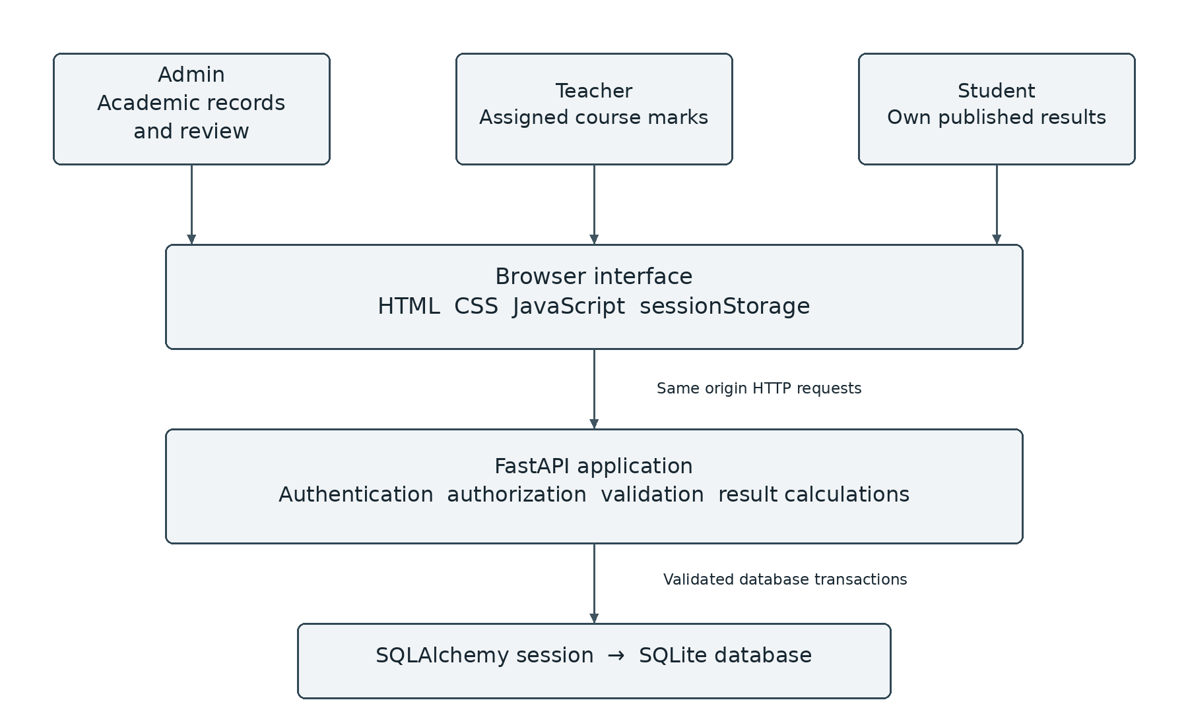
Figure 5.1 Application architecture

5.1 Main processing flow
Administrator setup → automatic core enrollment → session specific teacher assignment → teacher saves draft marks → administrator reviews and publishes → student views published results. Unpublishing returns the result to draft for correction.

5.2 Interface and transaction design
Forms show names together with public codes. Search and department, session and semester filters narrow records. Totals and grade points are calculated by the server. CSV imports and enrollment changes are validated and committed as a group. A rejected import writes no rows. Conditional updates compare the submitted revision with the stored revision to prevent silent overwrites.

5.3 Authentication and accounts
Academic registration and login accounts are separate. Administrators provision teacher and student accounts and receive a temporary password once. First login requires a password change. Password changes and resets invalidate existing tokens through a token version check. Access tokens expire after one hour and are held in browser session storage [1].

Chapter 5 Database Design
Ten tables represent academic records and access accounts. Departments and sessions identify batches. Enrollments connect students and courses; one marks record belongs to one enrollment. Teacher assignments also identify the academic session.
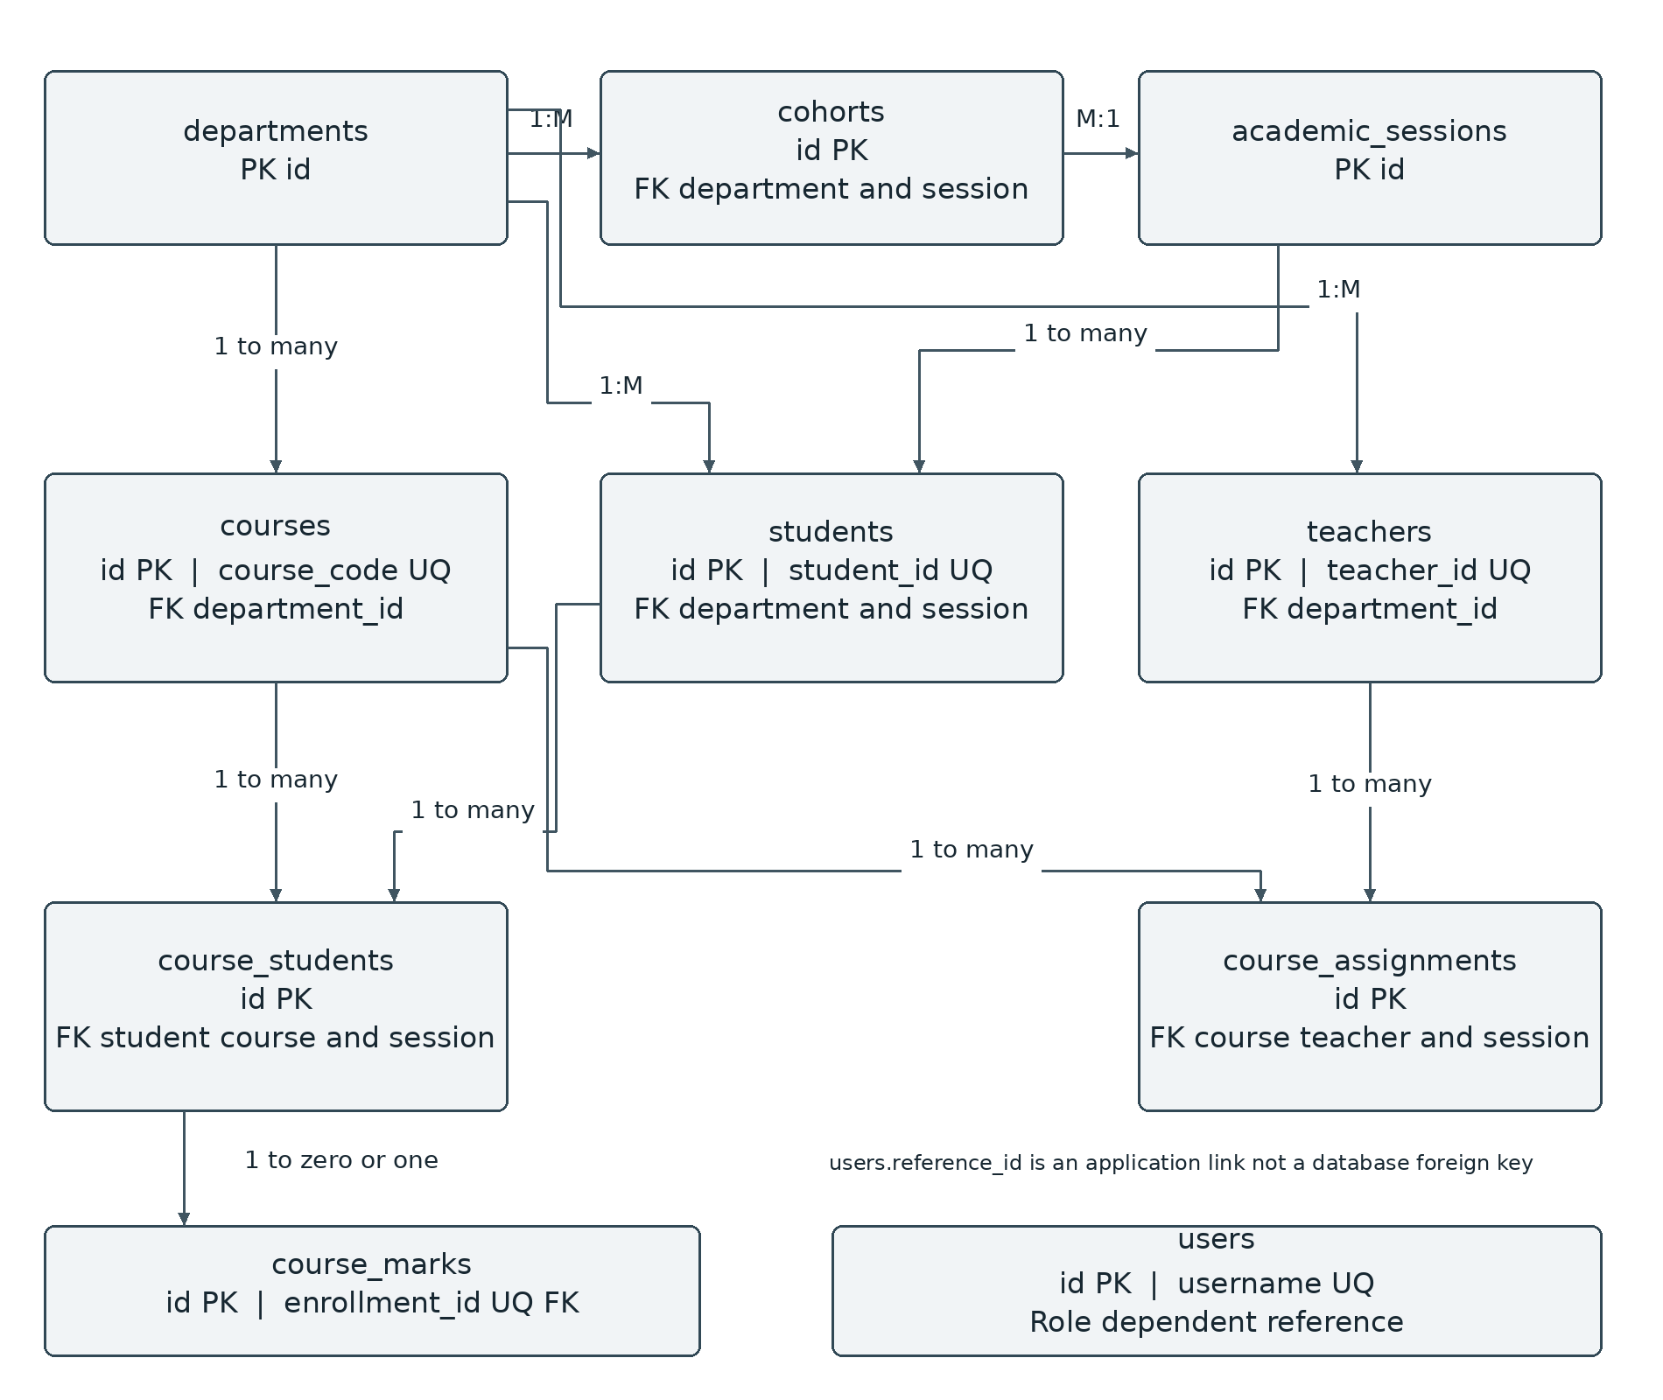
Figure 5.2 Main entities and relationships
PK means primary key, FK means foreign key and UQ means unique. users.reference_id is validated by application logic because it may identify either a teacher or a student. Enrollment and teacher assignment uniqueness prevents repeated registrations. Revision values increase after successful marks or publication changes.

Chapter 6 Implementation and Calculations

6.1 Application structure
Backend/app/main.py contains the API and business rules. Backend/app/models defines database entities; Backend/app/db handles connections and supported schema upgrades. Backend/app/services/curriculum.py synchronizes fixed enrollment. CSV validation is implemented in Backend/app/routes/imports.py. Frontend/index.html, app.js and style.css provide the interface. manage.py supports initialization, administrator creation and backup; start.sh starts the local application.

6.2 Assessment and grades
Total = assignment + class test + midterm + final. The limits are 10, 20, 40 and 80 respectively, giving a total of 150. All current course types use this structure, including labs and project courses. Institutional approval is required before using these weights for official results.
Percentage | Total out of 150 | Grade | Grade point
80 or more | 120.00 or more | A+ | 4.00
75 to below 80 | 112.50 to below 120 | A | 3.75
70 to below 75 | 105.00 to below 112.50 | A− | 3.50
65 to below 70 | 97.50 to below 105 | B+ | 3.25
60 to below 65 | 90.00 to below 97.50 | B | 3.00
55 to below 60 | 82.50 to below 90 | B− | 2.75
50 to below 55 | 75.00 to below 82.50 | C+ | 2.50
45 to below 50 | 67.50 to below 75 | C | 2.25
40 to below 45 | 60.00 to below 67.50 | D | 2.00
Below 40 | Below 60.00 | F | 0.00

6.3 GPA and CGPA
GPA = sum of eligible course credits × grade points, divided by the sum of eligible course credits. For two three credit courses with grade points 4.00 and 3.00, GPA = (3 × 4 + 3 × 3) ÷ 6 = 3.50. CGPA uses eligible results across all semesters, even when one semester is selected for viewing.
Student calculations use published marks only. A failed eligible course contributes credits and zero grade points. Pending courses are excluded, and the semester is marked Incomplete. Administrative previews may include saved draft marks. Decimal arithmetic reduces floating point errors. No retake or grade replacement policy is implemented.

Chapter 6 Software Interfaces
The interface uses a green navigation panel, searchable records and role specific pages. The examples below show fictional review records and sample grades rather than official student results.
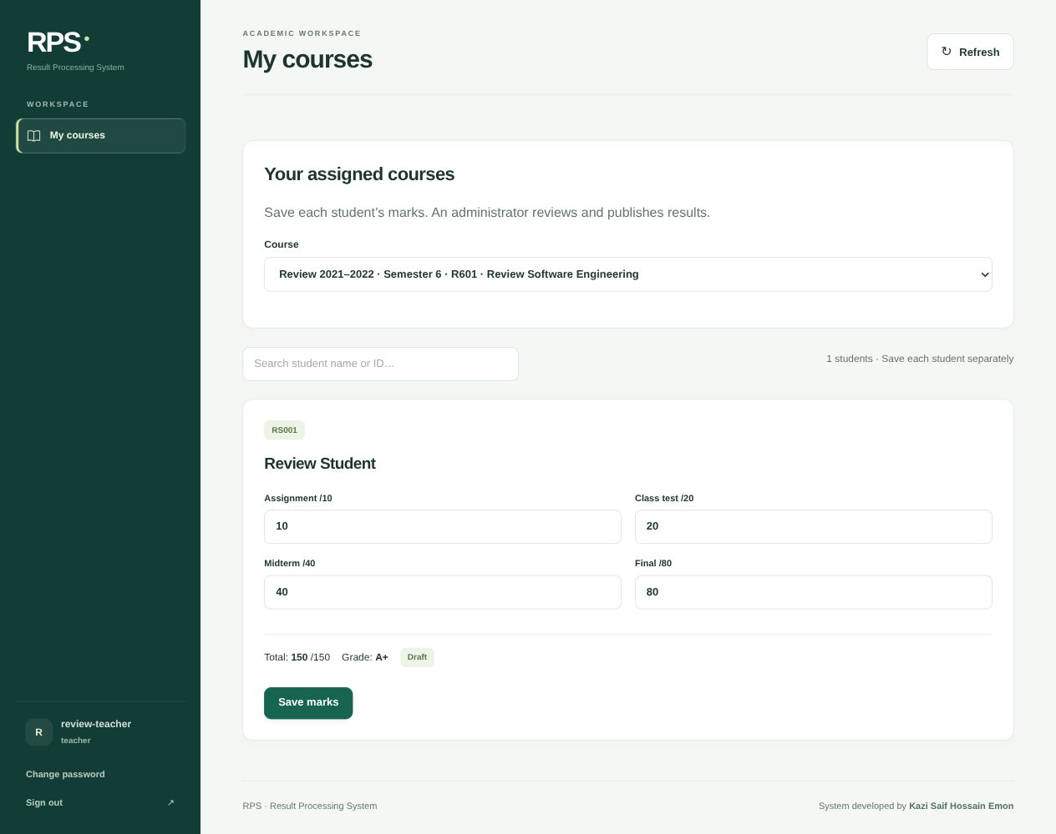
Figure 6.1 Teacher marks entry within an assigned session
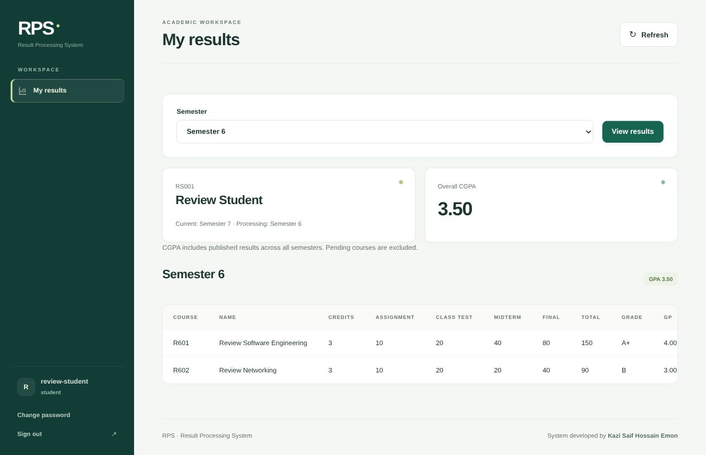
Figure 6.2 Student view of published results and CGPA

Chapters 7 and 8 Testing and Conclusion

7 Testing and validation
The verified regression run passed nine backend integration tests and six frontend state tests. Integration tests exercise HTTP requests against a separate temporary database. Browser checks verified the teacher save, administrative publication and student result journey using fictional records. Two equally weighted sample courses produced the expected GPA and CGPA of 3.50.
Test area | Verified result
Authorization | Unassigned teachers and other students cannot access restricted records.
Marks validation | Out of range, nonfinite and excessive precision values are rejected.
Revision conflicts | Concurrent stale saves and outdated publication requests are rejected.
Publication | Students see published results; teachers cannot edit published marks.
Enrollment | Core synchronization is repeatable; new students inherit core courses.
Optional courses | Choice limits apply; saved marks prevent enrollment removal.
CSV import | Invalid batches commit nothing; duplicates and file limits are checked.
Grading and state | Grade boundaries, GPA, confirmation, unsaved edits and sign out handling pass.

Database integrity and foreign key checks also passed. Test evidence verifies the exercised workflow; no formal usability study, public deployment security assessment or high concurrency load benchmark was conducted.

8 Conclusion
RPS provides a working local path from academic setup to published result viewing. Fixed enrollment reduces repetitive setup, session specific assignments restrict teachers to their responsibilities, and separate current and processing semesters support delayed results. Validation, role checks and revision control address practical errors while keeping the application understandable.

8.1 Limitations and future work
Current limitations include fixed assessment weights for all course types, no retake or grade replacement rules, manual credential distribution, no official transcript export, no full result change audit history and no production hosting configuration. Future work may add approved assessment policies, retakes, printable transcripts, notifications and an auditable change history.
The documented local workflow is implemented and regression tested. Final demonstration still requires administrator selected teaching assignments, teacher and student login accounts, and approved demonstration marks. Official academic use requires separate institutional acceptance.

User Manual Administrator

A1 Start and sign in
1. Open a terminal in the RPS project folder and run ./start.sh. Keep this terminal open while using the system.
2. Open http://127.0.0.1:8001 in a browser. The address refers to the same computer.
3. Sign in with the administrator username and chosen password. On first setup, the startup process asks for an administrator password if none exists.

A2 Set up the academic batch
1. Check Departments and Sessions, then add or import the required students, teachers and courses.
2. Open Batch settings and select CSE and session 2021–2022. Keep Current semester 7 and Result processing semester 6 for the prepared demonstration. Save batch settings.
3. Core courses are synchronized automatically. A separate student enrollment operation is unnecessary for the fixed curriculum.
4. Open Teacher assignment. Select department, session and semester; find the course code and title; select the teacher by name and teacher ID; choose Assign teacher.
5. For Semester 8, choose only the optional theory and lab actually taken by the batch. Choices affect the selected batch. Saved marks prevent removal.

A3 Create accounts and import records
Open Accounts → Add accounts. Choose Teacher or Student, select the registered person, check the username and save. Copy the displayed temporary password immediately and share it privately with its owner. If lost, use Reset password and copy the new value. Registering a person does not create a login automatically.
For bulk records, open Students or Teachers → Import CSV. Download the template. Student headers are student_id,name,email; teacher headers are teacher_id,name,email. Select the appropriate department and student session, preview the file, correct all errors and select Import records. Files must be smaller than 1 MB with at most 1,000 records. Invalid rows or duplicates block the whole batch.

A4 Review and publish
Open Publish results. Select department, session and semester. Review every assessment component, total, grade and grade point. Choose Publish result and confirm. If the revision changed, reload and review again. To correct a published result, unpublish it, ask the teacher to save corrected marks, then review and publish again. Publication is controlled by administrators.

User Manual Teacher and Student

B1 Teacher login
1. Sign out of the administrator account or use a separate browser profile.
2. Enter the teacher username and temporary password provided by the administrator.
3. Change the temporary password when prompted, then sign in again with the new password. Password length must be 12–128 characters.
4. Open My courses. Only assigned course and session combinations are available. If nothing appears, ask the administrator to check the account reference and assignment.

B2 Enter and correct marks
1. Select the correct session and course. Search for the student by name or ID.
2. Enter all four values: assignment 0–10, class test 0–20, midterm 0–40 and final 0–80. Use 0 for an actual zero; do not leave a component blank. At most two decimal places are allowed.
3. Select Save marks for that student and check the returned total and grade. Repeat for each remaining student; typing alone does not save marks.
4. Draft marks can be corrected and saved again. If a conflict appears, reload the latest record before entering the intended correction.
5. Confirm or cancel before switching courses with unsaved changes. Published marks require an administrator to unpublish them first. Future semester marks remain locked until the batch reaches that semester.

B3 Student login and results
1. Use the student username and temporary password supplied by the administrator. Change the password on first use and sign in again.
2. Open My results. The batch processing semester is selected by default. Choose another semester and select View results when needed.
3. Read the published course marks, grades, grade points, semester GPA and overall CGPA. Students can access only their own results.
4. Pending or a dash means there is no available published result. Incomplete means some enrolled courses do not yet have eligible grades. A displayed incomplete GPA is not a final official semester result.

B4 Password recovery and safe sign out
Existing plaintext passwords cannot be retrieved. Ask an administrator to reset the account if the password is forgotten. A reset generates a new temporary password and invalidates old logins. Sign out after using a shared computer and do not share account passwords with other users.

Maintenance and References

C1 Backup and recovery
From the Backend folder, run .venv/bin/python manage.py backup. On Windows use .venv\Scripts\python manage.py backup. Backups are saved under Backend/backups. Keep a protected copy outside the working computer. To restore, stop the server, preserve the current database, replace Backend/rps.sqlite3 with the selected backup and restart. Restoration is a deliberate manual operation.

C2 Troubleshooting
Problem | Action
127.0.0.1 refused to connect | Run ./start.sh and keep its terminal open.
Port 8001 is in use | Use the existing server or select another port with RPS_PORT=8002 ./start.sh.
Teacher has no courses | Check account reference, teacher assignment and academic session.
Password is unavailable | Administrator resets it and copies the newly displayed temporary password.
Marks save conflicts | Reload and review the current revision before editing again.
Student result is missing | Check enrollment, saved marks and publication status.

C3 Demonstration checklist
Confirm CSE 2021–2022, Current semester 7 and Result processing semester 6. Complete teaching assignments and accounts. Save approved demonstration marks, review and publish them, verify one student login, and take a backup before the presentation.

References
[1] FastAPI. OAuth2 with Password and Bearer JWT tokens. Official documentation. https://fastapi.tiangolo.com/tutorial/security/oauth2-jwt/
[2] SQLite. Foreign Key Support. https://www.sqlite.org/foreignkeys.html
[3] NIST. Role Based Access Control glossary. https://csrc.nist.gov/glossary/term/role_based_access_control
[4] Result Processing System version 2.1.0. Project source, README and automated tests. Reviewed 3 November 2026.
[5] CSE curriculum and academic roster supplied for the project, session 2021–2022.
[6] Omar Faruk. TaskFlow Role Based Project Management Workspace. IST project report, 2026. Formatting and chapter structure reference.

