
Institute of Science & Technology
Department of Computer Science and Engineering

Result Processing System
Role Based Academic Result Management
A project report submitted in partial fulfillment of the requirements
for the degree of Bachelor of Computer Science and Engineering
Submitted By
Kazi Saif Hossain Emon
Registration No 21502005399
Roll No 22075
Session 2021–2022
Supervised By
Saleh Muhammad Maruf
Assistant Professor
Department of Computer Science and Engineering
Date of Submission 4 November 2026

ABSTRACT
Academic result preparation requires consistent course registration, controlled marks entry and a clear decision about when results become visible to students. The Result Processing System (RPS) addresses these needs through a role-based web application that connects academic records, course assignments, assessment marks and result publication in a single local workflow. The objective is to reduce repeated data handling and prevent common errors involving batch identity, unauthorized access and premature result disclosure.
The application is implemented with FastAPI, SQLAlchemy and SQLite, supported by an HTML, CSS and JavaScript interface. Administrators maintain academic data and accounts, assign teachers to session-specific courses, configure batch semesters and publish reviewed results. Teachers enter four validated assessment components within their assigned scope. Students view their own published results, including credit-weighted semester GPA and CGPA. Fixed core-course enrollment, CSV import validation, revision checks and publication locks support data consistency.
Evaluation in this report uses isolated unit tests of grading functions, marks validation and frontend state handlers. Twelve Python test methods and six JavaScript test methods passed. Interface snapshots illustrate the implemented role-specific workspaces using demonstration records. The project provides a practical local academic result-processing prototype. Institution-approved grading policies, retakes, audit history and public deployment remain areas for further development.
Keywords: Result Processing System, academic records, role-based access control, result publication, GPA, CGPA.

DECLARATION
I, Kazi Saif Hossain Emon, Registration No 21502005399, Roll No 22075, Session 2021–2022, of the Department of Computer Science and Engineering at the Institute of Science & Technology, declare that this project report titled “Result Processing System” presents the software project prepared for my academic submission under the supervision of Saleh Muhammad Maruf, Assistant Professor.
The report explains the requirements, design, implementation and unit testing of the project. Technical ideas and documentation used in preparing the report are acknowledged through the references. The project is submitted for academic evaluation; demonstration results shown in the report are not official academic records.
Signature ______________________________
Kazi Saif Hossain Emon
Registration No 21502005399
Roll No 22075
Session 2021–2022
Date 4 November 2026

ACKNOWLEDGEMENT
I express my gratitude to Almighty Allah for the strength and opportunity to complete this project and report.
I sincerely thank my supervisor, Saleh Muhammad Maruf, Assistant Professor in the Department of Computer Science and Engineering at the Institute of Science & Technology, for academic guidance and supervision of this work.
I am grateful to the teachers and staff of the department for the learning environment and support provided during my studies. I also thank my classmates for their encouragement and the project report shared as a reference for the organization of this book.
I acknowledge the developers and maintainers of the open-source technologies and technical documentation used in the Result Processing System. Finally, I thank my parents and family for their patience, encouragement and support throughout my education.
Kazi Saif Hossain Emon

CONTENTS
Abstract i
Declaration ii
Acknowledgement iii
Chapter 1 Introduction 1
1.1 Definition of the system 1
1.2 Problem statement 1
1.3 Purpose 1
1.4 Report organization 1
1.5 Objectives 2
1.6 Scope of the implemented system 2
1.7 Project boundaries 2
1.8 Academic batch configuration 2
Chapter 2 Literature review 3
2.1 Academic result-processing approaches 3
2.2 Role-based access control 3
2.3 Authentication and validation 3
2.4 Relational integrity and transactions 4
2.5 Optimistic concurrency 4
2.6 Scope comparison 4
Chapter 3 Feasibility study 5
3.1 Operational feasibility 5
3.2 Technical feasibility 5
3.3 Economic feasibility 5
3.4 Adoption and schedule feasibility 5
Chapter 4 Requirement analysis 6
4.1 Development methodology 6
4.2 Actors and responsibilities 6

CONTENTS CONTINUED
4.3 Functional requirement groups 6
4.4 Data privacy requirements 6
4.5 Core business rules 8
4.6 Software and hardware environment 8
Chapter 5 System design 9
5.1 Architectural design 9
5.2 Input and output design 9
5.3 Use case diagram 10
5.4 Data flow diagram 11
5.5 Transaction boundaries 11
5.6 Entity relationships 12
5.7 Result processing sequence 13
Chapter 6 Implementation and results 14
6.1 Application structure 14
6.2 Database initialization and migration 14
6.3 Account lifecycle 14
6.4 Assessment total and grade mapping 15
6.5 GPA and CGPA 15
6.6 Login interface and first access 16
6.7 Interface conventions 16
6.8 Dashboard and batch summary 17
6.9 Teacher assignment and marks entry 18
6.10 Administrative review 19
6.11 Student result viewing 20

CONTENTS CONTINUED
6.12 Implemented outcome 20
Chapter 7 Testing 21
7.1 Unit testing approach 21
7.2 Test environment and isolation 21
7.3 Selection of cases 21
7.4 Backend unit cases 22
7.5 Frontend unit cases 22
7.6 Observed execution output 23
7.7 Interpretation and limits 23
Chapter 8 Conclusions and future work 24
8.1 Conclusion 24
8.2 Limitations 24
8.3 Future development 24
8.4 Completion status 24
References 25

LIST OF FIGURES
Figure 5.1 Layered architecture of the Result Processing System 9
Figure 5.2 Role-specific use cases 10
Figure 5.3 Main academic data flows and logical data stores 11
Figure 5.4 Database entities and principal relationships 12
Figure 5.5 Save review publish and view sequence 13
Figure 6.1 Redesigned login interface 16
Figure 6.2 Administrative dashboard with batch progress 17
Figure 6.3 Teacher marks entry in an assigned session 18
Figure 6.4 Component-level result review before publication 19
Figure 6.5 Student result view with verified GPA and CGPA 20
Figure 7.1 Captured Python and frontend unit test output 23

LIST OF TABLES
Table 2.1 Comparison of result-processing approaches 4
Table 3.1 Development milestones 5
Table 4.1 Role responsibility matrix 6
Table 4.2 Functional requirements 7
Table 4.3 Nonfunctional requirements 7
Table 4.4 Execution environment 8
Table 6.1 Implemented grade thresholds 15
Table 7.1 Executed unit test summary 21
Table 7.2 Backend unit case outcomes 22

CHAPTER 1
INTRODUCTION

1.1 Definition of the system
The Result Processing System (RPS) is a role-based web application for organizing academic records and processing semester results. It brings department and session records, students, teachers, curriculum courses, teaching assignments, assessment marks, publication and student result viewing into one local browser-based workspace. The application is developed using FastAPI, SQLAlchemy and SQLite, with a plain HTML, CSS and JavaScript interface.

1.2 Problem statement
A result-processing workflow involves more than adding marks. Each result must belong to the correct student, course, department, academic session and semester. When separate registers or spreadsheets are maintained without a shared workflow, repeated entry, inconsistent course lists and accidental access to the wrong batch become possible. A teacher also needs a clear boundary between the courses they teach and the records they are permitted to change.
A second problem is the distinction between a student’s current semester and the semester whose results are being processed. The prepared CSE 2021–2022 batch is currently in Semester 7, while the intended demonstration processes Semester 6 results. Treating these two values as the same would make past-semester result processing unnecessarily difficult.

1.3 Purpose
The purpose of RPS is to provide a small, understandable academic application in which administrators control academic setup, teachers enter marks within an assigned scope, and students view their own published results. It supports the practical sequence from registering a batch to reviewing and publishing a result, while preserving a clear separation between draft work and student-visible information.

1.4 Report organization
This report presents the project background, relevant technical concepts, feasibility, requirements, design, implementation and test evidence. Chapter 7 reports isolated unit tests of grading, input validation and frontend state. Chapter 8 discusses limitations and future work. The references identify the technical sources used throughout the book.

Objectives and scope

1.5 Objectives
- Maintain department, session, student, teacher and course records in a consistent relational database.
- Automatically assign the department’s fixed core curriculum to students of a configured academic batch.
- Assign teachers to courses for a specific session and prevent access to other sessions.
- Validate assessment marks, calculate totals and grades, and derive credit-weighted semester GPA and CGPA.
- Separate draft marks from published results and protect saved records against stale edits.
- Provide a clear user interface, a reproducible startup procedure, database backup and a practical user manual.

1.6 Scope of the implemented system
The implemented local application includes account provisioning, temporary passwords, forced first-login password change, role-based access checks, CSV imports for students and teachers, batch settings, fixed-course enrollment, teacher assignment, marks entry and result publication. The prepared curriculum contains 81 CSE courses: 53 core courses, 14 optional theory courses and 14 optional lab courses. Optional choices are made separately in Semester 8.

1.7 Project boundaries
RPS is a local academic demonstration rather than an institution-approved production service. It does not implement retake attempts, replacement of previous grades, automatic email delivery, single sign-on, printable official transcripts or a complete audit-history module. It does not claim that its configured grading policy has been formally approved by the institution. Public hosting requires additional deployment, security, backup and operational review.

1.8 Academic batch configuration
A batch is identified by its department and academic session. Its current semester determines which marks may be entered, while its processing semester selects the results being prepared. For the CSE 2021-2022 configuration, these values are 7 and 6 respectively. Keeping them separate supports the common situation in which teaching has moved forward while an earlier semester is still being processed.

CHAPTER 2
LITERATURE REVIEW

2.1 Academic result-processing approaches
Academic results can be maintained using paper registers, spreadsheet workbooks or a structured application. These approaches differ mainly in how they represent relationships, validate inputs, separate responsibilities and control publication. A spreadsheet can calculate a GPA correctly when its formulas and data are maintained carefully; the challenge addressed by RPS is the surrounding workflow, including batch identity, teaching responsibility, access control and review status.
RPS therefore models the academic entities explicitly. A student belongs to a department and session, a course belongs to a department and semester, and a teaching assignment joins a teacher, course and session. This design makes the batch boundary a condition checked by the application rather than a convention stored in a worksheet name.

2.2 Role-based access control
Role-based access control associates permissions with organizational responsibilities. NIST describes RBAC as restricting access according to user roles [3]. RPS applies this concept through three roles: administrator, teacher and student. Role checks alone are not sufficient: a teacher must also match the assigned teacher code, course and session, while a student request must match that student’s reference code.

2.3 Authentication and validation
FastAPI documents password hashing, bearer-token authentication and JWT validation as components of an authenticated application [1]. RPS uses this general approach with password hashes, expiring tokens and database-backed user checks. Input validation is performed on the server as well as in the interface. Browser controls improve usability, but the server remains responsible for rejecting invalid marks, duplicate records and unauthorized changes.

Technical foundations and comparison

2.4 Relational integrity and transactions
A relational database can express dependencies between academic records. SQLite documents foreign keys as a way to enforce that referenced records exist; the feature must be enabled for each connection [2]. RPS enables foreign-key enforcement and groups related writes within transactions. For example, a batch import is validated before insertion so that invalid rows do not leave a partially imported batch.

2.5 Optimistic concurrency
A user may review data that another user subsequently changes. SQLAlchemy’s documentation discusses version counters for detecting stale records [4]. RPS implements its own revision-checked conditional SQL updates for marks and publication. It does not configure the SQLAlchemy mapper version counter. The browser submits the revision it displayed; a mismatch returns a conflict instead of silently replacing a newer result.

2.6 Scope comparison
Table 2.1 Comparison of result-processing approaches
Criterion | Separate register or workbook | Implemented RPS
Academic relationships | Maintained through conventions and links | Department, session, course and enrollment records
Teacher access | Depends on document-sharing arrangements | Role plus course and session assignment checks
Publication | Usually a separate distribution step | Explicit draft and published states
Concurrent edits | Depends on the document platform | Marks revision checked before save or publish
Deployment | Document or spreadsheet environment | Local Python application with SQLite
Institutional fit | Highly adaptable manually | Fixed project rules requiring institutional review

The comparison describes the operational scope of this project, not a measured benchmark of commercial products. RPS concentrates on a small, demonstrable workflow and avoids claiming the reporting, scalability or integration capabilities of a full university information system.

CHAPTER 3
FEASIBILITY STUDY

3.1 Operational feasibility
The three roles correspond to familiar academic responsibilities. Administrators prepare records and review results; teachers enter assessment marks; students read published results. Fixed curriculum enrollment removes repeated course assignment for every student. Separate current and processing semesters allow the prepared batch to study Semester 7 while Semester 6 results are processed.

3.2 Technical feasibility
The application runs from one local address and serves both the interface and API. SQLite avoids a separate database-server installation for the demonstration. The backend uses typed validation, relational records and transaction boundaries. No controlled load benchmark has been performed; suitability for a larger workload requires measurement.

3.3 Economic feasibility
The project relies on open-source development tools and can be demonstrated on an existing computer. The principal practical costs are development time, data preparation, testing and maintenance. Public hosting would introduce additional operational costs, including a hosting environment, backups, secure access and administration. The feasibility assessment is qualitative; institutional deployment would require a formal cost and benefit review.

3.4 Adoption and schedule feasibility
The interface uses ordinary forms and role-specific navigation. Name-and-code selectors reduce the need to memorize identifiers, and temporary-password messages support first-time users. Development proceeded through repeated requirement clarification, implementation and testing. The milestones below summarize the implemented development phases.
Table 3.1 Development milestones
Milestone | Evidence
Academic model and setup | Application models and startup commands
Role workflow | Separate admin teacher and student workspaces
Calculation and validation checks | Twelve isolated Python unit methods
Frontend state checks | Six isolated JavaScript unit methods
Documentation | Eight chapters with diagrams and interface snapshots

CHAPTER 4
REQUIREMENT ANALYSIS

4.1 Development methodology
An iterative development approach was used because operational requirements were clarified while the application was being exercised. The implementation was organized around the academic model and role-specific pages. Later changes added the complete role workflow, batch-specific teacher assignment, fixed enrollment, safer marks editing and clearer frontend screens. The unit checks in Chapter 7 isolate selected functions and state handlers from the real academic records.

4.2 Actors and responsibilities
Table 4.1 Role responsibility matrix
Operation | Admin | Teacher | Student
Manage academic records | Yes | No | No
Create or reset login accounts | Yes | No | No
Set batch semesters and assign teachers | Yes | No | No
Enter assessment marks | No | Assigned scope only | No
Review and publish marks | Yes | No | No
View semester results | All students | No student-results endpoint | Own published results
Change own password | Yes | Yes | Yes

4.3 Functional requirement groups
The system must identify the user, establish the permitted academic scope and then apply the rules for the requested operation. Administrative maintenance, curriculum enrollment, assessment, publication and result viewing form the main functional groups. The distinction between authentication, role authorization and academic ownership is maintained in both the design and tests.

4.4 Data privacy requirements
Password hashes must not be returned by account-listing endpoints. A student must not retrieve another student’s results. A teacher must not retrieve the roster or marks of a course/session they are not assigned to. Demonstration screenshots use fictional records rather than publishing the supplied students’ personal email addresses.

Functional and nonfunctional requirements
Table 4.2 Functional requirements
ID | Requirement | Acceptance condition
FR01 | Authenticate users | Valid credentials return an expiring token
FR02 | Provision accounts | Temporary password displayed after creation/reset
FR03 | Maintain academic registries | Validated create, edit and protected delete
FR04 | Import students and teachers | Preview first; invalid batch writes nothing
FR05 | Configure academic batches | Processing semester does not exceed current semester
FR06 | Apply fixed curriculum | Core enrollment repeats without duplicates
FR07 | Assign teachers | Assignment includes teacher, course and session
FR08 | Save assessment marks | Four bounded values and revision checks
FR09 | Publish reviewed results | Only admin can change publication state
FR10 | Calculate results | Credit-weighted GPA/CGPA with pending exclusions
FR11 | Manage Semester 8 electives | At most one optional theory and one lab
FR12 | Back up local data | SQLite backup saved without changing records

Table 4.3 Nonfunctional requirements
Quality | Implemented measure
Security | Role/ownership checks, password hashes and token expiration
Integrity | Foreign keys, unique constraints and transaction boundaries
Usability | Role-specific navigation, search and clear confirmation controls
Reliability | Conflicts rejected instead of overwriting newer marks
Maintainability | Separated models, database setup, service logic and tests
Portability | Local browser interface and documented Python startup
Recoverability | Backup command and manual restoration procedure

Business rules and execution environment

4.5 Core business rules
- A configured batch is identified by department and academic session. Current semester and processing semester are separate values.
- All fixed core courses are enrolled automatically, including future-semester core courses. A future enrollment does not create a result.
- Teacher permissions are restricted by teacher code, course code and session. Future-semester marks remain locked until the batch reaches that semester.
- Assessment maxima are assignment 10, class test 20, midterm 40 and final 80. All four values are required and allow at most two decimal places.
- Students see published results only. Published marks must be unpublished by an administrator before teacher revision.
- Saved results protect relevant academic data: credits cannot change after marks exist, and course type cannot change after enrollment.

4.6 Software and hardware environment
Table 4.4 Execution environment
Component | Project configuration
Backend | Python, FastAPI 0.141.1 and Uvicorn 0.53.0
Persistence | SQLAlchemy 2.1.4 and SQLite
Validation and security | Pydantic 2.13.5, PyJWT 2.15.1 and pwdlib 0.3.1
Frontend | HTML, CSS and JavaScript without a frontend build step
Local address | http://127.0.0.1:8001
Practical equipment | A computer with Python, a modern browser and available disk space

These are the pinned project dependencies, not a claim that they are the latest releases. The supplied development environment uses a Python virtual environment. Hardware figures are not presented as benchmarked minimum requirements; the application should be checked on the actual demonstration computer before submission.

CHAPTER 5
SYSTEM DESIGN

5.1 Architectural design
RPS uses a browser interface, a FastAPI application layer and a relational persistence layer. The frontend calls the API from the same origin and does not open the SQLite database directly. Authentication and academic authorization are checked before business logic executes. SQLAlchemy sessions provide the boundary through which validated changes reach the database.
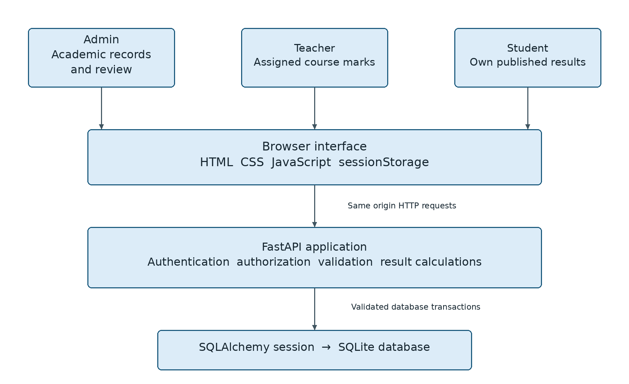
Figure 5.1 Layered architecture of the Result Processing System

5.2 Input and output design
Input forms use labels, bounded numeric fields, selection lists and human-readable errors. Names and public codes appear together when choosing a teacher or account owner. Outputs include record lists, academic-batch summaries, draft marks, publication status and student semester results. Generated totals and grade points are calculated by the server rather than trusted from browser input.

Use case design

5.3 Use case diagram
The administrator establishes the academic workspace and controls publication. Teachers act within assigned offerings, and students read their own results. Password changes are available to every authenticated role; account creation remains an administrative operation.
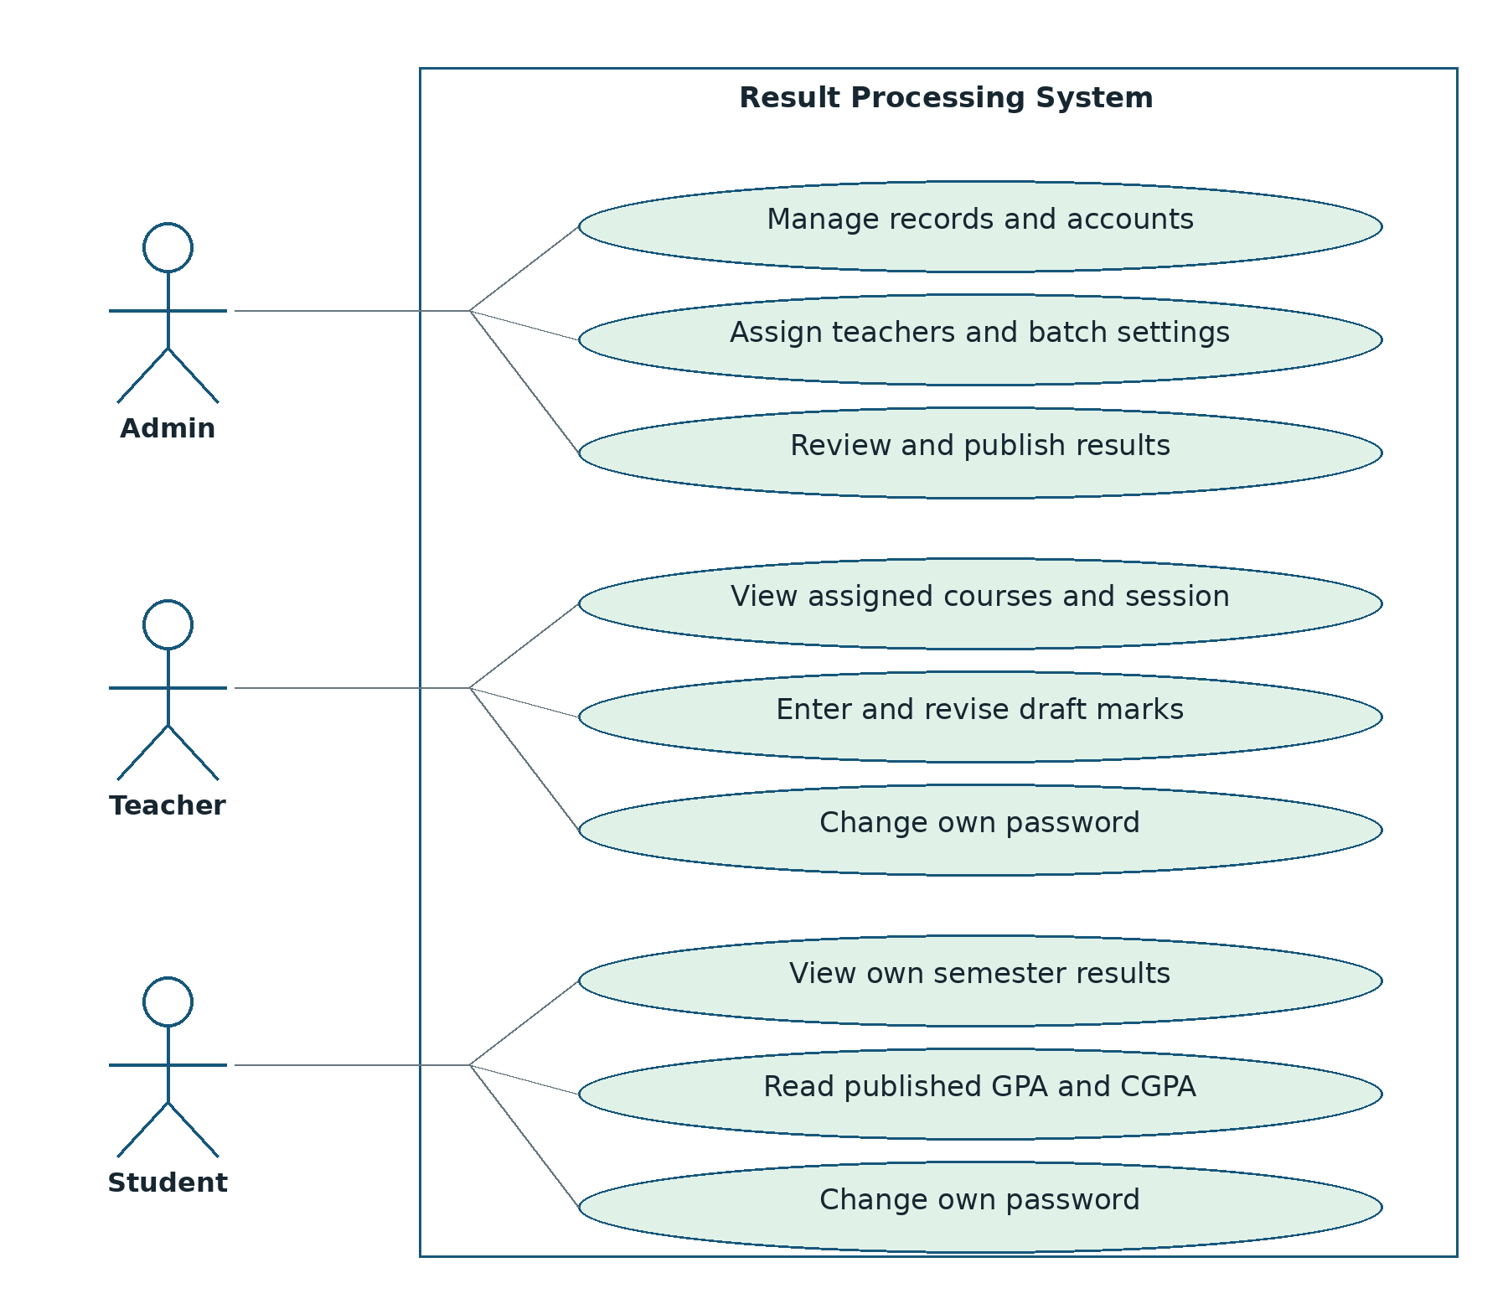
Figure 5.2 Role-specific use cases
A successful login does not grant every use case. Every protected operation still evaluates the required role and, where relevant, the session and owner of the requested record.

Data flow design

5.4 Data flow diagram
Academic setup, marks entry and published-result viewing exchange data through the application. Administrative publication changes the state of an existing marks record; it does not create a separate copy of a result. A student query therefore filters the same underlying records by publication status.
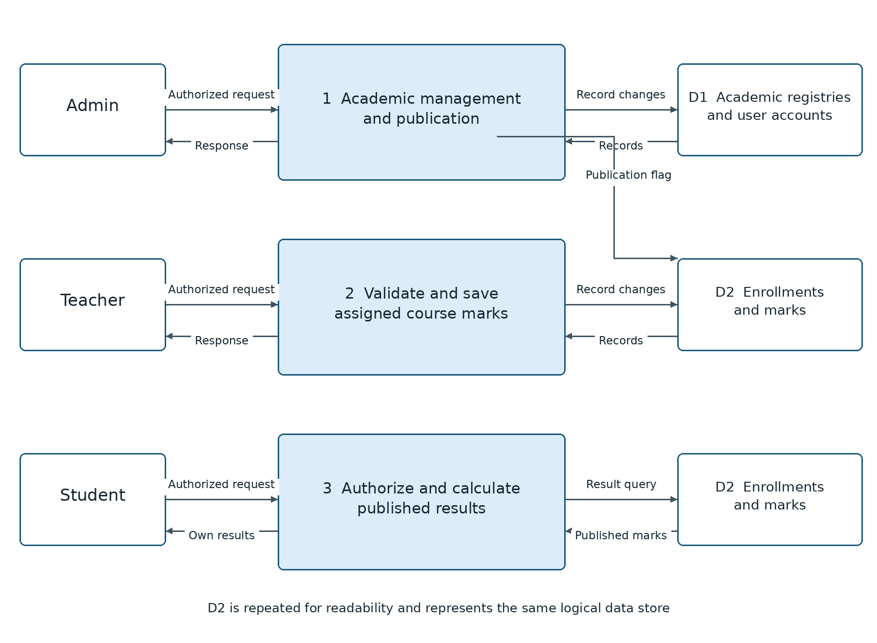
Figure 5.3 Main academic data flows and logical data stores

5.5 Transaction boundaries
CSV import and fixed enrollment are grouped with their associated record changes. Preview operations return validation results without saving. Optional-course removal is blocked when saved marks exist. Deletion checks use conditional database operations to avoid removing a result that was saved while an administrative request was in progress.

Database design

5.6 Entity relationships
The schema contains ten tables. Departments and academic sessions identify batches; students and teachers are registered separately from login accounts. Courses form the static curriculum. Enrollments connect students to courses, and marks connect to a unique enrollment. The diagram identifies the principal keys and relationships; account ownership uses an application-level reference.
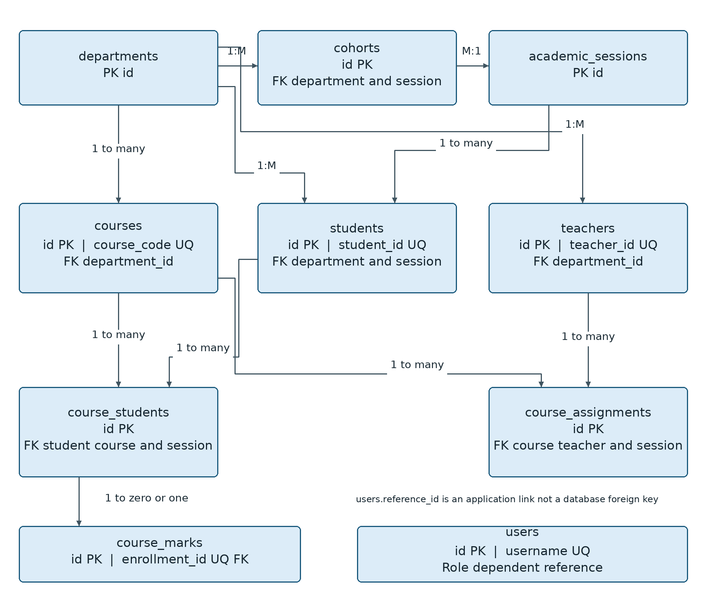
Figure 5.4 Database entities and principal relationships
The user reference code is validated by application logic and is not a database foreign key because it can identify either a teacher or a student. Enrollment stores session and semester explicitly; the API keeps these values aligned with the student and course. A course may have several teachers for a session.

Sequence and state design

5.7 Result processing sequence
Marks entry, administrative review and student viewing are separate actions. A revision number connects what a user reviewed with what the database is asked to modify. Publication increments the revision, so an older teacher screen cannot silently save over a publication decision.
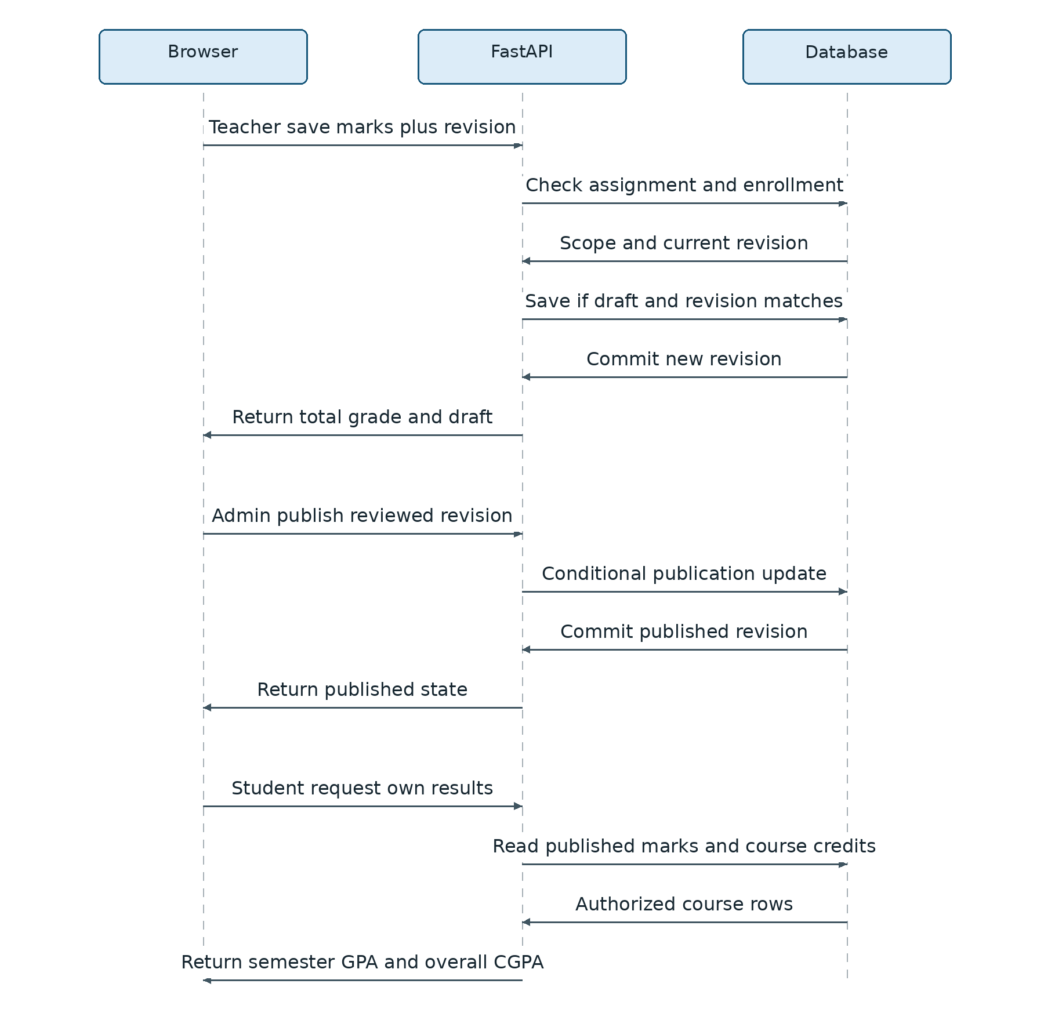
Figure 5.5 Save review publish and view sequence
The operational state changes are: no saved marks → draft → published. Unpublishing returns a record to draft. Each successful save or publication change advances the revision; a stale request receives a conflict and must reload.

CHAPTER 6
IMPLEMENTATION AND RESULTS

6.1 Application structure
RPS/
Backend/
app/main.py API and business rules
app/models/ Academic and account models
app/db/ Connection and schema upgrades
app/services/curriculum.py Fixed enrollment synchronization
app/routes/imports.py CSV validation and import
tests/test_system.py HTTP integration tests
manage.py Initialization admin setup backup
requirements.txt Pinned backend dependencies
Frontend/
index.html app.js style.css
tests/state.test.cjs Frontend state tests
start.sh Local startup helper

6.2 Database initialization and migration
The local database is stored separately at Backend/rps.sqlite3. The application deliberately does not reuse the original DATABASE_URL setting. Startup initializes the schema, applies supported local upgrades and synchronizes configured core enrollments. A legacy assignment without a session mapping is not guessed: startup stops with an explanatory error rather than assigning it to every session.

6.3 Account lifecycle
The first administrator is created through an interactive local command. Other accounts are created from the Accounts page. A generated temporary password is shown immediately after creation or reset and must be shared privately. First-time users change that password before accessing academic pages. Password changes and resets invalidate existing tokens through a token-version check.

Grading and result calculation

6.4 Assessment total and grade mapping
For each course, total marks equal assignment plus class test plus midterm plus final. The total is out of 150. Grade thresholds are percentages of that total; for example, 120 out of 150 is 80 percent and maps to A+. All courses currently use the same assessment structure, including lab and project courses. An alternative institutional structure requires a deliberate policy change before real use.
Table 6.1 Implemented grade thresholds
Minimum percentage | Minimum total out of 150 | Grade | GP
80 | 120.00 | A+ | 4.00
75 | 112.50 | A | 3.75
70 | 105.00 | A− | 3.50
65 | 97.50 | B+ | 3.25
60 | 90.00 | B | 3.00
55 | 82.50 | B− | 2.75
50 | 75.00 | C+ | 2.50
45 | 67.50 | C | 2.25
40 | 60.00 | D | 2.00
Below 40 | Below 60.00 | F | 0.00

6.5 GPA and CGPA
Semester GPA = sum of course credit × grade point for eligible courses, divided by their total credits. CGPA applies the same calculation across all semesters, even when one semester is selected for viewing. Student calculations use published marks only; administrative previews include saved draft marks. Failed eligible courses count with zero grade points. Pending courses are excluded and the semester is marked Incomplete.
Decimal arithmetic avoids avoidable floating-point artifacts. A verified example with two three-credit courses having grade points 4.00 and 3.00 gives (3 × 4.00 + 3 × 3.00) ÷ 6 = 3.50. No retake or grade-replacement rule is implemented.

Login interface

6.6 Login interface and first access
The login page provides one entry point for all roles. The server determines the correct workspace after authenticating the user. The page identifies the academic portal, provides clearly labelled inputs and displays the developer credit. The screenshot below shows the shared sign-in interface.
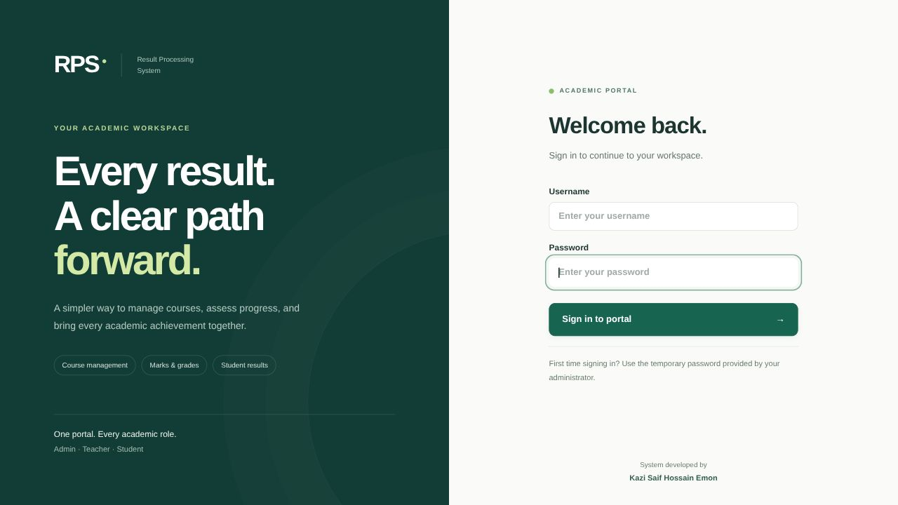
Figure 6.1 Redesigned login interface

6.7 Interface conventions
The interface uses dark green navigation, restrained cards, consistent controls and readable feedback. Role-specific navigation keeps unrelated operations out of each workspace. The footer displays “System developed by Kazi Saif Hossain Emon”. A responsive layout rearranges the navigation and cards for narrower screens; wide record tables remain horizontally scrollable when necessary.
For account recovery, administrators generate a new temporary password rather than retrieving the old password. Plaintext passwords are not stored in the account table, and the interface does not display existing password hashes.

Administrative dashboard

6.8 Dashboard and batch summary
The dashboard summarizes students, teachers, curriculum courses and course registrations. Batch progress displays the current semester separately from the result-processing semester. Interface illustrations in this chapter use fictional review records and sample grades, not official student results.
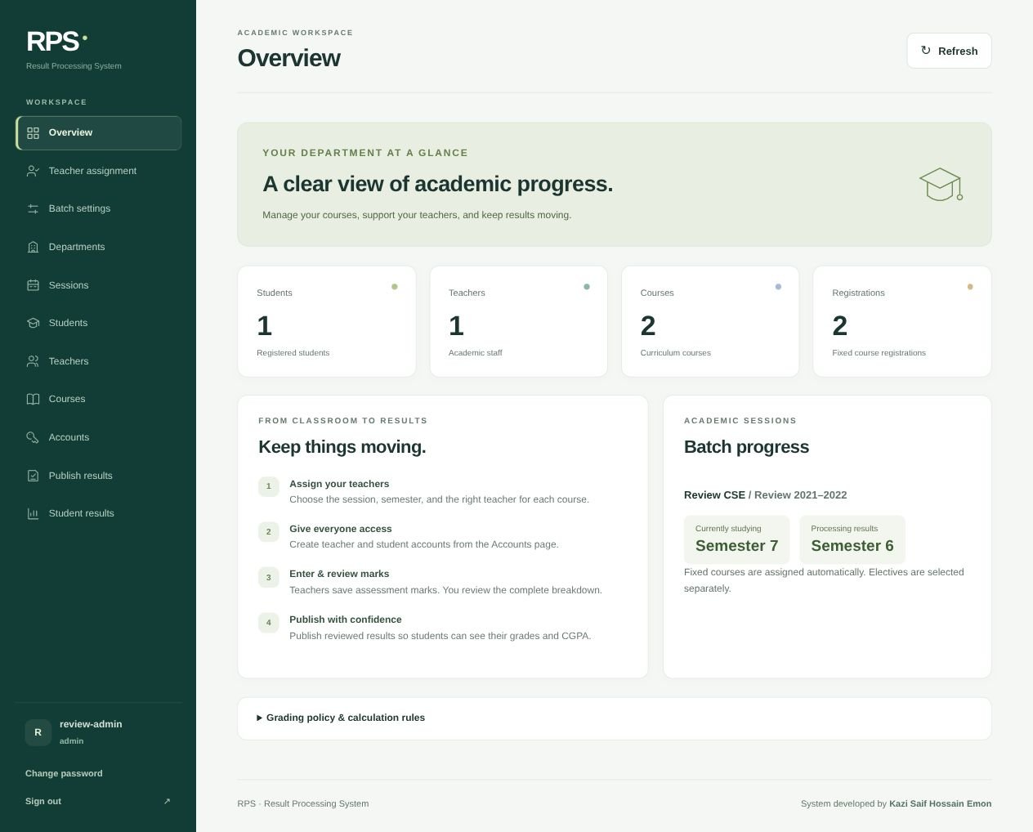
Figure 6.2 Administrative dashboard with batch progress
Teacher assignment and Batch settings are separate, visible navigation items. The removed Assignments and Enrollments menu pages are not required for the normal fixed-curriculum workflow.

Teacher and administrator workspaces

6.9 Teacher assignment and marks entry
The administrator selects a department, session and semester, then chooses a teacher beside a course card. Both the teacher’s name and code are visible. The teacher’s own workspace lists only assigned offerings, distinguishes sessions and provides searchable student cards with all four assessment fields and a Save marks button.
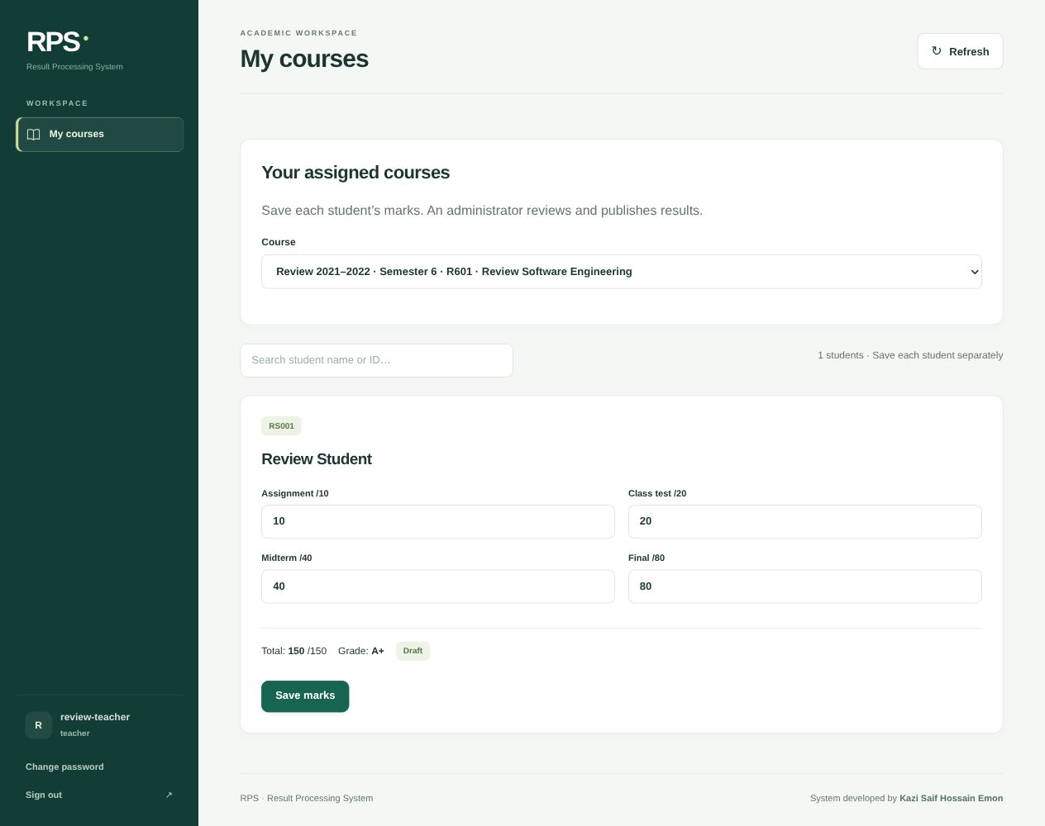
Figure 6.3 Teacher marks entry in an assigned session

Administrative result review

6.10 Administrative review
The Publish results page shows each saved result with its four assessment components, total, grade and grade point. Department, session, semester and text search narrow the list. An in-page confirmation is required before publication. If the record changed after review, publication is rejected and the administrator must reload the latest marks.
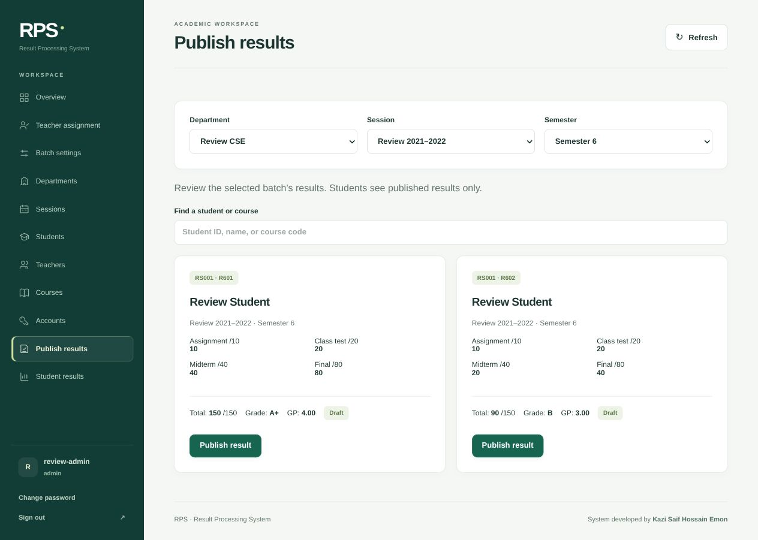
Figure 6.4 Component-level result review before publication

Student results and implementation outcome

6.11 Student result viewing
A student’s result page defaults to that student’s batch processing semester. It shows the student identity, current and processing semesters, overall CGPA and semester courses. Unpublished components are not returned to the student. The same backend ownership check prevents a modified URL from revealing a different student’s results.
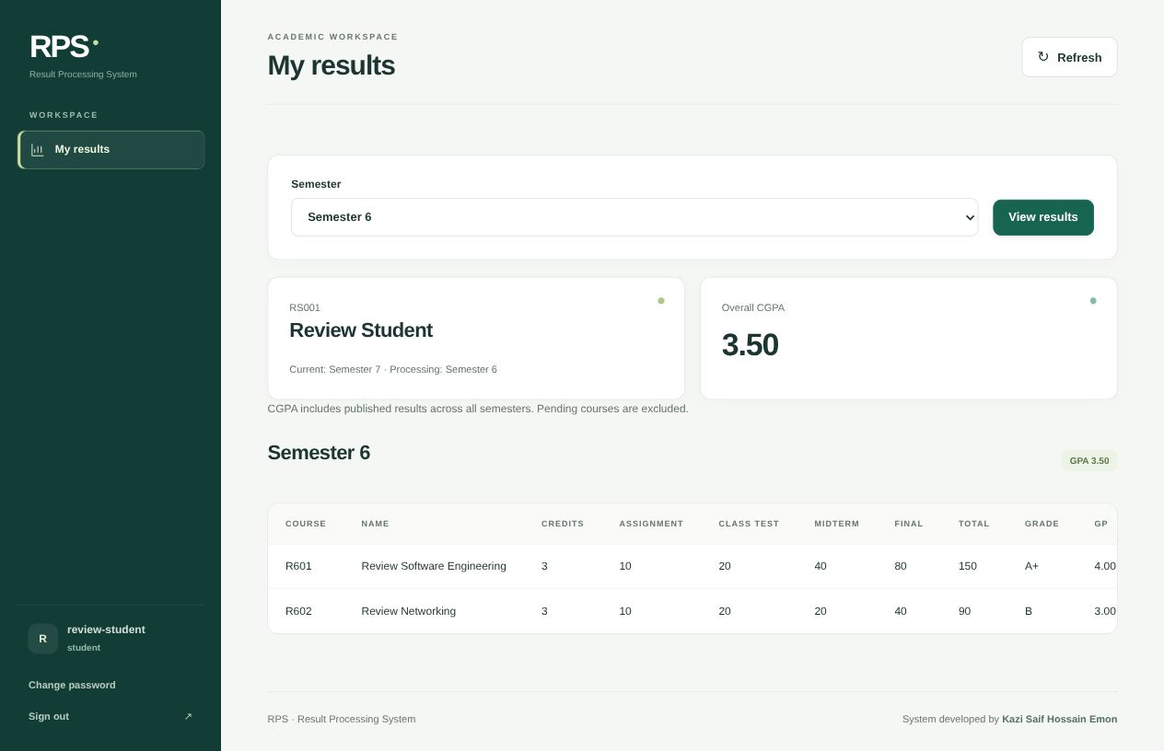
Figure 6.5 Student result view with verified GPA and CGPA

6.12 Implemented outcome
The captured demonstration illustrates two fictional course results with grade points 4.00 and 3.00 and an equal-credit GPA and CGPA of 3.50. The prepared real-data workspace is separate from that review fixture. Successful sample operation is evidence of the tested workflow, not an institutional acceptance certificate or a high-concurrency performance benchmark.

CHAPTER 7
TESTING

7.1 Unit testing approach
Unit testing examines a small function, validation model or state handler in isolation. Python unittest supplies assertions, test cases and reporting [7]. This chapter reports only unit tests. The Python checks call the implemented grading function and Pydantic marks model directly. JavaScript checks execute frontend handlers inside a virtual machine with mocked document, storage and fetch objects. No live browser, HTTP server or academic database is used by these tests.

7.2 Test environment and isolation
The Python unit runner sets an in-memory database configuration and an isolated signing key before importing the application. It does not start the application lifespan or connect to the project database. The frontend fixture supplies small stand-ins for page elements and API responses. Each test receives a fresh fixture, so unsaved marks and authentication state do not leak between cases.

7.3 Selection of cases
Grading cases target every configured threshold, the values immediately below pass and A+, zero and maximum marks. Validation cases cover permitted precision, omitted components, component limits, nonfinite input and invalid revisions. Frontend cases focus on confirmation outcomes, preservation of unsaved input, forced logout and stale asynchronous responses. The suite therefore checks both accepted and rejected input rather than only the normal path.
Table 7.1 Executed unit test summary
Unit group | Test methods | Passed | Failed
Grading and pending result functions | 5 | 5 | 0
Marks input model | 7 | 7 | 0
Frontend isolated state handlers | 6 | 6 | 0
Total | 18 | 18 | 0

Unit test cases

7.4 Backend unit cases
Table 7.2 Backend unit case outcomes
ID | Unit and input | Expected outcome
U01 | Every grade threshold from 120 to 60 | Correct grade and grade point
U02 | Total 59.99 | F and GP 0
U03 | Totals 0 and 150 | F and A+ respectively
U04 | Total 119.99 | A and GP 3.75
U05 | marks_info with no saved marks | Pending values and unpublished
U06 | Four components at maxima | Validation succeeds
U07 | Final marks 65.25 | Validation succeeds
U08 | Final marks 65.251 | Validation error
U09 | Negative or excessive component | Validation error for each field
U10 | Final component omitted | Validation error
U11 | NaN or infinity | Validation error
U12 | Revision zero | Validation error

7.5 Frontend unit cases
All six frontend tests passed: confirmation and cancellation resolve correctly; cancellation preserves unsaved marks while confirmation discards them; forced logout clears open dialogs and dirty state; an old unauthorized response does not clear a newer login; malformed server responses become readable errors; and a CSV preview dialog can remain open before the commit step.
Each row summarizes a test method. Some methods contain several subcases, so the 18-method total is not a claim that only 18 input values were checked. The complete runnable Python evidence is retained with the book output, and the frontend unit suite is part of the project source [6].

Unit testing snapshot

7.6 Observed execution output
The following snapshot reproduces the captured unit-runner output from 3 November 2026. It records twelve successful Python test methods and six successful JavaScript test methods. It is execution evidence for these isolated units, rather than evidence of whole-system correctness.
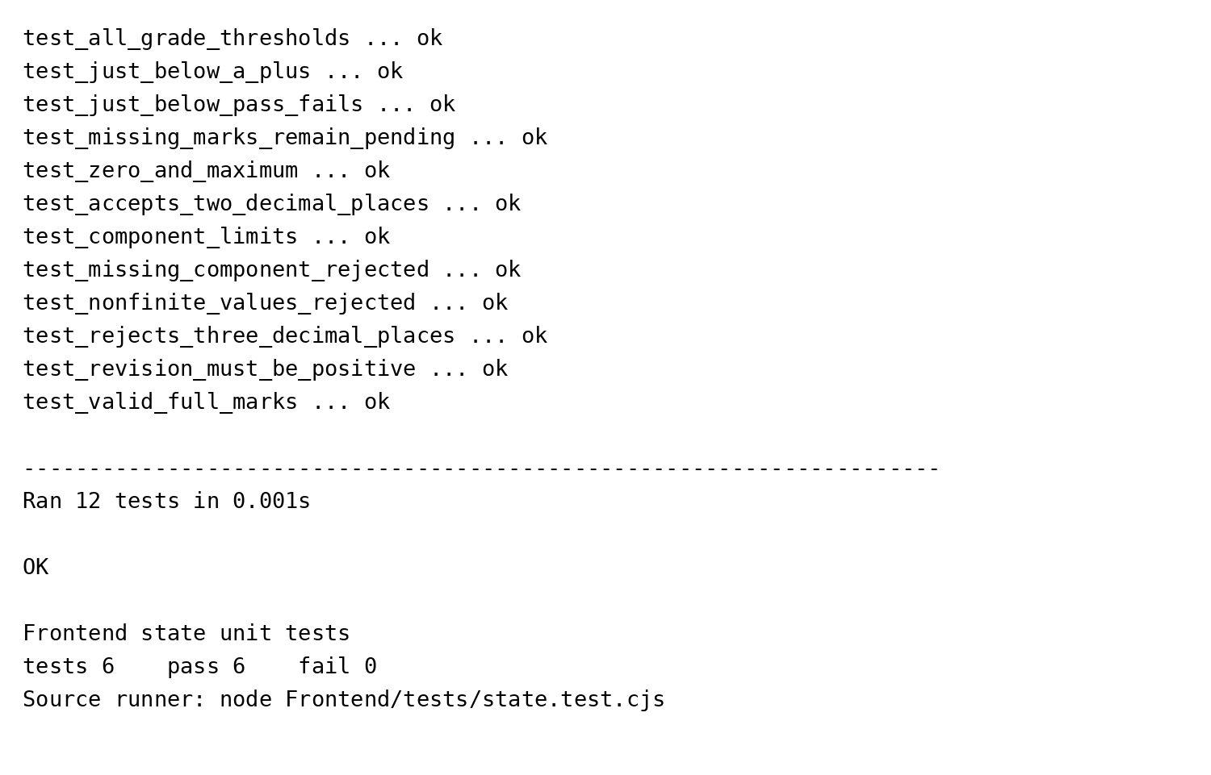
Figure 7.1 Captured Python and frontend unit test output

7.7 Interpretation and limits
All selected unit methods passed. These checks support the tested grading boundaries, validation constraints and state transitions. They do not establish load capacity, production security, institutional acceptance or complete workflow correctness. Credit-weighted GPA is explained mathematically in Chapter 6; it is not reported here as a separately isolated function test because the current implementation computes it within the result endpoint.

CHAPTER 8
CONCLUSIONS AND FUTURE WORK

8.1 Conclusion
RPS provides a working local path from academic setup to student result viewing. Its main contribution is the explicit connection between department, session, curriculum, teaching responsibility and publication state. Fixed core enrollment removes repetitive student-course assignment, while separate current and processing semesters support delayed result processing for a batch that has already progressed.
The implemented checks address practical failure modes: invalid marks, access to another session, stale edits, publication of an outdated review, accidental changes to credits after marks exist, and deletion of enrollments that have saved results. The user interface presents these rules through ordinary forms, selectors, student cards and confirmation controls.

8.2 Limitations
- Assessment weights are fixed at 10, 20, 40 and 80 for all course types.
- Retakes, repeated attempts and grade replacement are not modeled.
- Account credentials must be shared manually; there is no automated email or SSO.
- Official transcript generation and downloadable result sheets are not implemented.
- The local application has process-local login limits, no complete audit-history module and no production hosting configuration.

8.3 Future development
Useful extensions include institution-approved assessment policies per course type, retake handling, a verifiable result-change audit trail, student-specific elective planning, printable transcripts, notification delivery and a reviewed production deployment. These should be added only after requirements are confirmed and the existing grade calculations and access controls remain covered by tests.

8.4 Completion status
The local software workflow is implemented, and the isolated unit checks reported in Chapter 7 pass. Final academic demonstration still requires administrator-selected teaching assignments, teacher/student accounts and approved demonstration marks. Production readiness requires separate institutional and operational acceptance.

References
[1] FastAPI, “OAuth2 with Password and hashing Bearer with JWT tokens,” FastAPI Documentation. [Online]. Available: https://fastapi.tiangolo.com/tutorial/security/oauth2-jwt/. [Accessed: Nov. 3, 2026].
[2] SQLite, “SQLite Foreign Key Support,” SQLite Documentation. [Online]. Available: https://www.sqlite.org/foreignkeys.html. [Accessed: Nov. 3, 2026].
[3] National Institute of Standards and Technology, “Role based access control,” CSRC Glossary. [Online]. Available: https://csrc.nist.gov/glossary/term/role_based_access_control. [Accessed: Nov. 3, 2026].
[4] SQLAlchemy, “Configuring a Version Counter,” SQLAlchemy 2.1 Documentation. [Online]. Available: https://docs.sqlalchemy.org/en/21/orm/versioning.html. [Accessed: Nov. 3, 2026].
[5] K. S. H. Emon, “Result Processing System,” application source code, version 2.1.0, Institute of Science & Technology, 2026. Local project repository, reviewed Nov. 3, 2026.
[6] K. S. H. Emon, “RPS project documentation and unit test evidence,” README.md, Frontend/tests/state.test.cjs and test_rps_units.py, 2026.
[7] Python Software Foundation, “unittest — Unit testing framework,” Python Documentation. [Online]. Available: https://docs.python.org/3/library/unittest.html. [Accessed: Nov. 3, 2026].

