
Institute of Science & Technology
Department of Computer Science and Engineering

Result Processing System
Role Based Academic Result Management
A project report submitted in partial fulfillment of the requirements
for the degree of Bachelor of Computer Science and Engineering
Submitted By
Kazi Saif Hossain Emon
Registration No 21502005399
Roll No 22075
Session 2021–2022
Supervised By
Saleh Muhammad Maruf
Assistant Professor
Department of Computer Science and Engineering
Date of Submission 4 November 2026

ABSTRACT
Academic result preparation requires consistent course registration, controlled marks entry and a clear decision about when results become visible to students. The Result Processing System (RPS) addresses these needs through a role-based web application that connects academic records, course assignments, assessment marks and result publication in a single local workflow. The objective is to reduce repeated data handling and prevent common errors involving batch identity, unauthorized access and premature result disclosure.
The application is implemented with FastAPI, SQLAlchemy and SQLite, supported by an HTML, CSS and JavaScript interface. Administrators maintain academic data and accounts, assign teachers to session-specific courses, configure batch semesters and publish reviewed results. Teachers enter four validated assessment components within their assigned scope. Students view their own published results, including credit-weighted semester GPA and CGPA. Fixed core-course enrollment, CSV import validation, revision checks and publication locks support data consistency.
Evaluation in this report uses isolated unit tests of grading functions, marks validation and frontend state handlers. Twelve Python test methods and six JavaScript test methods passed. Interface snapshots illustrate the implemented role-specific workspaces using demonstration records. The project provides a practical local academic result-processing prototype. Institution-approved grading policies, retakes, audit history and public deployment remain areas for further development.
Keywords: Result Processing System, academic records, role-based access control, result publication, GPA, CGPA.

DECLARATION
I, Kazi Saif Hossain Emon, Registration No 21502005399, Roll No 22075, Session 2021–2022, of the Department of Computer Science and Engineering at the Institute of Science & Technology, declare that this project report titled “Result Processing System” presents the software project prepared for my academic submission under the supervision of Saleh Muhammad Maruf, Assistant Professor.
The report explains the requirements, design, implementation and unit testing of the project. Technical ideas and documentation used in preparing the report are acknowledged through the references. The project is submitted for academic evaluation; demonstration results shown in the report are not official academic records.
Signature ______________________________
Kazi Saif Hossain Emon
Registration No 21502005399
Roll No 22075
Session 2021–2022
Date 4 November 2026

ACKNOWLEDGEMENT
I express my gratitude to Almighty Allah for the strength and opportunity to complete this project and report.
I sincerely thank my supervisor, Saleh Muhammad Maruf, Assistant Professor in the Department of Computer Science and Engineering at the Institute of Science & Technology, for academic guidance and supervision of this work.
I am grateful to the teachers and staff of the department for the learning environment and support provided during my studies. I also thank my classmates for their encouragement and the project report shared as a reference for the organization of this book.
I acknowledge the developers and maintainers of the open-source technologies and technical documentation used in the Result Processing System. Finally, I thank my parents and family for their patience, encouragement and support throughout my education.
Kazi Saif Hossain Emon

CONTENTS
Abstract i
Declaration ii
Acknowledgement iii
Chapter 1 Introduction 1
1.1 Definition of the system 1
1.2 Problem statement 1
1.3 Purpose 1
1.4 Report organization 1
1.5 Objectives 2
1.6 Scope of the implemented system 2
1.7 Project boundaries 2
1.8 Academic batch configuration 2
Chapter 2 Literature review 3
2.1 Academic result-processing approaches 3
2.2 Role-based access control 3
2.3 Authentication and validation 3
2.4 Relational integrity and transactions 4
2.5 Optimistic concurrency 4
2.6 Scope comparison 4
Chapter 3 Feasibility study 5
3.1 Operational feasibility 5
3.2 Technical feasibility 5
3.3 Economic feasibility 5
3.4 Adoption and schedule feasibility 5
Chapter 4 Requirement analysis 6
4.1 Development methodology 6
4.2 Actors and responsibilities 6
4.3 Functional requirements 6
4.4 Core business rules 7
4.5 Privacy and execution environment 7
Chapter 5 System design 8

CONTENTS CONTINUED
5.1 Architecture and input design 8
5.2 Data flow and transactions 8
5.3 Use case diagram 9
5.4 Entity relationship diagram 10
5.5 Sequence diagram 11
Chapter 6 Implementation and results 12
6.1 Implementation structure 12
6.2 Account and database lifecycle 12
6.3 Assessment and grade calculation 12
6.4 GPA and CGPA 12
6.5 Login and administrative dashboard 13
6.6 Teacher entry and administrative review 14
6.7 Student results and implementation outcome 15
6.8 Operational boundaries 15
Chapter 7 Testing 16
7.1 Unit testing method and isolation 16
7.2 Unit cases and outcomes 16
7.3 Frontend cases and execution snapshot 17
7.4 Interpretation 17
Chapter 8 Conclusions and future work 18
8.1 Conclusion 18
8.2 Limitations 18
8.3 Future development 18
8.4 Completion status 18
References 19

LIST OF FIGURES
Figure 5.1 Layered architecture of the Result Processing System 8
Figure 5.2 Main academic data flows and logical data stores 8
Figure 5.3 Role-specific use cases 9
Figure 5.4 Database entities and principal relationships 10
Figure 5.5 Save review publish and view sequence 11
Figure 6.1 Redesigned login interface 13
Figure 6.2 Administrative dashboard with batch progress 13
Figure 6.3 Teacher marks entry in an assigned session 14
Figure 6.4 Component-level result review before publication 14
Figure 6.5 Student result view with verified GPA and CGPA 15
Figure 7.1 Captured Python and frontend unit test output 17
LIST OF TABLES
Table 2.1 Comparison of result-processing approaches 4
Table 3.1 Development milestones 5
Table 4.1 Functional requirements 6
Table 4.2 Nonfunctional requirements 7
Table 4.3 Execution environment 7
Table 6.1 Implemented grade thresholds 12
Table 7.1 Executed unit test summary 16
Table 7.2 Backend unit case outcomes 16

CHAPTER 1
INTRODUCTION

1.1 Definition of the system
The Result Processing System (RPS) is a role-based web application for organizing academic records and processing semester results. It brings department and session records, students, teachers, curriculum courses, teaching assignments, assessment marks, publication and student result viewing into one local browser-based workspace. The application is developed using FastAPI, SQLAlchemy and SQLite, with a plain HTML, CSS and JavaScript interface.

1.2 Problem statement
A result-processing workflow involves more than adding marks. Each result must belong to the correct student, course, department, academic session and semester. When separate registers or spreadsheets are maintained without a shared workflow, repeated entry, inconsistent course lists and accidental access to the wrong batch become possible. A teacher also needs a clear boundary between the courses they teach and the records they are permitted to change.
A second problem is the distinction between a student’s current semester and the semester whose results are being processed. The prepared CSE 2021–2022 batch is currently in Semester 7, while the intended demonstration processes Semester 6 results. Treating these two values as the same would make past-semester result processing unnecessarily difficult.

1.3 Purpose
The purpose of RPS is to provide a small, understandable academic application in which administrators control academic setup, teachers enter marks within an assigned scope, and students view their own published results. It supports the practical sequence from registering a batch to reviewing and publishing a result, while preserving a clear separation between draft work and student-visible information.

1.4 Report organization
This report presents the project background, relevant technical concepts, feasibility, requirements, design, implementation and test evidence. Chapter 7 reports isolated unit tests of grading, input validation and frontend state. Chapter 8 discusses limitations and future work. The references identify the technical sources used throughout the book.

Objectives and scope

1.5 Objectives
- Maintain department, session, student, teacher and course records in a consistent relational database.
- Automatically assign the department’s fixed core curriculum to students of a configured academic batch.
- Assign teachers to courses for a specific session and prevent access to other sessions.
- Validate assessment marks, calculate totals and grades, and derive credit-weighted semester GPA and CGPA.
- Separate draft marks from published results and protect saved records against stale edits.
- Provide a clear user interface, a reproducible startup procedure, database backup and a practical user manual.

1.6 Scope of the implemented system
The implemented local application includes account provisioning, temporary passwords, forced first-login password change, role-based access checks, CSV imports for students and teachers, batch settings, fixed-course enrollment, teacher assignment, marks entry and result publication. The prepared curriculum contains 81 CSE courses: 53 core courses, 14 optional theory courses and 14 optional lab courses. Optional choices are made separately in Semester 8.

1.7 Project boundaries
RPS is a local academic demonstration rather than an institution-approved production service. It does not implement retake attempts, replacement of previous grades, automatic email delivery, single sign-on, printable official transcripts or a complete audit-history module. It does not claim that its configured grading policy has been formally approved by the institution. Public hosting requires additional deployment, security, backup and operational review.

1.8 Academic batch configuration
A batch is identified by its department and academic session. Its current semester determines which marks may be entered, while its processing semester selects the results being prepared. For the CSE 2021-2022 configuration, these values are 7 and 6 respectively. Keeping them separate supports the common situation in which teaching has moved forward while an earlier semester is still being processed.

CHAPTER 2
LITERATURE REVIEW

2.1 Academic result-processing approaches
Academic results can be maintained using paper registers, spreadsheet workbooks or a structured application. These approaches differ mainly in how they represent relationships, validate inputs, separate responsibilities and control publication. A spreadsheet can calculate a GPA correctly when its formulas and data are maintained carefully; the challenge addressed by RPS is the surrounding workflow, including batch identity, teaching responsibility, access control and review status.
RPS therefore models the academic entities explicitly. A student belongs to a department and session, a course belongs to a department and semester, and a teaching assignment joins a teacher, course and session. This design makes the batch boundary a condition checked by the application rather than a convention stored in a worksheet name.

2.2 Role-based access control
Role-based access control associates permissions with organizational responsibilities. NIST describes RBAC as restricting access according to user roles [3]. RPS applies this concept through three roles: administrator, teacher and student. Role checks alone are not sufficient: a teacher must also match the assigned teacher code, course and session, while a student request must match that student’s reference code.

2.3 Authentication and validation
FastAPI documents password hashing, bearer-token authentication and JWT validation as components of an authenticated application [1]. RPS uses this general approach with password hashes, expiring tokens and database-backed user checks. Input validation is performed on the server as well as in the interface. Browser controls improve usability, but the server remains responsible for rejecting invalid marks, duplicate records and unauthorized changes.

Technical foundations and comparison

2.4 Relational integrity and transactions
A relational database can express dependencies between academic records. SQLite documents foreign keys as a way to enforce that referenced records exist; the feature must be enabled for each connection [2]. RPS enables foreign-key enforcement and groups related writes within transactions. For example, a batch import is validated before insertion so that invalid rows do not leave a partially imported batch.

2.5 Optimistic concurrency
A user may review data that another user subsequently changes. SQLAlchemy’s documentation discusses version counters for detecting stale records [4]. RPS implements its own revision-checked conditional SQL updates for marks and publication. It does not configure the SQLAlchemy mapper version counter. The browser submits the revision it displayed; a mismatch returns a conflict instead of silently replacing a newer result.

2.6 Scope comparison
Table 2.1 Comparison of result-processing approaches
Criterion | Separate register or workbook | Implemented RPS
Academic relationships | Maintained through conventions and links | Department, session, course and enrollment records
Teacher access | Depends on document-sharing arrangements | Role plus course and session assignment checks
Publication | Usually a separate distribution step | Explicit draft and published states
Concurrent edits | Depends on the document platform | Marks revision checked before save or publish
Deployment | Document or spreadsheet environment | Local Python application with SQLite
Institutional fit | Highly adaptable manually | Fixed project rules requiring institutional review

The comparison describes the operational scope of this project, not a measured benchmark of commercial products. RPS concentrates on a small, demonstrable workflow and avoids claiming the reporting, scalability or integration capabilities of a full university information system.

CHAPTER 3
FEASIBILITY STUDY

3.1 Operational feasibility
The three roles correspond to familiar academic responsibilities. Administrators prepare records and review results; teachers enter assessment marks; students read published results. Fixed curriculum enrollment removes repeated course assignment for every student. Separate current and processing semesters allow the prepared batch to study Semester 7 while Semester 6 results are processed.

3.2 Technical feasibility
The application runs from one local address and serves both the interface and API. SQLite avoids a separate database-server installation for the demonstration. The backend uses typed validation, relational records and transaction boundaries. No controlled load benchmark has been performed; suitability for a larger workload requires measurement.

3.3 Economic feasibility
The project relies on open-source development tools and can be demonstrated on an existing computer. The principal practical costs are development time, data preparation, testing and maintenance. Public hosting would introduce additional operational costs, including a hosting environment, backups, secure access and administration. The feasibility assessment is qualitative; institutional deployment would require a formal cost and benefit review.

3.4 Adoption and schedule feasibility
The interface uses ordinary forms and role-specific navigation. Name-and-code selectors reduce the need to memorize identifiers, and temporary-password messages support first-time users. Development proceeded through repeated requirement clarification, implementation and testing. The milestones below summarize the implemented development phases.
Table 3.1 Development milestones
Milestone | Evidence
Academic model and setup | Application models and startup commands
Role workflow | Separate admin teacher and student workspaces
Calculation and validation checks | Twelve isolated Python unit methods
Frontend state checks | Six isolated JavaScript unit methods
Documentation | Eight chapters with diagrams and interface snapshots

CHAPTER 4
REQUIREMENT ANALYSIS

4.1 Development methodology
RPS was developed iteratively: academic models and role workspaces were followed by session-specific assignments, fixed enrollment, marks safeguards and interface refinement. Chapter 7 reports isolated unit checks without using the real academic database.

4.2 Actors and responsibilities
Administrators manage records, accounts, assignments and publication. Teachers save draft marks only for assigned courses and sessions. Students view only their own published results. Every role can change its own password.

4.3 Functional requirements
The requirements below define the implemented academic workflow and its acceptance conditions.
Table 4.1 Functional requirements
ID | Requirement | Acceptance condition
FR01 | Authenticate users | Valid credentials return an expiring token
FR02 | Provision accounts | Temporary password displayed after creation/reset
FR03 | Maintain academic registries | Validated create, edit and protected delete
FR04 | Import students and teachers | Preview first; invalid batch writes nothing
FR05 | Configure academic batches | Processing semester does not exceed current semester
FR06 | Apply fixed curriculum | Core enrollment repeats without duplicates
FR07 | Assign teachers | Assignment includes teacher, course and session
FR08 | Save assessment marks | Four bounded values and revision checks
FR09 | Publish reviewed results | Only admin can change publication state
FR10 | Calculate results | Credit-weighted GPA/CGPA with pending exclusions
FR11 | Manage Semester 8 electives | At most one optional theory and one lab
FR12 | Back up local data | SQLite backup saved without changing records

Quality requirements and business rules
Table 4.2 Nonfunctional requirements
Quality | Implemented measure
Security | Role/ownership checks, password hashes and token expiration
Integrity | Foreign keys, unique constraints and transaction boundaries
Usability | Role-specific navigation, search and clear confirmation controls
Reliability | Conflicts rejected instead of overwriting newer marks
Maintainability | Separated models, database setup, service logic and tests
Portability | Local browser interface and documented Python startup
Recoverability | Backup command and manual restoration procedure

4.4 Core business rules
A batch is identified by department and session. Its processing semester cannot exceed its current semester. Fixed core enrollment is automatic; Semester 8 electives are selected separately. Teachers cannot edit published marks or enter future-semester marks. Assessment maxima are 10, 20, 40 and 80, with at most two decimal places. Saved results protect credits, course type and linked enrollments from inconsistent changes.

4.5 Privacy and execution environment
Account lists exclude password hashes. Server checks enforce student ownership and teacher course/session scope. Screenshots use fictional records. The portal runs locally at 127.0.0.1:8001, using Python and the pinned dependencies below; a modern browser and available disk space are required.
Table 4.3 Execution environment
Component | Project configuration
Backend | Python, FastAPI 0.141.1 and Uvicorn 0.53.0
Persistence | SQLAlchemy 2.1.4 and SQLite
Validation and security | Pydantic 2.13.5, PyJWT 2.15.1 and pwdlib 0.3.1
Frontend | HTML, CSS and JavaScript without a frontend build step
Local address | http://127.0.0.1:8001
Practical equipment | A computer with Python, a modern browser and available disk space

CHAPTER 5
SYSTEM DESIGN

5.1 Architecture and input design
The browser sends same-origin requests to FastAPI. The server authenticates users, checks academic scope, validates input and accesses SQLite through SQLAlchemy. Forms show names with public codes; totals and grades are calculated on the server.
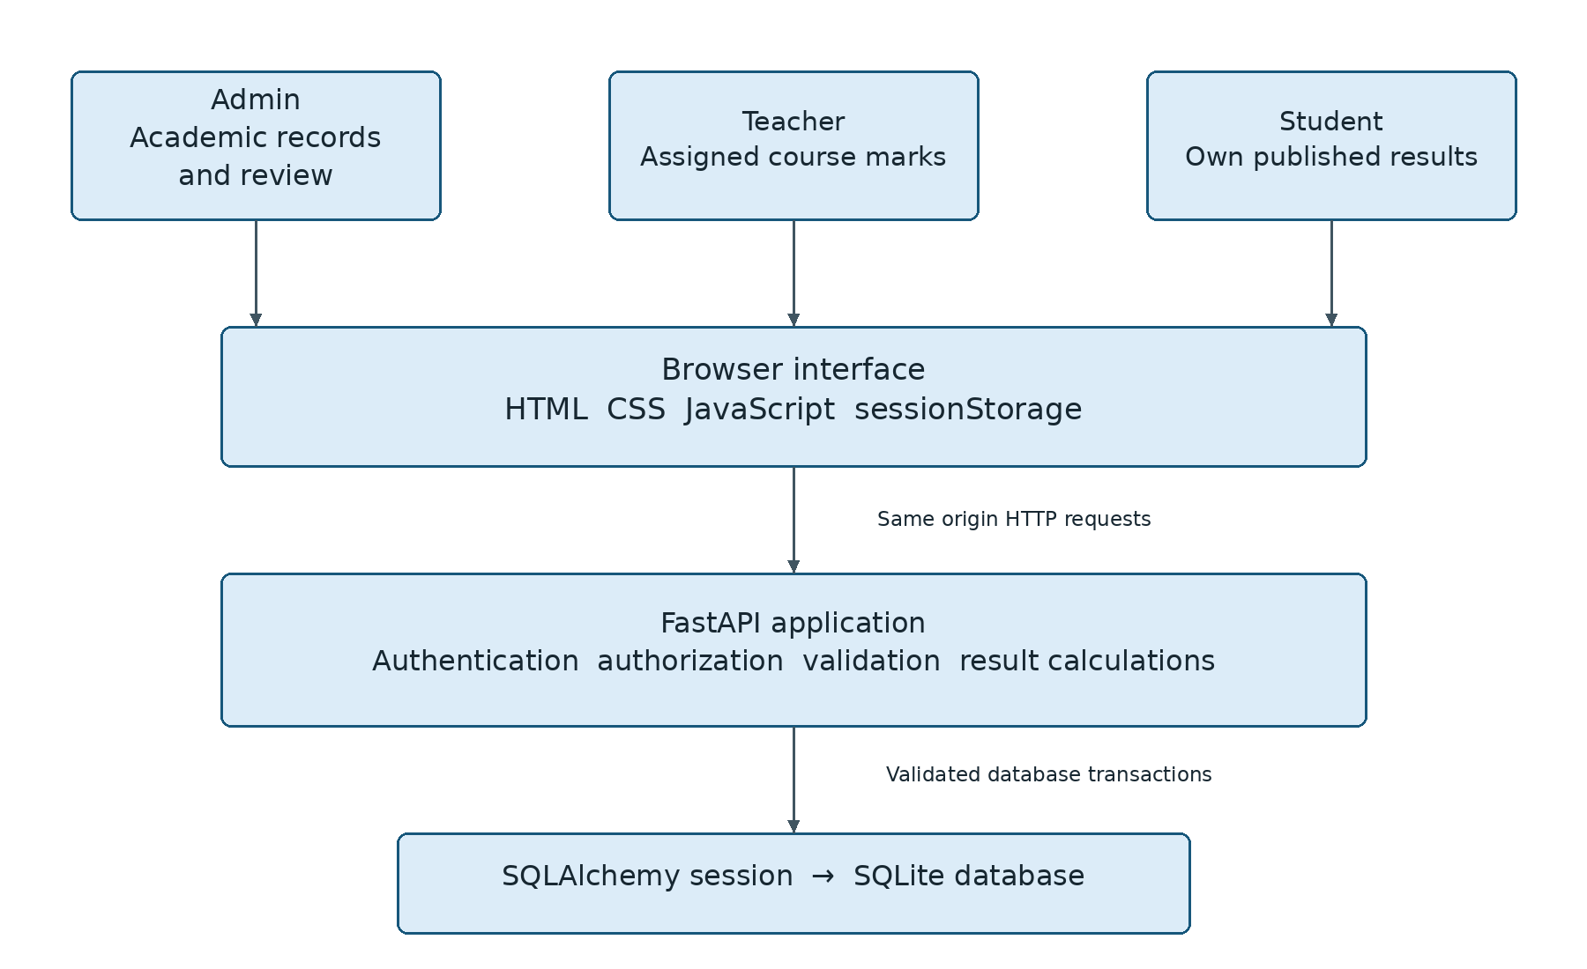
Figure 5.1 Layered architecture of the Result Processing System

5.2 Data flow and transactions
Academic setup, marks entry and published-result queries use the same database. Imports and batch changes use transactions; publication changes the existing marks record.
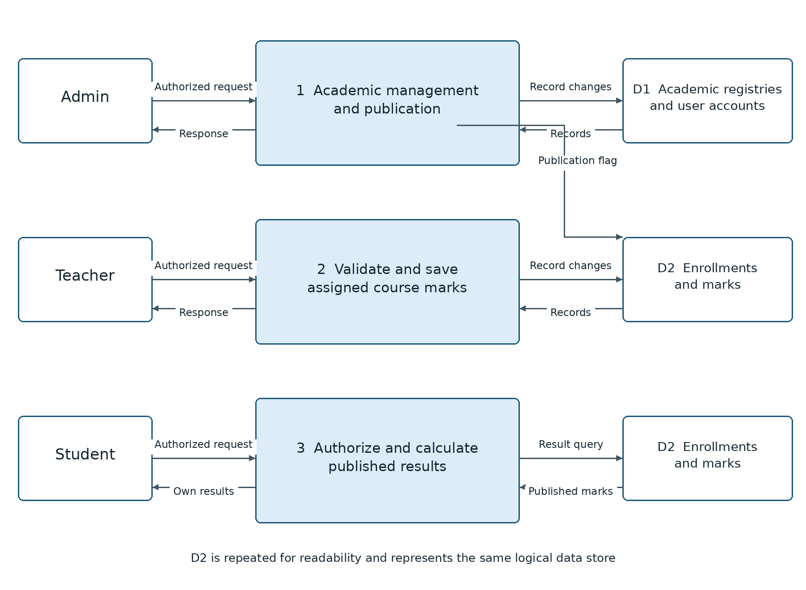
Figure 5.2 Main academic data flows and logical data stores

Use case design

5.3 Use case diagram
Administrators prepare academic data and publish reviewed results. Teachers enter marks within assigned offerings, and students read their own results. Account provisioning remains an administrative operation.
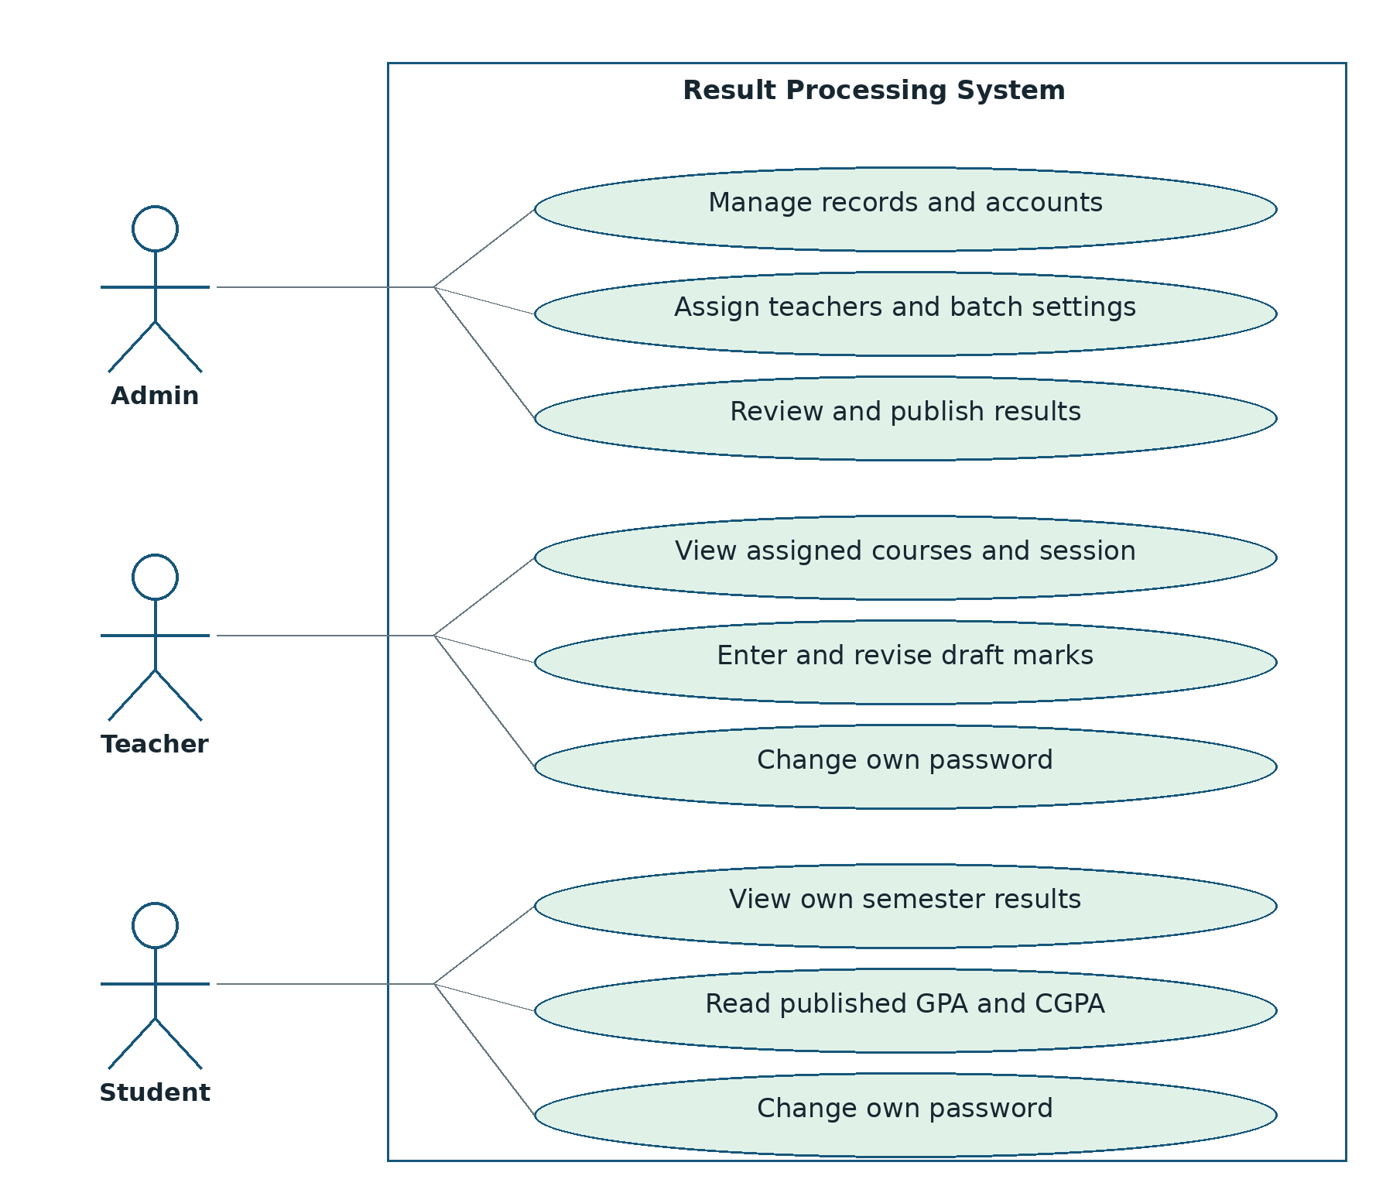
Figure 5.3 Role-specific use cases

Database design

5.4 Entity relationship diagram
Ten tables represent registries, accounts, batches, assignments, enrollments and marks. Each enrollment has at most one marks record. The user reference is an application-level link because it can identify a teacher or student; it is not a database foreign key.
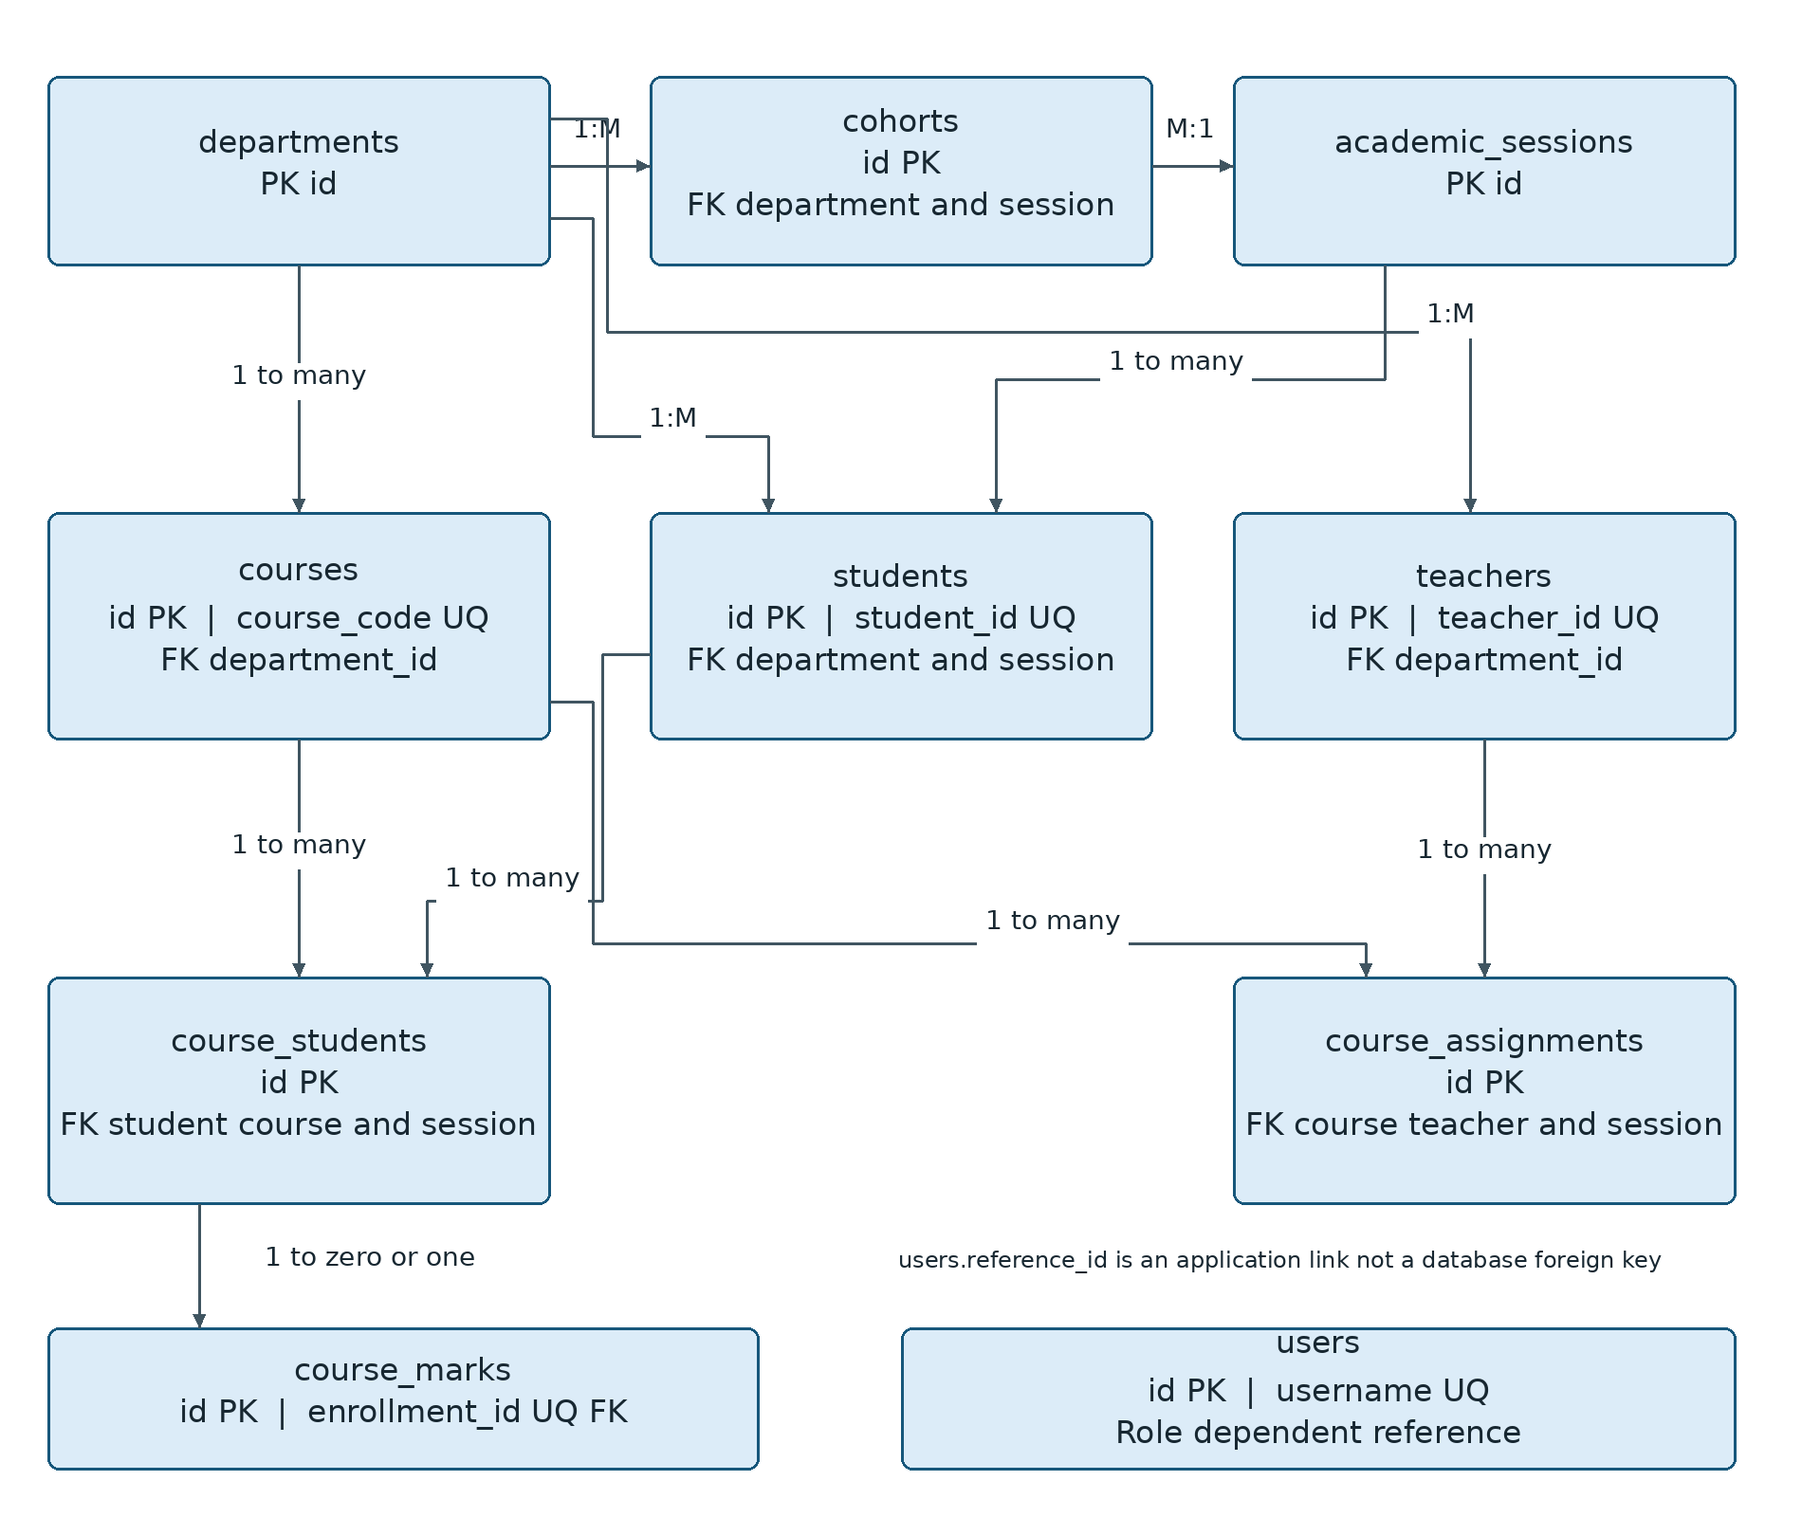
Figure 5.4 Database entities and principal relationships

Sequence and state design

5.5 Sequence diagram
A revision number links a reviewed record to its requested update. Saving, publishing or unpublishing advances the revision. Stale updates are rejected. The state sequence is no marks, draft and published; unpublishing returns a record to draft.
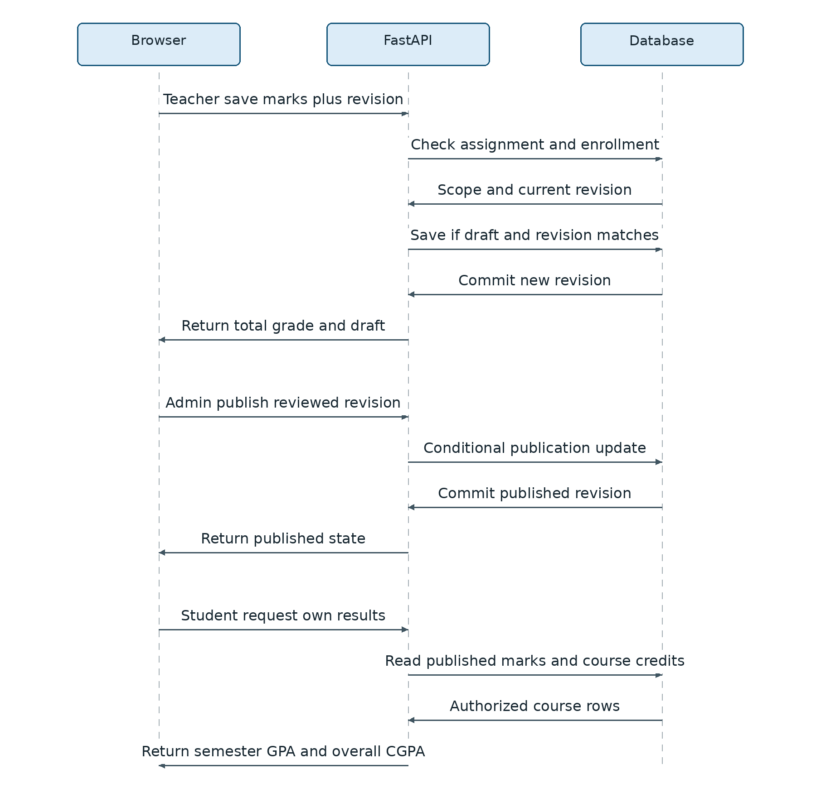
Figure 5.5 Save review publish and view sequence

CHAPTER 6
IMPLEMENTATION AND RESULTS

6.1 Implementation structure
FastAPI implements authentication, academic operations and results [5]. SQLAlchemy handles persistence; separate modules manage imports and fixed enrollment. HTML, CSS and JavaScript provide the interface.

6.2 Account and database lifecycle
Startup initializes Backend/rps.sqlite3 and synchronizes core enrollments. Administrators provision temporary passwords. First-login password changes and later resets invalidate earlier tokens.

6.3 Assessment and grade calculation
Total marks = assignment + class test + midterm + final, out of 150. The same configured weights apply to all course types. Percentage = total / 150 × 100; the mapping below is implemented in the application.
Table 6.1 Implemented grade thresholds
Minimum percentage | Minimum total out of 150 | Grade | GP
80 | 120.00 | A+ | 4.00
75 | 112.50 | A | 3.75
70 | 105.00 | A− | 3.50
65 | 97.50 | B+ | 3.25
60 | 90.00 | B | 3.00
55 | 82.50 | B− | 2.75
50 | 75.00 | C+ | 2.50
45 | 67.50 | C | 2.25
40 | 60.00 | D | 2.00
Below 40 | Below 60.00 | F | 0.00

6.4 GPA and CGPA
GPA = sum of credit × grade point / eligible credits. CGPA uses eligible courses across all semesters. Students receive published marks only; failed published courses count as zero points, while pending courses are excluded and the semester is marked Incomplete. Decimal arithmetic is used. Two three-credit courses with GP 4.00 and 3.00 produce GPA/CGPA 3.50. Retakes are not implemented.

Login and dashboard interfaces

6.5 Login and administrative dashboard
One sign-in page routes authenticated users to their role workspace. The dashboard summarizes academic records and separates current from result-processing semester. These snapshots use fictional demonstration data.
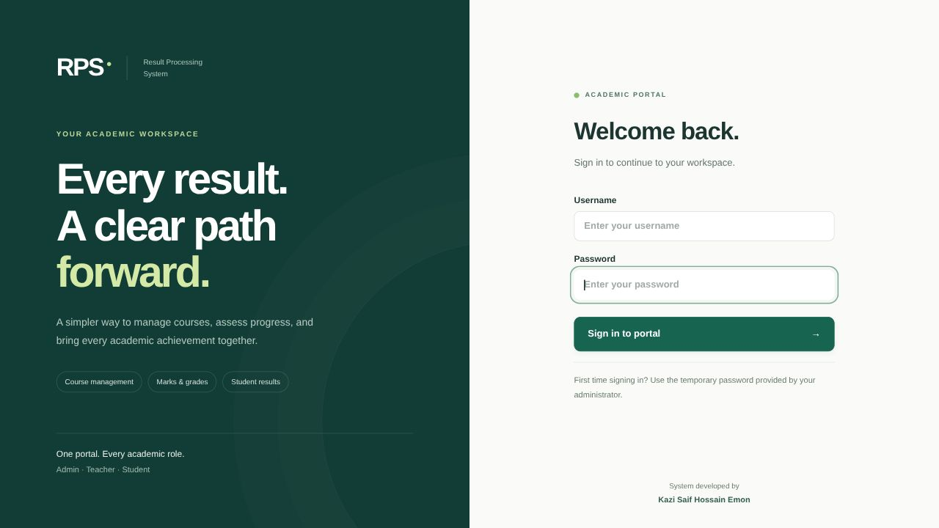
Figure 6.1 Redesigned login interface
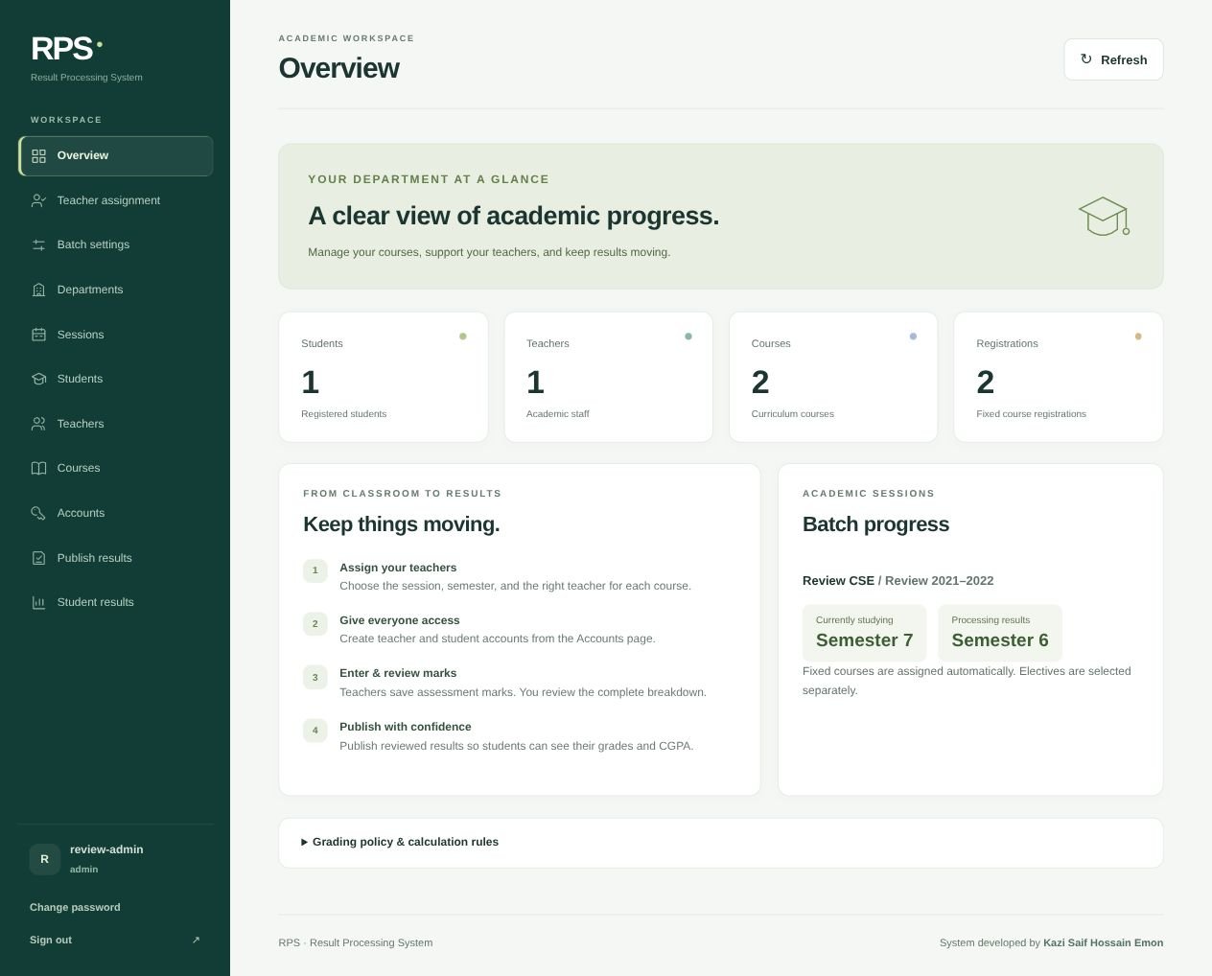
Figure 6.2 Administrative dashboard with batch progress

Marks entry and publication interfaces

6.6 Teacher entry and administrative review
Teachers select an assigned course/session, enter four bounded components and save each student separately. Unsaved input prompts confirmation. Administrators inspect the components, total and grade before publication; revision checks reject outdated saves and reviews.
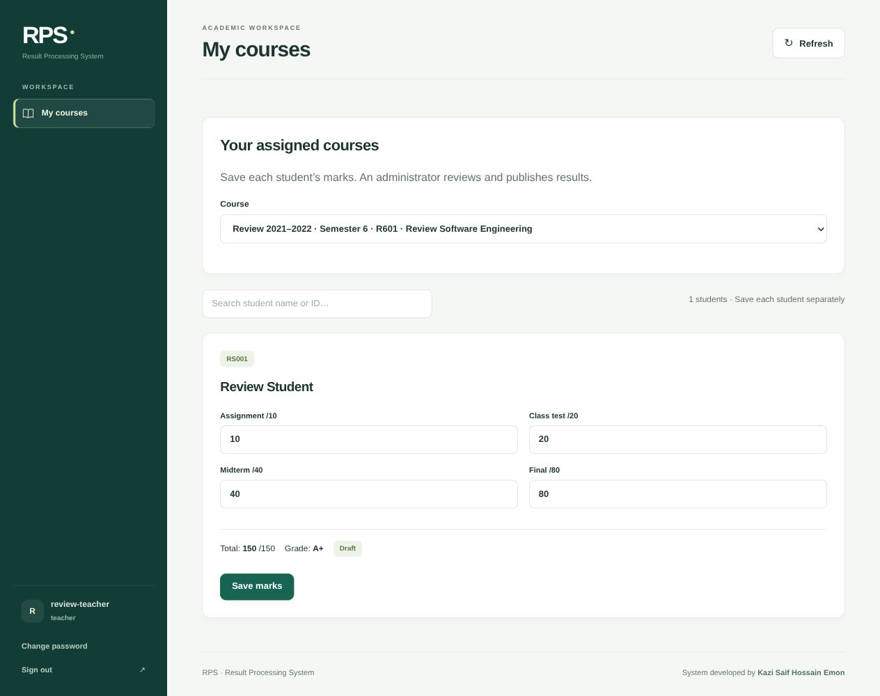
Figure 6.3 Teacher marks entry in an assigned session
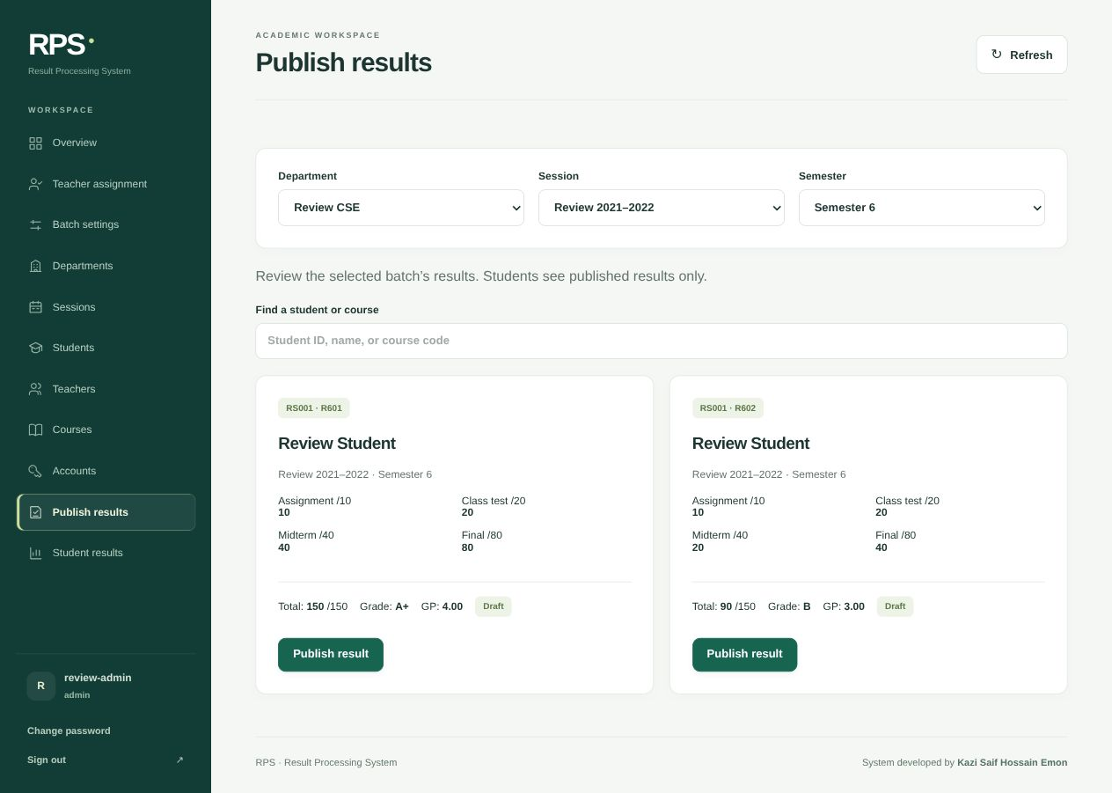
Figure 6.4 Component-level result review before publication

Student results and implementation outcome

6.7 Student results and implementation outcome
Students see their own published results, semester GPA and overall CGPA. The default semester follows batch settings. The snapshot illustrates two equal-credit courses with grade points 4.00 and 3.00, giving GPA and CGPA 3.50. This demonstration is separate from official academic records.
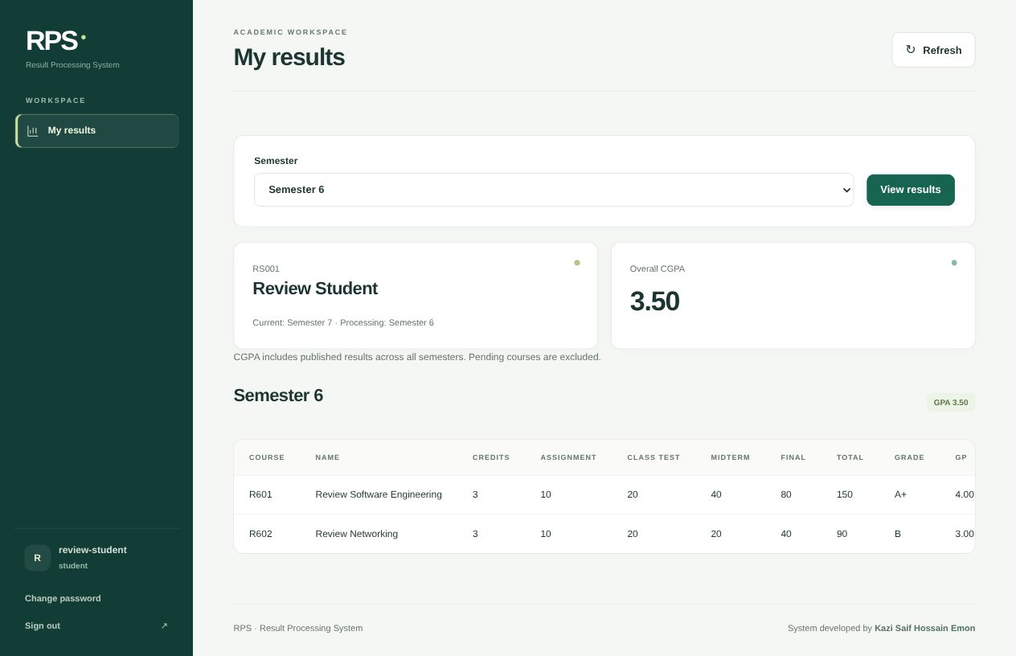
Figure 6.5 Student result view with verified GPA and CGPA

6.8 Operational boundaries
The prototype supports the local academic workflow. Official grading approval, retake rules, audit history and public hosting remain future work. Interface examples do not establish production capacity or institutional acceptance.

CHAPTER 7
TESTING

7.1 Unit testing method and isolation
Python unittest checks grading functions and the marks model directly [7]. JavaScript handlers use mocked page elements, storage and fetch. Tests use isolated configuration without a live browser, server or academic database.

7.2 Unit cases and outcomes
All 18 methods passed. Cases cover grade thresholds, boundary values, pending marks and validation failures. Methods may contain multiple input subcases.
Table 7.1 Executed unit test summary
Unit group | Test methods | Passed | Failed
Grading and pending result functions | 5 | 5 | 0
Marks input model | 7 | 7 | 0
Frontend isolated state handlers | 6 | 6 | 0
Total | 18 | 18 | 0

Table 7.2 Backend unit case outcomes
ID | Unit and input | Expected outcome
U01 | Every grade threshold from 120 to 60 | Correct grade and grade point
U02 | Total 59.99 | F and GP 0
U03 | Totals 0 and 150 | F and A+ respectively
U04 | Total 119.99 | A and GP 3.75
U05 | marks_info with no saved marks | Pending values and unpublished
U06 | Four components at maxima | Validation succeeds
U07 | Final marks 65.25 | Validation succeeds
U08 | Final marks 65.251 | Validation error
U09 | Negative or excessive component | Validation error for each field
U10 | Final component omitted | Validation error
U11 | NaN or infinity | Validation error
U12 | Revision zero | Validation error

Unit testing snapshot

7.3 Frontend cases and execution snapshot
The six frontend cases verify confirmation, cancellation, unsaved marks, forced logout, stale unauthorized responses, readable errors and preview-dialog state [6]. The snapshot reproduces captured execution output from 3 November 2026: 12 Python methods and 6 JavaScript methods passed.
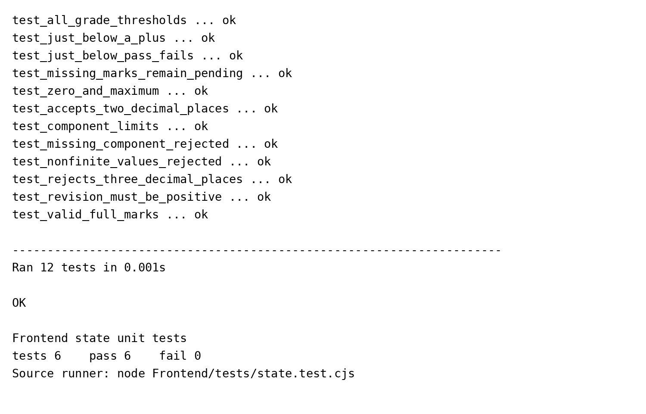
Figure 7.1 Captured Python and frontend unit test output

7.4 Interpretation
The results support only the tested functions, validation rules and state transitions. They do not establish full workflow correctness, load capacity or production security. GPA is computed inside the result endpoint and is not claimed as a separately isolated function test.

CHAPTER 8
CONCLUSIONS AND FUTURE WORK

8.1 Conclusion
RPS provides a working local path from academic setup to student result viewing. Its main contribution is the explicit connection between department, session, curriculum, teaching responsibility and publication state. Fixed core enrollment removes repetitive student-course assignment, while separate current and processing semesters support delayed result processing for a batch that has already progressed.
The implemented checks address practical failure modes: invalid marks, access to another session, stale edits, publication of an outdated review, accidental changes to credits after marks exist, and deletion of enrollments that have saved results. The user interface presents these rules through ordinary forms, selectors, student cards and confirmation controls.

8.2 Limitations
- Assessment weights are fixed at 10, 20, 40 and 80 for all course types.
- Retakes, repeated attempts and grade replacement are not modeled.
- Account credentials must be shared manually; there is no automated email or SSO.
- Official transcript generation and downloadable result sheets are not implemented.
- The local application has process-local login limits, no complete audit-history module and no production hosting configuration.

8.3 Future development
Useful extensions include institution-approved assessment policies per course type, retake handling, a verifiable result-change audit trail, student-specific elective planning, printable transcripts, notification delivery and a reviewed production deployment. These should be added only after requirements are confirmed and the existing grade calculations and access controls remain covered by tests.

8.4 Completion status
The local software workflow is implemented, and the isolated unit checks reported in Chapter 7 pass. Final academic demonstration still requires administrator-selected teaching assignments, teacher/student accounts and approved demonstration marks. Production readiness requires separate institutional and operational acceptance.

References
[1] FastAPI, “OAuth2 with Password and hashing Bearer with JWT tokens,” FastAPI Documentation. [Online]. Available: https://fastapi.tiangolo.com/tutorial/security/oauth2-jwt/. [Accessed: Nov. 3, 2026].
[2] SQLite, “SQLite Foreign Key Support,” SQLite Documentation. [Online]. Available: https://www.sqlite.org/foreignkeys.html. [Accessed: Nov. 3, 2026].
[3] National Institute of Standards and Technology, “Role based access control,” CSRC Glossary. [Online]. Available: https://csrc.nist.gov/glossary/term/role_based_access_control. [Accessed: Nov. 3, 2026].
[4] SQLAlchemy, “Configuring a Version Counter,” SQLAlchemy 2.1 Documentation. [Online]. Available: https://docs.sqlalchemy.org/en/21/orm/versioning.html. [Accessed: Nov. 3, 2026].
[5] K. S. H. Emon, “Result Processing System,” application source code, version 2.1.0, Institute of Science & Technology, 2026. Local project repository, reviewed Nov. 3, 2026.
[6] K. S. H. Emon, “RPS project documentation and unit test evidence,” README.md, Frontend/tests/state.test.cjs and test_rps_units.py, 2026.
[7] Python Software Foundation, “unittest — Unit testing framework,” Python Documentation. [Online]. Available: https://docs.python.org/3/library/unittest.html. [Accessed: Nov. 3, 2026].

